Table S1: Survey Responses Across Vaccine Knowledge, Risk Perception, and Trust
Knowledge | Perceived Risk of Vaccines  613ª | Trust in Vaccine Information  1117ª | Pandemic Influence on Vaccine Hesitancy  788ª
Understanding of Vaccine Efficacy and Safety | 142 (5.62)^{b} | 887 (35.1) ^{b} | 402 (15.9) ^{b}
Awareness of Vaccines for General Immunization | 305 (12.1) ^{b} | 813 (32.2) ^{b} | 478 (18.9) ^{b}
Exposure to Misinformation about Vaccines | 454 (18) ^{b} | 736 (29.1) ^{b} | 604 (23.9) ^{b}
Valuing Individual Autonomy in Healthcare Decisions | 563 (22.3) ^{b} | 1040 (41.2) ^{b} | 751 (29.7) ^{b}
Historical Influences on Vaccine Perception | 225 (8.9) ^{b} | 598 (23.7) ^{b} | 524 (20.7) ^{b}
Concerns About Equitable Vaccine Access | 423 (16.7) ^{b} | 948 (37.5) ^{b} | 670 (26.5) ^{b}
ª counts; ^{b} percentages (%)

Table S2: Responses on Side Effects and COVID‑19 Infections Across Vaccine Doses
Dose | One | Two | Booster Doses
Post-Vaccination Side Effects | 42(1.66) | 354 (14.0) | 66 (2.61)
Post-Vaccination COVID-19 Infection | 60(2.4) | 450 (17.8) | 80 (3.2)
Family/Friends’ COVID-19 Infections Post-Vaccination | 88(3.5) | 665 (26.3) | 112 (4.4)
Completion of Mandatory Vaccinations | 85 (3.4) | 854 (33.8) | 144 (5.7)
Counts, percentages

Table S3: Side Effects Following COVID‑19 Vaccines Across Different Brands
 | Vaccination site discomfort (pain/redness/swelling) | Tiredness | Headache | Muscle pain | Chills | Fever | Nausea
Pfizer | 124 (4.91) | 115 (4.6) | 113 (4.5) | 167 (6.6) | 105 (4.2) | 128 (5.1) | 27 (1.1)
Modrena | 25 (0.99) | 18 (0.7) | 21 (0.8) | 26 (1) | 17 (0.7) | 25 (1) | 4 (0.2)
Oxford–AstraZeneca | 6 (0.24) | 6 (0.2) | 8 (0.3) | 12 (0.5) | 10 (0.4) | 14 (0.6) | 0 (0)
Janssen | 0 (0) | 0 (0) | 2 (0.1) | 3 (0.1) | 1 (0) | 1 (0) | 1 (0)
Covisheld | 2 (0.08) | 1 (0) | 0 (0) | 3 (0.1) | 3 (0.1) | 2 (0.1) | 1 (0)
Sinopharm | 1 (0.04) | 3 (0.1) | 1 (0) | 3 (0.1) | 0 (0) | 0 (0) | 0 (0)
CoronaVac | 30 (1.19) | 36 (1.4) | 32 (1.3) | 45 (1.8) | 21 (0.8) | 24 (1) | 4 (0.2)
Novavax | 2 (0.08) | 1 (0) | 1 (0) | 2 (0.1) | 1 (0) | 1 (0) | 0 (0)
Covaxin | 1 (0.04) | 1 (0) | 0 (0) | 0 (0) | 0 (0) | 2 (0.1) | 0 (0)
Sinopharm | 0 (0) | 0 (0) | 0 (0) | 0 (0) | 0 (0) | 0 (0) | 0 (0)
Soberana | 0 (0) | 0 (0) | 0 (0) | 0 (0) | 0 (0) | 0 (0) | 0 (0)
Counts, percentages

Table S4: Vaccine Infection History and Experienced Side Effects by children
 | Overall Vaccination History | Last year vaccination status | Experienced vaccine side effects
rotavirus infection | 59 (2.34%) | 62 (2.45%) | 15 (0.59%)
pneumococcal infection | 53 (2.1%) | 54 (2.14%) | 7 (0.28%)
meningococcal infection | 36 (1.43%) | 38 (1.5%) | 3 (0.12%)
chicken pox | 97 (3.84%) | 102 (4.04%) | 20 (0.79%)
hepatitis A | 53 (2.1%) | 56 (2.22%) | 5 (0.2%)
human papilloma virus | 19 (0.75%) | 20 (0.79%) | 2 (0.08%)
flu | 140 (5.54%) | 147 (5.82%) | 32 (1.27%)
Counts; percentages

Table S5: Vaccine Necessity Perceptions, Sociocultural Influences, and Information Sources Across Attitude and Risk Concern Measures
 | Overall Attitude Toward Vaccines |  |  | Concern About Vaccine Side Effects or Risks
Variable | Neutral | Negative | Positive | No | Yes
Perceived Need and Attitudes Toward Vaccination
Perception of Vaccine Necessity | 735 (29.1) | 40 (1.58) | 1262 (50.0) | 442 (17.5) | 1595 (63.1)
Factors Influencing Vaccine Opinion
Safety and Risk Concerns | 905 (35.8) | 182 (7.21) | 1173 (46.4) | 421 (16.7) | 1839 (72.8)
Socio-Political and Economic Determinants
Political ideology | 74 (2.93) | 32 (1.27) | 43 (1.7) | 29 (1.15) | 120 (4.75)
Social influences | 289 (11.4) | 39 (1.54) | 322 (12.8) | 127 (5.03) | 523 (20.7)
Economic factors | 155 (6.14) | 24 (0.95) | 210 (8.31) | 75 (2.97) | 314 (12.4)
Cultural and Social Norms
Cultural Norms Toward Vaccination | 248 (9.82) | 25 (0.99) | 834 (33.0) | 259 (10.2) | 848 (33.6)
Influence of Peer or Familial Opinion on Vaccine Views | 155 (6.14) | 39 (1.54) | 155 (6.14) | 31 (1.23) | 318 (12.6)
Trust in Healthcare and Governmental Institutions | 526 (20.8) | 170 (6.73) | 435 (17.2) | 79 (3.13) | 1052 (41.6)
Trusted Sources for Vaccine-Related Information
Family doctor | 354 (14.0) | 36 (1.43) | 501 (19.8) | 170 (6.73) | 721 (28.5)
Friend/friends | 178 (7.05) | 72 (2.85) | 74 (2.93) | 34 (1.35) | 290 (11.5)
Government information sources | 141 (5.58) | 21 (0.83) | 231 (9.14) | 113 (4.47) | 280 (11.1)
Health care workers | 293 (11.6) | 49 (1.94) | 423 (16.8) | 161 (6.37) | 604 (23.9)

Table S6: Willingness for Future Vaccination and Trust in Healthcare Professionals’ Recommendations
 | Willingness to Receive Future Vaccination |  |  |  | Trust in Healthcare Professionals’ Recommendations
 | No | Yes | p-valueª | Post hoc^{b} | Low Trust | High Trust | p-valueª | Post hoc^{b}
History of Adverse Reactions to Vaccines | 217 (8.59) | 344 (13.6) | 0.0498 | No vs Yes: 0.001 | 326 (12.9) | 235 (9.3) | 0.000 | No vs Yes: 0.000
Influence of Personal Health Beliefs on Vaccine Perception | 550 (21.8) | 938 (37.1) | 0.0000 | No vs Yes: 0.000 | 880 (34.8) | 608 (24.1) | 0.000 | No vs Yes: 0.000
Impact of Socioeconomic Status on Vaccine Access | 156 (6.18) | 240 (9.5) | 0.0400 | No vs Yes: 0.000 | 209 (8.27) | 187 (7.4) | 0.001 | No vs Yes: 0.000
Local Access and Affordability of Vaccines | 586 (23.2) | 1574 (62.3) | 0.0000 | No vs Yes: 0.000 | 1109 (43.9) | 1051 (41.6) | 0.000 | No vs Yes: 0.000
Government Policy Influence on Vaccination Decisions | 165 (6.53) | 441 (17.5) | 0.0010 | No vs Yes: 0.000 | 295 (11.7) | 311 (12.3) | 0.029 | No vs Yes: 0.000
Economic Barriers to Vaccination | 103 (4.08) | 177 (7.01) | 0.0142 | No vs Yes: 0.000 | 141 (5.58) | 139 (5.5) | 0.021 | No vs Yes: 0.000
Effect of Political Beliefs on Vaccines | 63 (2.49) | 56 (2.22) | 0.0012 | No vs Yes: 0.000 | 82 (3.25) | 37 (1.46) | 0.000 | No vs Yes: 0.000
ª chi square test; ^{b} Post-Hoc Analysis

Table S7: Sociodemographic, Access, and Belief-Based Characteristics Associated with Vaccine Hesitancy
 | Perceived Vaccine Hesitancy in the Community
 | No | Yes
Trust place in healthcare professionals recommendations | 1101 (43.6) | 647 (25.6)
government vaccine policies influence on vaccinated decision | 311 (12.3) | 295 (11.7)
previous experiences with adverse reactions to vaccines | 300 (11.9) | 261 (10.3)
influence of perception of vaccines | 802 (31.8) | 686 (27.2)
Impact of Socioeconomic Status on Vaccine Access | 197 (7.8) | 199 (7.88)
Local Vaccine Accessibility and Affordability | 1298 (51.4) | 862 (34.1)
Urban–Rural Disparities in Vaccine Access | 330 (13.1) | 403 (16.0)
Challenges in Accessing Healthcare Facilities Locally | 122 (4.83) | 123 (4.87)
Influence of Political Ideology on Vaccine Views | 55 (2.18) | 64 (2.53)
Cultural and Societal Influences on Vaccine Hesitancy | 104 (4.12) | 434 (17.2)

Table S8: Cultural and Societal Beliefs Influencing Vaccine Hesitancy
 | Cultural and Societal Beliefs Influencing Vaccine Hesitancy
 | Yes | No | p-valueª | Cramer's V^{b} | Post hoc^{c}
Sharing Knowledge on COVID-19 Variants with Social Circles | 158 (6.25) | 76 (3.01) | 0.000 | 0.087 | No vs Yes: 0.000
Willingness to Discuss COVID-19 Variants with Others | 778 (30.8) | 257 (10.2) | 0.000 | 0.072 | No vs Yes: 0.000
Impact of Personal Health Beliefs on Vaccine Perception | 1112 (44.0) | 376 (14.9) | 0.000 | 0.116 | No vs Yes: 0.000
Vaccination History | 1825 (72.2) | 509 (20.2) | 0.029 | 0.043 | No vs Yes: 0.000
Economic Barriers to Vaccination | 181 (7.17) | 99 (3.92) | 0.000 | 0.121 | No vs Yes: 0.000
Political Ideology and Vaccine Perception | 68 (2.69) | 51 (2.02) | 0.000 | 0.117 | No vs Yes: 0.000
Perceived Urban–Rural Disparities in Vaccine Access | 504 (20.0) | 229 (9.07) | 0.000 | 0.155 | No vs Yes: 0.000
ª chi square test; ^{b}Cramer's V test ; ^{c} Post-Hoc Analysis

Table S9: Distribution of Behavioural, Socioeconomic, and Access Variables by Reported Environmental Influences on Vaccine Perceptions
 | Influence of Environmental Factors on Vaccine hasitency
 | No | Yes | p-valueª | Cramer's V^{b} | Post hoc^{c}
Avoidance of Crowded Places During COVID-19 | 638 (25.3) | 206 (8.16) | 0.2921 | 0.021 | NA
Socioeconomic Status and Vaccine Access | 240 (9.5) | 156 (6.18) | 0.0000 | 0.166 | No vs Yes: 0.000
Local Vaccine Accessibility and Affordability | 496 (19.6) | 1664 (65.9) | 0.5702 | 0.011 | NA
Regional Gaps in Vaccine Availability | 466 (18.4) | 267 (10.6) | 0.0000 | 0.201 | No vs Yes: 0.000
Challenges Accessing Local Healthcare Facilities | 144 (5.7) | 101 (4) | 0.0000 | 0.14 | No vs Yes: 0.000
ª chi square test; ^{b}Cramer's V test ; ^{c} Post-Hoc Analysis

Table S10: Policy Perception, Accessibility, and Conflict Exposure by Level of Trust in the Ukrainian Healthcare System
 | trust in the Ukrainian healthcare system
 | Low | Moderate | High | p-value ª | p-value ^{b}
Effectiveness of Government Policies on Vaccine Hesitancy | 122 (4.83) | 271 (10.7) | 195 (7.72) | 0.000 | 0.000
Trust in Healthcare System and Vaccine Decisions | 418 (16.6) | 349 (13.8) | 229 (9.07) | 0.000 | 0.000
Equity in Vaccine Access Across Ukraine | 438 (17.3) | 704 (27.9) | 301 (11.9) | 0.000 | 0.310
Residence in Conflict-Affected Region | 493 (19.5) | 675 (26.7) | 266 (10.5) | 0.043 | 0.029
ª chi square test; ^{b}Cochran-Armitage trend test.

Figure S1: Spider chart of performance measures for machine learning algorithms. ()1.knowledge), (2.belief), (3.Attitude), (4.Practice), (5.Access, Policy & Structural Barriers)
1.knowledge
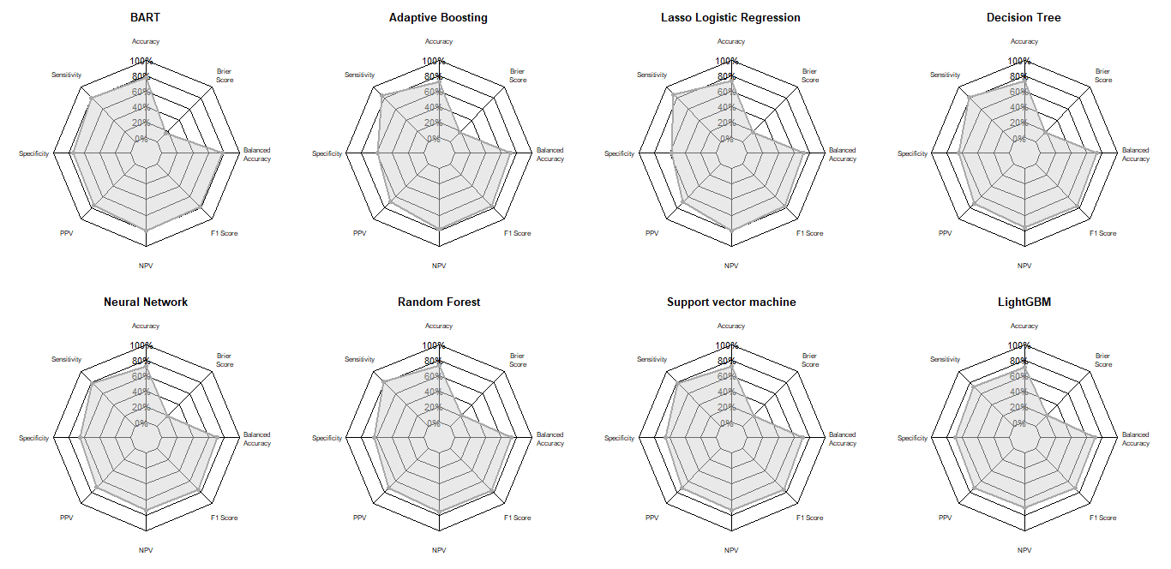
2.belief
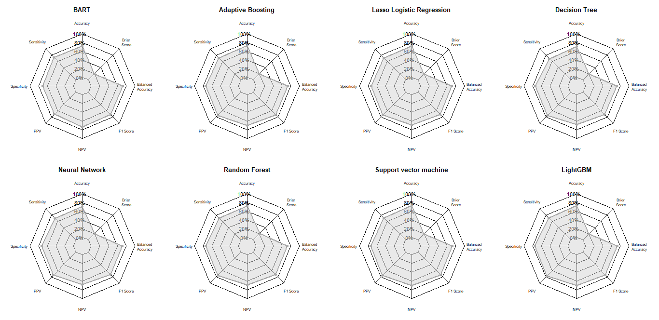

3.Attitude
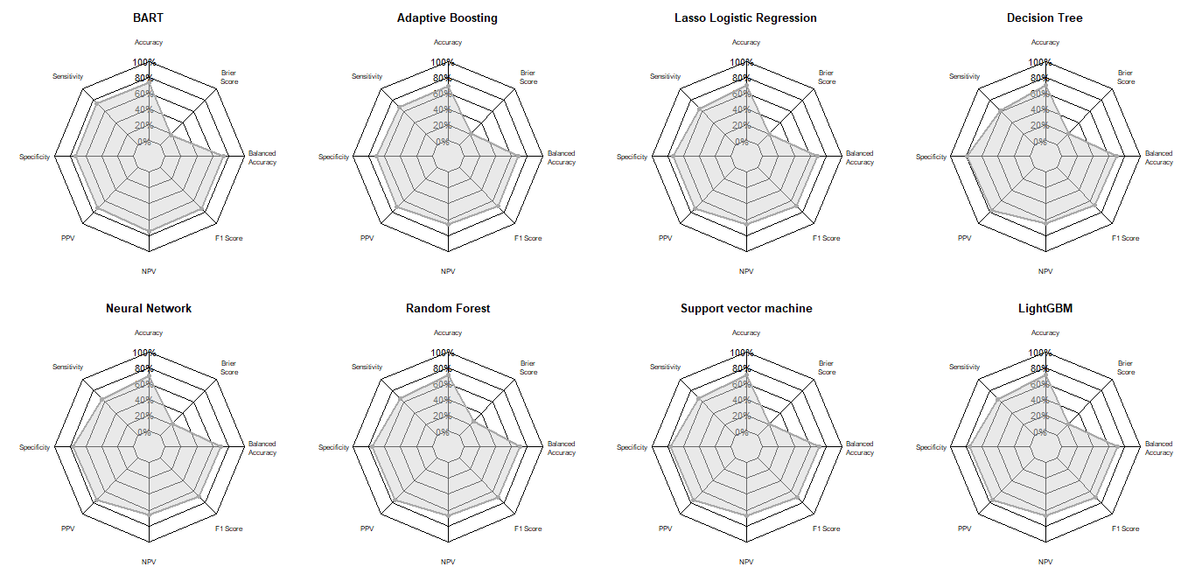
4.Practice
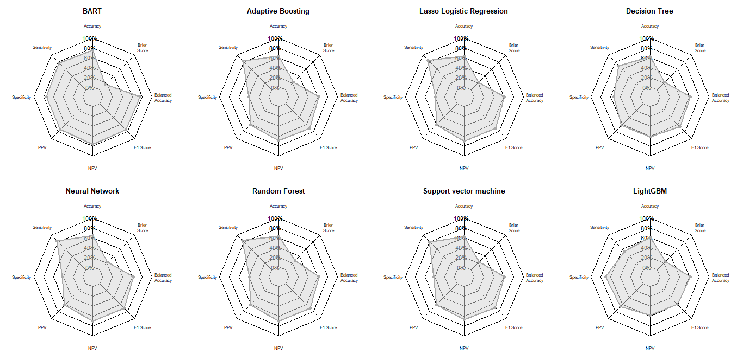

5.Access, Policy & Structural Barriers
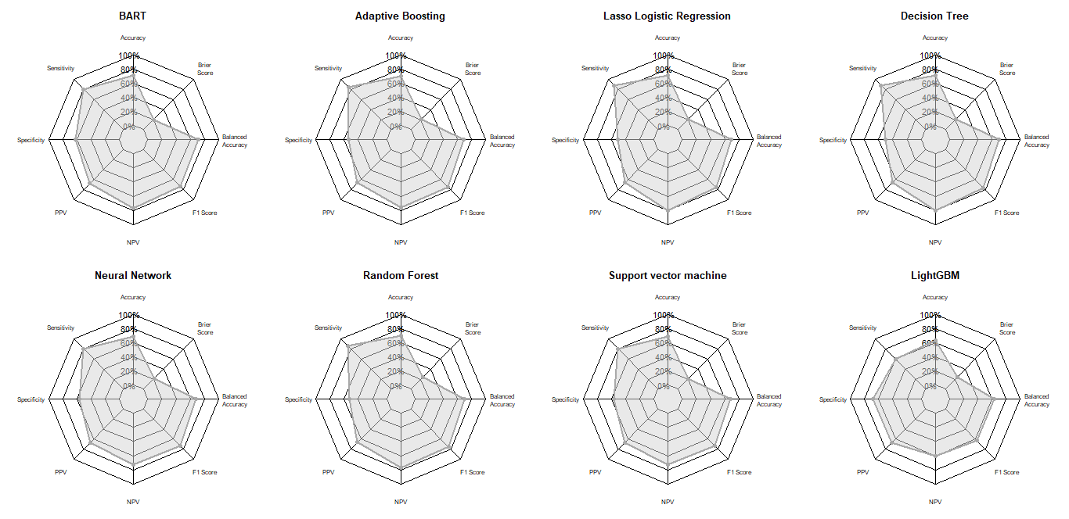

Figure S2: Important predictors determined by BART. (A) Variable inclusion proportions. (B) Local procedure to determine important predictors for α=0.05, (C) Global Max and Global SE thresholds to determine the important predictors. (1.knowledge), (2.belief), (3.Attitude), (4.Practice), (5.Access, Policy & Structural Barriers)

1.knowledge
A.
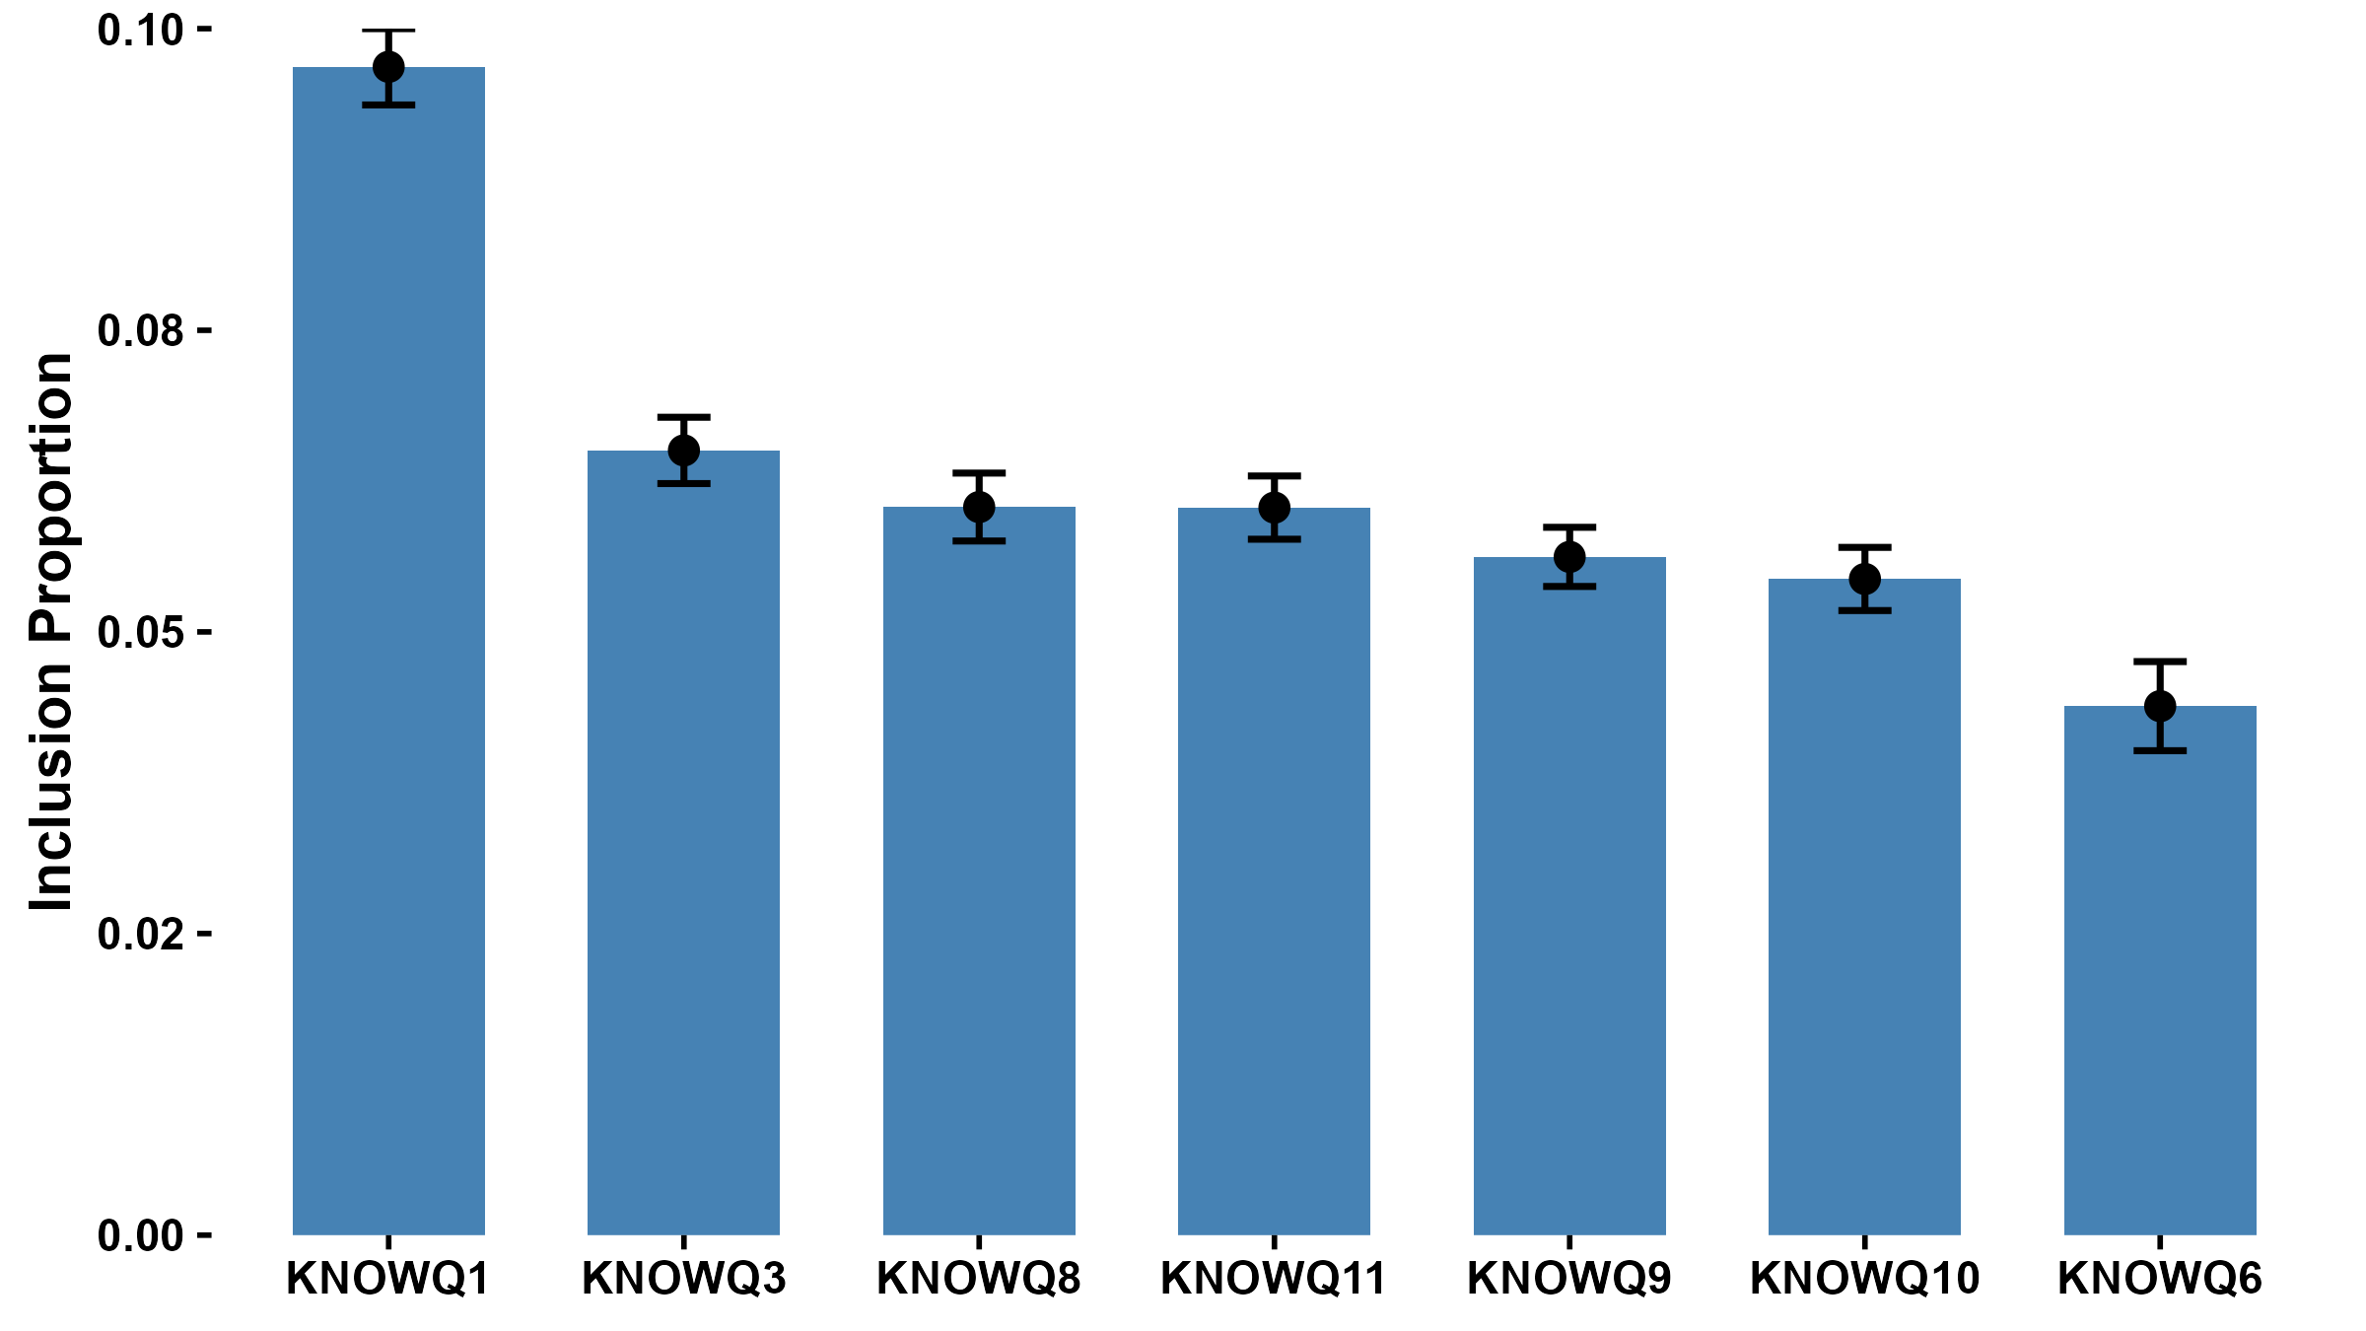
B.
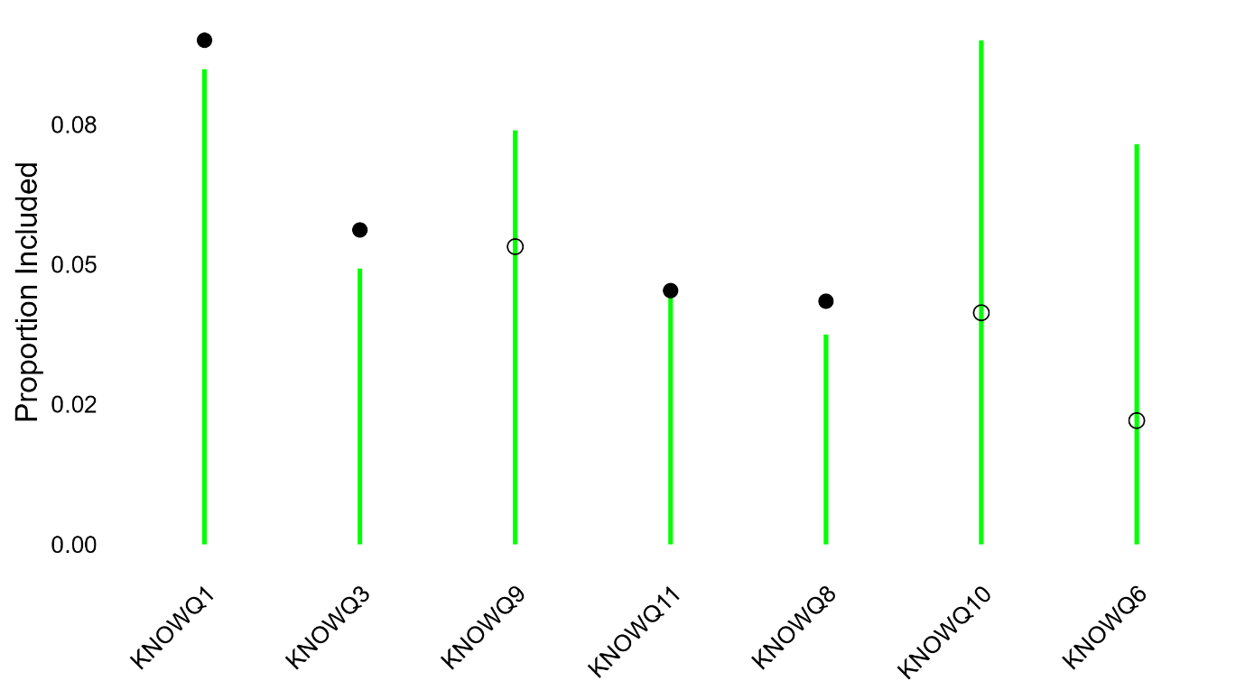
C.
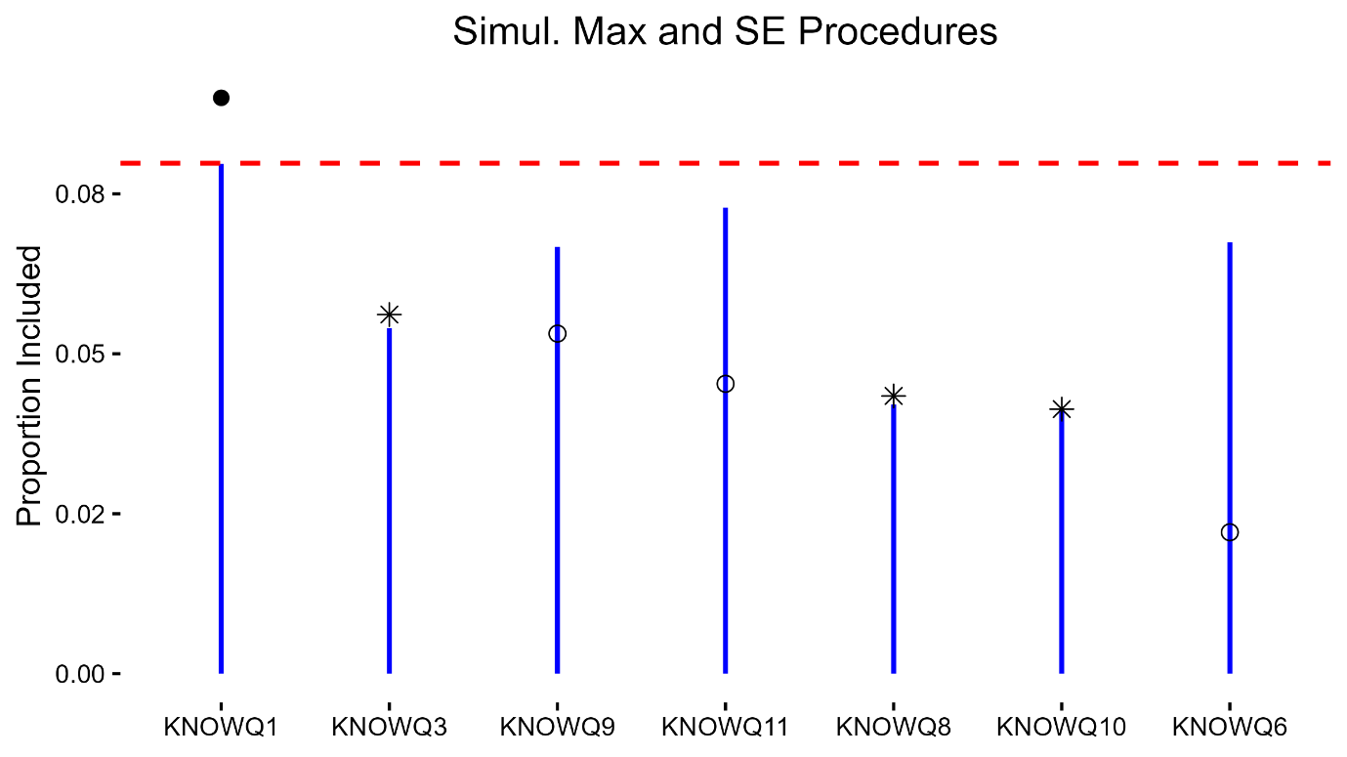

2. belief
A.
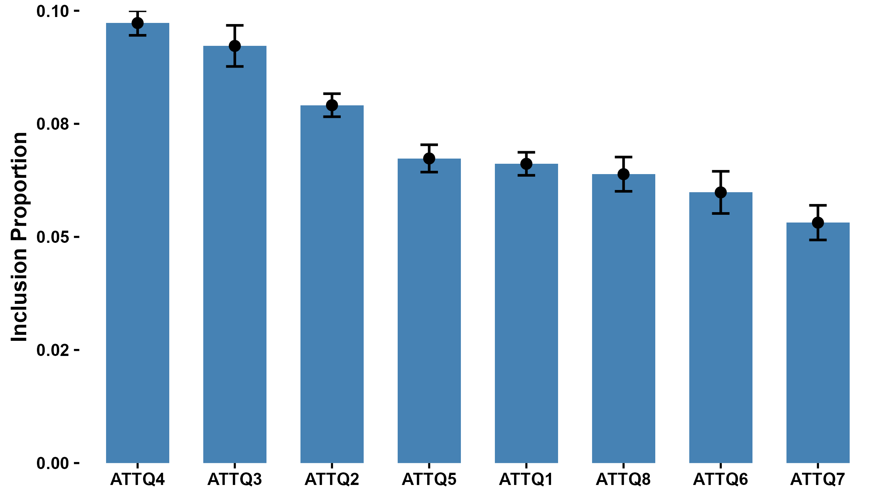
B.
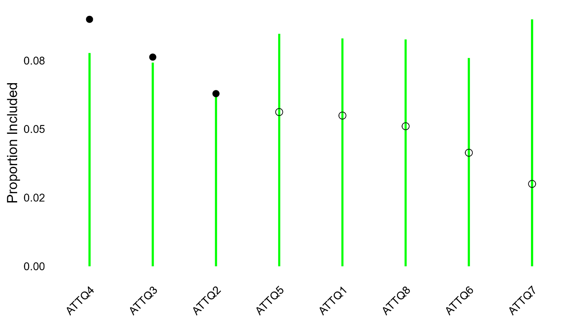

C.
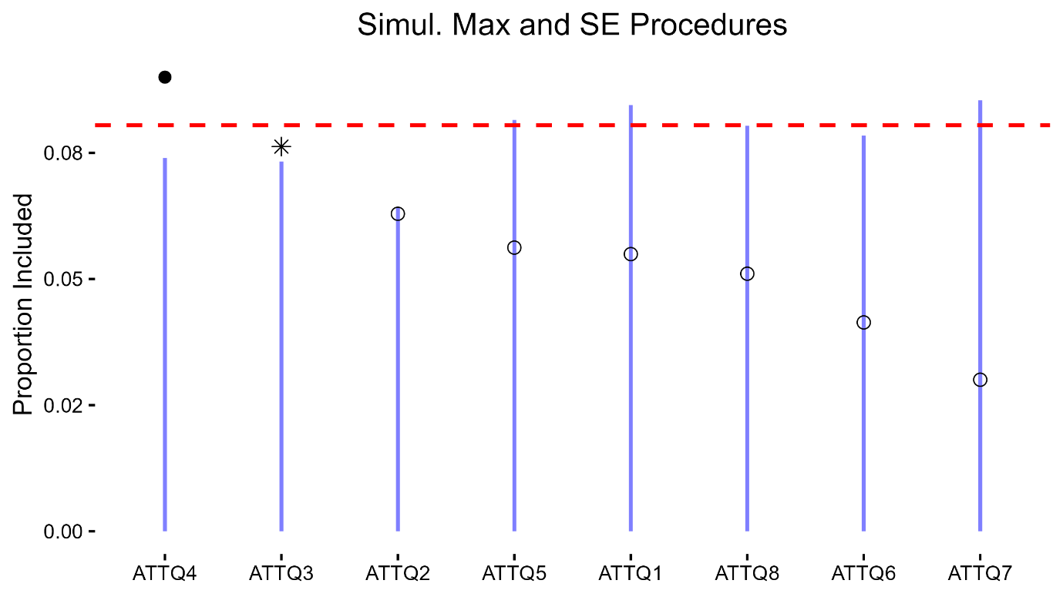

3.Attitude
A.
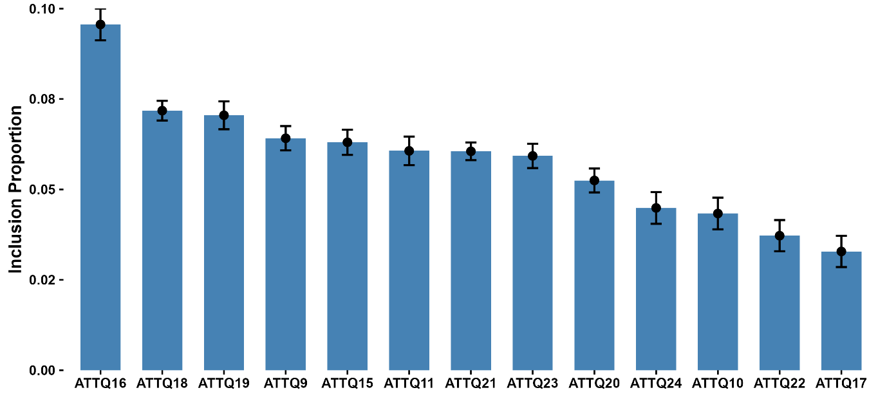
B.
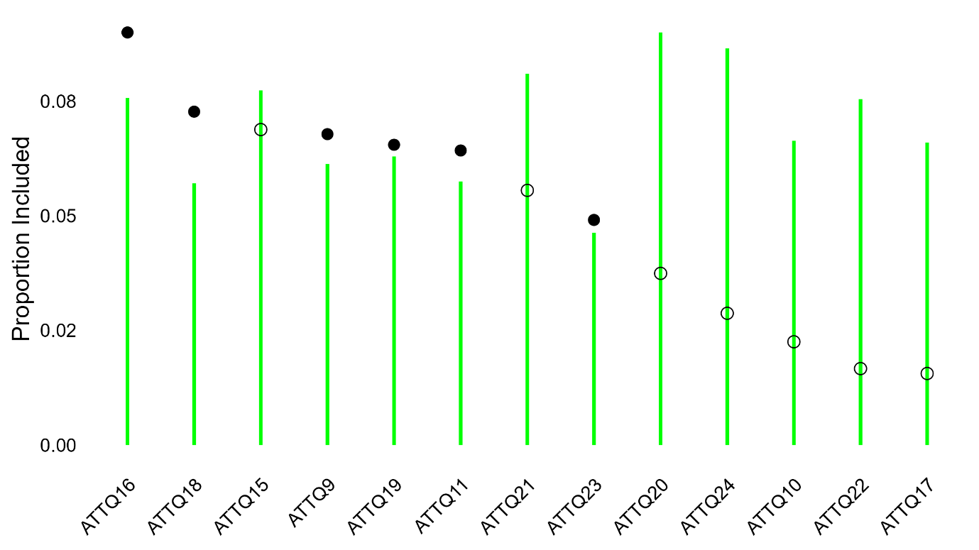

C.
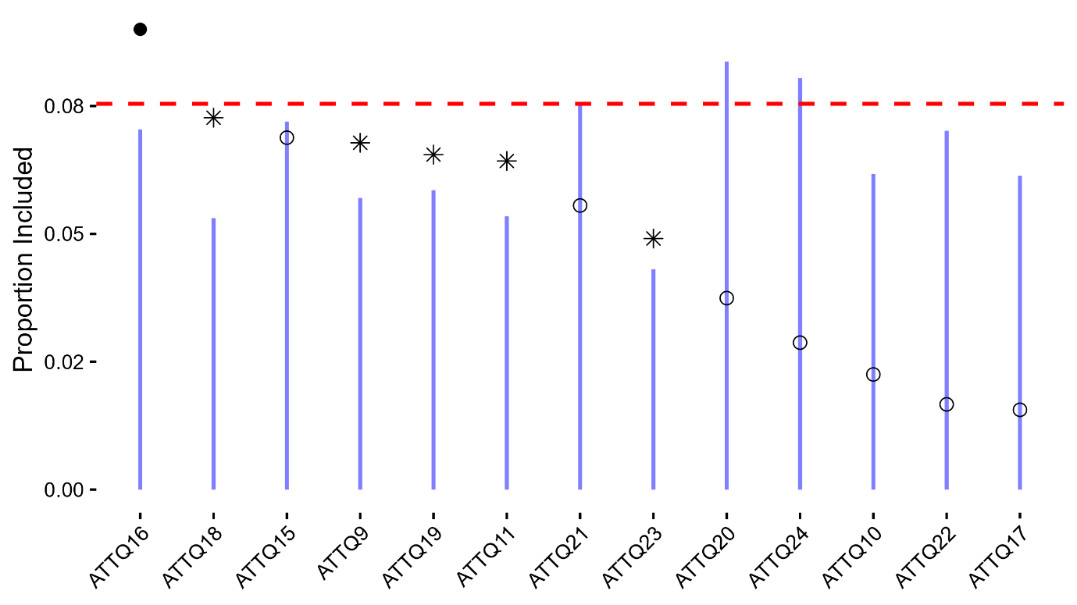

4. Practice
A.
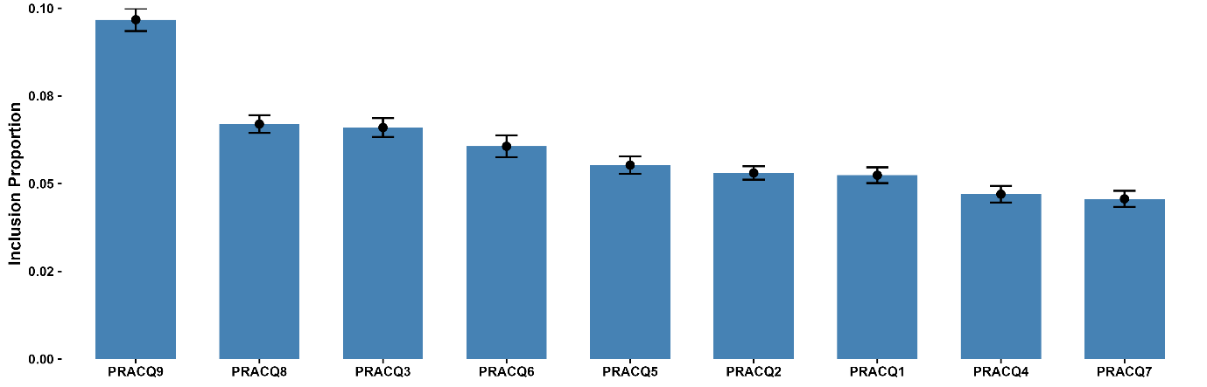
B.
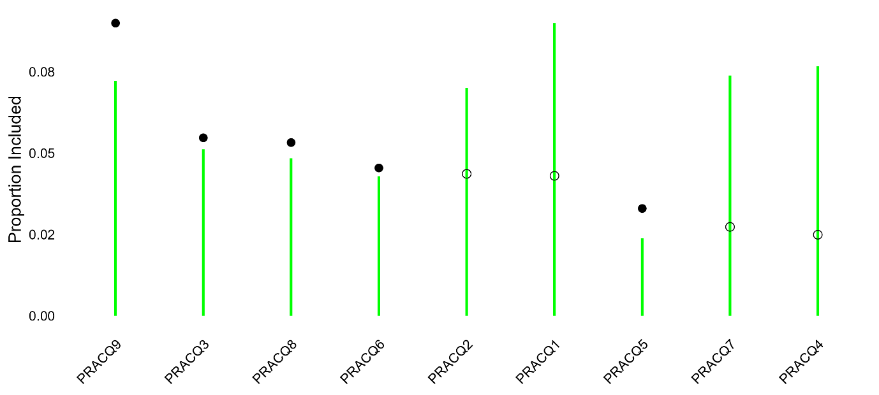

C.
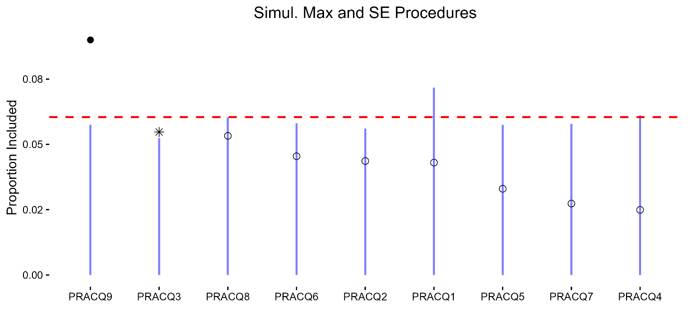
5.Access, Policy & Structural Barriers
A.
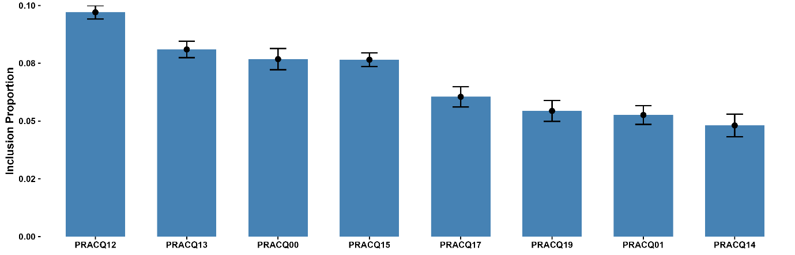
B.
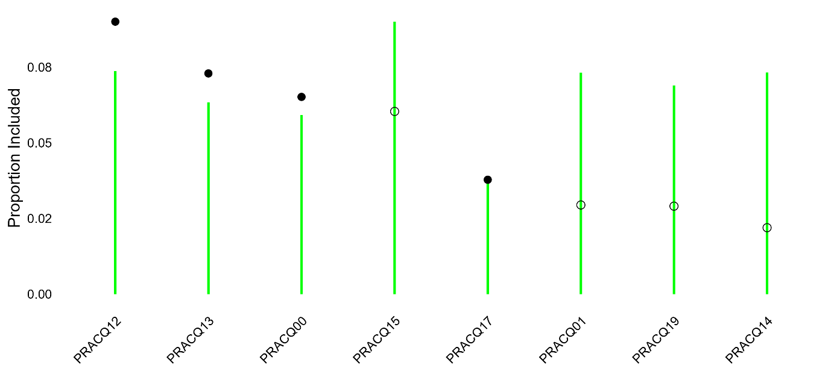
C.
