Supplementary file 2, Figure 1
Establishment of dose and timing

A)  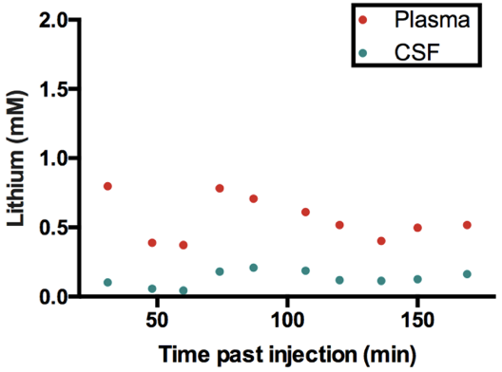 | B) 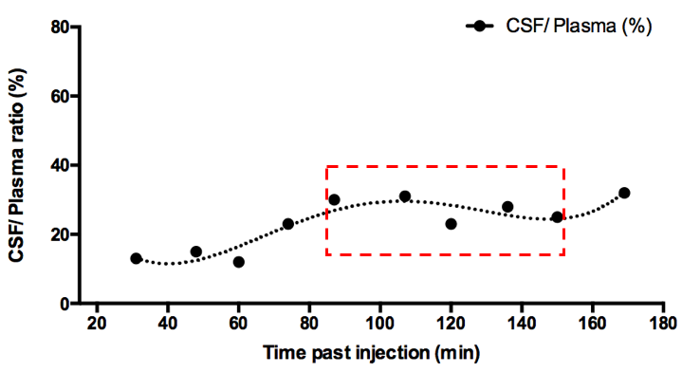
Concentration of lithium in plasma and CSF of P4 pups.
Each dot represents an individual pup collected 30-170 min (A). CSF/ Plasma ratio (%) for each animal is illustrated in (B). The time period when CSF/ Plasma ratios were relatively stable (90-150 min with ratios maintained at 25 $±$4%) boxed in (B).
NOTE: Each dot in (A) represent sample from individual animals, paired plasma and CSF from the same pup are aligned vertically on graph. CSF/ Plasma ratios (%, B) are calculated with the CSF and plasma concentration in the same animal.

