Supplementary file 4, Table 6. Neutrophil counts in plasma of control, acute and long-term treated rats at different stages of development.

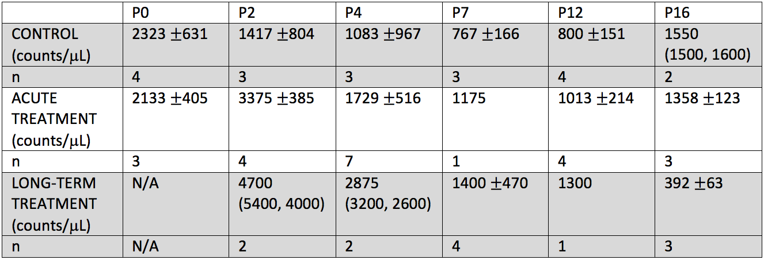
NOTE: P0 is not included in in long-term treated pups as the dam’s treatment started from the day of birth. $±$ represents standard deviation within each age group.

