Appendix 4
Establishment of dose and timing

A)  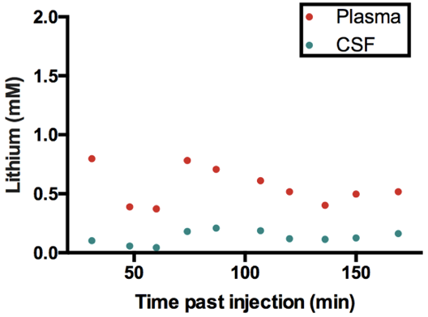 | B) 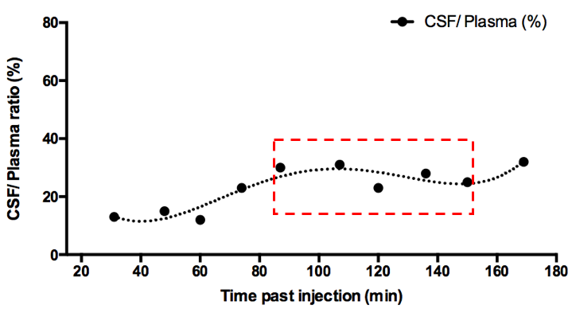
Figure 3. Concentration of lithium in plasma and CSF of P4 pups.
Each dot represents an individual pup collected 30-170 min (A). CSF/ Plasma ratio (%) for each animal is illustrated in (B). The time period when CSF/ Plasma ratios were relatively stable (90-150 min with ratios maintained at 25 $±$4%) boxed in (B).
NOTE: Each dot in (A) represent sample from individual animals, paired plasma and CSF from the same pup are aligned vertically on graph. CSF/ Plasma ratios (%, B) are calculated with the CSF and plasma concentration in the same animal.

Table 4. Neutrophil counts in plasma of control, acute and long-term treated rats at different stages of development.

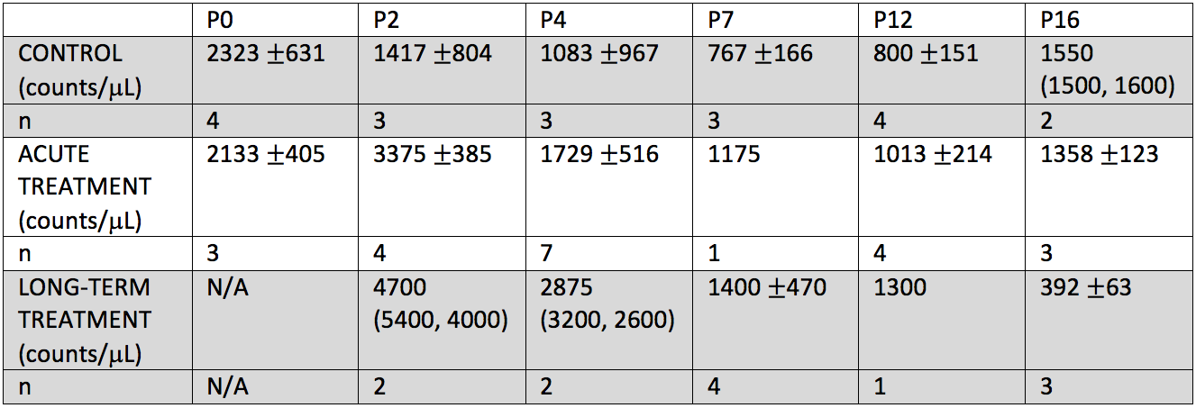
NOTE: P0 is not included in in long-term treated pups as the dam’s treatment started from the day of birth. $±$ represents standard deviation within each age group.

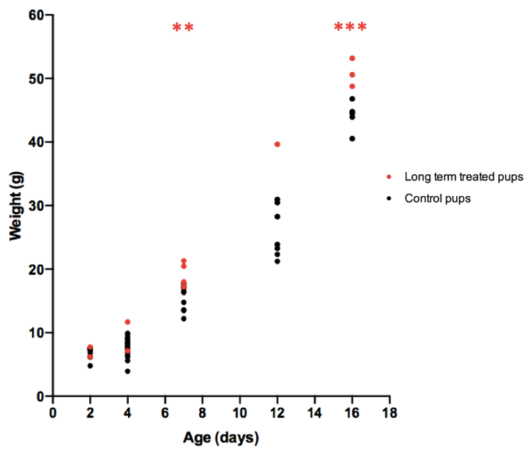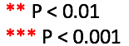
Figure 9. Weight of postnatal pups. Red dots are pups that received lithium via maternal milk, black dots are untreated age-matched controls. Weights of long-term treated pups (red) were indistinguishable from control until day 7 of lithium treatment via breast milk from dosed dam (P<0.01) and weights seem to diverge further on day 16 (P<0.001).

