 | E18 | P0 | P2 | P4 | P7 | P12 | P16 | Dam
Acute exposure  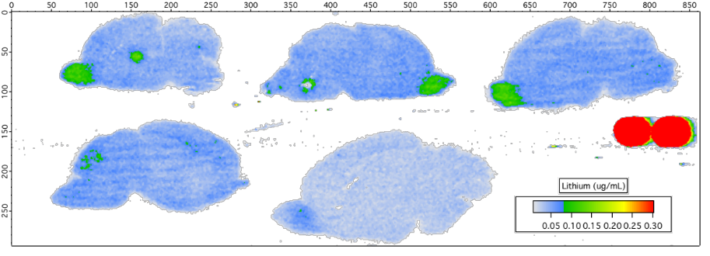 | 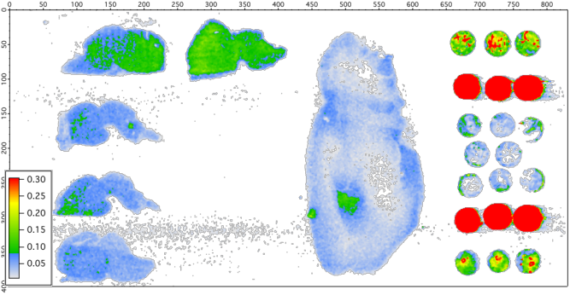 | 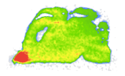 | 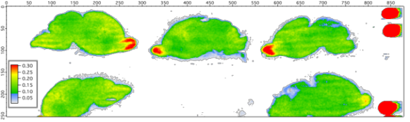 | 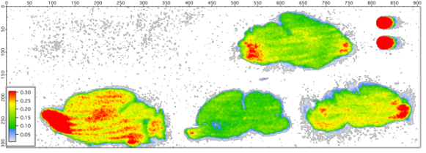 |  | 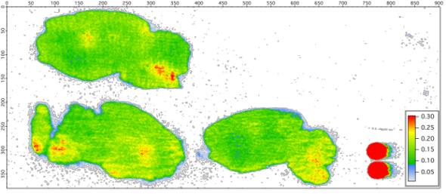
5 mm |  | 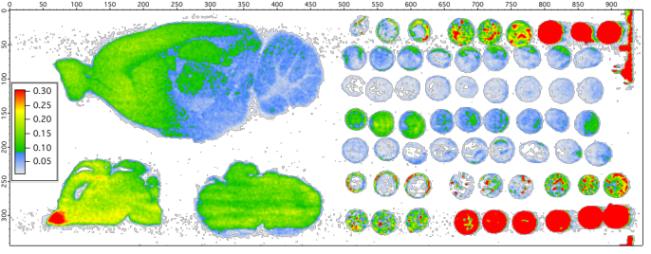
Chronic exposure |  | N/A |  |  | 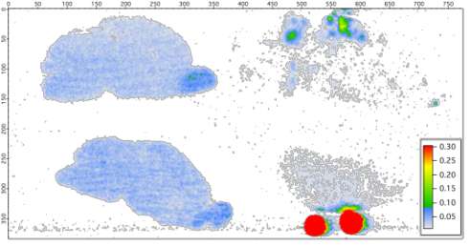 | 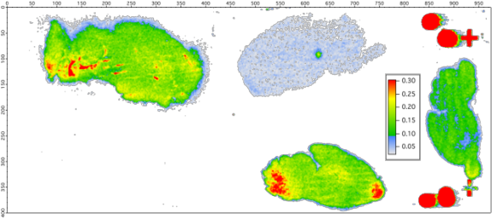 | 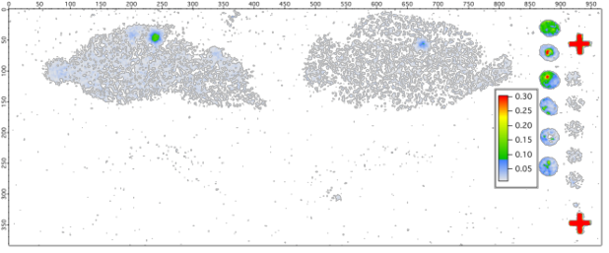 | 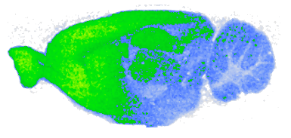
 |  |  |  |  | 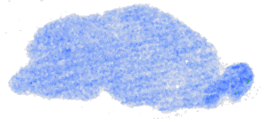 |  | 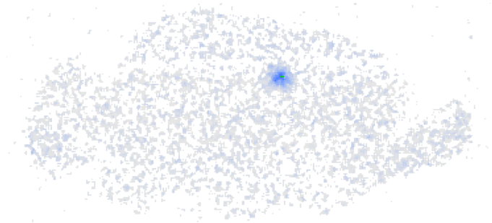
Control pups

Lithium levels are below LoD for all control brains.
Control pups  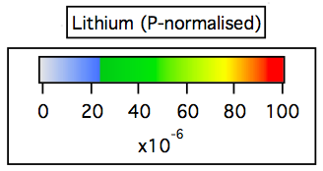  Distribution of lithium/ distribution on phosphorus (this represents presence of tissue) |  |  | 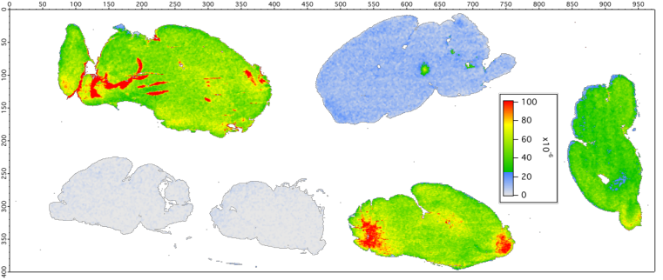 |  |  |  |  | 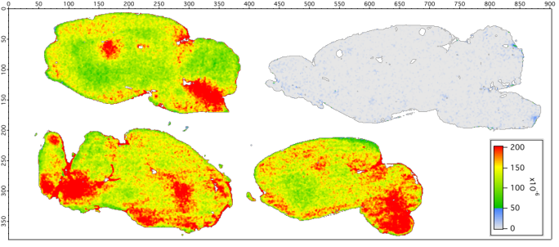
 |  |  |  | 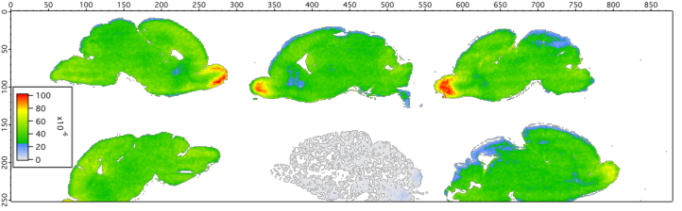

Additional File 3, Figure 1. LA-ICP-MS images for lithium distribution in brain at different ages after acute or chronic lithium exposure. Sagittal brain sections were scanned using a 60 x 60 μm square ablation spot size. For control pups, lithium levels were below limits of detection (LoD) and presented grey maps represent the presence of tissue on the slide.

Additional File 3 Table 1. Brain homogenate data for all treatment groups
