Supplementary
(Methods for comparisons)

All reference data used was obtained from Statistik Austria [1] and originates from either the quarterly population statistics for 2014 [2][3], the Microcensus 2014 [4][5] or the Austrian Health Interview Survey (ATHIS) 2014 [6][7]. Quarterly population statistics and Microcensus data were obtained via the statistical database StatCube [8]. For the ATHIS data we requested the original dataset. If not otherwise indicated, we merged data of the nine Austrian provinces to the Austrian population and accumulated all age groups to one group of 40- 69 years. In our study data set, we included only data of participants who were 40 to 69 years of age and excluded the few participants that were not from the province of Salzburg. Classification into different degrees of urbanization was conducted via the degree of urbanization (DEGURBA) criteria by Eurostat [9].
Regarding the ATHIS, we adopted the weights provided in the dataset to extrapolate to the Salzburgian and Austrian populations respectively. Microcensus data are already extrapolated and while this makes weighting unnecessary, we did not know the exact size of the relevant subgroups of the original sample. As an approximation, we multiplied the extrapolated values with 0.006, since the Microcensus included about 0.6% of the whole population as sample. This might slightly under or overestimate the sample size and thereby the width of the confidence interval, but we consider it a sufficient approximation for the purpose of the work presented here.
For categorical variables, confidence intervals in the figures are 95% Agresti-Coull confidence intervals for a binomial proportion. For continuous variables (only mean minutes of exercise per week) they are calculated as the mean +- 1.96 times the standard error.
For all statistical calculations and creation of figures the statistical software R™ (Version 4.0.2) [10] was used, in particular the package tidyverse [11].

- Age
We compared the ratio of women and man within the 40 to 69 years age group of our cohort with the Austrian population and the population of the province of Salzburg. Quarterly population statistics were used for comparison.

- Degree of Urbanisation
Reference data was taken from the Microcensus while we chose the DEGURBA criteria of Eurostat to classify settlement density.

- Migratory Background
We used reference data from the Microcensus while the definitions of migratory background were set according to the United Nations Economics Commission for Europe (UNECE) [12].
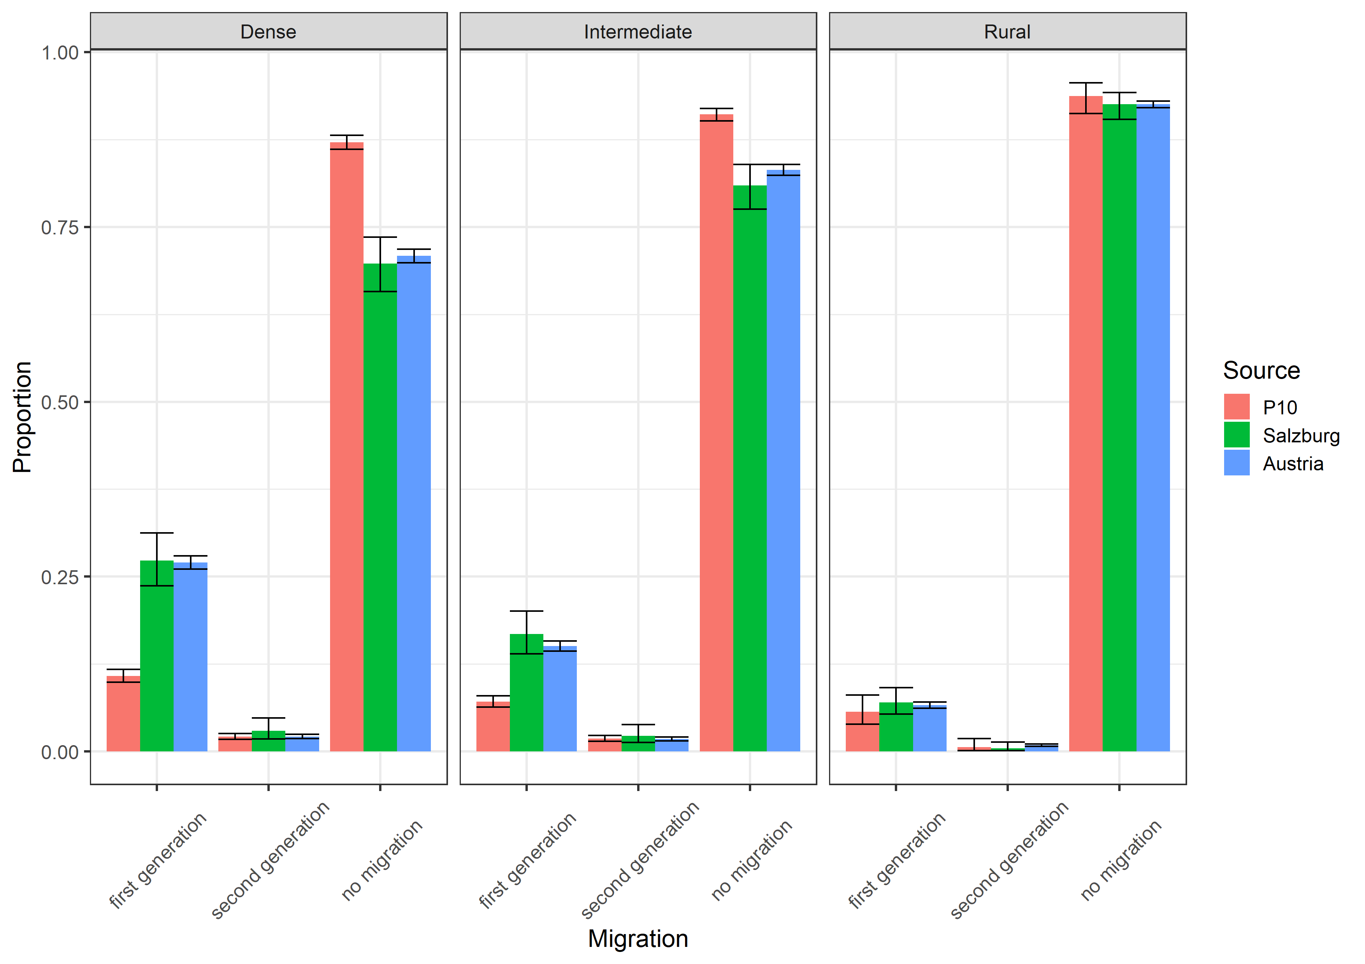
Figure S1: Distribution of the Paracelsus 10,000 cohort (P10), Salzburg population and Austrian population regarding migration background and degree of urbanization.

- Attained Education
We used reference data from the Microcensus and the International Standard Classification of Education (ISCED) [13]. Criteria were chosen as metric for degree of education to which the Austrian education attainments were adjusted (Table 1).
Table 1. Assignment of possible answers in the P10 questionnaire to ISCED Level.
P10 Categories | ISCED Level
No finished education, compulsory education | ISCED 0-2
Apprenticeship, master of a trade, secondary school with- and without qualification for university entrance | ISCED 3-5
University, technical college | ISCED 6-8

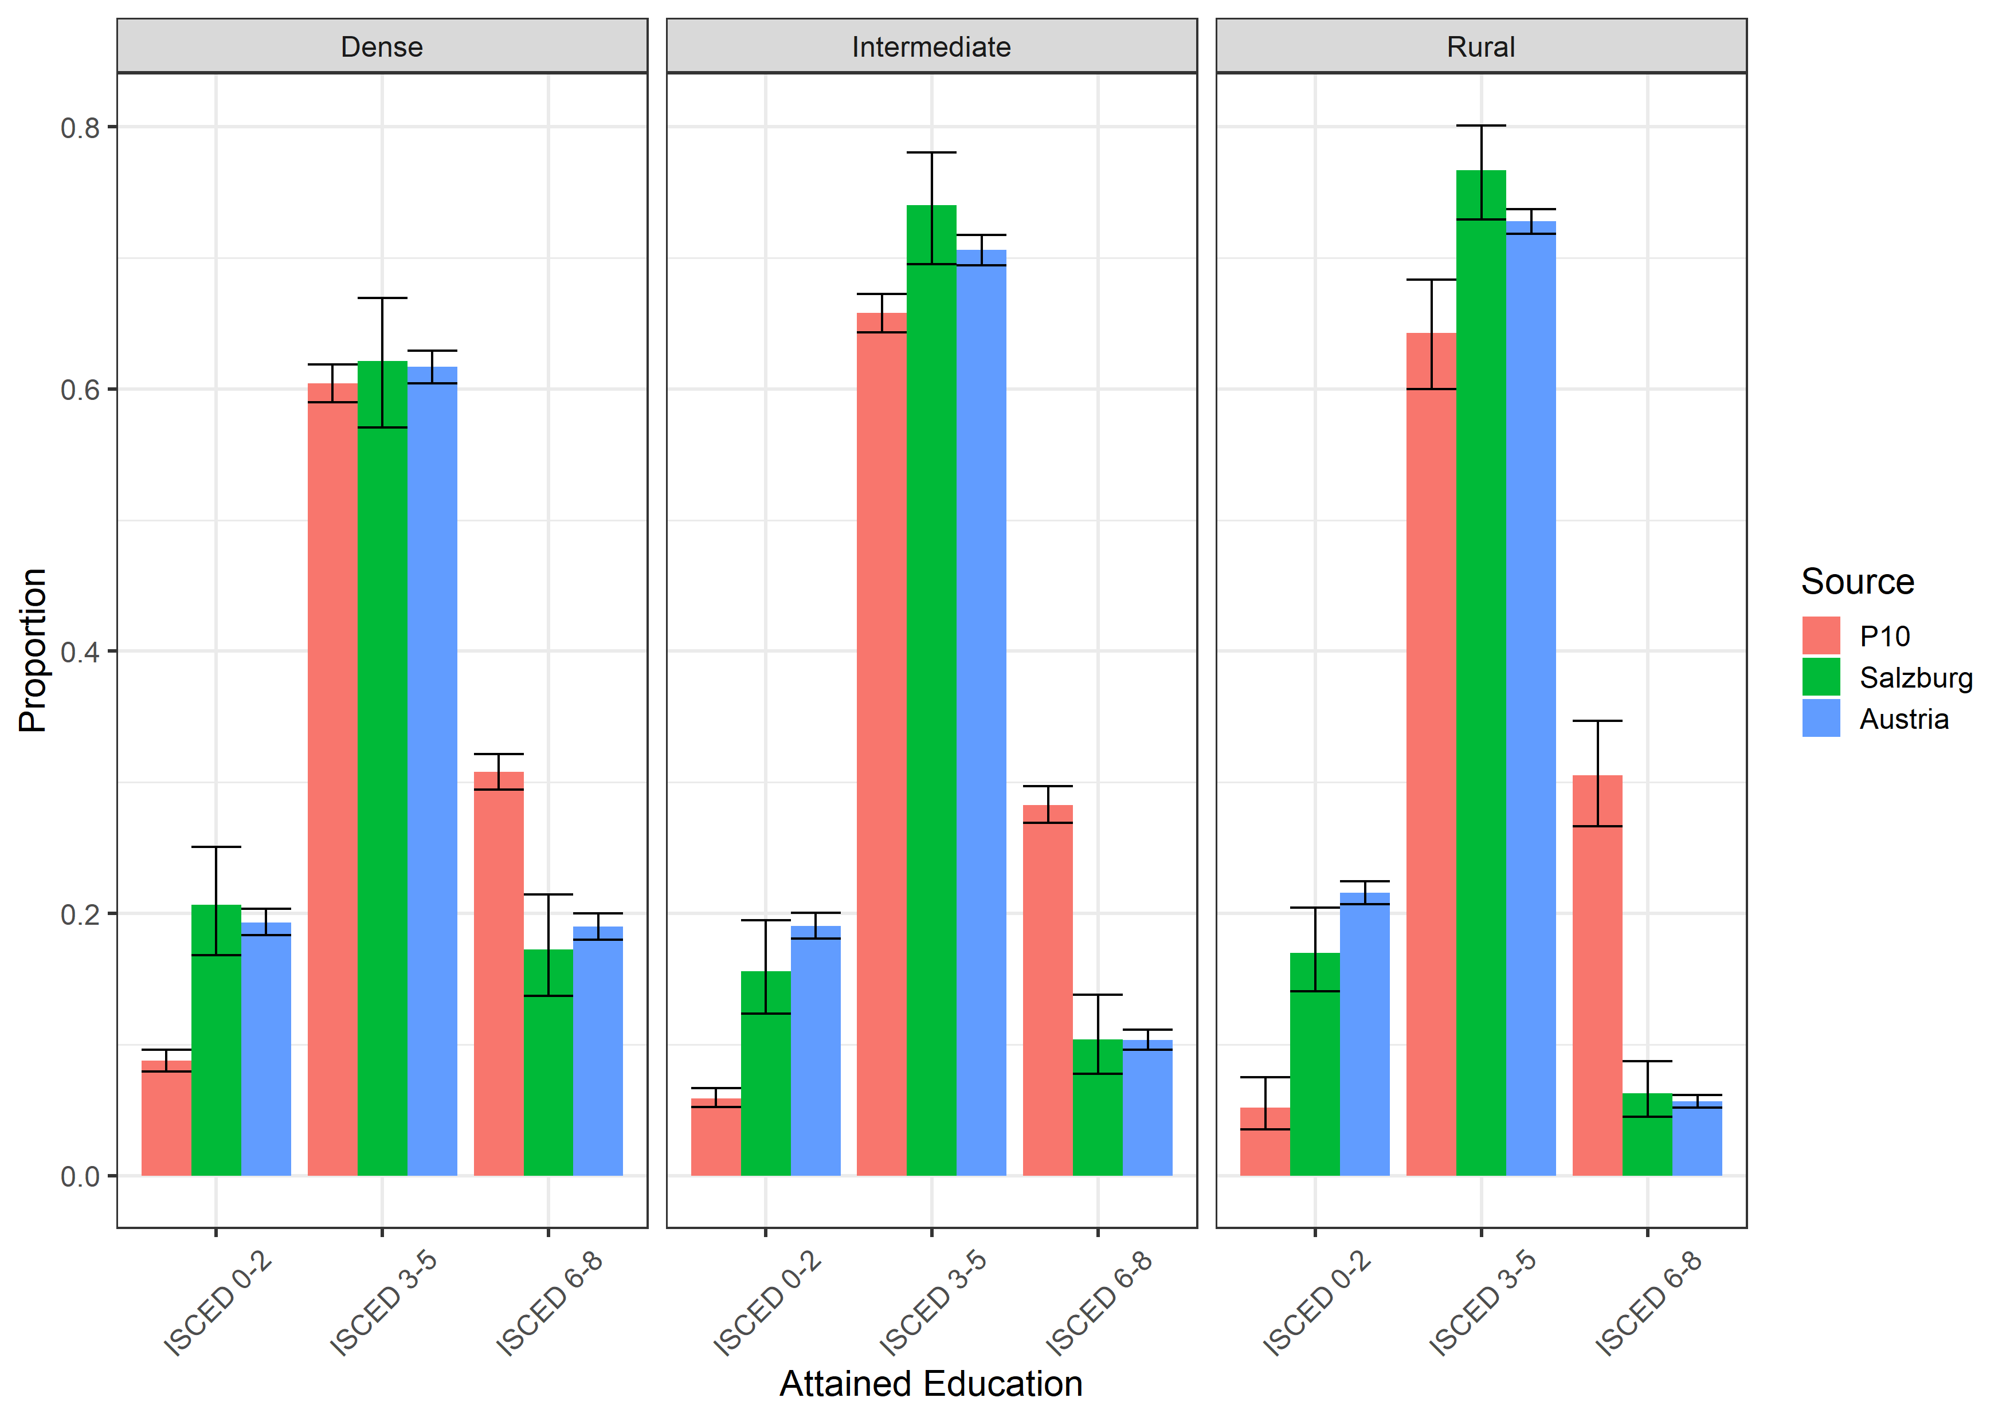
Fig.S2: Distribution of education in the Paracelsus 10,000 cohort (P10), the Salzburg population and the Austrian population. ISCED= International Standard Classification of Education. Data is split up in urbanization degrees.

- Type of Employment
We used reference data from the Microcensus while only the displayed types of employment were included. Family workers, unemployed and retired participants were excluded from the reference data to provide a valid comparison. The P10 cohort however was asked for the type of employment of the last engagement, including unemployed or retired participants.
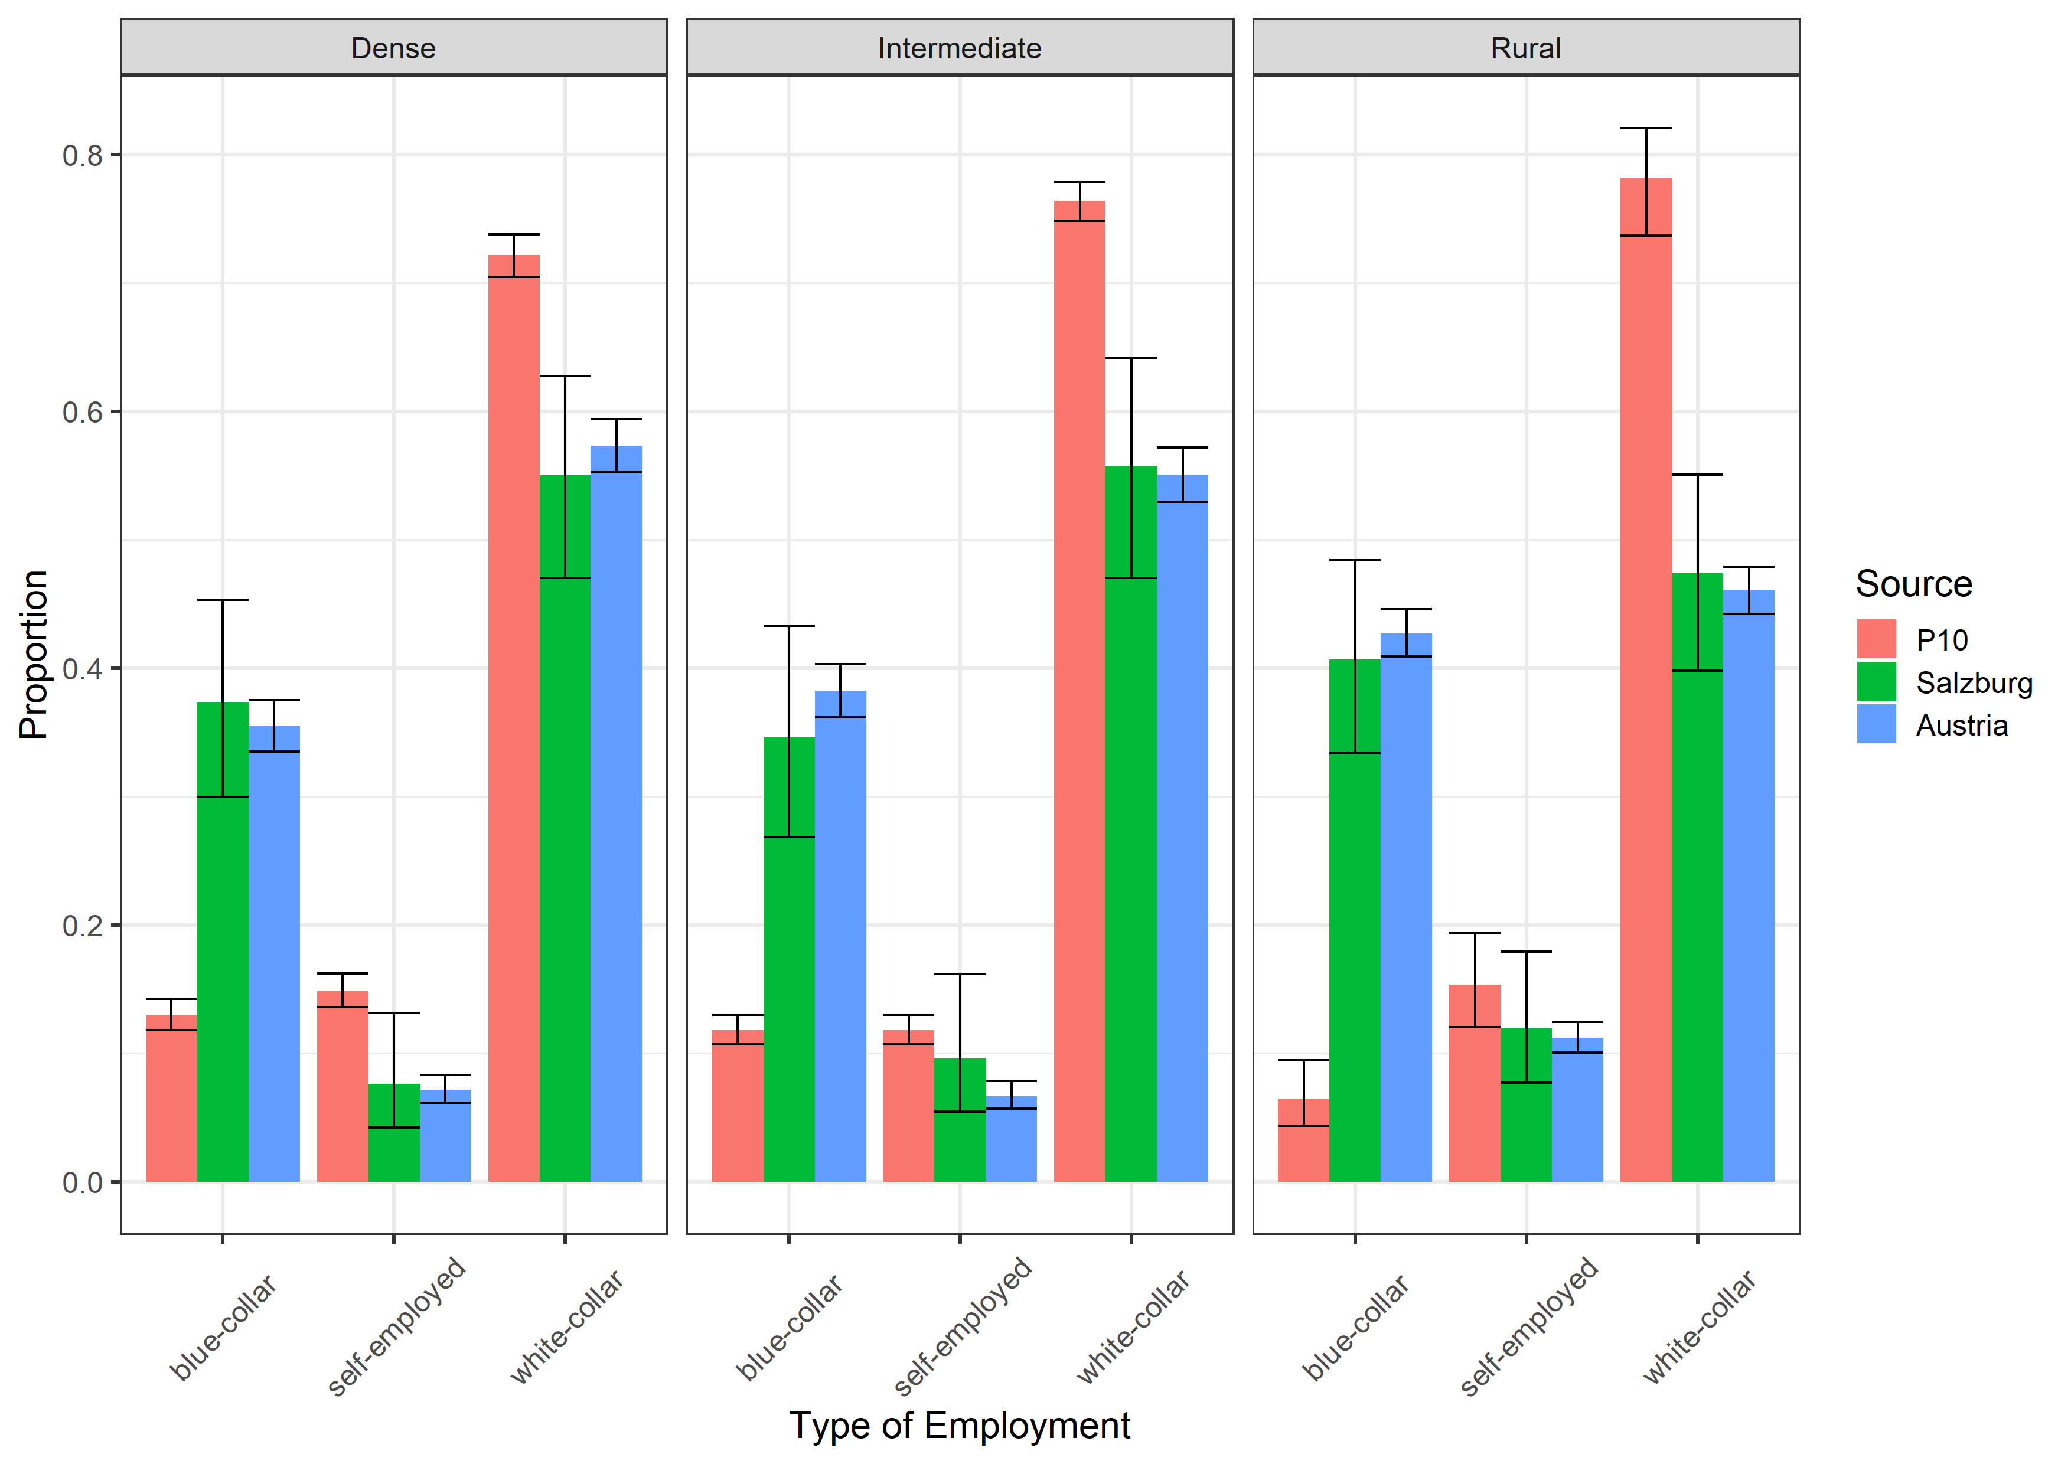
Fig.S3: Distribution of employment in the Paracelsus 10,000 cohort (P10), the Salzburg population and the Austrian population split up in different urbanization degrees.

- Smoking
Reference data was taken from the ATHIS, while we considered people as smokers if they reported current cigarette use, irrespective of the amount and regularity. Ex- Smokers are people who used to smoke cigarettes on a regular basis in the past but do not currently smoke at all. Never smokers are people who never regularly smoked cigarettes.

- Physical Activity
We compared the average minutes per week of moderate to vigorous exercise not related to transportation or work of our cohort and the Austrian population. Reference data was obtained from the ATHIS dataset containing the total number of minutes spent exercising in ones’ free time during a typical week. The data of the P10 cohort was extracted from two questions of the IPAQ, one on moderate and one on vigorous physical activity. We multiplied the number of days with hours/minutes per day spent with moderate or vigorous physical activity in ones’ free time in the last 7 days. Data of moderate and vigorous activity were then added up. For this analysis our sample size was smaller and age range was limited to 50-59 years, since only subjects participating in the extended program answered the IPAQ.

Literature supplementary material:

- Bundesanstalt Statistik, Austria, Guglgasse 13, 1110 Vienna. Website: http://www.statistik.at/web_en/statistics/index.html
- Statistik Austria. (2017). Meta information on Quarterly Population Statistics. Bundesanstalt Statistik, Austria, Guglgasse 13, 1110 Vienna. Retrieved from http://www.statistik.at/wcm/idc/idcplg?IdcService=GET_PDF_FILE&RevisionSelectionMethod=LatestReleased&dDocName=116970
- Statistik Austria. (2017). Metainformation über die Quartalsweise Statistik des Bevölkerungsstandes. Bundesanstalt Statistik, Austria, Guglgasse 13, 1110 Vienna. Retrieved from http://www.statistik.at/wcm/idc/idcplg?IdcService=GET_PDF_FILE&RevisionSelectionMethod=LatestReleased&dDocName=029355
- Statistik Austria. (2020). Meta information on Microcensus since 2004 – Labour Force and Housing Survey. Bundesanstalt Statistik, Austria, Guglgasse 13, 1110 Vienna. Retrieved from http://www.statistik.at/wcm/idc/idcplg?IdcService=GET_PDF_FILE&RevisionSelectionMethod=LatestReleased&dDocName=117000
- Statistik Austria. (2020). Metainformationen zu Mikrozensus ab 2004 Arbeitskräfte- und Wohnungserhebung. Bundesanstalt Statistik, Austria, Guglgasse 13, 1110 Vienna. Retrieved from http://www.statistik.at/wcm/idc/idcplg?IdcService=GET_PDF_FILE&RevisionSelectionMethod=LatestReleased&dDocName=008863
- Statistik Austria.(2016). Meta information on Austrian Health Interview Survey 2014. Bundesanstalt Statistik, Austria, Guglgasse 13, 1110 Vienna. Retrieved from http://www.statistik.at/wcm/idc/idcplg?IdcService=GET_PDF_FILE&RevisionSelectionMethod=LatestReleased&dDocName=116989
- Statistik Austria. (2016). Metainformationen zur Österreichische Gesundheitsbefragung 2014. Bundesanstalt Statistik, Austria, Guglgasse 13, 1110 Vienna. Retrieved from http://www.statistik.at/wcm/idc/idcplg?IdcService=GET_PDF_FILE&RevisionSelectionMethod=LatestReleased&dDocName=111025
8 Statistik-Austria. STATcube – Statistical Database. Bundesanstalt Statistik, Austria, Guglgasse 13, 1110 Vienna. Retrieved from http://www.statistik.at/web_en/publications_services/statcube/index.html.
9 Eurostat. (2018). Methodological manual on terrotorial typologies. Statistical Office of the European Union. Joseph Bech Building 5, rue Alphonse Weicker, 2721 Luxembourg. Retrieved from https://ec.europa.eu/eurostat/documents/3859598/9507230/KS-GQ-18-008-EN-N.pdf/a275fd66-b56b-4ace-8666-f39754ede66b?t=1573550953000
10 R Core Team (2020). R: A language and environment for statistical computing. R Foundation for Statistical
Computing, Vienna, Austria. URL https://www.R-project.org/.
11 Wickham et al., (2019). Welcome to the tidyverse. Journal of Open Source Software, 4(43), 1686. Retrieved from
https://doi.org/10.21105/joss.01686
12 UNECE. (2020). Conference of European Statisticians. Recommendations for the 2020 Censuses of Population and Housing.: United Nations Economic Commission for Europe. Palais des Nations. CH - 1211 Geneva 10, Switzerland. Retrieved from https://unece.org/fileadmin/DAM/stats/publications/2015/ECECES41_EN.pdf.
13 UNESCO. (2011). International Standard Classification of Education (ISCED).

