Materials and Methods
Data Preprocessing
Demographic Covariates
Table S1. Description of the demographic covariates in the GRF model.
*not available in the ABCD data (see the “Genetic covariates” section for preprocessing methods)
# | Variable | Variable name (ABCD Release 4.0) | Description | Coding
1 | Age | interview_age | Age in months
2 | Sex | sex | Sex assigned at birth  0 = Male, 1 = Female
3 | Genetic ethnicity | ethnic_g* | EUR = European; AFR = African;  EAS = East Asian; AMR = Admixed American | Dummy coding (categorical data)
4 | Family income | demo_comb_income_v2 | Total combined family income for the past 12 months  1= Less than $5 000;  2=$5 000 through $11 999;  3=$12 000 through $15 999;  4=$16 000 through $24 999;  5=$25 000 through $34 999;  6=$35 000 through $49 999;  7=$50 000 through $74 999;  8= $75 000 through $99 999;  9=$100 000 through $199 999;  10=$200 000 and greater | Continuous (ordinal data)

Environmental Covariates
Environmental covariates contained 24 risk factors (before dummy coding, Table S2) for childhood ADHD identified by six meta-analyses using a common methodology¹, that were available in the ABCD data. These factors consisted of prenatal (preeclampsia; pregnancy complications; alcohol, tobacco, cannabis, and cocaine exposures), child (preterm birth, birth weight, neonatal illness, breastfeeding duration, allergies, sleep problems, head injury), family (parental marital status; parental acceptance; family conflict; maternal and paternal age at the birth of this child; parental level of education; parental depression, anxiety, drug use, and antisocial personality problems), and community (area level of pollution) variables. Environmental covariates were included in each model to satisfy the GRF’s unconfoundedness assumption (i.e., all variables influencing both treatment and outcome are measured and controlled for). In models containing neuroimaging data, we also added 10 characteristics of the child’s environment and physiological and mental states that have been associated with brain morphometry in the ABCD study² (Table S3) to address the confounding effect.

Table S2. Description of the environmental covariates in the GRF model.
# | Variable | Variable name (ABCD Release 4.0) | Description | Note
1 | Preeclampsia | devhx_10c3_p | During the pregnancy with this child, did you/biological mother have pre-eclampsia, eclampsia, or toxemia?
2 | Pregnancy complications | devhx_10a3_p,  devhx_10b3_p,  devhx_10d3_p,  devhx_10e3_p,  devhx_10f3_p,  devhx_10g3_p,  devhx_10h3_p,  devhx_10i3_p,  devhx_10j3_p,  devhx_10k3_p,  devhx_10l3_p,  devhx_10m3_p | During the pregnancy with this child, did you/biological mother have:  1) severe nausea and vomiting extending past the 6th month or accompanied by weight loss  2) heavy bleeding requiring bed rest or special treatment  3) severe gall bladder attack  4) persistent proteinuria  5) rubella (German measles) during first 3 months of pregnancy  6) severe anemia  7) urinary tract infections  8) pregnancy-related diabetes  9) pregnancy-related high blood pressure  10) previa, abruption, or other problems with the placenta  11) an accident or injury requiring medical care  12) any other conditions requiring medical care | Continuous  (a sum of 12 variables)
3 | Prenatal alcohol exposure | devhx_8_alcohol,  devhx_9_alcohol | Alcohol before or after knowing of pregnancy | Binary (one if alcohol was consumed either before or after knowing of pregnancy)
4 | Prenatal tobacco exposure | devhx_8_tobacco,  devhx_9_tobacco | Tobacco before or after knowing of pregnancy | Binary (one if smoked either before or after knowing of pregnancy)
5 | Prenatal cannabis exposure | devhx_8_marijuana,  devhx_9_marijuana | Marijuana before or after knowing of pregnancy | Binary (one if cannabis was consumed either before or after knowing of pregnancy)
6 | Prenatal cocaine exposure | devhx_8_coc_crack,  devhx_9_coc_crack | Cocaine before or after knowing of pregnancy | Binary (one if cocaine was consumed either before or after knowing of pregnancy)
7 | Preterm birth | devhx_12a_p | Was the child born prematurely?
8 | Birth weight | birth_weight_lbs | Birth weight in pounds
9 | Neonatal illness | devhx_14a3_p,  devhx_14b3_p,  devhx_14c3_p,  devhx_14d3_p,  devhx_14e3_p,  devhx_14f3_p,  devhx_14g3_p,  devhx_14h3_p,  devhx_15,  devhx_17_p | Did he/she have any of the following complications at birth:  1) blue at birth  2) slow heartbeat  3) did not breathe at first  4) convulsions  5) jaundice needing treatment  6) required oxygen  7) required blood transfusion  8) Rh incompatibility  9) For how many days after birth was your child in an incubator? (converted to binary)  10) About how many days in the first 12 months of life did your child have any infections or serious illnesses? (converted to binary) | Continuous  (a sum of 10 variables)
10 | Breastfeeding duration | devhx_18_p | For how many months was your child breastfed?
11 | Allergies | medhx_2b | Has she/he ever been to a doctor for allergies?
12 | Sleep problems | sds_p_ss_total | The Sleep Disturbance Scale for Children (SDSC) Total score³
13 | Head injury | medhx_6i | Has he/she ever been to a doctor, a nurse, a nurse practitioner, the emergency room, or a clinic because of a head injury?
14 | Parental marital status | demo_prnt_  marital_v2 | Are you now married, widowed, divorced, separated, never married, or living with a partner?  1 = Married; 2 = Widowed; 3 = Divorced; 4 = Separated; 5 = Never married; 6 = Living with partner | Dummy coding (categorical data)
15 | Parental acceptance | crpbi_y_ss_parent | Primary Caregiver's Acceptance Subscale Mean of the Child  Report of Behavior Inventory (CRPBI)⁴
16 | Family conflict | fes_y_ss_fc | Family Conflict Subscale of the Moos Family Environment Scale (FES)⁵
17 | Parental depression problem | famhx_ss_momdad_  dprs_p | Either parent with a depression problem
18 | Parental drug use problem | famhx_ss_momdad_  dg_p | Either parent with a drug use problem
19 | Parental anxiety problem | asr_scr_anxdisord_t | Adult Self-Report (ASR) Anxiety Problems DSM-5-Oriented Scale t-score
20 | Parental antisocial personality disorder problem | asr_scr_antisocial_t | Adult Self-Report (ASR) Antisocial Personality Problems DSM-5-Oriented Scale t-score
21 | Maternal age at the birth of this child | devhx_3_p | How old were you/biological mother when the child was born?
22 | Paternal age at the birth of this child | devhx_4_p | How old was the child's biological father when the child was born?
23 | Parental level of education | demo_prnt_ed_v2 | What is the highest grade or level of school you have completed or the highest degree you have received?  0 = Never attended/Kindergarten only; 1 = 1st grade; 2 = 2nd grade; 3 = 3rd grade; 4 = 4th grade; 5 = 5th grade; 6 = 6th grade; 7 = 7th grade; 8 = 8th grade; 9 = 9th grade; 10 = 10th grade; 11 = 11th grade; 12 = 12th grade; 13 = High school graduate; 14 = GED or equivalent Diploma; 15 = Some college; 16 = Associate degree: Occupational; 17 = Associate degree: Academic Program; 18 = Bachelor's degree (ex. BA); 19 = Master's degree (ex. MA); 20 = Professional School degree (ex. MD); 21 = Doctoral degree (ex. PhD) | Continuous (ordinal data)
24 | Area level of pollution | reshist_addr1_  pm252016aa | Residential-history-derived annual average of PM 2.5 in 2016 at the primary residential address at 1x1 km²

Table S3. Description of the additional environmental covariates in GRF models with neuroimaging data.
# | Variable | Variable name (ABCD Release 4.0) | Description | Note
1 | BMI | Calculated from anthro_1_height_in and anthroweight1lb | Body mass index
2 | CBCL anxious  depression | cbcl_scr_syn_anxdep_t | AnxDep CBCL Syndrome Scale t-score
3 | CBCL withdrawn  depression | cbcl_scr_syn_withdep_t | WithDep CBCL Syndrome Scale t-score
4 | CBCL somatic  problems | cbcl_scr_syn_somatic_t | Somatic CBCL Syndrome Scale t-score
5 | CBCL social  problems | cbcl_scr_syn_social_t | Social CBCL Syndrome Scale t-score
6 | CBCL thought  problems | cbcl_scr_syn_thought_t | Thought CBCL Syndrome Scale t-score
7 | CBCL rule-breaking  behavior | cbcl_scr_syn_rulebreak_t | RuleBreak CBCL Syndrome Scale t-score
8 | CBCL aggressive  behavior | cbcl_scr_syn_aggressive_t | Aggressive CBCL Syndrome Scale t-score
9 | Planned pregnancy | devhx_6_p | Was your pregnancy with this child a planned pregnancy?
10 | Neighborhood deprivation | reshist_addr1_adi_wsum | Residential-history-derived Area Deprivation Index: scaled weighted sum

Genetic Covariates
For the genetic data, we used 30 polygenic scores (PGSs) that estimate a child’s genetic liability for complex traits. Genotypes were imputed at the Michigan Imputation Server⁶, and thorough quality control was applied to address the genetic relatedness (no individuals closer than third-degree relatives) and ancestry admixture⁷. For five traits (i.e., body mass index (BMI), post-traumatic stress disorder (PTSD), depression, schizophrenia, and alcohol dependence) with the genome-wide association studies (GWAS) summary statistics available in both European and non-European ancestries, PGSs were constructed separately for European and multiethnic samples. For other traits, only PGSs based on the European reference panel were available. In this study, we conducted analyses with both European and multiethnic samples to verify the robustness of the results. For details on the construction of PGSs, see Joo et al. (2024)⁷ (this preprint version mentions only 29 traits because the anxiety PGS was added later).
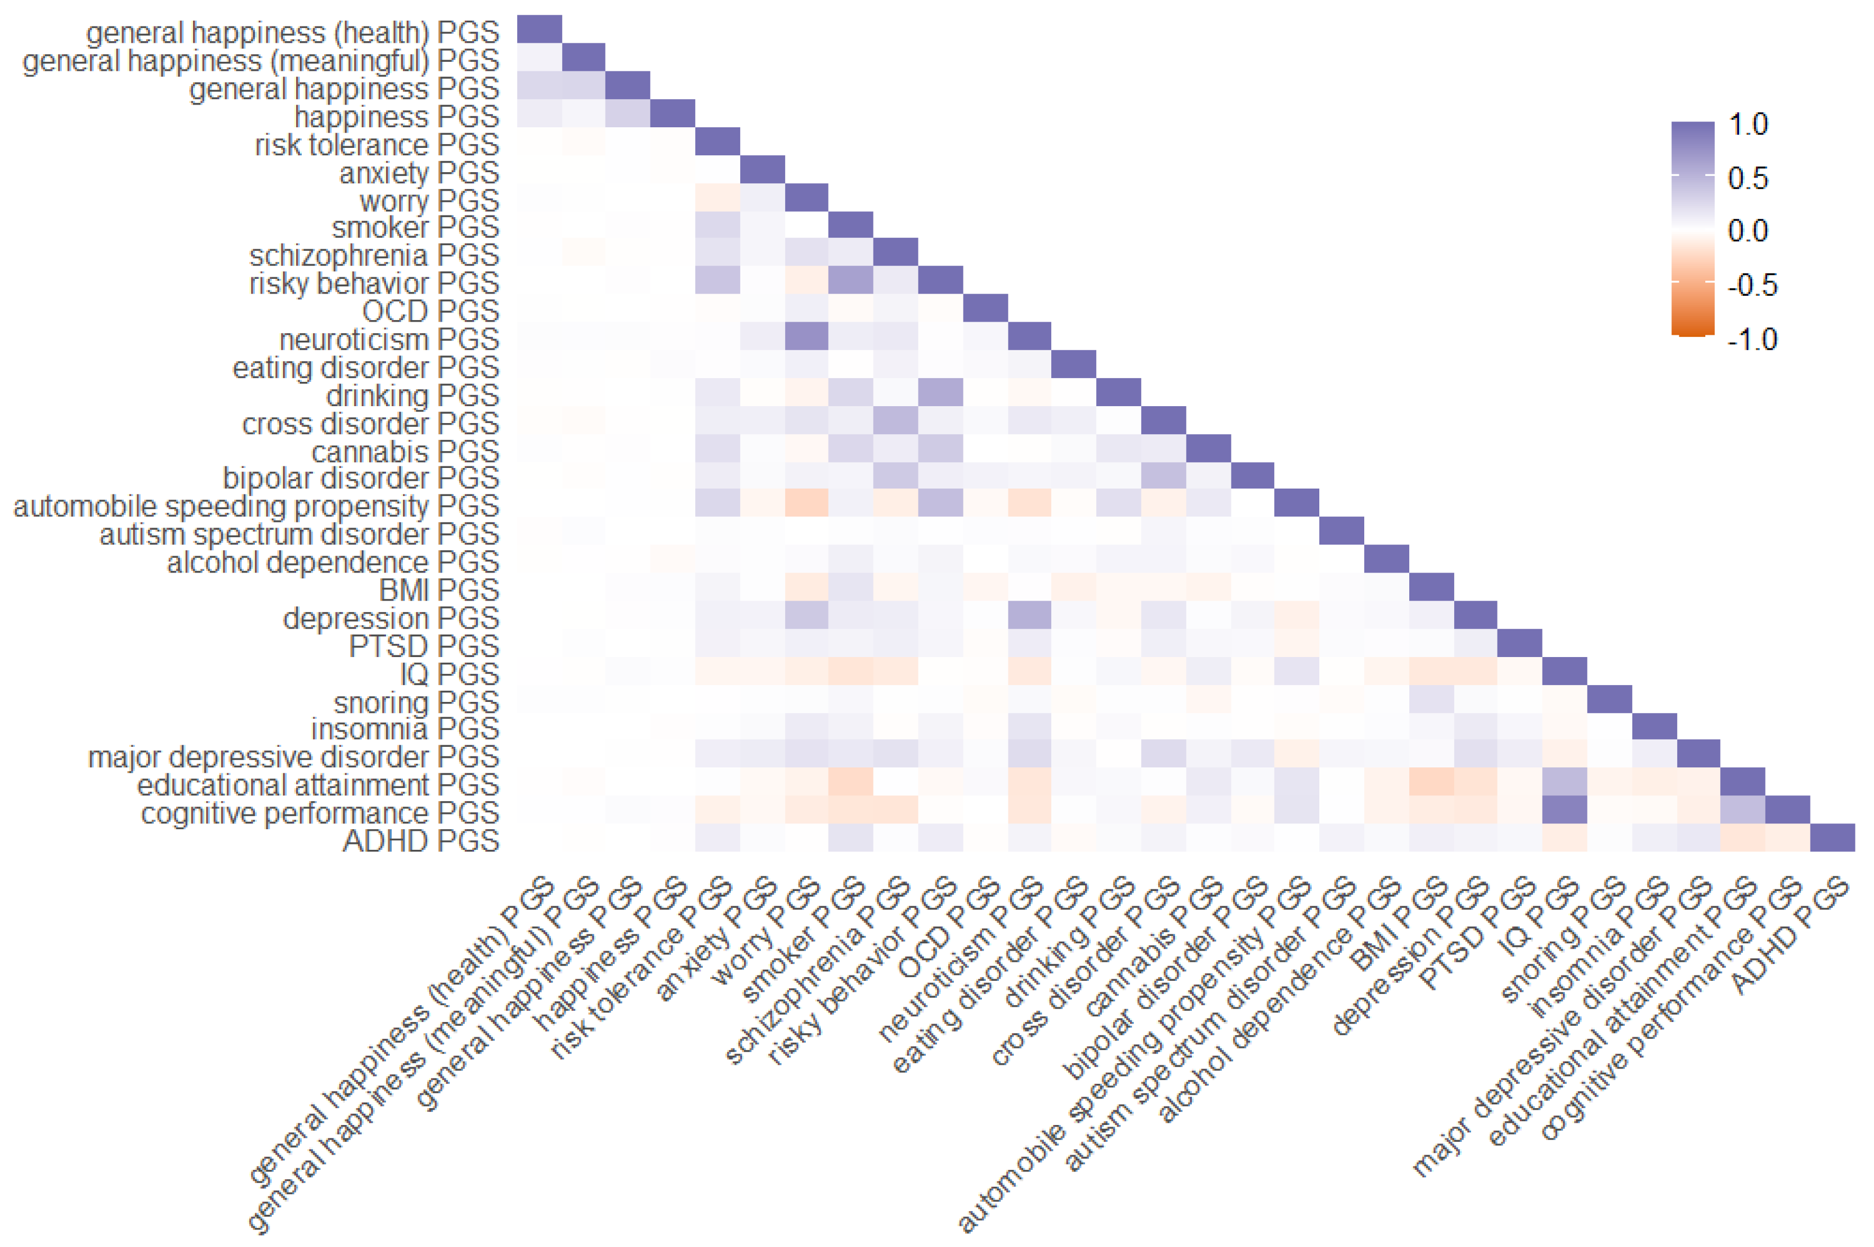
Figure S1. Correlation between polygenic scores (PGSs) in the Adolescent Brain Cognitive Development (ABCD) Study cohort.
Neuroimaging Covariates
Neuroimaging covariates comprised 98 cortical and subcortical brain volume measures obtained from the structural magnetic resonance imaging (sMRI) data (T1- and T2-weighted 3D images). sMRI data was acquired using Siemens Prisma and Prisma Fit, GE MR 750, and Philips 3T scanners and preprocessed following image processing and analysis methods for the ABCD study⁸. In Release 4.0, cortical surface reconstruction and subcortical segmentation were performed using FreeSurfer v7.1.1 (https://surfer.nmr.mgh.harvard.edu). Regions of interest (ROIs) consisted of subcortical structures labeled with atlas-based segmentation⁹ and cortical areas labeled with Desikan-Killiany atlas-based classification¹⁰. We removed global brain measures (e.g., right hemisphere cortical volume) to study the association of specific brain regions with the intergenerational transmission of ADHD. All regional volumes were normalized by intracranial volume, and variables with near-zero variance were excluded. Subjects who did not pass the ABCD quality control check for sMRI data were removed from the analysis.

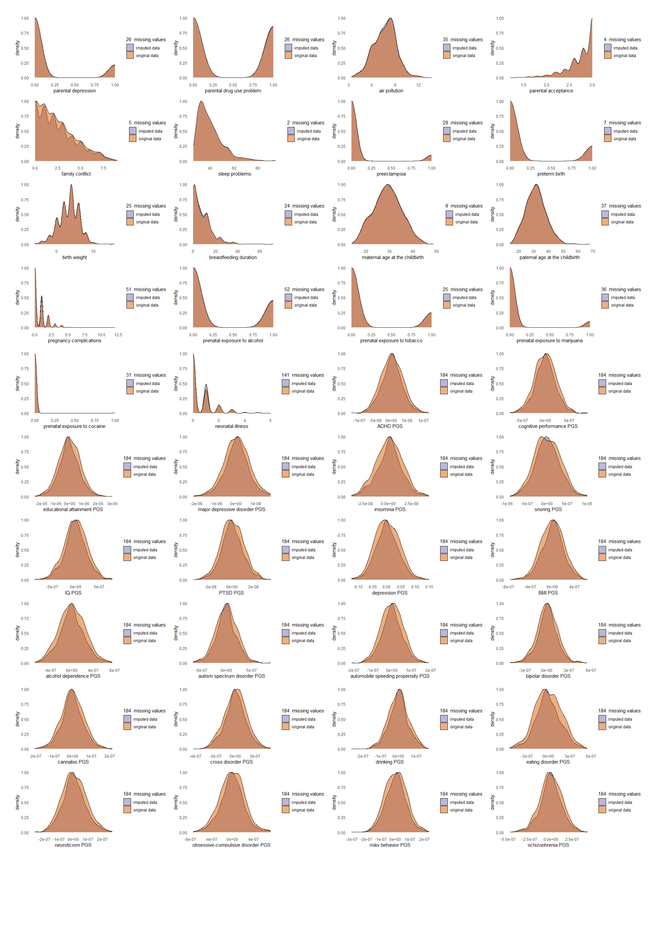
Figure S2. (Multiethnic sample) Comparison of the original and imputed data distributions.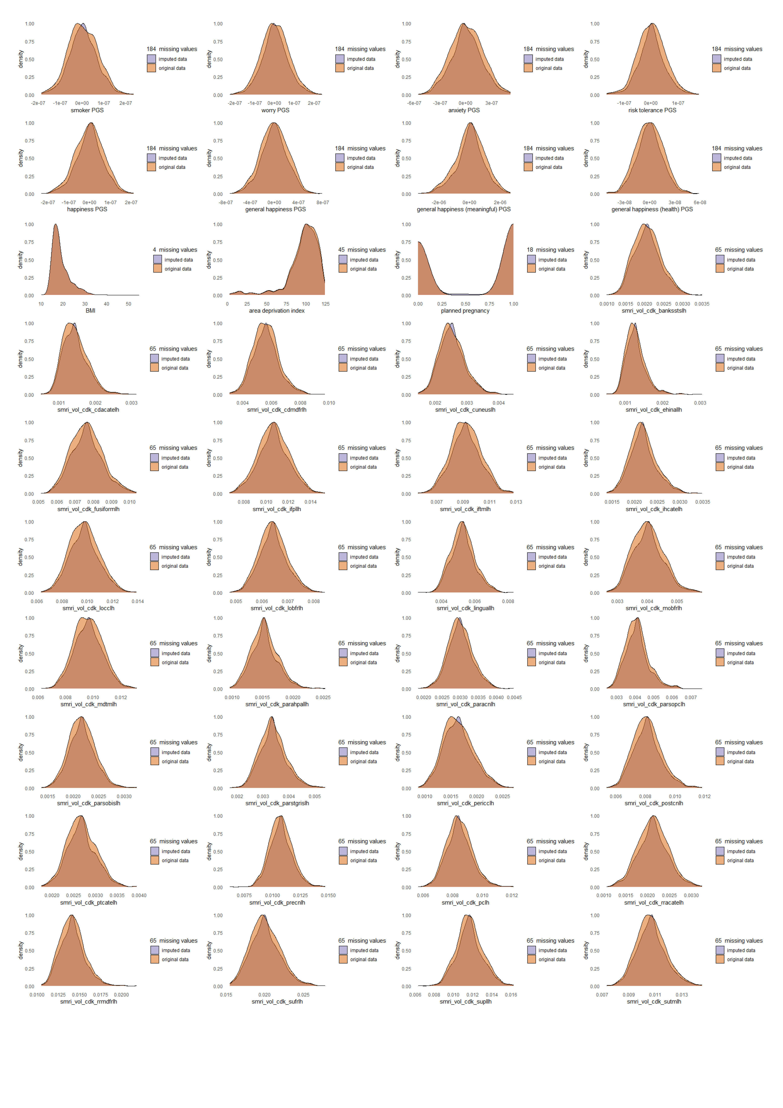Figure S2. (Multiethnic sample) Comparison of the original and imputed data distributions (cont.).
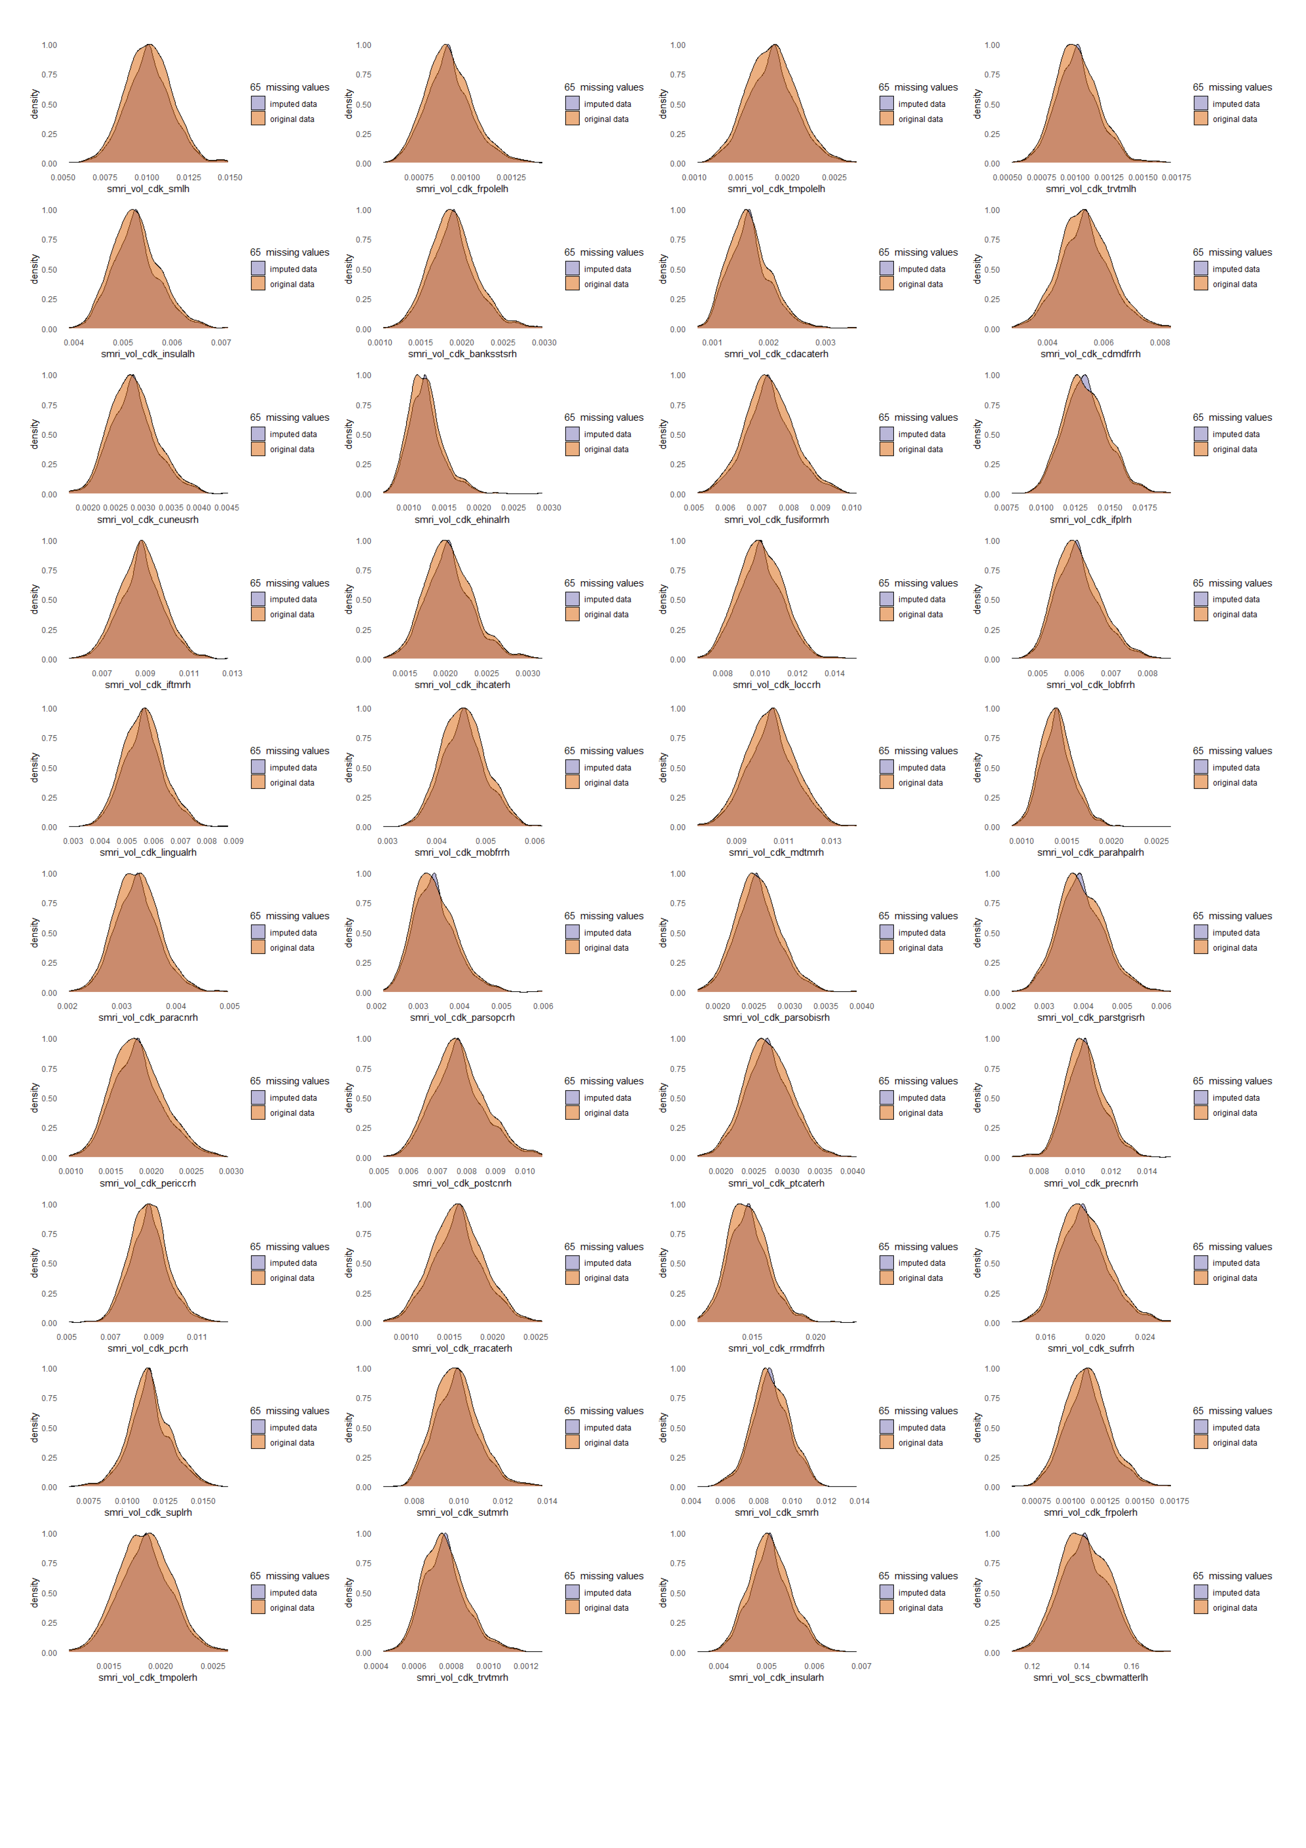
Figure S2. (Multiethnic sample) Comparison of the original and imputed data distributions (cont.).
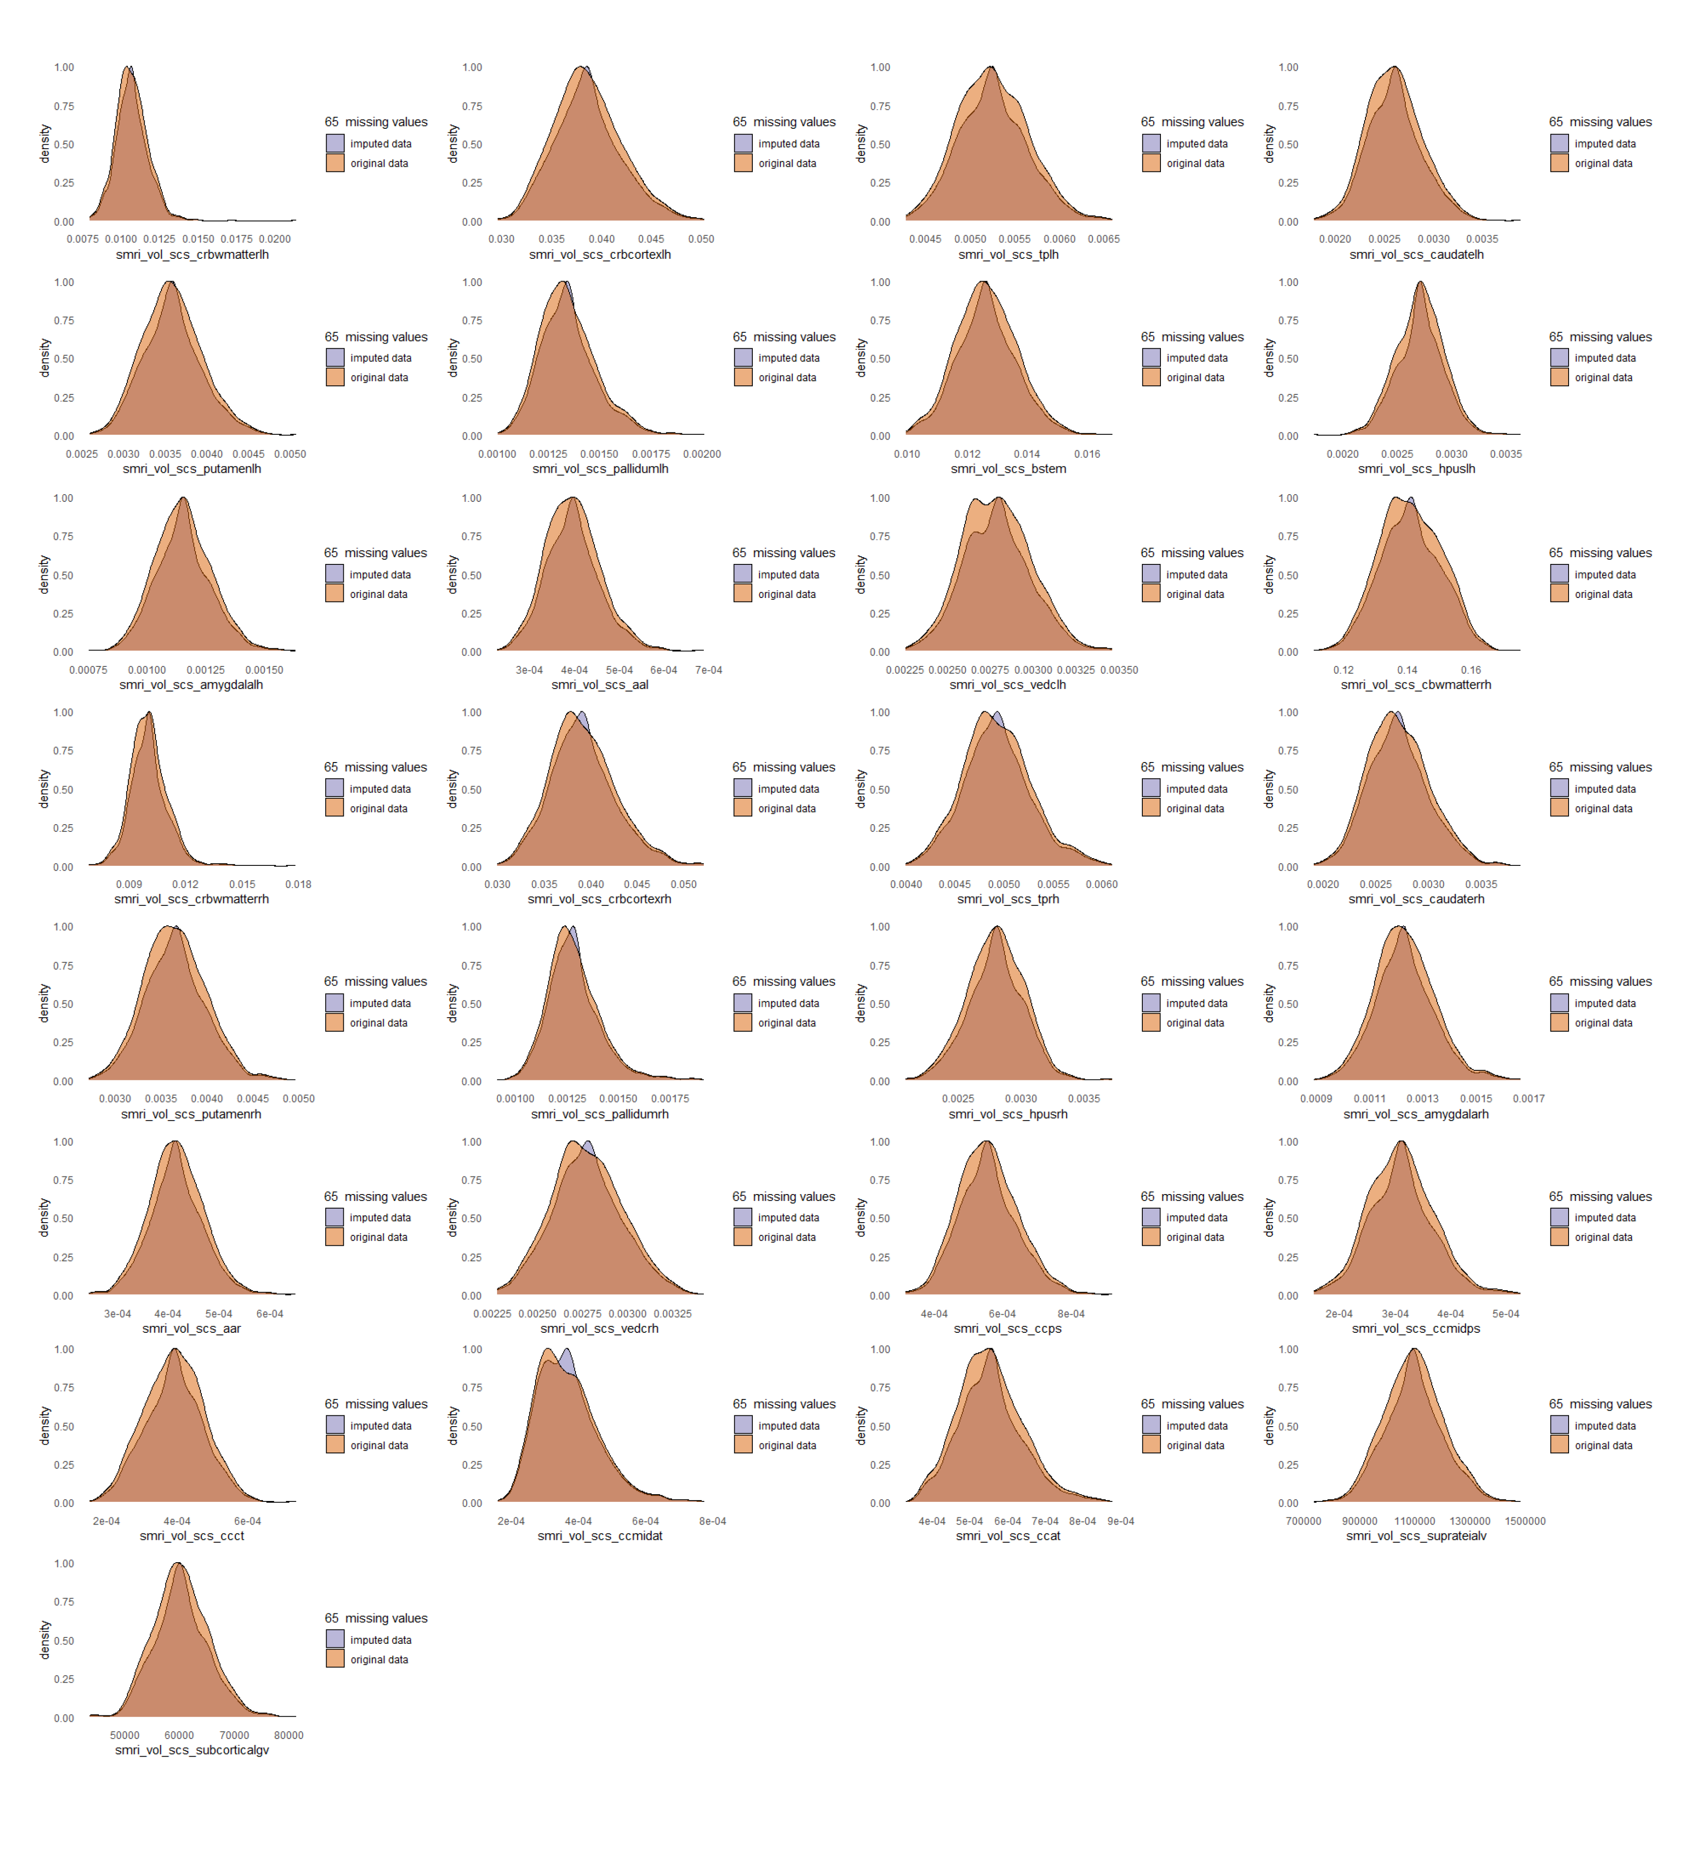
Figure S2. (Multiethnic sample) Comparison of the original and imputed data distributions (cont.).
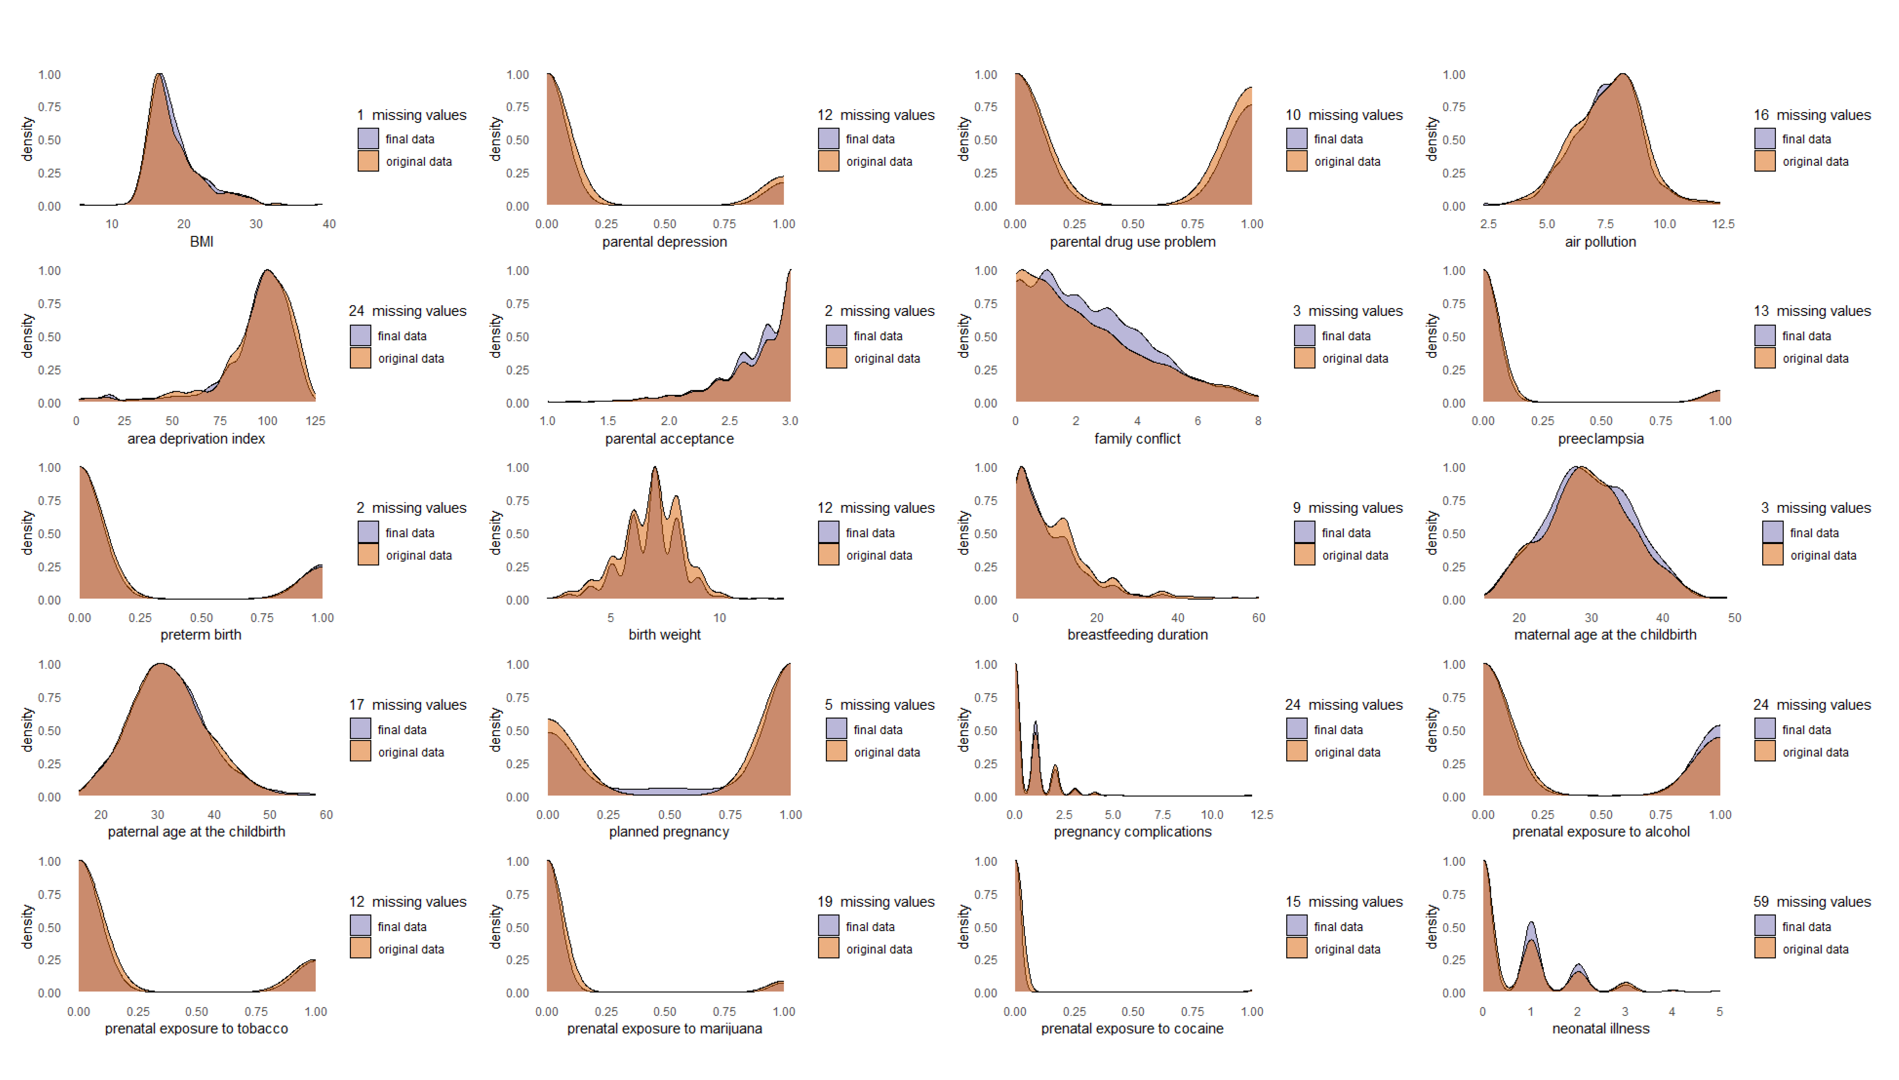
Figure S3. (European sample) Comparison of the original and final data distributions. Plots are provided for variables that had missing values before oversampling. The final data represents the dataset obtained after missing data imputation and oversampling.

Statistical analysis
Generalized Random Forest (GRF) Model
Estimating average treatment effect (ATE)
Generalized random forest (GRF)^{11,12} is a nonparametric approach for robust estimation of the average treatment effect (ATE). ATE is defined as the mean difference in potential outcomes between treatment and control groups: $τ=E[Y_{i}\left(1\right)-Y_{i}\left(0\right)]$, where $Y_{i}\left(W_{i}\right)$ is the potential outcome for a subject i under binary treatment $W_{i}$. GRF estimates ATE using augmented inverse propensity weighting (AIPW), a method that combines treatment propensity weighting and nonparametric outcome regression. This estimator is called doubly robust because it remains consistent if either the propensity score or the conditional outcome estimator is biased. We estimated ATE using the average_treatment_effect function from grf package. When used with clustering, it computes ATE $\hat{τ}$ as follows:
- Individual treatment effect estimate ($\hat{Γ_{i}}$):
$\hat{Γ_{i}}={\hat{τ}}^{\left(-i\right)}\left(X_{i}\right)+ \frac{W_{i}-{\hat{e}}^{\left(-i\right)}\left(X_{i}\right)}{{\hat{e}}^{\left(-i\right)}\left(X_{i}\right)\left(1-{\hat{e}}^{\left(-i\right)}\left(X_{i}\right)\right)}\left[Y_{i}-{\hat{m}}^{\left(-i\right)}\left(X_{i}\right)-\left(W_{i}-{\hat{e}}^{\left(-i\right)}\left(X_{i}\right)\right){\hat{τ}}^{\left(-i\right)}\left(X_{i}\right)\right]$,
- ${\hat{τ}}^{\left(-i\right)}\left(X_{i}\right)$: an estimate of the treatment effect adjusted for covariates $X_{i}$​, excluding the $i$-th observation
- $W_{i}$​: the treatment indicator (1 if treated, 0 if not)
- ${\hat{e}}^{\left(-i\right)}\left(X_{i}\right)$: the estimated propensity score excluding the $i$-th observation, which measures the probability of receiving the treatment given covariates $X_{i}$​
- $Y_{i}$: the observed outcome
- ${\hat{m}}^{\left(-i\right)}\left(X_{i}\right)$: the predicted outcome based on covariates $X_{i}$​, also excluding the $i$-th observation.
- Cluster average treatment effect ($\hat{τ_{j}}$):
$\hat{τ_{j}}= \frac{1}{n_{j}}\sum_{\{i:A_{i}=j\}}{\hat{Γ_{i}}}$,
- $n_{j}$: the number of subjects in the cluster $j$
- Overall average treatment effect ($\hat{τ}$):
$\hat{τ}= \frac{1}{J}\sum_{j=1}^{1}{\hat{τ_{j}}}$,
- $J$: the total number of clusters
- Variance estimate ($\hat{σ^{2}}$):
$$\hat{σ^{2}}=\frac{1}{J(J-1)}\sum_{j=1}^{J}{{\left(\hat{τ_{j}}-\hat{τ}\right)}^{2}}$$

Assessing individual differences in treatment effects
The conditional average treatment effect (CATE) represents the treatment effect of a subgroup based on the set of covariates $X_{i}$, showing how this effect varies across individuals: $τ\left(x\right)=E\left[Y_{i}\left(1\right)-Y_{i}\left(0\right) \right| X_{i}=x]$. We assessed these individual differences in treatment effects using the test_calibration function from grf package. It fits the CATE as a linear function of the treatment effect estimates ${\hat{τ}}^{\left(-i\right)}\left(X_{i}\right)$ as follows¹²:
- Create a synthetic predictor $C_{i}$:
$C_{i}=\overline{τ}\left(W_{i}-{\hat{e}}^{\left(-i\right)}\left(X_{i}\right)\right)$,
- $C_{i}$: indicates the average treatment effect adjusted for the propensity of receiving treatment
- $\overline{τ}$: the average of the out-of-bag (OOB) treatment effect estimates ${\hat{τ}}^{\left(-i\right)}\left(X_{i}\right)$
- $W_{i}$​: the treatment indicator
- ${\hat{e}}^{\left(-i\right)}\left(X_{i}\right)$: the estimated propensity score excluding the $i$-th observation, which measures the probability of receiving the treatment given covariates $X_{i}$​
- Create a synthetic predictor $D_{i}$:
$D_{i}=\left({\hat{τ}}^{\left(-i\right)}\left(X_{i}\right)-\overline{τ}\right)\left(W_{i}-{\hat{e}}^{\left(-i\right)}\left(X_{i}\right)\right)$,
- $D_{i}$: captures deviations of the individual-specific estimated treatment effect from the average effect, adjusting these deviations by the treatment propensity. $D_{i}$ reflects the individual differences in treatment effects estimated by the model.
- Regress $Y_{i}-{\hat{m}}^{\left(-i\right)}\left(X_{i}\right)$ against $C_{i}$ and $D_{i}$:
$$Y_{i}-{\hat{m}}^{\left(-i\right)}\left(X_{i}\right)=α+β_{1}C_{i}+β_{2}D_{i}+ϵ_{i}$$
- ${\hat{m}}^{\left(-i\right)}\left(X_{i}\right)$: the predicted outcome based on covariates $X_{i}$​, also excluding the $i$-th observation.
The values of $β_{1}$ and $β_{2}$ close to one suggest that model estimates are well calibrated. Moreover, the statistical significance of $β_{2}$ suggests significant individual differences in treatment effects. In this study, we refer to $β_{1}$ as “ATE coefficient” and $β_{2}$ as “CATE coefficient”.

Assessing variable importance significance
We computed variable importance scores using the variable_importance function from the grf package. However, it does not measure the statistical significance of the scores. Thus, we adapted a significance test designed by Gong et al. (2021)¹³ with a number of repetitions = 500. The procedure goes as follows:
- Given a dataset, the treatment variable is randomly permuted to destroy the relationships residing in the original dataset between treatment and outcome as well as treatment and covariates. As such, a permuted dataset is created to represent the dataset without the individual differences in treatment effects.
- Causal forest is applied to the permuted dataset to calculate variable importance values. These values represent the “baseline” variable importance originating theoretically from randomness (null distribution).
- Steps 1 and 2 are repeated a large number of times (here, 500), and the 95% upper bound is calculated from all baseline variable importance values. The obtained upper bound is used as the threshold for the statistical significance test.
- The variable importance value from the original dataset is considered statistically significant if it is greater than the threshold.

R Packages
- Main analysis: grf v. 2.3.2¹⁴
- Removing near-zero variance brain features: caret v. 6.0-93¹⁵
- Missing data imputation: impute v. 1.72.3¹⁶
- Oversampling with SMOTE: DMwR v. 0.4.1¹⁷
Results
Study Flowchart
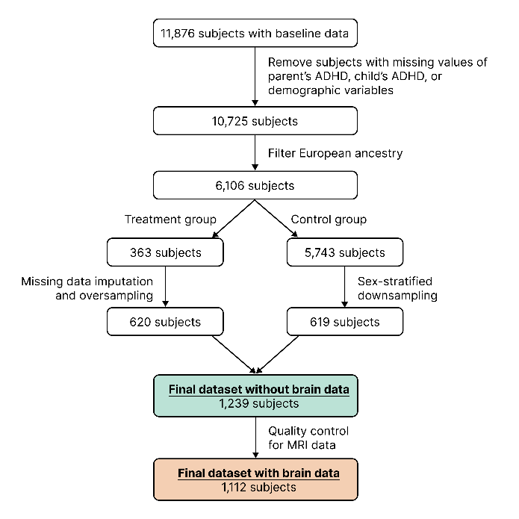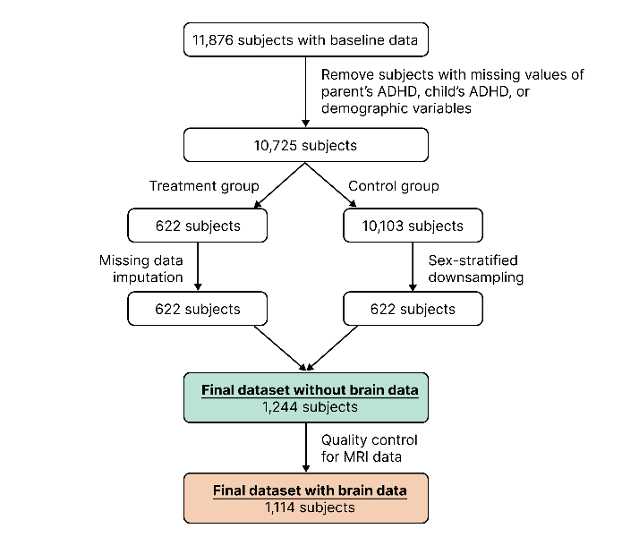
Figure S4. Study flowchart: (a) multiethnic sample, (b) European sample.
(a)
(b)

Main Analysis Results
Table S4. ATE estimates for GRF models with the baseline outcome.
Model | Sample | ATE (SE) | 95% CI | t | p
Environmental covariates | European | 0.44 (0.06) | (0.33, 0.55) | 7.88 | < .001
Environmental covariates | Multiethnic | 0.46 (0.04) | (0.39, 0.54) | 11.94 | < .001
Environmental and genetic covariates | European | 0.52 (0.05) | (0.41, 0.63) | 9.55 | < .001
Environmental and genetic covariates | Multiethnic | 0.54 (0.03) | (0.47, 0.60) | 16.06 | < .001
Environmental and brain covariates | European | 0.28 (0.04) | (0.19, 0.37) | 6.24 | < .001
Environmental and brain covariates | Multiethnic | 0.30 (0.03) | (0.23, 0.36) | 9.17 | < .001
Environmental, genetic, and brain covariates | European | 0.29 (0.05) | (0.20, 0.38) | 6.39 | < .001
Environmental, genetic, and brain covariates | Multiethnic | 0.30 (0.03) | (0.24, 0.37) | 9.32 | < .001

Table S5. Test calibration results for GRF models with the baseline outcome.
Model | ATE coefficient (SE) | ATE coefficient t | ATE coefficient p | CATE coefficient (SE) | CATE coefficient t | CATE coefficient p
European sample
Environmental covariates | 1.04 (0.19) | 5.35 | < .001 | 0.63 (0.78) | 0.81 | .21
Environmental and genetic covariates | 1.05 (0.17) | 6.29 | < .001 | 2.55 (0.67) | 3.79 | < .001
Environmental and brain covariates | 1.15 (0.28) | 4.10 | < .001 | -2.55 (1.98) | -1.29 | .90
Environmental, genetic, and brain covariates | 1.13 (0.24) | 4.71 | < .001 | -3.97 (2.18) | -1.82 | .97
Multiethnic sample
Environmental covariates | 0.99 (0.11) | 8.89 | < .001 | 0.38 (0.92) | 0.42 | .34
Environmental and genetic covariates | 1.00 (0.11) | 9.06 | < .001 | 2.17 (0.73) | 2.97 | 0.002
Environmental and brain covariates | 1.03 (0.16) | 6.31 | < .001 | -1.68 (1.45) | -1.16 | .88
Environmental, genetic, and brain covariates | 1.00 (0.16) | 6.14 | < .001 | -1.51 (1.66) | -0.91 | .82

Table S6. ATE estimates for the best GRF model (contains environmental and genetic covariates) with longitudinal outcomes in the multiethnic sample.
Outcome | Number of subjects | ATE (SE) | 95% CI | t | p
1-year follow-up | 1 173 | 0.52 (0.05) | (0.43, 0.61) | 10.85 | < .001
2-year follow-up | 872 | 0.46 (0.06) | (0.34, 0.57) | 7.66 | < .001
3-year follow-up | 687 | 0.39 (0.09) | (0.21, 0.58) | 4.17 | < .001

Table S7. Test calibration results for the best GRF model (contains environmental and genetic covariates) with longitudinal outcomes in the multiethnic sample.
Outcome | ATE coefficient (SE) | ATE coefficient t | ATE coefficient p | CATE coefficient (SE) | CATE coefficient t | CATE coefficient p
1-year follow-up | 1.02 (0.15) | 6.77 | < .001 | 1.83 (0.82) | 2.23 | .01
2-year follow-up | 1.02 (0.22) | 4.66 | < .001 | 1.27 (1.42) | 0.89 | .19
3-year follow-up | 1.09 (0.28) | 3.91 | < .001 | -4.66 (2.25) | -2.08 | .98

Sensitivity Analysis Results
In the main analysis, we built GRF models using a seed ensemble with five random seeds and 5,000 trees per seed. To verify the robustness of our results, we checked the best model with environmental and genetic covariates in various experimental settings. The results are presented below.

Table S8. ATE estimates for the best GRF model (contains environmental and genetic covariates) with the baseline outcome under various experimental settings.
Outcome | ATE (SE) | 95% CI | t | p
European sample
100 trees per seed | 0.50 (0.06) | (0.39, 0.61) | 8.76 | < .001
500 trees per seed | 0.51 (0.06) | (0.39, 0.62) | 8.72 | < .001
1000 trees per seed | 0.52 (0.06) | (0.41, 0.63) | 9.40 | < .001
2000 trees per seed | 0.51 (0.06) | (0.40, 0.62) | 9.05 | < .001
10,000 trees per seed | 0.52 (0.06) | (0.41, 0.63) | 9.09 | < .001
Seed set #1 | 0.52 (0.05) | (0.42, 0.63) | 9.71 | < .001
Seed set #2 | 0.51 (0.05) | (0.41, 0.62) | 9.56 | < .001
Seed set #3 | 0.51 (0.06) | (0.40, 0.63) | 8.85 | < .001
Multiethnic sample
100 trees per seed | 0.55 (0.04) | (0.47, 0.62) | 14.24 | < .001
500 trees per seed | 0.54 (0.03) | (0.48, 0.61) | 15.67 | < .001
1000 trees per seed | 0.53 (0.04) | (0.46, 0.60) | 14.53 | < .001
2000 trees per seed | 0.54 (0.03) | (0.47, 0.61) | 15.73 | < .001
10,000 trees per seed | 0.53 (0.03) | (0.47, 0.60) | 15.9 | < .001
Seed set #1 | 0.54 (0.03) | (0.47, 0.60) | 16.23 | < .001
Seed set #2 | 0.54 (0.03) | (0.48, 0.61) | 16.32 | < .001
Seed set #3 | 0.54 (0.03) | (0.47, 0.60) | 16.45 | < .001

Table S9. Test calibration results for the best GRF model (contains environmental and genetic covariates) with the baseline outcome under various experimental settings.
Outcome | ATE coefficient (SE) | ATE coefficient t | ATE coefficient p | CATE coefficient (SE) | CATE coefficient t | CATE coefficient p
European sample
100 trees per seed | 1.00 (0.16) | 6.28 | <.001 | 1.22 (0.41) | 2.99 | .001
500 trees per seed | 1.07 (0.18) | 5.83 | <.001 | 1.84 (0.73) | 2.53 | .006
1000 trees per seed | 1.10 (0.18) | 6.29 | <.001 | 2.81 (0.62) | 4.52 | <.001
2000 trees per seed | 1.05 (0.18) | 5.93 | <.001 | 2.27 (0.62) | 3.69 | <.001
10,000 trees per seed | 1.05 (0.17) | 6.01 | <.001 | 2.63 (0.72) | 3.64 | <.001
Seed set #1 | 1.05 (0.16) | 6.35 | <.001 | 2.44 (0.74) | 3.28 | <.001
Seed set #2 | 1.04 (0.17) | 6.1 | <.001 | 2.60 (0.65) | 4 | <.001
Seed set #3 | 1.04 (0.19) | 5.49 | <.001 | 2.65 (0.77) | 3.42 | <.001
Multiethnic sample
100 trees per seed | 1.07 (0.11) | 9.42 | <.001 | 1.07 (0.64) | 1.69 | .05
500 trees per seed | 1.03 (0.11) | 9.13 | <.001 | 2.62 (0.77) | 3.42 | <.001
1000 trees per seed | 0.98 (0.12) | 8.42 | <.001 | 1.77 (0.67) | 2.64 | .004
2000 trees per seed | 0.99 (0.12) | 8.5 | <.001 | 2.29 (0.80) | 2.87 | .002
10,000 trees per seed | 0.99 (0.11) | 9.04 | <.001 | 2.18 (0.76) | 2.88 | .002
Seed set #1 | 1.00 (0.11) | 8.94 | <.001 | 2.26 (0.76) | 2.97 | .002
Seed set #2 | 1.01 (0.11) | 9.04 | <.001 | 2.32 (0.77) | 3.02 | .001
Seed set #3 | 0.99 (0.11) | 9.27 | <.001 | 2.02 (0.75) | 2.69 | .004

Correlation Analysis Results
Table S10. (Multiethnic sample) Pairwise correlation results of regional brain volumes with the individual-level effect of parental ADHD on child ADHD symptoms obtained from the best model.
 | Full sample |  |  | Male sample |  |  | Female sample
Region | r(1070) | p | p_{FDR} | r(592) | p | p_{FDR} | r(476) | p | p_{FDR}
Left Banks of the Superior Temporal Sulcus | .00 | .91 | .97 | .03 | .44 | .94 | -.03 | .49 | .96
Left Caudal Anterior Cingulate Cortex | .00 | .99 | .99 | .06 | .17 | .90 | -.06 | .16 | .77
Left Caudal Middle Frontal Cortex | .02 | .59 | .86 | .03 | .52 | .94 | .01 | .91 | .99
Left Cuneus | -.02 | .57 | .86 | -.01 | .82 | 1.00 | -.03 | .56 | .96
Left Entorhinal Cortex | .02 | .47 | .86 | .04 | .39 | .94 | .00 | .91 | .99
Left Fusiform Gyrus | .00 | .98 | .99 | -.03 | .41 | .94 | .04 | .37 | .94
Left Inferior Parietal Cortex | .01 | .76 | .93 | -.01 | .86 | 1.00 | .03 | .53 | .96
Left Inferior Temporal Cortex | .01 | .69 | .92 | .00 | .93 | 1.00 | .02 | .64 | .99
Left Isthmus Cingulate Cortex | .02 | .50 | .86 | .02 | .68 | .96 | .02 | .60 | .96
Left Lateral Occipital Cortex | -.05 | .12 | .86 | -.03 | .48 | .94 | -.07 | .13 | .76
Left Lateral Orbitofrontal Cortex | .02 | .58 | .86 | .04 | .39 | .94 | .00 | .94 | .99
Left Lingual Gyrus | -.01 | .67 | .91 | .00 | .99 | 1.00 | -.03 | .54 | .96
Left Medial Orbitofrontal Cortex | -.01 | .78 | .93 | .01 | .76 | 1.00 | -.03 | .46 | .96
Left Middle Temporal Gyrus | -.01 | .80 | .93 | .02 | .59 | .94 | -.05 | .31 | .94
Left Parahippocampal Gyrus | -.03 | .28 | .86 | -.06 | .17 | .90 | .00 | .95 | .99
Left Paracentral Lobule | .02 | .50 | .86 | .08 | .05 | .90 | -.05 | .32 | .94
Left Pars Opercularis | .03 | .38 | .86 | .01 | .77 | 1.00 | .05 | .31 | .94
Left Pars Orbitalis | .03 | .35 | .86 | .08 | .04 | .90 | -.03 | .48 | .96
Left Pars Triangularis | .01 | .66 | .91 | .01 | .72 | 1.00 | .01 | .78 | .99
Left Pericalcarine Cortex | -.01 | .66 | .91 | .03 | .41 | .94 | -.07 | .13 | .76
Left Postcentral Gyrus | .07 | .02 | .58 | .04 | .31 | .94 | .11 | .01 | .60
Left Posterior Cingulate Cortex | .03 | .40 | .86 | .04 | .33 | .94 | .01 | .86 | .99
Left Precentral Gyrus | .00 | .91 | .97 | .02 | .62 | .94 | -.02 | .72 | .99
Left Precuneus | -.02 | .49 | .86 | -.03 | .54 | .94 | -.02 | .74 | .99
Left Rostral Anterior Cingulate Cortex | .04 | .22 | .86 | .08 | .04 | .90 | -.01 | .75 | .99
Left Rostral Middle Frontal Cortex | .03 | .28 | .86 | .06 | .17 | .90 | .00 | .96 | .99
Left Superior Frontal Gyrus | .01 | .79 | .93 | .00 | .94 | 1.00 | .01 | .75 | .99
Left Superior Parietal Cortex | .00 | .92 | .97 | .01 | .74 | 1.00 | -.01 | .85 | .99
Left Superior Temporal Gyrus | .03 | .30 | .86 | .05 | .21 | .93 | .01 | .88 | .99
Left Supramarginal Gyrus | -.04 | .15 | .86 | -.02 | .69 | .96 | -.08 | .07 | .70
Left Frontal Pole | -.02 | .46 | .86 | .00 | .94 | 1.00 | -.05 | .32 | .94
Left Temporal Pole | -.01 | .81 | .93 | .00 | .95 | 1.00 | -.01 | .80 | .99
Left Transverse Temporal Cortex | .01 | .80 | .93 | -.03 | .53 | .94 | .05 | .28 | .94
Left Insula | .05 | .08 | .86 | .05 | .18 | .90 | .05 | .25 | .94
Right Banks of the Superior Temporal Sulcus | .01 | .77 | .93 | .02 | .62 | .94 | -.01 | .91 | .99
Right Caudal Anterior Cingulate Cortex | .00 | .90 | .97 | .03 | .43 | .94 | -.03 | .47 | .96
Right Caudal Middle Frontal Cortex | .05 | .1 | .86 | .05 | .26 | .94 | .06 | .23 | .94
Right Cuneus | -.01 | .67 | .91 | -.02 | .65 | .95 | -.01 | .90 | .99
Right Entorhinal Cortex | .01 | .82 | .93 | .04 | .30 | .94 | -.04 | .38 | .94
Right Fusiform Gyrus | -.02 | .55 | .86 | -.05 | .22 | .93 | .02 | .63 | .99
Right Inferior Parietal Cortex | -.03 | .39 | .86 | .03 | .51 | .94 | -.09 | .04 | .70
Right Inferior Temporal Cortex | -.05 | .11 | .86 | -.01 | .85 | 1.00 | -.10 | .03 | .70
Right Isthmus Cingulate Cortex | .05 | .10 | .86 | .06 | .15 | .90 | .04 | .39 | .94
Right Lateral Occipital Cortex | -.02 | .52 | .86 | .00 | .99 | 1.00 | -.05 | .32 | .94
Right Lateral Orbitofrontal Cortex | .01 | .79 | .93 | .02 | .61 | .94 | -.01 | .88 | .99
Right Lingual Gyrus | -.02 | .58 | .86 | -.01 | .83 | 1.00 | -.03 | .57 | .96
Right Medial Orbitofrontal Cortex | -.02 | .60 | .86 | -.01 | .84 | 1.00 | -.02 | .59 | .96
Right Middle Temporal Gyrus | .02 | .48 | .86 | .00 | .91 | 1.00 | .04 | .34 | .94
Right Parahippocampal Gyrus | -.02 | .54 | .86 | -.06 | .16 | .90 | .03 | .58 | .96
Right Paracentral Lobule | .03 | .32 | .86 | .07 | .08 | .90 | -.02 | .66 | .99
Right Pars Opercularis | -.02 | .55 | .86 | -.02 | .66 | .95 | -.02 | .70 | .99
Right Pars Orbitalis | -.03 | .31 | .86 | -.03 | .44 | .94 | -.03 | .51 | .96
Right Pars Triangularis | -.04 | .21 | .86 | -.07 | .09 | .90 | .00 | 1.00 | 1.00
Right Pericalcarine Cortex | -.02 | .57 | .86 | .02 | .58 | .94 | -.07 | .15 | .76
Right Postcentral Gyrus | .09 | .00 | .26 | .10 | .02 | .90 | .09 | .06 | .70
Right Posterior Cingulate Cortex | .05 | .12 | .86 | .02 | .66 | .95 | .08 | .07 | .70
Right Precentral Gyrus | .04 | .17 | .86 | .07 | .11 | .90 | .01 | .76 | .99
Right Precuneus | .03 | .32 | .86 | .03 | .43 | .94 | .03 | .56 | .96
Right Rostral Anterior Cingulate Cortex | .02 | .59 | .86 | .03 | .41 | .94 | .00 | .94 | .99
Right Rostral Middle Frontal Cortex | .02 | .51 | .86 | .07 | .09 | .90 | -.04 | .37 | .94
Right Superior Frontal Gyrus | .02 | .58 | .86 | .04 | .38 | .94 | -.01 | .89 | .99
Right Superior Parietal Cortex | .00 | .97 | .99 | -.03 | .46 | .94 | .04 | .39 | .94
Right Superior Temporal Gyrus | .04 | .15 | .86 | .04 | .37 | .94 | .05 | .24 | .94
Right Supramarginal Gyrus | .05 | .14 | .86 | -.02 | .58 | .94 | .13 | .00 | .33
Right Frontal Pole | .02 | .49 | .86 | .04 | .28 | .94 | .00 | .96 | .99
Right Temporal Pole | -.04 | .16 | .86 | -.01 | .78 | 1.00 | -.08 | .09 | .70
Right Transverse Temporal Cortex | .02 | .53 | .86 | -.03 | .50 | .94 | .08 | .08 | .70
Right Insula | .03 | .28 | .86 | .00 | .95 | 1.00 | .08 | .10 | .76
Left Cerebral White Matter | -.02 | .57 | .86 | -.04 | .28 | .94 | .01 | .81 | .99
Left Cerebellum White Matter | .07 | .03 | .58 | .05 | .18 | .90 | .09 | .06 | .70
Left Cerebellum Cortex | .04 | .19 | .86 | .04 | .29 | .94 | .04 | .43 | .96
Left Thalamus | -.01 | .82 | .93 | -.01 | .88 | 1.00 | -.01 | .89 | .99
Left Caudate | -.02 | .56 | .86 | -.04 | .33 | .94 | .01 | .78 | .99
Left Putamen | -.01 | .85 | .95 | .01 | .88 | 1.00 | -.02 | .68 | .99
Left Pallidum | -.03 | .26 | .86 | -.01 | .89 | 1.00 | -.07 | .12 | .76
Left Brain Stem | -.02 | .50 | .86 | -.02 | .55 | .94 | -.01 | .75 | .99
Left Hippocampus | -.03 | .30 | .86 | .00 | .97 | 1.00 | -.07 | .13 | .76
Left Amygdala | -.02 | .42 | .86 | -.01 | .84 | 1.00 | -.05 | .32 | .94
Left Accumbens Area | -.04 | .14 | .86 | -.06 | .18 | .90 | -.03 | .45 | .96
Left Ventral Diencephalon | -.07 | .02 | .58 | -.06 | .14 | .90 | -.08 | .08 | .70
Right Cerebral White Matter | -.01 | .69 | .92 | -.04 | .34 | .94 | .02 | .71 | .99
Right Cerebellum White Matter | .03 | .41 | .86 | .03 | .52 | .94 | .03 | .56 | .96
Right Cerebellum Cortex | .04 | .19 | .86 | .04 | .31 | .94 | .04 | .38 | .94
Right Thalamus | .00 | .99 | .99 | .00 | .99 | 1.00 | .00 | .95 | .99
Right Caudate | -.02 | .59 | .86 | -.05 | .21 | .93 | .03 | .48 | .96
Right Putamen | .00 | .95 | .99 | .02 | .60 | .94 | -.02 | .65 | .99
Right Pallidum | -.04 | .14 | .86 | -.06 | .13 | .90 | -.02 | .67 | .99
Right Brain Stem | -.04 | .18 | .86 | .01 | .90 | 1.00 | -.10 | .03 | .70
Right Hippocampus | -.03 | .28 | .86 | -.01 | .85 | 1.00 | -.06 | .17 | .78
Right Amygdala | -.07 | .03 | .58 | -.09 | .04 | .90 | -.04 | .37 | .94
Right Accumbens Area | -.04 | .15 | .86 | -.04 | .35 | .94 | -.05 | .28 | .94
Right Ventral Diencephalon | .01 | .72 | .93 | .00 | 1.00 | 1.00 | .03 | .55 | .96
Middle Posterior Corpus Callosum | -.03 | .27 | .86 | -.06 | .14 | .90 | .00 | .98 | .99
Central Corpus Callosum | -.03 | .30 | .86 | .00 | .99 | 1.00 | -.07 | .14 | .76
Middle Anterior Corpus Callosum | .00 | .91 | .97 | .02 | .57 | .94 | -.03 | .47 | .96
Anterior Corpus Callosum | .01 | .83 | .93 | -.03 | .51 | .94 | .05 | .24 | .94
Supratentorial Volume | -.01 | .78 | .93 | -.03 | .52 | .94 | .00 | .97 | .99
Subcortical Gray Volume | -.03 | .27 | .86 | -.05 | .27 | .94 | -.04 | .41 | .96

Table S11. (European sample) Pairwise correlation results of regional brain volumes with the individual-level effect of parental ADHD on child ADHD symptoms obtained from the best model.
 | Full sample |  |  | Male sample |  |  | Female sample
Region | r(723) | p | p_{FDR} | r(365) | p | p_{FDR} | r(356) | p | p_{FDR}
Left Banks of the Superior Temporal Sulcus | -.05 | .14 | .80 | -.04 | .47 | .91 | -.07 | .17 | .93
Left Caudal Anterior Cingulate Cortex | .02 | .66 | .94 | .05 | .37 | .91 | -.01 | .78 | .93
Left Caudal Middle Frontal Cortex | .00 | .98 | .98 | -.05 | .37 | .91 | .04 | .41 | .93
Left Cuneus | .02 | .59 | .91 | .01 | .81 | .92 | .03 | .60 | .93
Left Entorhinal Cortex | .02 | .65 | .94 | .01 | .84 | .92 | .02 | .67 | .93
Left Fusiform Gyrus | .00 | .98 | .98 | -.01 | .86 | .92 | .01 | .85 | .93
Left Inferior Parietal Cortex | .01 | .73 | .94 | .03 | .54 | .91 | -.01 | .92 | .95
Left Inferior Temporal Cortex | .06 | .13 | .80 | .07 | .19 | .76 | .05 | .39 | .93
Left Isthmus Cingulate Cortex | .04 | .29 | .91 | .06 | .29 | .88 | .02 | .70 | .93
Left Lateral Occipital Cortex | .01 | .77 | .97 | .08 | .14 | .69 | -.05 | .31 | .93
Left Lateral Orbitofrontal Cortex | .08 | .02 | .80 | .08 | .13 | .69 | .09 | .08 | .93
Left Lingual Gyrus | .04 | .30 | .91 | .04 | .49 | .91 | .04 | .43 | .93
Left Medial Orbitofrontal Cortex | -.03 | .42 | .91 | .04 | .47 | .91 | -.09 | .09 | .93
Left Middle Temporal Gyrus | .04 | .24 | .91 | .04 | .40 | .91 | .04 | .42 | .93
Left Parahippocampal Gyrus | .00 | .92 | .97 | .01 | .88 | .92 | .00 | .97 | .98
Left Paracentral Lobule | .00. | .93 | .97 | -.02 | .73 | .92 | .01 | .81 | .93
Left Pars Opercularis | .03 | .46 | .91 | .00 | .93 | .95 | .06 | .27 | .93
Left Pars Orbitalis | .03 | .38 | .91 | .09 | .08 | .69 | -.02 | .74 | .93
Left Pars Triangularis | .04 | .24 | .91 | .09 | .10 | .69 | .00 | .96 | .98
Left Pericalcarine Cortex | .03 | .39 | .91 | .02 | .64 | .92 | .04 | .46 | .93
Left Postcentral Gyrus | .02 | .52 | .91 | -.05 | .32 | .91 | .09 | .08 | .93
Left Posterior Cingulate Cortex | .03 | .41 | .91 | .05 | .35 | .91 | .01 | .83 | .93
Left Precentral Gyrus | .04 | .29 | .91 | -.01 | .84 | .92 | .09 | .10 | .93
Left Precuneus | .04 | .30 | .91 | .03 | .60 | .92 | .05 | .33 | .93
Left Rostral Anterior Cingulate Cortex | .05 | .22 | .91 | .05 | .32 | .91 | .04 | .45 | .93
Left Rostral Middle Frontal Cortex | -.03 | .41 | .91 | -.03 | .54 | .91 | -.03 | .59 | .93
Left Superior Frontal Gyrus | .00 | .96 | .98 | .01 | .84 | .92 | -.01 | .92 | .95
Left Superior Parietal Cortex | .01 | .89 | .97 | .03 | .56 | .91 | -.02 | .73 | .93
Left Superior Temporal Gyrus | -.05 | .21 | .88 | -.01 | .86 | .92 | -.08 | .11 | .93
Left Supramarginal Gyrus | -.01 | .81 | .97 | -.01 | .83 | .92 | -.01 | .88 | .94
Left Frontal Pole | -.01 | .69 | .94 | .01 | .82 | .92 | -.04 | .48 | .93
Left Temporal Pole | -.05 | .17 | .85 | -.09 | .10 | .69 | -.02 | .71 | .93
Left Transverse Temporal Cortex | -.06 | .09 | .80 | -.11 | .04 | .69 | -.02 | .75 | .93
Left Insula | .07 | .07 | .80 | .06 | .25 | .82 | .08 | .15 | .93
Right Banks of the Superior Temporal Sulcus | -.02 | .56 | .91 | -.02 | .73 | .92 | -.02 | .64 | .93
Right Caudal Anterior Cingulate Cortex | -.01 | .84 | .97 | -.05 | .33 | .91 | .04 | .49 | .93
Right Caudal Middle Frontal Cortex | .03 | .38 | .91 | .04 | .47 | .91 | .03 | .57 | .93
Right Cuneus | -.02 | .55 | .91 | -.03 | .56 | .91 | -.01 | .80 | .93
Right Entorhinal Cortex | .00 | .90 | .97 | .04 | .45 | .91 | -.05 | .31 | .93
Right Fusiform Gyrus | .08 | .04 | .80 | .08 | .11 | .69 | .07 | .20 | .93
Right Inferior Parietal Cortex | -.02 | .61 | .93 | .02 | .63 | .92 | -.06 | .23 | .93
Right Inferior Temporal Cortex | .01 | .86 | .97 | .07 | .19 | .76 | -.05 | .31 | .93
Right Isthmus Cingulate Cortex | .04 | .26 | .91 | .07 | .15 | .69 | .01 | .83 | .93
Right Lateral Occipital Cortex | .04 | .34 | .91 | .10 | .06 | .69 | -.03 | .63 | .93
Right Lateral Orbitofrontal Cortex | .06 | .11 | .80 | .08 | .11 | .69 | .04 | .48 | .93
Right Lingual Gyrus | .03 | .47 | .91 | .01 | .85 | .92 | .04 | .41 | .93
Right Medial Orbitofrontal Cortex | -.02 | .57 | .91 | -.03 | .61 | .92 | -.02 | .77 | .93
Right Middle Temporal Gyrus | .01 | .89 | .97 | -.02 | .69 | .92 | .03 | .58 | .93
Right Parahippocampal Gyrus | .03 | .41 | .91 | .05 | .30 | .88 | .01 | .80 | .93
Right Paracentral Lobule | -.02 | .53 | .91 | -.07 | .16 | .7 | .02 | .65 | .93
Right Pars Opercularis | .03 | .49 | .91 | .04 | .48 | .91 | .01 | .78 | .93
Right Pars Orbitalis | -.03 | .37 | .91 | -.03 | .55 | .91 | -.03 | .52 | .93
Right Pars Triangularis | .03 | .37 | .91 | -.01 | .84 | .92 | .08 | .14 | .93
Right Pericalcarine Cortex | .02 | .64 | .94 | .00 | .94 | .95 | .04 | .50 | .93
Right Postcentral Gyrus | .01 | .69 | .94 | -.06 | .23 | .79 | .08 | .12 | .93
Right Posterior Cingulate Cortex | .06 | .08 | .80 | .04 | .48 | .91 | .09 | .09 | .93
Right Precentral Gyrus | .05 | .15 | .80 | .02 | .69 | .92 | .08 | .11 | .93
Right Precuneus | .08 | .03 | .80 | .11 | .04 | .69 | .05 | .32 | .93
Right Rostral Anterior Cingulate Cortex | .01 | .87 | .97 | -.02 | .65 | .92 | .03 | .54 | .93
Right Rostral Middle Frontal Cortex | -.06 | .11 | .80 | -.06 | .28 | .88 | -.06 | .25 | .93
Right Superior Frontal Gyrus | -.01 | .69 | .94 | .01 | .84 | .92 | -.04 | .47 | .93
Right Superior Parietal Cortex | .06 | .13 | .80 | .08 | .14 | .69 | .04 | .48 | .93
Right Superior Temporal Gyrus | .00 | .93 | .97 | .03 | .62 | .92 | -.03 | .59 | .93
Right Supramarginal Gyrus | .01 | .70 | .94 | -.03 | .61 | .92 | .06 | .29 | .93
Right Frontal Pole | -.03 | .35 | .91 | -.07 | .20 | .76 | -.01 | .92 | .95
Right Temporal Pole | -.01 | .72 | .94 | -.01 | .80 | .92 | -.01 | .81 | .93
Right Transverse Temporal Cortex | .02 | .54 | .91 | -.03 | .52 | .91 | .08 | .14 | .93
Right Insula | .05 | .19 | .88 | .00 | .97 | .97 | .09 | .08 | .93
Left Cerebral White Matter | .07 | .08 | .80 | .12 | .02 | .53 | .01 | .83 | .93
Left Cerebellum White Matter | .03 | .46 | .91 | .02 | .72 | .92 | .04 | .46 | .93
Left Cerebellum Cortex | .01 | .86 | .97 | .01 | .79 | .92 | .00 | .99 | .99
Left Thalamus | .06 | .12 | .80 | .10 | .05 | .69 | .02 | .75 | .93
Left Caudate | -.02 | .68 | .94 | .03 | .54 | .91 | -.06 | .24 | .93
Left Putamen | -.03 | .44 | .91 | -.01 | .79 | .92 | -.04 | .43 | .93
Left Pallidum | .07 | .08 | .80 | .08 | .12 | .69 | .05 | .35 | .93
Left Brain Stem | -.02 | .59 | .91 | -.01 | .81 | .92 | -.03 | .60 | .93
Left Hippocampus | .01 | .72 | .94 | .04 | .41 | .91 | -.01 | .78 | .93
Left Amygdala | .01 | .81 | .97 | .08 | .14 | .69 | -.06 | .27 | .93
Left Accumbens Area | .01 | .82 | .97 | .06 | .25 | .82 | -.04 | .42 | .93
Left Ventral Diencephalon | -.05 | .15 | .80 | -.04 | .44 | .91 | -.07 | .20 | .93
Right Cerebral White Matter | .07 | .06 | .80 | .13 | .01 | .42 | .01 | .84 | .93
Right Cerebellum White Matter | .03 | .48 | .91 | .07 | .21 | .76 | -.02 | .76 | .93
Right Cerebellum Cortex | .00 | .91 | .97 | .01 | .89 | .92 | -.01 | .78 | .93
Right Thalamus | .04 | .31 | .91 | .09 | .08 | .69 | -.01 | .82 | .93
Right Caudate | -.01 | .81 | .97 | .04 | .43 | .91 | -.06 | .28 | .93
Right Putamen | -.02 | .57 | .91 | -.02 | .73 | .92 | -.02 | .66 | .93
Right Pallidum | .04 | .29 | .91 | .07 | .15 | .69 | .01 | .86 | .93
Right Brain Stem | -.01 | .73 | .94 | .01 | .84 | .92 | -.04 | .51 | .93
Right Hippocampus | -.03 | .48 | .91 | .03 | .58 | .92 | -.08 | .15 | .93
Right Amygdala | .01 | .86 | .97 | .04 | .46 | .91 | -.02 | .69 | .93
Right Accumbens Area | -.02 | .51 | .91 | .00 | .93 | .95 | -.05 | .31 | .93
Right Ventral Diencephalon | .06 | .10 | .80 | .08 | .13 | .69 | .05 | .36 | .93
Middle Posterior Corpus Callosum | -.01 | .84 | .97 | -.05 | .35 | .91 | .03 | .57 | .93
Central Corpus Callosum | .02 | .52 | .91 | .04 | .50 | .91 | .01 | .79 | .93
Middle Anterior Corpus Callosum | .02 | .57 | .91 | .01 | .83 | .92 | .03 | .55 | .93
Anterior Corpus Callosum | .00 | .95 | .98 | -.01 | .80 | .92 | .01 | .85 | .93
Supratentorial Volume | .07 | .07 | .8 | .14 | .01 | .42 | .01 | .79 | .93
Subcortical Gray Volume | .05 | .20 | .88 | .13 | .01 | .42 | -.03 | .56 | .93

References

1 Rattay K, Robinson LR. Identifying Risk Factors for Attention-Deficit/Hyperactivity Disorder (ADHD): a Public Health Concern and Opportunity. Prev Sci Off J Soc Prev Res 2024; 25: 195–202.
2 Modabbernia A, Janiri D, Doucet GE, Reichenberg A, Frangou S. Multivariate Patterns of Brain-Behavior-Environment Associations in the Adolescent Brain and Cognitive Development Study. Biol Psychiatry 2021; 89: 510–520.
3 Bruni O, Ottaviano S, Guidetti V, Romoli M, Innocenzi M, Cortesi F et al. The Sleep Disturbance Scale for Children (SDSC). Construction and validation of an instrument to evaluate sleep disturbances in childhood and adolescence. J Sleep Res 1996; 5: 251–261.
4 Schaefer ES. Child’s Report of Parent Behavior Inventory (CRPBI). APA PsycTests, 1965https://doi.org/10.1037/t06333-000.
5 Moos RH, Insel PM, Humphrey B. Preliminary manual for Family Environment Scale, Work Environment Scale, Group Environment Scale. Consulting Psychologists Press: Palo Alto, CA, 1974.
6 Conomos MP, Miller MB, Thornton TA. Robust inference of population structure for ancestry prediction and correction of stratification in the presence of relatedness. Genet Epidemiol 2015; 39: 276–293.
7 Joo YY, Lee E, Kim B-G, Kim G, Seo J, Cha J. Polygenic architecture of brain structure and function, behaviors, and psychopathologies in children. BioRxiv Prepr Serv Biol 2024; : 2024.05.22.595444.
8 Hagler DJ, Hatton S, Cornejo MD, Makowski C, Fair DA, Dick AS et al. Image processing and analysis methods for the Adolescent Brain Cognitive Development Study. NeuroImage 2019; 202: 116091.
9 Fischl B, Salat DH, Busa E, Albert M, Dieterich M, Haselgrove C et al. Whole brain segmentation: automated labeling of neuroanatomical structures in the human brain. Neuron 2002; 33: 341–355.
10 Desikan RS, Ségonne F, Fischl B, Quinn BT, Dickerson BC, Blacker D et al. An automated labeling system for subdividing the human cerebral cortex on MRI scans into gyral based regions of interest. NeuroImage 2006; 31: 968–980.
11 Athey S, Tibshirani J, Wager S. Generalized random forests. Ann Stat 2019; 47: 1148–1178.
12 Athey S, Wager S. Estimating Treatment Effects with Causal Forests: An Application. Obs Stud 2019; 5: 37–51.
13 Gong X, Hu M, Basu M, Zhao L. Heterogeneous treatment effect analysis based on machine-learning methodology. CPT Pharmacomet Syst Pharmacol 2021; 10: 1433–1443.
14 Tibshirani J, Athey S, Sverdrup E, Wager S. grf: Generalized Random Forests. 2024.https://CRAN.R-project.org/package=grf.
15 Kuhn M. caret: Classification and Regression Training. 2022.https://CRAN.R-project.org/package=caret.
16 Hastie T, Tibshirani R, Narasimhan B, Chu G. impute: Imputation for microarray data. 2023.
17 Torgo L. Data Mining with R, learning with case studies. 2010.http://www.dcc.fc.up.pt/~ltorgo/DataMiningWithR.

