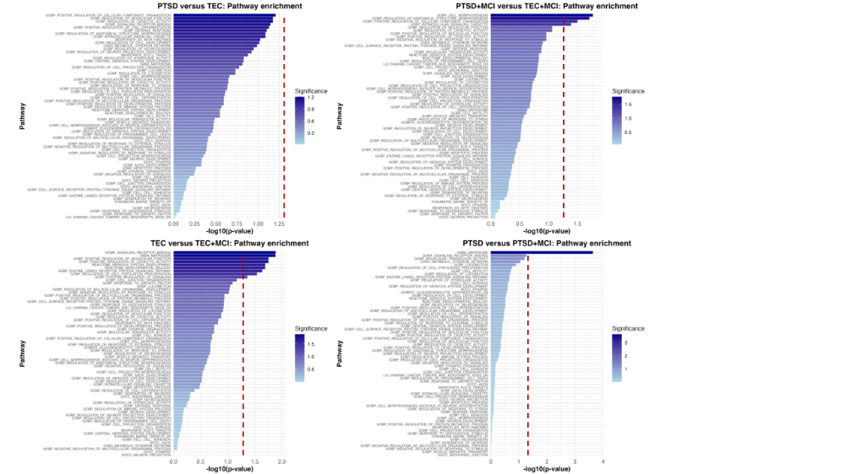
Supplementary Data

Figure S1A: Pathway enrichment analysis using Gene Set Enrichment Analysis (GSEA) for PTSD vs TEC. Each plot represents the enrichment profile for different group comparisons, based on ranked protein expression data from the Olink® Target 96 Neurology Panel. The x-axis displays the –log₁₀(p-value), indicating statistical significance, while the y-axis shows the enriched pathway name. Dashed horizontal lines represent the significance threshold at p = 0.05 (–log₁₀(0.05) = 1.3).

Figure S1B: Pathway enrichment analysis using Gene Set Enrichment Analysis (GSEA) for PTSD+MCI vs TEC+MCI. Each plot represents the enrichment profile for different group comparisons, based on ranked protein expression data from the Olink® Target 96 Neurology Panel. The x-axis displays the –log₁₀(p-value), indicating statistical significance, while the y-axis shows the enriched pathway name. Dashed horizontal lines represent the significance threshold at p = 0.05 (–log₁₀(0.05) = 1.3).

Figure S1C: Pathway enrichment analysis using Gene Set Enrichment Analysis (GSEA) for TEC-MCI vs TEC+MCI. Each plot represents the enrichment profile for different group comparisons, based on ranked protein expression data from the Olink® Target 96 Neurology Panel. The x-axis displays the –log₁₀(p-value), indicating statistical significance, while the y-axis shows the enriched pathway name. Dashed horizontal lines represent the significance threshold at p = 0.05 (–log₁₀(0.05) = 1.3).

Figure S1D: Pathway enrichment analysis using Gene Set Enrichment Analysis (GSEA) for PTSD-MCI vs PTSD+MCI. Each plot represents the enrichment profile for different group comparisons, based on ranked protein expression data from the Olink® Target 96 Neurology Panel. The x-axis displays the –log₁₀(p-value), indicating statistical significance, while the y-axis shows the enriched pathway name. Dashed horizontal lines represent the significance threshold at p = 0.05 (–log₁₀(0.05) = 1.3).

