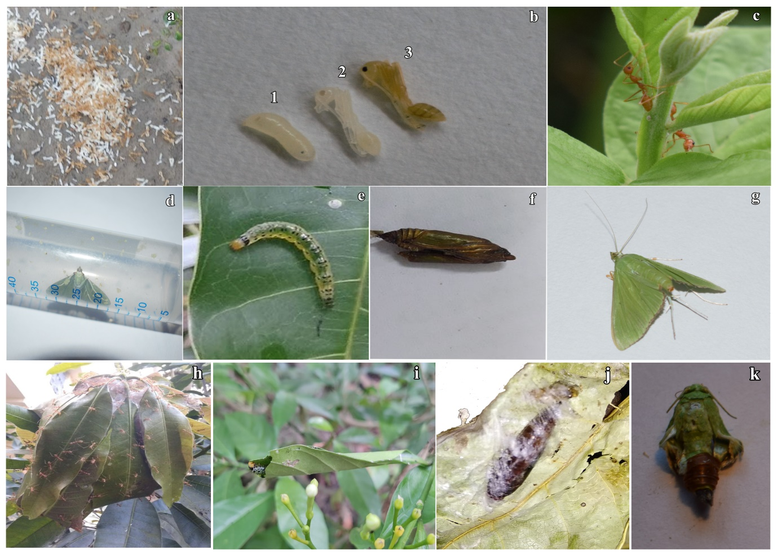
Supplementary 1. (a) Egg of O. smaragdina (b) different stages of O. smaragdina brood, 1,2- Oecophylla brood stage-I, 3- Oecophylla brood stage-II (c) Adult, O.smaragdina (d) P. marginata laying eggs inside an Eppendorf tube (e) P. marginata larvae (f) Pupae of P. marginata (g) Adult, P. marginata (h) Natural O. smaragdina nest (i) P. marginata nest in wild (j) Pupae of P. marginata wrapped inside the wild O. smaragdina nest (k) Transformation from pupae to adult (P. marginata) inside BOD.

