Supplementary Materials
The required experiment was conducted on Buchi sheep at the Government livestock farm Jugaitpeer, District Bahawalpur.
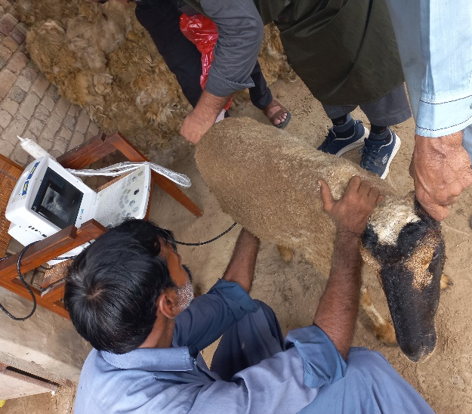
Supplementary Figure S1
A real-time, B-mode ultrasound scanner, DUS 60 Digital Ultrasonic Diagnostic Imaging System, with 5-7.5 MHz endocavity linear-array endorectal probes (Edan Endorectal Transducer E741-2) was utilized to differentiate between pregnant and non-pregnant sheep. After 27 days, ultrasonography was performed again to check embryonic mortality and to confirm pregnancy.
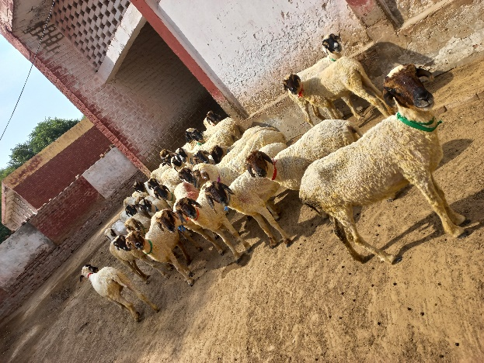
Supplementary Figure S2
Randomly allocated the animals (n=30) into three separate treatment groups. This minimized bias and ensured that the groups were equal at the onset of the trial. Group I (n=10) was the Control Group: Sheep that got no intervention. Group II (n=10) was the hCG treatment group, and Group III (n=10) was the GnRH group. All the sheep in various groups were marked with distinct colored ribbons.
Ewes were categorized into three groups. Group I was given no treatment and served as a control. Animals of Groups II and III were first administered a prostaglandin injection of 2ml Dalmazin (PGF2_{α}) (Fatro Pharmaceutical Veterinary Industry, Italy) at the onset of the breeding season, and the second injection was administered after 11 days.
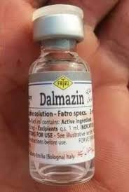
Supplementary Figure S3
Initially, the animals were weighed and assigned to the required groups. Estrus was synchronized in group II and III animals with two intramuscular injections of Dalmazin (PGF2α) prostaglandin analog given 11 days apart.
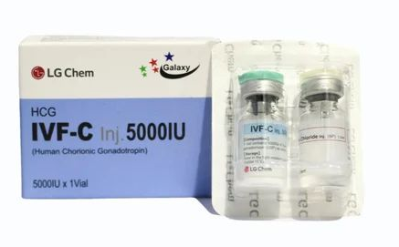
Supplementary Figure S4
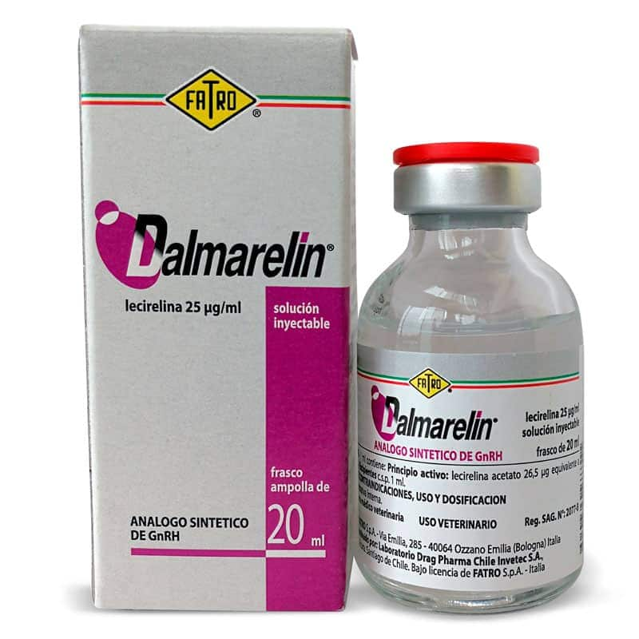
Supplementary Figure S5
After the second injection of prostaglandin, ewes in estrus were mated naturally. Group II (n=10) received 1ml hCG per sheep, whereas Group III (n=10) animals received 2ml Dalmaralin (GnRH) (Dalmaralin, Fatro Pharmaceutical Veterinary Industry, Italy) per sheep on the day of mating. The ewes were not slaughtered and not given any anesthesia for this study.
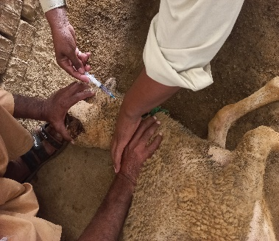
Supplementary Figure S6
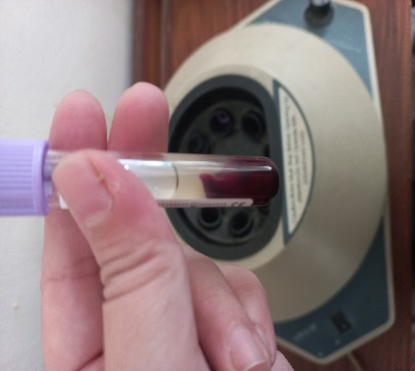
Supplementary Figure S7
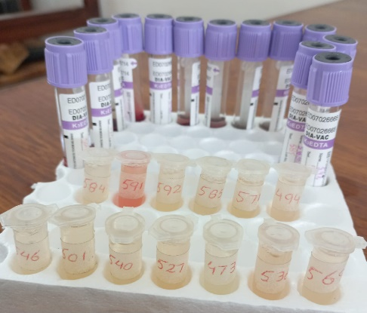
Supplementary Figure S8
For the progesterone assay, blood samples were obtained via jugular vein puncture from day 2 to 16 following hCG and GnRH injections, utilizing a 5 ml plastic syringe (Lahore Medical Instruments, Pakistan) and a 23-gauge x 1 needle, and subsequently transferred into pre-heparinized 5 ml glass tubes. In each test tube, 1 ml of heparin solution was added to 3 ml of the blood sample. Samples (about 3-5 ml) were collected at 8:00 AM before feeding. Blood samples were collected more often. Blood samples were centrifuged at 3000 rpm for 15 minutes, and the separated serum was placed into eppendorf tubes and kept at −20 °C until analyzed for progesterone using ELISA. The hemolyzed samples were eliminated from the data.
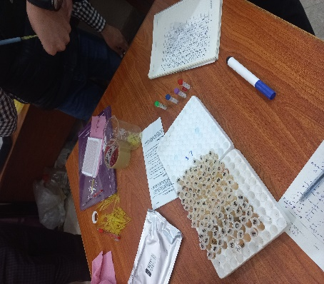
Supplementary Figure S9
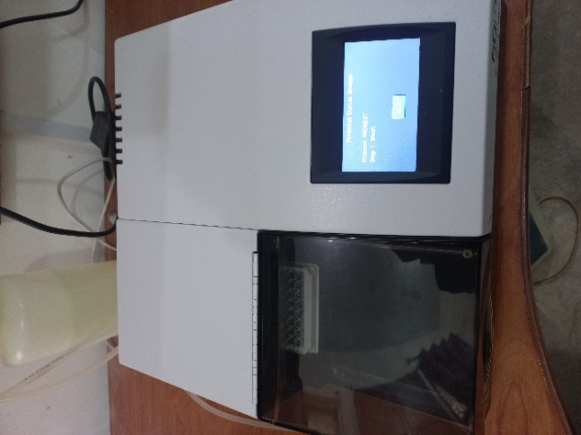
Supplementary Figure S10
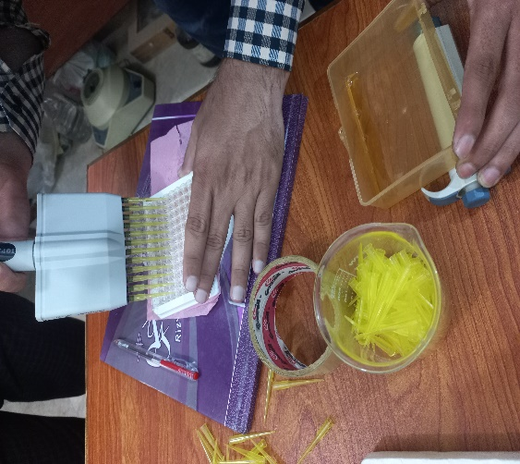
Supplementary Figure S11
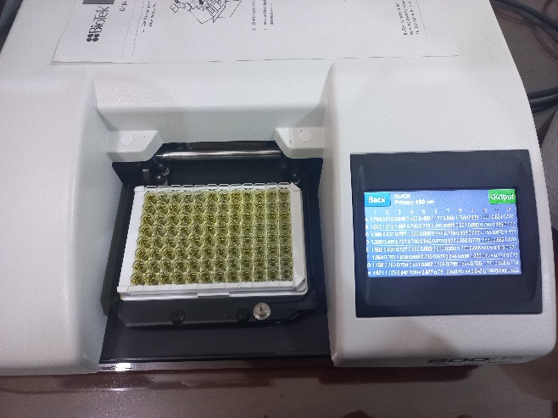
Supplementary Figure S12
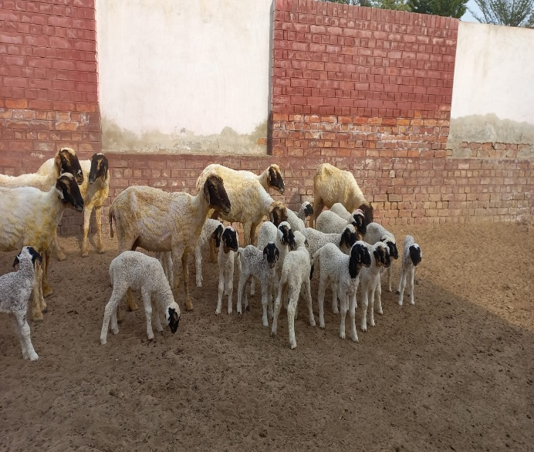
Supplementary Figure S13
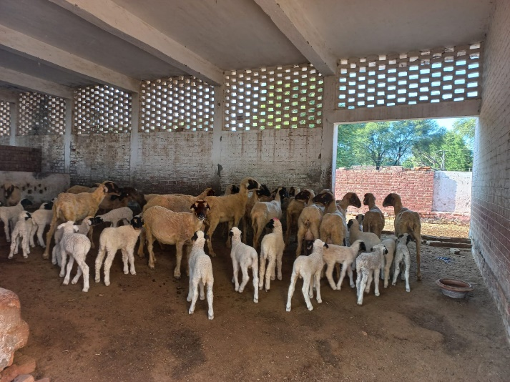
Supplementary Figure S14

