Supplementary Material
- Supplementary Data
  - Search Strategy
PUBMED：
((((((((("telitacicept" [Supplementary Concept]) OR ((Recombinant Fusion Proteins[Title/Abstract]) OR (Telitacicept[Title/Abstract]))) OR ("belimumab" [Supplementary Concept])) OR (((((((((BEL-114333[Title/Abstract]) OR (BEL114333[Title/Abstract])) AND (("Lupus Erythematosus, Systemic"[Mesh]) OR ((((((Lupus Erythematosus, Systemic[Title/Abstract]) OR (Systemic Lupus Erythematosus[Title/Abstract])) OR (Lupus Erythematosus Disseminatus[Title/Abstract])) OR (Libman-Sacks Disease[Title/Abstract])) OR (Disease, Libman-Sacks[Title/Abstract])) OR (Libman Sacks Disease[Title/Abstract])))

Web of Science：
telitacicept (topic) OR belimumab OR BEL-114333 OR BEL114333 OR HGS-1006 OR HGS1006 OR LymphoStat-B OR GSK-1550188 OR GSK1550188 OR Benlysta OR Belimumab (summary) OR belimumab (topic) and Preprint Citation Index (Exclusion – Database)
Lupus Erythematosus, Systemic (topic) OR Lupus Erythematosus, Systemic OR Systemic Lupus Erythematosus OR Lupus Erythematosus Disseminatus OR Libman-Sacks Disease OR Disease, Libman-Sacks OR Libman Sacks Disease (summary) and Preprint Citation Index (Exclusion – Database)

TS=(telitacicept) OR AB=(belimumab OR BEL-114333 OR BEL114333 OR HGS-1006 OR HGS1006 OR LymphoStat-B OR GSK-1550188 OR GSK1550188 OR Benlysta OR Belimumab) AND TS=(Lupus Erythematosus, Systemic) OR AB=(Lupus Erythematosus, Systemic OR Systemic Lupus Erythematosus OR Lupus Erythematosus Disseminatus OR Libman-Sacks Disease OR Disease, Libman-Sacks OR Libman Sacks Disease)

EMBASE:
#1. telitacicept:ab,ti
#2. belimumab:ab,ti OR 'bel 114333':ab,ti OR
bel114333:ab,ti OR 'hgs 1006':ab,ti OR
hgs1006:ab,ti OR 'lymphostat b':ab,ti OR 'gsk
1550188':ab,ti OR gsk1550188:ab,ti OR
benlysta:ab,ti
#3. #1 OR #2
#4. 'systemic lupus erythematosus':ab,ti OR 'lupus
erythematosus disseminatus':ab,ti OR
'libman-sacks disease':ab,ti OR 'disease,
libman-sacks':ab,ti OR 'libman sacks
disease':ab,ti
#5. #3 AND #5
#6. 'randomized controlled trial':it OR 'controlled
clinical trial':it OR randomized:ab,ti OR
placebo:ab,ti OR ('clinical trial':ab,ti AND
topic:ab,ti) OR randomly:ab,ti OR trial:ti
#7. #5 AND #6
Medline:
S4 (PT ( randomized controlled trials or rct or randomised control trials ) OR AB ( randomized or controlled or trials or placebo or randomly ) OR TI trial NOT ( animals not humans )) AND (S1 AND S2 AND S3)
S3 PT ( randomized controlled trials or rct or randomised control trials ) OR AB ( randomized or controlled or trials or placebo or randomly ) OR TI trial NOT ( animals not humans )
S2 AB ( Lupus Erythematosus, Systemic or Systemic Lupus Erythematosus or Lupus Erythematosus Disseminatus or Libman-Sacks Disease or Disease, Libman-Sacks or Libman Sacks Disease ) OR MH Lupus Erythematosus, Systemic
S1 AB Telitacicept or Belimumab or BEL-114333 or BEL114333 or HGS-1006 or HGS1006 or LymphoStat-B or GSK-1550188 or GSK1550188 or Benlysta
https://search.ebscohost.com/login.aspx?direct=true&db=cmedm&bquery=(PT+(randomized+controlled+trials+OR+rct+OR+randomised+control+trials)+OR+AB+(randomized+OR+controlled+OR+trials+OR+placebo+OR+randomly)+OR+TI+trial+NOT+(animals+NOT+humans))+AND+((AB+(Telitacicept+OR+Belimumab+OR+BEL-114333+OR+BEL114333+OR+HGS-1006+OR+HGS1006+OR+LymphoStat-B+OR+GSK-1550188+OR+GSK1550188+OR+Benlysta))+AND+((AB+(Lupus+Erythematosus%2c+Systemic+OR+Systemic+Lupus+Erythematosus+OR+Lupus+Erythematosus+Disseminatus+OR+Libman-Sacks+Disease+OR+Disease%2c+Libman-Sacks+OR+Libman+Sacks+Disease))+OR+(MH+Lupus+Erythematosus%2c+Systemic))+AND+((PT+(randomized+controlled+trials+OR+rct+OR+randomised+control+trials))+OR+(AB+(randomized+OR+controlled+OR+trials+OR+placebo+OR+randomly))+OR+(TI+trial)+NOT+(animals+NOT+humans)))&cli0=FT&clv0=Y&lang=zh-cn&type=1&searchMode=Standard&site=ehost-live

  - Supplementary Figures and Tables
Supplementary Figure 1. Diagram of judgements about each risk of bias items for eligible trials.
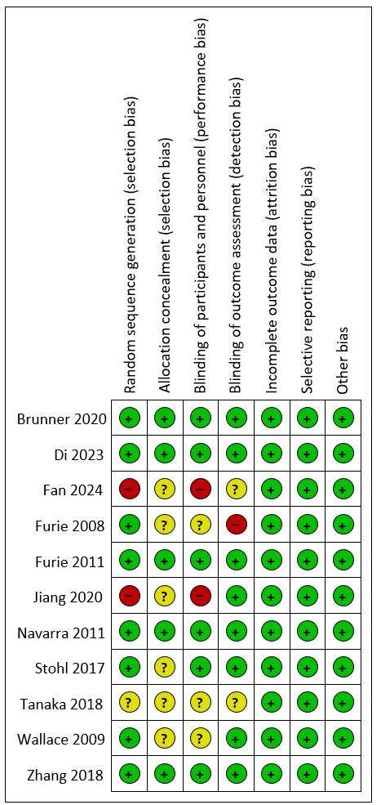

Supplementary Figure 2. Diagram conclusion of risk of bias.
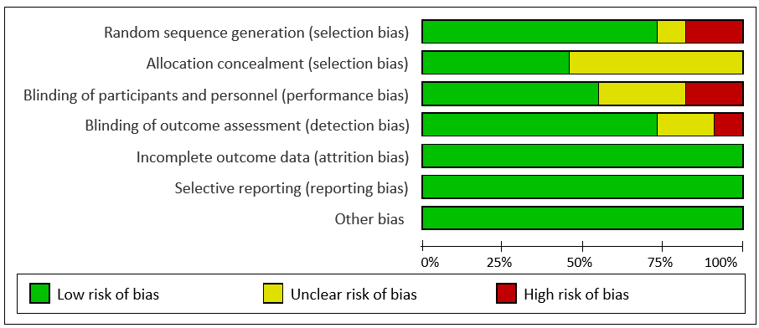

Supplementary Figure 3. Diagram of the SRI7 response rate for eligible studies. SRI, the Systemic Lupus Erythematosus Responder Index.
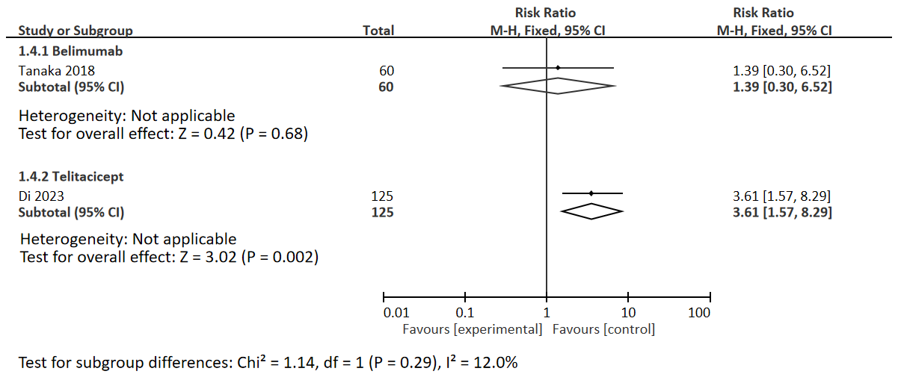

Supplementary Figure 4. Diagram of the kidney function enhancement for eligible studies.
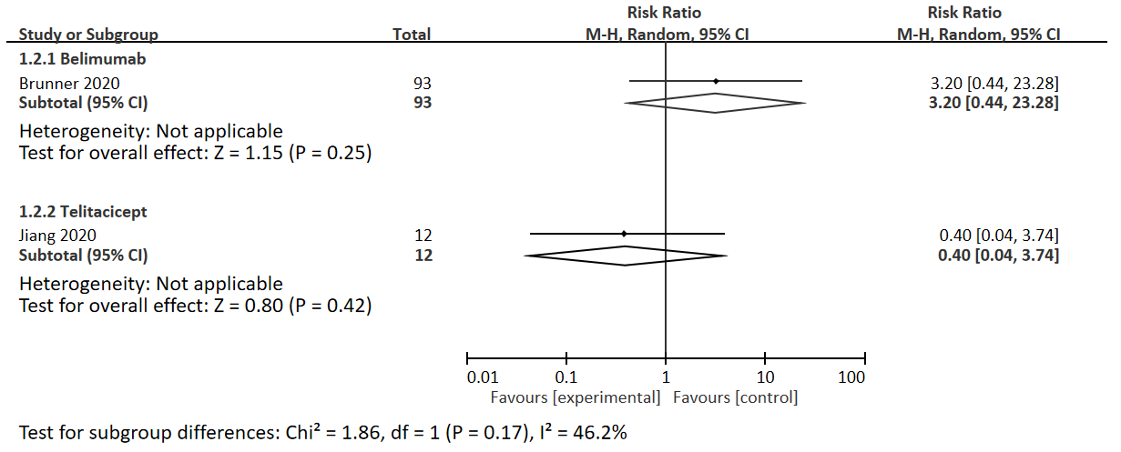
Supplementary Figure 5. Diagram of subgroup analysis for adverse events. *: p value of all groups.
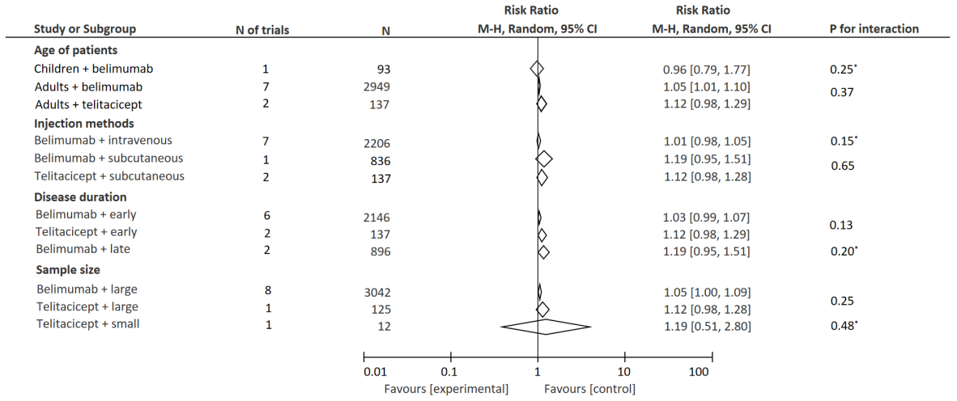

Supplementary Figure 6. Publication bias for SRI4 response rate, prednisone dose reduction, AEs and SAEs.
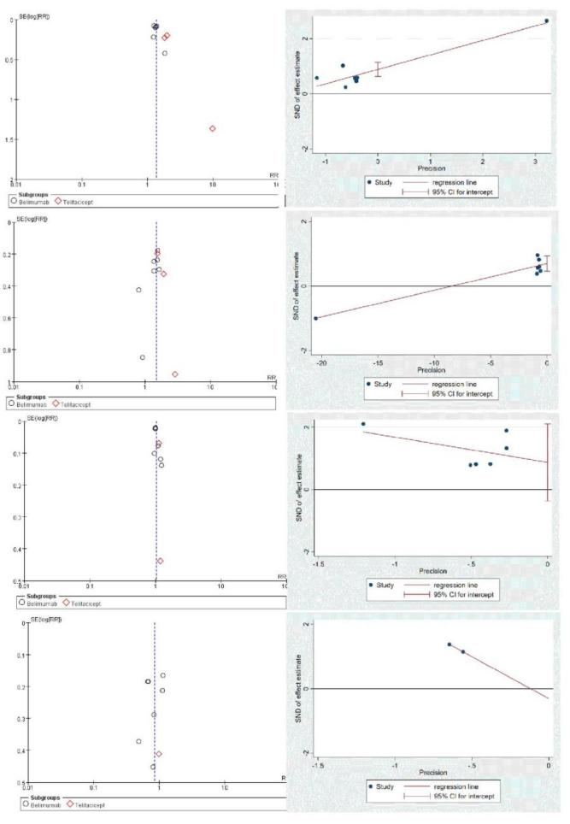

Supplementary Figure 7. Publication bias for SRI4 response rate, prednisone dose reduction, AEs and SAEs.
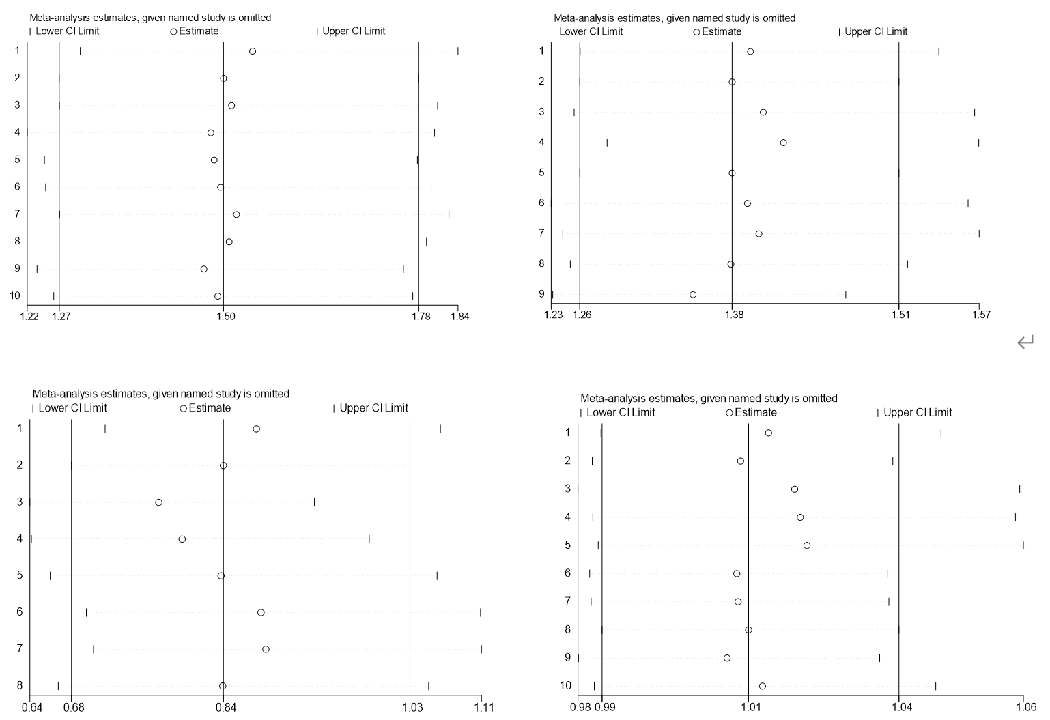

Supplementary Table 1. Results of ACNOVA analysis.
 | F score | p value
age | 4.81 | 0.08
gender | 0.37 | 0.56
baseline SLEDAI | 0.61 | 0.48
disease duration | 3.81 | 0.11

Supplementary Table 2. Results of meta-regression analysis.
Covariates (baseline) | Dependent | Coefficient (95%CI) | p value
SLEDAI | SRI4 response rate | -0.08(-1.48,1.32) | 0.892
SLEDAI | SLEDAI reduction | / | /
age | SRI4 response rate | -0.04(-0.73,0.64) | 0.886
age | SLEDAI reduction | 0.74(-8.09,9.57) | 0.479
gender | SRI4 response rate | -0.29(-4.85,4.26) | 0.881
gender | SLEDAI reduction | 0.99(-173.05,175.04) | 0.954
injection method | SRI4 response rate | 0.15(-0.07,0.36) | 0.155
injection method | SLEDAI reduction | 0.19(-15.43,15.81) | 0.902
prednisone use | SRI4 response rate | 1.56(-5.63,8.75) | 0.614
prednisone use | SLEDAI reduction | 41.53(-414.64,497.69) | 0.454
prednisone dose | SRI4 response rate | 0.01(-1.44,1.46) | 0.988
prednisone dose | SLEDAI reduction | / | /
disease duration | SRI4 response rate | -0.15(-0.96,0.67) | 0.676
disease duration | SLEDAI reduction | 2.67(-21.36,26.69) | 0.393
follow up | SRI4 response rate | -0.01(-0.02,0.01) | 0.674
follow up | SLEDAI reduction | -0.05(-3.95,3.86) | 0.902

