Supplementary Information for
All-dielectric Schrödinger colours across the visible spectrum
Yingjie Li^{1, 2}, Jun Yin², Chi Zhang², Yao Zhang², Qi Liu², Jing Han², Xinbo Sha¹, Kaixuan Li³, Kang Du², Zhengtong Liu¹, Cheng-Wei Qiu³, Qinghai Song^{1, 2, 4, 5#}, Shumin Xiao^{1, 2, 4, 5*}
1. Pengcheng Laboratory, Shenzhen 518055, P. R. China.
2. Ministry of Industry and Information Technology Key Lab of Micro-Nano Optoelectronic Information System, Guangdong Provincial Key Laboratory of Semiconductor Optoelectronic Materials and Intelligent Photonic Systems, Harbin Institute of Technology, Shenzhen 518055, P. R. China.
3. Department of Electrical and Computer Engineering, National University of Singapore, Singapore 117583, Singapore.
4. Quantum Science Center of Guangdong-Hong Kong-Macao Greater Bay Area, Shenzhen, China.
5. Collaborative Innovation Center of Extreme Optics, Shanxi University, Taiyuan 030006,
Shanxi, P. R. China.

Emails: # qinghai.song@hit.edu.cn, * shumin.xiao@hit.edu.cn

This file includes:
Figs. S1 to S12

- Flowchart of the gradient descent algorithm
This study adopts the gradient descent algorithm combined with the FDTD solution software to achieve gradient optimization of multiple parameters. The flowchart of the gradient descent algorithm is shown in Fig. S1(a). During the optimization process, both loss functions—the distance on the CIE diagram between the achieved structural colour coordinate and the target colour position, and the maximized ‘CIE y coordinate’—are randomly called to avoid local minima. The optimization trajectory of the Schrödinger green is shown in Fig. S1(b), where the blue, black, and red segments correspond to different optimization step sizes of 6 nm, 4 nm, and 2 nm, respectively. After multiple rounds of optimization, the colour gamut coordinates converge to (0.14, 0.78), which is very close to the perfect Schrödinger colour in the CIE1931 plot.
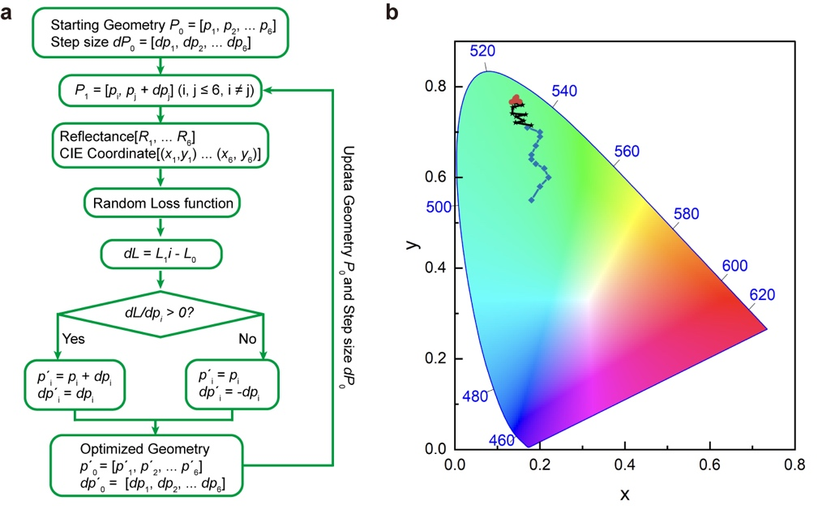
Fig. S1. Gradient descent algorithm for optimizing the designed nanopillar to achieve the Schrödinger colours. (a) Flowchart of the gradient descent algorithm. (b) Trajectory of the CIE coordinates during the optimization process.

- Reflection Spectra and CIE Coordinates of RGB Schrödinger colours​
The detailed reflection spectrum for the green Schrödinger colour and its corresponding CIE chromaticity coordinates are presented in Fig. 1(b) of the main text. Complementary simulated reflection spectra for blue and red, obtained through gradient optimization, are displayed in Fig. S2. In both figures, the simulated spectra are represented by solid lines, the passbands defining the Schrödinger pixels are indicated by filled areas, and the corresponding CIE coordinates are shown in the insets. These results demonstrate the successful realization of nearly ideal Schrödinger colour across all three primary colours (RGB).
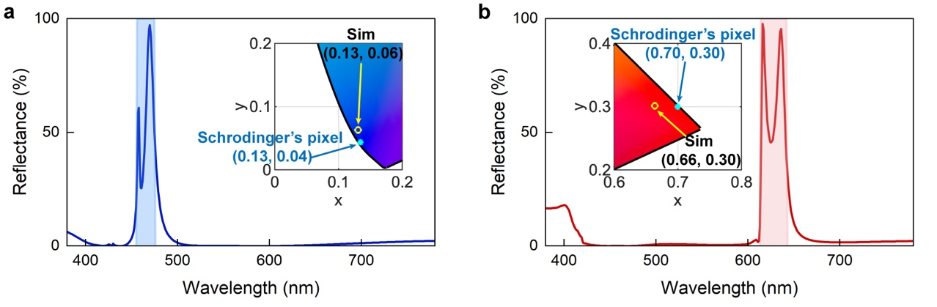
Fig. S2. Simulated performance of Schrödinger colour​​. Detailed reflection spectrum and corresponding CIE 1931 chromaticity coordinates (inset) for blue (a) and red (b).

- Eigenmodes vary with the ellipse’s minor axis
Figure S3(a) shows the dependence of four resonant modes on the size of minor axis of the ellipse. Here the period and major axis are fixed at 381 nm and 340 nm, respectively. Both the x-polarized and y-polarized modes shift to longer wavelength at larger minor axis of the ellipse. Four modes merge to two modes when the ellipse changes to a circle. In Fig. S3(a), we select the short axis at a size of 140 nm to ensure the separation of two x-polarized modes at around 40 nm. The corresponding electric field distributions of four modes are shown in Fig. S3(b). It is easy to see that the modes with the same polarization have quite different spatial distributions. As a consequence, their relative phase difference can be tuned with structural parameters.
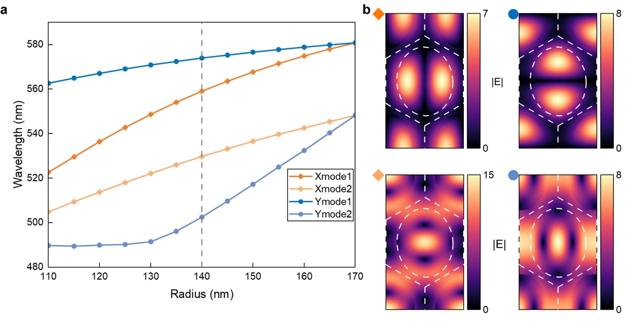
Fig. S3. Eigenmodes vary with the ellipse’s minor axis. (a) The resonant wavelength redshifts as the minor axis of the ellipse gradually increases to match the major axis. (b) Electric field distribution of the four resonance modes in the x-y plane when the semi-minor axis is 140 nm.

- Mode Decomposition
The extended state of the structure where the field, with the angular frequency $ω$, is input downwards above the photonic crystal slab is $\vec{E}\left(\vec{r}\right)$ and $\vec{H}\left(\vec{r}\right)$. The n-th resonant state of the structure is ${\vec{e}}_{n}\left(\vec{r}\right)$ and ${\vec{h}}_{n}\left(\vec{r}\right)$, where n = 1, 2, 3, … The permittivity distribution of the structure is $ε\left(\vec{r}\right)$.

The extended state $\vec{E}\left(\vec{r}\right)$ can be deemed as the superposition of the resonant states ${\vec{e}}_{n}\left(\vec{r}\right)$ and the uncoupled field ${\vec{E}}_{0}\left(\vec{r}\right)$, which is the residue field when the resonant states are removed from the extended state. As a result, the extend state is
$$\begin{aligned}\left\{\begin{aligned}&\vec{E}\left(\vec{r}\right)=\sum_{n}{a_{n}{\vec{e}}_{n}\left(\vec{r}\right)}+{\vec{E}}_{0}\left(\vec{r}\right) \\ &\vec{H}\left(\vec{r}\right)=\sum_{n}{a_{n}{\vec{h}}_{n}\left(\vec{r}\right)+{\vec{H}}_{0}\left(\vec{r}\right)}\end{aligned}\right..\# LISTNUM Equation \end{aligned}$$
where $a_{n}$ is the superposition coefficient of the n-th resonant state.

Now, with the known extended state and resonant states, we want to get the superposition coefficient $a_{n}$ and decompose the radiation of the extended state to that of different resonant states and the uncoupled field.

We mathematically define the uncoupled field as the field orthogonal with all resonant states in the way as
$$\begin{aligned}\iiint{dV(ε_{0}ε\left(\vec{r}\right){\vec{e}}_{m}^{*}\left(\vec{r}\right)∙{\vec{E}}_{0}\left(\vec{r}\right)+μ_{0}{\vec{h}}_{m}^{*}\left(\vec{r}\right)∙{\vec{H}}_{0}\left(\vec{r}\right)}=0.\# LISTNUM Equation \end{aligned}$$

In order to perform the mode decomposition and get the superposition coefficients $a_{n}$, we multiply the m-th resonant state to the Eq.1) to get
$$\iiint{dV\left(ε_{0}ε{\vec{e}}_{m}^{*}∙\vec{E}+μ_{0}{\vec{h}}_{m}^{*}∙\vec{H}\right)} \\ =\sum_{n}{a_{n}\iiint{dV\left(ε_{0}ε{\vec{e}}_{m}^{*}∙{\vec{e}}_{n}+μ_{0}{\vec{h}}_{m}^{*}∙{\vec{h}}_{n}\right)}}+\iiint{dV\left(ε_{0}ε{\vec{e}}_{m}^{*}∙{\vec{E}}_{0}+{\vec{h}}_{m}^{*}∙{\vec{H}}_{0}\right)}.$$
$$\begin{aligned} \# LISTNUM Equation \end{aligned}$$
Since the orthogonality of the uncoupled field and the resonant states, Eq.3) can be transformed as
$$\begin{aligned}\iiint{dV\left(ε_{0}ε{\vec{e}}_{m}^{*}∙\vec{E}+μ_{0}{\vec{h}}_{m}^{*}∙\vec{H}\right)}=\sum_{n}{a_{n}\iiint{dV\left(ε_{0}ε{\vec{e}}_{m}^{*}∙{\vec{e}}_{n}+μ_{0}{\vec{h}}_{m}^{*}∙{\vec{h}}_{n}\right)}}.\# LISTNUM Equation \end{aligned}$$

By denoting the resonant state and extend state overlap integral term $\iiint{dV\left(ε_{0}ε{\vec{e}}_{m}^{*}∙\vec{E}+μ_{0}{\vec{h}}_{m}^{*}∙\vec{H}\right)}$ as $ζ_{m}$ and the resonant states overlap integral term $\iiint{dV\left(ε_{0}ε{\vec{e}}_{m}^{*}∙{\vec{e}}_{n}+μ_{0}{\vec{h}}_{m}^{*}∙{\vec{h}}_{n}\right)}$ as $u_{mn}$, we can simplify Eq.4) as
$$\begin{aligned}ζ_{m}=\sum_{n}{u_{mn}a_{n}}.\# LISTNUM Equation \end{aligned}$$
Eq.5) can be transformed to the vector and the matrix form as
$$\begin{aligned}\left(\begin{matrix}ζ_{1} \\ ⋮ \\ ζ_{m} \\ ⋮\end{matrix}\right)=\left(\begin{matrix}u_{11} & … & … & … \\ ⋮ & ⋮ & ⋮ & ⋮ \\ … & u_{mn} & … & … \\ ⋮ & ⋮ & ⋮ & ⋮\end{matrix}\right)\left(\begin{matrix}a_{1} \\ ⋮ \\ a_{n} \\ ⋮\end{matrix}\right).\# LISTNUM Equation \end{aligned}$$

Denoting the vector of $ζ_{m}$ as $\left|ζ\right\rangle$, the matrix of $u_{mn}$ as $U$, and the superposition coefficients vector of $a_{n}$ as $\left|ψ\right\rangle$, we can express Eq.6) as
$$\begin{aligned}\left|ζ\right\rangle =U\left|ψ\right\rangle .\# LISTNUM Equation \end{aligned}$$

Multiplying the inverse matrix of U to Eq.7), we can get the superposition coefficients vector $\left|ψ\right\rangle$ as
$$\begin{aligned}\left|ψ\right\rangle =U^{-1}\left|ζ\right\rangle .\# LISTNUM Equation \end{aligned}$$
Therefore, the superposition coefficient $a_{n}$ is obtained.

According to Eq.1), the radiation of the extended state can be decomposed as
$$\begin{aligned}\left\{\begin{aligned}&{\vec{E}}^{\left(rad\right)}=\sum_{n}{a_{n}{\vec{e}}_{n}^{\left(rad\right)}}+{\vec{E}}_{0}^{\left(rad\right)} \\ &{\vec{H}}^{\left(rad\right)}=\sum_{n}{a_{n}{\vec{h}}_{n}^{\left(rad\right)}}+{\vec{H}}_{0}^{\left(rad\right)}\end{aligned}\right..\# LISTNUM Equation \end{aligned}$$
where $\left\{{\vec{E}}^{\left(rad\right)},{\vec{H}}^{\left(rad\right)}\right\}$ is the radiation of the extended state and $\left\{{\vec{e}}_{n}^{\left(rad\right)},{\vec{h}}_{n}^{\left(rad\right)}\right\}$ is the radiation of the n-th resonant state.

Hence, the electric field of the radiations of the uncoupled field and the m-th resonant state forming that of the extended state are obtained as
$$\begin{aligned}\left\{\begin{aligned}&{\vec{E}}_{0}^{\left(rad\right)}={\vec{E}}^{\left(rad\right)}-\sum_{n}{a_{n}}{\vec{e}}_{n}^{\left(rad\right)} \\ \\ &{\vec{E}}_{m}^{\left(rad\right)}=a_{m}{\vec{e}}_{m}^{\left(rad\right)}\end{aligned}\right..\# LISTNUM Equation \end{aligned}$$

- Simulated Schrödinger colour structure under y-polarized incident light
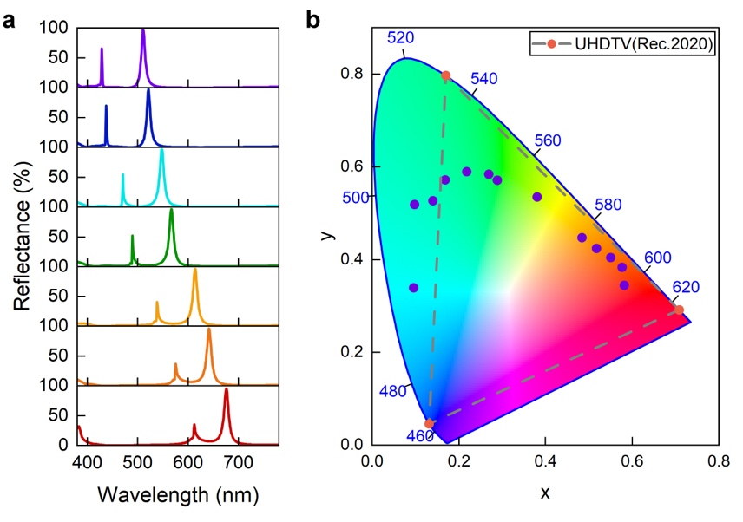
Fig. S4. Numerical simulation of the Schrödinger colour structure with y-polarized incident light. (a) Simulated reflection spectra of different metasurfaces. All parameters are the same as those in Fig. 2. (b) Corresponding colour coordinates in the CIE 1931 chromaticity diagram. The dashed triangle represents Rec. 2020 for UHDTV.

In the main text, we have shown the structural colours under the illumination of x-polarized white light. As mentioned above, the ellipse shaped cross section separates the resonances with x- and y- polarizations to different wavelengths. In this sense, the same metasurfaces in Fig. 2 of the main text shall produce quite different reflection spectra and colours. Here we show the detailed numerical results of the y-polarization. All the results are summarized in Fig. S4. It is obvious that the y-polarized spectra also have two resonances that shift to longer wavelength as the increase of scaling parameter. The background reflection at non-resonant wavelength is well suppressed too. Here the wavelength difference between peaks is around 70 nm. Then two peaks correspond to two different colours and thus spoil the overall colour performance. This can be seen from the colour coordinates in CIE 1931 chromaticity diagram. The corresponding colour gamut is smaller than Rec. 2020 for UHDTV.

- Polarization controlled tunable colour
As shown in Figs. S3 and S4, x-polarized and y-polarized resonances have quite different colours. For a fixed linear polarization, e.g. x-polarization, the rotation of nanostructure shall also induce the colour transition. This provides a different approach to control the colours. Here we numerically simulated the reflection spectrum as the ellipses rotated from perpendicular to parallel with respect to the x-direction. As the nanopillar orientation angle changes, the two pairs of reflectance peaks gradually shift, allowing for the mixing of x-polarization and y-polarization colours in different ratio and the change of colour presentation. For a fixed period of p = 381 nm, the reflection peaks vary with the orientation angle, as shown in Fig. S5(a). This process corresponds to a continuous colour change from green to yellow, as shown in the CIE 1931 map (Fig. S5(b)). Similar colour transition also holds true for the other colours.
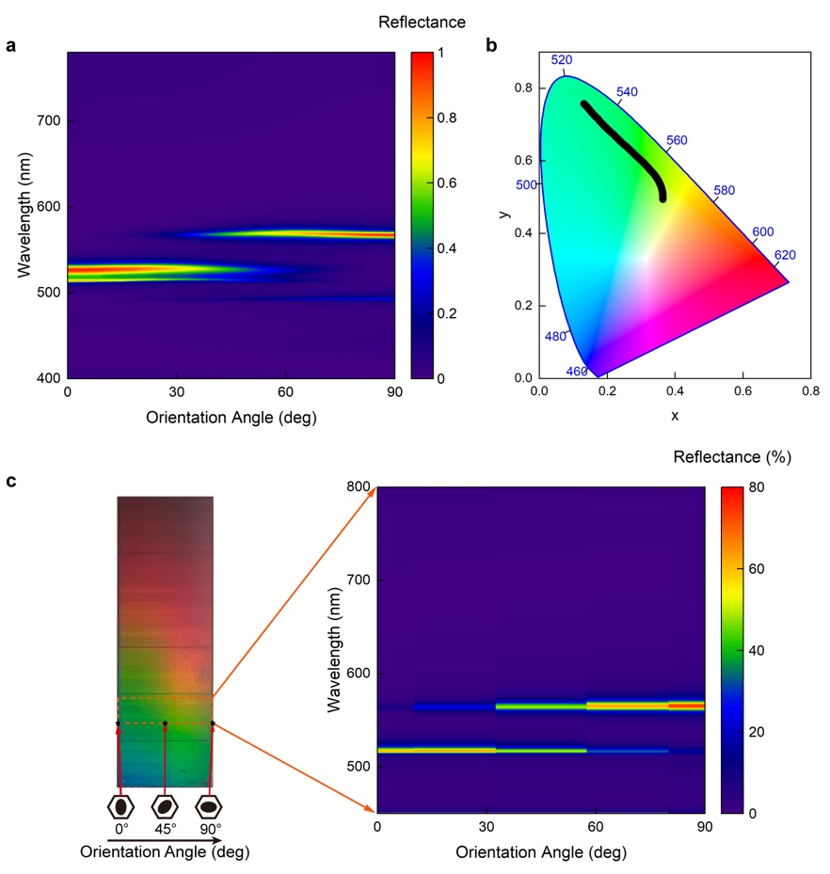
Fig. S5. Structural colour performance versus orientation angles. (a) Numerical simulation of the reflection spectrum as the orientation angle increases from 0° (with the major axis of the ellipse perpendicular to the x-axis) to 90° (with the major axis parallel to the x-axis). (b) The corresponding colour coordinates in CIE 1931 chromaticity diagram. (c) Optical micrograph of the sample with the orientation angle increasing in the x-direction and the S parameters continuously increasing in the y-direction (left), along with the measured reflection spectrum at the S = 1 part (dashed- line region) under different orientation angles (right).
Based on the above results, we prepared a rainbow sample in the experiment. In the horizontal direction, the orientation of nanopillars increase from 0° to 90°. In the vertical direction, the scaling parameter changes from 0.9 to 1.2, as shown in the left part of Fig. S5(c). Since both parameters relate to the colour presentation, obvious rainbow colours can be seen in both directions. In the region where S = 1 (indicated by the dashed line in Fig. S5(c) left), the reflection spectrum measured in areas with different orientation angles is shown in the right part of Fig. S5(c), where the experimental results show good consistence with the simulation. Such a rainbow colour is essential for many important applications such as optical sensing and detection.

- Mechanism for brightness control
In additional to the extremely large colour gamut, we pointed out in the main text that the DIRECT manipulation of colour brightness is also critical. In literatures, similar function is typically realized with the assistance of an external polarizer. In other words, the metasurface produce a refraction/transmission with cross-polarization for the generation of structural colours. By tuning the angle of polarizer, the brightness of colours can of course be tuned. This approach, however, is incompatible for real applications that no additional polarizer can be applied.

In order to realize the direct brightness control, we started to consider the local perturbation and high order diffractions. For the case in Fig. 1 of the main text, each unit cell is a small hexagon with a fixed lattice size. Following the theory of grating, we know that no higher order diffraction can happen and thus almost all the incident light at resonant wavelength is reflected. The situation becomes different when a local perturbation is introduced to one nanopillar. As depicted in Fig. S6(a), now the hexagon-shaped unit cell changes to a rectangle supercell. Due to the increase of lattice size, higher order diffraction occurs and takes away some energy. Then we know the reflectance can be tuned. The control of reflection and colour brightness have been discussed in Fig. 2(c) and (d) of the main text. Here we provide the detailed information to illustrate such kind of diffraction beams. As shown in Fig. S6(b) and (c), when Δr is 0, the hexagonal lattice doesn’t support higher-order diffraction; both transmission and reflection of the 1st-order diffraction are 0. When it is transformed into a rectangle supercell, as Δr increases, the energy of the 1st-order diffraction gradually increases. Correspondingly, the 0th-order reflection decreases in Fig. S6(d), and the corresponding brightness of structural colour is reduced.
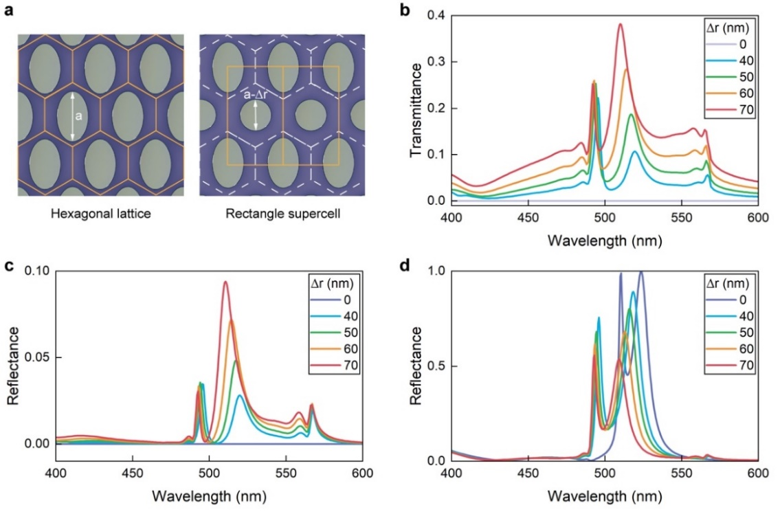
Fig. S6. Mechanism of structural colour brightness variation. (a) lattice diagram. (b, c) The simulated 1st-order transmission and reflection spectra of different Δr. (d) The simulated 0th-order reflection spectra of different Δr.
- Fabrication process of the metasurface
The metasurfaces were fabricated using electron beam lithography followed by a lift-off process. First, multi-dielectric layer of SiO₂ (54 nm) -Si₃N₄ (256 nm) - SiO₂ (110 nm) were deposited on a 13 nm ITO-coated glass substrate using plasma-enhanced chemical vapor deposition (PECVD). Next, a 120 nm PMMA film was spin-coated onto the dielectric layers, and the substrate was baked at 180 °C for 15 minutes. The PMMA resist was then exposed to the electron beam (Raith EBPG 5200Plus) and developed in a MIBK/IPA solution for 30 seconds to form the PMMA nanostructures. Afterward, the sample was transferred to an E-beam evaporator, where it was coated with a 25 nm Cr film. The samples were soaked in Remover PG for 8 hours, heated at 80 °C for 2 hours, and the PMMA resist was completely removed, leaving only the patterned Cr nanostructures. Subsequently, a two-step etching process for SiO₂ and Si₃N₄ was carried out using ICP-RIE (Oxford Plasmalab System 100). The top SiO₂ layer was etched with a mixture of CHF₃ (25 sccm) and Ar (30 sccm), followed by etching of the Si₃N₄ layer with O₂ (4 sccm) and CHF₃ (37 sccm). Finally, the sample was immersed in chromium etchant for 10 minutes, resulting in SiO₂-Si₃N₄ stacked metasurfaces.
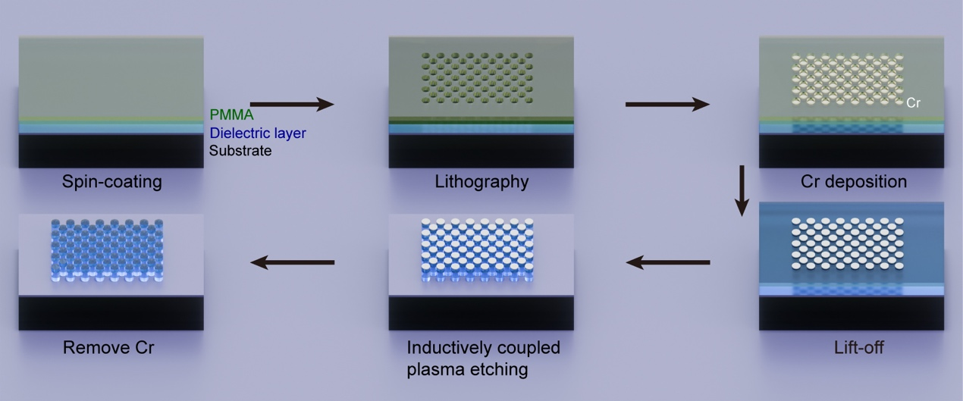
Fig. S7. The schematic of the fabrication process for SiO₂-Si₃N₄ stacked nanopillar.

- Optical measurements
In the main text, we have mentioned that the background reflection at non-resonant spectral range has been dramatically suppressed to be below 1%. Here we show some experimental proofs. The results are summarized in Fig. S8, where the reflection spectra are plotted in logs-scale. The dashed horizontal line represents the reflection of 1%. Taking the green line as an example, the background reflection is well below 1% from around 430 nm to 750 nm. The other two curves show a similar trend. This is a direct proof that our stacked metasurface can function as both of a reflection (at resonant wavelengths) and a broadband anti-reflection coating. This is the fundamentals for the generation of high-performance of Schrödinger colours.
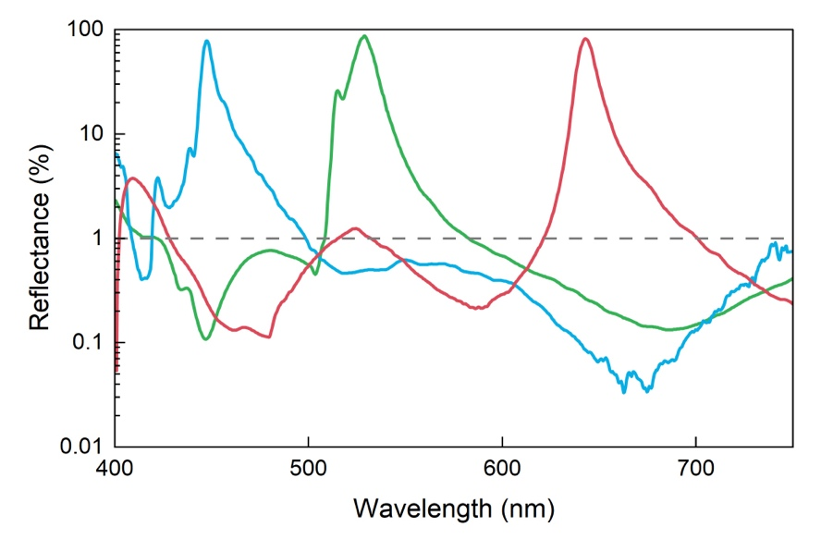
Fig. S8. Experimental reflection spectra of Schrödinger colour structure under the log coordinate axis.

- Direct comparison of different structural colour technologies
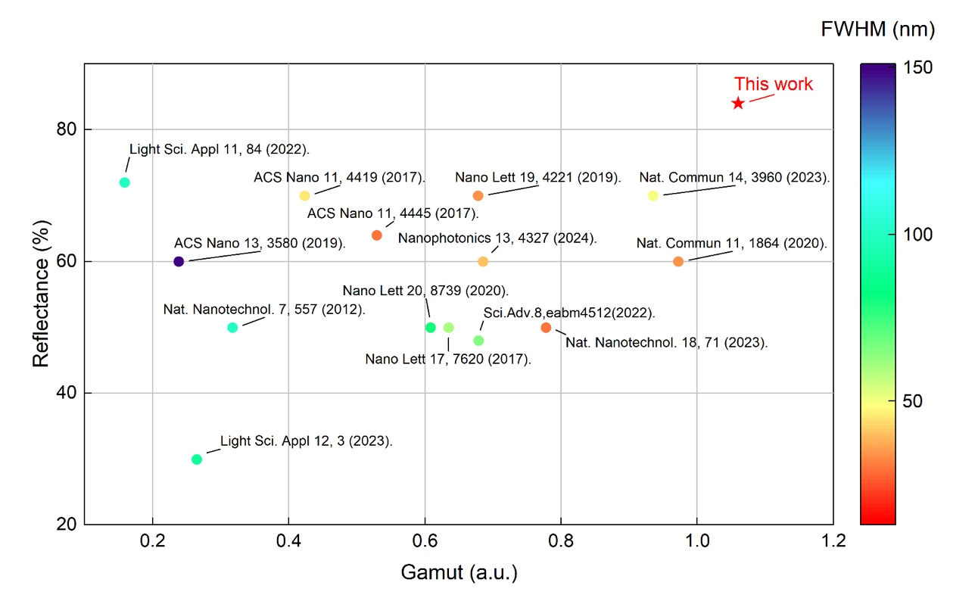
Fig. S9. The direct comparison of different structural colour technologies. Circles represent data from the references, while the star represent the experimental results of this work. The x-axis takes the area of the UHDTV(Rec.2020) colour gamut as 1. Note that # Sci. Adv. 8, eabm4512 (2022) only red experiments and green simulation are available. To calculate the possible colour gamut area, set the blue CIE coordinates to (0.15, 0.06), and only take the average reflectance as the average of red and green.

In the main text, we have mentioned that our Schrödinger colours can produce record-breaking colour gamut and average reflectance. Here we show the detailed information by directly comparing with a series of benchmark literatures. The results are summarized in Fig. S9. It is clear that our result is the first one that has a colour gamut larger than Rec.2020, a standard for UHDTV. All the others are smaller than Rec.2020. Meanwhile, as the metasurfaces are constructed with transparent materials, the reflectance in experiment is also much higher than the previously reported ones that are fabricated with absorptive materials such as Si or plasmonic materials.

- All-dielectric Schrödinger colours rainbow palette
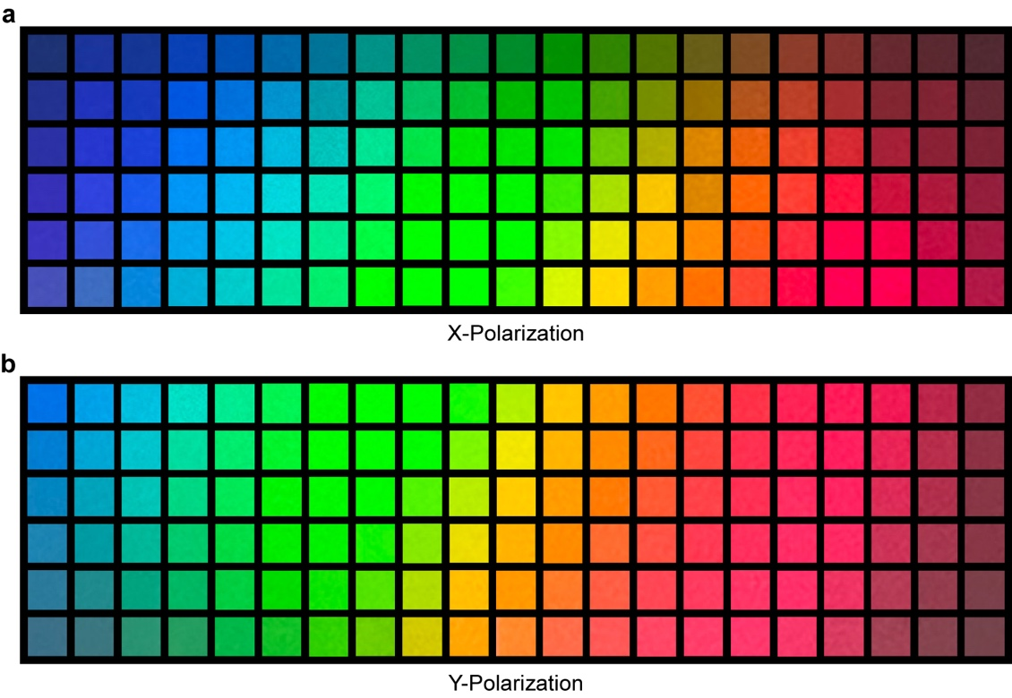
Fig. S10. Experimentally recorded colour palettes. In the x direction, the period p gradually increases from 312 nm to 485 nm, and in the y direction, both the major axis a and minor axis b of the ellipse gradually decrease by dr (dr = 4 nm). Panels (a) and (b) show bright-field microscope images of 126 SiO₂-Si₃N₄ stacked metasurfaces under x-polarized and y-polarized incident light, respectively.

To illustrate the university of our mechanism, we have fabricated 126 samples with different colours. All these samples are recorded under a bright field microscope and the results are summarized in Fig. S10. With the increase of scaling parameters, we can see that the structural colours can change gradually from blue to red, covering the entire visible spectrum. Similar trend has been observed from both x-polarization and y-polarization. The difference between two polarization lies in the exact colours. Y-polarized colours are closer to the red side (longer wavelength).

- Experimentally recorded y-polarized Schrödinger colours
In the main manuscript, we experimentally recorded the reflection spectra of the metasurfaces with x-polarized incident light. Here, we present the reflection spectra of the metasurfaces with y-polarized incident light, as shown in Fig. S11(a), along with the corresponding colours shown in Fig. S11(b). One important information should be noted here that the experimentally recorded colour gamut of y-polarization is actually larger than the one in simulation. This is because the short-wavelength y-polarized resonance is very narrow and too sensitive to the structural parameters. Due to the inevitable nanofabrication deviations and surface roughness, the high-Q resonance cannot be experimentally achieved, and thus the colour purity and colour gamut are significantly improved.
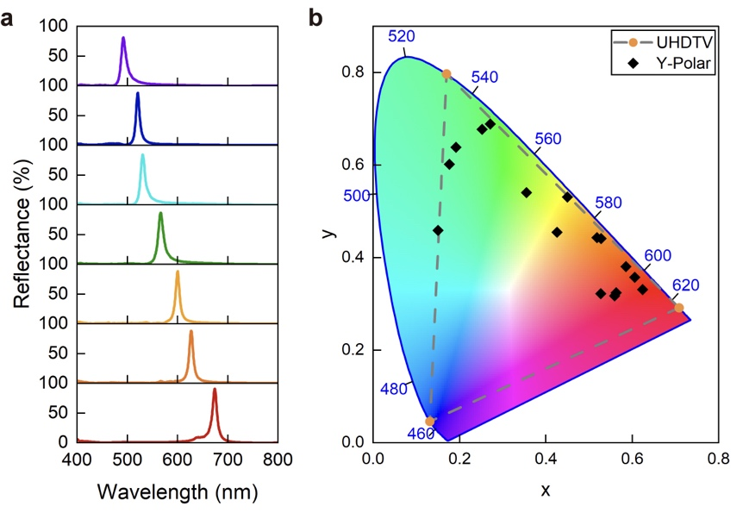
Fig. S11. Experiment demonstrations of Schrödinger colour structure under y-polarized incident light. (a) Experimentally recorded reflection spectra of different metasurfaces. (b) The corresponding colour coordinates in CIE 1931 chromaticity diagram. The dashed triangle represents Rec. 2020 for UHDTV.

- Optical characterization of pixel arrays
Pixel size is also an important indicator for structural colour. In Fig. S12(a), we show the bright-field microscopic images of blue, green, and red pixel array samples as the pixel size increases continuously from 3 μm to 8 μm. It can be seen from the figure that at 3 μm, this sample has already shown good colour effects, and as the pixel size increases, the colour gradually approaches the ideal effect. The corresponding reflection spectra of the samples are shown in Fig. S12(b), where the samples show sharp resonance peaks and good suppression of reflection at non-resonant wavelengths under different pixel sizes.
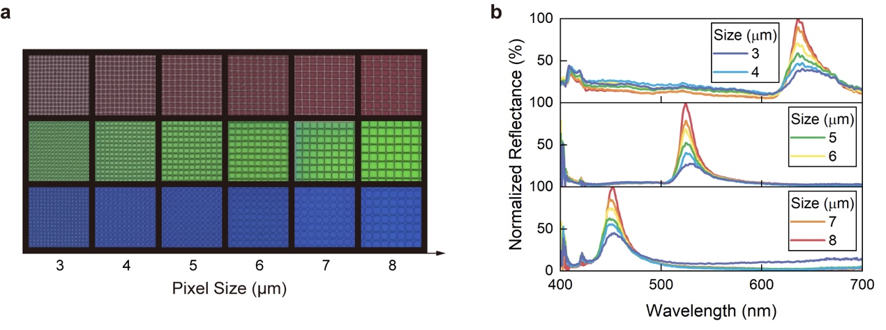
Fig. S12. Optical characterization of metasurfaces with different pixel sizes. (a) Pixel size ranges from 3 to 8 μm, RGB pixel samples under bright field microscope images. (b) reflection spectrum of the metasurfaces with varying pixel sizes.

