Supplementary Material for

Direct Joule-Heated Synthesis Enables High Performing Bulk Thermoelectrics

Chenguang Zhang¹*, Jose Recatala-Gomez¹*#, Zainul Aabdin²*, Yi Jiang³*, Luyang Jiang¹, Sze Yu Tan², Hong Liu^{4,5}, Yuting Qian^{4,5,6}, Coryl Jing Jun Lee², Sabrine Hachmioune⁷, Vaishali Taneja⁸, Anqi Sng², Pawan Kumar², Haiwen Dai¹, Zhiqian Lin¹, Weng Weei Tjiu², Fengxia Wei², Qianhong She^{4,5}, D. V. Maheswar Repaka^{2#}, David Scanlon⁹, Kanishka Biswas⁸, Yee Kan Koh^{2#}, Kedar Hippalgaonkar^{1,2#}

*These authors contributed equally to this work
#Corresponding author. Email: kedar@ntu.edu.sg, joserecatala.gomez@ntu.edu.sg, repakadvm@imre.a-star.edu.sg, kohyeekan@nus.edu.sg

The file includes:

List of compounds prepared in this work
Extended benchmarking of the thermoelectric performance
Supplementary Section S1: Further details of DJS reactions
Supplementary Section S2: Elemental compensation of pristine AgSbTe₂
Supplementary Section S3: Detailed analysis of XRD and EBSD of AgSbTe₂ samples
Supplementary Section S4: Detailed analysis of TEM results
Supplementary Section S5: Detailed analysis of the thermoelectric transport
Supplementary Section S6: Repeatability of the thermoelectric properties
Supplementary Section S7: Complementary structural and microstructure analysis for Bi_{0.5}Sb_{1.5}Te₃.
Supplementary Section S8: First principles electron bandstructure and phonon calculations and detailed analysis of electronic transport
Supplementary Section S9: Further TDTR Measurements and Boundary determination of thermal mapping.
Figures S1 to S44
Tables S1 to S8
Captions for Movie S1

Other Supplementary Materials for this manuscript include the following:

Movies S1

List of compositions prepared in this work

The density of the samples was measured using the Archimedes method. Theoretical density of AgSbTe₂ is 7.16 g cm⁻³.

Table S1. Measured density of synthesized samples.
Composition | Density (g cm⁻³) | Relative Percentage
AgSbTe₂ | 7.08 | 98.9
AgSb_{1.03}Te_{2.03} | 6.96 | 97.2
AgSb_{1.05}Te_{2.05} | 7.05 | 98.6
AgSb_{1.05}Te_{2.06} | 7.05 | 98.6
AgSb_{1.04}Cd_{0.01}Te_{2.06} | 7.02 | 98.1
AgSb_{1.03}Cd_{0.02}Te_{2.06} | 7.03 | 98.3
AgSb_{1.01}Cd_{0.04}Te_{2.06} | 7.02 | 98.3
AgSb_{0.99}Cd_{0.06}Te_{2.06} | 7.01 | 98.2
AgSb_{1.01}Cd_{0.04}Te_{2.01}Se_{0.05} | 6.95 | 97.6
AgSb_{1.01}Cd_{0.04}Te_{1.96}Se_{0.10} | 6.98 | 98.2
AgSb_{1.01}Cd_{0.04}Te_{1.91}Se_{0.15} | 6.90 | 97.0
AgSb_{1.01}Cd_{0.04}Te_{1.86}Se_{0.20} | 6.88 | 97.3
AgSb_{1.01}Cd_{0.04}Te_{1.81}Se_{0.25} | 6.78 | 96.0

Extended benchmarking of the thermoelectric performance

Table S2. Comparison of synthesis time and thermoelectric performance of DJS samples with respect to other AgSbTe₂ samples.
Reference | Nominal Composition | Synthesis | Max zT
(5) | AgSb_{0.94}Cd_{0.06}Te₂ | Furnace synthesis~2760 min | ~2.6 @ 573K
(6) | AgSb_{0.96}Yb_{0.04}Te₂ | Furnace synthesis~2760 min | ~2.4 @ 573K
(7) | AgSb_{0.96}Hg_{0.04}Te₂ | Furnace synthesis ~2760 min | ~2.4 @ 570K
(8) | AgSb_{0.97}Mg_{0.03}Te_{1.95}S_{0.05} | Furnace synthesis ~3480 min | ~1.96 @ 600K
(9) | (AgSbTe₂)_{0.98}(AgAlSe₂)_{0.02} | Furnace synthesis ~2970 min + hot press 50 min | ~1.9 @ 623K
(10) | AgSbTe_{1.85}Se_{0.1}S_{0.05} | Furnace synthesis ~1320 min + SPS 2 min | ~2.3 @ 673K
(11) | AgSbTe_{1.85}Se_{0.15} | Furnace synthesis ~5280 min + BM 10mins + SPS 5 min | ~2.0 @ 573K
(12) | AgSb_{0.98}Ce_{0.02}Te₂ | Furnace synthesis ~600 min + Hot Press 20 min | ~1.59 @ 673K
(13) | AgSb_{0.96}Mg_{0.02}Ti_{0.02}Te₂ | Furnace synthesis ~2760 min + SPS 5 min | 1.45 @ 523K
(14) | AgSb_{0.97}Ca_{0.03}Te₂ | Furnace synthesis ~6300 min | 1.17 @ 623K
(15) | AgSb_{0.93}In_{0.07}Te₂ | Furnace synthesis ~9840 min | 1.35 @ 650K
(16) | AgMnSbTe₃ | Furnace synthesis ~1440 min | ~1.46 @ 823K
(17) | AgSbTe₂ | Furnace synthesis ~1216 min +SPS 5 mins | 1.15 @ 623K
(18) | AgSb_{0.94}Sn_{0.06}Te₂ | Furnace synthesis 1320 min + SPS 2 min | 2.5 @ 673 K
This work | Se co-doped AgSb_{1.01}Cd_{0.04}Te_{1.86}Se_{0.20} | BM 400 mins + DJS synthesis ~ 2 mins | ~2.3 @ 573K

Supplementary Section S1: Further details of DJS reactions

The preparation of a DJS sample is shown in Fig. S1. A puncher is typically used to ensure a good size match between the carbon felt disks and the internal diameter of the tube. Through trial-and-error, we found that for 3 grams of undoped or doped AgSbTe₂ precursor powder, 8 carbon felt disks per side results in a smooth reaction when an 8 mm diameter quartz tube is used. There are four distinct steps in a typical DJS synthesis, shown in Fig. S2. The synthesis proceeds as such. At the start, the current flows through the carbon felt and passes directly through the powder. Consequently, Joule heating is generated due to the contact resistance arising between the powder and the carbon felt disk directly in contact with it (Fig. S2A). As time increases, there is an increase in resistance with constant current (Fig. S2B). As time increases, the temperature of the sample increases and melt the loaded powder (Fig. S2B). Once the melt has been completed (Fig. S2C), the current is stopped, and the system is left to cool down to ambient temperature (Fig. S2D).

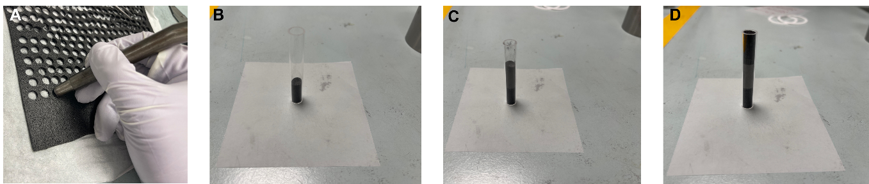
Fig. S1. Stepwise procedure for preparing DJS samples. (A) Carbon felt are cut using a puncher, thus ensuring a perfect size match between the carbon felt disks and the quartz tube. Then, they are introduced in the quartz tube forming a “carbon felt column” (B). Afterward, the powder that will undergo DJS reaction is introduced (C). Finally, the rest of the carbon felt disks are introduced (D). To ensure a smooth reaction, the whole tube must be filled with the carbon felt column – powder – carbon felt column.

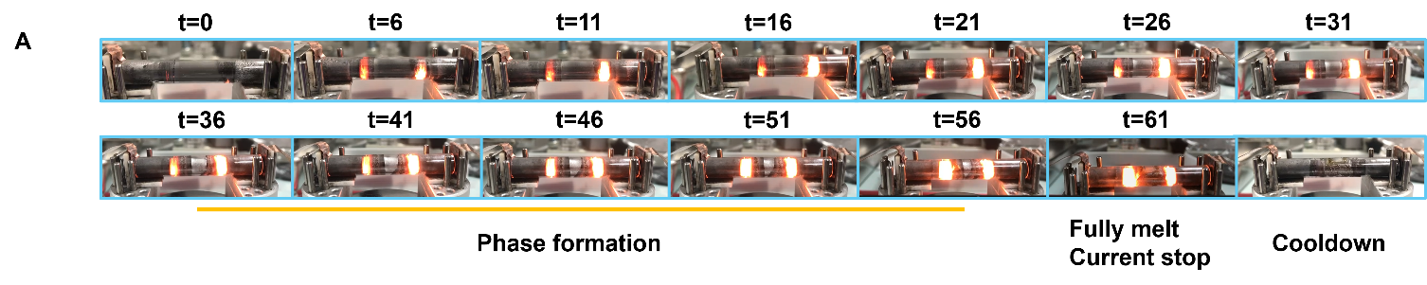
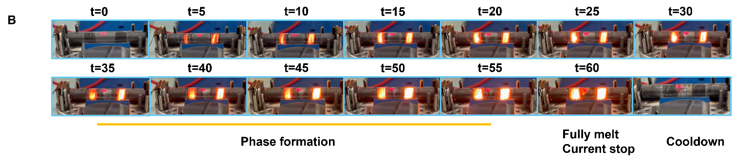
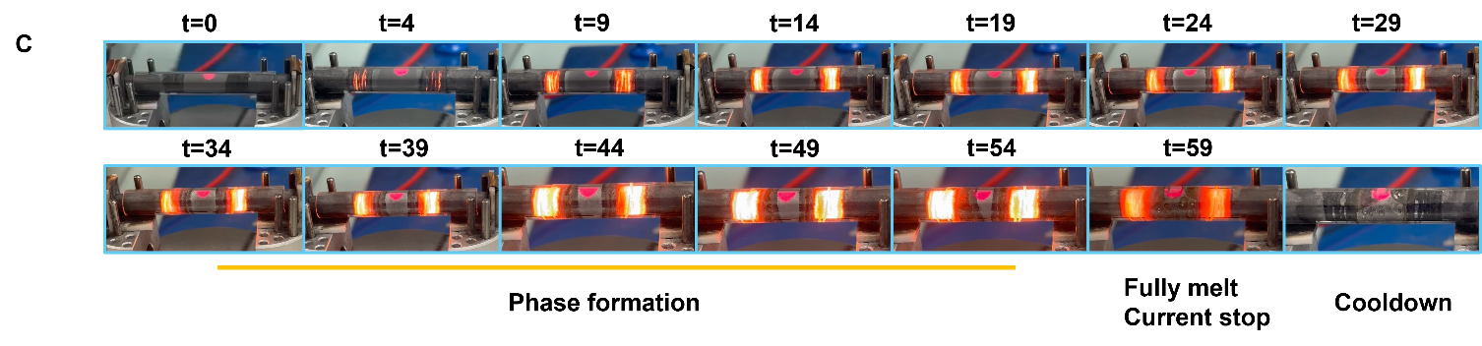
Fig S2. Repeatability of DJS synthesis of AgSbTe₂ compounds.

Supplementary Section S2: Elemental compensation of pristine AgSbTe₂
Compensation for samples was conducted to account for losses during DJS reaction. Initially, we conducted ICP-OES to accurately determine the concentration of Ag, Sb, Cd, Te and Se in the as-synthesized pellets. Numbers in brackets indicate the error. The standard deviation of ICP-OES is ±0.002. All numbers were normalized to Ag.

 | Table S3. Determination of the concentration of Ag and its ratios with respect to Sb, Te, Cd and Se. Ratios were calculated with respect to Ag because its concentration was normalized to 1.
Composition |  | Ag | Sb/Ag | Te/Ag | Te/Sb | Cd/Ag | Se/Ag
AgSbTe₂ |  | 1 | 0.98(2) | 1.88(6) | 1.92(0)
AgSb_{1.03}Te_{2.03} |  | 1 | 1.01(1) | 1.94(6) | 1.92(5) | - | -
AgSb_{1.05}Te_{2.05} |  | 1 | 1.08(2) | 2.03(9) | 1.88(4) | - | -
AgSb_{1.05}Te_{2.06} |  | 1 | 1.06(1) | 2.01(0) | 1.89(4) | - | -
AgSb_{1.04}Cd_{0.01}Te_{2.06} |  | 1 | 1.00(7) | 1.94(7) | 1.93(3) | 0.011(2) | -
AgSb_{1.03}Cd_{0.02}Te_{2.06} |  | 1 | 1.01(3) | 1.96(9) | 1.94(3) | 0.021(7) | -
AgSb_{1.01}Cd_{0.04}Te_{2.06} |  | 1 | 1.00(2) | 1.96(7) | 1.96(1) | 0.047(7) | -
AgSb_{0.99}Cd_{0.06}Te_{2.06} |  | 1 | 1.00(4) | 1.98(8) | 1.98(0) | 0.065(0) | -
AgSb_{1.01}Cd_{0.04}Te_{2.01}Se_{0.05} |  | 1 | 0.98(9) | 1.98(5) | 2.00(7) | 0.035(1) | 0.043(1)
AgSb_{1.01}Cd_{0.04}Te_{1.96}Se_{0.1} |  | 1 | 1.02(2) | 1.99(8) | 1.95(5) | 0.046(7) | 0.116(4)
AgSb_{1.01}Cd_{0.04}Te_{1.91}Se_{0.15} |  | 1 | 1.03(0) | 1.98(8) | 1.92(9) | 0.045(3) | 0.170(6)
AgSb_{1.01}Cd_{0.04}Te_{1.86}Se_{0.2} |  | 1 | 1.08(2) | 2.02(8) | 1.87(4) | 0.040(7) | 0.202(7)

Supplementary Section S3: Detailed analysis of XRD and EBSD of AgSbTe₂ samples

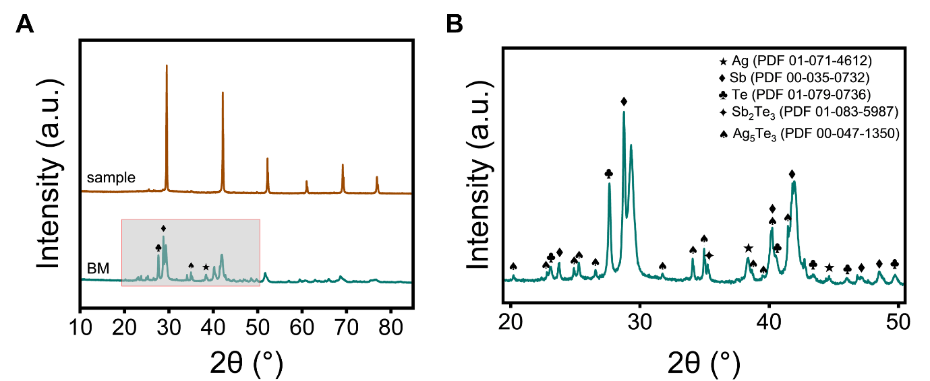
Fig. S3. Structural evolution of AgSbTe₂ in DJS. Unindexed peaks represent cubic phase AgSbTe₂. (A) Phase evolution over time in DJS; (B) Indexed impurity of ball milling precursor in zoom-in figure from 2θ of 20°- 50°.

The structure of Cd-doped AgSb_{1.01}Cd_{0.04}Te_{2.06} samples is investigated using XRD. For concentrations of CdTe below 4 mol %, we observe a linear decrease in the lattice parameter, indicating that Cd occupies lattice sites. The lattice parameter remains constant for values equal or greater than 4 mol % CdTe, which indicates that Cd no longer occupies lattice sites and precipitates out. This is clearly observed in both TEM analysis (Fig. 3) and SEM-EDX analysis (Fig. S9) where CdTe precipitates are observed.

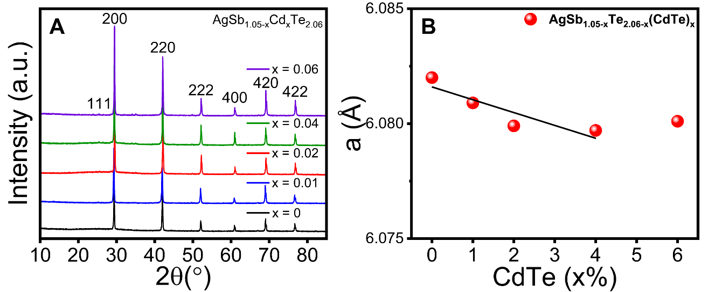
Fig S4. (A) Room temperature powder X-ray diffraction pattern for Cd-doped AgSb_{1.01}Cd_{0.04}Te_{2.06} and (B) Rietveld refined lattice parameter vs. mol % dopant.

The structure of Se co-doped AgSb_{1.01}Cd_{0.04}Te_{2.06-y}Se_{y} samples is investigated using XRD and the results are shown in Fig. S5. As Se content increases, we observe a monotonic displacement of the diffraction peaks towards higher 2θ (Fig. S6A), corresponding to a shrinkage of the unit cell, indicating that Se (198 picometers) is replacing Te (221 picometers). This is further corroborated by plotting the refined lattice parameter vs. the Se mol % (Fig. S5B). We observe a linear decrease in the lattice parameter as the Se mol % increases, following Vegard’s Law, and indicating that indeed all Se occupies Te lattice sites in rocksalt AgSbTe₂.

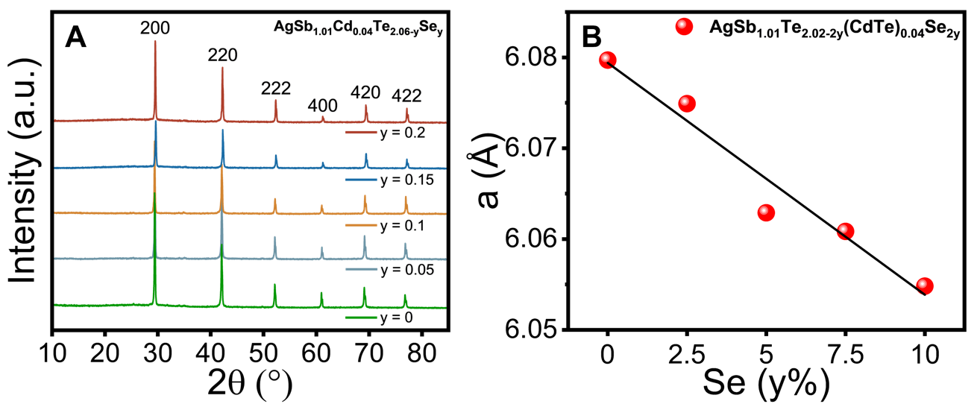
Fig. S5. (A) Room temperature powder X-ray diffraction patterns for Se co-doped AgSb_{1.01}Cd_{0.04}Te_{2.06-y}Se_{y} (y=0.05, 0.1, 0.15, 0.2). (B) Rietveld refined lattice parameter vs. mol % dopant.

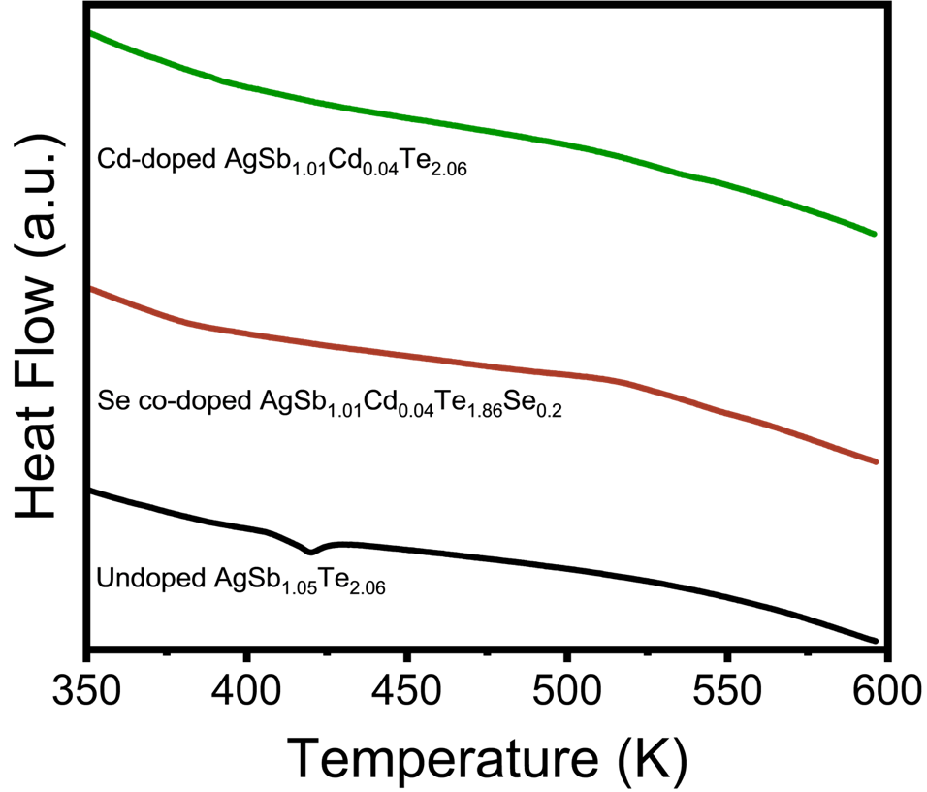
Fig. S6. Differential scanning calorimetry (DSC) measurements of undoped AgSb_{1.05}Te_{2.06}, Cd-doped AgSb_{1.01}Cd_{0.04}Te_{2.06} and Se co-doped AgSb_{1.01}Cd_{0.04}Te_{1.86}Se_{0.20}.

Fig. S6 shows the DSC curves for undoped AgSb_{1.05}Te_{2.06}, Cd-doped AgSb_{1.01}Cd_{0.04}Te_{2.06} and Se co-doped AgSb_{1.01}Cd_{0.04}Te_{1.86}Se_{0.20}. The small peak at ~420 K in the DSC curve for undoped AgSb_{1.05}Te_{2.06} is attributed to the Ag₂Te phase transition from monoclinic to cubic. No peak was observed in other samples, indicating that Ag-Te binary precipitates were suppressed.

Optical measurements show a bandgap increase for Cd-doped AgSb_{1.01}Cd_{0.04}Te_{2.06} and Se co-doped AgSb_{1.01}Cd_{0.04}Te_{1.86}Se_{0.2} from 0.13 eV to 0.30 eV (Fig. S7). Surprisingly, the bandgap almost does not change from Cd-doped AgSb_{1.01}Cd_{0.04}Te_{2.06} to Se co-doped AgSb_{1.01}Cd_{0.04}Te_{1.86}Se_{0.20}. A possible explanation for bandgap saturation after doping 4 mol % CdTe is Fermi level pinning due to dopant states. At high doping concentration, the formation of inactive clusters traps free carriers, leading to Fermi level pinning in n-type Si.(19) In Cu-doped CdTe, the Fermi energy is eventually pinned when equal amounts of substitutional Cu and interstitial Cu are formed.(20) SEM-EDX maps (Fig. S9) show formation of clusters in Cd-doped samples, which could cause Fermi level pinning in our samples.

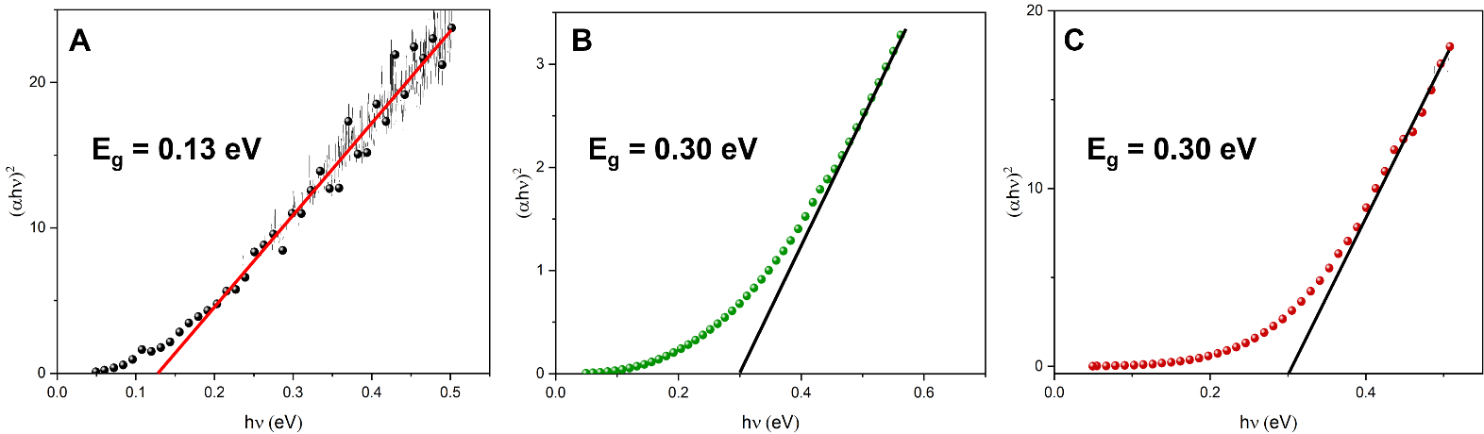
Fig. S7. Bandgap (E_{g}) estimation from Tauc plots of (A) undoped AgSb_{1.05}Te_{2.06} (B) Cd-doped AgSb_{1.01}Cd_{0.04}Te_{2.06} and (C) Se co-doped AgSb_{1.01}Cd_{0.04}Te_{1.86}Se_{0.20}. Values of the gap are given as labels within the panels.

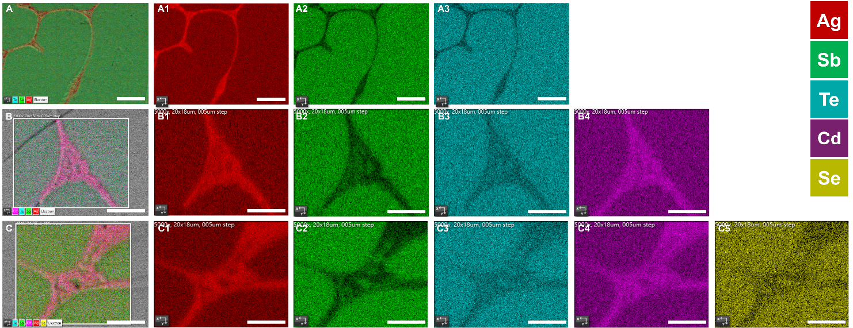
Fig. S8. EDX mappings corresponding to the EBSD data in the main text (A) undoped AgSb_{1.05}Te_{2.06}, (B) Cd-doped AgSb_{1.01}Cd_{0.04}Te_{2.06}, (C) Se co-doped AgSb_{1.01}Cd_{0.04}Te_{1.86}Se_{0.2}. Scale bar is 10μm.

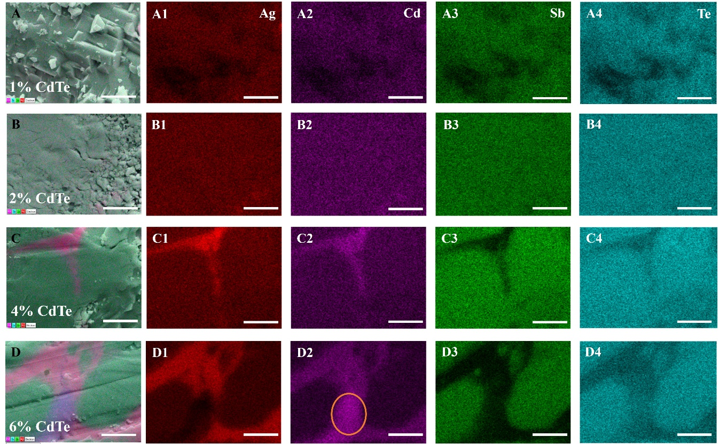
Fig.S9. SEM-EDX mapping of Cd-doped AgSb_{1.05-x}Cd_{x}Te_{2.06}. (A) 1 mol % CdTe. (B) 2 mol % CdTe. (C) 4 mol % CdTe. (D) 6 mol % CdTe. The orange circle in D1 indicates an area in which a precipitated of CdTe is found. The sale bar is 5μm.

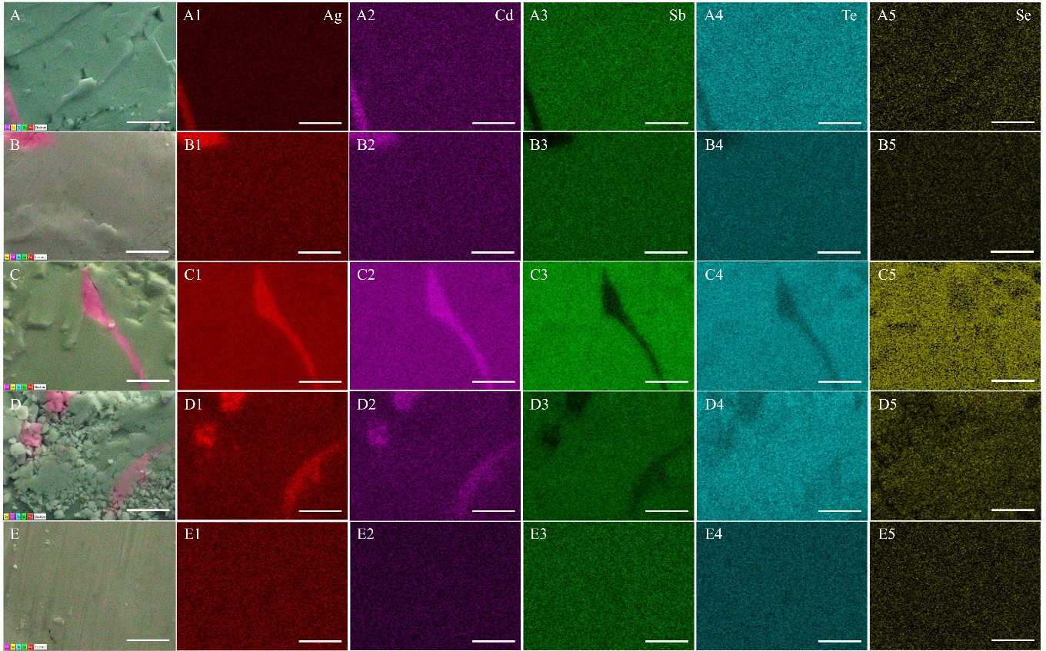
Fig. S10. SEM EDX mapping of Se co-doped AgSb_{1.01}Cd_{0.04}Te_{2.06-y}Se_{y}. A to E represents y=0.05, 0.1, 0.15, 0.2, 0.25, respectively. The scale bar is 5 μm.

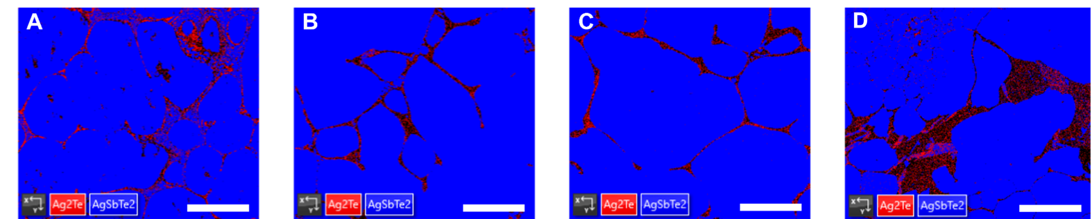
Fig. S11. EBSD images used to calculate phase fractions. A - D represents undoped AgSb_{1.05}Te_{2.06}, Cd-doped AgSb_{1.01}Cd_{0.04}Te_{2.06}, Se co-doped AgSb_{1.01}Cd_{0.04}Te_{1.86}Se_{0.2} and undoped AgSb_{1.05}Te_{2.06} (SPS), respectively. The scale bar is 25μm.

Table S4. EBSD phase fractions for selected samples. The phase fractions have been calculated from the images in Fig. S4 considering AgSbTe₂ () and Ag₂Te (P21/c) as present phases.
Composition | AgSbTe₂ Phase Fraction (%) | Ag₂Te Phase Fraction (%) | Zero solution (%)
Undoped AgSb_{1.05}Te_{2.06} | 90.75 | 5.24 | 4.02
Cd-doped AgSb_{1.01}Cd_{0.04}Te_{2.06} | 94.28 | 2.36 | 3.37
Se co-doped AgSb_{1.01}Cd_{0.04}Te_{1.86}Se_{0.2} | 94.88 | 2.32 | 2.80
Undoped AgSb_{1.05}Te_{2.06} (SPS) | 83.31 | 5.53 | 11.16

Table S5. EBSD phase fractions for selected samples. The phase fractions have been calculated from the images in Fig. S4 considering AgSbTe₂ (), Ag₂Te (P21/c) and Ag_{4.96}Te₃ () as present phases. The phase fractions of Ag-Te binary precipitates corresponding to Ag₂Te (P21/c) and Ag_{4.96}Te₃ () through EBSD are not possible because of the similarity between phases and presence of Ag-Te binary compounds with compositions in between Ag₂Te and Ag_{4.96}Te₃.

Composition | AgSbTe₂ Phase Fraction (%) | Ag₂Te Phase Fraction (%) | Ag_{4.96}Te₃ Phase Fraction (%) | Zero solution (%)
Undoped AgSb_{1.05}Te_{2.06} | 78.90 | 19.90 | 0.10 | 1.81
Cd-doped AgSb_{1.01}Cd_{0.04}Te_{2.06} | 92.2 | 2.57 | 0.09 | 5.22
Se co-doped AgSb_{1.01}Cd_{0.04}Te_{1.86}Se_{0.2} | 94.7 | 2.62 | 1.01 | 1.67
Undoped AgSb_{1.05}Te_{2.06} (SPS) | 89.7 | 6.33 | 0.99 | 2.98
Note 1: XRD results indicate that Ag_{4.96}Te₃ is only present in Cd-doped AgSb_{1.01}Cd_{0.04}Te_{2.06}, Se co-doped AgSb_{1.01}Cd_{0.04}Te_{1.86}Se_{0.2} and Undoped AgSb_{1.05}Te_{2.06} (SPS).
Note 2: XRD results indicate that no Ag₂Te is present in Se co-doped AgSb_{1.01}Cd_{0.04}Te_{1.86}Se_{0.2} and Undoped AgSb_{1.05}Te_{2.06} (SPS).

Table S6. Phase fraction for selected samples from Rietveld refinement. Data calculated from diffraction patterns shown in Fig. 2, Column 1.
Composition | AgSbTe₂ Phase Fraction (%) | Ag₂Te Phase Fraction (%) | Ag_{4.96}Te₃ Phase Fraction (%) | Sb₂Te₃ Phase Fraction (%)
Undoped AgSb_{1.05}Te_{2.06} | 91.40 | 8.60 | - | -
Cd-doped AgSb_{1.01}Cd_{0.04}Te_{2.06} | 92.19 | 2.92 | 4.89 | -
Se co-doped AgSb_{1.01}Cd_{0.04}Te_{1.86}Se_{0.2} | 94.29 | - | 5.71 | -
Undoped AgSb_{1.05}Te_{2.06} (SPS) | 92.80 | - | 6.20 | 0.99

Supplementary Section S4: Detailed analysis of TEM results

TEM/STEM imaging, selected area electron diffraction (SAED) and STEM-EDX maps for undoped AgSb_{1.05}Te_{2.06}, Cd-doped AgSb_{1.01}Cd_{0.04}Te_{2.06} and Se co-doped AgSb_{1.01}Cd_{0.04}Te_{1.86}Se_{0.2} are conducted to for a complete picture of microstructures and defects, phase analysis and elemental distribution homogeneity in the DJS samples. The following table summarizes the series of analysis performed for each set of samples. HR-TEM images (S12-S14 and S21-S23) show information about the lattice and microstructure/defects/cation ordering, while STEM-HAADF images (S15, S17, S19) provide details about the large grains and ILs. The STEM-EDX images (S16, S18, S20) provide information about elemental homogeneity.

To confirm the crystallinity of the large grains, we acquired TEM images (Fig. 3D, 3K, 3R) and SAED (Fig. 3F, 3M, 3T) patterns. SAED patterns match rocksalt AgSbTe₂ structure for all three samples. High-resolution TEM images and corresponding SAEDs (Fig. 3E, 3L, 3S; Fig. S21) confirm single crystalline nature of large grains with diffraction indexing and lattice fringe spacing matching well with face-centered-cubic (FCC) AgSbTe₂ (, PDF 00-015-0540). Most of the reflections from the matrix match (FCC) AgSbTe₂, with some minority phases matching monoclinic Ag₂Te (P21/c, PDF 00-034-0142) in undoped AgSb_{1.05}Te_{2.06} and Cd-doped AgSb_{1.01}Cd_{0.04}Te_{2.06}.

To study in detail the phase/precipitate formation and obtain elemental quantification of the dopants, we performed STEM-EDX chemical mapping for all three samples (Fig. 3G, 3N, 3U). EDX maps of undoped AgSb_{1.01}Te_{2.06} (Fig. S16) show that the IL is mainly comprised by Ag₂Te precipitates, with Sb-rich precipitates at the IL-bulk interfaces. Surprisingly, the matrix of undoped AgSb_{1.05}Te_{2.06} is full of Ag₂Te nanoprecipitates (Fig. 3G, Fig. S16).

These Ag-Te binary precipitates likely introduce stress and defects in the large grains that explains the observed texture in TEM images (Fig. 3D), resembling polycrystallinity. However, SAED measurements confirm that the large grains are, in fact, monocrystalline (Fig. 3F). For the Cd-doped AgSb_{1.01}Cd_{0.04}Te_{2.06}, EDX mapping of the matrix (Fig. 3N, Fig. S17) shows a Cd-deficient (~1 at %) matrix, uniquely indexed to (FCC) AgSbTe₂. The IL of this sample is also comprised by Ag₂Te, although this time there is a minority phase corresponding to CdTe precipitates embedded in the Ag₂Te layer.

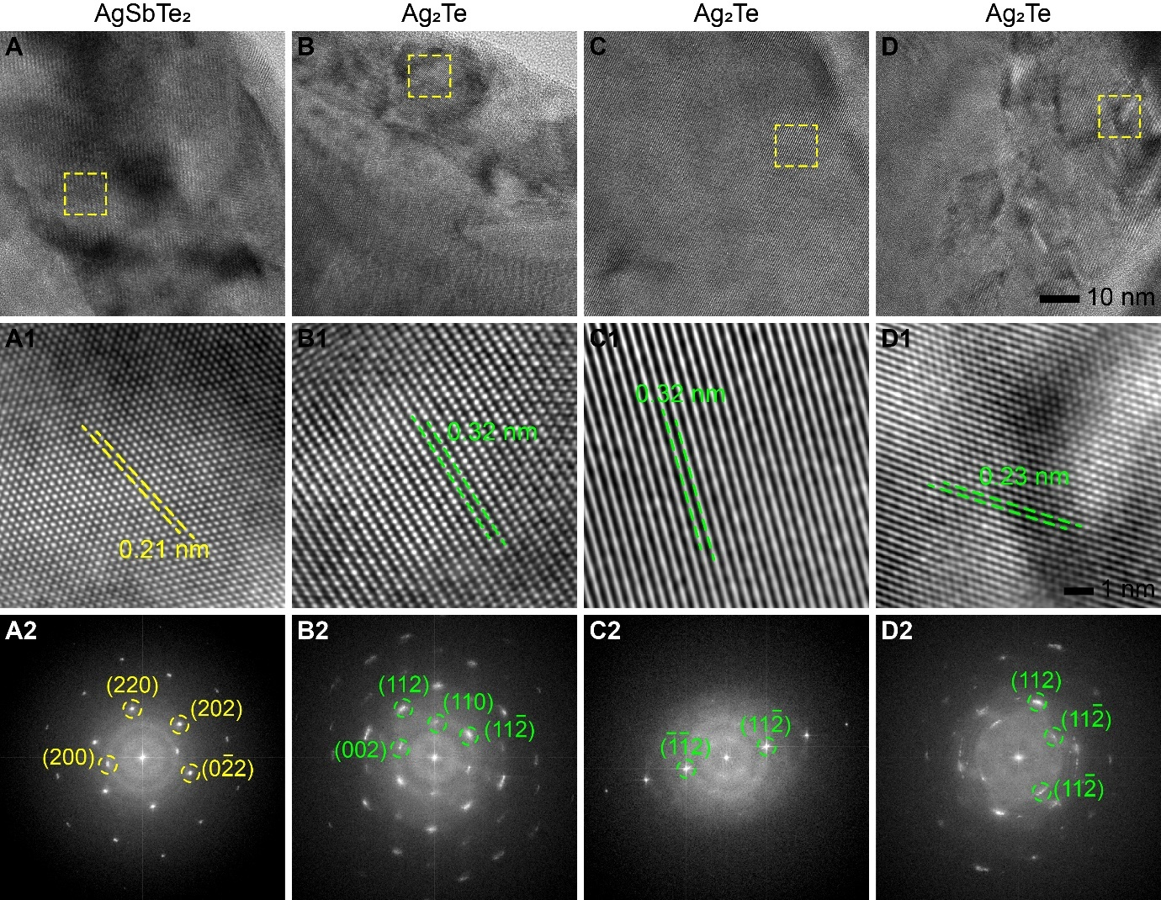
Fig. S12. High-resolution TEM (HR-TEM) imaging and phase identification for undoped AgSb_{1.05}Te_{2.06} sample. (A-D) HR-TEM images from four different areas. (A1-D1) Corresponding zoomed-in sections of the areas marked with dotted yellow rectangles in (A-D), showing lattice fringes and measured lattice fringe spacing indicated by dotted lines. (A2-D2) Corresponding Fast Fourier Transform (FFT) images. The indexed FFT confirms the presence of two phases: AgSbTe₂ and Ag₂Te. Detailed STEM imaging and STEM-EDX chemical mapping are provided in SI Fig. S15 and S16, respectively.

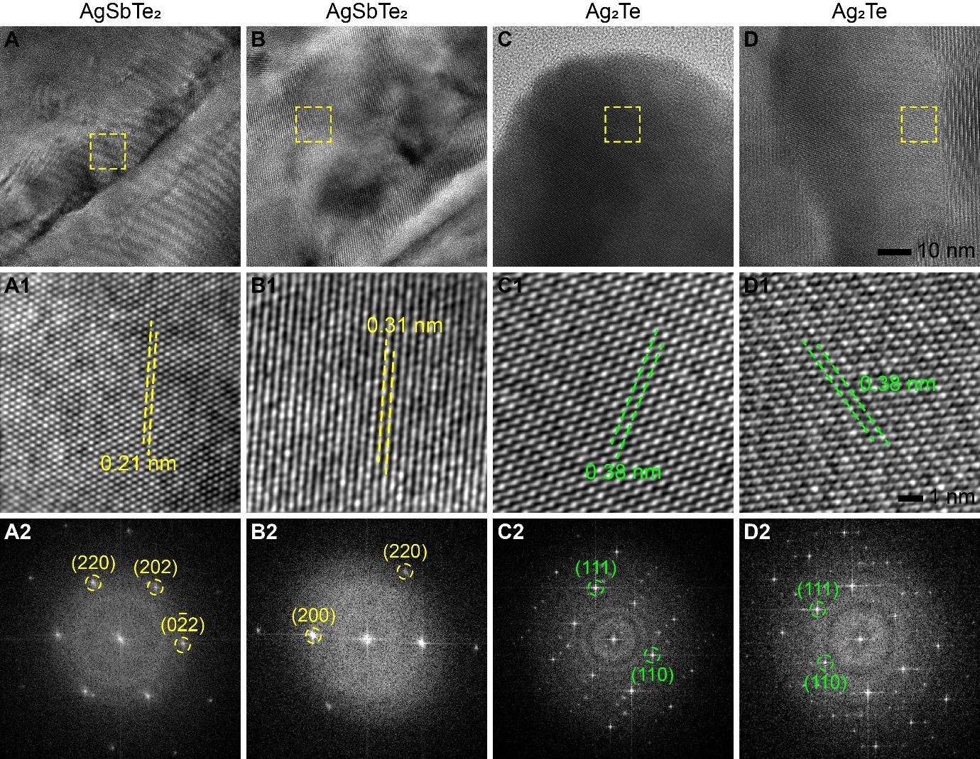
Fig. S13. High-resolution TEM (HR-TEM) imaging and phase identification for Cd-doped AgSb_{1.01}Cd_{0.04}Te_{2.06} sample. (A-D) HR-TEM images from four different areas. (A1-D1) Corresponding zoomed-in sections of the area marked with dotted yellow rectangles in (A-D), showing lattice fringes and measured lattice fringe spacing indicated by dotted lines. (A2-D2) Corresponding Fast Fourier Transform (FFT) images.The indexed FFT confirms the presence of two phases: AgSbTe₂ and Ag₂Te. Detailed STEM imaging and STEM-EDX chemical mapping are provided in SI Fig. S17 and S18, respectively.

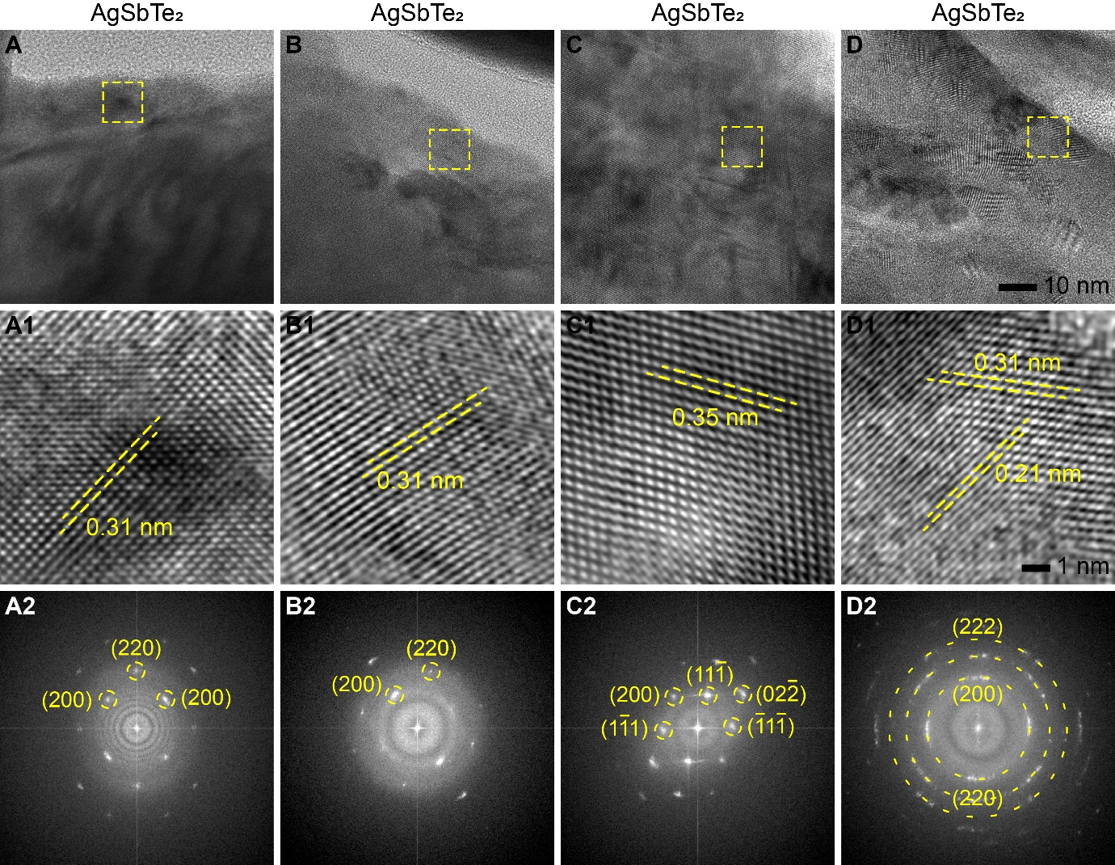
Fig. S14. High-resolution TEM (HR-TEM) imaging and phase identification for Se co-doped AgSb_{1.01}Cd_{0.04}Te_{1.86}Se_{0.2} sample. (A-D) HR-TEM images from four different areas. (A1-D1) Corresponding zoomed-in sections of the area marked with dotted yellow rectangles in (A-D), showing lattice fringes and measured lattice fringe spacing indicated by dotted lines. (A2-D2) Corresponding Fast Fourier Transform (FFT) of images. In this case, only the AgSbTe₂ phase was observed, with no evidence of the Ag₂Te phase. Detailed STEM imaging and STEM-EDX chemical mapping are provided in SI Fig. S19 and S20, respectively.

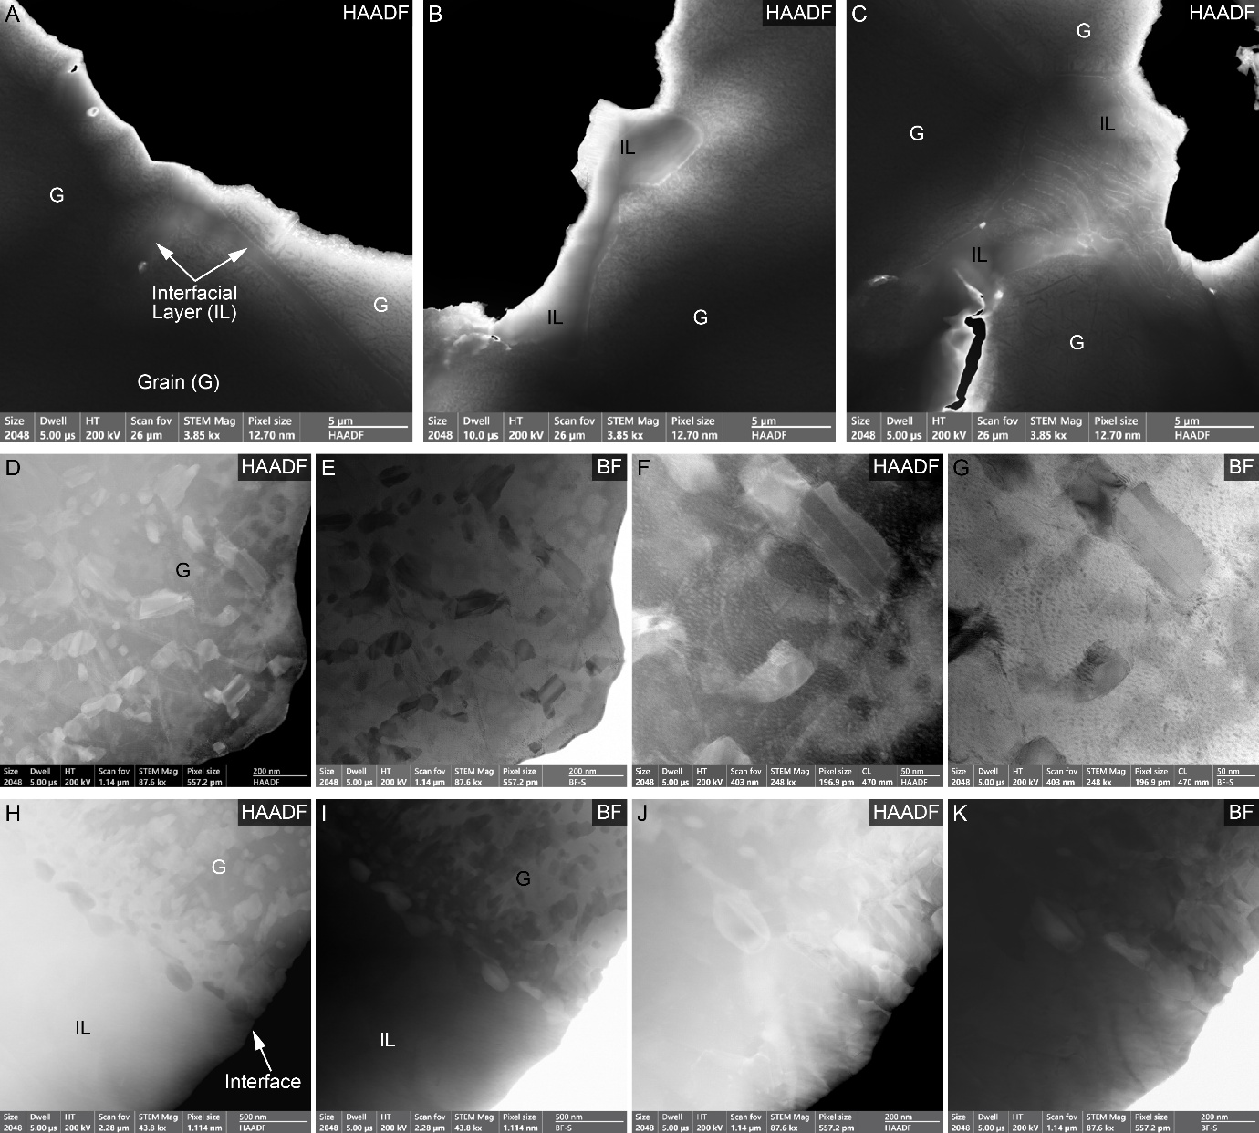
Fig. S15. STEM imaging of undoped AgSb_{1.05}Te_{2.06} sample, revealing the interfacial layer (IL) and its microstructure. (A-C) Low-magnification STEM-HAADF images from three different areas showing the microstructure of grains and IL High-magnification STEM-HAADF and STEM-BF images of (D-G) a large grains and (H-K) A detailed microstructural characterization and chemical analysis are presented in SI Fig. S12 and S16, respectively.
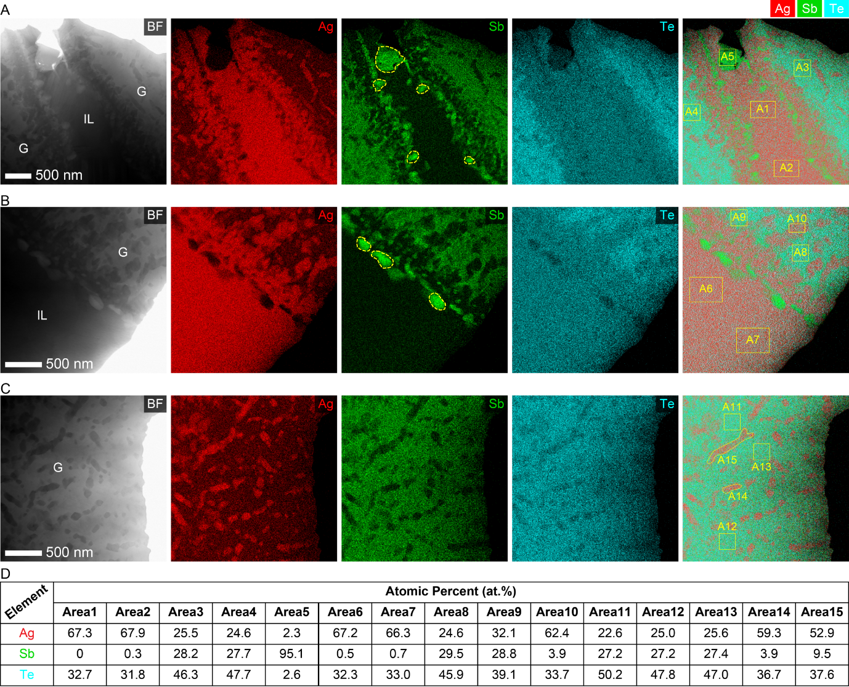
Fig. S16. STEM-EDX elemental mapping of undoped AgSb_{1.05}Te_{2.06}. (A-C) STEM-EDX elemental maps from three different regions, showing the chemical composition of the IL and grains. Each row shows STEM-BF, elemental maps of Ag (red), Sb (green), Te (cyan), and overlay (Ag+Sb+Te) image from left to right. (D) Chemical quantification of the regions marked with yellow boxes in the overlay images reveal the chemical composition of the grain (A3, A4, A8, A11, A12, A13) matches week with AgSbTe₂, while the IL (A1, A2, A6, A7) is mostly Ag₂Te with Sb precipitates decoration at the IL edges (A5). The precipitates within the grains (A10, A14, A15) are also mostly Ag₂Te.

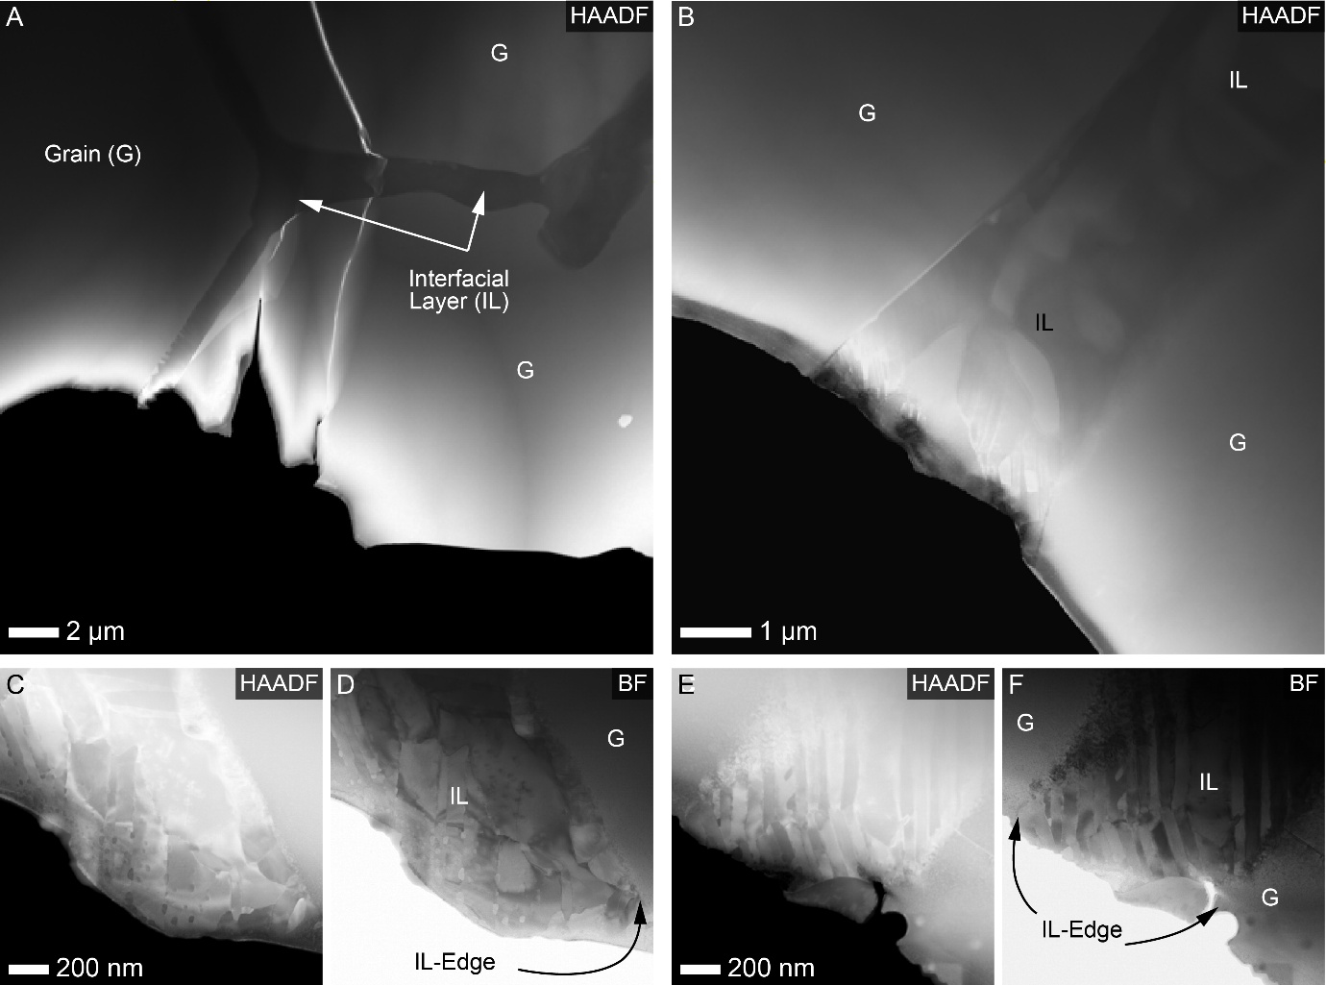
Fig. S17. STEM imaging of Cd-doped (AgSb_{1.01}Cd_{0.04}Te_{2.06}) sample, revealing the interfacial layer (IL) and its microstructure. (A-B) Low-magnification STEM-HAADF images from two different areas, showing the microstructure of grains and IL. (C-F) High-magnification STEM-HAADF and STEM-BF images of the IL. Interestingly, in this case we see no precipitates within the large grains, instead, the IL consists of lamellar Ag₂Te precipitates. This observation is in contrast to that we have seen in the undoped sample. A detailed microstructural characterization and chemical analysis are presented in SI Fig. S13 and S18, respectively.
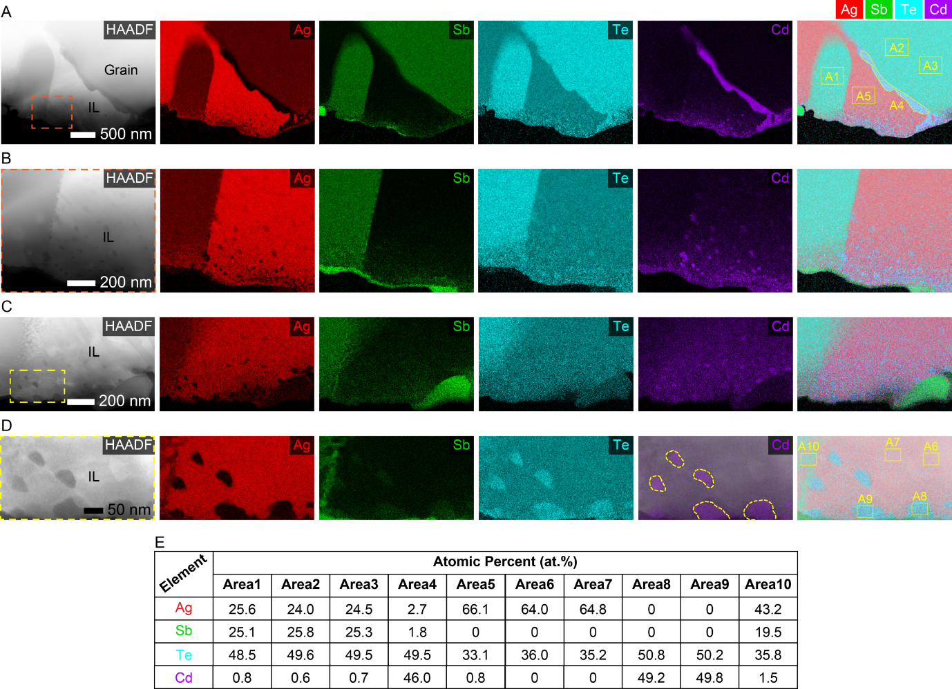 Fig. S18. STEM-EDX elemental mapping of Cd-doped (AgSb_{1.01}Cd_{0.04}Te_{2.06}) sample. (A) and (C) STEM-EDX elemental mapping of Cd-doped (AgSb_{1.01}Cd_{0.04}Te_{2.06}) sample from two different areas showing the chemical composition of the IL and grain. Each row shows STEM-HAADF, elemental maps of Ag (red), Sb (green), Te (cyan), Cd (purple) and overlay (Ag+Sb+Te+Cd) images from left to right. (B) and (D) are chemical mapping at higher magnification to resolve the precipitates within the IL. (E) Chemical quantification of the regions marked with yellow boxes in the overlay images reveals the chemical composition of the grain (A1, A2, A3) matches well with AgSbTe₂, while the IL is mostly Ag₂Te with embedded CdTe precipitate (A5, A6, A7). These results also show that the Cd composition is much lower (~ 1 at.%) in the grain than the expected doping level (4 at.%). and although the large grains are free from any precipitates, nanoscale Cd-rich precipitates (A8, A9) are observed in the IL.

The presence of Ag₅Te₃ in Cd-doped AgSb_{1.01}Cd_{0.04}Te_{2.06} and Se co-doped AgSb_{1.01}Cd_{0.04}Te_{1.86}Se_{0.20} could not be fully confirmed through TEM (contrary to XRD). This is because their d-spacing is too close to be able to differentiate them through DP or HR-TEM (d-spacing for most intense peaks of Ag₂Te and Ag₅Te₃ is 0.2299 nm and 0.2118 nm, respectively). Additionally, even though there are compositional fluctuations, our EDX quantitative analysis shows better matching to Ag₂Te (Table S7 and S8).

Table S7. STEM-EDX composition calculations for Cd dopped AST (Fig. S18).
 | IL |  |  | Grain
Elements | Area 5 | Area 6 | Area 7
Ag | 66.1 | 64 | 64.8
Sb | 0 | 0 | 0
Te | 33.1 | 36 | 35.2
Cd | 0.8 | 0 | 0
Ratio Ag/Te | 1.996979 | 1.777778 | 1.840909 | No precipitate found in the grain
Note 1: Ag/Te = 2 if it is Ag₂Te; Ag/Te = 1.67 if it is Ag₅Te₃.
Note 2: Area 5 and 7 are certainly Ag₂Te. Area 6 is quantitively closer to Ag5Te₃, however, image A6 and 7 are very similar. Therefore, this is not a different compound but rather a fluctuation in composition.

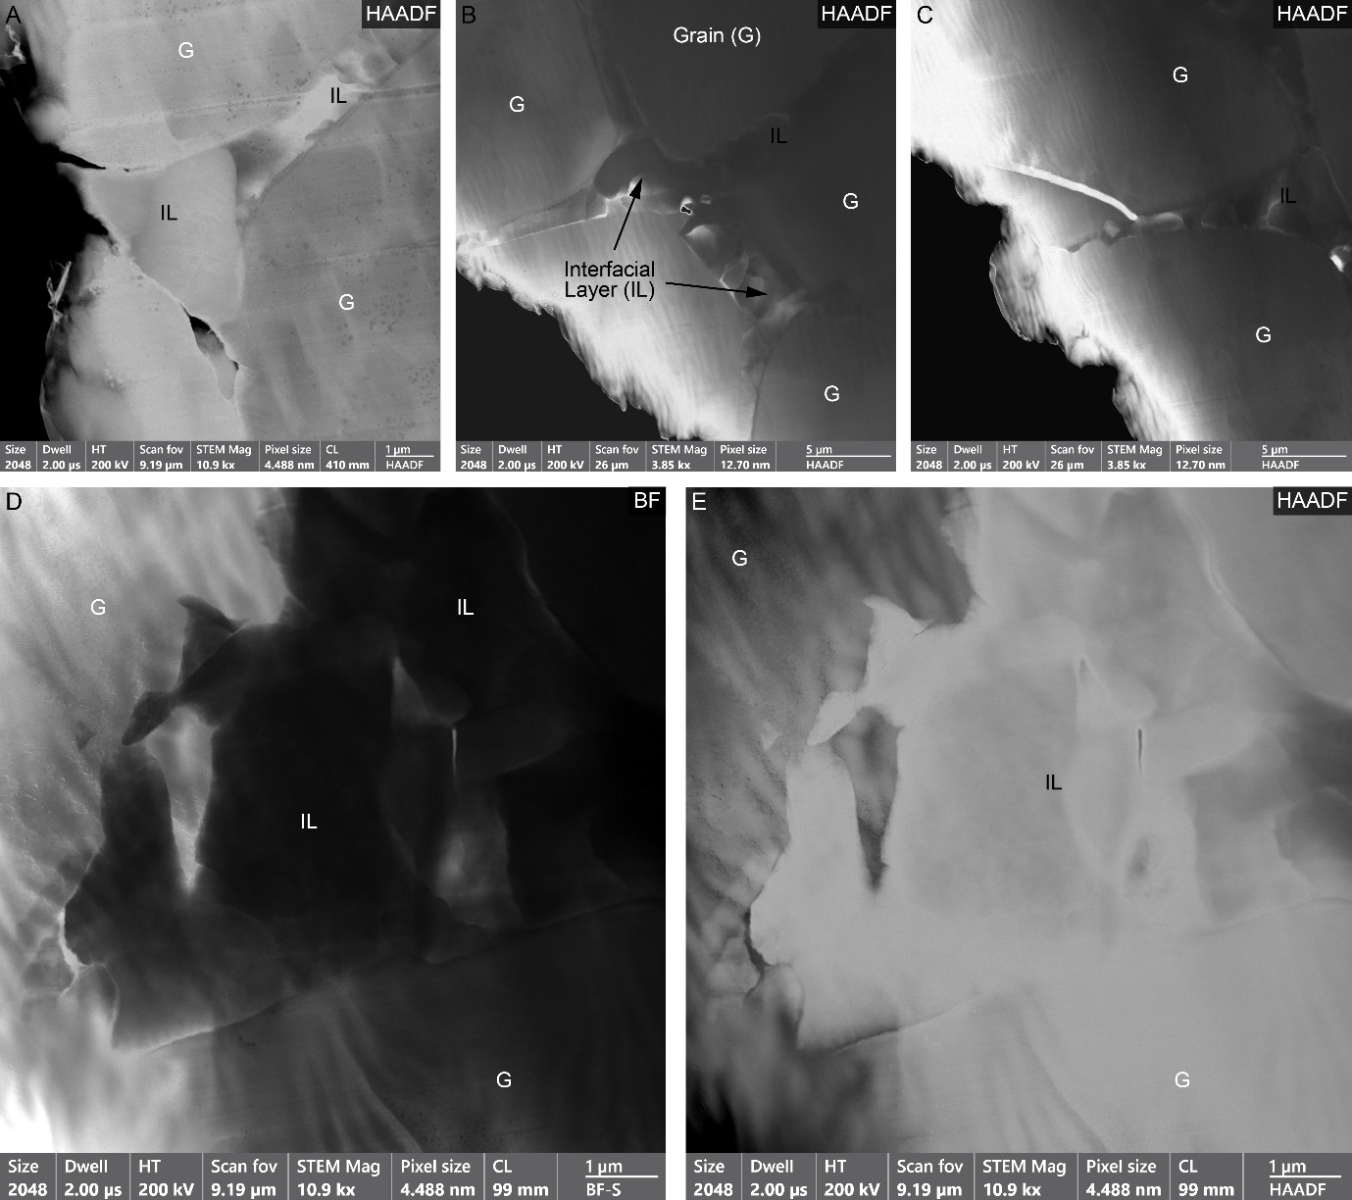
Fig. S19. STEM imaging of Se co-doped (AgSb_{1.01}Cd_{0.04}Te_{1.86}Se_{0.2}) sample, revealing the interfacial layer (IL) and its microstructure. (A-C) Low-magnification STEM-HAADF images from three different areas, showing the microstructure of grains and IL. High-magnification (D) STEM-HAADF and (E) STEM-BF images of the IL. In this case again the large grains has no precipitates while the IL consists Ag₂Te precipitates. This observation is similar to Cd-doped sample. A detailed microstructural characterization and chemical analysis are presented in SI Fig. S14 and S20, respectively.
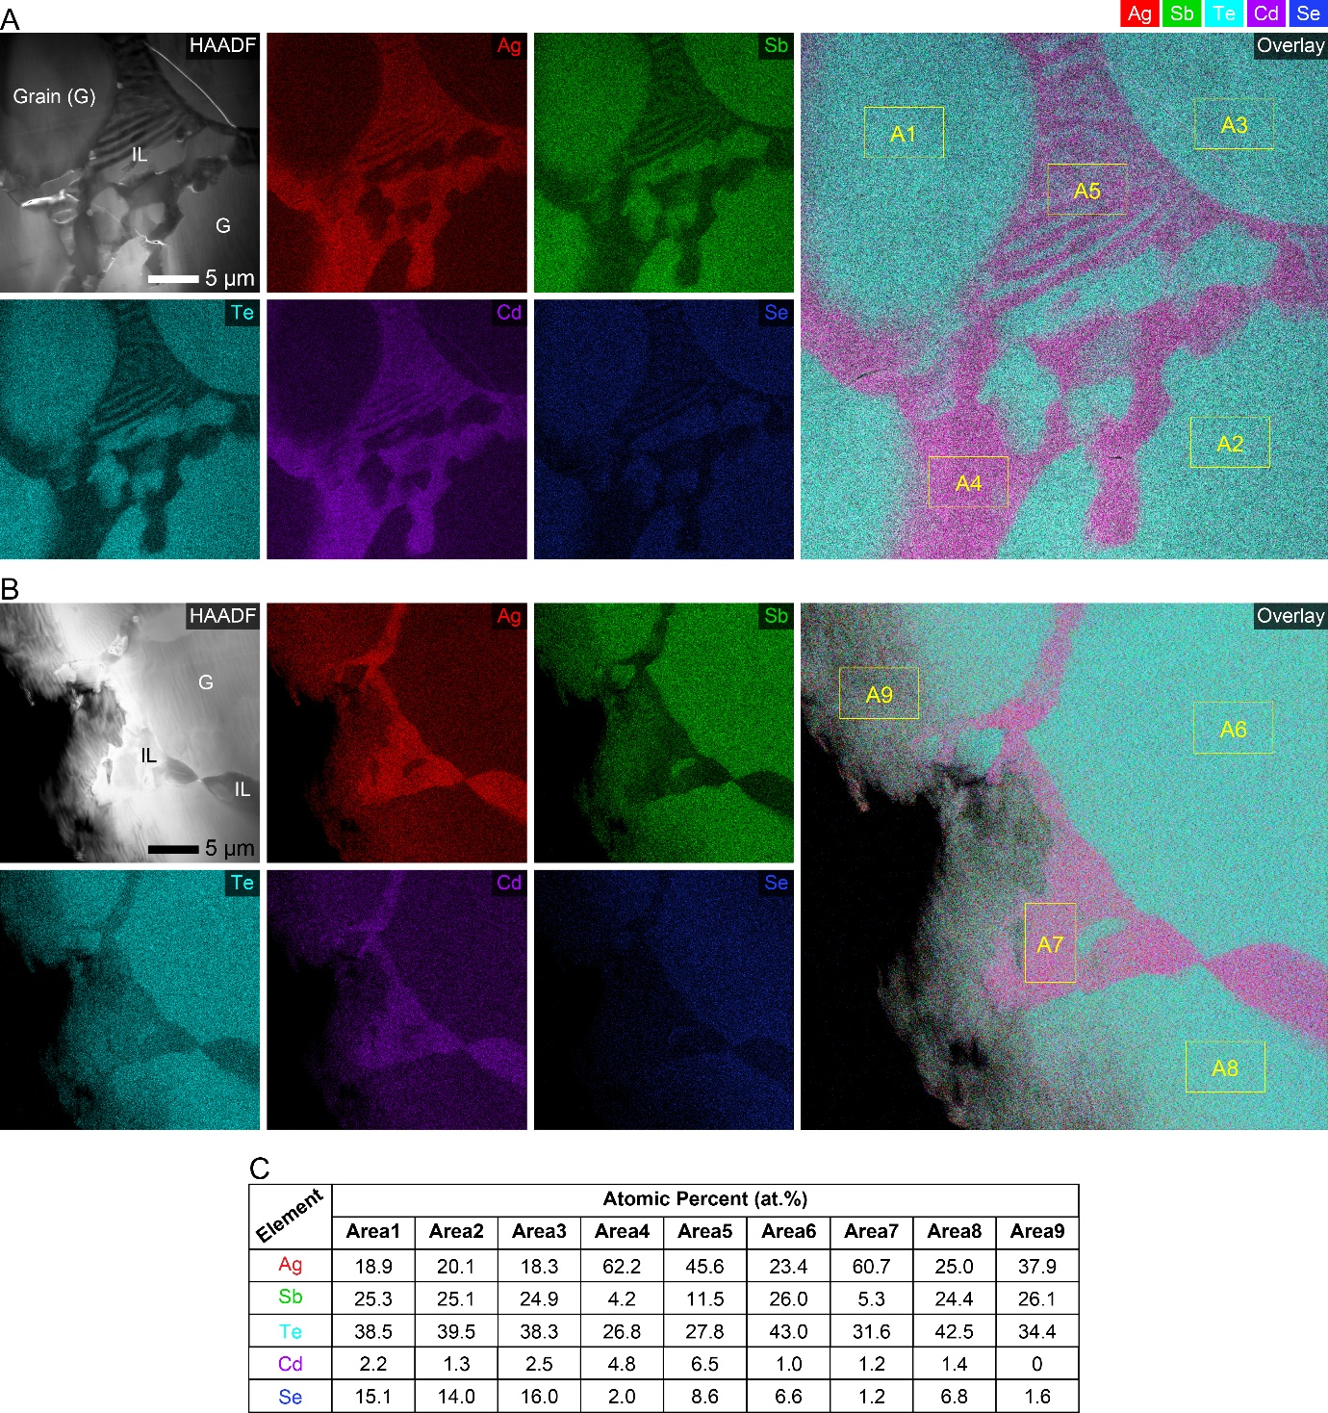
Fig. S20. STEM-EDX elemental mapping of Se co-doped (AgSb_{1.01}Cd_{0.04}Te_{1.86}Se_{0.2}) sample. (A) and (B) STEM-EDX elemental mapping from two different areas, showing the chemical composition of the IL and grain. Each row shows HAADF-STEM, elemental maps of Ag (red), Sb (green), Te (cyan), Cd (purple), Se (blue) and overlay (Ag+Sb+Te+Cd+Se) images. (C) Chemical quantification of the regions marked with yellow boxes in the overlay images reveals the chemical composition of the grain (A1, A2, A3, A6, A8) and the IL (A4, A5, A7). The grain composition is well matching with AgSbTe₂, whereas the ILs mostly show Ag₂Te precipitate with varying 1-4 at. % doping of Cd and Se. Within the grains Cd doping is lower while Se is higher than the expected doping.

Table S8. STEM-EDX composition calculations for Se co-dopped AST (Fig. S20).
 | IL |  |  | Grain
Elements | Area4 | Area5 | Area7
Ag | 62.2 | 45.6 | 60.7
Sb | 4.2 | 11.5 | 5.3
Te | 26.8 | 27.8 | 31.6
Cd | 4.8 | 6.5 | 1.2
Se | 2 | 8.6 | 1.2
Ratio Ag/Te | 2.320896 | 1.640288 | 1.920886 | No precipitate found in the grain
Note 1: Ag/Te = 2 if it is Ag₂Te; Ag/Te = 1.67 if it is Ag₅Te₃.
Note 2: Area 4 and 7 are certainly Ag₂Te. Area 5 cannot be considered as it includes clearly other area than just precipitate (see EDX map).

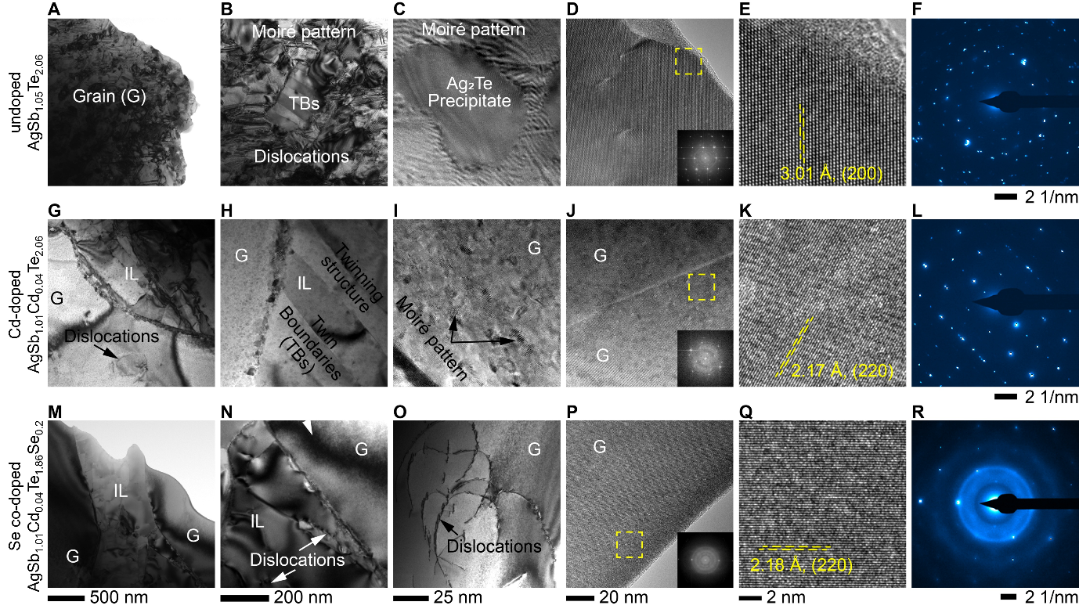
Fig. S21. Detailed microstructural characterization and comparison of undoped, Cd-doped and Se co-doped samples using TEM imaging and diffraction techniques. (A) Low-magnification, (B) high-magnification, (C, D) high-resolution TEM image of undoped sample. (E) A zoomed-in view of the rectangular region in (D), showing lattice fringes that match well with the pristine AgSbTe₂ phase. (F) SAED of the grain near the IL. The second row (G-L) and third row (M-R) shows exactly the same analysis under similar conditions for Cd-doped AgSb_{1.01}Cd_{0.04}Te_{2.06} and Se co-doped AgSb_{1.01}Cd_{0.04}Te_{1.86}Se_{0.2} samples, respectively. Both samples show similar microstructure with polycrystalline interfacial layer (IL) and monocrystalline large grains. In contrast, the undoped sample shows polycrystalline phase within the large grains.

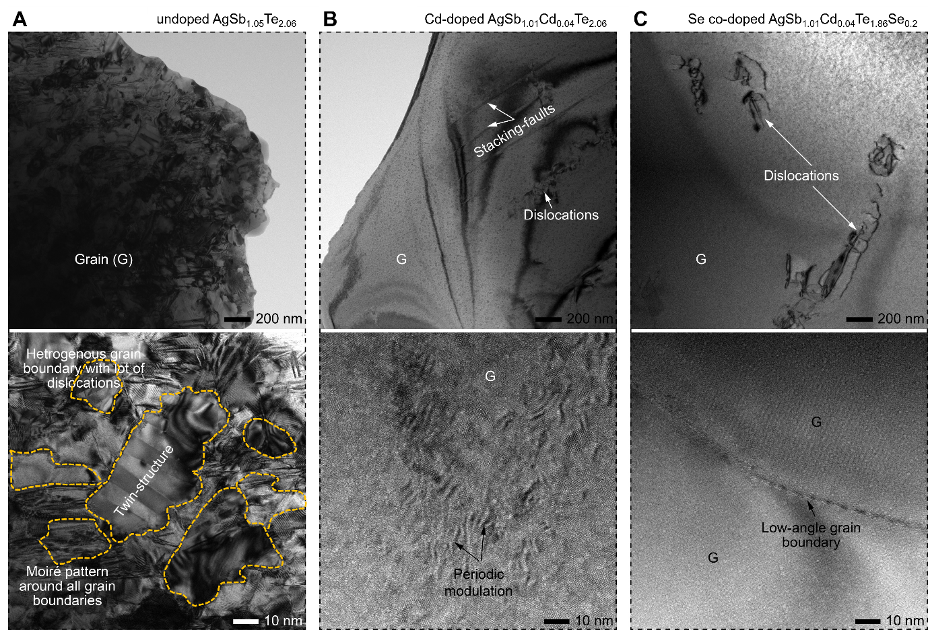
Fig. S22. Highlight of the major microstructural differences between undoped, Cd-doped and Se co-doped samples. Low-magnification (top row) and high-magnification (bottom row) TEM images of (A) undoped AgSb_{1.05}Te_{2.06}, (B) Cd-doped AgSb_{1.01}Cd_{0.04}Te_{2.06} and (C) Se co-doped AgSb_{1.01}Cd_{0.04}Te_{1.86}Se_{0.2} samples, showing different types of crystallographic defect formation due to secondary phase precipitation in the large grains in case of undoped sample; contrary, Cd-doped and Se co-dopped samples are free from secondary phase precipitation and large grains are mostly monocrystalline. While, Cd-doped sample shows periodic modulation, especially near the IL-edge, indicating cationic ordering, no such ordering observed for Se co-dopes sample except dislocations network randomly distributed within the large grains.

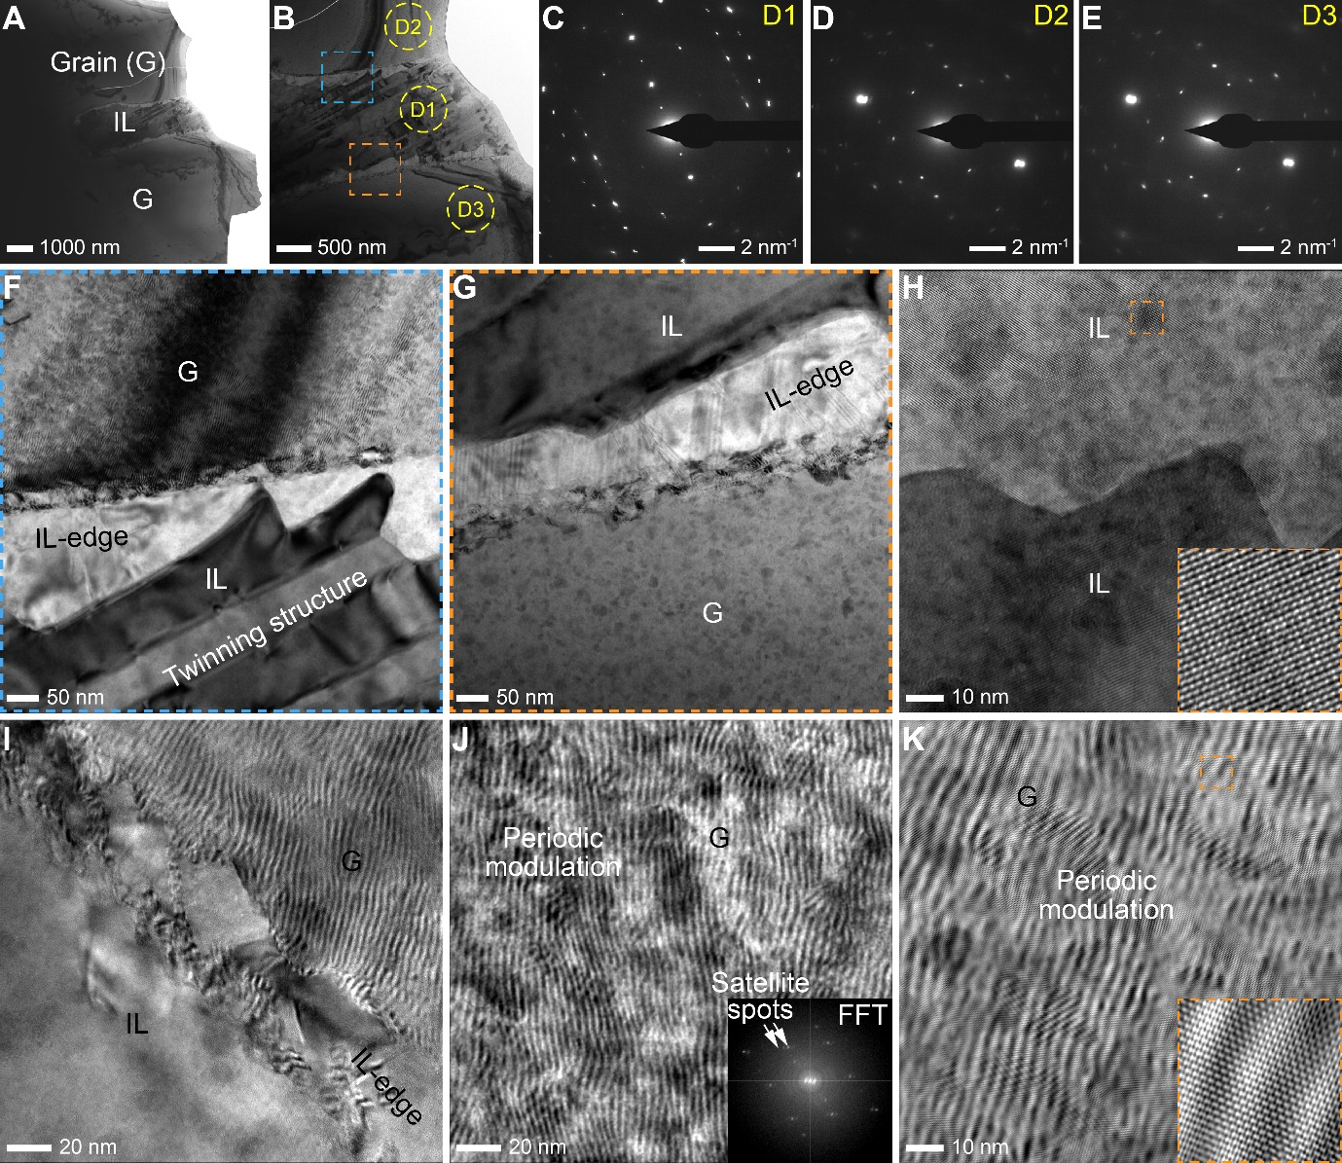
Fig. S23. Evidence of cation ordering in Cd-doped AgSb_{1.01}Cd_{0.04}Te_{2.06}. (A, B) Low-magnification TEM images, showing IL and grain. SAEDs of (C) IL, and (D, E) grains near the IL edge, confirming observed polycrystalline laminar structure of IL and monocrystalline structure of grains in the (F, G) high-magnification TEM images of interface regions. High-resolution TEM images of (H) center of IL, (I) IL-edge, and (J, K) grain near the IL-edge showing periodic modulation in the grains near the IL-edges. Insets in (H) and (K) show a zoomed-in view lattice fringes and in (J) FFT from the periodic modulation, showing satellite spots—an indication of cationic ordering.

Supplementary Section S5: Detailed analysis of thermoelectric transport

- Detailed analysis of the thermoelectric properties of compensated AgSbTe₂
Near room-temperature, we report a Seebeck coefficient of 257.57 μV K⁻¹ (Fig. S24A) and an electrical conductivity of 128.35 S cm⁻¹ (Fig. S24B) for undoped AgSb_{1.05}Te_{2.06}, with a maximum power factor of 8.51 μW cm⁻¹ K⁻² (Fig. 24C). The positive value of the Seebeck coefficient indicates that the sample is p-type, in very good agreement with previous reports of traditionally synthesized AgSbTe₂. These values generally increase when the temperature is increased, achieving maximum values at 600 K. At this temperature, we report electrical conductivity, Seebeck coefficient and power factor of 155.57 S cm^{–1}, 271.49 μV K^{–1} and 11.47 μW cm^{–1} K^{–2} respectively. Despite a general increasing trend of electrical conductivity with respect to temperature, it is not clear enough so that semiconducting behaviour can be ascribed. We measured the temperature-dependent total thermal conductivity (κ_{tot}) of undoped AgSb_{1.05}Te_{2.06} (Fig. S24D) and observe a gradual decrease in κ_{tot} from 0.58 W m^{–1} K^{–1} at near-ambient temperature to 0.55 W m^{–1} K^{–1} at 375 K. This value further decreases to ~0.47 W m^{–1} K^{–1} and remains constant until 525 K, temperature at which κ_{tot} increases again until 0.55 W m^{–1} K^{–1} at 600 K. Lattice thermal conductivity values were obtained using the Wiedemann-Franz Law (). The Lorentz number was calculated by numerically solving its Boltzmann Transport Equation (Methods). The temperature-dependent lattice thermal conductivity for undoped AgSb_{1.05}Te_{2.06} is shown in Fig. S24E. We observe the usual T⁻¹ dependence of κ_{lat}, indicating that phonon scattering dominates thermal transport, with a minimum value of κ_{lat} ~ 0.41 W m^{–1} K^{–1} at 573 K. Considering this, we attribute the increase in total thermal conductivity to increased electronic thermal conductivity (κ_{e}) due to bipolar conduction. Finally, we report a maximum zT value of ~1.2 at 600 K, a steep increase from a near-ambient value of ~0.4 (Fig. S24F). Compared to previously reported pristine AgSbTe₂ the samples in this work are beyond the optimal carrier concentration value i.e. overdoped. This is evidenced by several transport coefficients and temperature-dependences of our data. We report higher near-ambient values of electrical conductivity and similar Seebeck coefficient relative to the values reported by Roychowdhury et al. (σ ~ 121 S cm^{–1} and S ~279 μV K^{–1}), Bhui et al. (σ ~ 104 S cm^{–1} and S ~273 μV K^{–1}), Hu et al. (σ ~ 120 S cm^{–1} and S ~260 μV K^{–1}) and Pathak et al. (σ ~ 100 S cm^{–1} and S ~275 μV K^{–1}). These values lead to a much higher power factor values for our undoped AgSb_{1.05}Te_{2.06} than for those in the literature (Roychowdhury et al. ~9.5 μW cm⁻¹ K⁻², Bhui et al. ~7.8 μW cm⁻¹ K⁻²). Thus, the zT values obtained for undoped AgSb_{1.05}Te_{2.06} in this work are much higher than those reported in the literature: ~0.6 and ~0.9 for Roychowdhury et al. and Bhui et al., respectively.
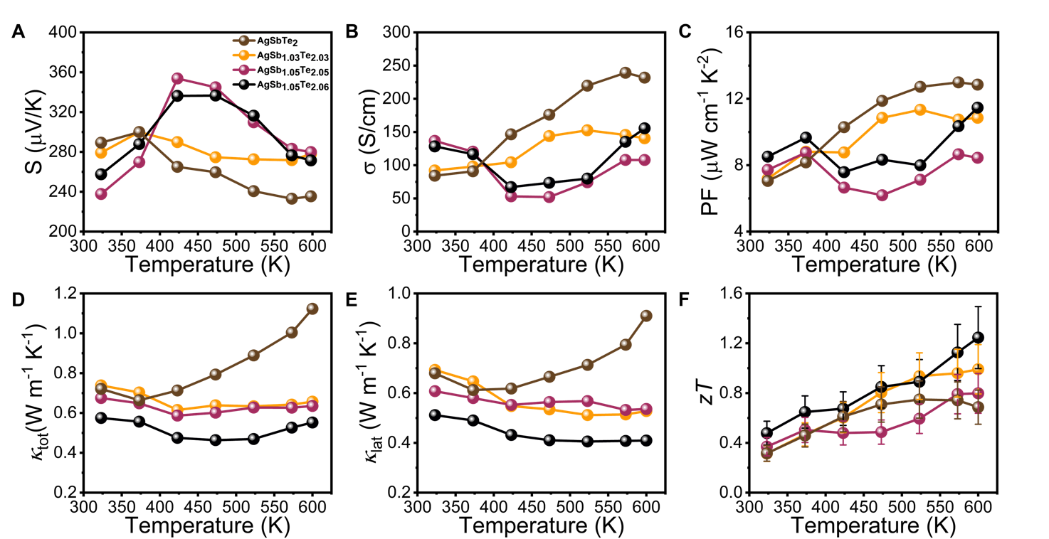
Figure. S24. Thermoelectric properties of polycrystalline nominal AgSbTe₂ and compensated AgSbTe₂ with different amounts of volatile elements (Sb and Te). The uncertainty in the zT measurement is 20%. ICP-OES and thermoelectric transport determine that after elemental loss during DJS reaction, undoped AgSb_{1.05}Te_{2.06} matches nominal AgSbTe₂.The compensated AgSb1.05Te2.06 achieved power factor of 11.47 μW cm^{–1} K^{–2} and zT of 1.2 at 600K.

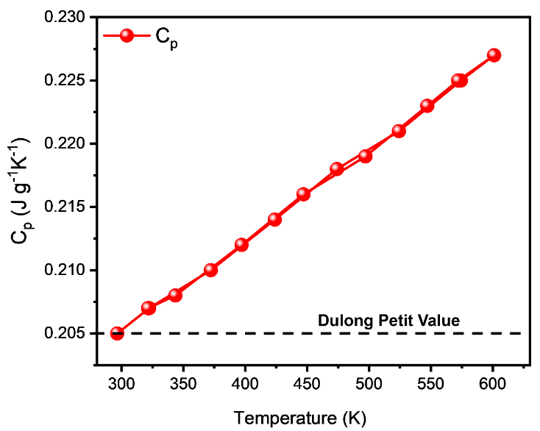
Figure. S25. Temperature-dependent heat capacity measurement of undoped AgSb_{1.05}Te_{2.06}.

- Detailed analysis of the thermoelectric properties of Cd-doped AgSb_{1.05-x}Cd_{x}Te_{2.06}
We measure the temperature-depending transport properties of the series (Fig. S26) to determine the best performing and select it for further experiments. Doping CdTe in AgSb_{1.05}Te_{2.06} results in a decrease in Seebeck coefficient (Fig. S26A) for the measured temperature range. Near-room temperature, S decreases from 257.57 μV K⁻¹ for AgSb_{1.05}Te_{2.06} to 241.30 μV K⁻¹ in 6 mol % CdTe–doped AgSb_{1.05}Te_{2.06}. The reduction in Seebeck coefficient is accompanied by an increase in electrical conductivity (Fig. S26B), from 128.35 S cm⁻¹ in the baseline material to 159.97 128.35 S cm⁻¹ in AgSb_{0.99}Cd_{0.06}Te_{2.06}. For all CdTe-doped samples, the electrical conductivity clearly increases with temperature, indicating semiconducting behaviour, in stark contrast with the baseline compound. The increased σ while retaining large values of S result in an overall large enhancement of the power factor throughout the measured temperature range, reaching a maximum value of 15.63 μW cm^{–1} K^{–2} at 573 K Fig. S26C). The total thermal conductivity for the doped samples decreases for all temperature values (Fig. S26D). We extracted κ_{lat} values using a calculated Lorentz number (Methods) and we observe a decrease in κ_{lat} with increasing mol % CdTe, from ~0.51 W m^{–1} K^{–1} at near-ambient temperature for the pristine sample to ~0.45 W m^{–1} K^{–1} for 6 mol % CdTe. As temperature increases, we observe a gradual decrease in κ_{lat}, with a T⁻¹ dependence. The minimum value of κ_{lat} is achieved at 573 K for 4 % mol CdTe: 0.33 W m^{–1} K^{–1}. Consequently, the largest zT value for Cd-doped AgSb_{1.05-x}Cd_{x}Te_{2.06} is achieved when x = 0.04, corresponding to Cd-doped AgSb_{1.01}Cd_{0.04}Te_{2.06}, which has a zT ~1.5 at 573 K (Fig. S26F). These values fall short from those reported by Roychowdhury et al. for AgSb_{0.94}Cd_{0.06}Te₂ (zT~2.6 at 573 K), Bhui et al. for AgSb_{0.96}Hg_{0.04}Te₂ (zT ∼2.4 at ∼570 K) and Taneja et al. for AgSb_{0.96}Yb_{0.04}Te₂ (zT ≈ 2.4 at 573 K) but are higher than any other single cation-site doped AgSbTe₂ (Table S3).

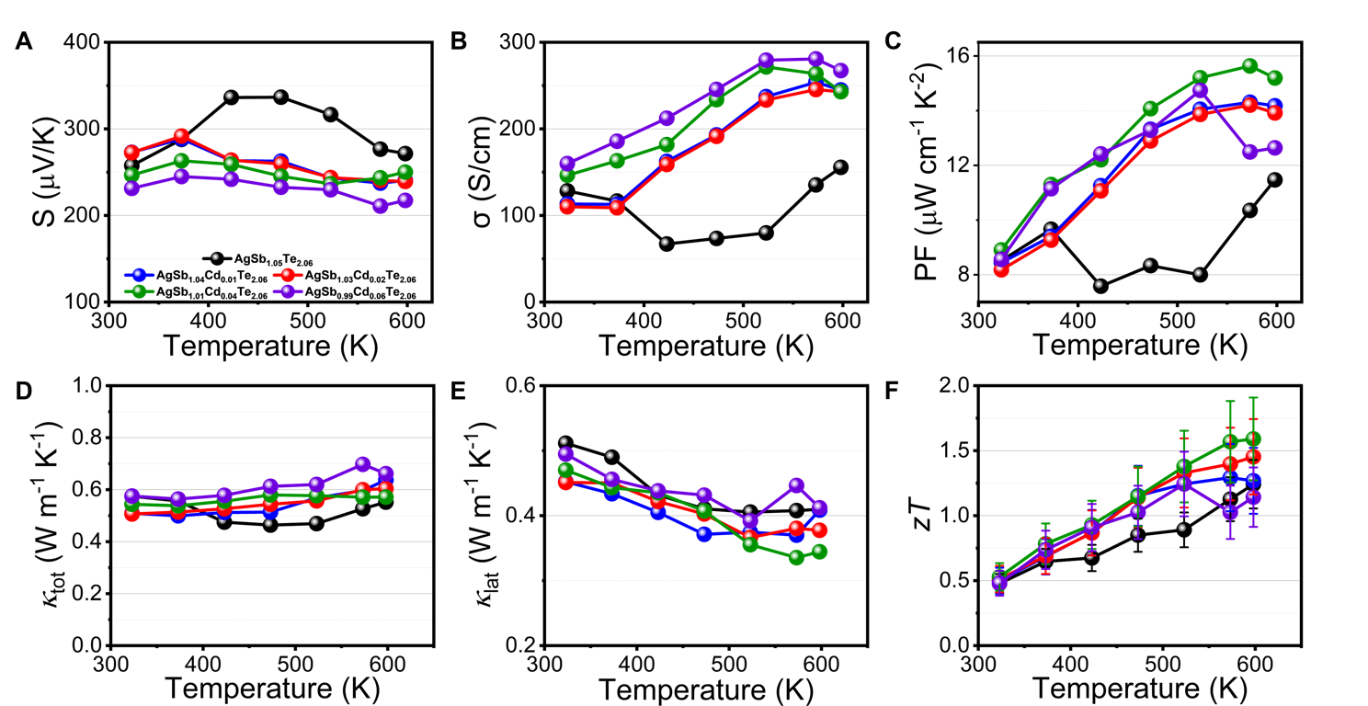
Fig. S26 Thermoelectric properties of Cd-doped AgSb_{1.05-x}Cd_{x}Te_{2.06} (x = 0 - 0.06). Temperature dependent (A) Seebeck coefficient (S), (B) electrical conductivity (σ), (C) power factor (σS²), (D) total thermal conductivity (κ_{tot}), (E) lattice thermal conductivity (κ_{lat}), (F) zT. The uncertainty of thermoelectric transport measurement is about 20%.

- Hall measurements for selected samples

Figure S27A shows the change in Hall resistivity with magnetic field and S27B shows magneto resistance for undoped AgSb_{1.05}Te_{2.06} at 300 K. The inset S27A shows the linear fit for the smaller magnetic fields (< 1T) to obtain the Hall coefficient, R_{H} (-1/nq), which is negative and equal to -0.926 m³/C. The non-linearity of Hall resistivity with applied magnetic field suggests that two carriers transport contribute to transport. And Fig. S26B shows a positive magnetoresistance, expected for bipolar conduction. The negative Hall coefficient at first glance indicates that the dominant carrier are electrons. However, the Seebeck coefficient is positive throughout the measured temperature range for undoped AgSb_{1.05}Te_{2.06} (Fig. S24), which confirms p-type conduction.
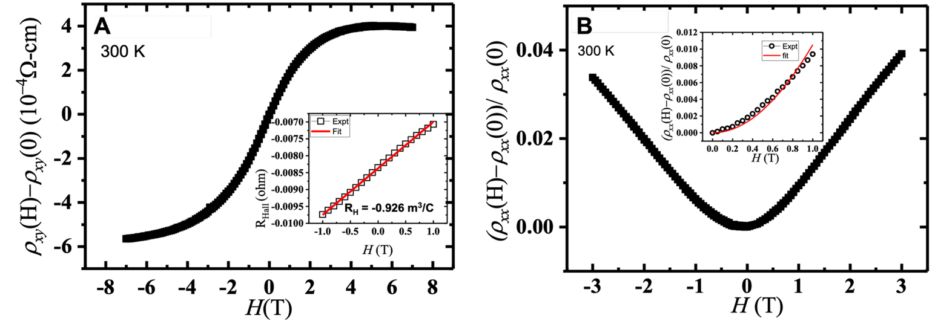
Figure. S27. (A) Change in the Hall resistivity and (B) change in magnetoresistance resistivity for the undoped AgSb_{1.05}Te_{2.06} at 300 K. The inset (A) is a fit to Hall resistance to obtain the Hall coefficient (B) is the 2 carrier model data fit data for low magnetic fields < 1T.

The negative Hall coefficient in AgSbTe₂ has been attributed to the dominance of high-mobility, low-concentration narrow-band electrons, which outweigh the contribution of holes in Hall transport due to their superior mobility. The positive Seebeck coefficient indicates hole-dominated transport, where the high hole concentration arises from multiple degenerate valence bands, leading to a large effective mass, enhanced Seebeck coefficient due to band degeneracy, and low hole mobility.^{24,25}

Using the two-carrier model, the Hall resistivity and the longitudinal resistivity can be expressed as:

(S5)

(S6)

The inset of Fig. S27B shows the magnetoresistance fit for low magnetic fields, < 1T, to obtain the carrier transport parameters. We obtain the hole and electron carrier concentration, p = 4.48 × 10¹⁹ cm⁻³ and n = 9.00 × 10¹⁷ cm⁻³ with corresponding hole and electron mobilities of μ_{p} = 18 cm² V⁻¹ s⁻¹ and μ_{n} = 2516 cm² V⁻¹ at 300 K for AgSb_{1.05}Te_{2.06.}

Figure S28A shows the Hall resistivity as a function of magnetic field, while Figure S26B shows the magnetoresistance at 300 K for both AgSb_{1.01}Cd_{0.04}Te_{2.06} and AgSb_{1.01}Cd_{0.04}Te_{1.86}Se_{0.2} at 300 K. The inset in Figure S28A shows a linear fit of the Hall resistivity at low magnetic fields (B < 1 T) used to extract the Hall coefficient R_{H} (-1/nq), which is negative and equal to -0.183 m³/C, indicating electron-dominated Hall transport. Despite this, both doped samples exhibit a positive Seebeck coefficient.

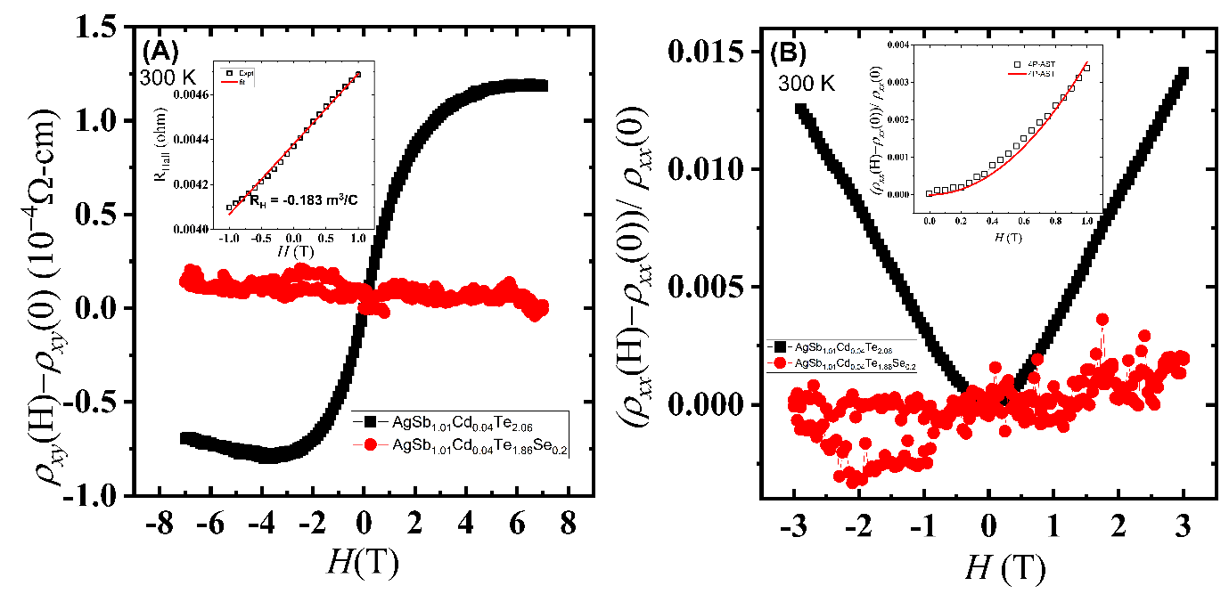
Fig. S28. (A) Change in the Hall resistivity and (B) change in magnetoresistance for both AgSb_{1.01}Cd_{0.04}Te_{2.06} and AgSb_{1.01}Cd_{0.04}Te_{1.86}Se_{0.2} at 300 K. The inset in (A) is a fit to Hall resistance to obtain the Hall coefficient for AgSb_{1.01}Cd_{0.04}Te_{2.06}. The inset in (B) is the 2 carrier model data fit data for low magnetic fields < 1T for AgSb_{1.01}Cd_{0.04}Te_{2.06}.

Fig. S28B shows a positive magnetoresistance for AgSb_{1.01}Cd_{0.04}Te_{2.06}. The change in magnetoresistance decreases in the Cd-doped sample compared to undoped AgSb_{1.05}Te_{2. 06}. The inset of fig. S28B shows the magnetoresistance fit for low magnetic fields (< 1T), from which we obtain the hole and electron carrier concentration, p = 2.37 × 10¹⁹ cm⁻³ and n = 1.00 × 10¹⁷ cm⁻³ with corresponding hole and electron mobilities of μ_{p} = 20 cm² V⁻¹ s⁻¹ and μ_{n} = 1410 cm² V⁻¹ s⁻¹at 300 K for AgSb_{1.01}Cd_{0.04}Te_{2.06}. Non-linearity in Hall resistivity and magnetoresistance decreased with Se doping. This suggests further suppression of electron carrier contributions to transport, accompanied by a reduction in magnetoresistance, indicative of decreased carrier–carrier scattering in the samples. The field-independent behaviour observed in both Hall resistivity and magnetoresistance may be attributed to an increase of pseudo-bandgap, reflecting lower contributions from narrow-band electrons and a transition from a two-carrier transport regime to a single (hole) carrier dominated transport upon Se substitution.^{26,27} Furthermore, Cd and Se doping, suppresses the formation of n-type Ag₂Te precipitates as evidenced from our spectroscopic studies.²⁸
Supplementary Section S6: Repeatability of the thermoelectric properties
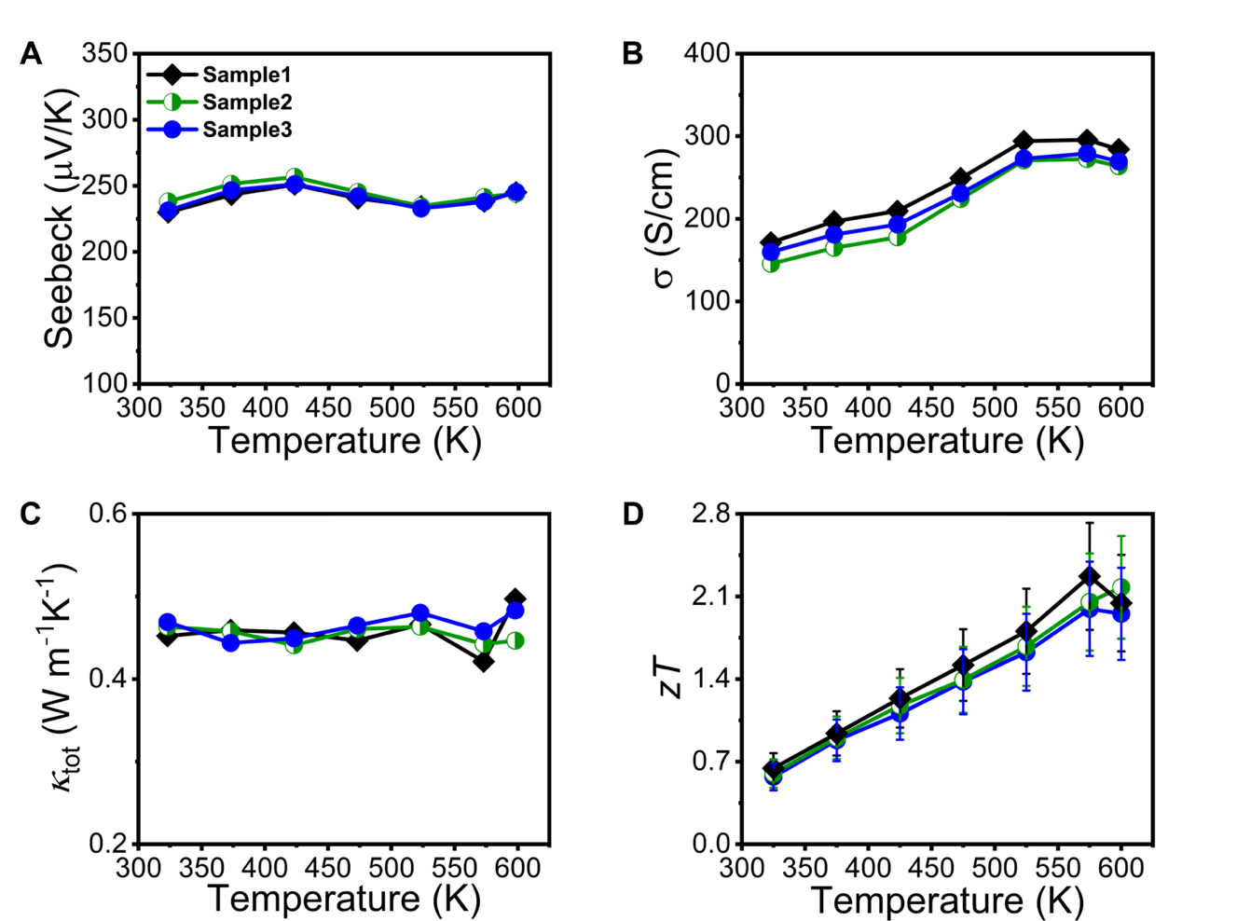
Figure. S29. Reproducibility of temperature-dependent thermoelectric properties Se co-doped AgSb_{1.01}Cd_{0.04}Te_{1.86}Se_{0.2}. (A) Seebeck coefficient, (B) electrical conductivity, and (C) thermal conductivity, (D) zT. A total of three different samples were measured.

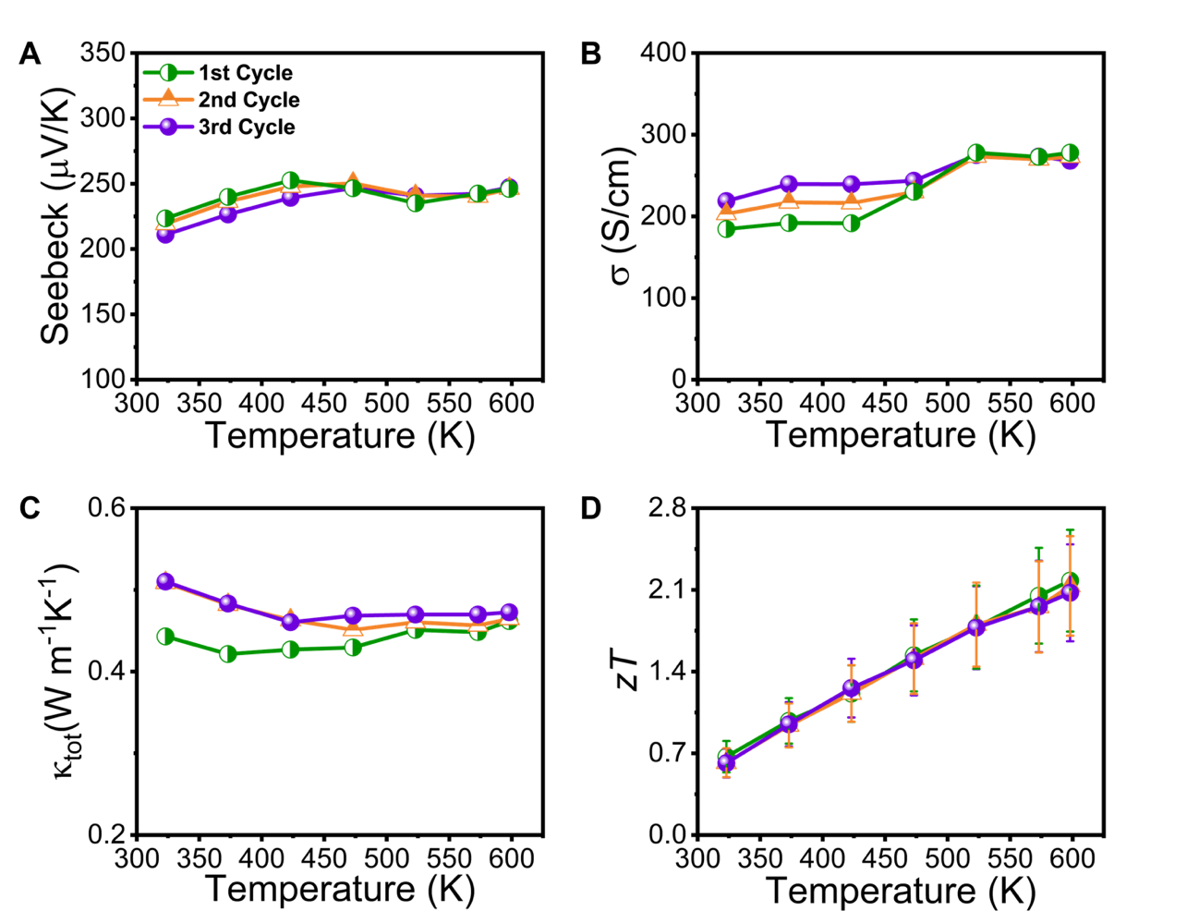
Figure. S30. Thermoelectric properties of polycrystalline Se co-doped AgSb_{1.01}Cd_{0.04}Te_{1.86}Se_{0.2} sample with several heating-cooling cycles.

Supplementary Section S7: Complementary structural and microstructure analysis for Bi_{0.5}Sb_{1.5}Te₃.
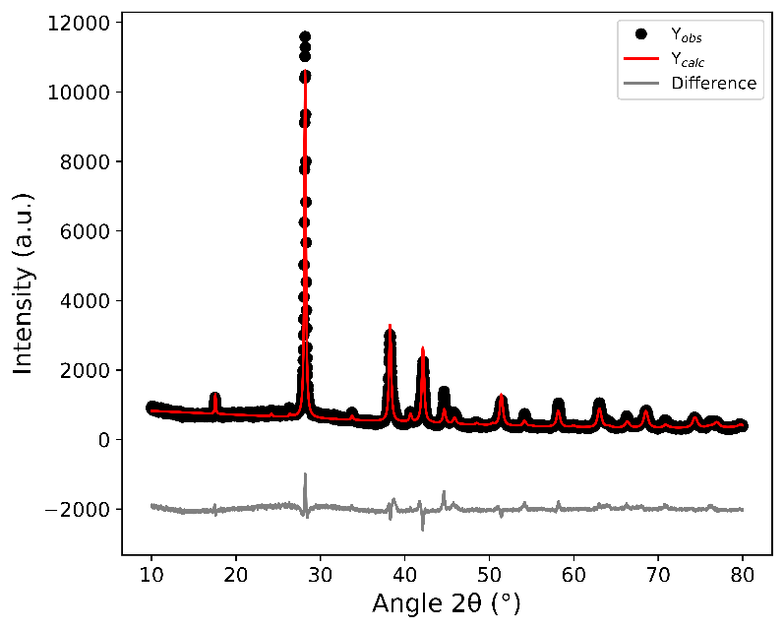
Figure. S31. Rietveld refined diffraction pattern for Bi_{0.5}Sb_{1.5}Te₃. The final R_{wp} of the refinement was 3.18. Peaks were refined against Bi_{0.5}Sb_{1.5}Te₃ (ICSD 184246). Minority impurities matched to Sb₂Te₃ (PDF 01-083-5987) were also found.

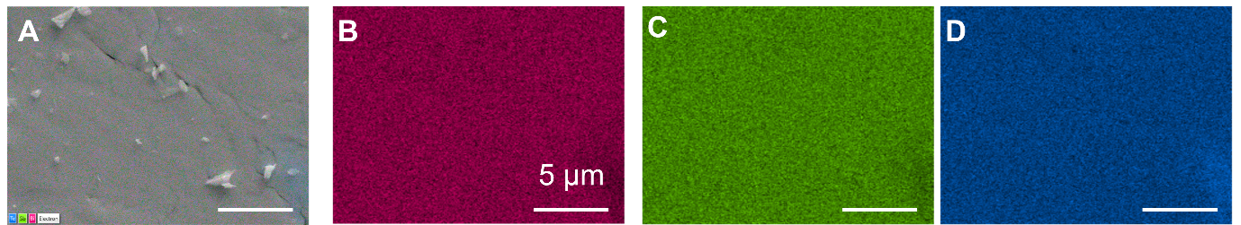
Figure. S32. SEM-EDX for Bi_{0.5}Sb_{1.5}Te₃. (A) Layered image. (B) EDX map for Bi. (C) EDX map for Sb. (D) EDX map for Te.

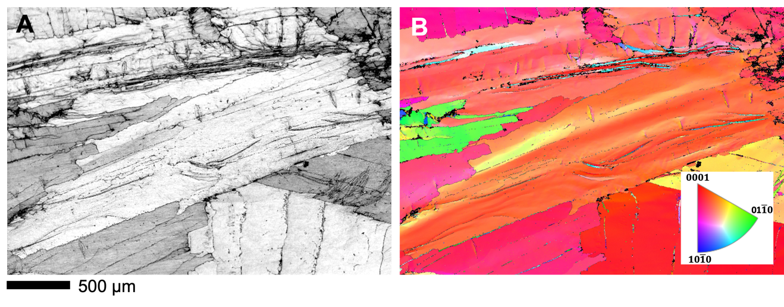
Fig. S33. EBSD for Bi_{0.5}Sb_{1.5}Te₃. (A) Low magnification band contrast image. (B) Inverse pole figure (IPF) map corresponding to (A).

Supplementary Section S8: First principles electron band structure and phonon calculations and detailed analysis of electronic transport

- First principles calculations
Fig. S34 shows the calculated phonon dispersion curves for ordered AgSbTe₂ in the $Fd\overline{3}m$ space group. Phonon frequencies were computed using the PBEsol+U functional, showing no imaginary (negative) frequencies across the Brillouin zone, indicating dynamical stability of the $Fd\overline{3}m$ structure. The phonon dispersions show avoided crossings between acoustic and optical modes, providing channels for phonon scattering that reduce lattice thermal conductivity. Additionally, the presence of soft, densely packed optical modes suggests strong phonon-phonon interactions and pronounced anharmonicity in the crystal lattice, which further suppress heat transport.
Fig. S34. Phonon dispersions of ordered AgSbTe₂ with $Fd\overline{3}m$ space group in a 3 x 3 x 3 supercell.
The electronic density of states (DOS) of ordered $Fd\overline{3}m$ AgSbTe₂ reveals that the valence band is predominantly composed of Te p-states, with a secondary contribution from Sb p-states and Ag d-states (Fig. S35). The conduction band minimum is mainly derived from Sb and Te p-states, with a minor presence of Ag s- and p-states. The total DOS exhibits a sharp onset at the conduction band edge and a broad peak in the valence band just below the Fermi level, indicative of a high density of available states for hole transport. This distribution suggests that electronic transport in the valence band is likely dominated by Te p-character, while the conduction band transport is governed by mixed Sb–Te p-character. The contribution from Ag is primarily localised and deep in the valence region, consistent with a limited role in conduction but potentially relevant for bonding and structural stability.

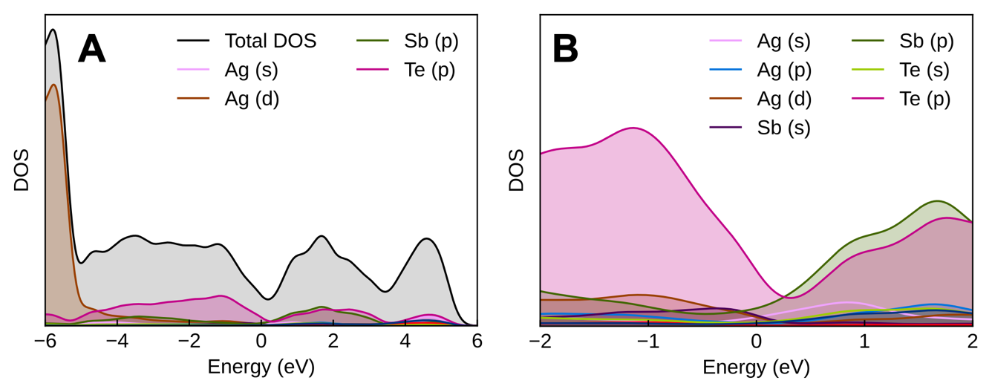
Fig. S35. (A) Electronic density of states of ordered $Fd\overline{3}m$ AgSbTe₂ calculated using PBEsol + U with spin-orbit coupling (SOC). (B) Zoomed-in region showing the DOS around the Fermi level.
Compared to the GGA-based results (Fig. S35), the DOS of ordered $Fd\overline{3}m$ AgSbTe₂ calculated using the hybrid functional show the formation of a bandgap (Fig. S35). The conduction band edge is shifted to higher energies, resulting in a clearer separation between the valence and conduction bands. This correction is consistent with the known underestimation of bandgaps by semi-local DFT and supports the use of hybrid functionals for a more accurate description of the electronic structure relevant to transport properties.
Fig. S36. Electronic density of states of ordered $Fd\overline{3}m$ AgSbTe₂ using hybrid functional and spin-orbit coupling (SOC).

Whilst a bandgap can be inferred from Fig. S36, it cannot be definitively confirmed from the DOS plot alone. This is because DOS plots have finite smearing (e.g. Gaussian broadening), which can artificially populate the gap region, making it difficult to determine whether the DOS at the Fermi level is truly zero. The apparent gap in the DOS could still correspond to a very narrow pseudo-gap. To definitively confirm the presence and magnitude of a bandgap, the band structure must be examined directly, however, has yet to be achieved for this structure.
The overall shape of the DOS in Fig. S36 remains qualitatively similar to the results in Fig. S35, with Te p-states dominating the valence band and Sb p-states contributing near the conduction band edge. However, the reduced overlap between valence and conduction states may influence carrier excitation and transport, particularly at elevated temperatures. The Ag d-states remain localised well below the Fermi level, and their contribution does not change significantly with the use of the hybrid functional, reinforcing their limited role in charge transport.
Based on the band structure, the valence and conduction bands overlap at the Fermi level (0 eV) and there is no clear gap between occupied and unoccupied states across the Brillouin zone (Fig. S37). This confirms that ordered $Fd\overline{3}m$ AgSbTe₂ is metallic at the PBEsol level. The zoomed-in panel shows that the conduction band dips below the Fermi level near X, while the valence band remains high between Γ and L indicating a band overlap rather than a bandgap.
In contrast to the hybrid functional result (Fig. S36), PBEsol fails to open a gap, characterising the system as metallic. This discrepancy reinforces that semi-local functionals like PBEsol are insufficient for predicting the correct electronic ground state in this material, and hybrid DFT is necessary to capture the semiconducting nature of the ordered phase.
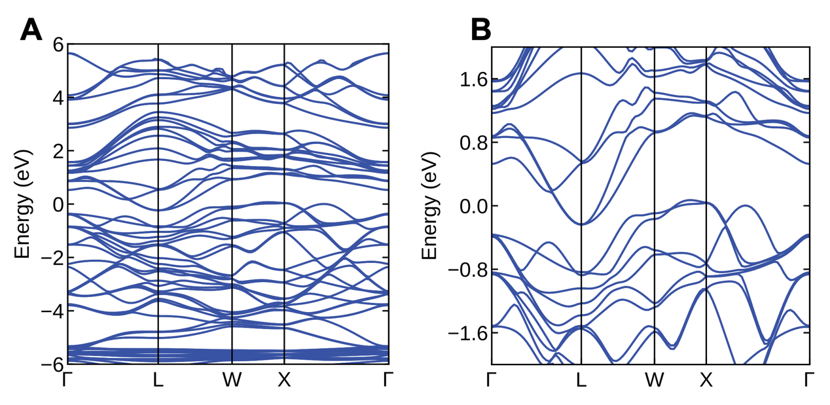
Fig. S37. (A) Electronic band structure of ordered AgSbTe₂ in structure calculated using PBEsol + U with spin-orbit coupling (SOC). (B) Enlarged section of (A).

The unfolded hybrid-functional band structure of disordered $Fm\overline{3}m$ AgSbTe₂ shows that the material appears to be semi-metallic (Fig. S38). There is no clear band gap is visible at the Fermi level (0 eV). Instead, the valence and conduction bands overlap in energy across different k-points. The valence states (mostly Te-derived) cross or touch the Fermi level near Γ–L, and the conduction states (mainly Sb-derived) are also present at or just below the Fermi level, particularly around X. The spectral weight is non-zero at multiple k-points at E=0, indicating a finite density of states at the Fermi level despite the band smearing from configurational disorder.
This strongly suggests that the disordered $Fm\overline{3}m$ phase is semi-metallic at the hybrid DFT level. In contrast to the ordered $Fd\overline{3}m$ phase, which may develop an indirect band gap with hybrid functionals, disorder in $Fm\overline{3}m$ appears to close or significantly reduce the gap, leading to band overlap. This distinction has important implications for transport: carrier concentrations in the disordered phase would be intrinsic and metallic-like rather than thermally activated across a gap.
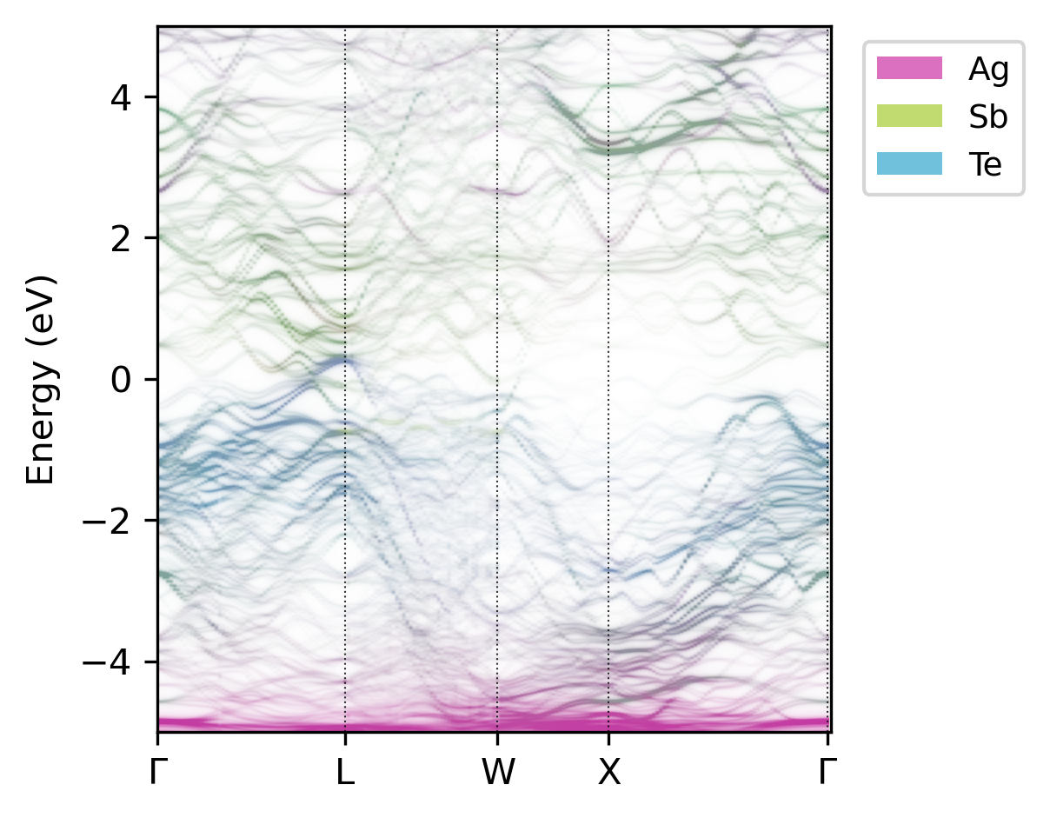
Fig. S38. Electronic band structure of disordered $Fd\overline{3}m$ AgSbTe₂, calculated using the HSE06 functional and SOC. The spectral weights are colour-resolved by atomic species: Ag (magenta), Sb (green), and Te (blue), showing the projected contribution of each element to the electronic states.
We proceed to use the most stable structure (at DFT level) to perform first principles calculations of the electronic transport properties. A C2/c unit cell was used as input for calculation using the Ab initio Scattering and Transport (AMSET) method, and the preliminary data is shown in Fig. S39. We observe that our experimentally measured data (in purple, Fig. S39) approaches a carrier concentration between 10¹⁹ and 10²⁰ cm⁻³, which is in good agreement with our Hall analysis.

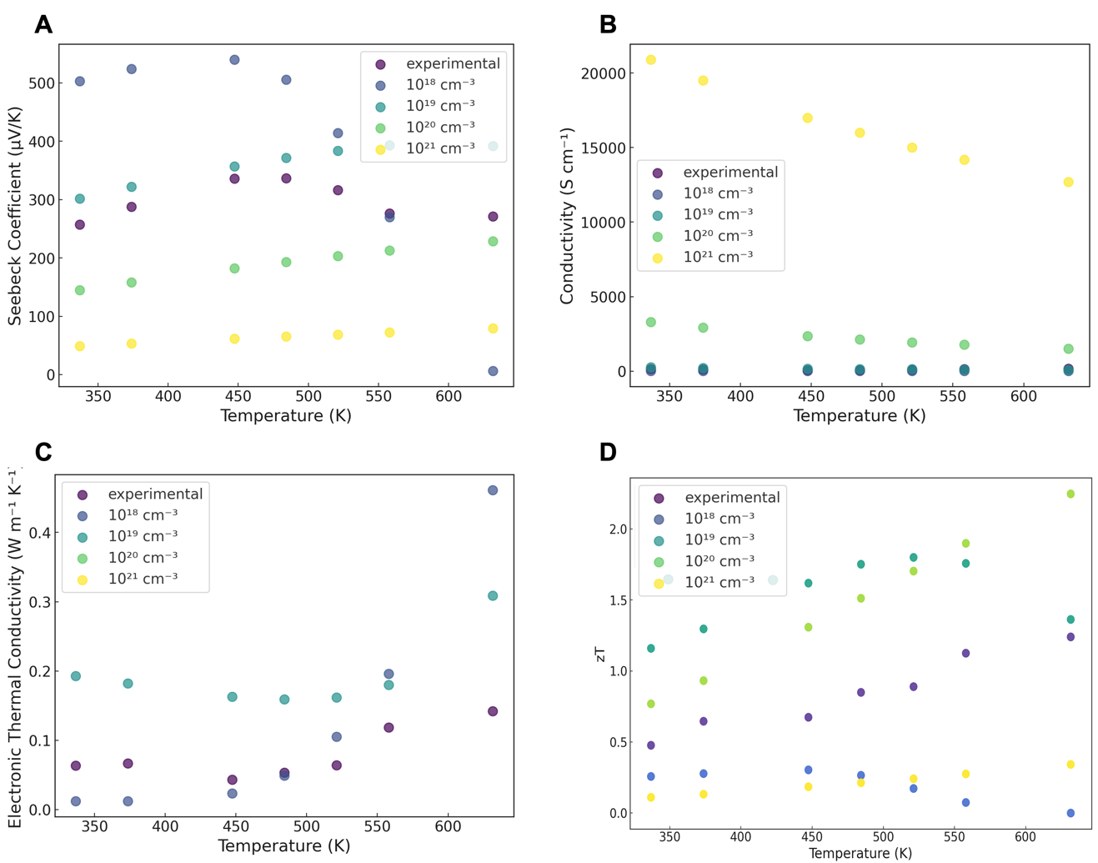
Figure S39. Comparison between experimental results and theoretical calculations for ordered AgSbTe₂. (A) Seebeck coefficient. (B) Electrical conductivity. (C) Electronic thermal conductivity. (D) zT. The experimental points correspond to data collected for undoped AgSb_{1.05}Te_{2.06}.

In order to obtain Jonker’s plot as shown in Figure S40 (A-D), the reduced chemical potential, η was extracted from equation S1:

(S1)

where F is the Fermi integral. Theoretical Seebeck coefficient value was calculated using η and different r values such as for acoustic phonon scattering (APS, r = -0.5), polar optical scattering (POP, r=+0.5) and ionized impurity scattering (IIS, r = 1.5). Subsequently, the corresponding η and r values can be used to obtain theoretical electrical conductivities σ for different transport coefficient values using Eq. S3.

(S3)

The theoretical curves of Seebeck coefficient versus electrical conductivity with different scattering parameters were plotted as shown in Figure S40 (A-D). can be estimated by looking the position and trend of the experimental data from each sample.
Figure S40(E-F) shows the theoretical zT values as a function of η for different B values. zT(B, η) can be written as:

(S7)

where L(η) is Lorentz number given by Eq. S4. Theoretical curve of zT versus η plotted at different B values. Experimental data of zT for AgSb_{1.05-x}Cd_{x}Te_{2.06} samples and AgSb_{1.01}Cd_{0.04}Te_{2.06-y}Se_{y} samples at 573 K were placed on those theoretical curves. As seen for a particular B value, experimental zT value is close to optimized η.

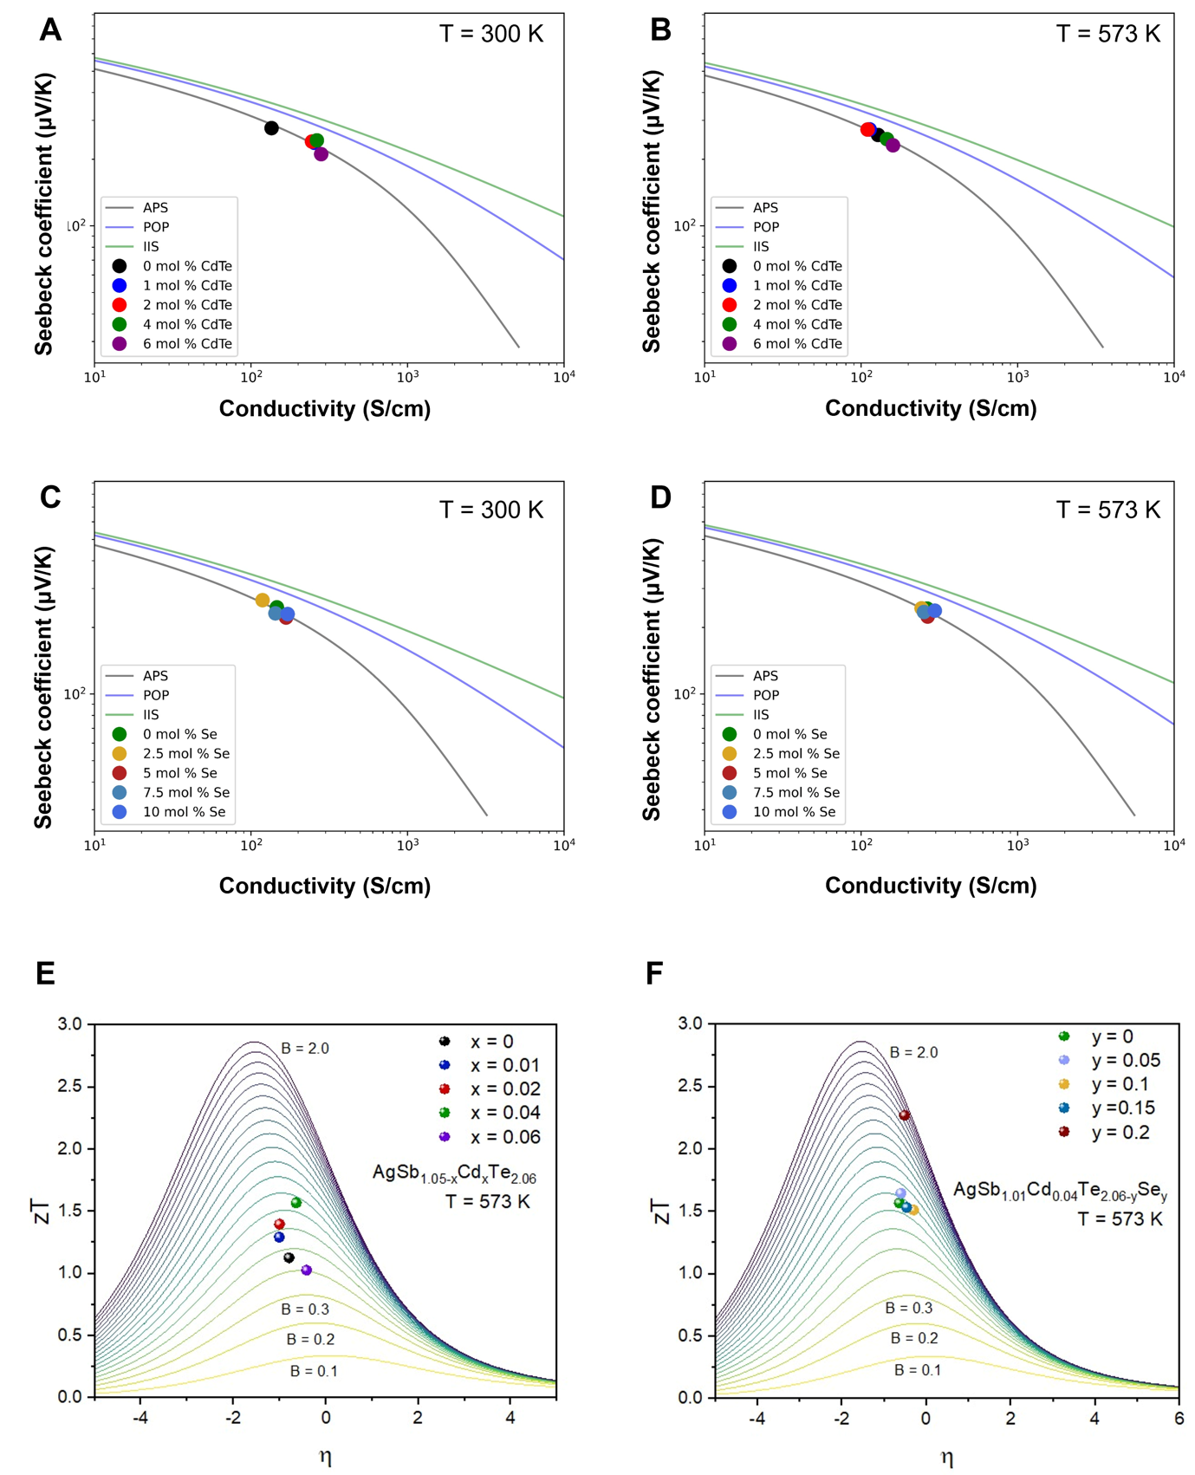
Figure S40. Electronic transport analysis. Jonker plots for Cd-doped AgSb_{1.05-x}Cd_{x}Te_{2.06} samples at (A) 300 K, (B) at 573 K and for Se co-doped AgSb_{1.01}Cd_{0.04}Te_{2.06-y}Se_{y} samples (C) 300 K and (D) 573 K. zT as a function of η at different B values for (E) Cd-doped AgSb_{1.05-x}Cd_{x}Te_{2.06} samples and (F) for Se co-doped AgSb_{1.01}Cd_{0.04}Te_{2.06-y}Se_{y} samples.

For both Cd-doped AgSb_{1.05-x}Cd_{x}Te_{2.06} samples and Se co-doped AgSb_{1.01}Cd_{0.04}Te_{2.06-y}Se_{y} it is clear from Fig S40 A-D that APS dominates at room temperature and above.
The values of for selected samples are benchmarked with the literature in Fig. S42. describes the conductive “quality” of charge carriers in the material (magnitude of conductivity for a given value of h). As temperature increases, increases, which indicates good material quality. Compared to the state-of-the-art material, AgSb_{0.94}Cd_{0.06}Te₂, we observe that both at room temperature and 573 K our values are lower. This could be attributed to lower carrier mobility and would also explain why our overall thermoelectric performance is lower.

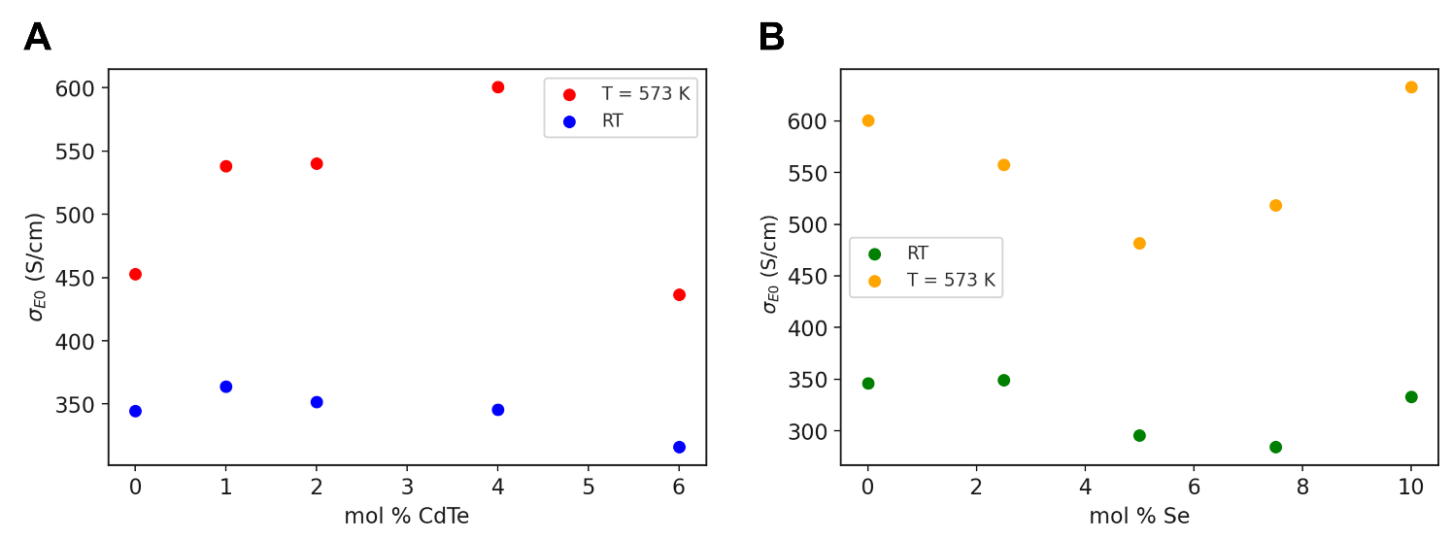
Figure. S41. Energy-independent transport parameter () as a function of doping for room temperature (RT, 300 K) and 573 K. (A) Cd-doped AgSb_{1.05-x}Cd_{x}Te_{2.06} samples at room temperature and 573 K. (B) Se co-doped AgSb_{1.01}Cd_{0.04}Te_{2.06-y}Se_{y} samples at room temperature and 573 K.

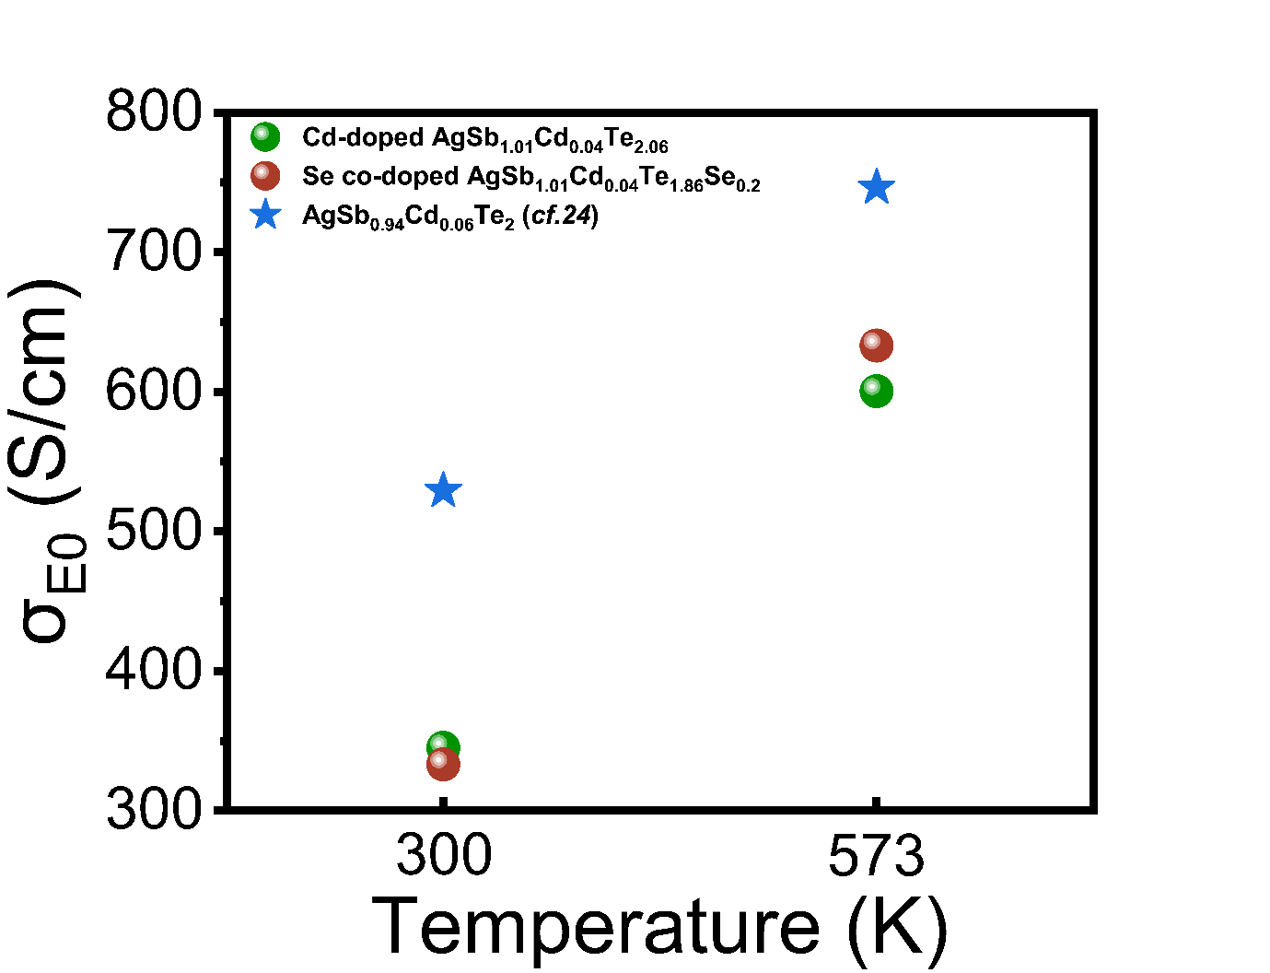
Figure. S42. (A) Comparison of of Cd-doped AgSb_{1.01}Cd_{0.04}Te_{2.06} and Se co-doped AgSb_{1.01}Cd_{0.04}Te_{1.86}Se_{0.2} with 6 mol % Cd doped AgSb_{0.94}Cd_{0.06}Te₂ ²⁴

Supplementary Section S9: Further TDTR Measurements and Boundary determination of thermal mapping.
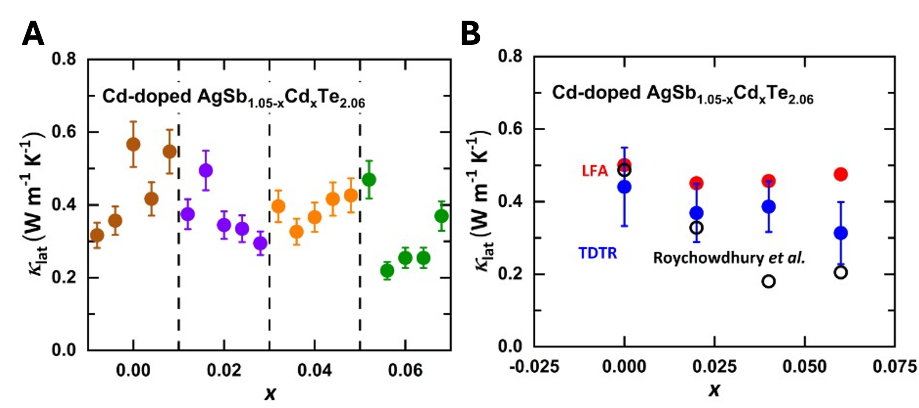
Figure. S43. More thermal conductivity measurements. (A) Variation in the lattice thermal conductivity (κ_{lat}) measured by TDTR. For each sample, TDTR measurements are performed at 4-5 random locations. The uncertainty of each measurement is estimated to be 11%. (B) κ_{lat} of Cd-doped AgSb_{1.05-x}Cd_{x}Te_{2.06} series measured by TDTR (blue) and LFA (red), compared to data from Roychowdhury et al. (black).²⁴ The blue circles and the error bars are the mean values and the standard deviations of 4 – 5 TDTR measurements at random locations, respectively.

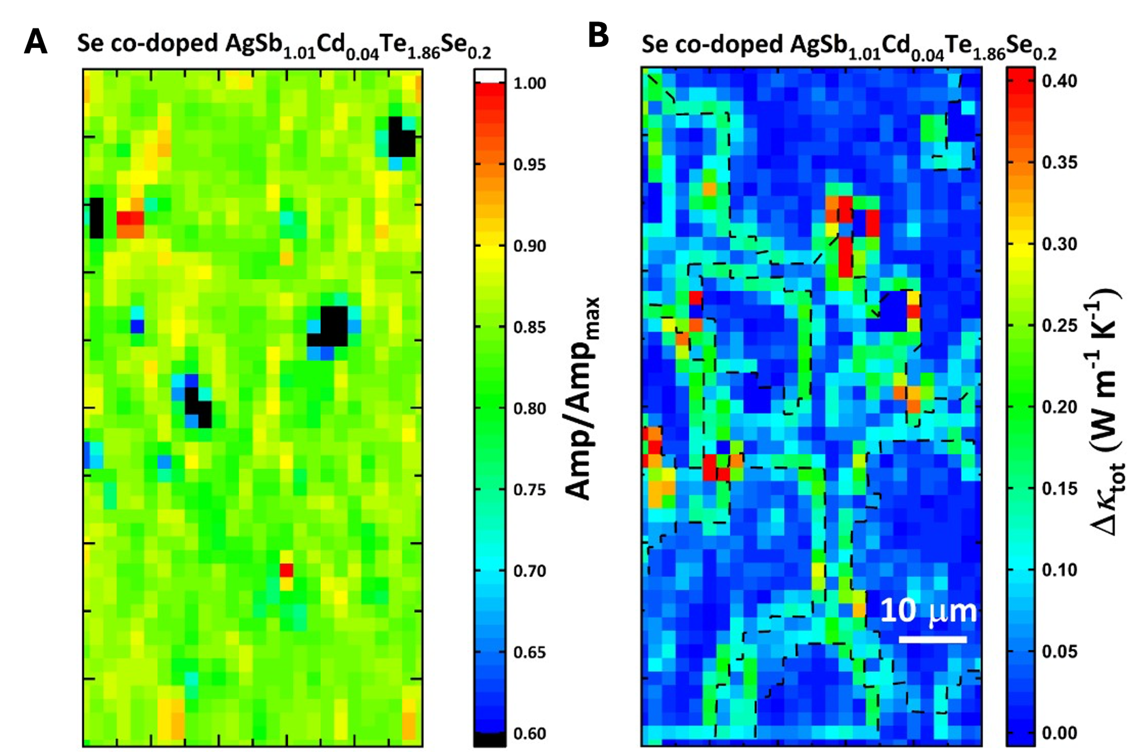
Figure. S44. Boundary determination of thermal mapping (A) Percentage of maximum amplitude of the TDTR signal. Points below 60% (black) are considered affected by surface defects. (B) ∆κ_{tot} mapping of the Se-codoped AgSb_{1.01}Cd_{0.04}Te_{1.86}Se_{0.2} sample. The mapping is derived from Figure. 5D by calculating the maximum absolute difference between each point and its right, top, and top-right neighbours.

To determine the boundaries of the thermal mapping, we first excluded the points affected by surface defects. We analysed the signal amplitude of each point, where V_{in} and V_{out} are the in-phase and out-of-phase components of the TDTR signal, respectively. Then, we excluded those that failed to reach 60% of the maximum amplitude. Then, we plotted ∆κ_{tot} mapping, as shown in Figure S44B. In this mapping, we considered the top-right corner of each point with high ∆κ_{tot} as the boundary between the matrix and the ILs. We connected these corners and then transferred this boundary to Figure. 5D to calculate the average κ_{tot} of the matrix and the ILs.

Supplementary Movie Legends
Movie S1. Typical DJS process for undoped AgSbTe₂. The corresponding time vs. temperature profile for the reaction can be found in Fig. 1C.

References
1. Cahill, D. G. et al. Nanoscale thermal transport. II. 2003–2012. Applied Physics Reviews 1, 011305 (2014).
2. Snyder, G. J. & Toberer, E. S. Complex thermoelectric materials. Nature Materials 7, 105–114 (2008).
3. Lundstrom, Mark. Fundamentals of Carrier Transport. Fundamentals of Carrier Transport (Cambridge University Press, Cambridge, 2000). doi:10.1017/CBO9780511618611.
4. Zevalkink, A. et al. A practical field guide to thermoelectrics: Fundamentals, synthesis, and characterization. Applied Physics Reviews 5, 021303 (2018).
5. Kresse, G. & Furthmüller, J. Efficient iterative schemes for ab initio total-energy calculations using a plane-wave basis set. Physical Review B 54, 11169–11186 (1996).
6. Kresse, G. & Hafner, J. Ab initio molecular dynamics for liquid metals. Physical Review B 47, 558–561 (1993).
7. Kresse, G. & Hafner, J. Ab initio molecular-dynamics simulation of the liquid-metal–amorphous-semiconductor transition in germanium. Physical Review B 49, 14251–14269 (1994).
8. Kresse, G. & Furthmüller, J. Efficiency of ab-initio total energy calculations for metals and semiconductors using a plane-wave basis set. Computational Materials Science 6, 15–50 (1996).
9. Kresse, G. & Joubert, D. From ultrasoft pseudopotentials to the projector augmented-wave method. Physical Review B 59, 1758–1775 (1999).
10. Blöchl, P. E. Projector augmented-wave method. Physical Review B 50, 17953–17979 (1994).
11. Perdew, J. P., Burke, K. & Ernzerhof, M. Generalized Gradient Approximation Made Simple. Physical Review Letters 77, 3865–3868 (1996).
12. Perdew, J. P. et al. Atoms, molecules, solids, and surfaces: Applications of the generalized gradient approximation for exchange and correlation. Physical Review B 46, 6671–6687 (1992).
13. Perdew, J. P. et al. Restoring the Density-Gradient Expansion for Exchange in Solids and Surfaces. Physical Review Letters 100, 136406 (2008).
14. Savory, C. N. et al. An assessment of silver copper sulfides for photovoltaic applications: theoretical and experimental insights. Journal of Materials Chemistry A 4, 12648–12657 (2016).
15. Hubbard, J. & Flowers, B. H. Electron correlations in narrow energy bands. II. The degenerate band case. Proceedings of the Royal Society of London. Series A. Mathematical and Physical Sciences 276, 238–257 (1997).
16. Togo, A. & Tanaka, I. First principles phonon calculations in materials science. Scripta Materialia 108, 1–5 (2015).
17. Togo, A., Chaput, L., Tadano, T. & Tanaka, I. Implementation strategies in phonopy and phono3py. Journal of Physics: Condensed Matter 35, 353001 (2023).
18. Ångqvist, M. et al. icet - A Python library for constructing and sampling alloy cluster expansions. (2019) doi:10.1002/adts.201900015.
19. Zunger, A., Wei, S.-H., Ferreira, L. G. & Bernard, J. E. Special quasirandom structures. Physical Review Letters 65, 353–356 (1990).
20. Heyd, J., Scuseria, G. E. & Ernzerhof, M. Hybrid functionals based on a screened Coulomb potential. The Journal of Chemical Physics 118, 8207–8215 (2003).
21. Zhu, B., Kavanagh, S. R. & Scanlon, D. easyunfold: A Python package for unfolding electronic band structures. Journal of Open Source Software 9, 5974 (2024).
22. M Ganose, A., J Jackson, A. & O Scanlon, D. sumo: Command-line tools for plotting and analysis of periodic ab initio calculations. Journal of Open Source Software 3, 717 (2018).
23. Ganose, A. M. et al. Efficient calculation of carrier scattering rates from first principles. Nature Communications 12, 2222 (2021).
24. Roychowdhury, S. et al. Enhanced atomic ordering leads to high thermoelectric performance in AgSbTe 2. Science 371, 722–727 (2021).
25. Jovovic, V. & Heremans, J. P. Measurements of the energy band gap and valence band structure of AgSbTe 2. Physical Review B 77, 245204–245204 (2008).
26. Zhang, K. et al. Dual Alloying Enables High Thermoelectric Performance in AgSbTe₂ by Manipulating Carrier Transport Behavior. Adv Funct Materials 34, 2400679 (2024).
27. Hong, M. et al. Achieving zT > 2 in p-Type AgSbTe 2− x Se x Alloys via Exploring the Extra Light Valence Band and Introducing Dense Stacking Faults. Advanced Energy Materials 8, 1702333–1702333 (2018).
28. Zhang, Y. et al. Defect‐Engineering‐Stabilized AgSbTe 2 with High Thermoelectric Performance. Advanced Materials 35, (2023).

