Supporting Information
Design of a Robust Graphene Oxide–Palladium Porphyrin Catalyst for the Selective and Sustainable Synthesis of Diaryl Ethers
Soheila Nakhjiri Kamrani,^{b} and Kiumars Bahrami,*^{a,b}
ª Department of Organic Chemistry, Faculty of Chemistry, Razi University, Kermanshah 67149-67346, Iran.
^{b} Nanoscience and Nanotechnology Research Center (NNRC), Razi University, Kermanshah, 67149-67346, Iran. E-mail: kbahrami2@hotmail.com; k.bahrami@razi.ac.ir; Fax: +98(833)4274559; Tel: +98(833)4274559

Contents
1. Experimental 2
  - Material and physical measurements 2
  - Porphyrin synthesis method 2
  - FT-IR spectrum of synthesized porphyrin 3
  - The ¹H-NMR spectrum of THPP structure 4

Experimental
Material and physical measurements
Yields refer to isolated products. All of the known products were characterized by comparison of their spectral data and physical properties with those reported in the literature. Progress of the reaction was followed by TLC (Thin Layer Chromatography) using silica gel polygrams SIL G/UV 254 plates. Infrared spectra were prepared on a Ray Leigh Wqf-510 FT-IR spectrophotometer. ¹H NMR and ¹³C NMR spectra were recorded with a Bruker (400 MHz) spectrometer in CDCl₃ as solvent. Melting points were determined in open capillaries with a Gallen-Kamp melting point apparatus. Chemicals were purchased from the Merck chemical company. The elemental palladium content of nanocatalyst was determined by Perk in Elmer Optima 2000DV inductively coupled plasma-atomic emission spectrometry (ICP-AES). TEM measurements were performed using a Philips CM120 operated at 100 kV electron beam accelerating voltage and equipped with a CCD camera. One drop of the sample solution was deposited onto a copper grid and the excess of the droplet was blotted off the grids with filter paper; then the sample was dried under ambient conditions. X-rays diffraction (XRD) patterns were obtained with an MSALXRD2 diffractometer using Cu Kα radiation. SEM and energy-dispersive X-ray (EDX)measurements were performed using a KYKY-EM3200 operated at 26 kV with the electron gun filament: tungsten [18].

1.2 5, 10, 15, 20-tetrakis-(4-hydroxyphenyl) porphyrin (THPP) synthesis method
Synthesis of THPP was achieved according with the following procedure. Pyrrole (0.02 mL) was slowly added under stirring to a solution of 4-Hydroxy benzaldehyde (0.02 g, 0.15mmol) in 1.5 mL of refluxing propionic acid. Refluxing was continued for 2 hours, then the reaction mixture was cooled to room temperature. Dark purple crystalline product was precipitated. It was filtered, washed thoroughly with hot water, and dried.

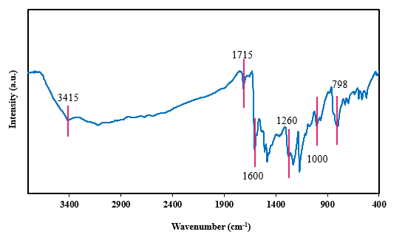

Figure S1. FT-IR spectrum of free THPP

The band observed at 3415 cm⁻¹ is attributed to the O–H stretching vibration of the THPP ring. The N–H stretching vibration appears at 3317 cm⁻¹. A absorption peak at 1715 cm⁻¹ corresponds to the C=N stretching mode, while the C–N bending vibration is observed at 798 cm⁻¹. The C–N stretching vibrations are represented by bands at approximately 1000 and 1350 cm⁻¹. Additionally, the bands located at 1600 and 1660 cm⁻¹ are associated with the stretching vibrations of the C=C bonds. Finally, the absorption bands at 1000 and 1260 cm⁻¹ are assigned to the C–O vibrations in the THPP structure.

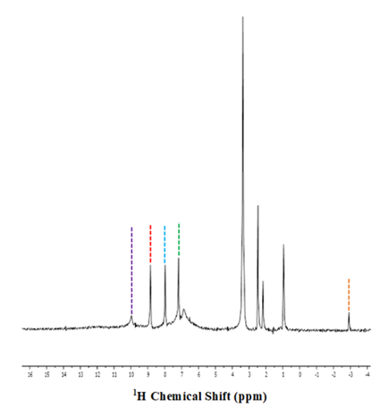

Figure S2. The ¹H-NMR spectrum of THPP structure

¹H NMR (500 MHz, in DMSO) δH: -2.94 (s, 2H, N-H), 7.23 (d, J = 8.4 Hz, 8H, Ar-H), 8.00 (d, J = 8.4 Hz, 8H, Ar-H), 8.83 (s, 8H, Pyrrol-H), 9.96 (s, 4H, Ar-OH).

