Supplemental Information
Particle Size Distribution Measurements and Source Interpretation
Figure S1 illustrates multiple measurements of the airborne particle size distribution using different instruments as a quality control check. If particle bounce were to occur in cascade impactors, the size distribution would be strongly skewed relative to measurements made with other devices. No evidence for high levels of particle bounce is evident in the data.
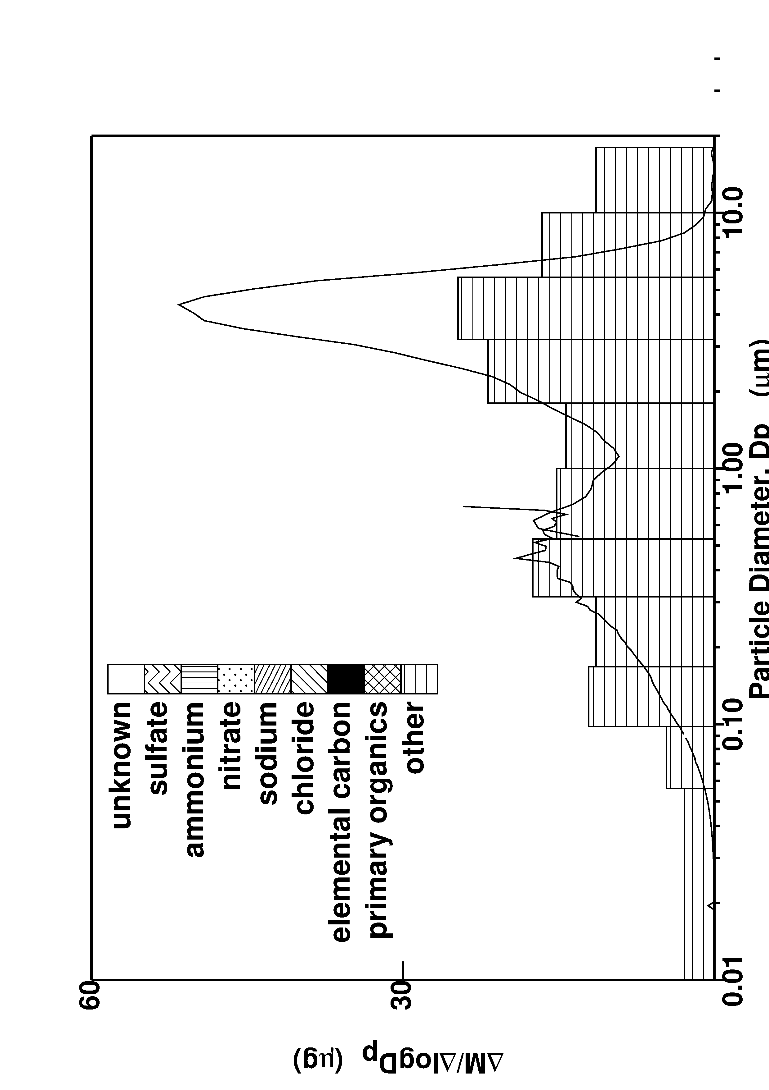 | 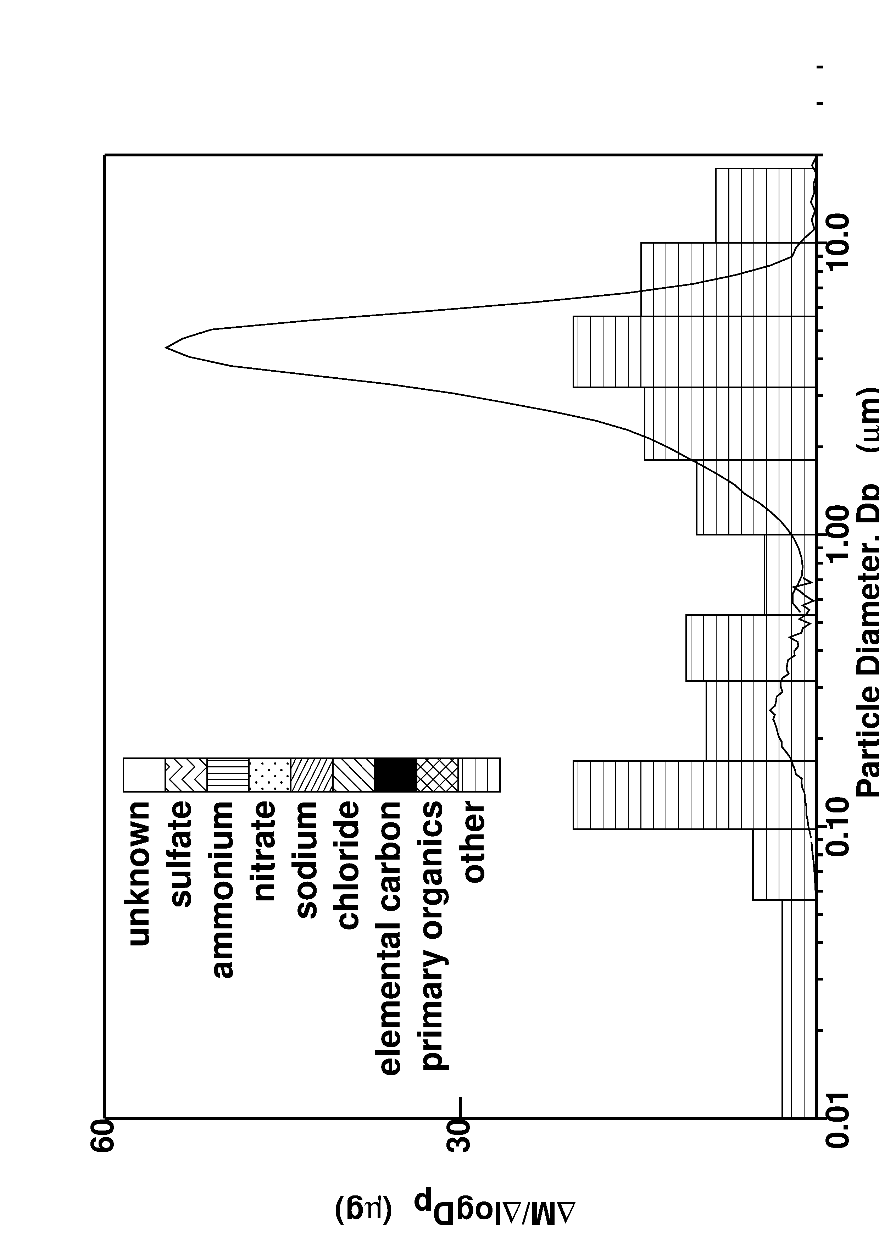
Figure S1. Particle size distributions measured using cascade impactors (bar plot), Scanning Mobility Particle Sizer (SMPS) (line plot Dp<0.7 µm), and Aerodynamic Particle Sizer (APS) (line plot Dp>0.7 µm). Left panel is Altadena, CA, on March 25, 2025, while right panel is Pacific Palisades, CA, on March 27, 2025.
Fig S2-S7 illustrated the full set of particle size and composition distributions measured adjacent to and within the wildfire cleanup zones in Altadena, CA, and Pacific Palisades, CA. The lower axis of each panel shows aerodynamic particle diameter ranging from 0.01 – 18 µm on a log scale, while the upper axis represents the measured mass of the indicated component divided by ΔlogDp. This representation naturally accomodates the log-normal distributions usually associated with airborne particulate matter.
Similarities between component size distributions are used as a chemical “fingerprint” to help identify sources based on previous source-specific measurements. Mg, Al, Ti, Mn, Fe, and Sr have a similar unimodal distribution across samples, peaking at a particle diameter between 3.2 – 5.6 µm. These size and composition profiles are consistent with windblown crustal material and/or road dust generated by vehicles.²⁵ Cu and Ba size distributions measured above 1.0 µm particle diameter also display similar behavior across sample events. Previous studies have found particles associated with brakewear generated by mobile sources to be entriched in these elements.²⁶ The intense truck traffic moving heavy debris loads through the cleanup zones would be expected to generate significant amounts of brakewear. Cu appears to have a secondary source capable of generating particles smaller than 0.1 µm, with secondary peaks below 0.56 µm particle diameter apparent at multiple locations. Heated brake pads can potentially produce ultrafine particles under extreme braking conditions, but these are usually composed of organic compounds, not Cu.²⁷ The source(s) of the ultrafine Cu observed in the current study are not known at this time.
Certain elements such as P, K, Pb, and As have bimodal size distributions in the debris cleanup zones, with a coarse mode apparent at particle diameters between 3.2 – 5.6 µm and a smaller mode sometimes appearing between 0.1 – 1.0 µm. All four elements are found in crustal material and road dust²⁵ which may explain the coarse mode, while the fine mode (when present) may be related to combusted materials. It is noteworthy that K is a primary tracer for biomass combustion^{28,29} and P is a major component of organophosphate ester flame retardants (OPFRs) that are often incorporated into furnishings³⁰ or ammonium polyphosphate that may be airdropped onto wildfires to suppress the fire progression.¹² Pb is found in paints applied to homes before 1978 and in lead-acid batteries used in both conventional and electric vehicles to operate electronics.¹⁸ Conventional vehicles typically have larger lead-acid batteries to start the internal combustion engine, whereas the traction batteries used in electric vehicles do not typically contain significant amounts of lead. Arsenic is a component of wood preservatives used in residential applications prior to 2003.¹⁸ Some of the particulate matter generated by the fires appears to have deposited onto the surface and become associated with larger crustal particles, but a subfraction retained a particle size distribution peaking at ~0.3 µm that is more closely associated with fresh smoke emissions. This could represent the original smoke particles deposited on surfaces but not agglomerated with larger particles that are resuspended during the debris removal process.
Polybrominated diphenyl ethers (PBDEs) containing a signficant amount of B are a second class of flame retardents used in older furnishings and all ages of electronic devices. Measured concentrations of B in airborne PM consistently exhibit a bimodal size distribution with the major peak at between 0.1 – 0.56 µm particle diameter and a minor peak above 10 µm particle diameter. It is likely that B measured in these particles originated from PBDEs, since B concentrations in the interior of the debris cleanup zones are significantly higher than concentrations on the edge of the cleanup zone (compare Fig 2 to Fig S2). The particle size fractions containing B (PBDEs) matches the smaller mode observed in the particle-phase distribution for P (OPFRs) (when present), suggesting that the two classes of flame retardants behaved similarly during the fire and after mixing with other debris during cleanup operations.

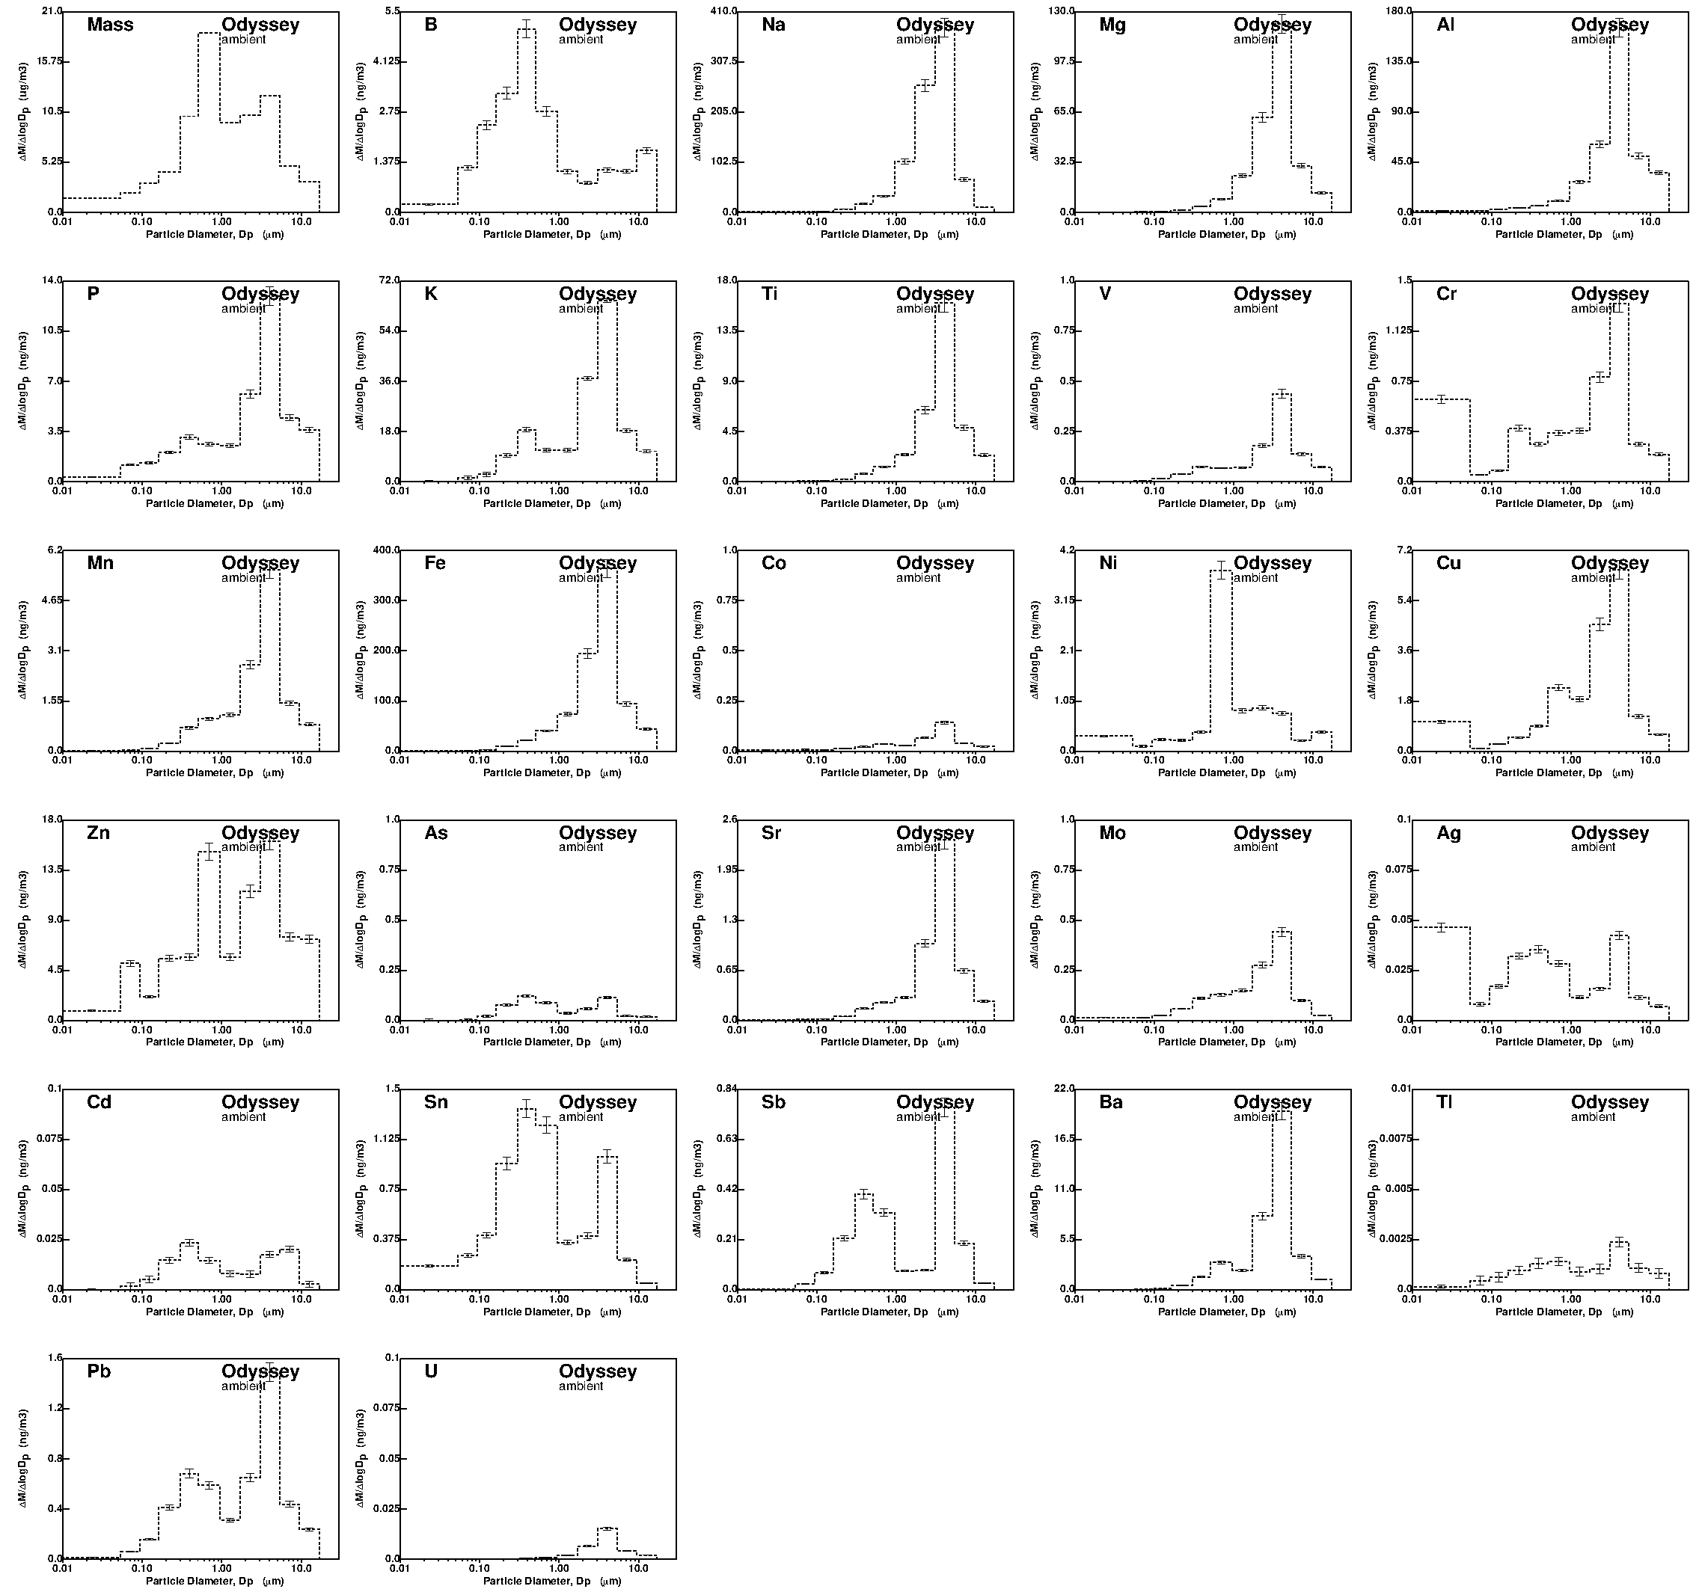
Figure S2: Size distribution of particle-phase components measured at 725 Altadena Dr, Altadena CA, over the time period March 24-26, 2025.

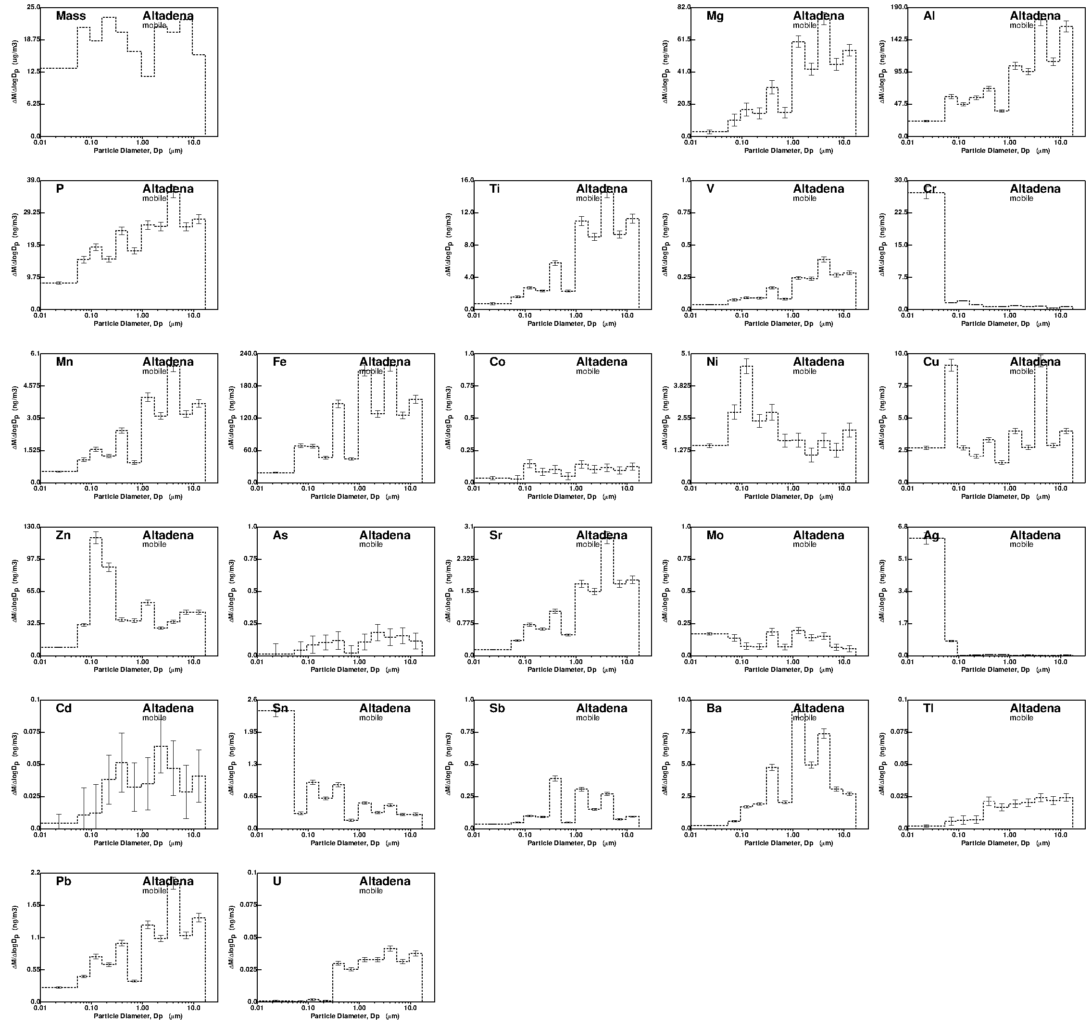
Figure S3: Size distribution of particle-phase components measured throughout the Eaton fire cleanup zone on March 24, 2025.
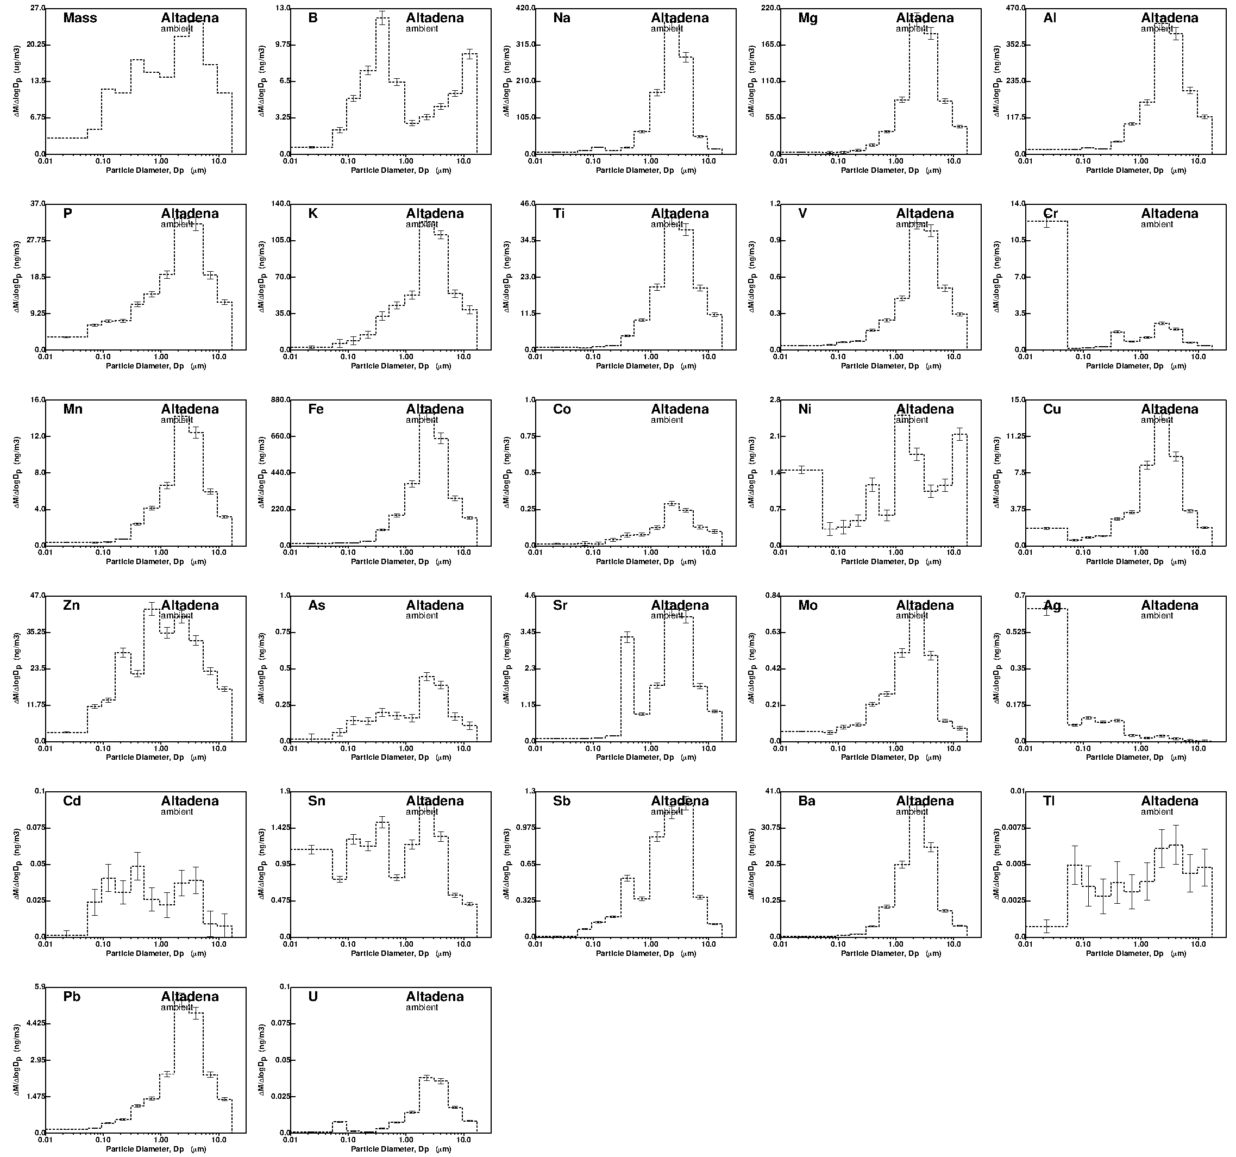
Figure S4: Size distribution of particle-phase components measured throughout the Eaton fire cleanup zone on March 25, 2025.

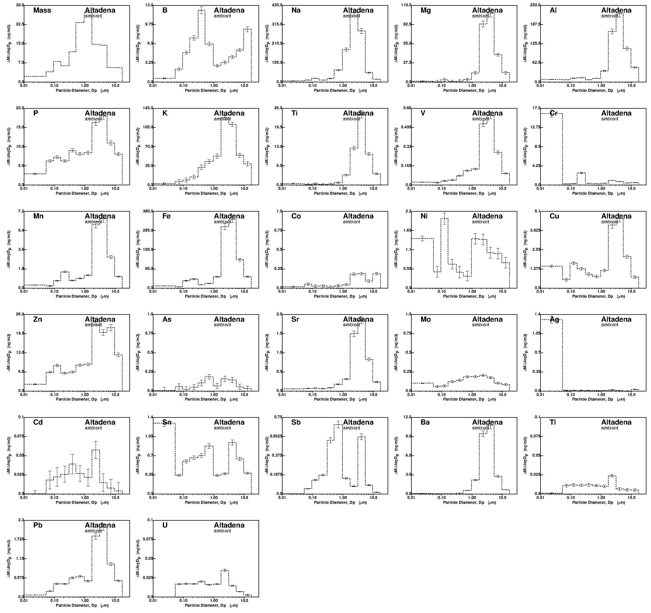
Figure S5: Size distribution of particle-phase components measured throughout the Eaton fire cleanup zone on March 26, 2025.
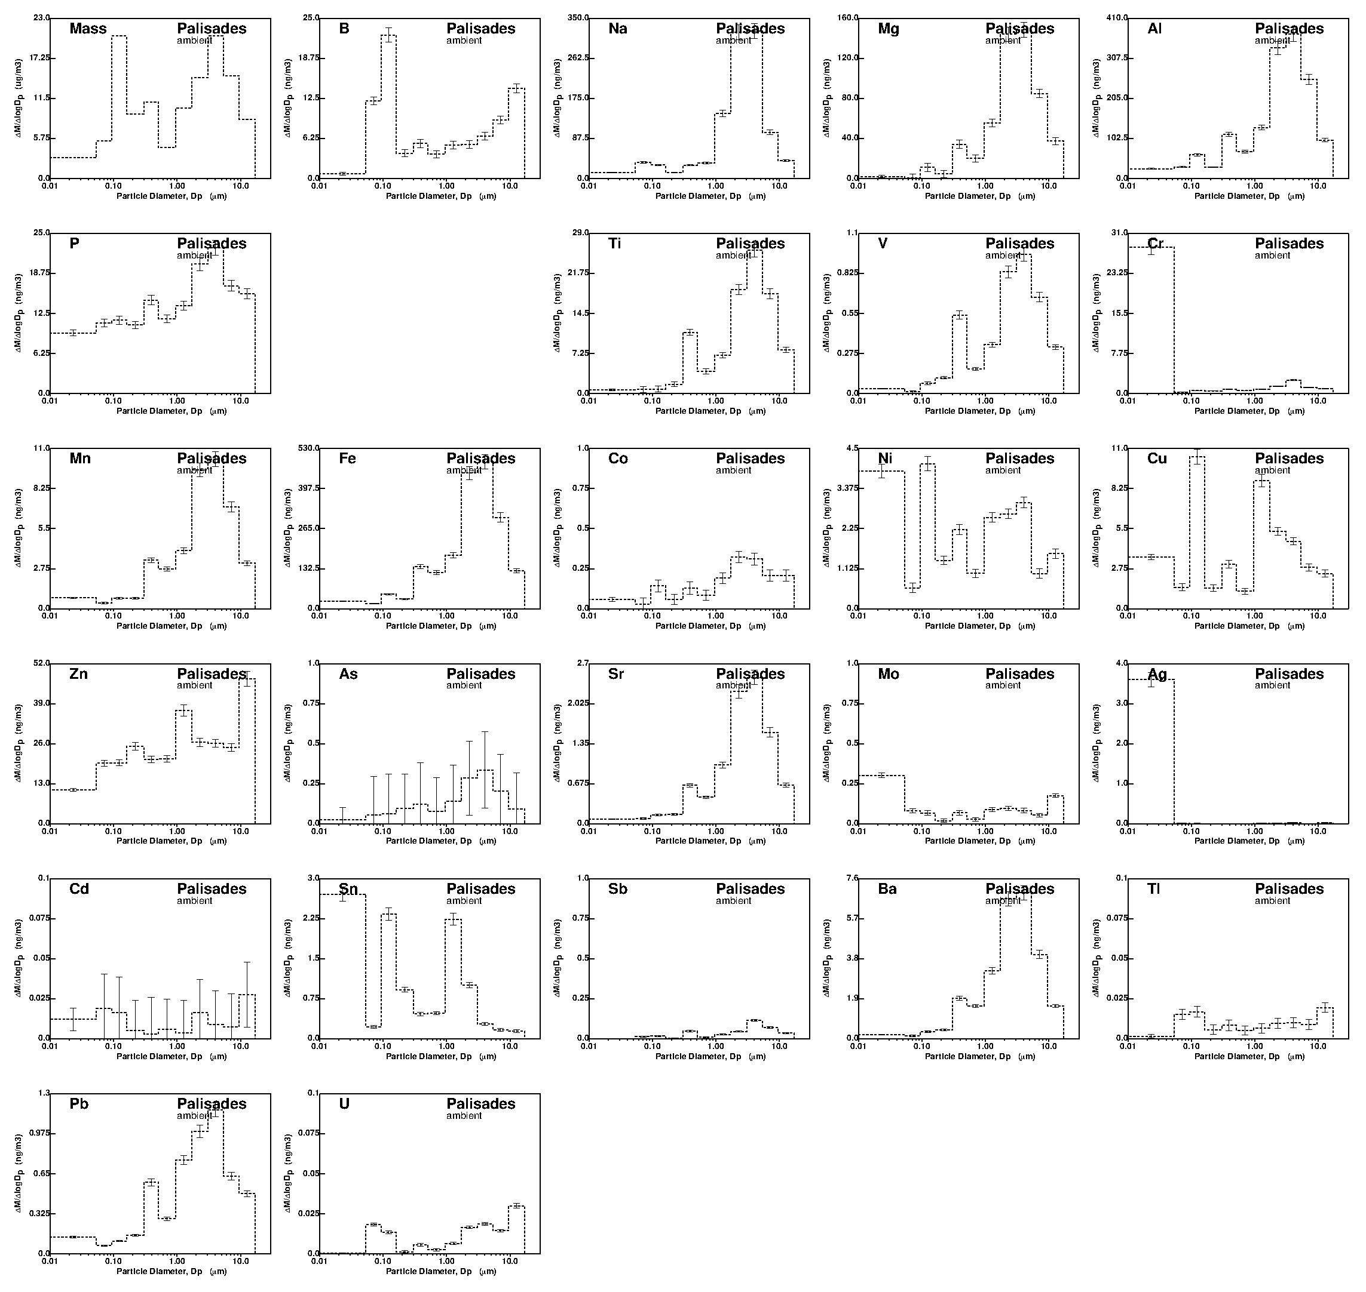
Figure S6: Size distribution of particle-phase components measured throughout the Palisades fire cleanup zone on March 27, 2025.

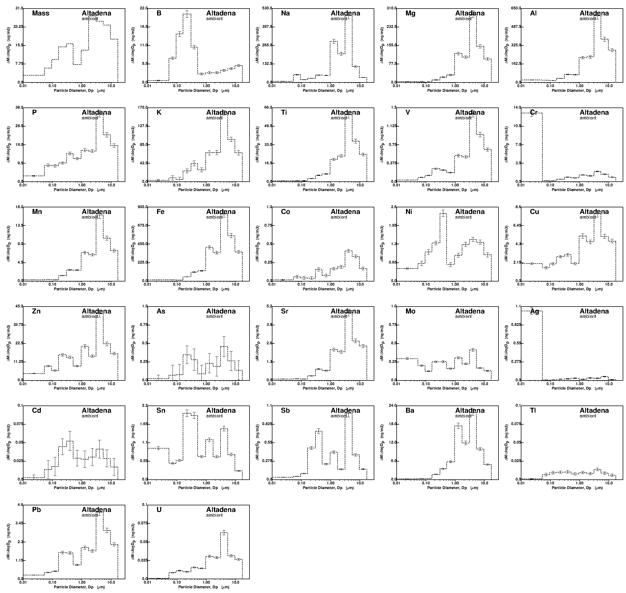
Figure S7: Size distribution of particle-phase components measured throughout the Eaton fire cleanup zone on April 9, 2025.

Calculations for Estimates of Nanoparticle Exposure Distance
Pollutant Decay Downwind of Roadways
Numerous studies have observed an exponential decay of traffic-related pollutant concentrations downwind of roadways due to atmospheric mixing, deposition to the surface, and chemical reaction.²² Measured concentrations follow a pattern predicted by
$C=C_{o}exp(\frac{-x}{Rd})$ (1)
where x is the distance between two measurements of pollutant concentrations C and C_{o}, while Rd is a “decay length scale”. A recent meta-analysis of published results suggested that a decay length scale of approximately 500 m is appropriate for slowly-reacting pollutants like carbon monoxide (CO).²² Hexavalent chromium nanoparticles will not evaporate in the atmosphere like ultrafine particles composed of organic compounds emitted from motor vehicles³¹, and so the CO length scale is adopted in the current analysis. Using this value in eq (1) with a goal to reduce concentrations by a factor of 13.6 / 0.1 = 136 yields a total decay distance of 2456 m (2.5 km). Traffic-related pollutants generally cannot be discerned at downwind distances greater than 1 km because these pollutants also exist in the background air. Eq (1) should not be used to predict concentration decay rates beyond the 1 km limit where it has been tested. At best, eq (1) predicts that health-relevant concentrations of hexavalent chromium nanoparticles can be transported more than 1 km downwind.
Pollutant Decay in a Well-Mixed Atmosphere
Much of the downwind concentration profile of hexavalent chromium nanoparticles will depend on how well mixed they were in the atmosphere when they were measured in the debris cleanup zone. If concentrations were already uniformly mixed up to some representative height in the atmosphere, then additional dilution is not a doinant process and removal at the earth’s surface is the only mechanism to reduce concentrations. In the absence of rain events, particles are removed from the atmosphere through a combination of gravitational settling (dominant for large particles) and Brownian motion (dominant for small particles). Fig S8 displays the combined “deposition velocity” for particles ranging in size from 0.01 to 10 µm^{23,32} under neutral atmospheric stability conditions. Applying this size-resolved deposition velocity to the particle size distributions displayed in Fig 2-3 and S2-S7 yields an average deposition velocity for each particle-phase element. Selected components from each of the source groupings discussed above are shown in Fig 4a, while results for all components are showing in Fig S9a. Assuming concentrations are uniformly mixed to some initial height H, then the concentration at any later time after the air mass moves out of the debris cleanup zone will be predicted by the equation
$C=C_{o}exp(\frac{-V_{d}t}{H})$ (2)
where C_{o} is the initial concentration, V_{d} is the deposition velocity, and t is time. Four of the timescales $τ=H/{V_{d}}$are sufficient to remove 98% of the material from the atmosphere, approximately meeting the health-protective threshold. The downwind distance (d) traveled during this time will be
$d=4τ\overline{u}$ (3)
where $\overline{u}$ is the mean windspeed. Fig 4b and Fig S9b illustrate the exposure distance for different pollutants, assuming a mean wind speed of 3 m/s and an initial mixing height of 5m under neutral atmospheric stability conditions. The results of these calculations suggest that windblown dust generated by cleanup activities can travel 2-10 km downwind of the cleanup zones. Crustal material (represented by Al) will have the shortest exposure distance, fragments of fire retardants (represented by B and P) may have slightly longer transport distances, and nanoparticles (Cr and Ag) will have the longest median transport distances.

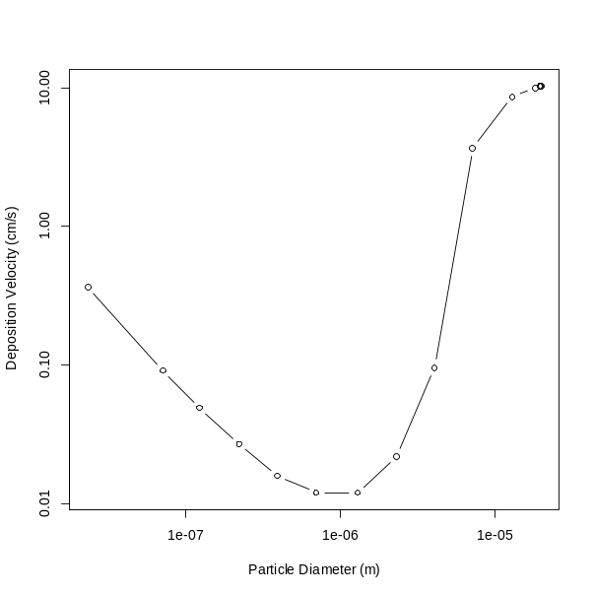
Figure S8: Particle deposition velocity at a reference height of 5 m calculated with an assumed particle density of 1.1 g/cm³ with a horizontal wind speed of 3 m/s in a neutral atmosphere.

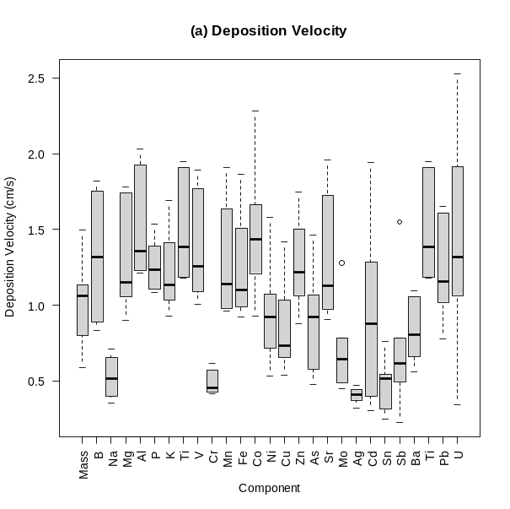 | 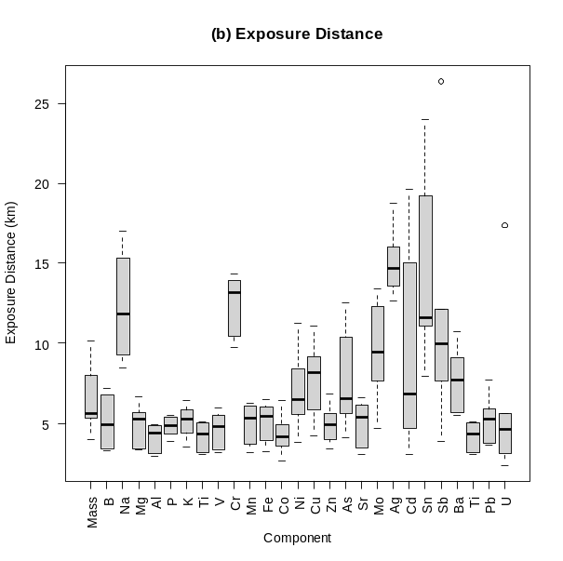
Figure S9: (a) Deposition velocity and (b) exposure distance for all components measured in the current study.
Pollutant Decay Due to Atmospheric Mixing
Atmospheric mixing by turbulent diffusion distributes pollutants in a Gaussian profile, leading to the well-known Gaussian Plume models that provide closed-form analytical solutions to pollutant concentration fields under simplified conditions.²³ Gaussian Plume models can be configured with elevated release, a perfectly absorbing surface, or a perfectly reflecting surface, but these models cannot represent partial loss rates that vary by pollutant as shown in Fig S9a. Elevated temperature inversions that inhibit mixing beyond a certain height can be configured. Concentrations are predicted as a function of downwind distance x, crosswind distance y, and vertical elevation z. Multiple Gaussian Plume models can be superimposed to describe a network of emissions sources.
In the current study, a network of Gaussian Plume models consisting of 11 emissions sources located 5 m above the surface were arranged in a line with regular spacing of 100 m, representing a fire cleanup zone with multiple demolition and debris removal activities occurring at the same time. The model was configured assuming that atmospheric dilution was the primary decay mechanism for ground-level nanoparticle concentrations (perfectly reflecting surface). Final ground level concentrations were predicted with the equation
$C=\frac{Q}{2πσ_{y}σ_{z}u}\sum{\left\{exp\left[\frac{-{(z-H+2jL)}^{2}}{2σ_{z}^{2}}\right]+exp\left[\frac{-{(z+H+2jL)}^{2}}{2σ_{z}^{2}}\right]\right\}}$ (4)
where Q is the emissions rate of the pollutant, $σ_{y}$ is the standard deviation of the pollutant concentration in the y direction (m), $σ_{z}$ is the standard deviation of the pollutant concentration in the z direction (m), u is the mean wind speed (m/sec), z is the height above ground where the measurement is taken (0 m), H is the height of the elevated release, L is the height of the elevated inversion layer, and the summation operates over a range j from -3 to +3 (using multiple imaginary sources to simulate the inversion layer). $σ_{y}$ and $σ_{z}$ increase with downwind distance based on atmospheric stability conditions ranging from highly unstable to neutral to highly stable.³³
All input meteorological data needed to drive the Gaussian plume calculation was predicted using the Weather Research and Forecast (WRF) model with assimilation of measurements from nearby weather stations for the month of March 2025. Hour-specific and location-specific wind speed and atmospheric mixing height were used to tailor the calculations for both Altadena and Pacific Palisades. A summary of wind speeds and mixing heights is shown in Fig 4c for the working hours of 8am to 6pm each day. Atmospheric stability class was assigned as a function of solar radiation and mean wind speed. Concentrations of hexavalent chromium nanoparticles were assumed to be measured 100 m downwind of an emissions source located 5 m above ground. Centerline concentrations were then predicted every 50 m downwind of the measurement location until health-protective threshold of 0.1 ng / m³ was achieved (Fig 4d). Decay distances were greater in the early morning and late afternoon hours because the reduced mixing height at these times inhibited atmospheric dilution. Median decay distances across all daytime hours varied from approximately 6 km in Altadena to 10 km in Pacific Palisades, but hour-to-hour variation was significant depending on the meteorological conditions on each specific day.

