Supporting Information for

A novel algorithm for 3D multi-level gravity interpretation: application to northwestern Iran

Ako Alipour^{1*}, Khalil Motaghi¹, Zahra Mousavi¹, Matteo Scarponi²
¹ Department of Earth Sciences, Institute for Advanced Studies in Basic Sciences (IASBS), Zanjan 45137-66731, Iran
² Laboratoire de Géologie de Lyon: Terre, Planètes, Environnement, Université Claude Bernard Lyon 1, Villeurbanne, France

Table of Contents
- Introduction
- Detailed Methodologies
Text S.1: Periodic Formulation of Gravity Data and Analytic Signal Concept
Text S.2: Classical Laplace Framework for Gravity Anomalies in ${SRWL}_{n}$ Context
- Knitting Gravity Datasets
Text S3: Weighted Averaging for Knitting Gravity Datasets
- Supplementary Figures
Figure S1: Synthetic model 2 (Table 2) and its power spectrum segmentation.
Figure S2. Spectral level decomposition and depth estimation for levels RWL1–RWL7 of the synthetic model shown in Figure S1.
Figure S3. Spectral level decomposition and depth estimation for levels SRWL1–SRWL7 of the synthetic model shown in Figure S1.
Figure S4. Stacked depth estimates for the synthetic model in Figure S1a: (a) From RWL1–RWL7; (b) From SRWL1–SRWL7.
Figure S5. Selection of optimal height factor ($Δz₁$) for FcAM3D modeling of gravity data in northwestern Iran.

1. Introduction
This supplementary document accompanies the study "A Novel Algorithm for 3D Multi-Level Gravity Interpretation: Application to Northwestern Iran." It provides a comprehensive and detailed presentation of the methodologies, theoretical foundations, and data analyses that underpin the main article. By elaborating on the analytical frameworks and step-by-step procedures, this supplement aims to enhance transparency, support reproducibility, and validate the novel techniques introduced in this research. Readers will find expanded explanations and illustrative figures that deepen the understanding of the multi-level gravity interpretation approach applied to the study area.

2. Detailed Methodologies

Text S.1
Periodic Formulation of Gravity Data and Analytic Signal Concept
To extend the analytic-signal approach into two spatial dimensions on a rectangular tile $L_{x}×L_{y}$, follow these steps (e.g., Bracewell, 1965; Papoulis, 1962):
Double Fourier Series of the Gravity Map
Express $U_{0}(x,y)$ as a truncated 2D Fourier series:
$$\begin{matrix}U_{0}(x,y)= & \sum_{p=0}^{P}{ } \sum_{q=0}^{Q}{ } \left[A_{pq}cos⁡\left(2πpx/L_{x}\right)cos⁡\left(2πqy/L_{y}\right)+B_{pq}cos⁡\left(2πpx/L_{x}\right)sin⁡\left(2πqy/L_{y}\right)\right. \\ & \left.+C_{pq}sin⁡\left(2πpx/L_{x}\right)cos⁡\left(2πqy/L_{y}\right)+D_{pq}sin⁡\left(2πpx/L_{x}\right)sin⁡\left(2πqy/L_{y}\right)\right] \end{matrix}$$
$p,q$ index harmonics up to orders $(P,Q)$. Coefficients $A_{pq},B_{pq},C_{pq},D_{pq}$ capture amplitudes of each 2D harmonic. Truncation $(P,Q)$ band-limits wavelengths below $L_{x}/P,L_{y}/Q$.
2D Hilbert Transform
Phase-shift each term by ${90}^{∘}$ independently in $x$ and $y$ :
$$\begin{matrix}H\{U_{0}\}(x,y) & =\sum_{p,q}{ } \left[-A_{pq}sin⁡\left(2πpx/L_{x}\right)sin⁡\left(2πqy/L_{y}\right)+B_{pq}sin⁡\left(2πpx/L_{x}\right)cos⁡\left(2πqy/L_{y}\right)\right. \\ & \left.+C_{pq}cos⁡\left(2πpx/L_{x}\right)sin⁡\left(2πqy/L_{y}\right)-D_{pq}cos⁡\left(2πpx/L_{x}\right)cos⁡\left(2πqy/L_{y}\right)\right]\end{matrix}$$
Complex Analytic Signal
Combine real and Hilbert parts (e.g., Nabighian, 1972; 2005):
$$A(x,y)=U_{0}(x,y)+iH\{U_{0}\}(x,y)$$
In coefficient form, each Fourier term acquires a complex amplitude that encodes the ${90}^{∘}$ shift.
Analytic-Signal Amplitude (Edge Strength)
Compute spatial derivatives term-by-term and simply take the magnitude (e.g., Nabighian, 1972; 2005):
$$AS(x,y)=|A(x,y)|=\sqrt{[RA(x,y)]^{2}+[IA(x,y)]^{2}}$$
This $AS(x,y)$ peaks along the strongest lateral gradients-ideal for mapping fault lines, basin edges, or intrusions.
Continuous-Spectrum Formulation (Quadrant-Filtered Approximation)
To approximate a one-sided analytic signal in 2D by keeping only the positive-frequency quadrants, define the 2D Fourier transform of the gravity map:
$$\hat{U_{0}}\left(k_{x},k_{y}\right)=\iint{ }U_{0}(x,y)e^{-i\left(k_{x}x+k_{y}y\right)}dxdy$$
Introduce the Heaviside step function $H(k)$ and Dirac delta $δ(k)$ :
$$H(k)=\left\{\begin{matrix}1, & k>0, \\ 0, & k<0,\end{matrix} δ(k)= \text{Dirac delta function centered at} k=0\right.$$
Then the quadrant mask is (e.g., Debeglia & Corpel, 1997):
$$M\left(k_{x},k_{y}\right)=H\left(k_{x}\right)+δ\left(k_{x}\right)H\left(k_{y}\right),$$
which equals 1 for $k_{x}>0$ or $\left(k_{x}=0,k_{y}>0\right)$, and 0 otherwise.
The approximate analytic-signal spectrum is:
$$\hat{A}\left(k_{x},k_{y}\right)=2\hat{U_{0}}\left(k_{x},k_{y}\right)M\left(k_{x},k_{y}\right)=2\hat{U_{0}}\left(k_{x},k_{y}\right)\left[H\left(k_{x}\right)+δ\left(k_{x}\right)H\left(k_{y}\right)\right].$$
Interpretation
This quadrant-filtered approximation effectively doubles the contribution of all retained positive-wavenumber components, enhancing features that propagate in the +x direction (and along +y when $k_{x}=0$). As a result, the reconstructed complex field $A(x,y)$ captures primarily those edge signatures whose wavevectors fall within the first and positive $k_{y}$ half-axis, making $AS(x,y)$ a directional edge detector.
Summary Table: 1D vs. 2D Analytic Signal for Gravity Data
Aspect | 1D Formulation | 2D Extension
Fourier Transform | $\hat{U_{0}}(k)=\int_{-∞}^{∞}{ }U_{0}(x)e^{-ikx}dx$ Fourier transform of profile $U_{0}(x)$ | $\hat{U_{0}}\left(k_{x},k_{y}\right)=\iint_{-∞}^{∞}{ }U_{0}(x,y)e^{-i\left(k_{x}x+k_{y}y\right)}dxdy$ Fourier transform of 2D map $U_{0}(x,y)$
Fourier Domain Filter | $$2\hat{U_{0}}\left(k\right)m\left(k\right),$$  $m(k)=1$ for $k>$ 0,  $m(k)=0$ for $k≤0$ | $$2\hat{U_{0}}\left(k_{x},k_{y}\right)M\left(k_{x},k_{y}\right),$$  $M\left(k_{x},k_{y}\right)=1$ for $k_{x}>0$ or $\left(k_{x}=0,k_{y}>0\right),$  $M\left(k_{x},k_{y}\right)=0$ otherwise
Inverse FT (Analytic Signal) | $$AS(x)=F^{-1}[2\hat{U_{0}}(k)m(k)]$$ | $$AS(x,y)=F^{-1}\left[2\hat{U_{0}}\left(k_{x},k_{y}\right)M\left(k_{x},k_{y}\right)\right]$$

Amplitude Spectrum (Frequency Domain)
$$A\left(k_{x},k_{y}\right)=\left\{\begin{matrix}2\left|\hat{U_{0}}\left(k_{x},k_{y}\right)\right|, & M\left(k_{x},k_{y}\right)=1 \\ 0, & M\left(k_{x},k_{y}\right)=0\end{matrix}\right.$$
Here the selected quadrant (positive-frequency region) is doubled, and all other regions are set to zero.
The factor of 2 ensures that the amplitude of the analytic signal matches the original signal in the spatial domain (as in 1D).
This formulation captures the non-negative frequency content of the 2D signal, which is crucial for constructing a meaningful complex analytic signal in space.
It is indeed an approximation because the mask doesn't account for symmetry conditions at the boundaries in a discrete setting, but it's widely used in practice.

Text S.2
Classical Laplace Framework for Gravity Anomalies in ${SRWL}_{n}$ Context
In a free-space domain (i.e., outside the mass distribution), the gravitational potential $ϕ(x,y,z)$ satisfies Laplace's equation (e.g., Hofmann & Moritz, 2006):
$∇^{2}ϕ=0, (x,y,z)∈R^{3}∖\{$ sources $\}$
In the upward-positive coordinate convention adopted here, the gravity anomaly $U_{0}(x,y)$ measured at a station elevation $z_{i}$ corresponds to the vertical derivative of the potential evaluated just above that elevation:
$$U_{0}(x,y)={\left.\frac{∂ϕ}{∂z}\right|}_{z=z_{i}^{+}}$$
Taking the 2D horizontal Fourier transform of the potential:
$Φ\left(k_{x},k_{y},z\right)=$ $\iint_{-∞}^{+∞}{ }ϕ(x,y,z)e^{-i\left(k_{x}x+k_{y}y\right)}dxdy$
with radial wavenumber $‖k‖=\sqrt{k_{x}^{2}+k_{y}^{2}}$ and invoking $∇^{2}ϕ=0$, the vertical dependence in Fourier space becomes:
$$Φ\left(k_{x},k_{y},z\right)=B\left(k_{x},k_{y}\right)e^{-‖k‖z}, z≥0$$
and $B\left(k_{x},k_{y}\right)$ is a spectral amplitude of $Φ\left(k_{x},k_{y},z=0\right)$ or Fourier-domain solution to Laplace’s equation. The gravity anomaly in Fourier space is thus:
$$\hat{U_{0}}\left(k_{x},k_{y}\right)=F\left\{U_{0}(x,y)\right\}=‖k‖B\left(k_{x},k_{y}\right)$$
As previously mentioned in main text, at each step of the decomposition, the continued field is recursively computed from the preceding level according to the method described by Blakely (1995).
$U_{n}(x,y)=F^{-1}\left\{F\left[U_{n-1}(x,y)\right]\left(k_{x},k_{y}\right)⋅e^{-‖k‖Δz_{n}}\right\}$ with $‖k‖=\sqrt{k_{x}^{2}+k_{y}^{2}}$.
We define the ${RWL}_{n}$ maps for $n=1,2,…,N$ by:
${RWL}_{n}(x,y)=$ $U_{n-1}(x,y)-U_{n}(x,y)$
Each ${RWL}_{n}$ field isolates a depth-specific spectral band of the gravity anomaly corresponding to the range of wavelengths attenuated between two successive continuation levels.
To explicitly represent this in spectral space, each ${RWL}_{n}$ field is confined to a wavenumber window $\left[k_{min}^{\left(n\right)},k_{max}^{\left(n\right)}\right]:$
${\hat{RWL}}_{n}\left(k_{x},k_{y}\right)=\left({\overset{ˆ}{U}}_{n-1}\left(k_{x},k_{y}\right)⋅e^{-‖k‖{Δz}_{n-1}}-{{\overset{ˆ}{U}}_{n}\left(k_{x},k_{y}\right)⋅e}^{-‖k‖Δz_{n}}\right),$
for $‖k‖∈\left[k_{min}^{(n)},k_{max}^{(n)}\right]$
This defines an explicit bandpass window for each level $n$, controlled by exponential continuation heights ${Δz}_{n-1}$ and ${Δz}_{n}$.
As we said before in the main text, to recover a balanced representation of ${RWL}_{n}$, the ${SRWL}_{n}$ field compensates for the depth-based attenuation (Eq. 9, 19 and 20):
${SRWL}_{n}(x,y)=\frac{1}{2π}F^{-1}\left\{\hat{{SRWL}_{n}}\left(k_{x},k_{y}\right)⋅W_{n}(‖k‖)\right\}$
where: $W_{n}(‖k‖)=\left\{\begin{matrix}e^{-‖k‖{Δz}_{n}}, & ‖k‖∈\left[k_{min}^{(n)},k_{max}^{(n)}\right] \\ 0, & \text{ otherwise }\end{matrix}\right.$
$W_{n}(‖k‖)$ is the spectral window function used in the decomposition of gravity anomalies at level n. It has two key roles:
The term $e^{-‖k‖{Δz}_{n}}$​ applies upward continuation in the frequency domain, it attenuates high-frequency (short-wavelength) components, simulating how gravity fields appear from a higher elevation.
The restriction $‖k‖∈\left[k_{min}^{(n)},k_{max}^{(n)}\right]$ ensures only a specific band of wavelengths (or spatial frequencies) is preserved at each decomposition level. This limits instability and allows decomposition into distinct depth-sensitive components.
Spectral Interpretation and Harmonic Validity
In the realistic, band-limited case, ${SRWL}_{n}$ is a harmonic approximation valid within its defined spectral window. The power spectrum (e.g., Spector & Grant, 1970; Bhattacharyya & Leu, 1975a, 1977; Ravat et al., 2007):
$$P_{n}(k)=\frac{1}{2π}\int_{0}^{2π}{ }{\left|F\left[{SRWL}_{n}\right](k,θ)\right|}^{2}dθ$$
Form Equation 17:
$$P_{n}(k)≈{\left|Re(F\left[SRWL_{n}\right])\right|}^{2}/2$$
shows linear decay in,
$lnP_{n}(k)$ for $k∈$ $\left[k_{min}^{(n)},k_{max}^{(n)}\right]:lnP_{n}(k)≈lnA_{n}-2d_{n}k$
Here, $A_{n}$ is a constant scaling factor, and $d_{n}$ corresponds to the depth to the top of the source layer, assuming a statistically random distribution of sources. Under the assumption of isotropy and negligible high-frequency noise, this spectrum decays approximately exponentially with wavenumber over the range $k∈\left[k_{min}^{(n)},k_{max}^{(n)}\right]$, producing a linear trend in logarithmic form. Hence, each ${SRWL}_{n}$ field represents a spectrally bounded, physically scaled, and polarity-preserving band of the gravity anomaly field, directly derived from Laplace theory and valid for interpretation within its active $k$ band $\left[k_{min}^{(n)},k_{max}^{(n)}\right]$.
3. Knitting Gravity Datasets
Text S.3
Weighted Averaging for knitting Gravity Datasets
To effectively knit satellite gravity anomaly data with higher-accuracy ground gravity data, Weighted Averaging provides a practical and reliable approach (Moritz, 1980). This method ensures that the resulting dataset retains the accuracy of ground gravity data while benefiting from the broad coverage provided by satellite measurements. In overlapping areas, compute a weighted average:
$$g_{combined}​=w_{1}​g_{ground}​+w_{2}​g_{satellite​}$$
Weights are determined based on the relative accuracies of the datasets. The weights are inversely proportional to the variances (or uncertainties) of the datasets. The weights $w_{1}$ and $w_{2}$ are inversely proportional to the variances of the datasets:
$$w_{1}=\frac{σ_{\text{satellite} }^{2}}{σ_{\text{ground} }^{2}+σ_{\text{satellite} }^{2}}, w_{2}=\frac{σ_{\text{ground} }^{2}}{σ_{\text{ground} }^{2}+σ_{\text{satellite} }^{2}}$$
$σ_{\text{ground} }$ represents the standard deviation (uncertainty) of ground gravity data, while $σ_{\text{satellite} }$ represents the uncertainty of satellite data. Since ground gravity data is typically more accurate ( $σ_{\text{ground} }<σ_{\text{satellite} }$ ), the weight $w_{1}$ for the ground data will be larger than $w_{2}$.
The advantages of this method include its simplicity and faster computation. It retains the higher accuracy of ground data in overlapping areas, while satellite data fills gaps beyond the ground data coverage, ensuring a consistent gravity anomaly dataset across the entire region. This approach also allows for adjustments based on the relative quality and resolution of the datasets. By applying Weighted Averaging, the integrated gravity dataset achieves a balance between the local precision of ground measurements and the extensive spatial coverage of satellite observations. Weighted averaging does not alter the ground data values significantly in areas where it exists. Instead, it integrates the broader trends from satellite data into regions beyond the ground data coverage.
Inside the ground data region, the gravity anomaly will be dominated by the ground data because it has a higher accuracy ($w_{1}$​ will be large).
At the border, the weighted average will combine the two datasets gradually, ensuring that both the ground and satellite data contribute according to their relative accuracies. This prevents a sharp discontinuity between the two types of data and creates a smooth transition in the gravity anomaly.
Inside the satellite-only region, the satellite data solely defines the gravity field because ground data is absent, but the satellite data will continue to reflect a broad-scale view of the gravity anomalies.
Now, define a spatially dependent exponential blending function $λ(x,y)$ that transitions smoothly near the boundary:
$$λ(x,y)=exp⁡\left(-\frac{d(x,y)}{L}\right)$$
$d(x,y)$, distance from the current point $(x,y)$ to the nearest ground gravity data point. This means:
Inside the ground data region:
$d(x,y)=0$
Near the boundary (edge of ground coverage):
$d(x,y)$ becomes small but > 0
Far outside the ground area (satellite-only region):
$d(x,y)$ becomes large
$L$: transition length scale (e.g., $10-50 km$). Then compute final spatially modulated weights:
$$\begin{matrix}w_{1}\left(x,y\right)=λ\left(x,y\right)⋅w_{1}^{0}(x,y) \\ \end{matrix}$$
$$w_{2}\left(x,y\right)=1-w_{1}\left(x,y\right)$$
$w_{1}^{0}\left(x,y\right)=w_{1}\left(x,y\right)$, $w_{2}^{0}\left(x,y\right)=w_{2}\left(x,y\right)$, This yields:
Inside ground-data region: $λ≈1$, we know $w_{1}\left(x,y\right)+w_{2}\left(x,y\right)=1$, so:
$$w_{1}≈w_{1}^{0}, w_{2}≈w_{2}^{0}$$
Far from ground data: $λ≈0$, so:
$$w_{1}≈0, w_{2}≈1$$
Near the boundary: $λ∈(0,1)$, providing a blended transition based on both spatial distance and statistical confidence.
Location | $$d(x,y)$$ | $w_{1}\left(x,y\right)$(ground) | $w_{2}\left(x,y\right)$(satellite)
Inside ground data | 0 | $$w_{1}^{0}.1=w_{1}^{0}$$ | $${1-w}_{1}^{0}$$
Near boundary | ≈ L/2 | decreases | increases
Outside ground region | large | ≈ 0 | ≈ 1

4. Supplementary Figures

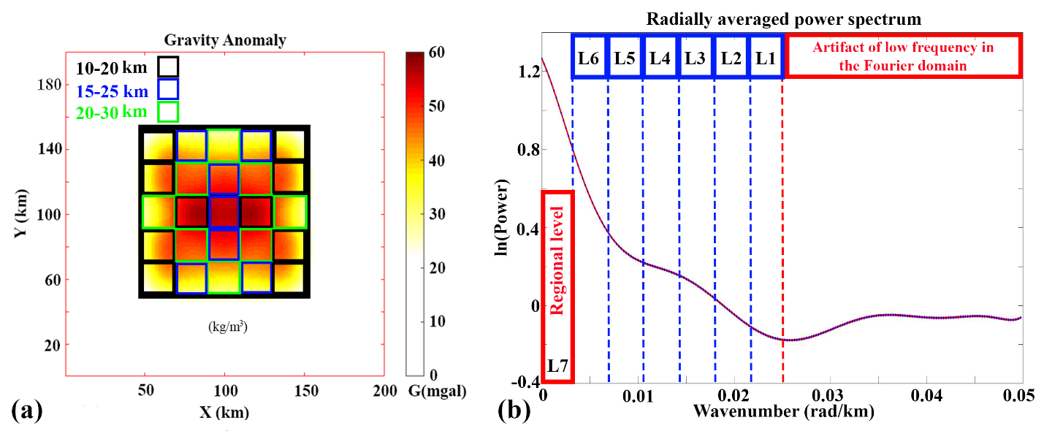
Figure S1: (a) Table 2; Synthetic model 2. (b) Polynomial fitted to the radially averaged power spectrum of the synthetic model 2 gravity anomaly in Figure S1a, plotting wavenumber (radian/km) against ln(power). The segments L1 to L7 represent different wavenumber ranges within the power spectrum. Blue dashed lines mark the wavenumber boundaries between these segments, while the red dashed line indicates the boundary between low-frequency artifacts in the Fourier domain (e.g., Alipour et al., 2023a, 2023b) and the actual signal levels.
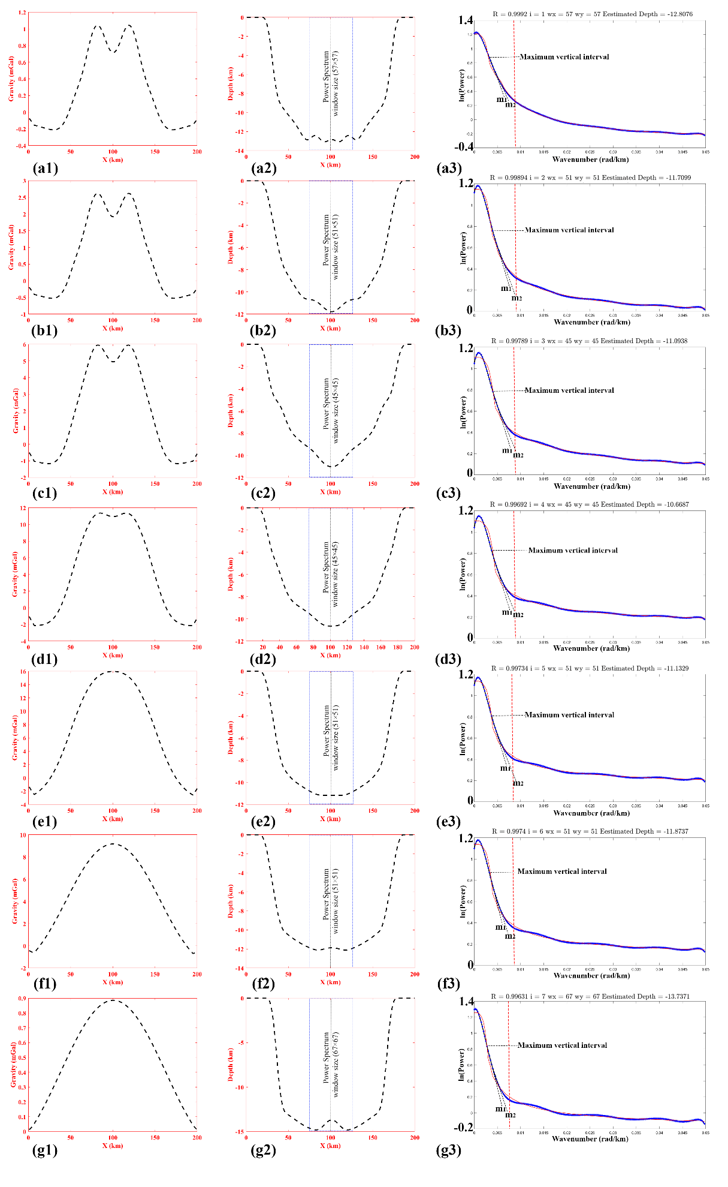
Figure S2: Panels (a1–g1) show Y = 100 km profiles from the synthetic model (Figure S1a) for levels L1–L7 (RWL1–RWL7). Panels (a2–g2) display the estimated depths from the radially averaged power spectrum within blue dashed windows. Panels (a3–g3) plot the ln(power) vs. wavenumber for the central parts (black dashed lines in a2–g2), with red dashed lines marking the low-frequency artifact boundary (e.g., Alipour et al., 2023a, 2023b). Each power spectrum shows the fit (blue) to the main curve (red), with correlation $R$. $Wx$ and $Wy$ are the $XY$ dimensions of the moving window, $i$is the number of spectral levels, and the final depth is derived from the slopes $m₁$ and $m₂$.

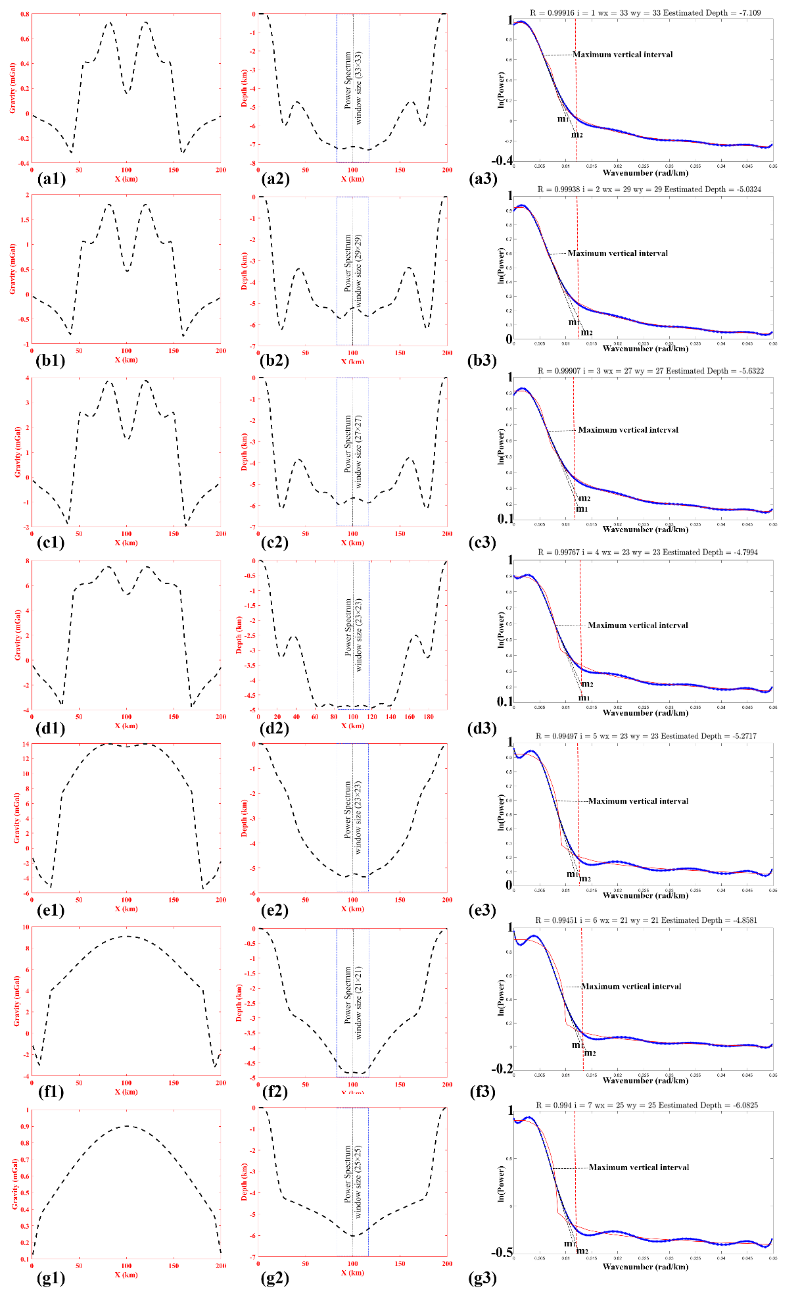
Figure S3: Panels (a1–g1) show the scaled normalized analytical signal amplitudes (SRWL1–SRWL7) for levels L1–L7 (Same profiles as those in Figure S2a1–g1). Panels (a2–g2) display the estimated depths from the radially averaged power spectrum within blue dashed windows. Panels (a3–g3) plot ln(power) vs. wavenumber for the central segments (black dashed lines in a2–g2), similar to Figure S2, with all additional details identical.
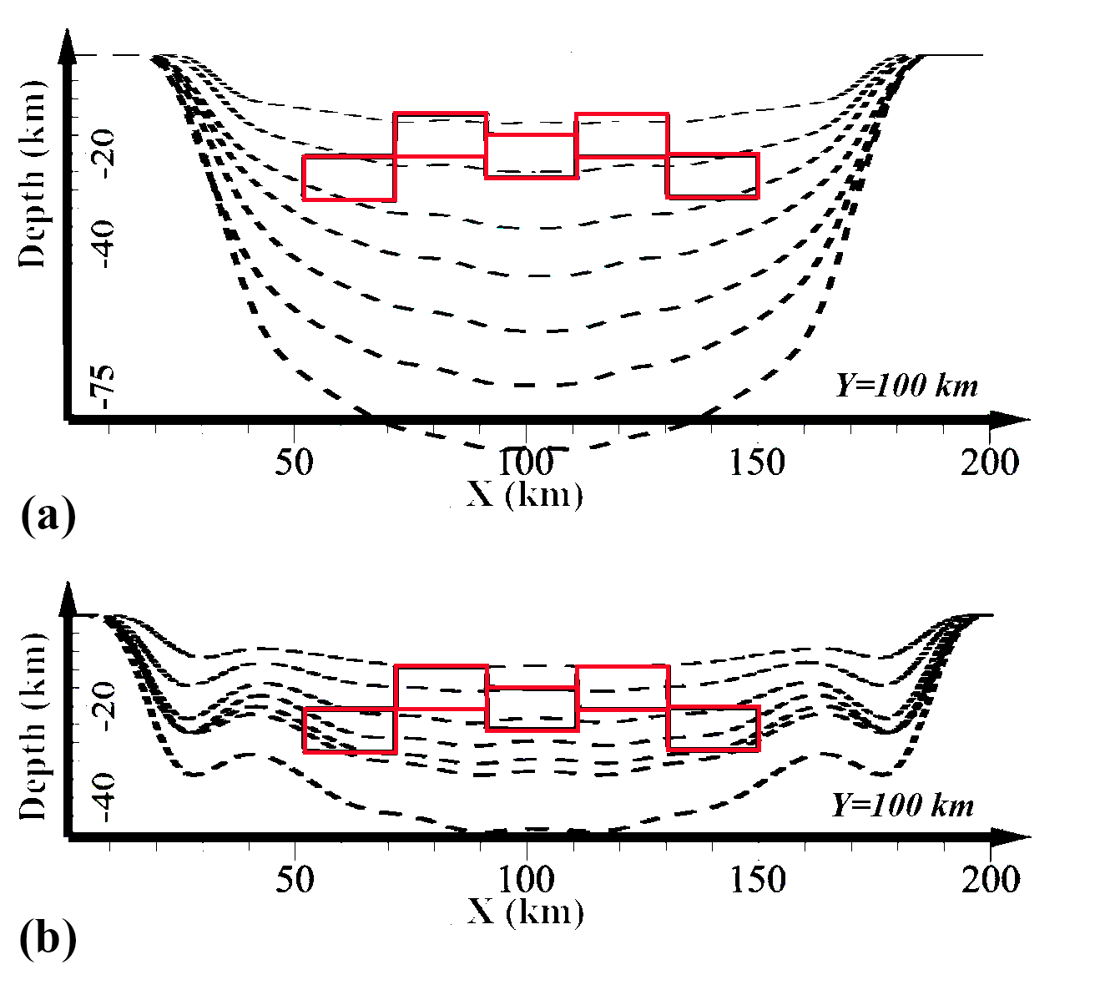
Figure S4: Estimated depths from each level (Figures S2a2–g2 and S3a2–g2) are stacked to reconstruct the geometry of the synthetic model (Figure S1a), with the model in red and depth estimates as black dashed lines. RWL-based depths (a) are overestimated, while SRWL-based results (b) are more reliable.
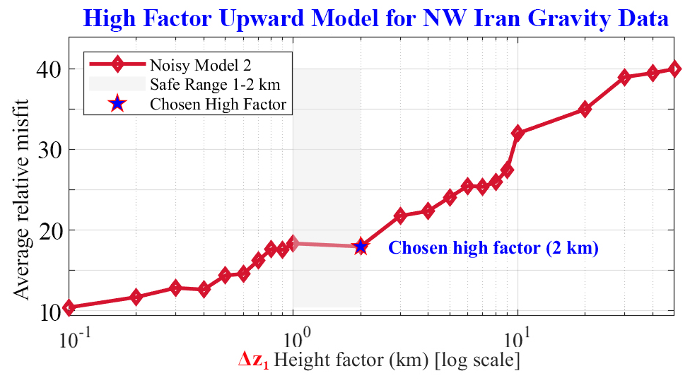
Figure S5. Selection of optimal height factor ($Δz₁$) for FcAM3D modeling of gravity data in northwestern Iran.

