Country | EAPC (%) | 95% CI | P-value
Turkey | 2.93 | (2.46, 3.39) | 0.000
Sierra Leone | 1.64 | (0.94, 2.34) | 0.000
Lao People's Democratic Republic | 1.57 | (1.12, 2.03) | 0.000
Bosnia and Herzegovina | 1.40 | (0.97, 1.83) | 0.000
Australia | 1.14 | (0.61, 1.68) | 0.000
France | 1.02 | (0.81, 1.22) | 0.000
Socialist Republic of Viet Nam | 0.98 | (0.69, 1.27) | 0.000
New Zealand | 0.85 | (0.54, 1.16) | 0.000
Cambodia | 0.78 | (0.65, 0.90) | 0.000
Egypt | 0.77 | (0.69, 0.85) | 0.000
Lesotho | 0.73 | (0.71, 0.75) | 0.000
Albania | 0.70 | (0.36, 1.04) | 0.000
Tunisia | 0.68 | (0.58, 0.78) | 0.000
Sudan | 0.59 | (0.55, 0.62) | 0.000
Iraq | 0.55 | (0.47, 0.62) | 0.000
Jordan | 0.55 | (0.48, 0.62) | 0.000
Lebanon | 0.55 | (0.47, 0.62) | 0.000
Ireland | 0.54 | (0.08, 1.01) | 0.023
Croatia | 0.53 | (0.22, 0.85) | 0.001
Brazil | 0.53 | (0.15, 0.90) | 0.007
Palestine | 0.48 | (0.38, 0.58) | 0.000
Oman | 0.48 | (0.42, 0.54) | 0.000
Kingdom of Eswatini | 0.47 | (0.45, 0.50) | 0.000
Romania | 0.46 | (0.12, 0.80) | 0.008
Afghanistan | 0.46 | (0.37, 0.54) | 0.000
Syrian Arab Republic | 0.40 | (0.32, 0.49) | 0.000
Slovakia | 0.36 | (0.09, 0.63) | 0.009
China | 0.36 | (0.02, 0.69) | 0.038
Poland | 0.34 | (0.09, 0.58) | 0.007
Namibia | 0.34 | (0.13, 0.54) | 0.002
Bahrain | 0.33 | (0.26, 0.41) | 0.000
Bulgaria | 0.29 | (-0.02, 0.60) | 0.064
Qatar | 0.29 | (0.20, 0.38) | 0.000
Hungary | 0.29 | (-0.21, 0.78) | 0.255
Algeria | 0.28 | (0.21, 0.34) | 0.000
Argentina | 0.27 | (-0.07, 0.62) | 0.118
Panama | 0.27 | (0.08, 0.46) | 0.007
Republic of Korea | 0.26 | (-0.33, 0.85) | 0.381
El Salvador | 0.26 | (0.09, 0.42) | 0.003
Thailand | 0.26 | (0.00, 0.51) | 0.047
Kuwait | 0.25 | (0.19, 0.31) | 0.000
Trinidad and Tobago | 0.24 | (0.10, 0.38) | 0.001
Greece | 0.24 | (-0.14, 0.62) | 0.213
Islamic Republic of Iran | 0.24 | (0.05, 0.42) | 0.015
Peru | 0.23 | (0.00, 0.47) | 0.046
Ecuador | 0.23 | (0.05, 0.41) | 0.014
Bhutan | 0.23 | (0.16, 0.30) | 0.000
Saudi Arabia | 0.22 | (0.05, 0.40) | 0.014
Republic of Cabo Verde | 0.22 | (0.18, 0.25) | 0.000
North Macedonia | 0.22 | (-0.15, 0.58) | 0.240
Sweden | 0.21 | (0.15, 0.27) | 0.000
Yemen | 0.21 | (0.04, 0.38) | 0.017
Pakistan | 0.19 | (0.12, 0.27) | 0.000
Uruguay | 0.19 | (0.07, 0.30) | 0.002
Lithuania | 0.18 | (0.07, 0.29) | 0.002
Serbia | 0.18 | (-0.18, 0.53) | 0.319
Bangladesh | 0.17 | (0.10, 0.23) | 0.000
Montenegro | 0.16 | (-0.18, 0.50) | 0.359
Estonia | 0.15 | (0.11, 0.19) | 0.000
India | 0.15 | (0.07, 0.23) | 0.000
Czech Republic | 0.15 | (-0.12, 0.42) | 0.282
Ethiopia | 0.14 | (0.07, 0.22) | 0.001
Singapore | 0.14 | (-0.42, 0.70) | 0.622
Norway | 0.14 | (-0.01, 0.28) | 0.066
Bermuda | 0.13 | (0.04, 0.23) | 0.007
Colombia | 0.12 | (-0.04, 0.29) | 0.136
Mali | 0.12 | (0.07, 0.18) | 0.000
Nicaragua | 0.12 | (-0.07, 0.30) | 0.201
Ghana | 0.12 | (0.06, 0.18) | 0.000
Indonesia | 0.11 | (-0.04, 0.26) | 0.139
Mexico | 0.11 | (-0.07, 0.28) | 0.237
Iceland | 0.09 | (-0.04, 0.21) | 0.179
Taiwan (Province of China) | 0.08 | (-0.02, 0.17) | 0.105
Canada | 0.07 | (-0.19, 0.33) | 0.596
Latvia | 0.07 | (0.01, 0.12) | 0.012
Burkina Faso | 0.07 | (0.03, 0.10) | 0.002
Finland | 0.06 | (-0.26, 0.38) | 0.730
Costa Rica | 0.05 | (-0.13, 0.23) | 0.580
Guatemala | 0.04 | (-0.19, 0.27) | 0.735
Bolivarian Republic of Venezuela | 0.04 | (-0.13, 0.21) | 0.677
United Kingdom of Great Britain and Northern Ireland | 0.03 | (-0.31, 0.37) | 0.850
United Arab Emirates | 0.01 | (-0.08, 0.10) | 0.871
Honduras | -0.01 | (-0.23, 0.21) | 0.932
Chile | -0.02 | (-0.50, 0.46) | 0.926
Belarus | -0.02 | (-0.15, 0.10) | 0.695
Morocco | -0.03 | (-0.19, 0.13) | 0.729
Cameroon | -0.04 | (-0.09, 0.01) | 0.109
Greenland | -0.04 | (-0.33, 0.25) | 0.776
Slovenia | -0.05 | (-0.29, 0.20) | 0.704
Liberia | -0.05 | (-0.12, 0.02) | 0.154
Mongolia | -0.08 | (-0.26, 0.10) | 0.400
American Samoa | -0.09 | (-0.14, -0.04) | 0.001
Guinea | -0.10 | (-0.16, -0.05) | 0.000
Dominican Republic | -0.15 | (-0.32, 0.02) | 0.081
Denmark | -0.15 | (-0.24, -0.07) | 0.001
Andorra | -0.16 | (-0.30, -0.02) | 0.025
Plurinational State of Bolivia | -0.17 | (-0.39, 0.06) | 0.153
Republic of the Gambia | -0.17 | (-0.31, -0.02) | 0.026
Kenya | -0.17 | (-0.24, -0.10) | 0.000
Italy | -0.17 | (-0.40, 0.06) | 0.148
Libya | -0.18 | (-0.27, -0.10) | 0.000
Turkmenistan | -0.19 | (-0.39, 0.01) | 0.061
Azerbaijan | -0.19 | (-0.44, 0.05) | 0.115
Grenada | -0.20 | (-0.33, -0.06) | 0.004
Kazakhstan | -0.20 | (-0.37, -0.04) | 0.014
Japan | -0.21 | (-0.74, 0.33) | 0.447
United States Virgin Islands | -0.22 | (-0.34, -0.10) | 0.000
Armenia | -0.23 | (-0.41, -0.06) | 0.010
Paraguay | -0.25 | (-0.54, 0.04) | 0.094
Netherlands | -0.26 | (-0.48, -0.04) | 0.024
Guyana | -0.26 | (-0.42, -0.11) | 0.001
Cuba | -0.26 | (-0.48, -0.05) | 0.017
Switzerland | -0.27 | (-0.45, -0.08) | 0.005
Puerto Rico | -0.27 | (-0.37, -0.18) | 0.000
Saint Vincent and the Grenadines | -0.27 | (-0.41, -0.13) | 0.000
Republic of Moldova | -0.28 | (-0.44, -0.12) | 0.001
Suriname | -0.30 | (-0.45, -0.14) | 0.000
Saint Kitts and Nevis | -0.30 | (-0.44, -0.15) | 0.000
Commonwealth of the Bahamas | -0.31 | (-0.47, -0.16) | 0.000
Nepal | -0.32 | (-0.65, 0.02) | 0.065
Russian Federation | -0.32 | (-0.36, -0.29) | 0.000
Belize | -0.35 | (-0.49, -0.20) | 0.000
Dominica | -0.36 | (-0.50, -0.21) | 0.000
Saint Lucia | -0.38 | (-0.53, -0.24) | 0.000
Georgia | -0.39 | (-0.56, -0.22) | 0.000
Antigua and Barbuda | -0.39 | (-0.52, -0.26) | 0.000
Belgium | -0.40 | (-0.57, -0.23) | 0.000
Democratic People's Republic of Korea | -0.40 | (-0.53, -0.28) | 0.000
Malta | -0.41 | (-0.58, -0.24) | 0.000
Luxembourg | -0.42 | (-0.59, -0.24) | 0.000
Jamaica | -0.43 | (-0.58, -0.28) | 0.000
Uzbekistan | -0.45 | (-0.66, -0.24) | 0.000
Sao Tome and Principe | -0.45 | (-0.66, -0.25) | 0.000
Austria | -0.46 | (-0.65, -0.28) | 0.000
Ukraine | -0.48 | (-0.53, -0.44) | 0.000
Zimbabwe | -0.51 | (-0.60, -0.42) | 0.000
Portugal | -0.51 | (-0.69, -0.34) | 0.000
Barbados | -0.52 | (-0.64, -0.39) | 0.000
Brunei Darussalam | -0.54 | (-1.07, -0.02) | 0.044
Cyprus | -0.59 | (-0.76, -0.42) | 0.000
Germany | -0.66 | (-1.06, -0.27) | 0.002
Guinea-Bissau | -0.67 | (-0.90, -0.43) | 0.000
Israel | -0.67 | (-0.86, -0.48) | 0.000
Togo | -0.67 | (-0.90, -0.44) | 0.000
Haiti | -0.70 | (-0.87, -0.52) | 0.000
Republic of San Marino | -0.70 | (-0.84, -0.57) | 0.000
Mauritania | -0.74 | (-0.93, -0.55) | 0.000
Chad | -0.76 | (-0.96, -0.55) | 0.000
Equatorial Guinea | -0.77 | (-1.11, -0.42) | 0.000
Benin | -0.79 | (-1.00, -0.58) | 0.000
United States of America | -0.83 | (-1.32, -0.35) | 0.001
Principality of Monaco | -0.84 | (-0.99, -0.69) | 0.000
Republic of C?te d'Ivoire | -0.84 | (-1.03, -0.65) | 0.000
Tajikistan | -0.91 | (-1.24, -0.57) | 0.000
Senegal | -0.99 | (-1.22, -0.77) | 0.000
Kyrgyzstan | -1.00 | (-1.23, -0.77) | 0.000
South Africa | -1.44 | (-1.65, -1.23) | 0.000
Myanmar | -1.50 | (-1.80, -1.19) | 0.000
Botswana | -1.50 | (-1.85, -1.15) | 0.000
Mauritius | -1.72 | (-2.19, -1.24) | 0.000
Zambia | -1.75 | (-2.20, -1.29) | 0.000
Timor-Leste | -1.88 | (-2.22, -1.54) | 0.000
Maldives | -1.98 | (-2.32, -1.64) | 0.000
Angola | -2.00 | (-2.31, -1.69) | 0.000
Gabon | -2.06 | (-2.36, -1.76) | 0.000
Malaysia | -2.08 | (-2.50, -1.65) | 0.000
Niger | -2.13 | (-2.89, -1.36) | 0.000
Seychelles | -2.17 | (-2.54, -1.79) | 0.000
Congo | -2.27 | (-2.60, -1.93) | 0.000
Eritrea | -2.63 | (-3.07, -2.18) | 0.000
United Republic of Tanzania | -2.73 | (-3.16, -2.30) | 0.000
Mozambique | -2.81 | (-3.30, -2.33) | 0.000
Djibouti | -2.85 | (-3.26, -2.43) | 0.000
Rwanda | -2.86 | (-3.30, -2.42) | 0.000
Uganda | -2.86 | (-3.38, -2.34) | 0.000
Comoros | -2.95 | (-3.39, -2.51) | 0.000
South Sudan | -3.04 | (-3.49, -2.58) | 0.000
Central African Republic | -3.09 | (-3.50, -2.67) | 0.000
Malawi | -3.16 | (-3.64, -2.68) | 0.000
Democratic Republic of the Congo | -3.28 | (-3.65, -2.90) | 0.000
Burundi | -3.50 | (-3.99, -3.00) | 0.000
Somalia | -4.16 | (-4.78, -3.54) | 0.000
Cook Islands | -4.21 | (-5.31, -3.09) | 0.000
Philippines | -4.33 | (-4.69, -3.96) | 0.000
Sri Lanka | -4.45 | (-5.09, -3.79) | 0.000
Nigeria | -5.89 | (-6.46, -5.31) | 0.000
Republic of Palau | -5.98 | (-7.07, -4.88) | 0.000
Tokelau | -6.00 | (-7.16, -4.82) | 0.000
Guam | -6.20 | (-7.10, -5.29) | 0.000
Spain | -6.38 | (-7.67, -5.08) | 0.000
Madagascar | -6.43 | (-7.59, -5.25) | 0.000
Northern Mariana Islands | -6.74 | (-7.73, -5.73) | 0.000
Fiji | -7.09 | (-8.18, -5.99) | 0.000
Republic of Niue | -7.11 | (-8.04, -6.17) | 0.000
Vanuatu | -7.21 | (-8.27, -6.14) | 0.000
Tuvalu | -7.28 | (-8.41, -6.13) | 0.000
Republic of Nauru | -7.30 | (-8.54, -6.04) | 0.000
Samoa | -7.44 | (-8.38, -6.48) | 0.000
Marshall Islands | -7.50 | (-8.63, -6.36) | 0.000
Tonga | -7.52 | (-8.49, -6.54) | 0.000
Solomon Islands | -7.52 | (-8.65, -6.38) | 0.000
Kiribati | -7.68 | (-8.83, -6.53) | 0.000
Federated States of Micronesia | -7.72 | (-8.70, -6.73) | 0.000
Papua New Guinea | -7.74 | (-8.75, -6.71) | 0.000
Supplementary Table 1. Estimated Annual Percentage Change (EAPC) in periodontal DALYs from 1990 to 2018 for the top 30 countries.
Variable | Coef | CI | P-value
Protective Score | -1.05 | (-1.52, -0.58) | 0.002
Risk Score | 0.87 | (0.30, 1.44) | 0.018
Supplementary Table 2. Multivariable regression analysis of dietary scores and periodontal DALYs

Variable | Coef. | 95% CI | P-value
Sex[T.Male] | 5.35 | (4.07, 6.62) | 0.000
WHO_region[T.AMRO] | 0.87 | (-11.50, 13.23) | 0.891
WHO_region[T.EMRO] | -10.74 | (-24.25, 2.78) | 0.119
WHO_region[T.EURO] | -14.64 | (-26.22, -3.06) | 0.013
WHO_region[T.SEARO] | -15.47 | (-33.23, 2.30) | 0.088
WHO_region[T.WPRO] | -41.31 | (-55.76, -26.86) | 0.000
Standardized SDI | -2.26 | (-2.63, -1.89) | 0.000
protective_score | -0.01 | (-0.17, 0.15) | 0.900
risk_score | -0.02 | (-0.14, 0.10) | 0.760
Group Var | 3.44 | (2.63, 4.25) | 0.000
Supplementary Table 3. Estimates from the multivariable linear mixed-effects model

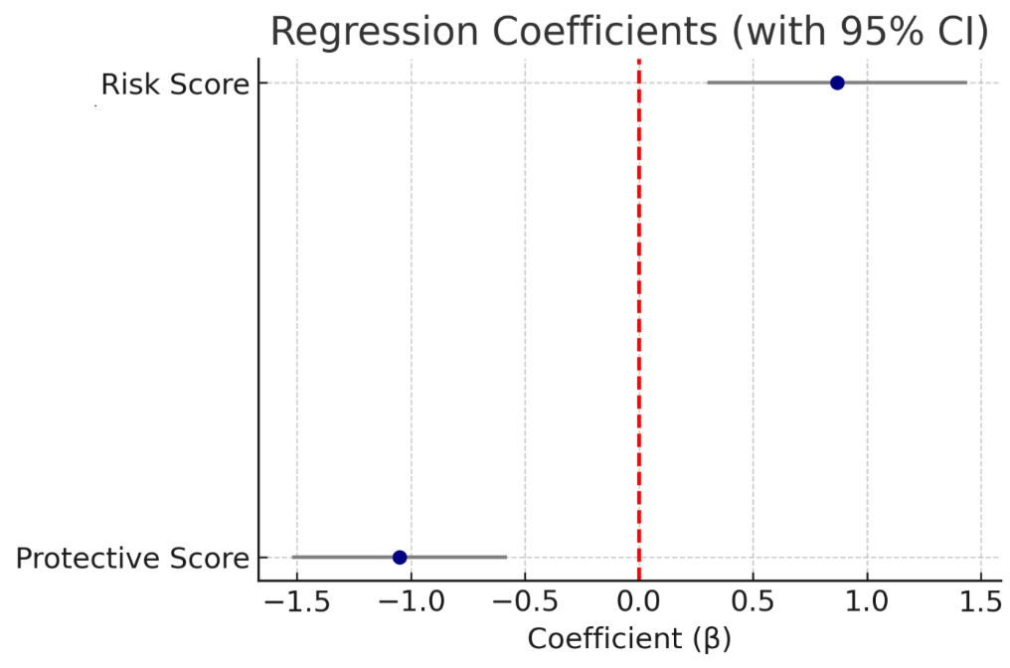
Supplementary Figure 1. Forest plot showing the regression coefficients (β) and 95% confidence intervals (CI) for the associations between dietary pattern scores and periodontal DALYs.
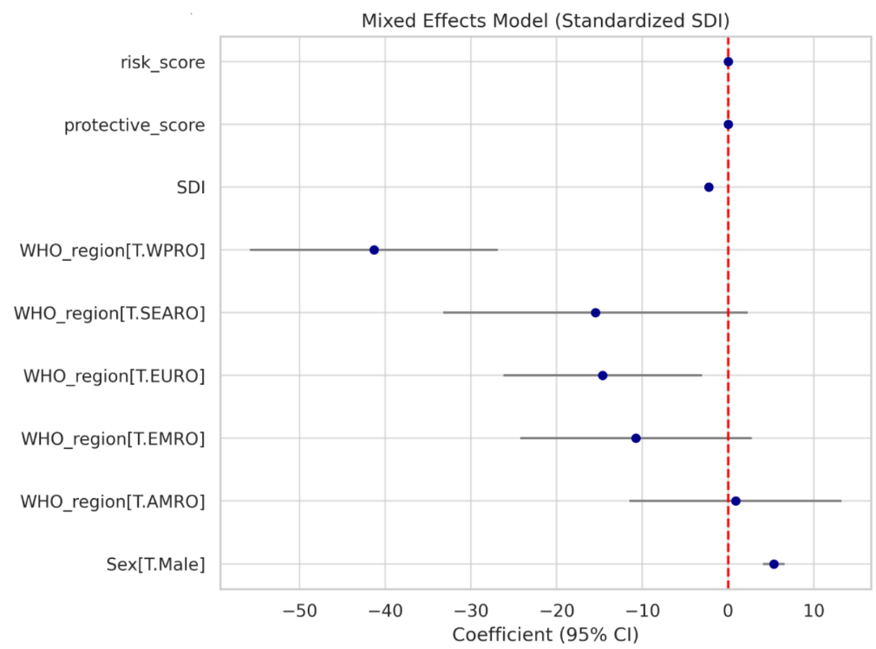
Supplementary Figure 2. Forest plot of the multivariable linear mixed-effects model
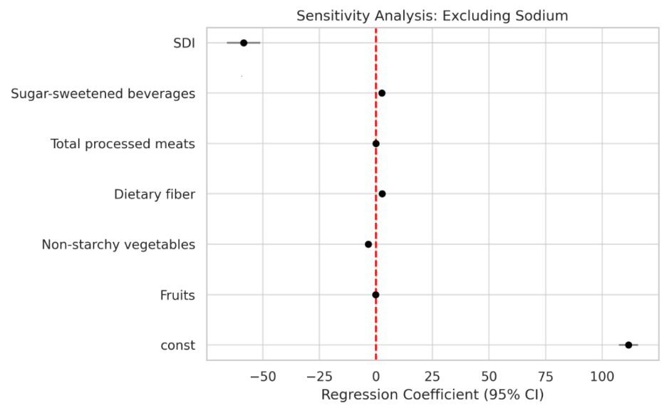
Supplementary Figure 3. Sensitivity analysis excluding dietary sodium from the regression model.

