Appendix
Inter-rater reliability
To ensure data quality, all ROIs were drawn by one rater (AL) and compared with a second rater (AV). In cases of doubt or poor agreement, we discussed with a third rater and corrected as required (SQ). ROIs were reviewed visually for accuracy, avoidance of error (no inclusion of Gibbs ringing in the aqueduct ROI and no overlap of the Eddy current correction ROI with the aqueduct, Gibbs ringing nor other vessel/moving tissue). The velocity waveforms over the cardiac frames were reviewed to further confirm that there were no discontinuities or errors in the velocity calculations. 36 of the 42 healthy controls previously measured and published by SQ were also compared with repeat measurements from the first rater (AL)²⁷.The inter-rater reliability for the 5 measured parameters was assessed between the raters using the two-way mixed effects model for intraclass correlation for measurements based on a single rater and consistency between raters. The ICCs for the iNPH cohort were 0.99 (0.98-0.99) for SV, 0.81 (0.72-0.88) for peak systolic velocity, 0.69 (0.55-0.79) for peak diastolic velocity and 0.69 (0.56-0.79) for netflow. For the healthy cohort, 0.96 (0.93-0.98) for SV, 0.82 (0.68-0.90) for peak systolic velocity, 0.81 (0.68-0.90) for peak diastolic velocity and 0.43 (0.15-0.65) for netflow. The final analysis was based on measurements from the first rater (AL), for both the iNPH patients and the healthy controls.
Post hoc analysis of outcome
Even though gait as the cardinal symptom of iNPH has been internationally agreed upon, there is evidence that classifies iNPH as a balance disorder as well^{39–41}. As such, we performed a post hoc analysis to consider balance as a parameter in post-operative improvement, both separate to and in combination with the gait. To define outcome based on balance, a cut-off of 3 points for the Tinetti balance scale was used as a significant result that has consistently been described to be above the average measurement error of the scale and interrater variability

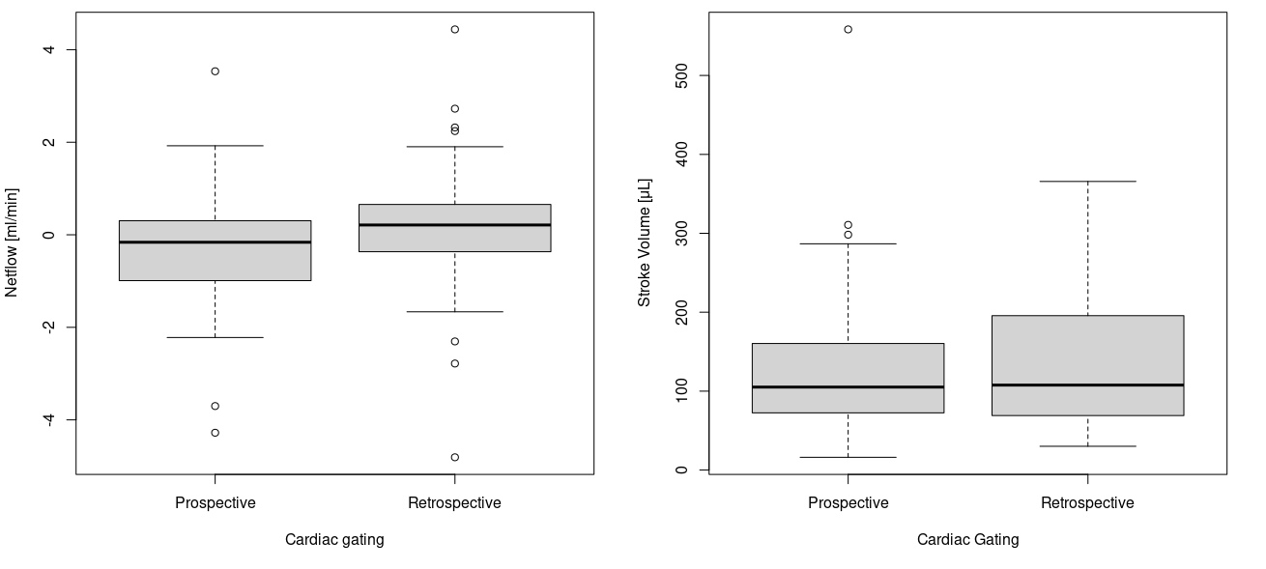
Cardiac gating
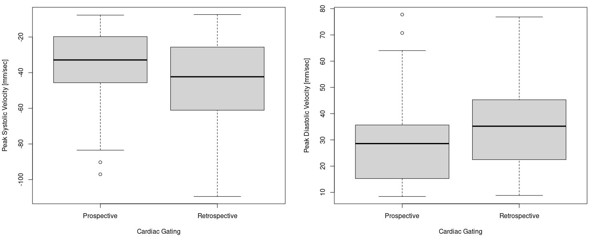

Netflow, Stroke Volume and Peak Velocities in N=49 with retrospective vs N =43 with prospective cardiac gating

Comparison with age and sex
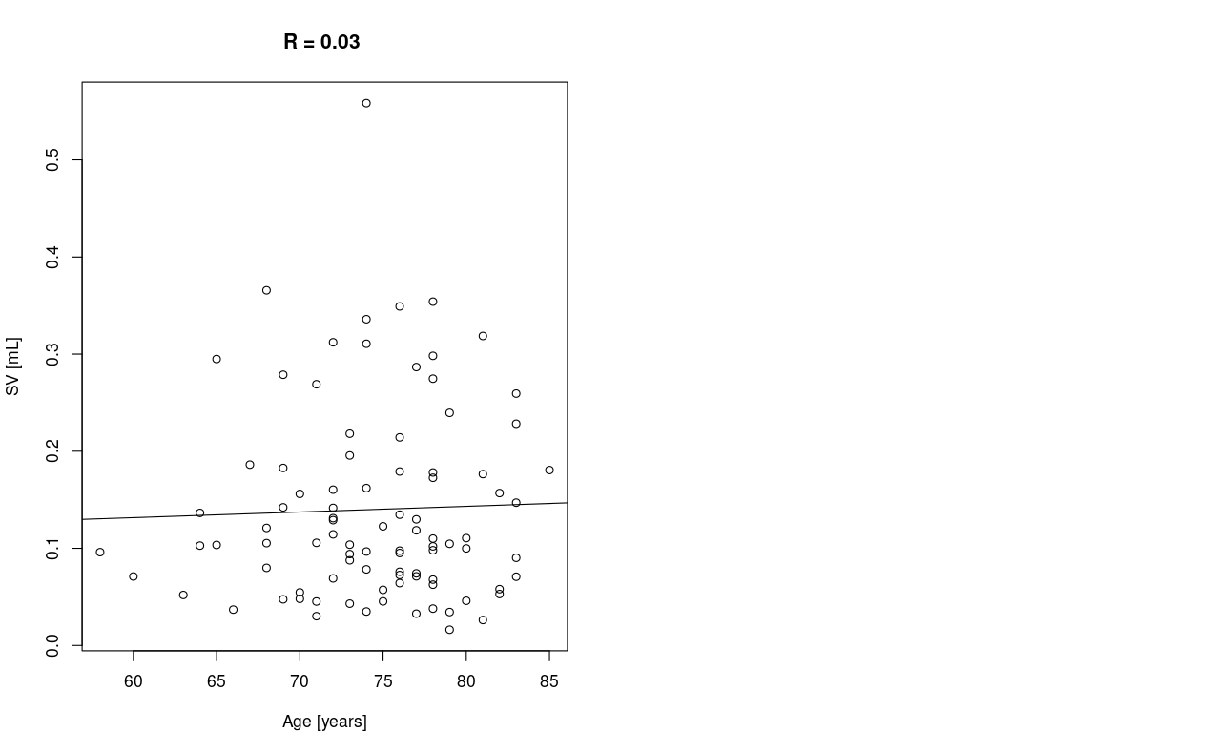
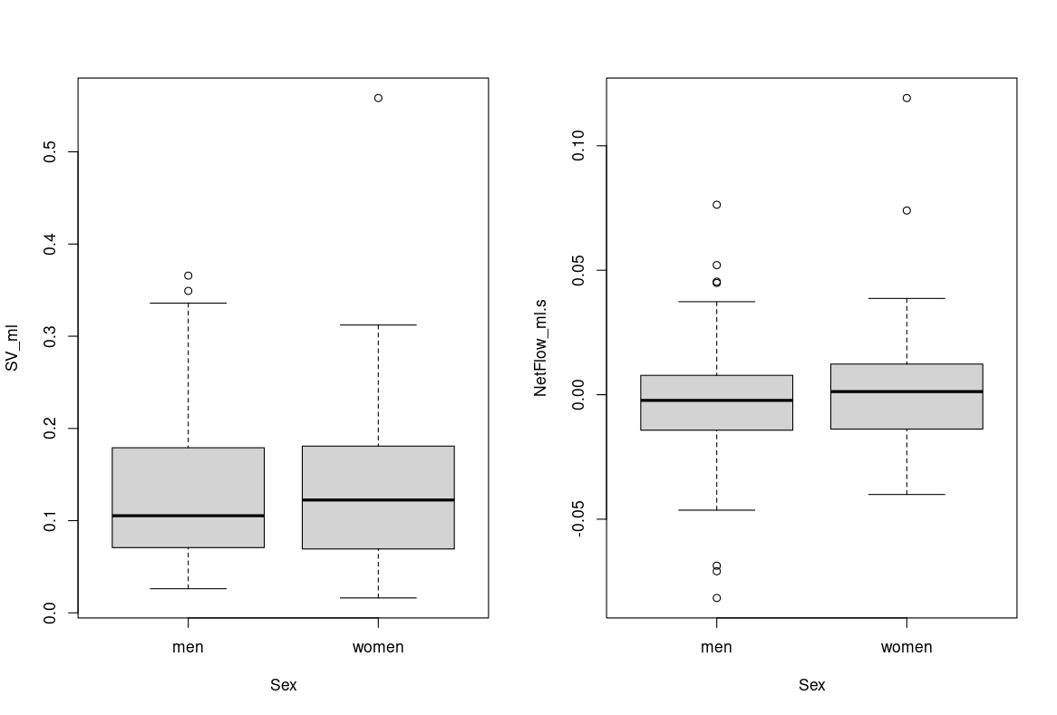
Correlation of SV with age and comparison of stroke volume and netflow in men and women (differences had previously been reported in Sartoretti et al¹⁴)

Correlation coefficients between the 5 CSF aqueductal flow parameters, preoperative gait velocity and postoperative gait changes.
Parameter | R with Gait preoperative | p-value | R with Gait changes postoperative | p-value
SV | 0.015 | 0.884 | -0.092 | 0.3819
Peak Systolic Velocity | 0.09 | 0.3906 | -0.05 | 0.6388
Peak Diastolic Velocity | -0.10 | 0.3339 | 0.06 | 0.53
Netflow | -0.03 | 0.7499 | -0.07 | 0.4709
Absolute Flow | -0.016 | 0.8755 | -0.08 | 0.4248

Outcome distribution based on Tinetti balance score - cutoff of 3 points.
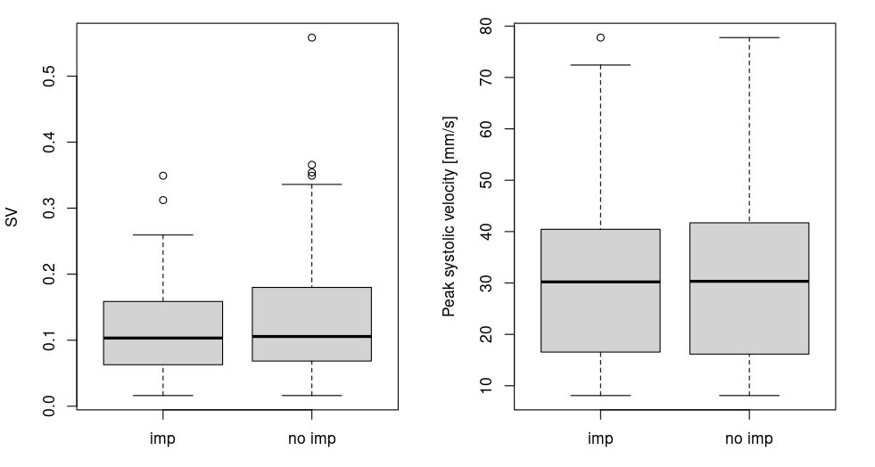
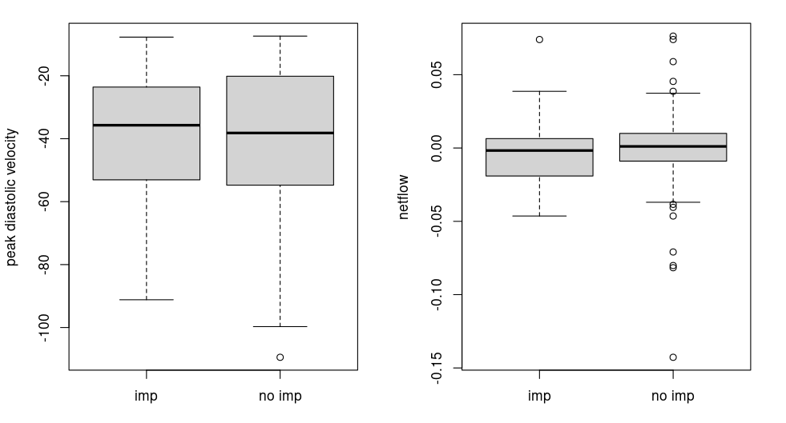
None of the differences were significant.

When using a combination of gait and Tinetti to classify responders (gait change >= 0.16 OR Tinetti change >= 3), there were no differences in the results.

