Supplementary Information

Supplementary Note 1: CO₂ Geological Storage definitions
In this study we discuss the permanent storage of CO₂ in deep geological formations, herein referred to as CO₂ geological storage (CGS). This definition is selected to be explicitly independent of the source of CO₂. According to IPCC (2022), Carbon Capture and Storage (CCS) is defined as the process in which CO₂ from “industrial and energy-related sources is separated (captured), conditioned, compressed and transported to a storage location for long-term isolation from the atmosphere”. This definition implies mitigation of emissions and is separate from the other primary use of CGS, that is the sequestration of CO₂ to facilitate Carbon Dioxide Removal. Here, CO₂ is sourced from negative emissions technologies such as Direct Air Capture, or Bioenergy. While the consequences of deploying emissions-reductions technologies versus CDR technologies have vast climatic and economic outcomes, the storage component remains largely ambivalent of the source, hence our use of the generic CGS definition. In separating and analysing datasets from the IPCC AR6 database (Byers et al., 2022), we separate where CGS is the storage component for emissions mitigation technologies (fossil energy and industrial processes) from carbon dioxide removal technologies (Bioenergy and Direct Air Capture). We refer to these throughout the study as “CGS for mitigation” and “CGS for removal” respectively.

Supplementary Note 2: Integrated Assessment Model regions
IAMs typically group countries with similar socio-economic and energy system characteristics. The six IAMs we studied each use a different approach to aggregate countries, and so they each vary in terms of (a) the number of regions (b) the countries that belong to each region and (c) the constraints assigned to each region (Supplementary Table 1; Supplementary Figure 1).

Supplementary Table 1: Lists of default regions per IAM. The regions are shown in map form in Supplementary Figure 1.
IMAGE (n = 26) | COFFEE (n = 18) | WITCH (n = 17) | GCAM (n = 14) | REMIND (n = 12) | MESSAGE (n = 12)
Brazil  Canada  Central America  Central Asia  Central Europe  China region  Eastern Africa  India  Indonesia region  Japan  Korea region  Mexico  Middle East  Northern Africa  Oceania  Rest of South America  Rest of South Asia  Rest of Southern Africa  Russia region  South Africa  Southeastern Asia  Turkey  Ukraine region  USA  Western Africa  Western Europe | AFR  AUS  BRA  CAM  CAN  CAS  CHN  EEU  IND  JPN  KOR  MEA  RAS  RUS  SAF  SAM  USA  WEU | brazil  canada  china  europe  india  indonesia  jpnkor  laca  mena  mexico  oceania  sasia  seasia  southafrica  ssa  te  usa | Africa  Australia_NZ  Canada  China  Eastern Europe  Former Soviet Union  India  Japan  Korea  Latin America  Middle East  Southeast Asia  USA  Western Europe | CAZ  CHA  EUR  IND  JPN  LAM  MEA  NEU  OAS  REF  SSA  USA | R12_AFR  R12_CHN  R12_EEU  R12_FSU  R12_LAM  R12_MEA  R12_NAM  R12_PAO  R12_PAS  R12_RCPA  R12_SAS  R12_WEU

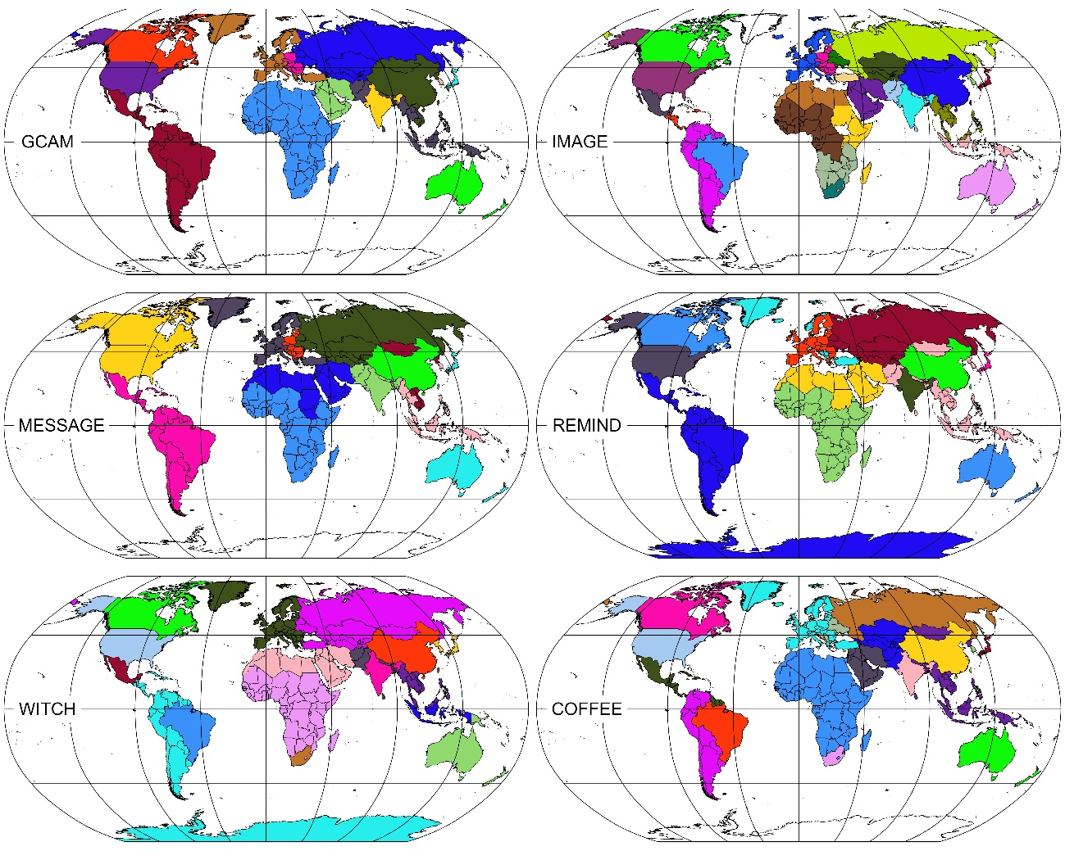
Supplementary Figure 1: Global maps highlighting the default regional aggregation schemes adopted by GCAM (14), IMAGE (26), MESSAGE (12), REMIND (12), WITCH (17) and COFFEE (18). The regions are listed in Supplementary Table 1.
The use of different region nomenclature across the IAMs introduced some challenges to analysing the conformance between boundaries. To address this, we utilised Geographical Information System analysis, particularly raster analysis function, through the following. We first mapped the regional schemes for each IAM (Supplementary Table 1) in shapefile format (Supplementary Figure 1). We then converted each shapefile into a coarse raster file (at 100,000 m cell size). For each raster file, we then extracted the cells belonging to the boundaries between regions, and these boundaries were assigned a value of 1. Finally, we summed the per-IAM boundary raster files to produce a count of overlapping regional boundaries (Supplementary Figure 2).
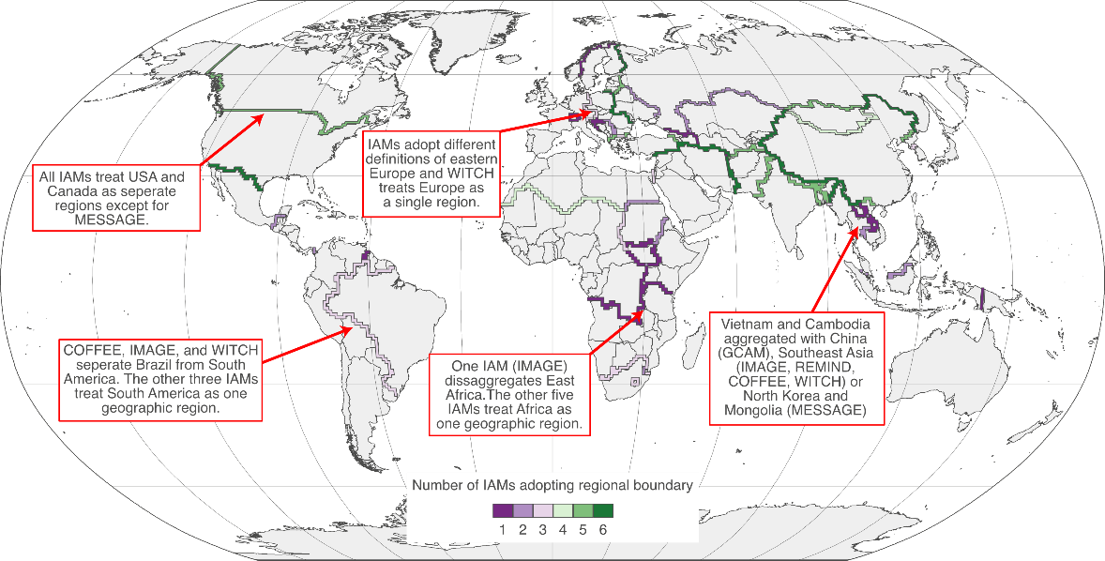
Supplementary Figure 2: Global map showing the number of IAMs that agree on a given regional boundary. We consider six IAMs (COFFEE, GCAM, IMAGE, MESSAGE, REMIND and WITCH) hence the maximum possible value is 6. If a single IAM utilises a boundary, the value is 1.

Supplementary Note 3: Studies constraining global saline aquifer CGS potential
The high degrees of uncertainty associated with estimating global geological storage potential, particularly within saline aquifer formations, has led to the publication of many different values often utilising different methodologies and datasets. Here, we summarise the evolution of these estimates from 1990 to present.
Saline aquifers consist of porous and permeable rock formations that are water-bearing, but at sufficient depths below the subsurface for that water to be saline. When buoyant CO₂ is injected into a saline aquifer it is generally (in the absence of significantly vertical heterogeneity) expected to rise to the top of the storage formation and migrate up-dip, displacing brine along the way. As this takes place, there are a variety of mechanisms by which the CO₂ can be permanently trapped, including structural trapping at the crest of a topographical high in the storage formation, residual trapping whereby CO₂ is trapped via surface tension at the boundary between grains in the storage formation, dissolution trapping where the CO₂ dissolves into the native brine and mineral trapping where the CO₂ precipitates as a solid.
Saline aquifers are the most widespread type of CGS formation globally, with their distribution closely linked to the distribution of sedimentary basins. Globally, there are 764 sedimentary basins, collectively spanning an estimated area of 1.2 x 10⁸ km² (Evenick, 2021). These basins vary significantly in size, from smaller examples like the Bokaro Rift Basin in India (624 km²) to expansive systems such as the West Siberian Intracratonic Basin in Russia, which spans over 2.6 × 10⁶ km² (Evenick, 2021).
Efforts to estimate the storage potential of saline aquifers on a global scale started in the early 1990s (Supplementary Table 2, Supplementary Figure 3), and capacity estimates utilised within the IMAGE and WITCH Integrated Assessment Models (IAMs) are derived from studies that adopt this methodology (Hendriks et al., 2004; IEAGHG, 2011). These studies adopt an ‘area-based’ methodology that is anchored on an assessment of the global distribution of sedimentary basins, while also applying various assumptions about geological factors (e.g., aquifer thickness, porosity) and fluid properties (e.g., CO₂ density, dissolution rates) to estimate storage potential.
Over the course of the early 1990s to early 2000s, several publications sought to estimate global CO₂ geological storage (CGS) potential following this approach. The concept of residual trapping and CO₂ plume mobility was relatively nascent in the early 1990s and some studies at this time considered that CO₂ could only be stored through dissolution within the native brine. Koide et al. (1992) assumed that 40 kg of CO₂ could be stored for every cubic metre of porewater, and calculated that from the distribution of onshore basins, and a constraint that only 1 % of each basin might be appropriate for storage, the global CO₂ capacity was 320 GtCO₂, which while large, is significantly lower than many subsequent estimates. A similar approach was adopted by Bruant et al. (2002), but those authors did not include the 1 % constraint on suitable areas, leading to a large global storage capacity of 56,000 GtCO₂, with an uncertainty range of between 10,000 GtCO₂ and 200,000 GtCO₂.
As the understanding of CO₂ displacing water upon injection matured (van der Meer, 1992), a suite of studies emerged that, while still treating the distribution of sedimentary basins as a key variable in capacity estimates, expanded the methodology to incorporate additional geological properties of the aquifer, such as porosity and thickness, displacement trapping, the need for a structural trap, and storage efficiency (Hendriks, 1994; Hendriks & Blok, 1993; Hendriks & Blok, 1995). With the exception of sedimentary basin area, all these parameters were kept constant—a necessary but highly simplifying assumption for calculating global storage capacity. These authors found that if structural trapping is required, the global capacity in saline aquifers is around 200 GtCO₂, but if this is removed and residual trapping is instead the main mechanism (at 5 % storage efficiency), capacity is several orders of magnitude greater (50,000 GtCO₂) (Hendriks, 1994). The findings from some of these early studies would be presented in the IPCC’s Second Assessment Report (Watson et al., 1996).
The work of Hendriks et al. (2004), which focused on defining global CGS potential and regional cost curves, is widely cited by IAMs, but in terms of storage potential, provided a relatively incremental update to Hendriks (1994). The authors considered that structural trapping was essential and assumed that 1 % of a basin might contain a trap and that 2 % of a trap could be filled with CO₂. This resulted in relatively conservative storage potential estimates (Supplementary Figure 3; Supplementary Table 2) when compared to other studies. They also presented a low, best and high case, with the best case of 240 GtCO₂, similar to their 1994 study (Hendriks, 1994).
Kearns et al. (2017) advanced this methodology by comparing sedimentary basin area to refined CGS capacity estimates in the USA, the authors demonstrated that the initially weak correlation between these two parameters could be improved by introducing a measure of the total sedimentary thickness, essentially providing a more refined correlation between sedimentary volume and CGS capacity. In addition to this, those authors presented a practically accessible storage capacity, based on further refinement of regions appropriate for CGS, including exclusion of deepwater areas (> 300 m water depth), regions 200 miles from a landmass and polar regions (outside 66° latitude). They found that this resulted in a global CGS capacity of either 7910 GtCO₂ or 55581 GtCO₂ depending on the precise correlation used. While the low estimates quoted by Kearns et al. (2017) align approximately with other studies, the high estimates are substantially larger than others (Supplementary Figure 3). Following this, Gidden et al. (2025) adopted further geospatial constraints on storage potential, presenting a significantly reduced global storage potential of 1,550 GtCO₂.
These studies sought to develop a methodology to estimate storage potential that prioritises consistency of method over accuracy. An alternative approach has been adopted by other studies, where global storage potential is compiled from existing country or region-specific sources. This approach was adopted by Dooley et al. (2005) for incorporation into GCAM, IEAGHG (2008) which would inform storage potentials incorporated into COFFEE and the OGCI (2005). The latter represents a comprehensive database of published storage potential data, robustly classified according to storage maturity criteria. By taking the sum of all saline aquifer entries in this database, we calculate a mid-case global storage potential of up to 13,488 GtCO2, which is closely aligned to the median of all storage potential estimates compiled for this work (Supplementary Figure 3).
Supplementary Table 2: Summary of key publications, in chronological order, that estimate the global geological storage potential within saline aquifers
Reference | Geological storage potential (GtCO₂) | Approach | Used by IAM?
Koide et al. (1992) | 319 | Area-based volumetric approach assuming trapping via dissolution only | No
Hendriks (1994) | 200 | Area-based volumetric approach assuming mobile trapping in structures only | No
Hendriks (1994) | 50,000 | Area-based volumetric approach assuming residual and mobile trapping without need for structures | No
Bruant et al. (2002) | 56,000 (range from 10,000 to 200,000) | Area-based volumetric approach assuming trapping via dissolution only | No
Hendriks et al. (2004) | 30 (low), 240 (best), 1,081 (high) | Area-based volumetric approach assuming mobile trapping in structures only | IMAGE, WITCH
Dooley et al. (2005) | 9,531 | Compilation of other literature sources | GCAM
IEAGHG (2008) | 11,760 | Compilation of other literature sources | COFFEE
Kearns et al. (2017) | 7,910 (low, practical), 12,211 (low, technical), 55,580 (high, practical), 85,803 (high, technical) | Sedimentary-based volumetric approach based on volume-to-capacity correlations developed from US data | MIT Integrated Global Systems Model (IGSM)
Oil and Gas Climate Initiative (OGCI) (2024) | 2,663 (low), 13,488 (medium), 22,720 (high) | Compilation of other literature sources, calculated in this study by summing all saline aquifer database entries | No
Gidden et al. (2025) | 11,314 (technical), 1,550 (practical) | Area-based volumetric approach | No

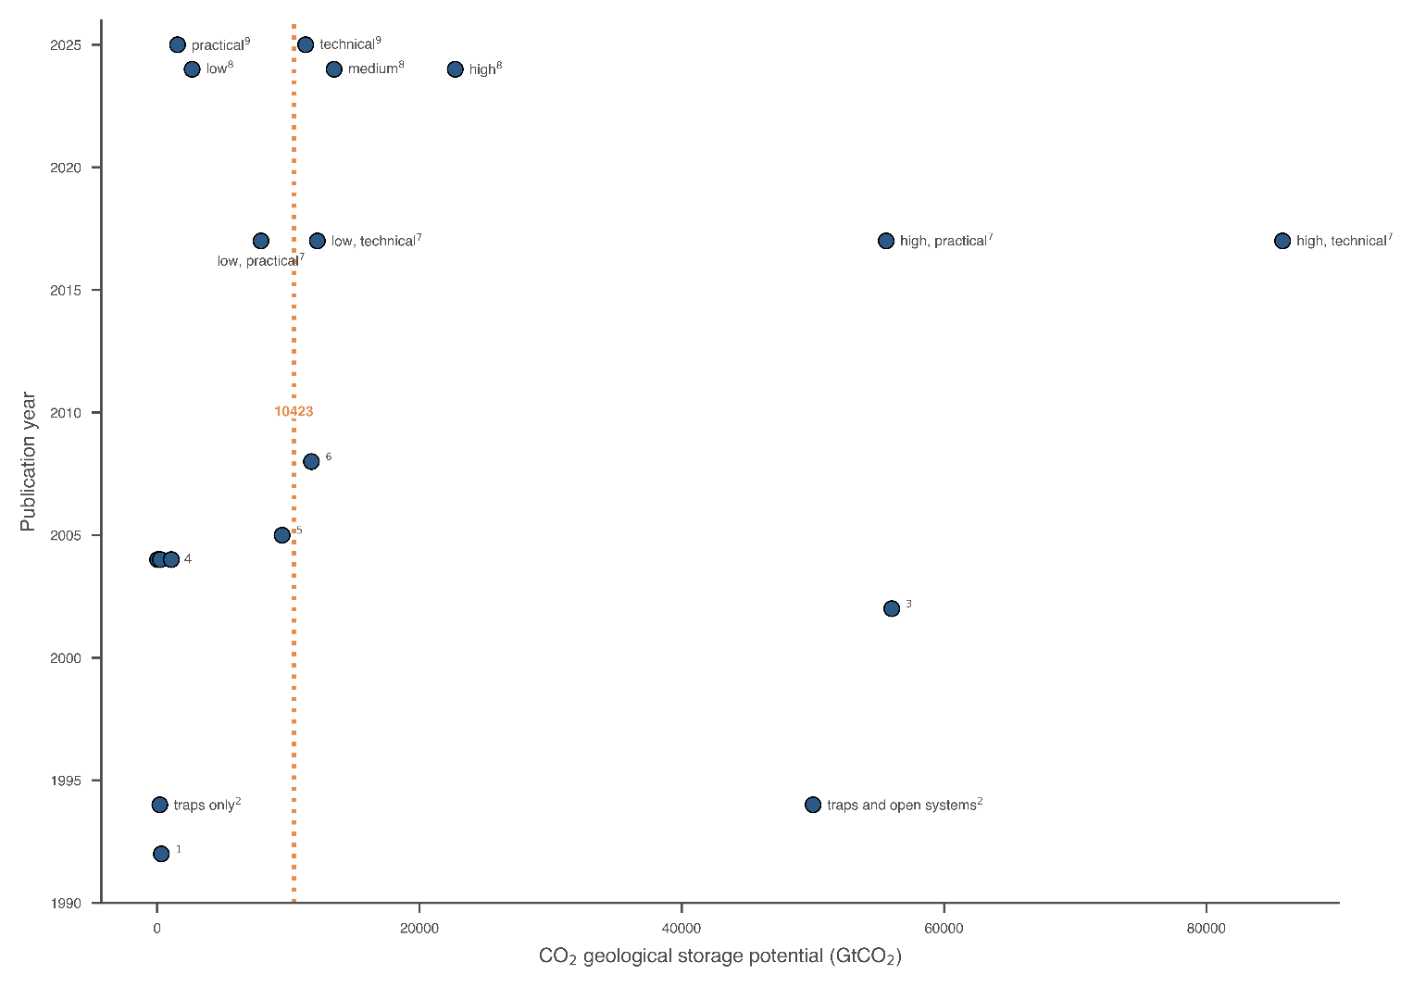
Supplementary Figure 3: Estimates of global CO₂ geological storage potential in saline aquifers against the year of publication. There is no significant trend in the estimates over time, with most estimates are below 20,000 GtCO₂ and a median estimate of 10,423 GtCO₂. Some large outliers also exist (up to 86,000 GtCO₂). 1: Koide et al. (1992), 2: Hendriks (1994), 3: Bruant et al. (2002), 4: Hendriks et al. (2004), 5: Dooley et al. (2005), 6: IEAGHG (2008), 7: Kearns et al. (2017), 8: Oil and Gas Climate Initiative (OGCI) (2024), 9: Gidden et al. (2025)

Supplementary Note 4: CO2 geological storage potential constraints
IAM’s adopt limits on the geological storage potential, and we compiled this data for the six of the nine IAMs that produced modelling results for IPCC Sixth Assessment Report. We compiled data for COFFEE, GCAM, IMAGE, MESSAGE, REMIND and WITCH (Supplementary Figure 4; Supplementary Tables 3-8). Limits are also adopted with POLES (Keramidas et al., 2018) but the specific data was not available, and no information on storage potential constraints could be ascertained for AIM and GEM.
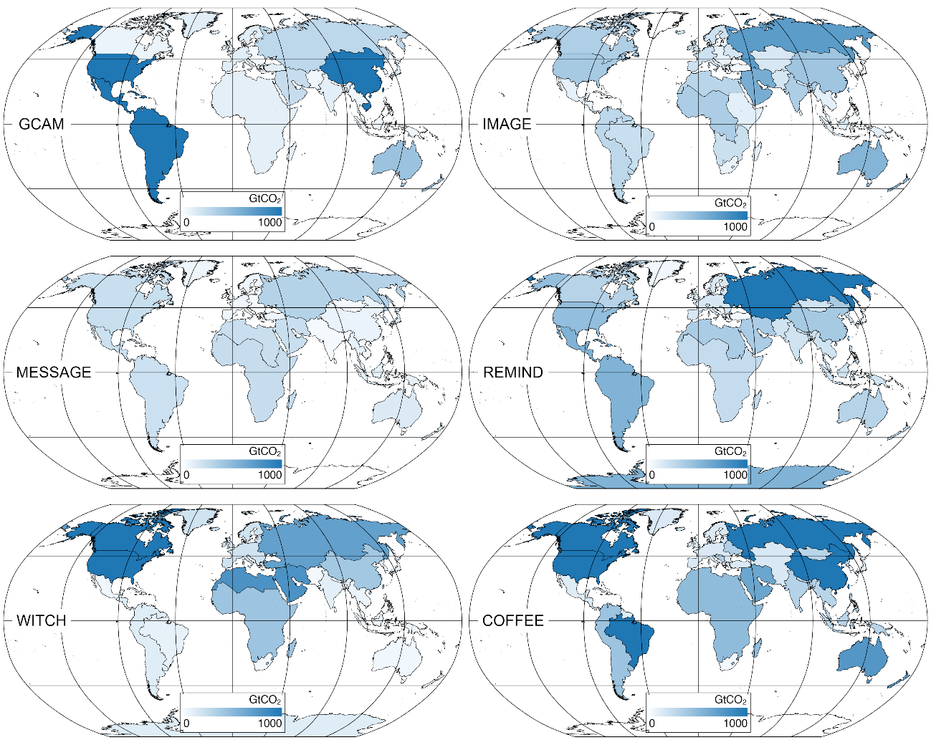
Supplementary Figure 4: Global maps highlighting regional geological storage potential limits adopted by GCAM (7,178 GtCO₂), IMAGE (5,805 GtCO₂), MESSAGE (1,503 GtCO₂), REMIND (3,929 GtCO₂), WITCH (11,372 GtCO₂) and COFFEE (13,010 GtCO₂). Note that for IMAGE and WITCH, the “medium” and “best” estimates, respectively, are adopted. The corresponding data can be viewed in Supplementary Tables 3-8).
Supplementary Table 3: COFFEE (Rochedo, 2016)
Region | EOR onshore (GtCO₂) | EOR offshore (GtCO₂) | Gas onshore (GtCO₂) | Gas offshore (GtCO₂) | Low-cost aquifer onshore (GtCO₂) | Low-cost aquifer offshore (GtCO₂) | High-cost aquifer onshore (GtCO₂) | High-cost aquifer offshore (GtCO₂)
AFR | 5 | 12 | 20 | 30 | 94 | 94 | 111 | 111
AUS | 0 | 1 | 0 | 16 | 70 | 630 | 4 | 36
BRA | 0 | 6 | 0 | 23 | 87 | 780 | 113 | 1020
CAM | 1 | 5 | 1 | 11 | 4 | 40 | 5 | 47
CAN | 0 | 0 | 7 | 1 | 264 | 88 | 711 | 237
CAS | 1 | 4 | 34 | 17 | 30 | 10 | 36 | 12
CHN | 2 | 1 | 20 | 1 | 803 | 268 | 273 | 91
EEU | 1 | 9 | 5 | 50 | 2 | 17 | 5 | 46
IND | 0 | 0 | 2 | 2 | 75 | 75 | 75 | 75
JAP | 0 | 0 | 0 | 0 | 15 | 15 | 36 | 36
KOR | 0 | 0 | 0 | 0 | 4 | 4 | 5 | 5
MEA | 27 | 18 | 114 | 29 | 158 | 53 | 187 | 62
RAS | 0 | 1 | 13 | 31 | 56 | 56 | 66 | 66
RUS | 9 | 6 | 44 | 128 | 481 | 481 | 569 | 569
SAF | 0 | 0 | 0 | 0 | 0 | 1 | 2 | 17
SAM | 6 | 5 | 15 | 12 | 88 | 88 | 104 | 104
USA | 3 | 3 | 62 | 5 | 426 | 142 | 1149 | 383
WEU | 0 | 0 | 4 | 0 | 64 | 21 | 176 | 59
Supplementary Table 4: GCAM (after Dooley et al. (2005))
Region | Coal Basins (GtCO₂) | Depleted Oil Plays (GtCO₂) | Gas Basins (GtCO₂) | Saline aquifers (onshore) (GtCO₂) | Saline aquifers (offshore) (GtCO₂)
Africa | 0 | 3 | 9 | 78 | 0
Australia_NZ | 0 | 12 | 0 | 265 | 152
Canada | 1 | 14 | 0 | 38 | 0
China | 9 | 4 | 4 | 1716 | 584
Eastern Europe | 1 | 2 | 0 | 13 | 0
Former Soviet Union | 0 | 16 | 256 | 0 | 0
India | 0 | 1 | 14 | 43 | 41
Japan | 0 | 3 | 0 | 41 | 66
Korea | 0 | 0 | 0 | 0 | 0
Latin America | 0 | 7.575 | 45 | 1562 | 0
Middle East | 0 | 53 | 169 | 0 | 0
Southeast Asia | 0 | 3.75 | 33 | 0 | 0
USA | 59 | 107 | 0 | 1161 | 491
Western Europe | 0 | 22 | 0 | 36 | 43
Supplementary Table 5: IMAGE (after (Hendriks et al., 2004))
Estimate | Region | Remaining oil, onshore (GtCO₂) | Remaining oil, offshore (GtCO₂) | Remaining gas, onshore (GtCO₂) | Remaining gas, offshore (GtCO₂) | Depleted oil, onshore (GtCO₂) | Depleted oil, offshore (GtCO₂) | Depleted gas, onshore (GtCO₂) | Depleted gas, offshore (GtCO₂) | ECBM (GtCO₂) | Aquifers 1 (GtCO₂) | Aquifers 2 (GtCO₂)
Low | Brazil | 0 | 0 | 3 | 1 | 0 | 0 | 0 | 0 | 0 | 1 | 0
Medium | Brazil | 3 | 2 | 6 | 5 | 0 | 1 | 1 | 0 | 1 | 11 | 186
High | Brazil | 20 | 19 | 17 | 21 | 1 | 1 | 1 | 0 | 5 | 50 | 279
Low | Canada | 0 | 0 | 7 | 1 | 1 | 0 | 0 | 0 | 0 | 2 | 0
Medium | Canada | 0 | 0 | 8 | 1 | 1 | 0 | 7 | 0 | 8 | 17 | 291
High | Canada | 3 | 3 | 10 | 1 | 2 | 0 | 8 | 0 | 51 | 78 | 437
Low | Central America | 0 | 0 | 0 | 3 | 0 | 0 | 0 | 0 | 0 | 0 | 0
Medium | Central America | 0 | 0 | 1 | 4 | 0 | 0 | 0 | 0 | 0 | 4 | 61
High | Central America | 2 | 3 | 2 | 12 | 0 | 1 | 0 | 0 | 0 | 16 | 92
Low | Central Asia | 0 | 0 | 12 | 4 | 0 | 0 | 0 | 0 | 0 | 1 | 0
Medium | Central Asia | 4 | 1 | 21 | 12 | 1 | 0 | 10 | 0 | 1 | 6 | 96
High | Central Asia | 25 | 4 | 55 | 48 | 1 | 1 | 17 | 1 | 4 | 26 | 144
Low | Central Europe | 0 | 0 | 3 | 0 | 0 | 0 | 0 | 0 | 0 | 0 | 0
Medium | Central Europe | 1 | 0 | 4 | 0 | 0 | 0 | 3 | 0 | 1 | 3 | 57
High | Central Europe | 5 | 0 | 7 | 0 | 1 | 0 | 4 | 0 | 4 | 15 | 85
Low | China + | 0 | 0 | 4 | 0 | 1 | 0 | 0 | 0 | 0 | 2 | 0
Medium | China + | 3 | 0 | 8 | 0 | 2 | 1 | 4 | 0 | 156 | 13 | 222
High | China + | 23 | 3 | 24 | 1 | 2 | 2 | 8 | 0 | 829 | 59 | 333
Low | Eastern Africa | 0 | 0 | 0 | 0 | 0 | 0 | 0 | 0 | 0 | 1 | 0
Medium | Eastern Africa | 0 | 0 | 0 | 1 | 0 | 0 | 0 | 0 | 0 | 5 | 92
High | Eastern Africa | 0 | 1 | 1 | 4 | 0 | 0 | 0 | 0 | 0 | 25 | 139
Low | India | 0 | 0 | 1 | 0 | 0 | 0 | 0 | 0 | 0 | 2 | 0
Medium | India | 0 | 0 | 3 | 1 | 0 | 1 | 2 | 0 | 5 | 25 | 300
High | India | 1 | 2 | 7 | 4 | 0 | 2 | 4 | 0 | 8 | 60 | 337
Low | Indonesia + | 0 | 0 | 1 | 8 | 0 | 1 | 0 | 1 | 0 | 0 | 0
Medium | Indonesia + | 1 | 1 | 4 | 16 | 1 | 2 | 2 | 2 | 18 | 3 | 52
High | Indonesia + | 3 | 6 | 9 | 31 | 1 | 4 | 4 | 2 | 105 | 14 | 78
Low | Japan | 0 | 0 | 0 | 0 | 0 | 0 | 0 | 0 | 0 | 0 | 0
Medium | Japan | 0 | 0 | 0 | 0 | 0 | 0 | 0 | 0 | 0 | 2 | 31
High | Japan | 0 | 0 | 0 | 0 | 0 | 0 | 0 | 0 | 1 | 8 | 47
Low | Korea Region | 0 | 0 | 0 | 0 | 0 | 0 | 0 | 0 | 0 | 0 | 0
Medium | Korea Region | 0 | 0 | 0 | 0 | 0 | 0 | 0 | 0 | 2 | 0 | 4
High | Korea Region | 0 | 0 | 0 | 0 | 0 | 0 | 0 | 0 | 12 | 1 | 7
Low | Mexico | 0 | 0 | 0 | 3 | 0 | 2 | 0 | 1 | 0 | 0 | 0
Medium | Mexico | 2 | 2 | 1 | 5 | 1 | 6 | 1 | 1 | 0 | 4 | 61
High | Mexico | 12 | 18 | 2 | 15 | 1 | 10 | 1 | 1 | 0 | 16 | 92
Low | Middle East | 51 | 1 | 92 | 70 | 8 | 3 | 0 | 1 | 0 | 1 | 0
Medium | Middle East | 62 | 9 | 168 | 85 | 12 | 10 | 92 | 1 | 0 | 8 | 142
High | Middle East | 405 | 61 | 372 | 116 | 16 | 18 | 168 | 1 | 0 | 38 | 213
Low | North Africa | 0 | 0 | 14 | 1 | 1 | 1 | 0 | 0 | 0 | 2 | 0
Medium | North Africa | 5 | 1 | 19 | 3 | 2 | 3 | 14 | 0 | 0 | 13 | 227
High | North Africa | 24 | 6 | 43 | 10 | 2 | 5 | 19 | 0 | 0 | 61 | 341
Low | Oceania | 0 | 0 | 0 | 7 | 0 | 1 | 0 | 0 | 0 | 4 | 0
Medium | Oceania | 0 | 1 | 0 | 17 | 0 | 1 | 0 | 0 | 11 | 28 | 474
High | Oceania | 0 | 5 | 1 | 40 | 0 | 3 | 0 | 1 | 54 | 126 | 711
Low | Rest of South America | 0 | 0 | 6 | 2 | 2 | 2 | 0 | 0 | 0 | 1 | 0
Medium | Rest of South America | 5 | 4 | 12 | 9 | 3 | 6 | 8 | 0 | 1 | 12 | 202
High | Rest of South America | 34 | 33 | 32 | 40 | 4 | 10 | 16 | 1 | 7 | 54 | 303
Low | Rest of South Asia | 0 | 0 | 3 | 1 | 0 | 0 | 0 | 0 | 0 | 1 | 0
Medium | Rest of South Asia | 0 | 0 | 7 | 3 | 0 | 0 | 2 | 0 | 1 | 8 | 134
High | Rest of South Asia | 1 | 1 | 17 | 9 | 0 | 0 | 6 | 1 | 4 | 36 | 201
Low | Rest of Southern America | 0 | 0 | 0 | 0 | 0 | 0 | 0 | 0 | 0 | 1 | 0
Medium | Rest of Southern America | 0 | 1 | 0 | 1 | 0 | 1 | 0 | 0 | 0 | 12 | 195
High | Rest of Southern America | 1 | 11 | 0 | 4 | 0 | 1 | 0 | 0 | 3 | 52 | 292
Low | Russia + | 1 | 0 | 58 | 20 | 4 | 2 | 0 | 2 | 0 | 3 | 0
Medium | Russia + | 18 | 2 | 103 | 58 | 7 | 5 | 59 | 2 | 24 | 25 | 420
High | Russia + | 106 | 15 | 270 | 234 | 9 | 8 | 105 | 4 | 142 | 112 | 629
Low | South Africa | 0 | 0 | 0 | 0 | 0 | 0 | 0 | 0 | 0 | 0 | 0
Medium | South Africa | 0 | 0 | 0 | 0 | 0 | 0 | 0 | 0 | 7 | 2 | 42
High | South Africa | 0 | 0 | 0 | 0 | 0 | 0 | 0 | 0 | 42 | 11 | 63
Low | Southeastern Asia | 0 | 0 | 1 | 8 | 0 | 0 | 0 | 1 | 0 | 0 | 0
Medium | Southeastern Asia | 0 | 1 | 3 | 16 | 0 | 1 | 1 | 1 | 1 | 3 | 56
High | Southeastern Asia | 3 | 5 | 9 | 30 | 0 | 2 | 3 | 2 | 9 | 15 | 84
Low | Turkey | 0 | 0 | 0 | 0 | 0 | 0 | 0 | 0 | 0 | 0 | 0
Medium | Turkey | 0 | 0 | 0 | 0 | 0 | 0 | 0 | 0 | 0 | 1 | 21
High | Turkey | 1 | 0 | 0 | 0 | 0 | 0 | 0 | 0 | 0 | 6 | 32
Low | Ukraine + | 0 | 0 | 1 | 0 | 0 | 0 | 0 | 0 | 0 | 1 | 0
Medium | Ukraine + | 0 | 0 | 2 | 1 | 0 | 0 | 2 | 0 | 1 | 9 | 146
High | Ukraine + | 2 | 0 | 6 | 5 | 0 | 0 | 3 | 0 | 4 | 39 | 220
Low | USA | 1 | 0 | 6 | 1 | 2 | 1 | 2 | 1 | 0 | 2 | 0
Medium | USA | 6 | 0 | 8 | 1 | 4 | 3 | 6 | 1 | 32 | 17 | 291
High | USA | 45 | 5 | 15 | 1 | 5 | 5 | 8 | 2 | 190 | 78 | 437
Low | Western Africa | 0 | 0 | 1 | 5 | 0 | 3 | 0 | 0 | 0 | 2 | 0
Medium | Western Africa | 2 | 6 | 3 | 12 | 0 | 8 | 1 | 49 | 0 | 15 | 255
High | Western Africa | 18 | 67 | 7 | 29 | 0 | 14 | 3 | 1 | 1 | 68 | 383
Low | Western Europe | 0 | 0 | 5 | 13 | 0 | 3 | 0 | 10 | 0 | 1 | 0
Medium | Western Europe | 0 | 4 | 10 | 27 | 0 | 10 | 5 | 10 | 1 | 7 | 119
High | Western Europe | 1 | 40 | 17 | 112 | 0 | 18 | 10 | 13 | 6 | 32 | 178
Supplementary Table 6: MESSAGE
Region | Capacity (GtCO₂)
R12_AFR | 225
R12_CHN | 58
R12_EEU | 7
R12_FSU | 305
R12_LAM | 205
R12_MEA | 210
R12_NAM | 216
R12_PAO | 126
R12_PAS | 77
R12_RCPA | 14
R12_SAS | 17
R12_WEU | 43
Supplementary Table 7: REMIND
Region | Capacity (GtCO₂)
CAZ | 303
CHA | 367
EUR | 148
IND | 183
JPN | 69
LAM | 550
MEA | 353
NEU | 26
OAS | 183
REF | 1056
SSA | 232
USA | 458

Supplementary Table 8: WITCH (after (Rottoli & Vinca, 2017))
 | Best estimate (GtCO₂) |  |  | High estimate (GtCO₂) |  |  | Low estimate (GtCO₂) |  |  | Single estimate (GtCO₂)
Region | aquifers | ECBM | OG | aquifers | ECBM | OG | aquifers | ECBM | OG | EOR
brazil | 63 | 0 | 10 | 249 | 1 | 37 | 17 |  | 3 | 1
canada | 4565 | 11 | 40 | 7288 | 14 | 42 | 1887 | 9 | 6 | 6
china | 215 | 138 | 31 | 938 | 744 | 79 | 31 |  | 12 | 5
europe | 147 | 3 | 26 | 147 | 3 | 26 | 147 | 3 | 26 | 5
india | 58 | 25 | 10 | 252 | 136 | 26 | 8 |  | 4 | 1
indonesia | 6 | 9 | 22 | 25 | 47 | 56 | 1 |  | 9 | 2
jpnkor | 50 | 4 | 1 | 219 | 23 | 1 | 7 |  | 0 | 0
laca | 53 | 2 | 50 | 209 | 9 | 187 | 14 |  | 16 | 6
mena | 223 | 0 | 468 | 658 | 0 | 1281 | 82 |  | 187 | 101
mexico | 5 | 0 | 29 | 20 | 2 | 107 | 1 |  | 9 | 3
oceania | 2 | 11 | 20 | 9 | 54 | 49 | 0 |  | 8 | 0
sasia | 20 | 0 | 4 | 88 | 1 | 12 | 3 |  | 2
seasia | 21 | 2 | 23 | 92 | 13 | 60 | 3 |  | 9 | 2
southafrica | 7 | 8 | 1 | 21 | 44 | 2 | 3 |  | 0 | 0
ssa | 358 | 0 | 54 | 1057 | 1 | 147 | 132 |  | 22 | 4
te | 314 | 23 | 303 | 314 | 25 | 303 | 314 | 23 | 303 | 46
usa | 3436 | 165 | 116 | 5486 | 215 | 124 | 1420 | 148 | 16 | 36

Supplementary Note 5: Storage costs
The following tables detail the storage and transport costs embedded in WITCH, IMAGE, GCAM and COFFEE. The costs have been adjusted for inflation to 2024 values and converted to U.S dollars where necessary using the following conversions:
Inflationary conversions (using CPI indexes):
- $1 (2005) = $1.61 (2024)
- $1 (2015) = $1.32 (2024)
- €1 (2004) = €1.56 (2024)
Currency conversions (using annual average spot prices):
- €1 (2024) = $1.08 (2024)
Supplementary Table 9: Summary of storage costs utilised by the WITCH IAM (after Rottoli and Vinca (2017), ZEP (2011) and Rubin et al. (2015)).
Storage type | Storage
Storage type | Low ($/tCO₂) |  |  | Best ($/tCO₂) |  | High ($/tCO₂)
Storage type | Source (2015) | Inflation-adjusted (2024) |  | Source (2015) | Inflation -adjusted (2024) | Source (2015) | Inflation -adjusted (2024)
Oil and gas (EOR, onshore) | 1.0 |  | 1.3 | 4 | 5.3 | 9 | 11.9
Oil and gas (no EOR, onshore) | 1.0 |  | 1.3 | 5 | 6.6 | 13 | 17.2
Aquifer onshore | 3.0 |  | 4.0 | 6 | 8.0 | 15 | 19.9
Oil and gas (EOR, offshore) | 3.0 |  | 4.0 | 8 | 10.6 | 12 | 15.9
Oil and gas (no EOR, offshore) | 4.0 |  | 5.3 | 13 | 17.2 | 18 | 23.8
Aquifer offshore | 8.0 |  | 10.6 | 18 | 23.8 | 26 | 34.4
ECBM | 0 |  | 0 | 45 | 59.6 | 90 | 119.1

Supplementary Table 10: Average storage cost per type (Hendriks et al., 2004). While not explicitly stated in Hendriks et al (2004), we assume costs are representative of 2004. The table presents the source values and values converted to 2024 values and converted to U.S dollars for comparison with the other datasets.
Storage type | Average cost (€/tCO₂)
Storage type | Source (€ 2004) | Inflation-adjusted ($ 2024)
Aquifer onshore | 2.7 | 4.6
Aquifer offshore | 7.3 | 12.3
Natural gas field onshore | 1.6 | 2.7
Natural gas field offshore | 5.7 | 9.6
Empty oil field onshore | 1.6 | 2.7
Empty oil field offshore | 5.7 | 9.6
EOR onshore | 0 | 0
EOR offshore | 3 | 5.1
ECBM | 10 | 16.9

Supplementary Table 11: Summary of storage costs used by the GCAM IAM to construct cost-supply curves
Grade | Fraction of total resource | Cost ($/tCO₂)
Grade | Fraction of total resource | Source ($ 2005) | Inflation -adjusted ($ 2024)
1 | 0 - 0.005 | 0.1 | 0.2
2 | 0.005 - 0.105 | 5.0 | 8.0
3 | 0.105 - 0.705 | 10.0 | 16.1
4 | 0.705 - 1 | 96 | 154.2

Supplementary Table 12: Storage costs per type used by the COFFEE IAM (Rochedo, 2016).
Storage type | Average cost ($/tCO₂)
Storage type | Source ($ 2016) | Inflation-adjusted ($ 2024)
EOR onshore | 3.0 | 3.9
EOR offshore | 6.0 | 7.8
Gas fields onshore | 4.0 | 5.2
Gas fields offshore | 10.0 | 13.1
Low cost aquifer onshore | 5.0 | 6.5
Low cost aquifer offshore | 7.0 | 9.1
High cost aquifer onshore | 12.0 | 15.7
High costs aquifer offshore | 14.0 | 18.3

References
Bruant, R., Guswa, A., Celia, M., & Peters, C. (2002). Safe storage of CO2 in deep saline aquifers. ENVIRONMENTAL SCIENCE AND TECHNOLOGY-WASHINGTON DC-, 36(11), 240A-245A.
Byers, E., Krey, V., Kriegler, E., Riahi, K., Schaeffer, R., Kikstra, J., Lamboll, R., Nicholls, Z., Sandstad, M., Smith, C., van der Wijst, K., Al -Khourdajie, A., Lecocq, F., Portugal-Pereira, J., Saheb, Y., Stromman, A., Winkler, H., Auer, C., Brutschin, E.,…van Vuuren, D. (2022). AR6 Scenarios Database (Integrated Assessment Modeling Consortium & International Institute for Applied Systems Analysis. https://doi.org/10.5281/ZENODO.7197970
Dooley, J. J., Kim, S. H., Edmonds, J. A., Friedman, S. J., & Wise, M. A. (2005). A first-order global geological CO2-storage potential supply curve and its application in a global integrated assessment model. In E. S. Rubin, D. W. Keith, C. F. Gilboy, M. Wilson, T. Morris, J. Gale, & K. Thambimuthu (Eds.), Greenhouse Gas Control Technologies 7 (pp. 573-581). Elsevier Science Ltd. https://doi.org/https://doi.org/10.1016/B978-008044704-9/50058-6
Evenick, J. C. (2021). Glimpses into Earth's history using a revised global sedimentary basin map. Earth-Science Reviews, 215, 103564. https://doi.org/https://doi.org/10.1016/j.earscirev.2021.103564
Gidden, M., Joshi, S., Armitage, J., Christ, A.-B., Boettcher, M., Brutschin, E., Koberle, A., Schellnhuber, H. J., Schleussner, C.-F., Riahi, K., & Rogelj, J. (2025, 27 Apr–2 May 2025). A prudent planetary boundary for geological carbon storage EGU General Assembly 2025, Vienna, Austria.
Hendriks, C. (1994). Carbon Dioxide Removal from Coal-Fired Power Plants. Energy & Environment. https://doi.org/10.1007/978-94-011-0301-5
Hendriks, C., Graus, W., & Van Bergen, F. (2004). Global Carbon Dioxide Storage Potential and Costs. http://inis.iaea.org/search/search.aspx?orig_q=RN:35053050
Hendriks, C. A., & Blok, K. (1993). Underground storage of carbon dioxide. Energy Conversion and Management, 34(9), 949-957. https://doi.org/https://doi.org/10.1016/0196-8904(93)90041-8
Hendriks, C. A., & Blok, K. (1995). Underground storage of carbon dioxide. Energy Conversion and Management, 36(6), 539-542. https://doi.org/https://doi.org/10.1016/0196-8904(95)00062-I
IEAGHG. (2008). Aquifer Storage – Development Issues.
IEAGHG. (2011). Potential for Biomass and Carbon Dioxide Capture and Storage (2011/06).
IPCC. (2022). Annex I: Glossary. In R. van Diemen, J.B.R. Matthews, V. Möller, J.S. Fuglestvedt, V. Masson-Delmotte, C. Méndez, A. Reisinger, & S. Semeno (Eds.), Climate Change 2022: Mitigation of Climate Change. Contribution of Working Group III to the Sixth Assessment Report of the Intergovernmental Panel on Climate Change. Cambridge University Press. https://doi.org/10.1017/9781009157926.020
Kearns, J., Teletzke, G., Palmer, J., Thomann, H., Kheshgi, H., Chen, Y.-H. H., Paltsev, S., & Herzog, H. (2017). Developing a Consistent Database for Regional Geologic CO2 Storage Capacity Worldwide. Energy Procedia, 114, 4697-4709. https://doi.org/https://doi.org/10.1016/j.egypro.2017.03.1603
Keramidas, K., Kitous, A., Schade, B., Després, J., & Schmitz, A. (2018). POLES-JRC model documentation – 2018 update. Publications Office. https://doi.org/doi/10.2760/814959
Koide, H., Tazaki, Y., Noguchi, Y., Nakayama, S., Iijima, M., Ito, K., & Shindo, Y. (1992). Subterranean containment and long-term storage of carbon dioxide in unused aquifers and in depleted natural gas reservoirs. Energy Conversion and Management, 33(5), 619-626. https://doi.org/https://doi.org/10.1016/0196-8904(92)90064-4
Oil and Gas Climate Initiative (OGCI). (2024). CO2 Storage Resource Catalogue - Cycle 4 Report. https://www.ogci.com/wp-content/uploads/2024/08/CSRC_Cycle_4_Main-Report_August_2024.pdf
Rochedo, P. R. R. (2016). Development of a global integrated energy model to evaluate the Brazilian role in climate change mitigation scenarios Federal University of Rio de Janeiro]. Brazil.
Rottoli, M., & Vinca, A. (2017). The role of carbon capture and storage for climate stabilization: a numerical assessment Politecnico di Milano]. POLITesi - Archivio digitale delle tesi di laurea e di dottorato. https://www.politesi.polimi.it/handle/10589/133979
Rubin, E. S., Davison, J. E., & Herzog, H. J. (2015). The cost of CO2 capture and storage. International Journal of Greenhouse Gas Control, 40, 378-400. https://doi.org/https://doi.org/10.1016/j.ijggc.2015.05.018
van der Meer, L. G. H. (1992). Investigations regarding the storage of carbon dioxide in aquifers in the Netherlands. Energy Conversion and Management, 33(5), 611-618. https://doi.org/https://doi.org/10.1016/0196-8904(92)90063-3
Watson, R. T., Zinyowera, M. C., & Moss, R. H. (1996). Climate change 1995. Impacts, adaptations and mitigation of climate change: scientific-technical analyses.
ZEP. (2011). The costs of CO2 storage: post-demonstration CCS in the EU. https://zeroemissionsplatform.eu/document/the-costs-of-co2-storage/

