Supporting information for
“Spatiotemporal slip distributions associated with the 2018-2019 Bungo Channel long-term slow slip event inverted from GNSS data”

Yukinari Seshimo^{1,}* and Shoichi Yoshioka^{2,1}

¹Department of Planetology, Graduate School of Science, Kobe University, Rokkodai-cho 1-1, Nada ward, Kobe 657-8501, Japan
²Research Center for Urban Safety and Security, Kobe University, Rokkodai-cho 1-1, Nada ward, Kobe 657-8501, Japan

*corresponding author

TEL: +81-80-2624-6982
FAX: +81-78-803-6598
e-mail: y.seshimo@stu.kobe-u.ac.jp

Contents
Table S1
Figures and figure captions S1-S4
References

Table S1
Slip-related values for the 1996-1998, 2002-2004, 2009-2011 and 2018-2019 Bungo Channel L-SSEs estimated from inversion analyses.
L-SSE | 1996-1998  L-SSE | 2002-2003  L-SSE |  | 2009-2011  L-SSE | 2018-2019  L-SSE
L-SSE | 1996-1998  L-SSE | 1st subevent | 2nd subevent | 2009-2011  L-SSE | 1st subevent | 2nd subevent
duration | 1.3 yr⁽¹⁾ | 0.7 yr⁽¹⁾ | 1.2 yr⁽¹⁾ | 1.2 yr⁽¹⁾ | 0.4 yr | 0.6 yr
maximum slip amount | 15 cm⁽¹⁾ | 7.3 cm⁽¹⁾ | 16 cm⁽¹⁾ | 19 cm⁽¹⁾ | 8.2 cm | 19 cm
maximum slip velocity | 28 cm/yr⁽¹⁾ | 13 cm/yr⁽¹⁾ | 44 cm/yr⁽¹⁾ | 39 cm/yr⁽¹⁾ | 36 cm/yr | 53 cm/yr
total amount of released seismic moment | $2.1×{10}^{19}$  Nm⁽¹⁾ | $8.3×{10}^{18}$  Nm⁽¹⁾ | $2.1×{10}^{19}$  Nm⁽¹⁾ | $2.2×{10}^{19}$  Nm⁽¹⁾ | $${9.0×10}^{18}$$  Nm | $2.2×{10}^{19}$  Nm
moment magnitude | 6.8⁽¹⁾ | 6.5⁽¹⁾ | 6.8⁽¹⁾ | 6.9⁽¹⁾ | 6.6 | 6.8

- Yoshioka et al. (2015)¹
Figure S1
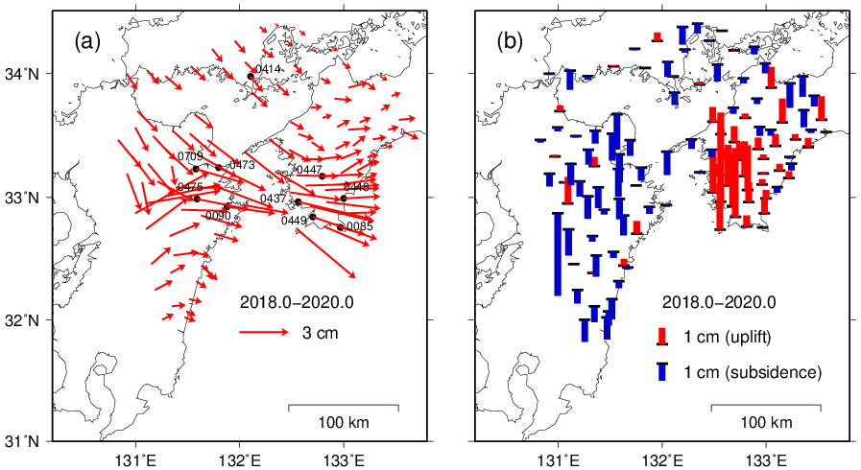

Figure S1 Total displacement fields associated with the L-SSE obtained at GNSS stations during the period from 2018.0 to 2020.0. (a) Total horizontal displacement field. The numbered stations indicate the locations of the time series data shown in Fig. S2. (b) Total vertical displacement field. The black horizontal bars indicate the locations of the GNSS stations, and the red and blue bars indicate uplift and subsidence, respectively.
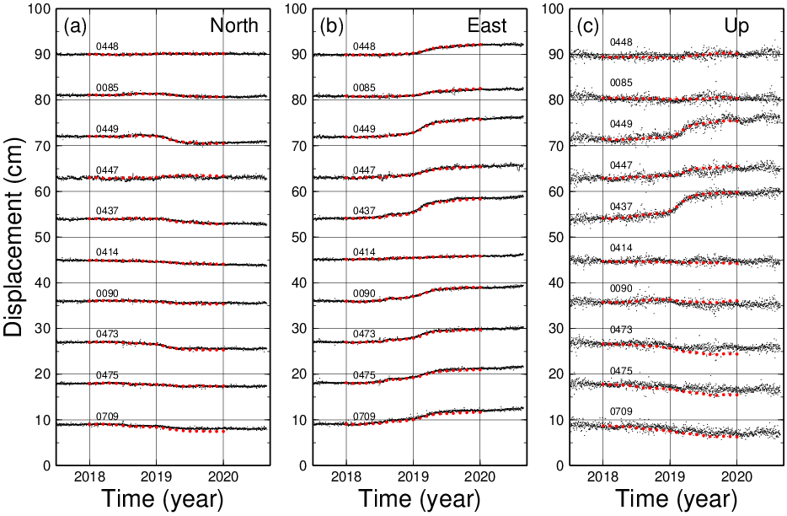
Figure S2

Figure S2 GNSS time series data including displacements associated with the 2018-2019 L-SSE at the stations shown in Fig. S1(a). The black dots indicate the daily data after removing the coseismic steps, steps due to antenna exchange, linear trends, annual and semiannual variations, and the common-mode error. The red dots denote the displacement at each station every 0.1 year calculated from the inverted spatiotemporal slip distributions shown in Fig. 4. (a) North-south component. (b) East-west component. (c) Vertical component.
Figure S3
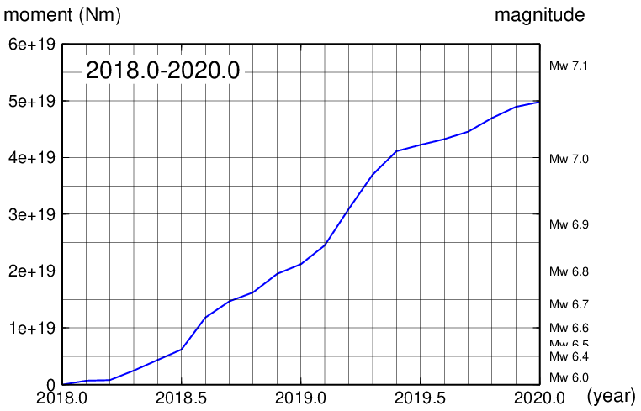

Figure S3 Time variation of the released seismic moment and equivalent moment magnitude during the period from 2018.0 to 2020.0.

Figure S4
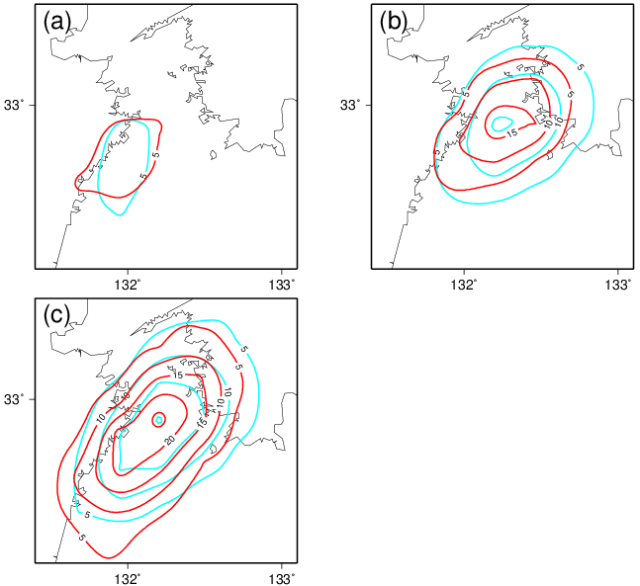

Figure S4 Comparison of slip distributions between the 2018-2019 Bungo Channel L-SSE (in red) obtained in this study and the 2002-2004 Bungo Channel L-SSE (in light blue) estimated by Yoshioka et al. (2015)¹. Contour interval is 5 cm. (a) Slip distributions of the two first subevents. (b) Slip distributions of the two second subevents. (c) Total slip distributions of the two L-SSEs.

References
- Yoshioka, S., Matsuoka, Y. & Ide, S. Spatiotemporal slip distributions of three long-term slow slip events beneath the Bungo Channel, southwest Japan, inferred from inversion analyses of GPS data. Geophys. J. Int. 201, 1437-1455 (2015).

