Supplemental Tables and Figures
Table S1. Isolates chosen for in planta screening for biocontrol of Rizoctonia solania AG8. % similarity indicates the percentage similarity to the closest identity of reference sequences in GenBank using BLASTn. PSI is Phosphate Solubilisation Index. ZSI is Zn Solubilisation Index, SPI is Siderophore Production Index. * Indicates isolates that should significantly lower disease incidence compared to No BCA control in planta assays.
Isolate | Identification | % similarity | Source | % inhibition of pathogen | PSI | ZSI | SPI | % Disease incidence in planta | Selected for further work
Bacteria
 | Pseudomonas sp. 21-C3-ER | 98.54 | Asymptomatic | 75.0 (0.44) | 1.51 | 1.86 | 3.85 | 39.5 (6.34) | Y
 | Pseudomonas sp. strain H2_H06 | 97.54 | Asymptomatic | 56.7 (2.09) | 1.75 | 0 | 3.22 | 17.9 (4.04)
 | Pseudomonas marginalis pv. marginalis strain 4 | 82.42 | Symptomatic | 55.6 (6.34) | 1.33 | 0 | 2.10 | 17.3 (0.48)
 | Erwinia persicina strain S1-10 | 97.51 | Asymptomatic | 55.4 (0.45) | 1.20 | 0 | 1.12 | 28.5 (2.32)
 | Pseudomonas sp. KAR75 | 97.71 | Asymptomatic | 53.4 (4.39) | 1.46 | 2.98 | 1.46 | 9.6 (0.42) | Y
 | Pseudomonas azotoformans | 98.22 | Asymptomatic | 41.2 (2.00) | 1.14 | 0 | 1.99 | 34.6 (3.15)
 | Erwinia rhapontici strain A533 | 89.22 | Symptomatic | 34.8 (12.8) | 1.31 | 0 | 2.59 | 22.1 (2.14)
 | Pseudomonas sp. K92.46 | 96.51 | Asymptomatic | 34.4 (5.59) | 3.00 | 0 | 1.86 | 26.7 (1.50)
 | Pseudomonas sp. K92.46 | 97.73 | Asymptomatic | 32.7 (1.55) | 1.52 | 1.05 | 1.62 | 23.8 (1.25)
 | Pseudomonas sp. TK32 | 98.24 | Asymptomatic | 27.9 (4.17) | 1.26 | 3.06 | 2.94 | 23.6 (4.77)
 | Pseudomonas moraviensis strain Hd7 | 98.32 | Symptomatic | 24.0 (5.12) | 1.95 | 0 | 1.76 | 37.1 (1.71)
 | Pseudomonas sp. strain H-7 | 97.81 | Asymptomatic | 9.60 (2.70) | 1.61 | 0 | 3.1 | 37.4 (1.25)
Fungi
 | Diaporthe sp. isolate HP016 | 98.63 | Asymptomatic | 81.4 (0.54) | 0 | 0 | 1.52 | 9.2 (0.50)* | Y
 | Periconia sp. isolate DS249 | 93.13 | Symptomatic | 73.2 (1.79) | 0 | 0 | 1.61 | 32.3 (2.62)
 | Uncultured fungus clone G1_GD2 | 99.49 | Asymptomatic | 73.2 (1.79) | 0 | 0 | 2.18 | 17.6 (1.58)
 | Microdochium sp. isolate root voucher AG35-1 | 95.63 | Asymptomatic | 65.0 (5.00) | 0 | 0 | 1.58 | 23.2 (1.86)
 | Fusarium tricinctum isolate 35.B.8 | 98.22 | Symptomatic | 63.6 (6.23) | 0 | 1.91 | 1.66 | 25.6 (1.62)
No BCA control |  |  |  |  |  |  |  | 37.6 (0.24)

Table S2. Nutrient content (n=5) of wheat grains grown for 5 months under glasshouse conditions in R. solani AG8 infected soil with different biological control agents (BCA) in the presence (with) and absence (w/o) of fungicide.
BCA treatment | Fungicide | N (%) | P (%) | K | Ca | Mg | Cu | Zn | Mn | Fe | Crude protein
 |  | (%) | (%) | mg kg⁻¹ |  |  |  |  |  |  | (%)
Control | with | 1.614 | 0.357 | 0.511 | 0.036 | 0.134 | 3.790 | 24.83 | 47.48 | 26.20 | 10.09
 |  | ±0.040 | ±0.003 | ±0.007 | ±0.001 | ±0.002 | ±0.084 | ±0.474 | ±0.831 | ±0.808 | ±0.249
 | w/o | 1.622 | 0.382 | 0.504 | 0.041 | 0.136 | 4.145 | 24.91 | 46.86 | 25.73 | 10.14
 |  | ±0.051 | ±0.005 | ±0.007 | ±0.001 | ±0.001 | ±0.164 | ±0.925 | ±0.661 | ±0.604 | ±0.318
BCA_A | with | 1.736 | 0.374 | 0.517 | 0.039 | 0.140 | 4.410 | 27.13 | 49.63 | 27.88 | 10.85
 |  | ±0.064 | ±0.006 | ±0.005 | ±0.001 | ±0.003 | ±0.273 | ±0.672 | ±1.760 | ±1.678 | ±0.401
 | w/o | 1.670 | 0.392 | 0.526 | 0.041 | 0.142 | 4.260 | 26.54 | 49.44 | 26.38 | 10.44
 |  | ±0.024 | ±0.017 | ±0.010 | ±0.002 | ±0.005 | ±0.142 | ±1.318 | ±1.849 | ±0.758 | ±0.151
BCA_E | with | 1.632 | 0.365 | 0.521 | 0.038 | 0.136 | 3.819 | 24.88 | 47.44 | 25.09 | 10.20
 |  | ±0.029 | ±0.011 | ±0.008 | ±0.001 | ±0.004 | ±0.130 | ±1.009 | ±1.114 | ±0.059 | ±0.178
 | w/o | 1.664 | 0.381 | 0.512 | 0.039 | 0.139 | 4.099 | 25.50 | 48.27 | 26.12 | 10.40
 |  | ±0.042 | ±0.012 | ±0.010 | ±0.002 | ±0.004 | ±0.063 | ±1.018 | ±1.858 | ±0.730 | ±0.265
BCA_M | with | 1.630 | 0.363 | 0.516 | 0.039 | 0.133 | 3.979 | 24.92 | 46.16 | 25.18 | 10.19
 |  | ±0.023 | ±0.006 | ±0.008 | ±0.001 | ±0.003 | ±0.078 | ±0.334 | ±1.922 | ±0.178 | ±0.147
 | w/o | 1.564 | 0.370 | 0.501 | 0.036 | 0.132 | 4.175 | 26.12 | 45.96 | 25.96 | 9.78
 |  | ±0.031 | ±0.010 | ±0.014 | ±0.001 | ±0.003 | ±0.159 | ±0.735 | ±1.831 | ±0.684 | ±0.191
SynCom | with | 1.640 | 0.370 | 0.518 | 0.040 | 0.137 | 4.036 | 25.56 | 46.89 | 26.41 | 10.25
 |  | ±0.028 | ±0.010 | ±0.015 | ±0.001 | ±0.003 | ±0.141 | ±0.616 | ±1.225 | ±1.015 | ±0.178
 | w/o | 1.704 | 0.382 | 0.525 | 0.041 | 0.140 | 4.160 | 26.26 | 47.71 | 26.71 | 10.65
 |  | ±0.040 | ±0.008 | ±0.005 | ±0.002 | ±0.002 | ±0.148 | ±0.125 | ±0.891 | ±1.706 | ±0.247

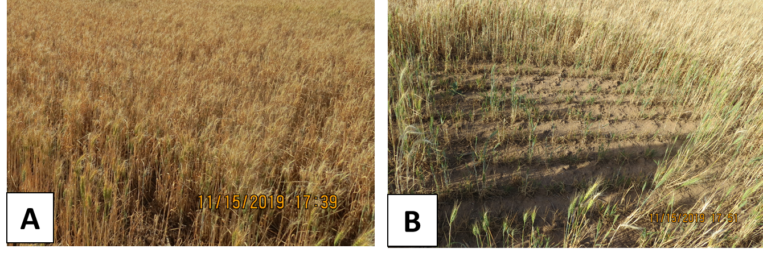
Figure S1 Healthy and Rhizoctonia bare patch infected wheat fields. (A) - healthy wheat field with no reported Rhizoctonia bare patch infection and (B) infected wheat field with prominent Rhizoctonia bare patches in Young, NSW, Australia

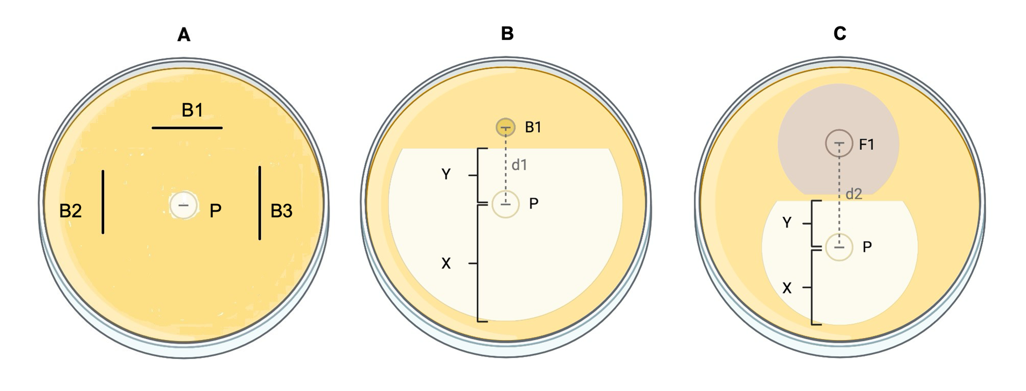Figure S2. PDA plate arrangements used in the qualitative and quantitative confrontation assay for the screening of potential biocontrol agents (BCAs). A: qualitative confrontation assay for bacterial BCAs, B: quantitative confrontation assay for bacterial BCAs, and C: quantitative confrontation assay for fungal BCAs against the pathogen R. solani AG8. B1, B2, B3 = tested bacterial BCA candidates, F1 = tested fungal BCA candidates, P = mycelial disc of the pathogen R. solani AG8. X = The radial growth of the fungal pathogen towards the opposite side of the plate where the candidate BCA was placed, and Y = the radial growth of the pathogen towards the BCA candidate.
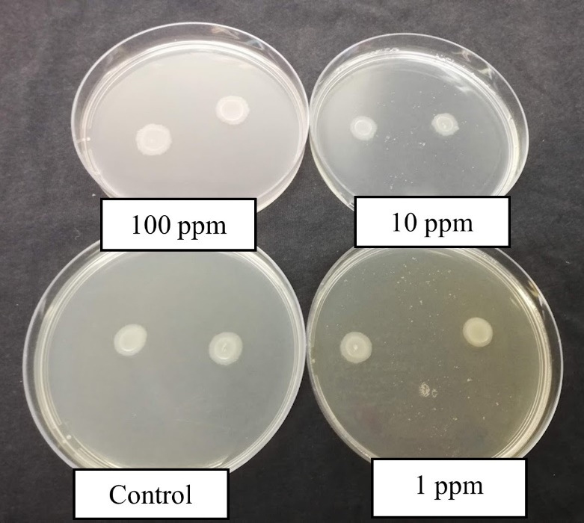

Figure S3. Example of the effect of the fungicide concentration on the growth of the bacterial BCA (BCA_E) on PDA medium supplemented with different concentrations of the fungicide (0, 1, 10, 100 ppm). Growth of all bacterial isolates were unaffected by fungicide at any concentration (data not shown).

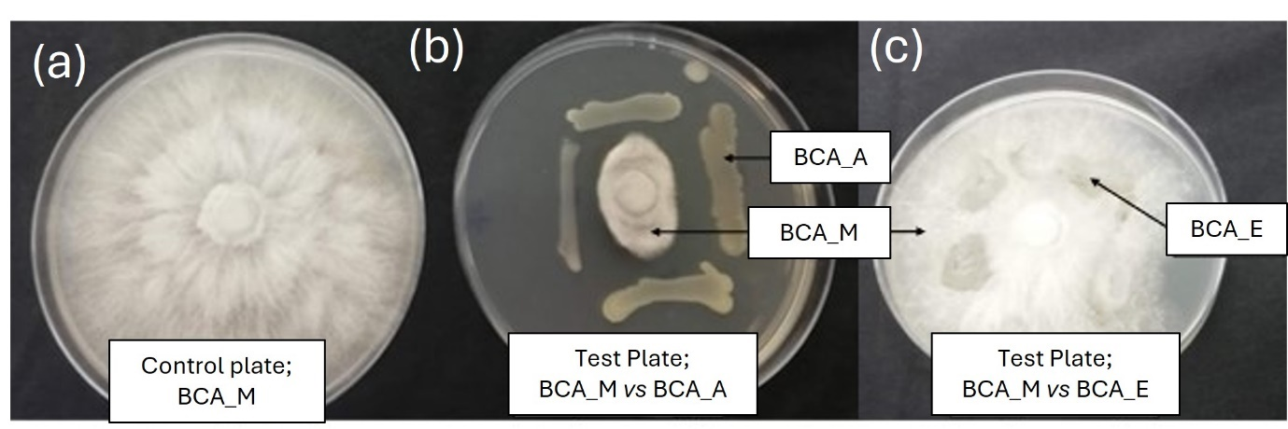
Figure S4 Compatibility test between the fungal BCA (BCA_M) and the bacterial BCAs (BCA_A and BCA_E) on PDA plates. (a) A pure culture of the fungus BCA_M served as the control plate. (b) compatibility between BCA_M vs BCA_A and (c) compatibility between BCA_M vs BCA_E.

