Supplementary Information

Carbene-Catalyzed Atroposelective Synthesis of Axially Chiral Styrenes Bearing Acyclic Alkenes
Jia-Lei Yan,^{1†} Rakesh Maiti,^{1†} Shi-Chao Ren,¹ Weiyi Tian,²* Tingting Li,³ Jun Xu,^{1,2} Bivas Mondal,¹ Zhichao Jin,³ and Yonggui Robin Chi^{1,3}*
† These authors contributed equally to this work.
* Corresponding author. Email: robinchi@ntu.edu.sg (Y.R.C.); tianweiyi@gzy.edu.cn (W.T.)

Table of Contents
1. Supplementary Figures 2
2. Supplementary Methods 117
2.1 General Information 117
2.2 Preparation of the NHC Pre-catalysts 118
2.3 Preparation of the Sulfinic Acids 119
2.4 Preparation of the Ynals 119
3. Supplementary Results of Condition Optimization 127
4. Proposed Reaction Mechanism 129
5. Supplementary Data of the Products 130
5.1 Characterization of the Axially Chiral Styrenes 130
5.2 Further Transformations of the Products 145
6. Supplementary Data for DFT Calculations on the Rotation Barrier 153
7. Supplementary Data for Experimental Racemization Studies 159
8. Supplementary References 163

1. Supplementary Figures
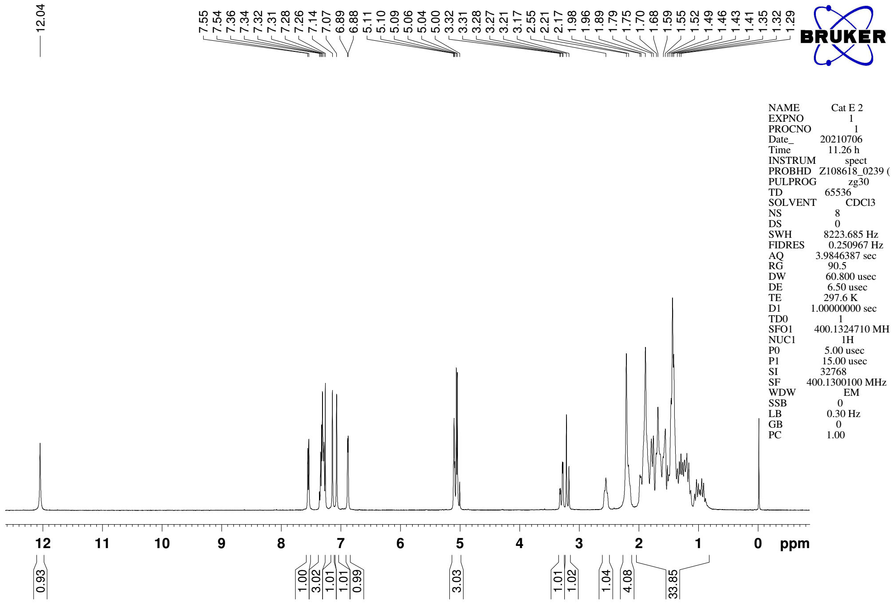
Supplementary Figure 1. ¹H NMR (CDCl₃, 400MHz) spectra of NHC pre-catalyst E

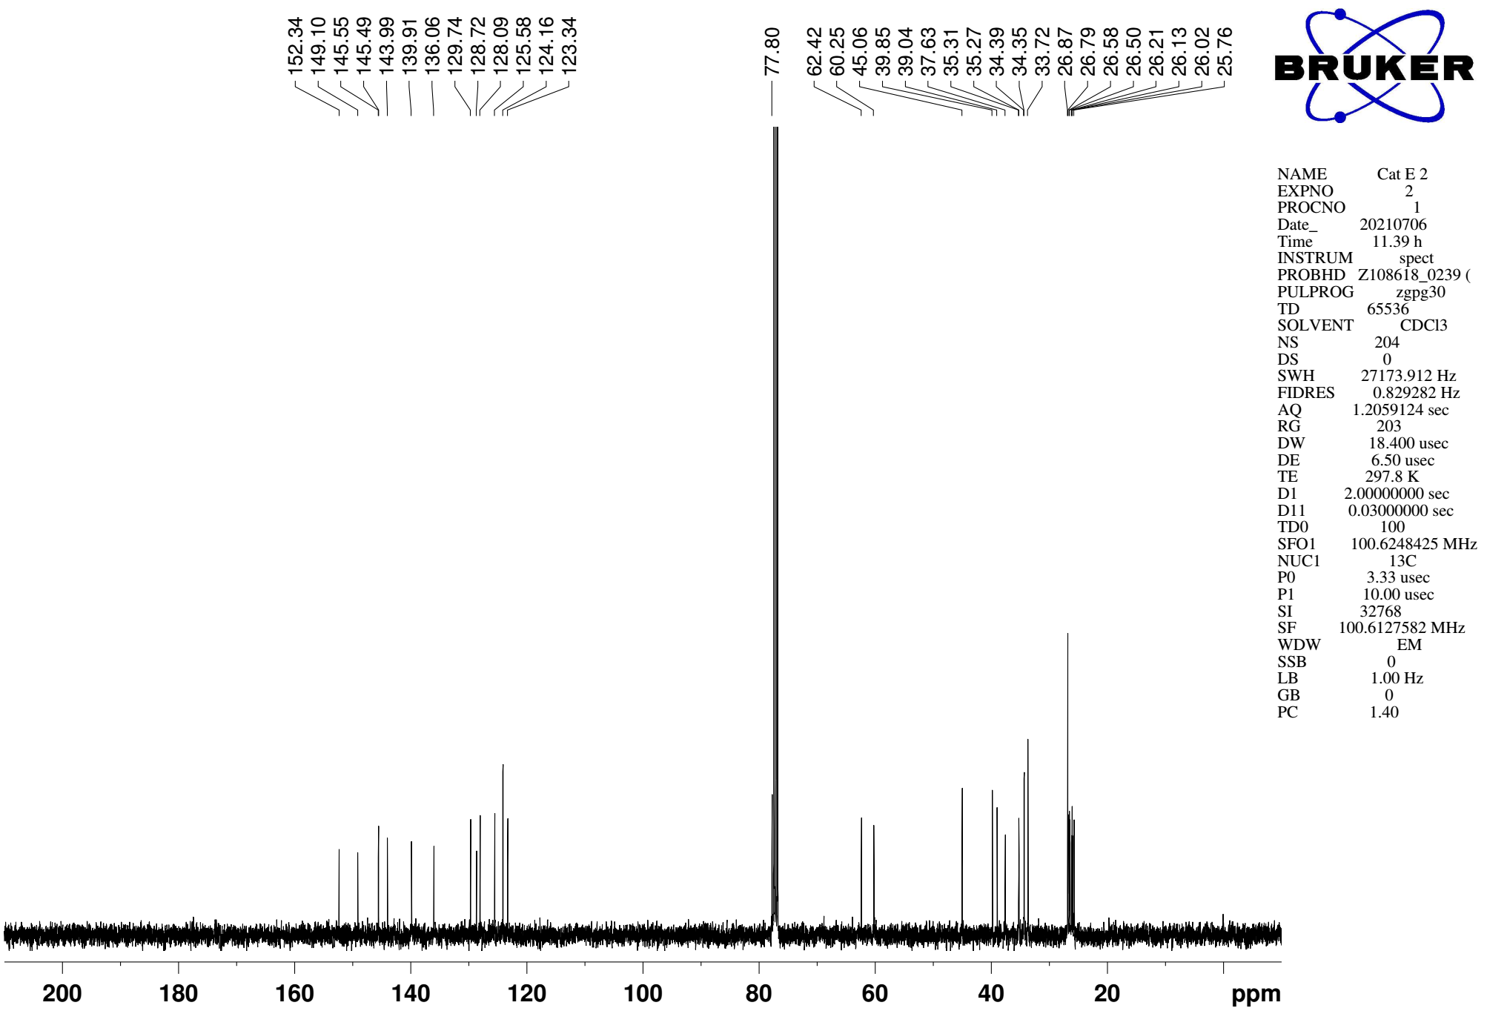
Supplementary Figure 2. ¹³C NMR (CDCl₃, 101MHz) spectra of NHC pre-catalyst E
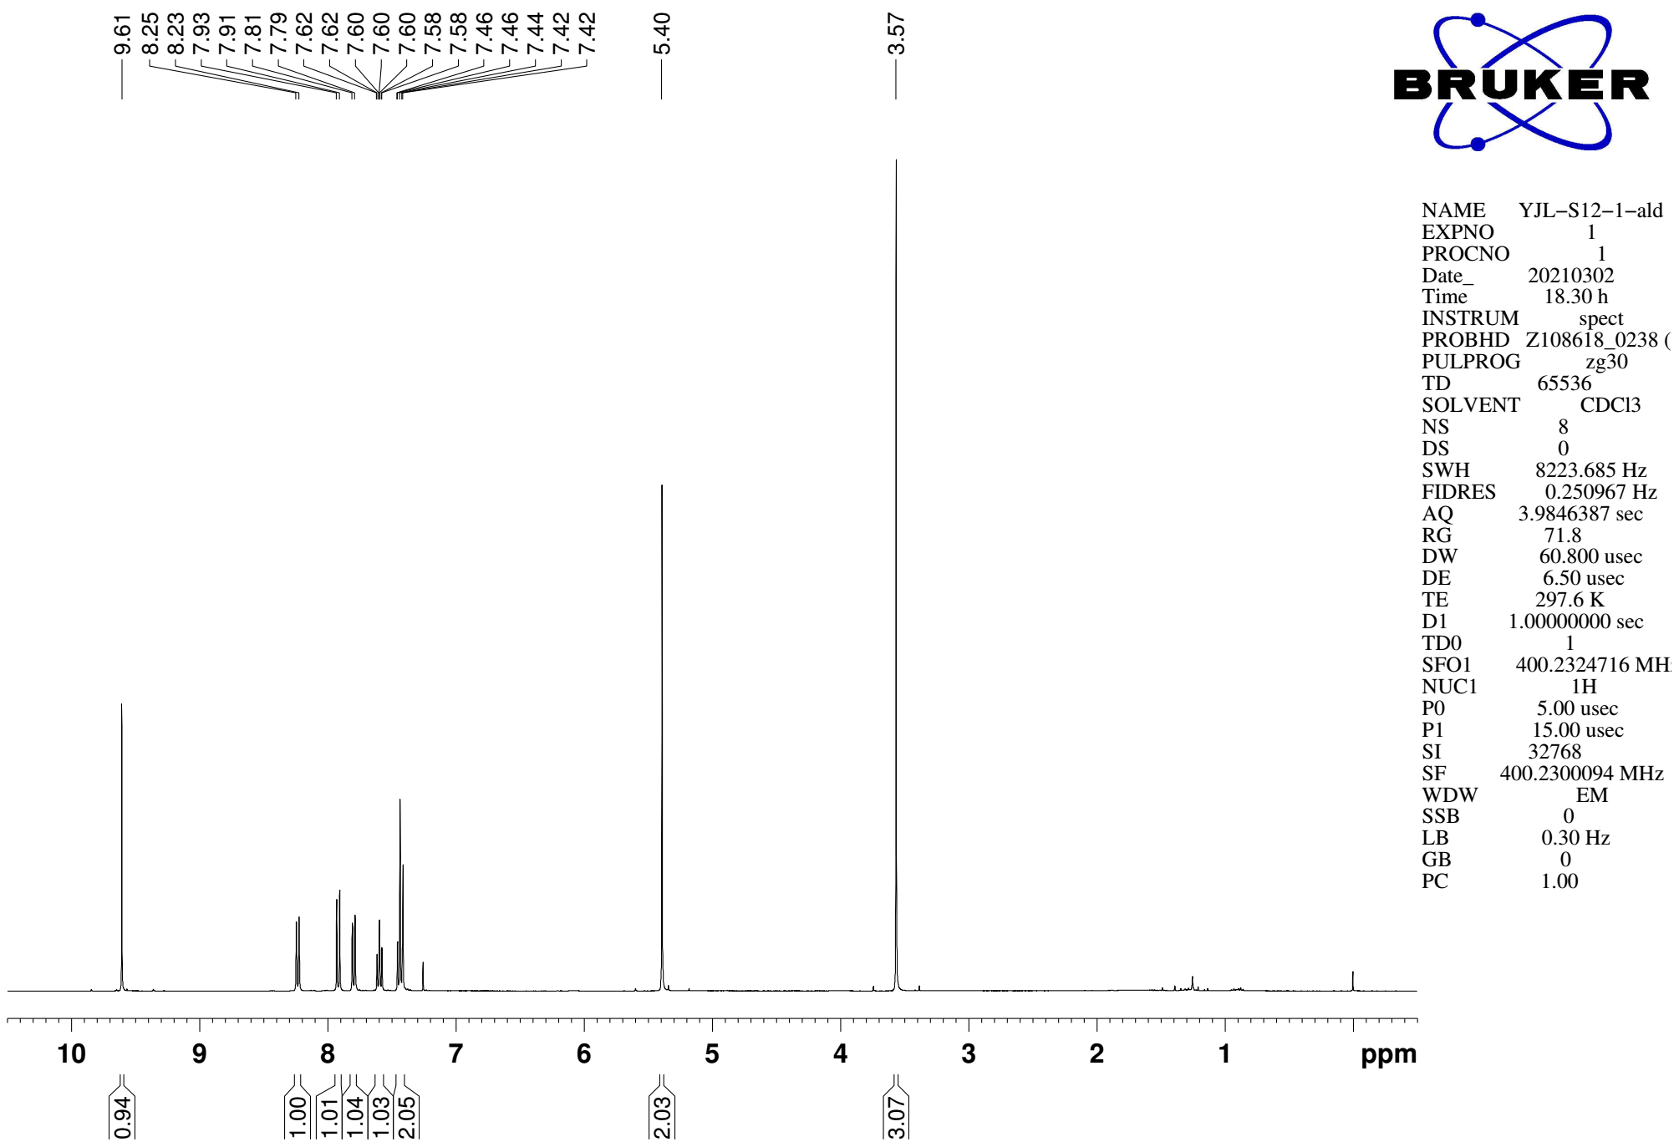
Supplementary Figure 3. ¹H NMR (CDCl₃, 400MHz) spectra of substrate 1o

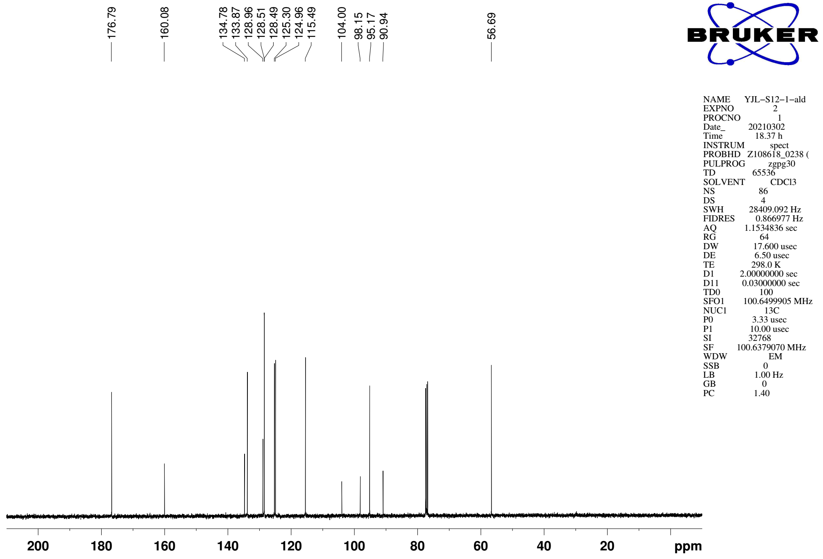
Supplementary Figure 4. ¹³C NMR (CDCl₃, 101MHz) spectra of spectra of substrate 1o
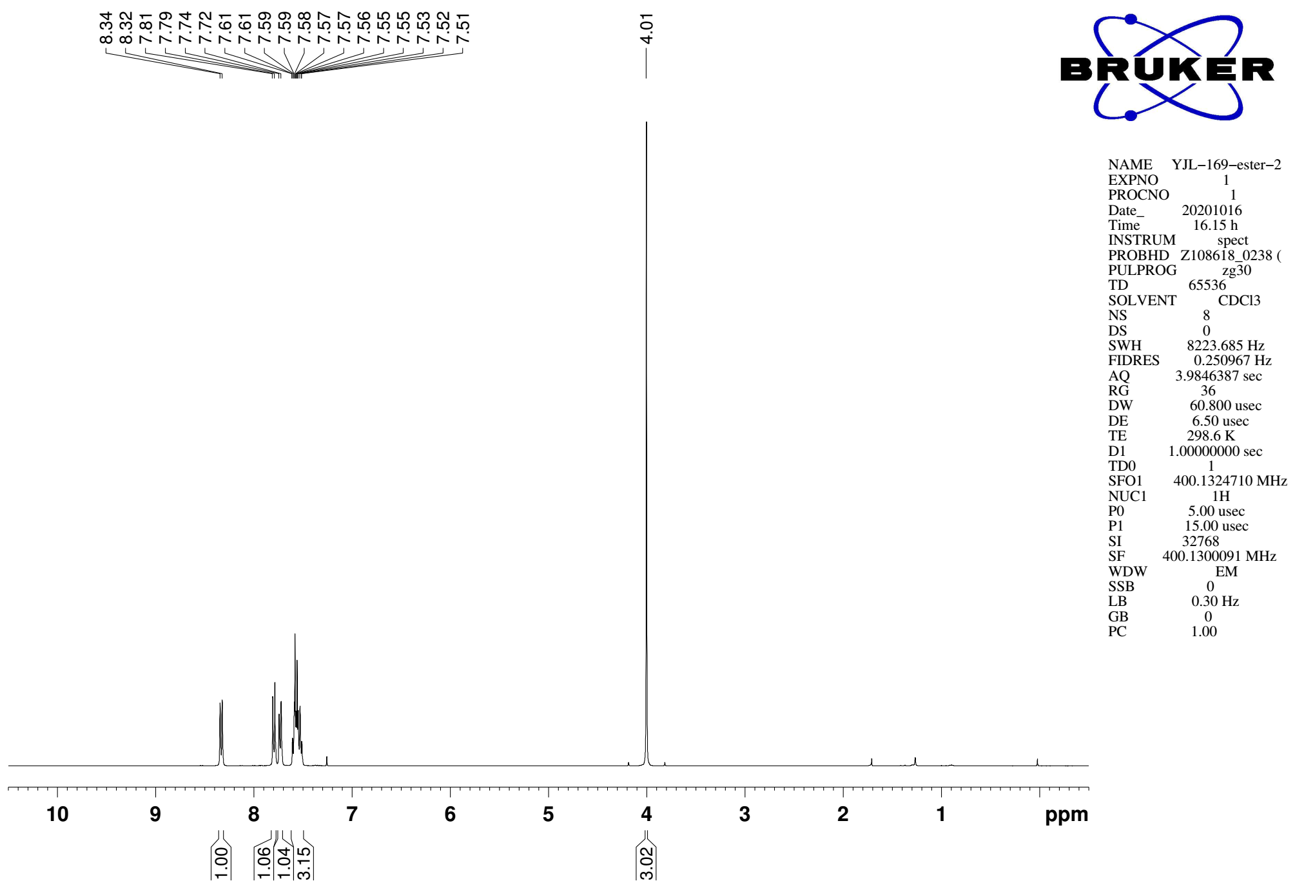
Supplementary Figure 5. ¹H NMR (CDCl₃, 400MHz) spectra of S12

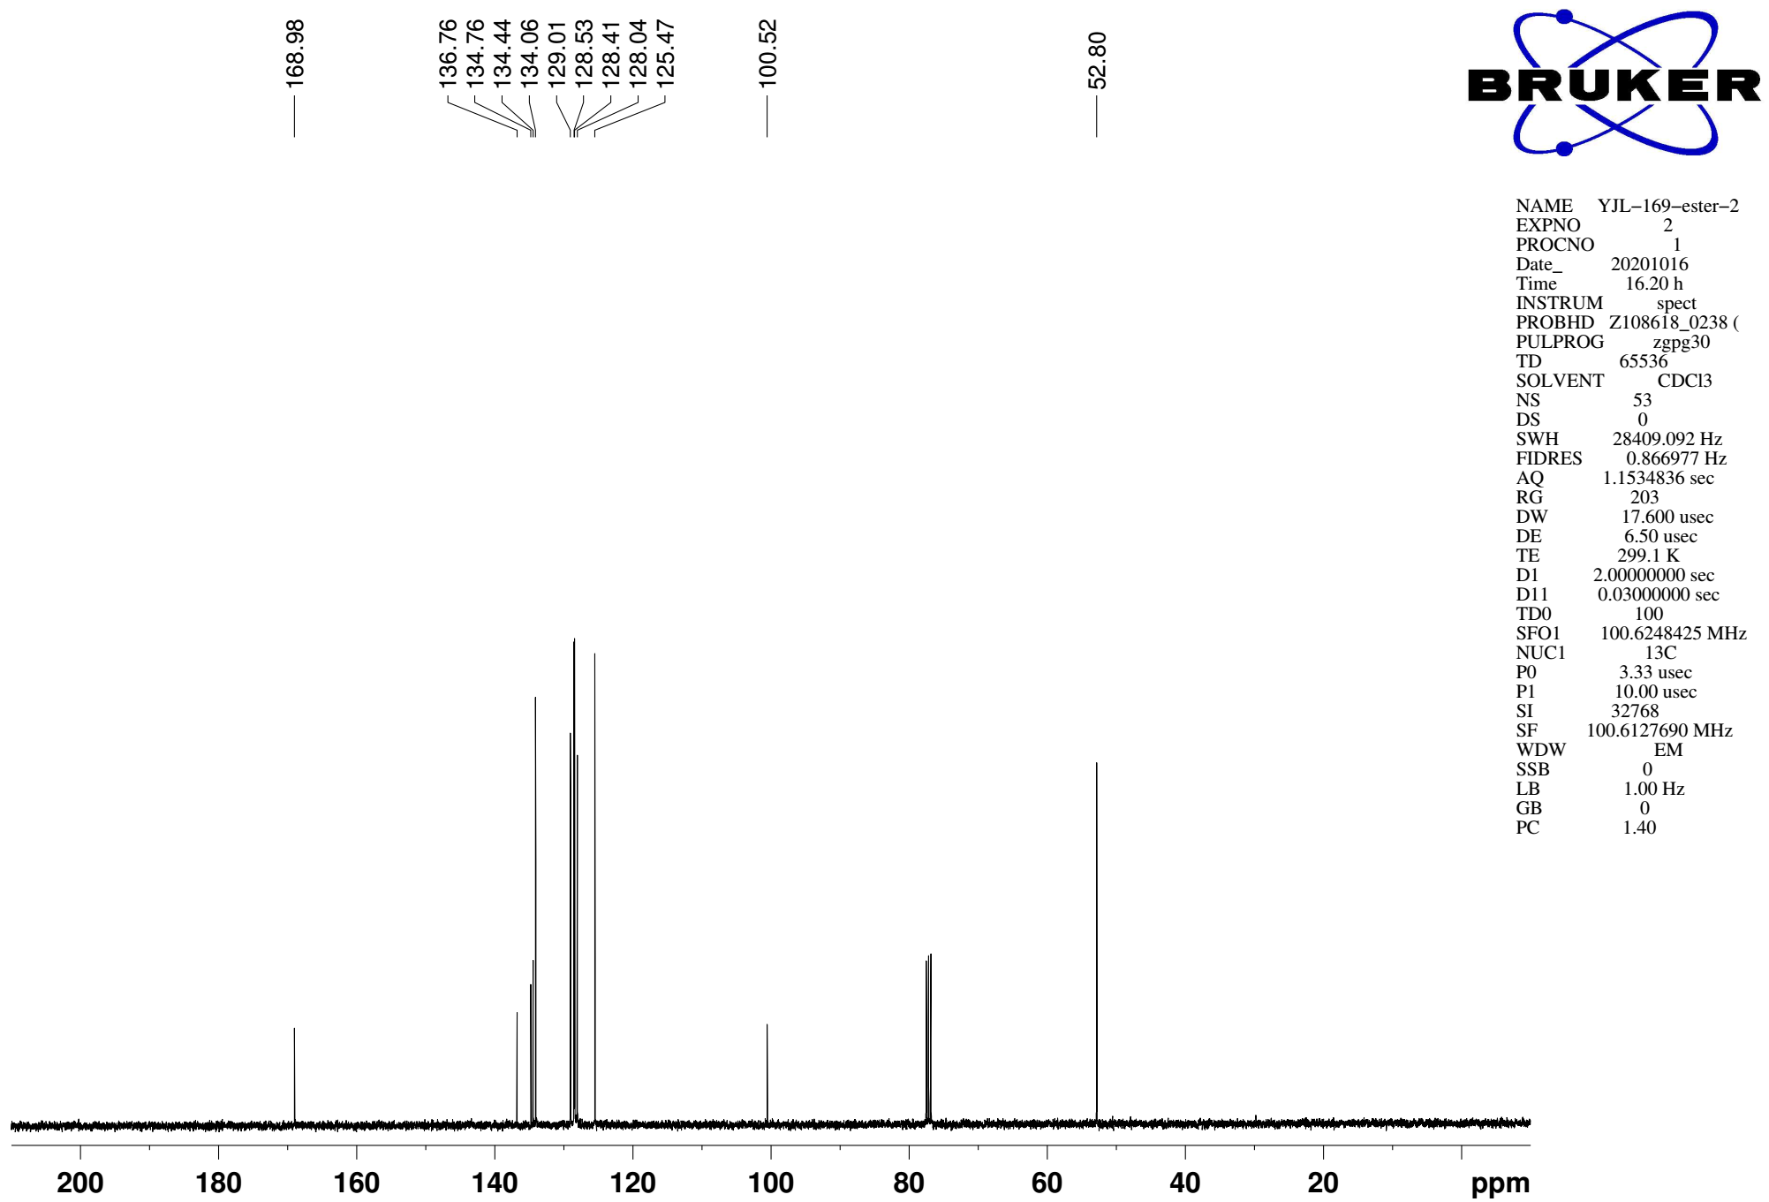
Supplementary Figure 6. ¹³C NMR (CDCl₃, 101MHz) spectra of spectra of S12
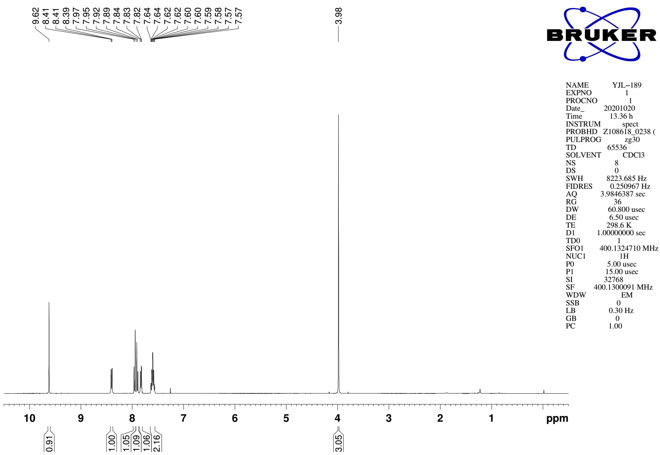
Supplementary Figure 7. ¹H NMR (CDCl₃, 400MHz) spectra of substrate 1p

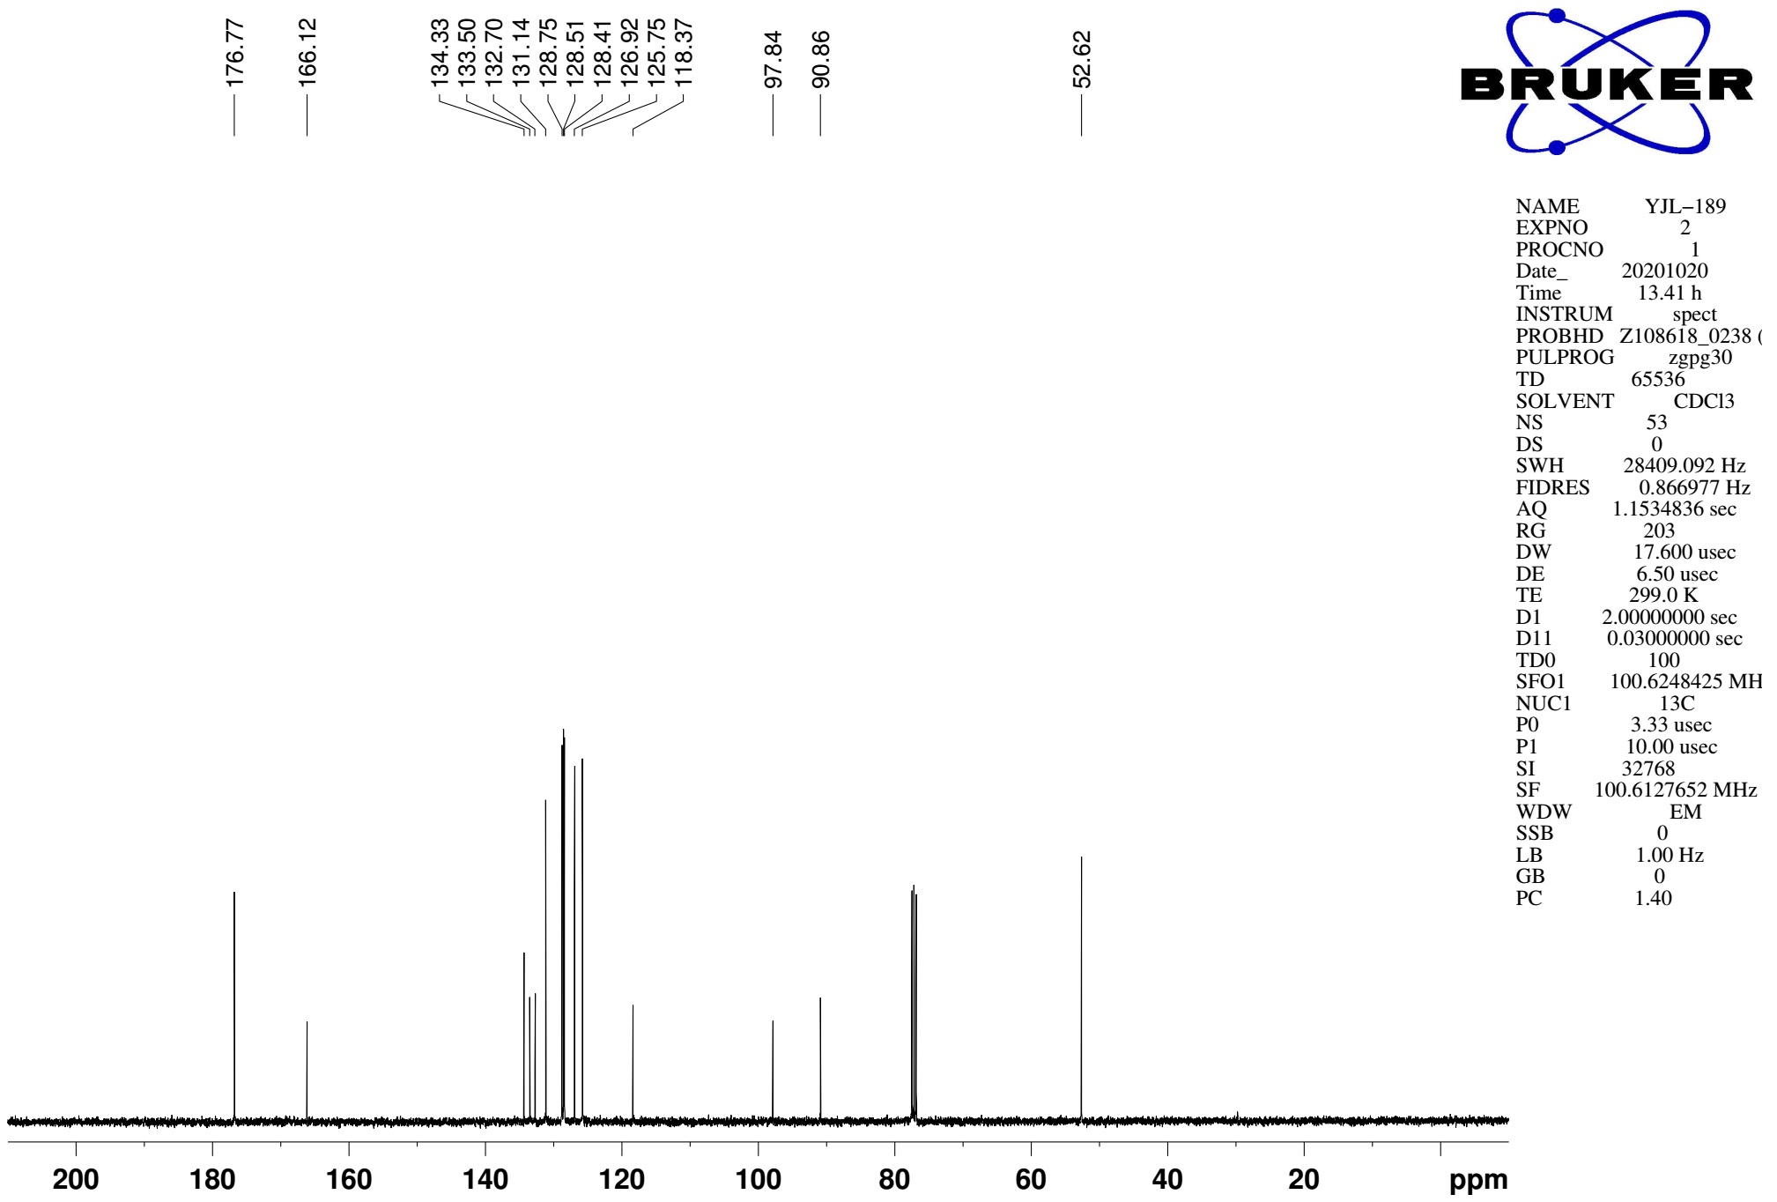
Supplementary Figure 8. ¹³C NMR (CDCl₃, 101MHz) spectra of spectra of substrate 1p
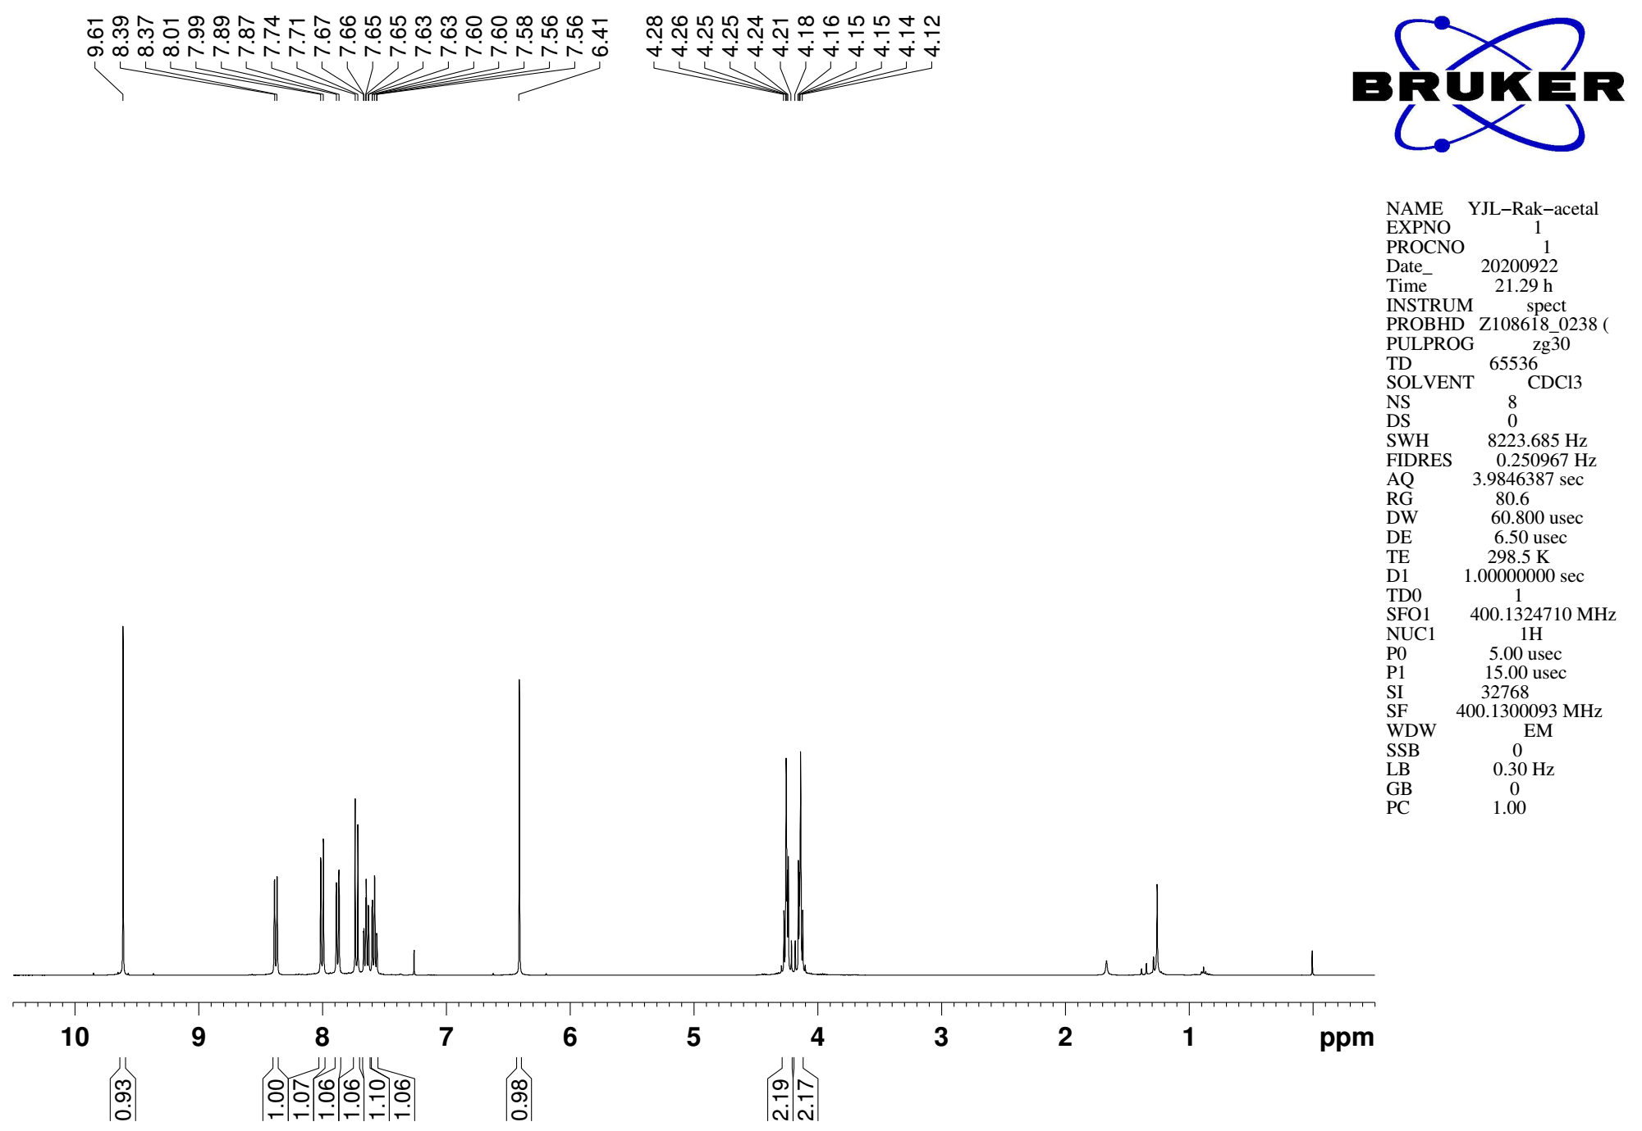
Supplementary Figure 9. ¹H NMR (CDCl₃, 400MHz) spectra of substrate 1q

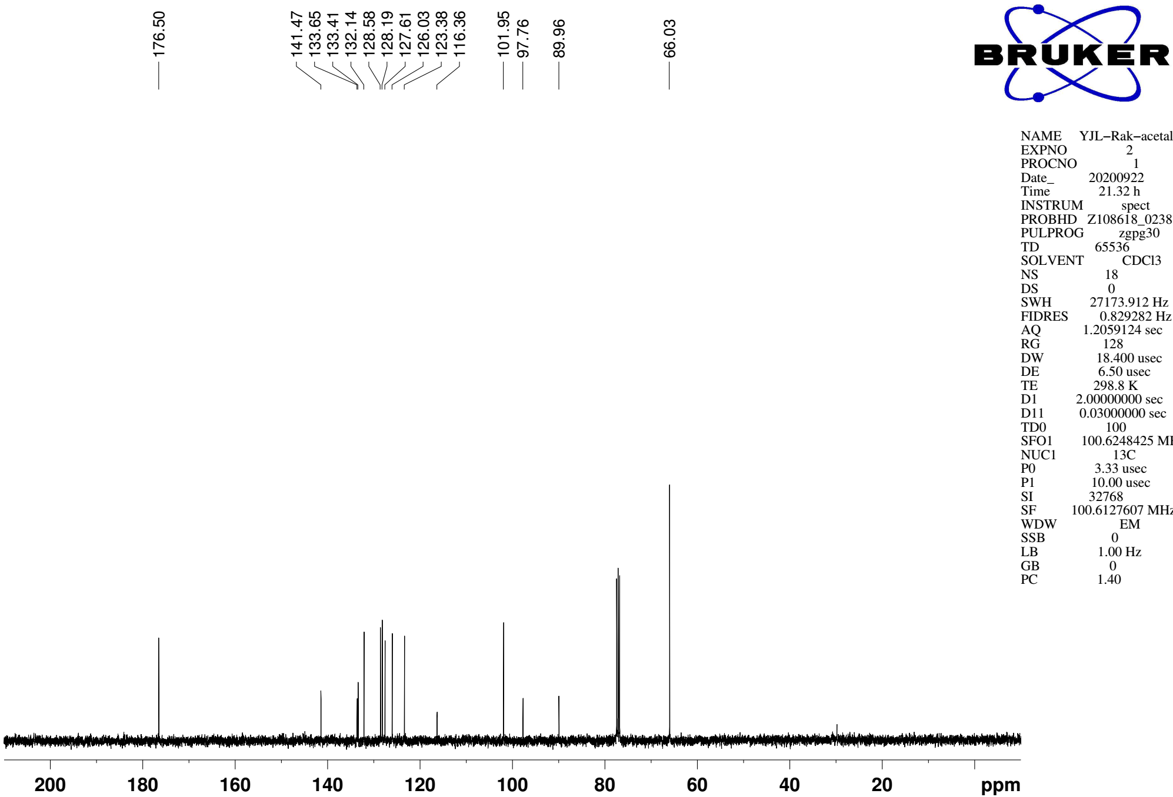
Supplementary Figure 10. ¹³C NMR (CDCl₃, 101MHz) spectra of spectra of substrate 1q
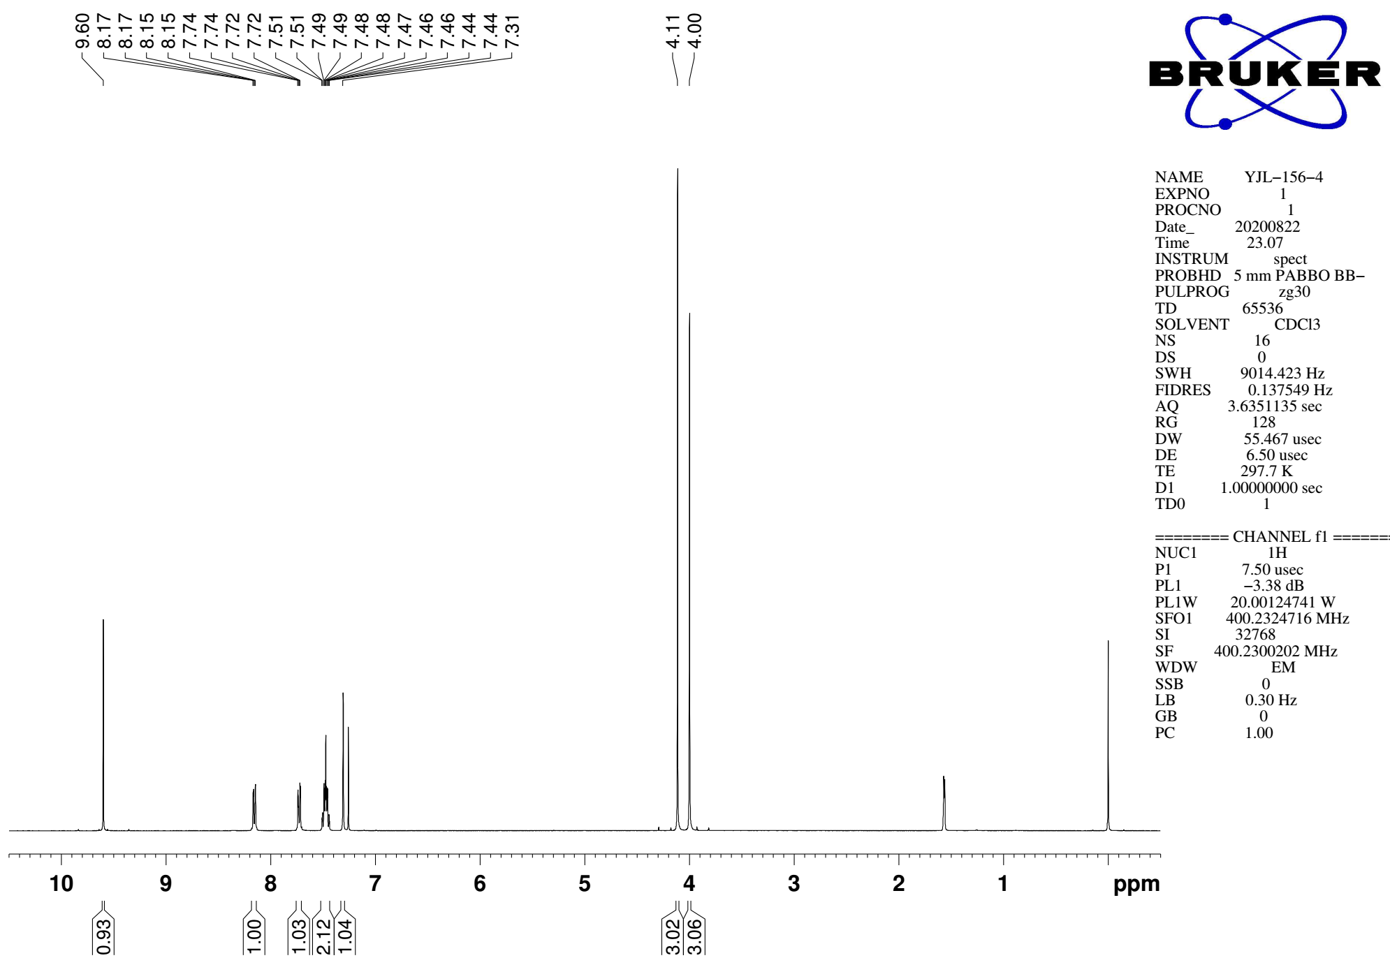
Supplementary Figure 11. ¹H NMR (CDCl₃, 400MHz) spectra of substrate 1r

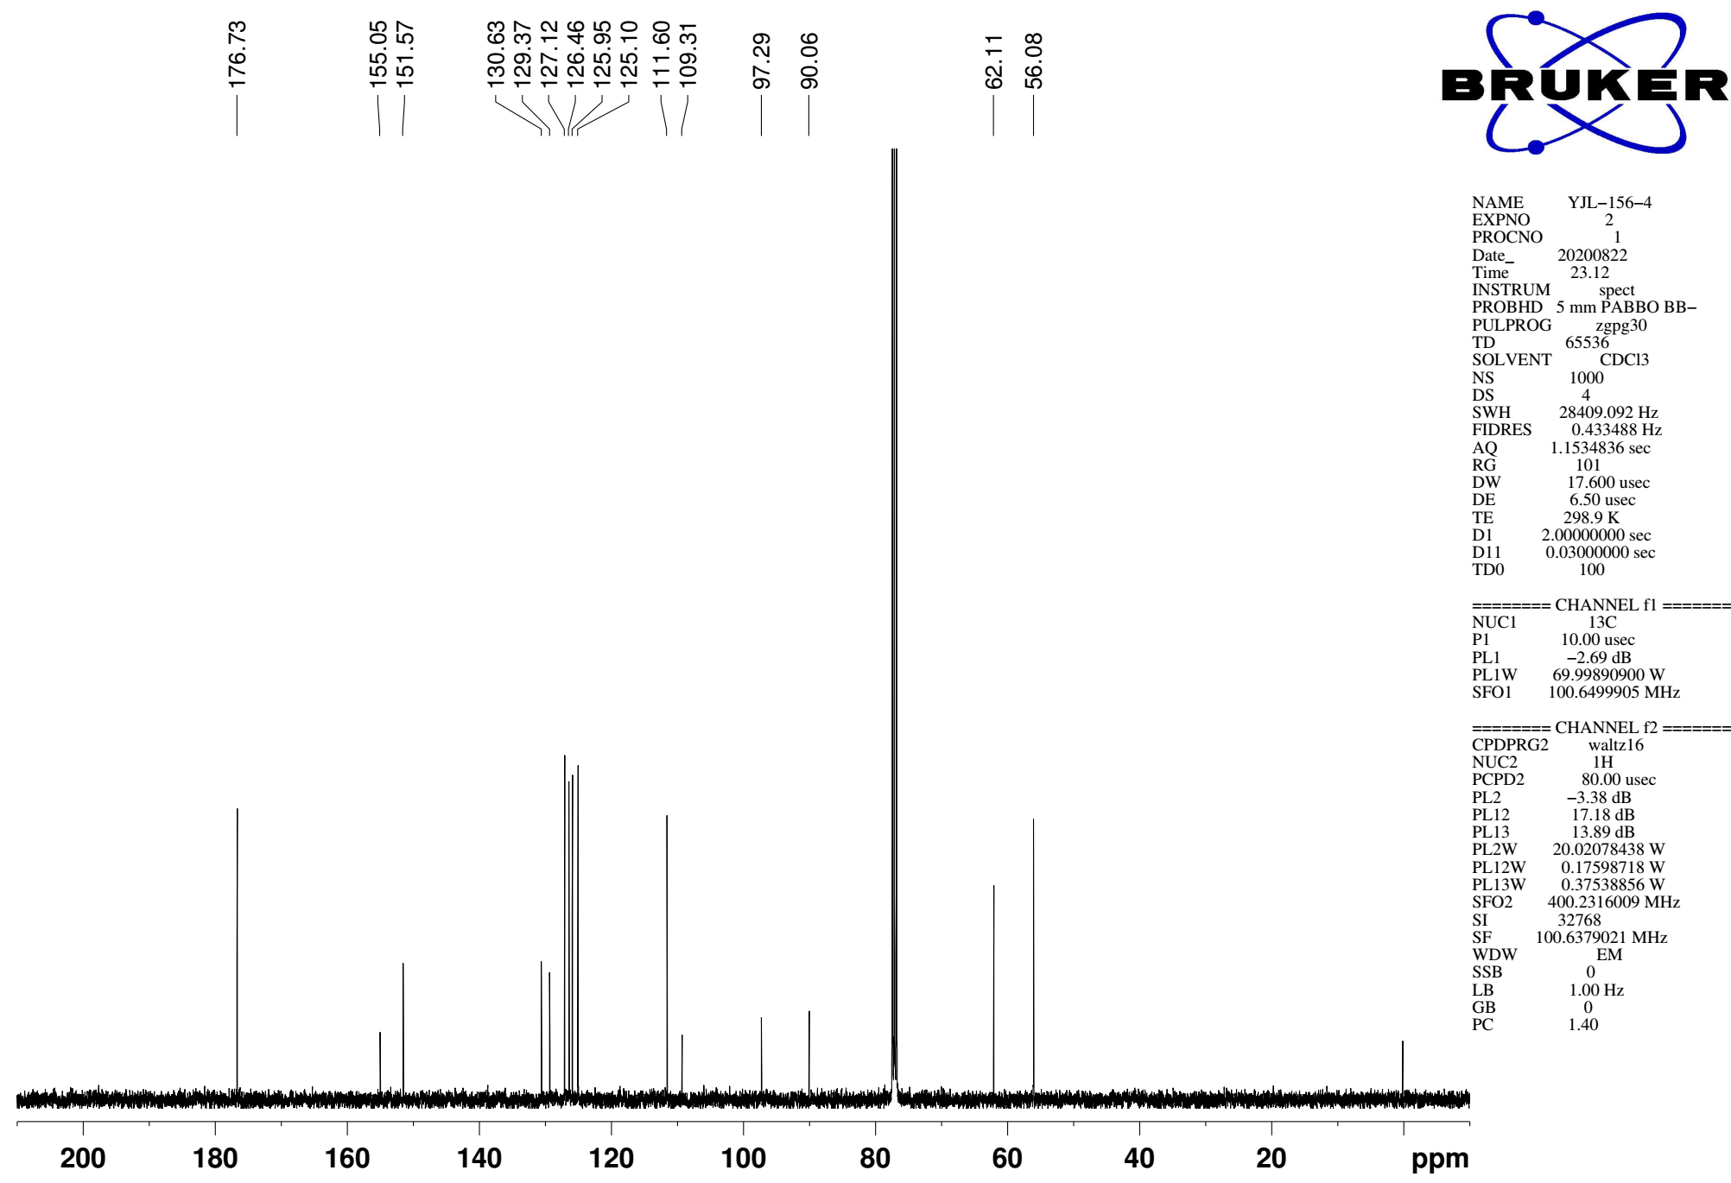
Supplementary Figure 12. ¹³C NMR (CDCl₃, 101MHz) spectra of spectra of substrate 1r
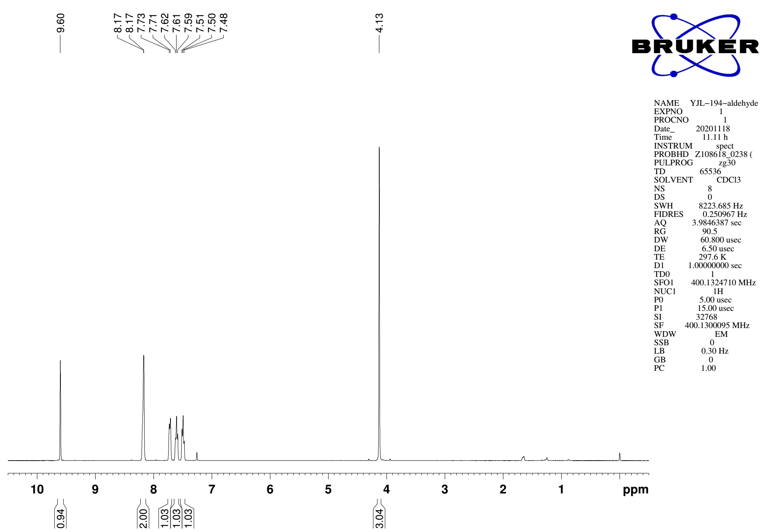
Supplementary Figure 13. ¹H NMR (CDCl₃, 400MHz) spectra of substrate 1s

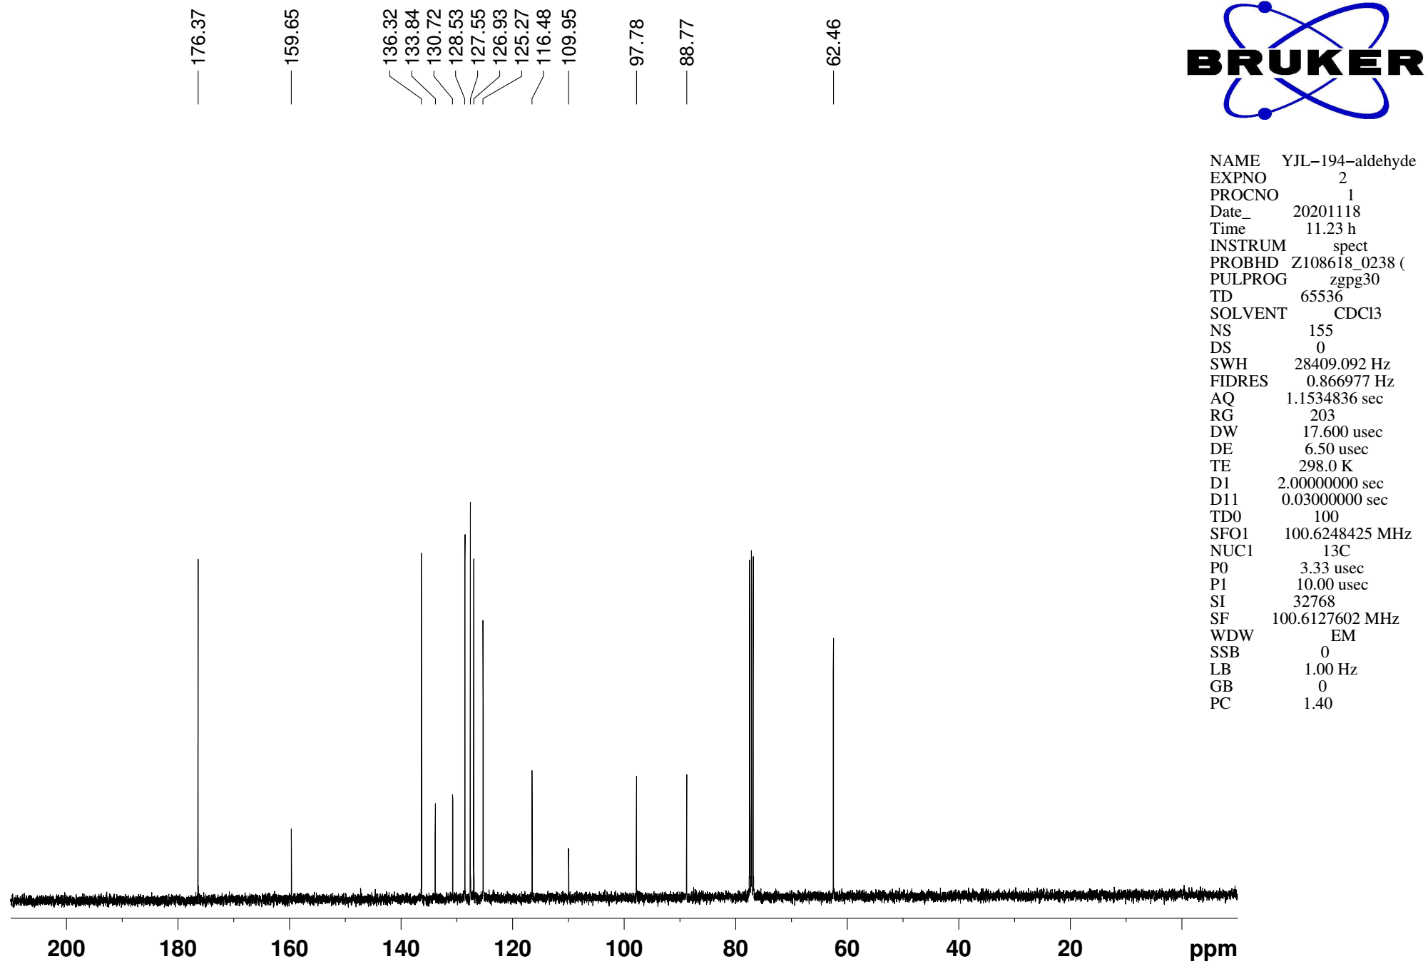
Supplementary Figure 14. ¹³C NMR (CDCl₃, 101MHz) spectra of spectra of substrate 1s
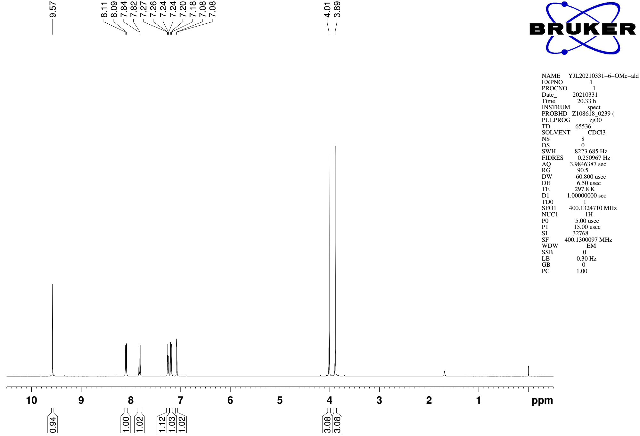
Supplementary Figure 15. ¹H NMR (CDCl₃, 400MHz) spectra of substrate 1t

¹³C NMR (CDCl₃, 101MHz)
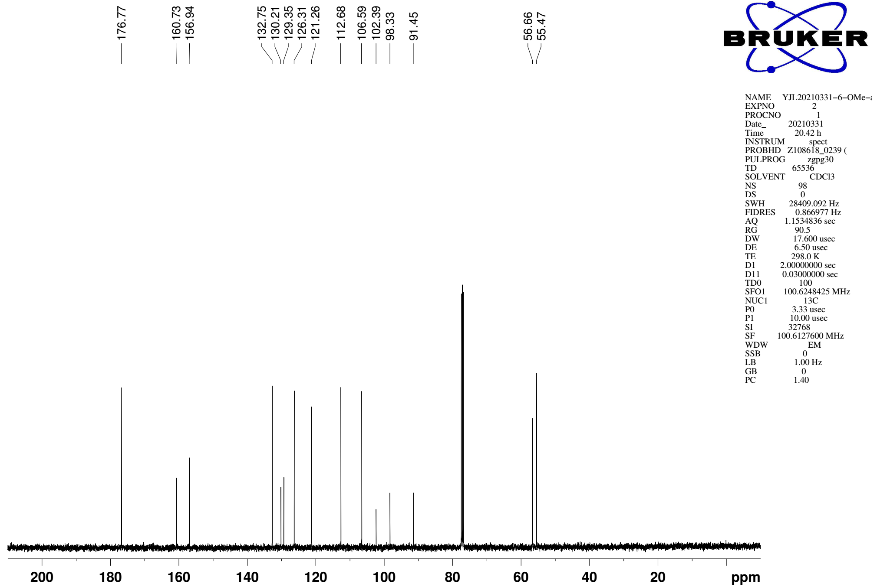
Supplementary Figure 16. ¹³C NMR (CDCl₃, 101MHz) spectra of spectra of substrate 1t
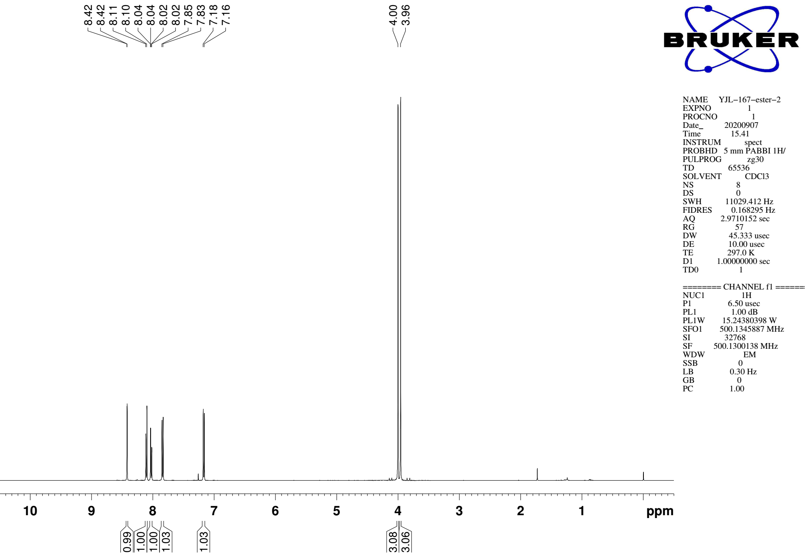
Supplementary Figure 17. ¹H NMR (CDCl₃, 500MHz) spectra of S14

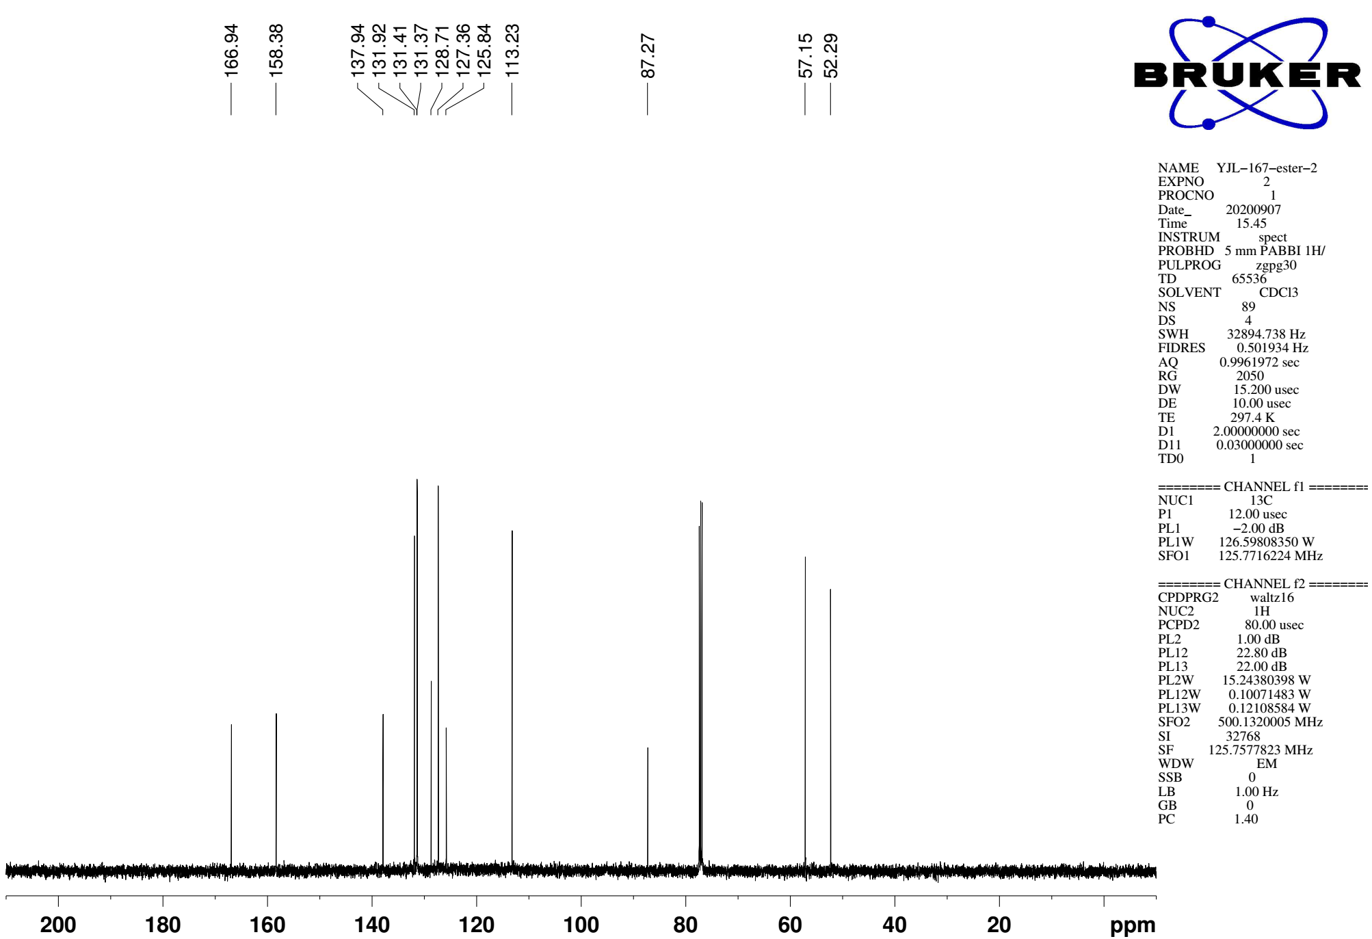
Supplementary Figure 18. ¹³C NMR (CDCl₃, 126MHz) spectra of spectra of S14
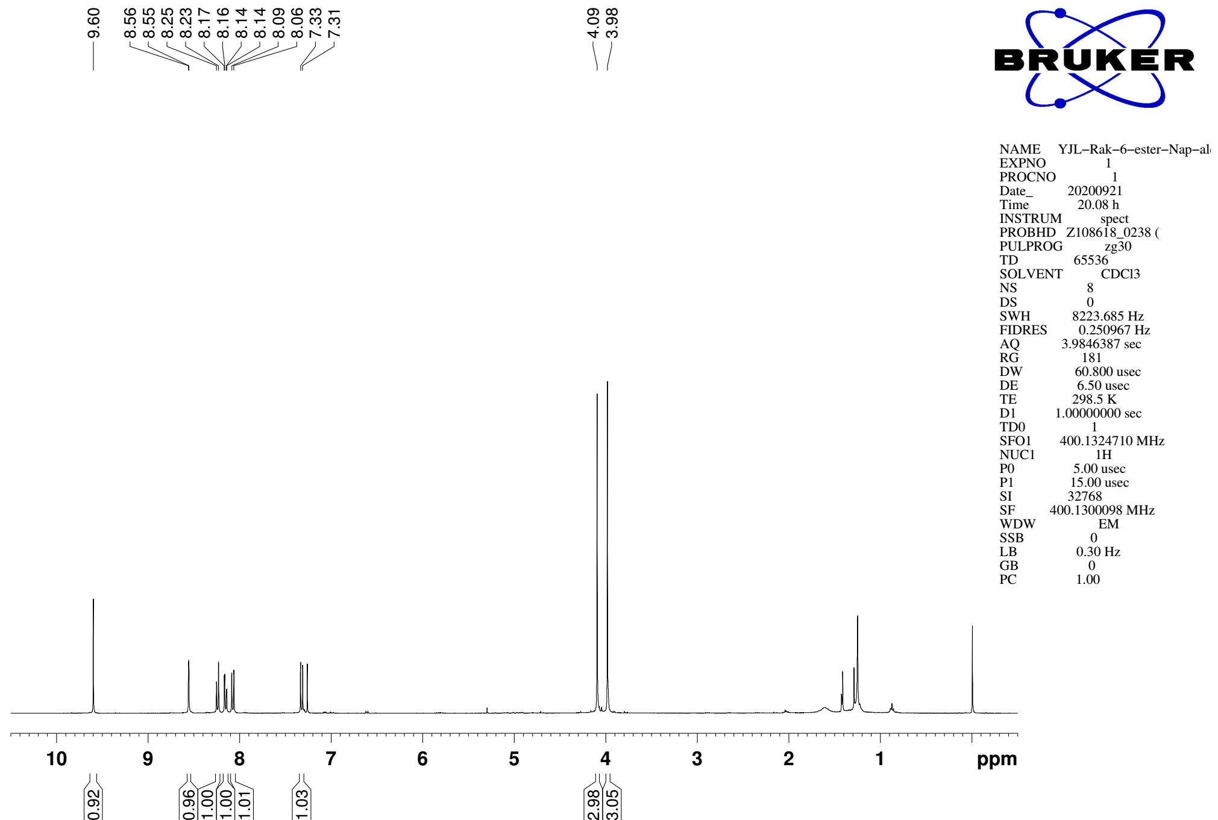
Supplementary Figure 19. ¹H NMR (CDCl₃, 400MHz) spectra of substrate 1y

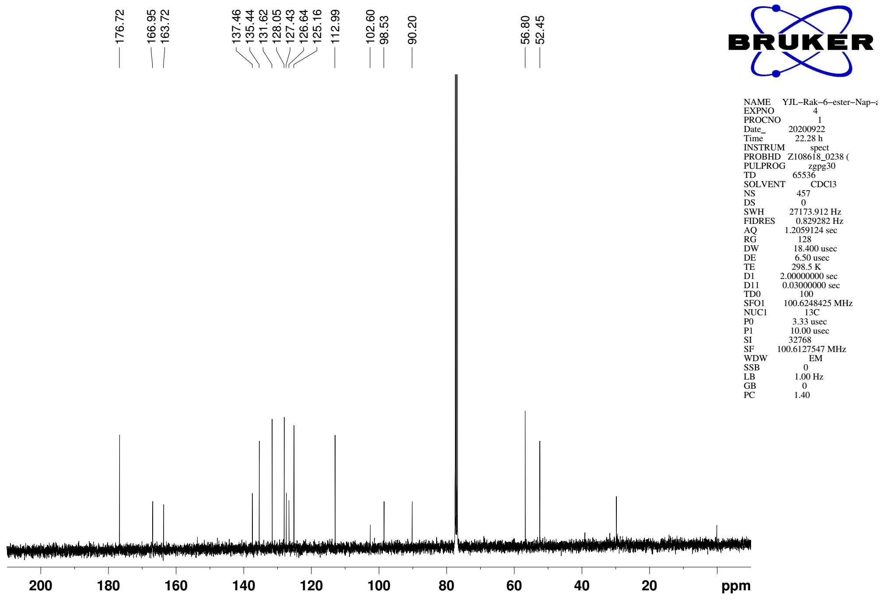
Supplementary Figure 20. ¹³C NMR (CDCl₃, 101MHz) spectra of spectra of substrate 1y

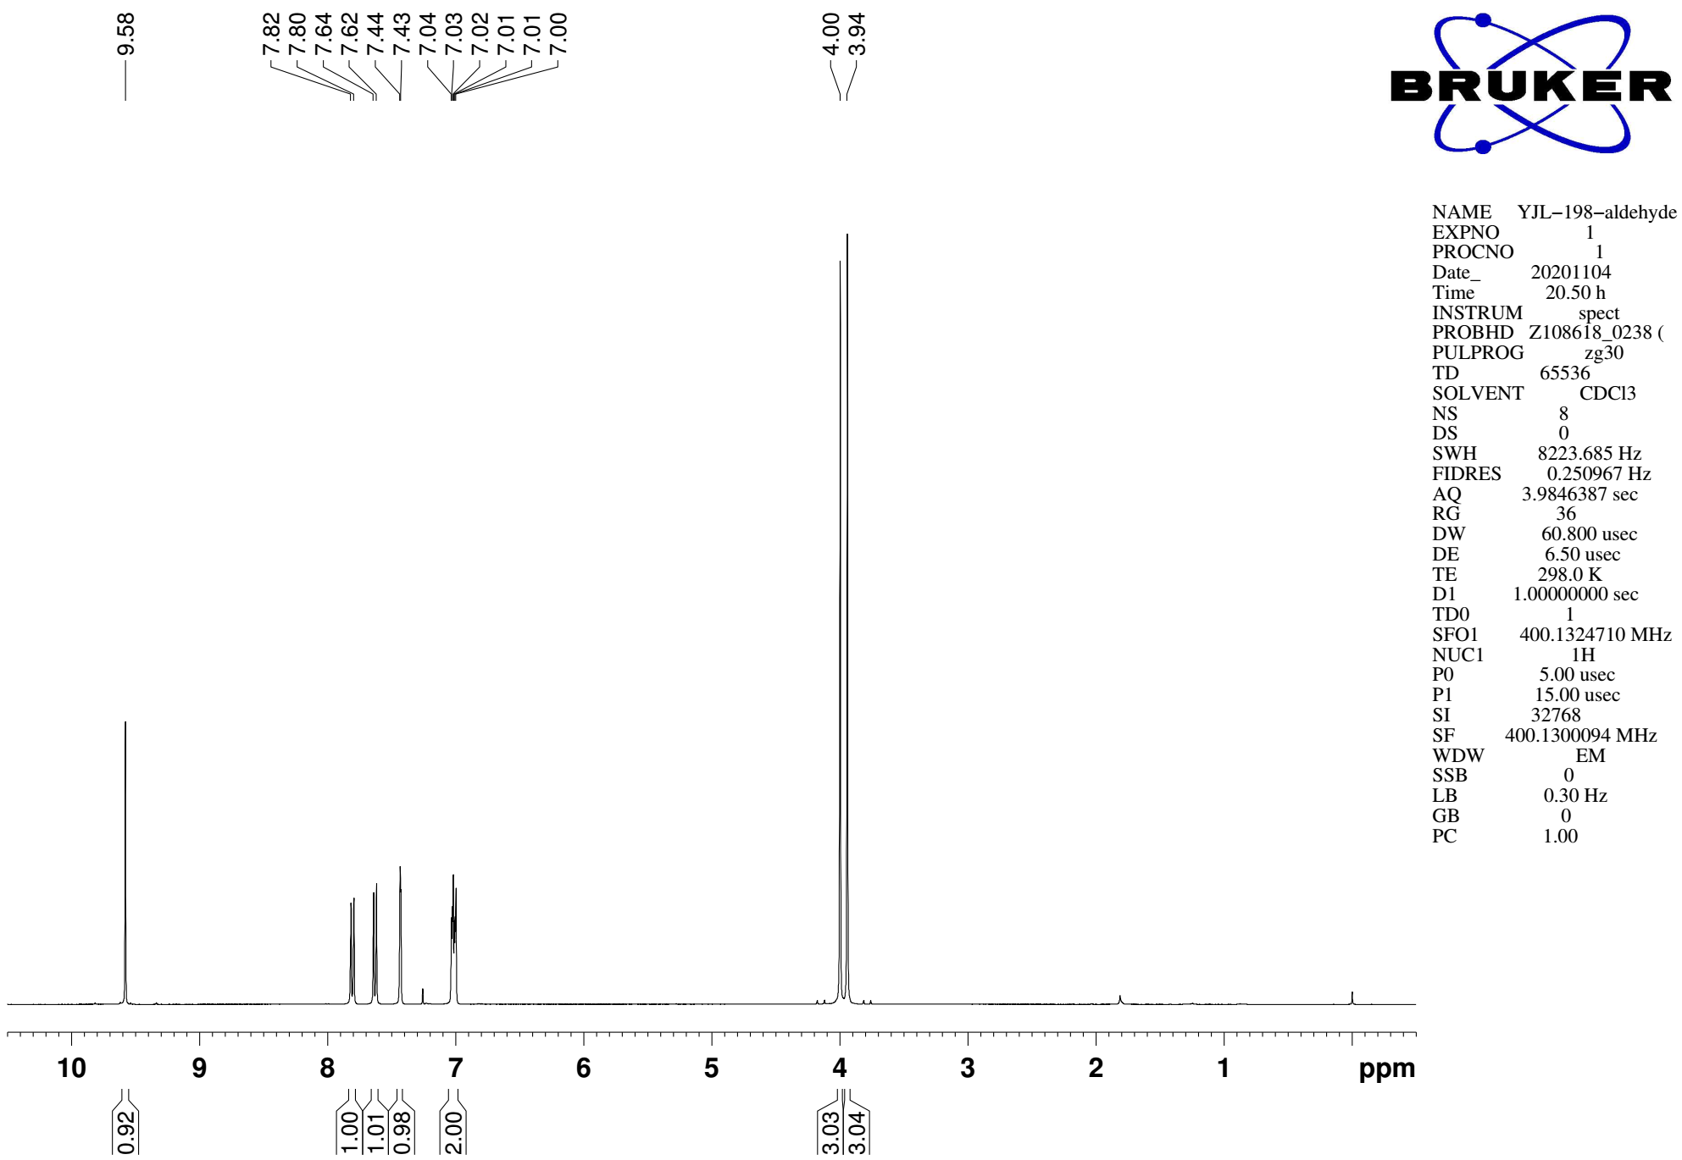
Supplementary Figure 21. ¹H NMR (CDCl₃, 400MHz) spectra of substrate 1z

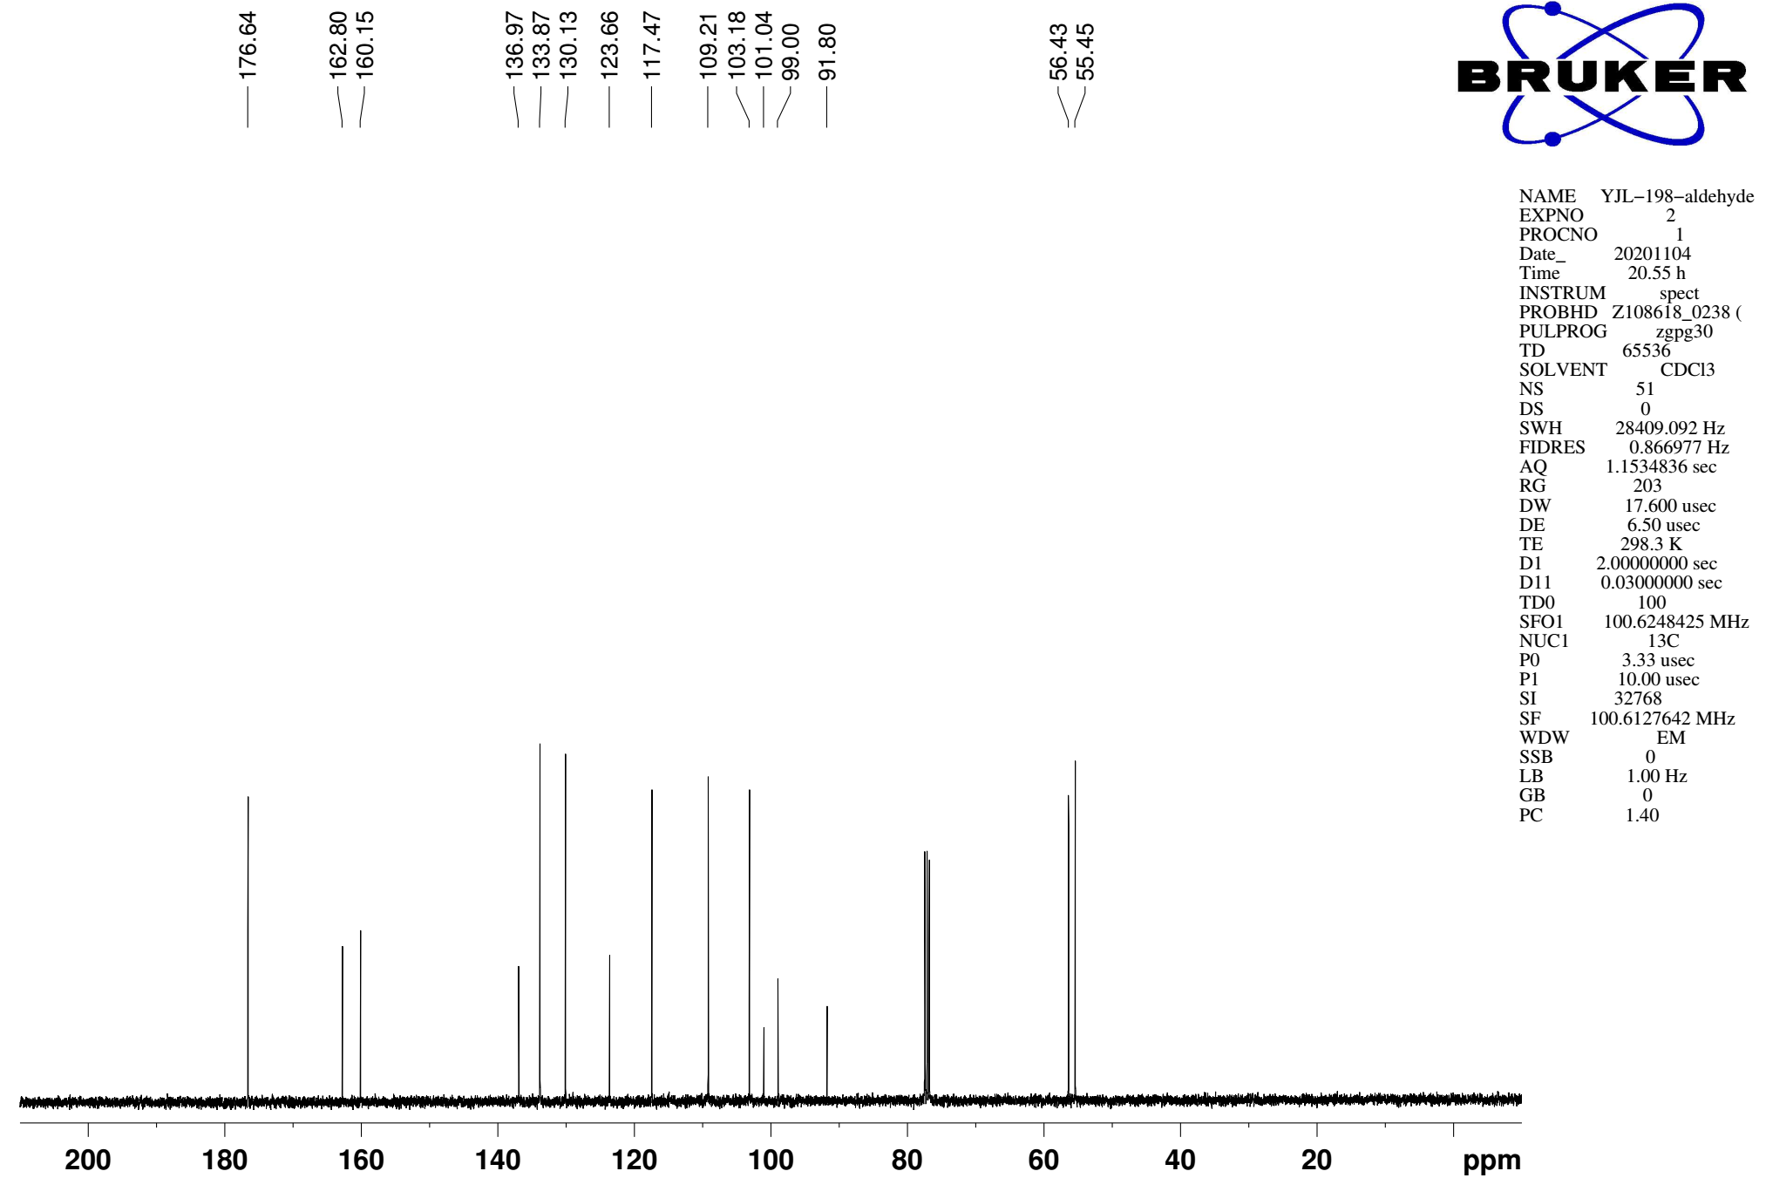
Supplementary Figure 22. ¹³C NMR (CDCl₃, 101MHz) spectra of spectra of substrate 1z
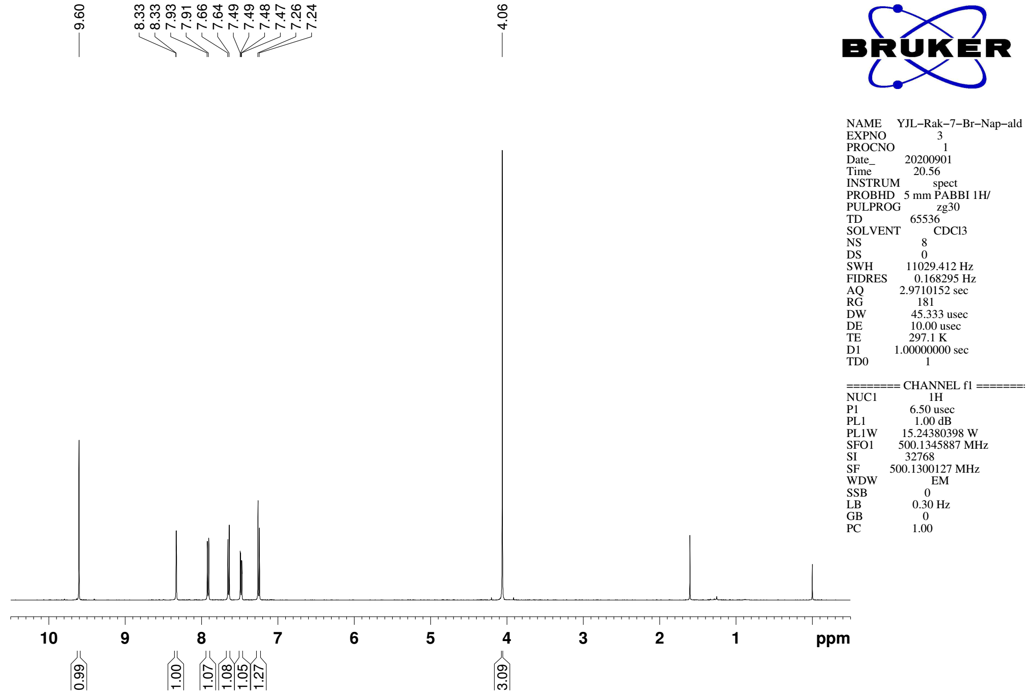
Supplementary Figure 23. ¹H NMR (CDCl₃, 500MHz) spectra of substrate 1aa

¹³C NMR (CDCl₃, 126MHz)
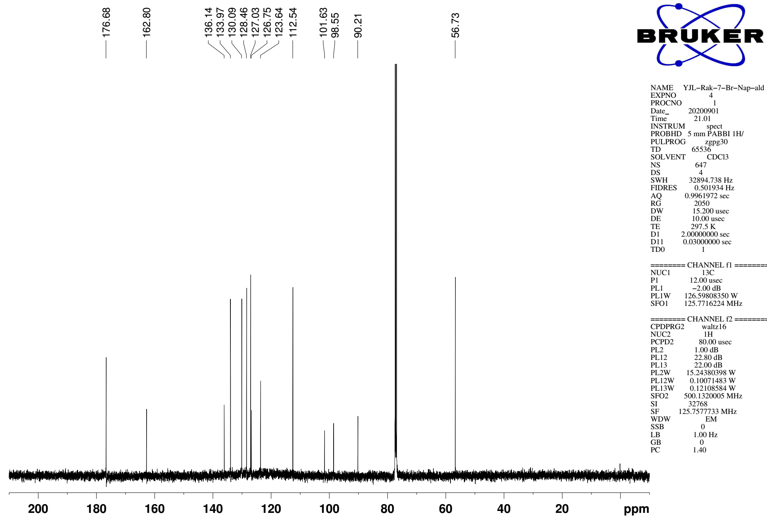
Supplementary Figure 24. ¹³C NMR (CDCl₃, 126MHz) spectra of spectra of substrate 1aa
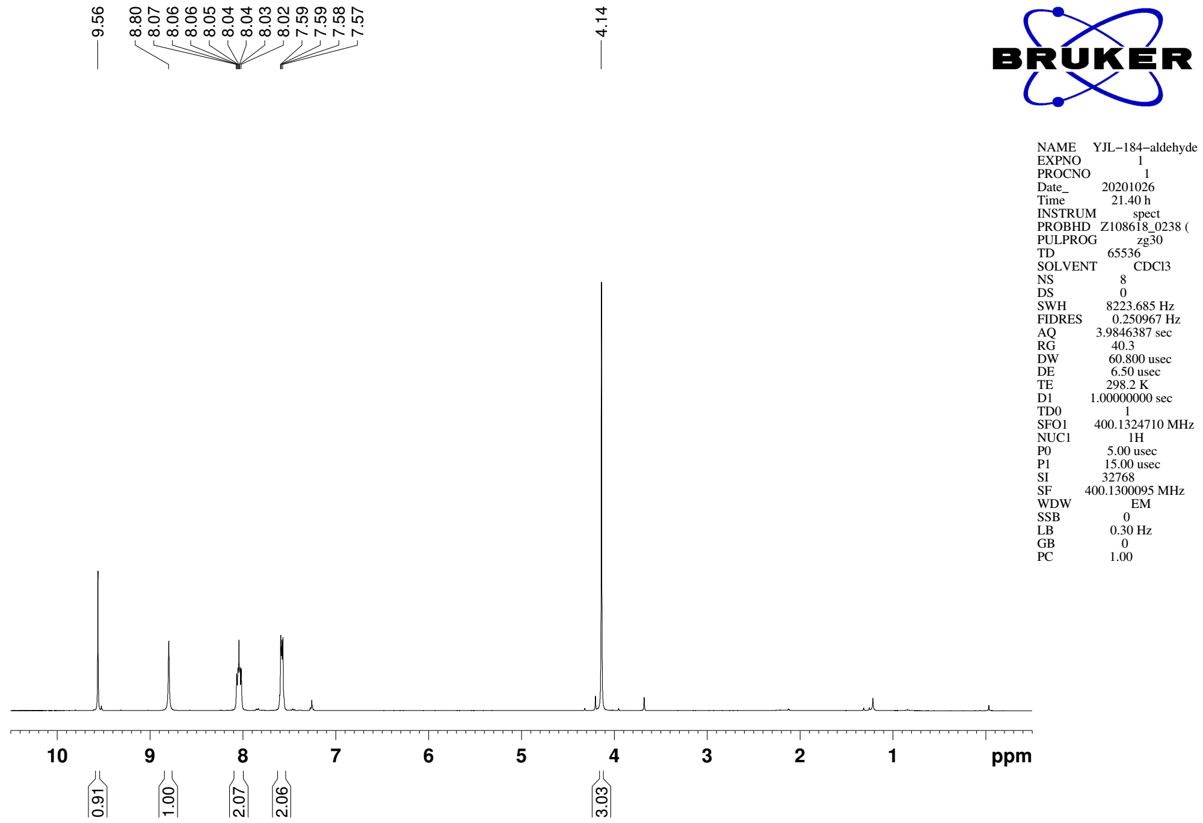
Supplementary Figure 25. ¹H NMR (CDCl₃, 400MHz) spectra of substrate 1ab

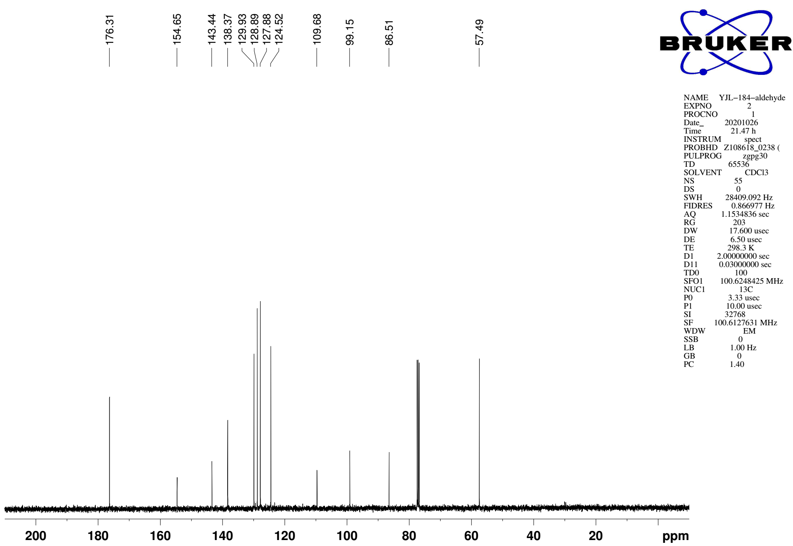
Supplementary Figure 26. ¹³C NMR (CDCl₃, 101MHz) spectra of spectra of substrate 1ab
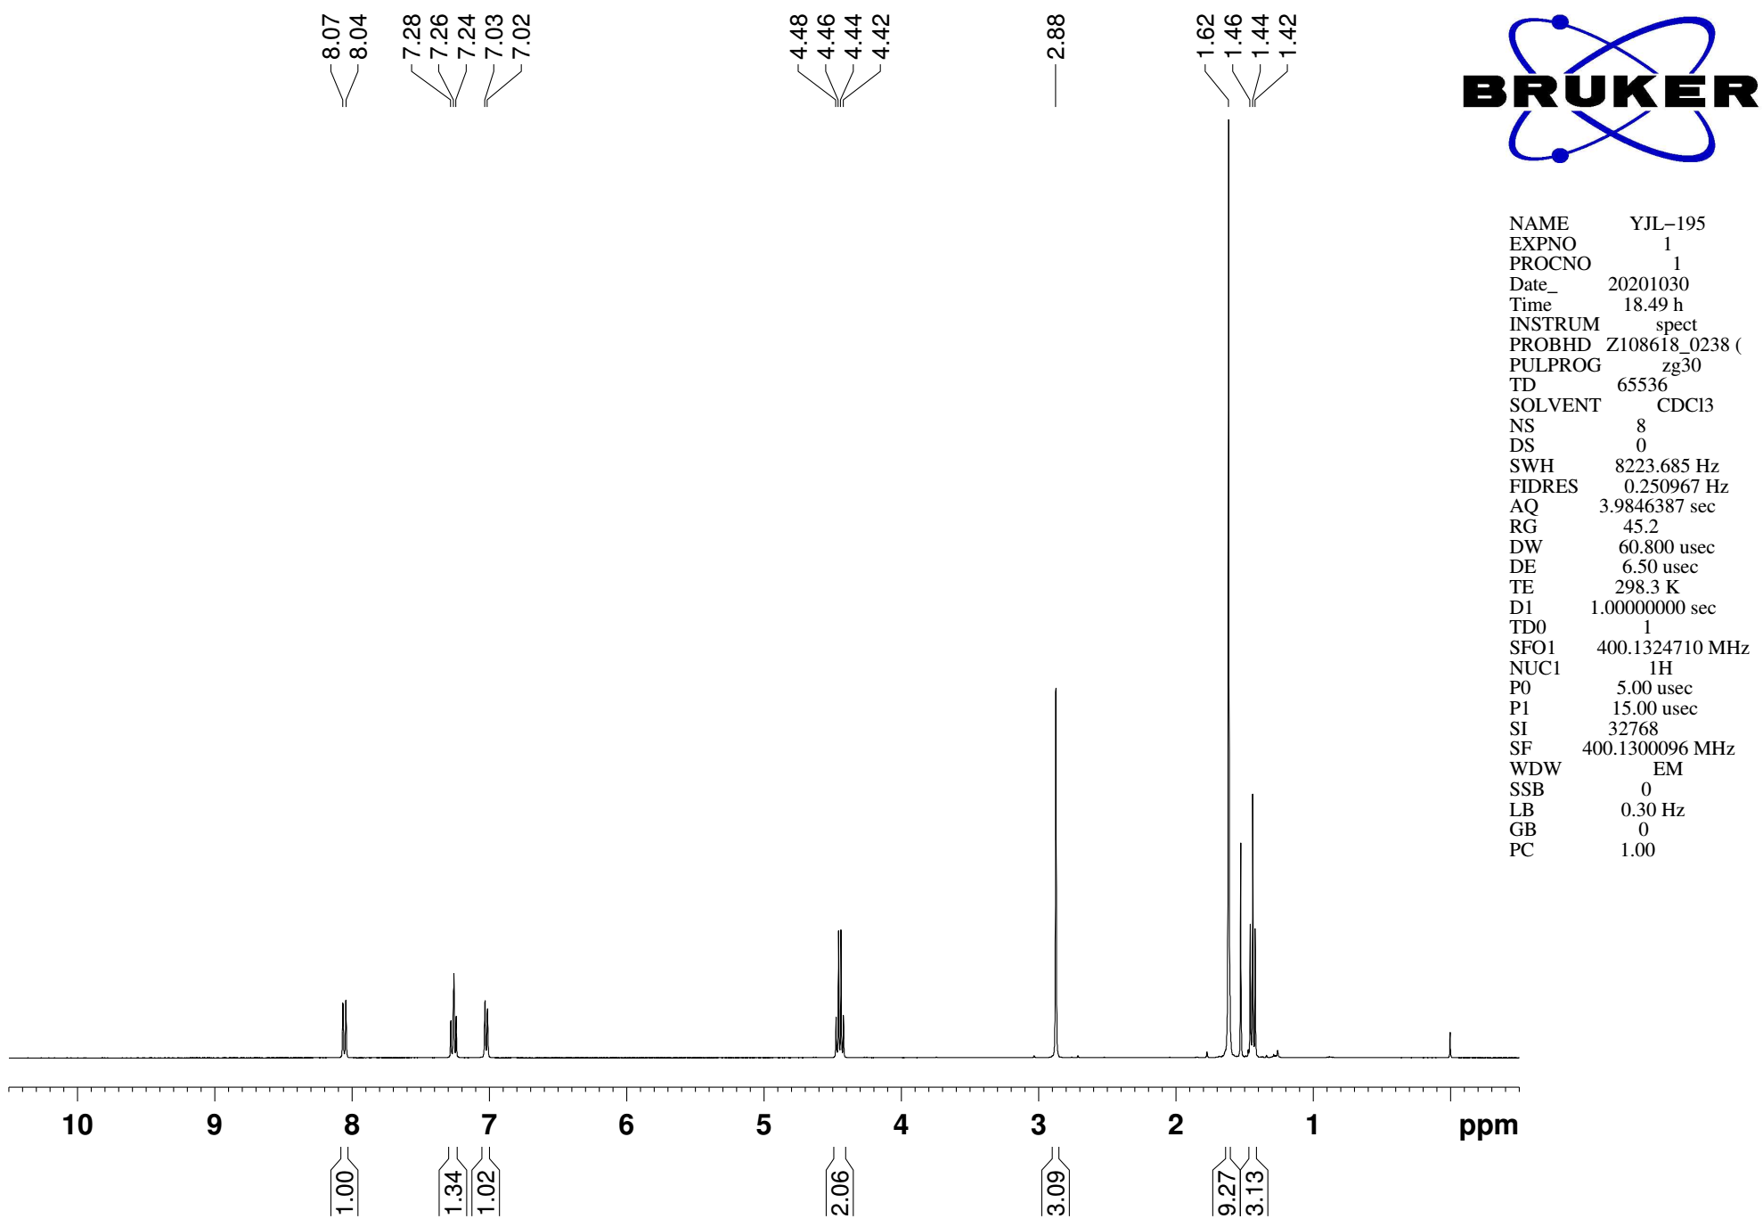
Supplementary Figure 27. ¹H NMR (CDCl₃, 400MHz) spectra of S16

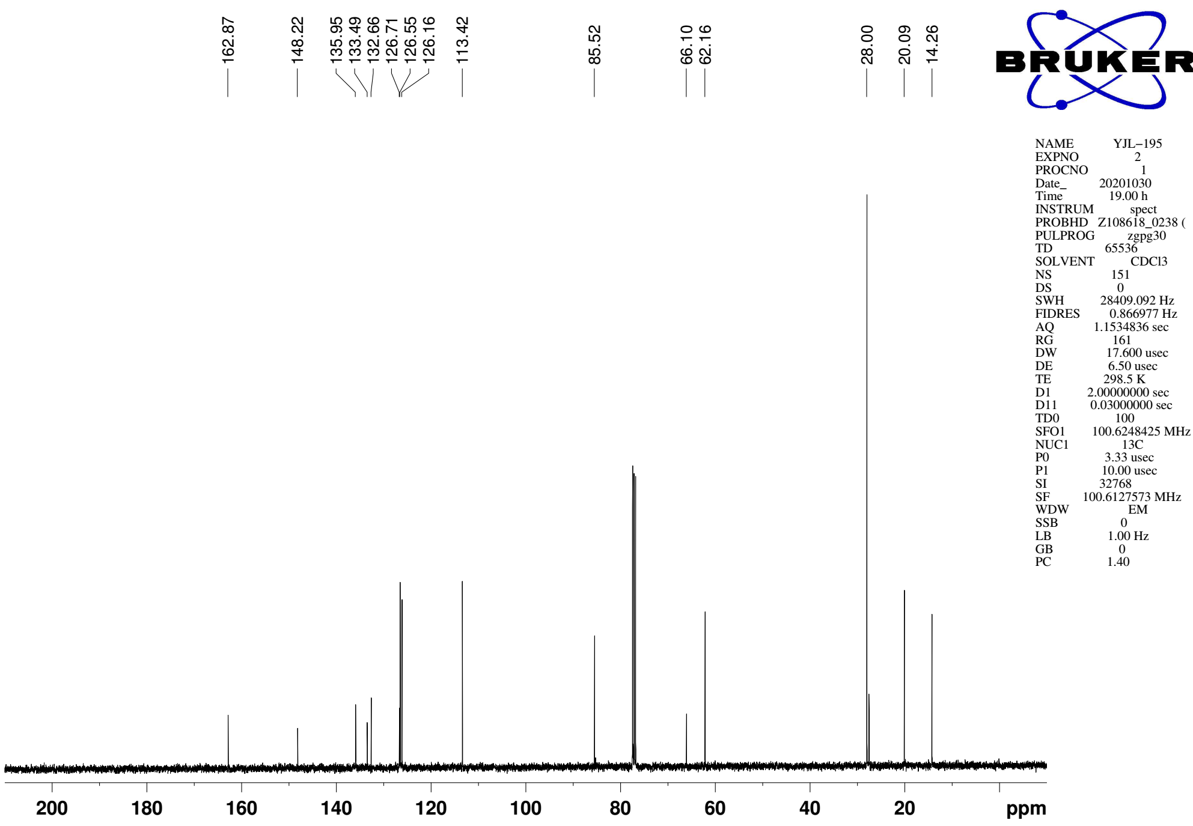
Supplementary Figure 28. ¹³C NMR (CDCl₃, 101MHz) spectra of spectra of S16
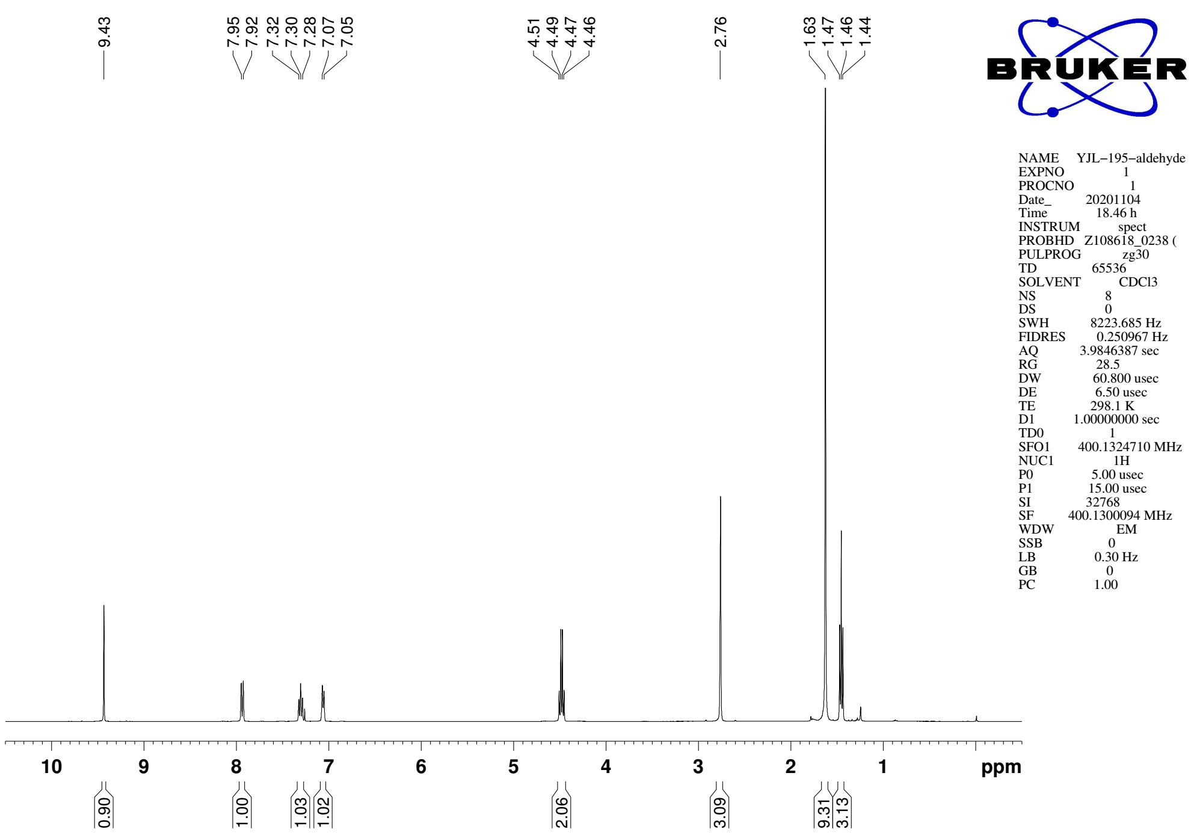
Supplementary Figure 29. ¹H NMR (CDCl₃, 400MHz) spectra of substrate 1ac

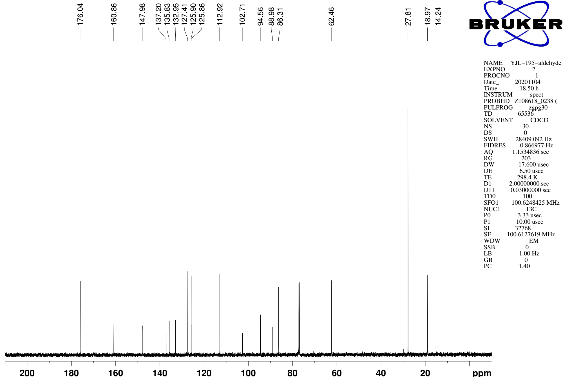
Supplementary Figure 30. ¹³C NMR (CDCl₃, 101MHz) spectra of spectra of substrate 1ac
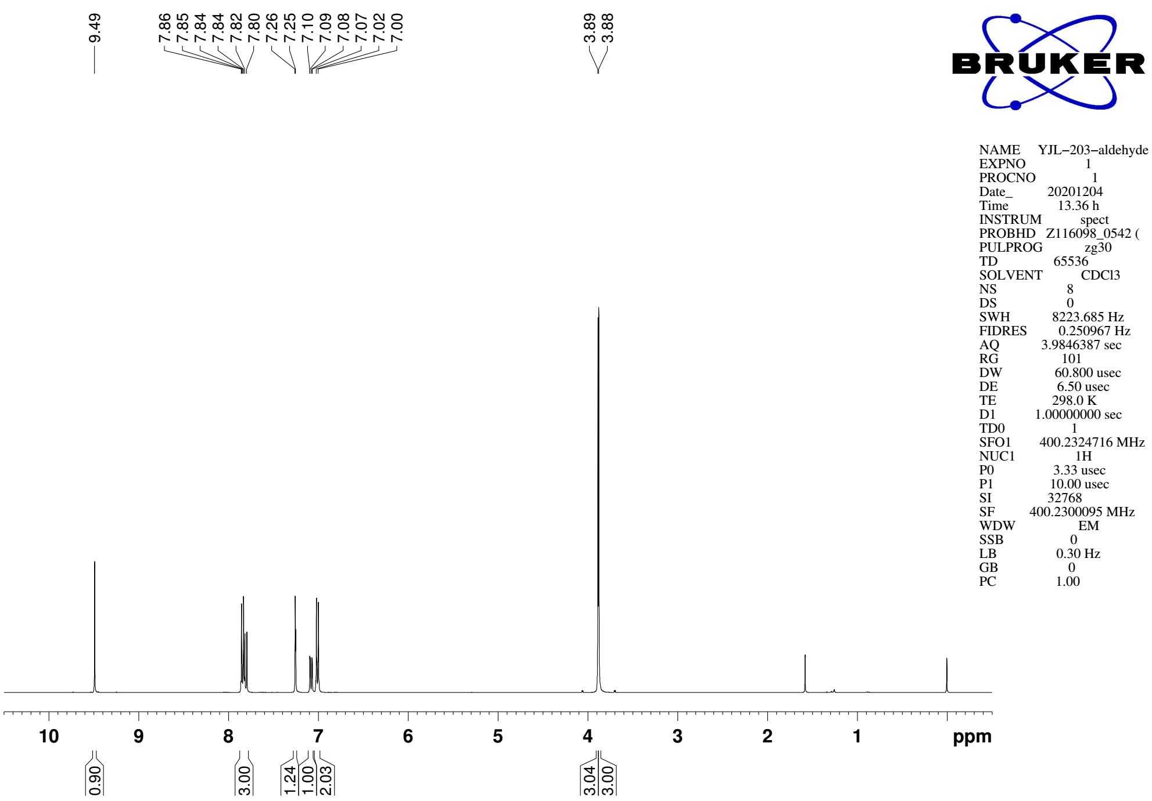
Supplementary Figure 31. ¹H NMR (CDCl₃, 400MHz) spectra of substrate 1ad

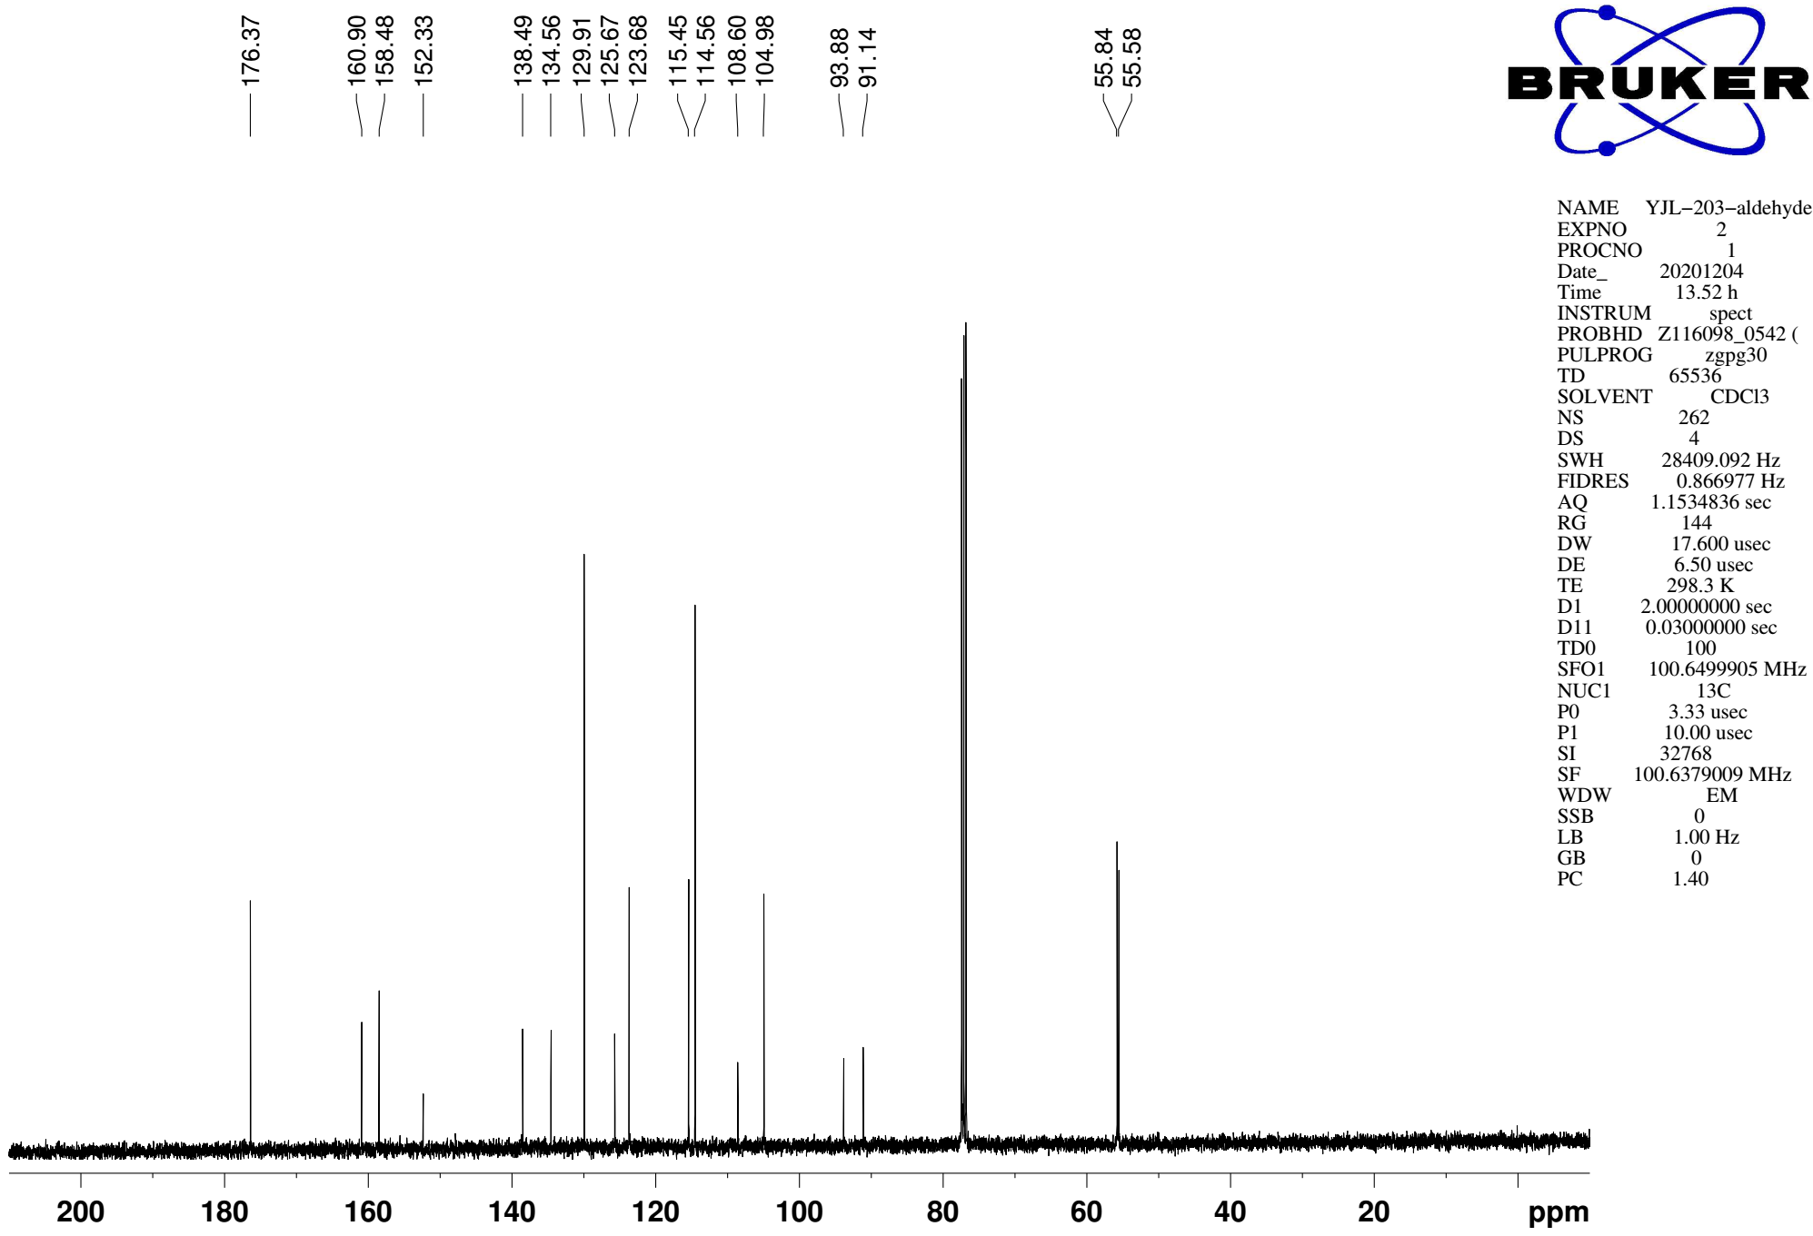
Supplementary Figure 32. ¹³C NMR (CDCl₃, 101MHz) spectra of spectra of substrate 1ad
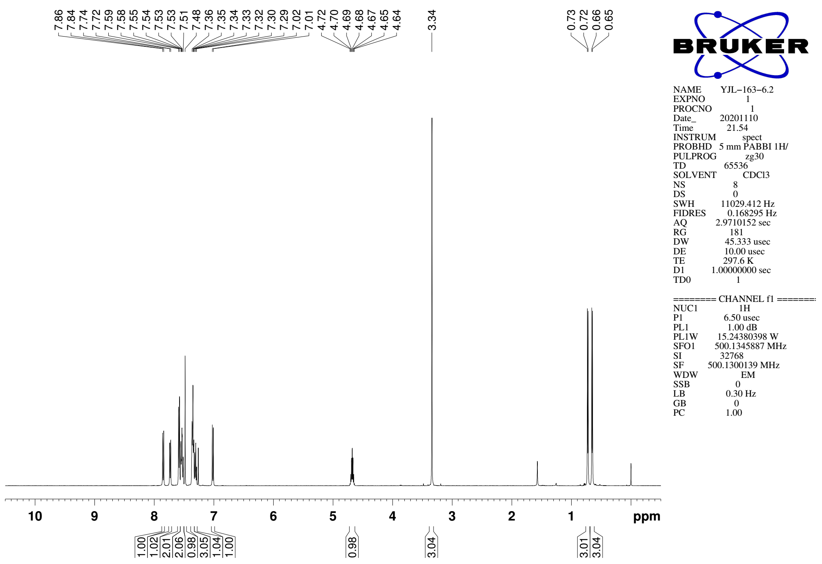
Supplementary Figure 33. ¹H NMR (CDCl₃, 500MHz) spectra of 3

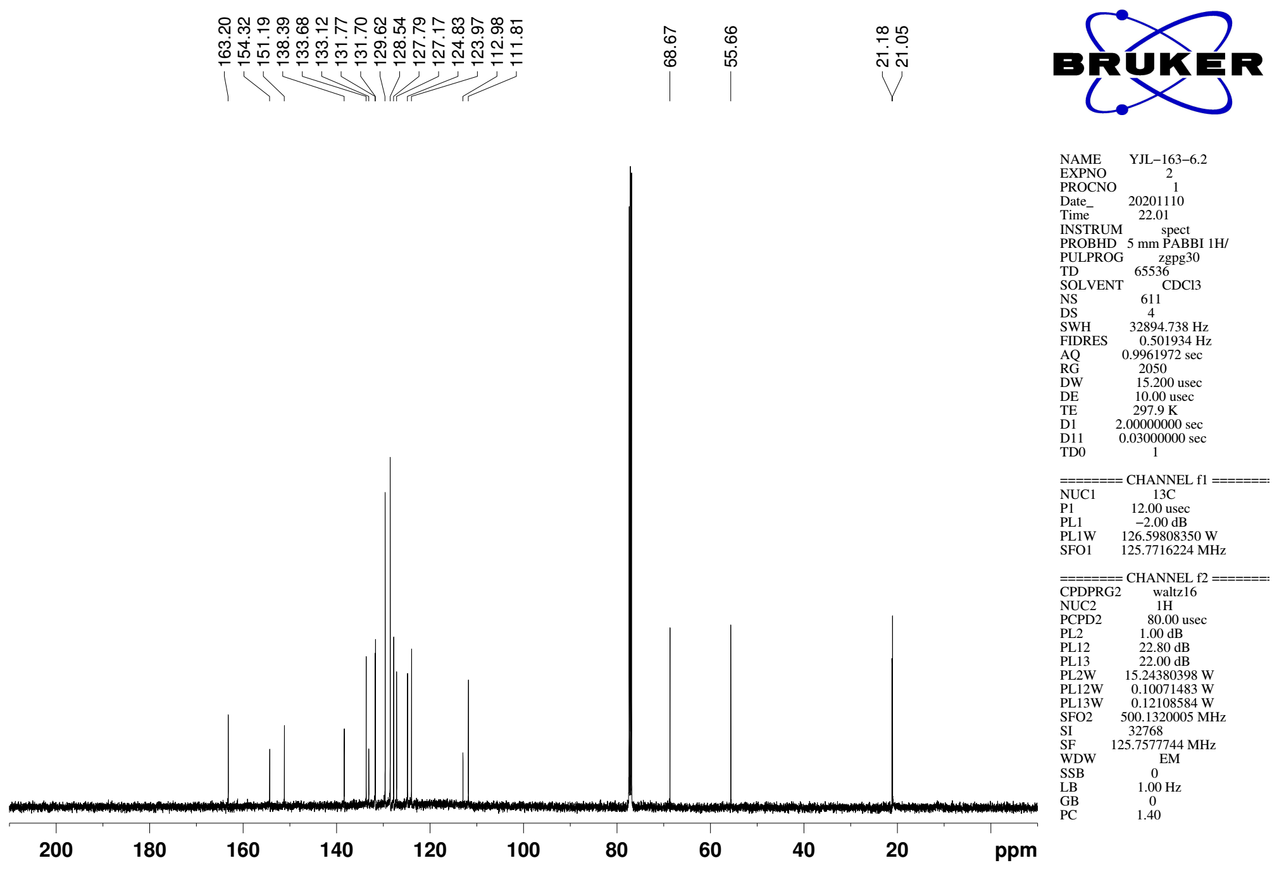
Supplementary Figure 34. ¹³C NMR (CDCl₃, 126MHz) spectra of spectra of 3

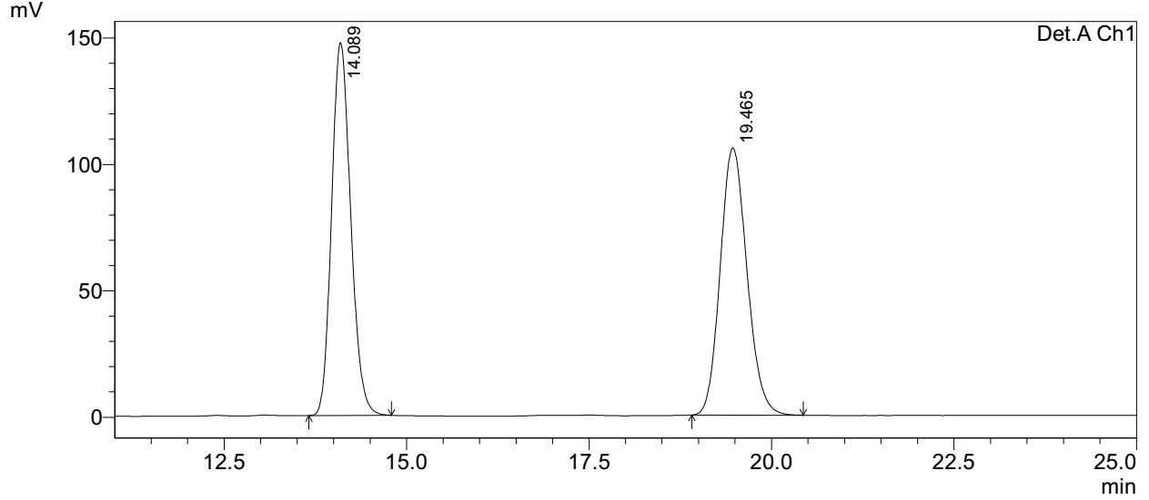
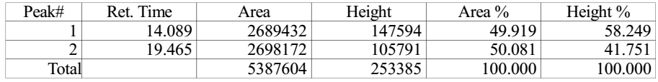

Axially chiral styrene 3 (prepared by NHC catalytic reaction)
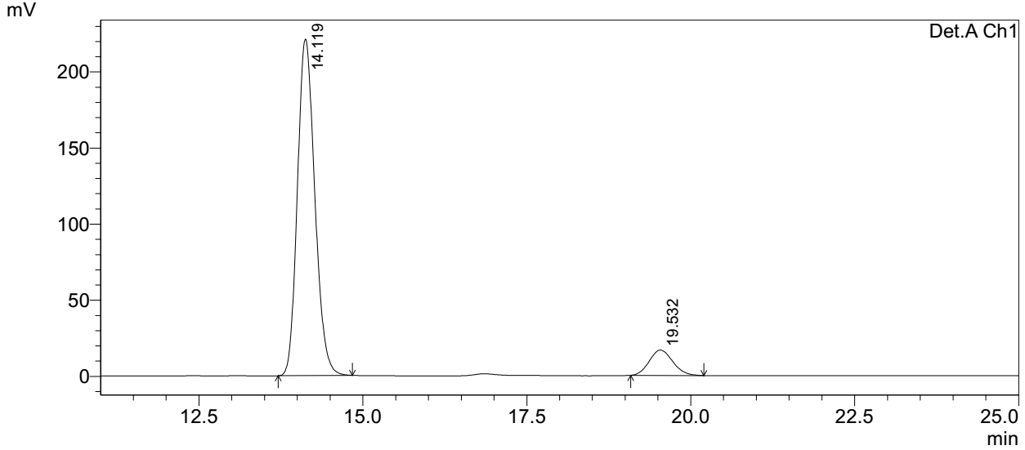
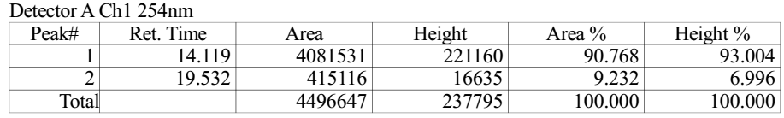
Supplementary Figure 35. HPLC spectra of 3 (prepared by NHC catalytic reaction)

Axially chiral styrene 3 (prepared by transesterification)
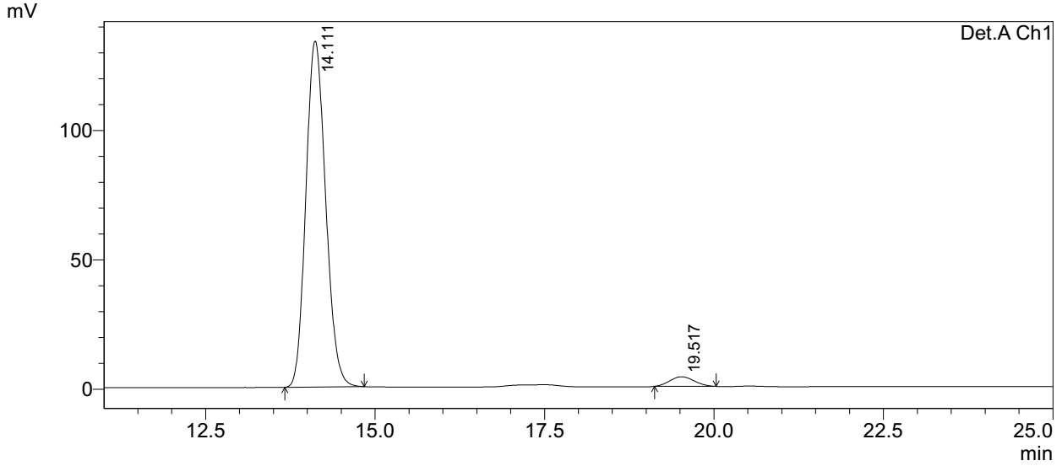
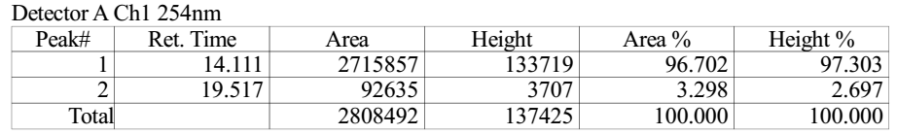
Supplementary Figure 36. HPLC spectra of 3 (prepared by transesterification)

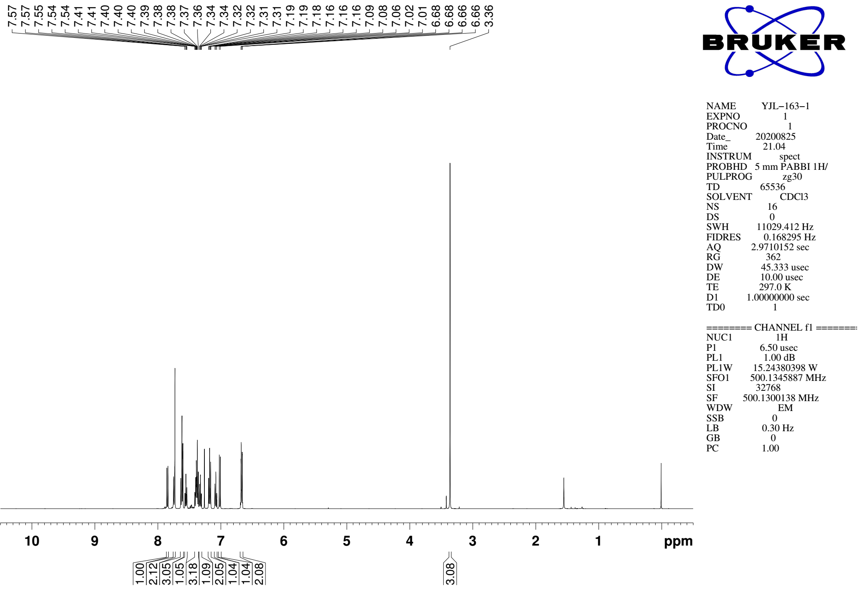
Supplementary Figure 37. ¹H NMR (CDCl₃, 500MHz) spectra of 5

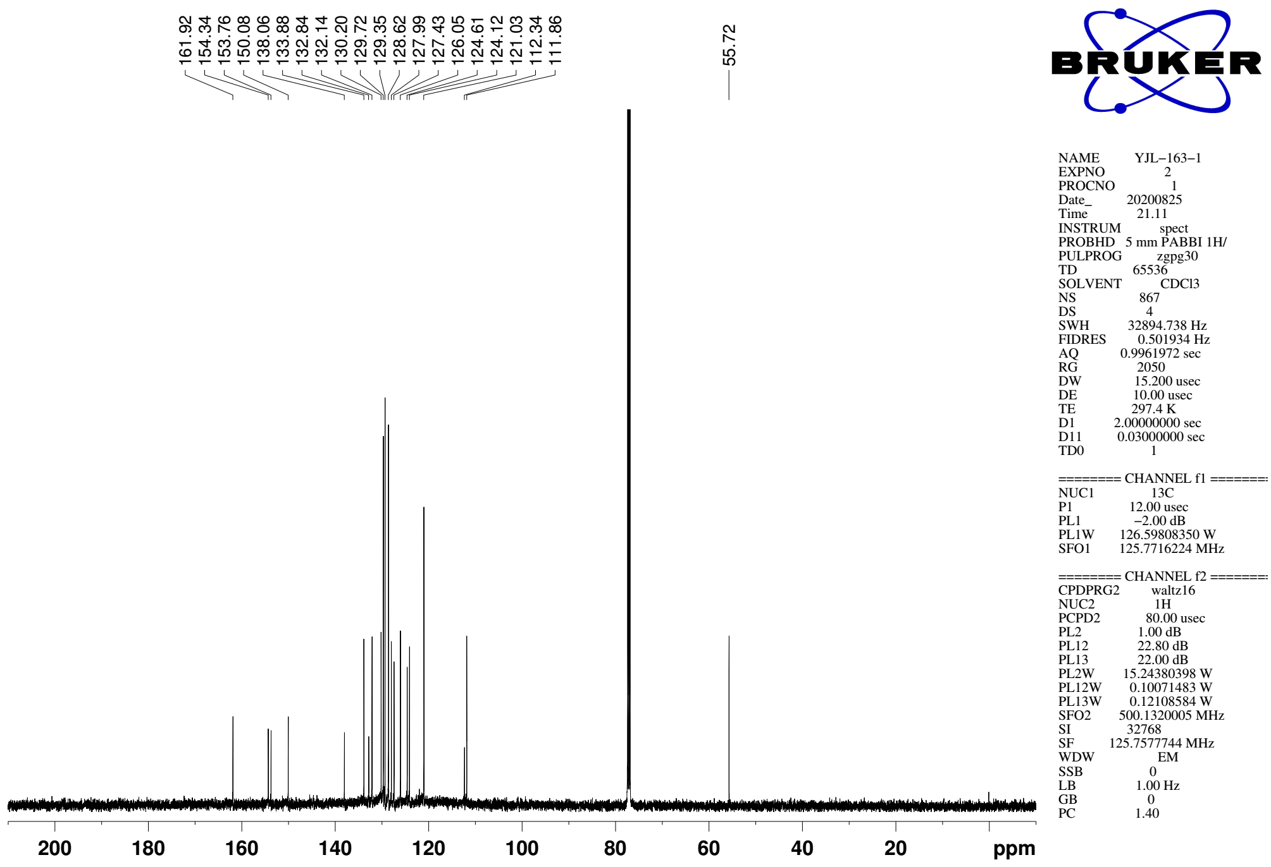
Supplementary Figure 38. ¹³C NMR (CDCl₃, 126MHz) spectra of spectra of 5

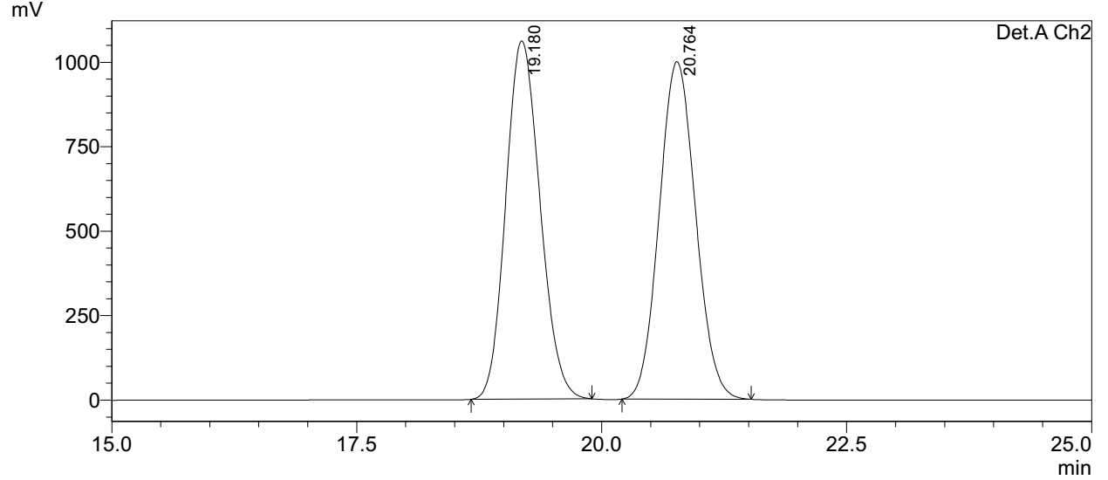
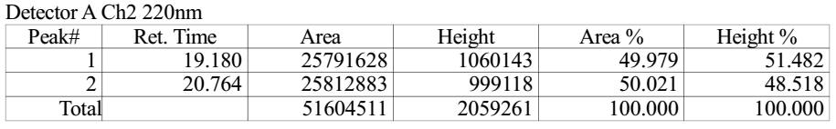

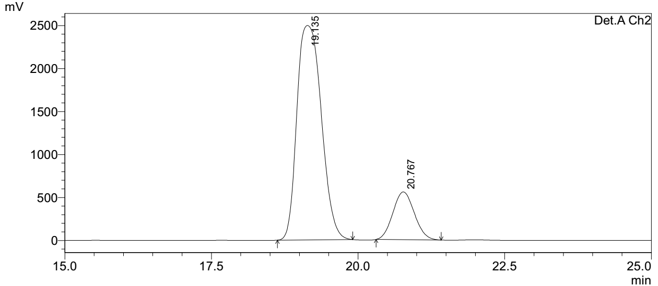
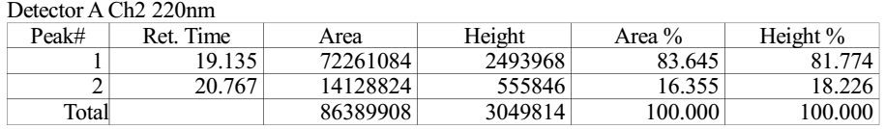
Supplementary Figure 39. HPLC spectra of 5
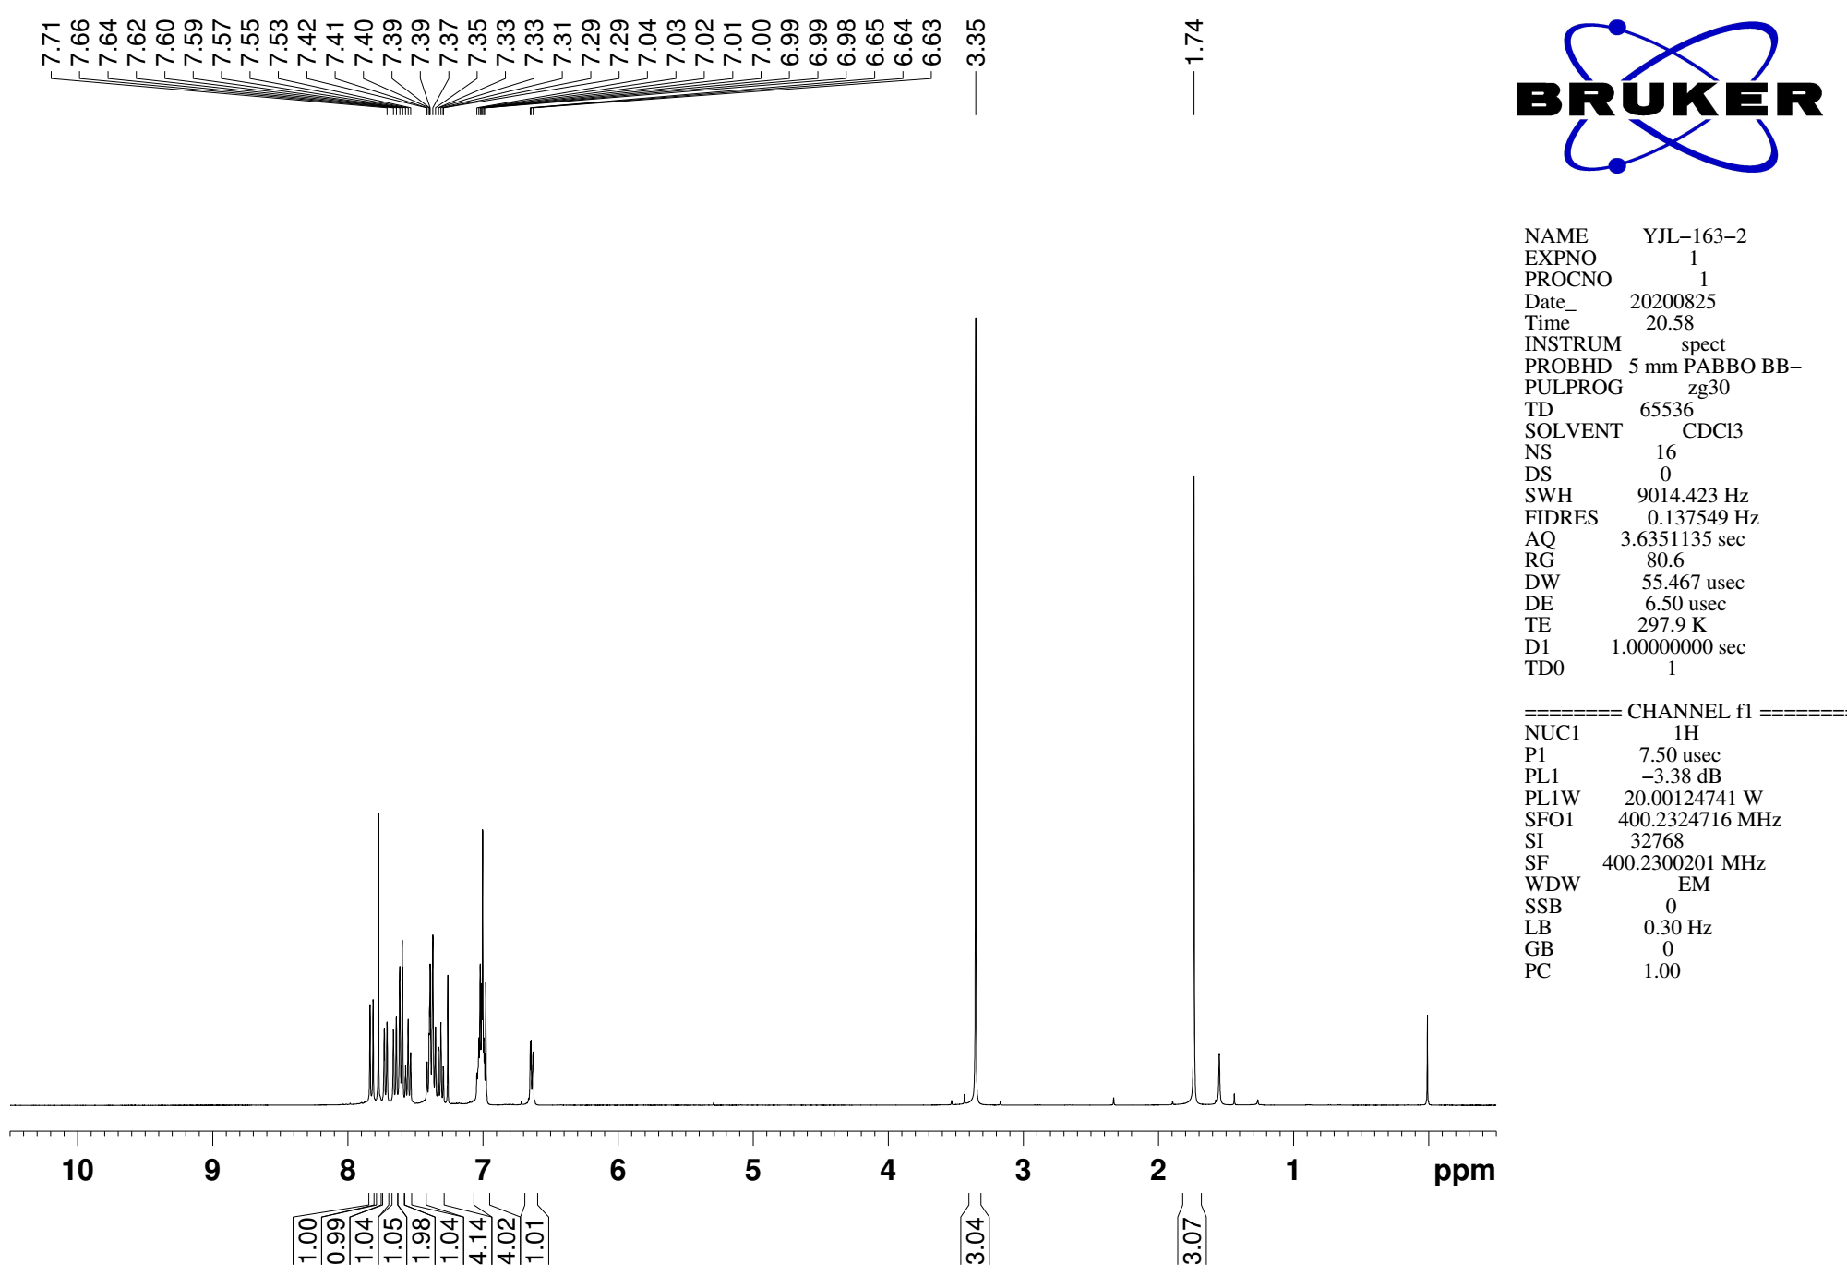
Supplementary Figure 40. ¹H NMR (CDCl₃, 400MHz) spectra of 6

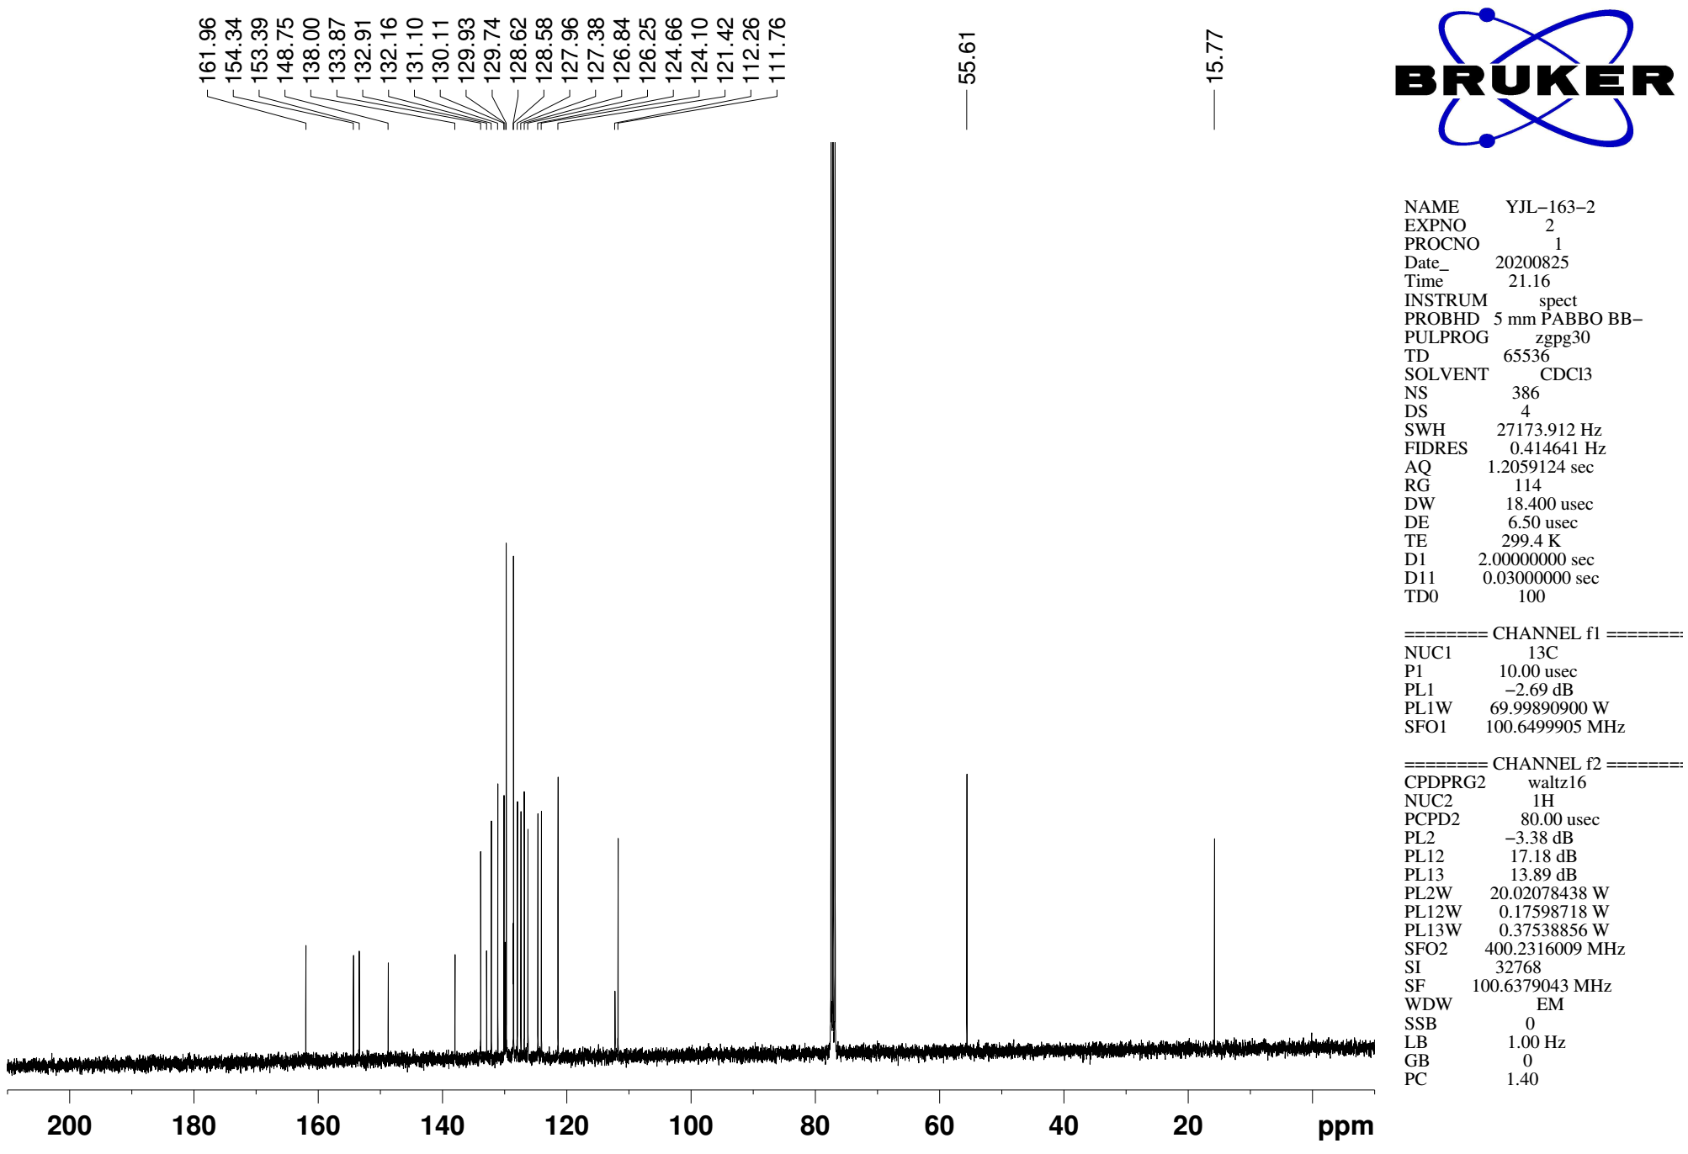
Supplementary Figure 41. ¹³C NMR (CDCl₃, 101MHz) spectra of spectra of 6

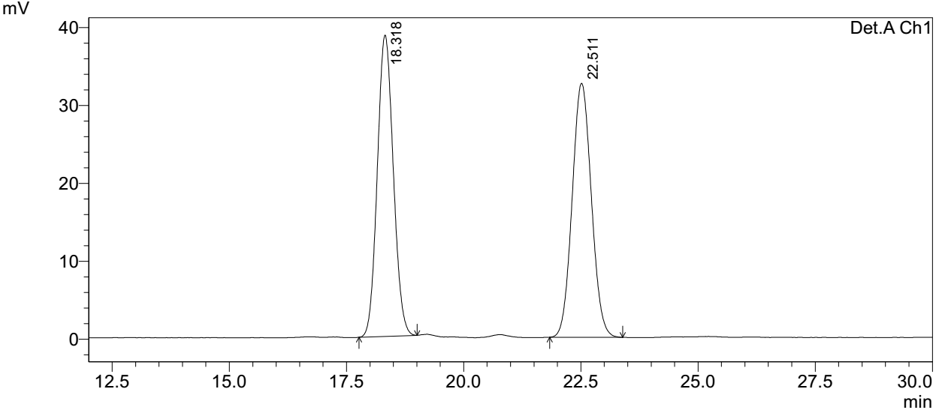
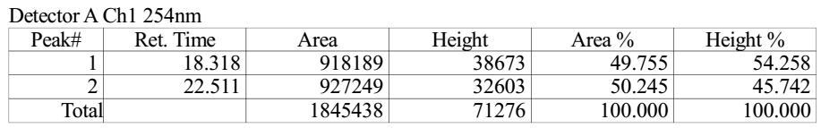

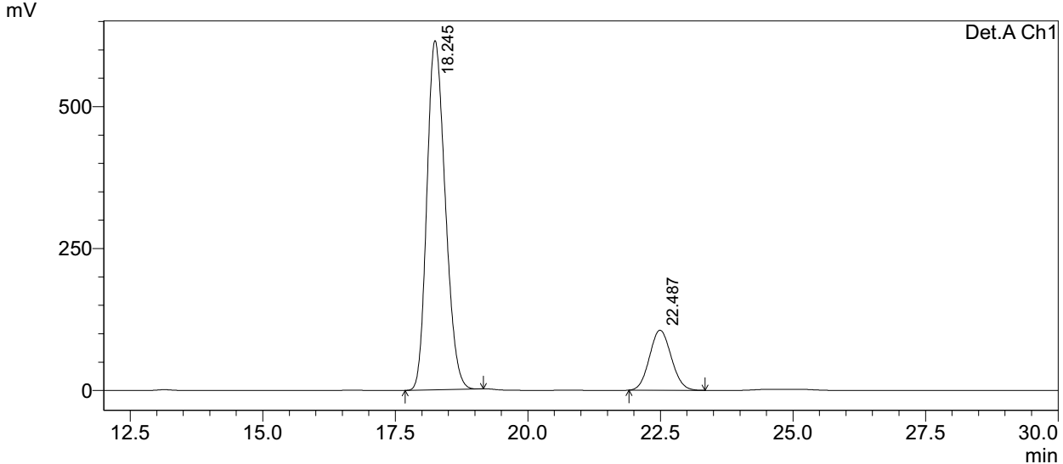
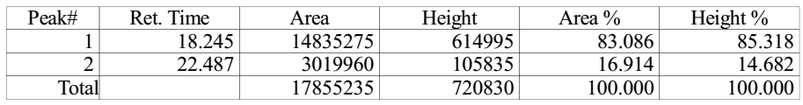
Supplementary Figure 42. HPLC spectra of 6
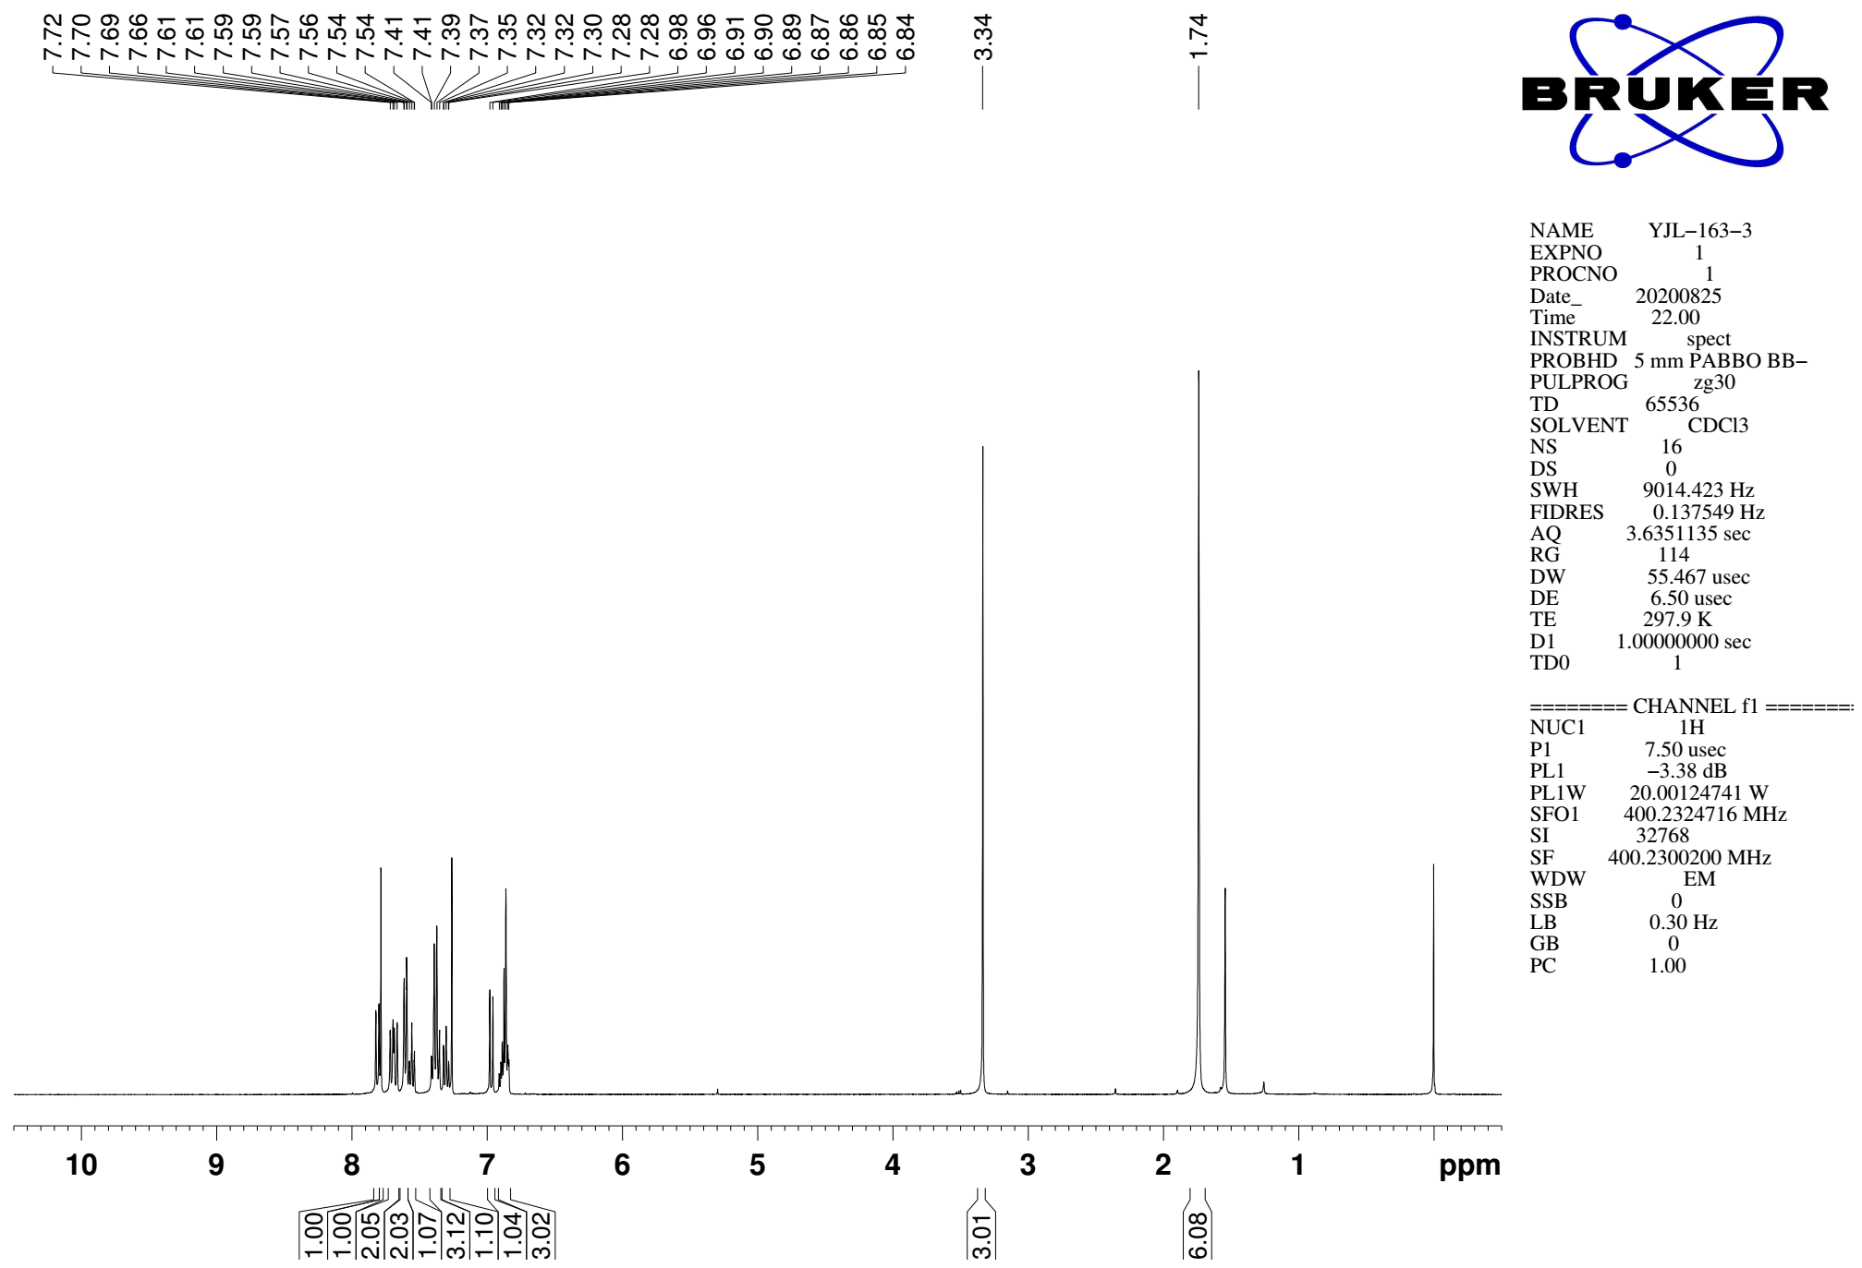
Supplementary Figure 43. ¹H NMR (CDCl₃, 400MHz) spectra of 7

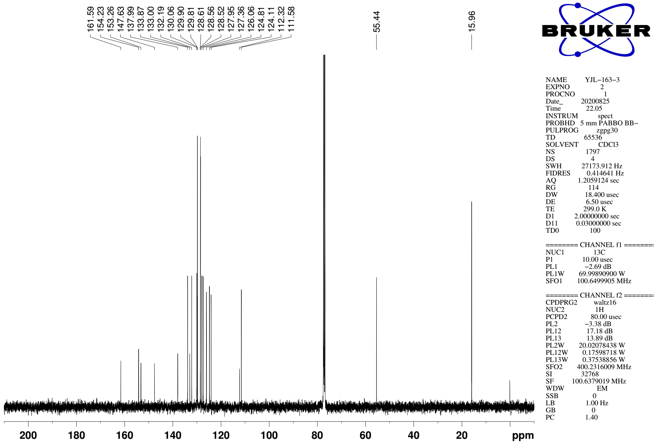
Supplementary Figure 44. ¹³C NMR (CDCl₃, 101MHz) spectra of spectra of 7

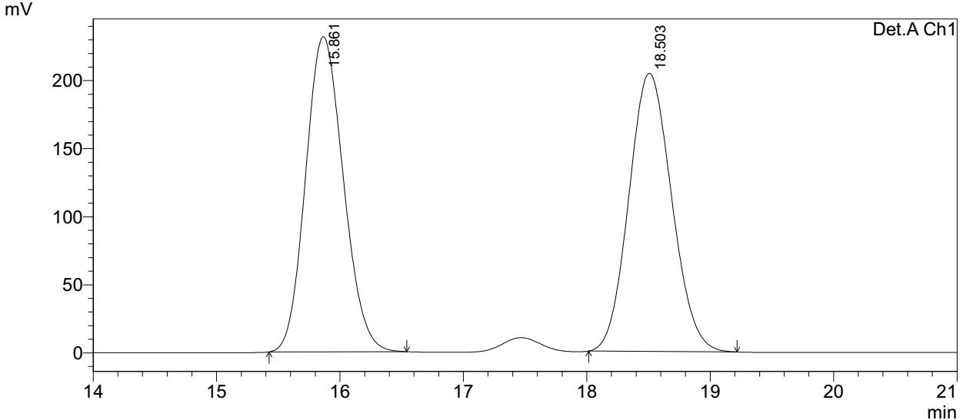
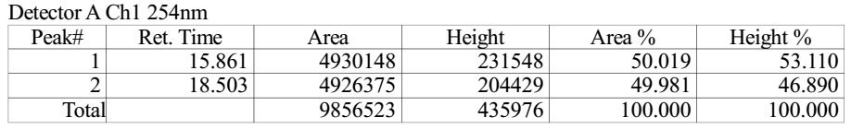

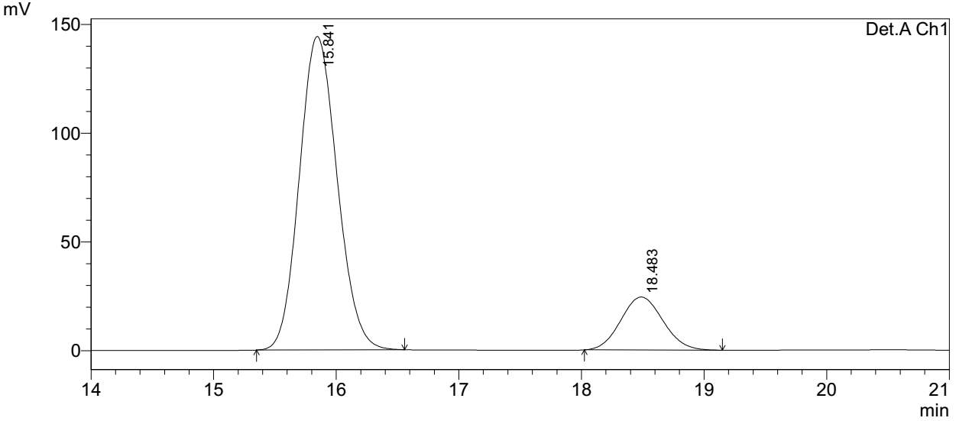
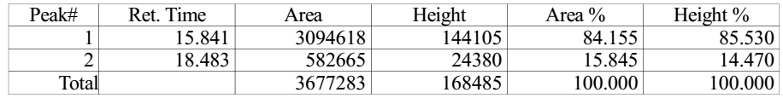
Supplementary Figure 45. HPLC spectra of 7
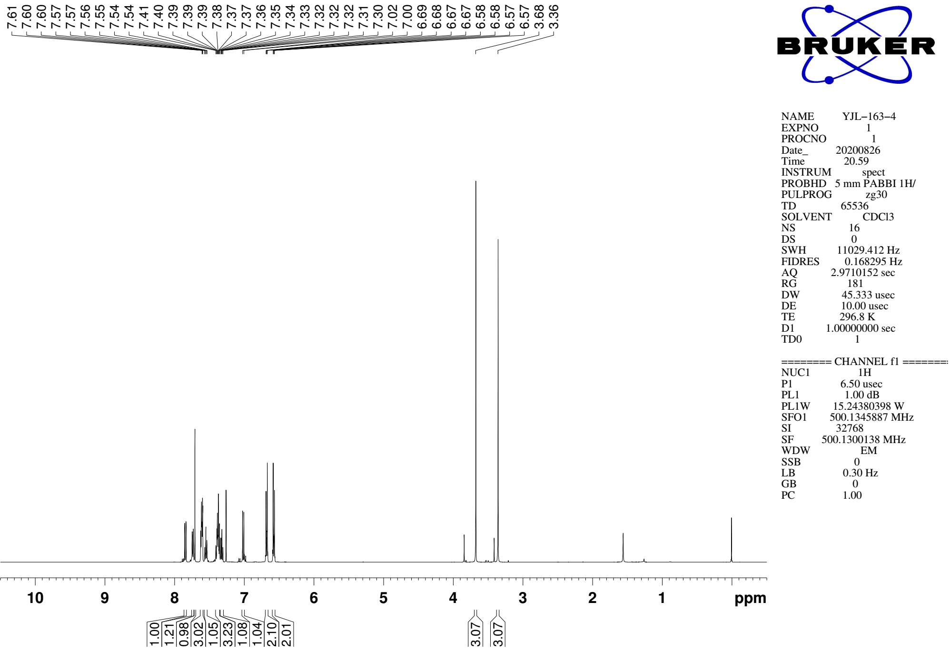
Supplementary Figure 46. ¹H NMR (CDCl₃, 500MHz) spectra of 8

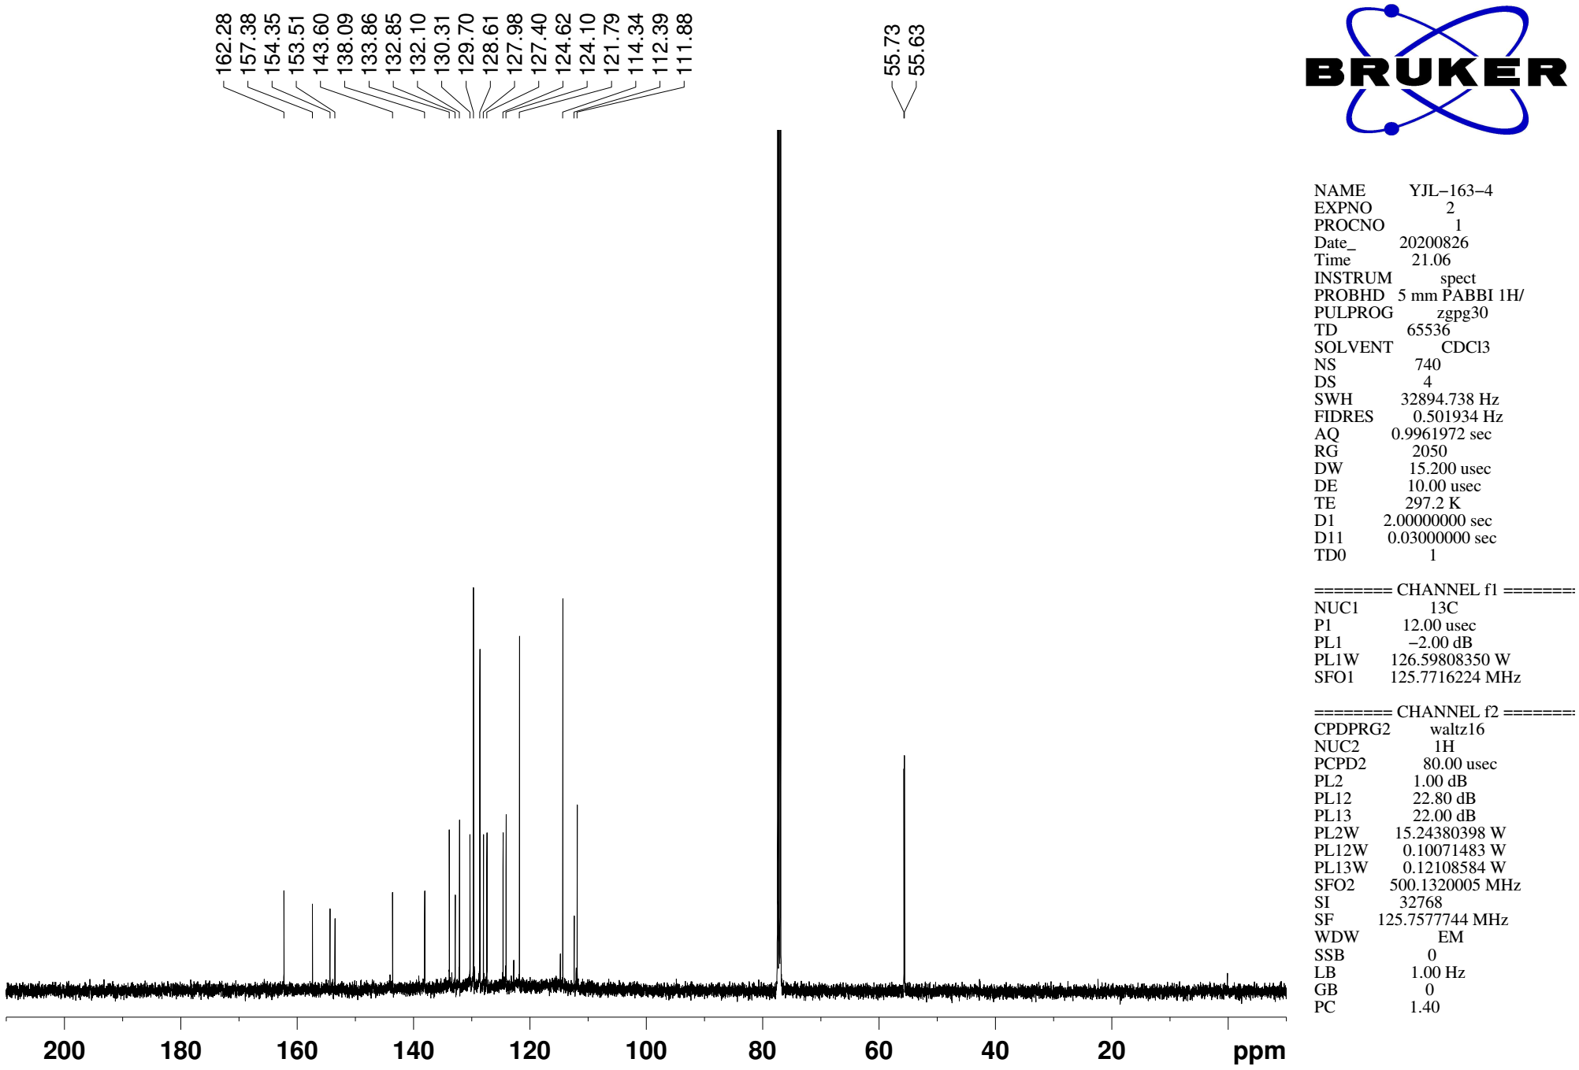
Supplementary Figure 47. ¹³C NMR (CDCl₃, 126MHz) spectra of spectra of 8

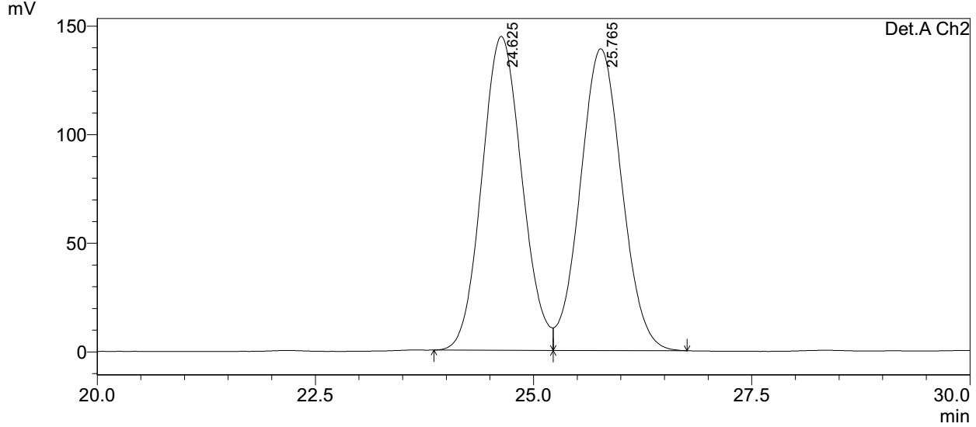
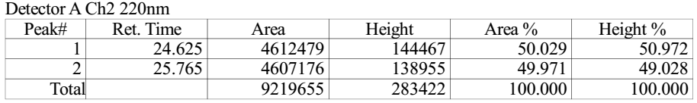

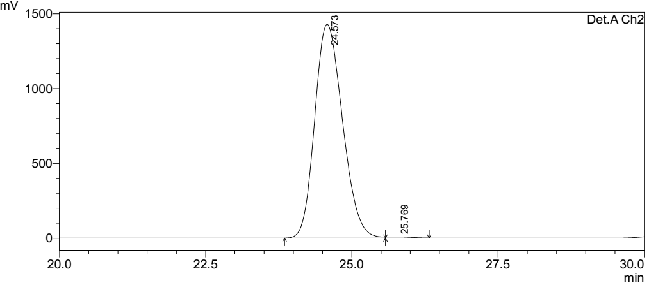
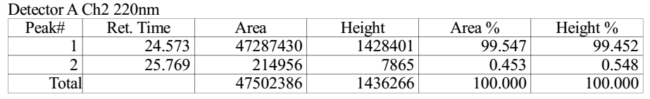
Supplementary Figure 48. HPLC spectra of 8
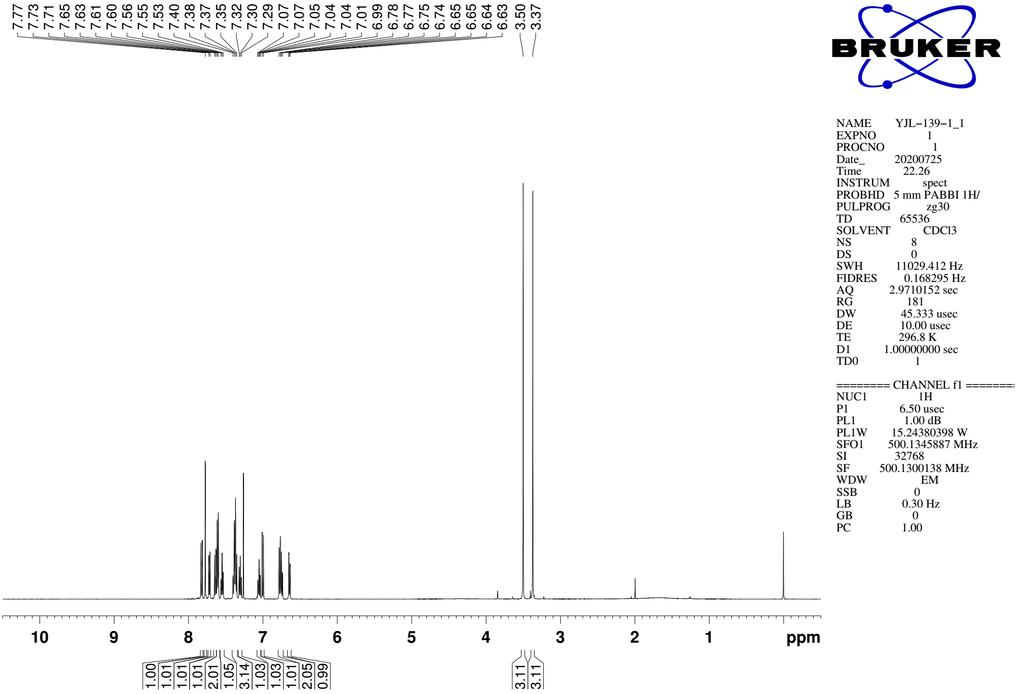
Supplementary Figure 49. ¹H NMR (CDCl₃, 500MHz) spectra of 9a

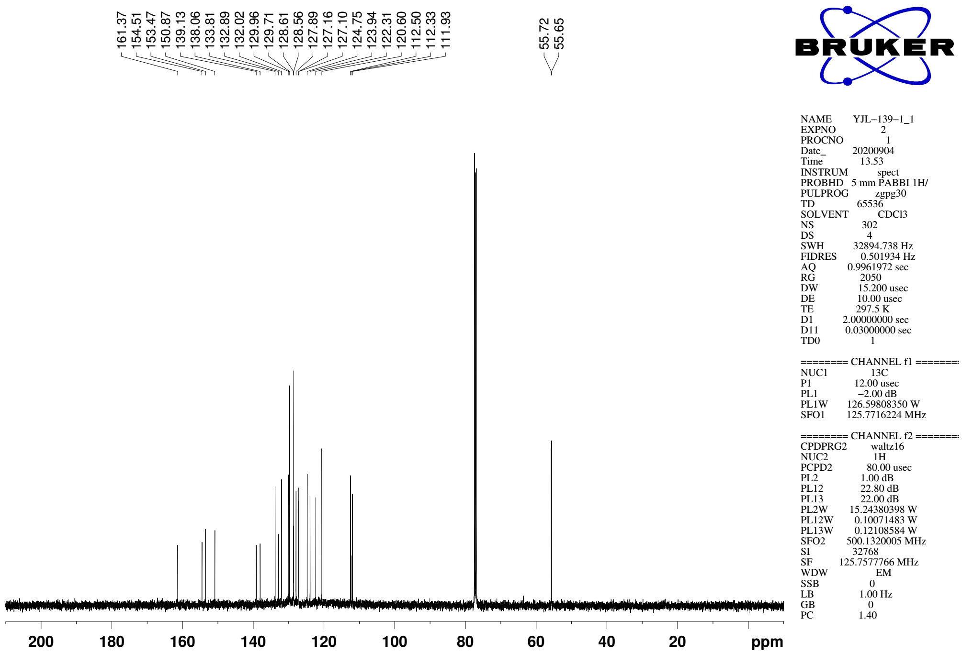
Supplementary Figure 50. ¹³C NMR (CDCl₃, 126MHz) spectra of spectra of 9a

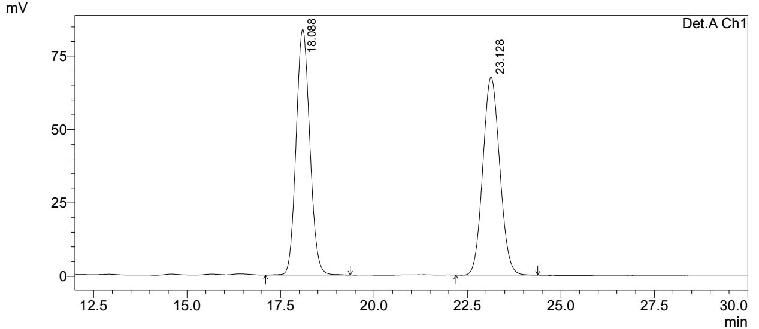
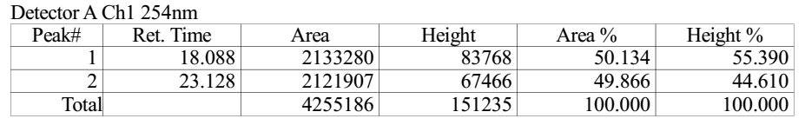

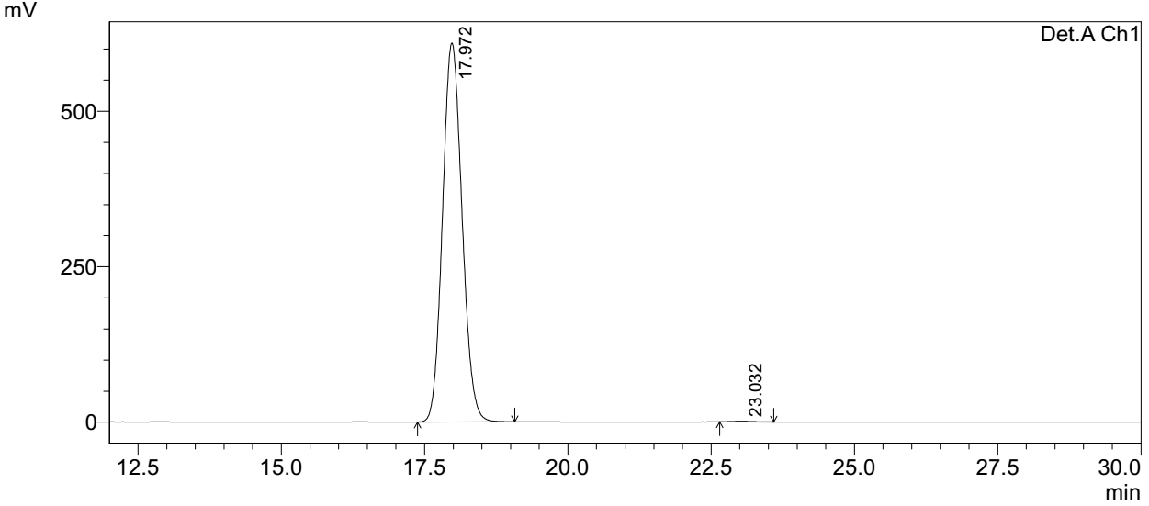
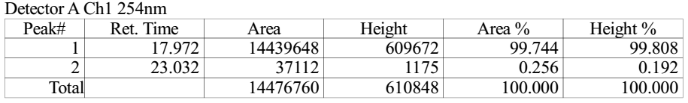
Supplementary Figure 51. HPLC spectra of 9a
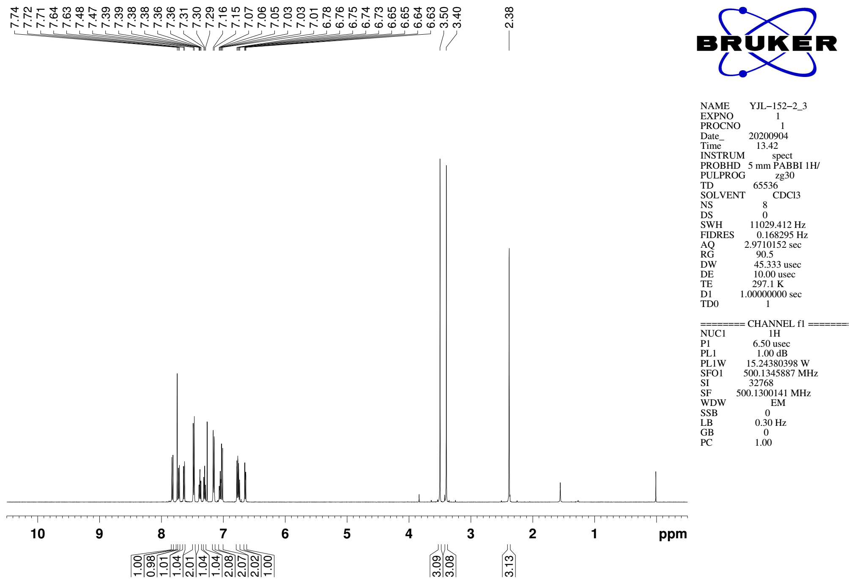
Supplementary Figure 52. ¹H NMR (CDCl₃, 500MHz) spectra of 9b

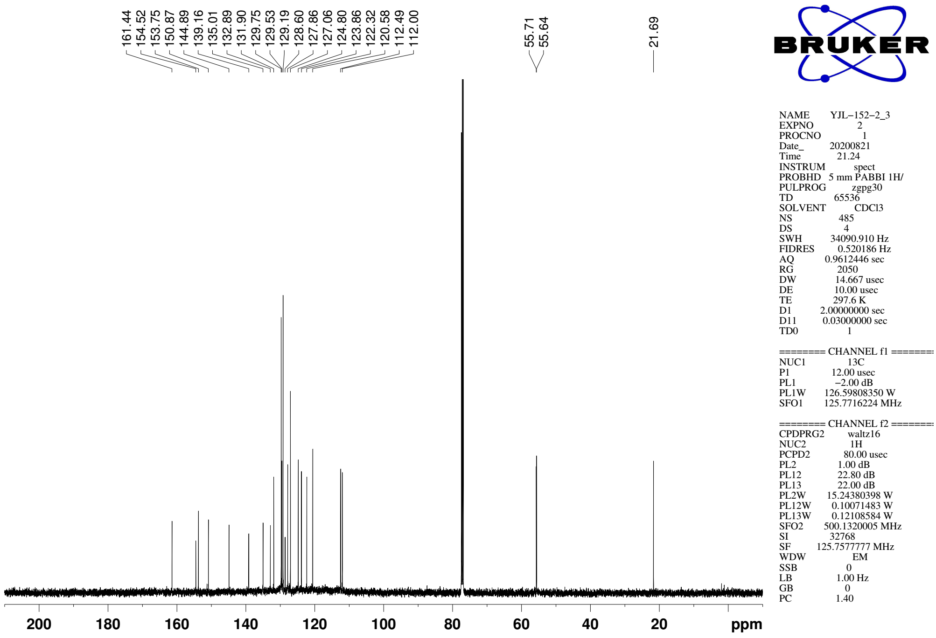
Supplementary Figure 53. ¹³C NMR (CDCl₃, 126MHz) spectra of spectra of 9b
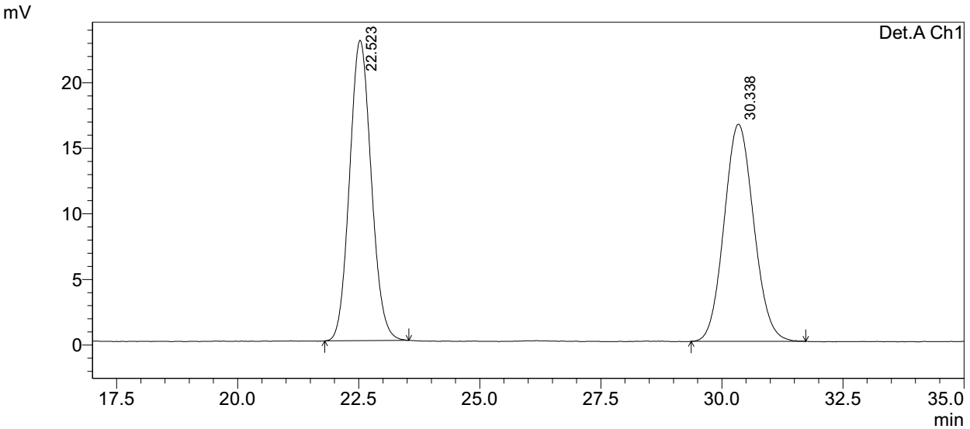
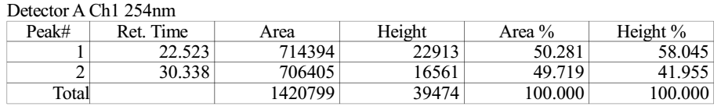

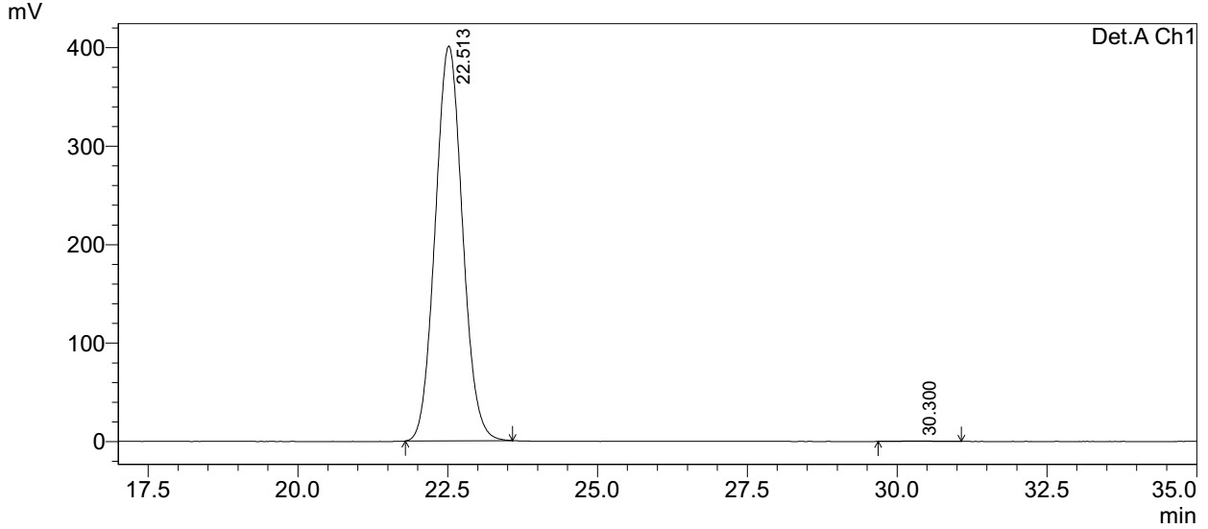
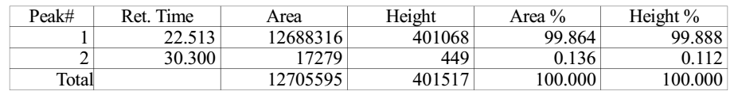
Supplementary Figure 54. HPLC spectra of 9b
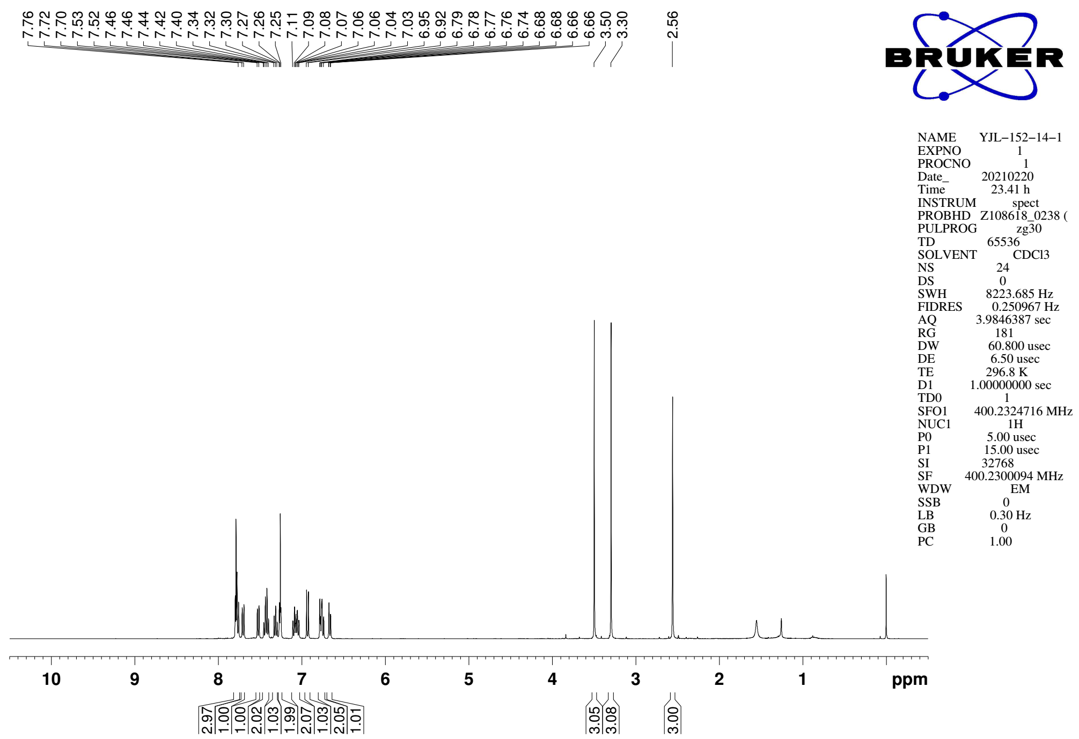
Supplementary Figure 55. ¹H NMR (CDCl₃, 400MHz) spectra of 9c

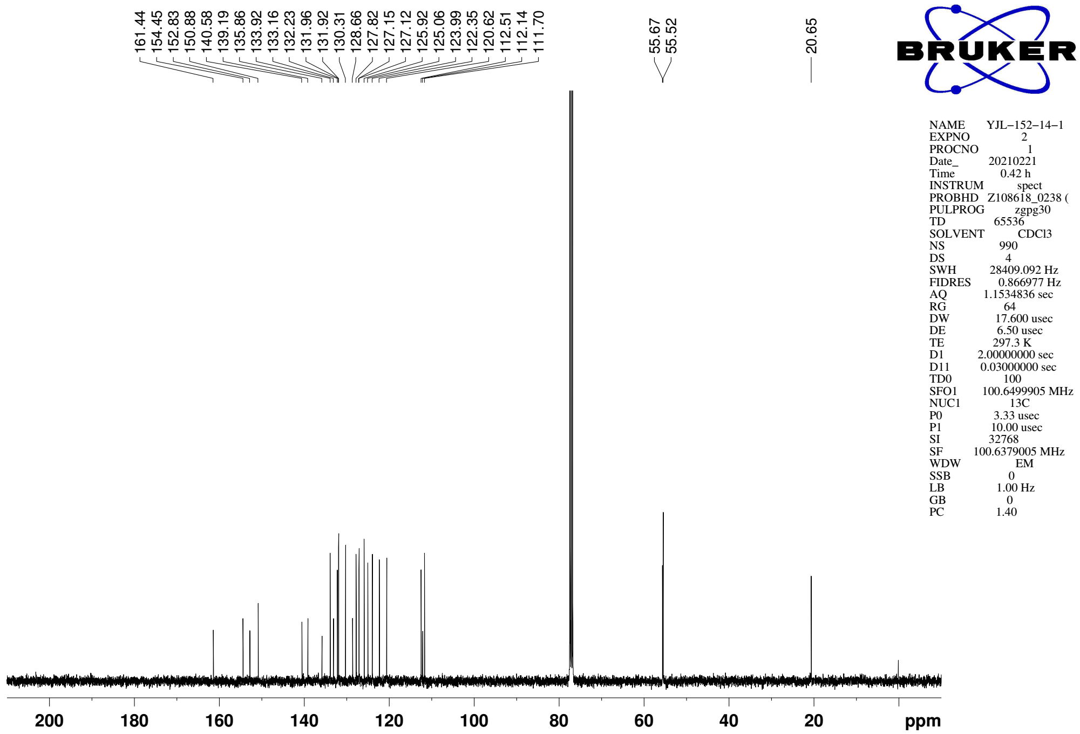
Supplementary Figure 56. ¹³C NMR (CDCl₃, 101MHz) spectra of spectra of 9c

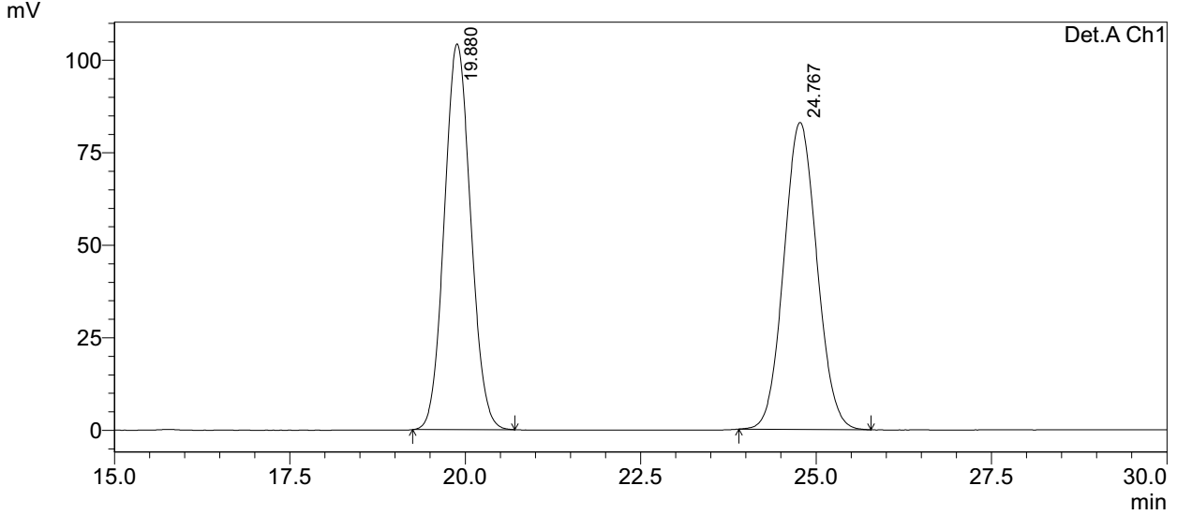
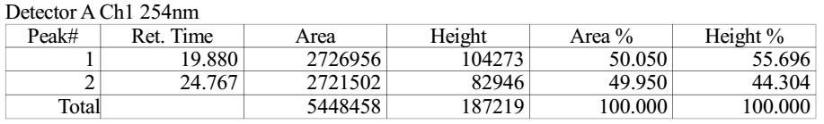

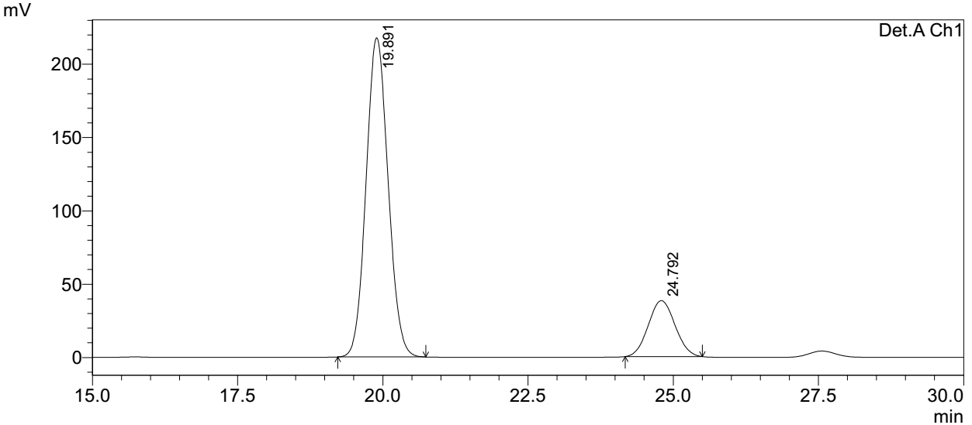
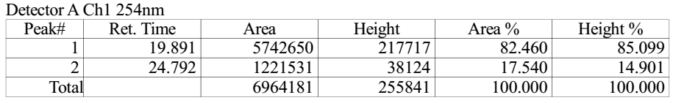
Supplementary Figure 57. HPLC spectra of 9c
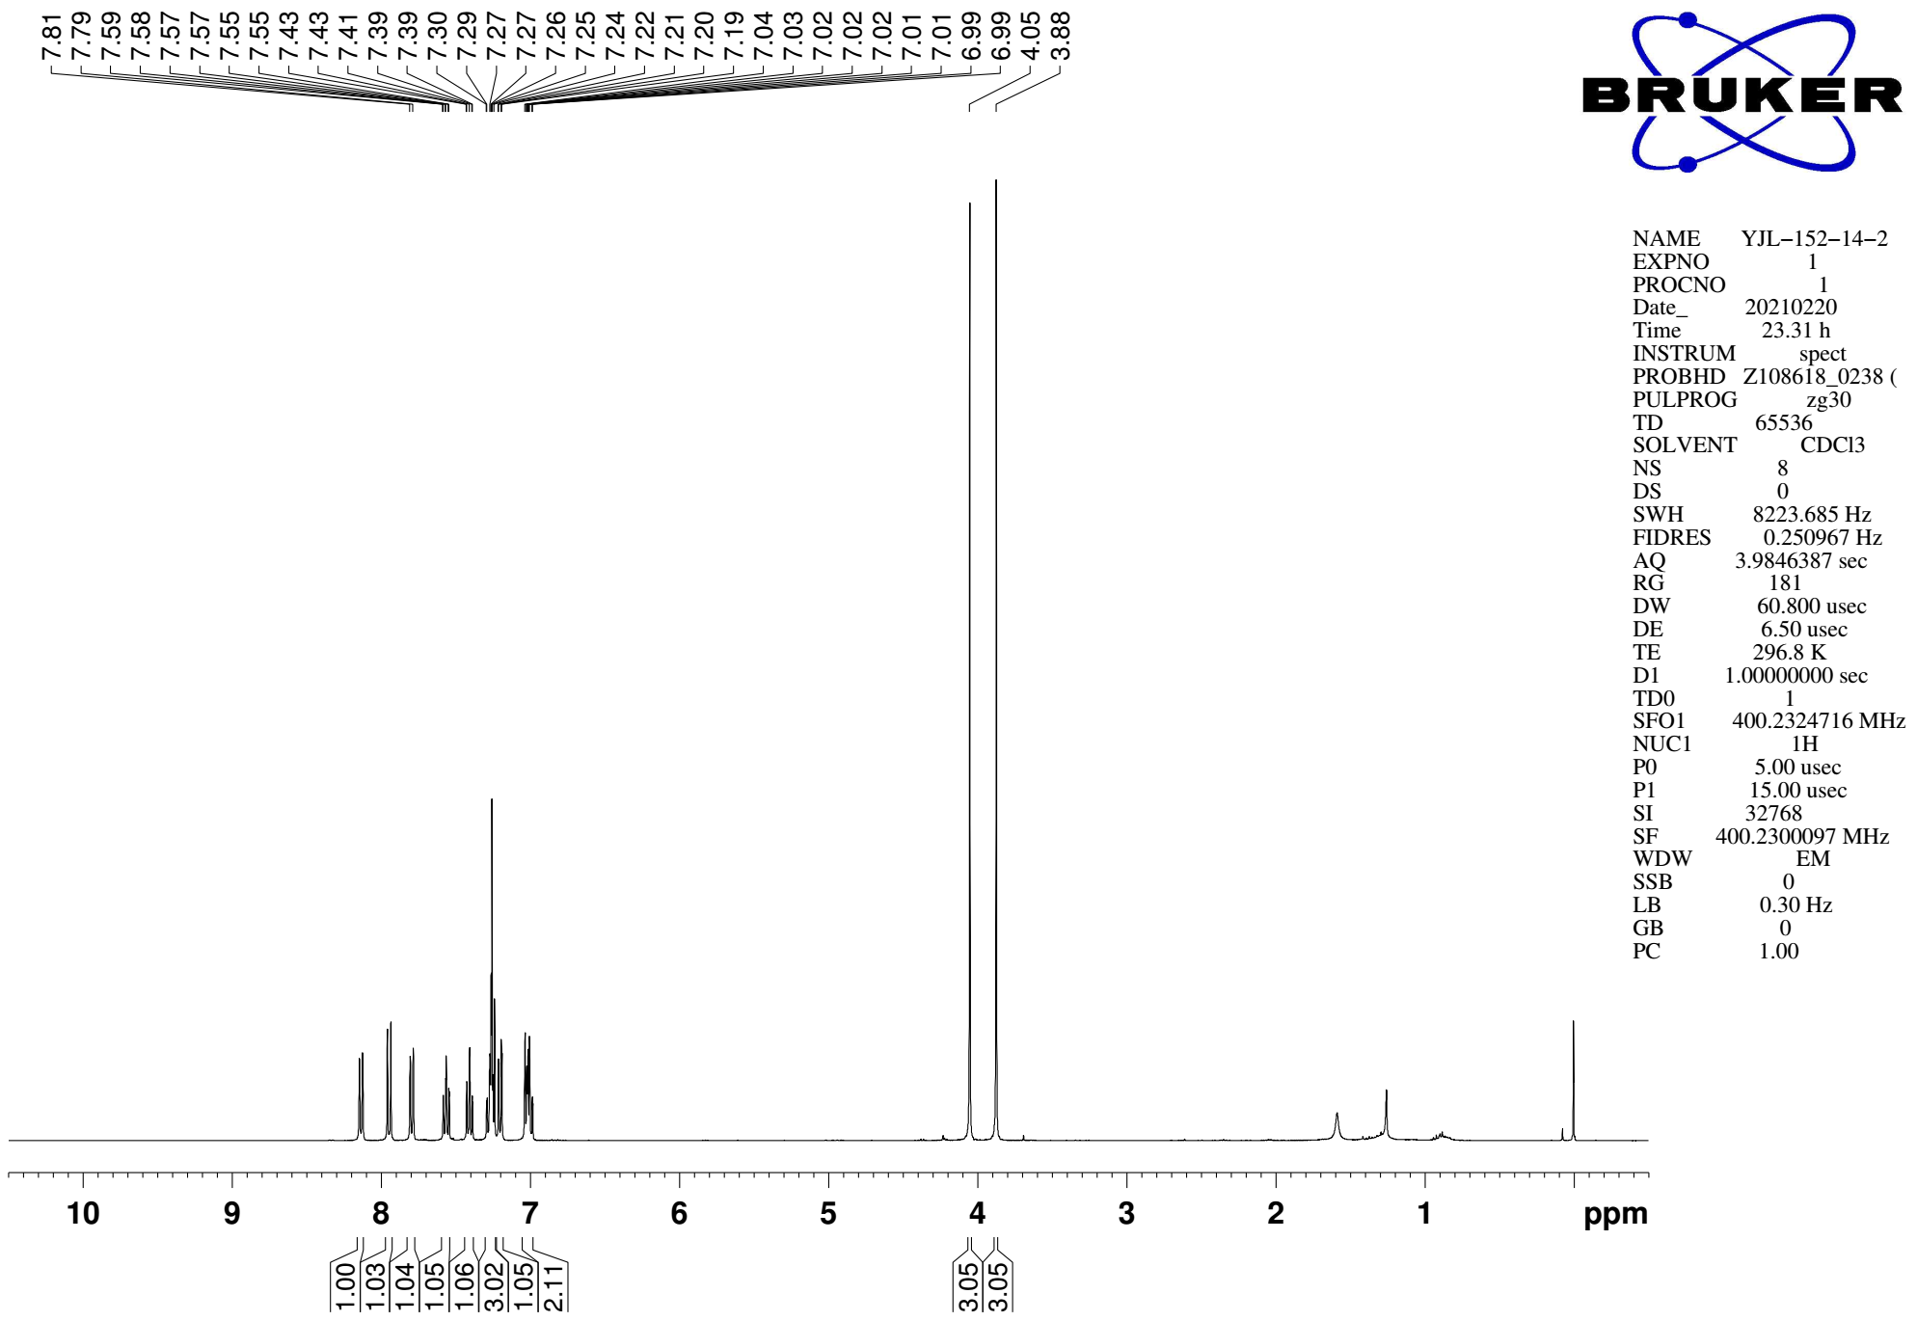
Supplementary Figure 58. ¹H NMR (CDCl₃, 400MHz) spectra of S15

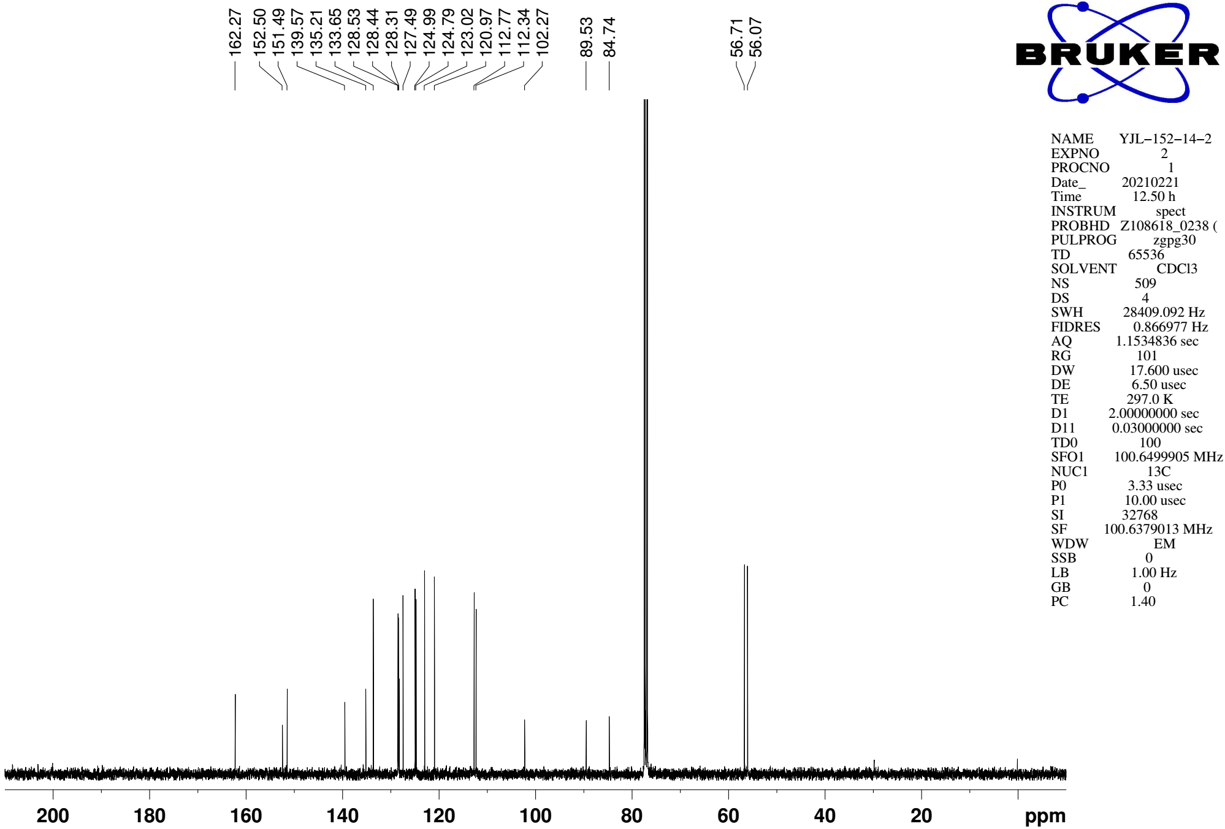
Supplementary Figure 59. ¹³C NMR (CDCl₃, 101MHz) spectra of spectra of S15
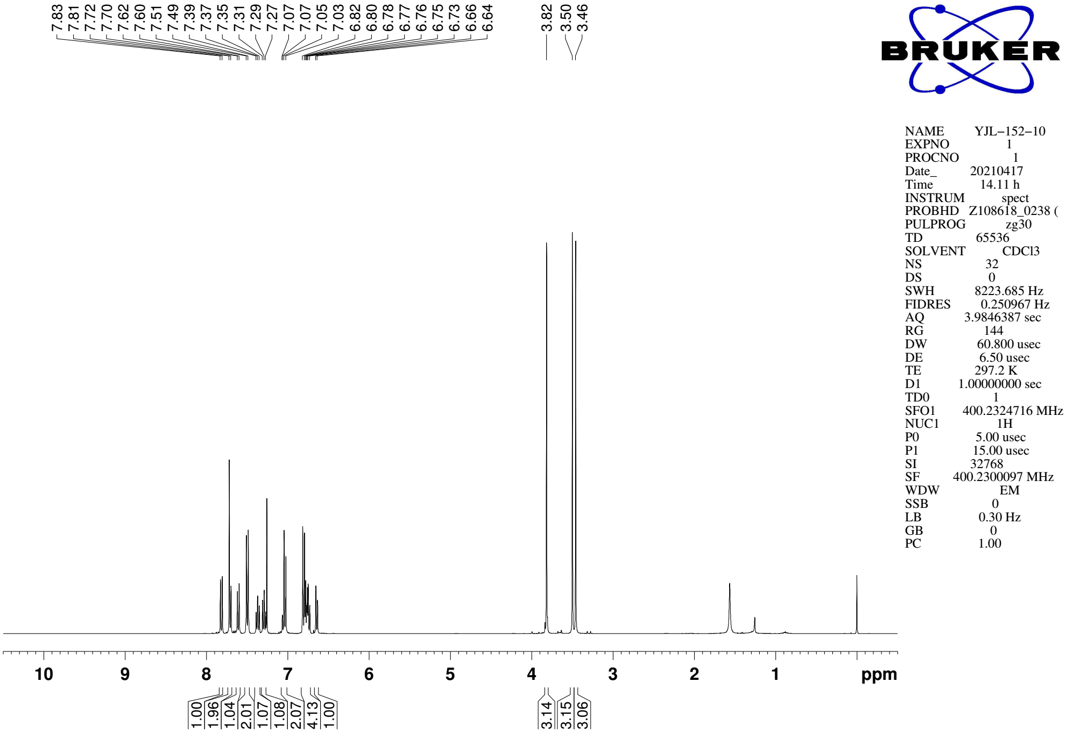
Supplementary Figure 60. ¹H NMR (CDCl₃, 400MHz) spectra of 9d

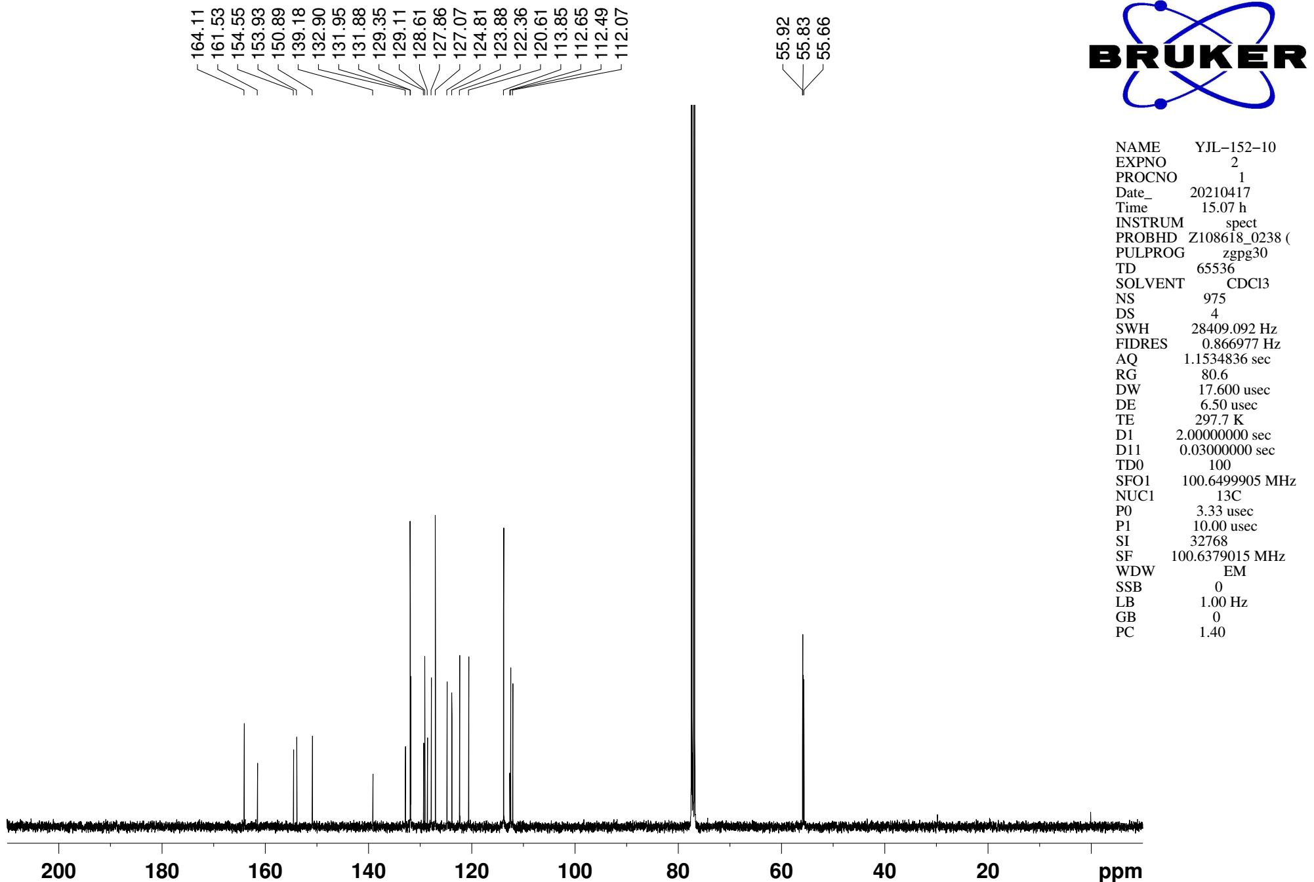
Supplementary Figure 61. ¹³C NMR (CDCl₃, 101MHz) spectra of spectra of 9d
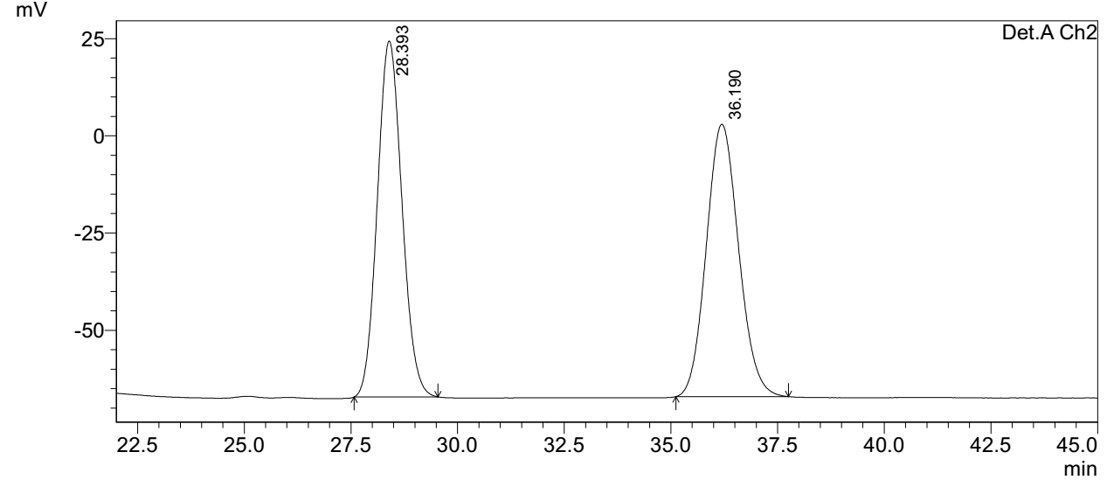
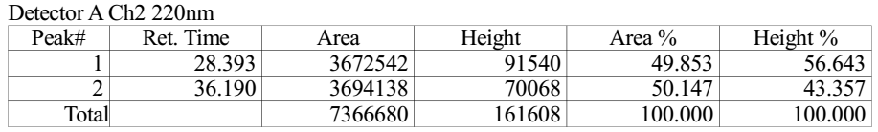

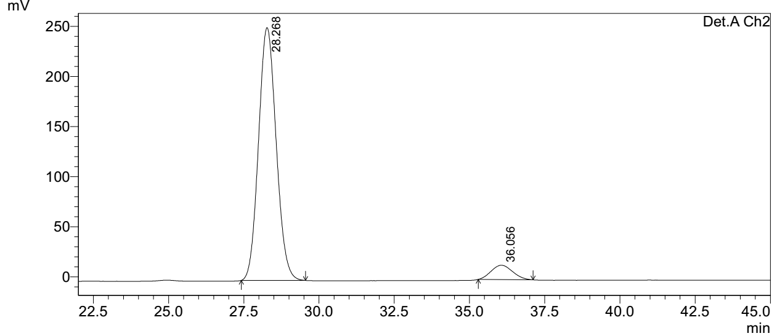
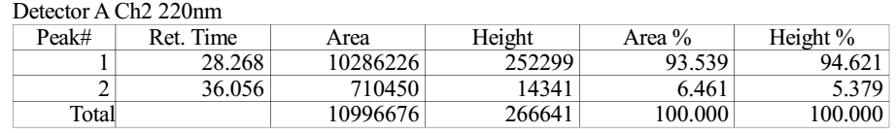
Supplementary Figure 62. HPLC spectra of 9d
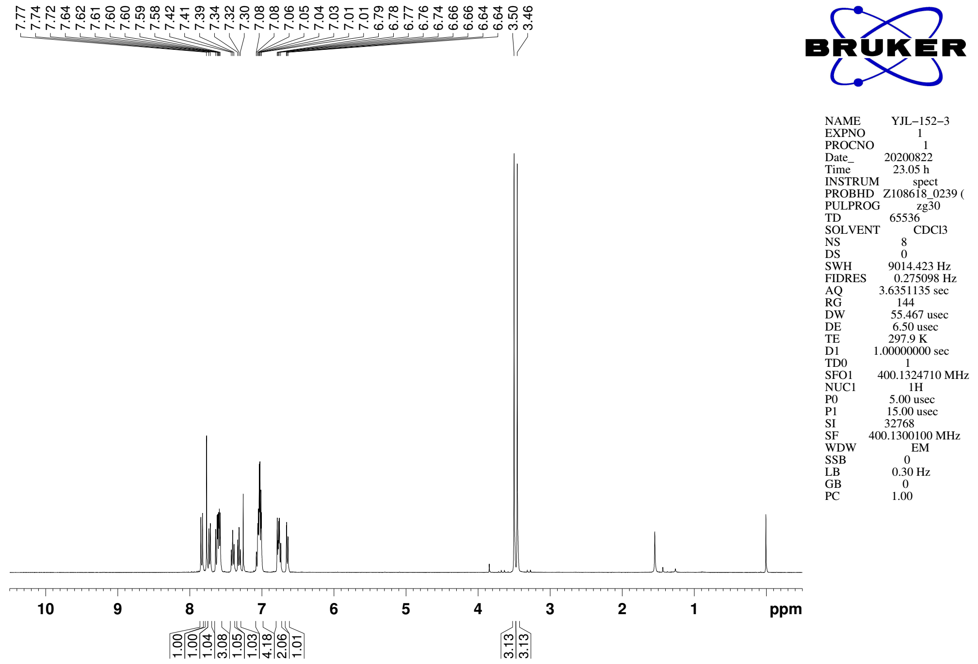
Supplementary Figure 63. ¹H NMR (CDCl₃, 400MHz) spectra of 9e

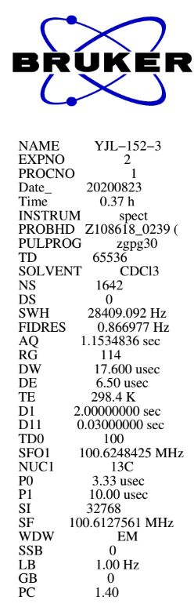
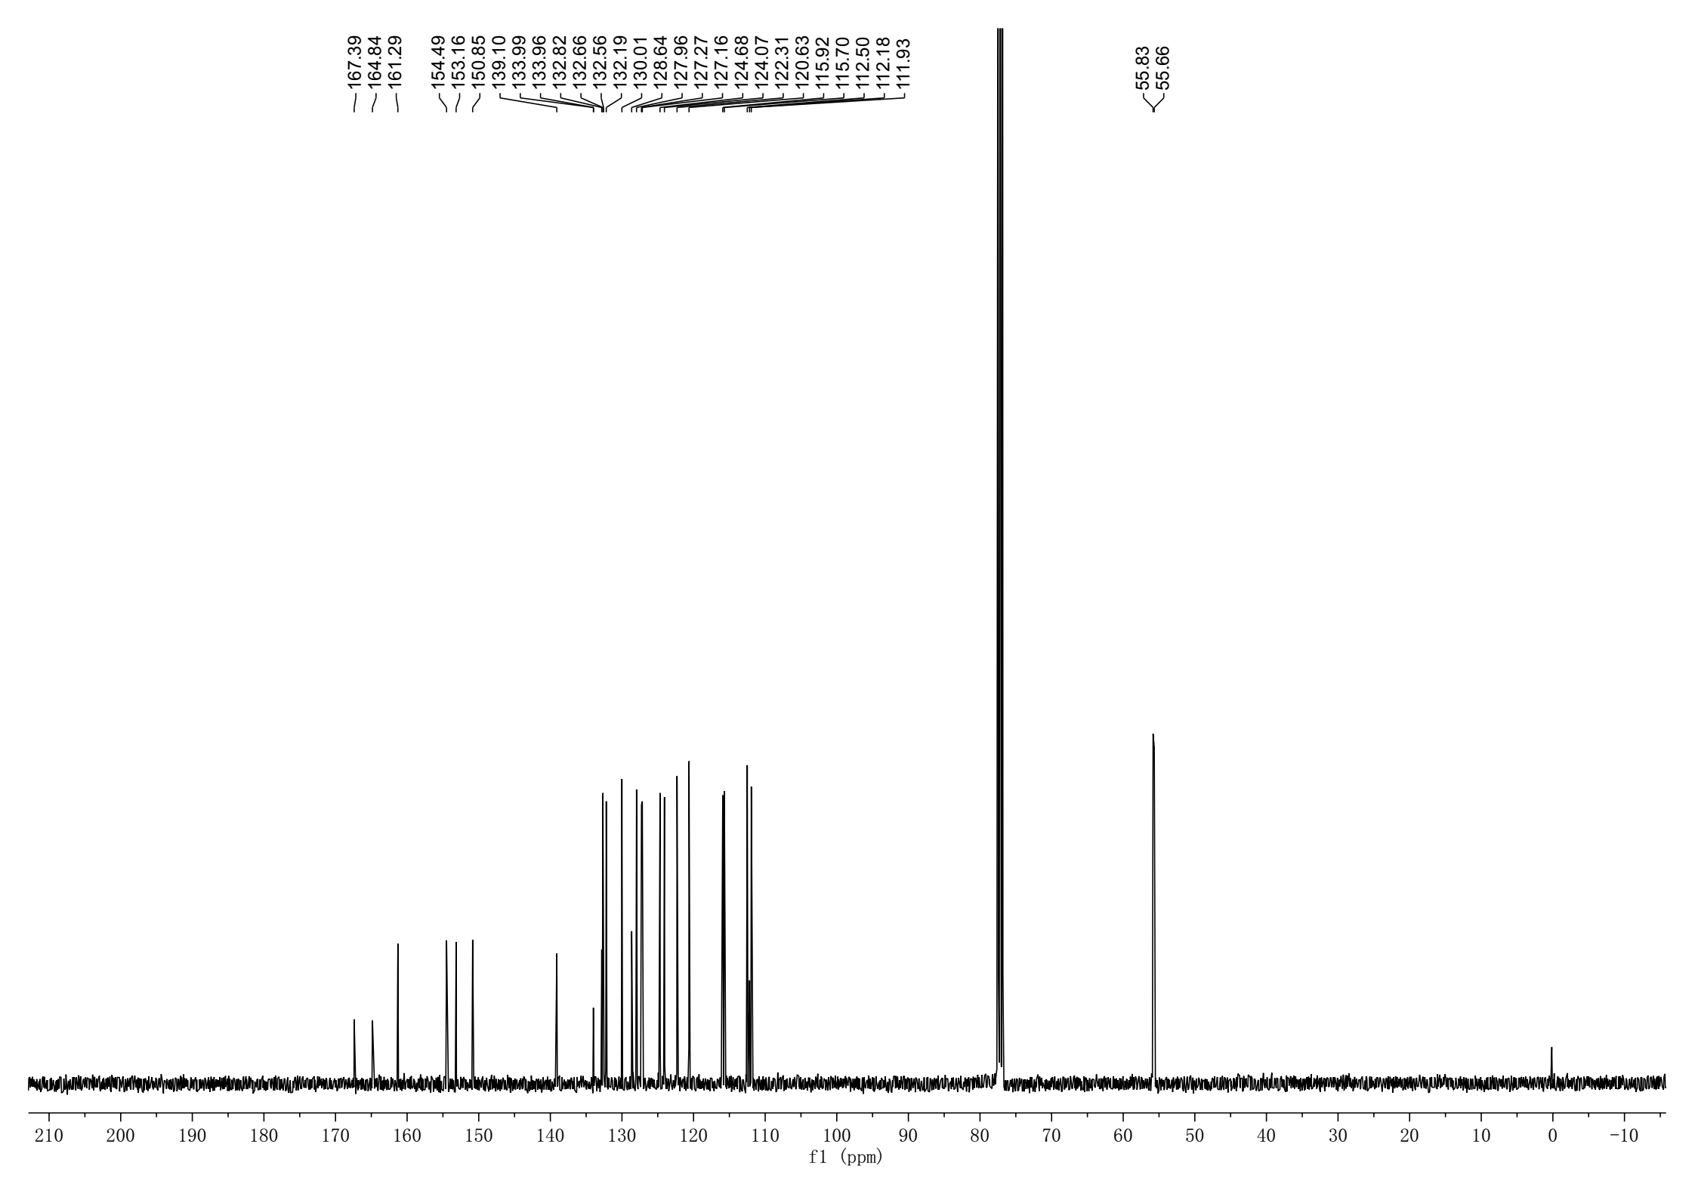
Supplementary Figure 64. ¹³C NMR (CDCl₃, 101MHz) spectra of spectra of 9e
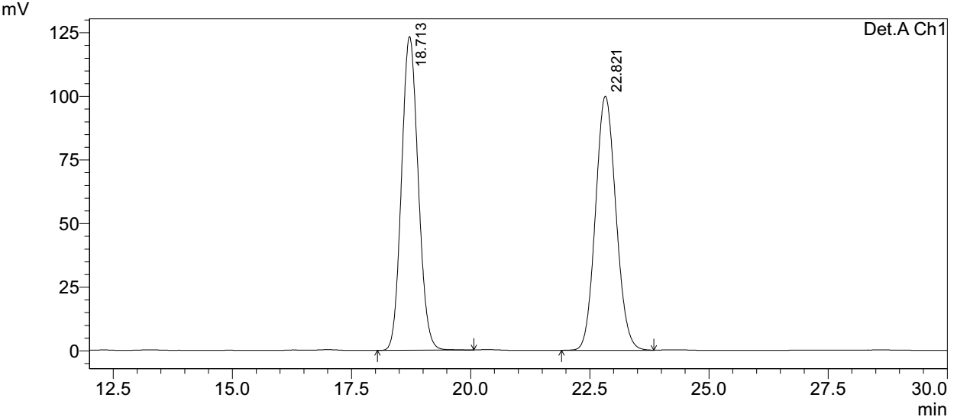
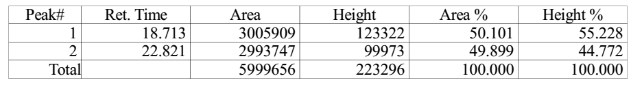

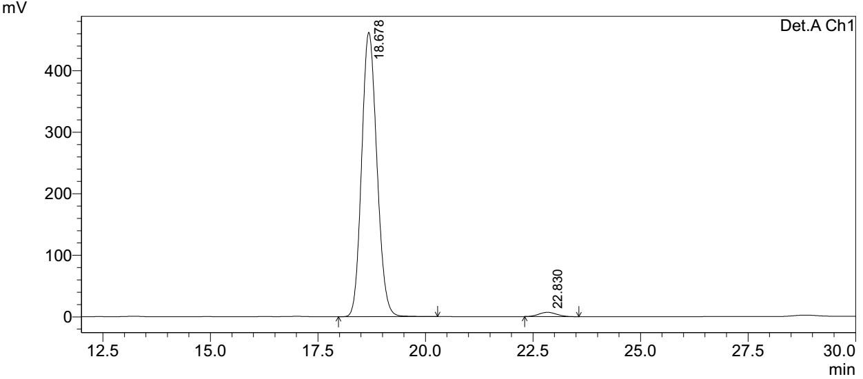
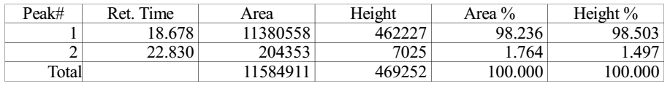
Supplementary Figure 65. HPLC spectra of 9e
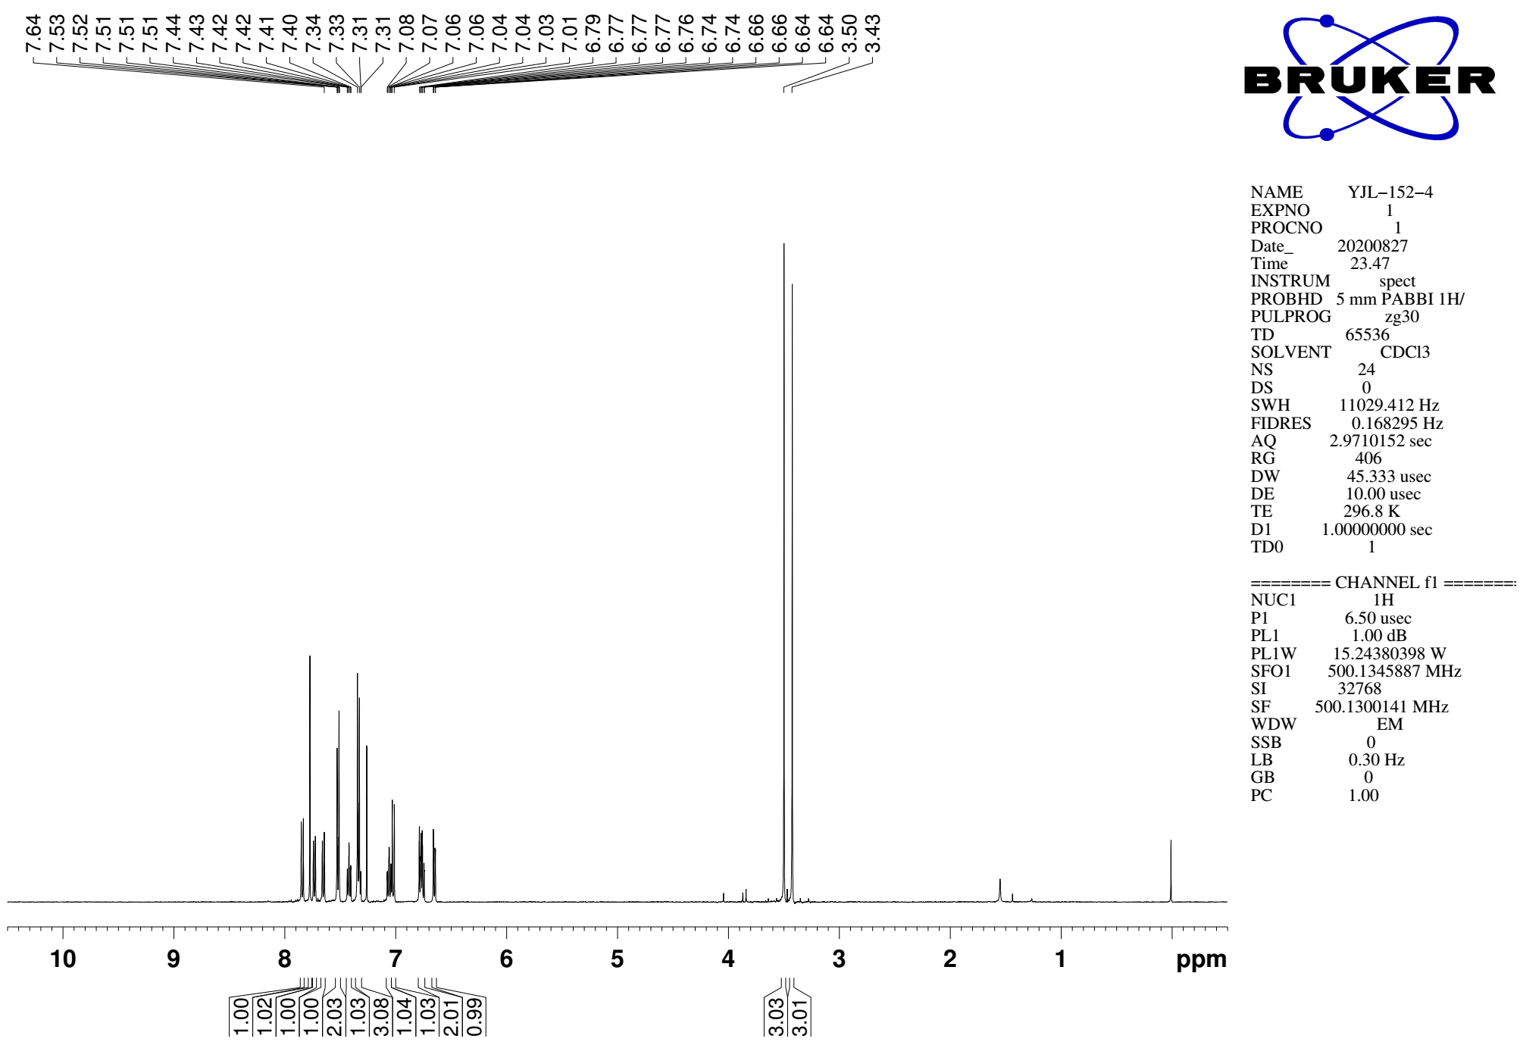
Supplementary Figure 41. ¹H NMR (CDCl₃, 500MHz) spectra of 9f

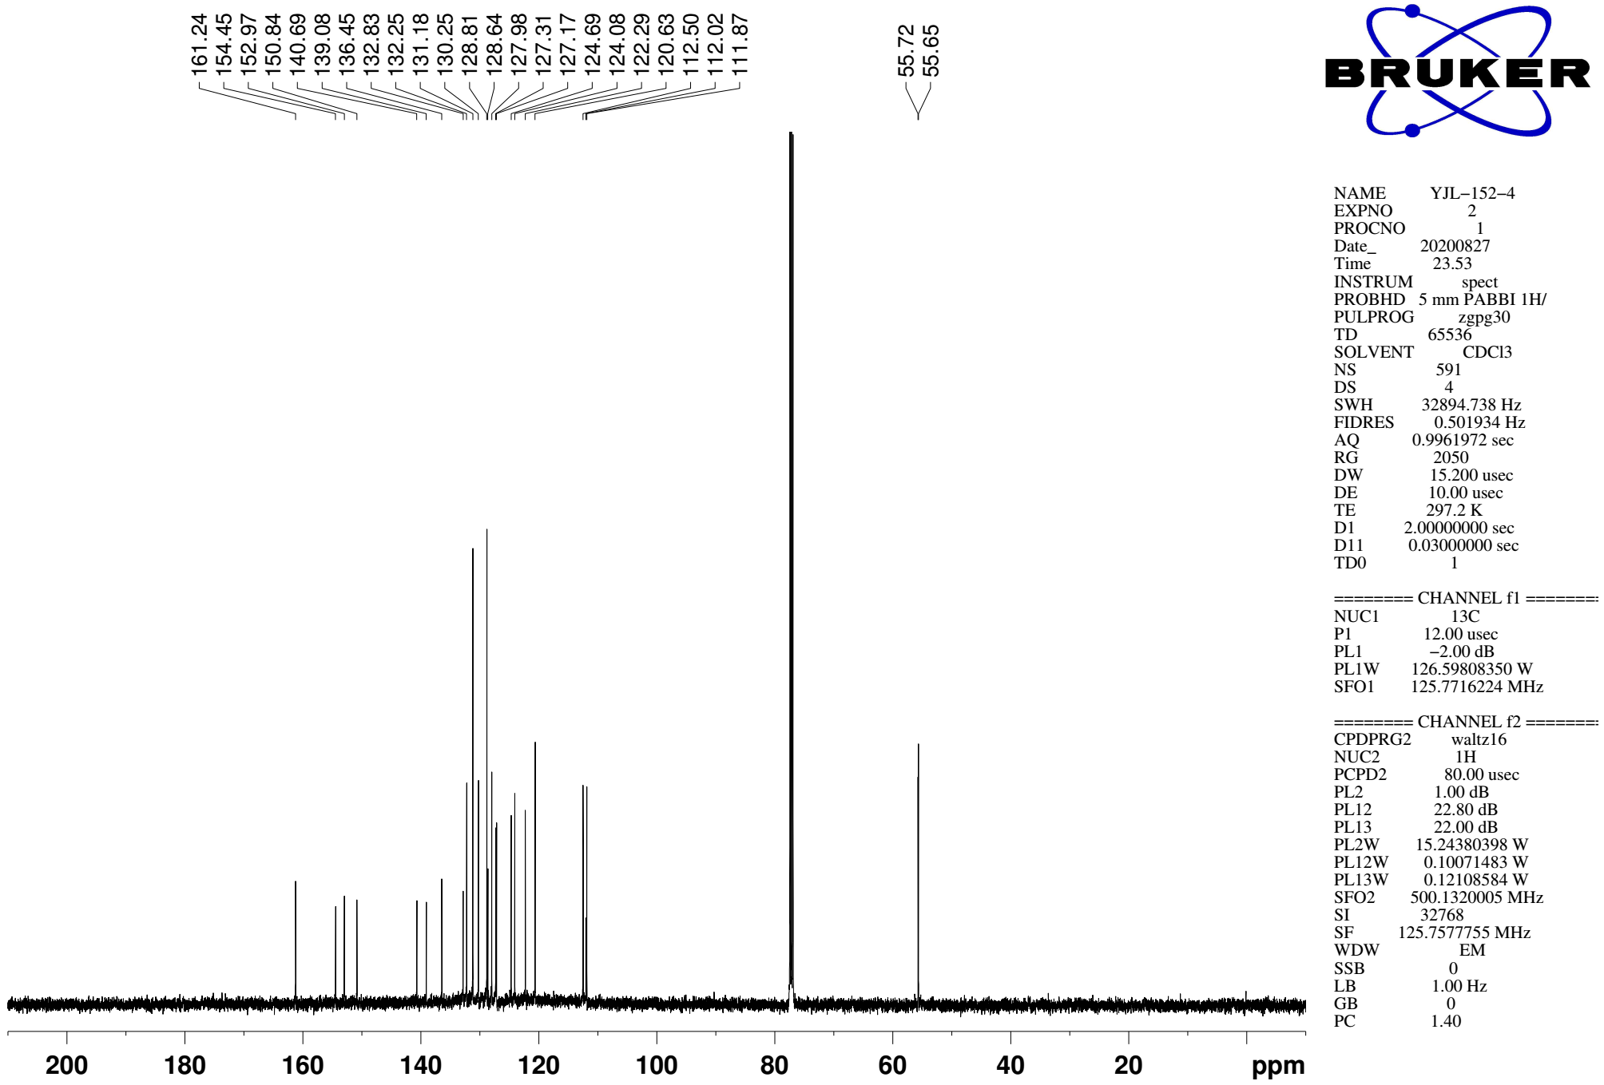
Supplementary Figure 66. ¹³C NMR (CDCl₃, 126MHz) spectra of spectra of 9f

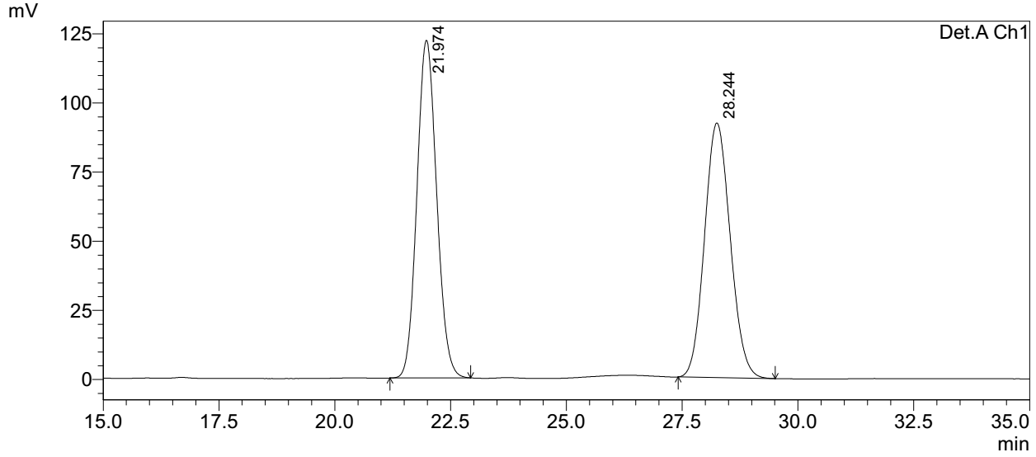
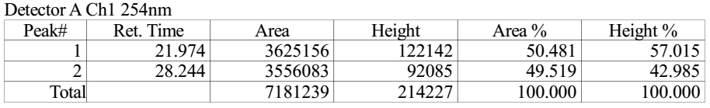

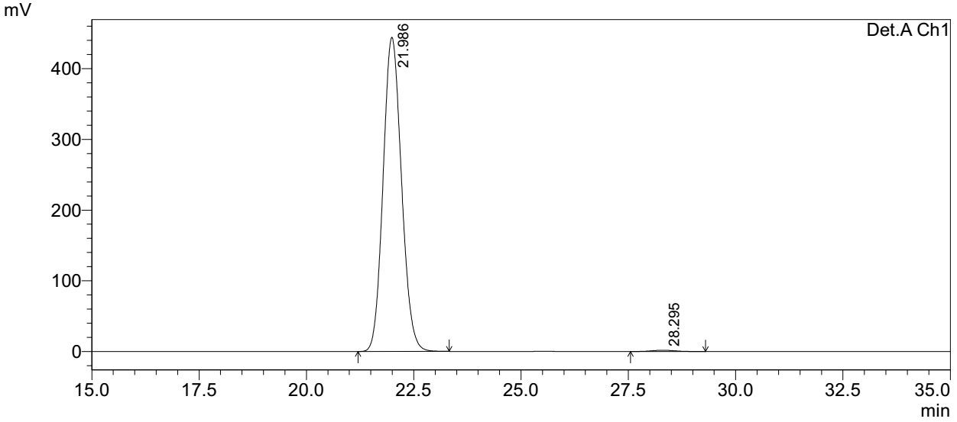
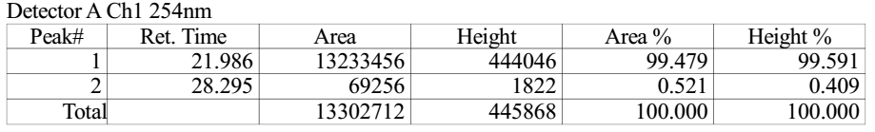
Supplementary Figure 67. HPLC spectra of 9f
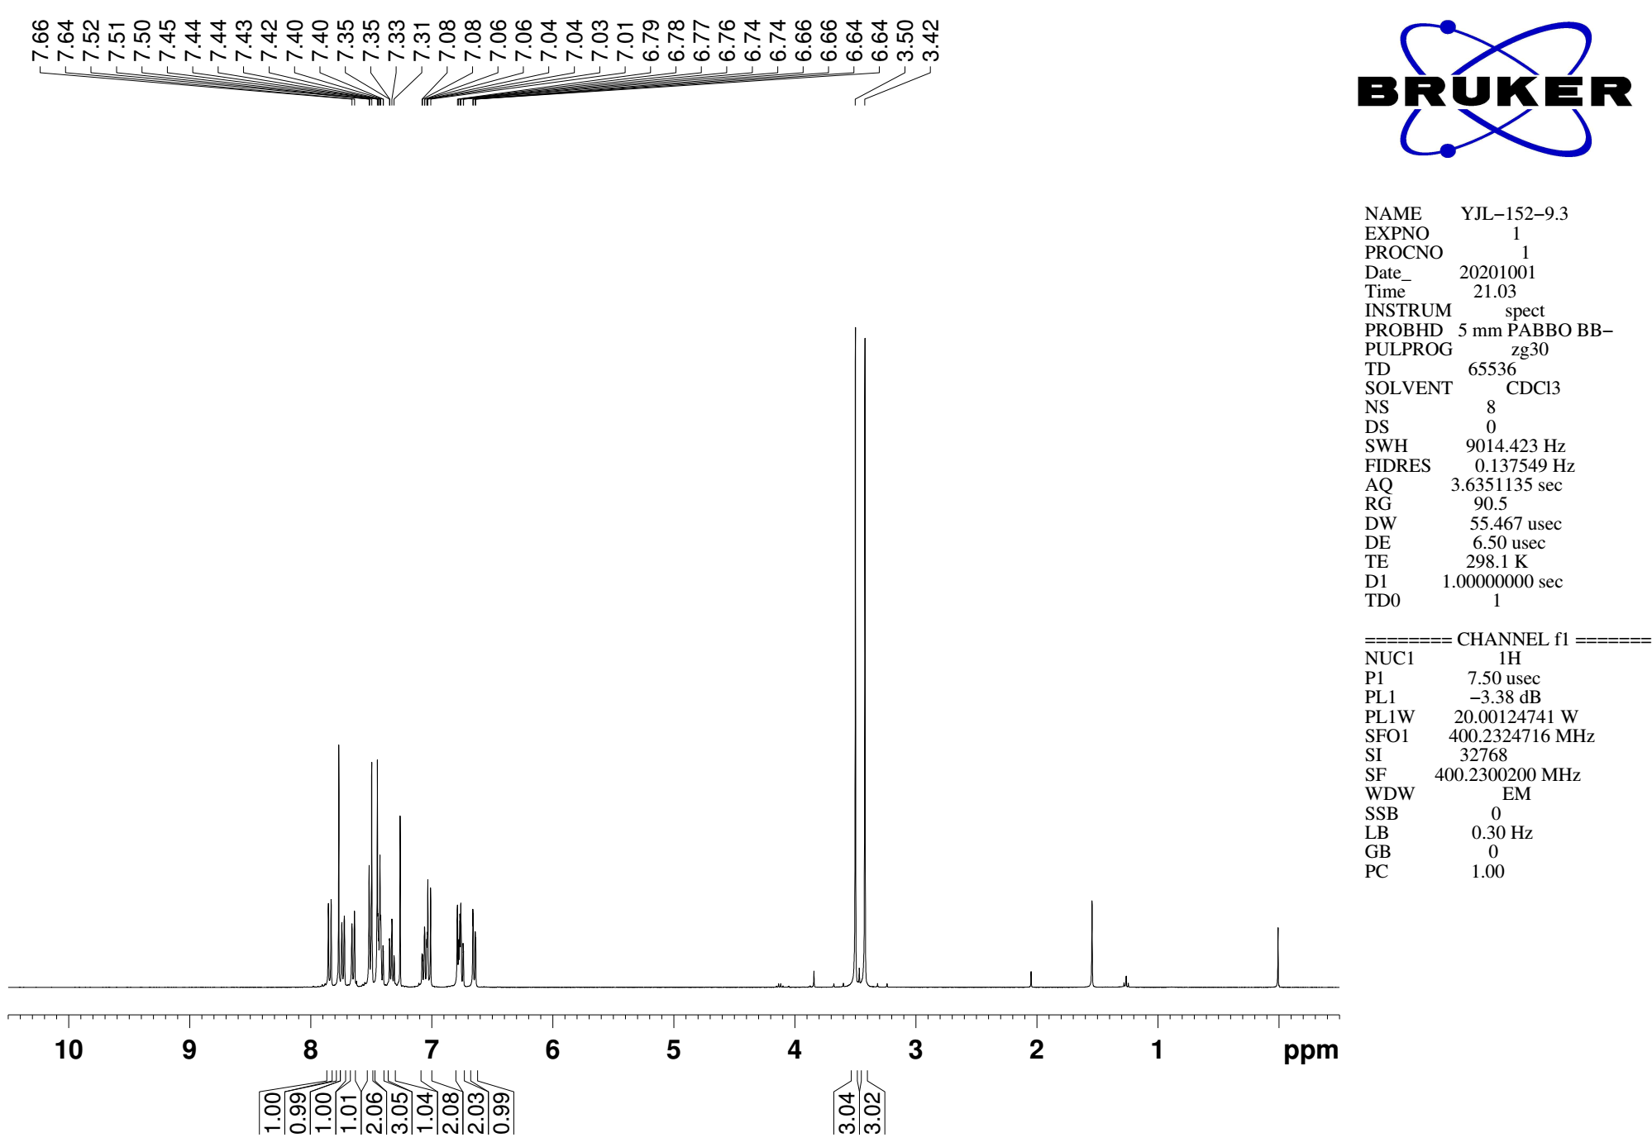
Supplementary Figure 68. ¹H NMR (CDCl₃, 400MHz) spectra of 9g

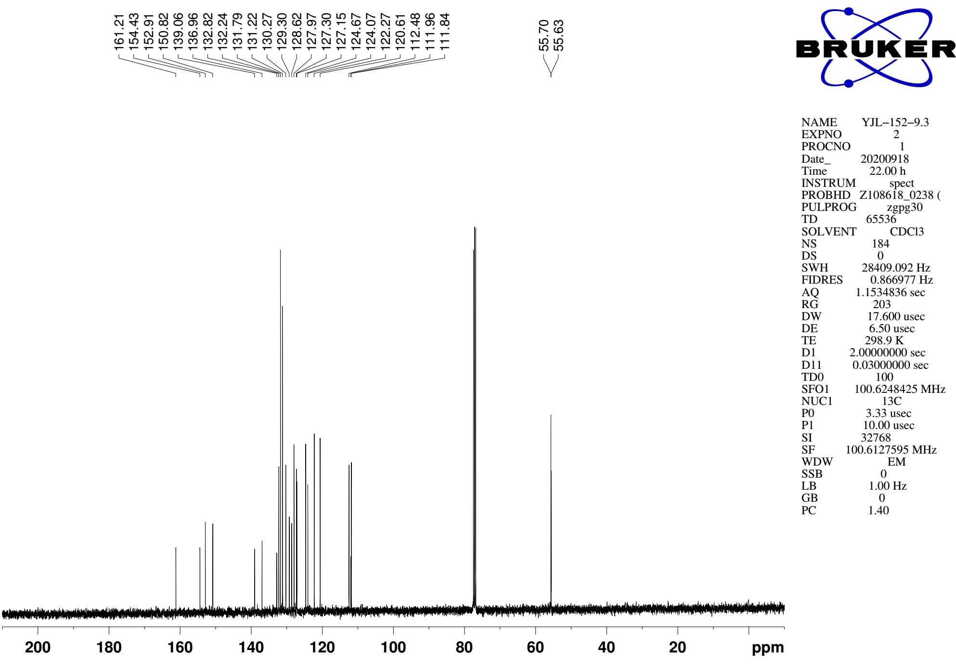
Supplementary Figure 69. ¹³C NMR (CDCl₃, 101MHz) spectra of spectra of 9g
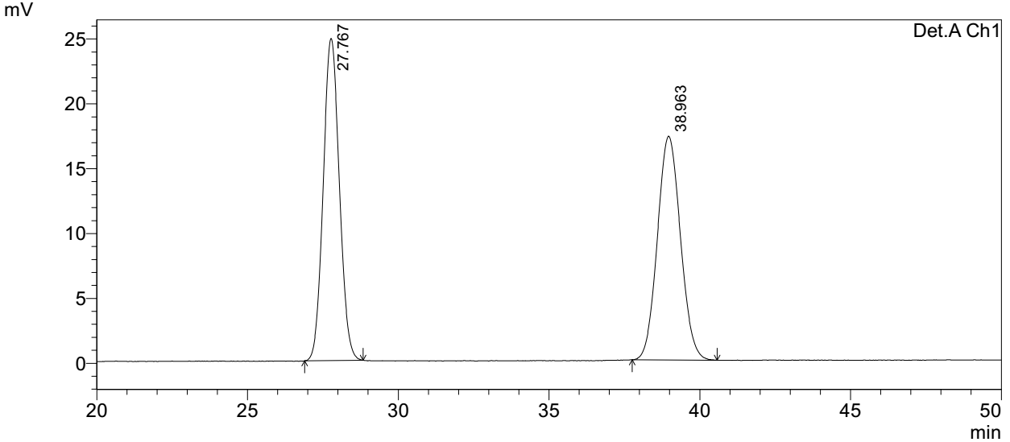
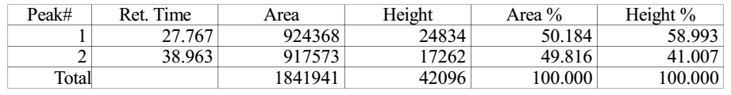

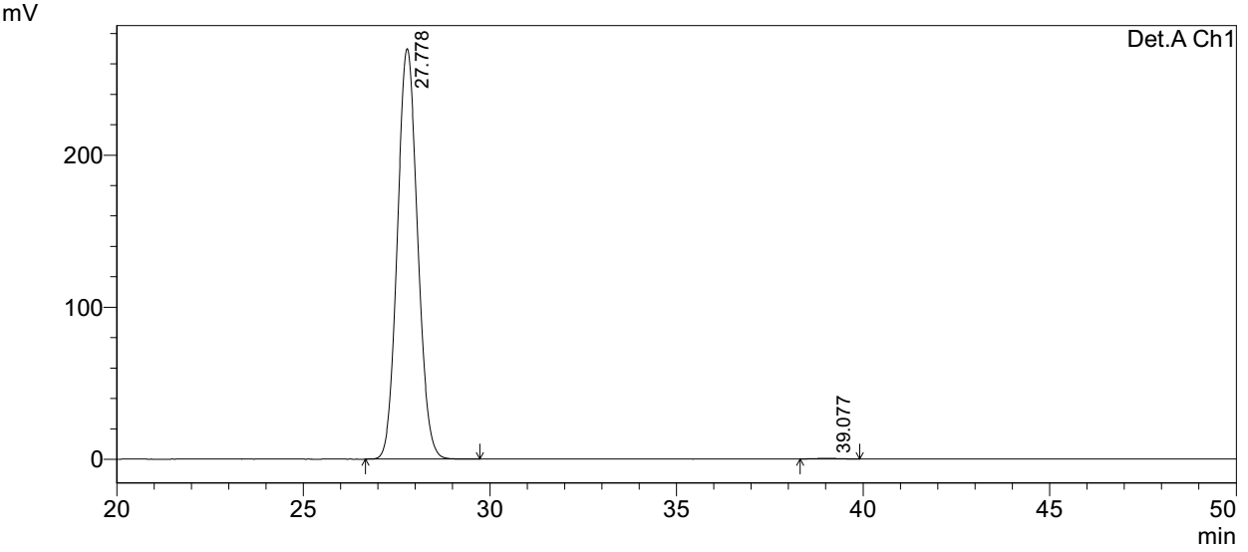
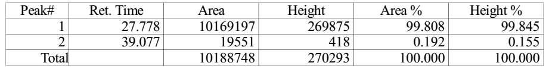
Supplementary Figure 70. HPLC spectra of 9g
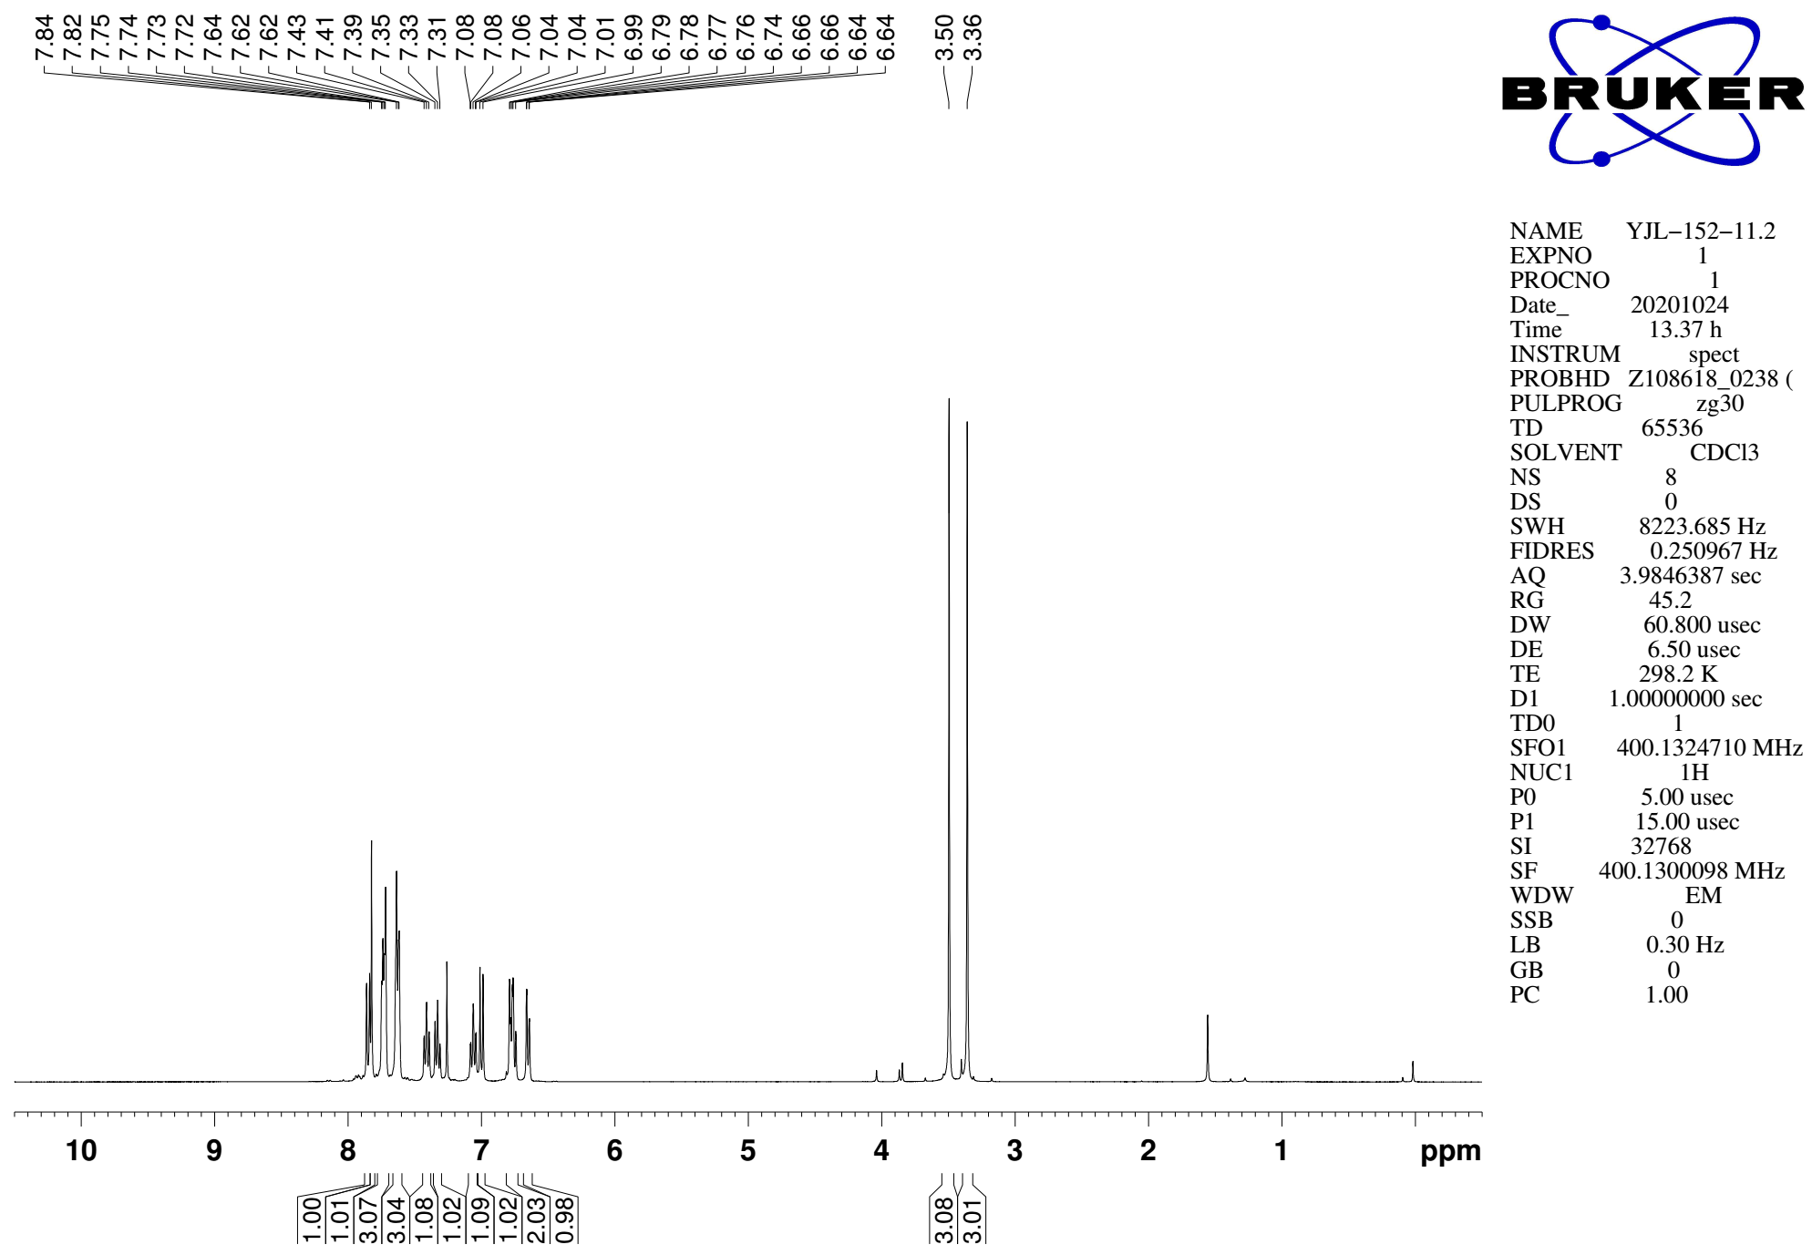
Supplementary Figure 71. ¹H NMR (CDCl₃, 400MHz) spectra of 9h

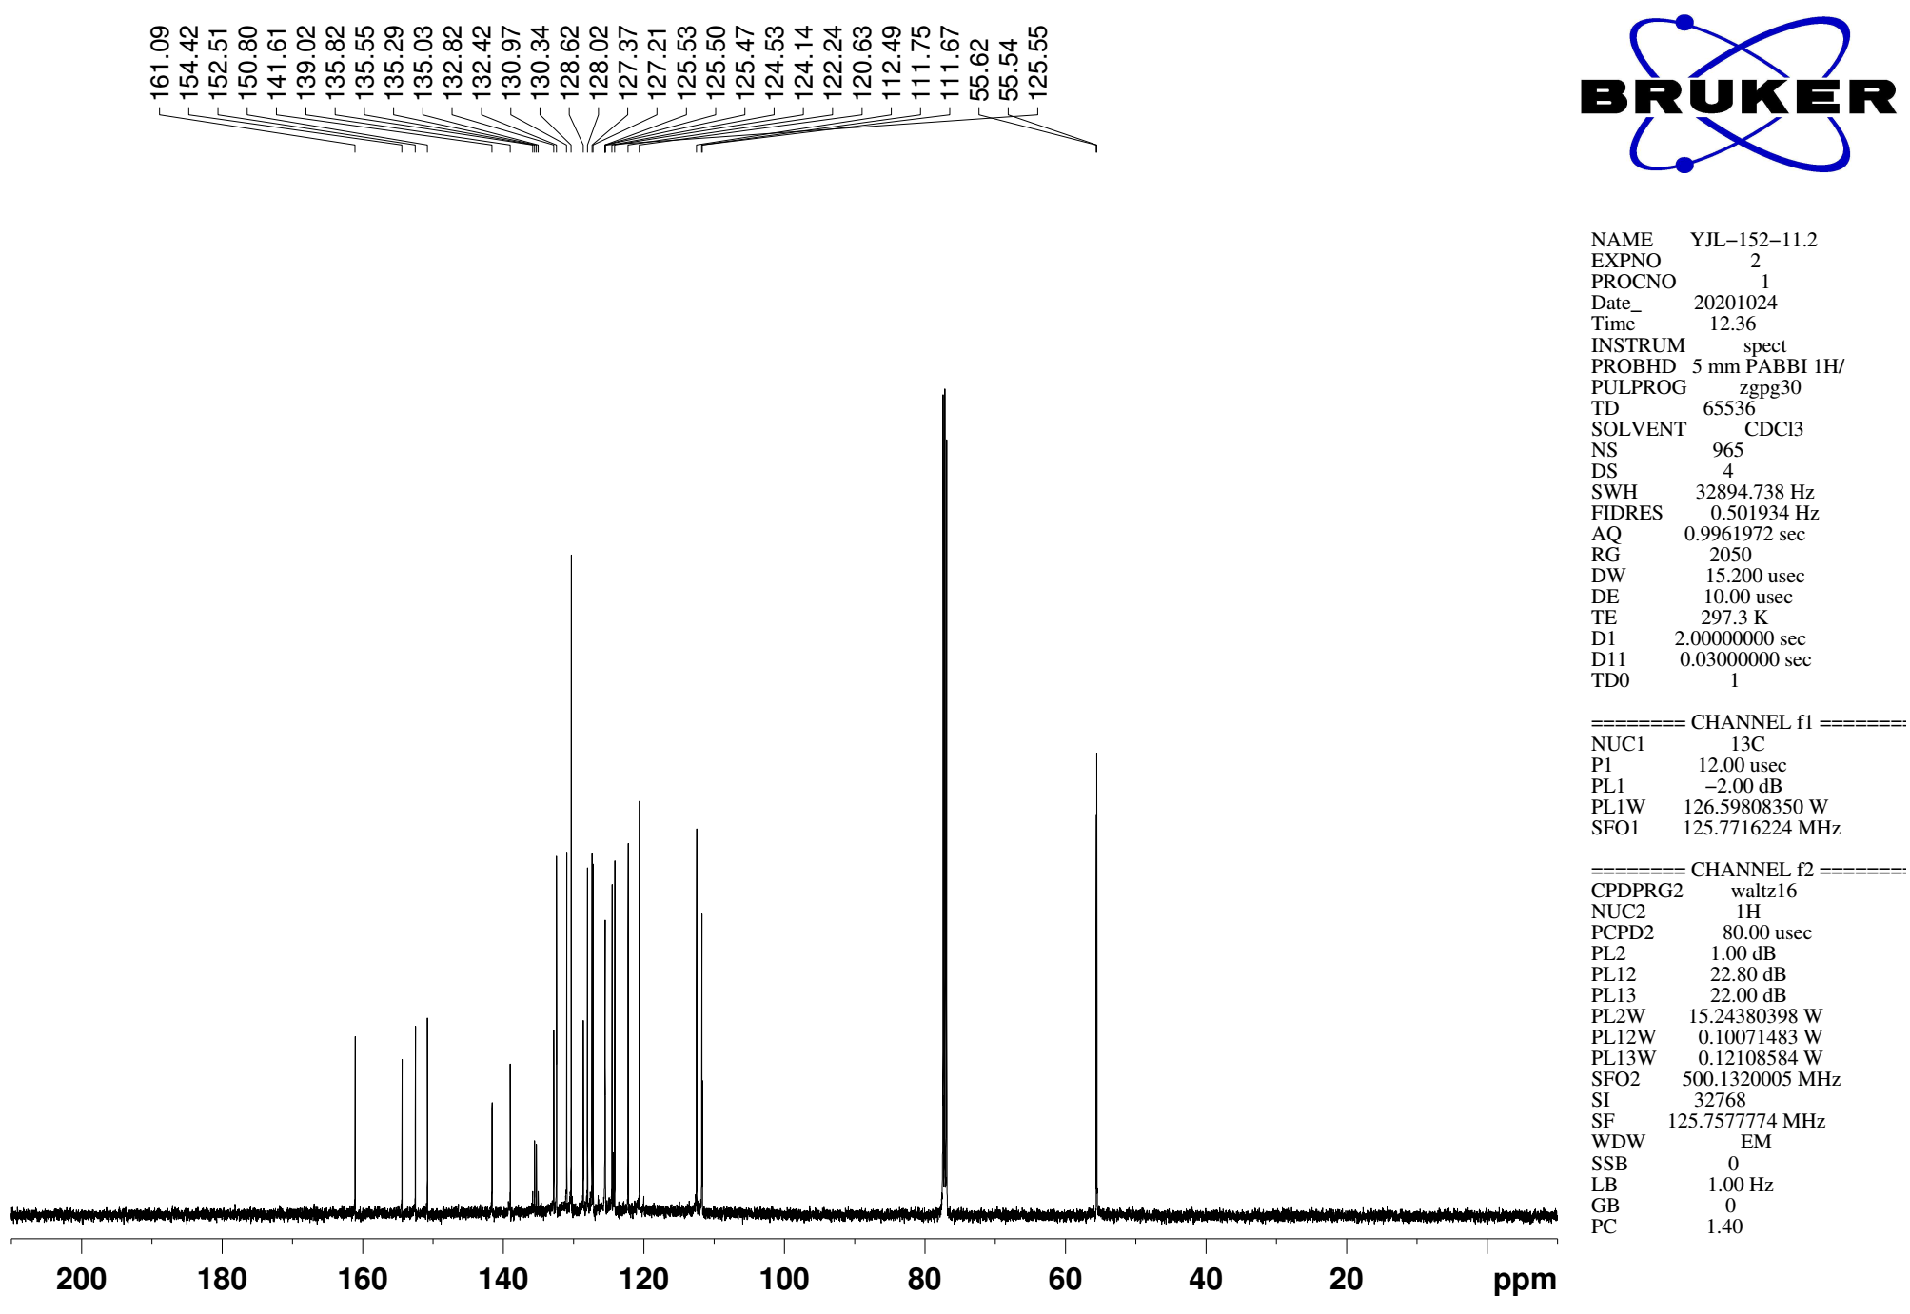
Supplementary Figure 72. ¹³C NMR (CDCl₃, 126MHz) spectra of spectra of 9h
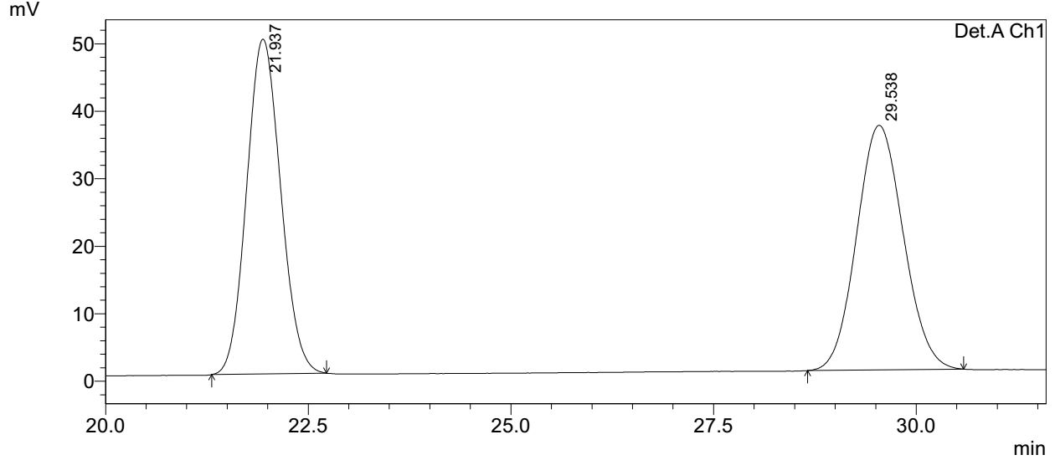
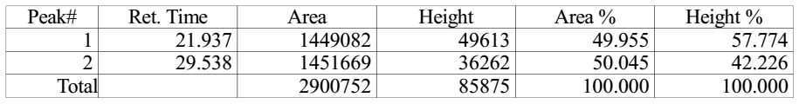

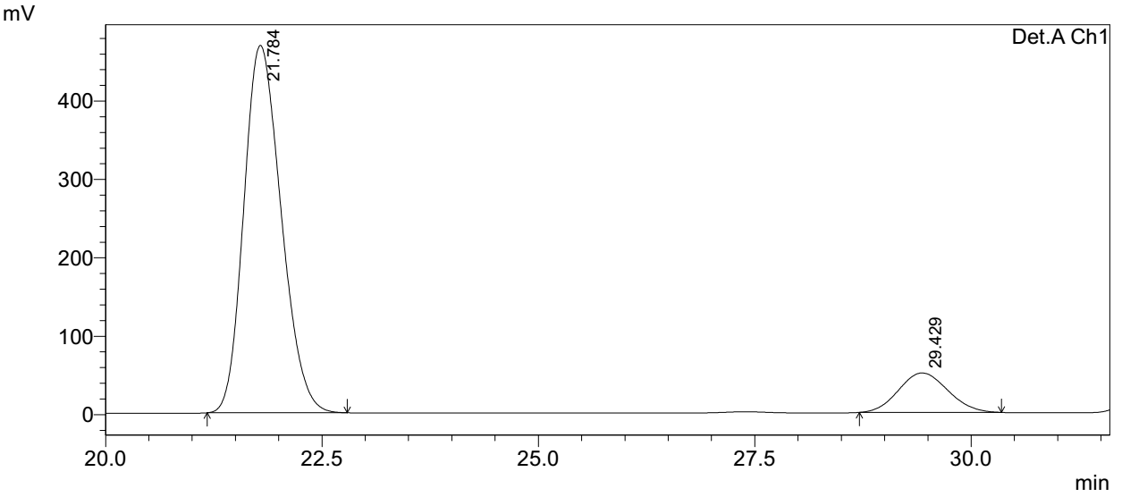
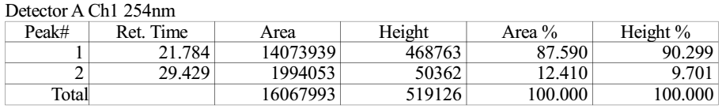
Supplementary Figure 73. HPLC spectra of 9h
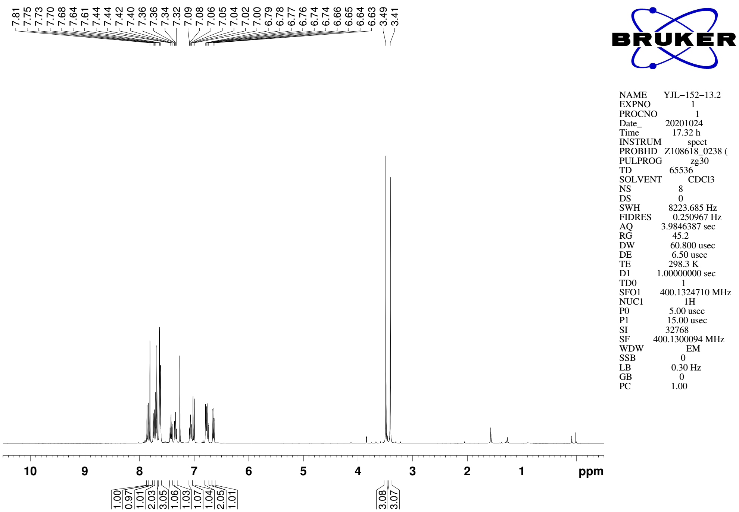
Supplementary Figure 74. ¹H NMR (CDCl₃, 400MHz) spectra of 9i

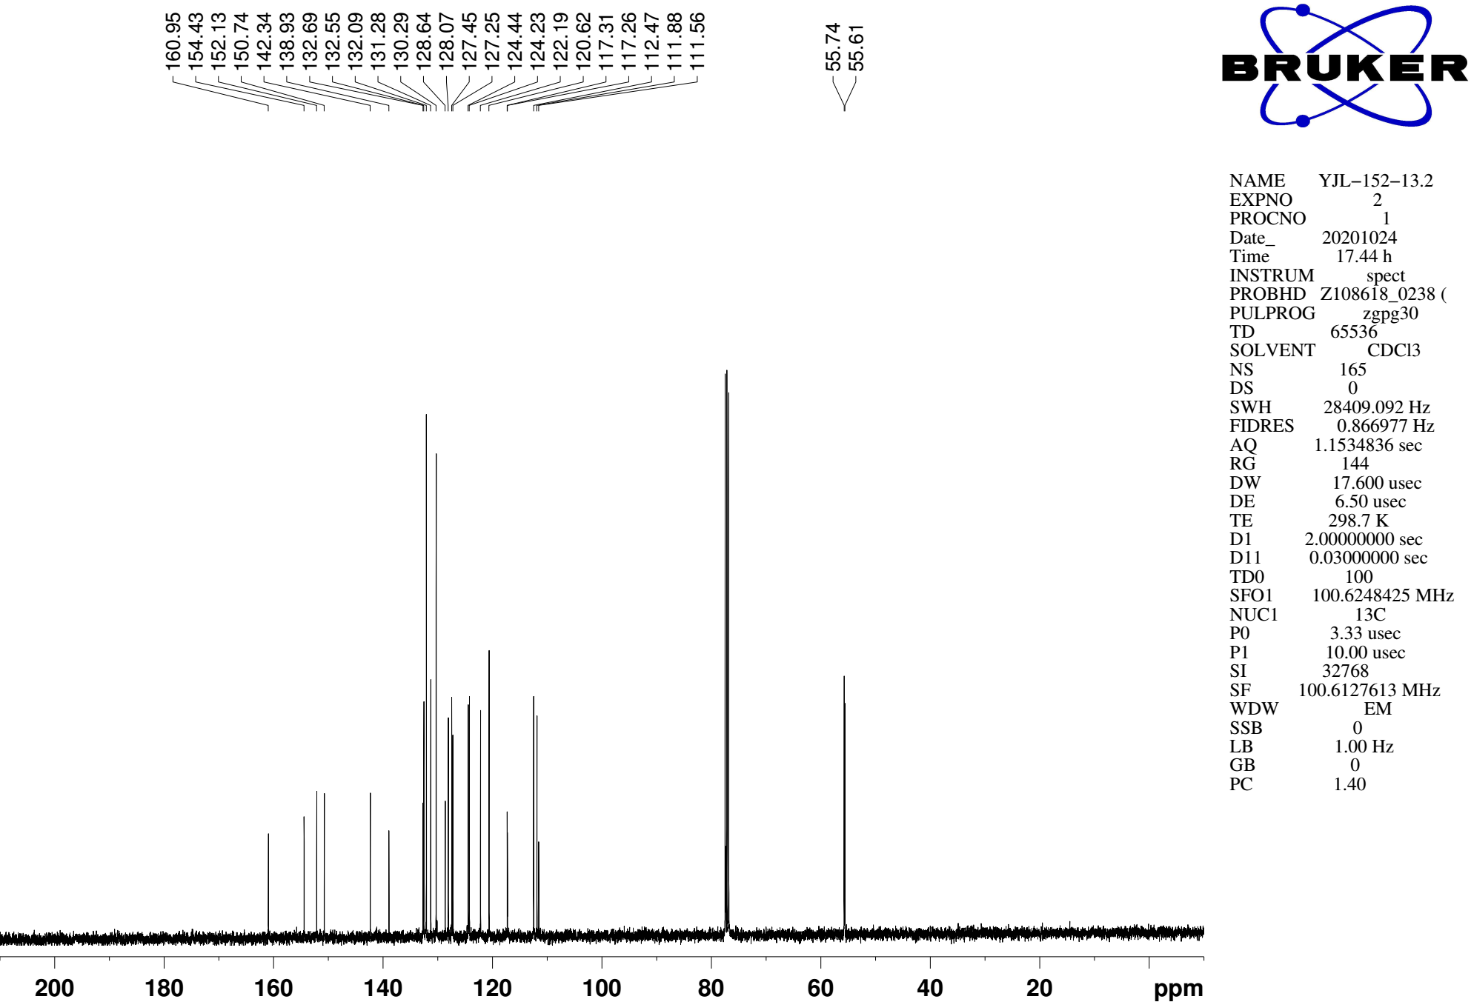
Supplementary Figure 75. ¹³C NMR (CDCl₃, 101MHz) spectra of spectra of 9i
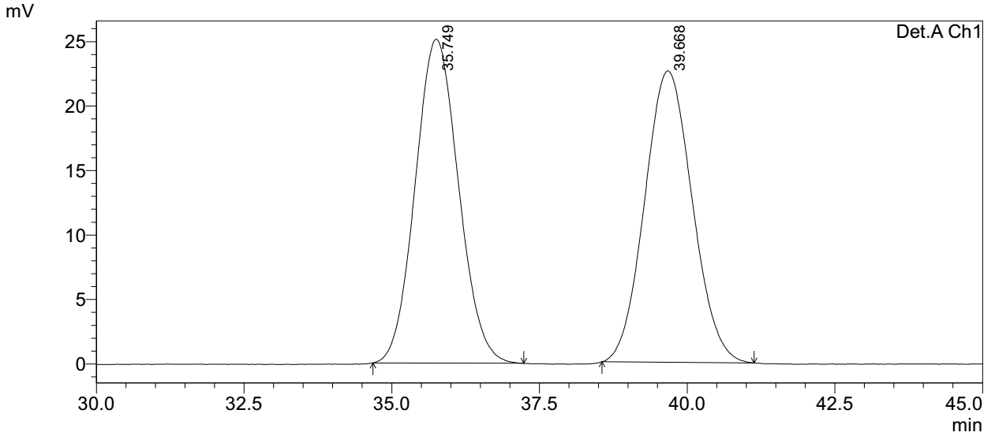
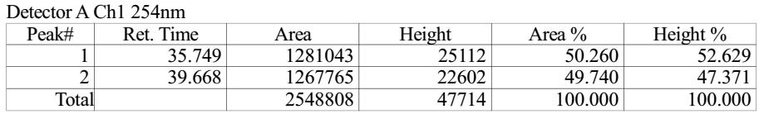

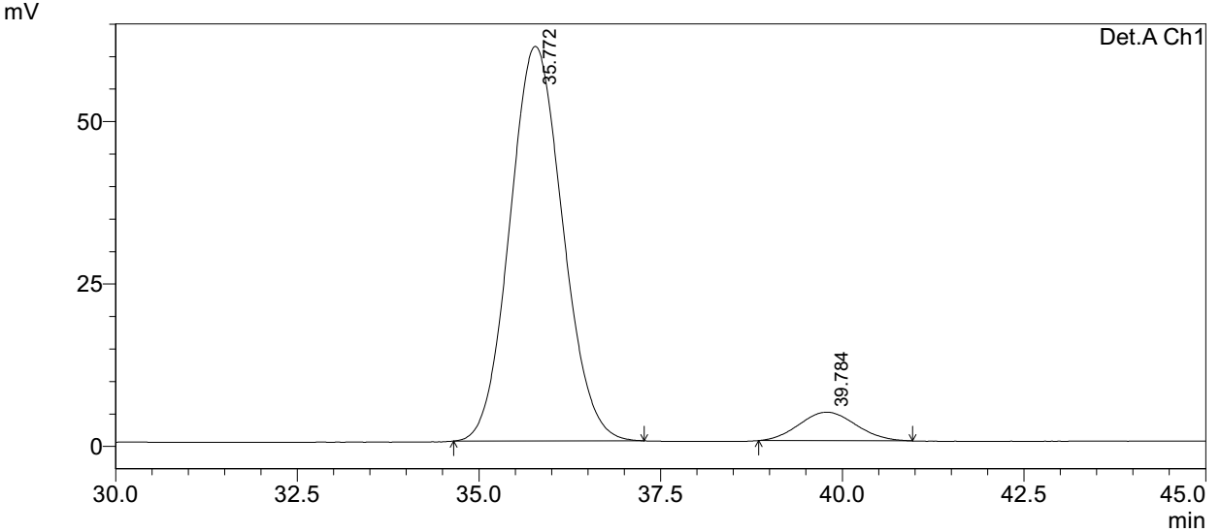
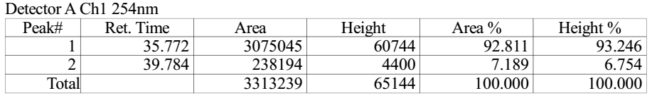
Supplementary Figure 76. HPLC spectra of 9i
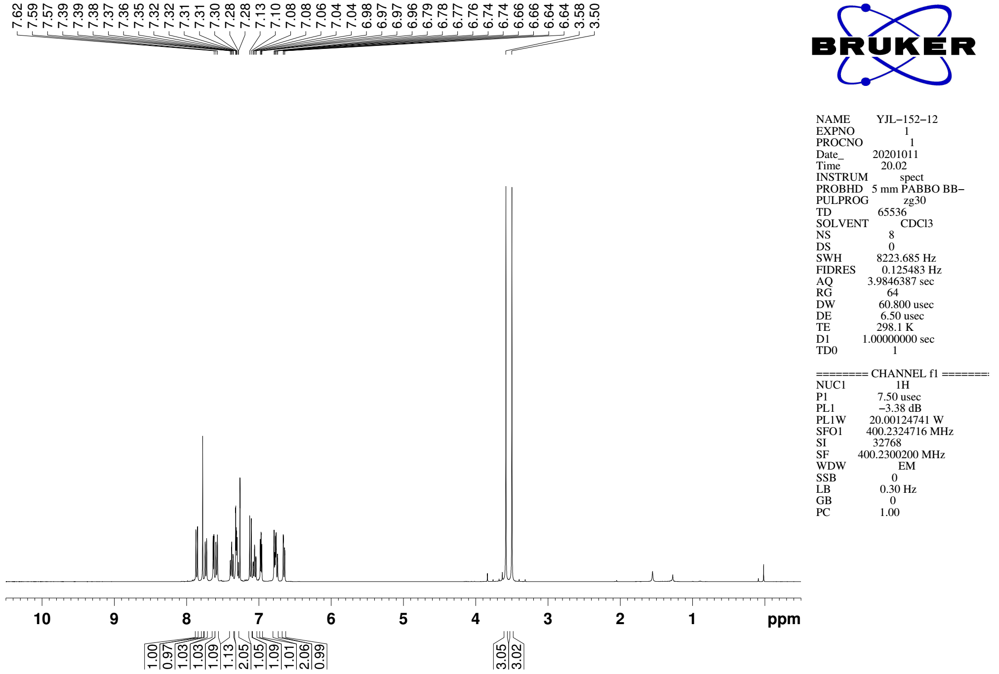
Supplementary Figure 77. ¹H NMR (CDCl₃, 400MHz) spectra of 9j

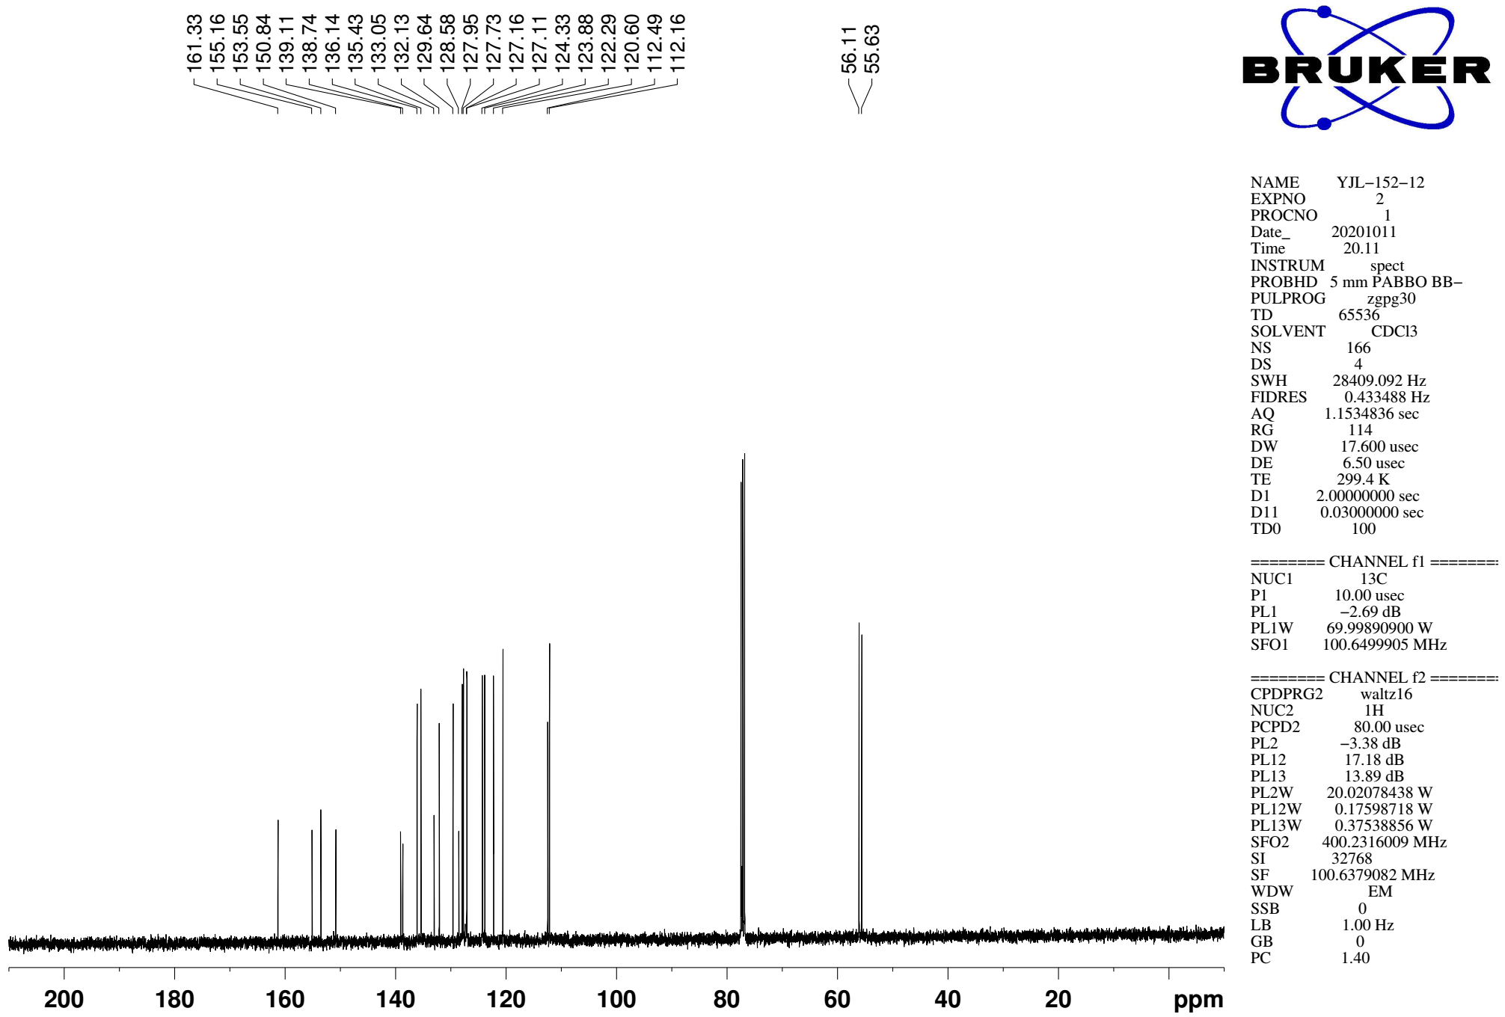
Supplementary Figure 78. ¹³C NMR (CDCl₃, 101MHz) spectra of spectra of 9j

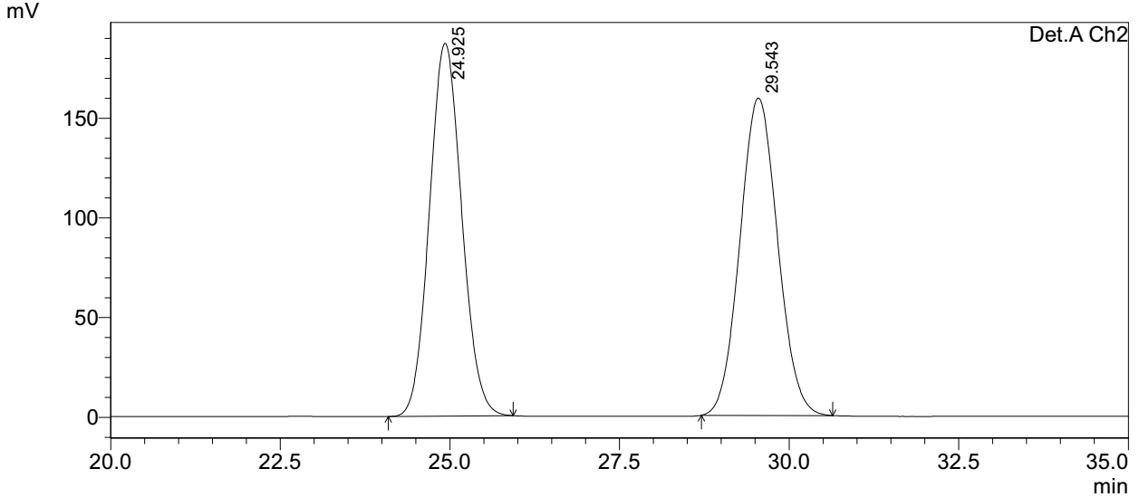
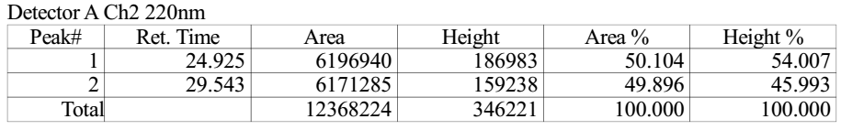

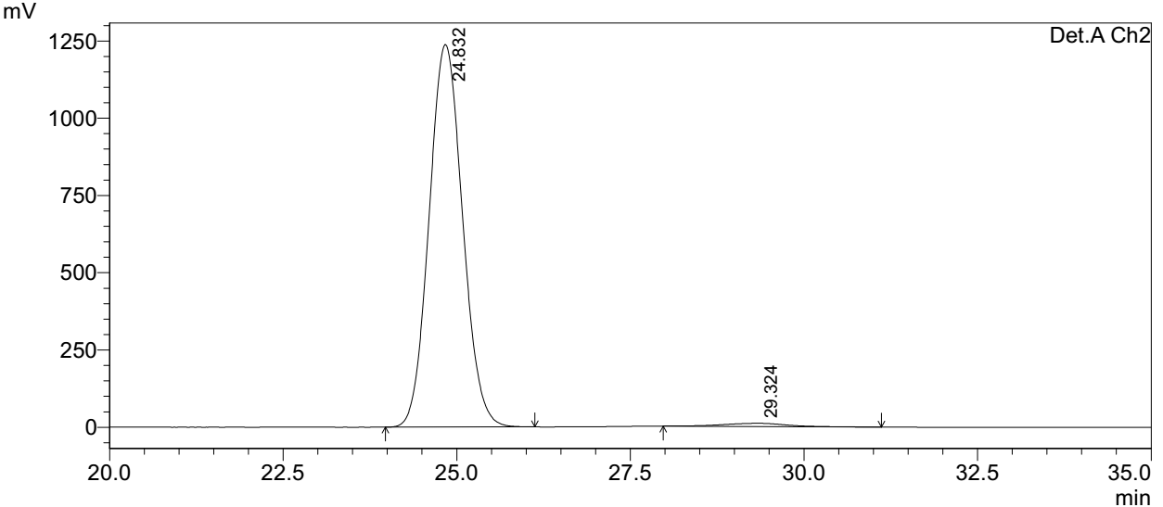
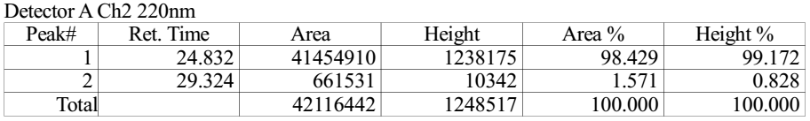
Supplementary Figure 79. HPLC spectra of 9j
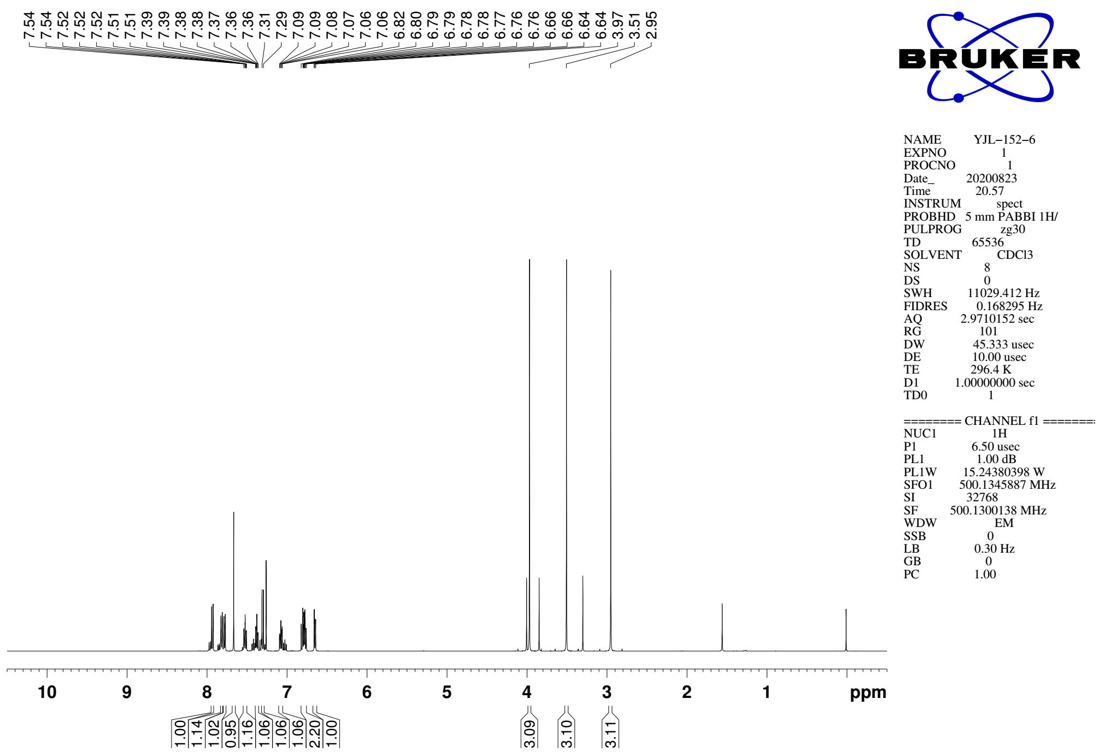
Supplementary Figure 80. ¹H NMR (CDCl₃, 500MHz) spectra of 9k

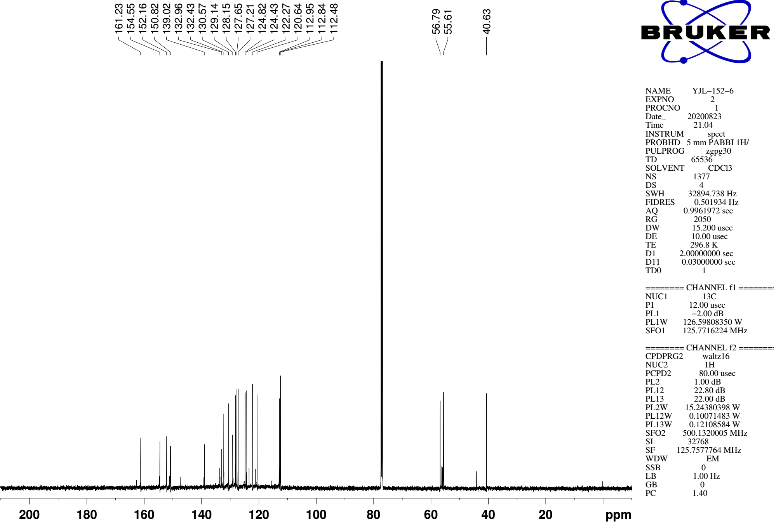
Supplementary Figure 81. ¹³C NMR (CDCl₃, 126MHz) spectra of spectra of 9k

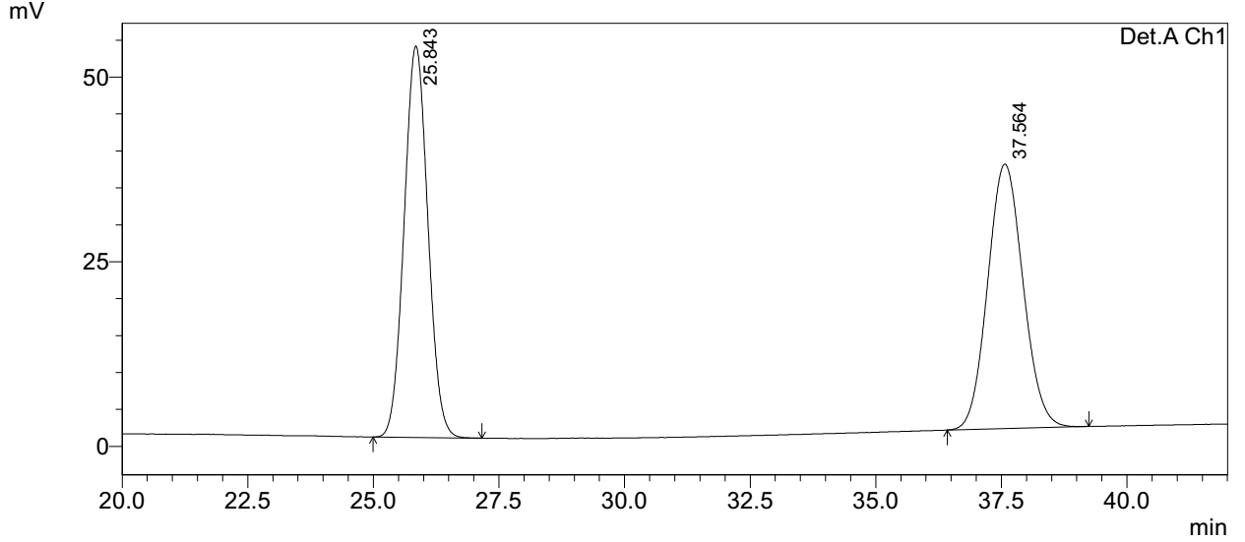
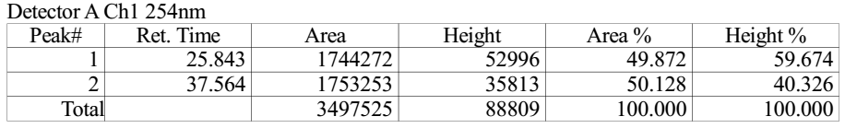

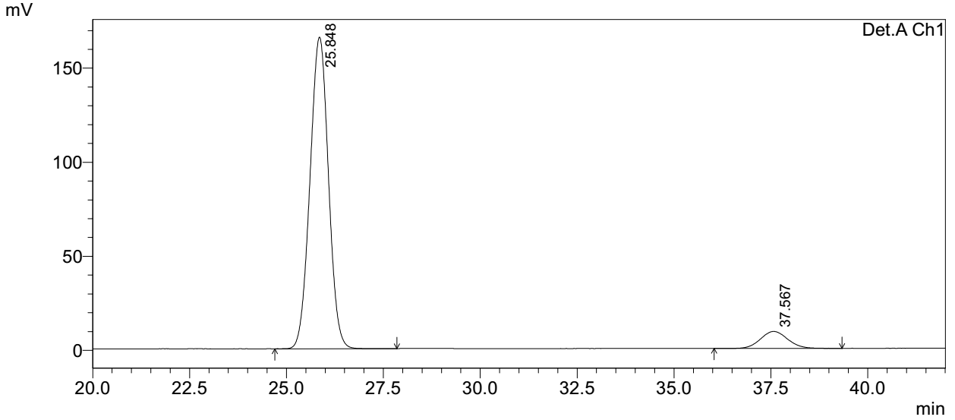
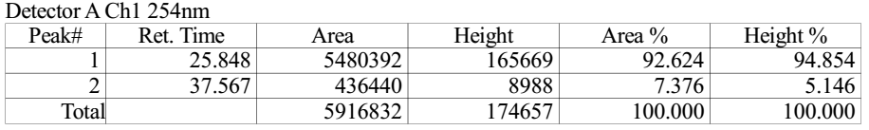
Supplementary Figure 82. HPLC spectra of 9k

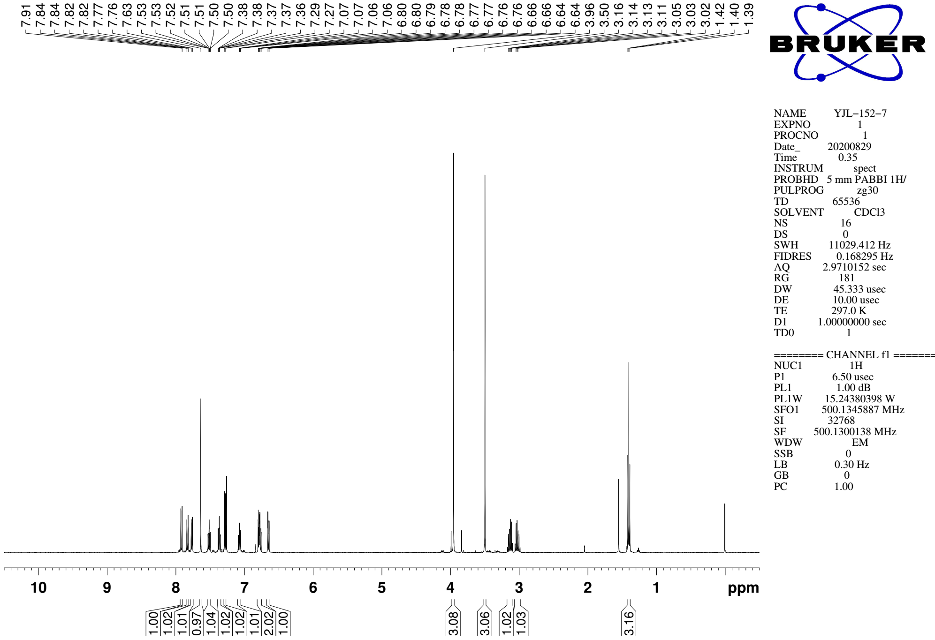
Supplementary Figure 83. ¹H NMR (CDCl₃, 500MHz) spectra of 9l

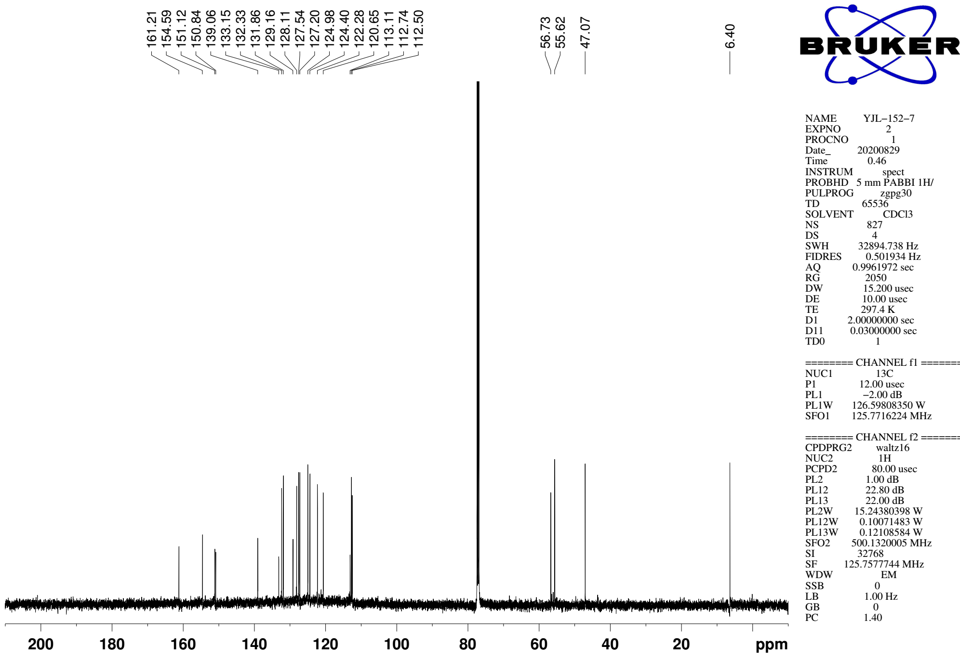
Supplementary Figure 84. ¹³C NMR (CDCl₃, 126MHz) spectra of spectra of 9l

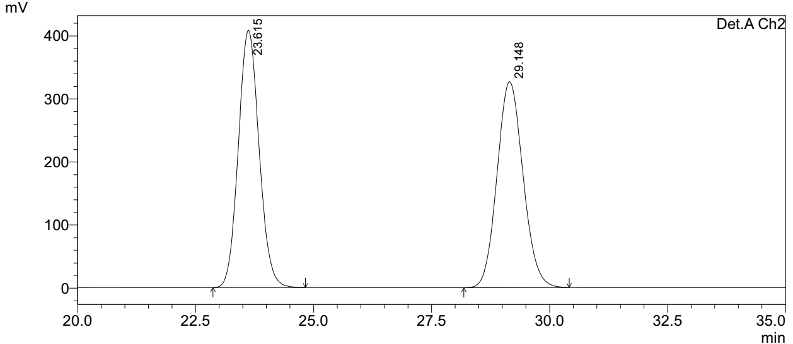
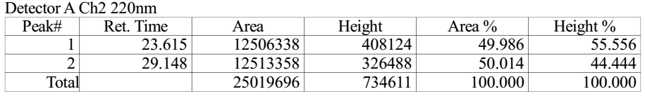

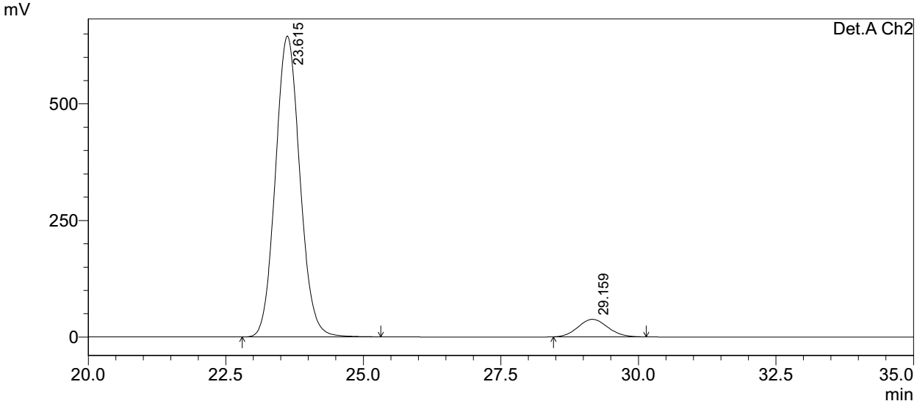
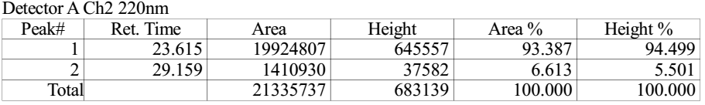
Supplementary Figure 85. HPLC spectra of 9l

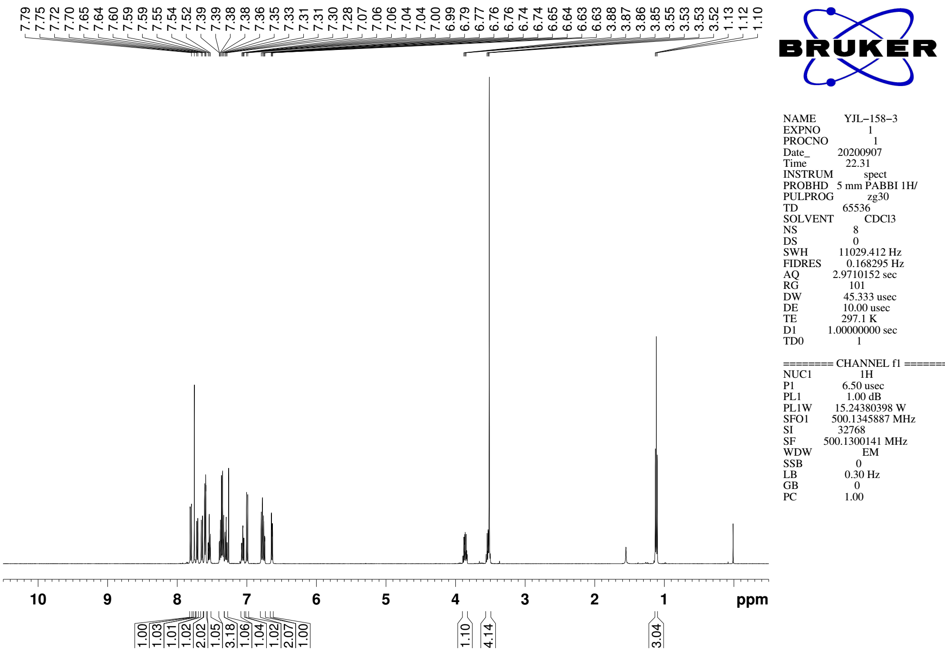
Supplementary Figure 86. ¹H NMR (CDCl₃, 500MHz) spectra of 9m

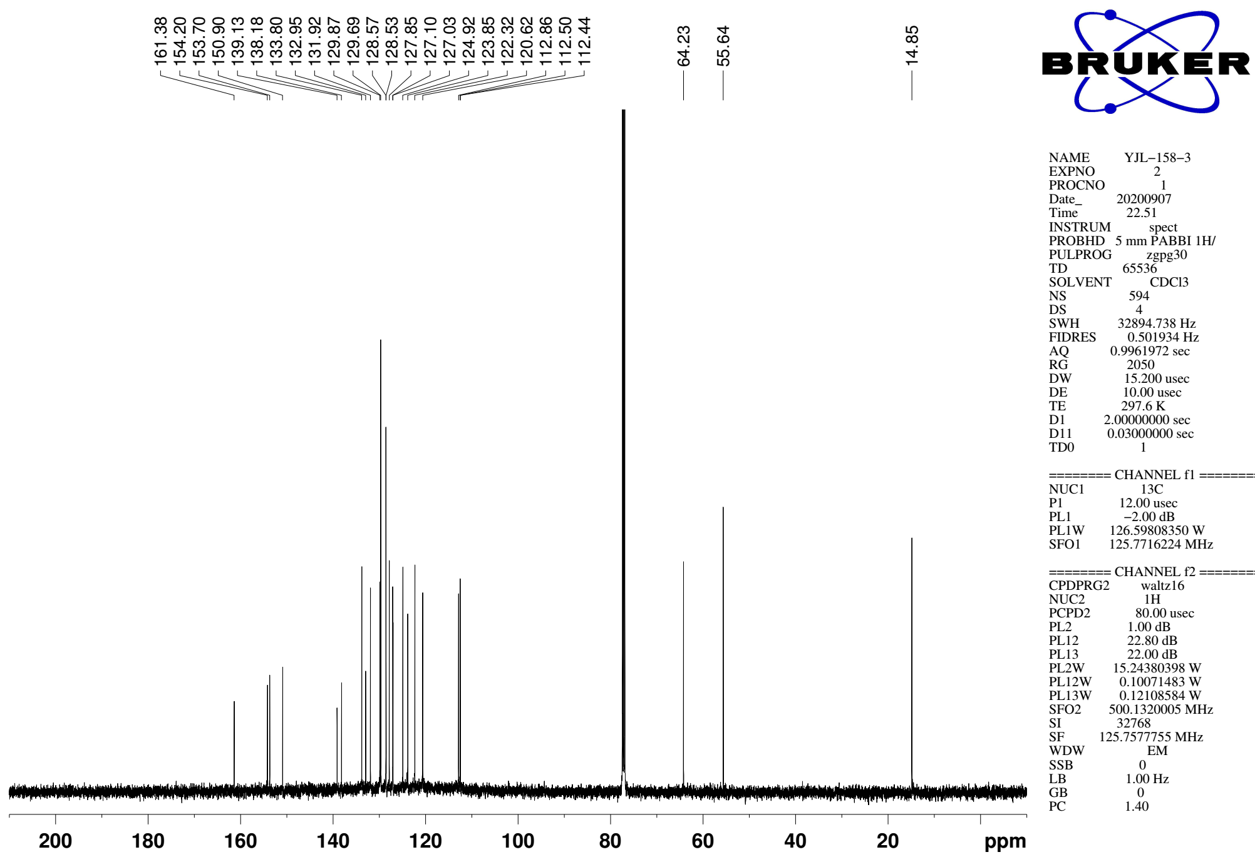
Supplementary Figure 87. ¹³C NMR (CDCl₃, 126MHz) spectra of spectra of 9m

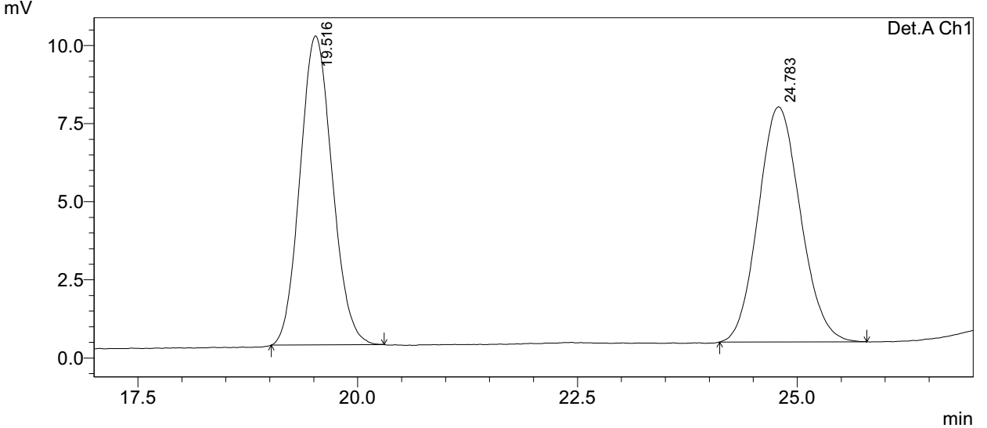
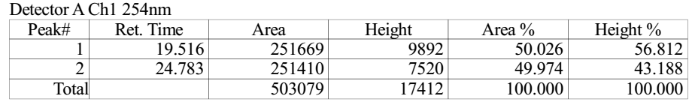

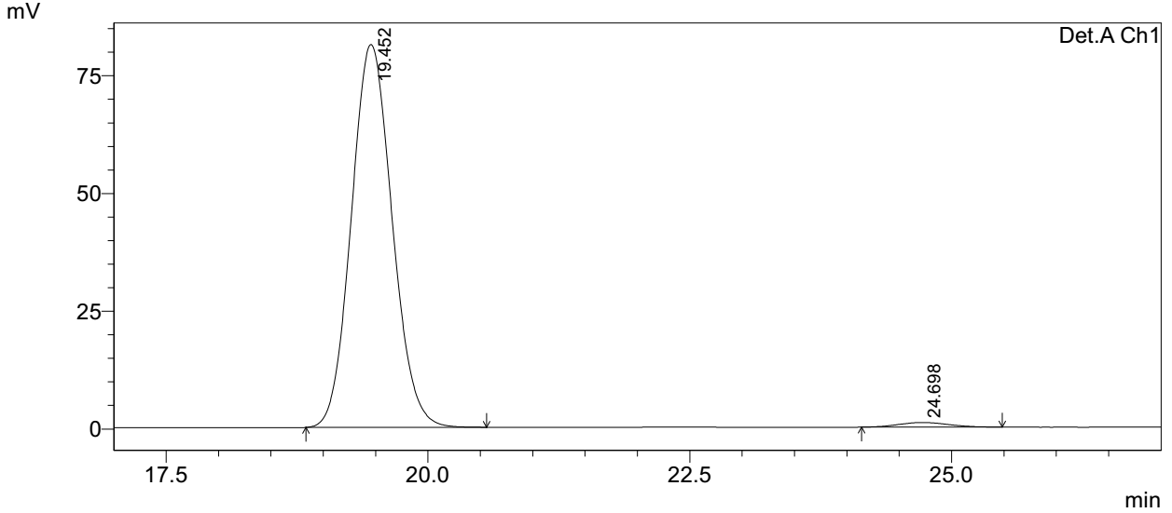
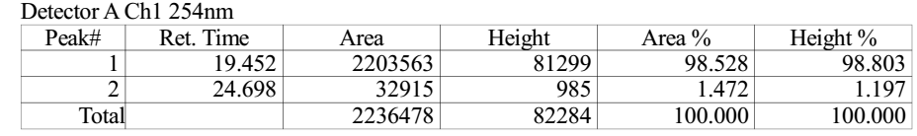
Supplementary Figure 88. HPLC spectra of 9m
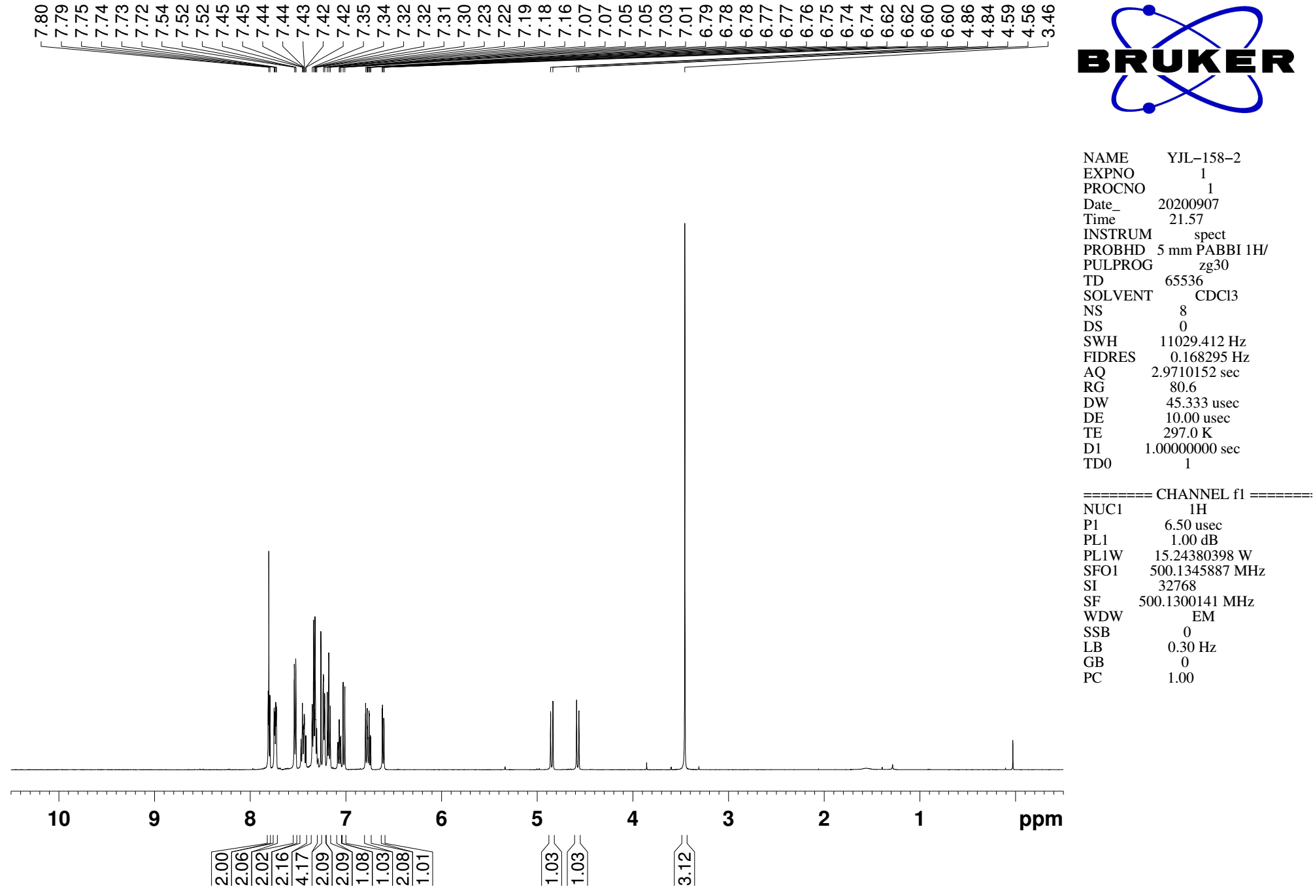
Supplementary Figure 89. ¹H NMR (CDCl₃, 500MHz) spectra of 9n

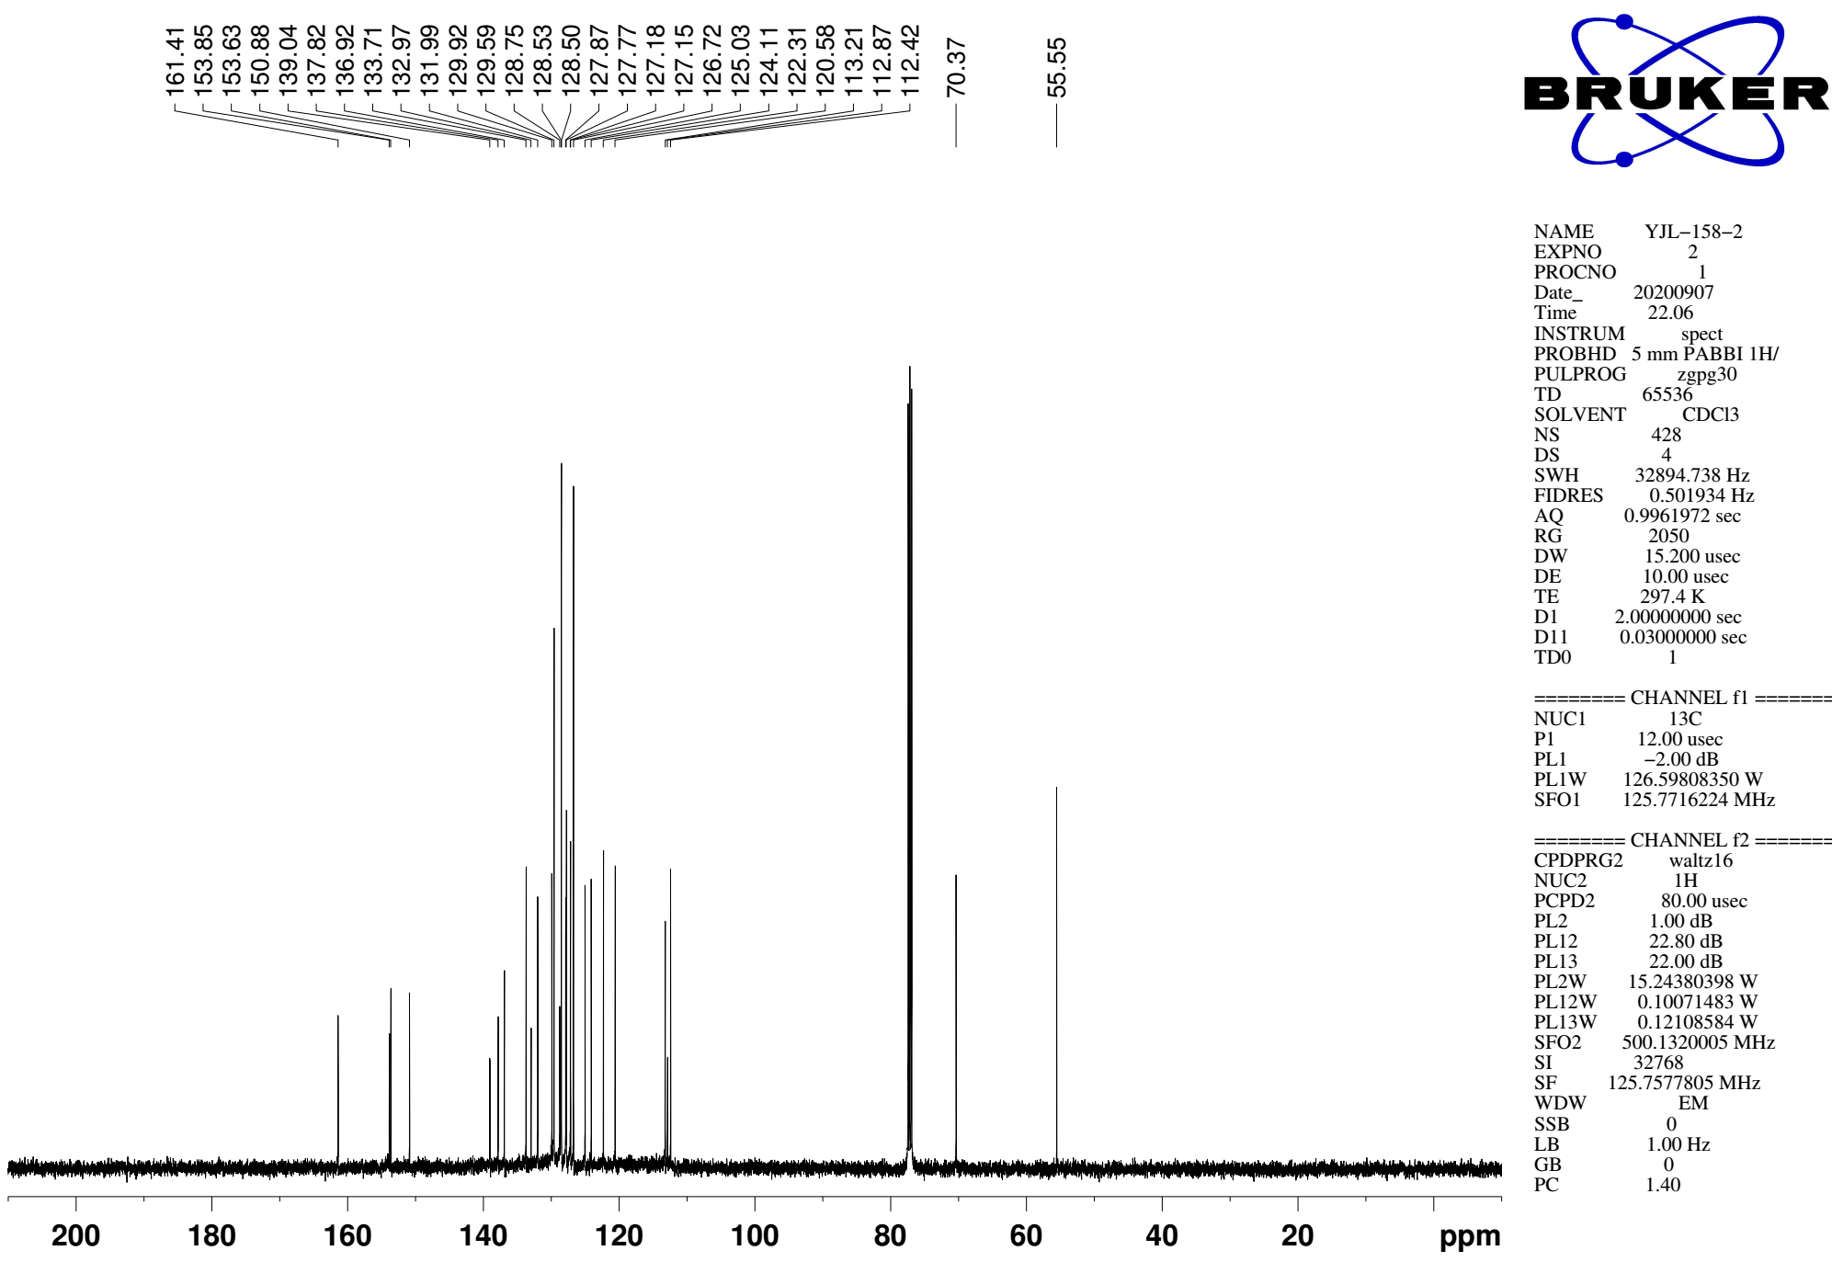
Supplementary Figure 90. ¹³C NMR (CDCl₃, 126MHz) spectra of spectra of 9n
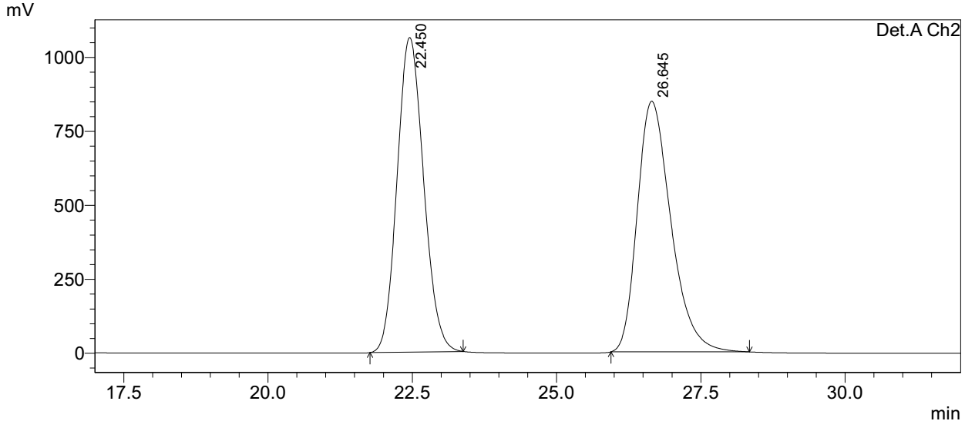
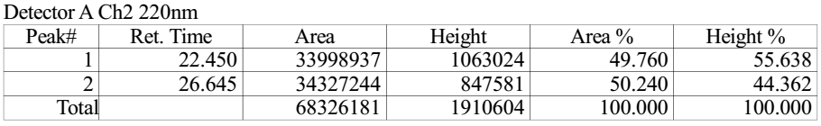

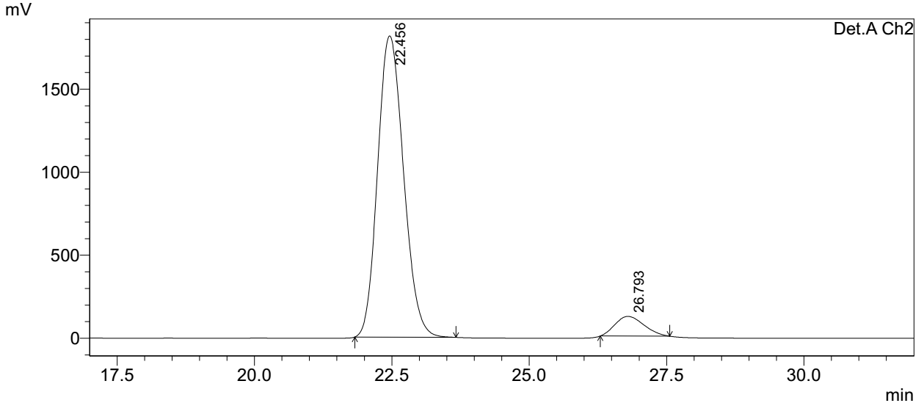
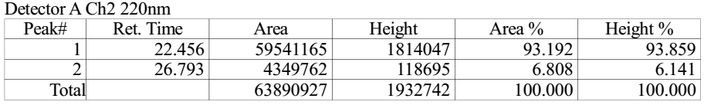
Supplementary Figure 91. HPLC spectra of 9n

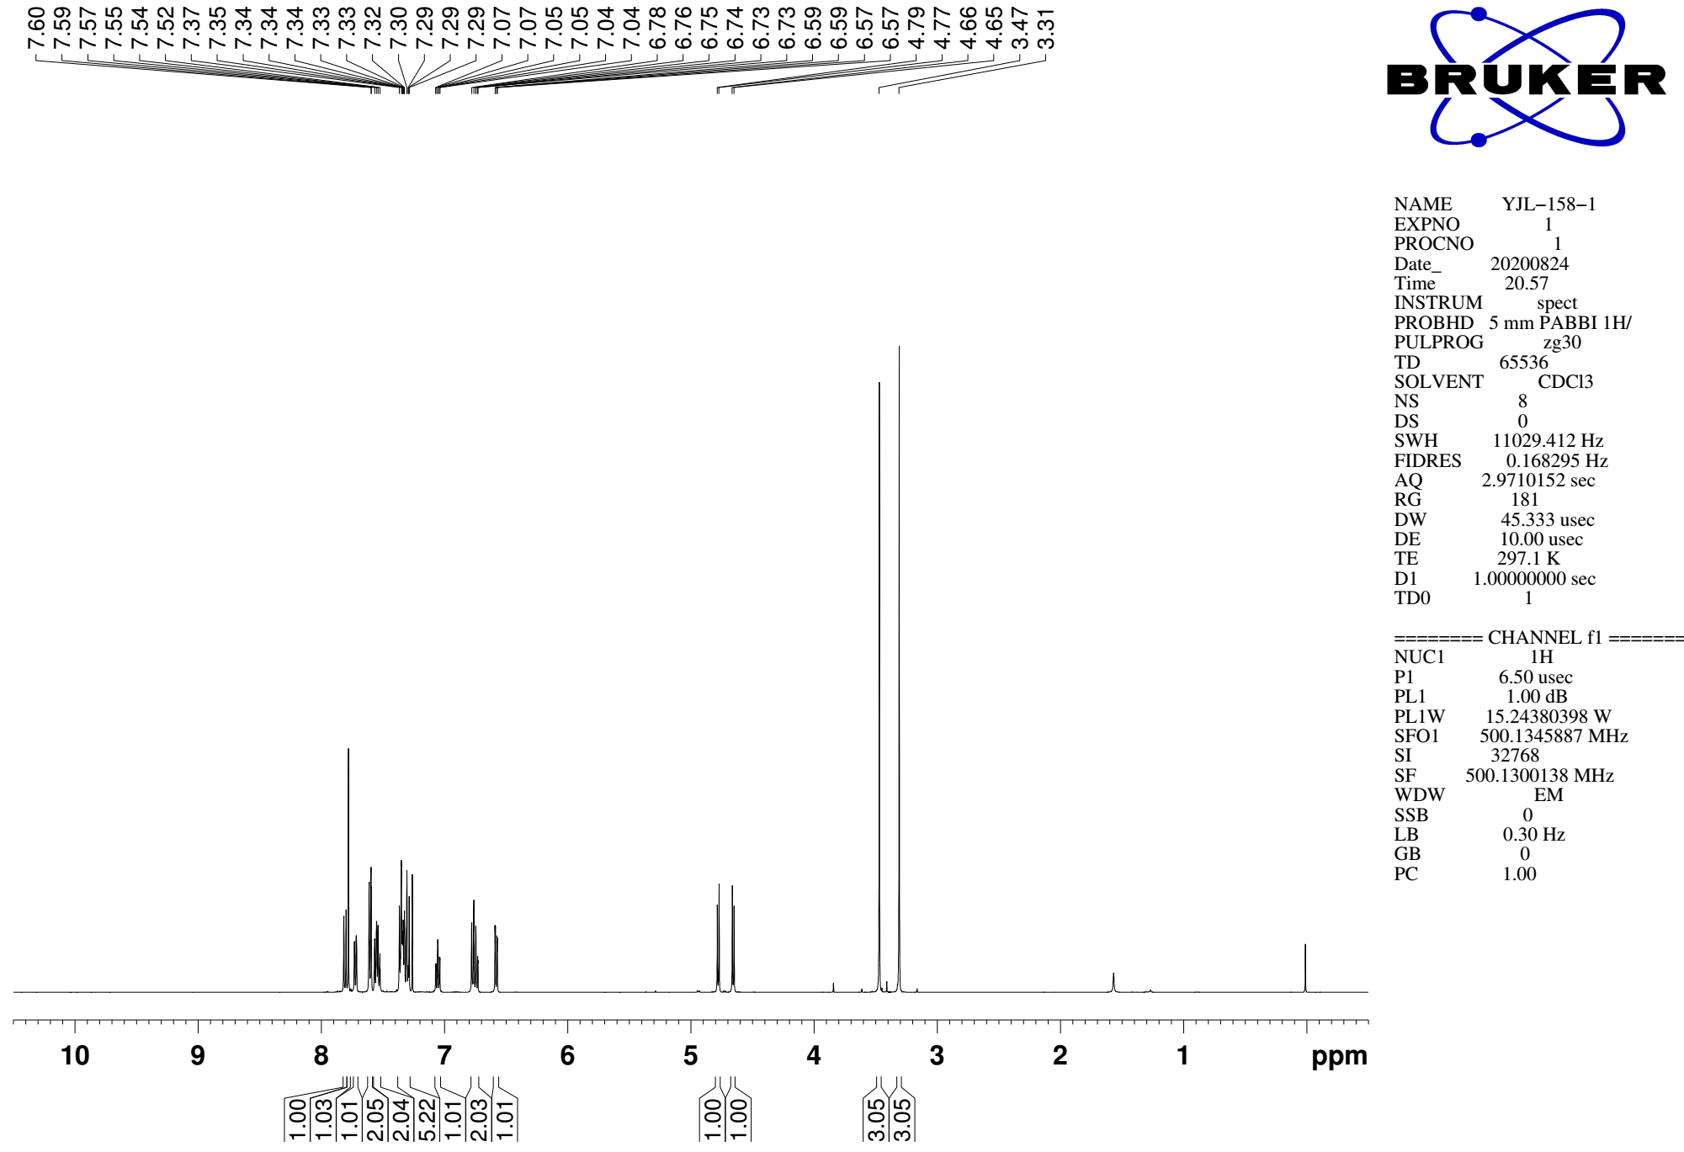
Supplementary Figure 92. ¹H NMR (CDCl₃, 500MHz) spectra of 9o

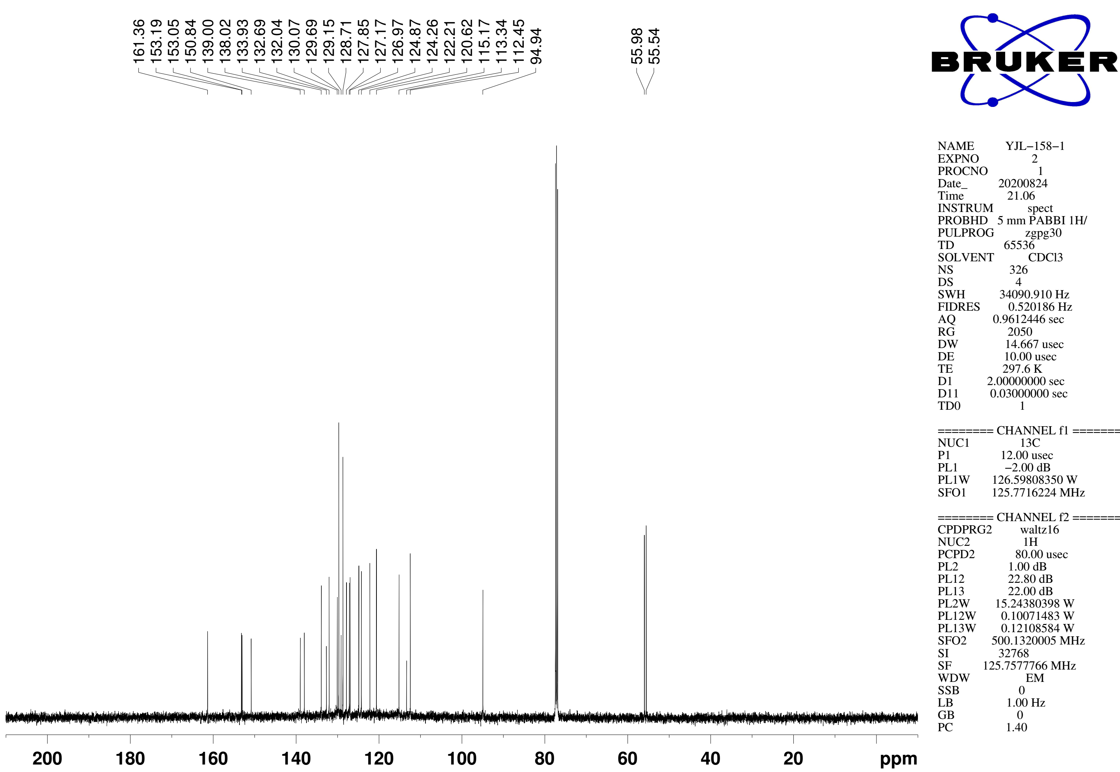
Supplementary Figure 93. ¹³C NMR (CDCl₃, 126MHz) spectra of spectra of 9o
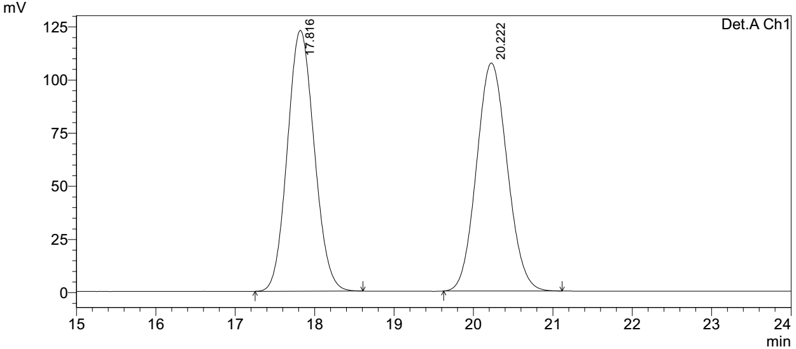
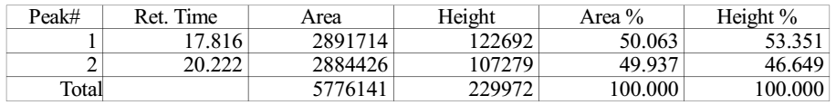

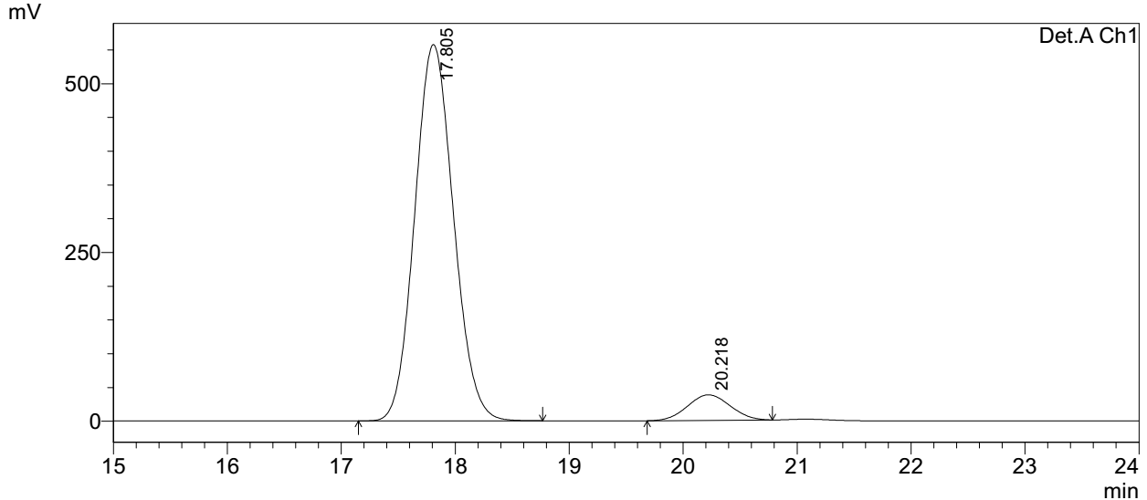
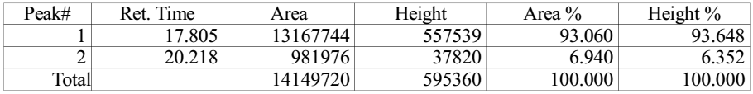
Supplementary Figure 94. HPLC spectra of 9o

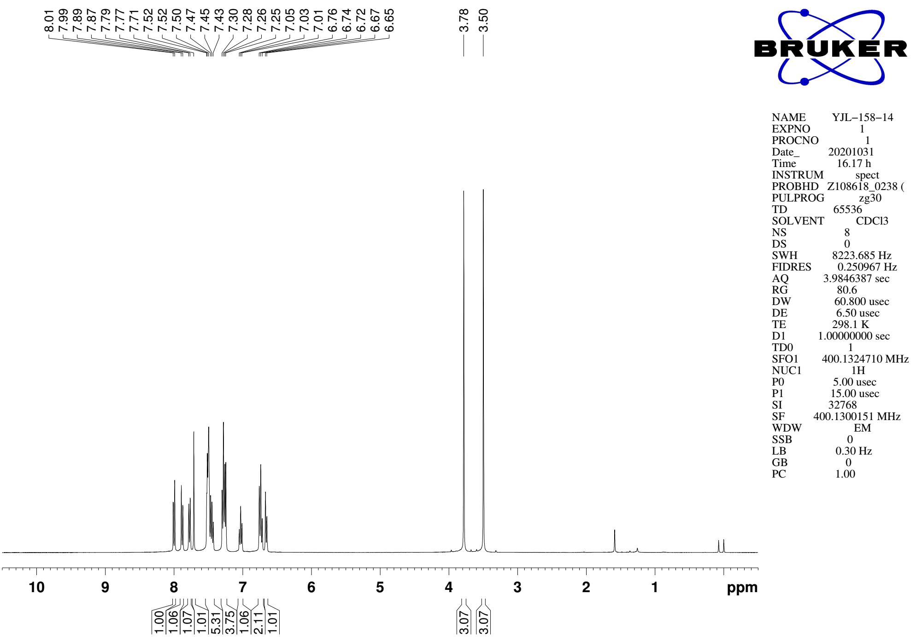
Supplementary Figure 95. ¹H NMR (CDCl₃, 400MHz) spectra of 9p

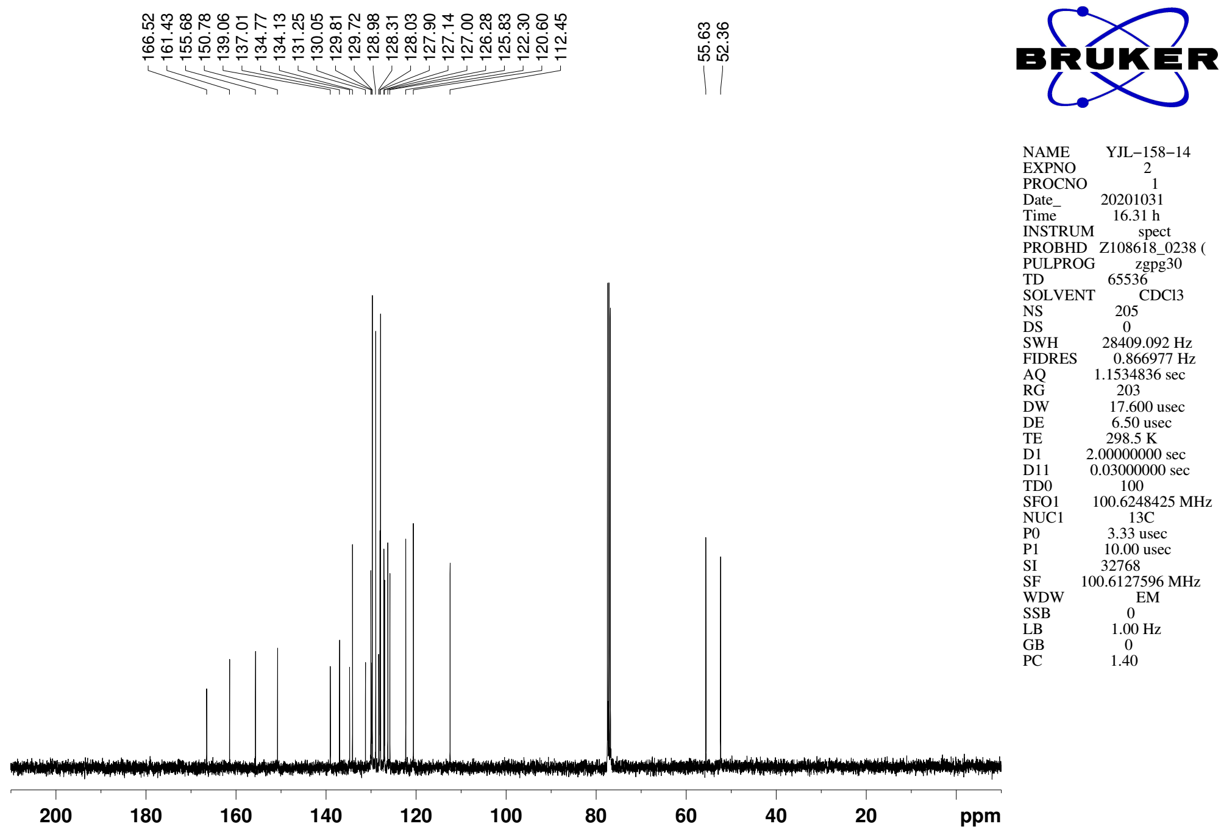
Supplementary Figure 96. ¹³C NMR (CDCl₃, 101MHz) spectra of spectra of 9p

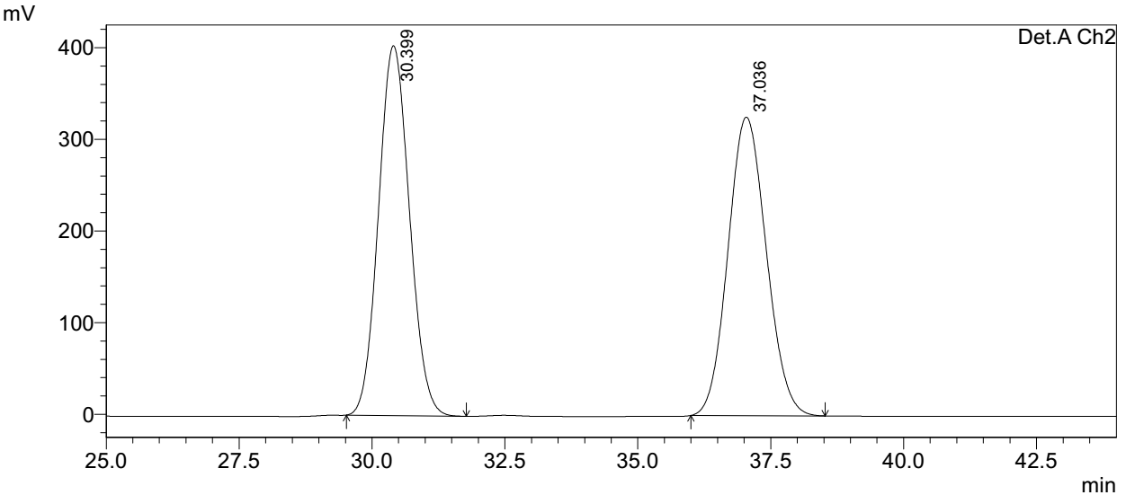
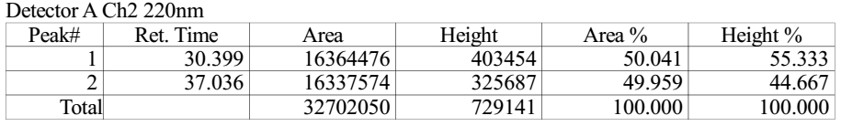

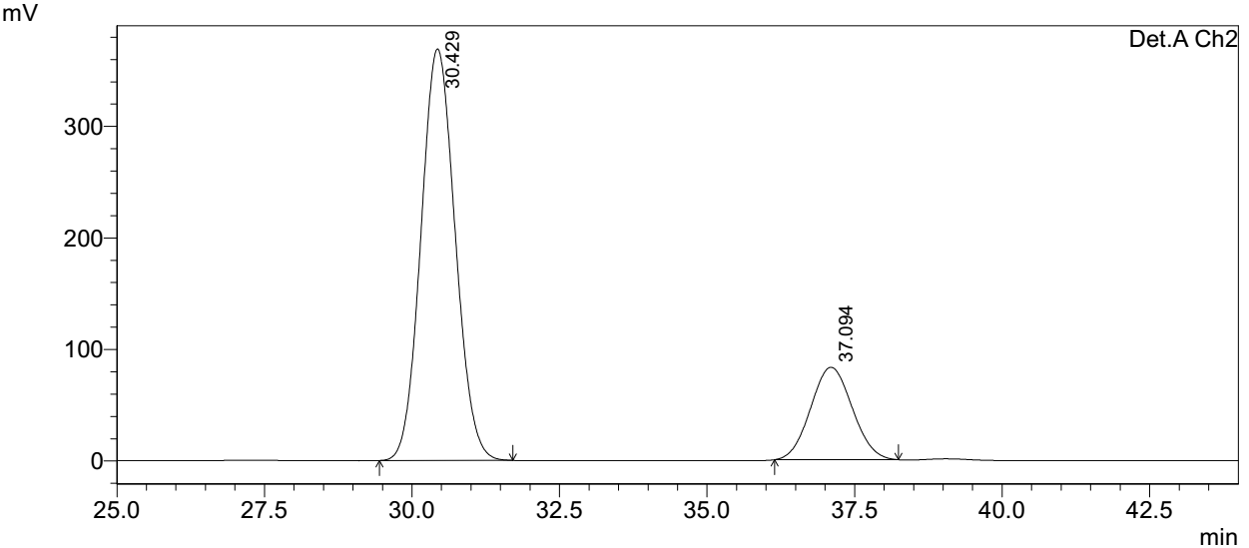
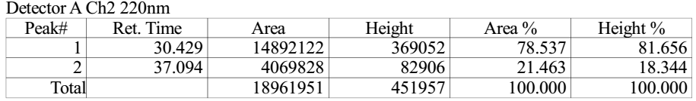
Supplementary Figure 97. HPLC spectra of 9p
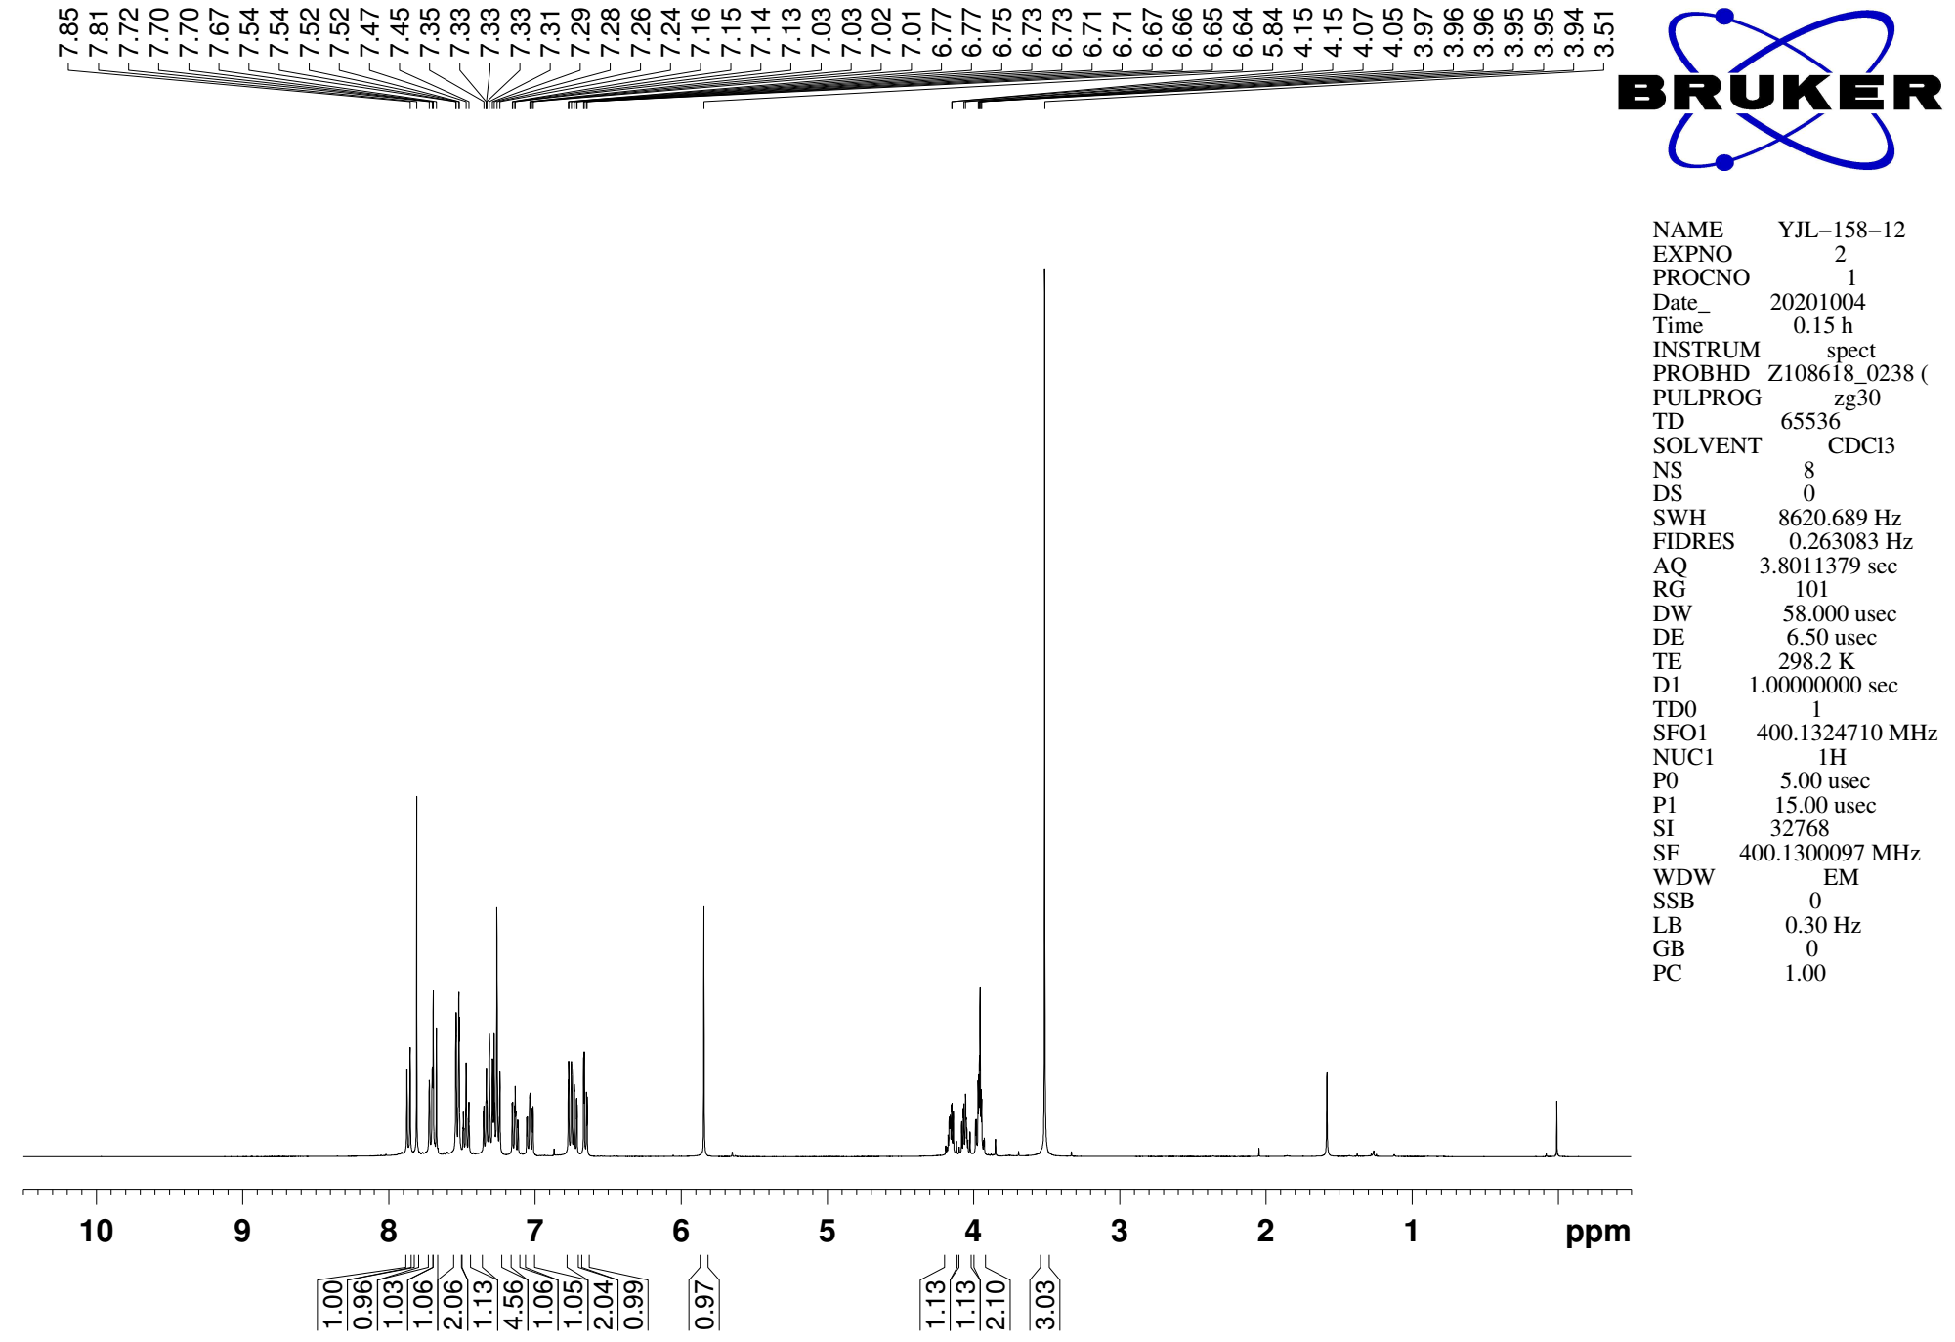
Supplementary Figure 98. ¹H NMR (CDCl₃, 400MHz) spectra of 9q

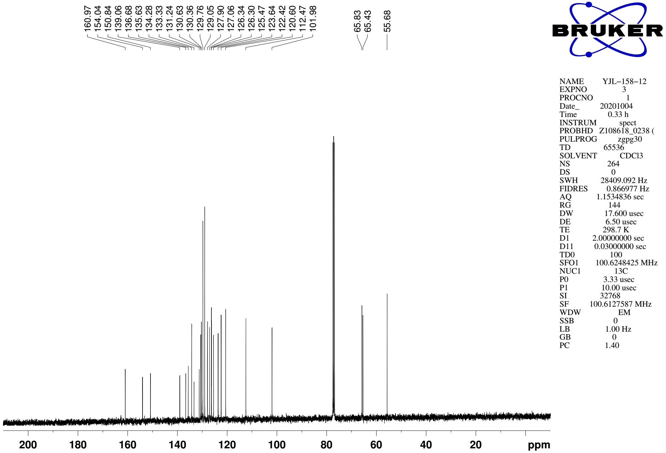
Supplementary Figure 99. ¹³C NMR (CDCl₃, 101MHz) spectra of spectra of 9q
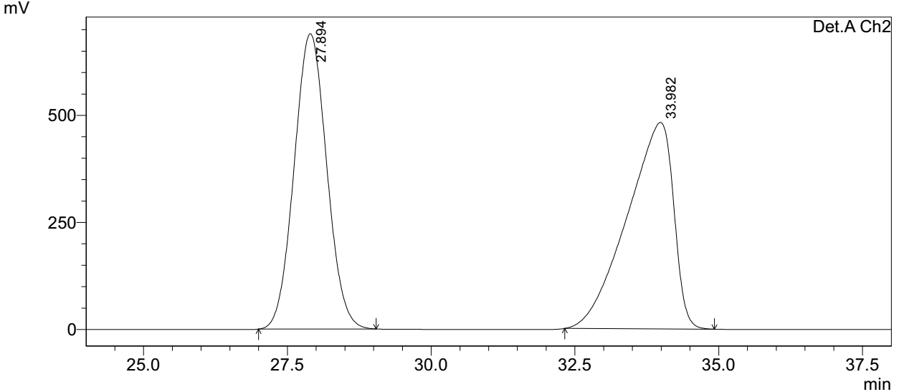
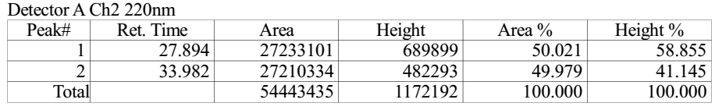

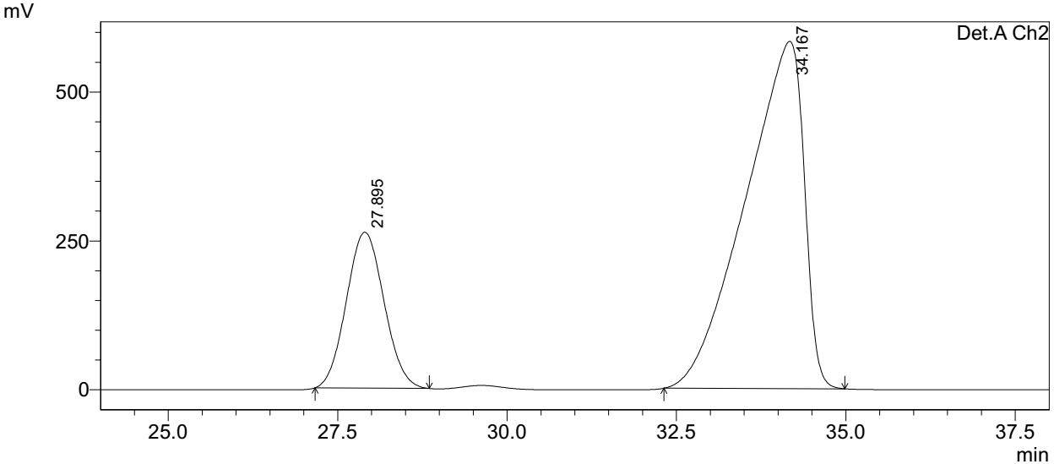
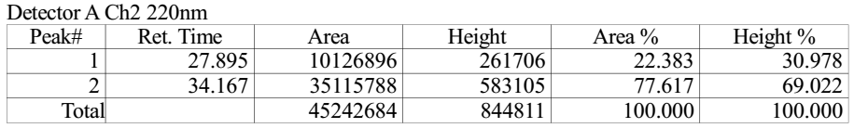
Supplementary Figure 100. HPLC spectra of 9q
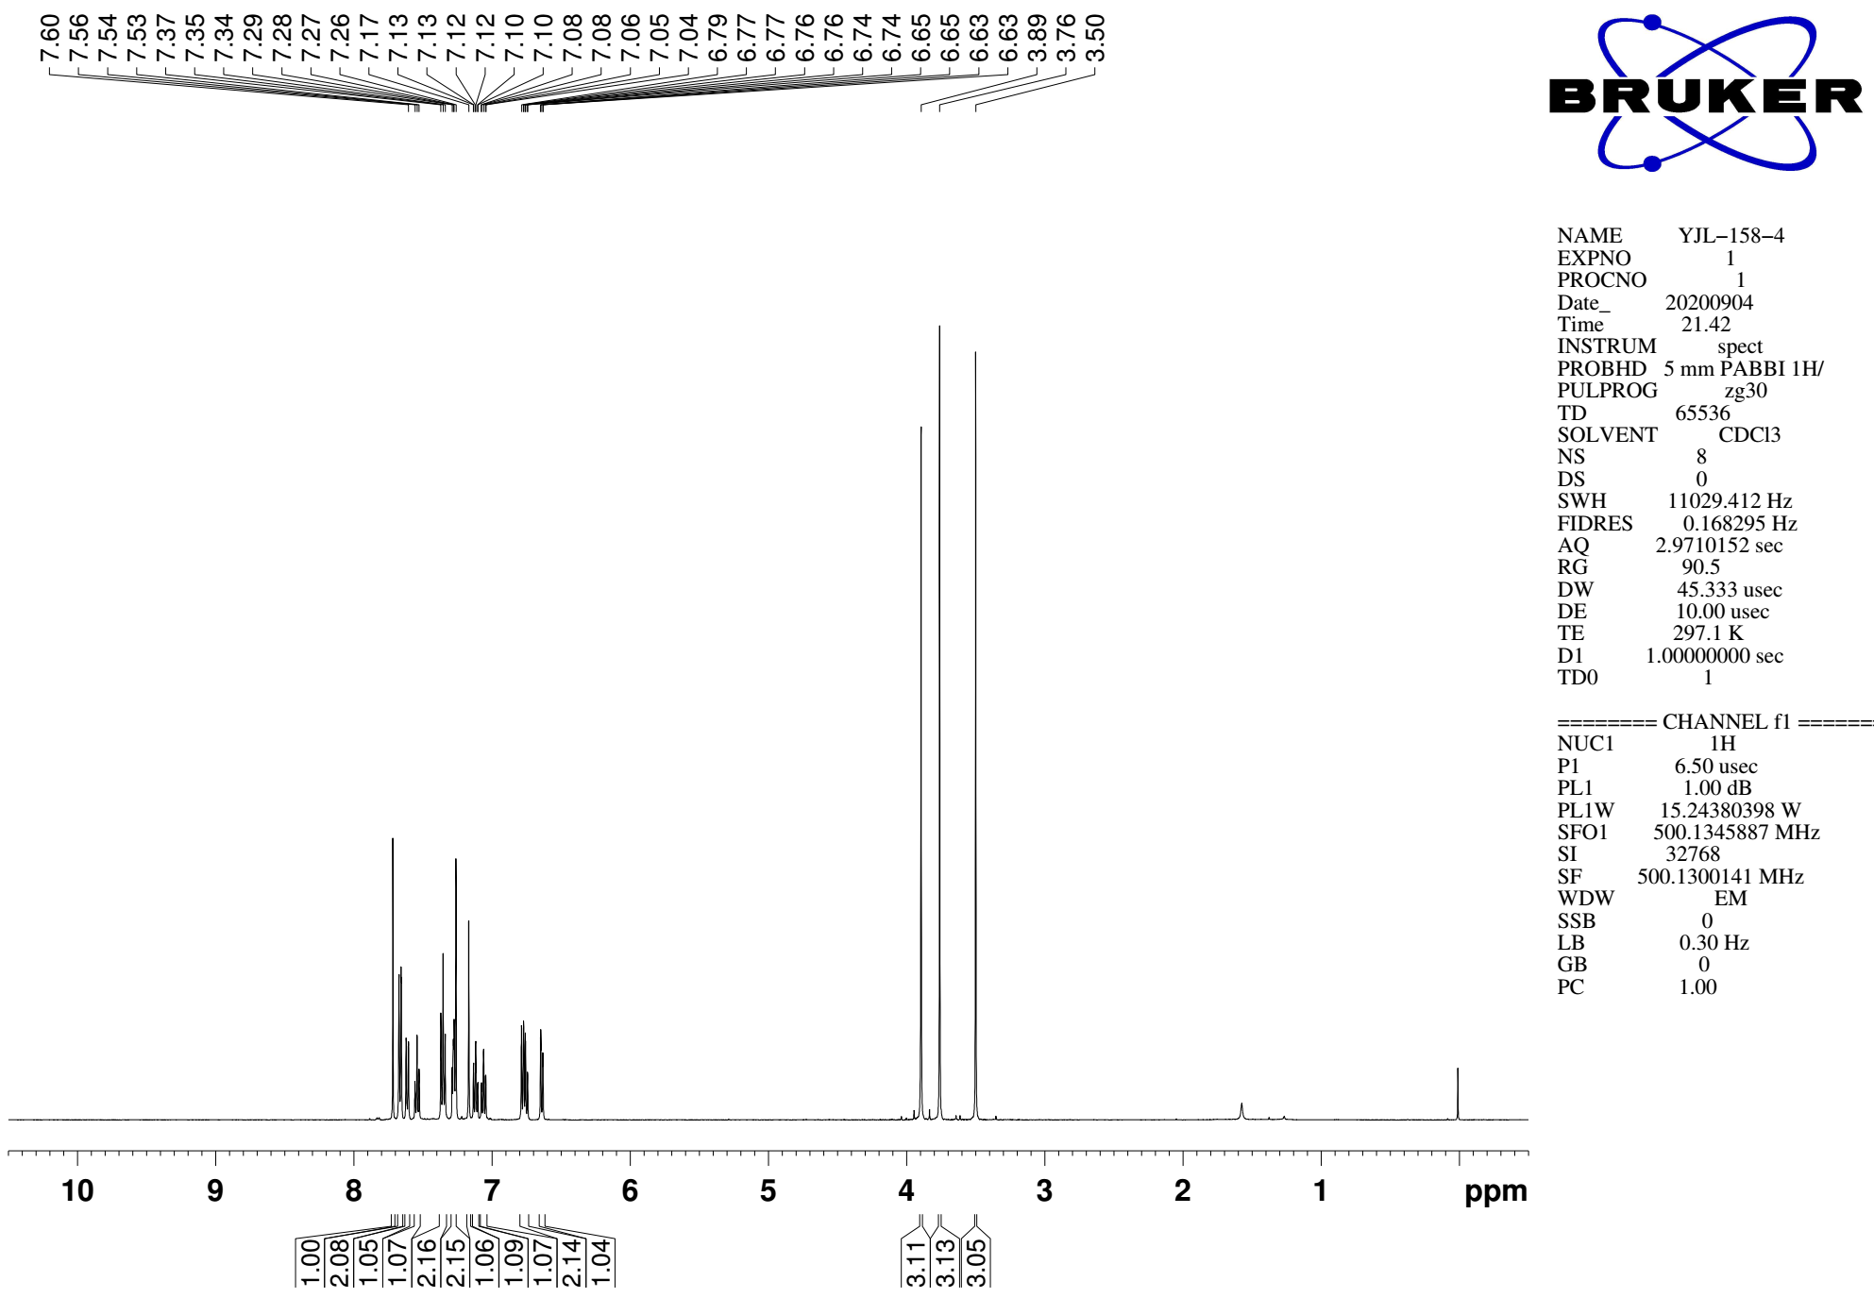
Supplementary Figure 101. ¹H NMR (CDCl₃, 500MHz) spectra of 9r

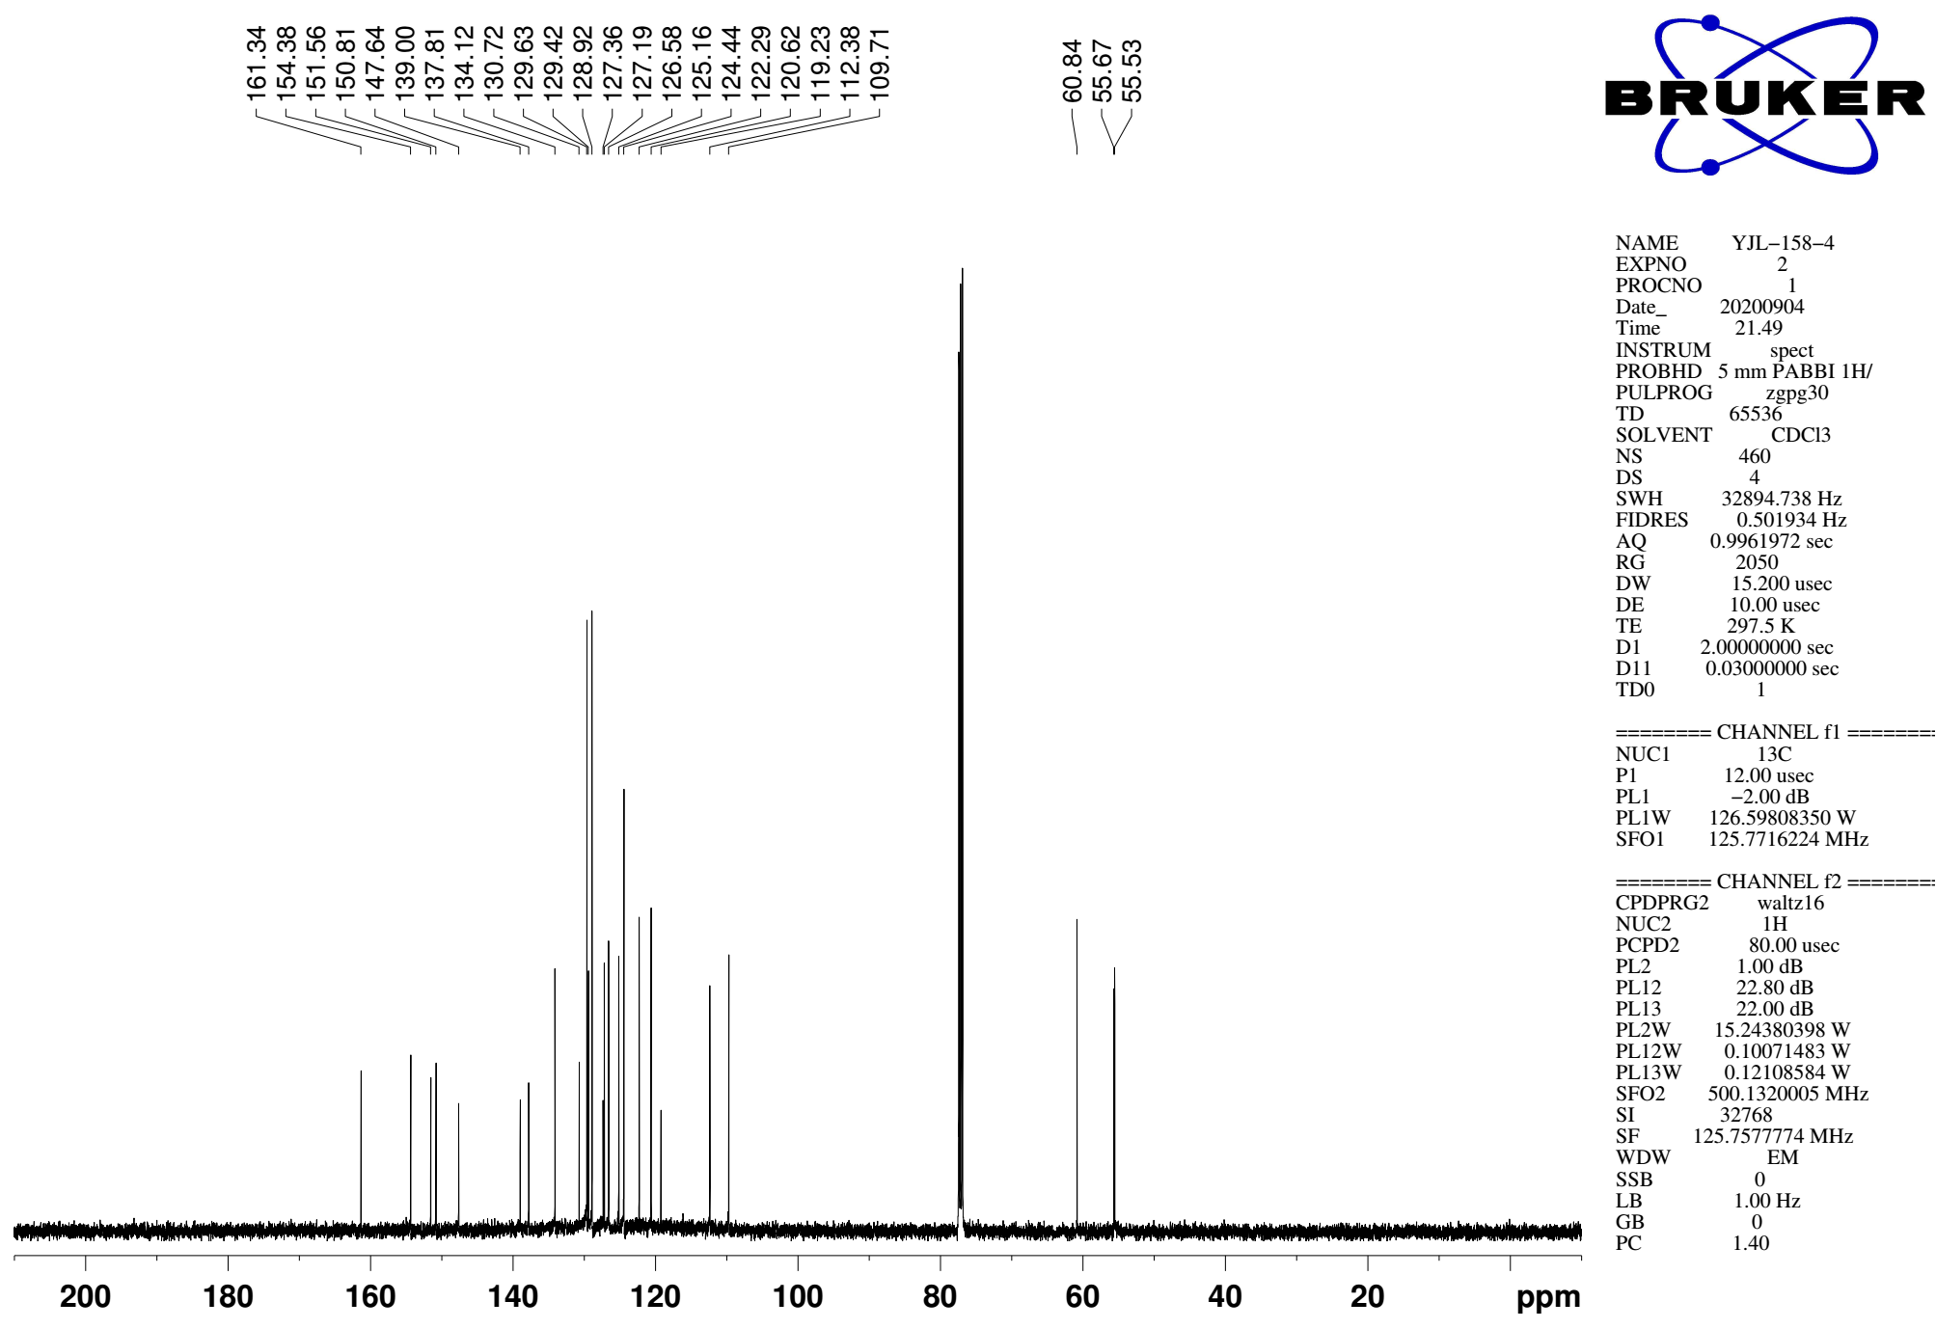
Supplementary Figure 102. ¹³C NMR (CDCl₃, 126MHz) spectra of spectra of 9r
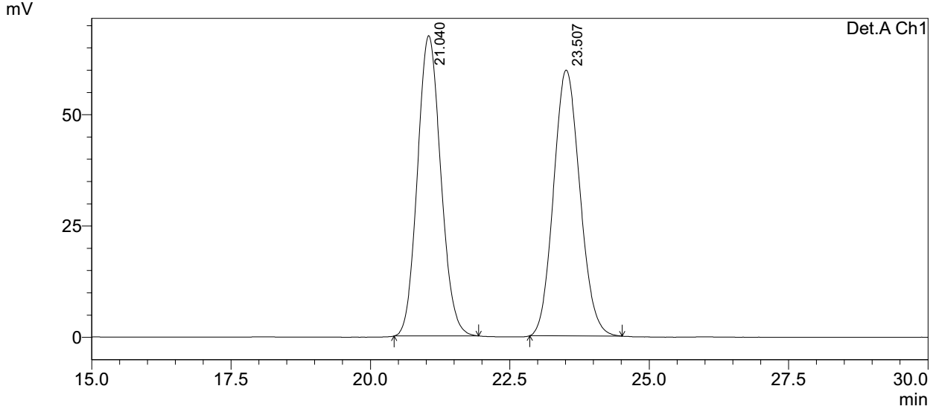
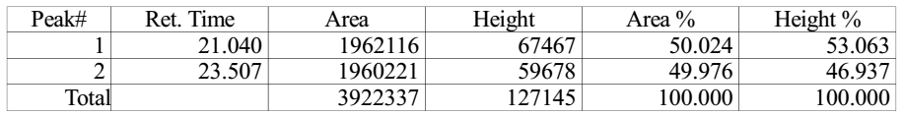

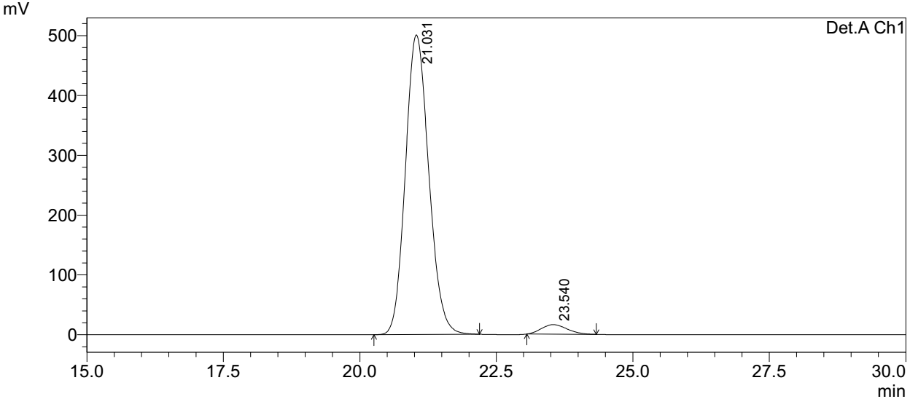
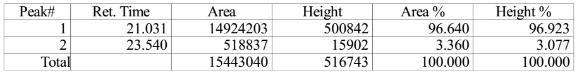
Supplementary Figure 103. HPLC spectra of 9r
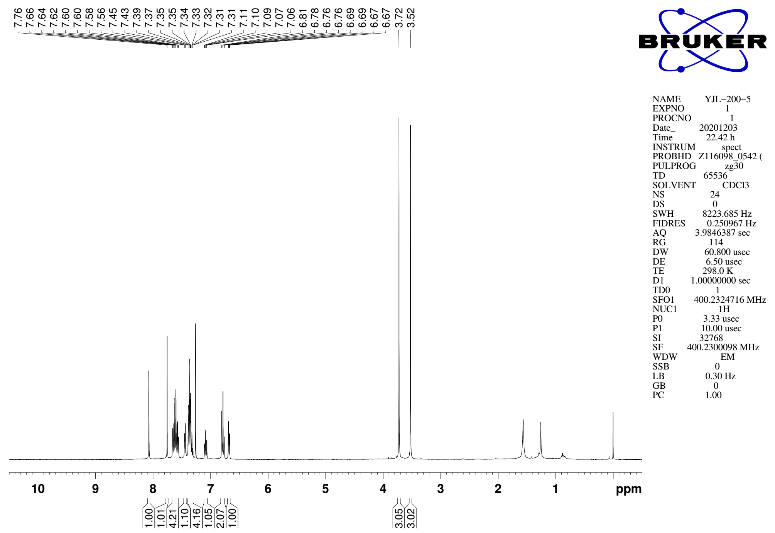
Supplementary Figure 104. ¹H NMR (CDCl₃, 400MHz) spectra of 9s

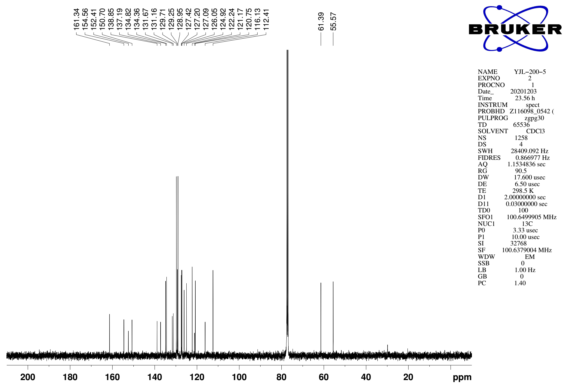
Supplementary Figure 105. ¹³C NMR (CDCl₃, 101MHz) spectra of spectra of 9s
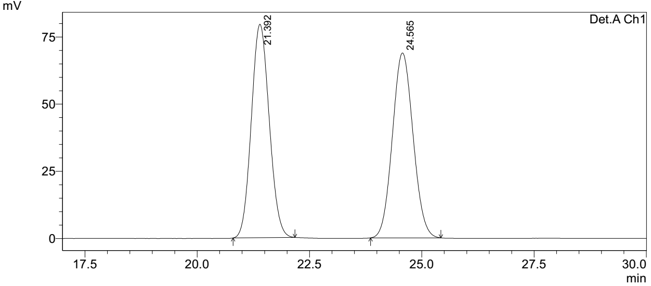
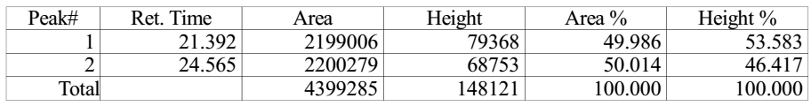

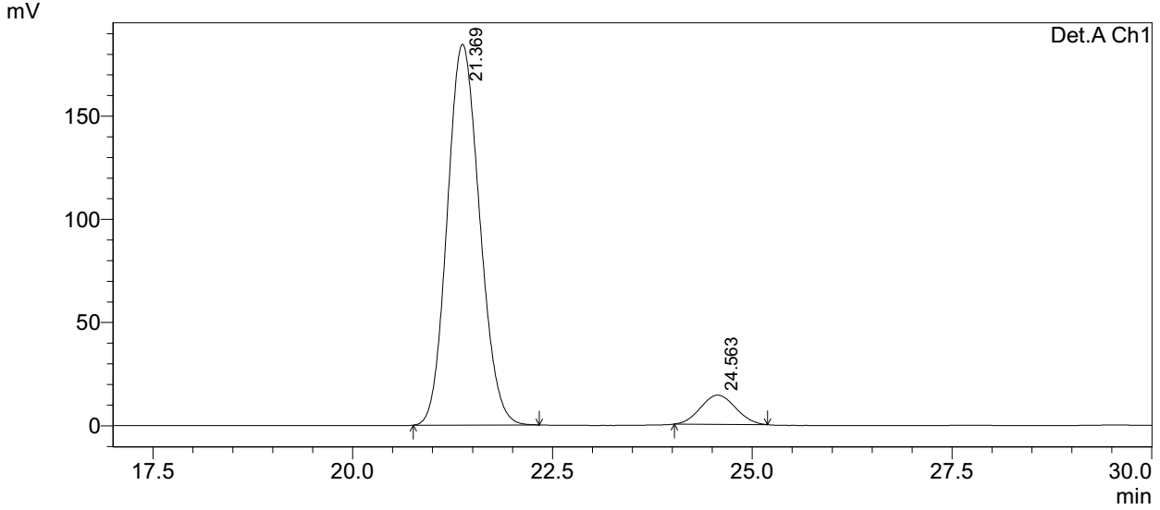
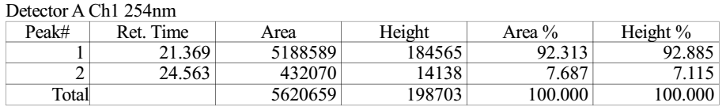
Supplementary Figure 106. HPLC spectra of 9s
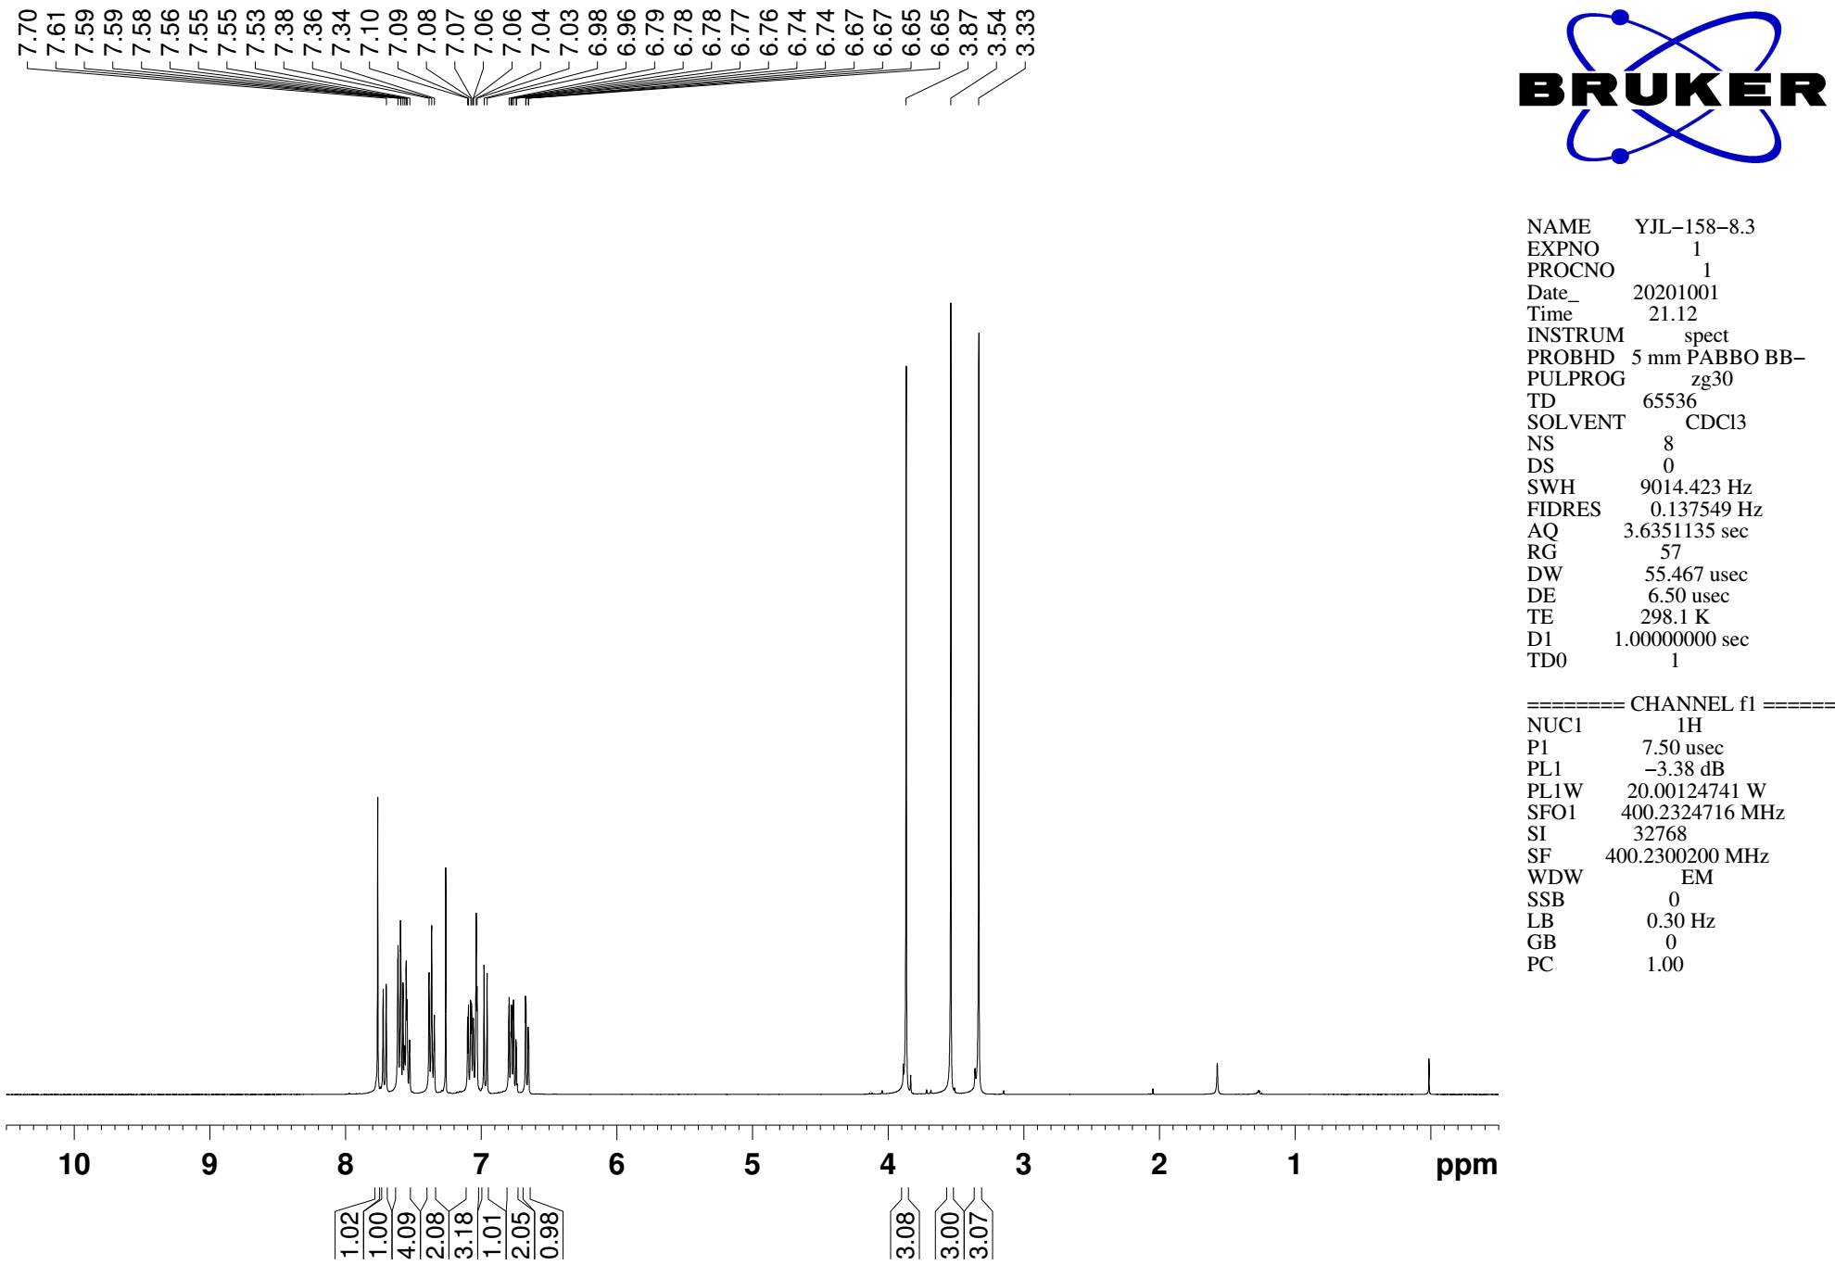
Supplementary Figure 107. ¹H NMR (CDCl₃, 400MHz) spectra of 9t

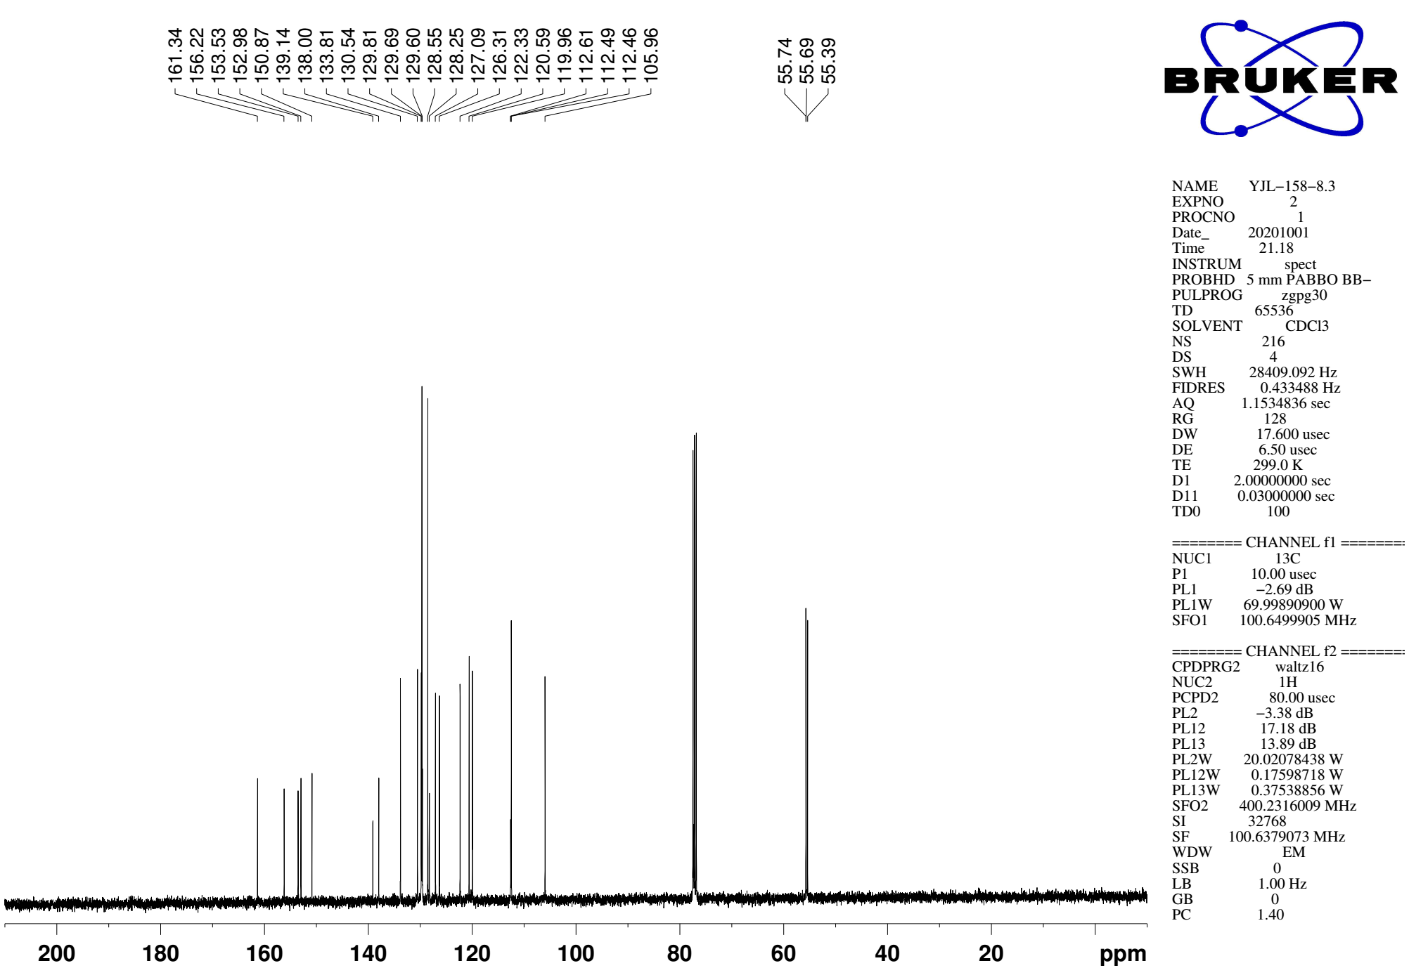
Supplementary Figure 108. ¹³C NMR (CDCl₃, 101MHz) spectra of spectra of 9t
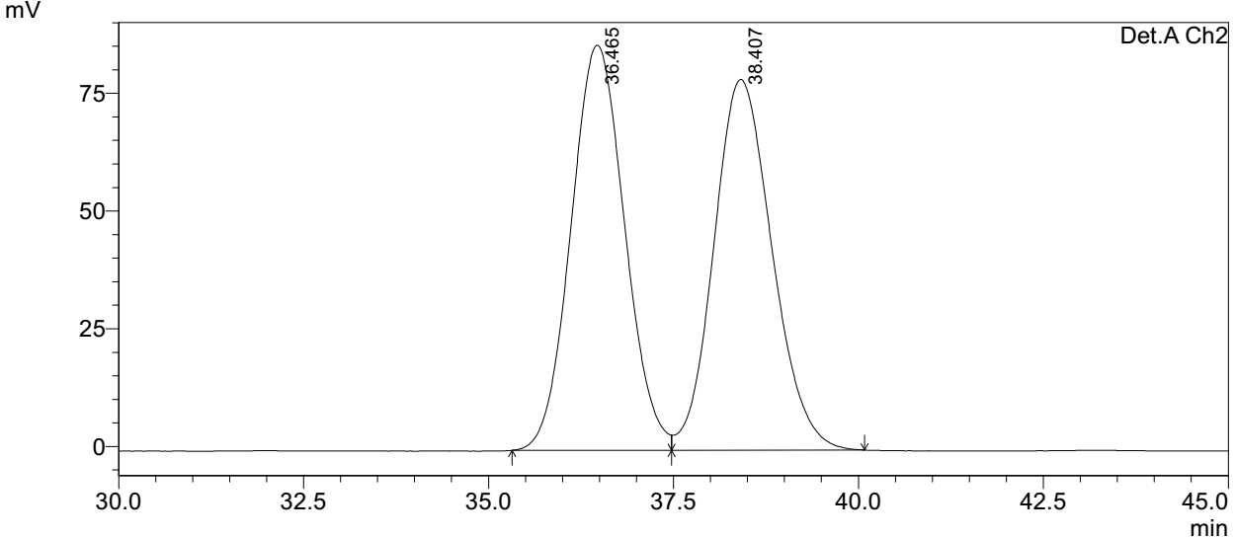
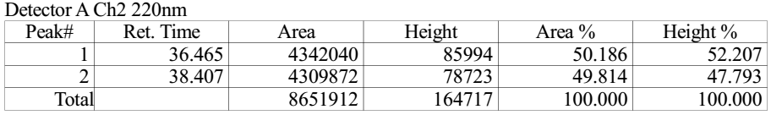

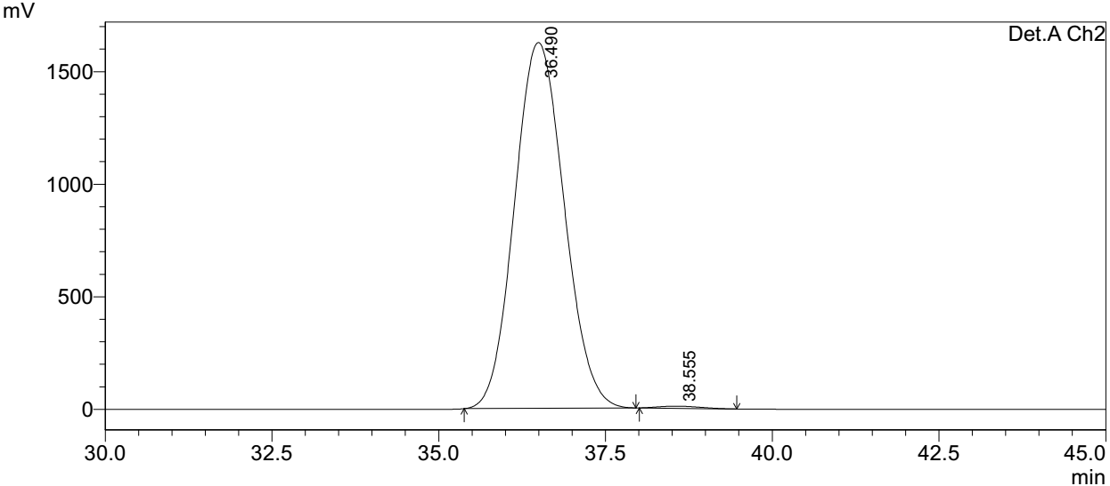
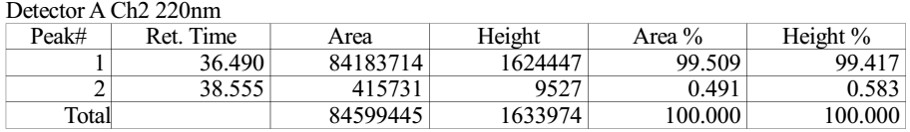
Supplementary Figure 109. HPLC spectra of 9t
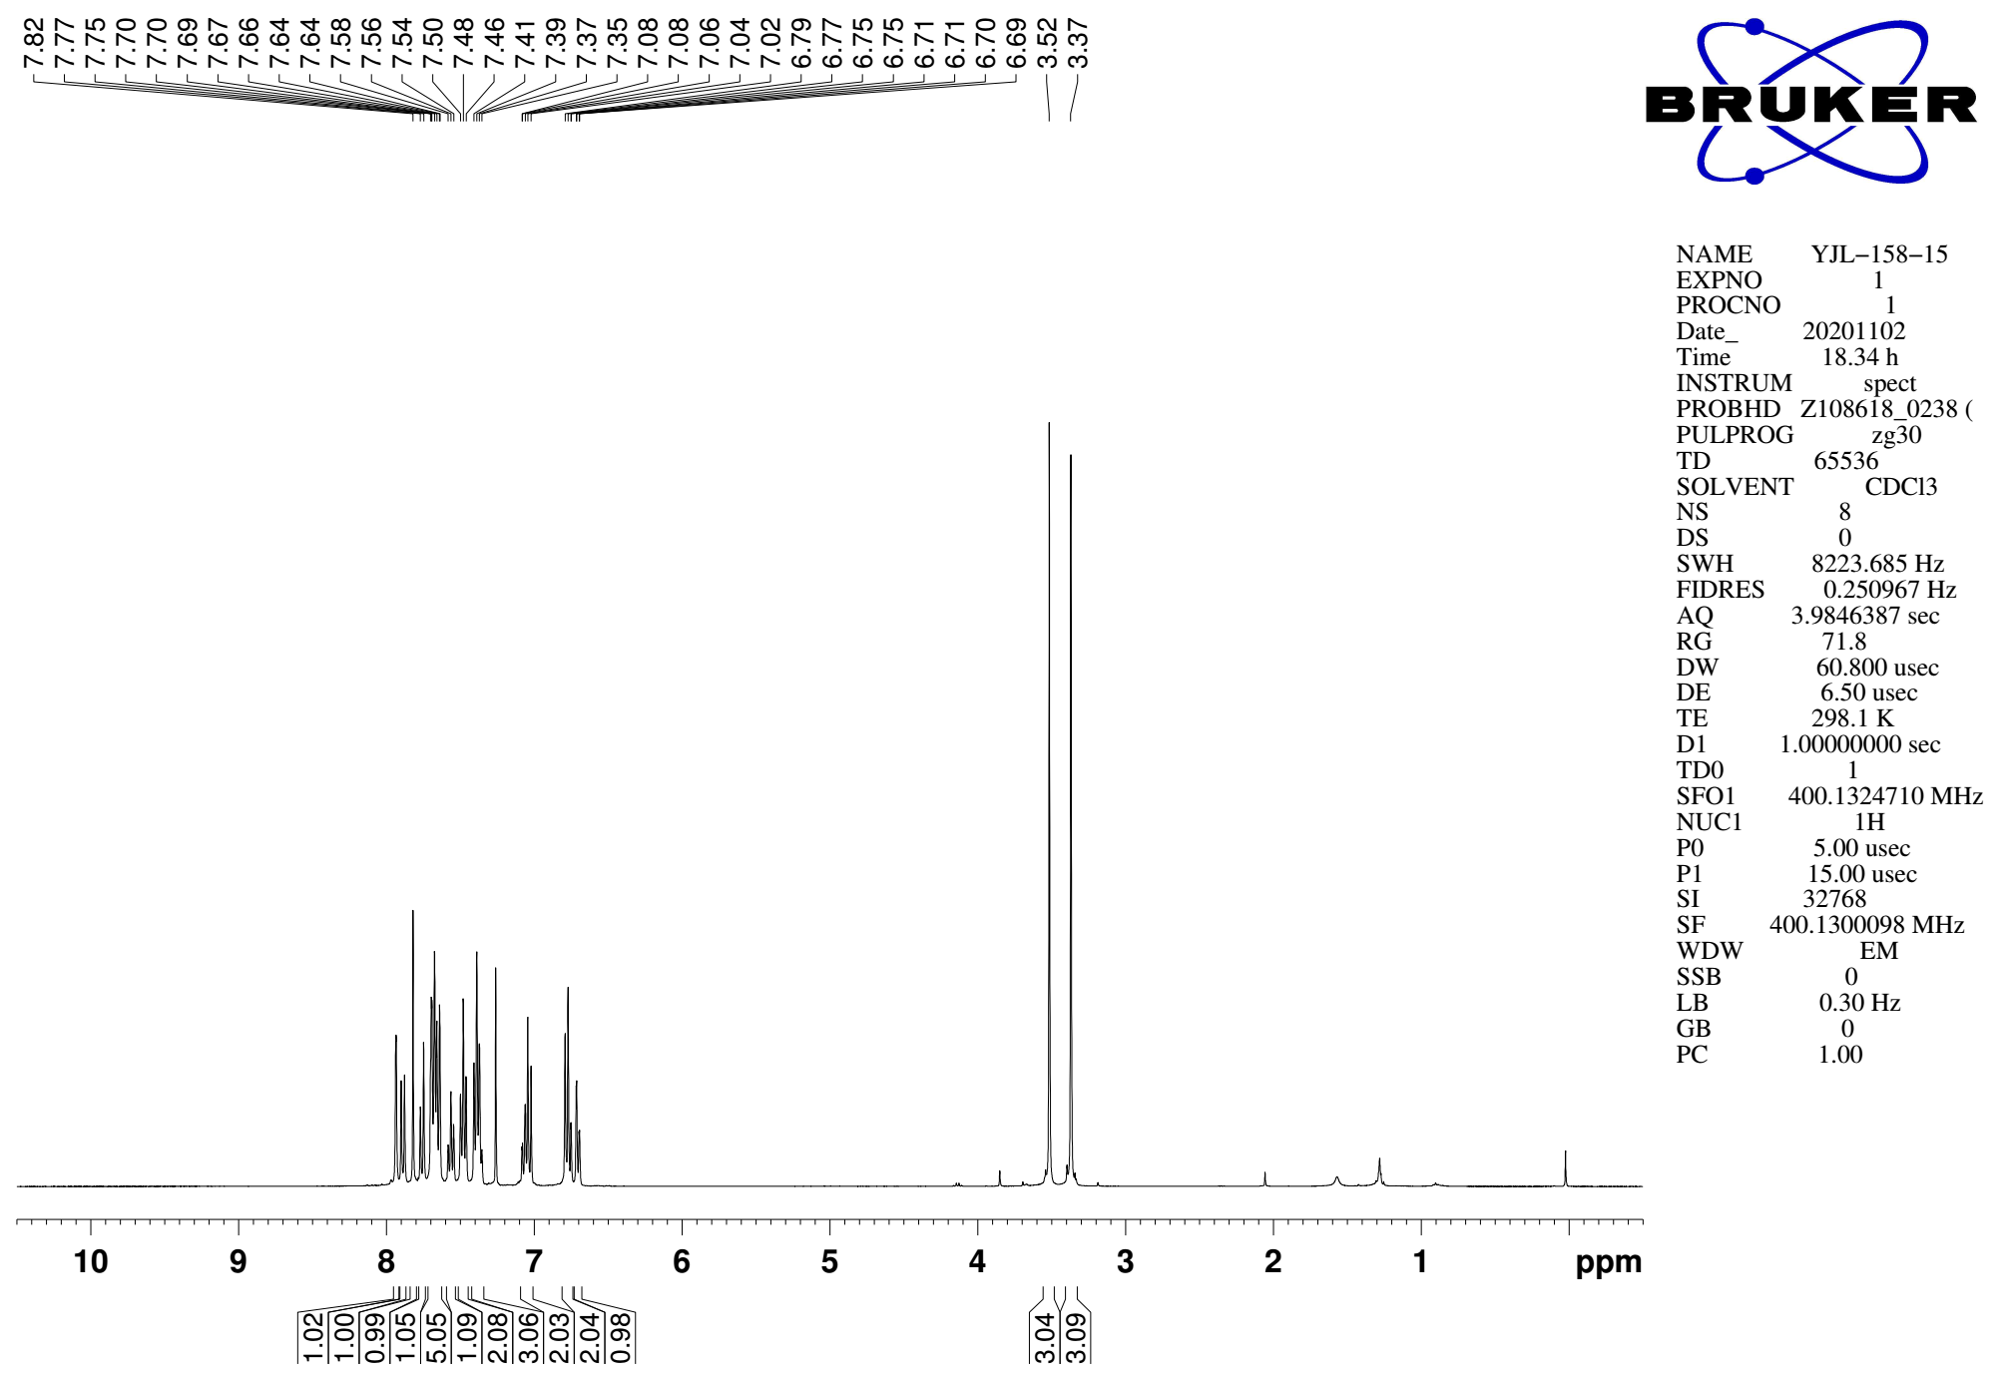
Supplementary Figure 110. ¹H NMR (CDCl₃, 400MHz) spectra of 9u

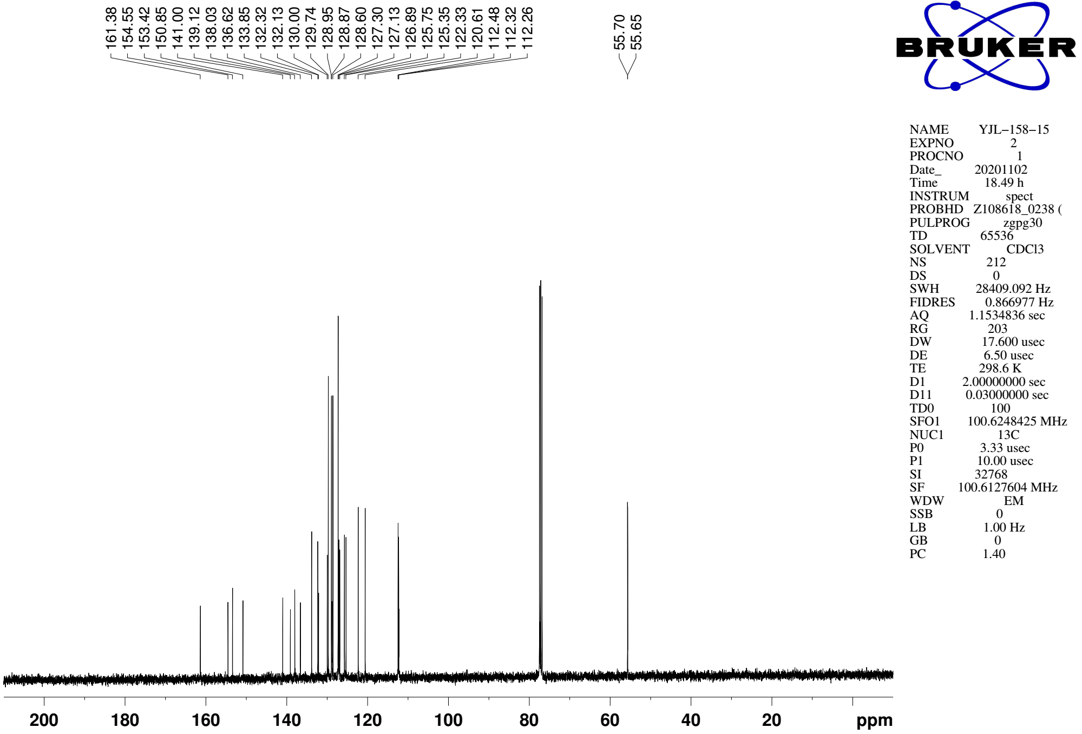
Supplementary Figure 111. ¹³C NMR (CDCl₃, 101MHz) spectra of spectra of 9u

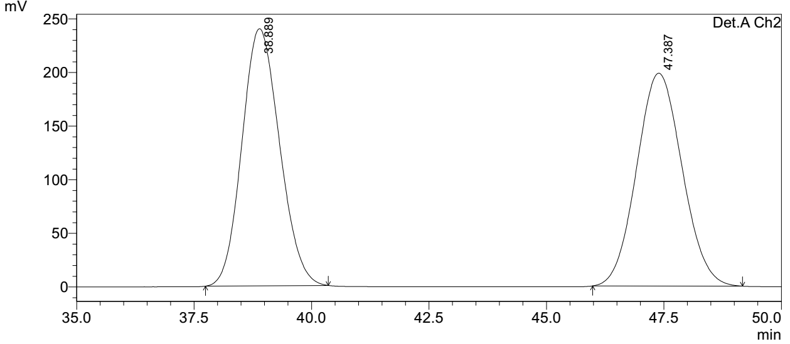
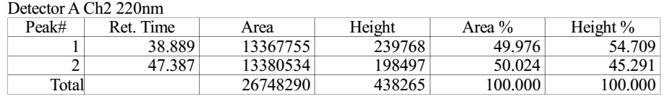

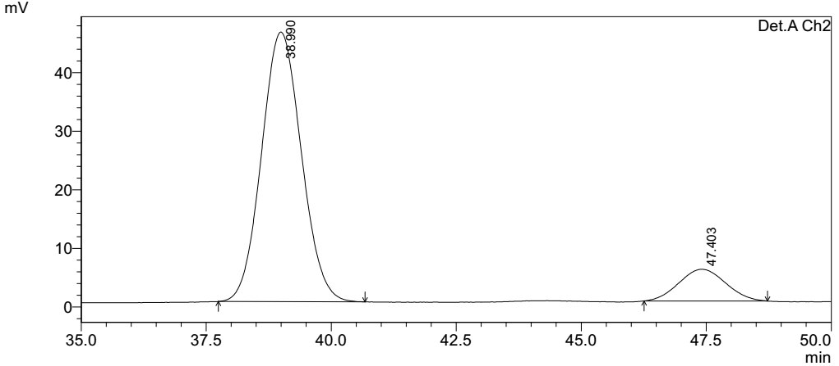
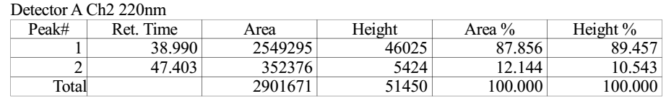
Supplementary Figure 112. HPLC spectra of 9u
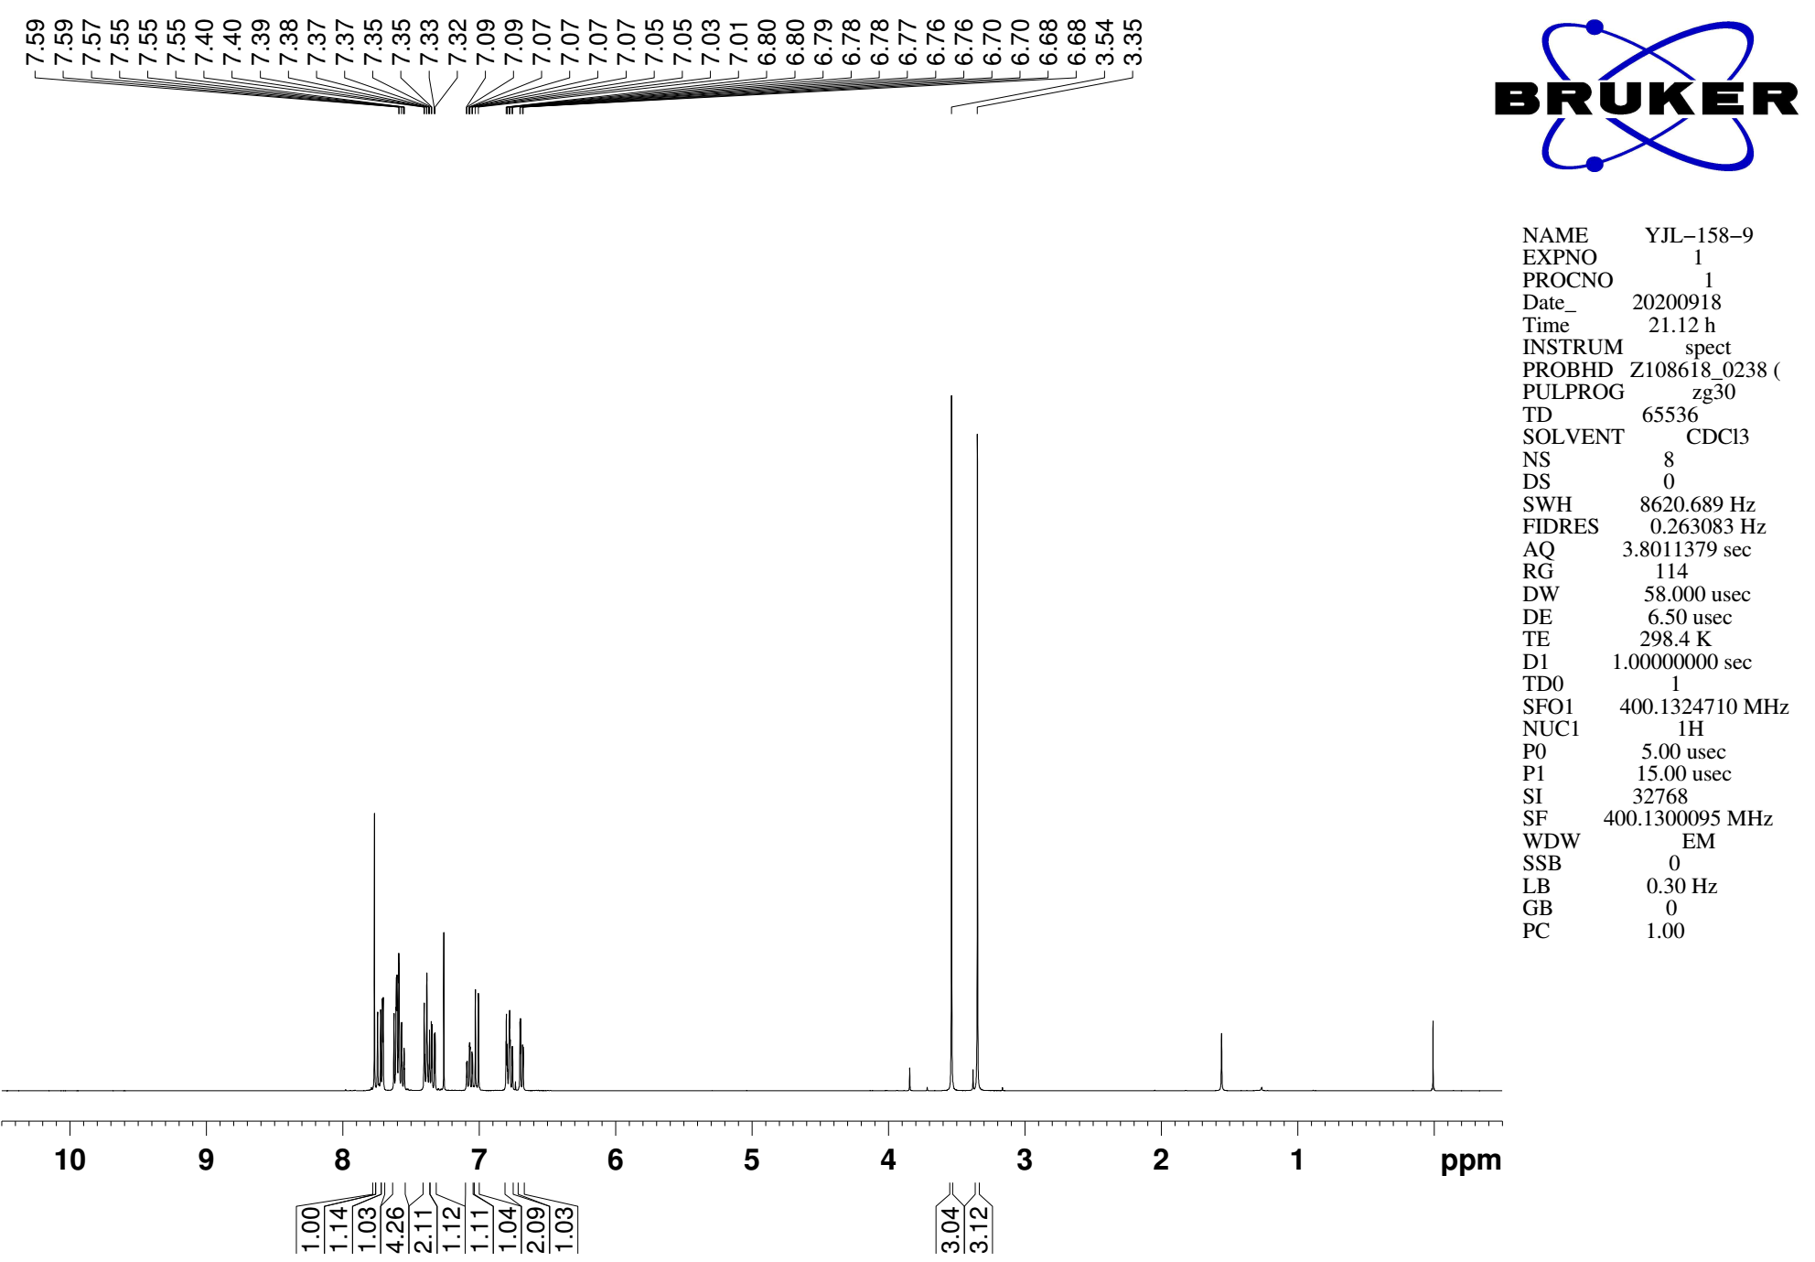
Supplementary Figure 113. ¹H NMR (CDCl₃, 400MHz) spectra of 9v

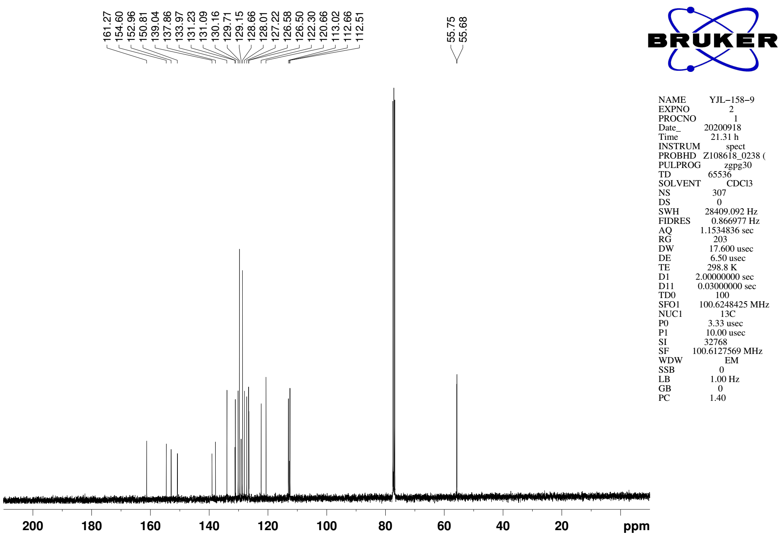
Supplementary Figure 114. ¹³C NMR (CDCl₃, 101MHz) spectra of spectra of 9v

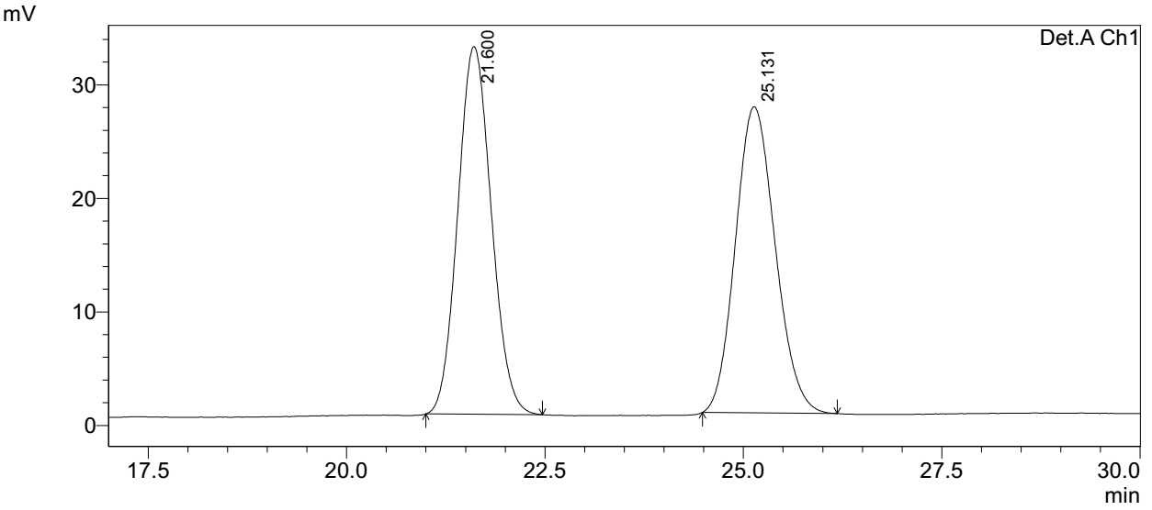
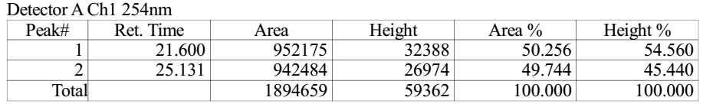

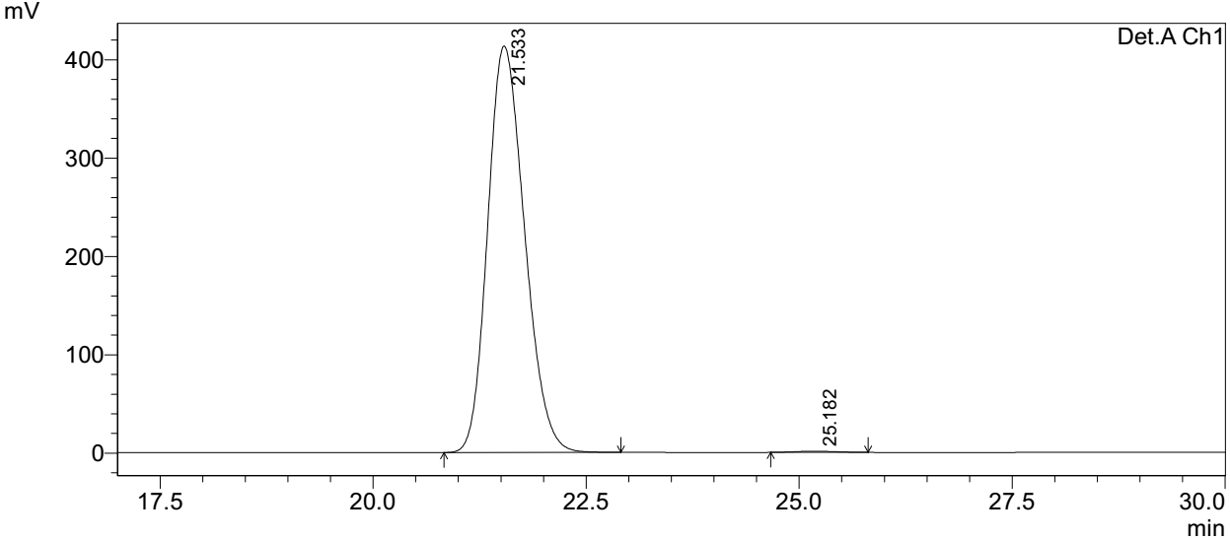
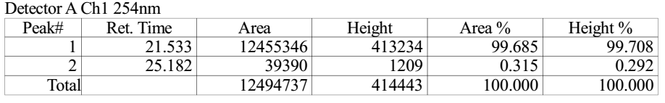
Supplementary Figure 115. HPLC spectra of 9v
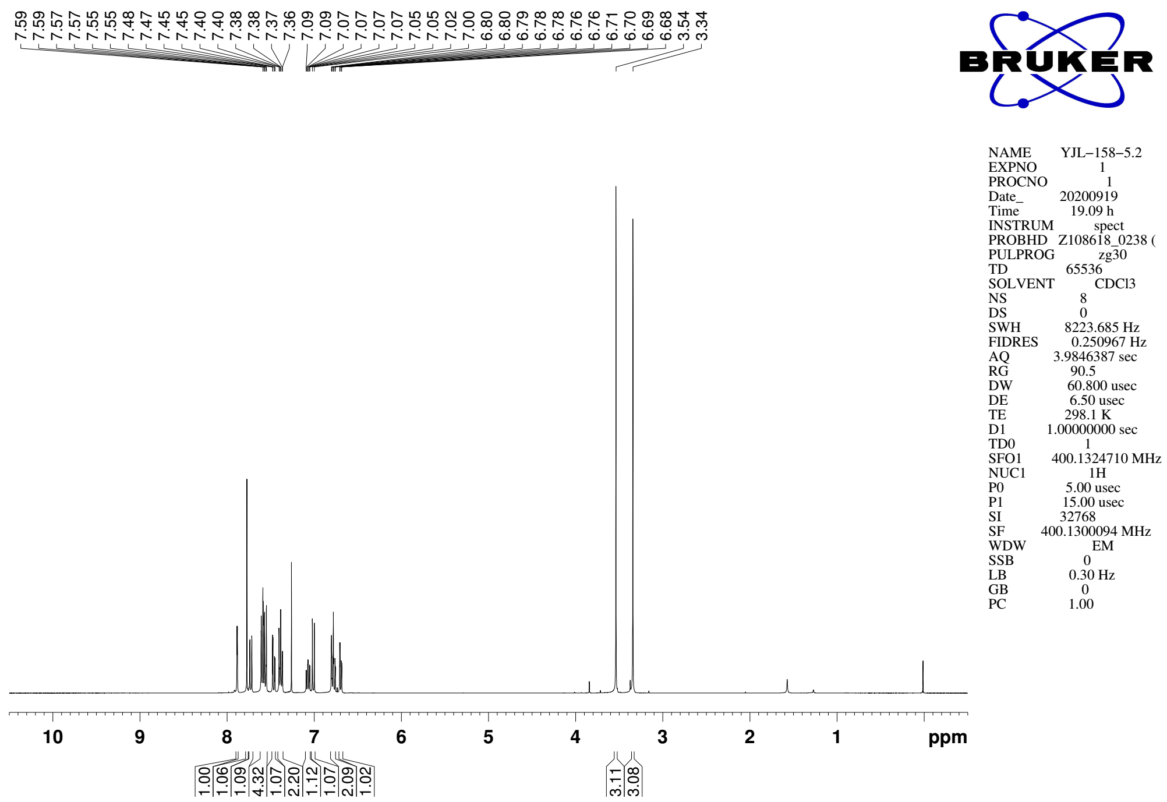
Supplementary Figure 115. ¹H NMR (CDCl₃, 400MHz) spectra of 9w

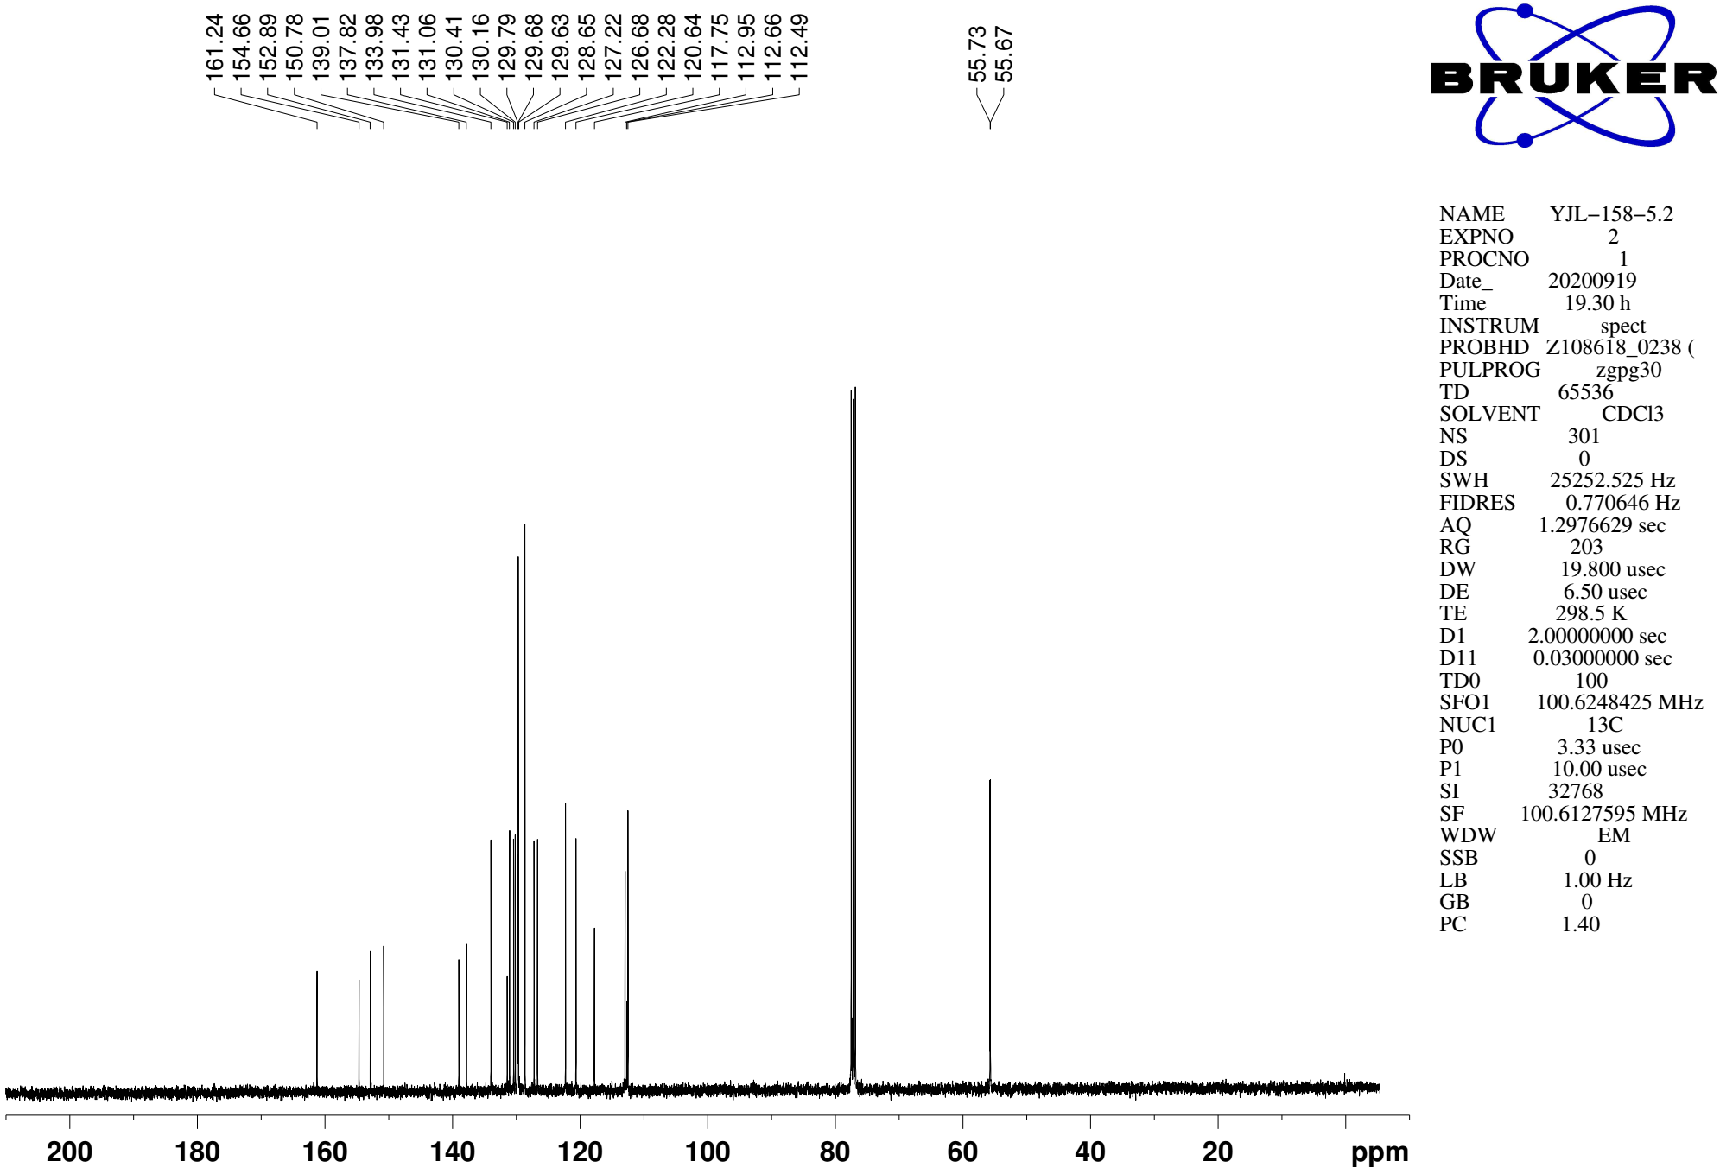
Supplementary Figure 117. ¹³C NMR (CDCl₃, 101MHz) spectra of spectra of 9w

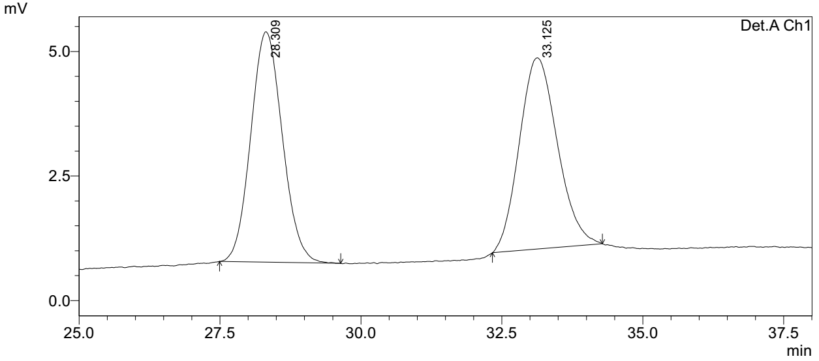
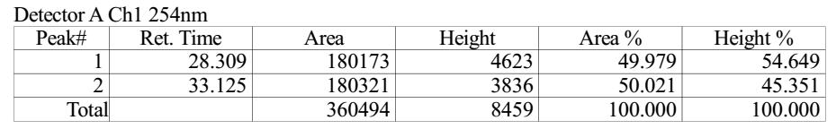

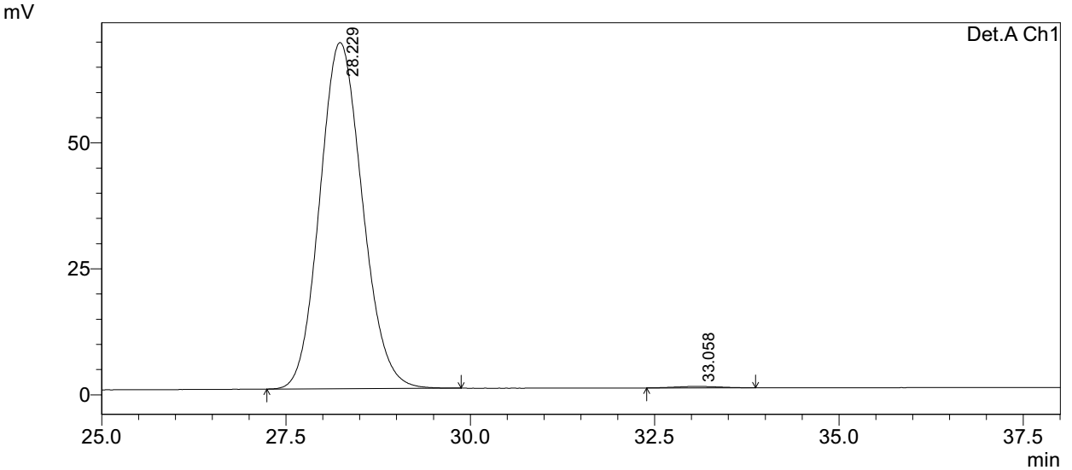
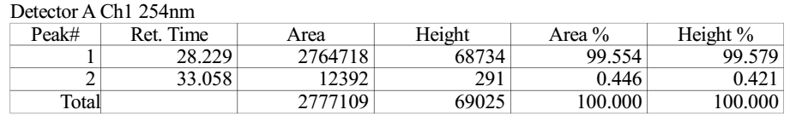
Supplementary Figure 118. HPLC spectra of 9w
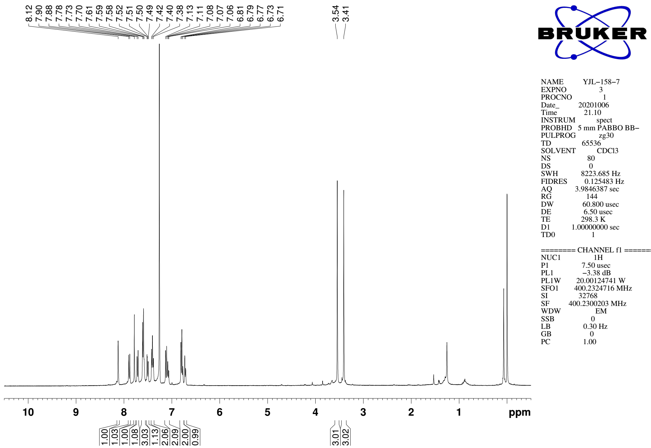
Supplementary Figure 119. ¹H NMR (CDCl₃, 400MHz) spectra of 9x

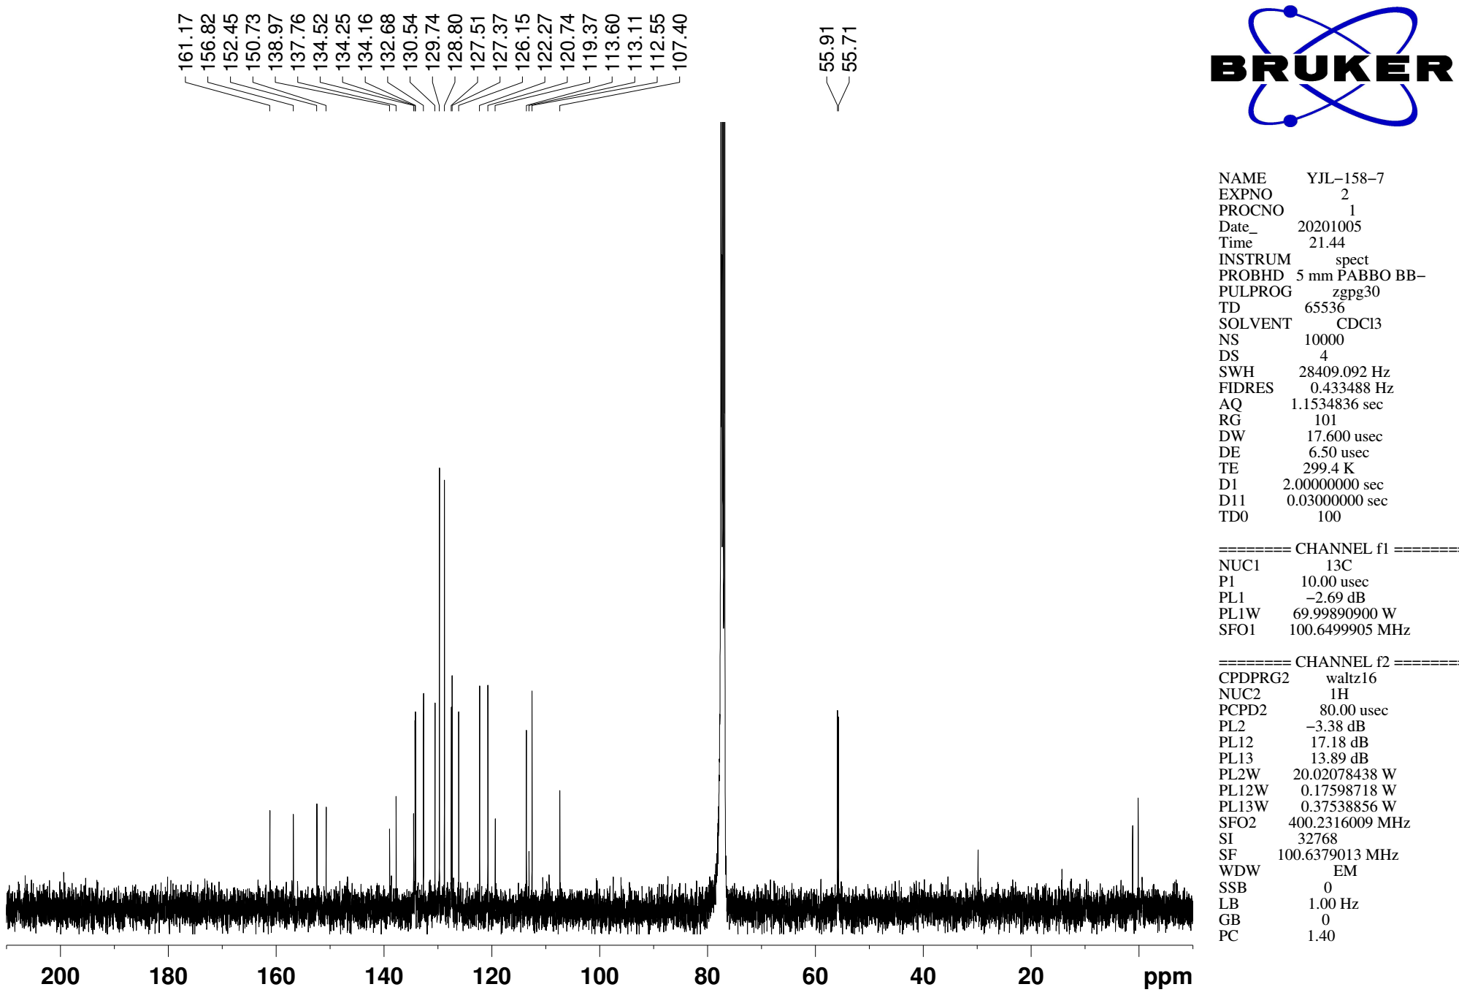
Supplementary Figure 120. ¹³C NMR (CDCl₃, 101MHz) spectra of spectra of 9x

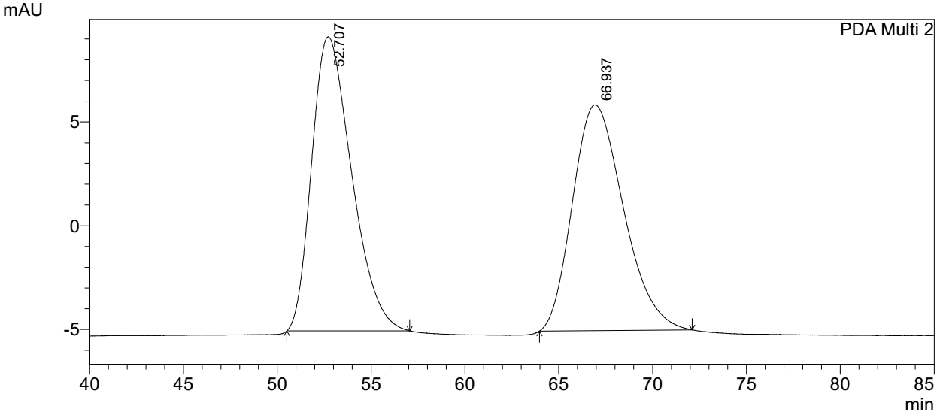
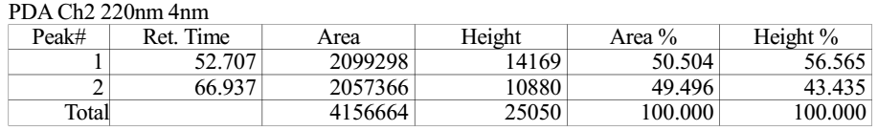

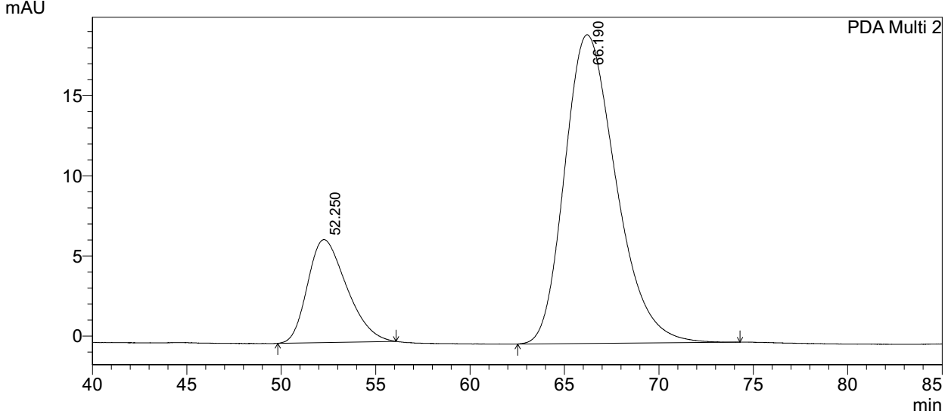
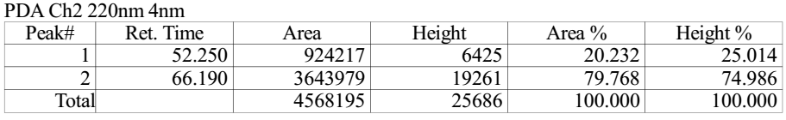
Supplementary Figure 121. HPLC spectra of 9x
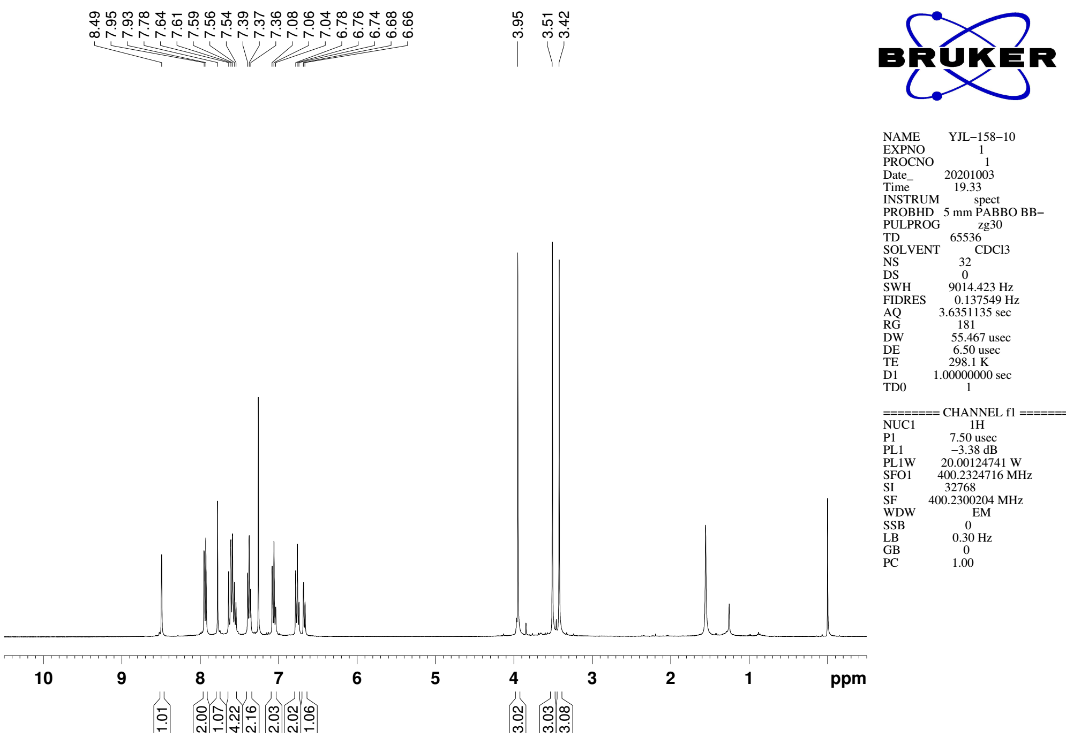
Supplementary Figure 122. ¹H NMR (CDCl₃, 400MHz) spectra of 9y

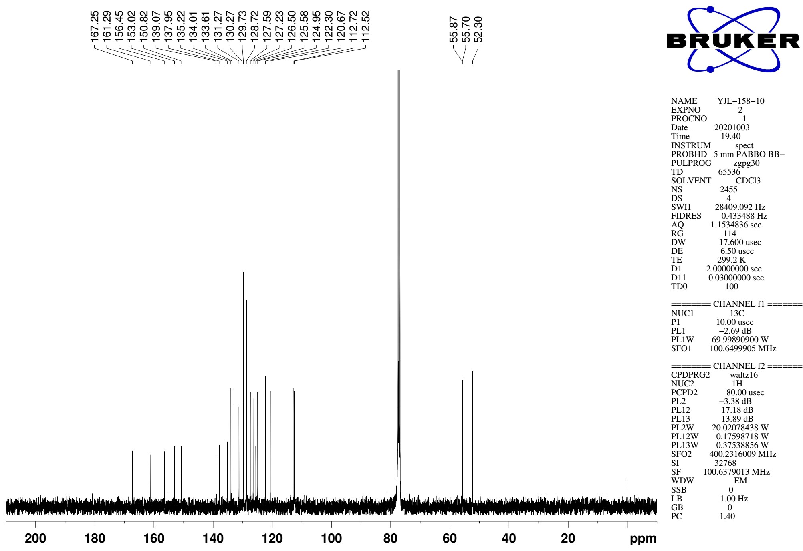
Supplementary Figure 123. ¹³C NMR (CDCl₃, 101MHz) spectra of spectra of 9y
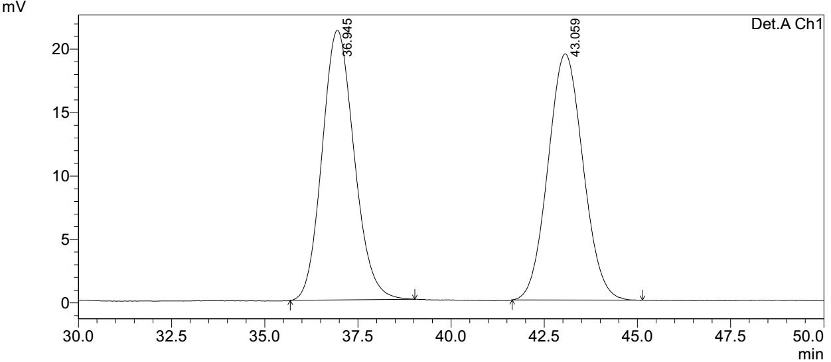
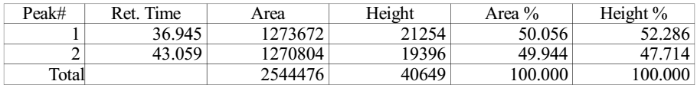

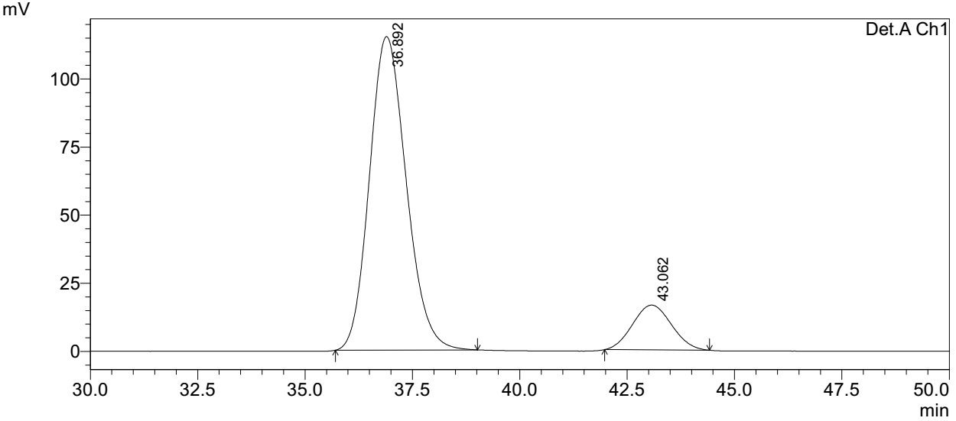
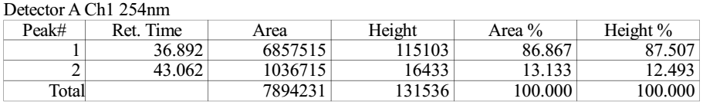
Supplementary Figure 124. HPLC spectra of 9y
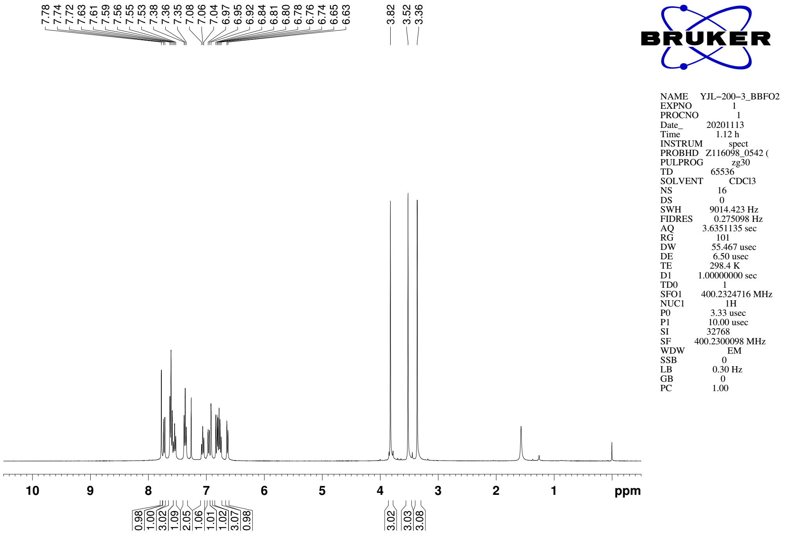
Supplementary Figure 125. ¹H NMR (CDCl₃, 400MHz) spectra of 9z

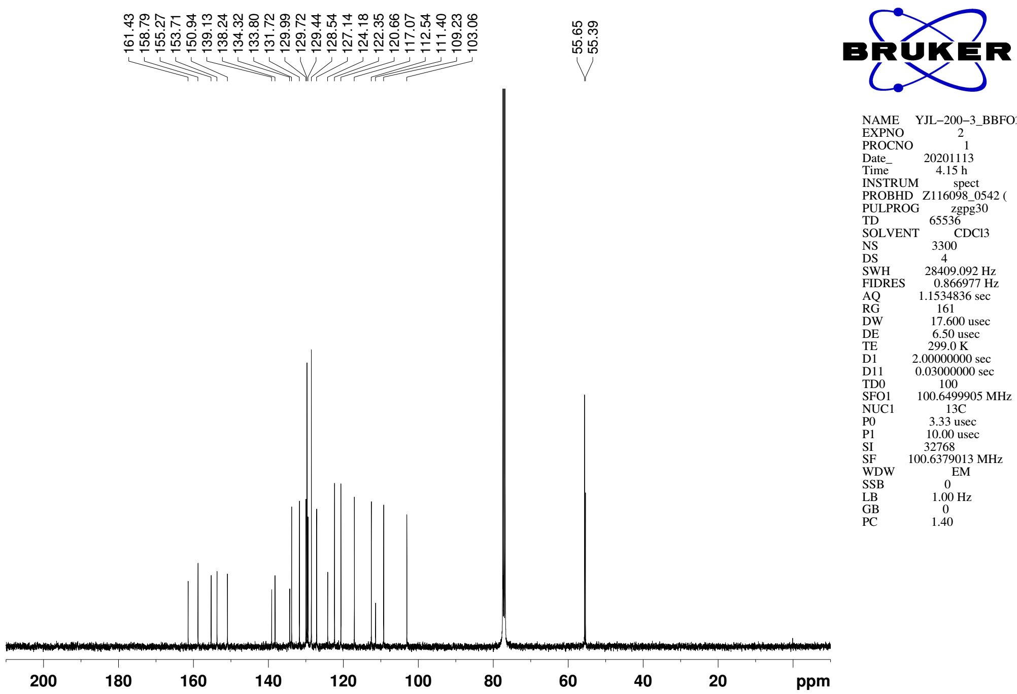
Supplementary Figure 126. ¹³C NMR (CDCl₃, 101MHz) spectra of spectra of 9z

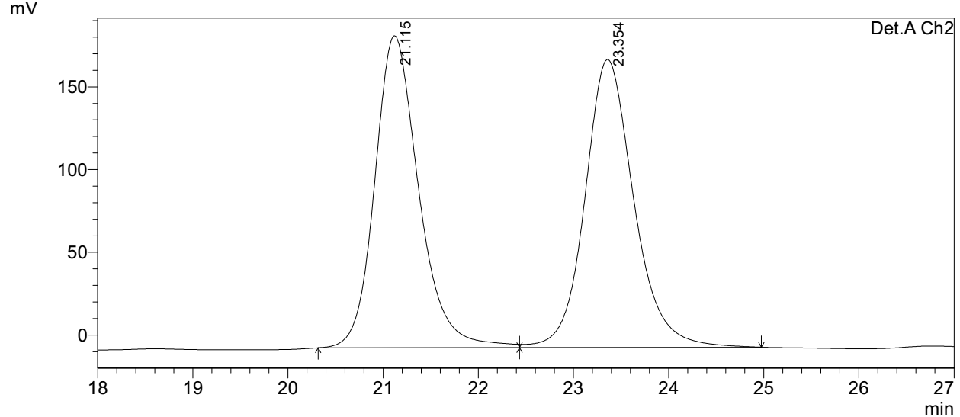
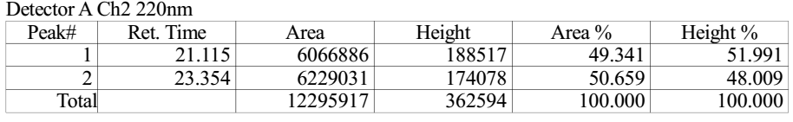

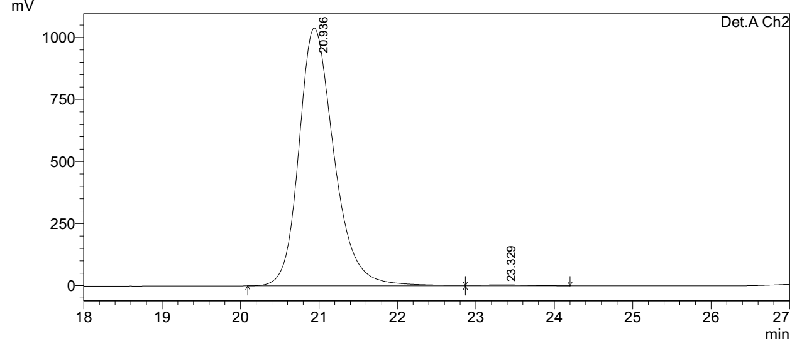
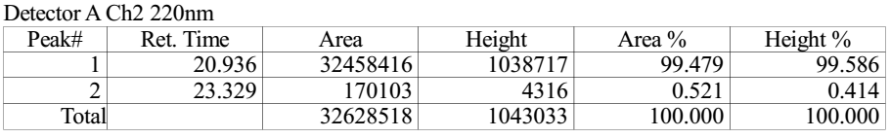
Supplementary Figure 127. HPLC spectra of 9z
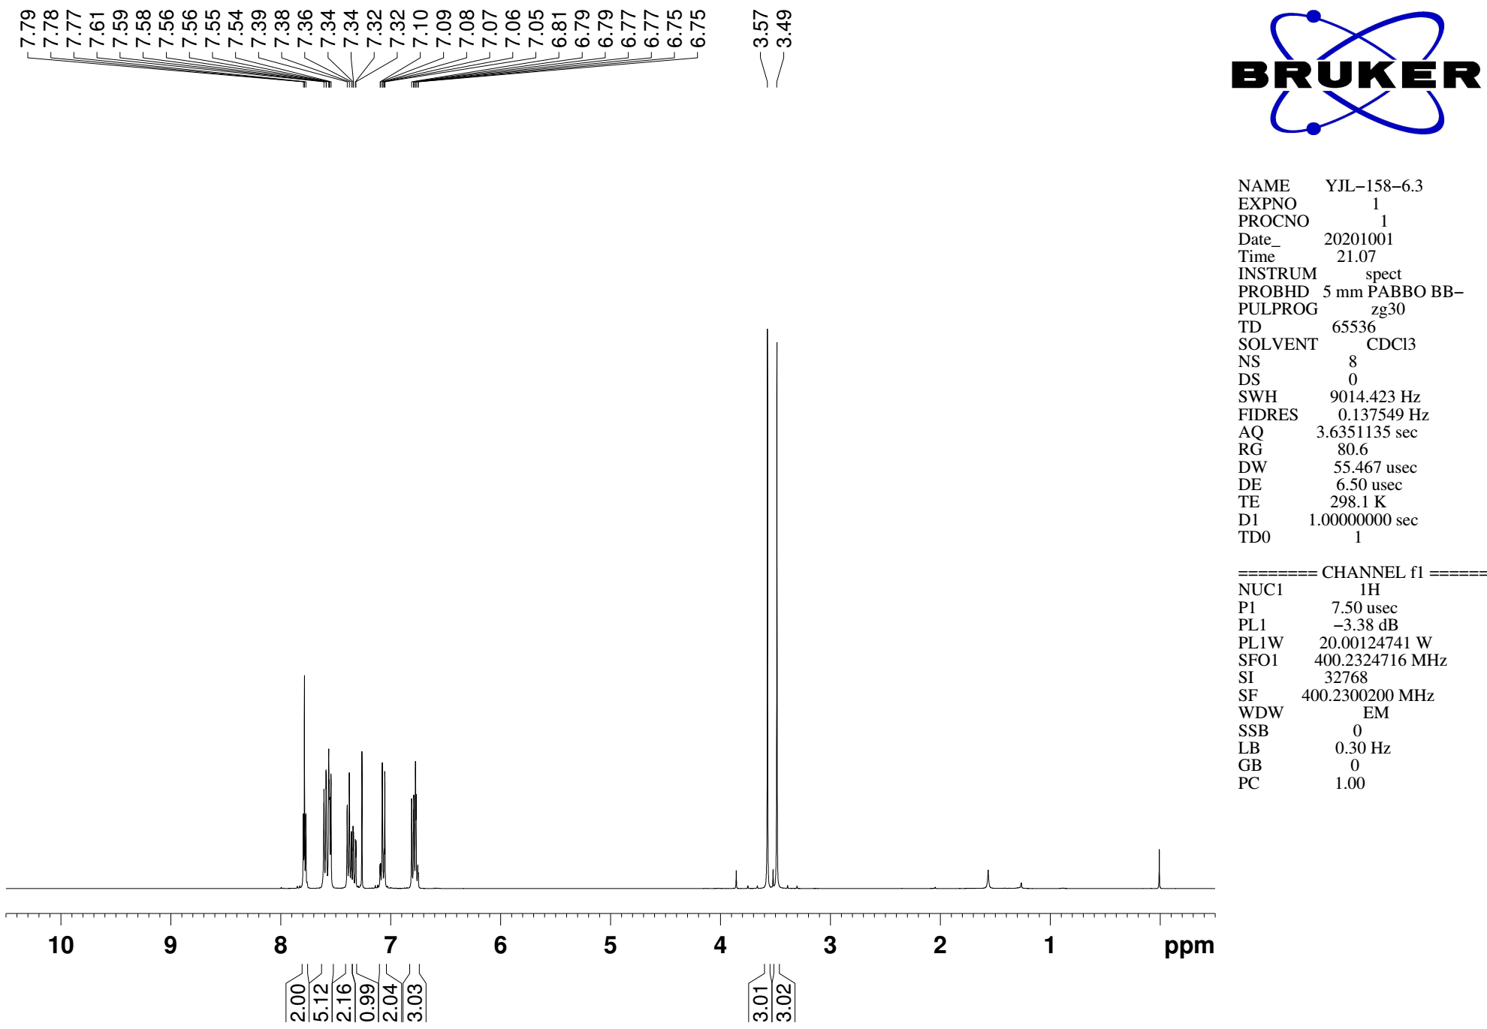
Supplementary Figure 128. ¹H NMR (CDCl₃, 400MHz) spectra of 9aa

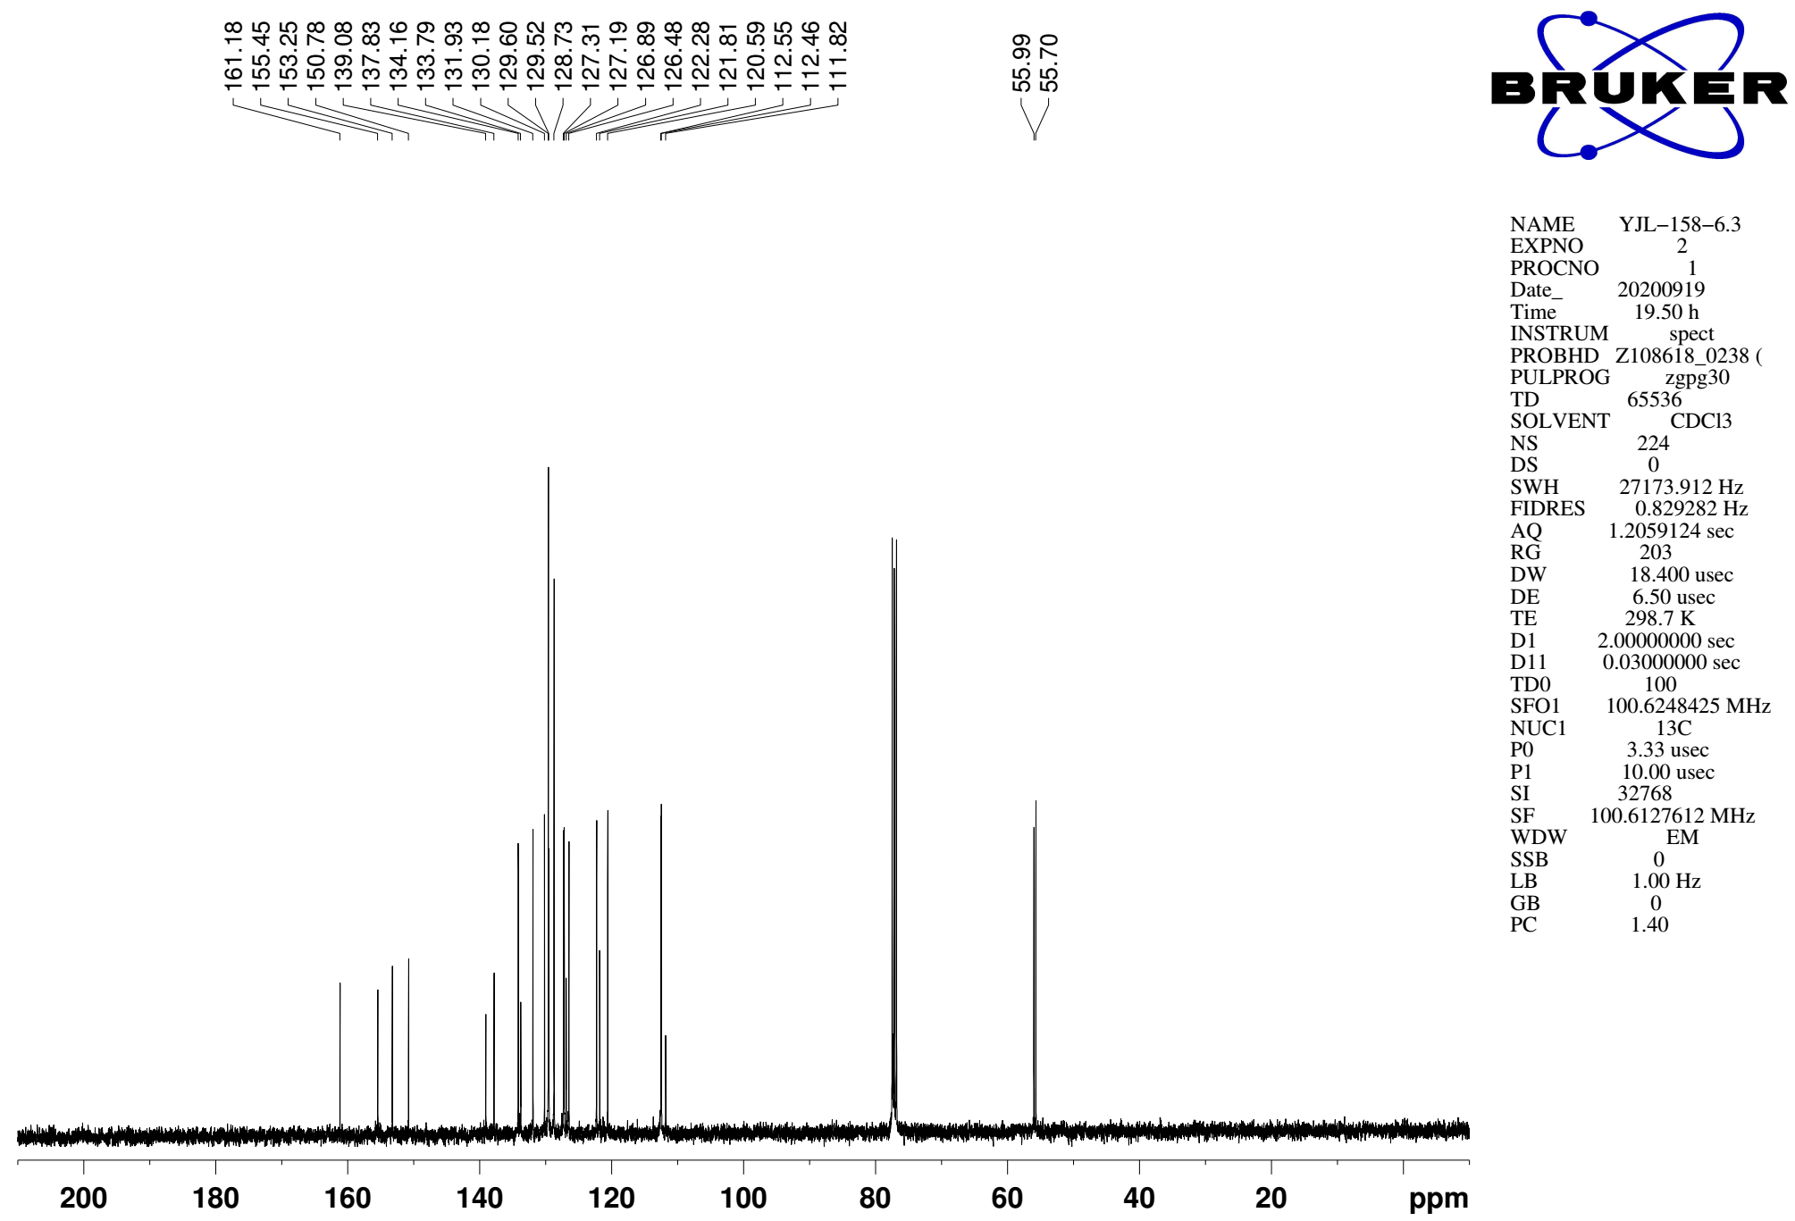
Supplementary Figure 129. ¹³C NMR (CDCl₃, 101MHz) spectra of spectra of 9aa

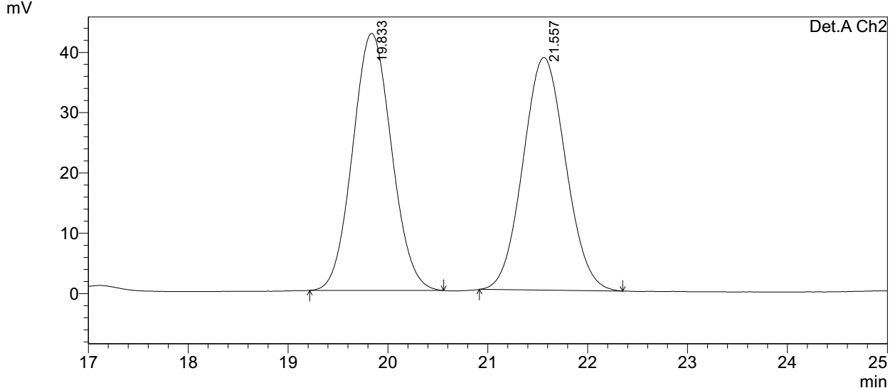
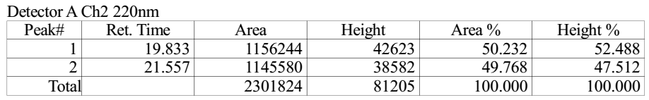

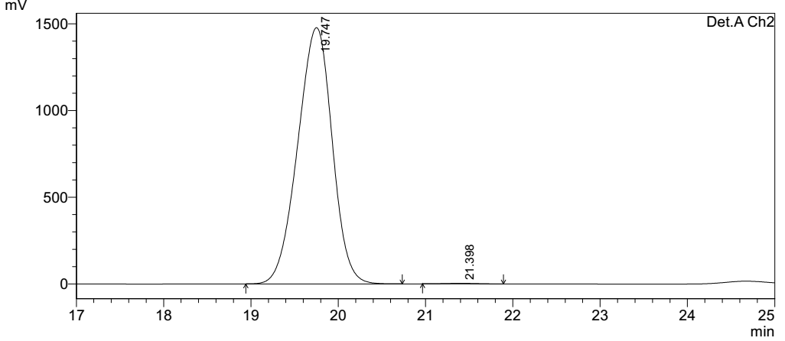
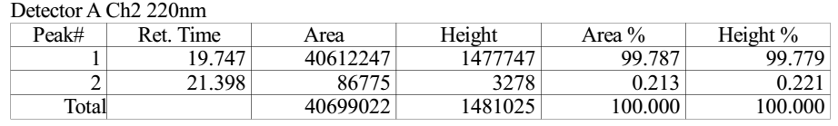
Supplementary Figure 130. HPLC spectra of 9aa
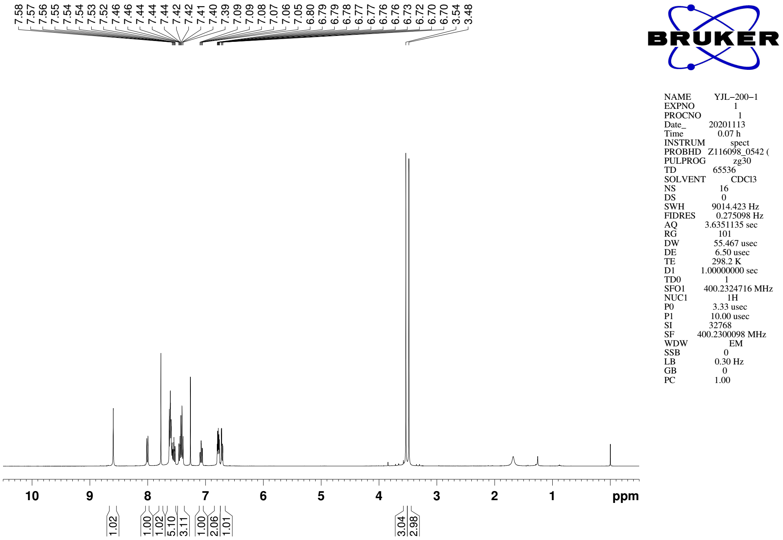
Supplementary Figure 131. ¹H NMR (CDCl₃, 400MHz) spectra of 9ab

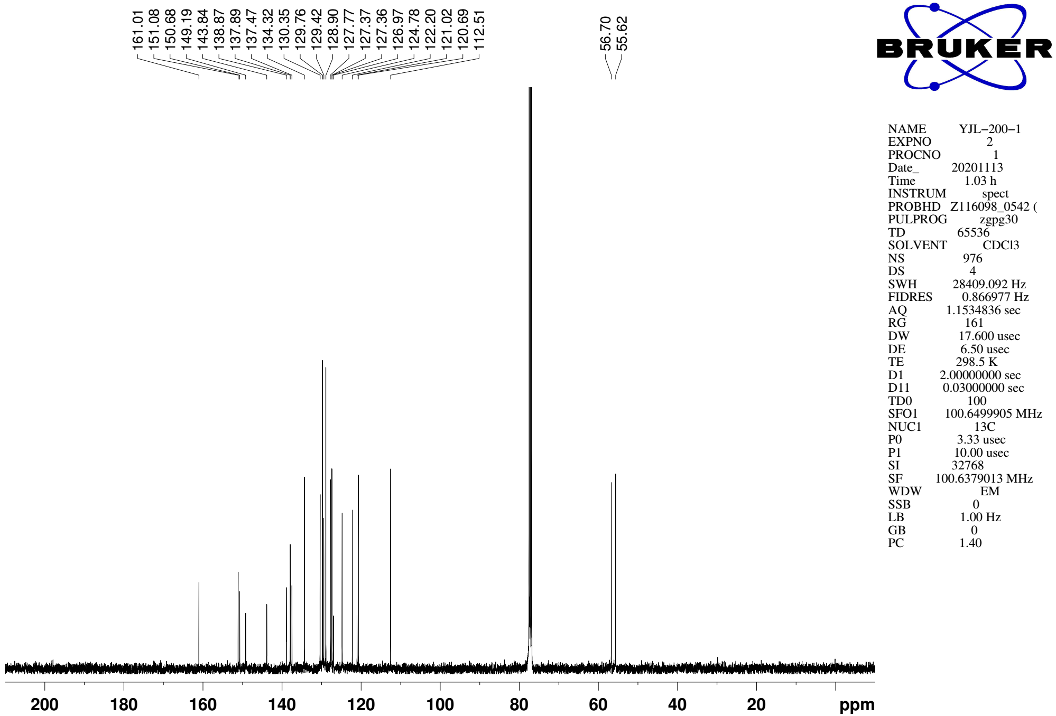
Supplementary Figure 132. ¹³C NMR (CDCl₃, 101MHz) spectra of spectra of 9ab

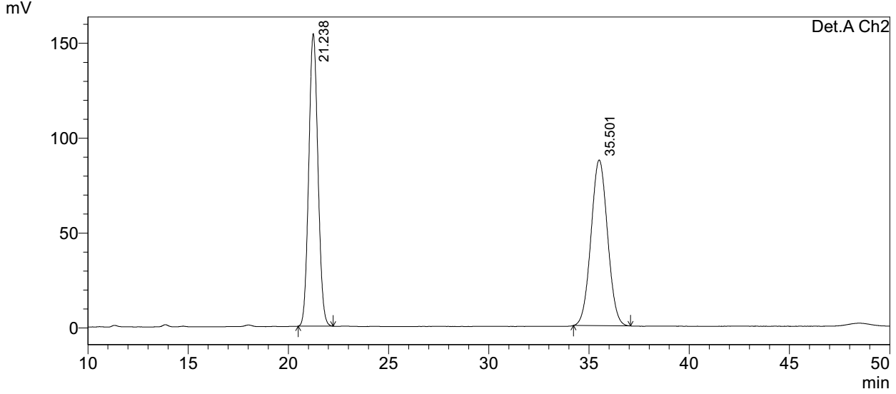
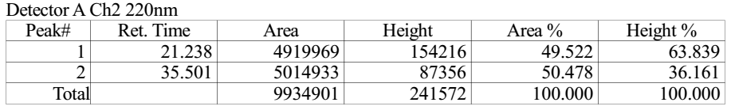

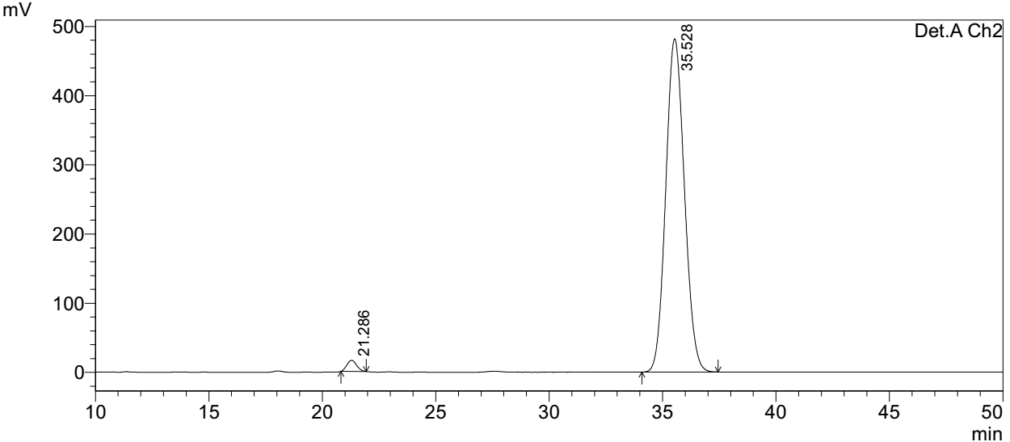
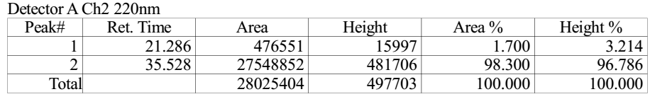
Supplementary Figure 133. HPLC spectra of 9ab
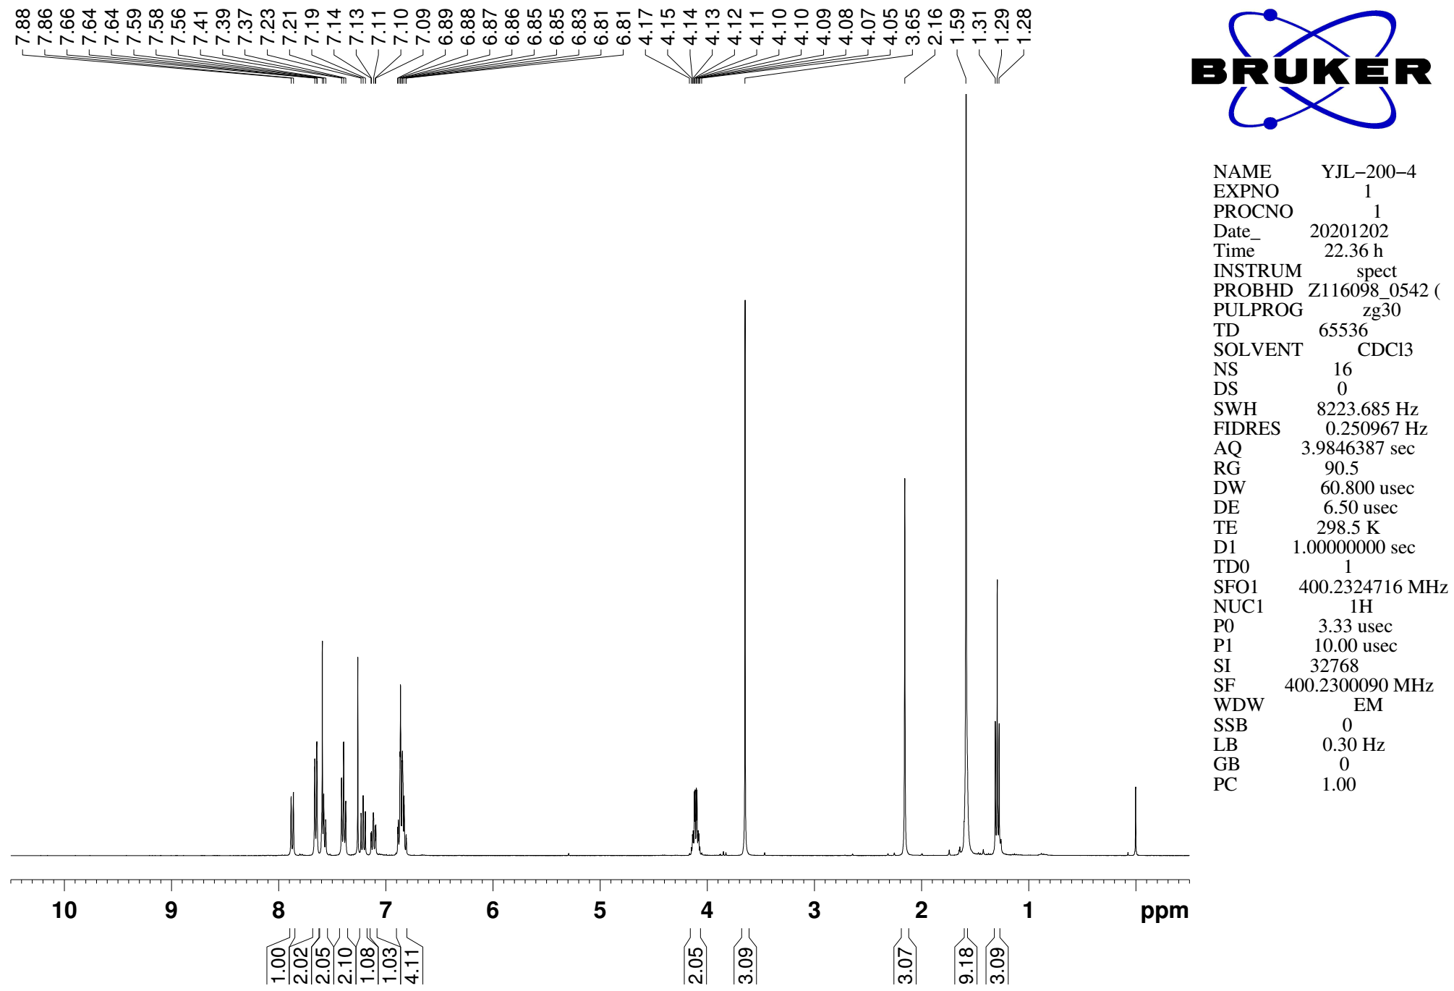
Supplementary Figure 134. ¹H NMR (CDCl₃, 400MHz) spectra of 9ac

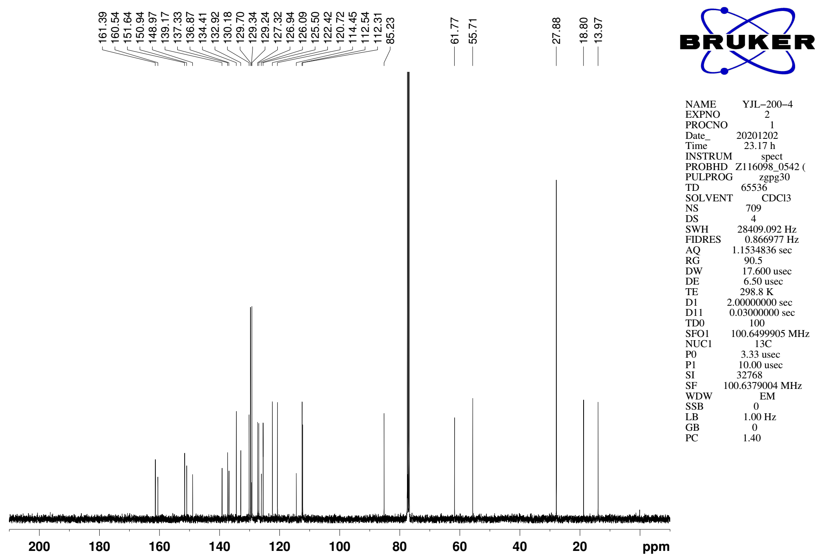
Supplementary Figure 135. ¹³C NMR (CDCl₃, 101MHz) spectra of spectra of 9ac

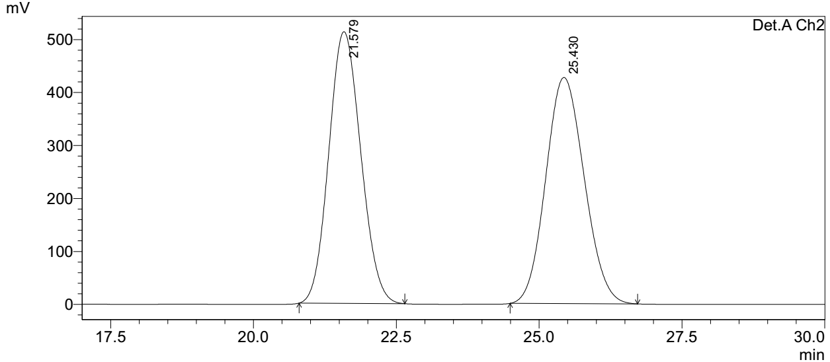
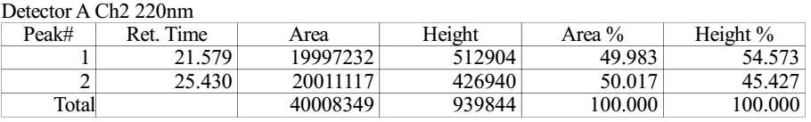

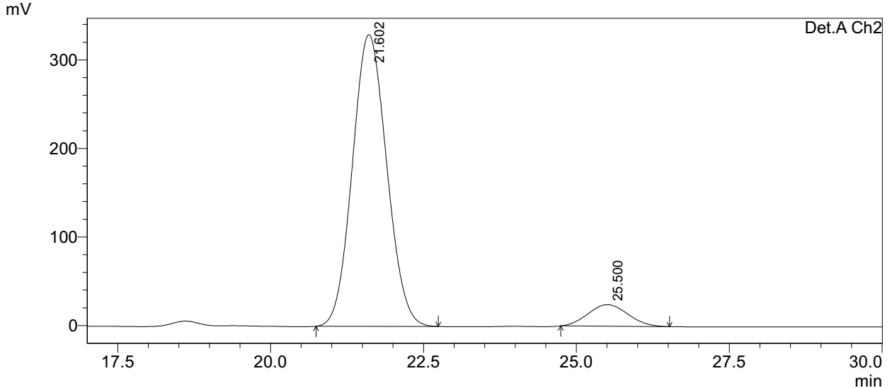
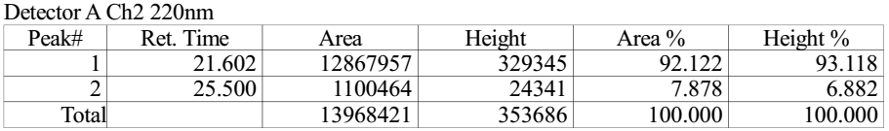
Supplementary Figure 136. HPLC spectra of 9ac
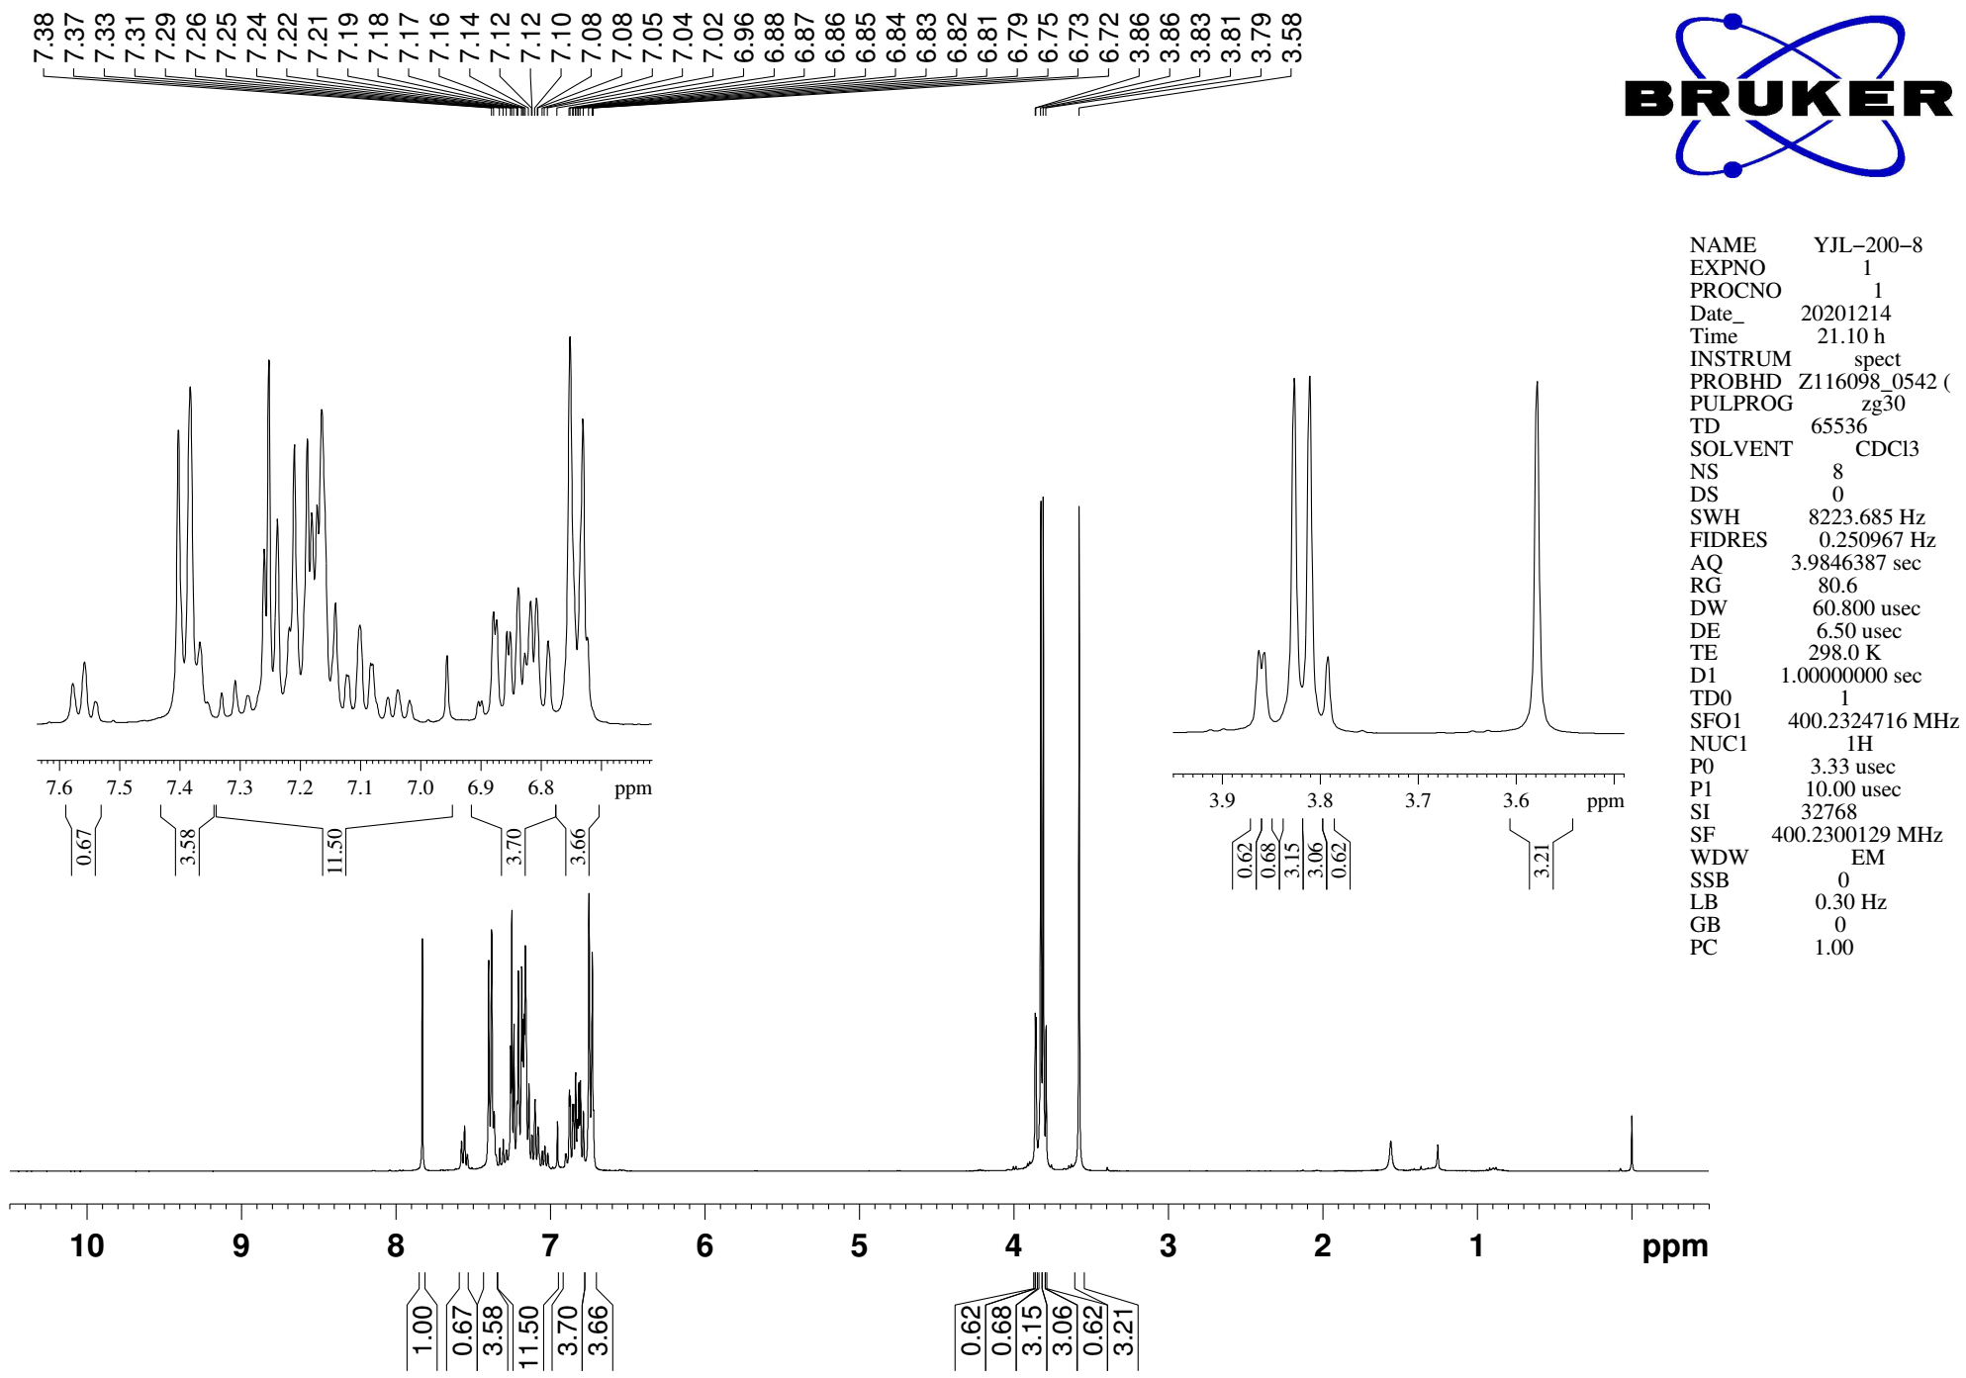
Supplementary Figure 137. ¹H NMR (CDCl₃, 400MHz) spectra of 9ad

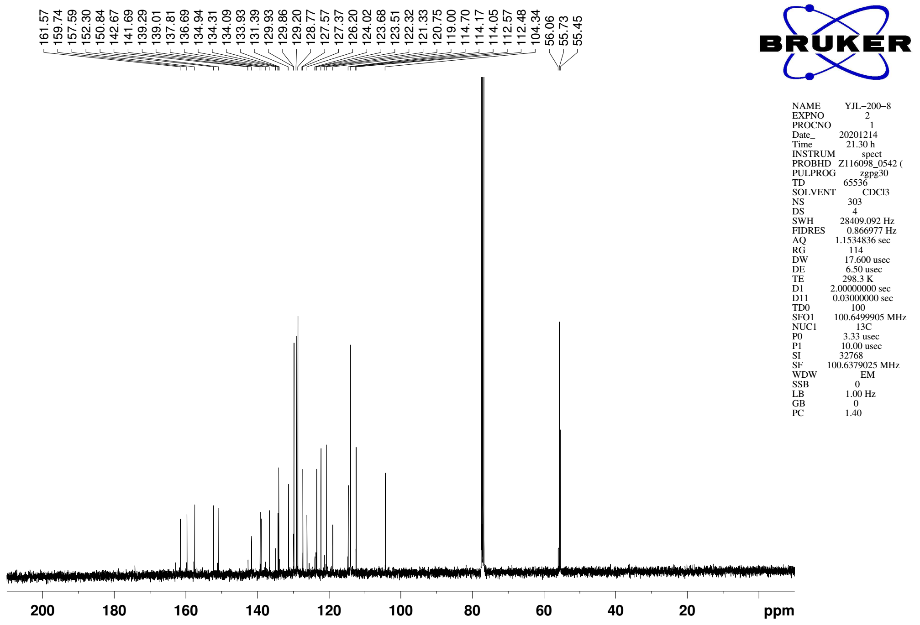
Supplementary Figure 138. ¹³C NMR (CDCl₃, 101MHz) spectra of spectra of 9ad

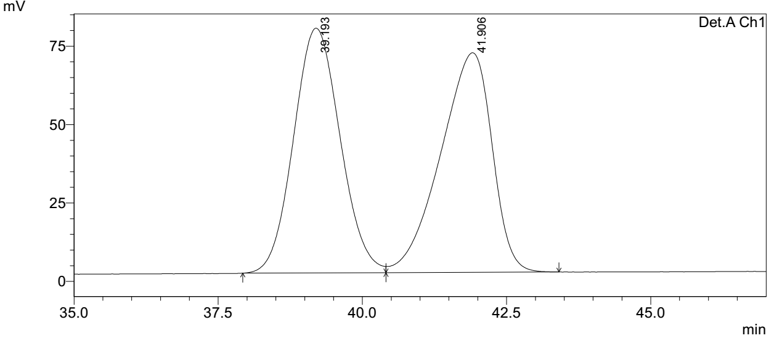
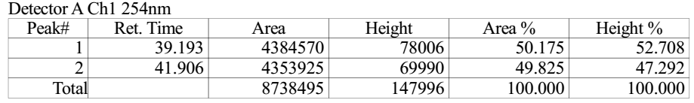

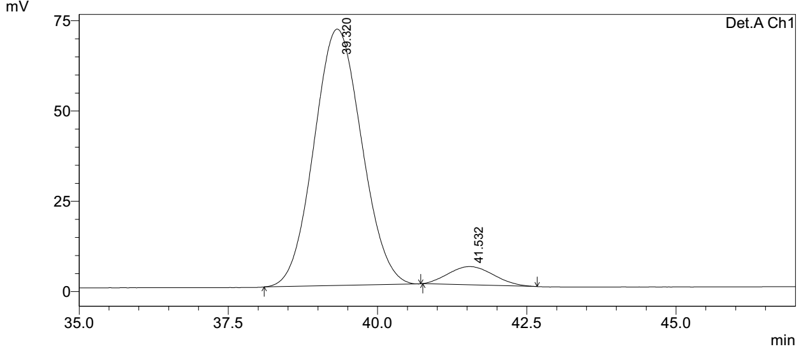
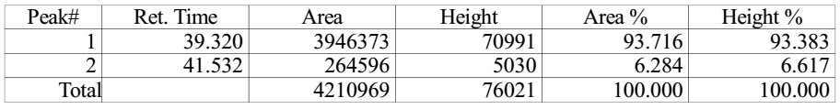
Supplementary Figure 139. HPLC spectra of 9ad
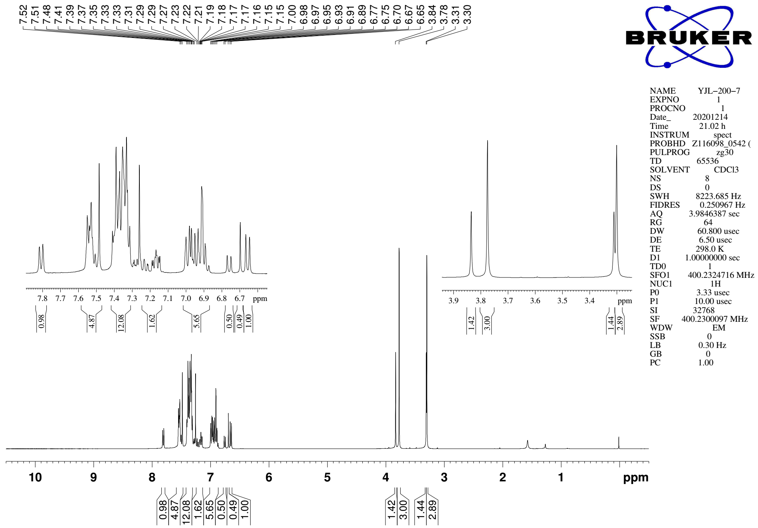
Supplementary Figure 140. ¹H NMR (CDCl₃, 400MHz) spectra of 9ae

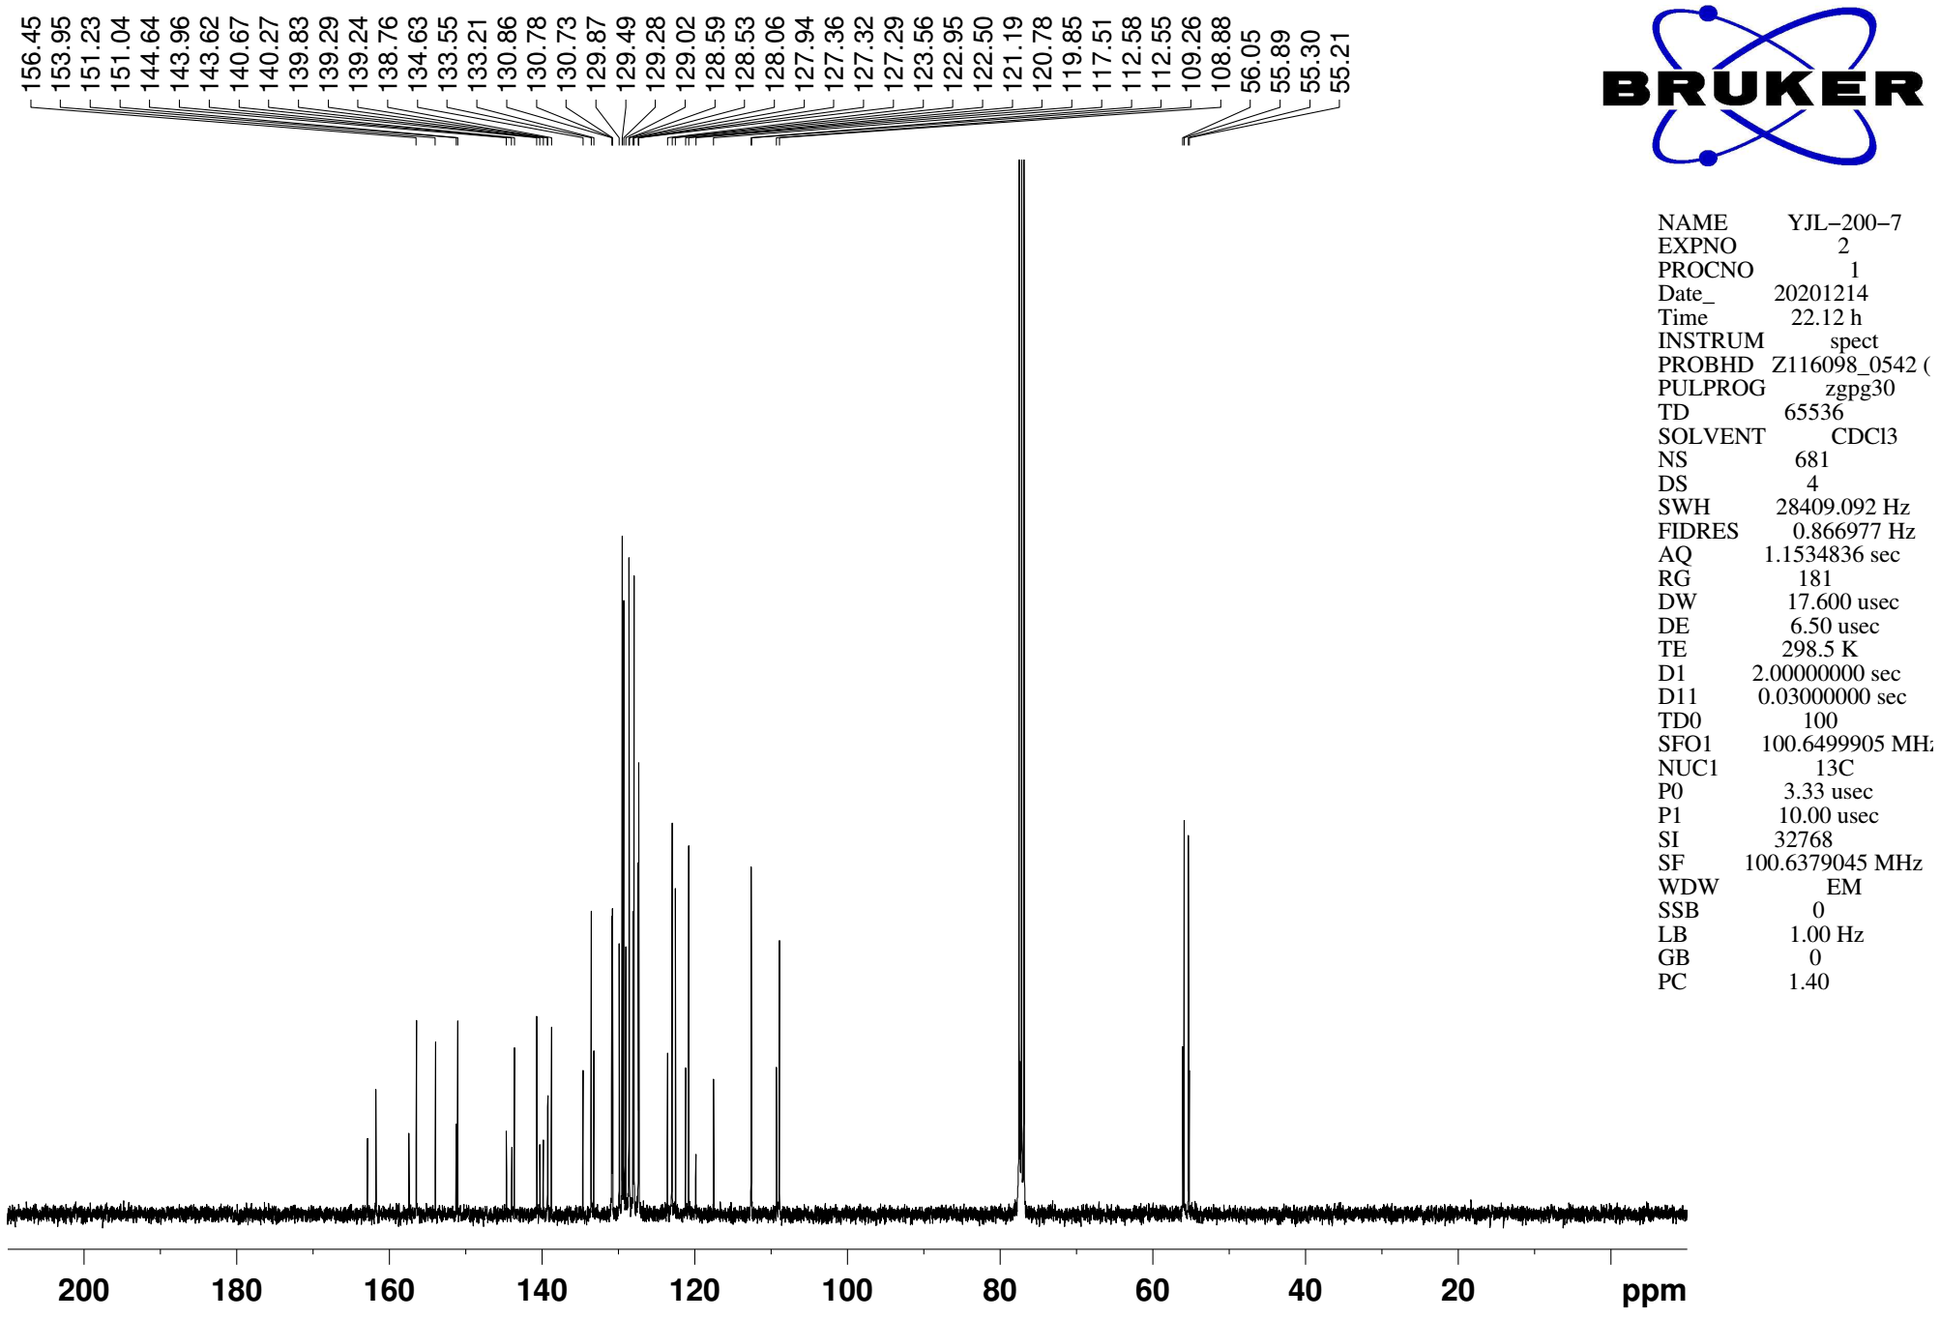
Supplementary Figure 141. ¹³C NMR (CDCl₃, 101MHz) spectra of spectra of 9ae
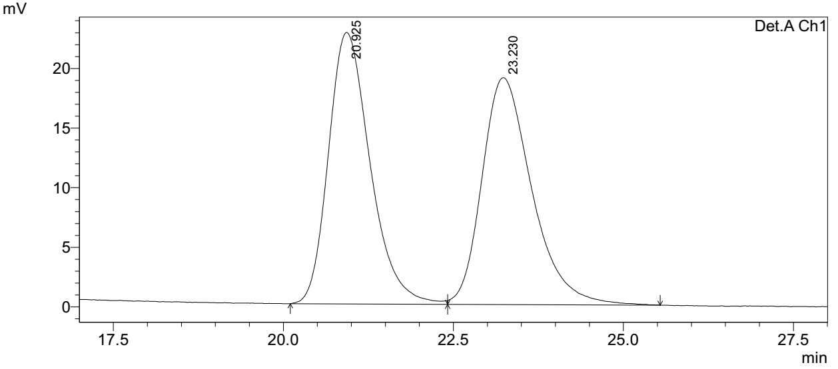
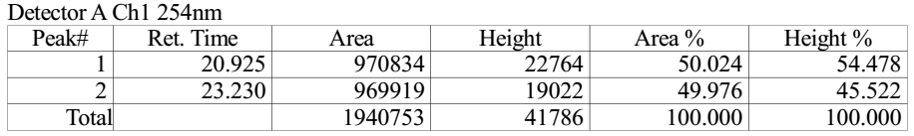

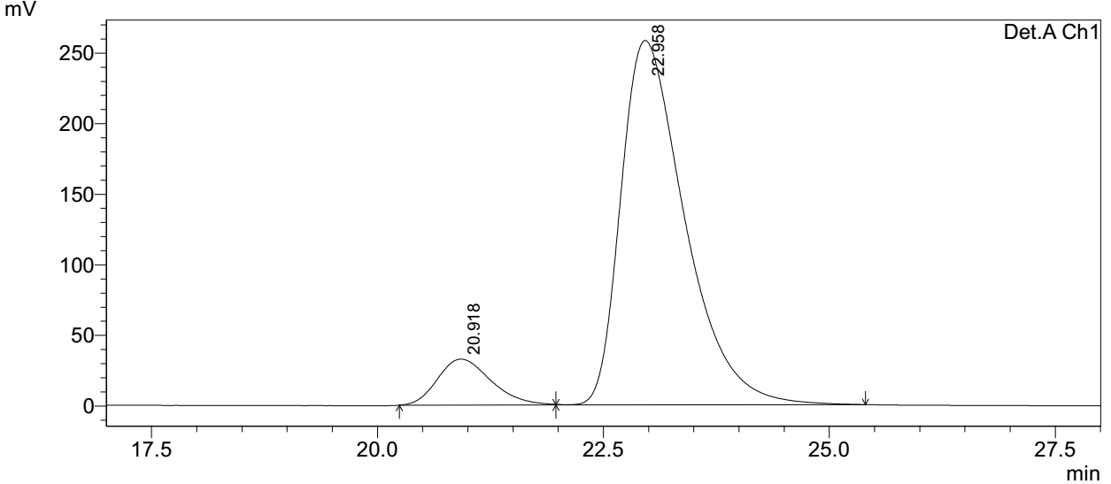
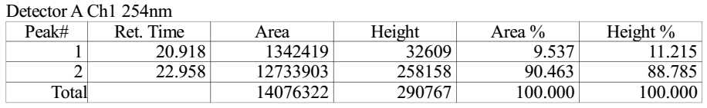
Supplementary Figure 142. HPLC spectra of 9ae
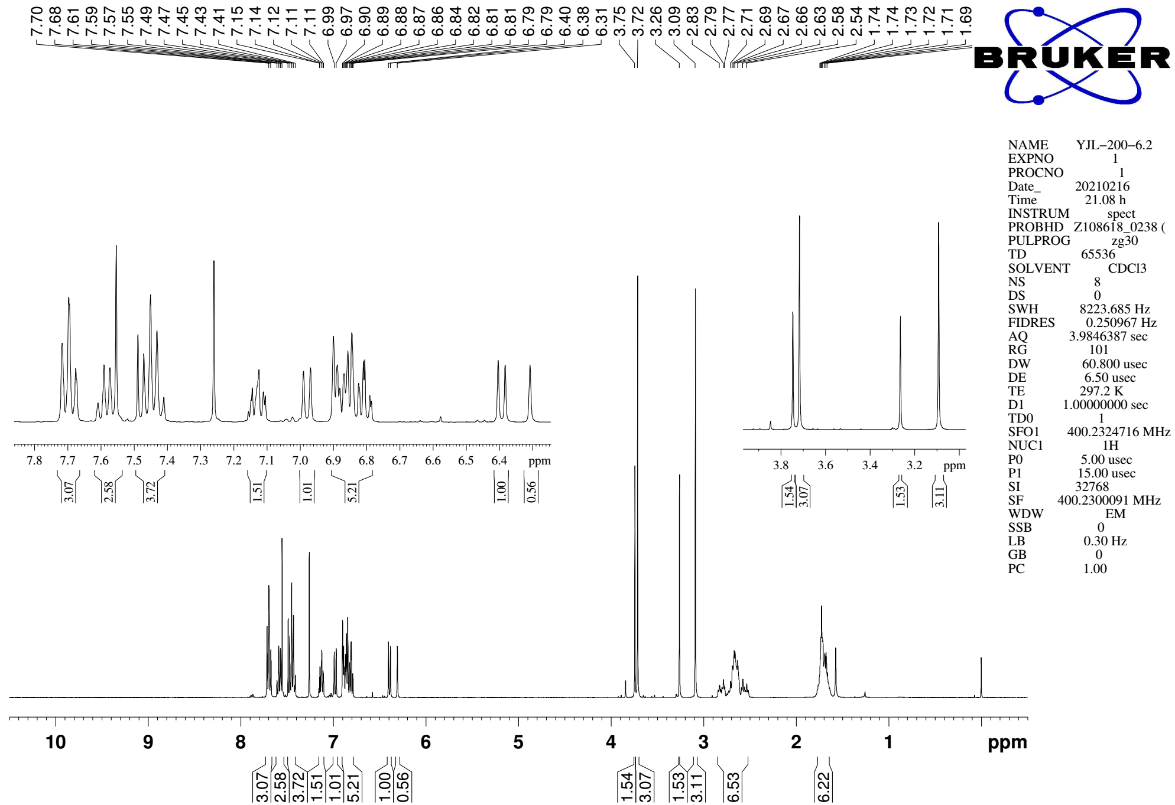
Supplementary Figure 143. ¹H NMR (CDCl₃, 400MHz) spectra of 9f

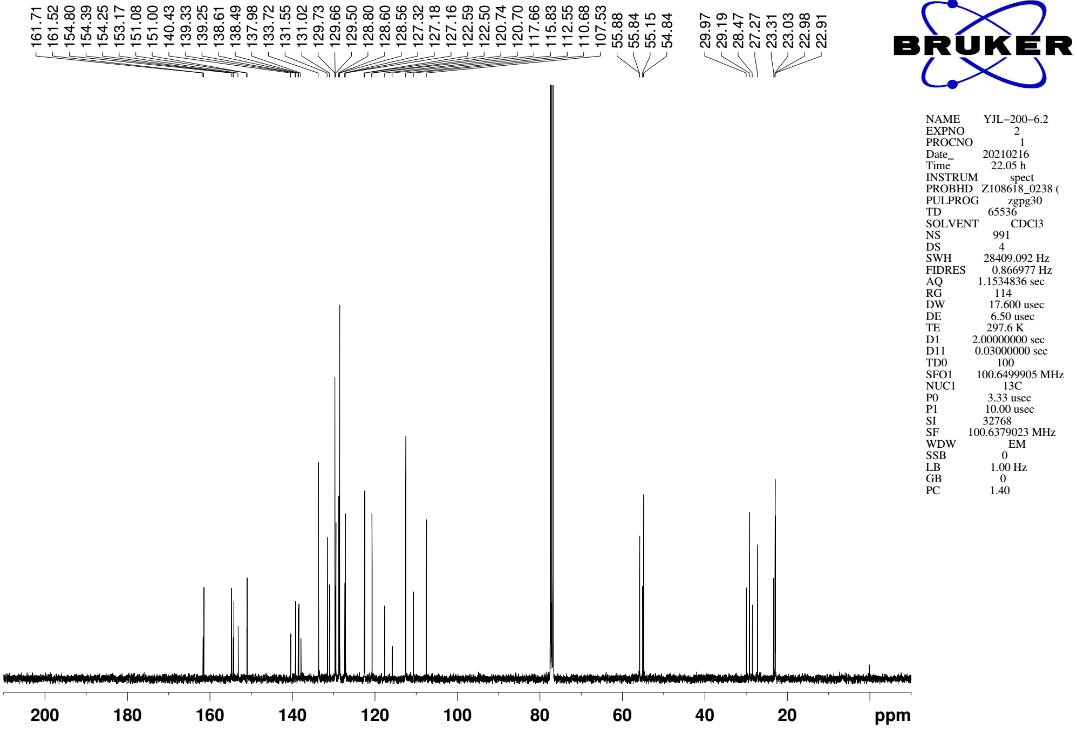
Supplementary Figure 144. ¹³C NMR (CDCl₃, 101MHz) spectra of spectra of 9f

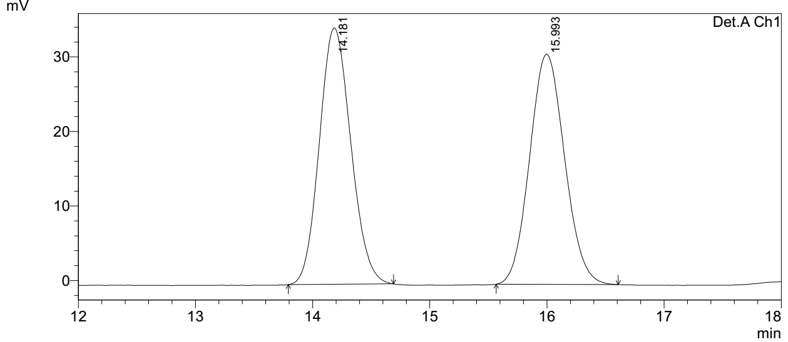
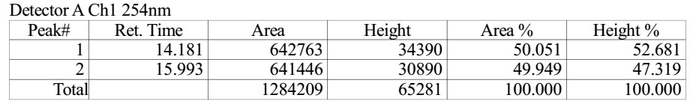

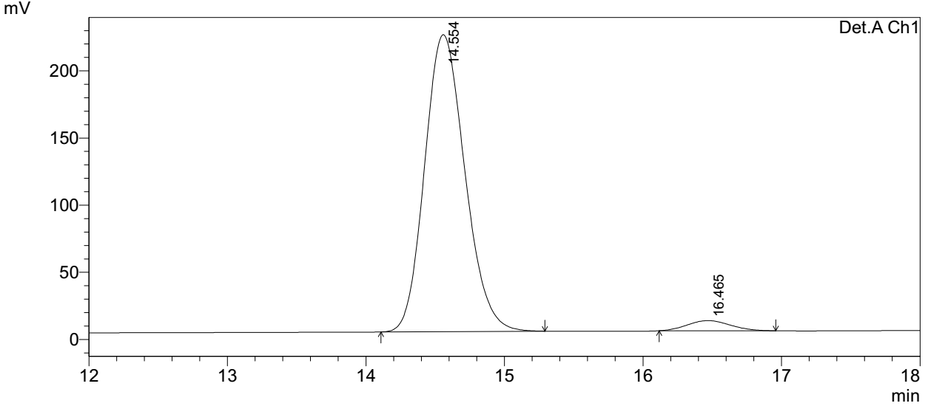
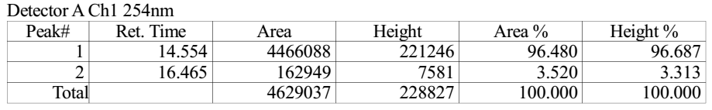
Supplementary Figure 145. HPLC spectra of 9af
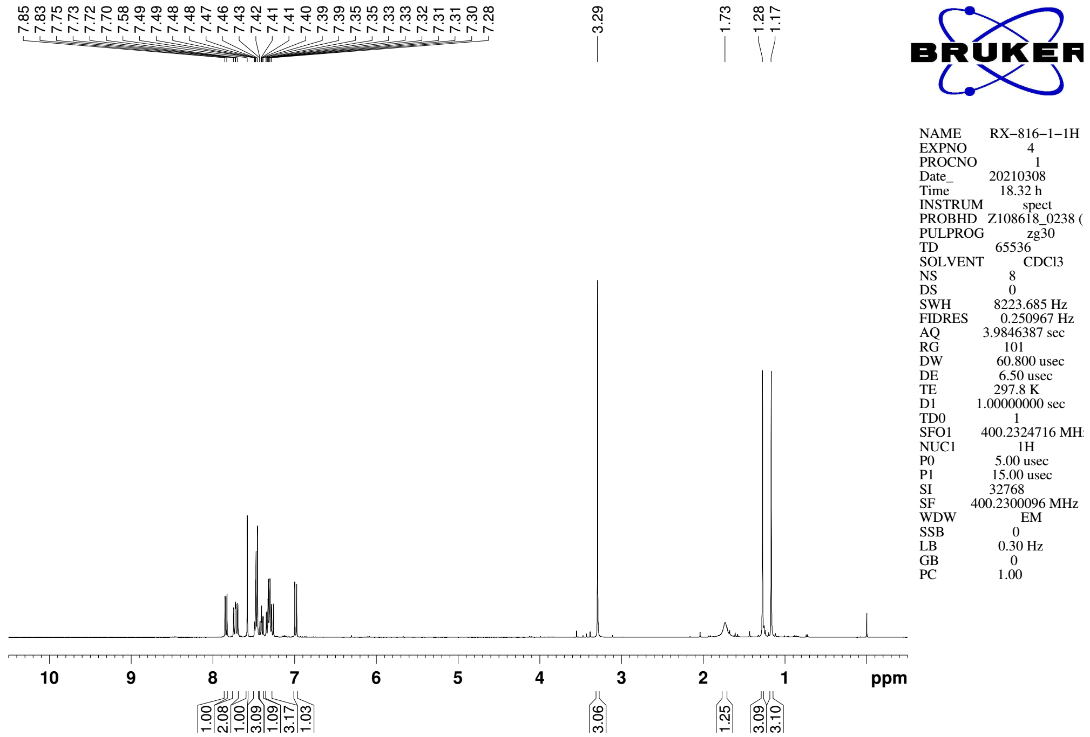
Supplementary Figure 146. ¹H NMR (CDCl₃, 400MHz) spectra of 10a

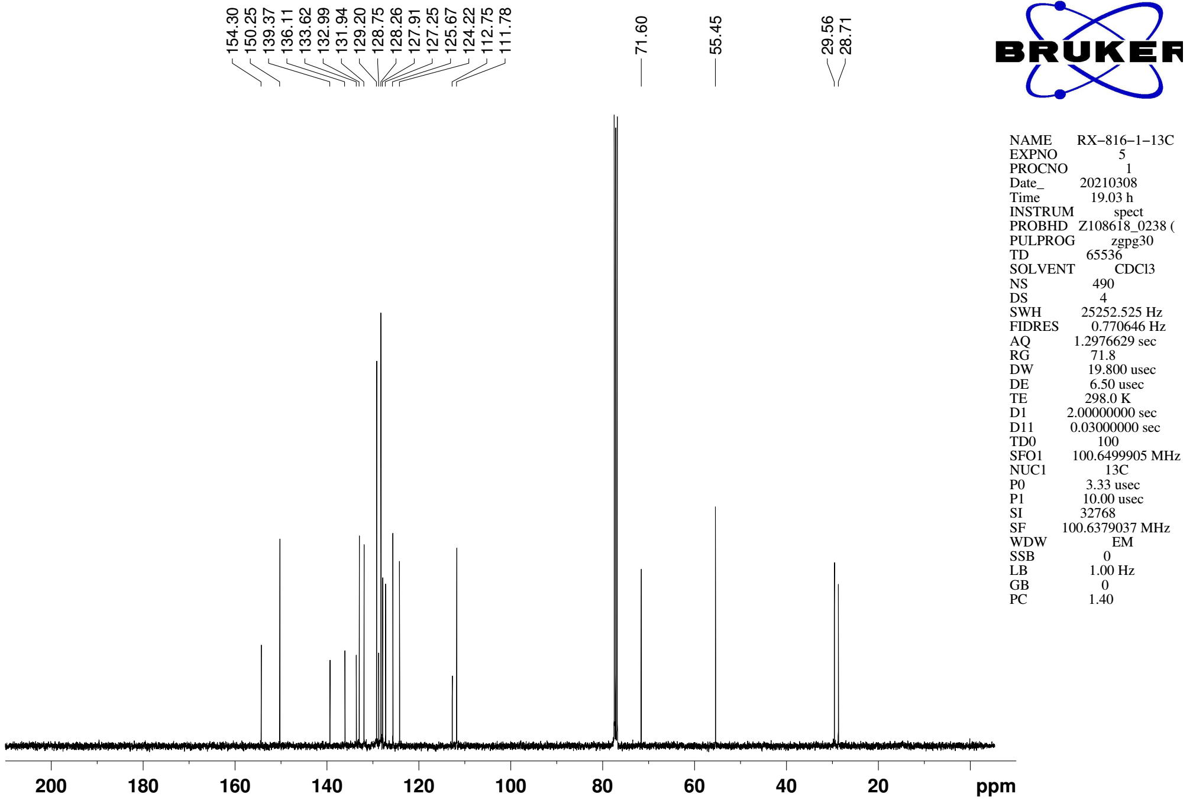
Supplementary Figure 147. ¹³C NMR (CDCl₃, 101MHz) spectra of spectra of 10a

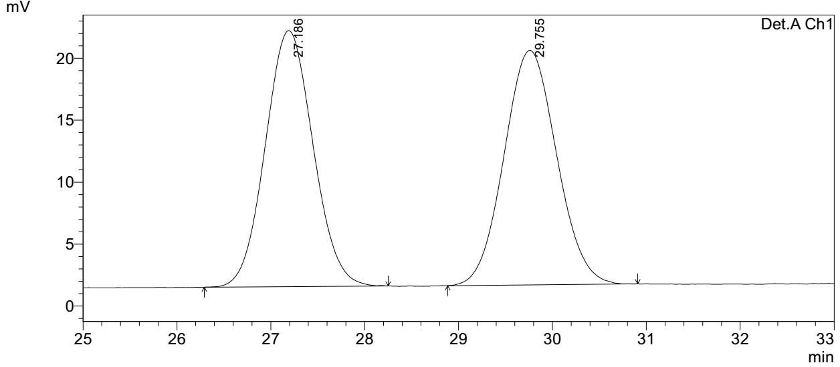
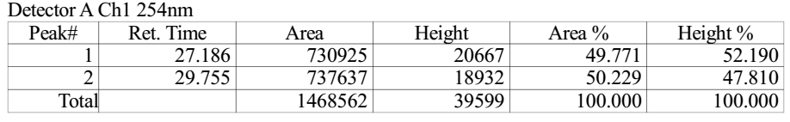

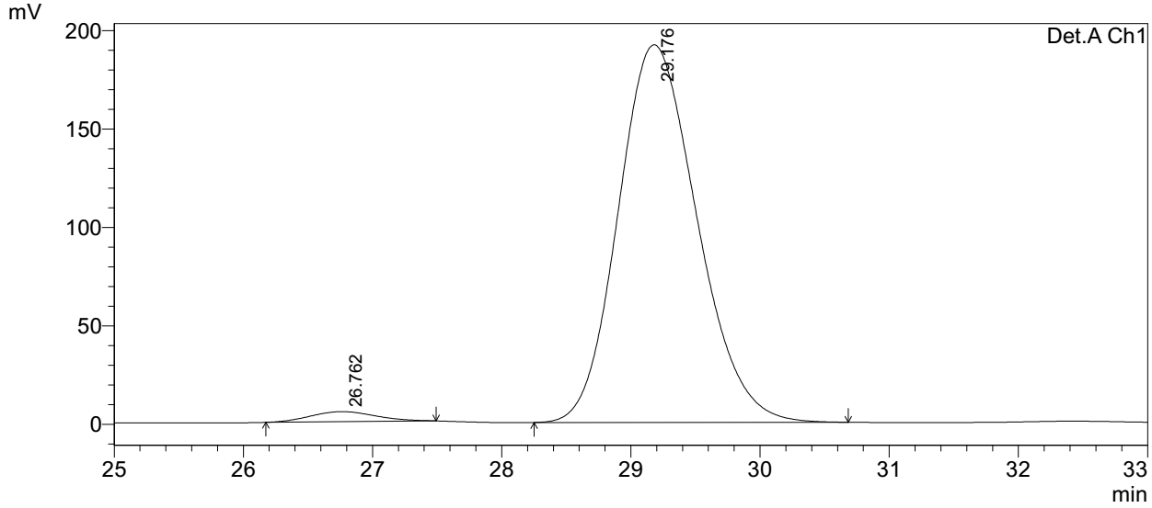
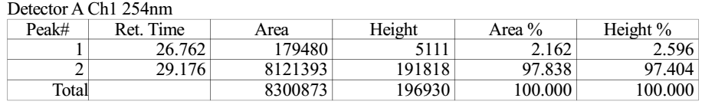
Supplementary Figure 148. HPLC spectra of 10a
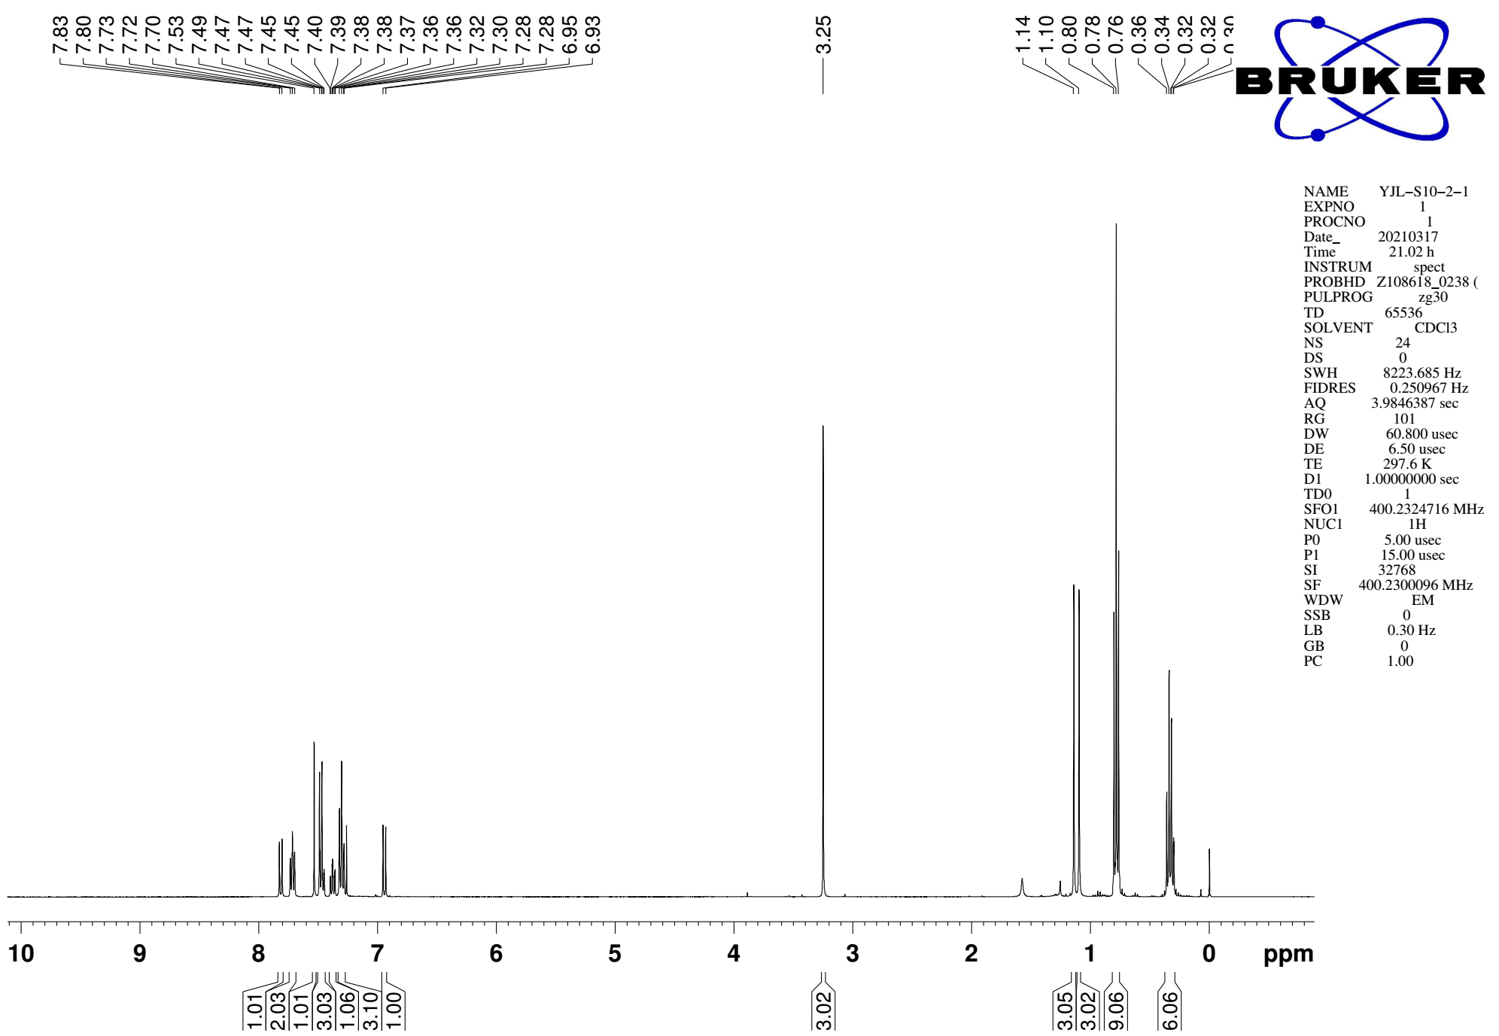
Supplementary Figure 149. ¹H NMR (CDCl₃, 400MHz) spectra of S20

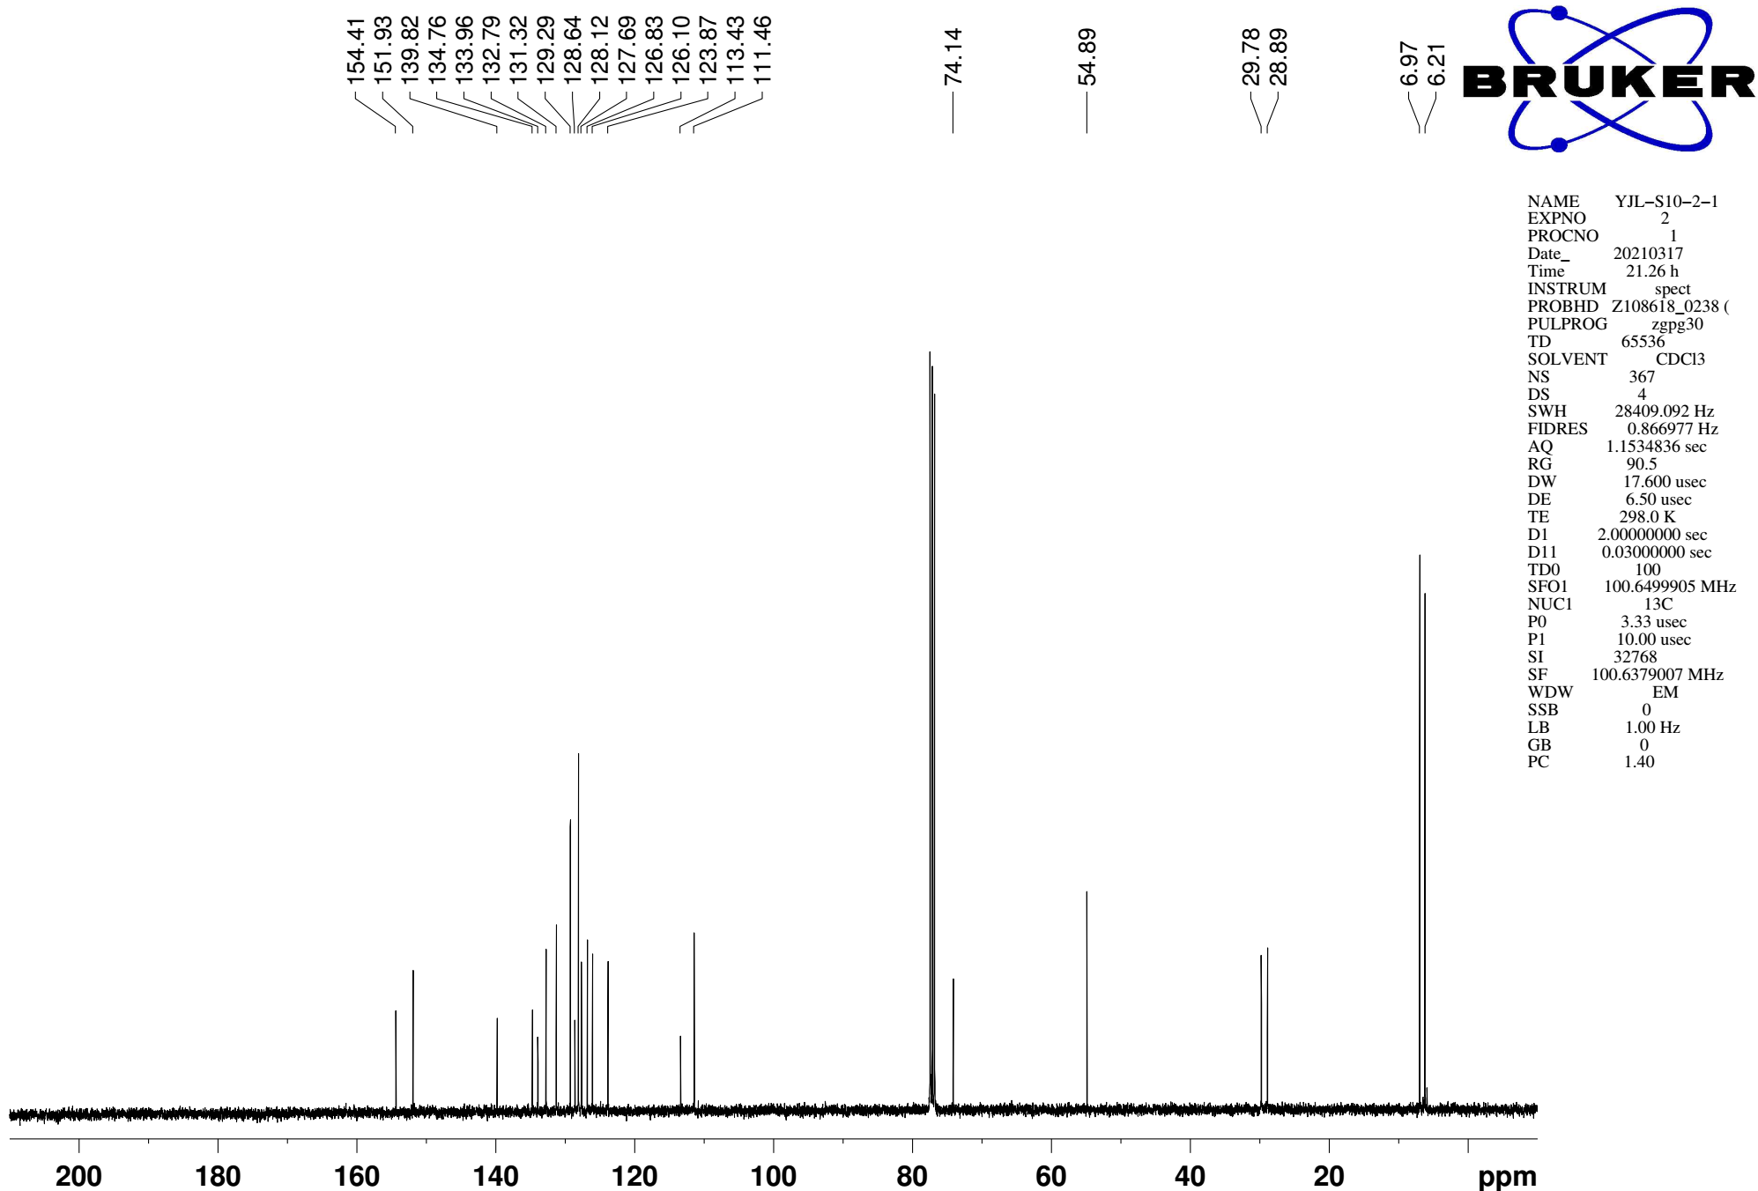
Supplementary Figure 150. ¹³C NMR (CDCl₃, 101MHz) spectra of spectra of S20

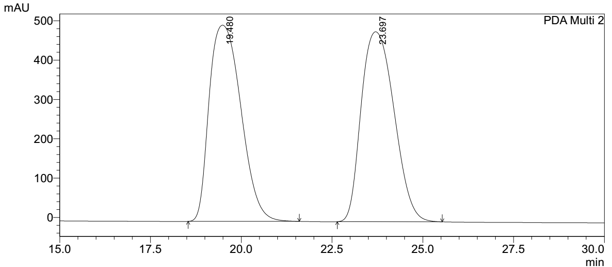
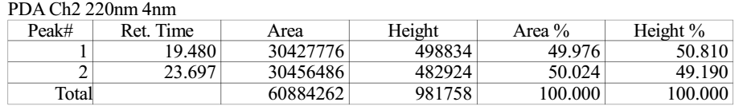

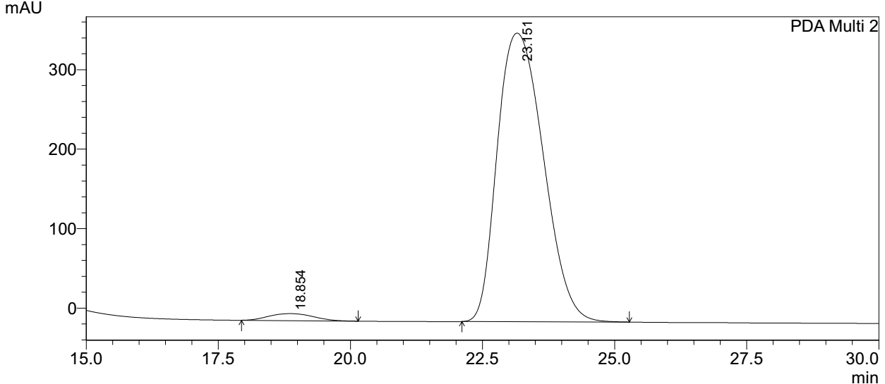
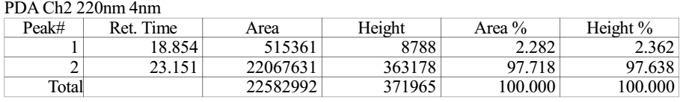
Supplementary Figure 151. HPLC spectra of S20
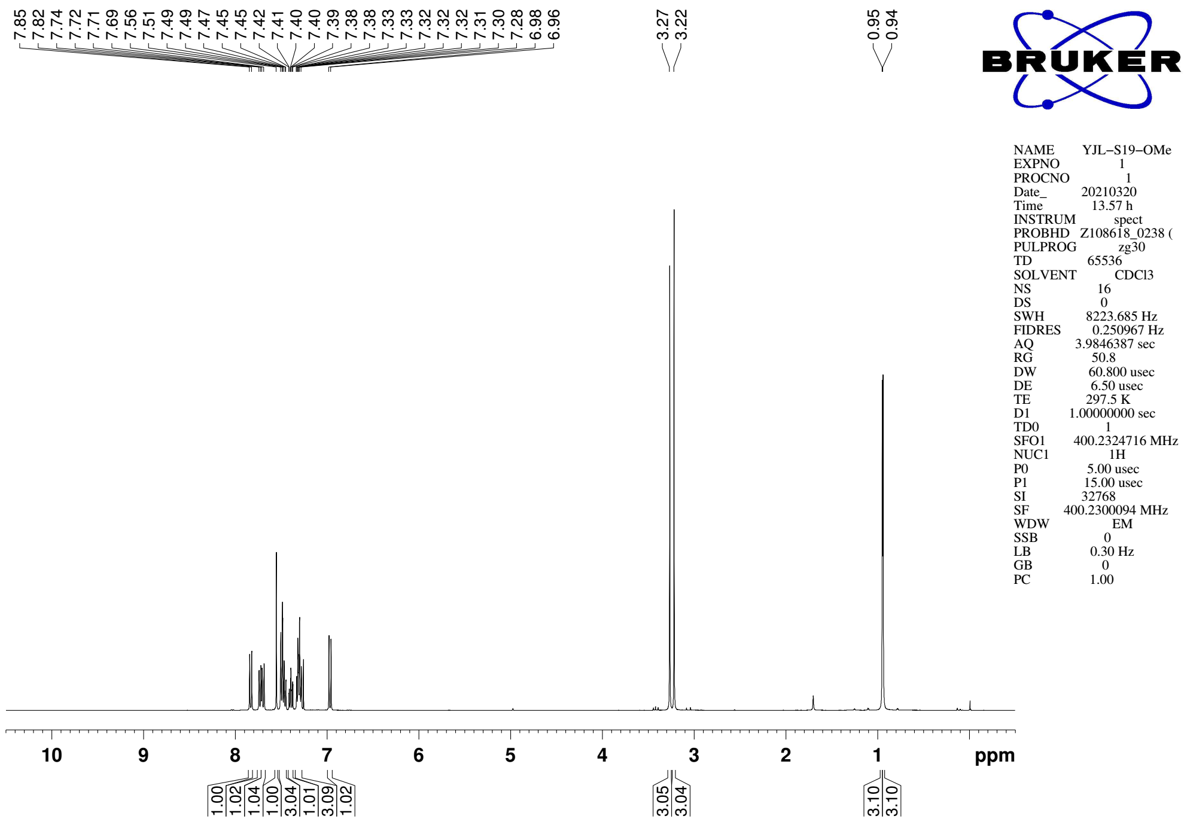
Supplementary Figure 152. ¹H NMR (CDCl₃, 400MHz) spectra of S21

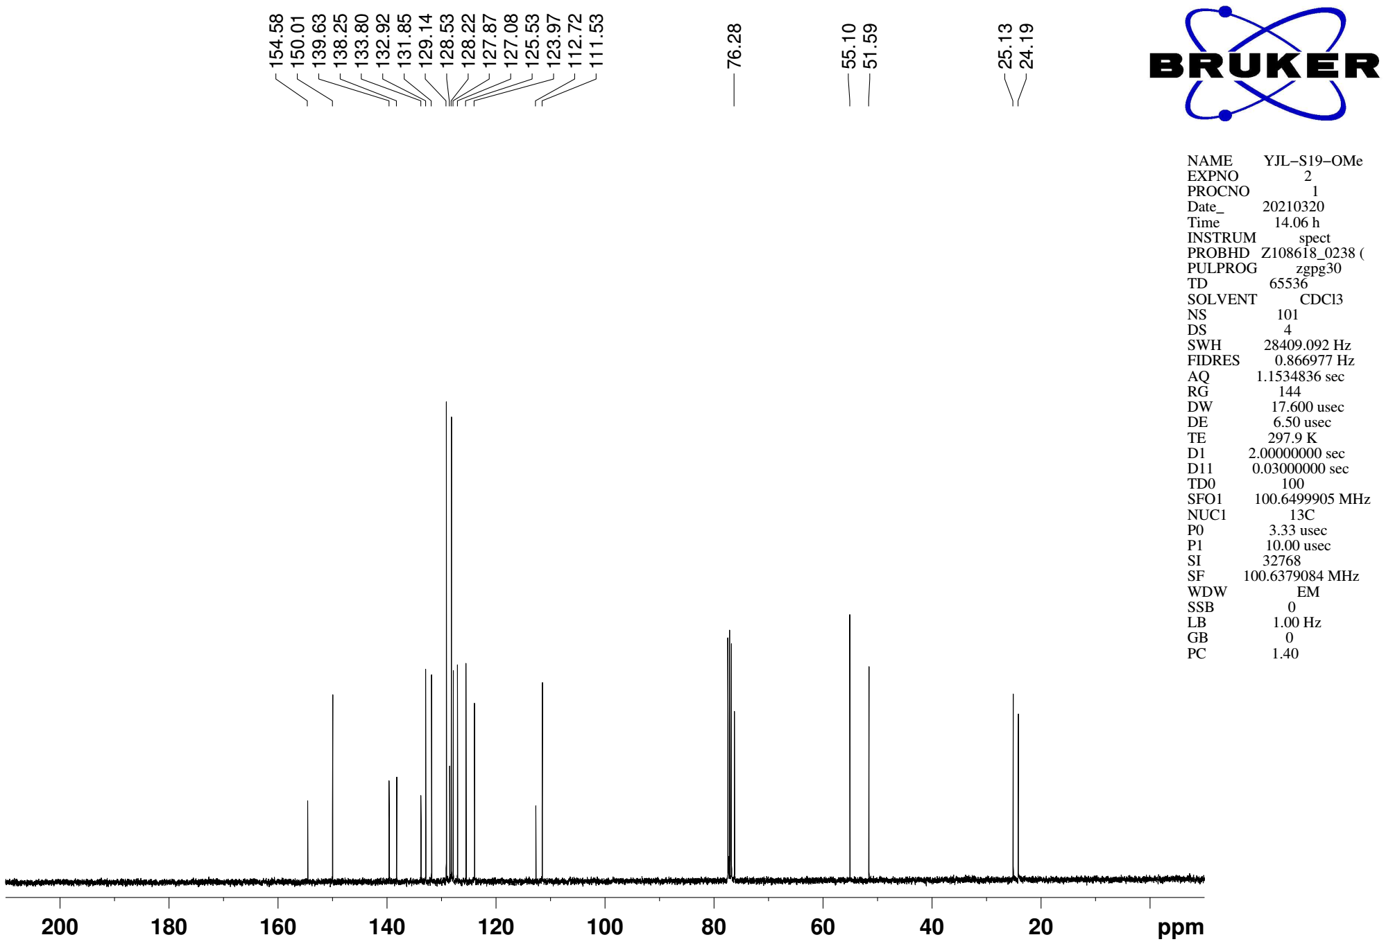
Supplementary Figure 153. ¹³C NMR (CDCl₃, 101MHz) spectra of spectra of S21

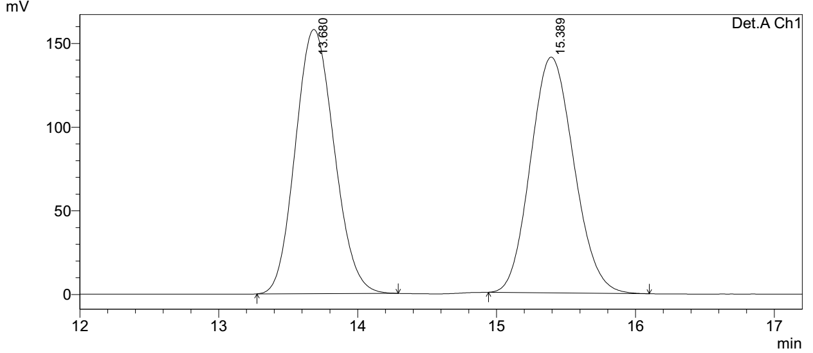
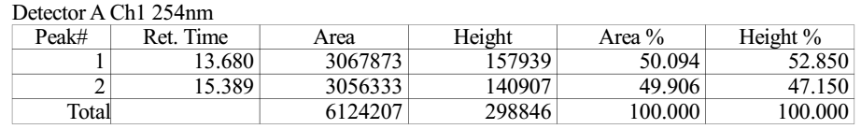

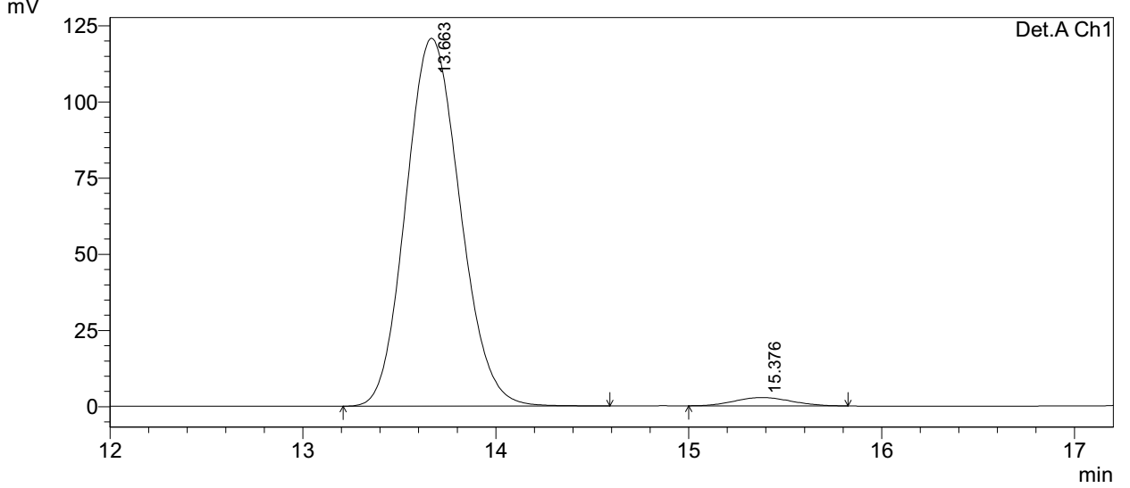
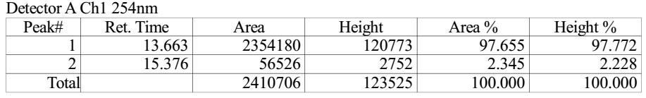
Supplementary Figure 154. HPLC spectra of S21
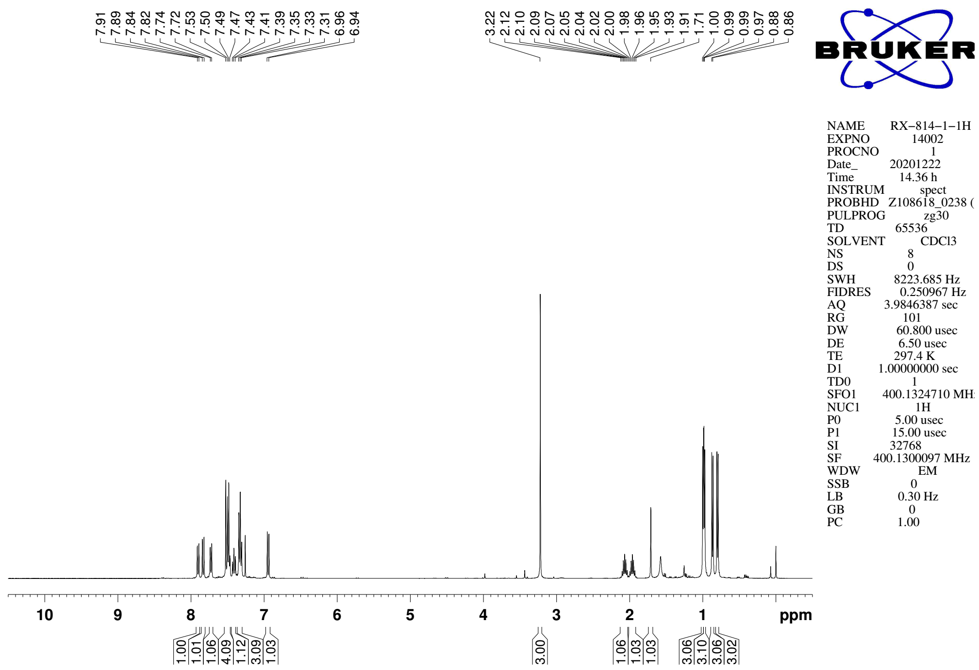
Supplementary Figure 155. ¹H NMR (CDCl₃, 400MHz) spectra of 10b

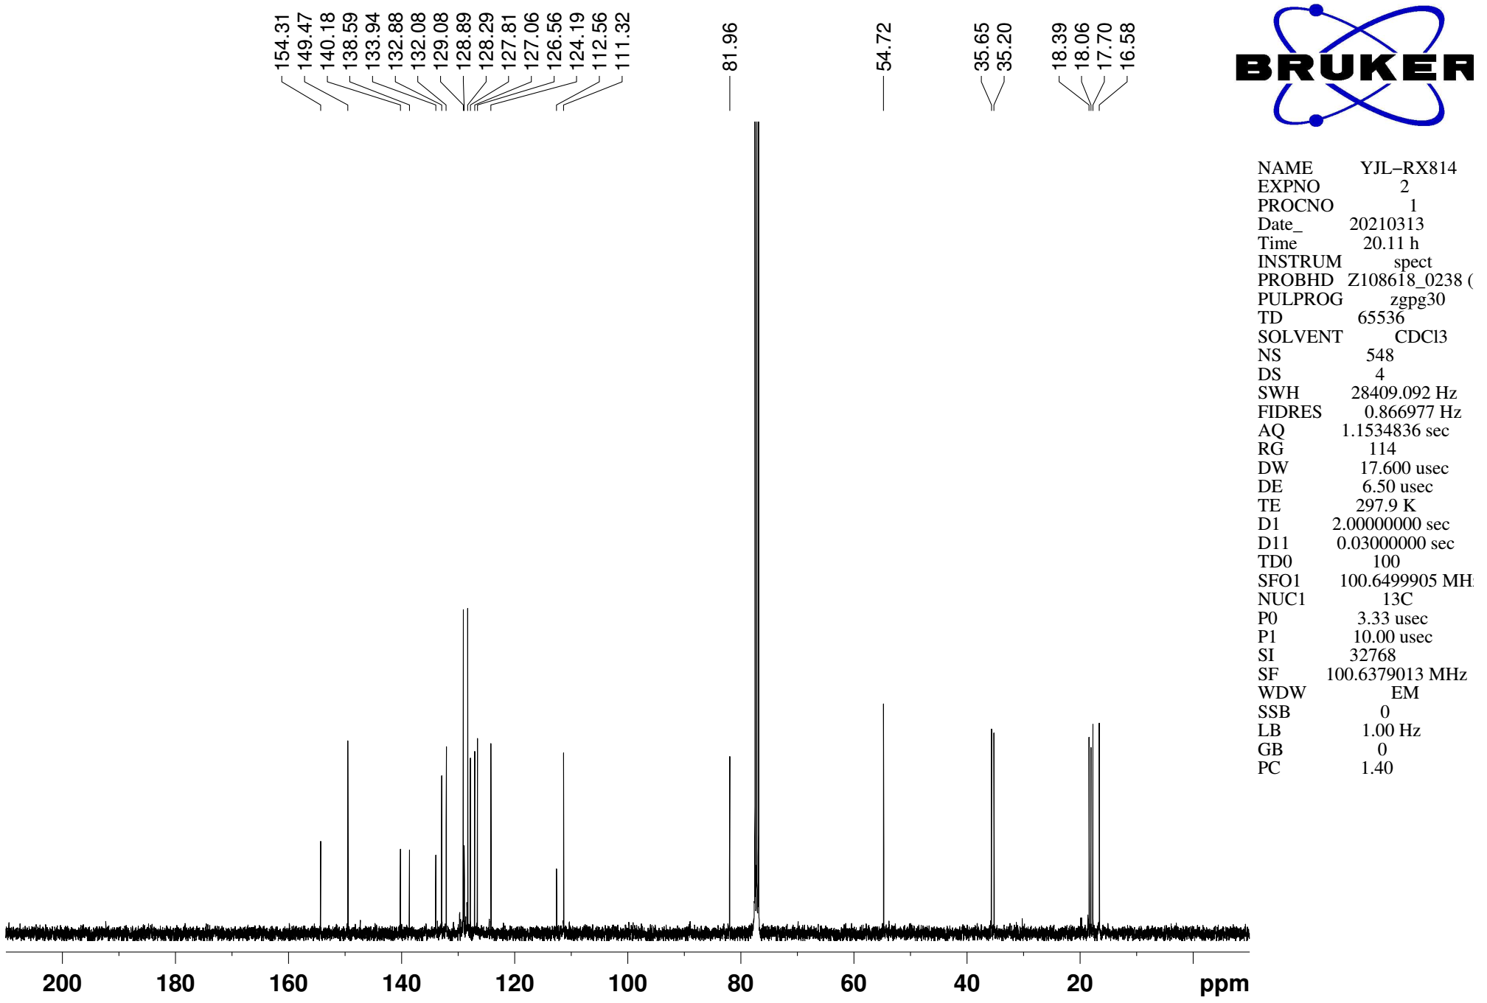
Supplementary Figure 156. ¹³C NMR (CDCl₃, 101MHz) spectra of spectra of 10b

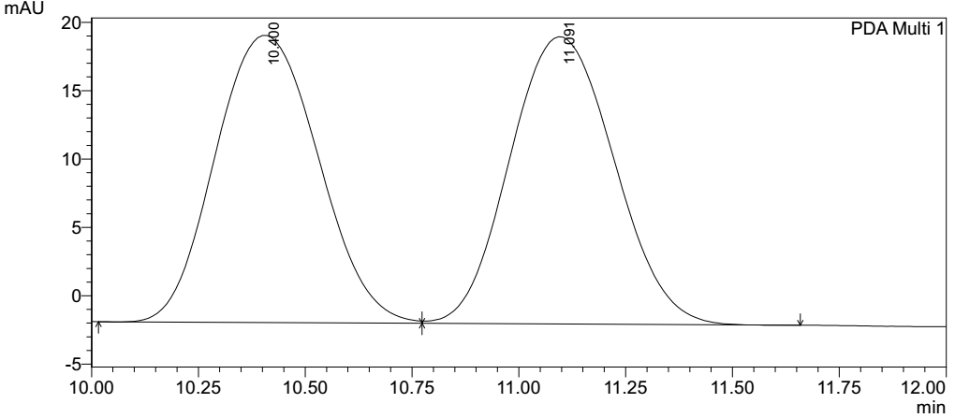
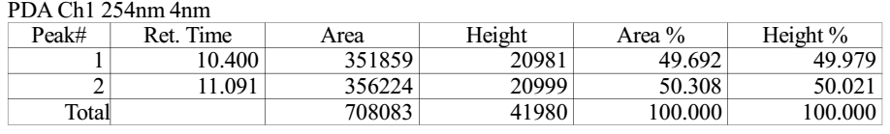

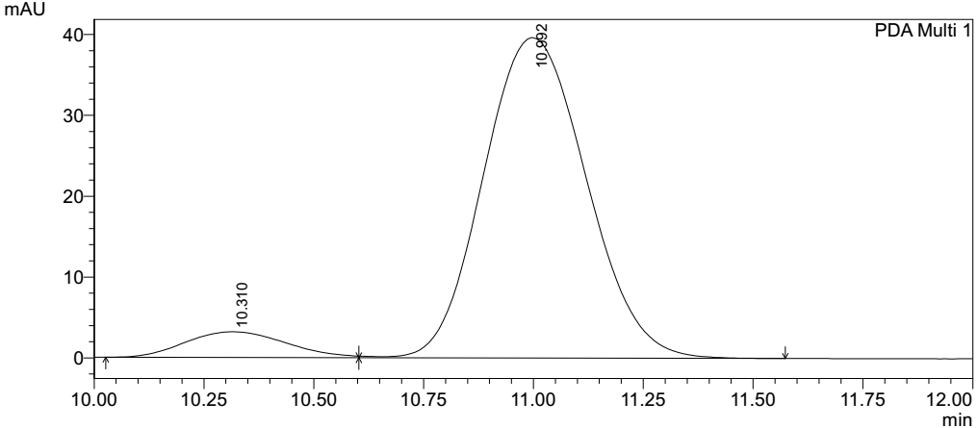
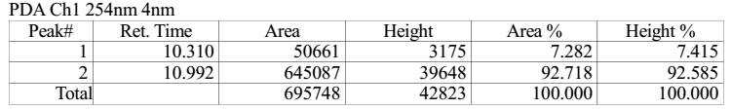
Supplementary Figure 157. HPLC spectra of 10b
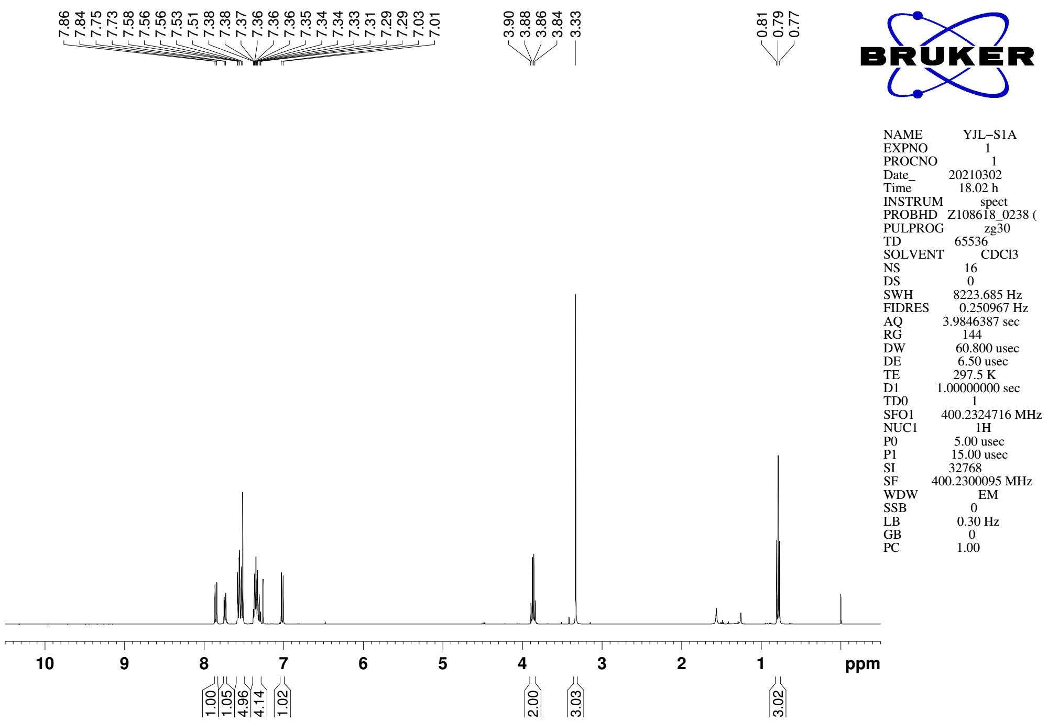
Supplementary Figure 158. ¹H NMR (CDCl₃, 400MHz) spectra of 11a

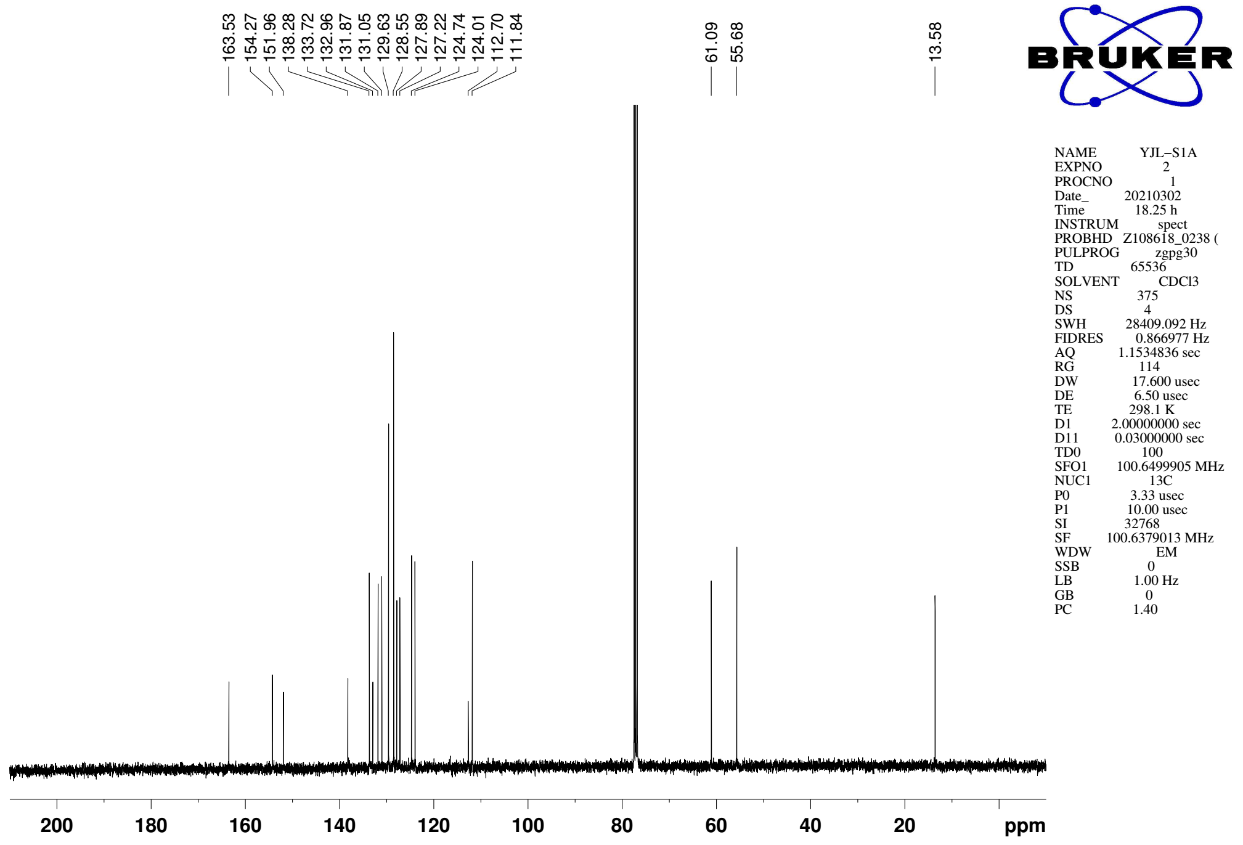
Supplementary Figure 159. ¹³C NMR (CDCl₃, 101MHz) spectra of spectra of 11a

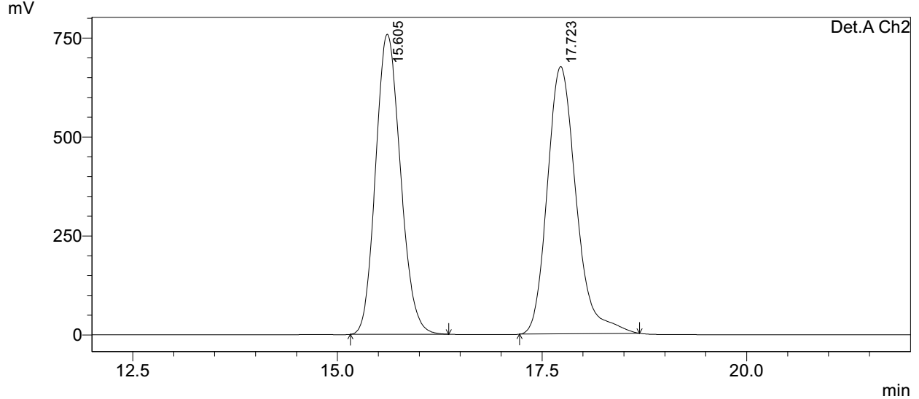
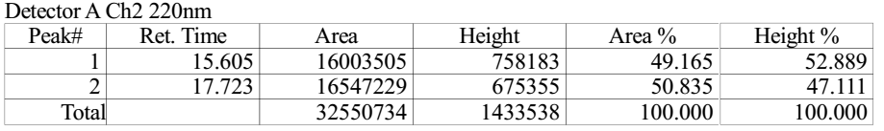

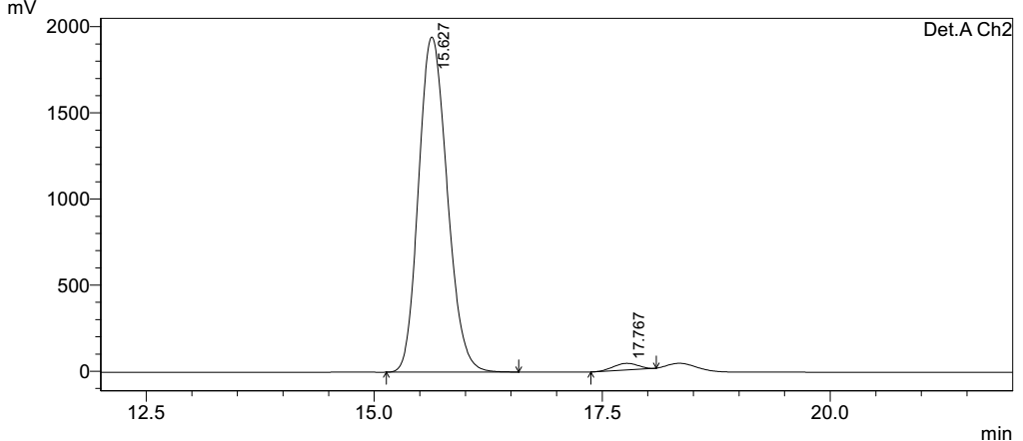
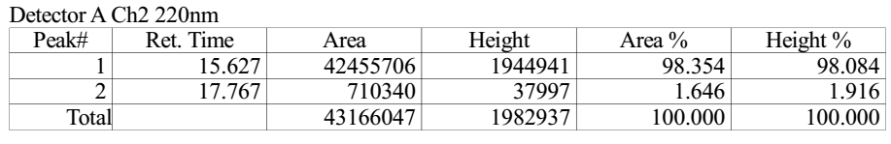
Supplementary Figure 160. HPLC spectra of 11a
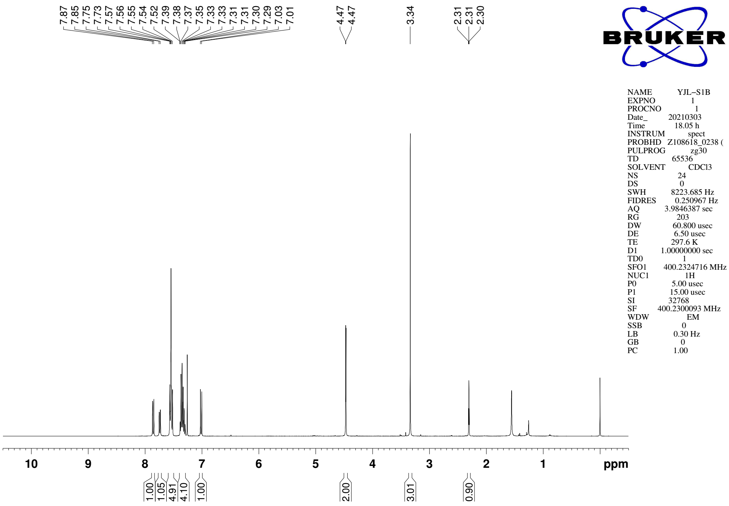
Supplementary Figure 161. ¹H NMR (CDCl₃, 400MHz) spectra of 11b

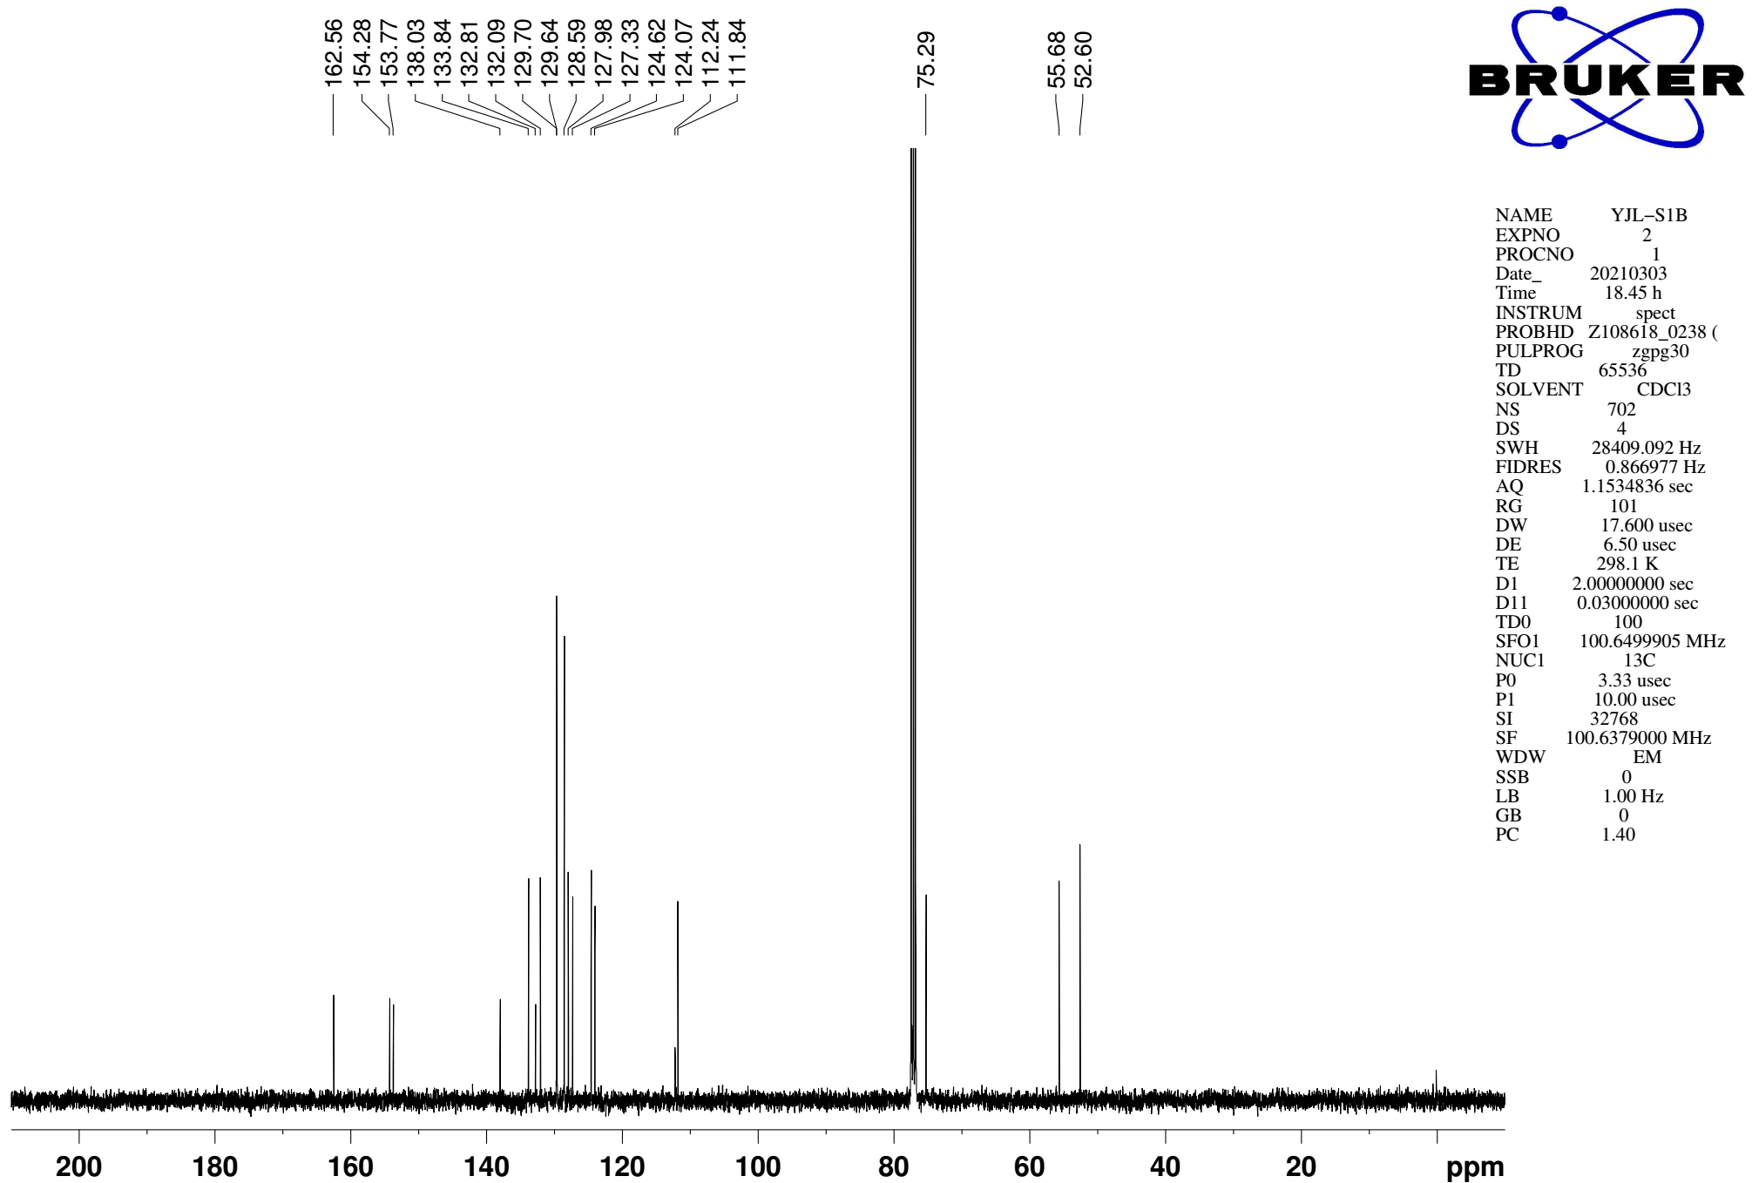
Supplementary Figure 162. ¹³C NMR (CDCl₃, 101MHz) spectra of spectra of 11b

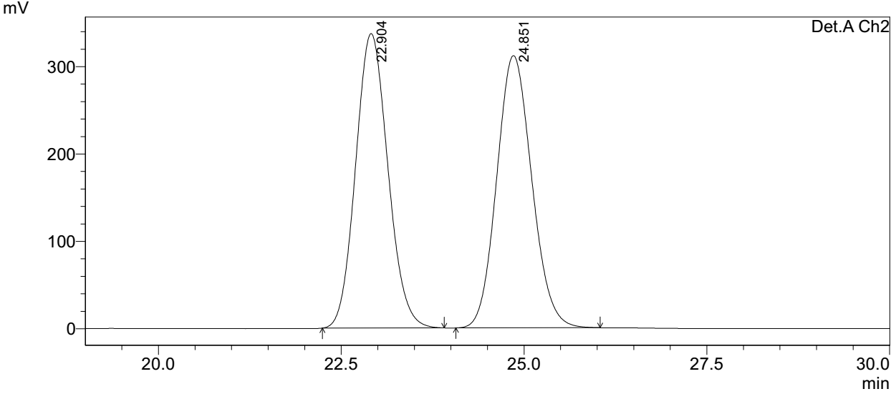
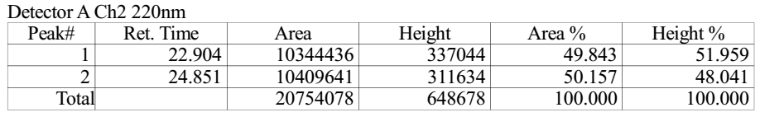

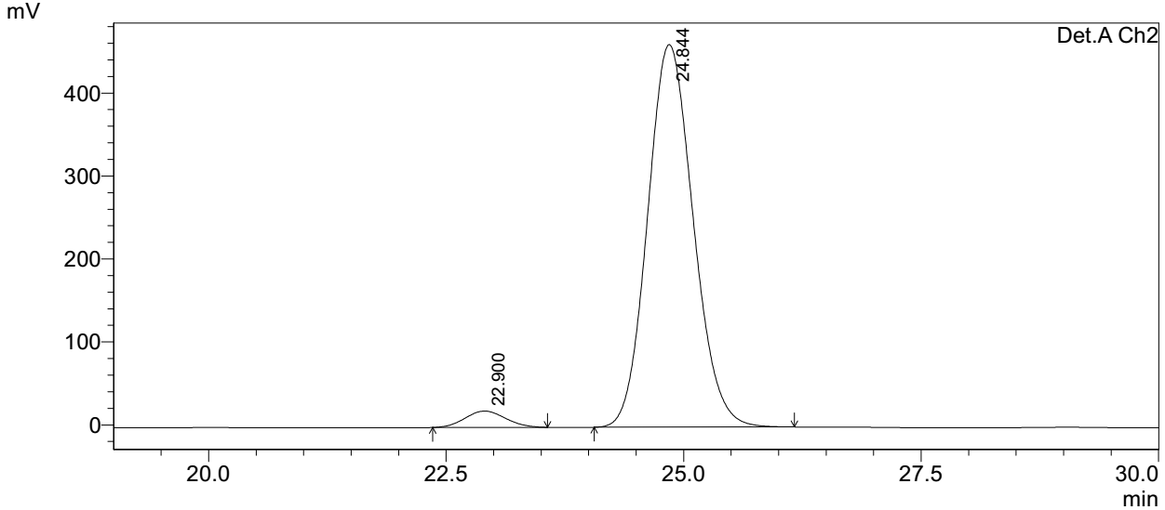
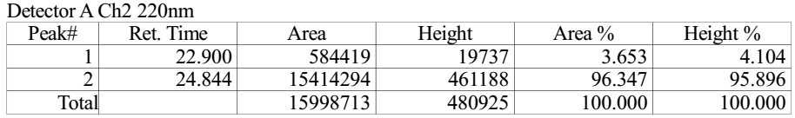
Supplementary Figure 163. HPLC spectra of 11b
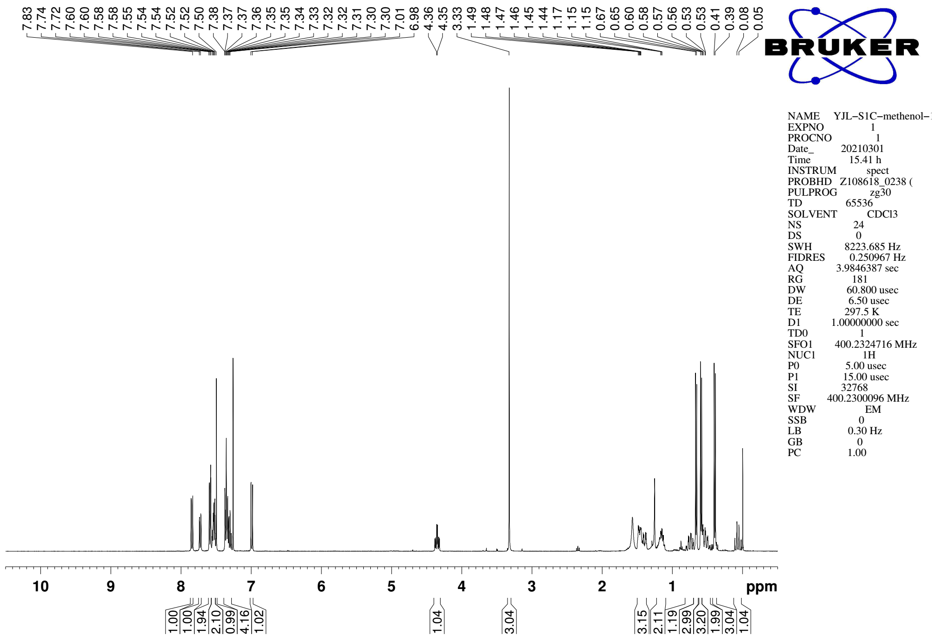
Supplementary Figure 164. ¹H NMR (CDCl₃, 400MHz) spectra of 11c

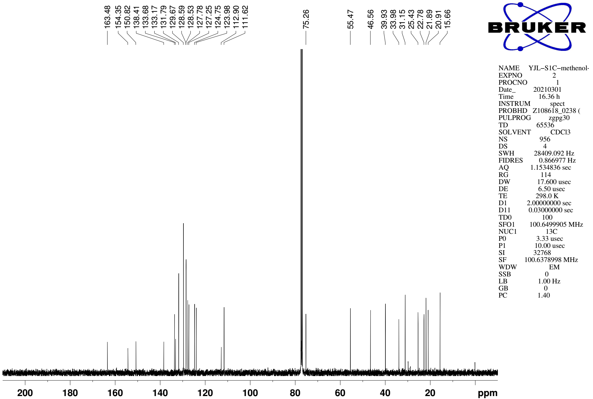
Supplementary Figure 165. ¹³C NMR (CDCl₃, 101MHz) spectra of spectra of 11c
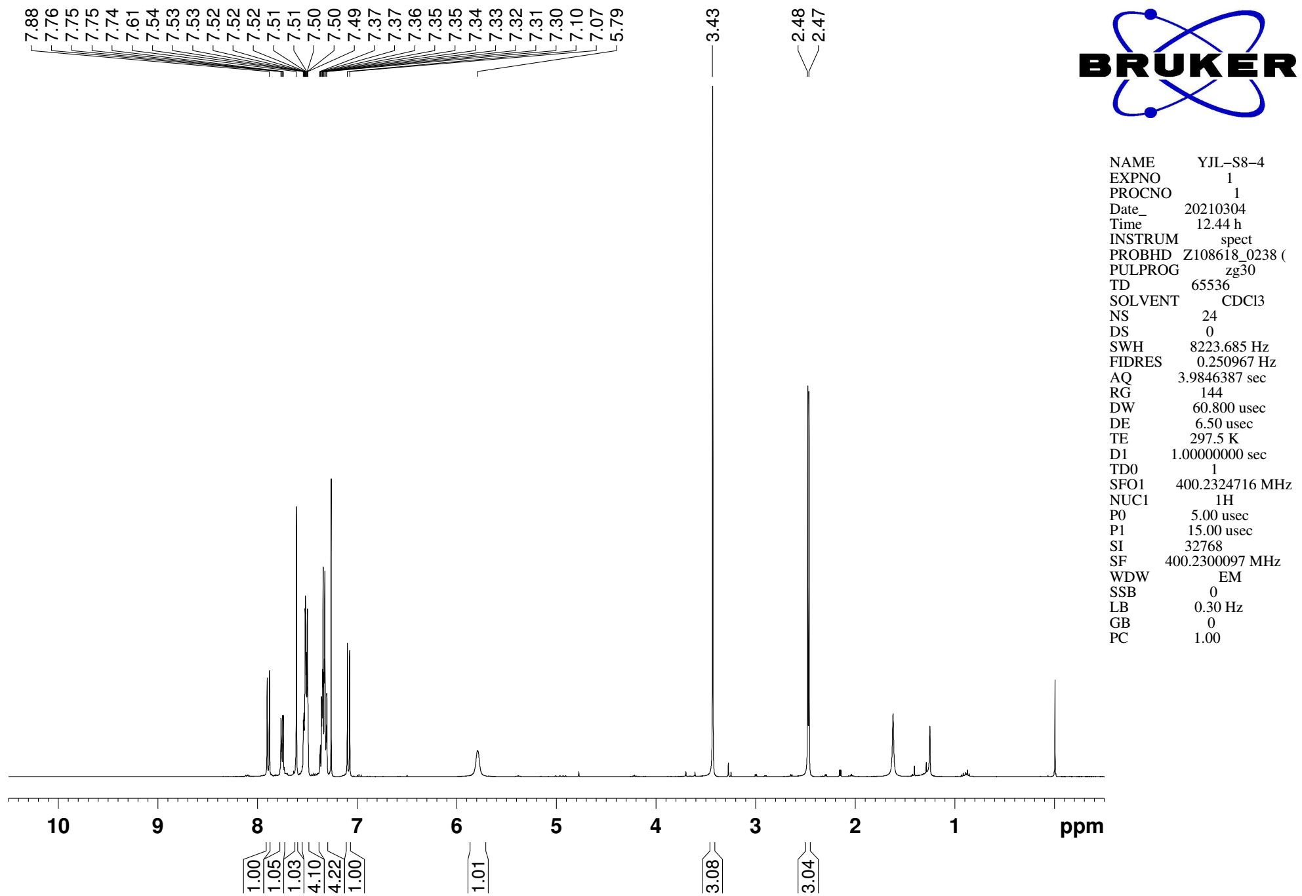
Supplementary Figure 166. ¹H NMR (CDCl₃, 400MHz) spectra of 12

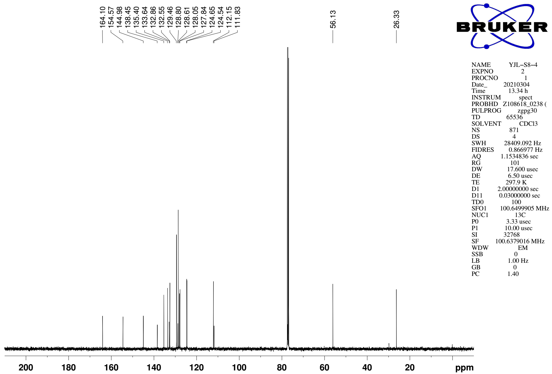
Supplementary Figure 167. ¹³C NMR (CDCl₃, 101MHz) spectra of spectra of 12

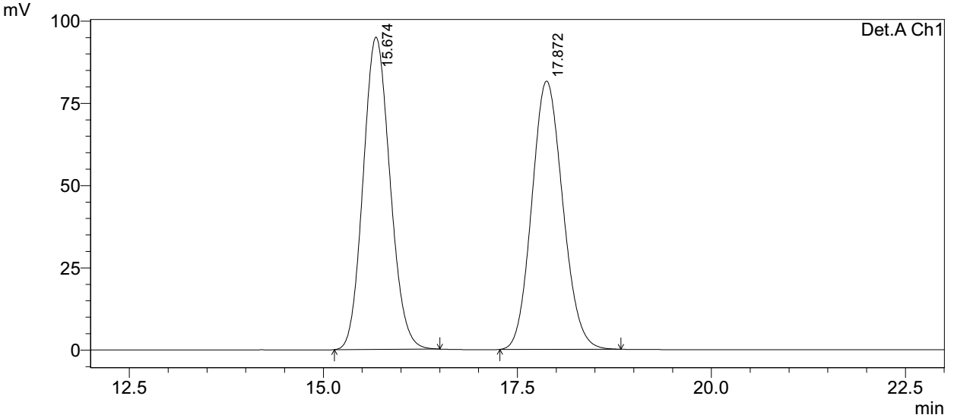
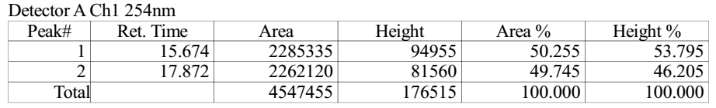

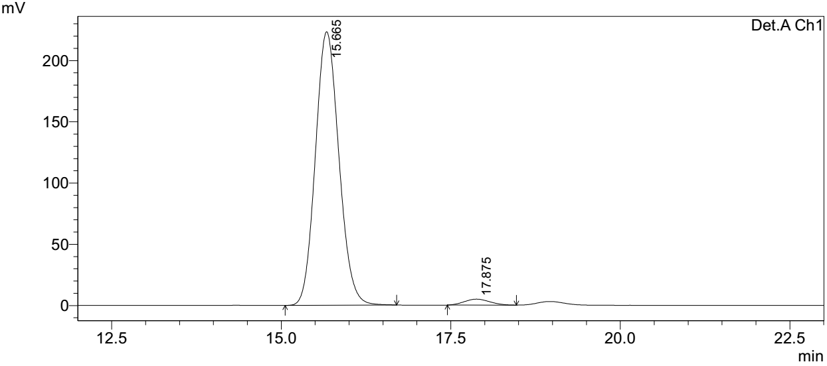
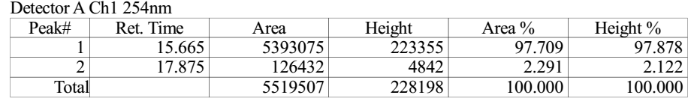
Supplementary Figure 168. HPLC spectra of 12
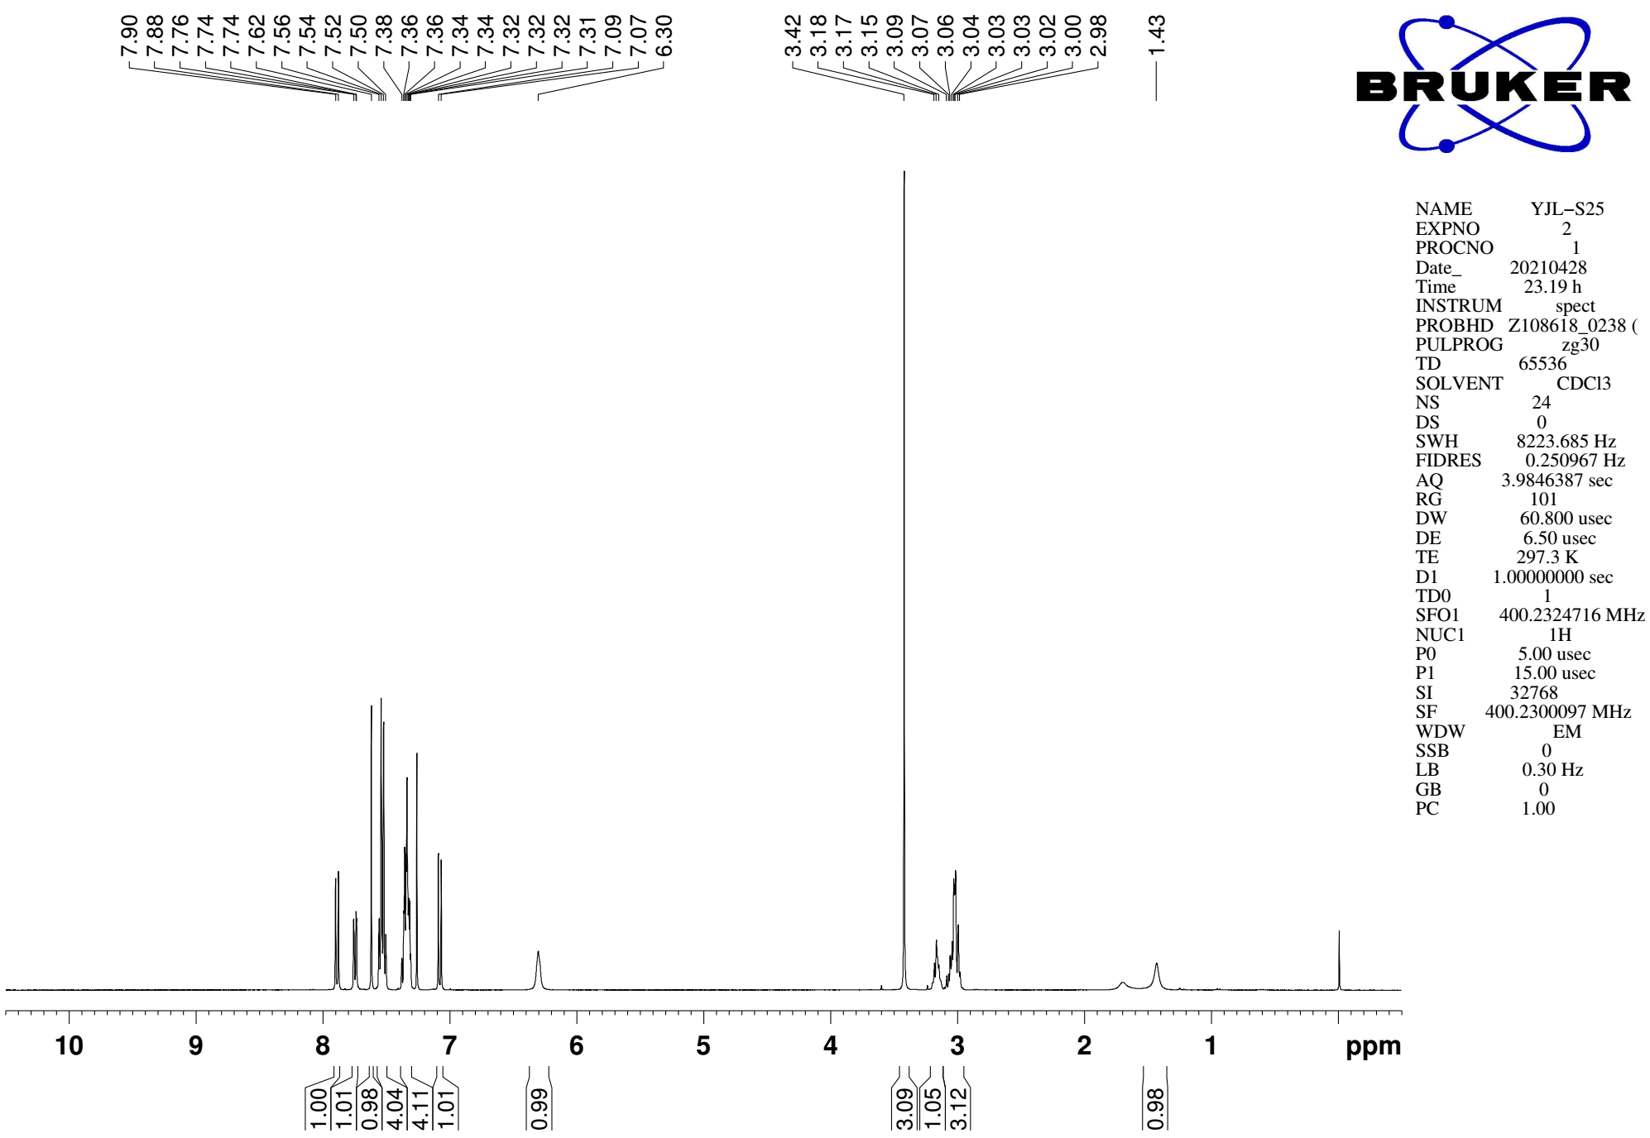
Supplementary Figure 169. ¹H NMR (CDCl₃, 400MHz) spectra of S22

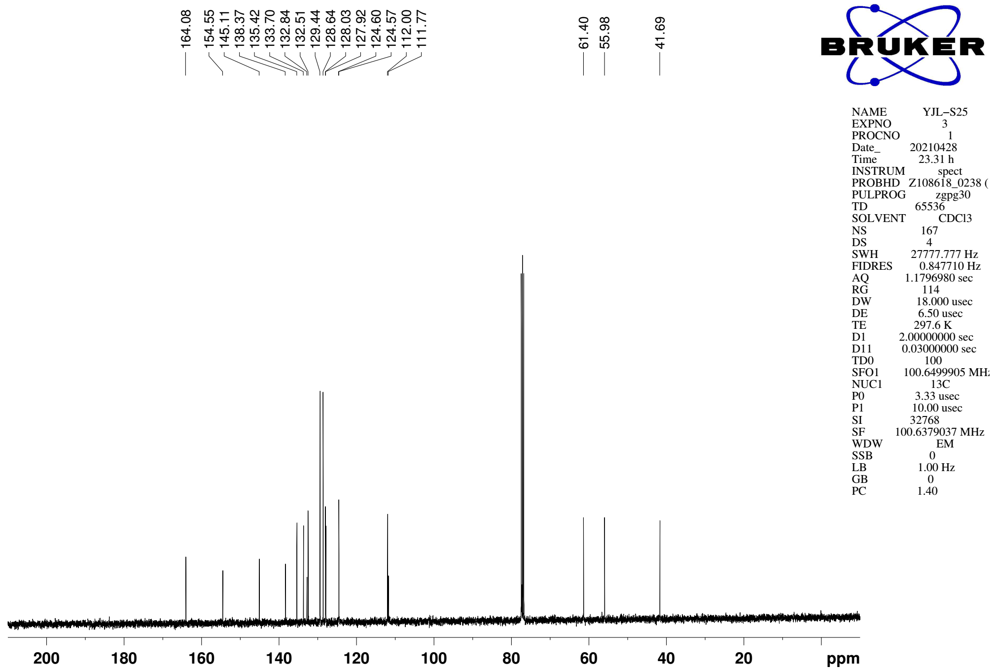
Supplementary Figure 170. ¹³C NMR (CDCl₃, 101MHz) spectra of spectra of S22

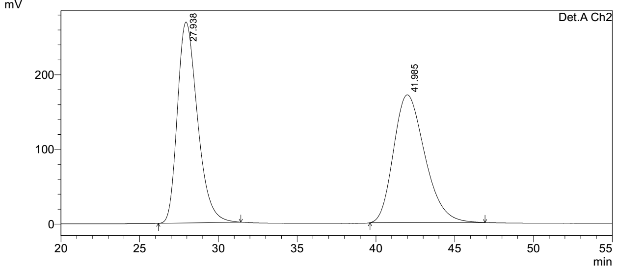
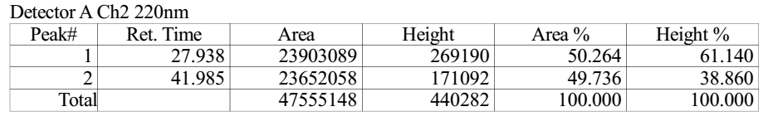

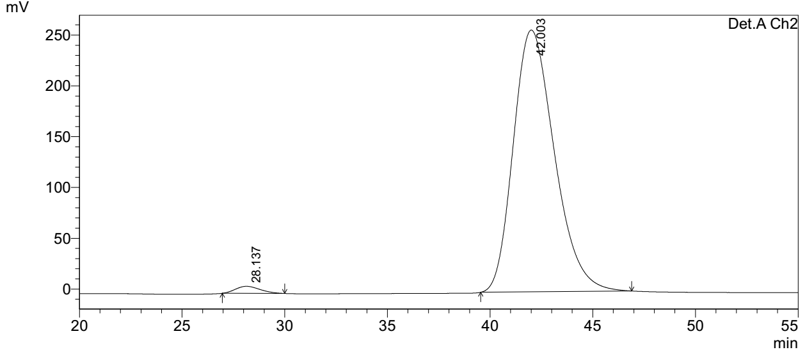
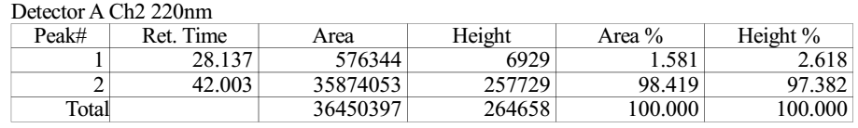
Supplementary Figure 171. HPLC spectra of S22
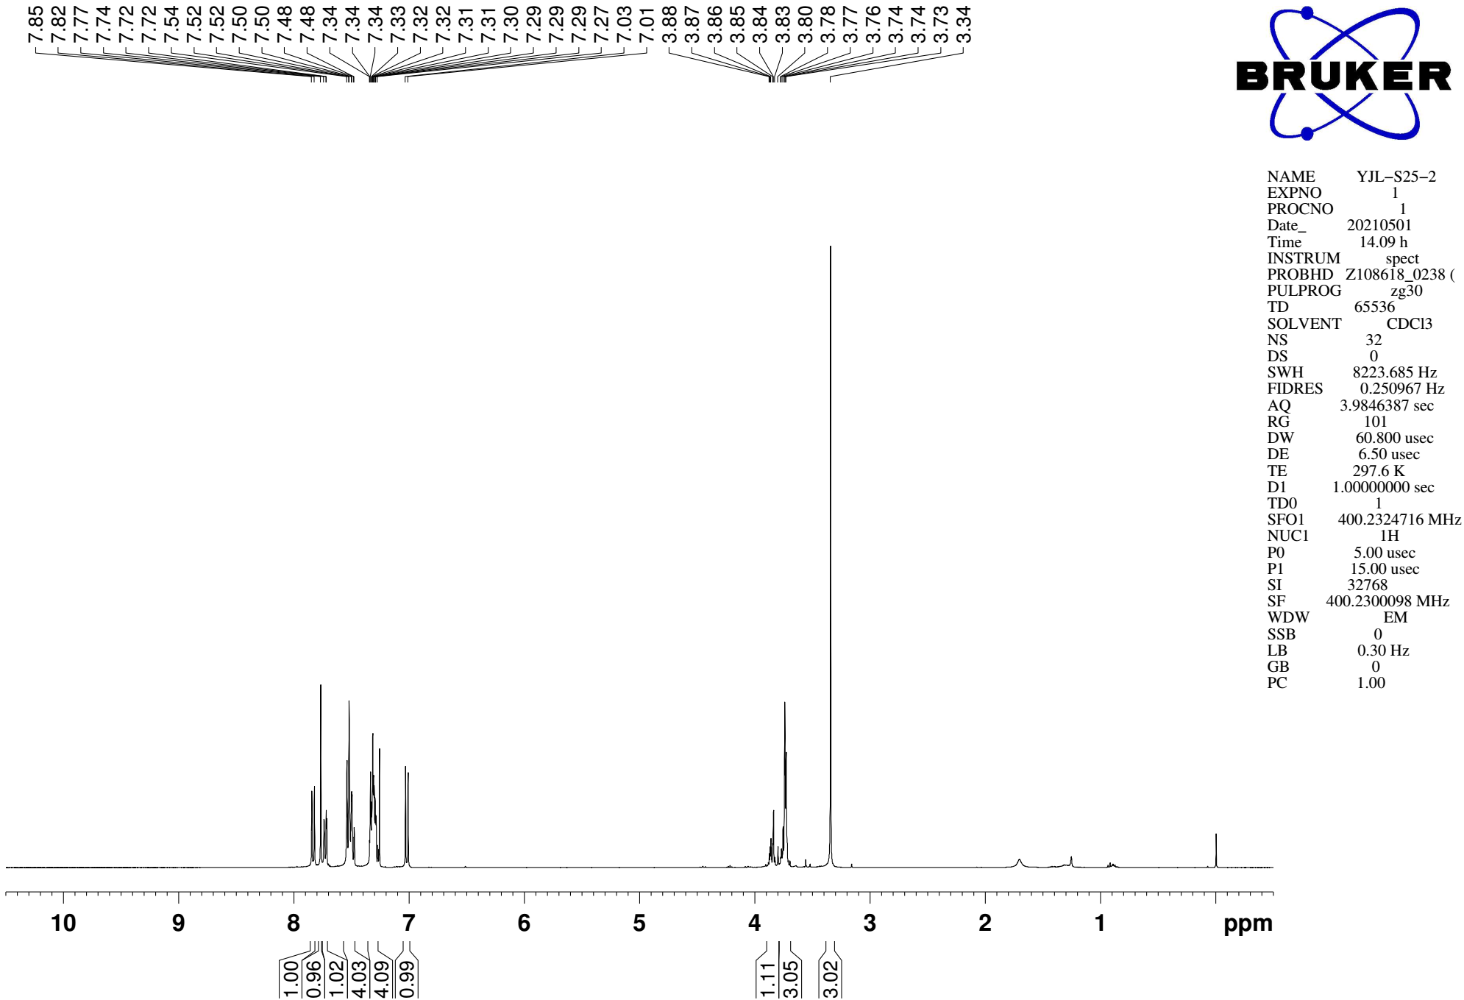
Supplementary Figure 172. ¹H NMR (CDCl₃, 400MHz) spectra of 13

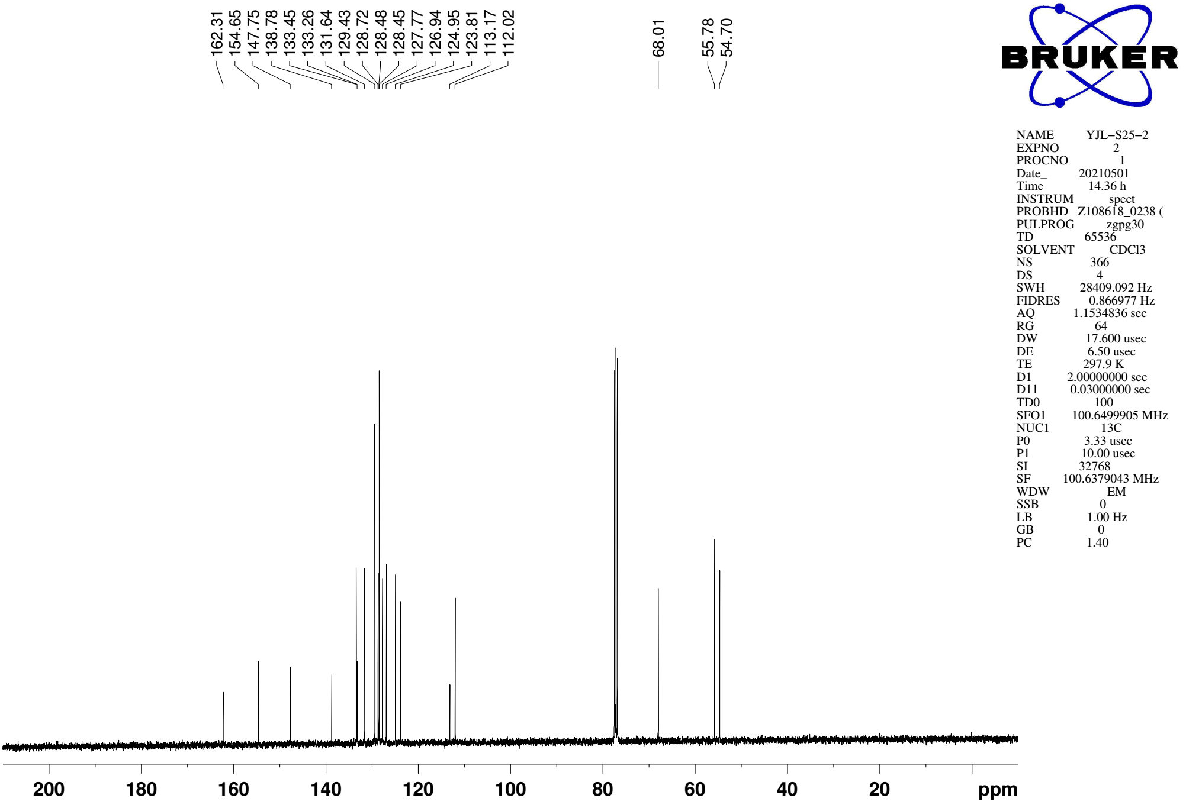
Supplementary Figure 173. ¹³C NMR (CDCl₃, 101MHz) spectra of spectra of 13

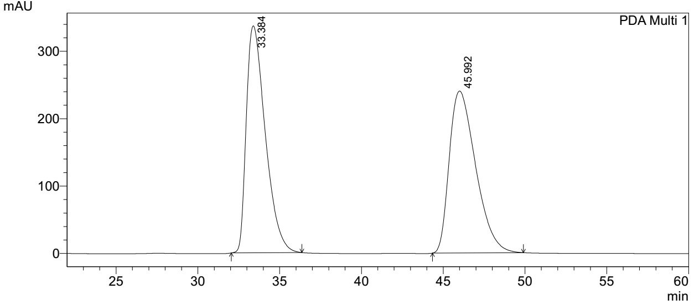
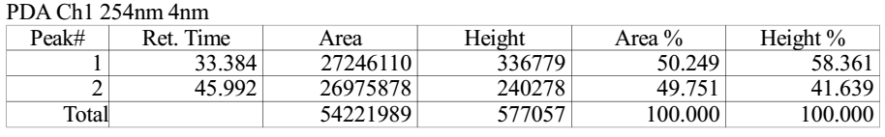

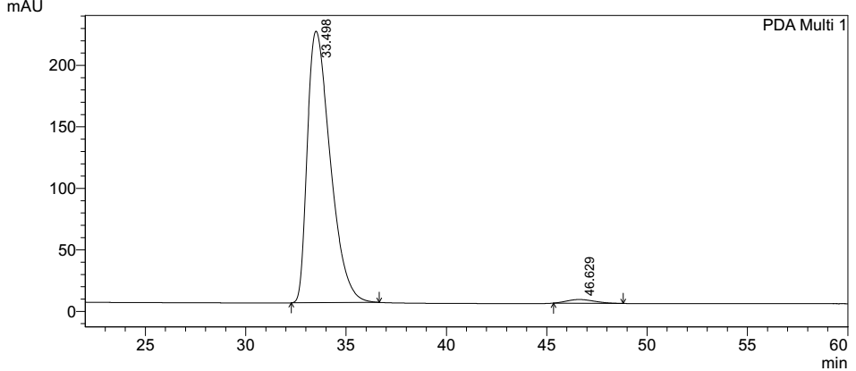
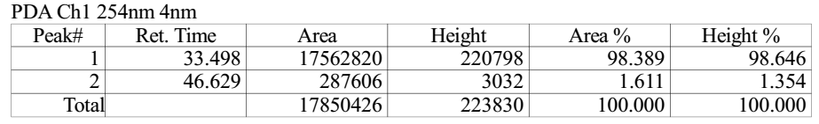
Supplementary Figure 174. HPLC spectra of 13

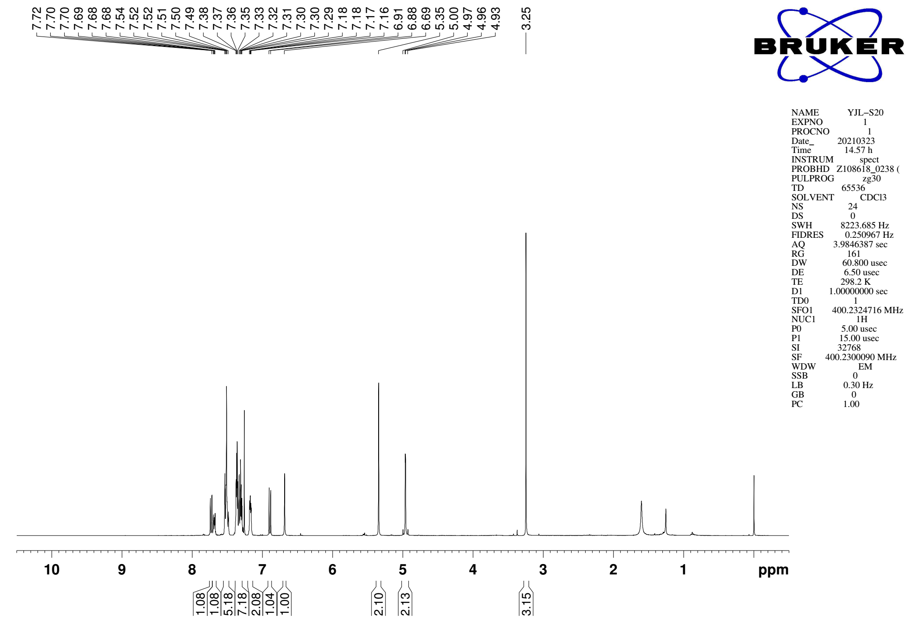
Supplementary Figure 175. ¹H NMR (CDCl₃, 400MHz) spectra of 14

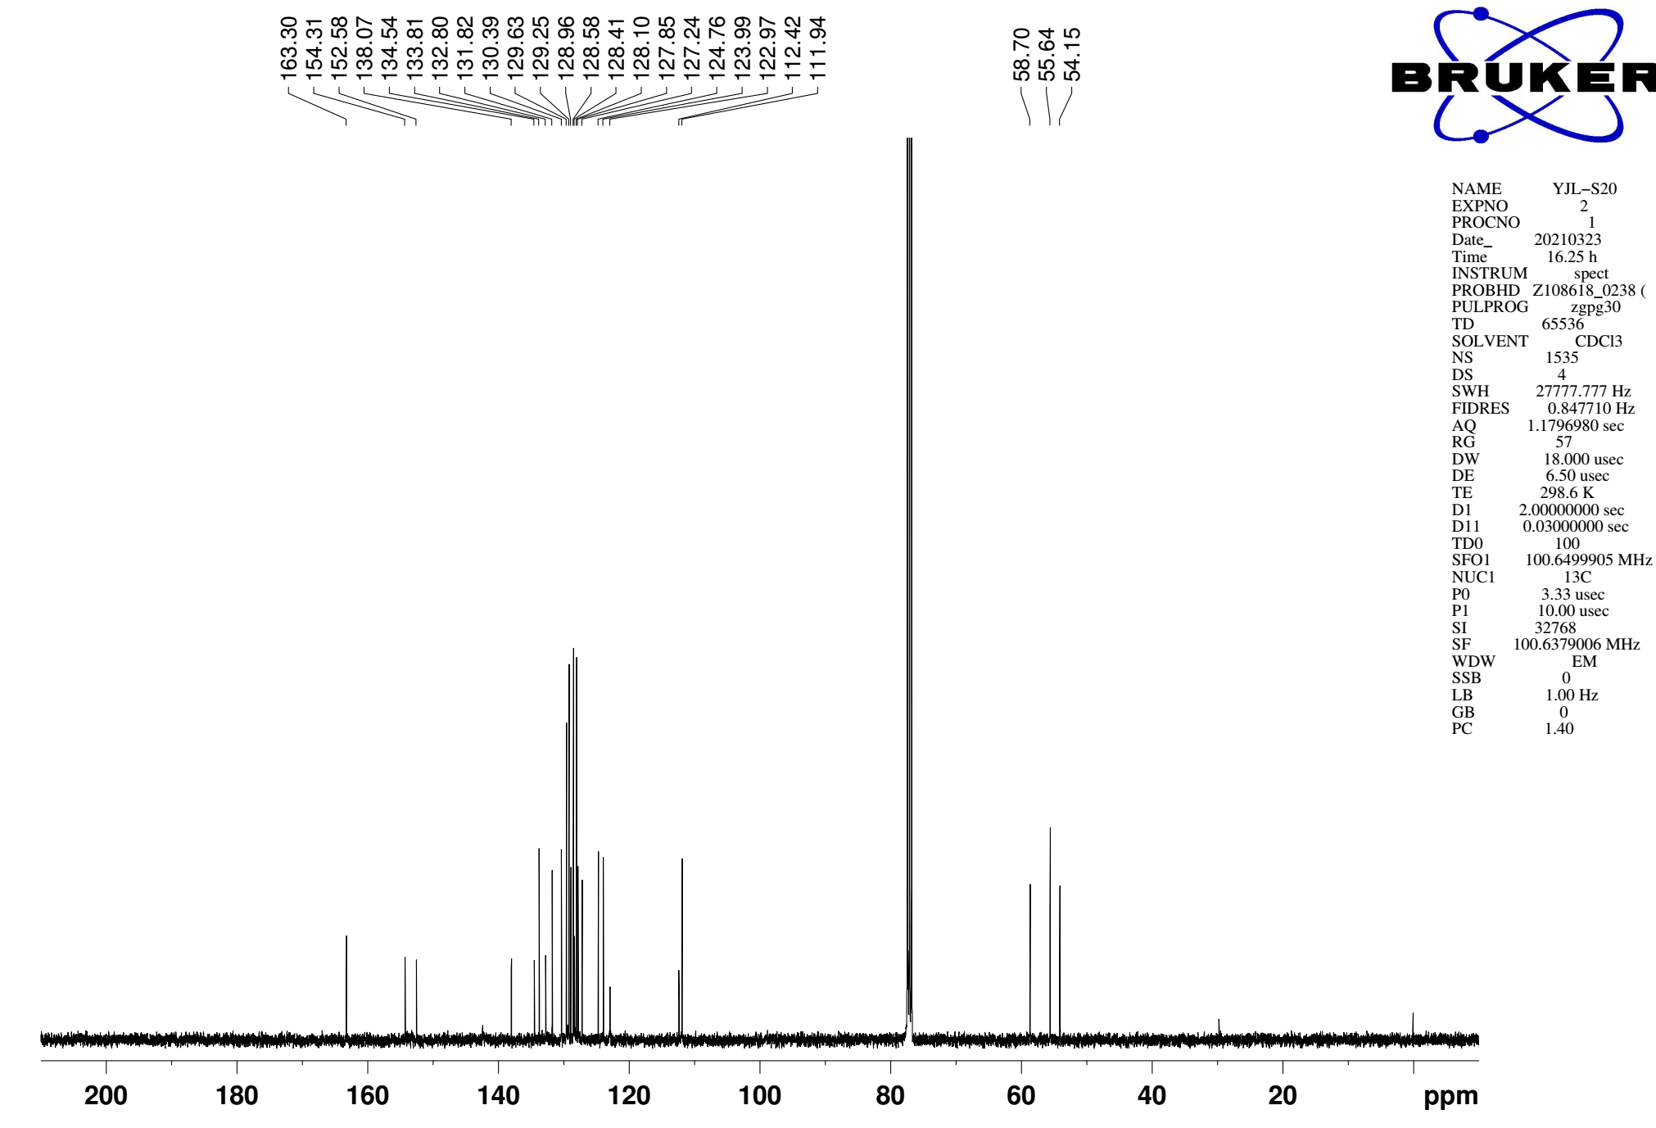
Supplementary Figure 176. ¹³C NMR (CDCl₃, 101MHz) spectra of spectra of 14

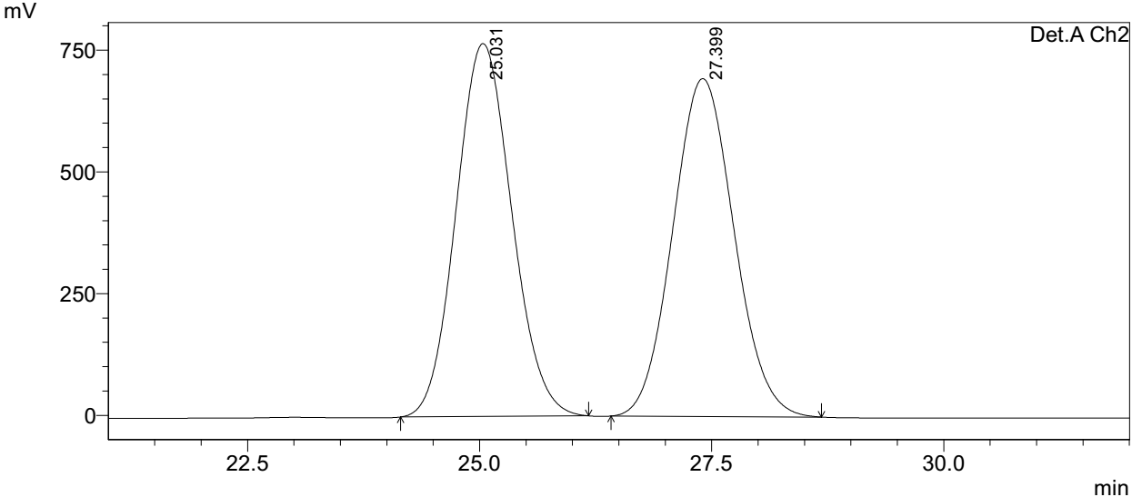
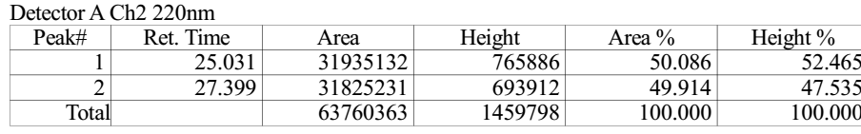

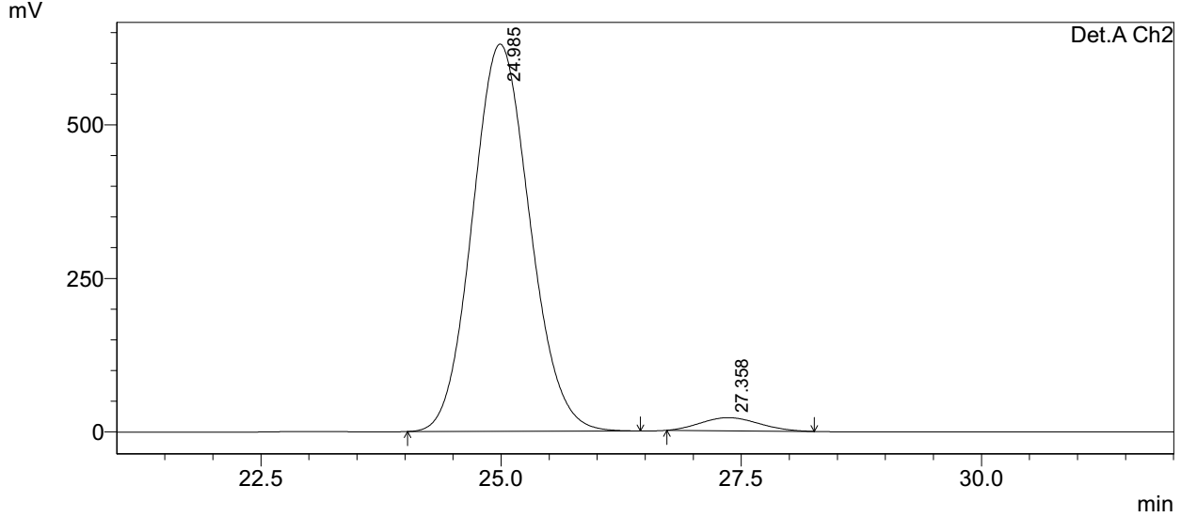
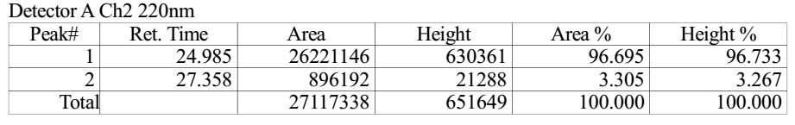
Supplementary Figure 177. HPLC spectra of 14
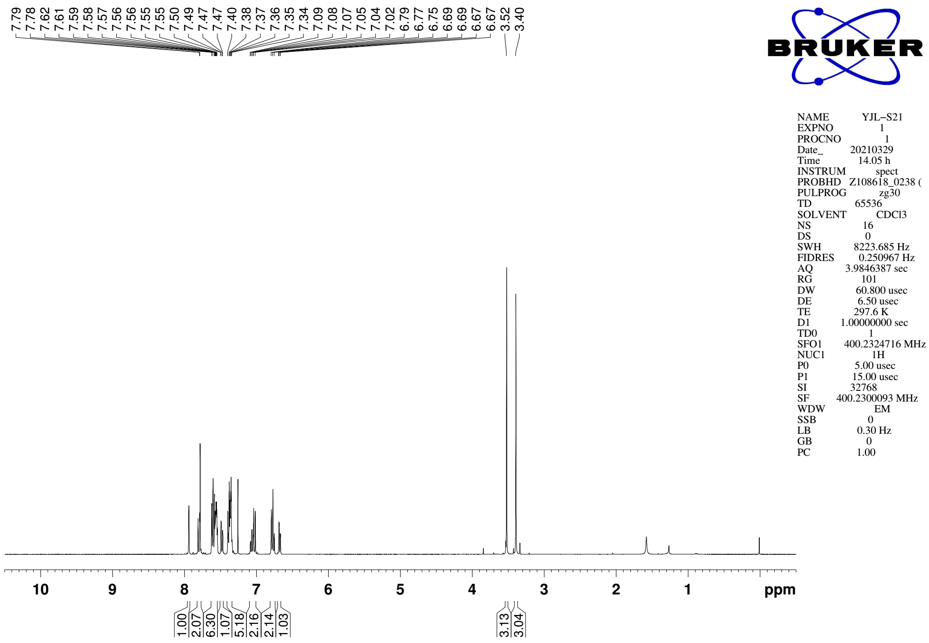
Supplementary Figure 178. ¹H NMR (CDCl₃, 400MHz) spectra of 15

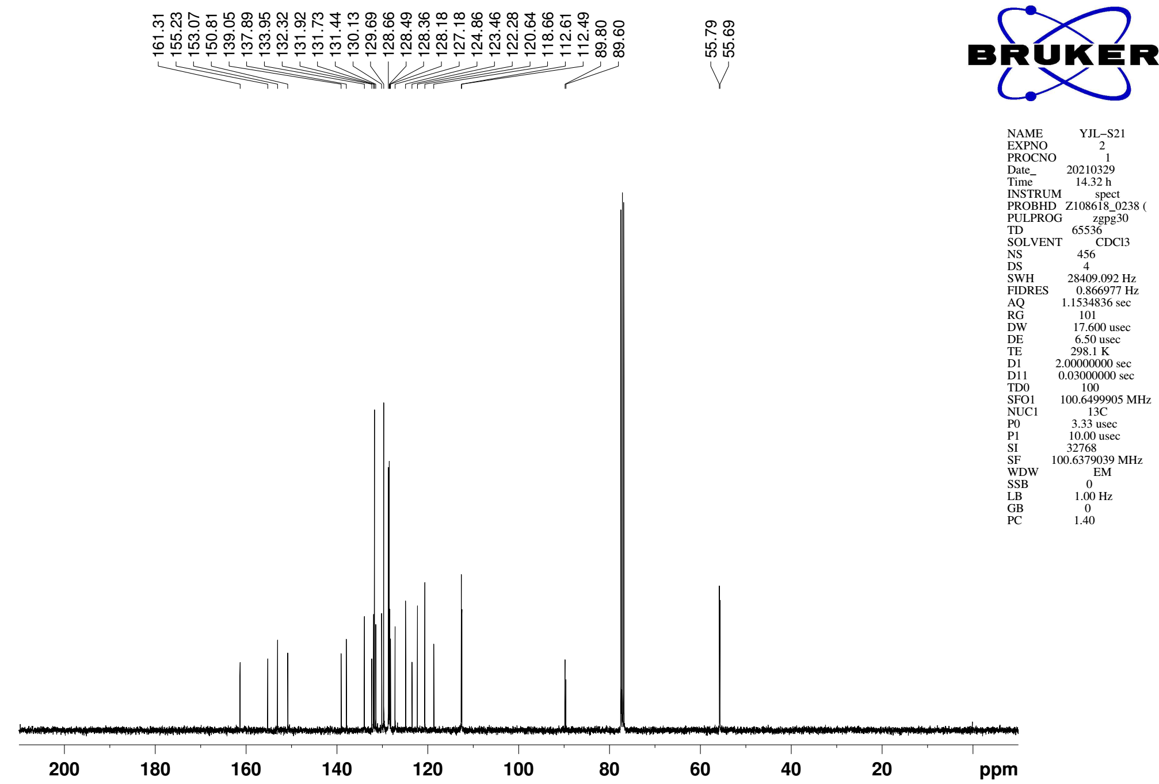
Supplementary Figure 179. ¹³C NMR (CDCl₃, 101MHz) spectra of spectra of 15
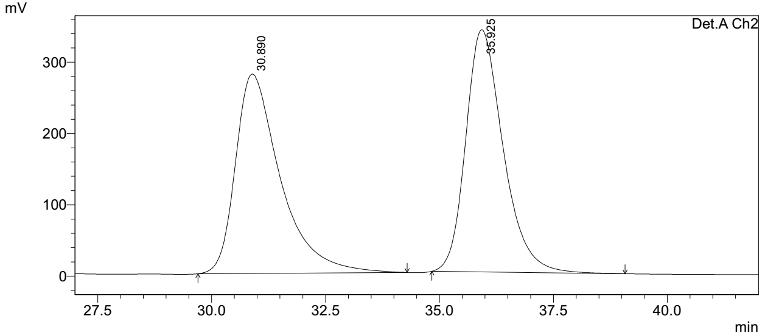
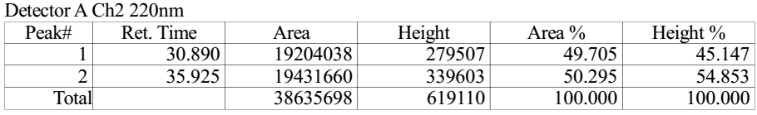

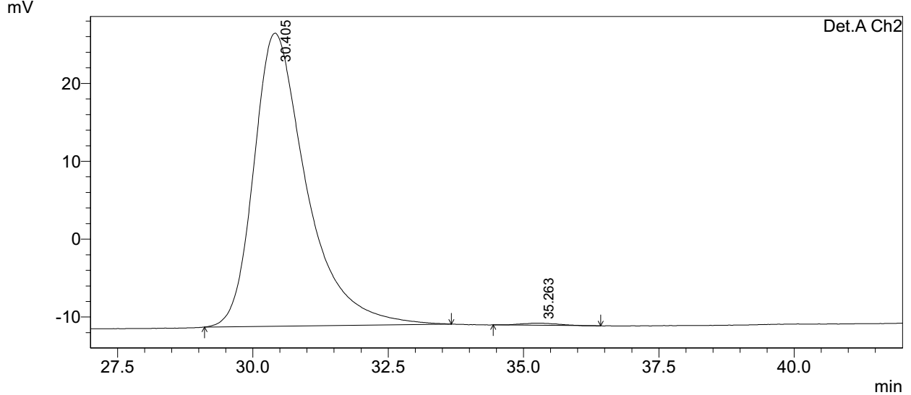
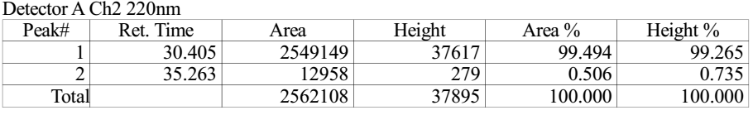
Supplementary Figure 180. HPLC spectra of 15

2. Supplementary Methods

2.1 General Information
All reactions were conducted in flame-dried or oven-dried glassware under an atmosphere of dry nitrogen or argon. Oxygen and/or moisture sensitive solids and liquids were transferred appropriately. Concentration of solutions in vacuo was accomplished using a rotary evaporator fitted with a water aspirator. Residual solvents were removed under high vacuum (0.1-0.2 mm Hg). All commercially available materials purchased form TCI or Sigma Aldrich was used as received. All reaction solvents were purified before use: Tetrahydrofuran were distilled from Na/benzophenone. Toluene was distilled over molten sodium metal. Dichloromethane, dimethylformamide, diethylamine, triethylamine and diisoproylethylamine were distilled from CaH₂. Methanol was distilled from Mg/I₂. Flash column chromatography was performed using silica gel (230 – 400 mesh). TLC was carried out using pre-coated sheets (Yantai silica gel 60-F250, 0.2 mm). Compounds were visualized with UV light, iodine, p-anisaldehyde stain, ceric ammonium molybdate stain, or phosphomolybdic acid in EtOH.
Proton nuclear magnetic resonance (¹H NMR) spectra were recorded with Bruker BBFO 400 MHz, Bruker Avance 400 MHz or Bruker Avance 500 MHz spectrometers. Chemical shifts are reported in delta (δ) units, parts per million (ppm) downfield from tetramethylsilane or ppm relative to the center of the singlet at 7.26 ppm for deuteriochloroform. The following abbreviations are used to describe spin multiplicity: s = singlet, d = doublet, t = triplet, q = quartet, qn = quintet, m = multiplet, br = broad, dd = doublet of doublets, dt = doublet of triplets, dq = doublet of quartets, ddd = doublet of doublet of doublets; other combinations are derived from those listed above. Integration and coupling constants were reported in Hertz (Hz). Coupling constants (J) are reported in Hertz (Hz) for corresponding solutions. Carbon-13 nuclear magnetic resonance (¹³C NMR) spectra were recorded with a 101 MHz or a 126 MHz spectrometer and were routinely run with broadband decoupling. Chemical shifts are reported in delta (δ) units, ppm relative to the center of the triplet at 77.16 ppm for deuteriochloroform. High-resolution mass spectra (HRMS) were obtained on Finnigan MAT 95 XP mass spectrometer (Thermo Electron Corporation) and are reported as m/z (relative intensity). Accurate masses are reported for the molecular ion (M+H⁺, M+Na⁺), or a suitable fragment ion. Optical rotations were measured using a 1 mL cell with a 1 dm path length on a Jasco P-1030 polarimeter and data were reported as follow: optical rotation (c in g per 100 mL solvent). The determination of e.r. was performed via chiral HPLC analysis using Shimadzu LC-20AD HPLC workstation.

2.2 Preparation of the NHC Pre-catalysts
NHC pre-catalysts A-D are known compounds in literature reports.¹⁻⁴ NHC pre-catalyst E are prepared according to the following procedures:

To a solution of compound S1 (5.0 g, 26.4 mmol) in DCM (100 mL) was added trimethyloxonium tetrafluoroborate (4.7 g, 31.7 mmol) portionwise at room temperature. The mixture was stirred for 24 h at room temperature. The reaction was quenched with a saturated aquous solution of NaHCO₃ (100 mL) at 0 °C, and the mixture was extracted with DCM (100 mL x 3). The combined organic phases were washed sequentially with a saturated aquous solution of NaHCO₃ (50 mL), water (50 mL) and brine (50 mL), dried over anhydrous Na₂SO₄ and concentrated in vacuo to provide the crude S2. To a solution of the above S2 and hydrazine chloride S3⁵ (10.3 g, 26.4 mmol) in anhydrous MeOH (100 mL) was added HCl (4.0 M in dioxane, 0.7 mL, 2.8 mmol) at room temperature. The resulting mixture was heated to 60 °C for 36 h. After cooled to room temperature, the reaction mixture was directly concentrated in vacuo to provide the crude S4. To a sealed tube equipped with a magnetic stir bar was added the crude hydrazine S4, chlorobenzene (27 mL, 264 mmol), triethyl orthoformate (39 mL, 264 mmol) and HCl (4.0 M in dioxane, 7 mL, 28 mmol). The tube was sealed and heated to 120 °C for 2 h. After cooled to room temperature, the reaction mixture was directly concentrated in vacuo, and the residue was purified by flash chromatography on silica gel (EtOAc/hexanes =1:5) to provide NHC pre-catalyst E (7.3 g, 48% yield for 3 steps) as a light yellow solid.
¹H NMR (400 MHz, CDCl₃) δ 12.04 (s, 1H), 7.55 (d, J = 7.4 Hz, 1H), 7.39 – 7.26 (m, 3H), 7.14 (s, 1H), 7.07 (s, 1H), 6.88 (d, J = 4.0 Hz, 1H), 5.14 – 4.97 (m, 3H), 3.30 (dd, J = 17.0, 4.6 Hz, 1H), 3.19 (d, J = 17.0 Hz, 1H), 2.62 – 2.48 (m, 1H), 2.31 – 2.08 (m, 2H), 2.03 – 0.83 (m, 30H) ppm.
¹³C NMR (101 MHz, CDCl₃) δ 152.3, 149.1, 145.6, 145.5, 144.0, 139.9, 136.1, 129.7, 128.7, 128.1, 125.6, 124.2, 123.4, 77.8, 62.4, 60.3, 45.1, 39.9, 39.1, 37.6, 35.3, 35.3, 34.4, 34.4, 33.7, 26.9, 26.8, 26.6, 26.5, 26.2, 26.1, 26.0, 25.8 ppm.
HRMS (ESI, m/z): calculated for C₃₆H₄₆N₃O⁺: 536.3641 (M-Cl⁻)⁺, found: 536.3639.
[α]²¹_{D} = +57.3 (c = 0.5 in MeOH).
M.P. 191 ℃ - 193 ℃

2.3 Preparation of the Sulfinic Acids
Benzenesulfinic acid and p-toluenesulfinic acid were obtained by acidification of the commercially available sodium benzenesulfinate and sodium p-toluenesulfinate, and then the mixture was extracted by Et₂O. After being dried by Na₂SO₄, the solvent was removed under vacuum at room temperature to provide the corresponding sulfinic acids which were directly used in the catalytic reaction without further purification.^{6,7}
Other arylsulfinic acids, heteroaromatic and aliphatic sulfinic acids were prepared according to the following procedures:^{8,9} arylsulfonyl chloride (10 mmol) and anhydrous sodium sulfite (30 mmol) were dissolved in 20 mL water. The reaction mixture was heated to 75 °C, and stirred for additional 5 h at 75 °C. After the reaction was complete, the mixture was transferred to separation funnel and washed with chloroform. The aqueous phase was acidified with 12 N HCl aq. (1.5 mL) at 0 °C and then extracted by Et₂O. After being dried by Na₂SO₄, the organic solvent was removed under vacuum at room temperature to provide the corresponding sulfinic acids which were directly used in the catalytic reaction without further purification.

2.4 Preparation of the Ynals
Ynals 1a, 1m-n, 1u-x, 1ae-af were prepared according to literature.¹⁰ The other ynals were prepared according to the following procedures.

General Procedure A:
To a stirred solution of sulfuric acid (98%, 1.5 eq.) in methanol (0.2 M) was added S5 (1.0 eq.), KI (1.0 eq.), and H₂O₂ (35%, 2.0 eq.) at 0 °C. The mixture was stirred at 0 °C for an additional 12 h. The reaction was quenched by adding excess saturated aqueous solution of Na₂S₂O₃. The methanol was evaporated, and the residue was extracted with EtOAc for three times. The combined organic phases were washed sequentially with water and brine, dried over anhydrous Na₂SO₄ and concentrated in vacuo to afford the product S6 which was directly used for the next step without further purification.
To a solution of the crude S6 (1.0 eq.) in anhydrous acetone (0.2 M) was added K₂CO₃ (3.0 eq.) and dimethyl sulfate (2.0 eq.) at room temperature. The resulting mixture was stirred at 60 °C for an additional 10 h, and then filtrated through a pad of silica gel, washed with EtOAc/hexanes =1:3. The combined filtrate was concentrated in vacuo to afford the product S7 which was directly used for the next step without further purification.

General Procedure B:
To a solution of S8 (1.0 eq.) and propargyl alcohol (5.0 eq.) in triethylamine (0.2 M) was added PdCl₂(PPh₃)₂ (5 mol%) and CuI (10 mol%) at room temperature. The flask was flushed with nitrogen gas. The resulting mixture was stirred at 40 °C for 20 h. The reaction mixture was filtered and washed with EtOAc/hexanes =1:1. The combined filtrate was concentrated in vacuo to provide the crude alcohol S9 which was directly used for the next step without further purification.
To a solution of S9 (1.0 eq.) in DCM (0.5 M) was added NaHCO₃ (3.0 eq.), and Dess-Martin periodinane (1.3 eq.) at 0 °C. The resulting mixture was stirred at room temperature for 15 min. The reaction was quenched by adding excess saturated aqueous solution of Na₂SO₃, and the mixture was extracted with EtOAc for three times. The combined organic phases were washed sequentially with water and brine, dried over anhydrous Na₂SO₄ and concentrated in vacuo. The residue was purified by flash chromatography on silica gel to provide aldehyde S10.

Aldehyde 1o was prepared from the corresponding aryl iodide¹¹ according to General Procedure B.
¹H NMR (400 MHz, CDCl₃) δ 9.61 (s, 1H), 8.24 (dd, J = 8.4, 1.1 Hz, 1H), 7.92 (d, J = 9.1 Hz, 1H), 7.82 – 7.78 (m, 1H), 7.63 – 7.57 (m, 1H), 7.47 – 7.40 (m, 2H), 5.40 (s, 2H), 3.57 (s, 3H) ppm.
¹³C NMR (101 MHz, CDCl₃) δ 176.8, 160.1, 134. 8, 133.9, 129.0, 128.5, 128.5, 125.3, 125.0, 115.5, 104.0, 98.2, 95.2, 90.9, 56.7 ppm.
M.P. 52 ℃ - 53 ℃
HRMS (ESI, m/z): calculated for C₁₅H₁₂O₃Na⁺: 263.0684 (M+Na)⁺, found: 263.0685.

To a solution of aldehyde S11¹² (1.95 g, 6.9 mmol) in ^{t}BuOH (30 mL) was added 2-methyl-2-butene (12 mL, 142.8 mmol), followed by addition of a solution of KH₂PO₄ (4.6 g, 33.8 mmol) and NaClO₂ (80%, 1.9 g, 16.8 mmol) in H₂O (10 mL) at 0 ℃. The reaction mixture was slowly warmed to room temperature and stirred for an additional 1 h. The mixture was diluted with brine (10 mL) and extracted with EtOAc (100 mL x 3). The combined organic phases were washed with brine (10 mL x 3), dried over anhydrous Na₂SO₄ and concentrated in vacuo to afford the corresponding acid. The acid was dissloved in methanol (20 mL) and cooled to 0 ℃. Then thionyl chloride (1.5 mL, 20.7 mmol) was added dropwise. The resulting mixture was warmed to room temperature and stirred for an additional 10 h. The mixture was concentrated in vacuo and the residue was purified by flash chromatography on silica gel (EtOAc/hexanes =1:5) to provide S12 (1.68 g, 78%) as a yellow solid.
¹H NMR (400 MHz, CDCl₃) δ 8.33 (d, J = 8.9 Hz, 1H), 7.80 (d, J = 8.4 Hz, 1H), 7.74 (dd, J = 7.8, 1.5 Hz, 1H), 7.63 – 7.49 (m, 3H), 4.01 (s, 3H) ppm.
¹³C NMR (101 MHz, CDCl₃) δ 169.0, 136.8, 134.8, 134.4, 134.1, 129.0, 128.5, 128.4, 128.0, 125.5, 100.5, 52.8 ppm.
HRMS (ESI, m/z): calculated for C₁₂H₉IO₂Na⁺: 334.9545 (M+Na)⁺, found: 334.9543.

Aldehyde 1p was prepared from iodide S12 according to General Procedure B.
¹H NMR (400 MHz, CDCl₃) δ 9.62 (s, 1H), 8.43 – 8.37 (m, 1H), 7.96 (d, J = 8.7 Hz, 1H), 7.91 (d, J = 8.7 Hz, 1H), 7.86 – 7.80 (m, 1H), 7.65 – 7.55 (m, 2H), 3.98 (s, 3H) ppm.
¹³C NMR (101 MHz, CDCl₃) δ 176.8, 166.1, 134.3, 133.5, 132.7, 131.1, 128.8, 128.5, 128.4, 126.9, 125.8, 118.4, 97.8, 90.9, 52.6 ppm.
M.P. 87 ℃ - 88 ℃
HRMS (ESI, m/z): calculated for C₁₅H₁₀O₃H⁺: 239.0708 (M+H)⁺, found: 239.0708.

Aldehyde 1q was prepared from the corresponding aryl iodide¹² according to General Procedure B.
¹H NMR (400 MHz, CDCl₃) δ 9.61 (s, 1H), 8.38 (dd, J = 8.4, 1.2 Hz, 1H), 8.00 (d, J = 8.6 Hz, 1H), 7.88 (d, J = 7.5 Hz, 1H), 7.72 (d, J = 8.6 Hz, 1H), 7.65 (ddd, J = 8.4, 6.8, 1.4 Hz, 1H), 7.58 (ddd, J = 8.2, 6.9, 1.3 Hz, 1H), 6.41 (s, 1H), 4.32 – 4.19 (m, 2H), 4.21 – 4.08 (m, 2H) ppm.
¹³C NMR (101 MHz, CDCl₃) δ 176.5, 141.5, 133.7, 133.4, 132.1, 128.6, 128.2, 127.6, 126.0, 123.4, 116.4, 102.0, 97.8, 90.0, 66.0 ppm.
HRMS (ESI, m/z): calculated for C₁₆H₁₂O₃H⁺: 253.0865 (M+Na)⁺, found: 253.0866.

Aldehyde 1r was prepared from 2,3-dihydroxynaphthalene according to General Procedures A and B sequentially.
¹H NMR (400 MHz, CDCl₃) δ 9.60 (s, 1H), 8.19 – 8.13 (m, 1H), 7.76 – 7.70 (m, 1H), 7.52 – 7.43 (m, 2H), 7.31 (s, 1H), 4.11 (s, 3H), 4.00 (s, 3H) ppm.
¹³C NMR (101 MHz, CDCl₃) δ 176.7, 155.0, 151.6, 130.6, 129.4, 127.1, 126.5, 125.9, 125.1, 111.6, 109.3, 97.3, 90.1, 62.1, 56.1 ppm.
M.P. 84 ℃ - 85 ℃
HRMS (ESI, m/z): calculated for C₁₅H₁₂O₃H⁺: 241.0865 (M+H)⁺, found: 241.0863.

Aldehyde 1s was prepared from 3-bromo-2-naphthol according to General Procedures A and B sequentially.
¹H NMR (400 MHz, CDCl₃) δ 9.60 (s, 1H), 8.22 – 8.14 (m, 2H), 7.75 – 7.68 (m, 1H), 7.65 – 7.56 (m, 1H), 7.54 – 7.45 (m, 1H), 4.13 (s, 2H) ppm.
¹³C NMR (101 MHz, CDCl₃) δ 176.4, 159.6, 136.3, 133.8, 130.7, 128.5, 127.5, 126.9, 125.3, 116.5, 110.0, 97.8, 88.8, 62.5 ppm.
M.P. 79 ℃ - 80 ℃
HRMS (ESI, m/z): calculated for C₁₄H₉BrO₂H⁺: 288.9864 (M+H)⁺, found: 288.9861.

Aldehyde 1t was prepared from 2,6-dihydroxynaphthalene according to General Procedures A and B sequentially.
¹H NMR (400 MHz, CDCl₃) δ 9.57 (s, 1H), 8.10 (d, J = 9.1 Hz, 1H), 7.83 (d, J = 9.1 Hz, 1H), 7.25 (dd, J = 9.1, 2.7 Hz, 1H), 7.19 (d, J = 9.1 Hz, 1H), 7.08 (d, J = 2.6 Hz, 1H), 4.01 (s, 3H), 3.89 (s, 3H) ppm.
¹³C NMR (101 MHz, CDCl₃) δ 176.8, 160.7, 156.9, 132.8, 130.2, 129.4, 126.3, 121.3, 112.7, 106.6, 102.4, 98.3, 91.5, 56.7, 55.5 ppm.
M.P. 120 ℃ - 121 ℃.
HRMS (ESI, m/z): calculated for C₁₅H₁₂O₃H⁺: 241.0865 (M+H)⁺, found: 241.0862.

To a solution of aldehyde S13 (1.0 g, 3.2 mmol) in ethanol (10 mL) was added 30% KOH aq. (10 mL) and H₂O₂ (35%, 10 mL) at room temperature. The reaction mixture was heated to 80 ℃ for 12 h. After cooled to 0 ℃, the mixture was acidified to pH=3 with 2.0 N HCl aq. and then extracted with EtOAc (100 mL x 3). The combined organic phases were washed with brine (10 mL), dried over anhydrous Na₂SO₄ and concentrated in vacuo to afford the corresponding acid. The acid was dissloved in methanol (10 mL) and cooled to 0 ℃. Then thionyl chloride (0.7 mL, 9.6 mmol) was added dropwise. The resulting mixture was warmed to room temperature and stirred for an additional 10 h. The mixture was concentrated in vacuo and the residue was purified by flash chromatography on silica gel (EtOAc/hexanes =1:3) to provide S14 (645.7 mg, 59%) as a yellow solid.
¹H NMR (500 MHz, CDCl₃) δ 8.42 (d, J = 1.7 Hz, 1H), 8.11 (d, J = 8.9 Hz, 1H), 8.03 (dd, J = 8.9, 1.7 Hz, 1H), 7.84 (d, J = 8.9 Hz, 1H), 7.17 (d, J = 8.9 Hz, 1H), 4.00 (s, 3H), 3.96 (s, 3H) ppm.
¹³C NMR (126 MHz, CDCl₃) δ 166.9, 158.4, 137.9, 131.9, 131.4, 131.4, 128.7, 127.4, 125.8, 113.3, 87.3, 57.2, 52.3 ppm.
HRMS (ESI, m/z): calculated for C₁₃H₁₁IO₃H⁺: 342.9831 (M+H)⁺, found: 342.9828.

Aldehyde 1y was prepared from iodide S10 according to General Procedure B.
¹H NMR (400 MHz, CDCl₃) δ 9.60 (s, 1H), 8.56 (d, J = 1.7 Hz, 1H), 8.24 (d, J = 8.8 Hz, 1H), 8.15 (dd, J = 8.8, 1.7 Hz, 1H), 8.07 (d, J = 9.2 Hz, 1H), 7.32 (d, J = 9.2 Hz, 1H), 4.09 (s, 3H), 3.98 (s, 3H) ppm.
¹³C NMR (101 MHz, CDCl₃) δ 176.7, 166.9, 163.7, 137.5, 135.4, 131.6, 128.0, 127.4, 126.6, 125.2, 113.0, 102.6, 98.5, 90.2, 56.8, 52.5 ppm.
HRMS (ESI, m/z): calculated for C₁₆H₁₂O₄H⁺: 269.0814 (M+H)⁺, found: 269.0813.

Aldehyde 1z was prepared from 2,7-dihydroxynaphthalene according to General Procedures A and B sequentially.
¹H NMR (400 MHz, CDCl₃) δ 9.58 (s, 1H), 7.81 (d, J = 9.1 Hz, 1H), 7.63 (d, J = 8.9 Hz, 1H), 7.43 (d, J = 2.5 Hz, 1H), 7.05 – 6.98 (m, 2H), 4.00 (s, 3H), 3.94 (s, 3H) ppm.
¹³C NMR (101 MHz, CDCl₃) δ 176.6, 162.8, 160.1, 137.0, 133.9, 130.1, 123.7, 117.5, 109.2, 103.2, 101.0, 99.0, 91.8, 56.4, 55.5 ppm.
M.P. 99 ℃ - 100 ℃.
HRMS (ESI, m/z): calculated for C₁₅H₁₂O₃H⁺: 241.0865 (M+H)⁺, found: 241.0864.

Aldehyde 1aa was prepared from 2-bromo-7-hydroxynaphthalene according to General Procedures A and B sequentially.
¹H NMR (500 MHz, CDCl₃) δ 9.60 (s, 1H), 8.33 (d, J = 1.9 Hz, 1H), 7.91 (d, J = 9.1 Hz, 1H), 7.65 (d, J = 8.6 Hz, 1H), 7.48 (dd, J = 8.7, 1.9 Hz, 1H), 7.25 (d, J = 9.3 Hz, 1H), 4.06 (s, 3H) ppm.
¹³C NMR (126 MHz, CDCl₃) δ 176.7, 162.8, 136.1, 134.0, 130.1, 128.5, 127.0, 126.8, 123.6, 112.5, 101.6, 98.6, 90.2, 56.7 ppm.
M.P. 136 ℃ - 137 ℃.
HRMS (ESI, m/z): calculated for C₁₄H₉BrO₂H⁺: 288.9864 (M+H)⁺, found: 288.9859.

Aldehyde 1ab was prepared from 3-hydroxyquinoline according to General Procedures A and B sequentially.
¹H NMR (400 MHz, CDCl₃) δ 9.56 (s, 1H), 8.80 (s, 1H), 8.11 – 7.98 (m, 2H), 7.64 – 7.52 (m, 2H), 4.14 (s, 3H) ppm.
¹³C NMR (101 MHz, CDCl₃) δ 176.3, 154.6, 143.4, 138.4, 129.9, 128.9, 127.9, 124.5, 109.7, 99.2, 86.5, 57.5 ppm.
M.P. 112 ℃ - 113 ℃.
HRMS (ESI, m/z): calculated for C₁₃H₉NO₂H⁺: 212.0712 (M+H)⁺, found: 212.0717.

To a solution of S15 (1.0 g, 5.7 mmol) in ethanol (10 ml) was added thionyl chloride (2.1 mL, 28.5 mmol) dropwise at 0 ℃. The resulting mixture was warmed to room temperature and stirred for an additional 10 h. The mixture was concentrated in vacuo to afford the corresponding ester which was redissolved in DMF (4.5 ml). To this solution was added KOH (1.2 g, 21.1 mmol) at room temperature. After 15 min, a solution of iodine (1.4 g, 5.7 mmol) in DMF (4.5 mL) was added dropwise at room temperature. The resulting mixture was stirred for an additional 45 min and then poured into a cold solution of Na₂S₂O₃. The precipitate was filterated and dried in vacuo to give a yellow solid. The solid was redissolved in THF (30 mL). Then Boc2O (1.4 mL, 6.1 mmol) and DMAP (6.7 mg, 0.06 mmol) were added at room temperature. The mixture was stirred for an additional 2 h before being concentated in vacuo. The residue was purified by flash chromatography on silica gel (EtOAc/hexanes =1:10) to provide S16 (1.6 g, 67%) as a yellow solid.
¹H NMR (400 MHz, CDCl₃) δ 8.06 (d, J = 8.5 Hz, 1H), 7.26 (dd, J = 8.5, 7.3 Hz, 1H), 7.03 (d, J = 7.3 Hz, 0H), 4.45 (q, J = 7.2 Hz, 2H), 2.88 (s, 3H), 1.62 (s, 9H), 1.44 (t, J = 7.2 Hz, 3H) ppm.
¹³C NMR (101 MHz, CDCl₃) δ 162.9, 148.2, 136.0, 133.5, 132.7, 126.7, 126.5, 126.2, 113.4, 85.5, 66.1, 62.2, 28.0, 20.1, 14.3 ppm.
HRMS (ESI, m/z): calculated for C₁₇H₂₀INO₄Na⁺: 452.0335 (M+Na)⁺, found: 452.0334.

Aldehyde 1ac was prepared from iodide S16 according to General Procedure B.
¹H NMR (400 MHz, CDCl₃) δ 9.43 (s, 1H), 7.94 (d, J = 8.5 Hz, 1H), 7.36 – 7.27 (m, 1H), 7.06 (d, J = 7.3 Hz, 1H), 4.48 (q, J = 7.2 Hz, 2H), 2.76 (s, 3H), 1.63 (s, 9H), 1.46 (t, J = 7.1 Hz, 3H) ppm.
¹³C NMR (101 MHz, CDCl₃) δ 176.0, 160.9, 148.0, 137.2, 135.8, 132.9, 127.4, 125.9, 125.9, 112.9, 102.7, 94.6, 89.0, 86.3, 62.5, 27.8, 19.0, 14.3 ppm.
M.P. 106 ℃ - 107 ℃.
HRMS (ESI, m/z): calculated for C₂₀H₂₁NO₅Na⁺: 378.1317 (M+Na)⁺, found: 378.1317.
To a solution of S17 (1.0 g, 3.7 mmol) in EtOAc (15 mL) was added H₂SO₄ (98%, 0.6 mL, 11.1 mmol), DMSO (1.6 mL, 22.2 mmol) and NH₄I (1.1g, 7.4 mmol) at room temperature. The mixture was heated to 80 °C and stirred for 20 h. The reaction was quenched by adding excess saturated aqueous solution of Na₂S₂O₃ at 0 °C. The mixture was extracted with EtOAc (50 mL x 3). The combined organic phases were washed sequentially with water (20 mL) and brine (20 mL), dried over anhydrous Na₂SO₄ and concentrated in vacuo to afford crude iodide S18 (1.3 g, 88%) which was directly used for the next step without further purification. S18 was further converted to aldehyde 1ad according to General Procedure B.
¹H NMR (400 MHz, CDCl₃) δ 9.49 (s, 1H), 7.88 – 7.78 (m, 3H), 7.26 (d, J = 2.2 Hz, 1H), 7.08 (dd, J = 8.8, 2.3 Hz, 1H), 7.04 – 6.98 (m, 2H), 3.89 (s, 3H), 3.88 (s, 3H) ppm.
¹³C NMR (101 MHz, CDCl₃) δ 176.4, 160.9, 158.5, 152.3, 138.5, 134.6, 129.9, 125.7, 123.7, 115.4, 114.6, 108.6, 105.0, 93.9, 91.1, 55.8, 55.6 ppm.
M.P. 131 ℃ - 132 ℃
HRMS (ESI, m/z): calculated for C₁₉H₁₄O₃SH⁺: 323.0742 (M+H)⁺, found: 323.0738.

3. Supplementary Results of Condition Optimization
Supplementary Table 1. Preliminary Screening of Nucleophiles^{[a]}
Entry | NuH | Yield^{[b]}
1 |  | trace
2 |  | NP
3 |  | NP
4 | PhSO₂H | 20%
5 | PhSO₂Na | trace
6 | Ph₂P(O)H | NP
8 | Ph₂PH | NP
[a] Reaction conditions: 1a (0.05 mmol), NuH (0.1 mmol), NHC precatalyst (20 mol%), K₂CO₃ (0.15 mmol), DQ (0.1 mmol), ^{i}PrOH (0.055 mmol), CH₂Cl₂ (1 mL), and 4 Å molecular sieve (100 mg), room temperature, 12 h. [b] Estimated via ¹H NMR analysis of the crude reaction mixture with 1,1,2,2-tetrachloroethane as an internal standard. NP = no desired product.

Supplementary Table 2. Screening of Solvents^{[a]}
Entry | Solvent | Yield^{[b]} | e.r.^{[c]} | E/Z^{[d]}
1 | CH₂Cl₂ | 37% | 65:35 | >20:1
2 | DCE | 41% | 66:34 | >20:1
3 | CHCl₃ | NP | - | -
4 | THF | NP | - | -
5 | DME | NP | - | -
6 | MeCN | NP | - | -
7 | toluene | 27% | 64:36 | >20:1
8 | Et₂O | 42% | 70:30 | >20:1
[a] Reaction conditions: 1a (0.05 mmol), 2a (0.1 mmol), NHC precatalyst A (20 mol%), K₂CO₃ (0.15 mmol), DQ (0.1 mmol), ^{i}PrOH (0.055 mmol), solvent (1 mL), and 4 Å molecular sieve (100 mg), room temperature, 12 h. [b] Estimated via ¹H NMR analysis of the crude reaction mixture with 1,1,2,2-tetrachloroethane as an internal standard. [c] Determined via HPLC on a chiral stationary phase. [d] Determined via ¹H NMR analysis of the crude reaction mixture. Mes = 2,4,6-trimethylphenyl. DCE = 1,2-dichloroethane.

Supplementary Table 3. Screening of Bases^{[a]}
Entry | Base | Yield^{[b]} | e.r. ^{[c]} | E/Z^{[d]}
1 | Cs₂CO₃ | trace | - | -
2 | Na₂CO₃ | 24% | 72:28 | >20:1
3 | K₃PO₄ | trace | - | -
4 | KOAc | 40% | 75:25 | >20:1
5 | NaOAc | 54% | 78:22 | >20:1
6 | DIPEA | trace | - | -
7 | DBU | trace | - | -
8 | DMAP | NP | - | -
[a] Reaction conditions: 1a (0.05 mmol), 2a (0.1 mmol), NHC precatalyst A (20 mol%), base (0.15 mmol), DQ (0.1 mmol), ^{i}PrOH (0.055 mmol), Et₂O(1 mL), and 4 Å molecular sieve (100 mg), room temperature, 12 h. [b] Estimated via ¹H NMR analysis of the crude reaction mixture with 1,1,2,2-tetrachloroethane as an internal standard. [c] Determined via HPLC on a chiral stationary phase. [d] Determined via ¹H NMR analysis of the crude reaction mixture. Mes = 2,4,6-trimethylphenyl. DIPEA = N, N-Diisopropylethylamine. DBU = 1,8-diazabicyclo[5.4.0]undec-7-ene. DMAP = 4-dimethylaminopyridine

Supplementary Table 4. Screening of NHC Pre-catalysts^{[a]}

Entry | NHC | Yield^{[b]} | e.r. ^{[c]} | E/Z^{[d]}
1 | ent-A | 54 | 22:78 | >20:1
2 | B | 40 | 78:22 | >20:1
3 | C | NP | - | -
4 | D | 37% | 85:15 | >20:1
5 | E | 40% | 87:13 | >20:1
6 | F | 22% | 83:17 | >20:1
7 | G | 29% | 60:40 | >20:1
8 | H | 10% | 76:24 | >20:1
9 | I | 63% | 52:48 | >20:1
[a] Reaction conditions: 1a (0.05 mmol), 2a (0.1 mmol), NHC precatalyst (20 mol%), NaOAc (0.15 mmol), DQ (0.1 mmol), ^{i}PrOH (0.055 mmol), Et₂O(1 mL), and 4 Å molecular sieve (100 mg), room temperature, 12 h. [b] Estimated via ¹H NMR analysis of the crude reaction mixture with 1,1,2,2-tetrachloroethane as an internal standard. [c] Determined via HPLC on a chiral stationary phase. [d] Determined via ¹H NMR analysis of the crude reaction mixture. Mes = 2,4,6-trimethylphenyl.

4. Proposed Reaction Mechanism
The proposed reaction mechanism is described in Supplementary Fig. 181. The free NHC catalyst was generated in situ from the pre-catalyst E after deprotonation, and then reacted with the ynal substrate (1) to afford the Breslow intermediate I. The Breslow intermediate I was further oxidized by DQ to give acetylenic acylazolium intermediate II, which then reacted with in situ generated sulfinic anion via a thio-Michael addition process to provide the allenolate III. E-Selective protonation of the allenolate III gave rise to the acylazolium intermediate IV, which was then trapped by a hard nucleophile (alcohol or phenol) to afford the corresponding axially chiral styrene (3 to 9) and release the NHC catalyst for additional catalytic cycles.
Supplementary Figure 181. Proposed Reaction Mechanism

5. Supplementary Data of the Products

5.1 Characterization of the Axially Chiral Styrenes
Light yellow oil, 48% yield, E/Z >20:1.
¹H NMR (500 MHz, CDCl₃) δ 7.85 (d, J = 9.0 Hz, 1H), 7.73 (d, J = 8.1 Hz, 1H), 7.61 – 7.56 (m, 2H), 7.56 – 7.50 (m, 2H), 7.48 (s, 1H), 7.38 – 7.33 (m, 3H), 7.30 (ddd, J = 8.0, 6.8, 1.2 Hz, 1H), 7.02 (d, J = 9.1 Hz, 1H), 4.73 – 4.62 (m, 1H), 3.34 (s, 3H), 0.73 (d, J = 6.2 Hz, 3H), 0.65 (d, J = 6.2 Hz, 3H) ppm.
¹³C NMR (126 MHz, CDCl₃) δ 163.2, 154.3, 151.2, 138.4, 133.7, 133.1, 131.8, 131.7, 129.6, 128.5, 127.8, 127.2, 124.8, 124.0, 113.0, 111.8, 68.7, 55.7, 21.2, 21.1 ppm.
HRMS (ESI, m/z): calculated for C₂₃H₂₂O₅SH⁺: 411.1266 (M+H)⁺, found: 411.1263.
[α]²¹_{D} = -27.5 (c = 0.6 in CHCl₃).
HPLC analysis: 91:9 e.r. (CHIRALPAK AD-H column, ^{i}PrOH/Hexane = 20:80, 0.5 mL/min, λ = 254 nm, t_{major} = 14.1 min, t_{minor}= 19.5 min).

Light yellow solid, 90% yield, E/Z 20:1.
¹H NMR (500 MHz, CDCl₃) δ 7.85 (d, J = 9.1 Hz, 1H), 7.77 – 7.72 (m, 2H), 7.65 – 7.58 (m, 3H), 7.58 – 7.53 (m, 1H), 7.42 – 7.35 (m, 3H), 7.32 (ddd, J = 8.0, 6.8, 1.2 Hz, 1H), 7.21 – 7.15 (m, 2H), 7.11 – 7.05 (m, 1H), 7.02 (d, J = 9.1 Hz, 1H), 6.69 – 6.65 (m, 2H), 3.36 (s, 3H) ppm.
¹³C NMR (126 MHz, CDCl₃) δ 161.9, 154.3, 153.8, 150.1, 138.1, 133.9, 132.8, 132.1, 130.2, 129.7, 129.3, 128.6, 128.0, 127.4, 126.1, 124.6, 124.1, 121.0, 112.3, 111.9, 55.7 ppm.
M.P. 51 ℃ - 52 ℃
HRMS (ESI, m/z): calculated for C₂₆H₂₀O₅SH⁺: 445.1110 (M+H)⁺, found: 445.1110.
[α]²¹_{D} = -19.4 (c = 2.0 in CHCl₃).
HPLC analysis: 86:14 e.r. (CHIRALPAK AD-H column, ^{i}PrOH/Hexane = 20:80, 0.5 mL/min, λ = 220 nm, t_{major} = 19.1 min, t_{minor}= 20.8 min).

Light yellow oil, 91% yield, E/Z >20:1.
¹H NMR (400 MHz, CDCl₃) δ 7.82 (d, J = 9.1 Hz, 1H), 7.77 (s, 1H), 7.72 (dd, J = 7.9, 1.2 Hz, 1H), 7.67 – 7.63 (m, 1H), 7.63 – 7.58 (m, 2H), 7.58 – 7.53 (m, 1H), 7.42 – 7.28 (m, 4H), 7.06 – 6.96 (m, 4H), 6.67 – 6.60 (m, 1H), 3.35 (s, 3H), 1.74 (s, 3H) ppm.
¹³C NMR (101 MHz, CDCl₃) δ 162.0, 154.3, 153.4, 148.7, 138.0, 133.9, 132.9, 132.2, 131.1, 130.1, 129.9, 129.7, 128.6, 128.6, 128.0, 127.4, 126.8, 126.3, 124.7, 124.1, 121.4, 112.3, 111.75, 55.6, 15.8 ppm.
HRMS (ESI, m/z): calculated for C₂₇H₂₂O₅SH⁺: 459.1266 (M+H)⁺, found: 459.1267.
[α]²¹_{D} = -15.5 (c = 2.1 in CHCl₃).
HPLC analysis: 83:17 e.r. (CHIRALPAK AD-H column, ^{i}PrOH/Hexane = 20:80, 0.5 mL/min, λ = 220 nm, t_{major} = 18.2 min, t_{minor}= 22.5 min).

Light yellow oil, 65% yield, E/Z >20:1.
¹H NMR (400 MHz, CDCl₃) δ 7.81 (d, J = 9.1 Hz, 1H), 7.78 (s, 1H), 7.73 – 7.65 (m, 2H), 7.64 – 7.58 (m, 2H), 7.58 – 7.53 (m, 1H), 7.42 – 7.34 (m, 3H), 7.30 (ddd, J = 8.1, 6.9, 1.2 Hz, 1H), 6.97 (d, J = 9.0 Hz, 1H), 6.93 – 6.82 (m, 3H), 3.34 (s, 3H), 1.74 (s, 6H) ppm.
¹³C NMR (101 MHz, CDCl₃) δ 161.6, 154.2, 153.2, 147.6, 138.0, 133.9, 133.0, 132.2, 130.1, 129.9, 129.8, 128.6, 128.6, 128.5, 127.9, 127.4, 126.1, 124.8, 124.1, 112.3, 111.6, 55.4, 16.0 ppm.
HRMS (ESI, m/z): calculated for C₂₈H₂₄O₅SH⁺: 473.1423 (M+H)⁺, found: 473.1423.
[α]²¹_{D} = -1.8 (c = 4.3 in CHCl₃).
HPLC analysis: 84:16 e.r. (CHIRALCEL AD-H column, ^{i}PrOH/Hexane = 20:80, 0.5 mL/min, λ = 220 nm, t_{major} = 15.8 min, t_{minor}= 18.5 min).

Light yellow solid, 97% yield, E/Z 15:1.
¹H NMR (500 MHz, CDCl₃) δ 7.84 (d, J = 9.0 Hz, 1H), 7.75 – 7.72 (m, 1H), 7.71 (s, 1H), 7.63 – 7.59 (m, 3H), 7.57 – 7.53 (m, 1H), 7.41 – 7.35 (m, 3H), 7.32 (ddd, J = 8.0, 6.8, 1.2 Hz, 1H), 7.01 (d, J = 9.1 Hz, 1H), 6.70 – 6.66 (m, 2H), 6.60 – 6.55 (m, 2H), 3.68 (s, 3H), 3.36 (s, 3H) ppm.
¹³C NMR (126 MHz, CDCl₃) δ 162.3, 157.4, 154.4, 153.5, 143.6, 138.1, 133.9, 132.8, 132.1, 130.3, 129.7, 128.6, 128.0, 127.4, 124.6, 124.1, 121.8, 114.3, 112.4, 111.9, 55.7, 55.6 ppm.
M.P. 49 ℃ - 50 ℃.
HRMS (ESI, m/z): calculated for C₂₇H₂₂O₆SH⁺: 475.1215 (M+H)⁺, found: 475.1215.
[α]²¹_{D} = -19.3 (c = 2.3 in CHCl₃).
HPLC analysis: >99:1 e.r. (CHIRALPAK AD-H column, ^{i}PrOH/Hexane = 24:76, 0.5 mL/min, λ = 220 nm, t_{major} = 24.6 min, t_{minor}= 25.8 min).

Light yellow oil, 94% yield, E/Z >20:1.
¹H NMR (500 MHz, CDCl₃) δ 7.82 (d, J = 9.1 Hz, 1H), 7.77 (s, 1H), 7.72 (d, J = 8.2 Hz, 1H), 7.64 (d, J = 8.5 Hz, 1H), 7.60 (dd, J = 7.7, 1.2 Hz, 2H), 7.57 – 7.52 (m, 1H), 7.41 – 7.34 (m, 3H), 7.33 – 7.28 (m, 1H), 7.08 – 7.03 (m, 1H), 7.00 (d, J = 9.0 Hz, 1H), 6.76 (ddd, J = 15.2, 7.9, 1.4 Hz, 2H), 6.64 (dd, J = 8.0, 1.6 Hz, 1H), 3.50 (s, 3H), 3.37 (s, 3H) ppm.
¹³C NMR (126 MHz, CDCl₃) δ 161.4, 154.5, 153.5, 150.9, 139.1, 138.1, 133.8, 132.9, 132.1, 130.0, 129.7, 128.6, 128.6, 127.9, 127.2, 127.1, 124.7, 123.9, 122.3, 120.6, 112.5, 112.3, 111.9, 55.7, 55.7 ppm.
HRMS (ESI, m/z): calculated for C₂₇H₂₂O₆SH⁺: 475.1215 (M+H)⁺, found: 475.1215.
[α]²¹_{D} = -13.4 (c = 4.9 in CHCl3).
HPLC analysis: >99:1 e.r. (CHIRALPAK AD-H column, ^{i}PrOH/Hexane = 24:76, flow rate = 0.5 mL/min, λ = 254 nm, t_{major} = 18.0 min, t_{minor}= 23.0 min).

Light yellow solid, 87% yield, E/Z >20:1
¹H NMR (500 MHz, CDCl₃) δ 7.82 (d, J = 9.0 Hz, 1H), 7.74 (s, 1H), 7.72 (dd, J = 8.1, 1.3 Hz, 1H), 7.65 – 7.62 (m, 1H), 7.50 – 7.46 (m, 2H), 7.38 (ddd, J = 8.4, 6.8, 1.3 Hz, 1H), 7.30 (ddd, J = 8.0, 6.8, 1.1 Hz, 1H), 7.16 (d, J = 8.1 Hz, 2H), 7.08 – 7.00 (m, 2H), 6.79 – 6.73 (m, 2H), 6.64 (dd, J = 7.9, 1.7 Hz, 1H), 3.50 (s, 3H), 3.40 (s, 3H), 2.38 (s, 3H) ppm.
¹³C NMR (126 MHz, CDCl₃) δ 161.4, 154.5, 153.7, 150.9, 144.9, 139.2, 135.0, 132.9, 131.9, 129.8, 129.5, 129.2, 128.6, 127.9, 127.1, 124.8, 123.9, 122.3, 120.9, 112.5, 112.0, 55.7, 55.6, 21.7 ppm.
M.P. 58 ℃ - 59 ℃.
HRMS (ESI, m/z): calculated for C₂₈H₂₄O₆SH⁺: 489.1372 (M+H)⁺, found: 489.1372.
[α]²¹_{D} = -8.5 (c = 3.7 in CHCl₃).
HPLC analysis: >99:1 e.r. (CHIRALPAK AD-H column, ^{i}PrOH/Hexane = 24:76, flow rate = 0.5 mL/min, λ = 254 nm, t_{major} = 22.5 min, t_{minor}= 30.3 min).

Light yellow oil, 46% yield, E/Z >20:1.
¹H NMR (400 MHz, CDCl₃) δ 7.82 – 7.74 (m, 3H), 7.71 (d, J = 8.2 Hz, 1H), 7.52 (d, J = 7.9 Hz, 1H), 7.48 – 7.38 (m, 2H), 7.36 – 7.28 (m, 1H), 7.29 – 7.23 (m, 2H), 7.13 – 7.01 (m, 2H), 6.93 (d, J = 9.1 Hz, 1H), 6.81 – 6.72 (m, 2H), 6.67 (dd, J = 7.9, 1.7 Hz, 1H), 3.50 (s, 3H), 3.30 (s, 3H), 2.56 (s, 3H) ppm.
¹³C NMR (101 MHz, CDCl₃) δ 161.4, 154.5, 152.8, 150.9, 140.6, 139.2, 135.9, 133.9, 133.2, 132.2, 132.0, 131.9, 130.3, 128.7, 127.8, 127.2, 127.1, 125.9, 125.1, 124.0, 122.4, 120.6, 112.5, 112.1, 111.7, 55.7, 55.5, 20.7 ppm.
HRMS (ESI, m/z): calculated for C₂₈H₂₄O₆SNa⁺: 511.1191 (M+Na)⁺, found: 511.1195.
[α]²¹_{D} = +15.5 (c = 1.0 in CHCl₃).
HPLC analysis: 82.5:17.5 e.r. (CHIRALCEL AD-H column, ^{i}PrOH/Hexane = 24:76, flow rate = 0.5 mL/min, λ = 254 nm, t_{major} = 19.9 min, t_{minor}= 24.8 min).
Side product, light yellow oil, 29% yield.
¹H NMR (400 MHz, CDCl₃) δ 8.14 (d, J = 8.3 Hz, 1H), 7.95 (d, J = 9.1 Hz, 1H), 7.80 (d, J = 8.7 Hz, 1H), 7.60 – 7.53 (m, 1H), 7.44 – 7.38 (m, 1H), 7.30 – 7.23 (m, 2H), 7.21 (dd, J = 7.9, 1.6 Hz, 1H), 7.05 – 6.98 (m, 2H), 4.05 (s, 3H), 3.88 (s, 3H) ppm.
¹³C NMR (101 MHz, CDCl₃) δ 162.3, 152.5, 151.5, 139.6, 135.2, 133.7, 128.5, 128.4, 128.3, 127.5, 125.0, 124.8, 123.0, 121.0, 112.8, 112.4, 102.3, 89.5, 84.8, 56.7, 56.1 ppm.
HRMS (ESI, m/z): calculated for C₂₁H₁₆O₄H⁺: 333.1127 (M+H)⁺, found: 333.1128.

Light yellow oil, 69% yield, E/Z >20:1.
¹H NMR (400 MHz, CDCl₃) δ 7.82 (d, J = 9.0 Hz, 1H), 7.74 – 7.69 (m, 2H), 7.61 (d, J = 8.5 Hz, 1H), 7.50 (d, J = 8.8 Hz, 2H), 7.37 (ddd, J = 8.4, 6.8, 1.3 Hz, 1H), 7.29 (ddd, J = 8.0, 6.9, 1.2 Hz, 1H), 7.05 (t, J = 8.8 Hz, 2H), 6.83 – 6.72 (m, 4H), 6.65 (d, J = 7.8 Hz, 1H), 3.82 (s, 3H), 3.50 (s, 3H), 3.46 (s, 3H) ppm.
¹³C NMR (101 MHz, CDCl₃) δ 164.1, 161.5, 154.6, 153.9, 150.9, 139.2, 132.9, 132.0, 131.9, 129.4, 129.1, 128.6, 127.9, 127.1, 124.8, 123.9, 122.4, 120.6, 113.9, 112.7, 112.5, 112.1, 55.9, 55.8, 55.7 ppm.
HRMS (ESI, m/z): calculated for C₂₈H₂₄O₇SNa⁺: 527.1140 (M+Na)⁺, found: 527.1136.
[α]²¹_{D} = -7.2 (c = 1.0 in CHCl₃).
HPLC analysis: 95:5 e.r. (CHIRALPAK AD-H column, ^{i}PrOH/Hexane = 30:70, flow rate = 0.5 mL/min), λ = 220 nm, t_{major} = 28.3 min, t_{minor}= 36.1 min).

Light yellow oil, 75% yield, E/Z >20:1.
¹H NMR (400 MHz, CDCl₃) δ 7.84 (d, J = 9.1 Hz, 1H), 7.77 (s, 1H), 7.73 (d, J = 8.1 Hz, 1H), 7.66 – 7.55 (m, 3H), 7.41 (ddd, J = 8.4, 6.7, 1.4 Hz, 1H), 7.32 (ddd, J = 8.1, 6.8, 1.2 Hz, 1H), 7.04 (ddt, J = 12.2, 8.5, 4.7 Hz, 4H), 6.80 – 6.72 (m, 2H), 6.65 (dd, J = 7.9, 1.7 Hz, 1H), 3.50 (s, 3H), 3.46 (s, 3H) ppm.
¹³C NMR (101 MHz, CDCl₃) δ 166.1 (d, J = 256.6 Hz), 161.3, 154.5, 153.2, 150.9, 139.1, 134.0 (d, J = 2.9 Hz), 132.8, 132.7, 132.6, 132.2, 130.0, 128.6, 128.0, 127.2 (d, J = 11.5 Hz), 124.7, 124.1, 122.3, 120.6, 115.8 (d, J = 22.6 Hz), 112.5, 112.2, 111.9, 55.8, 55.7 ppm.
HRMS (ESI, m/z): calculated for C₂₇H₂₁FO₆SH⁺: 493.1121 (M+H)⁺, found: 493.1121.
[α]²¹_{D} = -18.7 (c = 3.4 in CHCl₃).
HPLC analysis: 98:2 e.r. (CHIRALPAK AD-H column, ^{i}PrOH/Hexane = 24:76, flow rate = 0.5 mL/min), λ = 254 nm, t_{major} = 18.7 min, t_{minor}= 22.8 min).

Light yellow oil, 77% yield, E/Z >20:1.
¹H NMR (500 MHz, CDCl₃) δ 7.84 (d, J = 9.1 Hz, 1H), 7.77 (s, 1H), 7.73 (dd, J = 8.2, 1.2 Hz, 1H), 7.65 (dd, J = 8.4, 1.1 Hz, 1H), 7.55 – 7.49 (m, 2H), 7.42 (ddd, J = 8.3, 6.8, 1.3 Hz, 1H), 7.36 – 7.30 (m, 3H), 7.06 (ddd, J = 8.3, 7.5, 1.7 Hz, 1H), 7.02 (d, J = 9.1 Hz, 1H), 6.80 – 6.73 (m, 2H), 6.65 (dd, J = 7.9, 1.7 Hz, 1H), 3.50 (s, 3H), 3.43 (s, 3H) ppm.
¹³C NMR (126 MHz, CDCl₃) δ 161.2, 154.4, 153.0, 150.8, 140.7, 139.1, 136.5, 132.8, 132.2, 131.2, 130.2, 128.8, 128.6, 128.0, 127.3, 127.2, 124.7, 124.1, 122.3, 120.6, 112.5, 112.0, 111.9, 55.7, 55.6 ppm.
HRMS (ESI, m/z): calculated for C₂₇H₂₁ClO₆SH+: 509.0826 (M+H)+, found: 509.0826.
[α]²¹_{D} = +1.2 (c = 3.9 in CHCl₃).
HPLC analysis: >99:1 e.r. (CHIRALPAK AD-H column, ^{i}PrOH/Hexane = 24:76, flow rate = 0.5 mL/min, λ = 254 nm, t_{major} = 22.0 min, t_{minor}= 28.3 min).

Light yellow solid, 85% yield, E/Z >20:1.
¹H NMR (400 MHz, CDCl₃) δ 7.84 (d, J = 9.0 Hz, 1H), 7.77 (s, 1H), 7.75 – 7.71 (m, 1H), 7.68 – 7.63 (m, 1H), 7.54 – 7.48 (m, 2H), 7.47 – 7.39 (m, 3H), 7.33 (ddd, J = 8.0, 6.9, 1.2 Hz, 1H), 7.09 – 6.99 (m, 2H), 6.81 – 6.73 (m, 2H), 6.65 (dd, J = 7.9, 1.7 Hz, 1H), 3.50 (s, 3H), 3.42 (s, 3H) ppm.
¹³C NMR (101 MHz, CDCl₃) δ 161.2, 154.4, 152.9, 150.8, 139.1, 137.0, 132.8, 132.2, 131.8, 131.2, 130.3, 129.3, 128.6, 128.0, 127.3, 127.2, 124.7, 124.1, 122.3, 120.6, 112.5, 112.0, 111.8, 55.7, 55.6 ppm.
M.P. 166 ℃ - 167 ℃
HRMS (ESI, m/z): calculated for C₂₇H₂₁BrO₆SH⁺: 553.0320 (M+H)⁺, found: 553.0318.
[α]²¹_{D} = +9.6 (c = 4.2 in CHCl₃).
HPLC analysis: >99:1 e.r. (CHIRALPAK AD-H column, ^{i}PrOH/Hexane = 20:80, flow rate = 0.5 mL/min), λ = 254 nm, t_{major} = 27.8 min, t_{minor}= 39.1 min).

Light yellow oil, 98% yield, E/Z >20:1.
¹H NMR (400 MHz, CDCl₃) δ 7.85 (d, J = 9.1 Hz, 1H), 7.82 (s, 1H), 7.78 – 7.70 (m, 3H), 7.68 – 7.59 (m, 3H), 7.41 (ddd, J = 8.4, 6.8, 1.4 Hz, 1H), 7.33 (ddd, J = 8.1, 6.8, 1.2 Hz, 1H), 7.06 (td, J = 7.9, 1.7 Hz, 1H), 7.00 (d, J = 9.1 Hz, 1H), 6.82 – 6.72 (m, 2H), 6.65 (dd, J = 7.9, 1.7 Hz, 1H), 3.50 (s, 3H), 3.36 (s, 3H) ppm.
¹³C NMR (126 MHz, CDCl₃) δ 161.1, 154.4, 152.5, 150.8, 141.6, 139.0, 135.4 (q, J = 33.1 Hz), 132.8, 132.4, 131.0, 130.3, 128.6, 128.0, 127.4, 127.2, 125.5 (q, J = 3.7 Hz), 124.5, 124.1, 122.2, 120.6, 112.5, 111.8, 111.7, 55.6, 55.5 ppm.
HRMS (ESI, m/z): calculated for C₂₈H₂₁F₃O₆SH⁺: 543.1089 (M+H)⁺, found: 543.1089.
[α]²¹_{D} = -15.2 (c = 3.5 in CHCl₃).
HPLC analysis: 87.5:12.5 e.r. (CHIRALPAK AD-H column, ^{i}PrOH/Hexane = 20:80, flow rate = 0.5 mL/min, λ = 254 nm, t_{major} = 21.8 min, t_{minor}= 29.4 min).

Light yellow oil, 96% yield, E/Z >20:1.
¹H NMR (400 MHz, CDCl₃) δ 7.85 (d, J = 9.1 Hz, 1H), 7.81 (s, 1H), 7.74 (d, J = 8.1 Hz, 1H), 7.72 – 7.67 (m, 2H), 7.62 (dd, J = 8.5, 1.7 Hz, 3H), 7.42 (ddd, J = 8.4, 6.9, 1.4 Hz, 1H), 7.34 (ddd, J = 8.1, 6.8, 1.2 Hz, 1H), 7.10 – 7.03 (m, 1H), 7.01 (d, J = 9.1 Hz, 1H), 6.81 – 6.73 (m, 2H), 6.64 (dd, J = 7.9, 1.7 Hz, 1H), 3.49 (s, 3H), 3.41 (s, 3H) ppm.
¹³C NMR (101 MHz, CDCl₃) δ 160.9, 154.4, 152.1, 150.7, 142.3, 138.9, 132.7, 132.6, 132.1, 131.3, 130.3, 128.6, 128.1, 127.4, 127.2, 124.4, 124.2, 122.2, 120.6, 117.3, 117.3, 112.5, 111.9, 111.6, 55.7, 55.6 ppm.
HRMS (ESI, m/z): calculated for C₂₈H₂₁NO₆SH⁺: 500.1168 (M+H)+, found: 500.1169.
[α]²¹_{D} = +6.6 (c = 4.3 in CHCl₃).
HPLC analysis: 93:7 e.r. (CHIRALPAK AD-H column, ^{i}PrOH/Hexane = 30:70, flow rate = 0.5 mL/min, λ = 254 nm, t_{major} = 35.8 min, t_{minor}= 39.8 min).

Light yellow oil, 99% yield, E/Z >20:1.
¹H NMR (400 MHz, CDCl₃) δ 7.86 (d, J = 9.0 Hz, 1H), 7.78 (s, 1H), 7.75 – 7.71 (m, 1H), 7.63 (dd, J = 5.0, 1.4 Hz, 1H), 7.60 – 7.56 (m, 1H), 7.37 (ddd, J = 8.4, 6.8, 1.4 Hz, 1H), 7.33 – 7.27 (m, 2H), 7.12 (d, J = 9.0 Hz, 1H), 7.06 (ddd, J = 8.3, 7.5, 1.7 Hz, 1H), 6.97 (dd, J = 5.0, 3.8 Hz, 1H), 6.80 – 6.73 (m, 2H), 6.65 (dd, J = 7.8, 1.7 Hz, 1H), 3.58 (s, 3H), 3.50 (s, 3H) ppm.
¹³C NMR (101 MHz, CDCl₃) δ 161.3, 155.2, 153.5, 150.8, 139.1, 138.7, 136.1, 135.4, 133.1, 132.1, 129.6, 128.6, 128.0, 127.7, 127.2, 127.1, 124.3, 123.9, 122.3, 120.6, 112.5, 112.2, 56.1, 55.6 ppm.
HRMS (ESI, m/z): calculated for C₂₅H₂₀O₆S₂H+: 481.0780 (M+H)+, found: 481.0779.
[α]²¹_{D} = -34.1 (c = 4.9 in CHCl₃).
HPLC analysis: 98.5:1.5 e.r. (CHIRALPAK AD-H column, ^{i}PrOH/Hexane = 24:76, flow rate = 0.5 mL/min, λ = 220 nm, t_{major} = 24.8 min, t_{minor}= 29.3 min).

Light yellow oil, 90% yield, E/Z 5:1.
¹H NMR (500 MHz, CDCl₃) δ 7.93 (d, J = 9.0 Hz, 1H), 7.83 – 7.80 (m, 1H), 7.80 – 7.76 (m, 1H), 7.67 (s, 1H), 7.52 (ddd, J = 8.4, 6.8, 1.3 Hz, 1H), 7.38 (ddd, J = 8.1, 6.8, 1.2 Hz, 1H), 7.30 (d, J = 9.1 Hz, 1H), 7.08 (ddd, J = 8.2, 7.5, 1.7 Hz, 1H), 6.83 – 6.74 (m, 2H), 6.65 (dd, J = 7.9, 1.6 Hz, 1H), 3.97 (s, 3H), 3.51 (s, 3H), 2.95 (s, 3H) ppm.
¹³C NMR (126 MHz, CDCl₃) δ 161.2, 154.5, 152.2, 150.8, 139.0, 133.0, 132.4, 130.6, 129.1, 128.1, 127.6, 127.2, 124.8, 124.4, 122.3, 120.6, 113.0, 112.8, 112.5, 56.8, 55.6, 40.6 ppm.
HRMS (ESI, m/z): calculated for C₂₂H₂₀O₆SH⁺: 413.1059 (M+H)⁺, found: 413.1058.
[α]²¹_{D} = -54.3 (c = 3.7 in CHCl₃).
HPLC analysis for the E isomer: 93:7 e.r. (CHIRALPAK AD-H column, ^{i}PrOH/Hexane = 25:75, flow rate = 0.5 mL/min, λ = 254 nm, t_{major} = 25.8 min, t_{minor}= 37.6 min).

Light yellow oil, 83% yield, E/Z 20:1.
¹H NMR (500 MHz, CDCl₃) δ 7.92 (d, J = 9.0 Hz, 1H), 7.83 (dd, J = 8.6, 1.0 Hz, 1H), 7.78 – 7.75 (m, 1H), 7.63 (s, 1H), 7.51 (ddd, J = 8.4, 6.8, 1.3 Hz, 1H), 7.37 (ddd, J = 8.1, 6.8, 1.1 Hz, 1H), 7.28 (d, J = 9.1 Hz, 1H), 7.07 (ddd, J = 8.3, 7.5, 1.7 Hz, 1H), 6.81 – 6.75 (m, 2H), 6.65 (dd, J = 7.9, 1.7 Hz, 1H), 3.96 (s, 3H), 3.50 (s, 3H), 3.18 – 3.09 (m, 1H), 3.07 – 2.98 (m, 1H), 1.40 (t, J = 7.4 Hz, 3H) ppm.
¹³C NMR (126 MHz, CDCl₃) δ 161.2, 154.6, 151.1, 150.8, 139.1, 133.2, 132.3, 131.9, 129.2, 128.1, 127.5, 127.2, 125.0, 124.4, 122.3, 120.7, 113.1, 112.7, 112.5, 56.7, 55.6, 47.1, 6.4 ppm.
HRMS (ESI, m/z): calculated for C₂₃H₂₂O₆SH⁺: 427.1215 (M+H)+, found: 427.1211.
[α]²¹_{D} = -38.2 (c = 2.0 in CHCl₃).
HPLC analysis: 93:7 e.r. (CHIRALPAK AD-H column, ^{i}PrOH/Hexane = 24:76, flow rate = 0.5 mL/min, λ = 220 nm, t_{major} = 23.6 min, t_{minor}= 29.2 min).

Light yellow oil, 78% yield, E/Z >20:1.
¹H NMR (500 MHz, CDCl₃) δ 7.80 (d, J = 9.1 Hz, 1H), 7.75 (s, 1H), 7.73 – 7.69 (m, 1H), 7.65 (dd, J = 8.5, 1.1 Hz, 1H), 7.62 – 7.58 (m, 2H), 7.56 – 7.51 (m, 1H), 7.40 – 7.32 (m, 3H), 7.30 (ddd, J = 8.1, 6.8, 1.2 Hz, 1H), 7.06 (ddd, J = 8.2, 7.5, 1.7 Hz, 1H), 6.99 (d, J = 9.0 Hz, 1H), 6.80 – 6.73 (m, 2H), 6.64 (dd, J = 7.9, 1.7 Hz, 1H), 3.90 – 3.83 (m, 1H), 3.57 – 3.49 (m, 1H), 3.52 (s, 3H), 1.12 (t, J = 7.0 Hz, 3H) ppm.
¹³C NMR (126 MHz, CDCl₃) δ 161.4, 154.2, 153.7, 150.9, 139.1, 138.2, 133.79, 132.9, 131.9, 129.9, 129.7, 128.6, 128.5, 127.8, 127.1, 127.0, 124.9, 123.9, 122.3, 120.6, 112.9, 112.5, 112.4, 64.2, 55.6, 14.9 ppm.
HRMS (ESI, m/z): calculated for C₂₈H₂₄O₆SH⁺: 489.1372 (M+H)⁺, found: 489.1373.
[α]²¹_{D} = -24.1 (c = 2.8 in CHCl₃).
HPLC analysis: 98.5:1.5 e.r. (CHIRALPAK AD-H column, ^{i}PrOH/Hexane = 24:76, flow rate = 0.5 mL/min, λ = 254 nm, t_{major} = 19.5 min, t_{minor}= 24.7 min).

Light yellow oil, 82% yield, E/Z >20:1.
¹H NMR (500 MHz, CDCl₃) δ 7.83 – 7.78 (m, 2H), 7.74 (ddd, J = 7.6, 3.9, 1.1 Hz, 2H), 7.55 – 7.51 (m, 2H), 7.48 – 7.41 (m, 2H), 7.36 – 7.30 (m, 4H), 7.25 – 7.21 (m, 2H), 7.21 – 7.15 (m, 2H), 7.07 (ddd, J = 8.4, 7.5, 1.7 Hz, 1H), 7.02 (d, J = 9.1 Hz, 1H), 6.81 – 6.73 (m, 2H), 6.61 (dd, J = 8.0, 1.6 Hz, 1H), 4.85 (d, J = 12.2 Hz, 1H), 4.58 (d, J = 12.1 Hz, 1H), 3.46 (s, 3H) ppm.
¹³C NMR (126 MHz, CDCl₃) δ 161.4, 153.9, 153.6, 150.9, 139.0, 137.8, 136.9, 133.7, 133.0, 132.0, 129.9, 129.6, 128.7, 128.5, 128.5, 127.9, 127.8, 127.2, 127.1, 126.7, 125.0, 124.1, 122.3, 120.6, 113.2, 112.9, 112.4, 70.4, 55.6 ppm.
HRMS (ESI, m/z): calculated for C₃₃H₂₆O₆SH⁺: 551.1528 (M+H)⁺, found: 551.1528.
[α]²¹_{D} = -13.4 (c = 4.5 in CHCl₃).
HPLC analysis: 93:7 e.r. (CHIRALPAK AD-H column, ^{i}PrOH/Hexane = 24:76, flow rate = 0.5 mL/min, λ = 220 nm, t_{major} = 22.5 min, t_{minor}= 26.8 min).

Light yellow oil, 91% yield, E/Z >20:1.
¹H NMR (500 MHz, CDCl₃) δ 7.81 (d, J = 9.1 Hz, 1H), 7.78 (s, 1H), 7.72 (dd, J = 8.1, 1.4 Hz, 1H), 7.63 – 7.57 (m, 2H), 7.59 – 7.51 (m, 2H), 7.39 – 7.27 (m, 5H), 7.05 (dd, J = 1.6, 0.7 Hz, 1H), 6.76 (ddd, J = 9.1, 8.0, 1.4 Hz, 2H), 6.58 (dd, J = 8.0, 1.6 Hz, 1H), 4.78 (d, J = 7.0 Hz, 1H), 4.66 (d, J = 7.1 Hz, 1H), 3.47 (s, 3H), 3.31 (s, 3H) ppm.
¹³C NMR (126 MHz, CDCl₃) δ 161.4, 153.2, 153.0, 150.8, 139.0, 138.0, 133.9, 132.7, 132.0, 130.1, 129.7, 129.1, 128.7, 127.9, 127.2, 127.0, 124.9, 124.3, 122.2, 120.6, 115.2, 113.3, 112.5, 94.9, 56.0, 55.5 ppm.
HRMS (ESI, m/z): calculated for C₂₈H₂₄O₇SH⁺: 505.1321 (M+H)⁺, found: 505.1320.
[α]²¹_{D} = -7.3 (c = 4.6 in CHCl₃).
HPLC analysis: 93:7 e.r. (CHIRALPAK AD-H column, ^{i}PrOH/Hexane = 24:76, flow rate = 0.5 mL/min, λ = 254 nm, t_{major} = 17.8 min, t_{minor}= 20.2 min).
Light yellow oil, 84% yield, E/Z >20:1.
¹H NMR (400 MHz, CDCl₃) δ 8.00 (dd, J = 8.7, 1.3 Hz, 1H), 7.88 (d, J = 8.7 Hz, 1H), 7.78 (d, J = 8.2 Hz, 1H), 7.71 (s, 1H), 7.55 – 7.41 (m, 5H), 7.31 – 7.24 (m, 3H), 7.07 – 6.99 (m, 1H), 6.78 – 6.71 (m, 2H), 6.69 – 6.63 (m, 1H), 3.78 (s, 3H), 3.50 (s, 3H) ppm.
¹³C NMR (101 MHz, CDCl₃) δ 166.4, 161.3, 155.6, 150.7, 139.0, 136.9, 134.7, 134.0, 131.2, 129.9, 129.7, 129.6, 128.9, 128.2, 127.9, 127.8, 127.0, 126.9, 126.2, 125.7, 122.2, 120.5, 112.4, 55.5, 52.3 ppm.
HRMS (ESI, m/z): calculated for C₂₈H₂₂O₇SH⁺: 503.1164 (M+H)⁺, found: 503.1166.
[α]²¹_{D} = -52.1 (c = 2.0 in CHCl₃).
HPLC analysis: 78.5:21.5 e.r. (CHIRALPAK AD-H column, ^{i}PrOH/Hexane = 24:76, flow rate = 0.5 mL/min, λ = 220 nm, t_{major} = 30.4 min, t_{minor}= 37.1 min).

Light yellow oil, 75% yield, E/Z >20:1.
¹H NMR (400 MHz, CDCl₃) δ 7.86 (d, J = 8.6 Hz, 1H), 7.81 (s, 1H), 7.73 – 7.70 (m, 1H), 7.68 (d, J = 8.6 Hz, 1H), 7.56 – 7.50 (m, 2H), 7.50 – 7.44 (m, 1H), 7.35 – 7.23 (m, 4H), 7.13 (ddd, J = 8.4, 6.8, 1.3 Hz, 1H), 7.03 (ddd, J = 8.3, 7.4, 1.7 Hz, 1H), 6.74 (ddd, J = 14.6, 7.9, 1.4 Hz, 2H), 6.65 (dd, J = 7.9, 1.7 Hz, 1H), 5.84 (s, 1H), 4.19 – 4.11 (m, 1H), 4.10 – 4.01 (m, 1H), 3.99 – 3.91 (m, 2H), 3.51 (s, 3H) ppm.
¹³C NMR (101 MHz, CDCl₃) δ 161.0, 154.0, 150.8, 139.1, 136.7, 135.6, 134.3, 133.3, 131.2, 130.6, 130.4, 129.8, 129.1, 127.9, 127.1, 126.3, 126.3, 125.5, 123.6, 122.4, 120.6, 112.5, 102.0, 65.8, 65.4, 55.7 ppm.
HRMS (ESI, m/z): calculated for C₂₉H₂₄O₇SH⁺: 517.1321 (M+H)⁺, found: 517.1318.
[α]²¹_{D} = -18.0 (c = 3.9 in CHCl₃).
HPLC analysis: 78:22 e.r. (CHIRALPAK AD-H column, ^{i}PrOH/Hexane = 28:72, flow rate = 0.5 mL/min, λ = 220 nm, t_{minor}= 27.9 min, t_{major} = 34.2 min).

Light yellow oil, 88% yield, E/Z >20:1.
¹H NMR (500 MHz, CDCl₃) δ 7.72 (s, 1H), 7.69 – 7.64 (m, 2H), 7.61 (dd, J = 8.5, 1.2 Hz, 1H), 7.57 – 7.52 (m, 1H), 7.38 – 7.32 (m, 2H), 7.30 – 7.26 (m, 2H), 7.17 (s, 1H), 7.12 (ddd, J = 8.1, 6.9, 1.3 Hz, 1H), 7.06 (ddd, J = 8.3, 7.5, 1.7 Hz, 1H), 6.80 – 6.73 (m, 2H), 6.64 (dd, J = 7.9, 1.6 Hz, 1H), 3.90 (s, 3H), 3.76 (s, 3H), 3.50 (s, 3H) ppm.
¹³C NMR (126 MHz, CDCl₃) δ 161.3, 154.4, 151.6, 150.8, 147.6, 139.0, 137.8, 134.1, 130.7, 129.6, 129.4, 128.9, 127.4, 127.2, 126.6, 125.2, 124.4, 122.3, 120.6, 119.2, 112.4, 109.7, 60.8, 55.7, 55.5 ppm.
HRMS (ESI, m/z): calculated for C₂₈H₂₄O₇SH⁺: 505.1321 (M+H)⁺, found: 505.1315.
[α]²¹_{D} = -41.0 (c = 1.3 in CHCl₃).
HPLC analysis: 97:3 e.r. (CHIRALPAK AD-H column, ^{i}PrOH/Hexane = 24:76, flow rate = 0.5 mL/min, λ = 254 nm, t_{major}= 21.0 min, t_{minor} = 23.5 min).

Light yellow oil, 87% yield, E/Z >20:1.
¹H NMR (400 MHz, CDCl₃) δ 8.07 (s, 1H), 7.76 (s, 1H), 7.66 – 7.56 (m, 4H), 7.47 – 7.42 (m, 1H), 7.39 – 7.30 (m, 4H), 7.09 (ddd, J = 8.7, 7.5, 1.7 Hz, 1H), 6.82 – 6.75 (m, 2H), 6.68 (dd, J = 7.8, 1.7 Hz, 1H), 3.72 (s, 3H), 3.52 (s, 3H) ppm.
¹³C NMR (101 MHz, CDCl₃) δ 161.3, 154.6, 152.4, 150.7, 138.8, 137.2, 134.8, 134.4, 131.7, 131.2, 129.7, 129.2, 129.0, 127.4, 127.2, 127.1, 126.0, 124.9, 122.2, 121.2, 120.7, 116.1, 112.4, 61.4, 55.6 ppm.
HRMS (ESI, m/z): calculated for C₂₇H₂₁BrO₆SH⁺: 553.0320 (M+H)⁺, found: 553.0324.
[α]²¹_{D} = -23.1 (c = 1.0 in CHCl₃).
HPLC analysis: 92:8 e.r. (CHIRALPAK AD-H column, ^{i}PrOH/Hexane = 24:76, flow rate = 0.5 mL/min, λ = 254 nm, t_{major} = 21.4 min, t_{minor} = 24.6 min).

Light yellow oil, 94% yield, E/Z >20:1.
¹H NMR (400 MHz, CDCl₃) δ 7.76 (s, 1H), 7.71 (d, J = 9.0 Hz, 1H), 7.63 – 7.52 (m, 4H), 7.39 – 7.34 (m, 2H), 7.11 – 7.02 (m, 3H), 6.97 (d, J = 9.1 Hz, 1H), 6.81 – 6.73 (m, 2H), 6.66 (dd, J = 7.8, 1.7 Hz, 1H), 3.87 (s, 3H), 3.54 (s, 3H), 3.33 (s, 3H) ppm.
¹³C NMR (101 MHz, CDCl₃) δ 161.3, 156.2, 153.5, 153.0, 150.9, 139.1, 138.0, 133.8, 130.5, 129.8, 129.7, 129.6, 128.5, 128.2, 127.1, 126.3, 122.3, 120.6, 120.0, 112.6, 112.5, 112.5, 106.0, 55.7, 55.7, 55.4 ppm.
HRMS (ESI, m/z): calculated for C₂₈H₂₄O₇SH⁺: 505.1321 (M+H)⁺, found: 505.1321.
[α]²¹_{D} = -22.5 (c = 4.7 in CHCl₃).
HPLC analysis: >99:1 e.r. (CHIRALPAK AD-H column, ^{i}PrOH/Hexane = 20:80, flow rate = 0.5 mL/min, λ = 220 nm, t_{major} = 36.5 min, t_{minor}= 38.6 min).

Light yellow oil, 95% yield, E/Z >20:1.
¹H NMR (400 MHz, CDCl₃) δ 7.93 (d, J = 1.8 Hz, 1H), 7.89 (d, J = 9.1 Hz, 1H), 7.82 (s, 1H), 7.76 (d, J = 8.8 Hz, 1H), 7.72 – 7.62 (m, 5H), 7.59 – 7.53 (m, 1H), 7.48 (dd, J = 8.5, 6.9 Hz, 2H), 7.43 – 7.34 (m, 3H), 7.09 – 7.01 (m, 2H), 6.77 (dd, J = 8.5, 7.0 Hz, 2H), 6.70 (dd, J = 7.8, 1.7 Hz, 1H), 3.52 (s, 3H), 3.37 (s, 3H) ppm.
¹³C NMR (101 MHz, CDCl₃) δ 161.4, 154.5, 153.4, 150.8, 141.0, 139.1, 138.0, 136.6, 133.8, 132.3, 132.1, 130.0, 129.7, 128.9, 128.9, 128.6, 127.3, 127.1, 126.9, 125.7, 125.6, 122.3, 120.6, 112.5, 112.3, 112.3, 55.7, 55.7 ppm.
HRMS (ESI, m/z): calculated for C₃₃H₂₆O₆SNa⁺: 573.1348 (M+Na)⁺, found: 573.1351.
[α]²¹_{D} = -33.2 (c = 2.0 in CHCl₃).
HPLC analysis: 88:12 e.r. (CHIRALPAK AD-H column, ^{i}PrOH/Hexane = 24:76, flow rate = 0.5 mL/min, λ = 220 nm, t_{major} = 39.0 min, t_{minor}= 47.4 min).

Light yellow solid, 74% yield, E/Z >20:1.
¹H NMR (400 MHz, CDCl₃) δ 7.77 (s, 1H), 7.73 (d, J = 9.1 Hz, 1H), 7.71 (d, J = 2.2 Hz, 1H), 7.63 – 7.55 (m, 4H), 7.41 – 7.36 (m, 2H), 7.34 (dd, J = 9.1, 2.2 Hz, 1H), 7.07 (ddd, J = 8.3, 7.5, 1.7 Hz, 1H), 7.02 (d, J = 9.1 Hz, 1H), 6.82 – 6.75 (m, 2H), 6.69 (dd, J = 7.8, 1.7 Hz, 1H), 3.54 (s, 3H), 3.35 (s, 3H) ppm.
¹³C NMR (101 MHz, CDCl₃) δ 161.3, 154.6, 153.0, 150.8, 139.0, 137.9, 134.0, 131.2, 131.1, 130.2, 129.7, 129.1, 128.7, 128.0, 127.2, 126.6, 126.5, 122.3, 120.7, 113.0, 112.7, 112.5, 55.8, 55.7 ppm.
M.P. 165 ℃ - 166 ℃
HRMS (ESI, m/z): calculated for C₂₇H₂₁ClO₆SH⁺: 509.0826 (M+H)⁺, found: 509.0827.
[α]²¹_{D} = -5.2 (c = 0.1 in CHCl₃).
HPLC analysis: >99:1 e.r. (CHIRALPAK AD-H column, ^{i}PrOH/Hexane = 24:76, flow rate = 0.5 mL/min, λ = 254 nm, t_{major} = 21.5 min, t_{minor}= 25.2 min).

Light yellow solid, 78% yield, E/Z >20:1.
¹H NMR (400 MHz, CDCl₃) δ 7.88 (d, J = 2.0 Hz, 1H), 7.77 (s, 1H), 7.74 – 7.71 (m, 1H), 7.61 – 7.54 (m, 4H), 7.46 (dd, J = 9.1, 2.1 Hz, 1H), 7.41 – 7.36 (m, 2H), 7.07 (ddd, J = 8.3, 7.4, 1.7 Hz, 1H), 7.01 (d, J = 9.1 Hz, 1H), 6.81 – 6.75 (m, 2H), 6.69 (dd, J = 7.8, 1.7 Hz, 1H), 3.54 (s, 3H), 3.34 (s, 3H) ppm.
¹³C NMR (101 MHz, CDCl₃) δ 161.2, 154.6, 152.9, 150.8, 139.0, 137.8, 134.0, 131.4, 131.1, 130.4, 130.2, 129.8, 129.7, 129.6, 128.6, 127.2, 126.7, 122.3, 120.6, 117.7, 112.9, 112.7, 112.5, 55.7, 55.7 ppm.
M.P. 170 ℃ - 171 ℃
HRMS (ESI, m/z): calculated for C₂₇H₂₁BrO₆SH⁺: 553.0320 (M+H)⁺, found: 553.0314.
[α]²¹_{D} = -15.2 (c = 0.7 in CHCl₃).
HPLC analysis: >99:1 e.r. (CHIRALPAK AD-H column, ^{i}PrOH/Hexane = 24:76, flow rate = 0.5 mL/min, λ = 254 nm, t_{major} = 28.2 min, t_{minor}= 33.1 min).

Light yellow solid, 58% yield, E/Z >20:1
¹H NMR (400 MHz, CDCl₃) δ 8.12 (d, J = 1.8 Hz, 1H), 7.89 (d, J = 9.1 Hz, 1H), 7.78 (s, 1H), 7.71 (d, J = 8.8 Hz, 1H), 7.63 – 7.57 (m, 3H), 7.50 (dd, J = 8.8, 1.8 Hz, 1H), 7.40 (dd, J = 8.8, 6.9 Hz, 2H), 7.16 – 7.05 (m, 2H), 6.84 – 6.76 (m, 2H), 6.72 (dd, J = 7.8, 1.8 Hz, 1H), 3.54 (s, 3H), 3.41 (s, 3H) ppm.
¹³C NMR (101 MHz, CDCl₃) δ 161.2, 156.8, 152.5, 150.7, 139.0, 137.8, 134.5, 134.3, 134.2, 132.7, 130.5, 129.7, 128.8, 127.5, 127.4, 126.2, 122.3, 120.7, 119.4, 113.6, 113.1, 112.6, 107.4, 55.9, 55.7 ppm.
M.P. 195 ℃ - 197 ℃
HRMS (ESI, m/z): calculated for C₂₈H₂₂NO₆SH⁺: 500.1168 (M+H)⁺, found: 500.1166.
[α]²¹_{D} = -5.3 (c = 1.4 in CHCl₃).
HPLC analysis: 80:20 e.r. (CHIRALCEL AS-H column, ^{i}PrOH/Hexane = 25:75, flow rate = 0.5 mL/min, λ = 220 nm, t_{minor} = 52.3 min, t_{major}= 66.2 min).

Light yellow oil, 68% yield, E/Z >20:1.
¹H NMR (400 MHz, CDCl₃) δ 8.49 (s, 1H), 7.94 (dd, J = 9.0, 2.1 Hz, 2H), 7.78 (s, 1H), 7.64 – 7.54 (m, 4H), 7.38 (t, J = 7.7 Hz, 2H), 7.11 – 7.03 (m, 2H), 6.81 – 6.72 (m, 2H), 6.68 (dd, J = 7.9, 1.6 Hz, 1H), 3.95 (s, 3H), 3.51 (s, 3H), 3.42 (s, 3H) ppm.
¹³C NMR (101 MHz, CDCl₃) δ 167.2, 161.3, 156.4, 153.0, 150.8, 139.1, 137.9, 135.2, 134.0, 133.6, 131.3, 130.3, 129.7, 128.7, 127.6, 127.2, 126.5, 125.6, 124.9, 122.3, 120.7, 112.7, 112.5, 55.9, 55.7, 52.3 ppm.
HRMS (ESI, m/z): calculated for C₂₉H₂₄NO₈SH⁺: 533.1270 (M+H)⁺, found: 533.1271.
[α]²¹_{D} = -40.0 (c = 0.3 in CHCl₃).
HPLC analysis: 87:13 e.r. (CHIRALPAK AD-H column, ^{i}PrOH/Hexane = 28:72, flow rate = 0.5 mL/min, λ = 254 nm, t_{major} = 36.9 min, t_{minor}= 43.1 min).

Light yellow oil, 91% yield, E/Z >20:1
¹H NMR (400 MHz, CDCl₃) δ 7.78 (s, 1H), 7.73 (d, J = 9.0 Hz, 1H), 7.64 – 7.57 (m, 3H), 7.57 – 7.51 (m, 1H), 7.40 – 7.33 (m, 2H), 7.10 – 7.03 (m, 1H), 6.96 (dd, J = 8.8, 2.3 Hz, 1H), 6.92 (d, J = 2.4 Hz, 1H), 6.85 – 6.73 (m, 3H), 6.63 (dd, J = 8.0, 1.5 Hz, 1H), 3.82 (s, 3H), 3.52 (s, 3H), 3.36 (s, 3H) ppm.
¹³C NMR (101 MHz, CDCl₃) δ 161.4, 158.8, 155.3, 153.7, 150.9, 139.1, 138.2, 134.3, 133.8, 131.7, 130.0, 129.7, 129.4, 128.5, 127.1, 124.2, 122.4, 120.7, 117.1, 112.5, 111.4, 109.2, 103.1, 55.7, 55.4 ppm.
HRMS (ESI, m/z): calculated for C₂₈H₂₄O₇SH⁺: 505.1321 (M+H)⁺, found: 505.1320.
[α]²¹_{D} = -45.3 (c = 1.0 in CHCl₃).
HPLC analysis: 99:1 e.r. (CHIRALPAK IC column, ^{i}PrOH/Hexane = 24:76, flow rate = 0.5 mL/min, λ = 220 nm, t_{major} = 20.9 min, t_{minor}= 23.3 min).

Light yellow oil, 85% yield, E/Z >20:1
¹H NMR (400 MHz, CDCl₃) δ 7.80 – 7.76 (m, 2H), 7.62 – 7.53 (m, 5H), 7.41 – 7.35 (m, 2H), 7.33 (dd, J = 8.7, 1.9 Hz, 1H), 7.11 – 7.04 (m, 2H), 6.83 – 6.74 (m, 3H), 3.57 (s, 3H), 3.49 (s, 3H) ppm.
¹³C NMR (101 MHz, CDCl₃) δ 161.2, 155.4, 153.2, 150.8, 139.1, 137.8, 134.2, 133.8, 131.9, 130.2, 129.6, 129.5, 128.7, 127.3, 127.2, 126.9, 126.5, 122.3, 121.8, 120.6, 112.5, 112.5, 111.8, 56.0, 55.7 ppm.
HRMS (ESI, m/z): calculated for C₂₇H₂₁BrO₆SH⁺: 553.0320 (M+H)⁺, found: 553.0320.
[α]²¹_{D} = +19.5 (c = 4.9 in CHCl₃).
HPLC analysis: >99:1 e.r. (CHIRALCEL AD-H column, ^{i}PrOH/Hexane = 24:76, flow rate = 0.5 mL/min, λ = 220 nm, t_{major} = 19.7 min, t_{minor}= 21.4 min).

Light yellow oil, 89% yield, E/Z >20:1.
¹H NMR (400 MHz, CDCl₃) δ 8.59 (s, 1H), 8.03 – 7.98 (m, 1H), 7.77 (s, 1H), 7.66 – 7.50 (m, 5H), 7.49 – 7.35 (m, 3H), 7.12 – 7.03 (m, 1H), 6.83 – 6.74 (m, 2H), 6.71 (dd, J = 8.2, 1.7 Hz, 1H), 3.54 (s, 3H), 3.48 (s, 3H) ppm.
¹³C NMR (101 MHz, CDCl₃) δ 161.0, 151.1, 150.7, 149.2, 143.8, 138.9, 137.9, 137.5, 134.3, 130.4, 129.8, 129.4, 128.9, 127.8, 127.4, 127.4, 127.0, 124.8, 122.2, 121.0, 120.7, 112.5, 56.7, 55.6 ppm.
HRMS (ESI, m/z): calculated for C₂₆H₂₁NO₆SH⁺: 476.1168 (M+H)⁺, found: 476.1168.
[α]²¹_{D} = -19.7 (c = 1.0 in CHCl₃).
HPLC analysis: 98:2 e.r. (CHIRALPAK AD-H column, ^{i}PrOH/Hexane = 50:50, flow rate = 0.5 mL/min, λ = 220 nm, t_{minor} = 21.3 min, t_{major} = 35.5 min).

Light yellow oil, 58% yield, E/Z >20:1.
¹H NMR (400 MHz, CDCl₃) δ 7.87 (d, J = 8.5 Hz, 1H), 7.69 – 7.62 (m, 2H), 7.62 – 7.54 (m, 2H), 7.44 – 7.35 (m, 2H), 7.21 (dd, J = 8.5, 7.3 Hz, 1H), 7.12 (ddd, J = 8.2, 7.2, 1.9 Hz, 1H), 6.90 – 6.80 (m, 4H), 4.17 – 4.04 (m, 2H), 3.65 (s, 3H), 2.16 (s, 3H), 1.58 (s, 9H), 1.29 (t, J = 7.2 Hz, 3H) ppm.
¹³C NMR (101 MHz, CDCl₃) δ 161.4, 160.5, 151.6, 150.9, 149.0, 139.2, 137.3, 136.9, 134.4, 132.9, 130.2, 129.7, 129.3, 129.2, 127.3, 126.9, 126.1, 125.5, 122.4, 120.7, 114.5, 112.5, 112.3, 85.2, 61.8, 55.7, 27.9, 18.8, 14.0 ppm.
HRMS (ESI, m/z): calculated for C₃₃H₃₃NO₉SNa⁺: 642.1774 (M+Na)⁺, found: 642.1772.
[α]²¹_{D} = -58.1 (c = 1.0 in CHCl₃).
HPLC analysis: 92:8 e.r. (CHIRALPAK AD-H column, ^{i}PrOH/Hexane = 20:80, flow rate = 0.5 mL/min, λ = 220 nm, t_{major} = 21.6 min, t_{minor}= 25.5 min).

Yellow oil, 60% yield, E/Z 5:1.
¹H NMR (a mixture of E/Z 5:1 isomers, 400 MHz, CDCl₃) δ 7.83 (s, 1H), 7.59 – 7.53 (m, 0.6H), 7.43 – 7.34 (m, 3.6H), 7.33 – 6.94 (m, 11.5H), 6.92 – 6.77 (m, 3.7H), 6.77 – 6.70 (m, 3.7H), 3.86 (s, 0.6H), 3.86 (s, 0.6H), 3.83 (s, 3H), 3.81 (s, 3H), 3.79 (s, 0.6H), 3.58 (s, 3H) ppm.
¹³C NMR (a mixture of E/Z 5:1 isomers, 101 MHz, CDCl₃) δ 161.6, 159.7, 157.6, 152.3, 150.8, 142.7, 141.7, 139.3, 139.0, 137.8, 136.7, 134.9, 134.3, 134.1, 133.9, 131.4, 129.9, 129.9, 129.2, 128.7, 127.6, 127.4, 126.2, 124.0, 123.7, 123.5, 122.3, 121.3, 120.7, 119.0, 114.7, 114.2, 114.1, 112.6, 112.5, 104.3, 56.1, 55.7, 55.4 ppm.
HRMS (ESI, m/z): calculated for C₃₂H₂₆O₇S₂H⁺: 587.1198 (M+H)⁺, found: 587.1194.
[α]²¹_{D} = -34.0 (c = 3.0 in CHCl₃).
HPLC analysis for the E isomer: 94:6 e.r. (CHIRALPAK AD-H column, ^{i}PrOH/Hexane = 24:76, flow rate = 0.5 mL/min, λ = 254 nm, t_{major} = 39.3 min, t_{minor}= 41.5 min).

Light yellow oil, 65% yield, E/Z 2:1.
¹H NMR (a mixture of E/Z 2:1 isomers, 400 MHz, CDCl₃) δ 7.81 (d, J = 7.0 Hz, 1H), 7.57 – 7.46 (m, 5H), 7.43 – 7.30 (m, 12H), 7.24 – 7.14 (m, 1.5H), 7.01 – 6.86 (m, 5.5H), 6.76 (d, J = 8.7 Hz, 0.5H), 6.70 (s, 0.5H), 6.66 (d, J = 8.3 Hz, 1H), 3.84 (s, 1.5H), 3.78 (s, 3H), 3.31 (s, 1.5H), 3.30 (s, 3H) ppm.
¹³C NMR (a mixture of E/Z 2:1 isomers, 101 MHz, CDCl₃) δ 162.8, 161.7, 157.4, 156.5, 154.0, 151.2, 151.0, 144.6, 144.0, 143.6, 140.7, 140.3, 139.8, 139.3, 139.2, 138.8, 134.6, 133.5, 133.2, 130.9, 130.8, 130.7, 129.9, 129.5, 129.3, 129.0, 128.6, 128.5, 128.1, 127.9, 127.4, 127.3, 127.3, 123.6, 123.0, 122.5, 121.2, 120.8, 119.8, 117.5, 112.6, 112.6, 109.3, 108.9, 56.0, 55.9, 55.3, 55.2 ppm.
HRMS (ESI, m/z): calculated for C₂₉H₂₄O₆SNa⁺: 523.1191 (M+Na)⁺, found: 523.1193.
[α]²¹_{D} = -82.0 (c = 3.0 in CHCl₃).
HPLC analysis for the E isomer: 90.5:9.5 e.r. (CHIRALCEL OD-H column, ^{i}PrOH/Hexane = 20:80, flow rate = 0.5 mL/min, λ = 254 nm, t_{minor} = 20.9 min, t_{major} = 23.0 min).

Light yellow oil, 90% yield, E/Z 2:1.
¹H NMR (a mixture of E/Z 2:1 isomers, 400 MHz, CDCl₃) δ 7.74 – 7.66 (m, 3H), 7.62 – 7.54 (m, 2.5H), 7.49 – 7.41 (m, 3.5H), 7.16 – 7.09 (m, 1.5H), 6.98 (d, J = 8.5 Hz, 1H), 6.90 – 6.78 (m, 5H), 6.39 (d, J = 8.5 Hz, 1H), 6.31 (s, 0.5H), 3.75 (s, 1.5H), 3.72 (s, 3H), 3.26 (s, 1.5H), 3.09 (s, 3H), 2.83 – 2.51 (m, 6H), 1.76 – 1.63 (m, 6H) ppm.
¹³C NMR ((a mixture of E/Z 2:1 isomers, 101 MHz, CDCl₃) δ 161.7, 161.5, 154.8, 154.4, 154.3, 153.2, 151.1, 151.0, 140.4, 139.3, 139.3, 138.6, 138.5, 138.0, 133.7, 131.6, 131.0, 129.7, 129.7, 129.5, 128.8, 128.6, 128.6, 127.3, 127.2, 127.2, 122.6, 122.5, 120.8, 120.7, 117.7, 115.8, 112.6, 110.7, 107.5, 55.9, 55.9, 55.2, 54.8, 30.0, 29.2, 28.5, 27.3, 23.3, 23.0, 23.0, 22.9 ppm.
HRMS (ESI, m/z): calculated for C₂₇H₂₆O₆SNa⁺: 501.1348 (M+Na)⁺, found: 501.1348.
[α]²¹_{D} = +3.2 (c = 3.0 in CHCl₃).
HPLC analysis for the E isomer: 96.5:3.5 e.r. (CHIRALPAK AD-H column, ^{i}PrOH/Hexane = 24:76, flow rate = 0.5 mL/min, λ = 254 nm, t_{major} = 14.6 min, t_{minor}= 16.5 min)

5.2 Further Transformations of the Products
To a solution of compound 9a (150.0 mg, 0.32 mmol) in THF (3 mL) was added CH₃MgBr (3.0M in Et₂O, 0.32 mL, 0.96 mmol) dropwise at -78 °C. The mixture was allowed to warm to 0 °C gradually and then stirred for an additional 30 min. The reaction was quenched with phosphate buffer (pH = 7.0, 5 mL) at 0 °C, and the mixture was extracted with EtOAc (50 mL x 3). The combined organic phases were washed sequentially with water (8 mL) and brine (8 mL), dried over anhydrous Na₂SO₄ and concentrated in vacuo. The residue was purified by flash chromatography on silica gel (EtOAc/hexanes =1:5) to provide 10a (113.8 mg, 93% yield, 98:2 e.r., E/Z >20:1) as a colorless oil.
¹H NMR (400 MHz, CDCl₃) δ 7.84 (d, J = 9.0 Hz, 1H), 7.77 – 7.67 (m, 2H), 7.58 (s, 1H), 7.52 – 7.43 (m, 3H), 7.41 (ddd, J = 8.4, 6.8, 1.4 Hz, 1H), 7.32 (tdd, J = 8.9, 7.2, 3.8 Hz, 3H), 6.99 (d, J = 9.1 Hz, 1H), 3.29 (s, 3H), 1.73 (s, 1H), 1.28 (br s, 3H), 1.17 (s, 3H) ppm.
¹³C NMR (101 MHz, CDCl₃) δ 154.3, 150.3, 139.4, 136.1, 133.6, 133.0, 131.9, 129.2, 128.8, 128.3, 127.9, 127.3, 125.7, 124.2, 112.8, 111.8, 71.6, 55.5, 29.6, 28.7 ppm.
HRMS (ESI, m/z): calculated for C₂₂H₂₂O₄SNa⁺: 405.1136 (M+Na)⁺, found: 405.1134.
[α]²¹_{D} = +17.5 (c = 2.0 in CHCl₃).
HPLC analysis: 98:2 e.r. (CHIRALPAK AD-H column, ^{i}PrOH/Hexane = 20:80, flow rate = 0.5 mL/min, λ = 254 nm, t_{minor} = 26.8 min, t_{major} = 29.2 min)

To a solution of compound 10a (107.8 mg, 0.28 mmol) in DMF (2 mL) was added imidazole (114.4 mg, 1.68 mmol), TESCl (0.15 mL, 0.84 mmol) and DMAP (1.7 mg, 0.014 mmol) sequentially at 0 °C. The mixture was allowed to warm to room temperature and then stirred for an additional 1 h. The reaction was quenched with phosphate buffer (pH = 7.0, 10 mL) at 0 °C, and the mixture was extracted with EtOAc (50 mL x 3). The combined organic phases were washed sequentially with water (10 mL x 4) and brine (10 mL), dried over anhydrous Na₂SO₄ and concentrated in vacuo. The residue was purified by flash chromatography on silica gel (EtOAc/hexanes =1:20) to provide S20 (123.8 mg, 89% yield, 98:2 e.r., E/Z >20:1) as a colorless oil.

¹H NMR (400 MHz, CDCl₃) δ 7.81 (d, J = 9.0 Hz, 1H), 7.74 – 7.69 (m, 2H), 7.53 (s, 1H), 7.50 – 7.44 (m, 3H), 7.38 (ddd, J = 8.5, 6.8, 1.4 Hz, 1H), 7.33 – 7.27 (m, 3H), 6.94 (d, J = 9.0 Hz, 1H), 3.25 (s, 3H), 1.14 (s, 3H), 1.10 (s, 3H), 0.78 (t, J = 7.9 Hz, 9H), 0.37 – 0.28 (m, 6H) ppm.
¹³C NMR (101 MHz, CDCl₃) δ 154.4, 151.9, 139.8, 134.8, 134.0, 132.8, 131.3, 129.3, 128.6, 128.1, 127.7, 126.8, 126.1, 123.9, 113.4, 111.5, 74.2, 54.9, 29.8, 28.9, 7.0, 6.2 ppm.
HRMS (ESI, m/z): calculated for C₂₈H₃₆O₄SSiNa⁺: 519.2001 (M+Na)⁺, found: 519.2001.
[α]²¹_{D} = -7.6 (c = 1.0 in CHCl₃).
HPLC analysis: 98:2 e.r. (CHIRALCEL OD-H column, ^{i}PrOH/Hexane = 2:98, flow rate = 0.5 mL/min, λ = 220 nm, t_{minor} = 18.9 min, t_{major} = 23.2 min)

To a solution of compound 10a (83.3 mg, 0.22 mmol) in THF (2 mL) was added NaH (60 % dispersion in mineral oil, 26.1 mg, 0.65 mmol) and methyl iodide (41 μL, 0.65 mmol) sequentially at 0 °C. The mixture was allowed to warm to room temperature gradually and then stirred for an additional 1 h. The reaction was quenched with phosphate buffer (pH = 7.0, 10 mL) at 0 °C, and the mixture was extracted with EtOAc (50 mL x 3). The combined organic phases were washed sequentially with water (10 mL) and brine (10 mL), dried over anhydrous Na₂SO₄ and concentrated in vacuo. The residue was purified by flash chromatography on silica gel (EtOAc/hexanes =1:10) to provide S21 (76.0 mg, 87% yield, 98:2 e.r., E/Z >20:1) as a white solid.
¹H NMR (400 MHz, CDCl₃) δ 7.84 (d, J = 9.0 Hz, 1H), 7.73 (d, J = 7.5 Hz, 1H), 7.70 (d, J = 8.5 Hz, 1H), 7.56 (s, 1H), 7.52 – 7.44 (m, 3H), 7.40 (ddd, J = 8.5, 6.8, 1.4 Hz, 1H), 7.35 – 7.27 (m, 3H), 6.97 (d, J = 9.0 Hz, 1H), 3.27 (s, 3H), 3.22 (s, 3H), 0.95 (s, 3H), 0.94 (s, 3H) ppm.
¹³C NMR (101 MHz, CDCl₃) δ 154.6, 150.0, 139.6, 138.3, 133.8, 132.9, 131.9, 129.1, 128.5, 128.2, 127.9, 127.1, 125.5, 124.0, 112.7, 111.5, 76.3, 55.1, 51.6, 25.1, 24.2 ppm.
HRMS (ESI, m/z): calculated for C₂₃H₂₄O₄SNa⁺: 419.1293 (M+Na)⁺, found: 419.1296.
[α]²¹_{D} = +5.82 (c = 1.0 in CHCl₃).
HPLC analysis: 98:2 e.r. (CHIRALPAK AD-H column, ^{i}PrOH/Hexane = 20:80, flow rate = 0.5 mL/min, λ = 254 nm, t_{major} = 13.7 min, t_{minor}= 15.4 min)

To a solution of compound 9a (30.0 mg, 0.063 mmol) in THF (1 mL) was added ^{i}PrMgBr (2.0M in Et₂O, 0.10 mL, 0.20 mmol) dropwise at -78 °C. The mixture was allowed to warm to 0 °C gradually and then stirred for an additional 30 min. The reaction was quenched with phosphate buffer (pH = 7.0, 5 mL) at 0 °C, and the mixture was extracted with EtOAc (30 mL x 3). The combined organic phases were washed sequentially with water (8 mL) and brine (8 mL), dried over anhydrous Na₂SO₄ and concentrated in vacuo. The residue was purified by flash chromatography on silica gel (EtOAc/hexanes =1:10) to provide 10b (23.5 mg, 85% yield, 93:7 e.r., E/Z >20:1) as a colorless oil.
¹H NMR (400 MHz, CDCl₃) δ 7.90 (d, J = 8.5 Hz, 1H), 7.83 (d, J = 9.0 Hz, 1H), 7.73 (d, J = 8.1 Hz, 1H), 7.55 – 7.45 (m, 4H), 7.44 – 7.38 (m, 1H), 7.37 – 7.29 (m, 3H), 6.95 (d, J = 9.1 Hz, 1H), 3.22 (s, 3H), 2.13 – 2.02 (m, 1H), 2.02 – 1.90 (m, 1H), 1.71 (s, 1H), 1.00 (d, J = 4.8 Hz, 3H), 0.98 (d, J = 4.7 Hz, 3H), 0.87 (d, J = 6.8 Hz, 3H), 0.80 (d, J = 6.8 Hz, 3H) ppm.
¹³C NMR (101 MHz, CDCl₃) δ 154.3, 149.5, 140.2, 138.6, 134.0, 132.9, 132.1, 129.1, 128.9, 128.3, 127.8, 127.1, 126.6, 124.2, 112.6, 111.3, 82.0, 54.7, 35.7, 35.2, 18.4, 18.1, 17.7, 16.6 ppm.
HRMS (ESI, m/z): calculated for C₂₆H₃₀O₄SNa⁺: 461.1762 (M+Na)⁺, found: 461.1763.
[α]²¹_{D} = +11.3 (c = 1.0 in CHCl₃).
HPLC analysis: 93:7 e.r. (CHIRALPAK AD-H column, ^{i}PrOH/Hexane = 20:80, flow rate = 0.5 mL/min, λ = 254 nm, t_{minor} = 10.3 min, t_{major} = 11.0 min)

NaH (60 % dispersion in mineral oil, 3.8 mg, 0.095 mmol) was added to isopropanol (1 mL) at 0 °C. The mixture was warmed to room temperature and stirred for 2 min. Then the mixture was added to a solution of compound 9a (29.7 mg, 0.063 mmol) in THF (0.5 mL) dropwise at -20 °C. After being stirred for 30 min at -20 °C, the reaction was quenched with phosphate buffer (pH = 7.0, 5 mL). The mixture was extracted with EtOAc (50 mL x 3). The combined organic phases were washed sequentially with water (8 mL) and brine (8 mL), dried over anhydrous Na₂SO₄ and concentrated in vacuo. The residue was purified by flash chromatography on silica gel (EtOAc/hexanes =1:10) to provide 11a (22.8 mg, 92% yield, 98:2 e.r., E/Z >20:1) as a colorless oil.
¹H NMR (400 MHz, CDCl₃) δ 7.85 (d, J = 9.1 Hz, 1H), 7.74 (dd, J = 8.3, 1.3 Hz, 1H), 7.60 – 7.49 (m, 5H), 7.39 – 7.28 (m, 4H), 7.02 (d, J = 9.1 Hz, 1H), 3.87 (q, J = 7.1 Hz, 2H), 3.33 (s, 3H), 0.79 (t, J = 7.1 Hz, 3H) ppm.
¹³C NMR (101 MHz, CDCl₃) δ 163.5, 154.3, 152.0, 138.3, 133.7, 133.0, 131.9, 131.1, 129.6, 128.6, 127.9, 127.2, 124.7, 124.0, 112.7, 111.8, 61.1, 55.7, 13.6 ppm.
HRMS (ESI, m/z): calculated for C₂₂H₂₀O₅SH⁺: 397.1110 (M+H)⁺, found: 397.1110.
[α]²¹_{D} = -0.5 (c = 1.0 in CHCl₃).
HPLC analysis: 98:2 e.r. (CHIRALPAK AD-H column, ^{i}PrOH/Hexane = 24:76, flow rate = 0.5 mL/min, λ = 220 nm, t_{major} = 15.6 min, t_{minor}= 17.8 min)

NaH (60 % dispersion in mineral oil, 3.8 mg, 0.095 mmol) was added to isopropanol (1 mL) at 0 °C. The mixture was warmed to room temperature and stirred for 2 min. Then the mixture was added to a solution of compound 9a (29.1 mg, 0.061 mmol) in THF (0.5 mL) dropwise at -20 °C. After being stirred for 30 min at -20 °C, the reaction was quenched with phosphate buffer (pH = 7.0, 5 mL). The mixture was extracted with EtOAc (50 mL x 3). The combined organic phases were washed sequentially with water (8 mL) and brine (8 mL), dried over anhydrous Na₂SO₄ and concentrated in vacuo. The residue was purified by flash chromatography on silica gel (EtOAc/hexanes =1:10) to provide 3 (21.8 mg, 87% yield, 97:3 e.r., E/Z >20:1) as a colorless oil.
¹H, ¹³C NMR and HRMS data are the same as the previously reported analysis data of 3.
[α]²¹_{D} = -28.3 (c = 0.6 in CHCl₃).
HPLC analysis: 97:3 e.r. (CHIRALPAK AD-H column, ^{i}PrOH/Hexane = 24:76, flow rate = 0.5 mL/min, λ = 254 nm, t_{major} = 14.1 min, t_{minor}= 19.5 min)

To a solution of propargyl alcohol (36.7 μL, 0.64 mmol) in THF (1 mL) was added NaH (60 % dispersion in mineral oil, 3.8 mg, 0.095 mmol) at 0 °C. The mixture was warmed to room temperature and stirred for 5 min. Then the mixture was added to a stirred solution of compound 9a (30.2 mg, 0.064 mmol) in THF (0.6 mL) dropwise at -20 °C. After being stirred for 60 min at -20 °C, the reaction was quenched with phosphate buffer (pH = 7.0, 5 mL). The mixture was extracted with EtOAc (50 mL x 3). The combined organic phases were washed sequentially with water (8 mL) and brine (8 mL), dried over anhydrous Na₂SO₄ and concentrated in vacuo. The residue was purified by flash chromatography on silica gel (EtOAc/hexanes =1:10) to provide 11b (20.6 mg, 79% yield, 96.5:3.5 e.r., E/Z >20:1) as a colorless oil.
¹H NMR (400 MHz, CDCl₃) δ 7.86 (d, J = 9.0 Hz, 1H), 7.74 (dd, J = 8.4, 1.3 Hz, 1H), 7.59 – 7.50 (m, 5H), 7.40 – 7.29 (m, 4H), 7.02 (d, J = 9.0 Hz, 1H), 4.47 (d, J = 2.5 Hz, 2H), 3.34 (s, 3H), 2.31 (t, J = 2.5 Hz, 1H) ppm.
¹³C NMR (101 MHz, CDCl₃) δ 162.6, 154.3, 153.8, 138.0, 133.8, 132.8, 132.1, 129.7, 129.6, 128.6, 128.6, 128.0, 127.3, 124.6, 124.1, 112.2, 111.8, 75.3, 55.7, 52.6 ppm.
HRMS (ESI, m/z): calculated for C₂₃H₁₈O₅SNa⁺: 429.0773 (M+Na)⁺, found: 429.0774.
[α]²¹_{D} = -11.9 (c = 1.0 in CHCl₃).
HPLC analysis: 96.5:3.5 e.r. (CHIRALPAK AD-H column, ^{i}PrOH/Hexane = 24:76, flow rate = 0.5 mL/min, λ = 220 nm, t_{minor}= 22.9 min, t_{major} = 24.8 min)

To a solution of L-menthol (51.6 mg, 0.33 mmol) in THF (1 mL) was added NaH (60 % dispersion in mineral oil, 5.3 mg, 0.13 mmol) at 0 °C. The mixture was warmed to room temperature and stirred for 10 min. Then the mixture was added to a solution of compound 9a (31.4 mg, 0.066 mmol) in THF (0.6 mL) dropwise at -20 °C. After being stirred for 60 min at -20 °C, the reaction was quenched with phosphate buffer (pH = 7.0, 5 mL). The mixture was extracted with EtOAc (50 mL x 3). The combined organic phases were washed sequentially with water (8 mL) and brine (8 mL), dried over anhydrous Na₂SO₄ and concentrated in vacuo. The residue was purified by flash chromatography on silica gel (EtOAc/hexanes =1:10) to provide 11c (21.7 mg, 65% yield, > 20:1 d.r., E/Z >20:1) as a colorless oil.
¹H NMR (400 MHz, CDCl₃) δ 7.85 (d, J = 9.0 Hz, 1H), 7.73 (dd, J = 8.3, 1.2 Hz, 1H), 7.62 – 7.57 (m, 2H), 7.57 – 7.51 (m, 2H), 7.50 (s, 1H), 7.39 – 7.28 (m, 4H), 6.99 (d, J = 9.1 Hz, 1H), 4.35 (td, J = 10.8, 4.3 Hz, 1H), 3.33 (s, 3H), 1.51 – 1.36 (m, 3H), 1.23 – 1.10 (m, 2H), 0.81 – 0.69 (m, 1H), 0.66 (d, J = 6.5 Hz, 3H), 0.59 (d, J = 7.0 Hz, 3H), 0.58 – 0.49 (m, 2H), 0.40 (d, J = 6.9 Hz, 3H), 0.12 – 0.01 (m, 1H) ppm.
¹³C NMR (101 MHz, CDCl₃) δ 163.5, 154.4, 150.8, 138.4, 133.7, 133.2, 131.8, 129.7, 128.6, 128.5, 127.8, 127.3, 124.8, 124.0, 112.9, 111.6, 75.3, 55.5, 46.6, 39.9, 34.0, 31.2, 25.4, 22.8, 21.9, 20.9, 15.7 ppm.
HRMS (ESI, m/z): calculated for C₃₀H₃₄O₅SNa⁺: 529.2025 (M+Na)⁺, found: 529.2029.
[α]²¹_{D} = -33.8 (c = 1.0 in CHCl₃).

To a solution of methylamine (2.0M in THF, 0.4 mL, 0.8 mmol) in THF (0.5 mL) was added NaH (60 % dispersion in mineral oil, 6.6 mg, 0.17 mmol) at 0 °C. The mixture was warmed to room temperature and stirred for 10 min. Then the mixture was added to a solution of compound 9a (39.2 mg, 0.083 mmol) in THF (1 mL) dropwise at -20 °C. After being stirred for 60 min at -20 °C, the reaction was quenched with phosphate buffer (pH = 7.0, 5 mL). The mixture was extracted with EtOAc (50 mL x 3). The combined organic phases were washed sequentially with water (8 mL) and brine (8 mL), dried over anhydrous Na₂SO₄ and concentrated in vacuo. The residue was purified by flash chromatography on silica gel (EtOAc/hexanes =1:10) to provide 12 (26.6 mg, 84% yield, 98:2 e.r., E/Z >20:1) as a colorless oil.
¹H NMR (400 MHz, CDCl₃) δ 7.89 (d, J = 9.0 Hz, 1H), 7.78 – 7.72 (m, 1H), 7.61 (s, 1H), 7.55 – 7.48 (m, 4H), 7.38 – 7.29 (m, 4H), 7.09 (d, J = 9.1 Hz, 1H), 5.79 (s, 1H), 3.43 (s, 3H), 2.47 (d, J = 5.0 Hz, 3H) ppm.
¹³C NMR (101 MHz, CDCl₃) δ 164.1, 154.6, 145.0, 138.5, 135.4, 133.6, 132.9, 132.6, 129.5, 128.8, 128.6, 128.1, 127.8, 124.7, 124.5, 112.2, 111.8, 56.1, 26.3 ppm.
HRMS (ESI, m/z): calculated for C₂₁H₁₉NO₄SH⁺: 382.1113 (M+H)⁺, found: 382.1114.
[α]²¹_{D} = +24.1 (c = 1.0 in CHCl₃).
HPLC analysis: 98:2 e.r. (CHIRALPAK AD-H column, ^{i}PrOH/Hexane = 30:70, flow rate = 0.5 mL/min, λ = 254 nm, t_{major} = 15.7 min, t_{minor}= 17.9 min)

To a solution of 9a (89.0 mg, 0.51 mmol) in THF (1 mL) was added ^{n}BuLi (2.0 M in cyclohexane, 0.25 mL, 0.5 mmol) at -20 °C. The mixture was warmed to room temperature and stirred for 5 min. Then the mixture was added to a solution of compound 9a (80.0 mg, 0.17 mmol) in THF (1.5 mL) dropwise at -20 °C. After being stirred for 20 min at -20 °C, the reaction was quenched with phosphate buffer (pH = 7.0, 5 mL). The mixture was extracted with EtOAc (50 mL x 3). The combined organic phases were washed sequentially with water (8 mL) and brine (8 mL), dried over anhydrous Na₂SO₄ and concentrated in vacuo. The residue was purified by flash chromatography on silica gel (EtOAc/hexanes =2:1) to provide S22 (58.7 mg, 84% yield, 98:2 e.r., E/Z >20:1) as a colorless oil.
¹H NMR (400 MHz, CDCl₃) δ 7.89 (d, J = 9.1 Hz, 1H), 7.75 (dd, J = 7.5, 1.9 Hz, 1H), 7.62 (s, 1H), 7.57 – 7.49 (m, 4H), 7.39 – 7.30 (m, 4H), 7.08 (d, J = 9.1 Hz, 1H), 6.30 (s, 1H), 3.42 (s, 3H), 3.23 – 3.11 (m, 1H), 3.09 – 2.94 (m, 3H), 1.43 (s, 1H) ppm.
¹³C NMR (101 MHz, CDCl₃) δ 164.1, 154.6, 145.1, 138.4, 135.4, 133.7, 132.8, 132.5, 129.5, 128.6, 128.0, 127.9, 124.6, 124.6, 112.0, 111.8, 61.4, 56.0, 41.7 ppm.
HRMS (ESI, m/z): calculated for C₂₂H₂₁NO₅SH⁺: 412.1219 (M+H)⁺, found: 412.1222.
[α]²¹_{D} = +15.1 (c = 0.3 in CHCl₃).
HPLC analysis: 98:2 e.r. (CHIRALCEL AS-H column, ^{i}PrOH/Hexane = 30:70, flow rate = 0.5 mL/min, λ = 220 nm, t_{minor} = 28.1 min, t_{major} = 42.0 min)

To a solution of compound S22 (30.0 mg, 0.073 mmol) in DCM (1.5 mL) was added diethylaminosulfur trifluoride (14.4 μL, 0.11 mmol) dropwise at -78 °C. The mixture was stirred for an additional 1h at -78 °C. Then K₂CO₃ (30.0 mg, 0.22 mmol) was added, and the mixture was allowed to warm to room temperature. The reaction mixture was poured into a saturated solution of NaHCO₃ (10 mL) and extracted with DCM. The combined organic phases were washed sequentially with water (8 mL) and brine (8 mL), dried over anhydrous Na₂SO₄ and concentrated in vacuo. The residue was purified by flash chromatography on silica gel (EtOAc/hexanes =1:10) to provide 13 (22.5 mg, 78% yield, 98:2 e.r., E/Z >20:1) as a colorless oil.
¹H NMR (400 MHz, CDCl₃) δ 7.84 (d, J = 9.0 Hz, 1H), 7.77 (s, 1H), 7.73 (dd, J = 8.0, 1.6 Hz, 1H), 7.56 – 7.47 (m, 4H), 7.35 – 7.27 (m, 4H), 7.02 (d, J = 9.1 Hz, 1H), 3.90 – 3.79 (m, 1H), 3.78 – 3.69 (m, 3H), 3.34 (s, 3H) ppm.
¹³C NMR (101 MHz, CDCl₃) δ 162.3, 154.7, 147.8, 138.8, 133.5, 133.3, 131.6, 129.4, 128.7, 128.5, 128.5, 127.8, 127.0, 125.0, 123.8, 113.2, 112.0, 68.0, 55.8, 54.7 ppm.
HRMS (ESI, m/z): calculated for C₂₂H₁₉NO₄SH⁺: 394.1113 (M+H)⁺, found: 394.1117.
[α]²¹_{D} = -156.5 (c = 0.3 in CHCl₃).
HPLC analysis: 98:2 e.r. (CHIRALCEL AS-H column, ^{i}PrOH/Hexane = 30:70, flow rate = 0.5 mL/min, λ = 254 nm, t_{major} = 33.5 min, t_{minor} = 46.6 min)

To a solution of compound 11b (11.9 mg, 0.029 mmol) in DCM (1 mL) and H₂O (1 mL) was added BnN₃ (4.3 mg, 0.032 mmol), CuSO₄ (1.0 mg, 0.006 mmol) and sodium ascorbate (2.3 mg, 0.012 mmol) sequentially at room temperature. After being stirred for 2 h, the reaction mixture was cooled to 0 °C and quenched with a saturated aqueous solution of NaHCO₃ (5 mL). The mixture was extracted with DCM (50 mL x 3). The combined organic phases were washed sequentially with water (8 mL) and brine (8 mL), dried over anhydrous Na₂SO₄ and concentrated in vacuo. The residue was purified by flash chromatography on silica gel (EtOAc/hexanes =1:10) to provide 14 (14.9 mg, 95% yield, 96.5:3.5 e.r., E/Z >20:1) as a colorless oil.
¹H NMR (400 MHz, CDCl₃) δ 7.73 (d, J = 9.1 Hz, 1H), 7.71 – 7.66 (m, 1H), 7.55 – 7.48 (m, 5H), 7.38 – 7.29 (m, 7H), 7.20 – 7.14 (m, 2H), 6.90 (d, J = 9.1 Hz, 1H), 6.69 (s, 1H), 5.35 (s, 2H), 4.97 (d, J = 1.9 Hz, 2H), 3.25 (s, 3H) ppm.
¹³C NMR (101 MHz, CDCl₃) δ 163.3, 154.3, 152.6, 138.1, 134.5, 133.8, 132.8, 131.8, 130.4, 129.6, 129.3, 129.0, 128.6, 128.4, 128.1, 127.9, 127.3, 124.8, 124.0, 123.0, 112.4, 112.0, 58.7, 55.7, 54.2 ppm.
HRMS (ESI, m/z): calculated for C₃₀H₂₅N₃O₅SH⁺: 540.1593 (M+H)⁺, found: 540.1600.
[α]²¹_{D} = +2.4 (c = 1.0 in CHCl₃).
HPLC analysis: 96.5:3.5 e.r. (CHIRALPAK AD-H column, ^{i}PrOH/Hexane = 50:50, flow rate = 0.5 mL/min, λ = 220 nm, t_{major} = 25.0 min, t_{minor}= 27.4 min)

In a glove box, Pd₂dba₃ (3.9 mg, 0.0043 mmol) and ^{t}Bu₃P.HBF₄ (2.5 mg, 0.0086 mmol) were dissolved in THF (0.6 mL) and diisopropylamine (0.3 mL). The mixture was stirred at room temperature for 15 min. Then compound 9w (40.0 mg, 0.072 mmol) and zinc chloride (3.0 mg, 0.022 mmol) were added. The mixture was stirred for 15 min to dissolve the solid, and then phenylacetylene (20 μL, 0.18 mmol) was added. The resulting mixture was stirred at room temperature for 2.5 h, and then diluted with EtOAc (10 mL), filtrated through a pad of silica gel. The filtrate was concentrated in vacuo and the residue was purified by flash chromatography on silica gel (EtOAc/hexanes =1:10) to provide 15 (33.9 mg, 82% yield, > 99:1 e.r., E/Z >20:1) as a yellow solid.
¹H NMR (400 MHz, CDCl₃) δ 7.94 (d, J = 1.6 Hz, 1H), 7.82 – 7.78 (m, 2H), 7.63 – 7.54 (m, 6H), 7.48 (dd, J = 8.8, 1.7 Hz, 1H), 7.40 – 7.34 (m, 5H), 7.09 – 7.01 (m, 2H), 6.81 – 6.74 (m, 2H), 6.68 (dd, J = 7.8, 1.7 Hz, 1H), 3.52 (s, 3H), 3.40 (s, 3H) ppm.
¹³C NMR (101 MHz, CDCl₃) δ 161.3, 155.2, 153.1, 150.8, 139.1, 137.9, 134.0, 132.3, 131.9, 131.7, 131.4, 130.1, 129.7, 128.7, 128.5, 128.4, 128.2, 127.2, 124.9, 123.5, 122.3, 120.6, 118.7, 112.6, 112.5, 89.8, 89.6, 55.8, 55.7 ppm.
HRMS (ESI, m/z): calculated for C₃₅H₂₆O₆SNa⁺: 597.1348 (M+Na)⁺, found: 597.1348.
[α]²¹_{D} = -8.2 (c = 1.0 in CHCl₃).
HPLC analysis: > 99:1 e.r. (CHIRALCEL IA column, ^{i}PrOH/Hexane = 24:76, flow rate = 0.5 mL/min, λ = 220 nm, t_{major} = 30.4 min, t_{minor} = 35.3 min)

6. Supplementary Data for DFT Calculations on the Rotation Barrier
In order to explore the possibility of racemization of the axially chiral styrenes in our study, the energetic barriers of the racemization process was investigated computationally. The ground-stage structure (9a) and two transition states (TS9a, TS9a’) corresponding to the rotation along two directions were located. The rotational barrier (ΔG‡) for enantiomerization was obtained as the Gibbs free energy difference from the ground-state structure to the more stable transition state. The rate constants for enantiomerization (k_{ent}) and racemization (k_{rac}), and half-life for racemization (t_{1/2}) were calculated based on the following equations:⁹
$$k_{ent}=κ\frac{k_{B}T}{h}exp\frac{-{∆G}^{≠}}{RT}$$
$$k_{rac}=2k_{ent}$$
$$t_{1/2}=\frac{ln2}{k_{rac}}$$
where the transmission coefficient κ is set as 1, Boltzmann constant k_{B} = 1.3806503× 10⁻²³ J·K⁻¹, Planck constant h = 6.62606876×10⁻³⁴ J·s, idea gas constant R = 8.314472 J·mol⁻¹·K⁻¹, T = 373.15 K.
The DFT calculation results are shown below: ΔG‡ =30.1 kcal/mol, and at 100 ℃ (373.15 K), k_{rac} = 3.56 ×10⁻⁵ s⁻¹, t_{1/2} = 5.4 h; at 25 ℃ (298.15 K), k_{rac} = 1.04 ×10⁻⁹ s⁻¹, t_{1/2} = 21.2 years.

Supplementary Table 5. Computationally derived energy scans for 9a. Dihedral angles were scanned from -180° to 180° in 5° increments.

Dihedral  angle | ∆E  /kcal·mol⁻¹ | Dihedral  angle | ∆E  /kcal·mol⁻¹ | Dihedral  angle | ∆E  /kcal·mol⁻¹ | Dihedral  angle | ∆E  /kcal·mol⁻¹
-175 | 25.0 | -85 | 0.6 | 5 | 24.4 | 95 | 1.9
-170 | 22.5 | -80 | 1.3 | 10 | 26.5 | 100 | 2.4
-165 | 20.0 | -75 | 2.3 | 15 | 28.4 | 105 | 3.4
-160 | 17.6 | -70 | 3.2 | 20 | 30.1 | 110 | 4.7
-155 | 15.3 | -65 | 3.5 | 25 | 11.3 | 115 | 5.9
-150 | 13.2 | -60 | 3.9 | 30 | 9.7 | 120 | 6.9
-145 | 11.3 | -55 | 4.5 | 35 | 8.2 | 125 | 7.9
-140 | 9.4 | -50 | 5.2 | 40 | 7.0 | 130 | 9.3
-135 | 7.7 | -45 | 6.2 | 45 | 6.0 | 135 | 10.8
-130 | 6.4 | -40 | 7.4 | 50 | 5.1 | 140 | 12.6
-125 | 4.8 | -35 | 8.8 | 55 | 4.5 | 145 | 14.5
-120 | 3.3 | -30 | 10.4 | 60 | 4.1 | 150 | 16.6
-115 | 2.2 | -25 | 12.1 | 65 | 3.9 | 155 | 18.9
-110 | 1.4 | -20 | 13.5 | 70 | 1.4 | 160 | 21.5
-105 | 0.7 | -15 | 15.5 | 75 | 1.0 | 165 | 23.9
-100 | 0.2 | -10 | 17.6 | 80 | 0.8 | 170 | 25.6
-95 | 0.0 | -5 | 19.8 | 85 | 0.9 | 175 | 27.3
-90 | 0.1 | 0 | 22.1 | 90 | 1.3 | 180 | 28.8

Computational Methods
All calculations were carried out using the Gaussian 16 C.01 program package. The geometry optimizations were performed using hybrid B3LYP exchange correlation.¹³⁻¹⁵ The 6-31G(d, p) basis set¹⁶⁻¹⁸ was used for H, C, O, and S atoms. Vibrational frequency calculations were performed (at 303.15 K) to characterize the nature of each stationary point. A tight convergence (10⁻¹² au) criterion was employed, and the solvent toluene (ε= 2.40) was considered using the SMD¹⁹ continuum solvent model (UFF radii). Single-point calculations were carried out for each optimized structure by using M06-2X functional^{20,21} and Def2-TZVP basis sets.^{22,23}

Cartesian Coordinates and Energies of the Optimized Structures
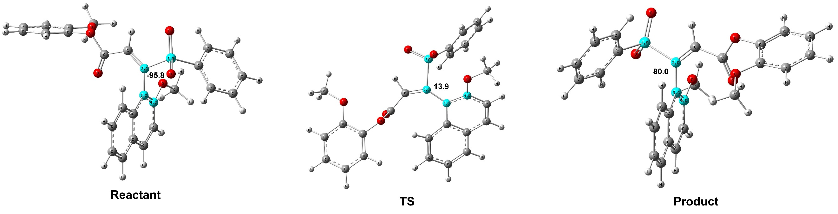9a
Sum of electronic and thermal Free Energies @ B3lYP/6-31g(d,p) = -1890.94142800 a.u
Single point energy @ M06-2X/Def2-TZVP = -1891.56059590 a.u

S -3.35266200 3.68797100 -1.20061200
C -2.22046500 2.35624700 -1.79565300
C -0.79157700 2.71249000 -1.96228200
C -0.34469100 3.08687500 -3.22967300
C -3.21881800 5.01559000 -2.40595600
C -4.04776900 4.99754500 -3.53013700
C -2.31700800 6.05523500 -2.17382900
C -3.96213400 6.04576700 -4.44499200
H -4.75357200 4.18675100 -3.67326200
C -2.24071400 7.09738200 -3.09897500
H -1.70351400 6.05201700 -1.28005100
C -3.05875200 7.09092100 -4.23077900
H -4.60605600 6.05147200 -5.31928300
H -1.54767900 7.91589500 -2.93008100
H -2.99906100 7.90738600 -4.94472000
O -2.80093100 4.18252800 0.07477300
O -4.73361800 3.17053300 -1.25544300
C -2.81950000 1.17383700 -1.98247800
H -3.88893800 1.08581500 -1.82069300
C 0.12772500 2.66207600 -0.86692900
C -0.25219000 2.26084900 0.44466200
C 1.49949500 3.01640200 -1.09301900
C 1.00981100 3.44426500 -3.44078600
C 0.66959900 2.21531000 1.46579100
H -1.28526400 2.00021200 0.64106300
C 2.42370900 2.96120300 -0.01455500
C 1.90055000 3.40746300 -2.39416600
H 1.34866900 3.73760300 -4.42671400
C 2.02213400 2.56836500 1.24041100
H 0.35405200 1.90680600 2.45840900
H 3.45896500 3.23264000 -0.20497400
H 2.93949900 3.67827700 -2.56279000
H 2.73577500 2.52712700 2.05800500
O -1.27527300 3.08121800 -4.22189200
C -0.90743600 3.52823200 -5.52280600
H -1.81797000 3.47270000 -6.12167400
H -0.55151200 4.56510100 -5.50934100
H -0.14432100 2.88189000 -5.97261500
C -2.11224000 -0.06667800 -2.39693400
O -0.96198700 -0.17846500 -2.74487200
O -2.99397300 -1.11182900 -2.30774000
C -2.55647200 -2.37343800 -2.71518700
C -2.28537900 -3.33834800 -1.75825300
C -2.48154300 -2.66387500 -4.09029200
C -1.92348000 -4.62936800 -2.15477400
H -2.36263500 -3.06883600 -0.70977400
C -2.11479900 -3.95656600 -4.47917300
C -1.83819300 -4.92830200 -3.51190700
H -1.71010700 -5.38618000 -1.40698300
H -2.04524300 -4.21080800 -5.53014200
H -1.55634200 -5.92669500 -3.83342100
O -2.78724600 -1.64414500 -4.93387600
C -2.69028500 -1.87985800 -6.33458500
H -1.66912500 -2.15189200 -6.62801000
H -3.38548300 -2.66282100 -6.66194500
H -2.96211100 -0.93815300 -6.81454000

TS9a
Sum of electronic and thermal Free Energies @ B3lYP/6-31g(d,p) = -1890.89338400 a.u
Single point energy @ M06-2X/Def2-TZVP = -1891.56059590 a.u

S -3.33860000 3.76500000 -3.18960000
C -2.01820000 2.50790000 -2.55020000
C -0.68750000 2.96870000 -2.06110000
C -0.44460000 4.32710000 -1.77290000
C -2.46420000 4.93670000 -4.24690000
C -1.52410000 4.47300000 -5.16840000
C -2.86800000 6.27150000 -4.22340000
C -0.95690000 5.37880000 -6.06540000
H -1.23770000 3.42660000 -5.19070000
C -2.30350000 7.16390000 -5.13600000
H -3.61200000 6.59730000 -3.50500000
C -1.34610000 6.72010000 -6.05080000
H -0.21740000 5.03160000 -6.78050000
H -2.61400000 8.20450000 -5.13150000
H -0.90710000 7.41860000 -6.75710000
O -4.04490000 4.46500000 -2.10320000
O -4.18920000 2.99420000 -4.12730000
C -2.55060000 1.30110000 -2.83100000
H -3.52670000 1.33610000 -3.31970000
C 0.47650000 2.09890000 -1.96040000
C 0.40740000 0.70120000 -1.73980000
C 1.79870000 2.66380000 -1.98890000
C 0.86350000 4.87500000 -1.74400000
C 1.53190000 -0.09920000 -1.71190000
H -0.53700000 0.25720000 -1.47830000
C 2.93920000 1.81940000 -1.99680000
C 1.95470000 4.06980000 -1.92480000
H 0.99080000 5.94120000 -1.60890000
C 2.81610000 0.45300000 -1.89070000
H 1.42060000 -1.16370000 -1.52770000
H 3.91990000 2.28440000 -2.05520000
H 2.95330000 4.49630000 -1.95790000
H 3.69420000 -0.18530000 -1.89020000
O -1.52300000 5.10110000 -1.54180000
C -1.38240000 6.47560000 -1.19410000
H -2.39610000 6.82530000 -0.99800000
H -0.78070000 6.59050000 -0.28570000
H -0.94400000 7.06260000 -2.00810000
C -2.15060000 -0.13370000 -2.79540000
O -1.60370000 -0.71060000 -3.70090000
O -2.64970000 -0.73770000 -1.67420000
C -2.68060000 -2.13740000 -1.63790000
C -1.88590000 -2.81090000 -0.72480000
C -3.59230000 -2.82210000 -2.46390000
C -1.96880000 -4.20370000 -0.62630000
H -1.21550000 -2.23960000 -0.09060000
C -3.66270000 -4.21550000 -2.36520000
C -2.85180000 -4.89570000 -1.45070000
H -1.34730000 -4.73410000 0.08780000
H -4.34890000 -4.77200000 -2.99240000
H -2.92300000 -5.97750000 -1.38650000
O -4.34240000 -2.05000000 -3.28990000
C -5.24910000 -2.69460000 -4.18050000
H -4.72460000 -3.36520000 -4.87160000
H -6.01750000 -3.25630000 -3.63540000
H -5.72590000 -1.89440000 -4.74850000

TS9a’
Sum of electronic and thermal Free Energies @ B3lYP/6-31g(d,p) = -1890.94043300 a.u
Single point energy @ M06-2X/Def2-TZVP = -1891.60763237 a.u

S -3.08421200 2.95693700 -3.37016800
C -2.12115000 2.70045500 -1.80699700
C -0.66603500 2.95801400 -1.88211800
C -0.23399800 4.28247200 -1.81570000
C -2.75473900 1.48923200 -4.36075700
C -3.56159000 0.36015600 -4.19535300
C -1.71744000 1.51832000 -5.29485900
C -3.31103900 -0.76659100 -4.97725300
H -4.37862600 0.37350700 -3.48220700
C -1.47872700 0.38394500 -6.07103600
H -1.12237000 2.41616200 -5.41638400
C -2.27008300 -0.75511600 -5.90970000
H -3.93314900 -1.64921500 -4.86410100
H -0.67677600 0.39289200 -6.80279000
H -2.07969700 -1.63523700 -6.51692000
O -2.50315000 4.10778100 -4.08116900
O -4.51672200 2.93947300 -3.01534400
C -2.86103900 2.33531900 -0.75295700
H -3.92896600 2.18563300 -0.87163300
C 0.28571600 1.90143000 -2.03530400
C -0.07868800 0.52576200 -2.07008100
C 1.67621900 2.23270100 -2.16247600
C 1.14046500 4.60001000 -1.95037900
C 0.87271900 -0.45704500 -2.22837900
H -1.12262000 0.25063900 -1.96944300
C 2.63099500 1.19264100 -2.32440700
C 2.06305700 3.59569600 -2.12299800
H 1.46570200 5.63236900 -1.90793200
C 2.24326100 -0.12649200 -2.35816500
H 0.56703200 -1.49936400 -2.25523200
H 3.67964600 1.46320800 -2.41898500
H 3.11632100 3.84372400 -2.22427200
H 2.98135700 -0.91344300 -2.48212000
O -1.19355600 5.21336100 -1.58754300
C -0.88844200 6.59074000 -1.78653300
H -1.83391400 7.12211100 -1.66687300
H -0.17547100 6.96086400 -1.03985000
H -0.49895200 6.77413700 -2.79432700
C -2.31689900 2.13563000 0.61642300
O -1.22094200 2.43441300 1.02277600
O -3.29625800 1.56378900 1.38676300
C -2.97560300 1.20457500 2.69671400
C -3.56195300 1.89419100 3.74606300
C -2.13358600 0.09971100 2.92526000
C -3.31199600 1.49938300 5.06390800
H -4.20915900 2.73546500 3.51947400
C -1.88239000 -0.28419100 4.24669300
C -2.47116300 0.41603600 5.30479700
H -3.76894100 2.03891200 5.88711300
H -1.23466000 -1.12735900 4.45599200
H -2.26610700 0.10137700 6.32385800
O -1.63997700 -0.51297000 1.81867900
C -0.68296700 -1.55315300 1.99402700
H 0.19475900 -1.20168300 2.54913400
H -1.11775300 -2.42101500 2.50538700
H -0.37529800 -1.84542800 0.98892600

7. Supplementary Data for Experimental Racemization Studies
The axially chiral product 9a, 9m and 9n (0.005 mmol) were dissolved in toluene (100 mL) separately and heated at 100 ºC (373.15 K) for 10 h. The ee value was tested every one hour via HPLC on chiral stationary phase. The rotation barrier was determined according to the literature method.²⁴⁻²⁹

Supplementary Table 6. The Detailed Racemization Result of 9a, 9m and 9n over 24 h
Time/h | ee (%)  (9a, 100 ºC) | ee (%)  (9a, 75 ºC) | ee (%)  (9a, 50 ºC) | ee (%)  (9m, 100 ºC) | ee (%)  (9n, 100 ºC)
0 | 99.45 | 99.45 | 99.45 | 97.27 | 85.01
1 | 89.68 | - | - | 93.95 | 82.2
2 | 82.53 | 97.54 | 99.21 | 90.67 | 80.1
3 | 73.42 | - | - | 87.15 | 78.06
4 | 65.87 | 96.6 | 99.01 | 83.9 | 75.32
5 | 60.73 | - | - | 80.55 | 73.49
6 | 53.53 | 95.29 | 98.75 | 77.81 | 71.48
7 | 48.45 | - | - | 74.76 | 69.71
8 | 43.87 | 91.23 | - | 71.52 | 67.6
9 | 39.14 | - | 98.38 | 68.66 | 66.14
10 | 36.07 | 89.98 | - | 66.87 | 64.49
11 | - | - | - | 63.76 | 63.38
12 | 28.24 | 87.42 | 98.17 | 61.18 | 62.16
13 | - | - | - | - | -
14 | 21.79 | 86.76 | - | - | -
15 | - | - | - | 54.61 | -
16 | 16.83 | 83.94 | 97.96 | - | 56.27
17 | - | - | - | - | -
18 | 14.98 | 82.38 | - | 49.21 | -
19 | - | - | - | - | -
20 | - | 80.28 | 97.43 | - | 50.58
21 | 9.34 | - | - | 45.25 | -
22 | - | 78.24 | - | - | -
23 | - | - | - | - | -
24 | 7.12 | 76.82 | 97.09 | 39.01 | 47.21

a) Determination of t_{1/2rac} and ΔG‡ for 9a.
The rotation barrier of 9a was determined according to the literature method (t_{1/2rac} = 6.7 h at 100 ºC (373.15 K), toluene; ΔG‡ = 30.26 kcal/mol).

Supplementary Table 7. Calculation Result for Racemization Test of 9a at 100 ºC
Time (s) | ee (%) | ee₀/ee_{t} | ln(ee₀/ee_{t})
0 | 99.45 | 1 | 0
3600 | 89.68 | 1.108943 | 0.103407
7200 | 82.53 | 1.205016 | 0.186493
10800 | 73.42 | 1.354536 | 0.303459
14400 | 65.87 | 1.509792 | 0.411972
18000 | 60.73 | 1.637576 | 0.493217
21600 | 53.53 | 1.857837 | 0.619413
25200 | 48.45 | 2.052632 | 0.719123
28800 | 43.87 | 2.266925 | 0.818424
32400 | 39.14 | 2.540879 | 0.932510
36000 | 36.07 | 2.757139 | 1.014194
Supplementary Figure 182. Rotation Barrier Analysis of 9a
ln(ee₀/ee_{t})=2k_{ent}t+C
therefore, k_{ent}=1/2 slope = 1.43 x 10⁻⁵
k_{rac}=2k_{ent}=2.86 x 10⁻⁵ s⁻¹
t_{1/2rac}=ln2/k_{rac}= 2.42 x 10⁴ s = 6.7 h
ΔG‡ = -RTln(k_{ent}h/k_{B}T) = 126.70 kJ/mol = 30.26 kcal/mol

b) Determination of t_{1/2rac} and ΔG‡ for 9m
The rotation barrier of 9m was determined according to the literature method (t_{1/2rac} = 18.1 h at 100 ºC (373.15 K), toluene; ΔG‡ = 30.99 kcal/mol).

Supplementary Table 8. Calculation Result for Racemization Test of 9m at 100 ºC
Time (s) | ee (%) | ee₀/ee_{t} | ln(ee₀/ee_{t})
0 | 97.27 | 1 | 0
3600 | 93.95 | 1.035338 | 0.034728
7200 | 90.67 | 1.072791 | 0.070264
10800 | 87.15 | 1.116122 | 0.109860
14400 | 83.90 | 1.159356 | 0.147865
18000 | 80.55 | 1.207573 | 0.188613
21600 | 77.81 | 1.250096 | 0.223221
25200 | 74.76 | 1.301097 | 0.263208
28800 | 71.52 | 1.360039 | 0.307513
32400 | 68.66 | 1.416691 | 0.348324
36000 | 66.87 | 1.454613 | 0.374740

9m
Supplementary Figure 183. Rotation Barrier Analysis of 9m
ln(ee₀/ee_{t})=2k_{ent}t+C
therefore, k_{ent}=1/2 slope = 5.33 x 10⁻⁶
k_{rac}=2k_{ent}=1.07 x 10⁻⁵ s⁻¹
t_{1/2rac}=ln2/k_{rac}= 6.50 x 10⁴ s = 18.1 h
ΔG‡ = -RTln(k_{ent}h/k_{B}T) = 129.76 kJ/mol = 30.99 kcal/mol

b) Determination of t_{1/2rac} and ΔG‡ for 9n
The rotation barrier of 9n was determined according to the literature method (t_{1/2rac} = 25.1 h at 100 ºC (373.15 K), toluene; ΔG‡ = 31.24 kcal/mol).

Supplementary Table 9. Calculation Result for Racemization Test of 9n at 100 ºC
Time (s) | ee (%) | ee₀/ee_{t} | ln(ee₀/ee_{t})
0 | 85.01 | 1 | 0
3600 | 82.20 | 1.034185 | 0.033614
7200 | 80.10 | 1.061298 | 0.059493
10800 | 78.06 | 1.089034 | 0.085291
14400 | 75.32 | 1.128651 | 0.121023
18000 | 73.49 | 1.156756 | 0.145620
21600 | 71.48 | 1.189284 | 0.173351
25200 | 69.71 | 1.219481 | 0.198425
28800 | 67.60 | 1.257544 | 0.229161
32400 | 66.14 | 1.285304 | 0.250995
36000 | 64.49 | 1.318189 | 0.276259

9n
Supplementary Figure 184. Rotation Barrier Analysis of 9n
ln(ee₀/ee_{t})=2k_{ent}t+C
therefore, k_{ent}=1/2 slope = 3.84 x 10⁻⁶
k_{rac}=2k_{ent}=7.67 x 10⁻⁶ s⁻¹
t_{1/2rac}=ln2/k_{rac}= 9.03 x 10⁴ s = 25.1 h
ΔG‡ = -RTln(k_{ent}h/k_{B}T) = 130.78 kJ/mol = 31.24 kcal/mol

8. Supplementary References
1. He, M., Struble, J.R. & Bode, J.W. Highly Enantioselective Azadiene Diels−Alder Reactions Catalyzed by Chiral N-Heterocyclic Carbenes. J. Am. Chem. Soc. 128, 8418-8420 (2006).
2. Wu, X. et al. Sulfinate and Carbene Co-catalyzed Rauhut-Currier Reaction for Enantioselective Access to Azepino 1,2-a indoles. Angew. Chem. Int. Ed. 58, 477-481 (2019).
3. Zhao, C., Li, F. & Wang, J. N-Heterocyclic Carbene Catalyzed Dynamic Kinetic Resolution of Pyranones. Angew. Chem. Int. Ed. 55, 1820-1824 (2016).
4. Zhuo, S. et al. Access to All-Carbon Spirocycles through a Carbene and Thiourea Cocatalytic Desymmetrization Cascade Reaction. Angew. Chem. Int. Ed. 58, 1784-1788 (2019).
5. Dong, S. et al. Organocatalytic Kinetic Resolution of Sulfoximines. J. Am. Chem. Soc. 138, 2166-2169 (2016).
6. Li, W. & Lam, Y. A Facile Solid-Phase Synthesis of 1,2,4,5-Tetrasubstituted Imidazoles Using Sodium Benzenesulfinate as a Traceless Linker. J. Comb. Chem. 7, 644-647 (2005).
7. Sisko, J., Mellinger, M., Sheldrake, P.W. & Baine, N.H. α‐Tosylbenzyl Isocyanide: Benzene, 1‐[(isocyanophenylmethyl) sulfonyl]‐4‐methyl‐. Org. Synth. 77, 198-198 (2003).
8. Qi, Z., Jiang, Y., Wang, Y. & Yan, R. tert-Butyl Nitrite Promoted Oxidative Intermolecular Sulfonamination of Alkynes to Synthesize Substituted Sulfonyl Pyrroles from the Alkynylamines and Sulfinic Acids. J. Org. Chem. 83, 8636-8644 (2018).
9. Yuan, Z. et al. Highly Selective Pd-Catalyzed Intermolecular Fluorosulfonylation of Styrenes. J. Am. Chem. Soc. 137, 2468-2471 (2015).
10. Zhao, C. et al. Enantioselective [3+3] atroposelective annulation catalyzed by N-heterocyclic carbenes. Nat. Commun. 9, 611 (2018).
11. Jia, S. et al. Organocatalytic Enantioselective Construction of Axially Chiral Sulfone-Containing Styrenes. J. Am. Chem. Soc. 140, 7056-7060 (2018).
12. Sakai, H. et al. Formation of One-Dimensional Helical Columns and Excimerlike Excited States by Racemic Quinoxaline-Fused [7]Carbohelicenes in the Crystal. Chem. Eur. J. 20, 10099-10109 (2014).
13. Lee, C., Yang, W. & Parr, R.G. Development of the Colle-Salvetti correlation-energy formula into a functional of the electron density. Phys. Rev. B 37, 785-789 (1988).
14. Becke, A.D. Density‐functional thermochemistry. III. The role of exact exchange. J. Chem. Phys. 98, 5648-5652 (1993).
15. Stephens, P.J., Devlin, F.J., Chabalowski, C.F. & Frisch, M.J. Ab Initio Calculation of Vibrational Absorption and Circular Dichroism Spectra Using Density Functional Force Fields. J. Phys. Chem 98, 11623-11627 (1994).
16. Francl, M.M. et al. Self‐consistent molecular orbital methods. XXIII. A polarization‐type basis set for second‐row elements. J. Chem. Phys. 77, 3654-3665 (1982).
17. Hehre, W.J., Ditchfield, R. & Pople, J.A. Self—Consistent Molecular Orbital Methods. XII. Further Extensions of Gaussian—Type Basis Sets for Use in Molecular Orbital Studies of Organic Molecules. J. Chem. Phys. 56, 2257-2261 (1972).
18. Hariharan, P.C. & Pople, J.A. The influence of polarization functions on molecular orbital hydrogenation energies. Theor. Chim. Acta 28, 213-222 (1973).
19. Marenich, A.V., Cramer, C.J. & Truhlar, D.G. Universal Solvation Model Based on Solute Electron Density and on a Continuum Model of the Solvent Defined by the Bulk Dielectric Constant and Atomic Surface Tensions. J. Phys. Chem. B 113, 6378-6396 (2009).
20. Zhao, Y. & Truhlar, D.G. The M06 suite of density functionals for main group thermochemistry, thermochemical kinetics, noncovalent interactions, excited states, and transition elements: two new functionals and systematic testing of four M06-class functionals and 12 other functionals. Theor. Chem. Acc. 120, 215-241 (2008).
21. Zhao, Y. & Truhlar, D.G. Density Functionals with Broad Applicability in Chemistry. Acc. Chem. Res. 41, 157-167 (2008).
22. Weigend, F. & Ahlrichs, R. Balanced basis sets of split valence, triple zeta valence and quadruple zeta valence quality for H to Rn: Design and assessment of accuracy. Phys. Chem. Chem. Phys 7, 3297-3305 (2005).
23. Weigend, F. Accurate Coulomb-fitting basis sets for H to Rn. Phys. Chem. Chem. Phys 8, 1057-1065 (2006).
24. Reist, M., Testa, B., Carrupt, P.-A., Jung, M. & Schurig, V. Racemization, enantiomerization, diastereomerization, and epimerization: Their meaning and pharmacological significance. Chirality 7, 396-400 (1995).
25. Curran, D.P., Liu, W. & Chen, C.H.-T. Transfer of Chirality in Radical Cyclizations. Cyclization of o-Haloacrylanilides to Oxindoles with Transfer of Axial Chirality to a Newly Formed Stereocenter. J. Am. Chem. Soc. 121, 11012-11013 (1999).
26. Shirakawa, S., Liu, K. & Maruoka, K. Catalytic Asymmetric Synthesis of Axially Chiral o-Iodoanilides by Phase-Transfer Catalyzed Alkylations. J. Am. Chem. Soc. 134, 916-919 (2012).
27. Ma, C. et al. Atroposelective Access to Oxindole-Based Axially Chiral Styrenes via the Strategy of Catalytic Kinetic Resolution. J. Am. Chem. Soc. 142, 15686-15696 (2020).
28. Wang, Q. et al. Rhodium-Catalyzed Atroposelective Oxidative C–H/C–H Cross-Coupling Reaction of 1-Aryl Isoquinoline Derivatives with Electron-Rich Heteroarenes. J. Am. Chem. Soc. 142, 15678-15685 (2020).
29. Li, T. et al. N-Heterocyclic Carbene-Catalyzed Atroposelective Annulation for Access to Thiazine Derivatives with C−N Axial Chirality. Angew. Chem. Int. Ed. 60, 9362-9367 (2021).

