Supplementary Materials
Methods
Considered that the daytime temperature may have cumulative effect on sleep duration, we classified the day-night temperature patterns into three types in hot season: (a) hot daytime only: at least two consecutive hot days without preceding hot nights, (b) hot nighttime only: at least two consecutive hot nights without hot days, (c) compound hot day and night: at least two consecutive days with both hot days and hot nights. Typically, the daily maximum temperature occurs during the daytime, whereas the daily minimum temperature is usually observed at night. Therefore, hot days are defined as: $T_{max}$ > $T_{max, 90th}$; $T_{max, 90th}$ indicates the temperature threshold which is the 90th percentile of maximum temperatures within three years. Similarly, hot nights are defined as: $T_{min}$ > $T_{min, 90th}$.
In a similar way, we also had three types in the cold season: (a) cold daytime-only, (b) cold nighttime only, (c) compound cold day and night. Cold days and cold nights are defined as $T_{max}$ < $T_{max, 10th}$ and $T_{min}$ < $T_{min, 10th}$, respectively.

Table S1. The association between three day-night temperature pattern and sleep duration by mixed-effect model.
From: Distinction in the impact of temperature patterns on sleep duration.
Classification | Observations | β value
Classification | Observations | Total sleep duration (min) | Light sleep duration (min) | Deep sleep duration (min)
Hot Season
Normal | 13185 | Ref | Ref | Ref
Hot daytime only | 2181 | -5.17 (-8.13, -2.21) | -4.15 (-6.8, -1.49) | -0.97 (-2.53, 0.59)
Hot nighttime only | 19 | 5.5 (-24.25, 35.24) | 13.81 (-12.9, 40.53) | -8.50 (-24.28, 7.27)
Compound hot day and night | 555 | -2.11 (-7.69, 3.46) | -2.45 (-7.45, 2.56) | 0.01 (-2.95, 2.95)
Cold Season
Normal | 10696 | Ref | Ref | Ref
Cold daytime only | 0 | -- | -- | --
Cold nighttime only | 3096 | 6.52 (3.92, 9.12) | 2.07 (-0.28, 4.42) | 4.13 (2.79, 5.47)
Compound cold day and night | 429 | 11.78 (5.41, 18.15) | 9.97 (4.21, 15.73) | 1.88 (-1.41, 5.17)
Note: Estimates were adjusted for age, gender, body mass index, frequency of drinking and smoking, sleep day type and city groups.

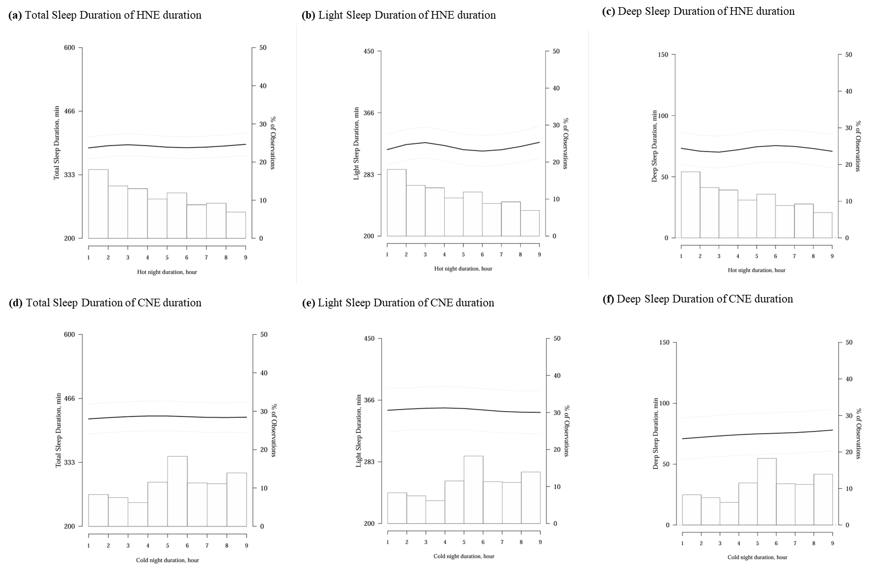
Figure S1. Exposure-response relationships between temperature excess duration and sleep parameters: (a-f)
Note: The exposure-response curve was calculated using restricted cubic splines with knots at the 5th, 35th, 65th, and 95th percentiles of the distribution of nighttime light. β was adjusted for age, gender, body mass index, frequency of drinking and smoking, sleep day type, and city groups.
- Minimum nighttime temperature during cold season
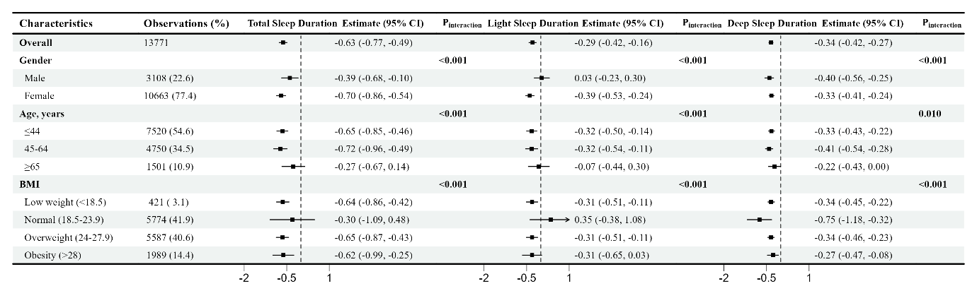

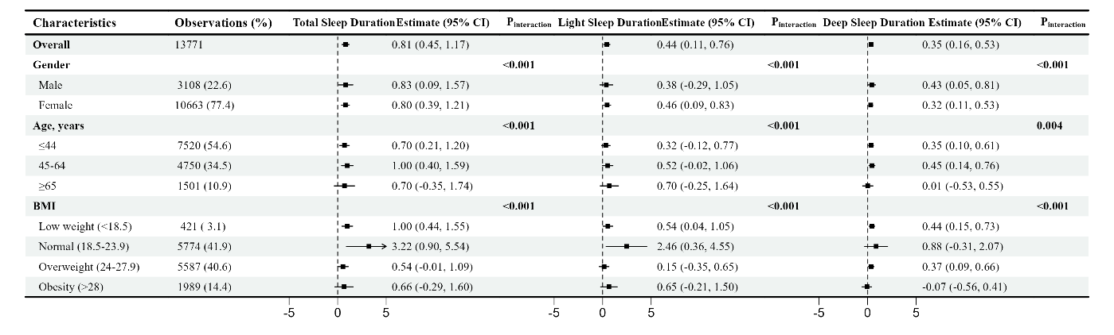
- Cold night excess, per 5℃
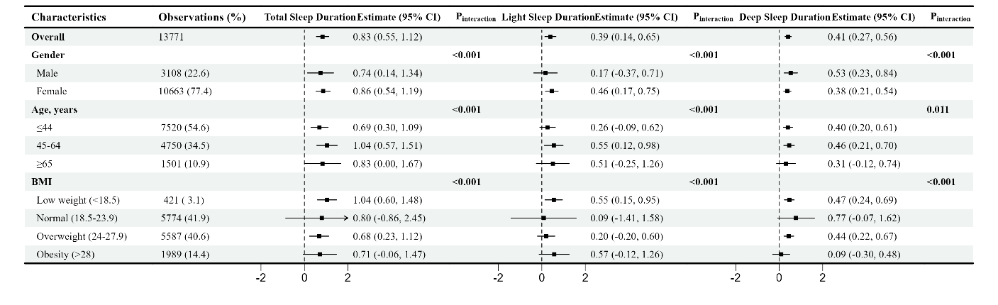
- Cold night duration

Figure S2. Association between temperature and sleep parameters in different subgroups in cold seasons: (a-c)
Abbreviation: BMI, body mass index
Note: Estimates were adjusted for age, gender, body mass index, frequency of drinking and smoking, sleep day type, and city groups. Estimates were yielded by the likelihood ratio test, which quantifies the statistical significance of subgroup interaction effects within a model.

Hot seasons
(a) Maximum nighttime temperature during hot season
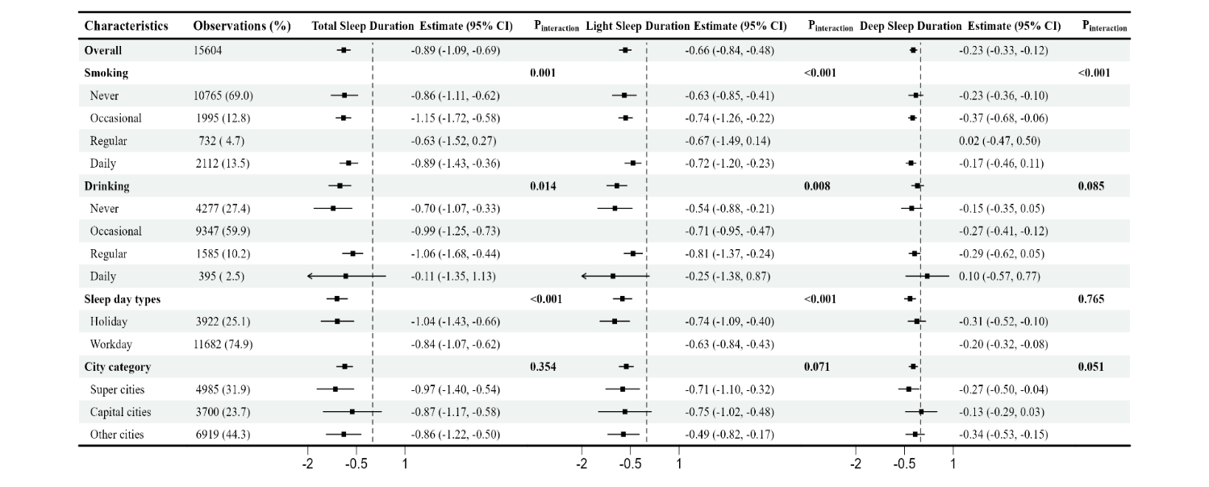
(b) Hot night excess, per 10℃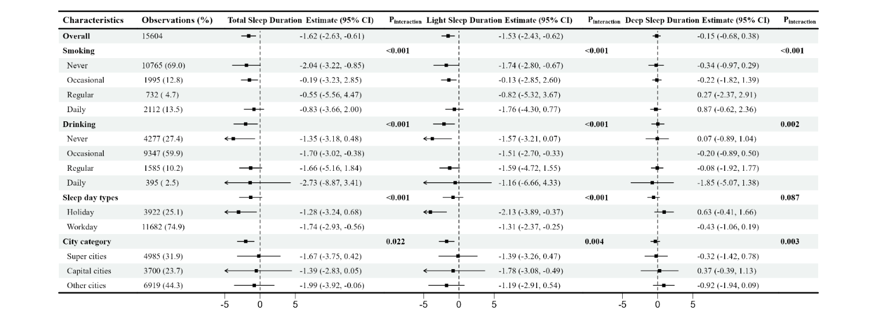
(c) Hot night duration
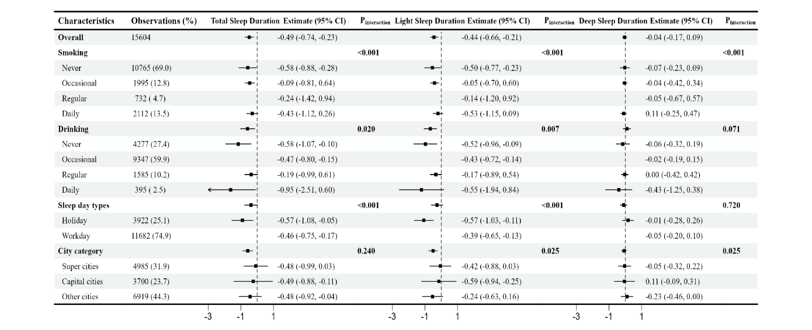
Cold seasons
(d) Minimum nighttime temperature during cold season
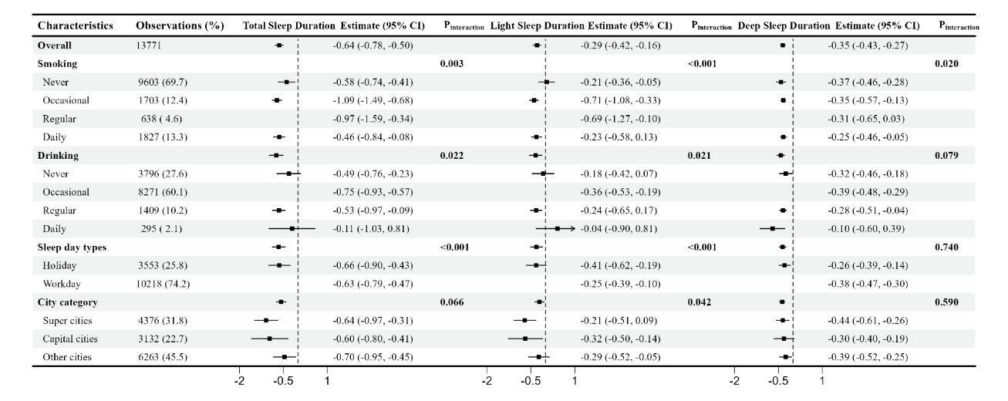
(e) Cold night excess, per 10℃
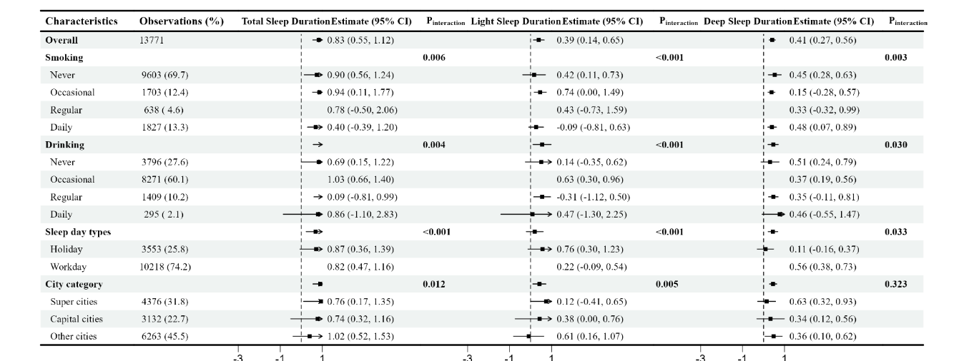
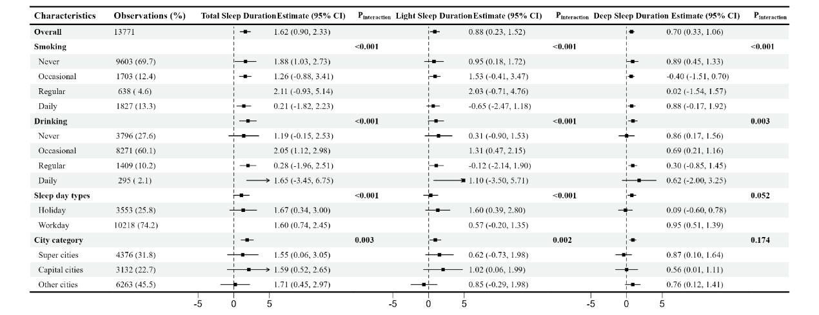
(f) Cold night duration
Figure S3. Association between temperature and sleep parameters in different subgroups: (a-f)
Abbreviation: BMI, body mass index. Note: Estimates were adjusted for age, gender, body mass index, frequency of drinking and smoking, sleep day type, and city groups. Estimates were yielded by the likelihood ratio test, which quantifies the statistical significance of subgroup interaction effects within a model.

