Additional material
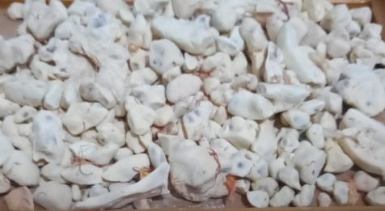
Adansonia digitata pulp collected from west Sudan.
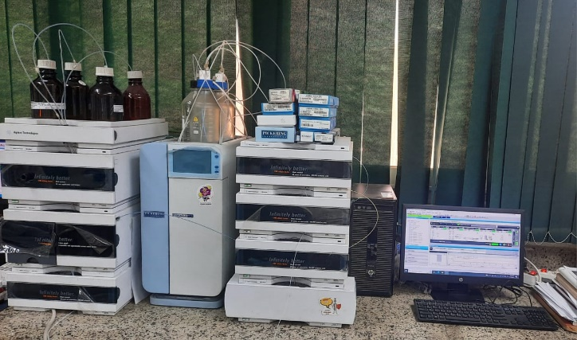
High Performance Liquid Chromatography device (used in this study)
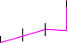

mAU
60
50
40
30
20
10
0
-10
2.5
5
7.5
10
12.5
15
17.5
20
22.5 min
3.572 - Gallic acid
4. 4.183 - Chlorogenic acid
423 - Catechin
5.413 - Methyl gallate 5.823 - Coffeic acid
6.313 - Syringic acid 6.722 - Rutin
7.102 - Ellagic acid
8.542 - Coumaric acid
8.967 - Vanillin
9.574 - Ferulic acid
10.194 - Naringenin
11.610 - Rosmarinic acid
19.112 - Cinnamic acid
20.502 - Kaempferol
21.095 - Hesperetin
Area: 248.328

Phenolic compounds of Adansonia digitata pulp extract identified by HPLC.

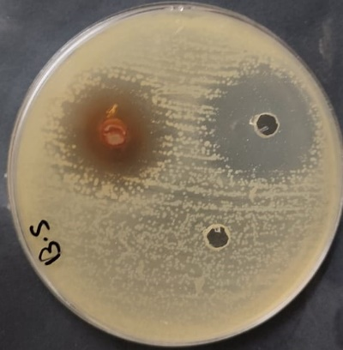

Inhibitions zones (in mm) byAdansonia digitata ethanoic pulp extracts against Bacillus subtilis.
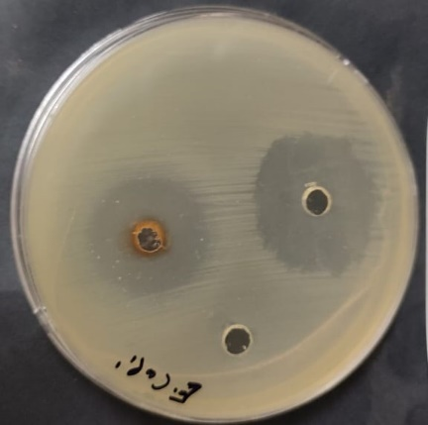
Inhibitions zones (in mm) byAdansonia digitata ethanoic pulp extracts against Escherichia coli.
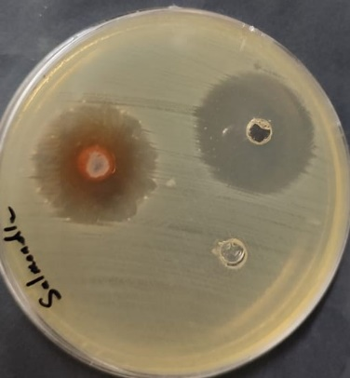
Inhibitions zones (in mm) by Adansonia digitata ethanoic pulp extracts against Salmonella typhi.

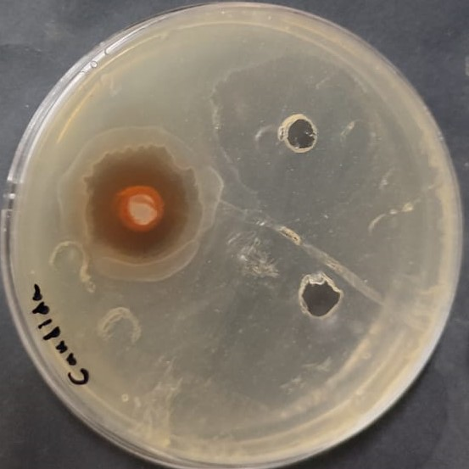
Inhibitions zones (in mm) by Adansonia digitata ethanoic pulp extracts against fungi Candida albicans.
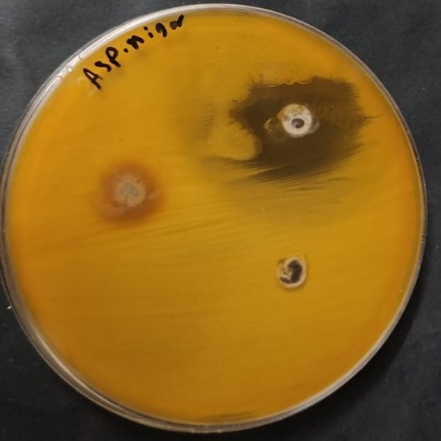
Inhibitions zones (in mm) by Adansonia digitata ethanoic pulp extracts against fungi Aspergillus niger.

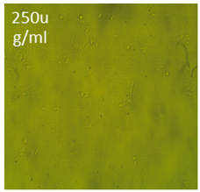 | 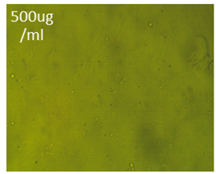 | 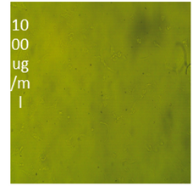 | 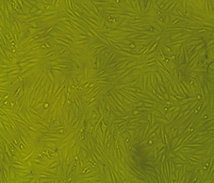
at concentration 250ug/ml | at concentration 500ug/ml | at concentration 1000ug/ml | Hela cell Control)

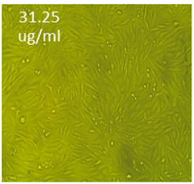 | 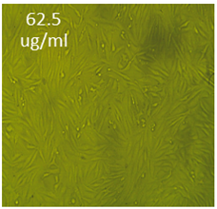 | 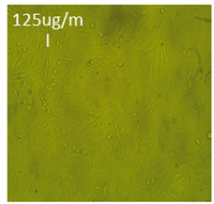
at concentration 31.25ug/ml | at concentration 62.5ug/ml | at concentration 125ug/ml
Effect of Adansonia digitata pulp extracts against Hela cell at different concentration.

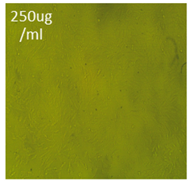 | 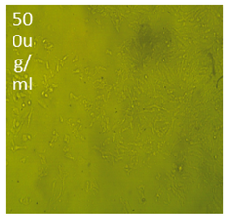 | 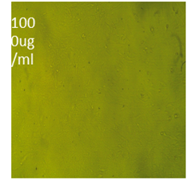 | 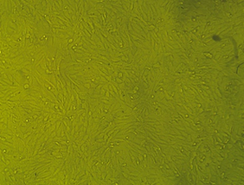
at concentration 250ug/ml | at concentration 500ug/ml | at concentration 1000ug/ml | HepG2 cell Control)

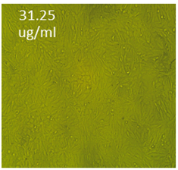 | 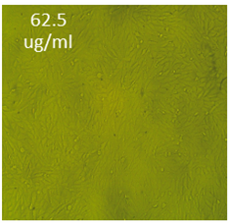 | 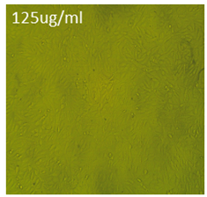
at concentration 31.25ug/ml | at concentration 62.5ug/ml | at concentration 125ug/ml
Effect of Adansonia digitata pulp extracts against HepG2 cell at different concentration.

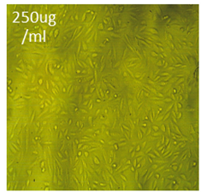 | 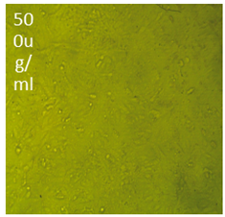 | 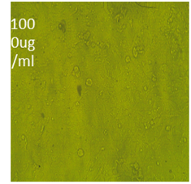 | 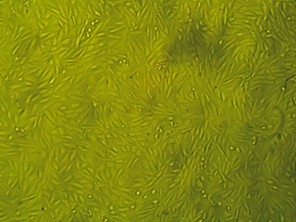
Figure 8.4.at concentration 250ug/ml | at concentration 500ug/ml | at concentration 1000ug/ml | A549 cell Control)
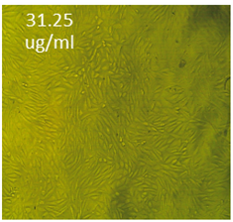 | 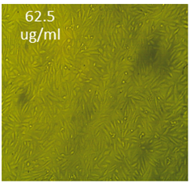 | 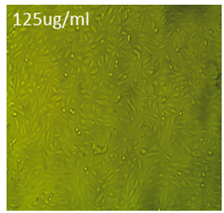
. at concentration 31.25ug/ml | at concentration 62.5ug/ml | at concentration 125ug/ml

Effect of Adansonia digitata pulp extracts against A549 cell at different concentration

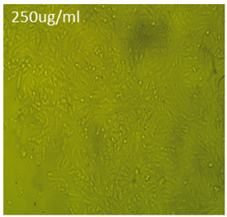 | 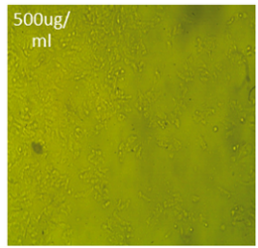 | 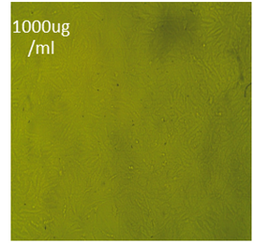 | 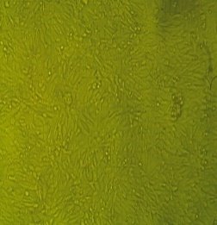
at concentration 250ug/ml | at concentration 500ug/ml | at concentration 1000ug/ml | A431 cell Control)

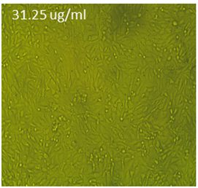 | 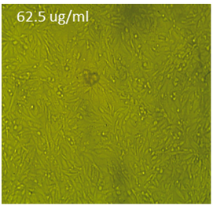 | 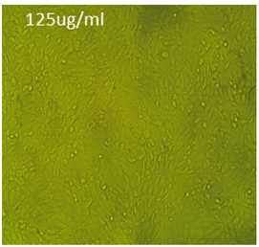
at concentration 31.25ug/ml | at concentration 62.5ug/ml | at concentration 125ug/ml
Effect of Adansonia digitata pulp extracts against A431 cell at different concentration.

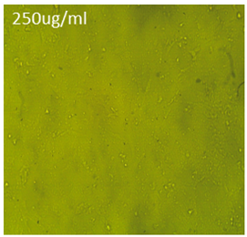 | 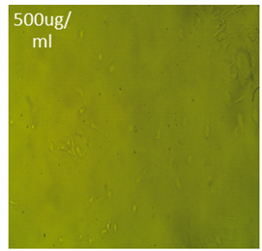 | 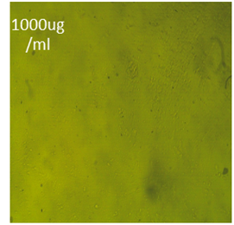 | 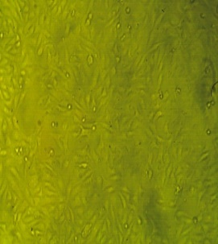
at concentration 250ug/ml | at concentration 500ug/ml | at concentration 1000ug/ml | Pc3 cell Control)

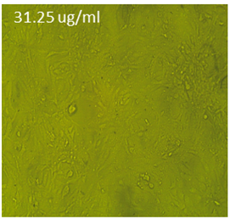 | 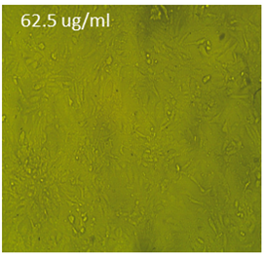 | 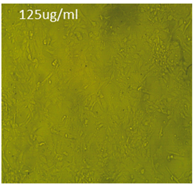
at concentration 31.25ug/ml | at concentration 62.5ug/ml | at concentration 125ug/ml
Effect of Adansonia digitata pulp extracts against Pc3 cell at different concentration.

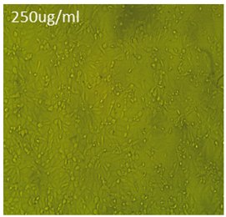 | 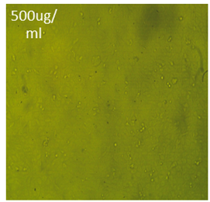 | 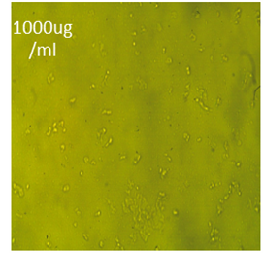 | 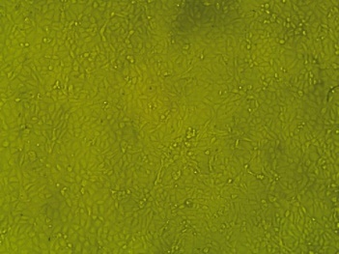
at concentration 250ug/ml | at concentration 500ug/ml | at concentration 1000ug/ml | T47D cell Control)

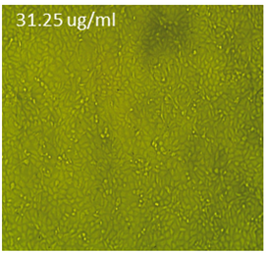 | 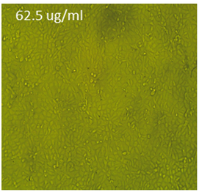 | 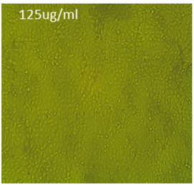
At concentration 31.25ug/ml | At concentration 62.5ug/ml | at concentration 125ug/ml
Effect of Adansonia digitata pulp extracts against T47D cell at different concentration.

