Supporting Information

High-throughput DL-amino acid analysis of deep sea water from Toyama Bay and anti-aging activity assessment using C. elegans

Takahiro Takayama*†, Haruto Iwata*, Reina Fujio*, Ayaka Minamida*, Yuko Sakaguchi**,
and Koichi Inoue*

* Laboratory of Clinical & Analytical Chemistry, College of Pharmaceutical Sciences, Ritsumeikan University, Shiga, Japan
** College of Pharmaceutical Sciences, Ritsumeikan University, Shiga, Japan

† Author for correspondence: Takahiro Takayama, Assistant Prof., Ph. D.
Laboratory of Clinical & Analytical Chemistry, College of Pharmaceutical Sciences, Ritsumeikan University, 1-1-1 Nojihigashi, Kusatsu, Shiga 525-8577, Japan
E-mail address: t-takaym@fc.ritsumei.ac.jp (T. Takayama)

Table of Contents
Purity test for 2,4-Dichloro-6-methoxy-1,3,5-triazine-D-Leu 3
Additional instrumental conditions. 4
Figure S1. Purity test results of (A) HPLC assay (190-600 nm) and (B) mass spectrum of the peak. 5
Figure S2. MS chromatograms of D-Leu-modified reagents using BEH-C18 column with (A) 0.1% formic acid mobile phase and (B) 10 mmol/L ammonium formate. 6
Figure S3. MS chromatograms of D-Leu-modified reagents using CAPCELL PAK ADME-HR with (A) 0.1% formic acid mobile phase and (B) 10 mmol/L ammonium formate. 7
Table S1. The optimized detection condition of MS/MS. 8
Table S2. The LOQ values in optimization conditions. 9
Table S3 Analytical method validation results of DSW as of recovery rate and repeatability 10
Table S3 Analytical method validation results of DSW as of recovery rate and repeatability (Continues) 11
Table S3 Analytical method validation results of DSW as of recovery rate and repeatability (Continues) 12
Table S4. The LOQ values in optimization conditions. 13

Purity test for 2,4-Dichloro-6-methoxy-1,3,5-triazine-D-Leu
The purity test of tag was performed using an ACQUITY UPLC H-Class PLUS system (including PDA) coupled to a quadrupole time-of-flight mass spectrometer (QToF-MS, Xevo G2XS QTOF, Waters, Milford, MA). The LC conditions were as follows: Column temperature: 40 °C, flow rate: 0.4 mL/min, Injection volume: 1 µL, mobile phase A: 0.1% FA in water, mobile phase B: 0.1% FA in acetonitrile, gradient programs: phase A/B (%): 95/5 (0–0.5 min) → 5/95 (55.0–57.0 min) → 95/5 (57.1–60.0 min), PDA range: 190 nm–600 nm. The MS system was equipped with an ESI source operating in positive ion mode. Nitrogen was used for the nebulization and desolvation (N₂ Supplier Model T30F, Anest Iwata, Yokohama, Japan), and argon was used as the collision gas. The column temperature was 40°C. The ESI source conditions included a capillary voltage of 2.50 kV, source temperature of 150°C, and desolvation temperature of 400°C. The cone and desolvation gas flows were 50 L/hr and 800 L/hr, respectively. The collision gas flow rate and was regulated at 0.15 mL/min.

Additional instrumental conditions.
The MS system (Xevo TQ-XS) was equipped with an ESI source operating in positive ion mode. Nitrogen was used for the nebulization and desolvation (Oilfree Scroll SmartAir SLP-221EFD, Anest Iwata, Yokohama, Japan), and argon was used as the collision gas. The ESI source conditions included a capillary voltage of 2.50 kV, source temperature of 150°C, and desolvation temperature of 500°C. The cone and desolvation gas flows were 150 L/hr and 1000 L/hr, respectively. The collision gas flow rate was regulated at 0.19 mL/min. The LH resolution 1, HM resolution 1, ion energy 1, LM resolution 2, HM resolution 2, and ion energy 2 were 2.8, 15.1, 0.5, 2.7, 14.7 and 0.9, respectively. The dwell time was automatically set by the software.
The MRM transitions with detection energies were optimized before the analysis. These values were summarized in Table S1

Figure S1. Purity test results of (A) HPLC assay (190-600 nm) and (B) mass spectrum of the peak.
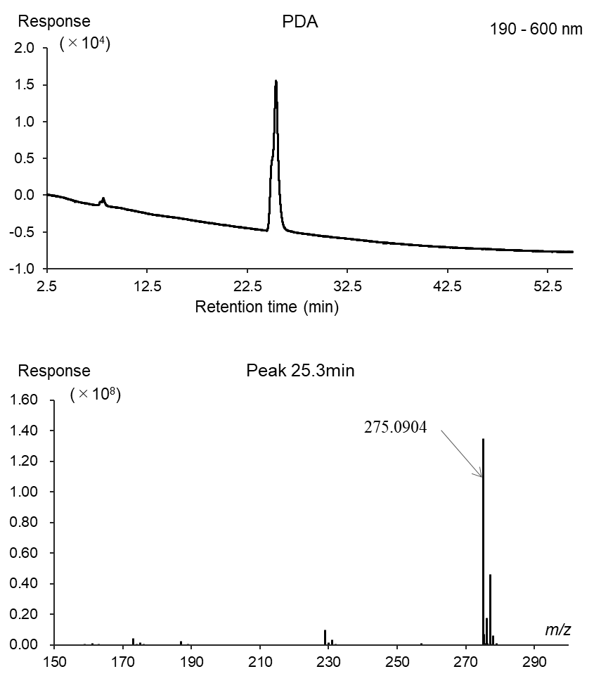

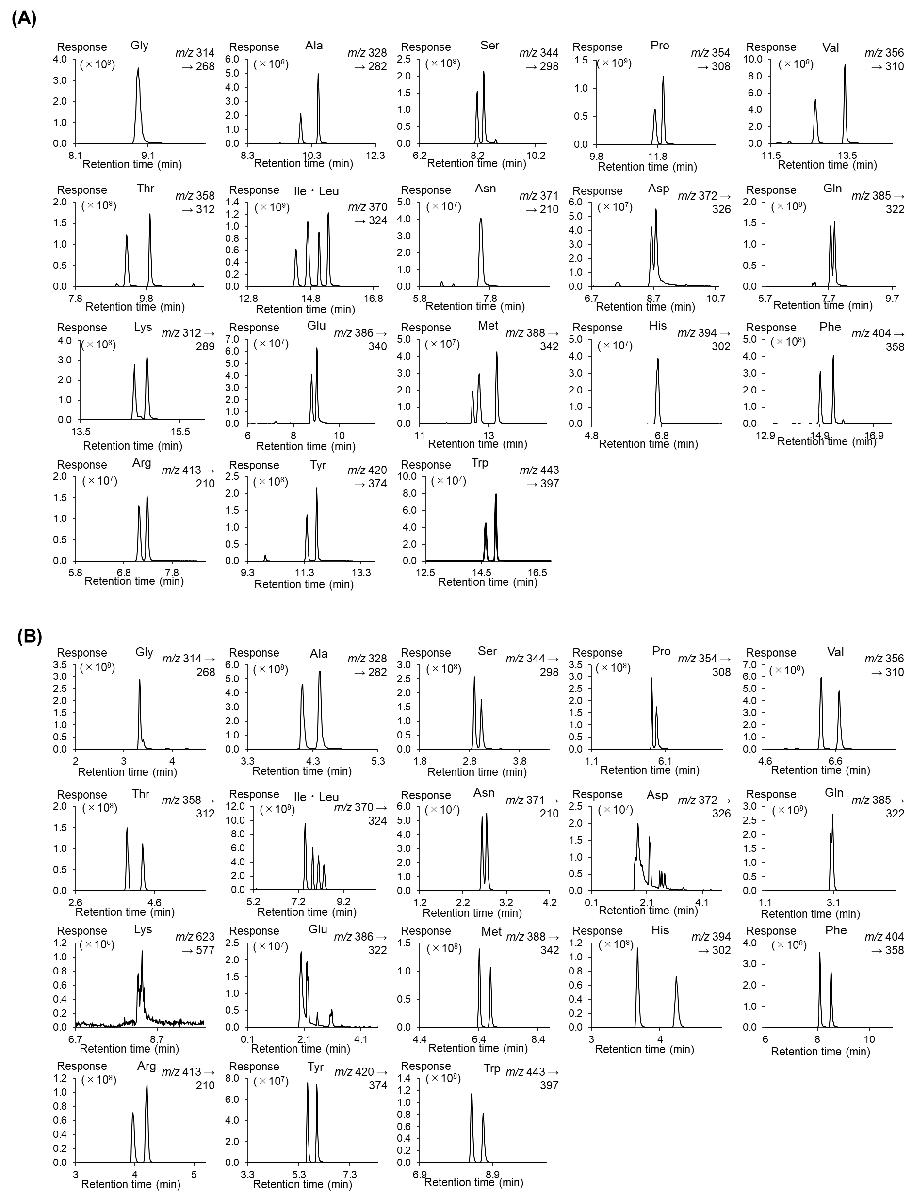

Figure S2. MS chromatograms of D-Leu-modified reagents using BEH-C18 column with (A) 0.1% formic acid mobile phase and (B) 10 mmol/L ammonium formate.
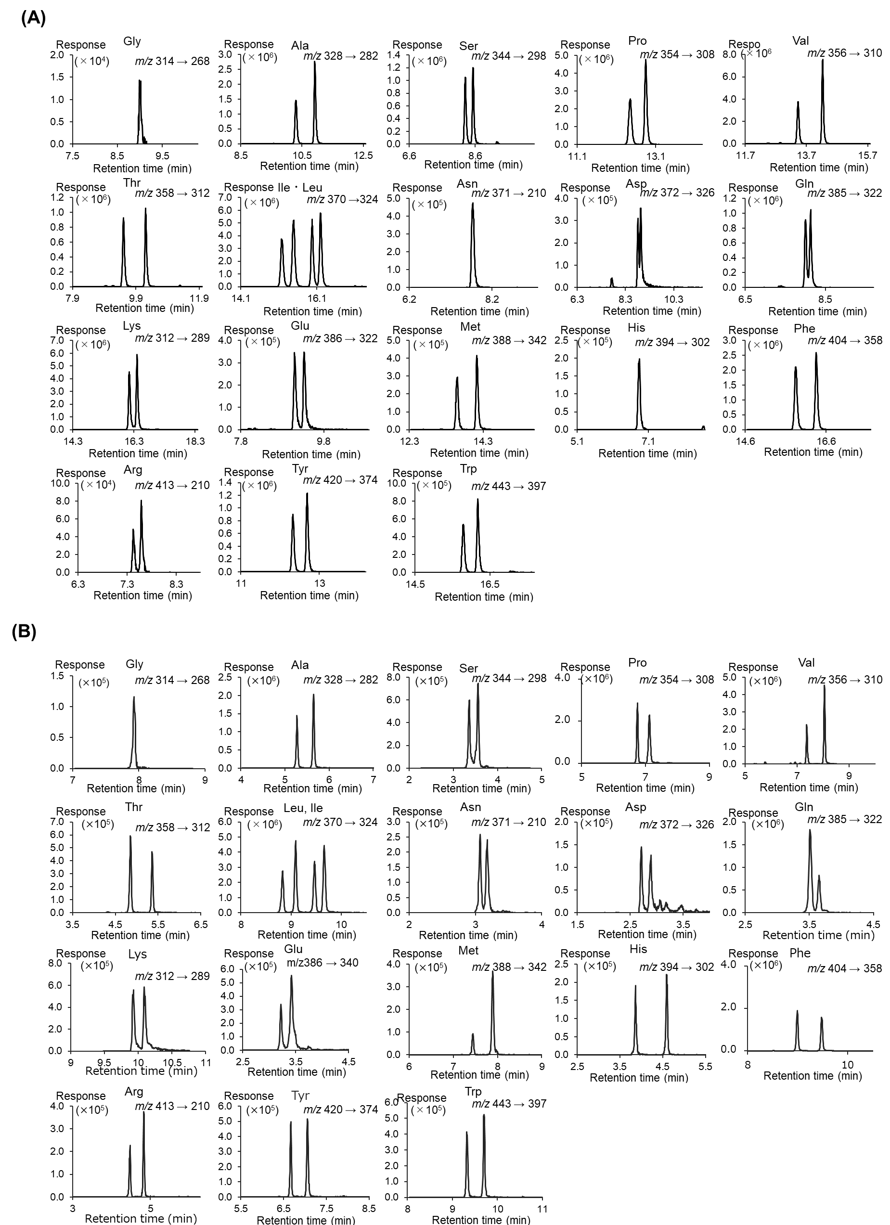

Figure S3. MS chromatograms of D-Leu-modified reagents using CAPCELL PAK ADME-HR with (A) 0.1% formic acid mobile phase and (B) 10 mmol/L ammonium formate.

Table S1. The optimized detection condition of MS/MS.
Analytes  (Abbreviation) | Monitoring ions (m/z) | Cone voltage (V)  /Collision energy (eV)
Gly | 314 > 268 | 40/30
Ala | 328 > 282 | 40/20
Ser | 344 > 298 | 40/20
Pro | 354 > 308 | 40/20
Val | 356 > 223 | 40/20
Thr | 358 > 312 | 40/20
Ile | 370 > 324 | 40/20
Leu | 370 > 324 | 40/20
Asn | 371 > 210 | 40/31
Asp | 372 > 326 | 40/20
Gln | 385 > 322 | 40/24
Lys | 312 > 289 | 40/15
Glu | 386 > 340 | 40/21
Met | 388 > 342 | 40/20
His | 394 > 302 | 40/30
Phe | 404 > 358 | 40/20
Arg | 413 > 210 | 40/40
Tyr | 420 > 374 | 40/25
Trp | 443 > 397 | 40/20

Table S2. The LOQ values in optimization conditions.

Analyte |  | Callibration range (nmol/L) |  | LOQ (pmol/L) |  | R²
Gly |  | 1-2500 |  | 0.33 |  | 0.999
Ala |  | 1-2500 |  | 4.3 |  | 0.999
Ser |  | 1-2500 |  | 9.2 |  | 0.999
Thr |  | 1-2500 |  | 2.8 |  | 0.997
Pro |  | 1-2500 |  | 1.0 |  | 0.992
Val |  | 1-2500 |  | 4.0 |  | 0.994
Leu |  | 1-2500 |  | 2.7 |  | 0.996
Ile |  | 1-2500 |  | 1.4 |  | 0.997
Met |  | 1-2500 |  | 30.5 |  | 0.993
Glu |  | 1-2500 |  | 20.8 |  | 0.998
Gln |  | 1-2500 |  | 1.8 |  | 0.999
Asp |  | 1-2500 |  | 11.1 |  | 0.996
Asn |  | 1-2500 |  | 54.9 |  | 0.993
Lys |  | 1-2500 |  | 54.9 |  | 0.998
Arg |  | 1-2500 |  | 12.0 |  | 0.998
His |  | 1-2500 |  | 9.3 |  | 0.998
Tyr |  | 1-2500 |  | 13.6 |  | 0.996
Phe |  | 1-2500 |  | 4.0 |  | 0.995
Trp |  | 1-2500 |  | 20.5 |  | 0.996

Table S3 Analytical method validation results of DSW as of recovery rate and repeatability

Analytes |  |  | spiked concentration /nmol/L |  | Intra-day |  |  | Inter-day
 |  |  | spiked concentration /nmol/L |  | Accuracy, % | Precision, % |  | Accuracy, % | Precision, %
Gly | Null |  | 1 |  | 100.1 | 0.8 |  | 100.5 | 1.8
Gly | Null |  | 10 |  | 100.6 | 1.5 |  | 101.2 | 1.5
Gly | Null |  | 60 |  | 101.0 | 0.3 |  | 101.5 | 0.8
Ala | D |  | 1 |  | 100.9 | 0.8 |  | 100.1 | 2.1
Ala | D |  | 10 |  | 100.9 | 0.8 |  | 101.1 | 1.0
Ala | D |  | 60 |  | 101.5 | 2.5 |  | 101.4 | 1.5
Ala | L |  | 1 |  | 99.6 | 3.1 |  | 100.6 | 1.9
Ala | L |  | 10 |  | 100.9 | 0.9 |  | 100.7 | 1.8
Ala | L |  | 60 |  | 101.3 | 1.2 |  | 100.3 | 0.6
Ser | D |  | 1 |  | 100.2 | 1.5 |  | 100.8 | 1.8
Ser | D |  | 10 |  | 100.4 | 0.5 |  | 100.8 | 2.4
Ser | D |  | 60 |  | 99.9 | 1.9 |  | 100.0 | 1.5
Ser | L |  | 1 |  | 100.8 | 0.8 |  | 100.8 | 1.2
Ser | L |  | 10 |  | 100.6 | 0.1 |  | 101.0 | 0.4
Ser | L |  | 60 |  | 100.3 | 0.1 |  | 101.4 | 1.9
Thr | D |  | 1 |  | 99.9 | 0.7 |  | 101.3 | 1.5
Thr | D |  | 10 |  | 99.8 | 1.4 |  | 100.3 | 0.5
Thr | D |  | 60 |  | 99.1 | 0.7 |  | 101.0 | 0.7
Thr | L |  | 1 |  | 100.6 | 1.9 |  | 99.5 | 1.9
Thr | L |  | 10 |  | 99.8 | 2.0 |  | 101.0 | 1.0
Thr | L |  | 60 |  | 101.0 | 0.9 |  | 100.8 | 0.9
Pro | D |  | 1 |  | 99.6 | 0.8 |  | 100.6 | 1.1
Pro | D |  | 10 |  | 100.0 | 3.1 |  | 101.5 | 1.0
Pro | D |  | 60 |  | 100.6 | 0.7 |  | 101.1 | 1.2
Pro | L |  | 1 |  | 101.9 | 1.1 |  | 102.8 | 1.3
Pro | L |  | 10 |  | 100.7 | 2.4 |  | 101.3 | 2.2
Pro | L |  | 60 |  | 100.2 | 0.2 |  | 100.8 | 0.8
Val | D |  | 1 |  | 100.8 | 1.2 |  | 102.2 | 2.1
Val | D |  | 10 |  | 100.2 | 1.5 |  | 101.0 | 0.7
Val | D |  | 60 |  | 101.1 | 1.3 |  | 100.9 | 1.1
Val | L |  | 1 |  | 99.4 | 3.2 |  | 99.8 | 1.2
Val | L |  | 10 |  | 100.2 | 0.1 |  | 101.2 | 1.9
Val | L |  | 60 |  | 100.5 | 0.2 |  | 99.9 | 0.9

Table S3 Analytical method validation results of DSW as of recovery rate and repeatability (Continues)

Analytes |  |  | spiked concentration /nmol/L |  | Intra-day |  |  | Inter-day
 |  |  | spiked concentration /nmol/L |  | Accuracy, % | Precision, % |  | Accuracy, % | Precision, %
Leu | D |  | 1 |  | 101.8 | 3.8 |  | 102.2 | 2.6
Leu | D |  | 10 |  | 100.9 | 3.1 |  | 101.6 | 1.6
Leu | D |  | 60 |  | 100.2 | 1.1 |  | 99.5 | 1.0
Leu | L |  | 1 |  | 102.4 | 1.0 |  | 101.4 | 2.8
Leu | L |  | 10 |  | 100.9 | 3.1 |  | 99.2 | 0.6
Leu | L |  | 60 |  | 100.2 | 1.1 |  | 100.5 | 0.6
Ile | D |  | 1 |  | 99.2 | 1.0 |  | 101.7 | 1.7
Ile | D |  | 10 |  | 101.1 | 0.8 |  | 99.0 | 0.6
Ile | D |  | 60 |  | 101.1 | 1.9 |  | 101.1 | 0.3
Ile | L |  | 1 |  | 100.7 | 1.4 |  | 101.9 | 1.1
Ile | L |  | 10 |  | 100.7 | 0.4 |  | 100.2 | 2.2
Ile | L |  | 60 |  | 100.3 | 2.0 |  | 100.9 | 0.6
Met | D |  | 1 |  | 99.7 | 0.9 |  | 103.8 | 1.4
Met | D |  | 10 |  | 101.3 | 0.8 |  | 102.5 | 1.2
Met | D |  | 60 |  | 100.4 | 0.9 |  | 101.9 | 1.5
Met | L |  | 1 |  | 100.7 | 0.9 |  | 101.0 | 1.2
Met | L |  | 10 |  | 101.5 | 0.8 |  | 100.7 | 0.7
Met | L |  | 60 |  | 99.0 | 0.4 |  | 101.5 | 0.4
Glu | D |  | 1 |  | 100.9 | 0.5 |  | 100.0 | 2.5
Glu | D |  | 10 |  | 101.4 | 2.1 |  | 102.2 | 1.0
Glu | D |  | 60 |  | 100.6 | 2.7 |  | 101.1 | 1.0
Glu | L |  | 1 |  | 101.7 | 1.1 |  | 101.0 | 1.4
Glu | L |  | 10 |  | 102.6 | 1.2 |  | 101.3 | 1.0
Glu | L |  | 60 |  | 100.0 | 0.5 |  | 100.9 | 0.5
Gln | D |  | 1 |  | 100.9 | 2.4 |  | 100.8 | 1.4
Gln | D |  | 10 |  | 101.0 | 0.3 |  | 101.8 | 0.9
Gln | D |  | 60 |  | 100.7 | 0.7 |  | 100.4 | 1.5
Gln | L |  | 1 |  | 99.9 | 0.8 |  | 101.1 | 0.9
Gln | L |  | 10 |  | 101.0 | 0.1 |  | 101.3 | 1.1
Gln | L |  | 60 |  | 101.0 | 0.1 |  | 101.9 | 1.9
Asp | D |  | 1 |  | 100.7 | 2.4 |  | 103.8 | 1.4
Asp | D |  | 10 |  | 102.0 | 1.1 |  | 101.5 | 2.0
Asp | D |  | 60 |  | 100.7 | 1.0 |  | 101.2 | 1.2
Asp | L |  | 1 |  | 100.6 | 0.2 |  | 101.0 | 1.5
Asp | L |  | 10 |  | 100.8 | 0.1 |  | 101.4 | 0.5
Asp | L |  | 60 |  | 100.8 | 0.3 |  | 99.9 | 0.6

Table S3 Analytical method validation results of DSW as of recovery rate and repeatability (Continues)

Analytes |  |  | spiked concentration /nmol/L |  | Intra-day |  |  | Inter-day
 |  |  | spiked concentration /nmol/L |  | Accuracy, % | Precision, % |  | Accuracy, % | Precision, %
Asn | D |  | 1 |  | 100.1 | 0.5 |  | 100.6 | 1.7
Asn | D |  | 10 |  | 100.2 | 2.2 |  | 100.7 | 2.4
Asn | D |  | 60 |  | 100.1 | 0.5 |  | 100.9 | 2.5
Asn | L |  | 1 |  | 99.3 | 2.8 |  | 102.0 | 3.1
Asn | L |  | 10 |  | 100.9 | 1.2 |  | 100.9 | 1.4
Asn | L |  | 60 |  | 99.0 | 0.9 |  | 100.5 | 1.1
Lys | D |  | 1
Lys | D |  | 10 |  | 100.5 | 1.1 |  | 100.8 | 1.9
Lys | D |  | 60 |  | 100.5 | 2.8 |  | 101.7 | 2.0
Lys | L |  | 1 |  | 101.8 | 1.4 |  | 101.0 | 0.3
Lys | L |  | 10 |  | 101.7 | 0.8 |  | 102.6 | 1.0
Lys | L |  | 60 |  | 101.0 | 0.3 |  | 100.8 | 0.6
Arg | D |  | 1 |  | 99.0 | 0.2 |  | 99.2 | 1.0
Arg | D |  | 10 |  | 100.9 | 0.7 |  | 101.1 | 0.6
Arg | D |  | 60 |  | 101.8 | 0.9 |  | 101.1 | 1.5
Arg | L |  | 1 |  | 100.5 | 0.3 |  | 99.6 | 0.9
Arg | L |  | 10 |  | 100.1 | 0.8 |  | 100.4 | 1.9
Arg | L |  | 60 |  | 100.5 | 4.3 |  | 100.4 | 1.9
His | D |  | 1 |  | 100.6 | 1.3 |  | 101.3 | 2.7
His | D |  | 10 |  | 98.5 | 3.1 |  | 101.5 | 1.7
His | D |  | 60 |  | 101.1 | 2.2 |  | 102.8 | 1.0
His | L |  | 1 |  | 100.0 | 0.1 |  | 102.2 | 1.5
His | L |  | 10 |  | 99.6 | 0.4 |  | 100.4 | 0.8
His | L |  | 60 |  | 101.3 | 0.8 |  | 100.7 | 1.5
Tyr | D |  | 1 |  | 100.2 | 1.7 |  | 100.8 | 1.9
Tyr | D |  | 10 |  | 100.9 | 1.5 |  | 101.0 | 0.9
Tyr | D |  | 60 |  | 101.5 | 1.3 |  | 102.1 | 1.4
Tyr | L |  | 1 |  | 99.5 | 2.9 |  | 100.6 | 0.4
Tyr | L |  | 10 |  | 100.9 | 0.7 |  | 100.3 | 0.1
Tyr | L |  | 60 |  | 100.5 | 0.2 |  | 100.4 | 1.2
Phe | D |  | 1 |  | 99.2 | 0.1 |  | 99.9 | 2.2
Phe | D |  | 10 |  | 99.5 | 1.2 |  | 102.0 | 1.1
Phe | D |  | 60 |  | 99.6 | 1.1 |  | 100.2 | 0.9
Phe | L |  | 1 |  | 99.1 | 1.1 |  | 100.0 | 1.9
Phe | L |  | 10 |  | 101.0 | 0.6 |  | 102.0 | 0.9
Phe | L |  | 60 |  | 100.6 | 0.2 |  | 100.2 | 0.7
Trp | D |  | 1 |  | 100.8 | 2.0 |  | 101.4 | 0.8
Trp | D |  | 10 |  | 99.1 | 5.0 |  | 101.8 | 2.4
Trp | D |  | 60 |  | 100.2 | 1.7 |  | 101.3 | 1.3
Trp | L |  | 1 |  | 99.7 | 0.7 |  | 100.2 | 1.1
Trp | L |  | 10 |  | 101.6 | 2.0 |  | 102.8 | 1.2
Trp | L |  | 60 |  | 100.4 | 1.3 |  | 100.6 | 1.6

Table S4. The LOQ values in optimization conditions.

Logrank test | Control | Met | DSW2.5 | DSW10
Control
Met | 1.8E-09
DSW2.5 | 6.5E-09 | 1
DSW10 | 0.000075 | 0.29 | 0.81

