Table1. List of drugs for molecular docking.
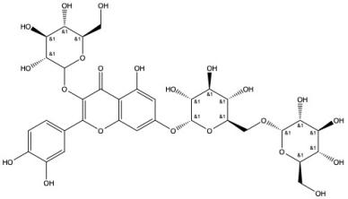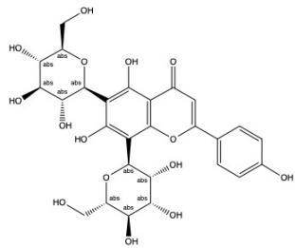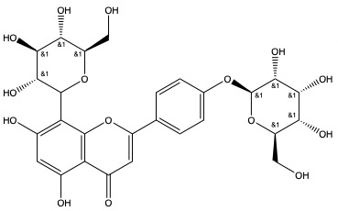
Quercetin-3-O-β-D-glucose- Schaftoside(2) Vitexia-glucoside(3)
7-O-β-D-gentiobiosiden(1) docking score(-12.347) docking score(-11.668) docking score(-13.503)
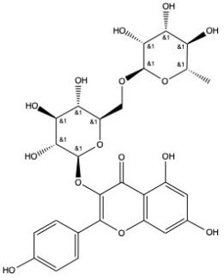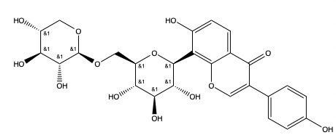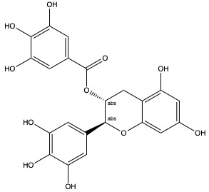
Nicotiflorin(4) Puerarin 6''-O-Xyloside(5) Isorhamnetin 3- O-neohesperidin (6)
docking score(-11.362) docking score(-11.356) docking score(-10.963)
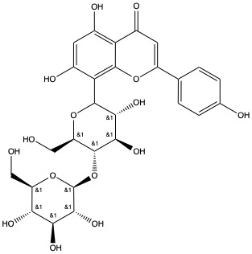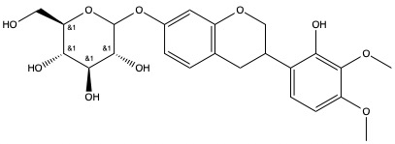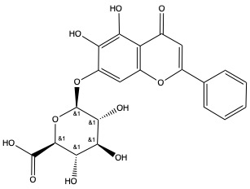
Glucosylvitexin (7) 7,2'-dihydroxy-3',4'-dimeth- Baicalin(9)
docking score(-10.576) oxyisoflavane-7-O-glucoside (8) docking score(-9.855)
docking score(-10.163)
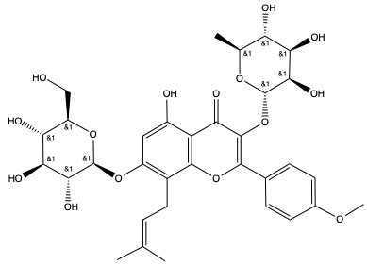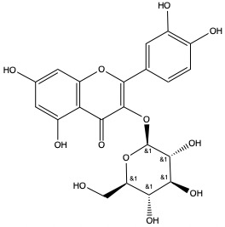
(-)-Gallocatechin gallate(10) Icariin (11) Isoquercitrin (12)
docking score(-9.733) docking score(-9.477) docking score(-9.204)
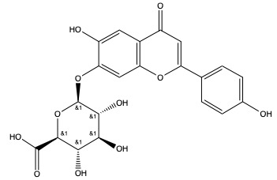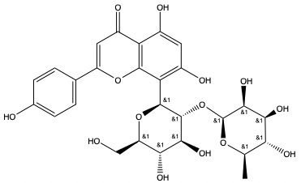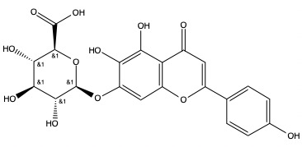
Apigenin-7-glucuronide(13) Vitexin-2''-O-rhamnoside(14) Scutellarin(15)
docking score(-9.162) docking score(-9.073) docking score(-8.848) 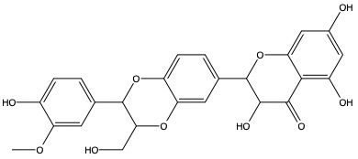 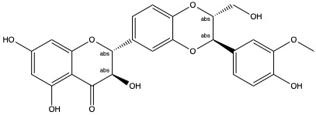 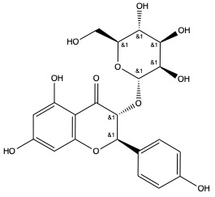
Silymarin(16) Silibinin(17) Engeletin (18)
docking score(-8.803) docking score(-8.766) docking score(-8.63)
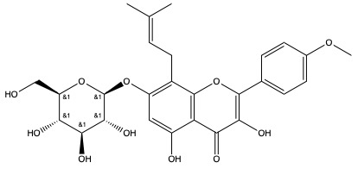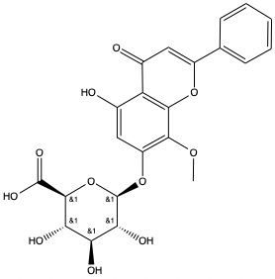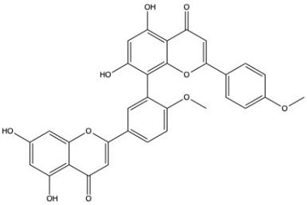
Icariside I (19) Wogonoside (20) Isoginkgetin (21)
docking score(-8.63) docking score(-8.344) docking score(-7.999)
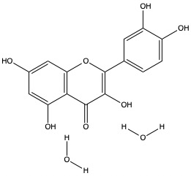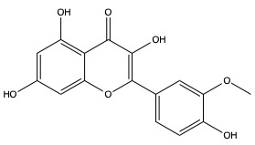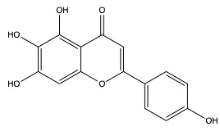
Quercetin Dihydrate(22) Isorhamnetin(23) Scutellarein (24)
docking score(-7.973) docking score(-7.597) docking score(-7.488)
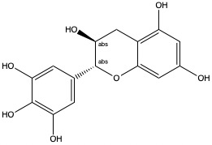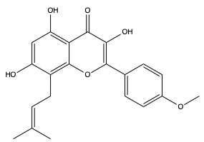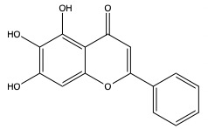
(+)-Gallocatechin(25) Icaritin(26) Baicalein(27)
docking score(-7.395) docking score(-6.862) docking score(-6.691)
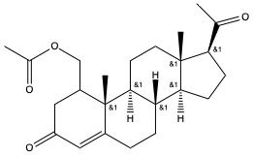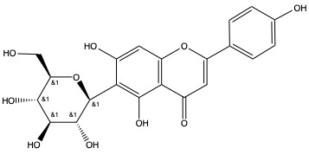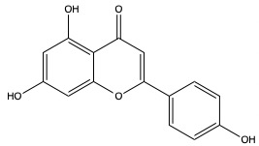
Medroxyprogesterone Acetate(28) Isovitexin(29) Apigenin(30)
docking score(-6.6) docking score(-6.345) docking score(-5.705)
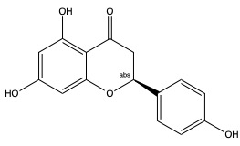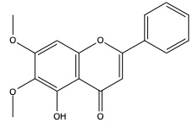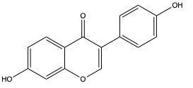
Naringenin(31) Mosloflavone(32) Daidzein(33)
docking score(-5.631) docking score(-5.568) docking score(-5.485)
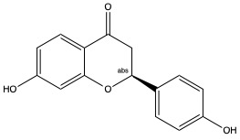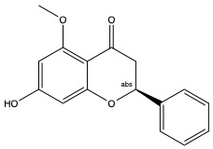
Liquiritigenin(34) Alpinetin(35)
docking score(-5.463) docking score(-5.37)

