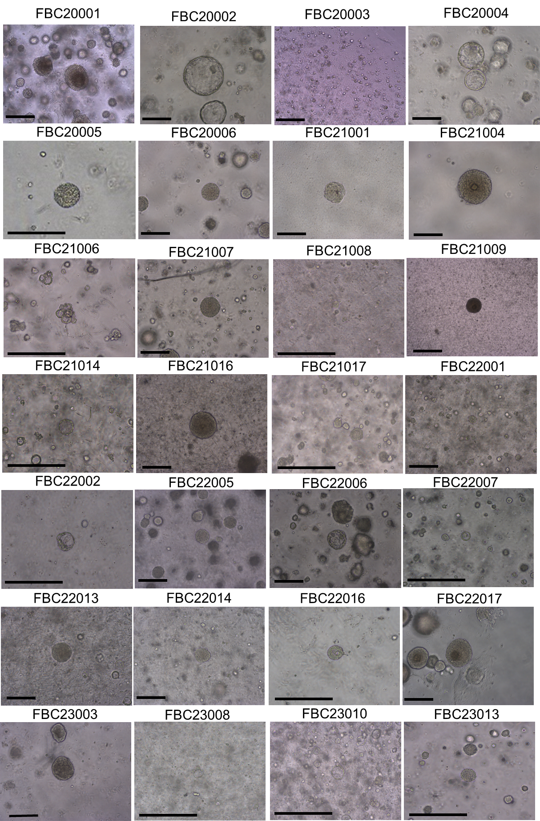

Fig. S1. Feline breast cancer (FBC) organoids. Representative bright-field images of FBC organoids from each case. Scale bar: 250 μm
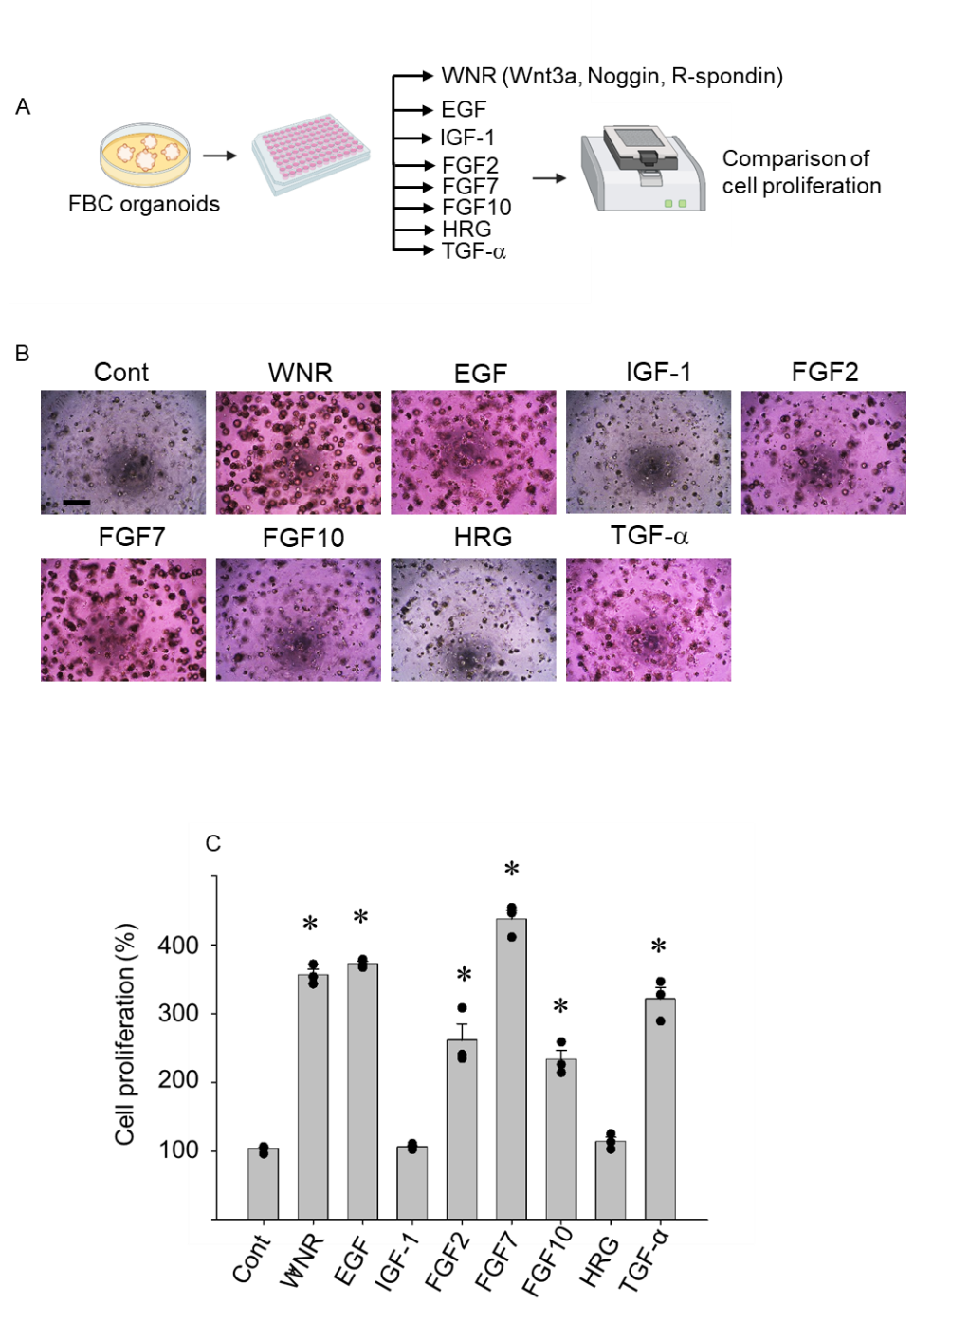

Fig. S2. Search for suitable media components of FBC organoids. Experimental schema in (A). Representative bright-field images (B) show the effects of different supplements on FBC organoid growth, scale bar: 500 μm. Cell proliferation of FBC organoids after treatment of each supplement was quantified by cell proliferation assay. (C) Results were expressed as mean ± S.E.M. n=3. ∗P<0.05 vs. Cont.

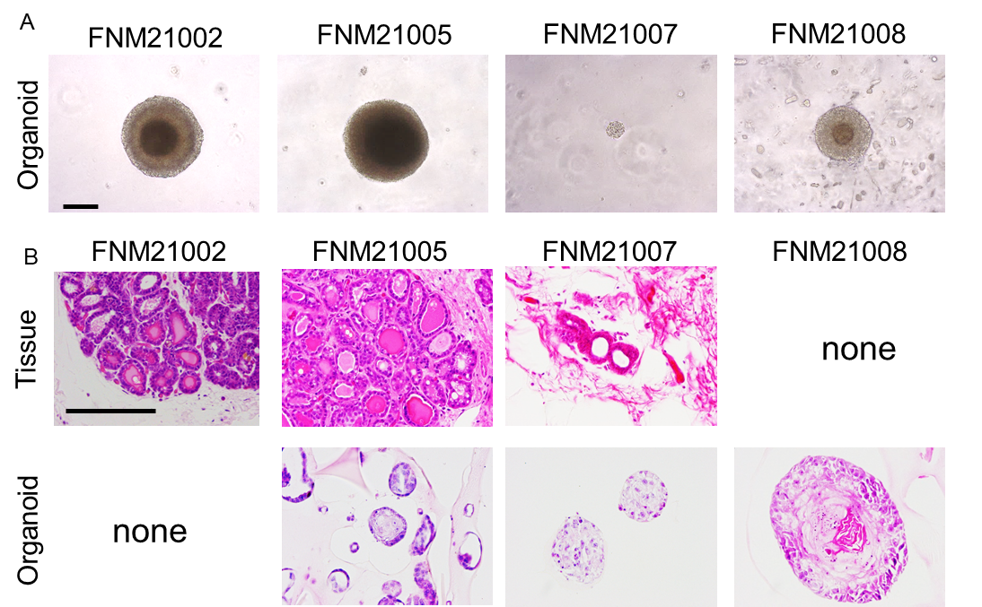

Fig. S3. Feline normal mammary (FNM) organoids. (A) Representative bright-field images of FNM organoids in (B), scale bar: 200 μm, and H&E staining of FNM organoids and their original tissues were also shown in (B), scale bar: 200 μm.

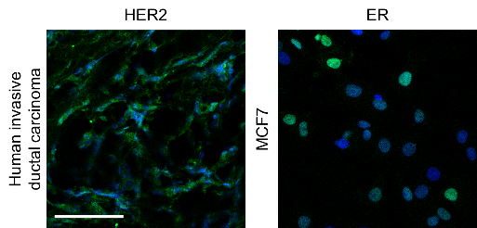
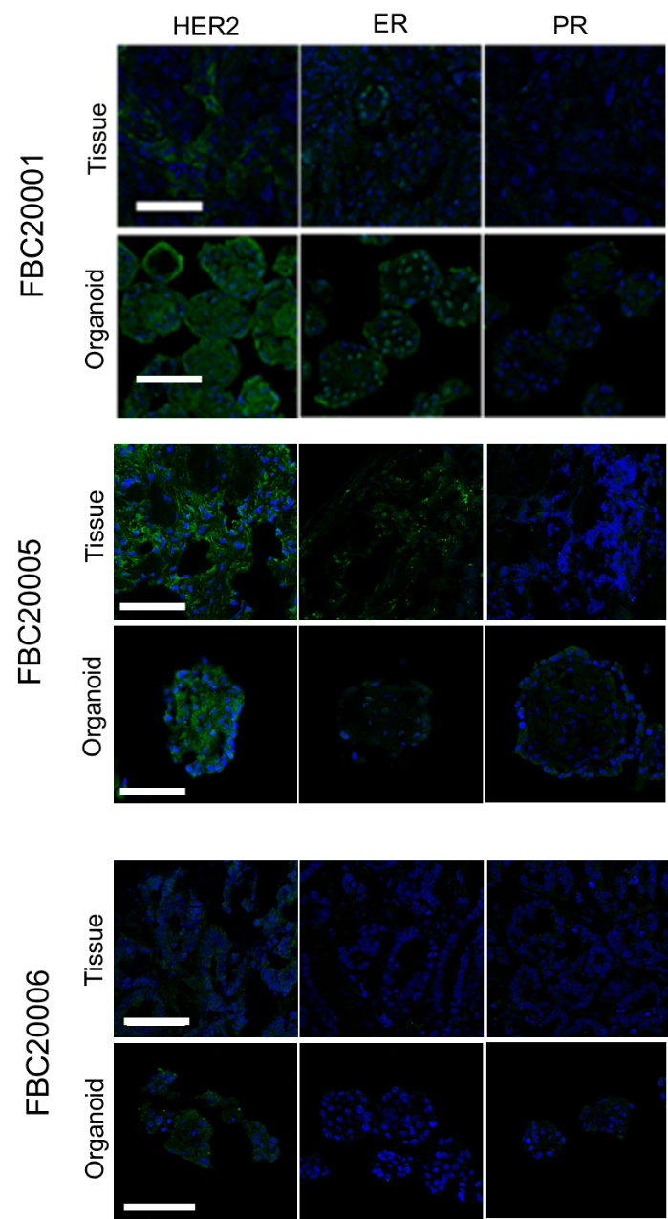

Fig. S4. Representative expression of hormone receptors in FBC organoids was observed. Human epidermal growth factor receptor (HER2), estrogen receptor (ER), and progesterone receptor (PR) expression in other cases of FBC organoids and their original tissues was evaluated. Three cases of representative photomicrographs are shown. Scale bar: 100 µm. Human invasive ductal carcinoma tissue (HER2) and MCF7 (ER) were used as positive controls for IF.

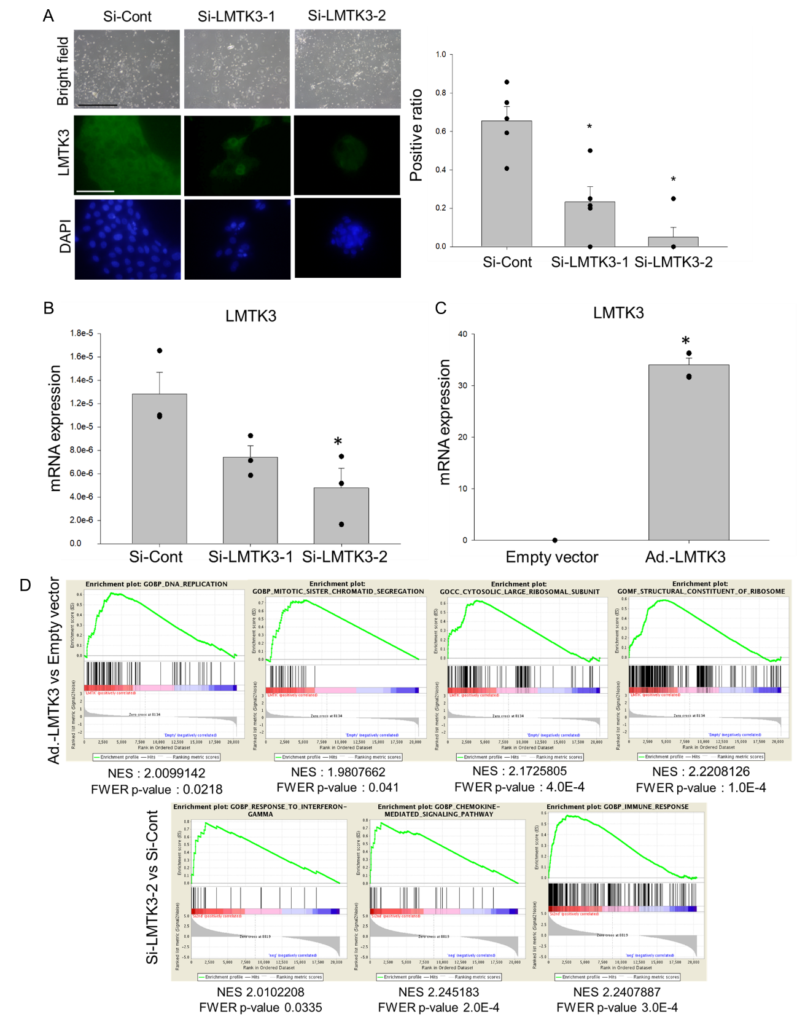

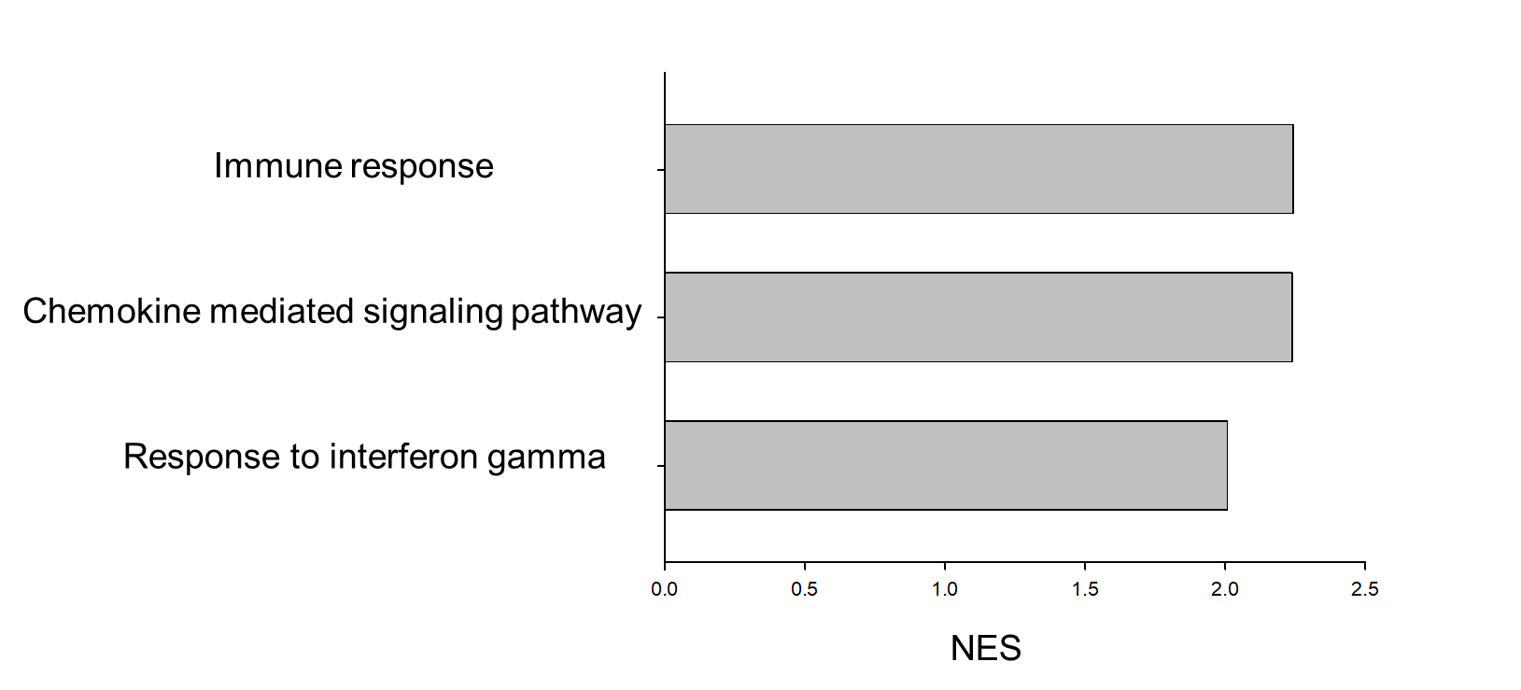
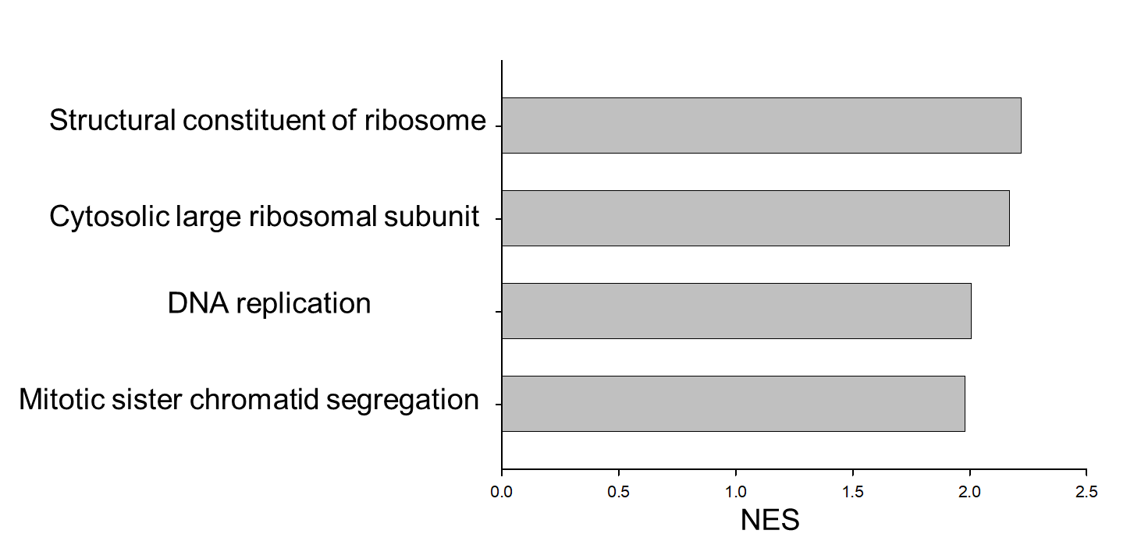

Fig. S5. RNA sequencing using FBC organoid, downstream signal of LMTK3 in FBC organoids was explored. Efficacy of LMTK3 gene knockdown on LMTK3 protein expression in FBC organoids was evaluated by IF. Results were expressed as mean ± S.E.M. n=5. ∗P<0.05 vs. Si-Cont., scale bar: 100 μm (A). Efficacy of LMTK3 gene knockdown on LMTK3 mRNA expression in FBC organoids was evaluated by quantified PCR. Results were expressed as mean ± S.E.M. n=3. ∗P<0.05 vs. Si-Cont, scale bar: 100 μm (B). Efficacy of overexpression of LMTK3 gene on LMTK3 mRNA expression in FBC organoids was analyzed. Results were expressed as mean ± S.E.M. n=4. ∗P<0.05 vs. Cont. (C). In Gene Set Enrichment Analysis (GSEA) from RNA-Seq data, some pathways related to ribosome structure or immune response were activated along with LMTK3 behavior (D). Horizontal axis graph in (D) shows normalized enrichment score (NES) in some pathways.

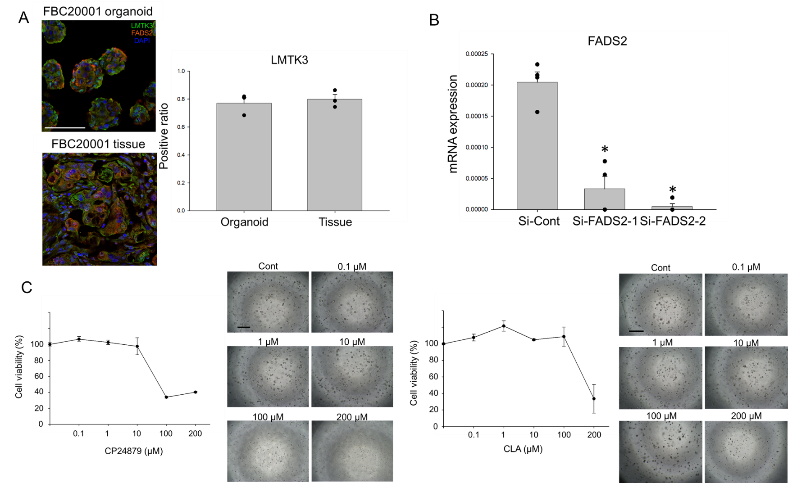

Fig. S6. Role of FADS2 in FBC organoids. Co-localization of LMTK3 and FADS2 proteins in FBC organoids and their original tissues by IF was observed. Scale bar: 100 μm. Results were expressed as mean ± S.E.M. n=3 (A). SiRNA efficiency was evaluated by qPCR and (B) shows efficacy of FADS2 gene knockdown on FADS2 mRNA expression in FBC organoids. Results were expressed as mean ± S.E.M. n=4. ∗P<0.05 vs. Si-Cont. Effects of FADS2 inhibitors, CP24879, and conjugated linoleic acid (CLA) on cell viability in FBC organoids was shown. In high concentration treatment of these drugs, drug effect was confirmed. Results were expressed as mean ± S.E.M. n=3, scale bar: 500 μm (C).

