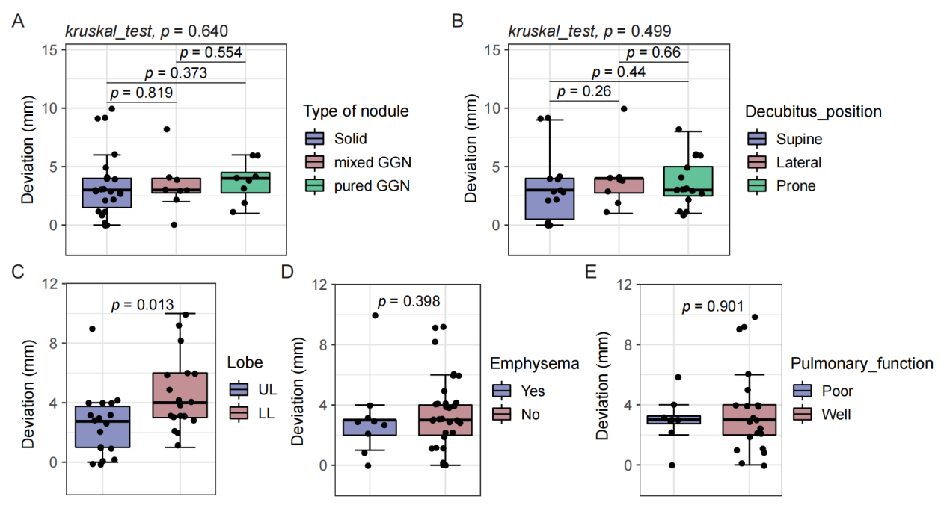
Figure S1. Stratified analyses of the correlations between pulmonary nodule features, pulmonary function, pulmonary background disease, and accuracy. (A) Nodule types. (B) Decubitus positions. (C) Lobar location. (D) Presence or absence of emphysema. (E) Different pulmonary function statuses.

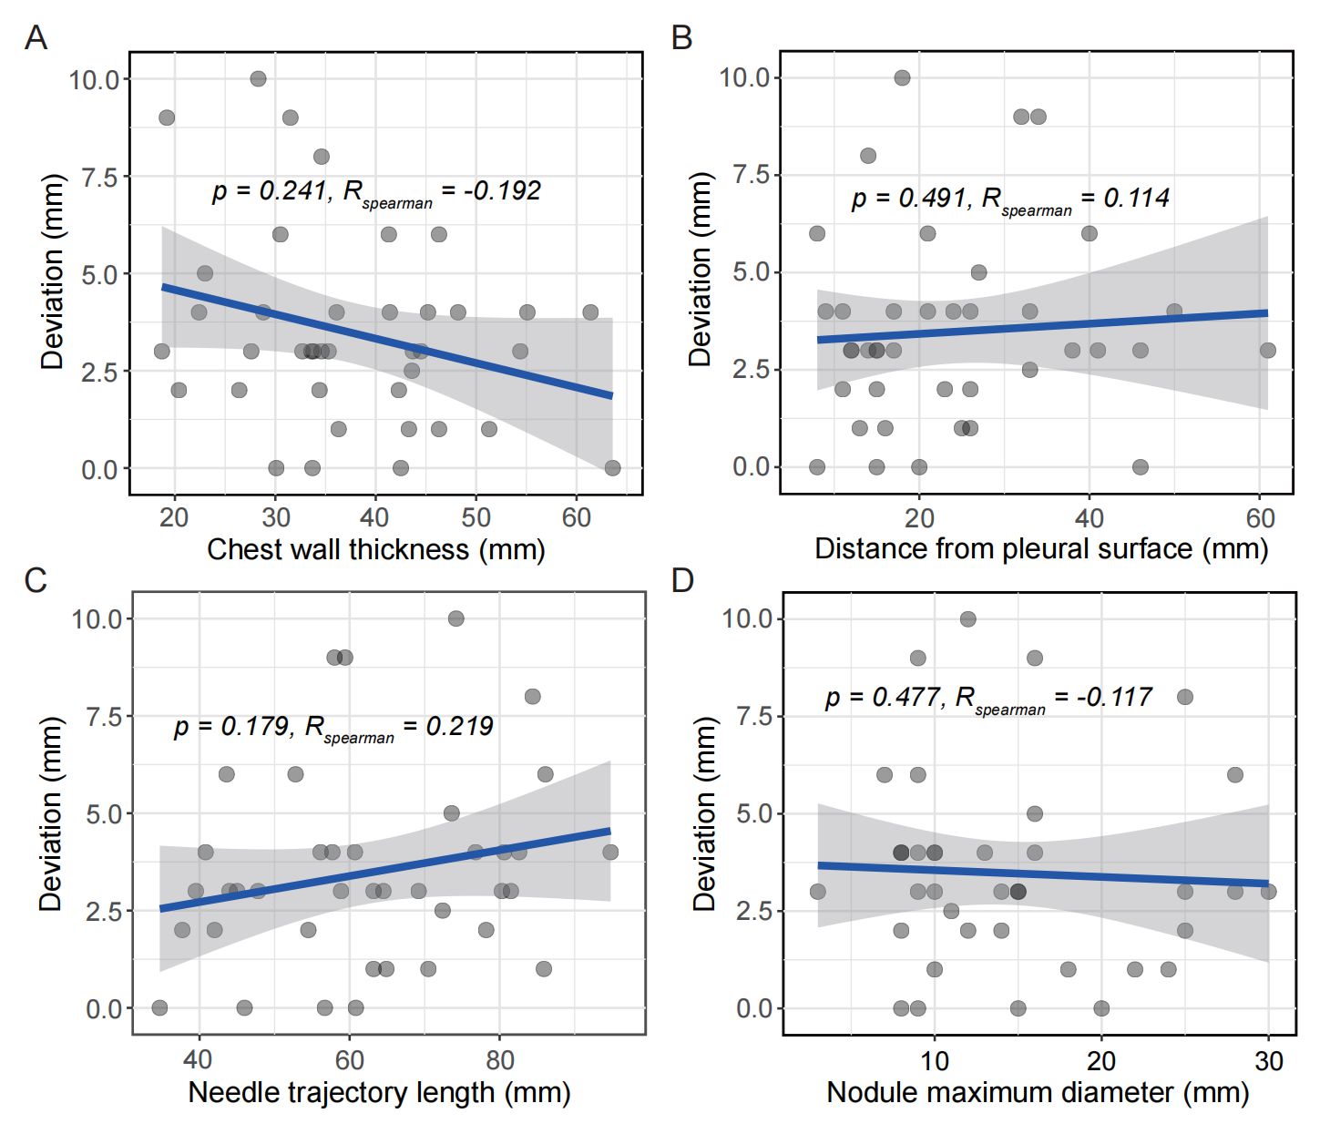
Figure S2. Stratified analyses of the correlations between pulmonary nodule features and accuracy. (A) Chest wall thickness. (B) Distance from the outer edge of the nodule to pleura. (C) Needle trajectory length. (D) Nodule maximum diameter.
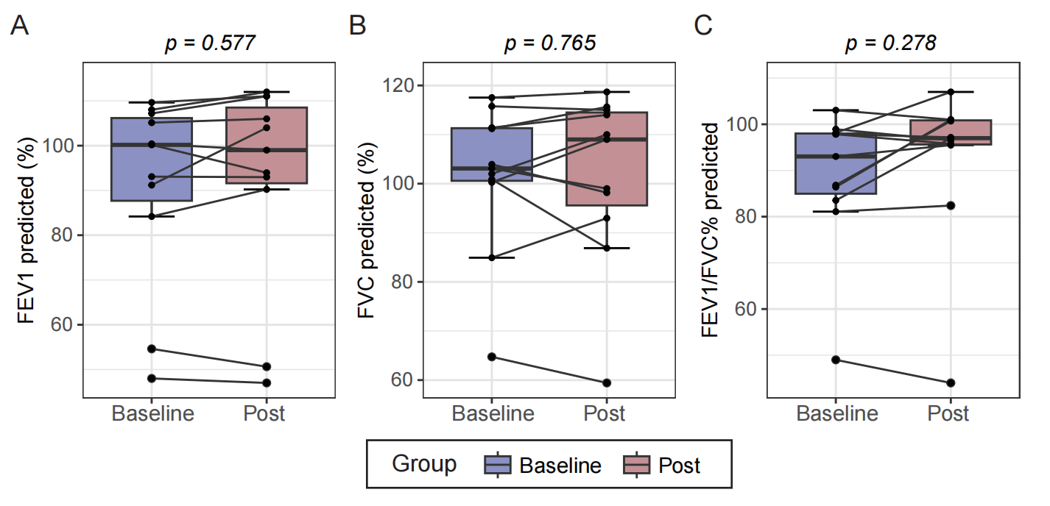
Figure S3. Dynamic changes in pulmonary function between baseline and postoperative periods following robotic-assisted cryoablation. (A) Forced expiratory volume in the first second as a percentage of predicted (FEV₁% predicted). (B) Forced vital capacity as a percentage of predicted (FVC% predicted). (C) FEV₁ to FVC ratio as a percentage of predicted (FEV₁/FVC% predicted).

