Supplementary Information for

Unraveling the dynamics of multiple excited states in a single-molecule transistor

Hao Zhang¹†, Lijue Chen¹†, Ziheng Yuan¹†, Jingyu Yang²†, Yu Zhou¹†, Yixuan Gao², Zhixin Qiu¹, Wei Xu¹, Zhexiong Zheng¹, Cankun Zhang¹, Haojie Liu¹, Kai-Qiang Lin¹, Ye Yang¹, Jing Li¹, Junyang Liu¹*, Shixuan Du²*, Wenjing Hong¹*

¹State Key Laboratory of Physical Chemistry of Solid Surfaces & IKKEM, College of Chemistry and Chemical Engineering, Xiamen University, Xiamen 361005, China
²Institute of Physics & University of Chinese Academy of Sciences, Chinese Academy of Sciences, Beijing 100190, China.
†These authors contributed equally: Hao Zhang, Lijue Chen, Ziheng Yuan, Jingyu Yang, Yu Zhou
*Corresponding authors:E-mail: whong@xmu.edu.cn (W. Hong); sxdu@iphy.ac.cn (S. Du); jyliu@xmu.edu.cn (J. Liu)

Table of Contents
Section I. Molecular Synthesis
Fig. S1. ¹HNMR spectrum of 1-ethynylpyrene (Compound 3) in chloroform-D
Fig. S2. ¹HNMR spectrum of 1,4-bis(hexyloxy)-2,5-diiodobenzene (Compound 6) in chloroform-D
Fig. S3. ¹HNMR spectrum of 1,4-bis(hexyloxy)-2,5-bis(ethynylpyrene)benzene (BP molecule) in chloroform-D
Fig. S4. HR-MS of 1,4-bis(hexyloxy)-2,5-bis(ethynylpyrene)benzene (BP molecule)
Section II. Device fabrication and characterization
Fig. S5. Characterizations in device fabrication
Fig. S6. Characterizations of I-V traces and current magnitude difference among six devices at 30 K on a continuous V_{G} = 0 V
Fig. S7. Temperature and gating voltage dependent current-voltage curves of device 1
Fig. S8. Absorption spectra of BP molecule
Section III. Data processing details of Methods
Fig. S9. Pulse current-voltage characterizations at N−1 (blue dots, V_{G}= −2.5 V) and N (red dots, V_{G}= 0 V) states of single molecule
Fig. S10. All-electronic pump-probe measurements of the charged molecule in device 1
Fig. S11. Forward and reverse scan of pump–probe spectra
Fig. S12. All-electronic pump-probe measurements of the charged molecule in device 2
Fig. S13. Single-pulse measurement of the charged single molecule shown in Fig. 2 by pulse-width dependence experiment
Fig. S14. Transient I_{pulse}-V_{pulse} pump-probe measurements of the charged molecule
Fig. S15. Electrical characterizations and all-electronic pump-probe measurements on a graphene tunnel junction
Fig. S16. The differential conductance (right panel) derived from Iprobe-Vprobe curves (left panel) before (black) and after (blue) smoothing
Fig. S17. The time evolution of energy space between Peak 2 and Peak 3 shown in Fig. 4b
Section IV. Theoretical calculation
Fig. S18. Calculated molecular structure and frontier orbitals of BP molecule
Fig. S19. Illustration of single-particle picture and many-body pictures of the resonance peaks in Fig.4
Fig. S20. Optimized structures of molecular junctions for different charged states.
Fig. S21. Energy level of single molecule in molecular junctions for different charged states and structure
Table S1. Calculated energy variations relative to D₀⁺ due to molecule geometries
Table S2. Calculated dipole moment of N, N-1 and N-2 state
Table S3. Calculated energy variations due to molecule geometries.

Section Ⅰ. Molecular Synthesis
All reagents were purchased from TCI and used without further purification. The NMR spectra were recorded on a BRUKER AVANCE NEO 500 instrument and Tetramethylsilane (TMS) was used as an internal standard.
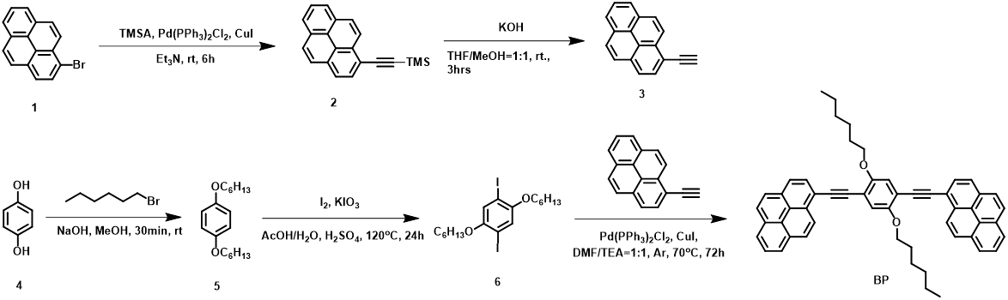
Scheme 1: Schematic representations of 1,4-bis(hexyloxy)-2,5-bis(ethynylpyrene)benzene (BP) molecule synthesis

Synthesis of trimethyl(pyren-1-ylethynyl)silane (Compound 2): A mixture of 1-bromopyrene (562 mg, 2 mmol), Pd(PPh₃)₂Cl₂ (70 mg, 0.1 mmol), and CuI (4 mg, 0.02 mmol) was dissolved in Et3N (10 mL). The solution was then degassed and refilled with N₂. TMSA (236 mg, 2.4 mmol in 10 mL Et₃N) was slowly added to the mixture. The reaction was allowed to proceed at room temperature for 6 hours. The resulting residue was purified using a silica chromatography column (EA/Hex = 1:4) to obtain a yellow solid, which was directly used in the subsequent step without any further purification.
Synthesis of 1-ethynylpyrene (Compound 3) ¹: A mixture of trimethyl(pyren-1-ylethynyl)silane (597 mg, 2 mmol), KOH (561 mg, 10 mmol), MeOH (10 mL), and THF (10 mL) was stirred at room temperature for 3 hours. Subsequently, the reaction mixture was extracted with ethyl acetate and washed with brine. After the solvent was evaporated, 1-ethynylpyrene was obtained as a yellow-brown solid. The compound was further purified using a silica chromatography column (DCM/Hex, v/v = 1:20 to 1:10), resulting in the isolation of the product (355 mg, 80% yield). 1HNMR (500 MHz, CDCl₃): δ =8.59 (d, 2H, J = 9.1 Hz), 8.17-8.25 (m, 4H), 8.11 (d, 2H, J = 8.5 Hz), 8.0-8.06 (m, 2H), 3.63 (s, 1H) ppm.
Synthesis of 1,4-bis(hexyloxy)benzene (Compound 5): To 100 mL of distilled dimethylformamide, hydroquinone (13.21 g, 120 mmol) and potassium hydroxide (27 g, 480 mmol) were added with vigorous stirring for 30 minutes under a nitrogen atmosphere. Subsequently, n-hexyl bromide (59 g, 260 mmol) was added dropwise to the mixture. The reaction was allowed to proceed for 7 hours, after which the mixture was poured into an ample amount of distilled water, resulting in the formation of a light-yellow solid at the upper layer. The crude product was recrystallized with isopropyl and then filtered. The filtered product was washed successively with distilled water and 10% sodium hydroxide, followed by drying under vacuum, yielding a white sheet-like product. This product was directly used in the subsequent step without further purification.
Synthesis of 1,4-bis(hexyloxy)-2,5-diiodobenzene (Compound 6)²: To a solution of 1,4-Bis(hexyloxy)benzene (1.8 g, 6.5 mmol) in 8 mL of acetic acid, 1 mL of water, and 0.5 mL of H₂SO₄, KIO₃ (1.08 g, 5.05 mmol) and I₂ (1.21 g; 4.77 mmol) were added. The reaction mixture was stirred at 120°C for 24 hours and then cooled to room temperature. Excess iodine was eliminated by the addition of sodium thiosulfate until the brown color of iodine disappeared. Excess H₂SO₄ was neutralized by the addition of Na₂CO₃ until the vigorous effervescence ceased. The resulting mixture was extracted with chloroform, dried over Na₂SO₄, concentrated, and subsequently purified by column chromatography using silica with hexane as the eluent, yielding the compound as a white crystalline solid (yield = 41%). ¹HNMR (500 MHz, CDCl3): δ =7.17 (s, 2H), 3.92 (t, 4H, J = 6.45 Hz), 1.79 (m, 4H), 1.3-1.55 (m, 12H), 0.91 (t, 6H, J = 7.05 Hz) ppm.
Synthesis of 1,4-bis(hexyloxy)-2,5-bis(ethynylpyrene)benzene (BP molecule) ³: 1-Ethynylpyrene (61 mg, 0.27 mmol) and 1,4-bis(hexyloxy)-2,5-diiodobenzene (159 mg, 0.3 mmol) were dissolved in a mixture of dry dimethylformamide (10 mL) and triethylamine (10 mL) under a nitrogen atmosphere. To the solution, [PdCl₂(PPh₃)₂] (4.2 mg, 0.006 mmol) and CuI (1.1 mg, 0.006 mmol) were added. After stirring the reaction solution at 70 °C for 36 hours, the solvent was removed under vacuum, resulting in a light-yellow solid. The solid was then purified by silica gel column chromatography (eluent: DCM/hexane; v/v = 1/7). The solvent was evaporated, and the resulting solid was dried under vacuum, yielding a yellow powder. The yellow powder was precipitated with DCM/Hex and subsequently recrystallized with DCM/Hex at a ratio of 1:5 to obtain a single crystal (180 mg, 60% yield). ¹HNMR (500 MHz, CDCl3): δ =8.89 (d, 2H, J = 9 Hz), 8.03-8.25 (m, 18H), 4.24 (t, 4H, J = 6.4 Hz), 1.69 (m, 4H), 1.69 (m, 4H), 1.36-1.51 (m, 8H), 0.90 (t, 6H, J = 7.15 Hz) ppm. HR-MS: [M+Na]⁺ calcd for C₅₄H₄₆O₂Na⁺: 749.3396, found 749.3353.

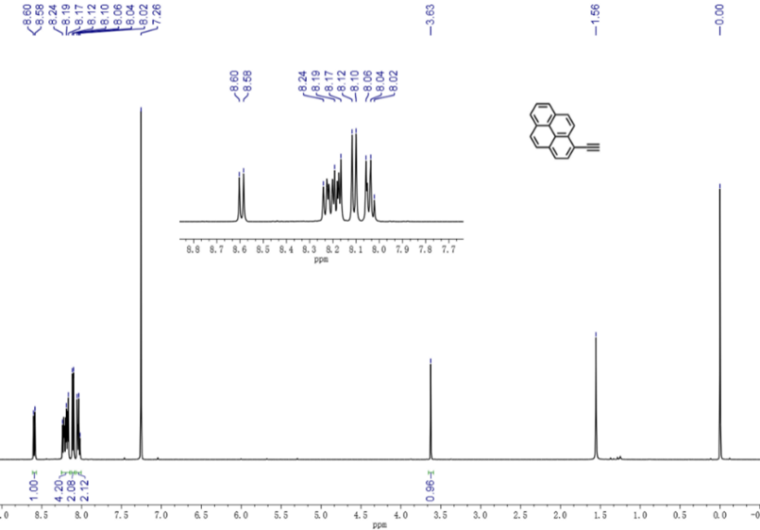
Fig. S1 ¹HNMR spectrum of 1-ethynylpyrene (Compound 3) in chloroform-D
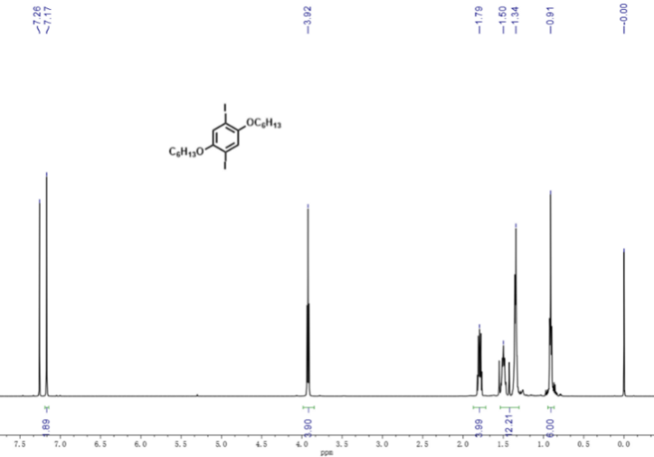
Fig. S2 ¹HNMR spectrum of 1,4-bis(hexyloxy)-2,5-diiodobenzene (Compound 6) in chloroform-D

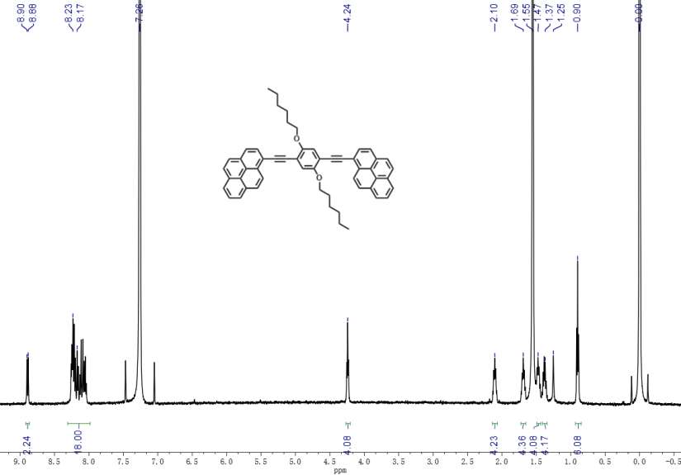
Fig. S3 ¹HNMR spectrum of 1,4-bis(hexyloxy)-2,5-bis(ethynylpyrene)benzene (BP molecule) in chloroform-D
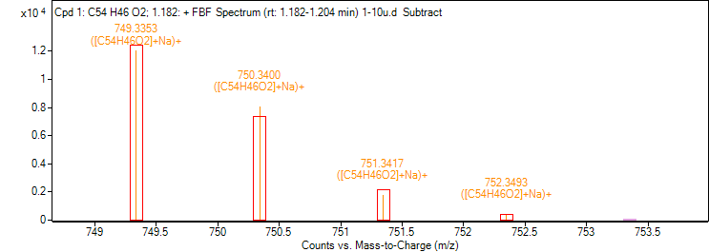
Fig. S4 HR-MS of 1,4-bis(hexyloxy)-2,5-bis(ethynylpyrene)benzene (BP molecule)

Section Ⅱ. Device fabrication and characterization
The device fabrication process is summarized in Scheme 2. A 4-inch silicon wafer (with a 500 nm oxide layer) was utilized for photolithography and electron beam evaporation to fabricate a 30 nm thick gold back-gate array with an adhesion layer of 10 nm titanium. A 10 nm insulating layer of HfO₂ was deposited using an atomic layer deposition system. Subsequently, a second array of 60 nm thick gold source and drain electrodes with an adhesion layer of 10 nm titanium was fabricated by wafer-level alignment of photolithography and electron beam evaporation. The silicon wafer was sliced into chip units for further fabrication of graphene electrodes.
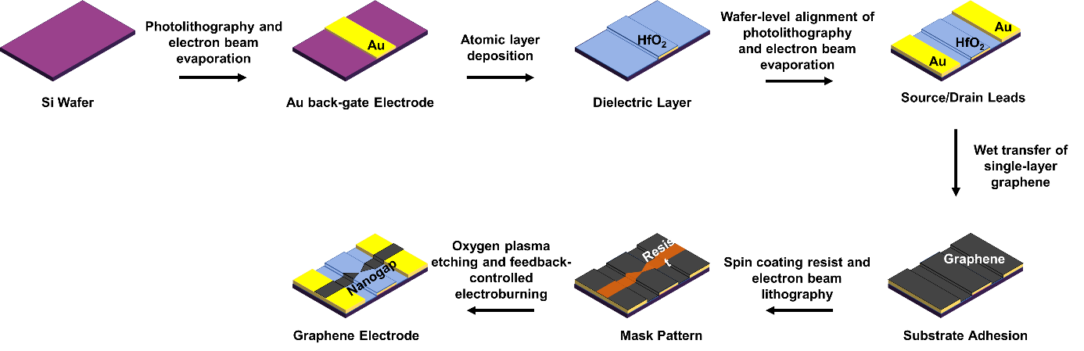
Scheme 2: Schematic diagram of the preparation process for the graphene electrode and gold back gate before assembling molecules

The monolayer graphene (MLG) was grown using chemical vapor deposition (CVD, Equipment Corporation ET3000EXT) on a copper foil. Subsequently, the copper foil was cut into a suitable size after spin-coating with PMMA. The copper foil was etched with ammonium persulfate solution (7.2 g (NH₄)₂S₂O₈ in 80 mL H₂O) for 24 hours and then washed with deionized water three times to remove residual etching solution. The pre-processed silicon unit was used to pick up the PMMA/MLG sheet, which was then immersed in acetone to remove the PMMA three times. By using mixed hydrogen-argon gas and annealing at 210 ℃ for 3 hours, the PMMA residue was removed and some graphene defects were reduced. The negative resist ma-N 2403 (Micro Resist Technology) was used for electron beam lithography to write bowtie patterns on the MLG on the silicon unit after development by the ma-D 525 (Micro Resist Technology). The areas not covered by the resist were etched using O₂-plasma to produce the MLG bowtie pattern. Subsequently, the sample was immersed in mr-Rem 700 (Micro Resist Technology) for 30 s and washed with acetone and ethanol to remove the residual resist. Utilizing the feedback-controlled electroburning, the graphene bowtie was further processed to produce a 1-2 nm gap in the narrowest constriction area, resulting in a graphene nanoelectrodes pair with resistance in the range of hundreds of megaohms. The processing method follows the procedures outlined in previously published work ⁴. Further current-voltage characterization before and after depositing molecules are performed in room temperature. More detailed characterizations of the devices are displayed in Fig. S5. The ultraviolet-visible absorption and luminescence spectrum summarized in Fig. S6. The yield of single-molecule junctions is 4% (6/150) according to room-temperature I-V characteristics. Due to the different coefficients of thermal expansion of graphene and HfO₂, the contact configuration between graphene and HfO₂ changes during the cooling down, leaving only two molecules still surviving after the temperature drops to 30 K⁵.
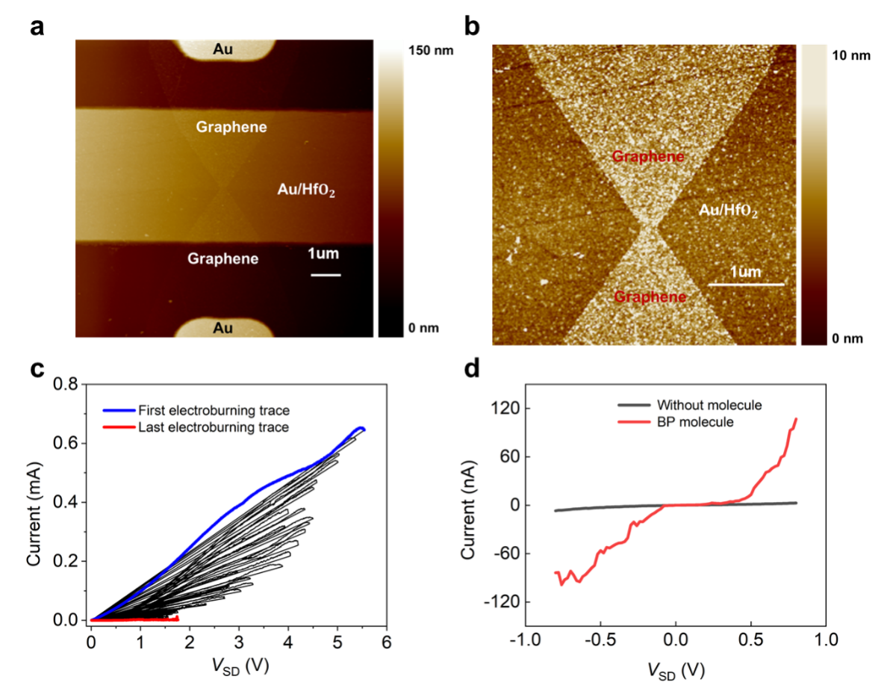
Fig. S5 Characterizations of device fabrication. a, Characterization of patterned graphene at core area using Atomic force microscope (AFM) images of 10 μm × 10 μm region, with graphene serving as the source-drain electrodes and gold contacting both sides, with the underlying gold serving as the gate electrode. b, Characterization of AFM image of the 4 μm × 4 μm region at the center of graphene constriction, with RMS-roughness: 1.62 nm (graphene) and 0.87 nm (HfO₂). c, Feedback-controlled electroburning traces of graphene bowtie. d, Room temperature I-V traces before (black lines) and after (red lines) depositing molecules.

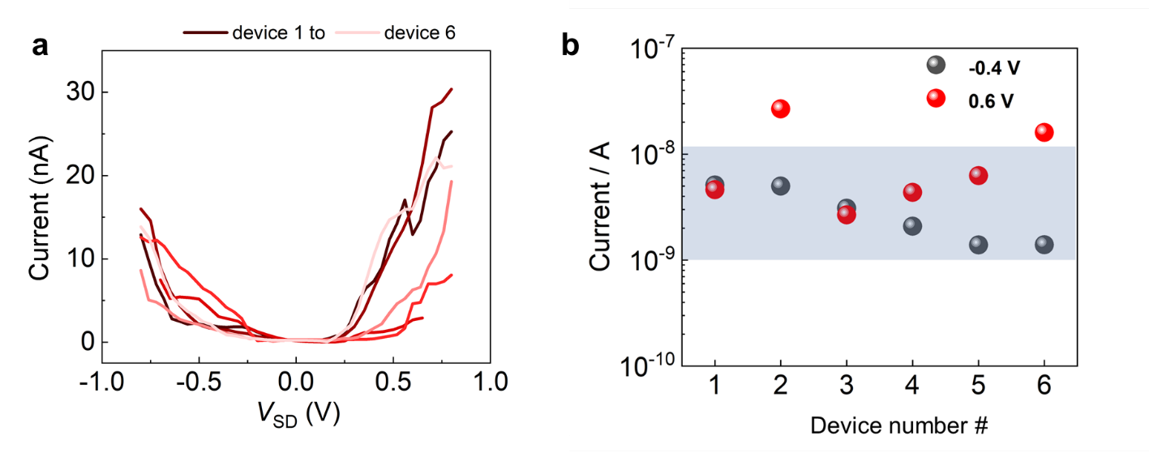
Fig. S6 Characterizations of I-V traces (a) and Current magnitude difference (b) among six devices at 30 K on a continuous V_{G} = 0 V.

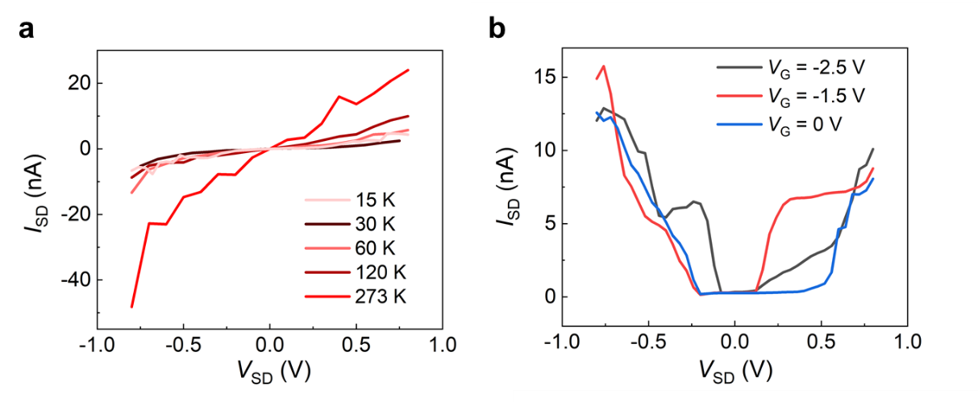
Fig. S7 Temperature and gating voltage dependent current-voltage curves of device 1. a, I-V curves at different temperatures (273 K, 120 K, 60 K, 30 K, 15 K). b, I-V curves at different gating voltage V_{G} (0 V, -1.5 V, -2.5 V) at 30 K.

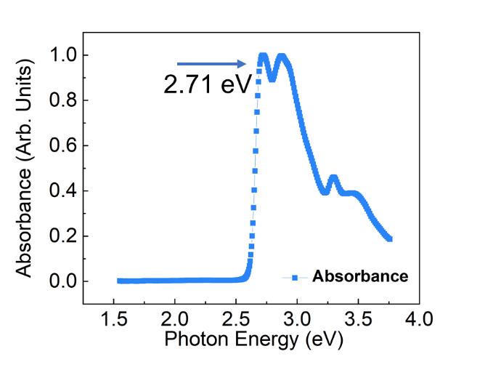
Fig. S8 Absorption spectra of BP molecule.

Section Ⅲ. Details of Methods
To verify the reproducibility of the observed dynamic phenomena, we fabricated another BP single-molecule transistor device (Device 2) and performed steady-state differential conductance measurements within a voltage window of ±0.8 V. The results are shown in Fig. S12a. We noted that the gate voltage at which the transition between the N and N−1 charge states occurs at the gate voltage of V_{cross} = −2.5 V, which is very close to that of Device 1, with only minor differences. These differences may arise from slight variations in the molecular conformation during the assembly process. Under V_{G}=−2.5 V, the dynamic behavior of Device 2 shown in Fig. S12b was essentially consistent with the phenomena previously observed (Fig. 2e). In addition, we also performed dynamic measurements at V_{G} = −1 V, with the results shown in Fig. S12c. Under this condition, the excitation threshold for the dynamics was significantly higher than that at V_{G} = −2.5 V. We attribute this phenomenon to the N → N−1 dynamic process, with an estimated lifetime of approximately 30 ns based on our established analysis framework.
Varying the voltage pulse width could be used in principle to characterize the charged excited states dynamics, which has been demonstrated in probing the triplet quenching in individual pentacene⁶. Therefore, we performed the voltage pulse-width dependence measurements using a V_{pulse} = −0.8 V, as shown in Fig. 2d. Since current grows with the increase of pulse width (Fig. S13, a-b), we normalized the relationship between I_{pulse} and τ_{pulse} by extracting the amount of current change caused by unit pulse width, I_{pulse}/τ_{pulse} = (I_{pulse} − I_{τ=0 ns})/τ_{pulse}. The signal at τ_{pulse} = 0 ns is subtracted in order to minimize the impact of rising and falling edges on the accuracy of normalization. The normalized I_{pulse} at V_{G} = 0 V corresponding to the N state is insensitive to the pulse width. In contrast, a low-to-high dynamical curve of normalized I_{pulse} appears at V_{G} = −2.5 V and the single-exponential fitting reflects a lifetime of ~86 ns (Fig. S13c). Such a lifetime is too long for the recombination of excited doublet state and it quenches at 160 K (Fig. S13, d-f) due to the thermal fluctuation-induced dephasing, suggesting the occurrence of excited state dynamics.

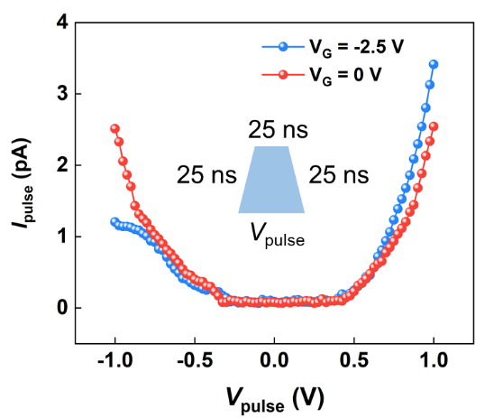
Fig. S9 Pulse current-voltage characterizations at N−1 (blue dots, V_{G}= −2.5 V) and N (red dots, V_{G}= 0 V) states of single molecule

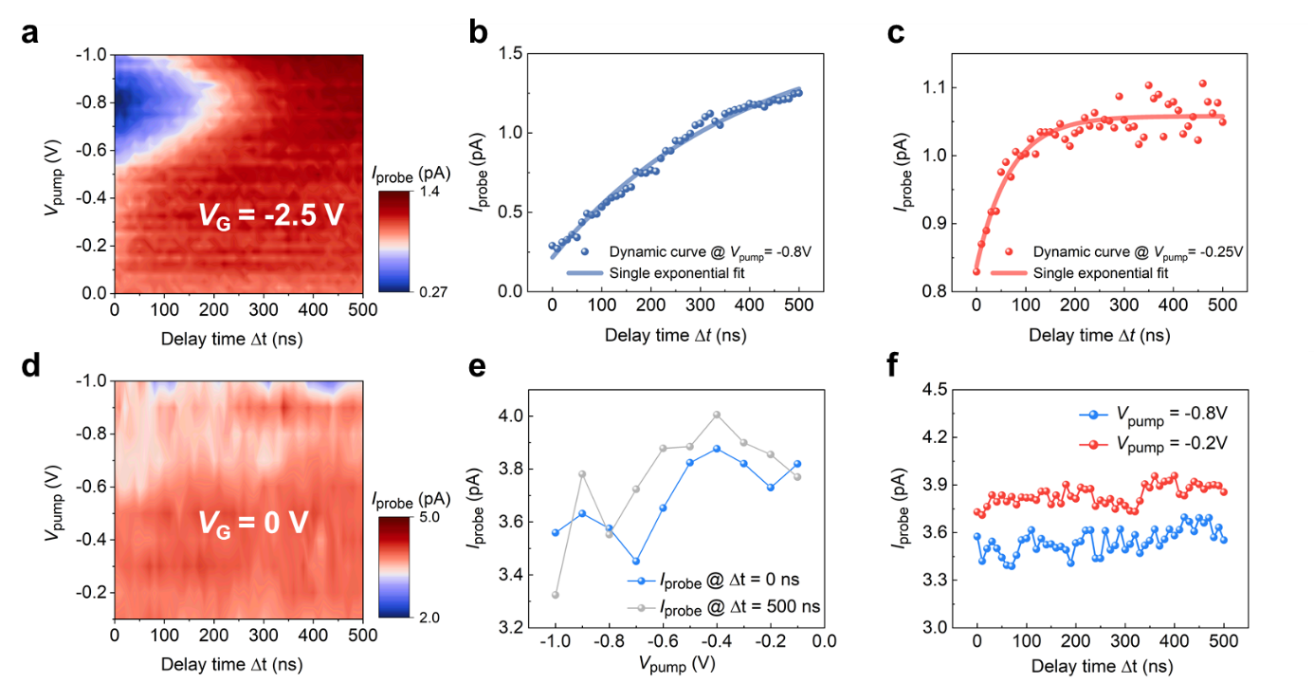
Fig. S10 All-electronic pump-probe measurements of the charged molecule in device 1. a, Corresponding dependence of the probe current I_{probe} on the delay time as a function of trigger voltage V_{pump.} at a continues V_{G} = −2.5 V. b, Single pump–probe spectra under a pump voltage of −0.8 V and its single-exponential fitting curve. c, Single pump–probe spectra under a pump voltage of −0.25 V and its single-exponential fitting curve. d, Corresponding dependence of the probe current I_{probe} on the delay time as a function of trigger voltage V_{pump.} at a continues V_{G} = 0 V. e, Corresponding dependence of the probe current I_{probe} at Δt = 0 and 500 ns as a function of trigger voltage V_{pump} of a neutral BP molecule. f, Corresponding dependence of the probe current I_{probe} as a function of the delay time at V_{pump} = −0.2 and −0.8 V.
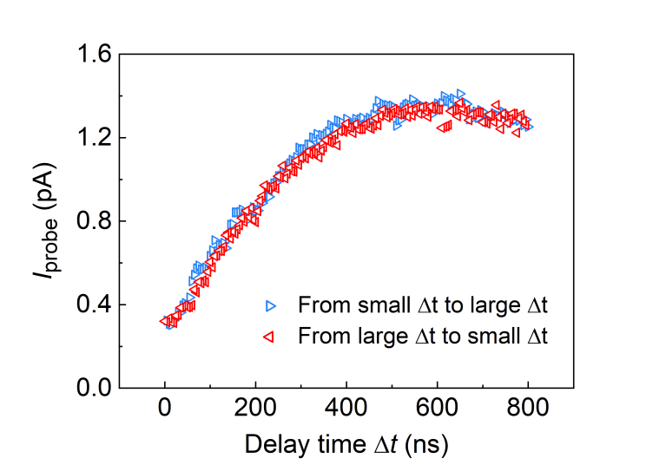
Fig. S11 Forward and reverse scan of pump–probe spectra. The blue triangle represents the signal response of the probe current increasing from 0 ns to 800 ns with 10 ns intervals, where red triangle represents the opposite.

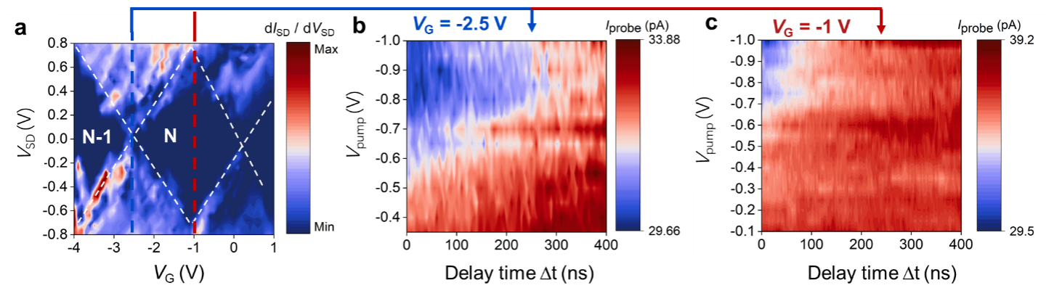
Fig. S12 All-electronic pump-probe measurements of the charged molecule in device 2. a. Charge stability diagram of device 2 showing the differential conductance (dI_{SD}/dV_{SD}) as a function of bias voltage (V_{SD}) and gate voltage (V_{G}) at 30 K. b, c, Corresponding dependence of the probe current I_{probe} on the delay time as a function of trigger voltage V_{pump.} at a continues V_{G} = −2.5 V (b, N-1 state) and V_{G} = −1 V (c, N state). Similar feature with Device 1 could be observed in b, where an obvious low conducted state was found around V_{pump} = −0.8 V. A short-lived state with ~30 ns lifetime is found in c, which is mainly caused by the inconsistency of the molecular configuration among devices. Therefore, the transition from S₀ to D₀²⁺ can be observed at this condition, which is different from Fig. S10d.

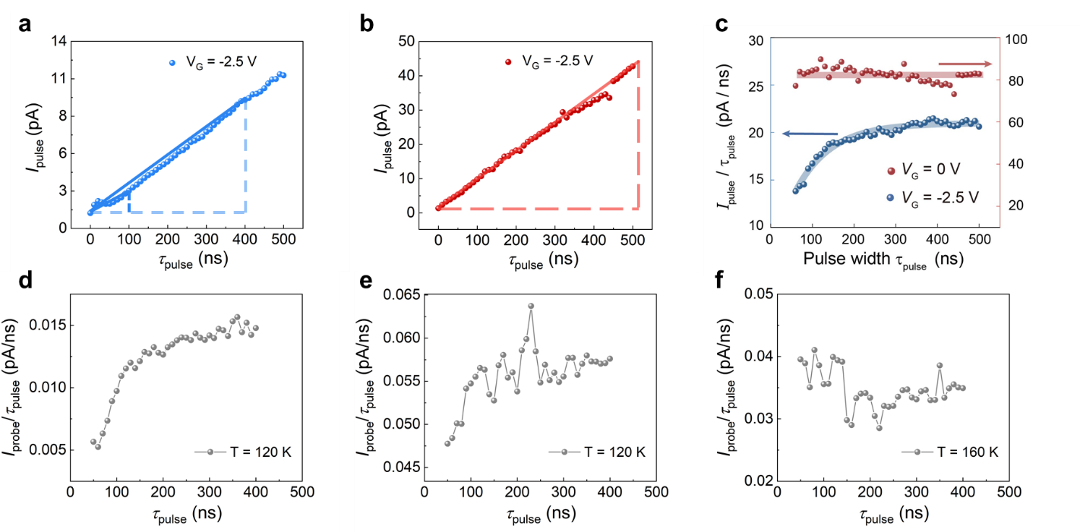
Fig. S13 Single-pulse measurement of the charged single molecule by pulse-width dependence experiment. a,b, Measured pulse current I_{pulse} as a function of pulse width τ_{pulse} with fixed −0.8 V amplitude at V_{G}= −2.5 V (a) and 0 V (b). c.The normalized pulse current by variable pulse width voltage at V_{G} = −2.5 V (blue line) and 0 V (red line). The red and blue lines are guides for the eye. The normalization method was to extract the slope of the signal difference under different pulse widths compared to that at τ_{pulse} = 0 ns. d, e, f, The normalized probe current by variable pulse width voltage at 50 K (d), 120 K (e) and 160 K (f). As the temperature increasing, its dynamic response with pulse width also disappears.
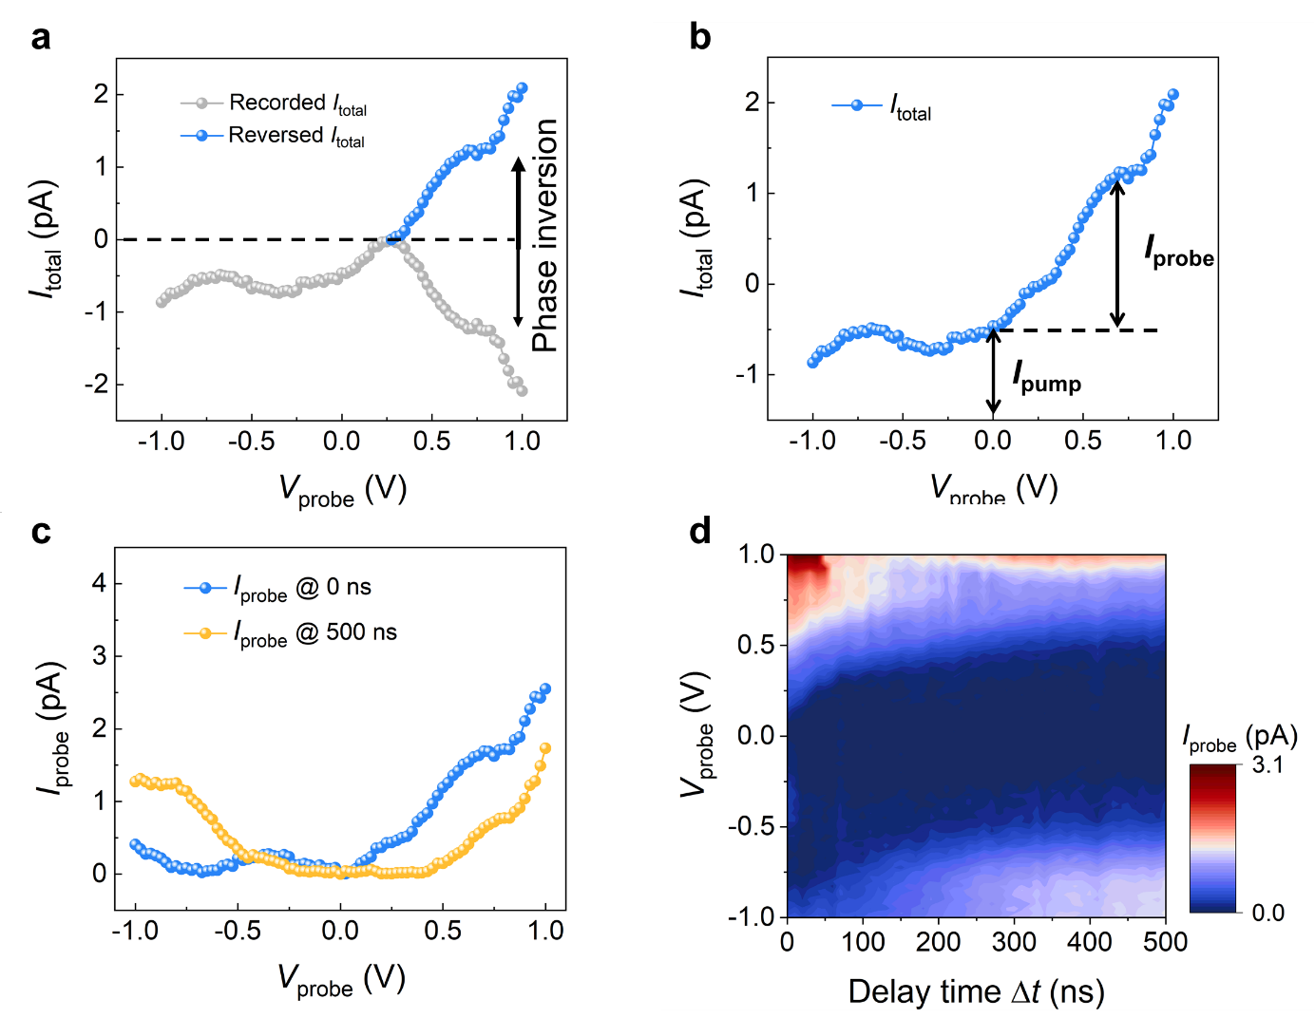
Fig. S14 Transient I_{pulse}-V_{pulse} pump-probe measurements of the charged molecule. a, Total current I_{total} recorded in a lock-in amplifier before (gray) and after (blue) considering phase inversion. b, Total current after considering phase inversion and the method for extracting probe current. c, Transient pulsed I-V characterization at 0 ns (blue) and 500 ns (yellow). d, Corresponding dependence of the probe current I_{probe} on the delay time as a function of probe voltage V_{probe} at a continuous V_{G} = −2.5 V.

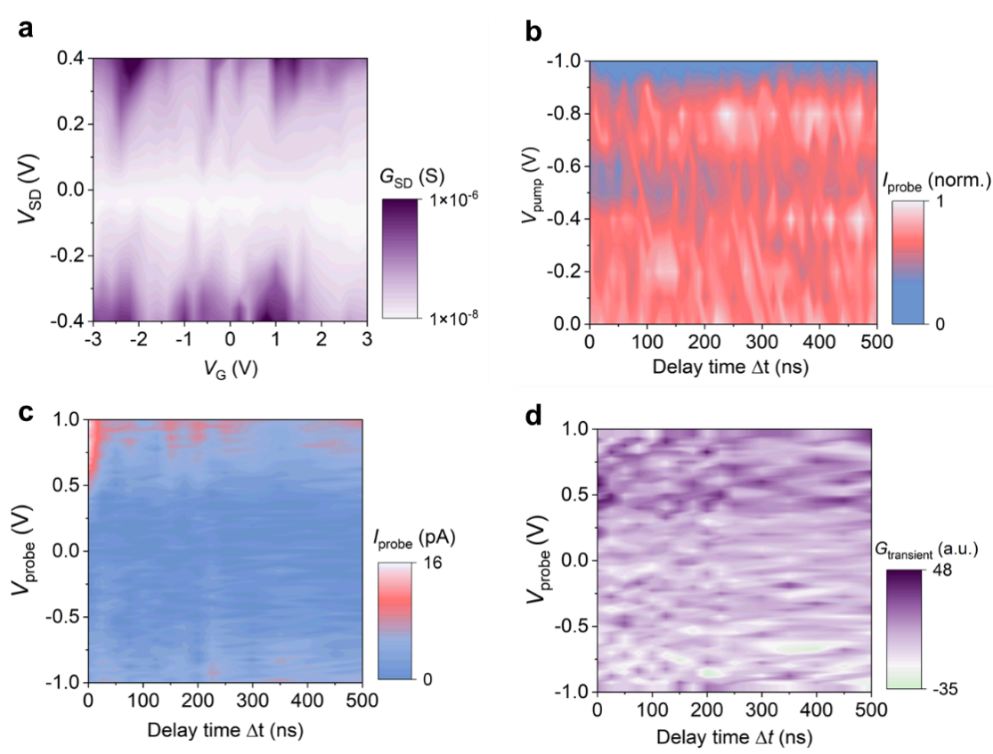
Fig. S15 Electrical characterizations and all-electronic pump-probe measurements on a graphene tunnel junction. a, Charge stability diagram showing the differential conductance G_{SD} (dI_{SD}/dV_{SD}) as a function of bias voltage (V_{SD}) and gate voltage (V_{G}) at 30 K. b, Corresponding dependence of the probe current I_{probe} on the delay time as a function of trigger voltage V_{pump.} at a continuous V_{G} = 0 V. c, Corresponding dependence of the probe current I_{probe} on the delay time as a function of probe voltage V_{probe} at a continuous V_{G} = 0 V. d, Transient differential conductance spectroscopy G_{transient} (dI_{probe}/dV_{probe}) of graphene tunneling junction.
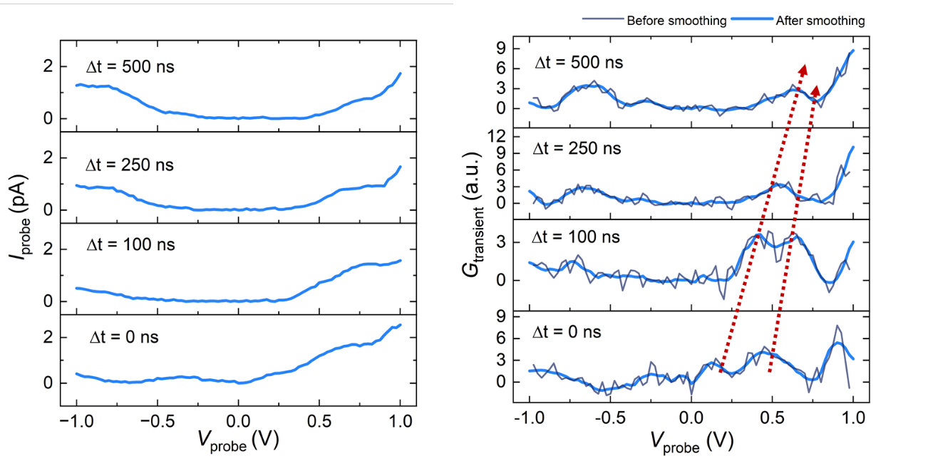
Fig. S16 The differential conductance (right panel) derived from I_{probe}-V_{probe} curves (left panel) before (black) and after (blue) smoothing The red dashed lines indicate the movement of resonance peak over time.
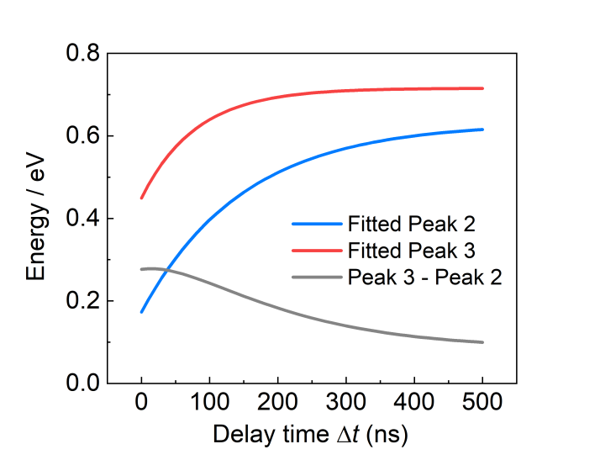
Fig. S17 The time evolution of energy space between Peak 2 and Peak 3 shown in Fig. 4b

Section Ⅳ. Details of Methods
As shown in Fig. S18a, the alkane branched chains of BP molecule was simplified due to its small impact on energy levels but not conducive to convergence during optimization. We considered various initial structures of the BP molecule, the configuration with the symmetry of C_{2h} has the lowest energy after relaxation (Fig. S18b). Then, the energy levels and electron distribution of BP molecular frontier orbitals are also calculated and shown in Fig. S18c. The calculated energy difference of HOMO and LUMO is 2.73 eV, which is consistent with the bandgap of 2.71 eV observed in the Ultraviolet-Visible spectrum (Fig. S8).
For neutral molecule, the excitation energies of the lowest three excited states are calculated by TDDFT method adopted in Gaussian 16, with T₁ − S₀ = 1.65 eV, T₂ − S₀ = 1.89 eV, S₁ − S₀ = 2.50 eV. We also calculate the energy of T₁ state by DFT method adopted in Gaussian 16, with T₁ – S₀ = 1.71 eV, which is consistent with the TDDFT results. The excitation energies of the lowest three excited state for BP⁺ are calculated to be D₁⁺ − D₀⁺ = 0.82 eV, D₂⁺ − D₀⁺ = 1.11 eV, D₃⁺ − D₀⁺ = 1.51 eV. While the excitation energies of the lowest two excited state for BP²⁺ are T₁²⁺ − S₀²⁺ = 0.11 eV, S₁²⁺ − S₀²⁺ = 0.92 eV.

Table S1 Calculated energy variations relative to D₀⁺ due to molecule geometries. The BP molecule geometries are optimized under different external electric fields (E = 0.8 V and 0 V).
D₀⁺ | S₀ | D₁⁺ | D₂⁺ | S₀²⁺ | T₁²⁺
0 eV | -0.07 eV | +0.02 eV | +0.02 eV | 0 eV | +0.01 eV

Table S2 Calculated dipole moments of N, N−1 and N−2 states. The BP molecule geometries are optimized under different external electric fields (E = 0.8 V and 0 V).
E | N state (S₀) | N−1 state (D₀⁺) | N−2 state (S₀²⁺) | N−2 state (T₁²⁺)
0.8 V | -5.12 Debye | -14.37 Debye | -14.20 Debye | -11.64 Debye
0 V | 0 Debye | 0 Debye | 0 Debye | 0 Debye

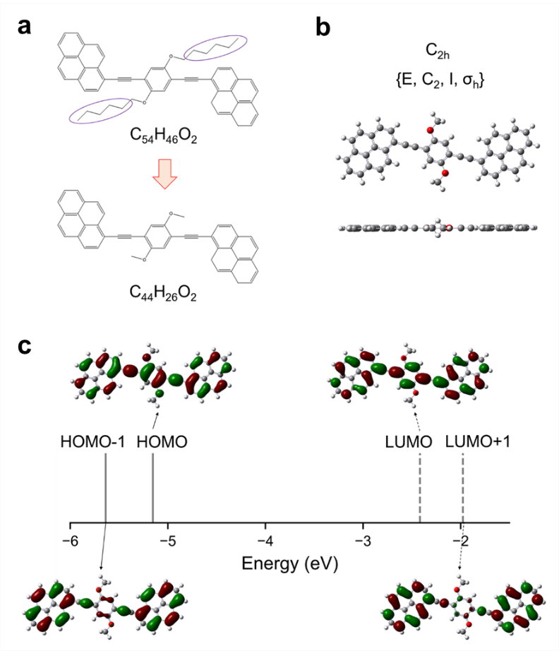
Fig. S18 Calculated molecular structure and frontier orbitals of BP molecule. a, Schematic diagram of structural simplification. b, The top view, side view and symmetry of BP molecule. c, Energy level and molecular frontier orbitals of BP molecular frontier orbitals.

We plot the energy alignment between electrode and molecular is shown at Fig. S21 in a single-particle picture according to the calculated results. The resonant peaks occur in Fig.4 corresponds to the transition from T₁²⁺ and S₀²⁺ to D_{n}⁺ in a many-body picture.

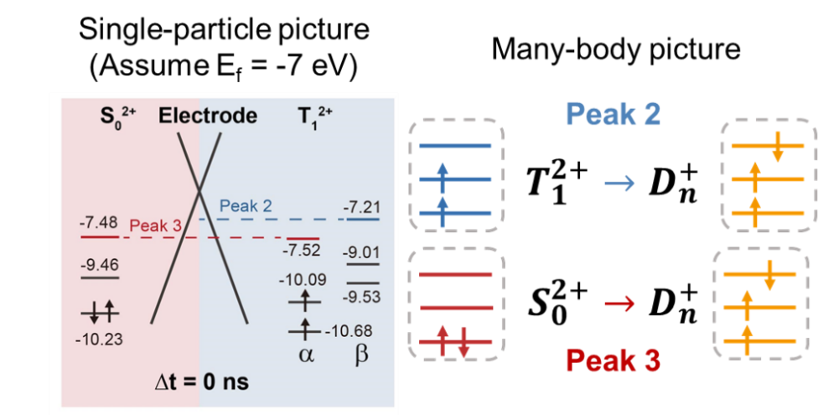
Fig. S19 Illustration of single-particle picture and many-body pictures of the resonance peaks in Fig.4

To exclude the contribution of structural relaxation-induced changes in the energy level structure, we optimized the molecular junction configurations for different charged states. For isolated molecules, the structures showed negligible variation across charged states, necessitating investigation of electrode-coupled configurations. We employed hydrogen-saturated graphene fragments as electrodes and optimized the molecular junction using the B3LYP-D3(BJ) functional with the 6-31G(d) basis set. The initial electrode separation was set to ~10.9 Å (C···C distance, matching the spacing between two pyrene groups in the molecule). During optimization, we fixed the electrodes while allowing the molecule to relax without constraints, simultaneously applying a 1 V/nm electric field along the electrode axis.

As shown in Fig. S20, electrostatic interactions between oxygen atoms and hydrogen atoms on the graphene electrodes induced rotation of the central benzene ring in the molecule, with distinct dihedral angles observed for different charged states. Additionally, charged states exhibited varying stacking offsets relative to graphene, particularly pronounced for T₁²⁺. Using these optimized structures, we calculated single-electron energy level changes before and after structural relaxation within the same electronic state. The structural modifications were found to induce negligible energy level and state energy shifts (Fig. S21 and Table S3, mostly <0.1 eV), thereby confirming that configurational relaxation of the molecular junction contributes negligibly to the electronic energy levels.

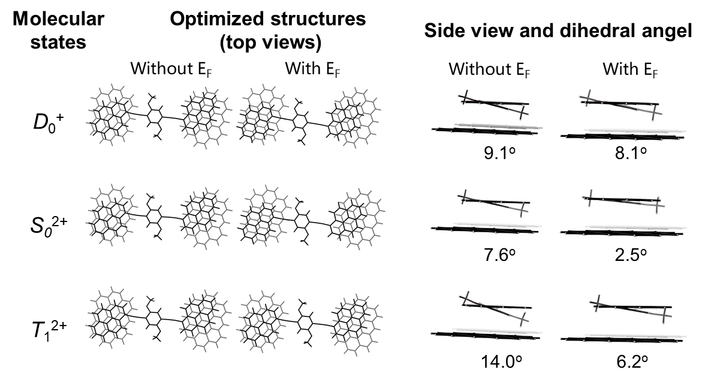
Fig. S20. Optimized structures of molecular junctions for different charged states.

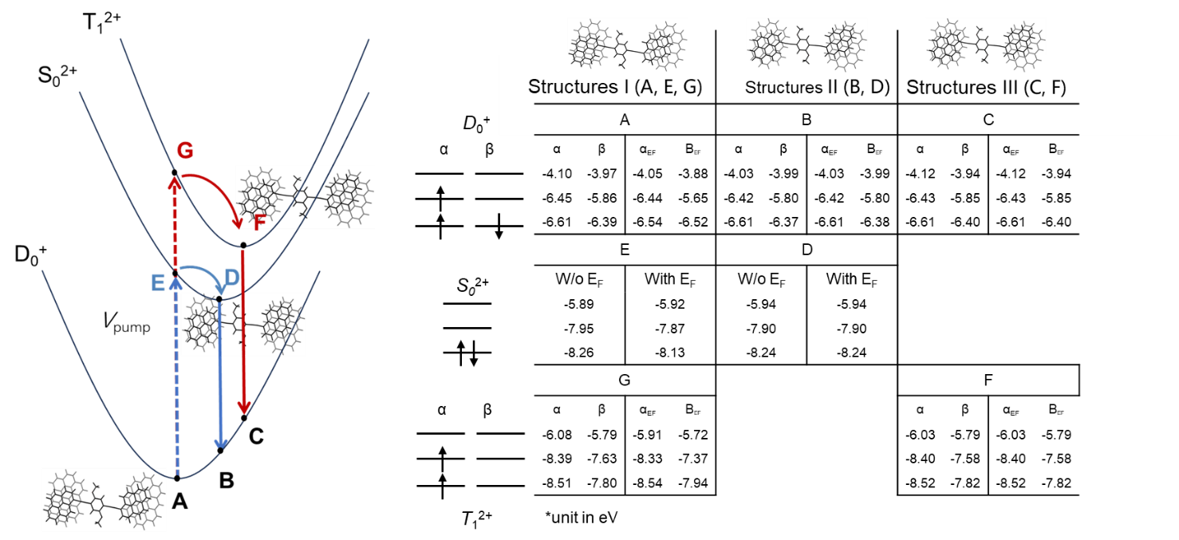

Fig. S21. Energy level of single molecule in molecular junctions for different charged states and structure.

Table S3 Calculated energy variations due to molecule geometries.
ΔE_{E} − ΔE_{D} | ΔE_{G} − ΔE_{F} | ΔE_{C} − ΔE_{A} | ΔE_{B} − ΔE_{A}
0.0174 eV | 0.0463 eV | 0.1204 eV | 0.0600 eV

References:
1. Wu W., Sun J., Ji S., Wu W., Zhao J., Guo H. Tuning the emissive triplet excited states of platinum(ii) schiff base complexes with pyrene, and application for luminescent oxygen sensing and triplet–triplet-annihilation based upconversions. Dalton Trans. 40, 11550 (2011).
2. Gopi A., Sajitha M., Haridas R., Varghese L., Yoosaf K. Cooperative and fret-assisted brightness enhancement in oligo(phenylene ethynylene): Quantum dot organic–inorganic nanohybrids. Chem. Asian J. 13, 1492 (2018).
3. Constantinescu C., Diallo A. K., D’Aleo A., Fages F., Rotaru P., Videlot-Ackermann C., et al. Thermal behaviour and thin film properties of a bis-pyrene compound for organic thin film transistor applications. Synth. Met. 209, 29 (2015).
4. Thomas J. O., Limburg B., Sowa J. K., Willick K., Baugh J., Briggs G. A. D., et al. Understanding resonant charge transport through weakly coupled single-molecule junctions. Nat. Commun. 10, 4628 (2019).
5. Limburg B., Thomas J. O., Holloway G., Sadeghi H., Sangtarash S., Hou I. C.-Y., et al. Anchor groups for graphene-porphyrin single-molecule transistors. Adv. Funct. Mater. 28, 1803629 (2018).
6. Peng J., Sokolov S., Hernangómez-Pérez D., Evers F., Gross L., Lupton J. M., et al. Atomically resolved single-molecule triplet quenching. Science 373, 452 (2021).

