EXTENDED DATA
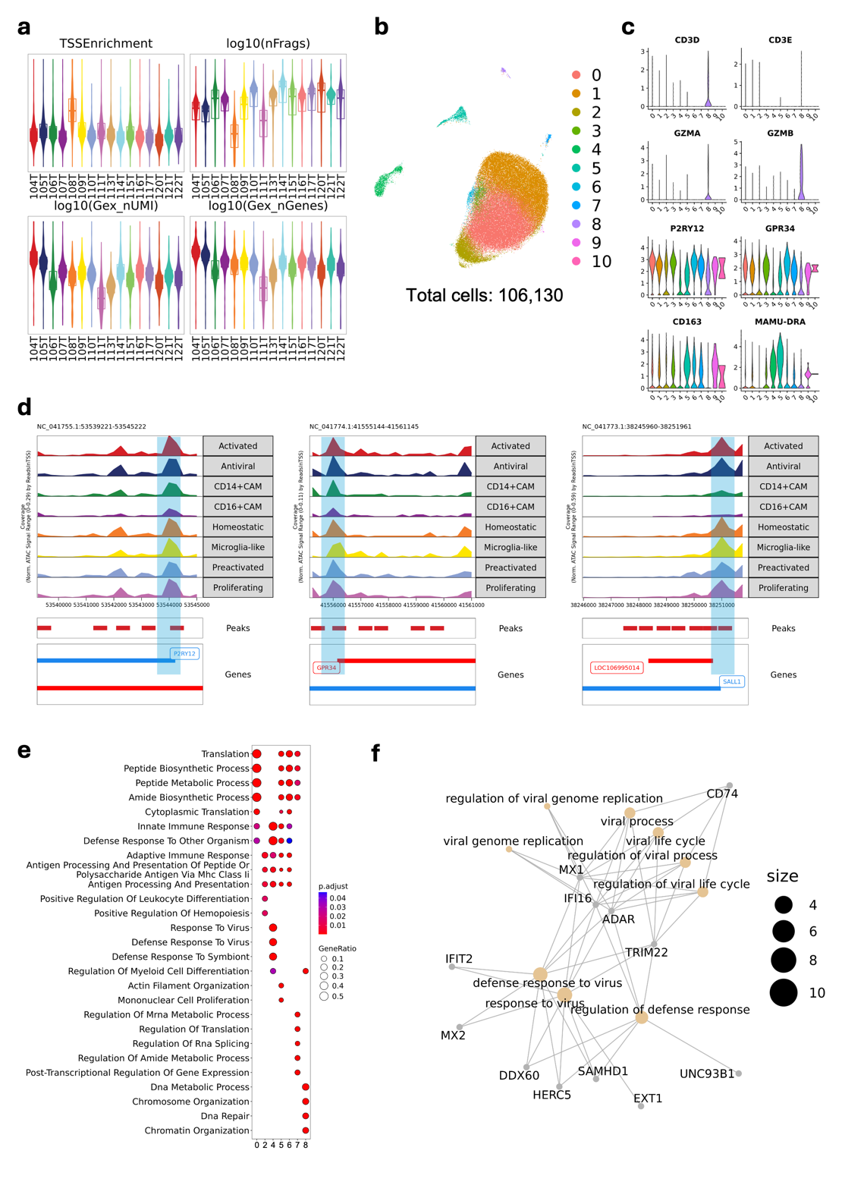
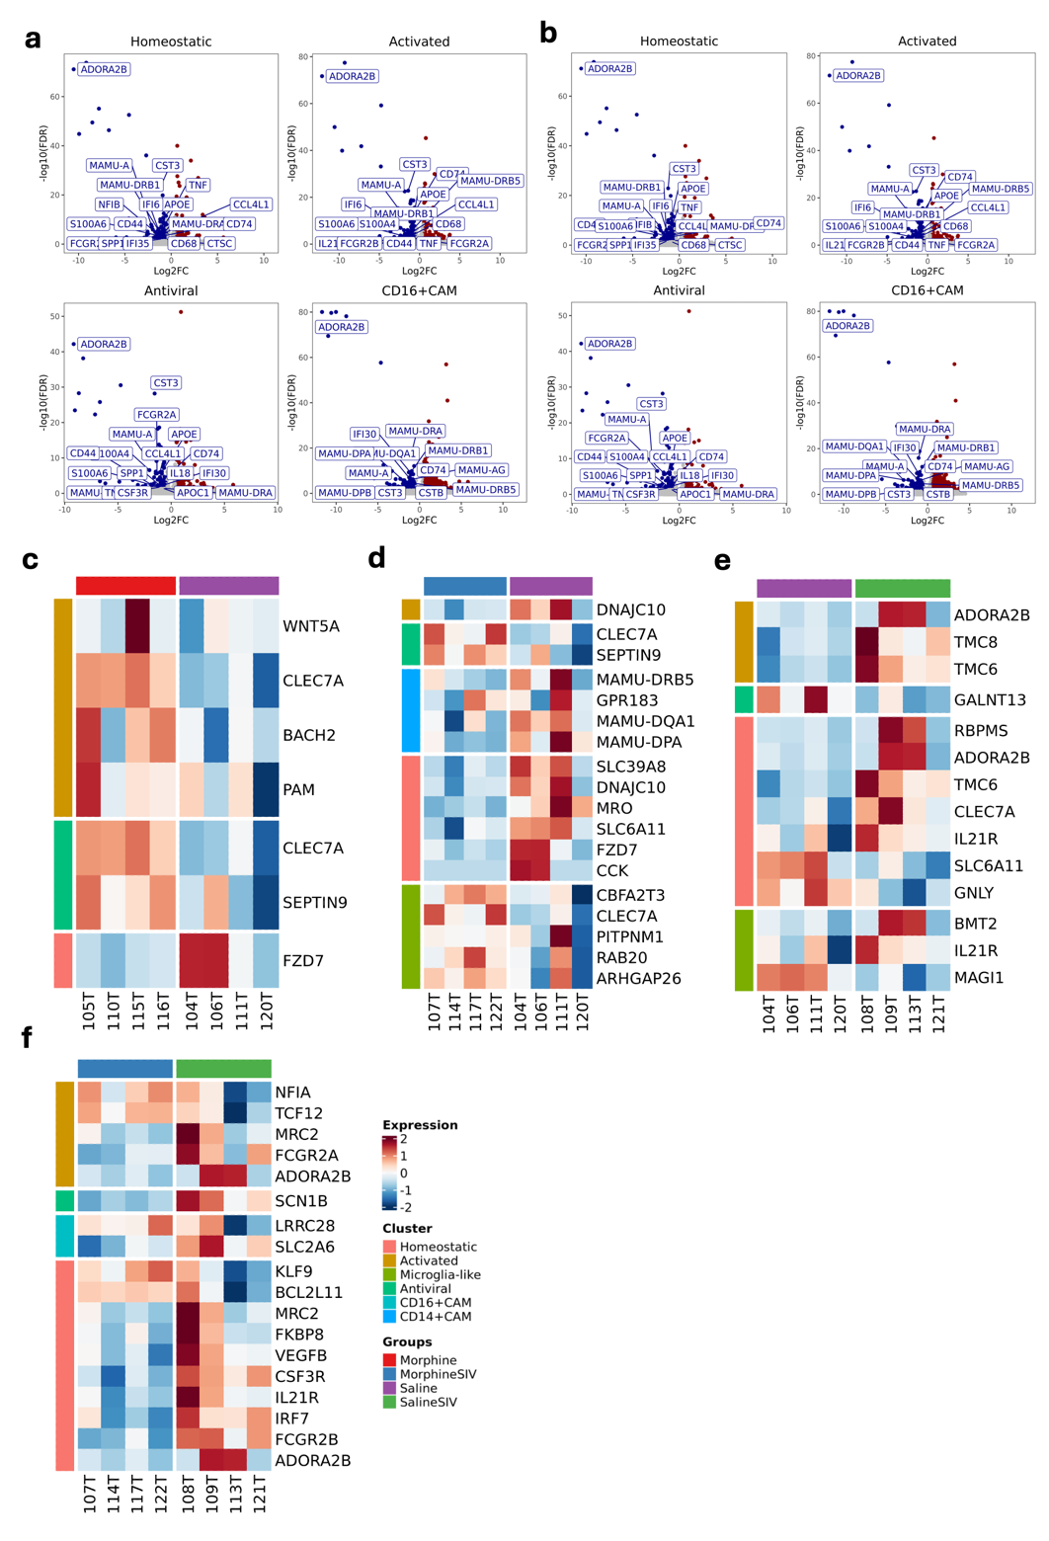
Extended Data Fig. 1. Preprocessing and characterization of single-nucleus data generated by multiomic experiment. a. Violin plots for TSS enrichment score and number of unique fragments (from the snATAC-seq), UMI and gene counts (from the snRNA-seq) for each sample subjected to multiomic sequencing. b. UMAP projection of the transcriptomic profile for 106,130 cells from 16 samples. c. Violin plots for the RNA expression of lymphoid (CD3D, CD3E, GZMA, GZMB) and myeloid (P2RY12, GPR34, CD163, and MAMU-DRA) markers in each cell cluster. d. Gene browser of the chromatin accessibility of homeostatic microglial core genes (P2RY12, GPR34, SALL1) in each myeloid cell cluster. e. The Gene Ontology (GO) characterization of different brain myeloid cell clusters. The GO terms of Biological Processes (BP) were used for this pathway enrichment. The top 5 pathways in each cluster are shown in the graph. f. Genes associated with the antiviral pathways that were enriched in cluster 4.
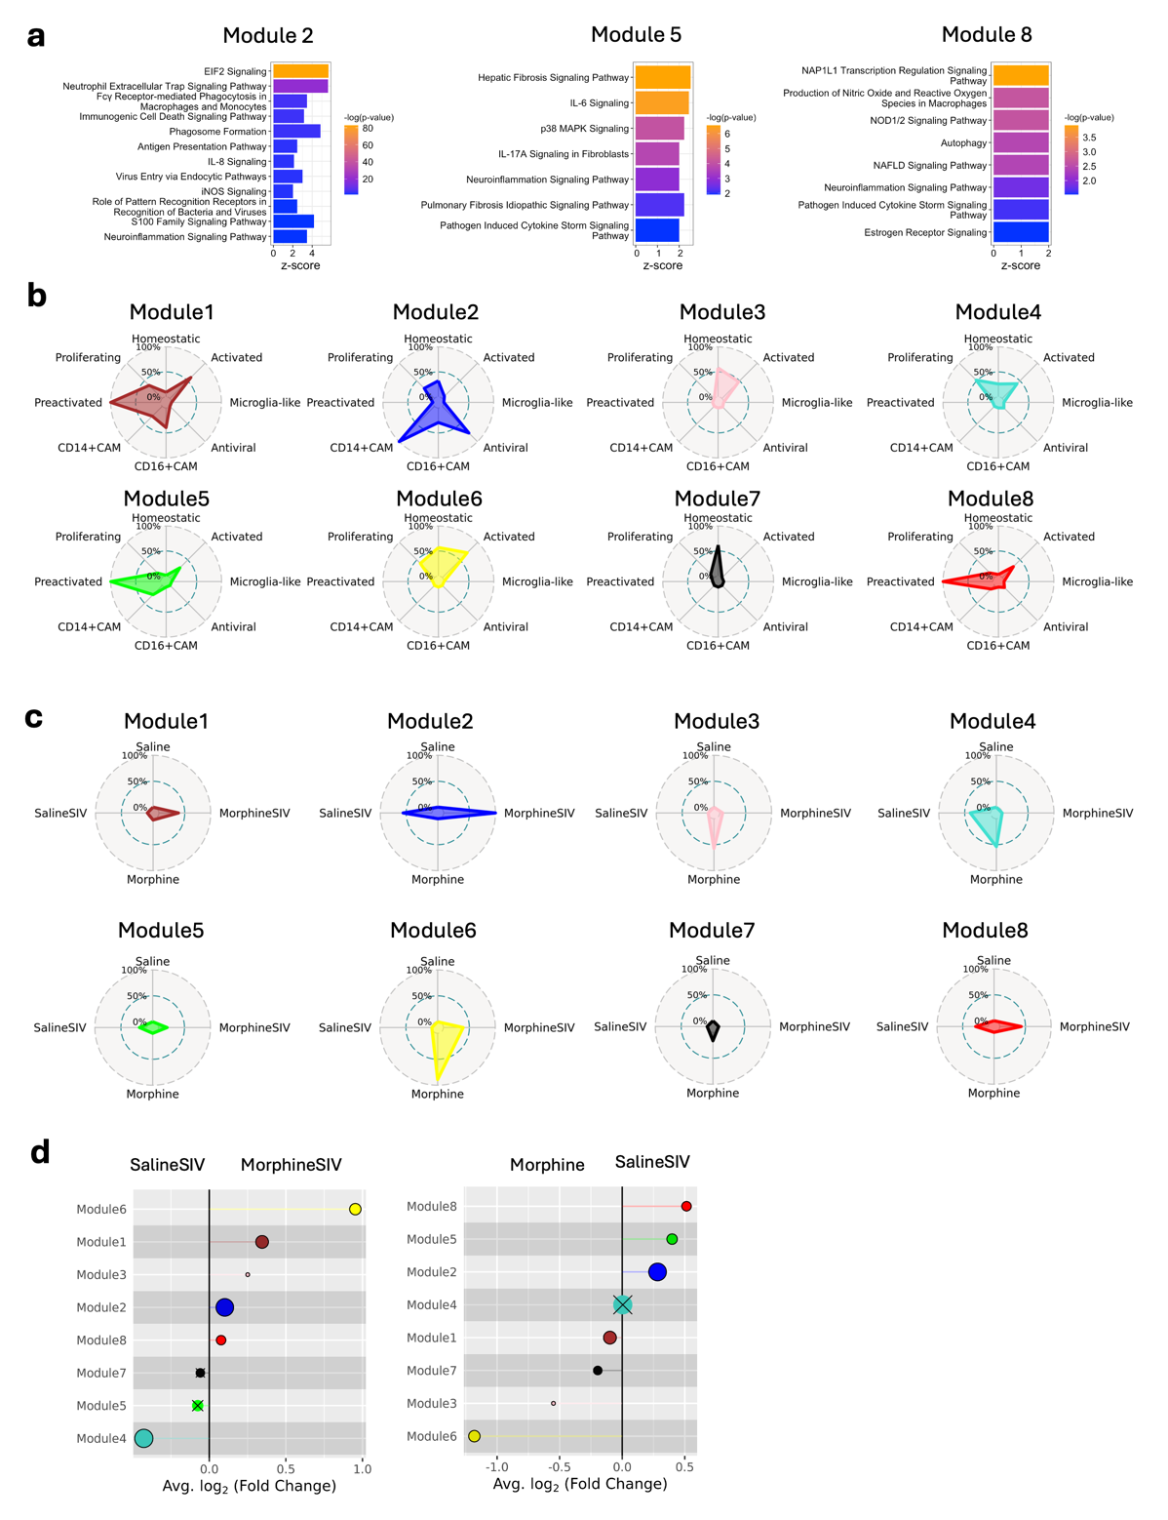
Extended Data Fig. 2. The significantly changed genes in different brain myeloid cell clusters in response to morphine and/or ART-treated SIV infection. a,b. Cell-level DEGs in a, Morphine SIV or b, Morphine group. In comparison, SalineSIV or Saline group was set as background. c-f. The selected sample-level DEGs (ranked by Log₂ FC) between c, Morphine and Saline groups, d, MorphineSIV and Saline groups, e, SalineSIV and Saline groups, and f, MorphineSIV and SalineSIV groups. For sample-level comparison (pseudobulk), a negative binomial model with the Wald test implemented in DESeq2 was used for aggregated expression data. The cut-off for detecting DEGs was set as adjusted p-value ≤ 0.05 and log₂FC ≥ 0.25. For cell-level comparison, the DEGs were detected using the Wilcoxon rank sum test on single-cell expression data, and the cut-off for detecting DEGs was set as FDR ≤ 0.05 and absolute log₂FC ≥ 0.5.
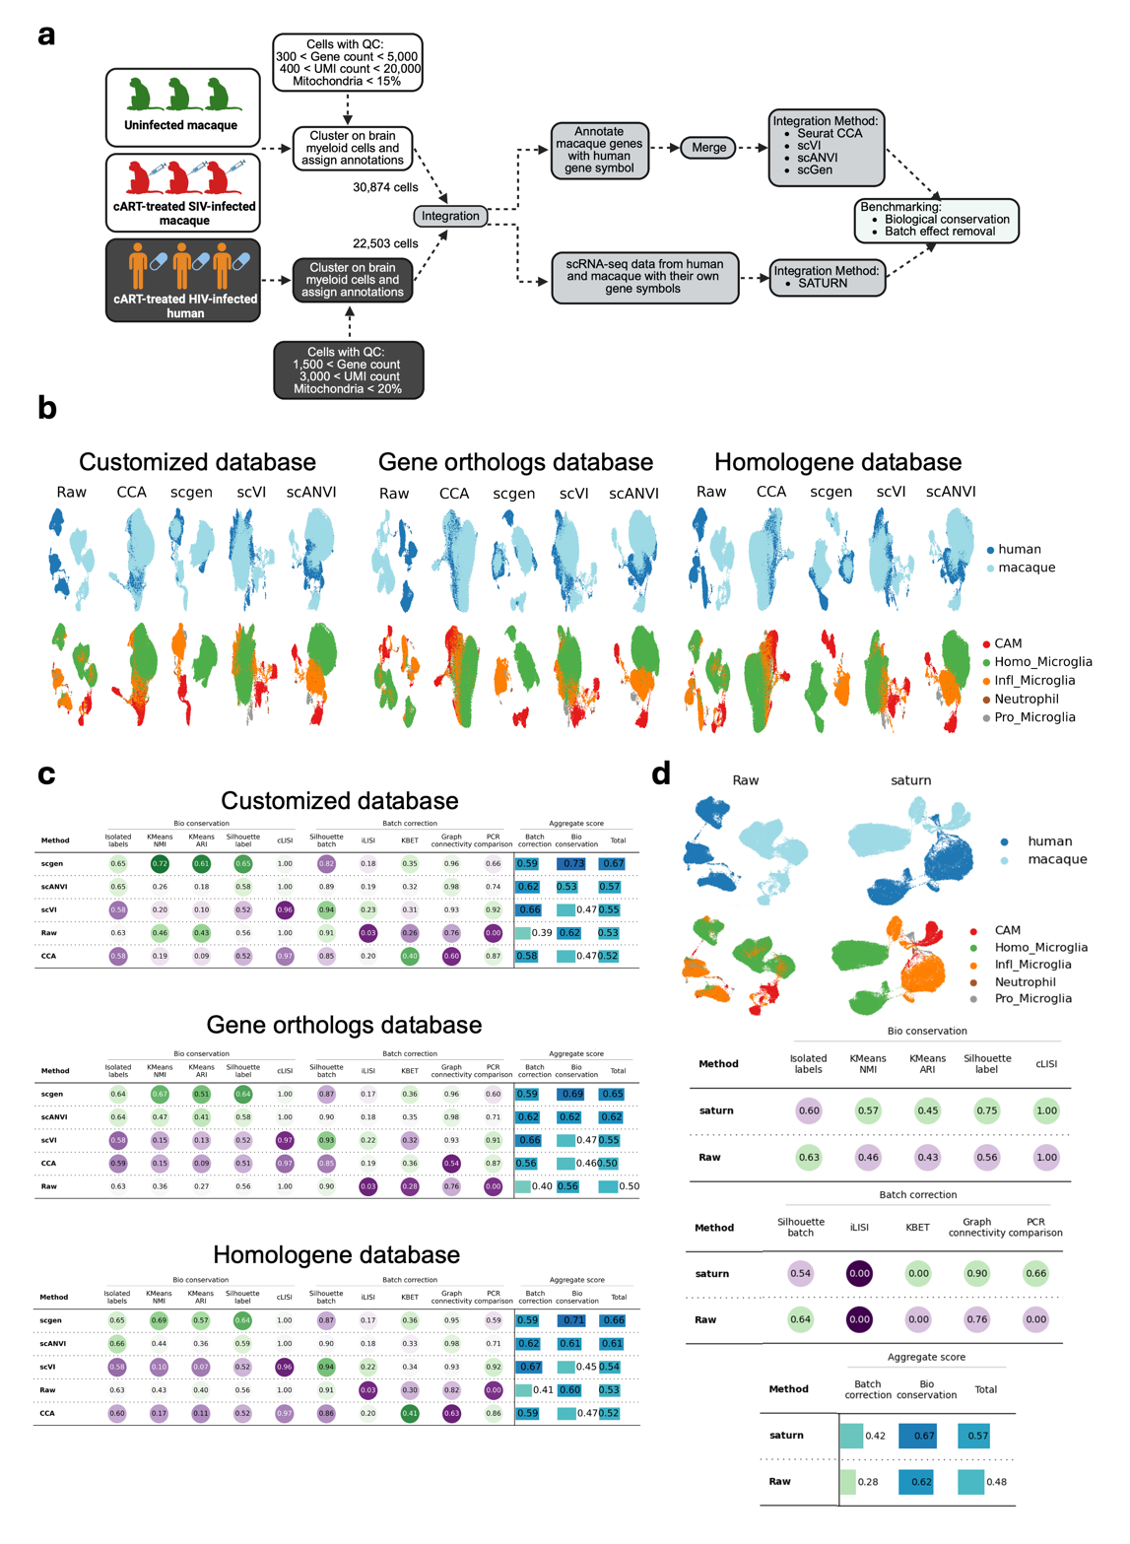
Extended Data Fig. 3. WGCNA for brain myeloid cells. a. The selected enriched terms for the hub genes in modules 2, 5, 8. The pathway analysis was performed with Ingenuity Pathway Analysis (IPA) and the analysis was based on eigengene-based connectivity (kME) calculated for each hub gene. The pathways with -log(p-value) > 1.3 and z-score ≥ 2 were considered as significantly upregulated pathways. b. The radar plot shows the relative expression level of each module across different brain myeloid cell clusters. c. The radar plot shows the relative expression level of each module across different treatment groups. d. Lollipop plot shows the up- or down-regulated modules in two treatment groups. The groups used for each comparison were labeled on the top of the plot. The modules with negative fold-change were upregulated in the group labeled on the left, and the modules with positive fold-change were upregulated in the group labeled on the right. The size of each dot corresponds to the number of genes in that module. An “X” is placed over each point that did not reach statistical significance.
Extended Data Fig. 4. Benchmarking of methods for human and rhesus macaque microglial scRNA-seq data integration. a. Workflow for integration methods comparisons. b. UMAP visualization of data before (Raw) and after integration using different integration methods and orthologous gene mapping databases. c. Benchmarking matrices for evaluating the integration results from scgen, scANVI, scVI, and CCA with three selected orthologous gene mapping databases. The evaluation matrices can be categorized into batch correction and biological conservation. d. Benchmarking matrices for evaluating the integration results from SATURN.

