Supporting information

Preparation of ZIF-8(600nm):
5 mmol of Zn(NO₃)₂⋅6H₂O and 40 mmol of 2-methy-limidazole were dissolved in 50 mL of ethanol 10 V/V% solution, so that ZIF-8 was synthesised in a static state at RT for 12 h, and then the material was dried overnight in an oven at 60 °C, and the sample obtained was noted as ZIF-8 (600 nm).
Preparation of ZIF-8(1000nm):
5 mmol of Zn(NO₃)₂⋅6H₂O and 40 mmol of 2-methy-limidazole were dissolved in 50 mL of ethanol 10 V/V% solution, so that ZIF-8 was synthesised in a static state at RT for 24 h, and then the material was dried overnight in an oven at 60 °C, and the sample obtained was noted as ZIF-8 (1000 nm).
Characterization:
X-ray diffraction (XRD) characterisation was carried out using an X-ray diffractometer from Shimadzu, Japan, with Cu Ka as the radiation source, an instrumental tube voltage of 40 kV, an instrumental tube current of 30 mA, a set scanning rate of 5 °/ min, and a scanning range of 5 to 40°.X-ray photoelectron spectroscopy (XPS) spectra were measured on the Thermo ESCALAB 250Xi system with Al Kα (hυ =1486.6 eV) as the excitation source. The samples need to be pre-treated before testing: oven drying at 60 °C for 12 h, and the obtained ZIF material was powdered finely with an onyx mortar and pestle. FT-IR analyses were carried out using a Thermo Scientific Nicolet iS50 infrared spectrometer with pure KBr as the reference background and the scanning range was set from 4000 to 400 cm-1 at a scanning rate of 4 cm⁻¹.SEM characterisation of the samples was carried out using a Zeiss 400 Compact Scanning Electron Microscope manufactured in Germany to observe the particle size and morphological features of the samples at different magnifications. The test and accelerating voltages of the equipment were adjusted to a range of 0.3 kV to 3.0 kV during the test. To ensure the suitability of the samples for microscopic analysis, the synthesised ZIF-8 samples were pre-treated as follows: firstly, the samples were ground to fine particles using an agate mortar, then dispersed in ethanol and dried before being sputter-coated with a layer of gold approximately 15 nm thick for scanning analysis.The morphology of ZIF-8 was observed using a transmission electron microscope (TEM) (HITACHI, HT 7700, Japan). For TEM analysis, the sample powder was well dispersed in water and the droplets were fixed onto a copper TEM grid. TEM images were acquired at 100 kV. The porosity of the crystals was determined using a Micrometrics Gemini VII 2390a instrument in a nitrogen atmosphere at 77 K. The powder samples were initially subjected to a degassing procedure at 120 °C for 8 h. Subsequently, the specific surface area and the adsorption/desorption behaviour of the powder samples were calculated and analysed using the BET model. The total pore volume Vt was estimated from the isothermal desorption branch at P/P0 = 0.99, assuming complete pore saturation.

Calculation details:
The Cambridge Sequential Total Energy Package (CASTEP) is used to calculate the structure optimization, adsorption and other related electronic structure properties in this work. The Perdew-Burke-Ernzerhof (PBE) functional and generalized gradient approximation (GGA) are used to express the exchangecorrelation potential. In order to better describe the weak force between layers, the van der Waals correction (DFT-D3) is added. In the process of structural optimization and energy calculation, the cutoff energy is set to 500 eV. Optimized structures were obtained by minimizing the forces on each ion until they were less than 0.03 eV/Å.
Using of kits
For CAT enzyme activity test sample processing: (1) Spectrophotometer or enzyme labeling instrument preheating for more than 30min, adjust the wavelength to 240nm, distilled water zero. (2) Before measurement, put the working solution of CAT assay in a water bath at 37℃ (mammals) or 25℃ (other species) for more than 10min. (3) Add 10uL of sample and 190μL of working solution into a micro quartz cuvette or 96-well plate, mix immediately and time, record the initial absorbance value A1 at 240nm and the absorbance value A2 after 1min, and calculate ΔA = A1-A2. CAT activity was determined by UV spectrophotometry, CAT activity assay was operated according to the instructions in the kit, and the formula for calculating CAT activity in bacteria was as follows：
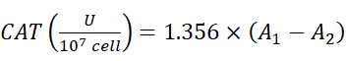 （1） For the SOD enzyme activity test sample processing: (1) Spectrophotometer or enzyme meter preheating more than 30min, adjust the wavelength to 560nm, distilled water zero. (2) Mix thoroughly, 37℃ water bath for 30min, placed in 1mL glass cuvette to determine the absorbance at 560nm, were recorded as A_{m}, A_{c}，A_{1b}, A_{2b}, calculated ΔA _{m} = A_{m} - A_{c}, ΔA_{b}= A_{1b} - A_{2b}. If there is precipitation at the bottom, mix and repeat the assay (blank tube 1 and blank tube 2 should be done in 1-2 tubes each, one control tube for each sample) (3) Calculation of Percentage inhibition:
（2）
（3）
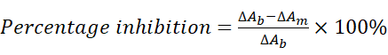 （4）
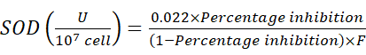 （5）

Antibacterial experiment：
Preparation of LB liquid medium: Weigh 3 g of beef paste, 10 g of peptone and 5 g of sodium chloride into a beaker, add 1 L of deionised water, and then adjust the pH of the medium to 7 with sodium hydroxide solution to obtain LB medium. The required LB medium was evenly dispensed into conical flasks with a measuring cylinder, sealed and put into a sterilisation pot, sterilised at 121℃ with moist heat, dried in an oven and stored for spare.
Preparation of LB solid medium:In the experimental operation, 2 g of agar powder was weighed into a conical flask and subsequently 100 ml of pre-prepared LB medium was added. The conical flask was sealed and placed in an autoclave for moist heat sterilisation at 121℃. After sterilisation, the conical flasks were transferred to an oven for drying and finally stored properly.
0.03 mol/L PBS (phosphate) buffer: 2.84 g of Na₂HPO₄ and 1.36 g of KH₂PO₄ were dissolved in 1 L of deionised water, and the solution was adjusted to pH neutral. The prepared solution was evenly distributed into conical flasks, sealed and transferred to a sterilisation pot, sterilised by moist heat at 121°C, dried in an oven and stored for spare use.
Pore size distribution：
Fig.1 shows the pore size distribution of ZIF-8 with different particle sizes, which shows that ZIF-8 with different particle sizes shows pore volume contribution peaks near 0.9 nm and 1.1 nm, indicating that no matter what kind of difference exists in the samples, ZIF-8 takes these two pore sizes as the main pore pathways, reflecting the inherent pore distribution law given by its framework structure, which reflects that the pore structure of ZIF-8 is governed by the framework of ZIF-8 and is subject to certain stability and commonality. This reflects that the pore structure of ZIF-8 is governed by its own framework and has certain stability and commonality.

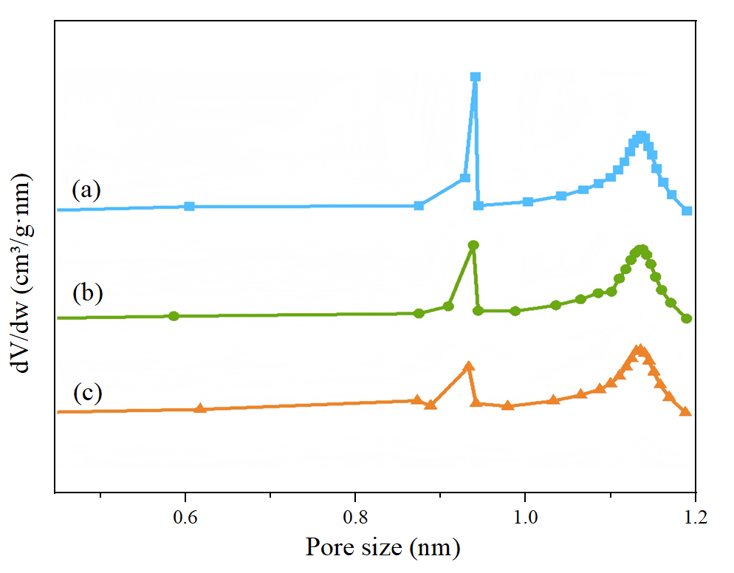
Fig.1.Pore size distribution of ZIF-8 samples with different particle sizes:(a)120nm;(b)600nm;(c)1000nm.

