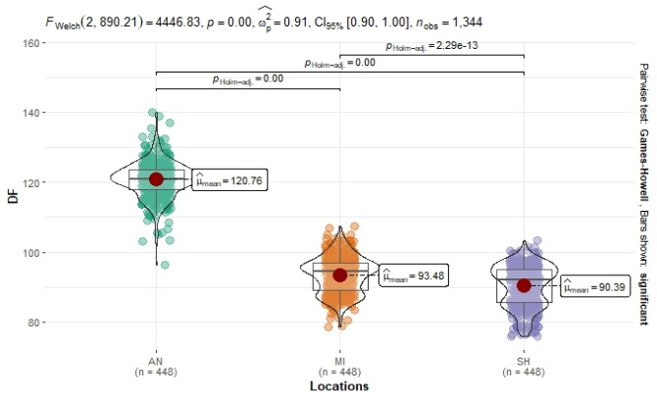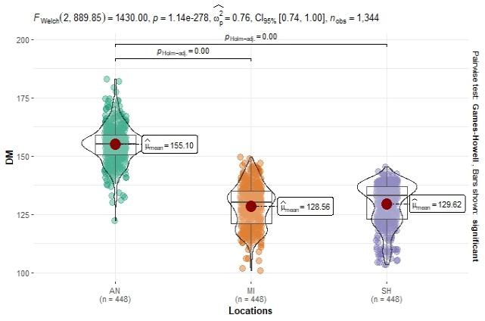
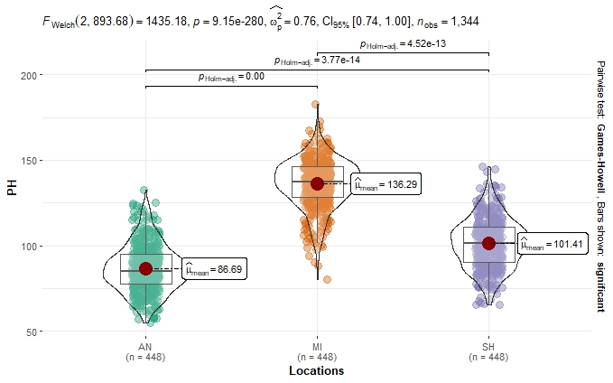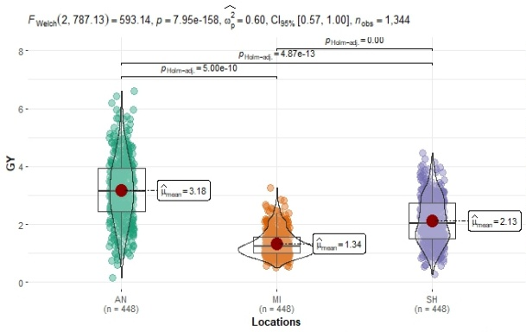
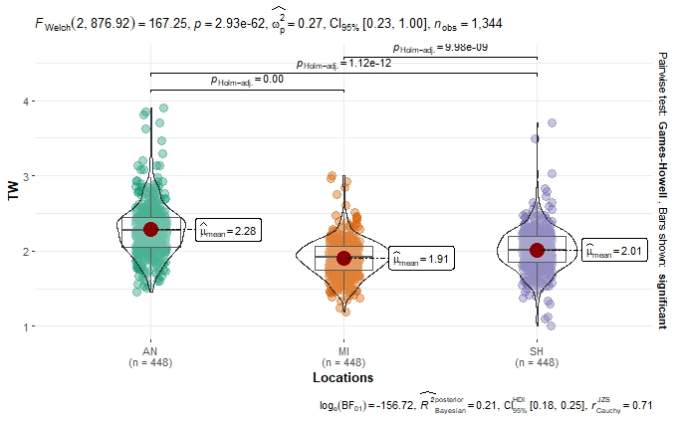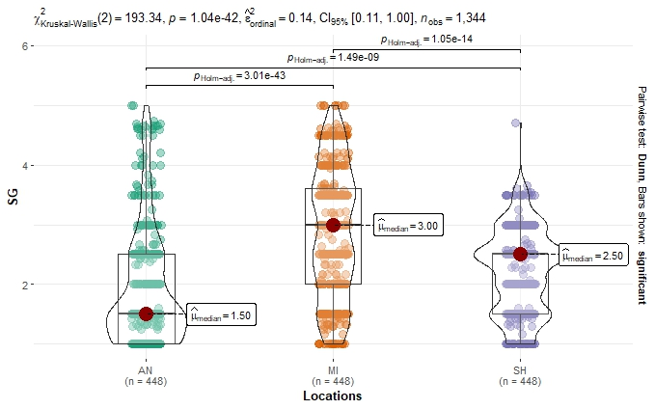
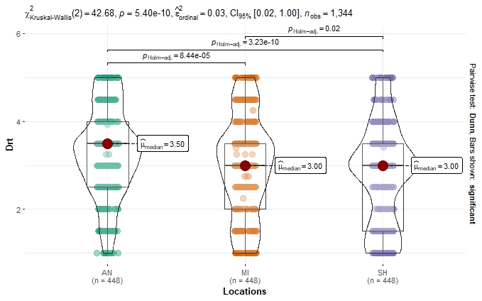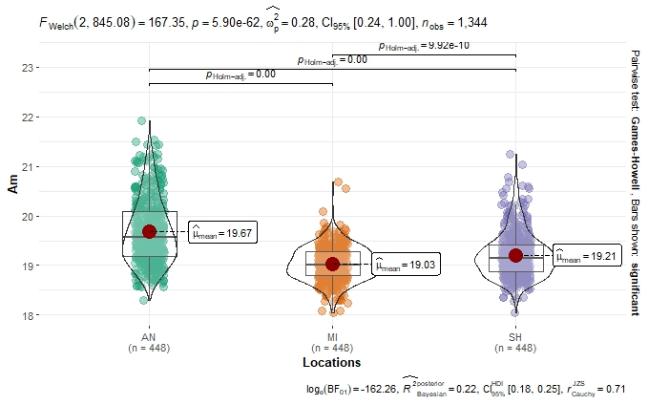
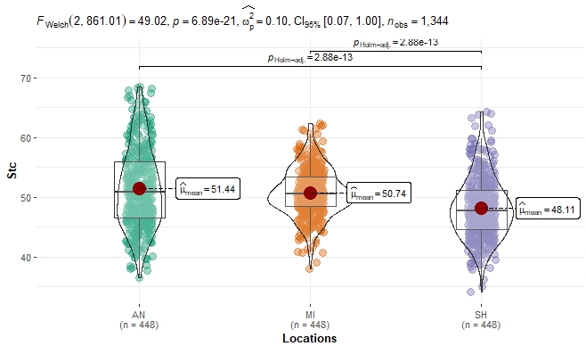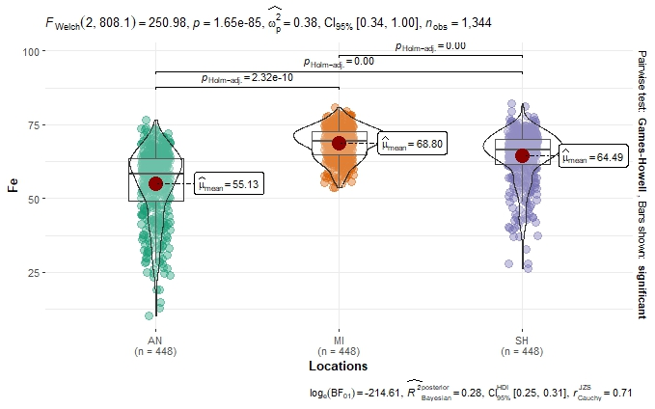
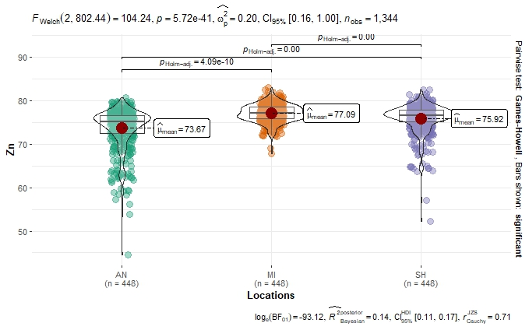
Supplemental Figure S1. Distribution of agronomic, drought-responsive, and nutritional traits of 448 finger millet genotypes across three locations in Ethiopia. Note: DF = days to 50% flowering, DM = days to maturity, PH = plant height, GY = grain yield, TW = thousand seed weight, SG = stay green score, and Drt = drought score, Am = amylose content, Stc = starch content, Fe = iron concentration, and Zn=zinc concentration, AN = Arsinegelle, MI = Meiso, and SH = Maitsebri.

Supplemental Table S1. Names, region of collection and grain colour of 448 finger millet genotypes used in the study
Genotype code | Genotype name | Grain colour | Regions of collection |  | Genotypes code | Genotypes name | Grain colour | Regions of collection
G1 | 24268 | Dark brown | Benishangul & Gumuz |  | G61 | 213835 | Brown | SNNP
G2 | 24269 | Dark brown | Benishangul & Gumuz |  | G62 | 215017 | Black | Oromia
G3 | 24270 | Brown | Amhara |  | G63 | 215798 | Dark brown | Oromia
G4 | 24392 | Dark brown | Oromia |  | G64 | 215802 | Dark brown | Oromia
G5 | 24393 | Light brown | Oromia |  | G65 | 215804 | Dark brown | Oromia
G6 | 24394 | Brown | Oromia |  | G66 | 215805 | Black | Oromia
G7 | 24395 | Light brown | Oromia |  | G67 | 215829 | White | Amhara
G8 | 24396 | Light brown | Oromia |  | G68 | 215837 | White | Amhara
G9 | 100064 | Brown | Oromia |  | G69 | 215841 | White | Amhara
G10 | 100065 | Black | Oromia |  | G70 | 215843 | Light brown | Amhara
G11 | 100092 | Black | Oromia |  | G71 | 215844 | Black | Amhara
G12 | 100093 | Black | Oromia |  | G72 | 215847 | Black | Amhara
G13 | 100095 | Brown | Oromia |  | G73 | 215848 | White | Amhara
G14 | 100097 | Brown | Oromia |  | G74 | 215850 | Dark brown | Amhara
G15 | 207543 | Black | Amhara |  | G75 | 215867 | Dark brown | Amhara
G16 | 207591 | Black | Tigray |  | G76 | 215869 | Dark brown | Amhara
G17 | 207593 | Black | Tigray |  | G77 | 215872 | Black | Amhara
G18 | 207897 | Black | Tigray |  | G78 | 215873 | Dark brown | Amhara
G19 | 207900 | Black | Tigray |  | G79 | 215875 | Black | Amhara
G20 | 207960 | Black | Oromia |  | G80 | 215878 | Dark brown | Amhara
G21 | 207961 | Black | Oromia |  | G81 | 215879 | Black | Amhara
G22 | 207962 | Black | Oromia |  | G82 | 215883 | Dark brown | Amhara
G23 | 207963 | Black | Oromia |  | G83 | 215887 | Dark brown | Amhara
G24 | 207964 | Dark brown | Oromia |  | G84 | 215889 | White | Amhara
G25 | 208013 | Brown | Amhara |  | G85 | 215896 | Dark brown | Amhara
G26 | 208015 | Dark brown | Amhara |  | G86 | 215908 | Dark brown | Amhara
G27 | 208016 | Dark brown | Amhara |  | G87 | 215916 | Dark brown | Amhara
G28 | 208438 | Black | Amhara |  | G88 | 215962 | Dark brown | Amhara
G29 | 208439 | Black | Amhara |  | G89 | 215963 | Black | Amhara
G30 | 208440 | Black | Amhara |  | G90 | 215966 | Brown | Amhara
G31 | 208442 | Dark brown | Amhara |  | G91 | 215967 | Dark brown | Amhara
G32 | 208443 | Black | Amhara |  | G92 | 215968 | Dark brown | Amhara
G33 | 208444 | Dark brown | Amhara |  | G93 | 215970 | Dark brown | Amhara
G34 | 208445 | Dark brown | Amhara |  | G94 | 215973 | Dark brown | Amhara
G35 | 208446 | Black | Amhara |  | G95 | 215976 | Black | Amhara
G36 | 208447 | Dark brown | Amhara |  | G96 | 215981 | Dark brown | Amhara
G37 | 208448 | Light brown | Amhara |  | G97 | 215982 | Black | Amhara
G38 | 208724 | Dark brown | Oromia |  | G98 | 215984 | Black | Amhara
G39 | 208725 | Brown | Oromia |  | G99 | 215985 | Black | Amhara
G40 | 208726 | Dark brown | Oromia |  | G100 | 215986 | Black | Amhara
G41 | 208727 | Brown | Oromia |  | G101 | 215989 | Black | Amhara
G42 | 208728 | White | Oromia |  | G102 | 215992 | Black | Amhara
G43 | 208729 | Dark brown | Oromia |  | G103 | 215994 | Black | Amhara
G44 | 208730 | Black | Oromia |  | G104 | 215996 | Black | Amhara
G45 | 211029 | Black | Tigray |  | G105 | 216020 | Black | Oromia
G46 | 211473 | Black | SNNP |  | G106 | 216021 | Brown | Oromia
G47 | 211474 | Dark brown | SNNP |  | G107 | 216023 | white | Oromia
G48 | 211504 | Black | Oromia |  | G108 | 216024 | white | Oromia
G49 | 211505 | Brown | Oromia |  | G109 | 216025 | White | Oromia
G50 | 211506 | Black | Oromia |  | G110 | 216026 | Black | Oromia
G51 | 212461 | Brown | Oromia |  | G111 | 216027 | Black | Oromia
G52 | 212462 | White | Oromia |  | G112 | 216028 | black | Oromia
G53 | 212692 | Dark brown | Amhara |  | G113 | 216029 | Dark brown | Oromia
G54 | 212693 | Black | Amhara |  | G114 | 216030 | Dark brown | Oromia
G55 | 212694 | Black | Amhara |  | G115 | 216031 | Black | Oromia
G56 | 213032 | Black | SNNP |  | G116 | 216032 | Black | Oromia
G57 | 213033 | Dark brown | SNNP |  | G117 | 216033 | Black | Oromia
G58 | 213034 | Dark brown | SNNP |  | G118 | 216034 | Black | Oromia
G59 | 213035 | Dark brown | SNNP |  | G119 | 216035 | Black | Oromia
G60 | 213228 | Black | Tigray |  | G120 | 216037 | Dark brown | Oromia
G121 | 216038 | Dark brown | Oromia |  | G122 | 216039 | Dark brown | Oromia
G123 | 216040 | Black | Oromia |  | G185 | 230562 | Black | Oromia
G124 | 216041 | Black | Oromia |  | G186 | 234148 | white | Tigray
G125 | 216045 | Black | Oromia |  | G187 | 234149 | Black | Tigray
G126 | 216046 | Black | Oromia |  | G188 | 234151 | Black | Tigray
G127 | 216047 | Black | Oromia |  | G189 | 234154 | Black | Tigray
G128 | 216048 | Black | Oromia |  | G190 | 234157 | Black | Tigray
G129 | 216049 | Black | Oromia |  | G191 | 234158 | Black | Tigray
G130 | 216050 | Black | Oromia |  | G192 | 234159 | Black | Tigray
G131 | 216051 | Black | Oromia |  | G193 | 234160 | Black | Tigray
G132 | 216052 | Brown | Oromia |  | G194 | 234162 | Black | Tigray
G133 | 216053 | Brown | Oromia |  | G195 | 234165 | Black | Tigray
G134 | 216054 | Brown | Oromia |  | G196 | 234168 | Black | Tigray
G135 | 216055 | Brown | Oromia |  | G197 | 234169 | Brown | Tigray
G136 | 216057 | Brown | Oromia |  | G198 | 234170 | Black | Tigray
G137 | 219503 | Dark brown | Amhara |  | G199 | 234171 | Black | Tigray
G138 | 219807 | Black | Tigray |  | G200 | 234172 | Dark brown | Tigray
G139 | 219817 | white | Tigray |  | G201 | 234173 | Black | Tigray
G140 | 219818 | Black | Tigray |  | G202 | 234174 | Dark brown | Tigray
G141 | 219819 | Black | Tigray |  | G203 | 234175 | Black | Tigray
G142 | 219821 | Dark brown | Tigray |  | G204 | 234176 | Black | Tigray
G143 | 219824 | Brown | Tigray |  | G205 | 234178 | Black | Tigray
G144 | 219831 | Brown | Tigray |  | G206 | 234179 | Black | Tigray
G145 | 221697 | Dark brown | Tigray |  | G207 | 234183 | Black | Tigray
G146 | 223145 | Dark brown | Tigray |  | G208 | 234184 | Dark brown | Tigray
G147 | 223146 | white | Tigray |  | G209 | 234185 | Dark brown | Tigray
G148 | 225892 | Black | Amhara |  | G210 | 234186 | Dark brown | Tigray
G149 | 225894 | Black | Amhara |  | G211 | 234187 | Brown | Tigray
G150 | 225895 | Black | Amhara |  | G212 | 234188 | Dark brown | Tigray
G151 | 227165 | Black | Amhara |  | G213 | 234190 | Black | Tigray
G152 | 227166 | Dark brown | Amhara |  | G214 | 234192 | Black | Tigray
G153 | 227973 | white | SNNP |  | G215 | 234193 | Dark brown | Tigray
G154 | 227974 | Dark brown | SNNP |  | G216 | 234194 | Dark brown | Tigray
G155 | 227975 | Dark brown | SNNP |  | G217 | 234198 | Dark brown | Tigray
G156 | 228202 | white | Amhara |  | G218 | 234201 | Black | Tigray
G157 | 228304 | Dark brown | Amhara |  | G219 | 234202 | Black | Tigray
G158 | 228305 | Black | Amhara |  | G220 | 234203 | Black | Tigray
G159 | 228306 | Black | Amhara |  | G221 | 234204 | Dark brown | Tigray
G160 | 228309 | Dark brown | Amhara |  | G222 | 234205 | Dark brown | Tigray
G161 | 228901 | Dark brown | Oromia |  | G223 | 234206 | Dark brown | Tigray
G162 | 228902 | white | Oromia |  | G224 | 234207 | Dark brown | Tigray
G163 | 229718 | white | Amhara |  | G225 | 234208 | Black | Tigray
G164 | 229719 | white | Amhara |  | G226 | 234209 | Dark brown | Tigray
G165 | 229720 | Dark brown | Amhara |  | G227 | 234210 | Dark brown | Tigray
G166 | 229721 | Dark brown | Amhara |  | G228 | 235140 | Dark brown | Amhara
G167 | 229722 | Dark brown | Benishangul & Gumuz |  | G229 | 235141 | Brown | Amhara
G168 | 229723 | Dark brown | Benishangul & Gumuz |  | G230 | 235151 | Black | Tigray
G169 | 229724 | Dark brown | Benishangul & Gumuz |  | G231 | 235153 | Brown | Tigray
G170 | 229725 | Dark brown | Benishangul & Gumuz |  | G232 | 235154 | Dark brown | Tigray
G171 | 229726 | Dark brown | Benishangul & Gumuz |  | G233 | 235155 | Dark brown | Tigray
G172 | 229728 | Dark brown | Benishangul & Gumuz |  | G234 | 235699 | Black | SNNP
G173 | 229729 | Brown | Amhara |  | G235 | 235700 | Dark brown | SNNP
G174 | 229730 | white | Amhara |  | G236 | 235782 | white | Amhara
G175 | 229731 | Dark brown | Amhara |  | G237 | 235783 | Black | Amhara
G176 | 229732 | Dark brown | Amhara |  | G238 | 235828 | Dark brown | Amhara
G177 | 229733 | Black | Amhara |  | G239 | 235833 | Black | Amhara
G178 | 229734 | Dark brown | Amhara |  | G240 | 235835 | Brown | Amhara
G179 | 229735 | Dark brown | Amhara |  | G241 | 235836 | Black | Amhara
G180 | 229736 | Black | Amhara |  | G242 | 235838 | Dark brown | Amhara
G181 | 229738 | Dark brown | Amhara |  | G243 | 235846 | Dark brown | Amhara
G182 | 230255 | Brown | Benishangul & Gumuz |  | G244 | 237443 | white | Amhara
G183 | 230560 | Dark brown | Oromia |  | G245 | 237446 | black | Tigray
G184 | 230561 | Black | Oromia |  | G246 | 237447 | Dark brown | Tigray
G247 | 237449 | Dark brown | Tigray |  | G309 | 238342 | Black | Amhara
G248 | 237450 | Dark brown | Tigray |  | G310 | 238343 | Dark brown | Amhara
G249 | 237452 | Dark brown | Tigray |  | G311 | 238344 | Dark brown | Amhara
G250 | 237458 | Dark brown | Tigray |  | G312 | 238345 | Dark brown | Amhara
G251 | 237459 | Dark brown | Tigray |  | G313 | 238346 | Dark brown | Amhara
G252 | 237461 | Dark brown | Tigray |  | G314 | 238460 | Dark brown | Tigray
G253 | 237462 | Dark brown | Tigray |  | G315 | 240506 | Brown | SNNP
G254 | 237463 | Black | Tigray |  | G316 | 241768 | Brown | SNNP
G255 | 237466 | Black | Tigray |  | G317 | 241769 | Dark brown | SNNP
G256 | 237467 | Dark brown | Tigray |  | G318 | 242105 | Black | Amhara
G257 | 237468 | Brown | Tigray |  | G319 | 242106 | Black | Amhara
G258 | 237471 | Dark brown | Tigray |  | G320 | 242107 | Black | Amhara
G259 | 237473 | Dark brown | Tigray |  | G321 | 242108 | Brown | Amhara
G260 | 237474 | Dark brown | Tigray |  | G322 | 242109 | Black | Amhara
G261 | 237476 | Dark brown | Tigray |  | G323 | 242111 | white | Amhara
G262 | 237477 | Black | Tigray |  | G324 | 242112 | Black | Amhara
G263 | 237582 | Dark brown | Oromia |  | G325 | 242113 | Brown | Amhara
G264 | 237583 | Light brown | Oromia |  | G326 | 242114 | Dark brown | Amhara
G265 | 237584 | Dark brown | SNNP |  | G327 | 242115 | Dark brown | Amhara
G266 | 237969 | Black | Oromia |  | G328 | 242117 | Dark brown | Amhara
G267 | 237970 | Dark brown | Oromia |  | G329 | 242118 | Brown | Amhara
G268 | 237971 | white | Oromia |  | G330 | 242119 | Brown | Amhara
G269 | 237972 | Light brown | Oromia |  | G331 | 242120 | Brown | Amhara
G270 | 237973 | Brown | Oromia |  | G332 | 242121 | Dark brown | Amhara
G271 | 238297 | Black | Tigray |  | G333 | 242122 | Dark brown | Amhara
G272 | 238298 | Black | Tigray |  | G334 | 242123 | Dark brown | Amhara
G273 | 238300 | Black | Tigray |  | G335 | 242125 | Black | Amhara
G274 | 238302 | Black | Tigray |  | G336 | 242126 | Dark brown | Amhara
G275 | 238303 | Black | Tigray |  | G337 | 242127 | Dark brown | Amhara
G276 | 238304 | Black | Tigray |  | G338 | 242128 | Dark brown | Amhara
G277 | 238305 | Brown | Tigray |  | G339 | 242129 | Black | Amhara
G278 | 238306 | Dark brown | Tigray |  | G340 | 242130 | Brown | Amhara
G279 | 238307 | Black | Tigray |  | G341 | 242131 | Dark brown | Amhara
G280 | 238308 | Black | Tigray |  | G342 | 242132 | Dark brown | Amhara
G281 | 238309 | Dark brown | Tigray |  | G343 | 242133 | Dark brown | Amhara
G282 | 238310 | Dark brown | Tigray |  | G344 | 242134 | Dark brown | Amhara
G283 | 238311 | Black | Tigray |  | G345 | 242135 | white | Amhara
G284 | 238312 | Black | Tigray |  | G346 | 242611 | Black | Tigray
G285 | 238313 | Dark brown | Tigray |  | G347 | 242612 | Black | Tigray
G286 | 238314 | Dark brown | Tigray |  | G348 | 242615 | Black | Tigray
G287 | 238316 | Dark brown | Tigray |  | G349 | 242616 | Dark brown | Tigray
G288 | 238317 | Black | Tigray |  | G350 | 242618 | Dark brown | Tigray
G289 | 238318 | Dark brown | Tigray |  | G351 | 242619 | Black | Tigray
G290 | 238319 | white | Tigray |  | G352 | 242620 | Dark brown | Tigray
G291 | 238320 | Black | Tigray |  | G353 | 242621 | Dark brown | Tigray
G292 | 238321 | Dark brown | Tigray |  | G354 | 242622 | Dark brown | Tigray
G293 | 238322 | Dark brown | Tigray |  | G355 | 242624 | Black | Tigray
G294 | 238323 | Dark brown | Tigray |  | G356 | 242626 | Brown | Tigray
G295 | 238324 | black | Tigray |  | G357 | 242627 | Black | Tigray
G296 | 238325 | Black | Tigray |  | G358 | 242628 | Black | Tigray
G297 | 238326 | Black | Tigray |  | G359 | 243615 | Brown | Amhara
G298 | 238328 | Black | Tigray |  | G360 | 243616 | white | Amhara
G299 | 238329 | Black | Tigray |  | G361 | 243617 | white | Amhara
G300 | 238331 | Dark brown | Tigray |  | G362 | 243629 | white | Amhara
G301 | 238333 | Black | Tigray |  | G363 | 243630 | Dark brown | Amhara
G302 | 238334 | Dark brown | Tigray |  | G364 | 243631 | Brown | Amhara
G303 | 238335 | Black | Tigray |  | G365 | 243632 | white | Amhara
G304 | 238336 | Dark brown | Tigray |  | G366 | 243633 | Dark brown | Amhara
G305 | 238337 | Brown | Tigray |  | G367 | 243634 | Black | Amhara
G306 | 238338 | Dark brown | Amhara |  | G368 | 243635 | Black | Amhara
G307 | 238340 | Dark brown | Amhara |  | G369 | 243637 | Black | Amhara
G308 | 238341 | Dark brown | Amhara |  | G370 | 243638 | Brown | Amhara
G371 | 243639 | Black | Amhara |  | G432 | Mecha (229371) | Brown | Released
G372 | 243640 | Dark brown | Amhara |  | G433 | Necho (203572) | white | Released
G373 | 243641 | Dark brown | Amhara |  | G434 | Axum (ACC#229355) | Brown | Released
G374 | 243642 | Dark brown | Amhara |  | G435 | Meba (GBK011119A) | Light brown | Released
G375 | 243643 | Dark brown | Amhara |  | G436 | Bareda (BRE356-10) | Brown | Released
G376 | 243644 | Dark brown | Amhara |  | G437 | Baruda (Pw01-075) | Brown | Released
G377 | 244798 | Light brown | SNNP |  | G438 | Boneya (KNE#411) | Brown | Released
G378 | 245084 | Black | Oromia |  | G439 | Debatsi (Debatsi) | Light brown | Released
G379 | 245085 | Black | Oromia |  | G440 | Padet (KNE#409) | Brown | Released
G380 | 245086 | Black | Oromia |  | G441 | Tadesse (KNE#1098) | Red | Released
G381 | 245087 | Black | Oromia |  | G442 | Tesema (ACC_229469) | Light brown | Released
G382 | 245088 | white | Oromia |  | G443 | Wama (KNE-392) | Brown | Released
G383 | 245089 | Brown | Oromia |  | G444 | Kako-1 (203351) | Light brown | Released
G384 | 245090 | Brown | Oromia |  | G445 | Bako-09 (ACC#214995) | Brown | Released
G385 | 245091 | Dark brown | Oromia |  | G446 | Diga-2 (BKFM0010) | Black | Released
G386 | 245092 | Light brown | Oromia |  | G447 | Mereb-1 (KNE#622) | Red | Released
G387 | AxumARCColl#1 | Dark brown | Tigray |  | G448 | Tekeze-1 (SMARC coll#60) | Dark brown | Released
G388 | AxumARCColl#2 | Dark brown | Tigray
G389 | AxumARCColl#3 | Dark brown | Tigray
G390 | AxumARCColl#4 | Black | Tigray
G391 | AxumARCColl#5 | Black | Tigray
G392 | AxumARCColl#6 | Black | Tigray
G393 | AxumARCColl#7 | Dark brown | Tigray
G394 | AxumARCColl#8 | Dark brown | Tigray
G395 | AxumARCColl#9 | Dark brown | Tigray
G396 | AxumARCColl#10 | Dark brown | Tigray
G397 | AxumARCColl#11 | Black | Tigray
G398 | AxumARCColl#12 | Dark brown | Tigray
G399 | AxumARCColl#13 | Red | Tigray
G400 | AxumARCColl#14 | Dark brown | Tigray
G401 | AxumARCColl#15 | Dark brown | Tigray
G402 | AxumARCColl#16 | Black | Tigray
G403 | AxumARCColl#17 | Black | Tigray
G404 | AxumARCColl#18 | Black | Tigray
G405 | AxumARCColl#19 | Dark brown | Tigray
G406 | AxumARCColl#20 | Dark brown | Tigray
G407 | AxumARCColl#21 | Black | Tigray
G408 | AxumARCColl#22 | Black | Tigray
G409 | AxumARCColl#23 | Red | Tigray
G410 | AxumARCColl#24 | Black | Tigray
G411 | AxumARCColl#25 | Black | Tigray
G412 | AxumARCColl#26 | Dark brown | Tigray
G413 | AxumARCColl#27 | Dark brown | Tigray
G414 | AxumARCColl#28 | Brown | Tigray
G415 | AxumARCColl#29 | Dark brown | Tigray
G416 | AxumARCColl#30 | Black | Tigray
G417 | AxumARCColl#31 | Black | Tigray
G418 | AxumARCColl#32 | Red | Tigray
G419 | AxumARCColl#33 | Black | Tigray
G420 | AxumARCColl#34 | Dark brown | Tigray
G421 | AxumARCColl#35 | Dark brown | Tigray
G422 | AxumARCColl#36 | Dark brown | Tigray
G423 | AxumARCColl#37 | Dark brown | Tigray
G424 | AxumARCColl#38 | Brown | Tigray
G425 | AxumARCColl#39 | Dark brown | Tigray
G426 | Degu (215874) | Black | Released
G427 | Addis-01 (ACC#203544) | Red | Released
G428 | Urgi (242617) | white | Released
G429 | Diga-1 (216036) | Dark brown | Released
G430 | Gudetu (215990) | Brown | Released
G431 | Gute (229373) | Brown | Released

