Supplementary Table 1 Clinical characteristics of a subcohort of CAPNETZ admitted between 2017-2022 including all, type 2 diabetic and non-diabetic patients.

 | All patients | Type 2 Diabetes mellitus | Non-diabetic | p-value
% (n/N) | 100 (1692) | 19 (317/1692) | 81 (1375/1692) | -
Age in years (Mean (SD)) | 64 (17) | 72 (12) | 62 (17) | <0,0001
Male Sex, (% (n/ N)) | 63 (1085/1692) | 66 (208/317) | 63 (860/1375) | 0,30
BMI (kg/m2), Median (IQR), available n | 26 (23-30) | 29 (25-34) | 26 (23-29) | <0,0001
Nursing home residency (%, n/available N) | 4 (61/1690) | 9 (28/317) | 2 (33/1373) | <0,0001
Cigarette smoking during the last 12 months (%, n/available N) | 23 (368/1625) | 16 (47/303) | 24 (321/1322) | <0,01 (0,001)
Chronic heart failure (%, n/available N) | 7 (112/1692) | 14 (44/317) | 5 (68/1375) | <0,0001
Chronic respiratory/pulmonary disease (%, n/available N) | 35 (595/1692) | 41 (130/317) | 34 (465/1375) | <0,05 (0,0156)
Vascular/Cerebrovascular disease (%, n/available N) | 59 (996/1692) | 89 (282/317) | 52 (714/1375) | <0,0001
Chronic kidney disease (%, n/available N) | 13 (217/1692) | 26 (83/317) | 10 (134/1375) | <0,0001
Previous antibiotic therapy within the last 4 weeks (%, n/available N) | 13 (223/1692) | 8 (24/317) | 14 (199/1375) | <0,01 (0,001)
Malignant disease | 16 (274/1692) | 17 (53/317) | 16 (221/1375) | 0,78
Oxygen Therapy | 3 (51/1692) | 4 (14/317) | 3 (37/1375) | 0,10

Available n is indicated where variables were not available for all patients. P-values comparing type 2 diabetic and non-diabetic patients (based on self-reporting) were calculated using the Wilcoxon test for medians after rolling out a normal distribution, and unadjusted Chi-square test for frequencies of comorbidities. All clinical variables shown were significantly different between diabetic and non-diabetic patients except for gender, malignant disease and oxygen therapy . Abbreviations : IQR : interquartile range, SD: standard deviation, BMI : body mass index.

Supplementary Table 2 Multivariate logistic regression model of outcome including demographic characteristics and comorbidities as predictors

 | Outcome ICU admission |  | Outcome death
Predictors | aOR | 95% CI | aOR | 95% CI
Age | 1.01 | 1.00, 1.02 | 1.05 | 1.05, 1.06
Male sex at birth | 1.73 | 1.44, 2.10 | 1.56 | 1.35, 1.82
BMI | 1.01 | 1.00, 1.03 | 0.93 | 0.91, 0.94
Heart disease | 1.51 | 1.20, 1.89 | 1.78 | 1.52, 2.08
Cerebrovascular disease | 1.50 | 1.21, 1.85 | 1.50 | 1.28, 1.76
Kidney disease | 1.59 | 1.24, 2.04 | 1.50 | 1.25, 1.80
Respiratory disease | 1.05 | 0.88, 1.25 | 0.98 | 0.85, 1.13
Malignant disease | 0.99 | 0.75, 1.29 | 1.91 | 1.60, 2.28
Diabetes mellitus | 1.56 | 1.26, 1.93 | 1.31 | 1.11, 1.54

Available n/N was 9,168/13,611 for the outcome ICU admission and 13,164/13,611 for the outcome death. Logistic regression on the outcome ICU admission within 28 days versus not and death from any cause within 180 days post enrolment was performed including baseline characteristics and comorbidities as predictors.
Abbreviations: ICU: intensive care unit. aOR: adjusted Odd’s ratio. CI: confidence interval. BMI: body mass index.

Supplementary Table 3 Specific pathogen group comparison between DM- and DM+ patients
Pathogen | P value | Adjusted P Value (p_{adj})
S. pneumoniae | 0.2406 | 0.8894
H. influenzae | 0.0191 | 0.1430
Enterobacteriaceae | 0.0006 | 0.0048
Atypical bacteria | 0.0734 | 0.4566
Non-fermenting gram-negative bacteria | 0.4569 | 0.9924
S. aureus | 0.7240 | 1.0000
Viruses | 0.0612 | 0.3966
Others | 0.7292 | 1.0000
Chi-square test was used to evaluate the individual difference between each pathogen group versus all other pathogens, and the obtained P values were adjusted for multiple comparisons with the Bonferroni-Sidak test.

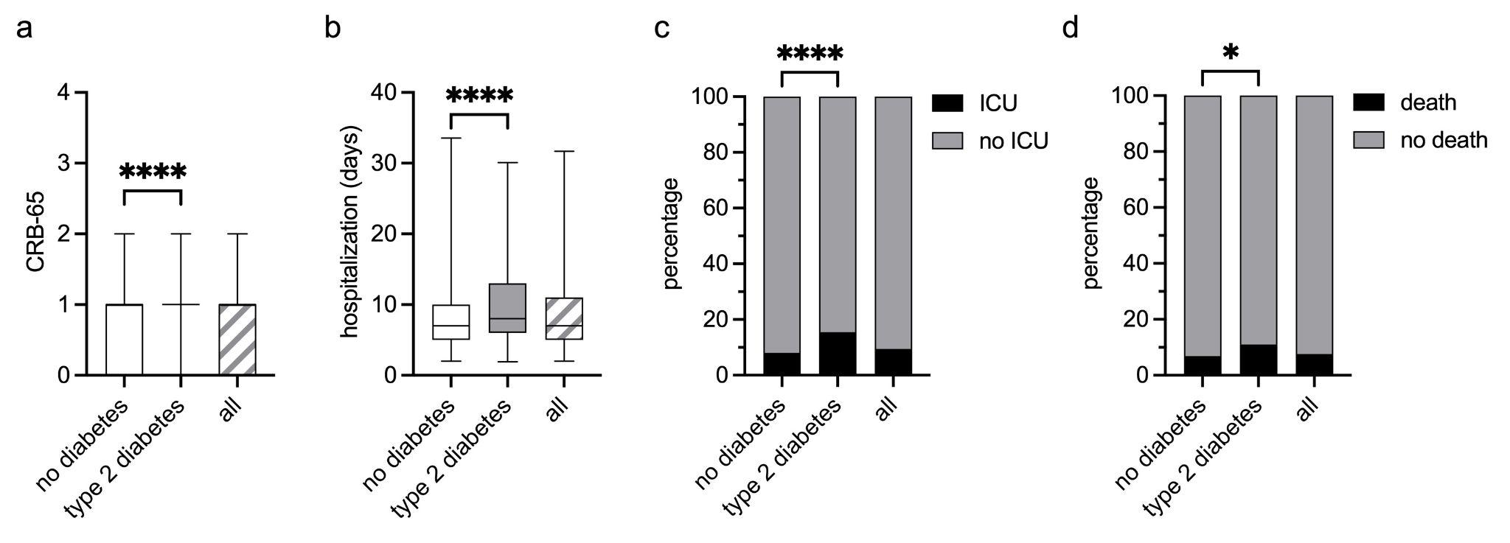Supplementary Fig.1 Outcome in non-diabetic versus type 2 diabetic patients from CAPNETZ study Nr. 2
(a, b) Box-plot showing the distribution (median and IQR) of CRB-65 score (a) and hospitalization days (b) in non-diabetic, type 2 diabetic, and all patients (available 1,516/1,692 for a) and 1,652/1,692 for b)). Whiskers represent the 2,5 - 97,5 percentile. Mann-Whitney statistical analysis was used. (c, d) Percentages of ICU admission within 28 days (c) and death within 180 days (d), both from any cause following CAP in non-diabetic vs type 2 diabetic patients, as well as all patients in the CAPNETZ 2 cohort (available n = 1,688/1,692 for c) and 1,692/1,692 for d)). Chi-square test was used to analyze the shown groups. *: p<0,05 ; ****: p<0,0001. ICU: intensive care unit, CRB-65: pneumonia severity index (see methods). Diabetes Type 2 was defined on a self-report basis.

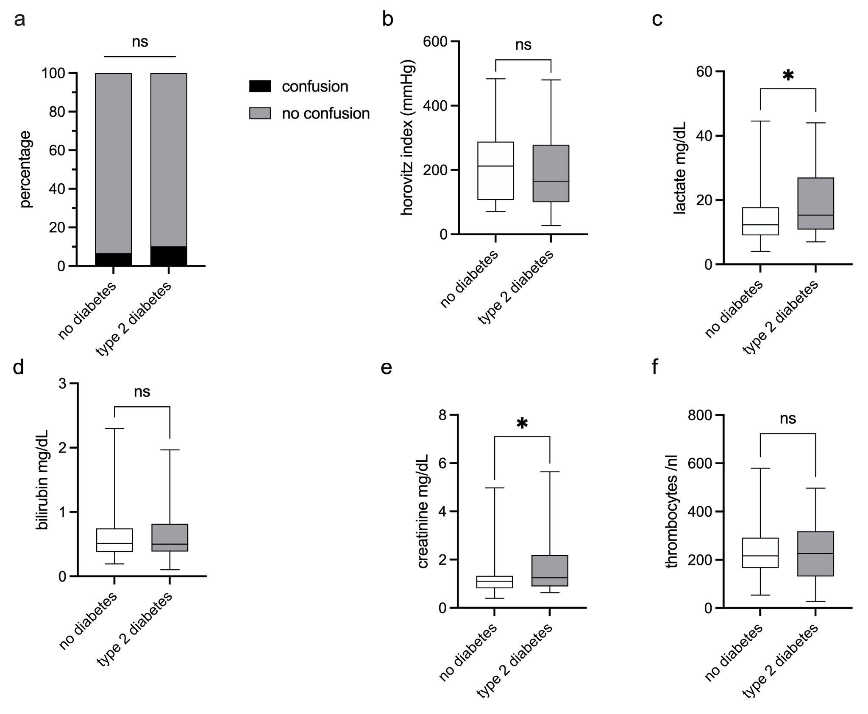
Supplementary Fig. 2 Markers for organ failure in non-diabetic versus type 2 diabetic patients admitted in the ICU
(a) Percentage of confusion at the time of ICU admission in non-diabetic vs. type 2 diabetic patients. Fisher’s exact test was used to analyze the difference between both groups. (b–f) Box plots showing values of the Horovitz index (b), lactate (c), bilirubin (d), creatinine (e), and thrombocytes (f) from baseline blood samples collected within 48 hours after inclusion, comparing non-diabetic and type 2 diabetic patients. Whiskers represent the 2.5th to 97.5th percentiles. After ruling out normal distribution, the Mann–Whitney test was applied. Available data for non-diabetic and type 2 diabetic patients: (a) 105 and 49; (b) 84 and 41; (c) 56 and 31; (d) 93 and 40; (e) 107 and 49. *p < 0.05. The Horovitz index (PaO₂/FiO₂ ratio) reflects pulmonary gas exchange efficiency and is used here as a marker of lung failure severity. Diabetes status and type was determined by self-report. Abbreviations: ns = not significant

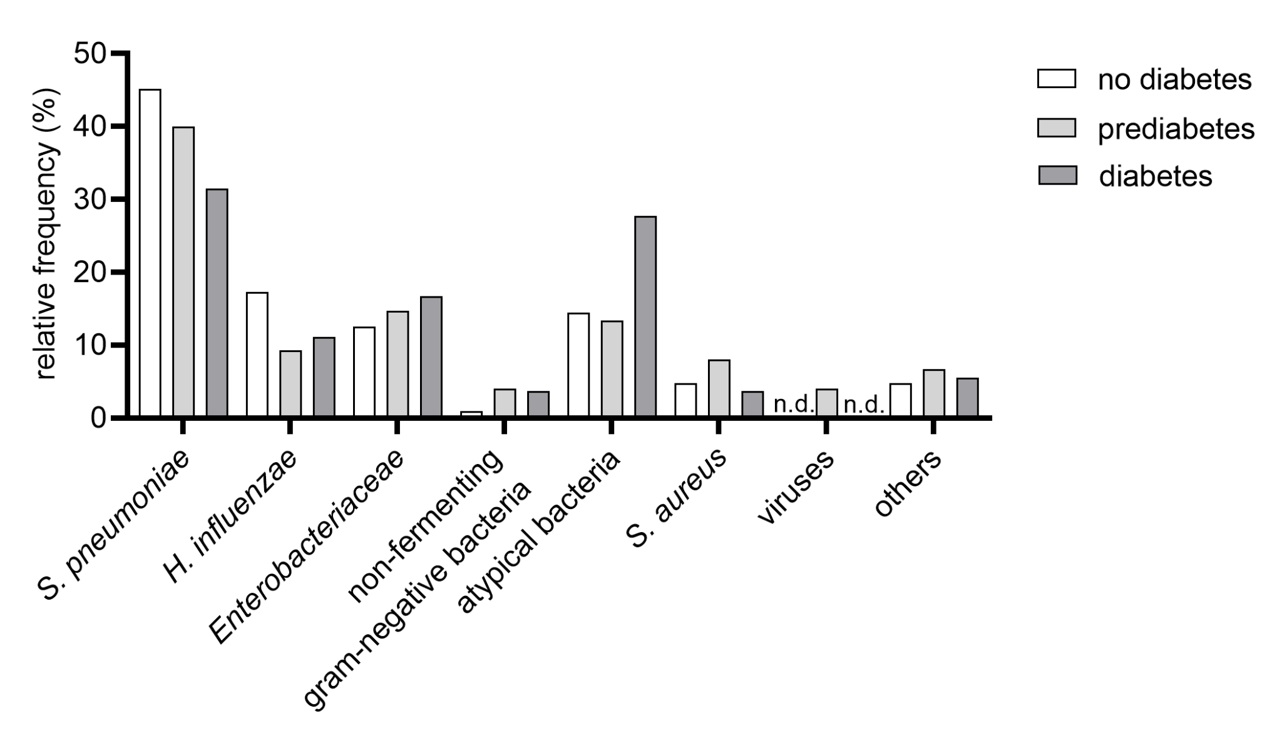
Supplementary Fig.3 Relative frequencies of isolated pathogens in non-diabetic, pre-diabetic and diabetic patients based on HbA1c levels and self-reporting.
Pathogen relative frequency summarized in seven biologically relevant groups and “others” in 104 non-diabetic, 75 pre-diabetic, and 54 diabetic patients based on available HbA1c data (see methods). n.d.: not detected.

