Figure and Tables
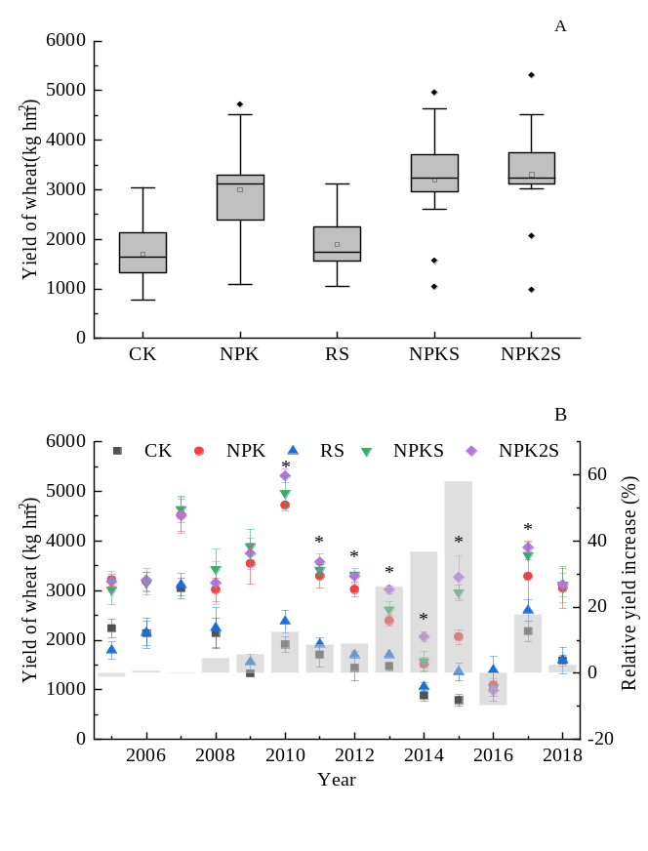
Fig. S1 Wheat yields as affected by different straw return treatments from 2005 to 2018 (CK, no fertilization and straw; NPK, recommended fertilization and no straw return; RS, no fertilization and straw return to fields with 6000 kg hm⁻², NPKS, recommended fertilization and straw return to fields with 3000 kg hm⁻²; and NPK2S, recommended fertilization and straw return to fields with 6000 kg hm⁻² * indicates significant differences among NPK and NPK2S treatments (p < 0.05), and error bar values represent the mean±SD. The solid and short dash lines represent the median and mean values, respectively. The lower and upper edges represent the 25th and 75th percentiles of all data, respectively. The bars and dots represent the 5th and 95th percentile of all data, respectively. The inside or outside of the boxes represent the <5th and >95th percentiles of all data, respectively.)

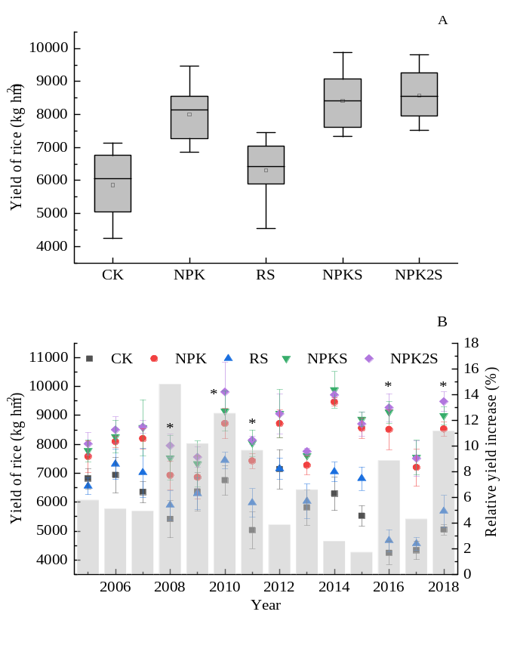
Fig. S2 Rice yields as affected by different straw return treatments from 2005 to 2018 (CK, no fertilization and straw; NPK, recommended fertilization and no straw return; RS, no fertilization and straw return to fields with 6000 kg hm⁻², NPKS, recommended fertilization and straw return to fields with 3000 kg hm⁻²; and NPK2S, recommended fertilization and straw return to fields with 6000 kg hm⁻² * indicates significant differences among NPK and NPK2S treatments (p < 0.05), and error bar values represent the mean±SD. The solid and short dash lines represent the median and mean values, respectively. The lower and upper edges represent the 25th and 75th percentiles of all data, respectively. The bars and dots represent the 5th and 95th percentile of all data, respectively. The inside or outside of the boxes represent the <5th and >95th percentiles of all data, respectively.)
Table S1
Semi-quantitative analysis of clay minerals by XRD techniques using an oriented specimen slide (%)
Treatment | Smectite | Vermiculite and HIV | Illite | Kaolinite
CK | 4.9ª | 19.1 | 26.0 | 50.1
NPK | 4.5 | 19.0 | 29.0 | 47.4
RS | 3.0 | 19.9 | 28.5 | 48.6
NPK2S | 3.2 | 21.5 | 25.1 | 50.2
ª Semi-quantitative analysis of Mg-gly XRD patterns; HIV, hydroxyl-interlayered minerals; CK, no fertilization and straw; NPK, recommended fertilization and no straw return; RS, no fertilization and straw return to fields with 6000 kg hm⁻²; NPK2S, recommended fertilization and straw return to fields with 6000 kg hm⁻².
Table S2
Some properties of illite of tested soils
Treatment | d-value (Å) | FWHM (º2θ) | IB | MCD (Å) | ALN
CK | 0.997 | 0.280 | 0.406 | 105 | 106
NPK | 0.997 | 0.281 | 0.411 | 104 | 105
RS | 0.997 | 0.252 | 0.384 | 116 | 117
NPK2S | 0.997 | 0.250 | 0.381 | 117 | 118
FWHM, Full width at half maximum height of 001 diffraction peak; IB, integral width of 001 diffraction peak; MCD, mean crystal dimension along 001 direction; ALN, average layer number; CK, no fertilization and straw; NPK, recommended fertilization and no straw return; RS, no fertilization and straw return to fields with 6000 kg hm⁻²; NPK2S, recommended fertilization and straw return to fields with 6000 kg hm⁻².

