Dual-emission ratiometric fluorescent probe based on Uio-66-NH₂@CQDs for quantitative detection of acetophenone
Yongze Shou, Zhouqing Xu*, Huijun Li*, Wenjie Liu, Junkun Wang
Department of Chemistry and Chemical Engineering, Henan Polytechnic University, Jiaozuo, Henan 454000, China.
*Corresponding author. E-mail addresses: zhqxu@hpu.edu.cn (Z. Xu), lihuijunxgy@hpu.edu.cn (H. Li).

Experimental procedures
Materials
All materials used in this assay are in the analytical grade without any purification. 2-Aminoterephthalic Acid (H₂BDC-NH₂, 99%), zirconium chloride (ZrCl₄, 98%), N,N-dimethylformamide (DMF), and acetic acid (HAc, 99.5%) for the synthesis of Uio-66-NH₂. The chemicals such as Na₂SO₄ (AR), KCl (AR), FeCl₃(AR), FeCl₂(AR), HgCl₂ (AR), CuCl₂ (AR), MnCl₂ (AR), AlCl₃ (AR), BaCl₂ (AR), Zn(NO₃)₂⋅6H₂O (AR), KNO₃ (AR), 2,2-pyridinone, 2,4-pyridine diketone, 2,4-dihydroxypropiophenone (98%), 2,6-dihydroxyacetophenone, 4-aminobenzophenone, benzylacetone, acetone, cyclohexanone. All reagents were stored at 4°C for subsequent uses.
Instruments
Powder X-ray diffraction (PXRD) data were obtained using a Bruker D8 Advance X-ray diffractometer with Cu Kα radiation in the range of θ = 5–60◦. The morphology was recorded through field-emission scanning electron microscopy (SEM) (S-4800, Hitachi, Japan), and energy dispersive spectroscopy (EDS) was used to map the surface elements of the samples. UV–vis spectra were measured on a Shimadzu UV-2600. The Fourier transform infrared spectroscopy (FT-IR) of the materials was characterized on a Nicolet 670 Fourier Infrared Spectrometer (with KBr pellet) in the range of 4000-400 cm⁻¹. The X-ray photoelectron spectroscopy (XPS) was performed on a Thermal ESCALAB 250XI system. FluoroMax-4spectrophotometer was used to complete the detection of fluorescence spectrum data. Transmission electron microscopy (TEM) was carried out on a Hitachi HT7700. Fluorescence lifetime was performed on the Edinburgh FLS1000. A model 744 digital pH meter (Metrohm Ltd, Switzerland) was used to adjust pH values. The synthesis of CQDs and MOFs was provided in an oven (Initiator 8 EXP, 2450 MHz frequency, Biotage Corp).
Preparation procedures of CQDs
CQDs were synthesized according to the reported literature with slight modifications [1]. Briefly, 0.126 g of terephthalic acid (TPA) and 0.1 g of o-phenylenediamine (OPD) were dissolved in 15 mL ethanol with sonicating for 30 min. After that, the mixture was transferred into a Teflon lined stainless steel autoclave of 50 mL and reacted at 160 ℃ for 12 h. Then, the resulting solution was filtered with a 0.22 μm microporous membrane and then purified by dialysis in ethanol solvent. Finally, the synthesized CQDs were stored at 4 °C for later use.
Preparation procedures of Uio-66-NH₂
This Uio-66-NH₂ was synthesized according to previous work [2,3]. This involved mixing equal quantities (1 mmol) of NH₂-BDC and ZrCl₄ in 30 mL of DMF, which was then dissolved completely by being sonicated in an ultrasonic oscillator for 30 minutes. Afterwards, the mixture was transferred to a Teflon lined stainless steel autoclave and then heated into a preheated oven at 130 ℃ for 24 h. Finally, the resulting product was cooled to room temperature, the precipitate was rinsed with DMF to remove unreacted excess organic compounds, and the solids were then immersed in methanol for 24 h to remove residual DMF molecules. Lastly, the product was dried through vacuum at 60 °C for 24 h.
Preparation procedures of Uio-66-NH₂@CQDs
Uio-66-NH₂ (150 mg) and CQDs (2 mL) were dispersed in CH₃OH (10 mL) at room temperature. After stirring without disturbance at room temperature for 24 h, the final product was collected by washing with distilled water and CH₃OH.
Fluorescence sensing experiment
The Uio-66-NH₂@CQDs probe (10 mg) was dispersed in 10 mL of aqueous solution and subject to ultrasonication for 5 min. Then, different interfering substances, such as Na⁺, K⁺, NH₄⁺, Mg²⁺, Zn²⁺, Ba²⁺, Hg²⁺, Al³⁺, I⁻, SO₄²⁻, Br⁻, NO₃⁻, Cl⁻, methyl-benzene, petroleum ether, acetone, DMF, m-Xylene, 2,5-dihydroxyacetophenone, 3,4-dihydroxyacetophenone, 4-hydroxyacetophenones, 2-hydroxyacetophenones, 4-fluoroacetophenone, benzylacetone, cyclopentanone, and acetophenone, were added to the solution of Uio-66-NH₂@CQDs. After 30 s, the emission spectrum was measured at an excitation wavelength of 365 nm by a fluorescence spectrophotometer.
Preparation of Uio-66-NH₂@CQDs paper-based sensor
50 mg of Uio-66-NH₂@CQDs powder was mixed with 500 μL of 0.1 mol L⁻¹ in PBS buffer solution, diluted to 5 mL with deionized water, and then sonicated at room temperature for 15 minutes. Cut the cellulose acetate membrane into triangles, soak it in the Uio-66-NH₂@CQDs solution described above, and remove it after 15 min of sonication. Finally, the obtained paper-based sensor is placed on a clean glass plate and dried for later use.
Material Characterization Section
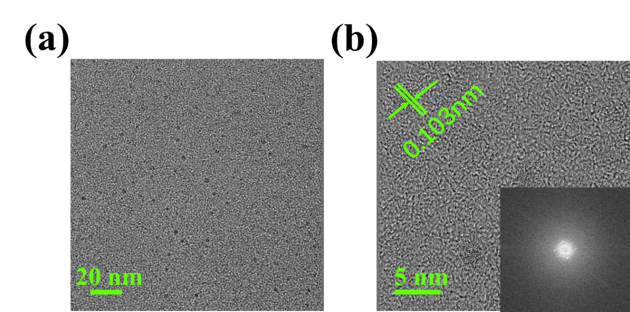
Fig. S1. The TEM images and corresponding lateral size distributions of CQDs (inset: fast Fourier transform patterns)
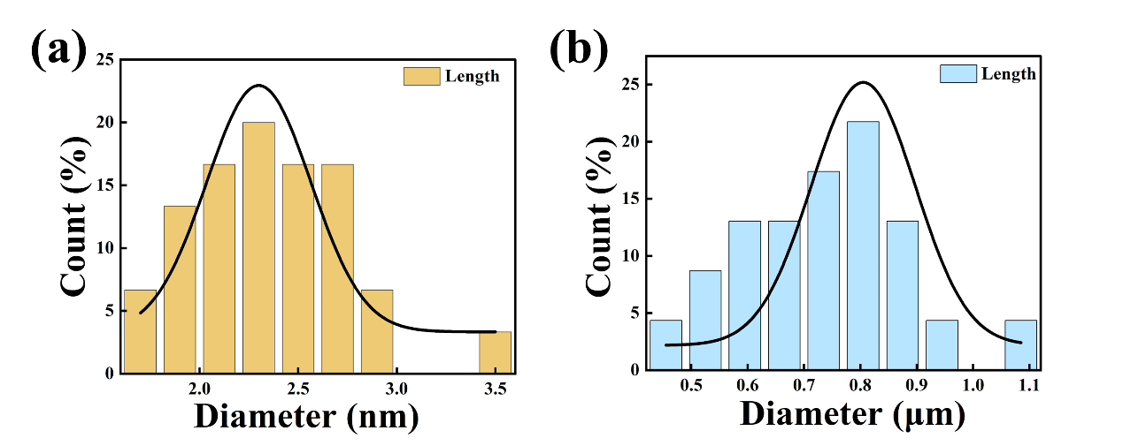
Fig. S2. Size distribution histograms of (a) CQDs and (b) Uio-66-NH₂@CQDs obtained from TEM images

Experimental Section
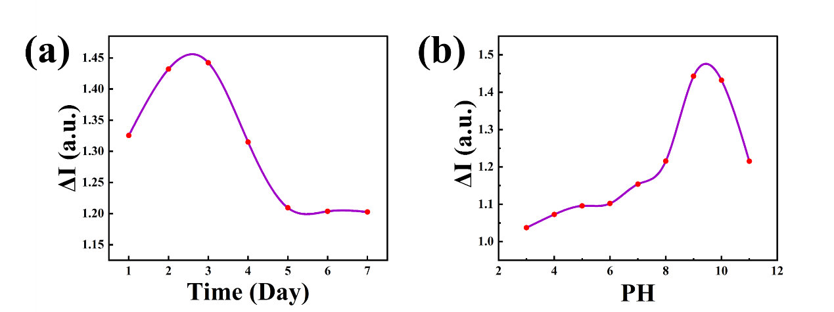
Fig. S3. Effect of (a) time on the response of Uio-66-NH₂@CQDs, (b) pH changing (ΔI= I₄₃₀/I₅₅₀)
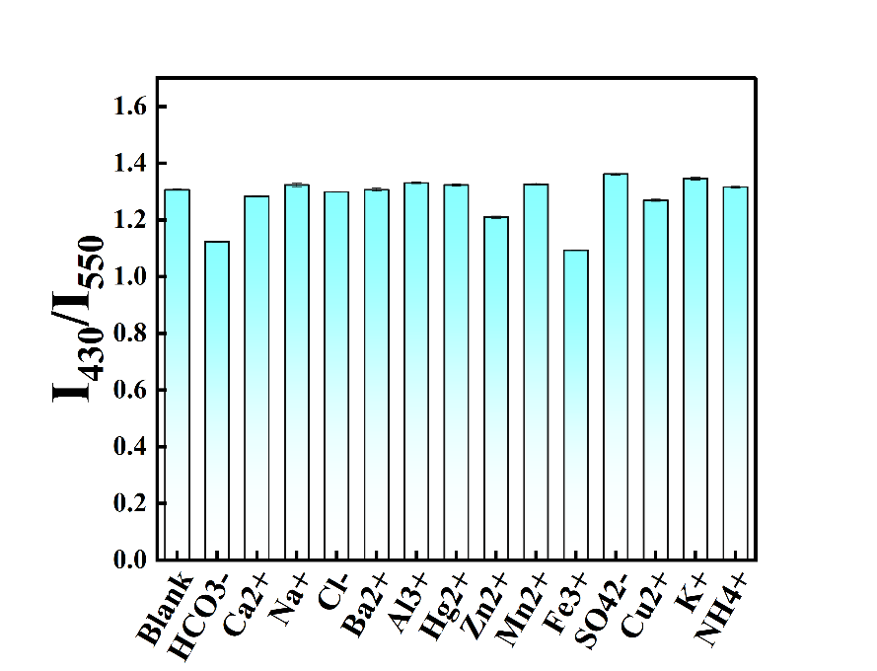
Fig. S4. Suspension-state photoluminescence spectra of Uio-66-NH₂@CQDs in the presence of common ions and anions.
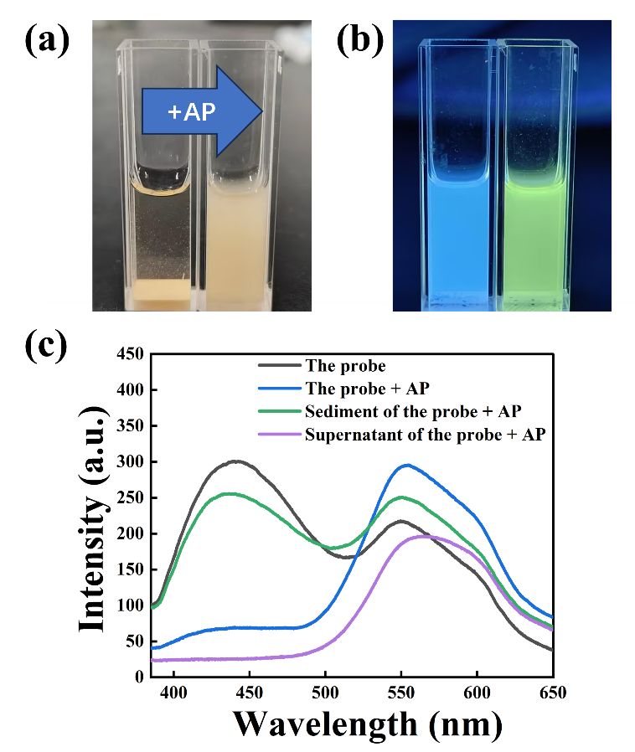
Fig. S5. Photos of Uio-66-NH₂@CQDs under ambient light (a) and ultraviolet light (365 nm) (b) in the absence and presence of AP; (c) Fluorescence photographs of the probe and the sediment and supernatant after the addition of AP.
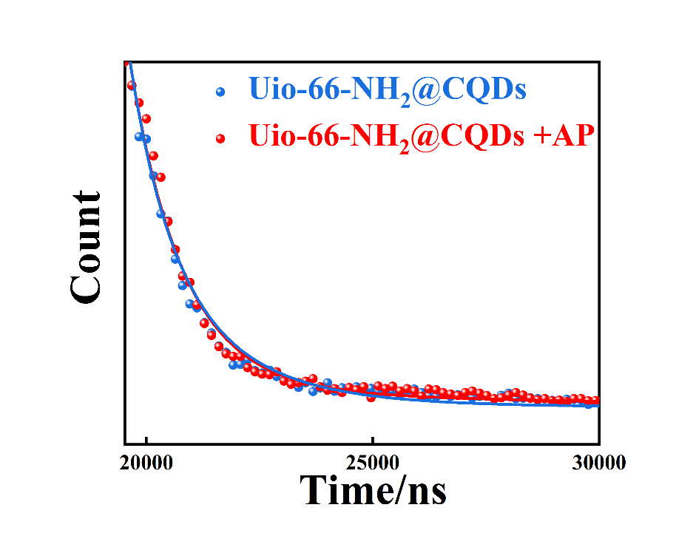
Fig. S6. Fluorescence lifetime of Uio-66-NH₂@CQDs (⟨τ⟩=1635 ns) and Uio-66-NH₂@CQDs+AP (⟨τ⟩=1622 ns) at 550 nm.
References
- Wang L, Li WT, Yin LQ, Liu YJ, Guo HZ, Lai JW, Han Y, Li G, Li M, Wu MH (2020) Full-color fluorescent carbon quantum dots. Sci Adv 6:40
- Lee DT, Zhao JJ, Oldham CJ, Peterson GW, Parsons GN (2017) UiO-66-NH₂ metal-organic framework (MOF) nucleation on TiO₂, ZnO, and Al₂O₃ atomic layer deposition-treated polymer fibers: role of metal oxide on MOF growth and catalytic hydrolysis of chemical warfare agent simulants. ACS Appl Mater Interfaces 9:44847–44855
- Cavka JH, Jakobsen S, Olsbye U, Guillou N, Lamberti C, Bordiga S, Lillerud KP (2008) A new zirconium inorganic building brick forming metal organic frameworks with exceptional stability. J Am Chem Soc 130:13850–13851

