Identification of the gut commensal Candida parapsilosis as a causative fungus for the development of high fat-diet induced obesity in mice
Shanshan Sun^{1, 2, 3, #}, Li Sun^{1,4, #}, Kai Wang^{1, #}, Shanshan Qiao^{1,4}, Xinyue Zhao⁵, Xiaomin Hu⁶, Wei Chen⁷, Shuyang Zhang⁵, Hantian Li¹, Huanqin Dai^{1,4*}, Hongwei Liu^{1,4*}
1 State Key Laboratory of Mycology, Institute of Microbiology, Chinese Academy of Sciences, Beijing 100101, China
2 School of Life Sciences, University of Science and Technology of China, Hefei, China
3 The Second Hospital of Anhui Medical University, Hefei, China
4 University of Chinese Academy of Sciences, Beijing, 100049, China
5 Department of Cardiology, Peking Union Medical College Hospital, Chinese Academy of Medical Science & Peking Union Medical College, Beijing, 100730, China
6 Department of Medical Research Center, State Key Laboratory of Complex Severe and Rare Diseases, Peking Union Medical College Hospital, Chinese Academy of Medical Science & Peking Union Medical College, Beijing, 100730, China
7 Department of Clinical Nutrition, Dept. of Health Medicine, Peking Union Medical College Hospital, Chinese Academy of Medical Sciences and Peking Union Medical College, Beijing, China
* Corresponding Author Tel: +86 10 64806074; E-mail: liuhw@im.ac.cn (H-W, Liu) or daihq@im.ac.cn (Huanqin Dai)
# SS Sun, L Sun and K Wang contributed equally to this work.

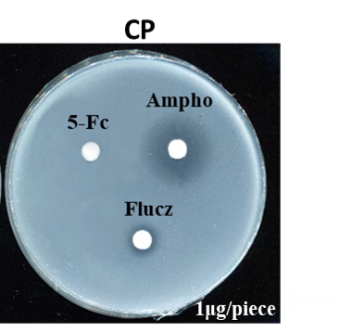
Supplementary Figure 1. Antifungal effect of amphotericin B, fluconazole, and 5-fluorocytosine on C. parapsilosis. The C. parapsilosis was cultured on PDA along with 1 μg of amphotericin B, fluconazole, and 5-fluorocytosine in each paper disc.

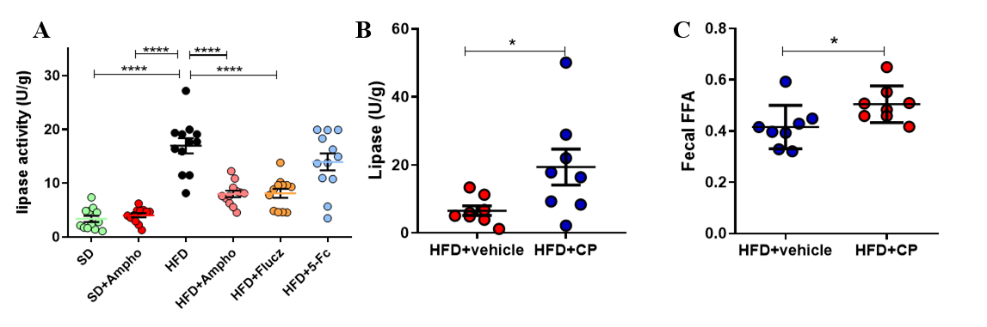
Supplementary Figure 2. The levels of lipase activity, FFA under the antifungal treatment and the oral treatment with C. parapsilosis. (A) Fecal lipase activity after antifungal treatment; (B) Fecal lipase activity after intragastric administration of C. parapsilosis; (C) Fecal FFA after intragastric administration of C. parapsilosis. SD, stand diet fed mice group; SD+Ampho, stand diet fed mice treated with amphotericin B; HFD, high-fat diet fed mice group; HFD+Ampho, high-fat diet fed mice treated with amphotericin B; HFD+Flucz, high-fat diet fed mice treated with fluconazole; HFD+5-Fc, high-fat diet fed mice treated with 5-fluorocytosine. HFD+vehicle, high-fat diet fed and fungi-free mice treated with PBS; HFD+CP, high-fat diet fed and fungi-free mice treated with the live C. parapsilosis. Data are presented as the mean ± SEM. N = 8 mice per group. Statistical analysis was performed using one-way ANOVA followed by the Tukey post hoc test for (A-C). *p < 0.05; **p < 0.01; ***p < 0.001.

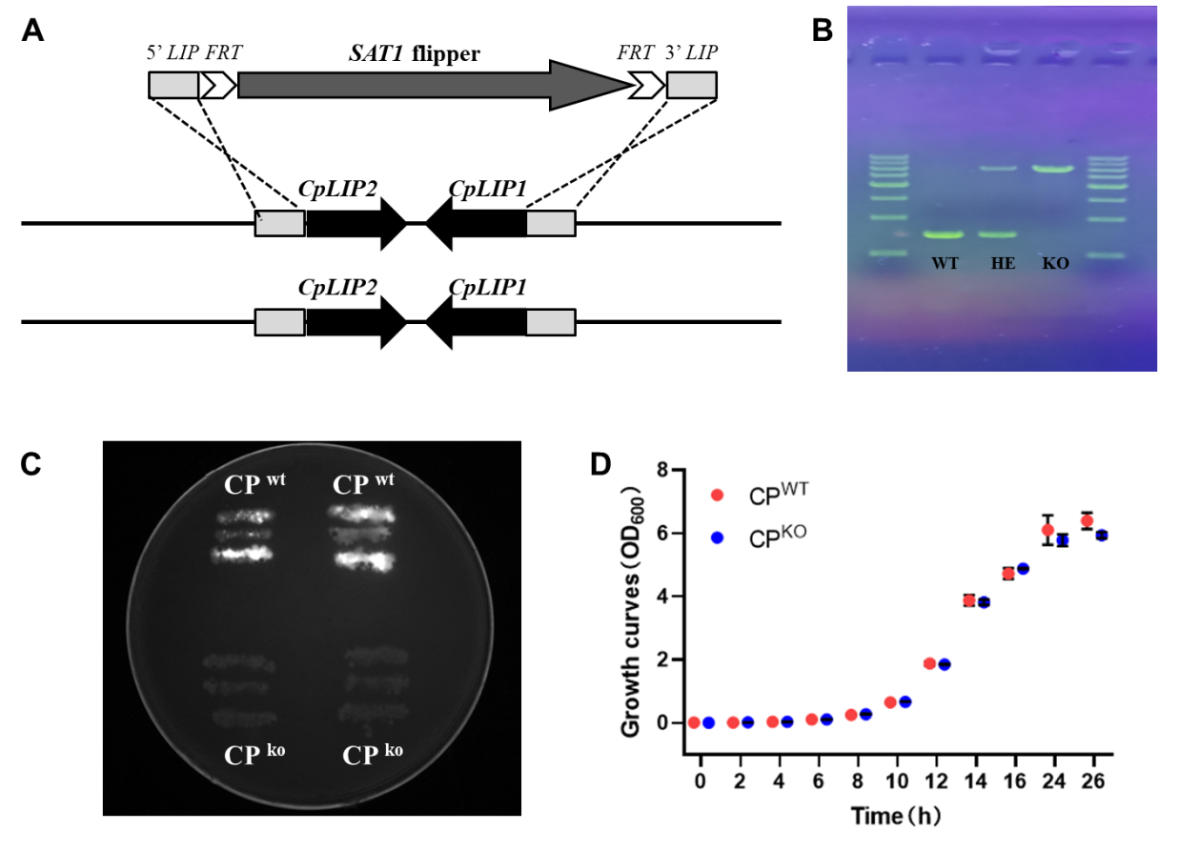 Supplementary Figure 3. Construction of lipase mutant strain of C. parapsilosis. (A, B) Design of gene targeting for the C. parapsilosis lipase locus showing the SAT1 flipper cassette with the homologous C. parapsilosis lipase fragments 5′ LIP and 3′ LIP as well as the FLP recombination target sequences (FRT). (C) Lipolytic activity of C. parapsilosis (CP^{WT}) and lipase mutants (CP^{KO}); (D) Growth curves of C. parapsilosis (CP^{WT}) and lipase-negative mutant strain of C. parapsilosis (CP^{KO}) in YPD media. Statistical analysis was performed using two-way ANOVA followed by the Bonferroni post hoc test for (D).

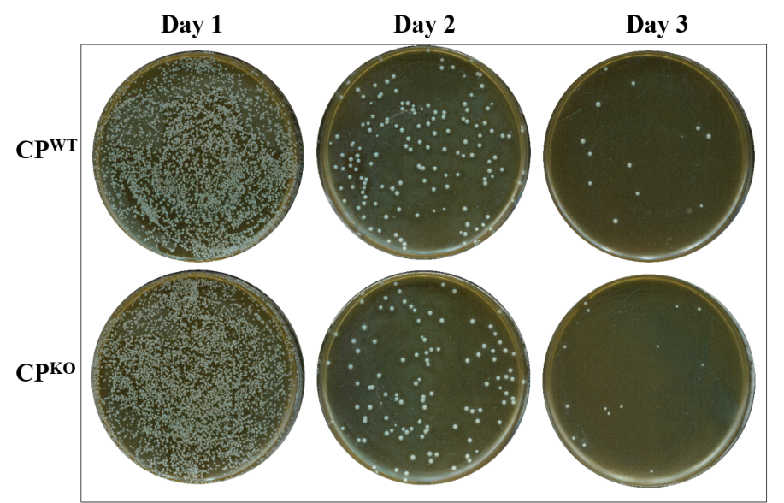
Supplementary Figure 4. Colonization of the wild type strain (CP^{WT}) and the lipase-negative mutant strain of C. parapsilosis (CP^{KO}) in the colon of HFD-fed mice. Feces were obtained and cultured on days 1–3 after oral administration of the wild type strain and the lipase-negative mutant strain of C. parapsilosis in the amphotericin B-pretreated HFD-fed mice, respectively.

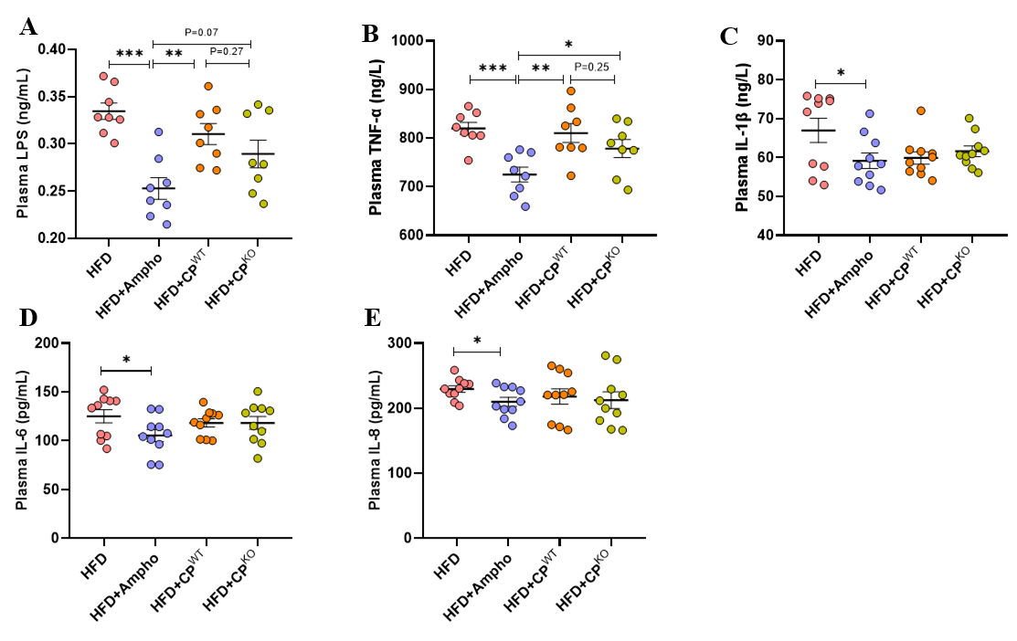Supplementary Figure 5. Effects of the wild type strain and the lipase mutant strain of C. parapsilosis on inflammation in HFD-induced obese mice. The HFD-fed mice were pretreated by addition of AmpB in the drinking water for two weeks, and then orally given with the live C. parapsilosis (CP^{WT}) or the lipase-negative mutant strain of C. parapsilosis (CP^{KO}) for 7 weeks. (A) plasma LPS; (B) plasma TNF-α; (C) plasma IL-1β; (D) plasma IL-6; (E) plasma IL-8; (F) relative mRNA expression of CD36 in liver. DIO, high-fat diet fed mice; HFD+Ampho, high-fat diet fed mice treated with amphotericin B; HFD+CP^{WT}, high-fat diet fed and fungi-free mice treated with live C. parapsilosis; HFD+CP^{KO}, high-fat diet fed and fungi-free mice treated with the lipase-negative mutant strain of C. parapsilosis. Data are presented as the mean ± SEM. N = 7-10 mice per group. Statistical analysis was performed using one-way ANOVA followed by the Tukey post hoc test (A-E). *p < 0.05; **p < 0.01; ***p < 0.001.

Supplementary Table S1. Minimum inhibitory concentration (MIC₈₀) values ([μg/mL]) of amphotericin B and fluconazole on C. parapsilosis.
Drug | CP
amphotericin B | 6.25±0.25
fluconazole | 12.5±0.55

Supplementary Table 2. Main characteristics of the samples used in this study.
Sample name | Collection date | Clinical status | Age | Sex | BMI
health 1 | 2021 | Health | 32 | Male | 21.4
health 2 | 2021 | Health | 35 | Male | 23.8
health 3 | 2021 | Health | 57 | Male | 21.1
health 4 | 2021 | Health | 33 | Female | 20.9
health 5 | 2021 | Health | 33 | Female | 23.4
health 6 | 2021 | Health | 35 | Female | 21.8
health 7 | 2021 | Health | 36 | Male | 21.7
health 8 | 2021 | Health | 42 | Male | 18.2
health 9 | 2021 | Health | 57 | Male | 24
obesity 1 | 2021 | Obesity | 38 | Male | 39.2
obesity 2 | 2021 | Obesity | 20 | Male | 41.9
obesity 3 | 2021 | Obesity | 45 | Male | 34.6
obesity 4 | 2021 | Obesity | 29 | Male | 63.1
obesity 5 | 2021 | Obesity | 30 | Male | 35.5
obesity 6 | 2021 | Obesity | 35 | Female | 33
obesity 7 | 2021 | Obesity | 34 | Female | 31.1
obesity 8 | 2021 | Obesity | 28 | Female | 30.4

Supplementary Table 3. Primer sequences used for the quantitative PCR.
Primer Name | Sequence (5' to 3')
Gapdh-F | AGGTCGGTGTGAACGGATTTG
Gapdh-R | TGTAGACCATGTAGTTGAGGTCA
CD36-F  CD36-R | TCCTCTGACATTTGCAGGTCTATC  AAAGGCATTGGCTGGAAGAA
ITS1-F | TCCGTAGGTGAACCTGCGG
ITS4-R | TCCTCCGCTTATTGATATGC
Cpar-F | GATCAGACTTGGTATTTTGTATGTTACTCTC
Cpar-R | CAGAGCCACATTTCTTTGCAC

