Lethal temperature regimes of cabbage seeds and Xcc 1-1 in the water-soaking treatment
Our experiments include 1155 cabbage seeds with the water-soaking treatment, irradiated by different combinations of microwave power and irradiation time. According to the bacteria and germination status after irradiation, all data are divided into 4 groups:
1. Xcc (+), seed (+): Xcc 1-1 bacterial population is detectable, and cabbage seeds can germinate after irradiation. The microwave intensity of this group is lower than causing thermal damage to both bacteria and seeds.
2. Xcc (-), seed (+): Xcc 1-1 bacterial population is undetectable, but cabbage seeds can germinate after irradiation. This group represents the desired result of complete elimination of bacteria without influencing the seed germination.
3. Xcc (-), seed (-): Xcc 1-1 bacterial population is undetectable, and cabbage seeds fail to germinate after irradiation. The microwave intensity of this group is too high that neither bacterium or seed can survive the treatment.
4. Xcc (+), seed (-): Xcc 1-1 bacterial population is detectable, but the cabbage seed fails to germinate after irradiation. In all 1155 cases, only 4 cases belong in this group, likely due to individual variation among cabbage seeds. We have hence ignored this group in the following analysis.
Fig. 6 shows the seed surface temperature after treatment of each group [not including Xcc (+), seed (-) group] as a function of irradiation time. To better describe the temperature regimes, data of the Xcc (+), seed (+) group and the Xcc (-), seed (-) group are averaged with error bars and added with a trendline, while the Xcc (-), seed (+) group are showed as red points. Most data points of Xcc (-), seed (+) are between these two trendlines, meaning that in water-soaking treatment, seeds can tolerate higher temperature than bacteria.

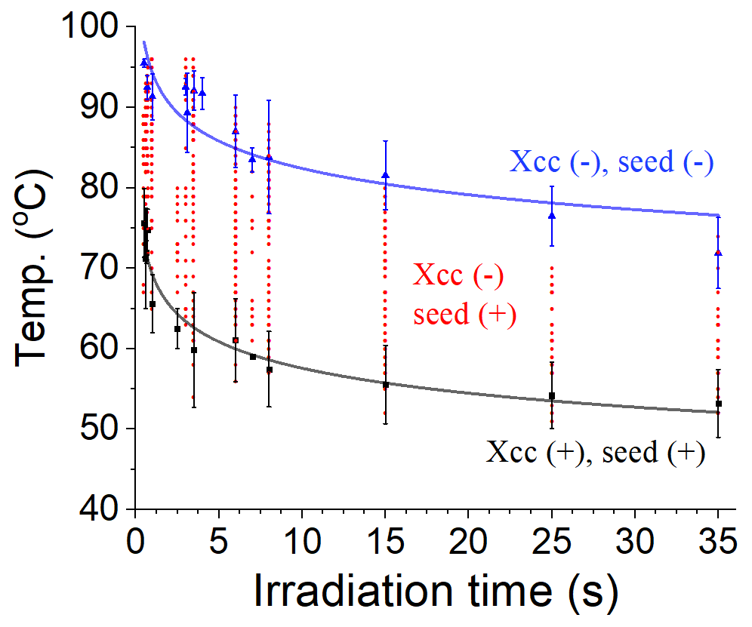

Fig. 6. Status of artificially inoculated cabbage seeds and Xcc 1-1 in water-soaking treatment, irradiated by 24-GHz microwave with different combinations of power and irradiation time. With same irradiation time, results can be classified into three lethal temperature regimes: both seeds and bacteria undamaged, only bacteria eliminated, and then all eliminated.

Raw data of the main experiments
In the previous section, Fig. 6 shows the lethal temperature regime of bacteria and seeds with same irradiation time, but lacks of the corresponding microwave power. As a result, in our manuscript, all treated seeds are grouped by microwave dose instead (see section 3.2). The proportion of the Xcc (-), seed (+) and Xcc (-), seed (-) groups relative to all data represents the mortality rate of bacteria, while the proportion of the Xcc (+), seed (+) and Xcc (-), seed (+) represents the germination rate of seed.
Here are the data compilation of Fig. 3 and raw data for individual experiments of each microwave dose group.

1. Microwave dose = 38±5 J/cm²
Data compilation for Fig. 3
Radiation  time (s) | Avg. Dose  (J/cm²) | Replicate | Ave. T  (℃) | Standard  Deviation of T | Mortality rate  of bacteria (%) | Germination rate  of seed (%)
0.4 | 33.2 | 12 | 81.2 | 3.5 | 83.3 | 100.0
0.5 | 36.0 | 23 | 78.3 | 4.6 | 73.9 | 100.0
0.6 | 35.0 | 30 | 76.6 | 3.2 | 73.3 | 100.0
0.7 | 35.2 | 14 | 72.6 | 3.9 | 71.4 | 100.0
0.8 | 36.4 | 10 | 70.6 | 2.2 | 60.0 | 100.0
1.0 | 33.1 | 39 | 67.5 | 3.9 | 53.8 | 100.0
2.5 | 35.1 | 10 | 63.2 | 2.6 | 40.0 | 100.0
3.5 | 35.7 | 26 | 58.4 | 4.4 | 38.5 | 92.3
6.0 | 38.3 | 29 | 56.0 | 3.4 | 31.0 | 89.7
15.0 | 38.3 | 10 | 53.7 | 3.2 | 20.0 | 100.0

Raw data for individual experiments
Radiation  time (s) | Microwave  Power (W) | Seed temperature (℃) |  |  |  | Replicate
Radiation  time (s) | Microwave  Power (W) | Xcc+ / seed+ | Xcc- / seed+ | Xcc- / seed- | Xcc+ / seed- | Replicate
0.4 | 650 | 78, 85 | 74, 77, 79, 81, 81, 82, 82, 83, 85, 87 |  |  | 12
0.5 | 500 |  | 67 |  |  | 1
0.5 | 550 | 67, 72, 76, 79 | 73, 73, 75, 76, 80, 89 |  |  | 10
0.5 | 580 | 78, 82 | 68, 75, 79, 79, 83, 84, 86, 88 |  |  | 10
0.5 | 600 |  | 84, 88 |  |  | 2
0.6 | 380 | 64, 65, 66 | 67, 67 |  |  | 5
0.6 | 400 | 70 | 71, 72, 73, 74 |  |  | 5
0.6 | 480 | 72, 72 | 75, 75, 79, 82, 83, 85, 86, 88 |  |  | 10
0.6 | 500 | 77, 79 | 74, 76, 78, 79, 82, 88, 88, 90 |  |  | 10
0.7 | 380 | 66, 68, 71, 74 |  |  |  | 4
0.7 | 400 |  | 69, 70, 71, 72, 72, 73, 75, 77, 79, 80 |  |  | 10
0.8 | 380 | 67, 69, 70, 72 | 68, 70, 71, 71, 73, 75 |  |  | 10
1.0 | 250 | 59, 61, 61, 62, 63, 64, 64, 65, 65, 65, 65, 67 | 62, 63, 64, 65, 65, 66, 67, 67 |  |  | 20
1.0 | 270 | 63, 65, 66, 68, 68, 72 | 65, 66, 67, 67, 70, 70, 70, 72, 72, 77, 83, 85, 85 |  |  | 19
2.5 | 110 | 60, 61, 61, 62, 63, 65 | 62, 63, 66, 69 |  |  | 10
3.5 | 80 | 49, 52, 53, 54, 54, 55, 56, 56, 57, 57, 58, 58, 60, 61, 61, 62 | 57, 57, 59, 60, 61, 61, 62, 63 | 67, 69 |  | 26
6 | 50 | 50, 50, 51, 52, 52, 55, 55, 56, 56, 57, 57, 57, 57, 57, 57, 58, 58, 58, 58, 59 | 51, 52, 53, 56, 59, 60 | 58, 61, 64 |  | 29
15 | 20 | 49, 51, 52, 52, 53, 53, 54, 57 | 55, 61 |  |  | 10

2. Microwave dose = 48±5 J/cm²
Data compilation for Fig. 3
Radiation  time (s) | Avg. Dose  (J/cm²) | Replicate | Ave. T  (℃) | Standard  deviation | Mortality rate  of bacteria (%) | Germination rate  of seed (%)
0.6 | 49.7 | 10 | 88.8 | 2.9 | 100.0 | 100.0
1.0 | 45.9 | 50 | 85.7 | 2.9 | 100.0 | 100.0
3.1 | 49.4 | 10 | 78.9 | 3.1 | 100.0 | 90.0
3.5 | 49.3 | 50 | 72.2 | 5.7 | 88.0 | 100.0
6.0 | 49.5 | 60 | 70.0 | 3.3 | 85.0 | 98.3
7.0 | 49.1 | 10 | 66.2 | 2.8 | 80.0 | 100.0
8.0 | 50.5 | 38 | 64.7 | 3.8 | 71.0 | 100.0
15.0 | 46.9 | 20 | 59.0 | 2.2 | 60.0 | 100.0
25.0 | 47.8 | 18 | 51.9 | 1.5 | 27.8 | 100.0

Raw data for individual experiments
Radiation  time (s) | Microwave  Power (W) | Seed temperature (℃) |  |  |  | Replicate
Radiation  time (s) | Microwave  Power (W) | Xcc+ / seed+ | Xcc- / seed+ | Xcc- / seed- | Xcc+ / seed- | Replicate
0.6 | 650 |  | 83, 86, 87, 87, 89, 90, 90, 91, 92, 93 |  |  | 10
1.0 | 350 |  | 75, 76, 76, 76, 79, 79, 80, 80, 80, 81, 82, 83, 84, 84, 86, 86, 87, 88, 88, 89 |  |  | 20
1.0 | 360 |  | 84, 85, 86, 86, 86, 86, 86, 87, 87, 88, 88, 88, 88, 88, 90, 90, 91, 91, 93, 93 |  |  | 20
1.0 | 380 |  | 85, 87, 88, 88, 88, 89, 89, 90, 91, 91 |  |  | 10
3.1 | 125 |  | 74, 76, 76, 78, 79, 79, 79, 80, 85 | 83 |  | 10
3.5 | 100 | 60, 64, 67 | 58, 61,61, 61, 61, 62, 64, 65, 65, 70, 74, 75, 75, 76, 78, 79, 79 |  |  | 20
3.5 | 110 | 67, 67 | 61, 63, 64, 64, 66, 67, 67, 71 |  |  | 10
3.5 | 120 | 74 | 69, 71, 73, 74, 74, 75, 75, 79, 79, 82, 82, 83, 83, 86, 86, 86, 88, 89, 89 |  |  | 20
6 | 60 | 63, 63, 67, 67, 67, 68, 73, 73 | 61, 63, 63, 64, 64, 64, 65, 66, 67, 67, 67, 68, 70, 70, 70, 71, 72, 73, 74, 74, 75, 75 |  |  | 30
6 | 68 |  | 65, 65, 67, 68, 70, 70, 70, 71, 74 | 69 |  | 10
6 | 70 | 70 | 63, 67, 69, 70, 71, 71, 72, 73, 74, 74, 75, 75, 76, 76, 76, 77, 80, 80, 80 |  |  | 20
7 | 55 | 63, 64 | 63, 63, 65, 67, 68, 69, 69, 71 |  |  | 10
8 | 49 | 57, 59, 60, 60, 61, 61, 62 | 59, 60, 60, 61, 61, 61, 63, 63, 65, 66, 69 |  |  | 18
8 | 50 | 61, 61, 63, 64 | 61, 61, 61, 63, 65, 67, 67, 70, 70, 70, 71, 73, 73, 74, 77, 80, |  |  | 20
15 | 24 | 56, 57, 57 | 57, 59, 59, 60, 61, 62, 63 |  |  | 10
15 | 25 | 55, 57, 58, 60, 65 | 55, 58, 59, 60, 61 |  |  | 10
25 | 15 | 49, 49, 50, 51, 51, 52, 52, 53, 53, 53, 54, 54, 54 | 51, 51, 52, 52, 53 |  |  | 18

3. Microwave dose = 58±5 J/cm²
Data compilation for Fig. 3
Radiation  time (s) | Avg. Dose  (J/cm²) | Replicate | Ave. T  (℃) | Standard  deviation | Mortality rate  of bacteria (%) | Germination rate  of seed (%)
0.7 | 58.0 | 10 | 93.9 | 1.6 | 100.0 | 90.0
0.8 | 61.8 | 14 | 92.6 | 1.0 | 100.0 | 100.0
3.5 | 60.2 | 31 | 86.7 | 2.6 | 100.0 | 96.8
6.0 | 61.2 | 20 | 81.2 | 4.3 | 100.0 | 100.0
7.0 | 60.7 | 9 | 76.2 | 2.7 | 100.0 | 88.9
8.0 | 61.2 | 20 | 72.3 | 3.7 | 100.0 | 100.0
15.0 | 57.7 | 21 | 66.2 | 2.6 | 85.7 | 100.0
25.0 | 61.6 | 30 | 59.8 | 2.4 | 80.0 | 100.0
35.0 | 58.0 | 10 | 50.4 | 1.2 | 10.0 | 100.0

Raw data for individual experiments
Radiation  time (s) | Microwave  Power (W) | Seed temperature (℃) |  |  |  | Replicate
Radiation  time (s) | Microwave  Power (W) | Xcc+ / seed+ | Xcc- / seed+ | Xcc- / seed- | Xcc+ / seed- | Replicate
0.7 | 650 |  | 91, 92, 93, 94, 94, 95, 95, 96, 96 | 93 |  | 10
0.8 | 600 |  | 90, 91, 92, 92, 92, 92, 92, 93, 93, 93 |  |  | 10
0.8 | 620 |  | 92, 95, 95, 95 |  |  | 4
3.5 | 125 |  | 76, 79, 80, 81, 81, 82, 83, 86, 88, 88 |  |  | 10
3.5 | 130 |  | 88 |  |  | 1
3.5 | 140 |  | 81, 86, 87, 88, 88, 88, 88, 88, 89, 89, 89, 89, 90, 90, 90, 91, 91, 91, 92 | 92 |  | 20
6 | 80 |  | 73, 74, 75, 77, 79, 79, 80, 80, 80, 81, 81, 82, 83, 83, 84, 85, 85, 86, 88, 89, |  |  | 20
7 | 68 |  | 73, 73, 73, 73, 74, 74, 75, 76, 76, 77, 78, 78, 79, 80, 81, 81 | 74, 76 |  | 18
8 | 60 |  | 64, 69, 69, 70, 70, 70, 70, 70, 70, 71, 71, 72, 74, 74, 75, 75, 77, 77, 78, 79, |  |  | 20
15 | 30 | 62, 65, 67 | 60, 62, 64, 64, 65, 65, 65, 66, 67, 67, 67, 67, 69, 70, 67, 71, 71 |  |  | 20
15 | 33 |  | 70 |  |  | 1
25 | 15 | 49, 49, 50, 51, 51, 52, 52, 53, 53, 53, 54, 54, 54, 54, 56 | 51, 51, 52, 52, 53 |  |  | 20
25 | 20 | 57, 59, 61, 67 | 57, 57, 57, 57, 58, 60, 61, 61, 61, 61, 61, 61, 62, 63, 63, 65 |  |  | 20
35 | 13 | 48, 48, 50, 50, 51, 51, 51, 51, 52 | 52 |  |  | 10

4. Microwave dose = 70±5 J/cm²
Data compilation for Fig. 3
Radiation  time (s) | Avg. Dose  (J/cm²) | Replicate | Ave. T  (℃) | Standard  deviation | Mortality rate  of bacteria (%) | Germination rate  of seed (%)
3.5 | 71.2 | 21 | 88.8 | 2.0 | 100.0 | 52.4
6.0 | 72.8 | 39 | 86.1 | 3.0 | 100.0 | 61.5
8.0 | 70.5 | 32 | 79.7 | 2.8 | 100.0 | 78.1
15.0 | 74.3 | 36 | 72.9 | 3.2 | 100.0 | 80.6
25.0 | 70.2 | 20 | 69.4 | 0.7 | 100.0 | 85.0
35.0 | 67.0 | 30 | 56.2 | 3.0 | 66.7 | 100.0

Raw data for individual experiments
Radiation  time (s) | Microwave  Power (W) | Seed temperature (℃) |  |  |  | Replicate
Radiation  time (s) | Microwave  Power (W) | Xcc+ / seed+ | Xcc- / seed+ | Xcc- / seed- | Xcc+ / seed- | Replicate
3.5 | 150 |  | 94 |  |  | 1
3.5 | 160 |  | 84, 86, 87, 87, 88, 88, 89, 89, 91, 92 | 85, 86, 88, 88, 89, 89, 90, 91, 91, 92 |  | 20
6 | 90 |  | 77, 80, 80, 81, 82. 82, 83, 83, 84, 86, 86, 86, 86, 86, 88, 88, 89, 90 | 88, 89 |  | 20
6 | 100 |  | 86, 86, 87, 88, 88, 89 | 86, 86, 87, 87, 87, 87, 87, 88, 88, 88, 89, 89, 90 |  | 19
8 | 65 |  | 76, 79 |  |  | 2
8 | 68 |  | 68, 75, 76, 78, 80, 81, 82, 83 | 80, 83 |  | 10
8 | 70 |  | 76, 77, 77, 77, 79, 79, 79, 80, 80, 81, 81, 81, 82, 83, 85 | 77, 81, 82, 85, 88 |  | 20
15 | 35 |  | 65, 70 |  |  | 2
15 | 37 |  | 67, 67, 67, 67, 69, 70, 71, 71, 71, 73 |  |  | 10
15 | 38 |  | 74 |  |  | 1
15 | 40 |  | 63, 71, 71, 71, 72, 72, 73, 75, 75, 75, 75, 76, 77, 78, 79, 79 | 70, 75, 76, 77, 79, 81, 83 |  | 23
25 | 22 |  | 68, 68, 69, 69, 69, 69, 69, 69, 69, 69, 69, 70, 70, 70, 70, 70, 70 | 70, 70, 71 |  | 20
35 | 15 | 51, 52, 52, 53, 53, 53, 56, 57, 58, 61 | 52, 52, 52, 54, 54, 55, 55, 55, 57, 57, 57, 57, 59, 59, 59, 60, 60, 61, 61, 63 |  |  | 30

5. Microwave dose = 92±5 J/cm²
Data compilation for Fig. 3
Radiation  time (s) | Avg. Dose  (J/cm²) | Replicate | Ave. T  (℃) | Standard  deviation | Mortality rate  of bacteria (%) | Germination rate  of seed (%)
3.0 | 96.6 | 20 | 92.9 | 1.0 | 100.0 | 10.0
3.5 | 96.0 | 32 | 90.4 | 1.4 | 100.0 | 18.7
15.0 | 95.1 | 29 | 82.1 | 2.2 | 100.0 | 27.6
25.0 | 95.7 | 20 | 74.0 | 3.0 | 100.0 | 35.0
35.0 | 89.3 | 20 | 63.8 | 5.2 | 90.0 | 100.0

Raw data for individual experiments
Radiation  time (s) | Microwave  Power (W) | Seed temperature (℃) |  |  |  | Replicate
Radiation  time (s) | Microwave  Power (W) | Xcc+ / seed+ | Xcc- / seed+ | Xcc- / seed- | Xcc+ / seed- | Replicate
3 | 250 |  | 93, 95 | 92, 92, 92, 93, 93, 94, 94, 95 |  | 10
3 | 255 |  |  | 91, 91, 92, 92, 93, 93, 93, 93, 93, 94 |  | 10
3.5 | 215 |  | 88, 89, 91, 91, 91, 92 | 87, 88, 88, 89, 89, 89, 89, 89, 90, 90, 90, 90, 90, 91, 91, 91, 91, 91, 91, 91, 92, 92, 92, 93, 93, 94 |  | 32
15 | 49 |  | 75, 76, 77, 79, 80, 80 | 80, 81, 81 |  | 9
15 | 50 |  | 74, 78 | 78, 80, 83, 83, 84, 84, 85, 85, 85, 85, 85, 85, 86, 86, 86, 86, 86, 87 |  | 20
25 | 30 |  | 65, 67, 67, 67, 70, 70, 72 | 70, 73, 75, 75, 77, 77, 77, 79, 79, 79, 79, 80, 81 |  | 20
35 | 20 | 53, 66 | 54, 57, 60, 61, 63, 63, 63, 63, 63, 63, 63, 64, 65, 67, 70, 72, 72, 74 |  |  | 20

