Compositional and Structural Reconstitution of Woody Biomass Framework via Dual-Functional Lignin Engineering Toward Efficient and Salt-Resistant Solar Desalination

Bin Wang ^{1,3}, Yanrong He ^{1,3}, Zhihao Yang ^{1,3}, Qian Sun ¹, Jiaming Wang ¹, Xipeng Zhang ¹, Xiaojun Shen ^{1,}*, Jia-Long Wen ¹, Chaoji Chen ^{2,}* Tong-Qi Yuan ^{1,}*

¹ State Key Laboratory of Efficient Production of Forest Resources, Beijing Key Laboratory of Lignocellulosic Chemistry, Beijing Forestry University, Beijing 100083, China
² Hubei Biomass-Resource Chemistry and Environmental Biotechnology Key Laboratory, School of Resource and Environmental Sciences, Wuhan University, Wuhan 430079, China
³ These authors contributed equally: Bin Wang, Zhihao Yang, and Yanrong He

E-mail: shenxiaojun@bjfu.edu.cn, chenchaojili@whu.edu.cn, and ytq581234@bjfu.edu.cn

The solar absorptivity
The solar absorptivity by the evaporator surface was calculated in equation (S1) as follows:
C_{opt} = (∫w1 w2 R*i dw)/ (∫w1 w2 i dw) (S1)
Where C_{opt} is the solar absorptivity, i is the intensity of solar radiation at the corresponding wavelength, w is the corresponding wavelength of solar light, and R is the solar absorptivity at the corresponding wavelength of the evaporator surface.

Sodium chlorite pretreatment
Preparation of acetic acid-sodium acetate buffer with pH 4.6 (AA buffer) was as follows: 40 g of sodium acetate trihydrate was added into 3 L of deionized water (DW) and stirred until completely dissolved, then 18.3 mL of acetic acid was added and stirred for 5 min. The balsa wood blocks were placed in an AA buffer, and the appropriate amount of sodium chlorite was added. Then, the reaction was carried out in a water bath at 80 ºC for 6 h, and the operation was repeated for a total of 36 h after the reaction was completed. The delignified balsa wood was soaked in DW until all impurities had been precipitated. The blocks were then freeze-dried to obtain a balsa woody biomass framework with the lignin completely removed (W-A).

Extract the native lignin from various woody biomass frameworks
The native lignin named double enzymatic lignin (DEL) was developed for isolating native lignin from different biomasses due to the ideal yields and unaltered structures¹. The isolation of DEL was performed according to our previous publications². In detail, ball-milled wood sample powders (Wood and W-150) were subjected to enzymatic hydrolysis in the acetate buffer (0.05 mol/L, 200 mL, pH 4.8), then cellulase (50 FPU/g) was added. The reaction mixtures were incubated in a rotary shaker (50 ºC, 150 rpm) for 48 h. The enzymatic residues were washed repeatedly with hot water to remove the hydrolyzed carbohydrates, centrifuged, and freeze-dried. The obtained solids underwent ball-milling for 2 h and then underwent the same enzymatic hydrolysis. After the purification and freeze-drying process, the DEL samples were achieved, labeled as L-Wood and L-W150.

Molecular Dynamics Simulation
The partial charge of Pure wood (MM1), experimental molecules (MM2), and logs (MM3) molecule was calculated using the Gaussian 16 code and the 6-311G (d, p) basis functions were applied³. The OPLS-AA force field⁴ and Auxiliary Tools of Force Field (AuToFF) were used to parametrize all atoms, such as the bond parameters, angle parameters and the dihedral angles, and so on.
The interaction between different molecules and water molecules was studied by molecular dynamics (MD) simulation. The MD simulations were performed in the GROMACS 2021 software package^{5,6,7}.

Fig. S1. Chemical composition of different wood substrates (w/w, %).
The chemical composition analysis of the wood samples was performed according to National Renewable Energy Laboratory (NREL) standard analytical procedures^{8,9}. In brief, the wood samples were first crushed into powder through a coffee machine. For chemical composition analysis, 0.3 g of powder was hydrolyzed with 3 ml of 72 % sulfuric acid at 30 ºC for 60 min, then diluted to 4 % sulfuric acid and hydrolyzed at 121 ºC for 60 min. Klason lignin and acid-soluble lignin were determined by gravimetric and absorbance methods, respectively. Sugar monomers of the samples were analyzed by high-performance anion-exchange chromatography (HPAEC).
As shown in Fig. S1, the contents of cellulose, hemicellulose and total lignin (KL and ASL) in raw wood were 49.37%, 19.15% and 25.77%, respectively. The contents of lignin and hemicellulose in the woody biomass framework decreased gradually with the increase in pretreatment temperature, indicating that the removal rates of lignin and hemicellulose were positively correlated with the pretreatment temperature. In addition, lignin and hemicellulose were almost completely removed from the wood W-A obtained by sodium chlorite pretreatment, and their contents were 5.06% and 2.67%, respectively.

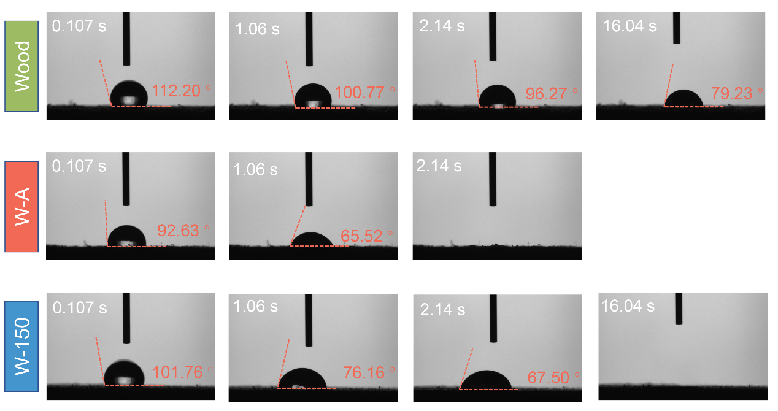
Fig. S2. Surface wettability of wood substrates with different lignin content.

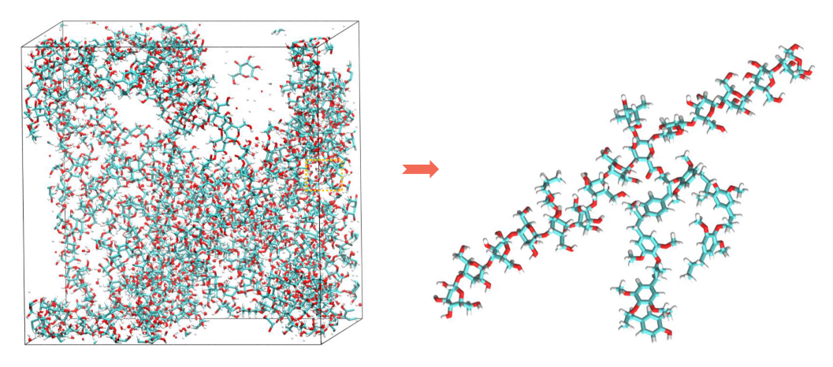
Fig. S3. The final state models of Wood through Visual Molecular Dynamics.

Fig. S4. The simulated variation trend of the overall cyclotron radius of macromolecules and water molecules in the system.
As shown in Fig. S4, the radius of gyration of the different systems decreases rapidly with increasing simulation time and then reaches a stable fluctuation state. Using the data from the final 1 ns of the simulation for statistical analysis, the overall radius of gyration for the Wood, W-A, and W-150 systems was calculated to be 3.02 nm, 2.75 nm, and 2.14 nm, respectively. The W-150 system exhibited the smallest radius of gyration, indicating the most compact molecular aggregation among the three systems.

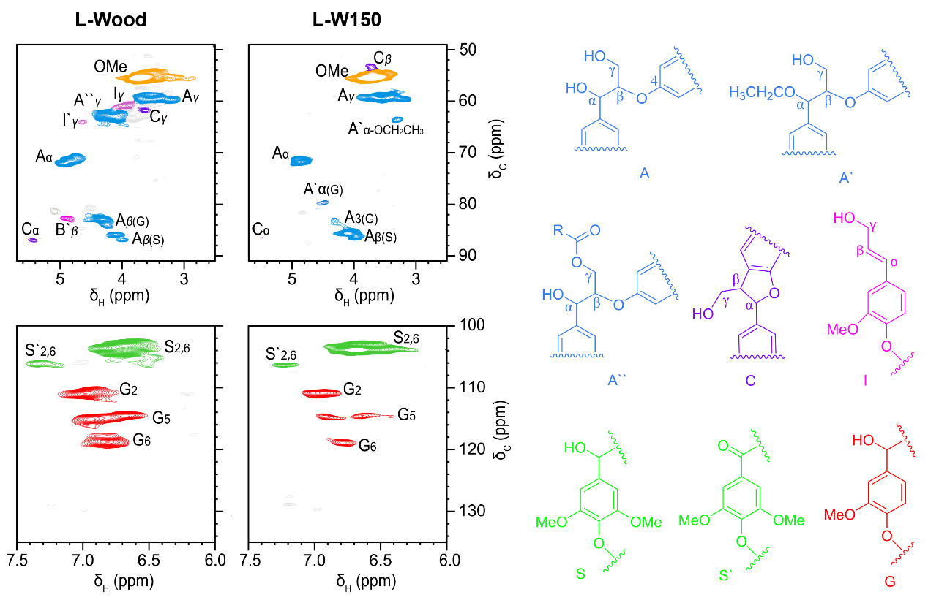
Fig. S5. Side-chain and aromatic regions in the 2D-HSQC NMR spectra of the lignins within Wood (L-Wood) and W-150 (L-W150).
The 2D-HSQC NMR technique was performed to characterize the lignin structure, and it can provide structural characteristics of lignin substructure and S/G ratio. A thorough investigation of the structural units and bonding links of lignin in various woody biomass frameworks will help us understand the form of water within them. Since the lignin in W-A is almost completely removed, no further discussion will be made. The side-chain and aromatic regions in the 2D-HSQC NMR spectra of the lignin fractions extracted from Wood (L-Wood) and W-150 (L-W150), as well as the main identified substructures, are displayed in Fig. S5. It could be observed that the protruding methoxyl groups (OMe), the noticeable aryl ethers (β-O-4, A) and visible phenylcoumarans (β-5, C) substructures in the side-chain (δ_{C}/δ_{H} 2.5–5.7/48–92) of the spectra, which were assigned according to previous publications^{10,11}. For the chemical composition of lignin fractions, syringyl (S) and guaiacyl (G) units primarily appeared in the aromatic area (δ_{C}/δ_{H} 5.7–8.0/100–135) in the 2D-HSQC spectra. In more detail, C_{2,6}-H_{2,6} correlations in S-type units and the C_{α}-oxidized S units (S′) were defined at δ_{C}/δ_{H} 103.8/6.68 and 106.3/7.21, respectively. Besides, there were three distinct cross-signals of G units: C₂–H₂ (δC/δH 110.9/6.95 ppm, G₂), C₅–H₅ (δ_{C}/δ_{H} 115.1/6.71 ppm, G₅), and C₆–H₆ (δ_{C}/δ_{H} 119.0/6.75 ppm, G₆).
Comparative analysis revealed a significant reduction in ether linkages (primarily β-O-4) in L-W150 relative to L-Wood (Table S2). This cleavage occurred during pretreatment, where Lewis acid catalysis under elevated temperature fragmented ether bonds within the native lignin of the woody biomass framework. This process facilitates matrix loosening and enhanced exposure of lignin structural units. Crucially, pretreatment enriched the proportion of syringyl (S) units in L-W150, elevating the S/G ratio from 2.31 to 5.05. Structurally, S units, bearing two methoxy groups and one phenolic hydroxyl on the aromatic ring, provide a greater density of hydrogen-bond acceptors (methoxy oxygen atoms) and donors (phenolic hydroxyl) than guaiacyl (G) units (single methoxy and phenolic hydroxyl groups). The balanced hydrophilicity of S-units enables efficient water adsorption without inducing excessive dissociation into tightly bound water¹². Furthermore, the symmetric distribution of the two methoxy groups in S-units creates a uniform polar microenvironment¹³. This configuration favors the entrapment of water molecules via a multi-site, weak-to-moderate hydrogen-bonding network, promoting the formation of stable intermediate water layers. Consequently, the substantially higher S/G ratio in L-W150 is anticipated to drive increased generation of intermediate water.

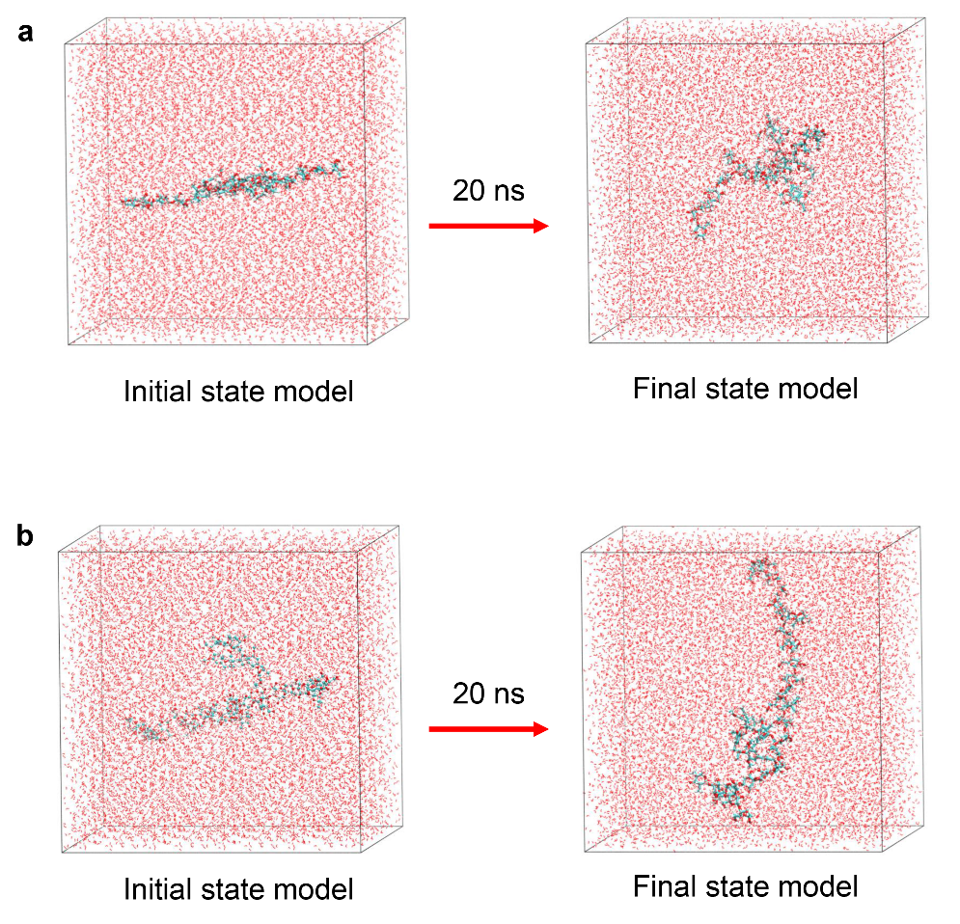
Fig. S6. Molecular dynamics simulation of water-macromolecules interactions.

Fig. S7. The percentages of various water states in the system obtained through molecular dynamics simulation calculation: bound water (CW), intermediate water (IW), and free water (FW).

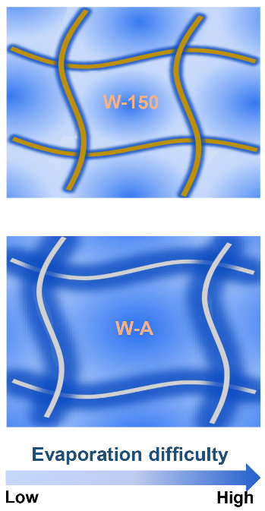
Fig. S8. Schematic diagram of water states in W-150 and W-A, and the positive correlation between fiber color depth and lignin content.

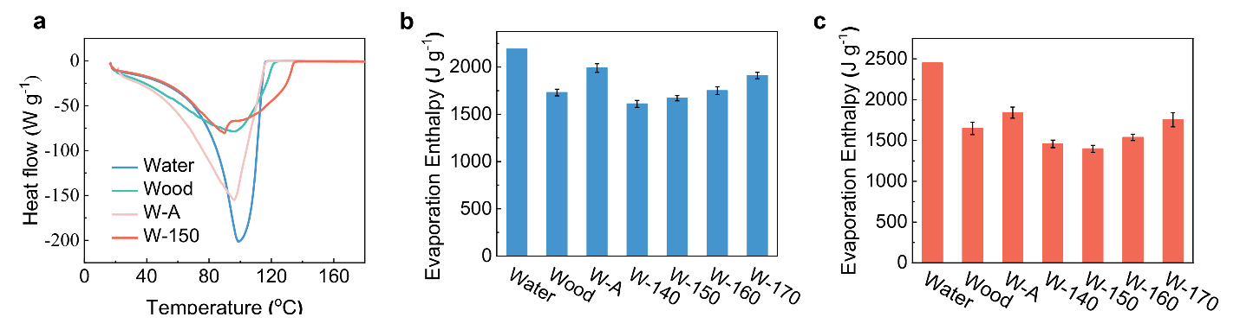
Fig. S9. a) DSC curves of water in different wood substrates; b) Evaporation enthalpy of water in different wood substrates measured by the DSC method; c) Evaporation enthalpy of water in different wood substrates measured by the dark evaporation experiment.

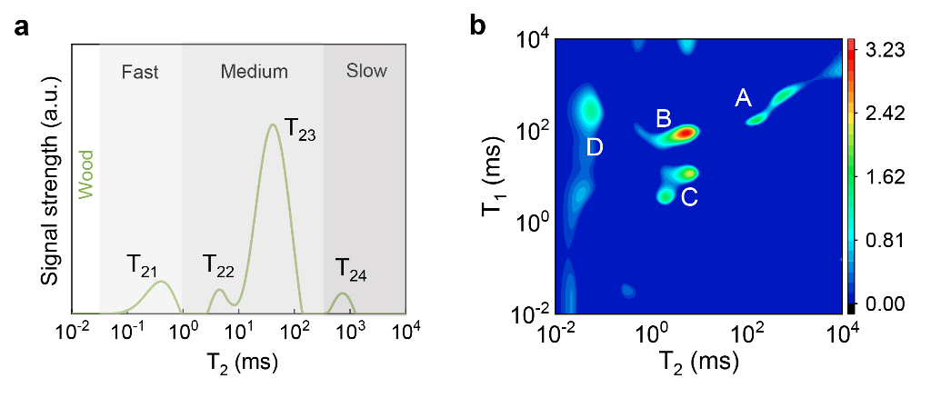
Fig. S10. a) T₂ distribution, and b) T₁-T₂ correlation spectra of Wood in the fiber saturated state.

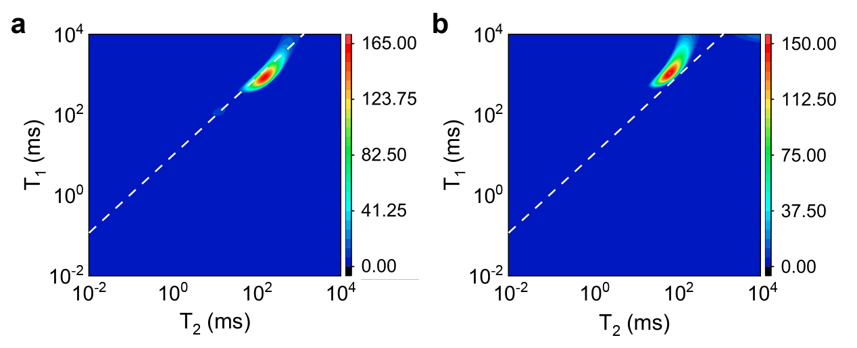
Fig. S11. T₁-T₂ correlation spectra of a) E-A, and b) E-150 in a water-filled state.

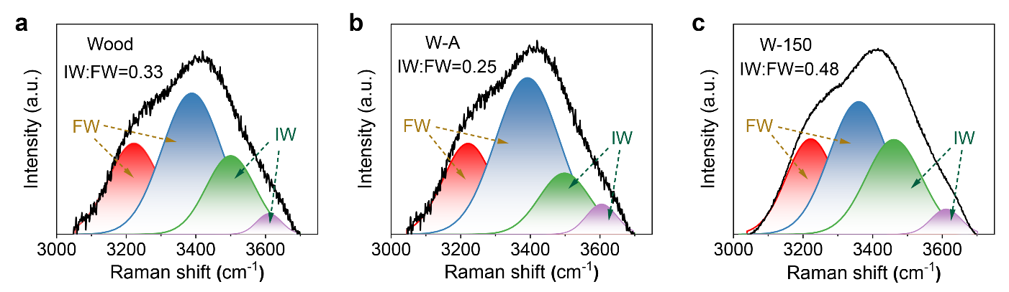
Fig. S12. Fitting curves based on the Gaussian function in the energy region of O-H stretching modes of water in the a) Wood, b) W-A, and c) W-150.
To prove the existence of different types of water molecules, Raman spectroscopy was fitted into four peaks by the Gaussian function, as shown in Fig. S12. These peaks are classified as two types of modes: (1) Water molecules with four hydrogen bonds, i.e., two protons and two electron pairs, are involved in hydrogen bonding (the peaks around 3233 and 3401 cm⁻¹); (2) weakly or non-hydrogen-bonded water molecules in which the hydrogen bonds of the water molecules have been broken, in part or entirely (the peaks around 3514 and 3630 cm⁻¹)¹⁴. Within the band corresponding to the four hydrogen-bonded molecules, the peak at 3233 cm⁻¹ is associated with the collective in-phase vibrations of all molecules in the aggregate, whereas the peak around 3401 cm⁻¹ is associated with a vibration, which is not in-phase between the first and higher shells of neighboring molecules (i.e., the out-of-phase mode of O-H stretching)¹⁵. The peaks at 3514 and 3630 cm⁻¹ correspond to the symmetric and asymmetric stretching of the weakly hydrogen-bonded H₂O molecules, respectively¹⁶. As shown in Fig. S12, the resulting ratio of intermediate water (IW) to free water (FW) was 0.33 for Wood, 0.25 for W-A and 0.48 for W-150, respectively. W-150 presented the largest ratio of intermediate water to free water due to the proper delignification, facilitating water evaporation.

Fig. S13. SEM images of W-150 at different scales.

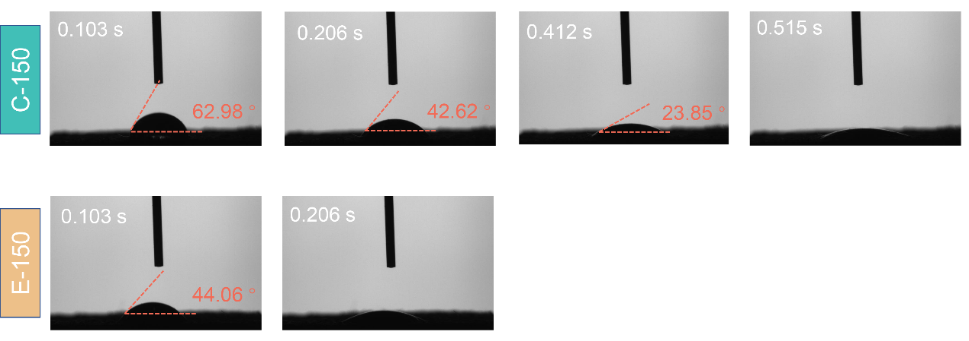
Fig. S14. Surface wettability of C-150 and E-150.
As shown in Fig. S14, compared with W-150, the contact angle of the C-150 surface decreased to 62.98° due to the introduction of hydrophilic sodium alginate. After laser etching, the surface hydrophilicity of the evaporator E-150 was further increased.

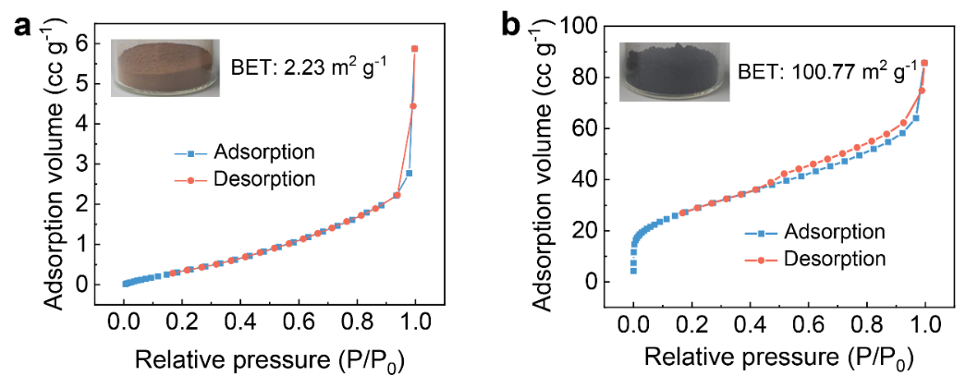
Fig. S15. N₂ adsorption and resolution curve of lignin before and after laser etching.

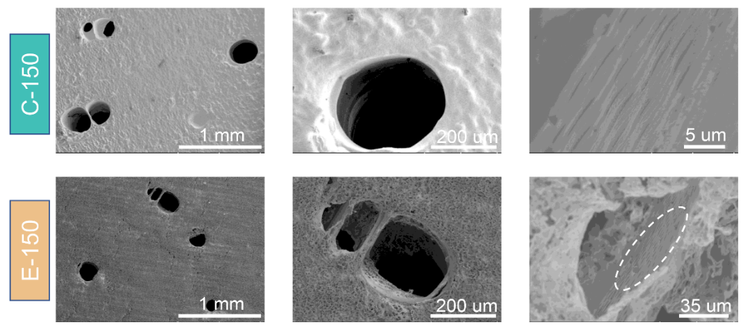
Fig. S16. SEM images of C-150 and E-150 at different scales.
As shown in Fig. S16, the surface of C-150 was sealed and smooth, while laser etching could carbonize the coating surface and form a porous structure. The carbonized layer obtained by laser etching technology showed a pleasing surface morphology (rich, multi-layered and ordered hierarchical pores), which not only helped to fully absorb sunlight, but also was expected to promote the formation of micro-droplets of the pumped water, thereby reducing the evaporation enthalpy and accelerating the evaporation rate. Moreover, regardless of the coating process or the laser etching process, the multistage channels and transversely shuttling ray cells in the wood substrate were retained, which would guarantee the anti-salt crystallization performance of E-150.

Fig. S17. SEM images of E-150 at different scales.

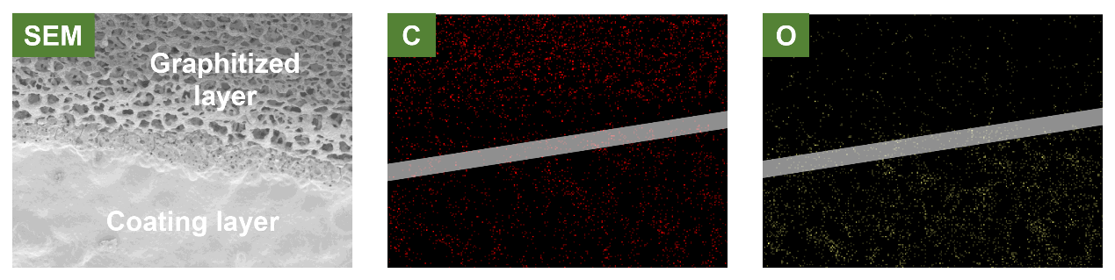
Fig. S18. Elemental mapping images on the surface of the evaporator before and after laser etching, as shown in the symmetry of the SEM image.
As shown in Fig. S18, the carbon element on the surface increased after laser etching, while the oxygen element significantly decreased, indicating that graphitization occurred during the laser etching process. The oxygen element was usually released as a gas.

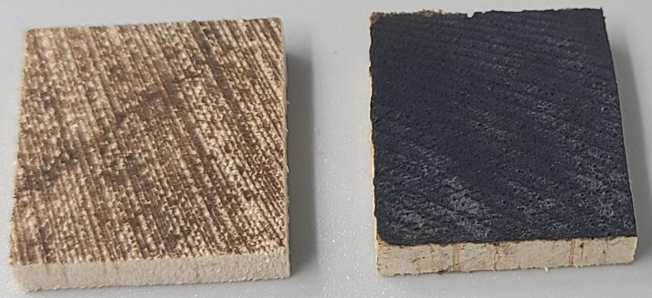
Fig. S19. Comparison images of carbonized untreated Balsa wood (left) and C-150 (E-150, right) at the same laser intensity of 45% (a peak laser power of 7.0 W).

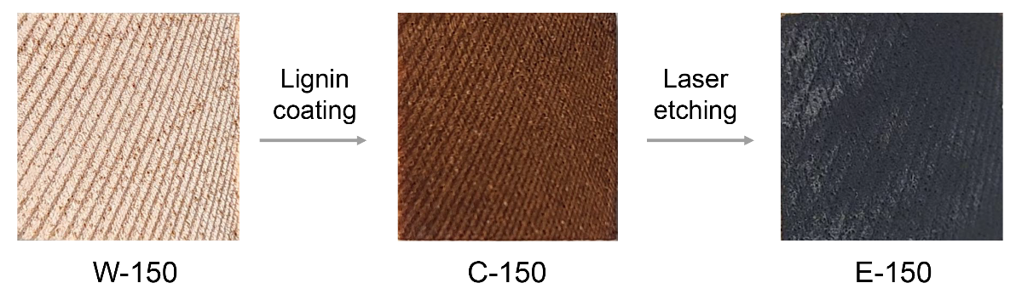
Fig. S20. Surface images of partially lignin-removed wood (W-150), lignin-coated W-150 (C-150), and laser-etched C-150 (E-150).

Fig. S21. The surface absorbance of different woody biomass-based solar evaporators was determined by using a UV–vis–IR spectrophotometer.

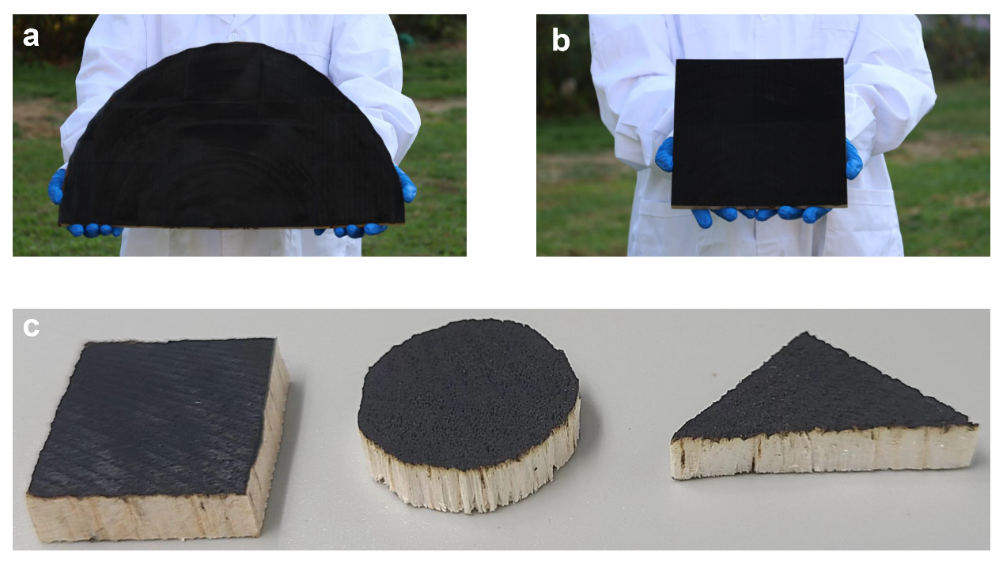
Fig. S22. Different scales (a and b), and different shapes (c) of laser etching woody biomass-based solar evaporators.

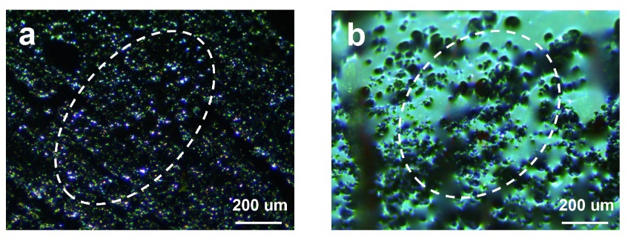
Fig. S23. Microscope image of the wood substrate with water.

Fig. S24. Evaporation rate curves of woody biomass-based solar evaporators with different lignin content under one solar irradiation.

Fig. S25. Raman spectra of E-150 photothermal conversion layer at 50% laser power.

Fig. S26. Evaporation rate curves of E-150 in brines with different salinities under one solar radiation.

Fig. S27. The ability of E-150 to eliminate salt crystallization under dark conditions. (In simulated salt water with a salinity of 20%, salt crystals appeared after 12 hours of sunlight exposure, and the salt crystals were automatically eliminated under simulated night conditions)

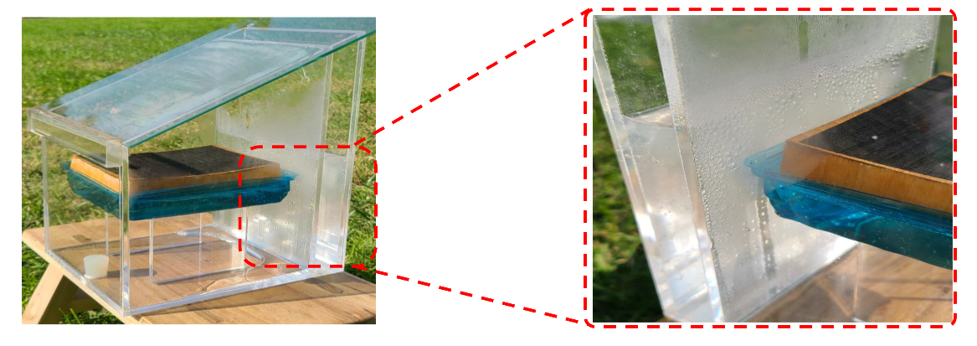
Fig. S28. Images of the E-150 outdoor solar evaporation test and evaporation water condensation location.

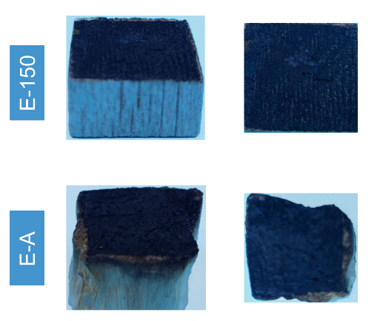
Fig. S29. Images of the E-A and E-150 before and after recycling.

Fig. S30. Compression properties of Wood, W-A, and W-150.

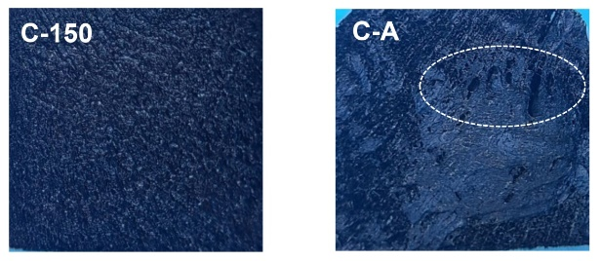
Fig. S31. Surface coating picture of C-A and C-150.

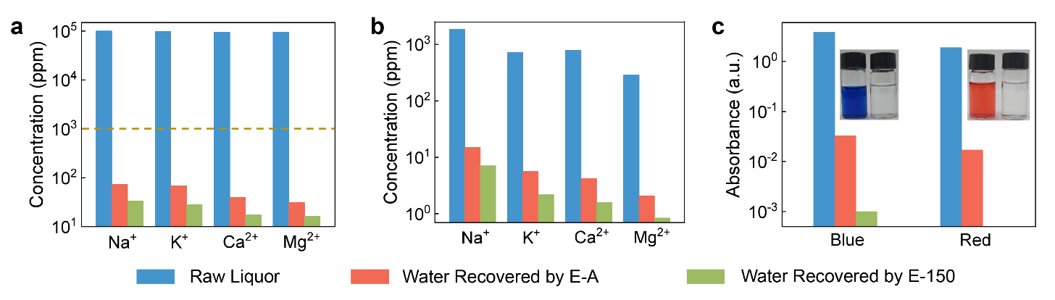
Fig. S32: a The concentrations of K⁺, Ca²⁺, Na⁺ and Mg²⁺ in raw simulated brine (blue column) and water extracted by E-A (red column) and E-150 (green column). b The concentrations of K⁺, Ca²⁺, Na⁺ and Mg²⁺ in raw actual seawater (blue column) and water extracted by E-A (red column) and E-150 (green column). c The concentrations of methylene blue and reactive red 80 in raw dye wastewater (blue column) and water extracted by E-A (red column) and E-150 (green column). Illustration of dye effluent stock and water collected from the evaporative condensation process.
The purification performance of the evaporator is also important for its practical application. As shown in Fig. S32a, solutions containing K⁺, Ca²⁺, Na⁺ and Mg²⁺, as well as the ion concentrations of the collected condensed water, were detected. The results showed that the ion concentrations in the condensed water obtained by E-150 and E-A were less than 100 ppm. The interception rates exceeded 99.93%, meeting the drinking water requirements. Notably, the purification performance of E-150 was better than that of E-A, and the evaporation experiment on actual seawater was consistent with this conclusion (Fig. S32b). This was mainly attributed to the fact that E-150 contained more intermediate water with weak or no hydrogen bonding properties, and the binding energy between intermediate water and metal ions was smaller, so fewer metal ions were carried during the evaporation process. In addition, for the methylene blue solution, the removal rates of E-A and E-150 were 99.13% and 99.97%, respectively, while for the direct red 80 solutions, the removal rates of E-A and E-150 were 99.10% and 100%, respectively (Fig. S32c), once again demonstrating the superior purification capacity of E-150. These results verified that the appropriate lignin content in the woody biomass framework could not only enhance the evaporation performance but also improve the purification capacity of the evaporator.
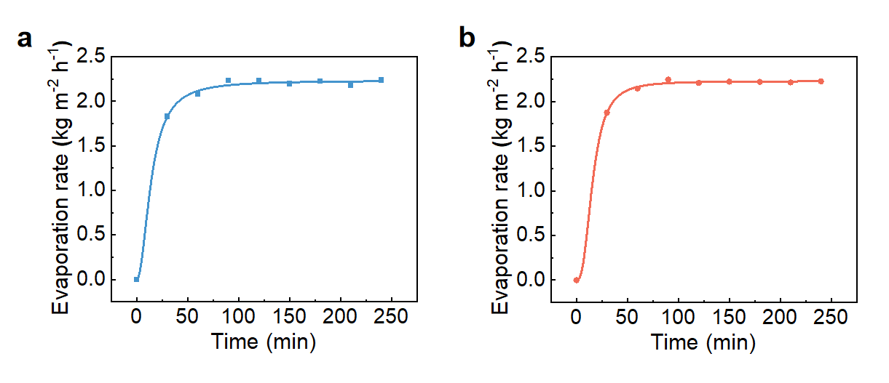
Fig. S33. Evaporation rate curves of E-150 in (a) Methylene Blue wastewater, and (b) Direct Red wastewater.

Table S1 Chemical compositions of substrates after different pretreatment conditions (%).
Samples | Hemicelluloses | Cellulose | Lignin
Wood | 19.15±0.4 | 49.37±0.8 | 25.77±0.5
W-140 | 13.45±0.6 | 59.87±0.3 | 20.12±0.5
W-150 | 10.81±0.3 | 68.04±0.5 | 16.70±0.4
W-160 | 6.57±0.6 | 72.63±0.8 | 12.71±0.3
W-170 | 4.36±1.1 | 76.87±0.9 | 10.19±0.3
W-A | 5.06±0.5 | 85.74±1.0 | 2.67±0.1

Table S2 Quantification of lignin fractions by quantitative 2D-HSQC NMR method.
Samples | β-O-4 ª | S units | G units | S/G ^{b}
L-Wood | 62.68 | 69.83 | 30.17 | 2.31
L-W150 | 51.54 | 83.46 | 16.54 | 5.05
ª Results expressed per 100 Ar based on quantitative 2D-HSQC spectra.
^{b} S/G ratio obtained by the equation: S/G ratio = 0.5I (S_{2,6})/I (G₂).

Table S3 Comparison of efficiency and evaporation rate of woody biomass-based solar evaporators.
Numerical order | Samples | Efficiency (%) | Evaporation rate (kg m^{–2} h^{–1}) |  | Ref.
1 | Carbon nanotube/Balsa wood (delignification) | 65 | 0.95 | ¹⁷
2 | Graphite/Balsa wood | 80 | 1.20 | ¹⁸
3 | Carbon powder/Boxwood | 65 | 1.0 | ¹⁹
4 | Candle soot nanoparticles/Balsa wood | 67.9 | 0.95 | ²⁰
5 | Carbon nanoparticles/Pine wood | 90 | 2.06 | ²¹
6 | Lignin carbon quantum dots/Balsa wood (delignification) | 79.5 | 1.09 | ²²
7 | Coal pitch carbon dots/Balsa wood (delignification) | 92.5 | 2.27 | ²³
8 | Chinese ink/Balsa wood | 74 | 1.6 | ²⁴
9 | Fe₃O₄/Balsa wood (delignification) | 73 | 1.3 | ²⁵
10 | MnO₂/Paulownia wood | 81.4 | 1.22 | ²⁶
11 | WO_{3-x} nanorod/Balsa wood | 82.5 | 1.28 | ²⁷
12 | Pd nanoparticles/Balsa wood | 67 | 1.0 | ²⁸
13 | MoS₂ nanosheets/Balsa wood | 82.5 | 1.46 | ²⁹
14 | Ti₃C₂ nanosheets/Paulownia wood | 96 | 1.465 | ³⁰
15 | Catechin-Fe³⁺/Basswood | 54 | 0.92 | ³¹
16 | Tannic acid-Fe³⁺/Poplar wood | 90 | 1.85 | ³²
17 | Polydopamine/Camphorwood | 76.8 | 0.91 | ³³
18 | Polydopamine/Pine wood | 87 | 1.38 | ³⁴
19 | Polypyrrole/Basswood | 83 | 1.33 | ³⁵
20 | Polypyrrole/Balsa wood | 72.5 | 1.014 | ³⁶
21 | Poly(N-phenylglycine)/Wood | 90.4 | 1.64 | ³⁷
22 | Lignin-dioxane/Balsa wood (delignification) | 91.74 | 1.93 | ³⁸
23 | MnO₂/Impregnated CNTs/Balsa wood | 97.8 | 2.74 | ³⁹
24 | Ag Doping with Carbonized DES Lignin/ Balsa wood (delignification) | 88.1 | 2.89 | ⁴⁰
25 | This work | 91.52 | 2.24
References
1. Wang, H.-M. et al. Structural variations of lignin macromolecules from early growth stages of poplar cell walls. ACS Sustain. Chem. Eng. 8, 1813-1822 (2019).
2. Chen, T.-Y. et al. Structural variations of lignin macromolecule from different growth years of Triploid of Populus tomentosa Carr. Int. J. Biol. Macromol. 101, 747-757 (2017).
3. Petersson, G. & Al‐Laham, M. A. A complete basis set model chemistry. II. Open‐shell systems and the total energies of the first‐row atoms. J. Chem. Phys. 94, 6081-6090 (1991).
4. Jorgensen, W. L., Maxwell, D. S. & Tirado-Rives, J. Development and testing of the OPLS all-atom force field on conformational energetics and properties of organic liquids. J. Am. Chem. Soc. 118, 11225-11236 (1996).
5. Van Der Spoel, D. et al. GROMACS: fast, flexible, and free. J. Comput. Chem. 26, 1701-1718 (2005).
6. Abraham, M. J. et al. GROMACS: High performance molecular simulations through multi-level parallelism from laptops to supercomputers. SoftwareX 1, 19-25 (2015).
7. Berendsen, H. J., van der Spoel, D. & van Drunen, R. GROMACS: A message-passing parallel molecular dynamics implementation. Comput. Phys. Commun. 91, 43-56 (1995).
8. Van Wychen, S. & Laurens, L. M. Determination of total solids and ash in algal biomass: laboratory analytical procedure (LAP). National Renewable Energy Laboratory (NREL), Golden, CO (United States) (2023).
9. Sluiter, A. et al. Determination of structural carbohydrates and lignin in biomass. Laboratory analytical procedure 1617, 1-16 (2008).
10. Zhang, C. et al. Understanding the structural changes of lignin macromolecules from balsa wood at different growth stages. Front. Energy Res. 8, 181 (2020).
11. Yuan, T.-Q. et al. Characterization of lignin structures and lignin–carbohydrate complex (LCC) linkages by quantitative ¹³C and 2D HSQC NMR spectroscopy. J. Agric. Food. Chem. 59, 10604-10614 (2011).
12. Wang, J. et al. Atomic force microscopy and molecular dynamics simulations for study of lignin solution self‐assembly mechanisms in organic–aqueous solvent mixtures. ChemSusChem 13, 4420-4427 (2020).
13. Hackenstrass, K., Hasani, M. & Wohlert, M. Structure, flexibility and hydration properties of lignin dimers studied with Molecular Dynamics simulations. Holzforschung 78, 98-108 (2024).
14. Monosmith, W. & Walrafen, G. Temperature dependence of the Raman OH‐stretching overtone from liquid water. J. Chem. Phys. 81, 669-674 (1984).
15. Zhao, F. et al. Highly efficient solar vapour generation via hierarchically nanostructured gels. Nat. Nanotechnol. 13, 489-495 (2018).
16. Kudo, K. et al. Structural changes of water in poly (vinyl alcohol) hydrogel during dehydration. J. Chem. Phys. 140, (2014).
17. Chen, C. et al. Highly flexible and efficient solar steam generation device. Adv. Mater. 29, 1701756 (2017).
18. Li, T. et al. Scalable and highly efficient mesoporous wood‐based solar steam generation device: localized heat, rapid water transport. Adv. Funct. Mater. 28, 1707134 (2018).
19. Luo, X. et al. High performance of carbon‐particle/bulk‐wood bi‐layer system for solar steam generation. Int. J. Energ. Res. 42, 4830-4839 (2018).
20. Wang, Z. et al. Candle soot nanoparticle-decorated wood for efficient solar vapor generation. Sustain. Energ. Fuels. 4, 354-361 (2020).
21. Hu, Z. et al. High-performance bilayer solar evaporators constructed by candle-derived carbon nanoparticle/wood hybrid. Mater. Today. Commun. 28, 102636 (2021).
22. Chao, W. et al. Enhanced wood-derived photothermal evaporation system by in-situ incorporated lignin carbon quantum dots. Chem. Eng. J. 405, 126703 (2021).
23. Hou, Q. et al. Self-assembly carbon dots for powerful solar water evaporation. Carbon 149, 556-563 (2019).
24. Zhang, X.-F. et al. Chinese ink enabled wood evaporator for continuous water desalination. Desalination 496, 114727 (2020).
25. Song, L. et al. Fe₃O₄/polyvinyl alcohol decorated delignified wood evaporator for continuous solar steam generation. Desalination 507, 115024 (2021).
26. Li, D. et al. Facile preparation of MnO₂-deposited wood for high-efficiency solar steam generation. ACS Appl. Energy Mater. 4, 1752-1762 (2021).
27. Li, Z. et al. Broadband-absorbing WO_{3-x} nanorod-decorated wood evaporator for highly efficient solar-driven interfacial steam generation. Sol. Energy Mater. Sol. Cells 205, 110254 (2020).
28. Zhu, M. et al. Plasmonic wood for high‐efficiency solar steam generation. Adv. Energy Mater. 8, 1701028 (2018).
29. He, X. et al. Formation of S defects in MoS₂-coated wood for high-efficiency seawater desalination. Environ. Sci-Nano. 8, 2069-2080 (2021).
30. Ma, N. et al. Processing natural wood into an efficient and durable solar steam generation device. ACS Appl. Mater. Interfaces 12, 18165-18173 (2020).
31. Gan, W. et al. Magnetically driven 3D cellulose film for improved energy efficiency in solar evaporation. ACS Appl. Mater. Interfaces 13, 7756-7765 (2021).
32. He, F. et al. A simple, mild and versatile method for preparation of photothermal woods toward highly efficient solar steam generation. Nano Energy 71, 104650 (2020).
33. Zou, Y. et al. Boosting solar steam generation by photothermal enhanced polydopamine/wood composites. Polymer 217, 123464 (2021).
34. Wu, X. et al. A plant‐transpiration‐process‐inspired strategy for highly efficient solar evaporation. Adv. Sustain. Syst. 1, 1700046 (2017).
35. Huang, W. et al. Nature-inspired salt resistant polypyrrole–wood for highly efficient solar steam generation. Sustain. Energ. Fuels. 3, 3000-3008 (2019).
36. Wang, Z. et al. A wood–polypyrrole composite as a photothermal conversion device for solar evaporation enhancement. J. Mater. Chem. A 7, 20706-20712 (2019).
37. Lin, Z. et al. Nature-inspired poly (N-phenylglycine)/wood solar evaporation system for high-efficiency desalination and water purification. Colloid. Surface. A. 637, 128272 (2022).
38. Gu, Y. et al. Solar‐powered high‐performance lignin‐wood evaporator for solar steam generation. Adv. Funct. Mater. 33, 2306947 (2023).
39. Zhang, T. et al. All‐in‐one self‐floating wood‐based solar‐thermal evaporators for simultaneous solar steam generation and catalytic degradation. Adv. Funct. Mater., 2403505 (2024).
40. Wu, S. et al. All-biomass-based solar steam generator with deep eutectic solvent lignin porous carbon/silver nanoparticle coatings for efficient water evaporation. ACS Appl. Nano Mater., (2024).

