Supplementary Information
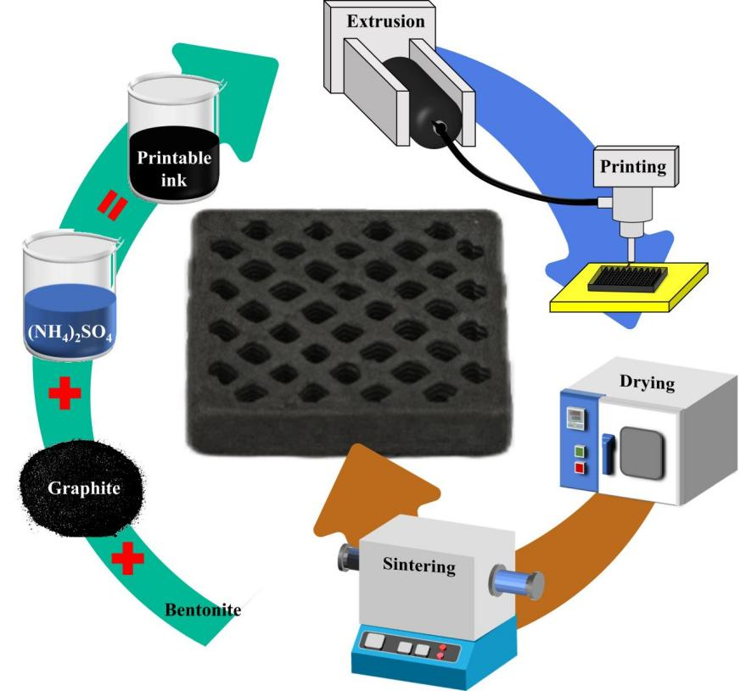
Fig. S1. Preparation process of 3D-printed HB composites.

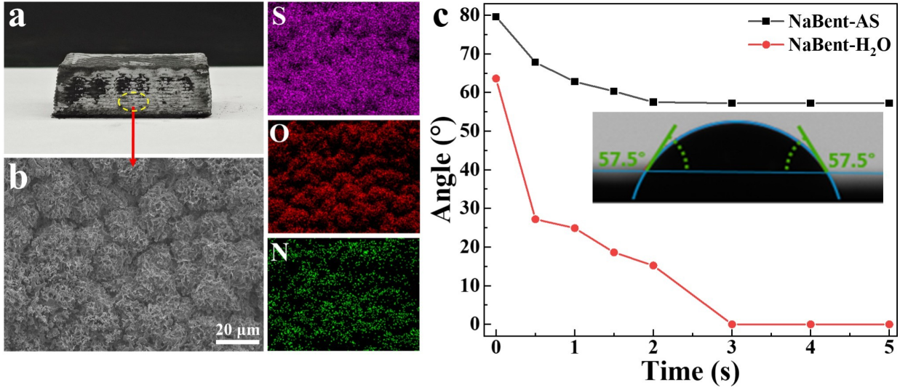
Fig. S2. (a) Optical image of dried HB composites, (b) SEM image and elemental analysis of precipitated salt, and (c) the contact angle changes of NaBent-AS and NaBent-H₂O.
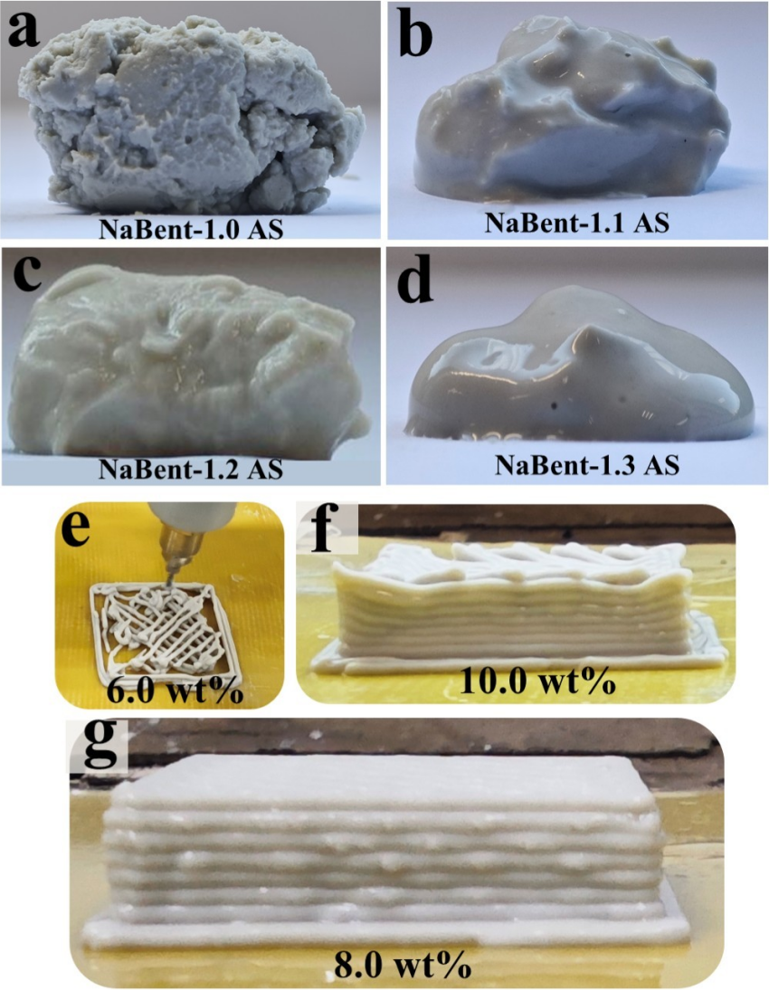
Fig. S3. The viscous state of four NaBent-AS colloids: (a) m_{NaBent}:m_{AS}=1:1.0, (b) m_{NaBent}:m_{AS}=1:1, (c) m_{NaBent}:m_{AS}=1:1.2, (d) m_{NaBent}:m_{AS}=1:1.3. (e) Optical images of NaBent with different concentrations of AS solutions.

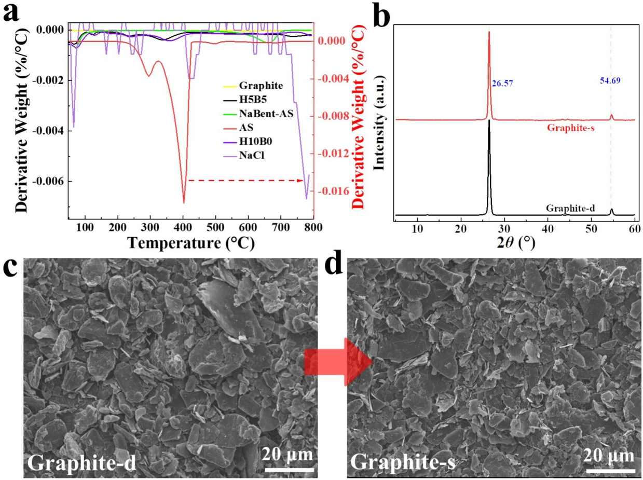
Fig. S4. (a) TG analysis of raw materials and their composites. (b) XRD profiles and (c) SEM images of graphite before (Graphite-d) and after sintering at 1000 °C (Graphite-s).

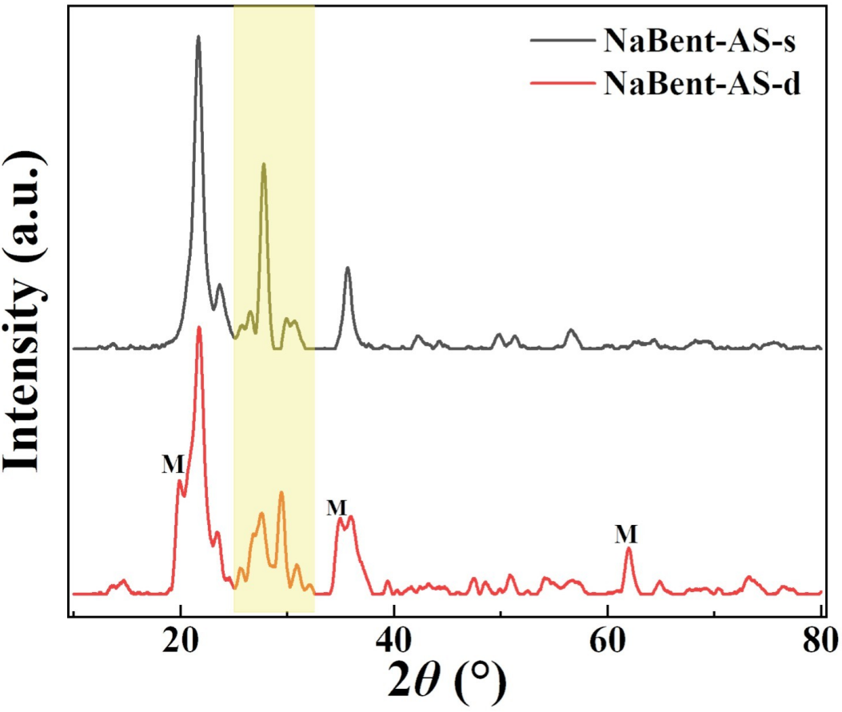
Fig. S5. XRD profiles of NaBent-AS-s and NaBent-AS-d composites.

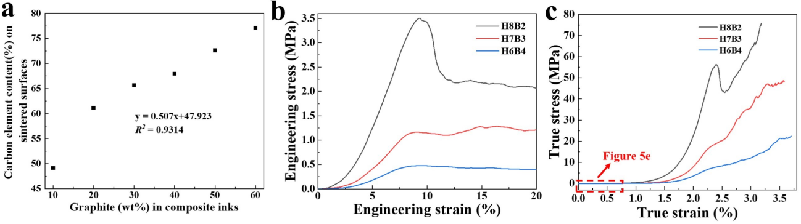
Fig. S6. (a) Quantitative relationship between graphite and carbon elements in composite materials. (b) Engineering stress-strain curves and (c) Real stress-strain curves of 3D-printed composites with different graphite contents.

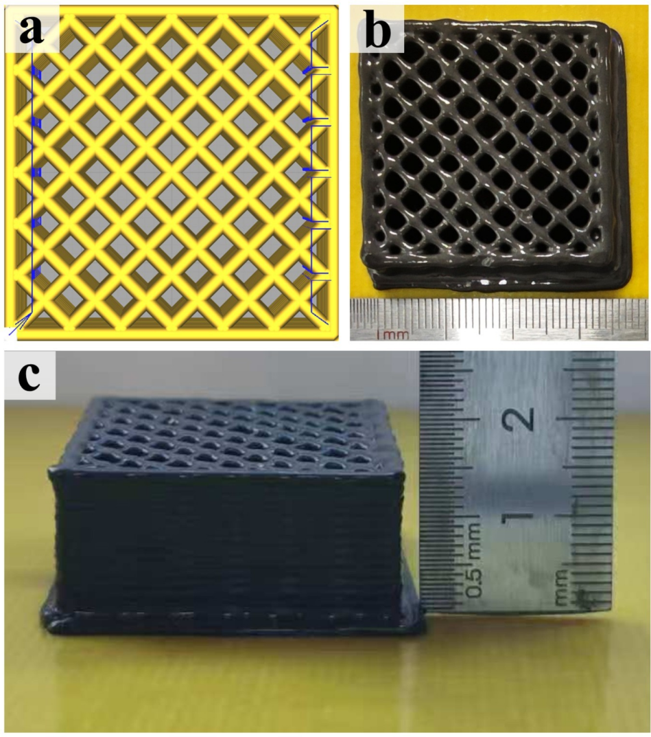
Fig. S7. (a) 3D model, (b) Top-view, and (c) Front view of a 3D-printed HB composite colloid.

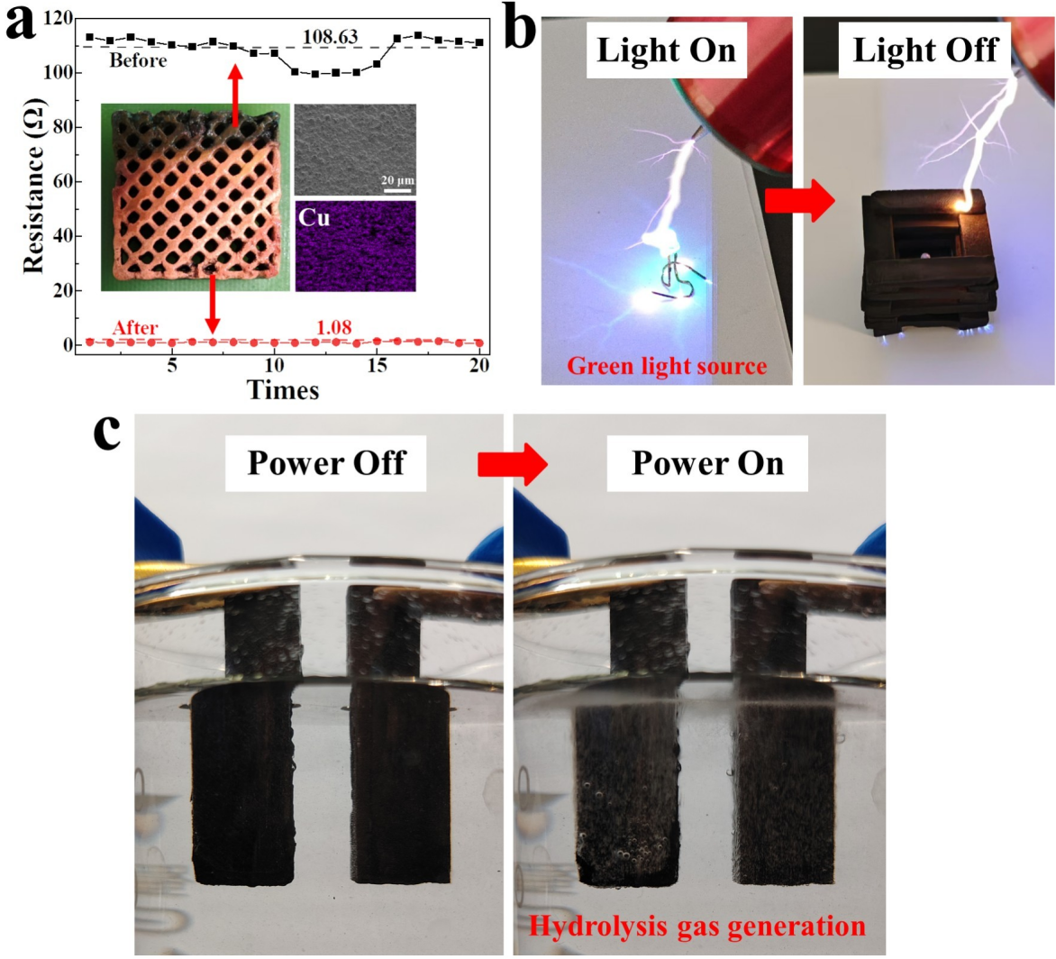
Fig. S8. Functional display of 3D-printed HB composites. (a) Electroplated copper, (b) Electrostatic shielding, and (c) Water electrolysis.

