The invasive freshwater jellyfish Craspedacusta sowerbii: silent invasion of an unknown species?
Guillaume Marchessaux^{1,*}, Kristína Slovák Švolíková², Barbora Števove², Ali Serhan Tarkan^{3,4}, Daniela Giannetto⁵, Cristina Preda⁶, Belma Kalamujić Stroil⁷, Maciej K. Mańko⁸, András Abonyi ^{9,10}, Álmos Becz⁹, Massimo Morpurgo¹¹, Evgeny A. Pakhomov^{12,13}, Levan Mumladze¹⁴, Mar Bosch-Belmar^{15,16}, Aino Hosia¹⁷, Patricia Ventura¹⁸, Jamileh Javidpour¹⁹, Florian Lüskow^{12,13,20,*}
¹ Aix Marseille Univ, Université de Toulon, CNRS, IRD, MIO, Marseille, France
² Department of Ecology, Faculty of Natural Sciences, Comenius University, Mlynská dolina, Bratislava, Slovakia
³ Department of Ecology and Vertebrate Zoology, Faculty of Biology and Environmental Protection, University of Lodz, Lodz, Poland
⁴ Department of Basic Sciences, Faculty of Fisheries, Muğla Sıtkı Koçman University, Muğla, Türkiye
⁵ Department of Biology, Faculty of Science, Muğla Sıtkı Koçman University, Muğla, Türkiye
⁶ Department of Natural Sciences, Ovidius University of Constanta, 1 Universitatii Alley, Constanta, Romania
⁷ University of Sarajevo, Institute for Genetic Engineering and Biotechnology, Zmaja od Bosne 8, Sarajevo, Bosnia and Herzegovina
⁸ Laboratory of Plankton Biology, Department of Marine Biology and Biotechnology, University of Gdańsk, Gdynia, Poland
⁹ MTA-ÖK Lendület Fluvial Ecology Research Group, Institute of Aquatic Ecology, HUN-REN Centre for Ecological Research, Budapest, Hungary
¹⁰ WasserCluster Lunz – Biologische Station GmbH, Lunz am See, Austria
¹¹ Museum of Nature South Tyrol, Via Bottai 1, Bolzano, Italy
¹² Department of Earth, Ocean and Atmospheric Sciences, University of British Columbia, 2039–2207 Main Mall, Vancouver, British Columbia V6T 1Z4, Canada
¹³ Institute for the Oceans and Fisheries, University of British Columbia, 2202 Main Mall, Vancouver, British Columbia V6T 1Z4, Canada
¹⁴ Institute of Zoology, Ilia State University, G. Tsereteli St. 3/5, 0179, Tbilisi, Georgia
¹⁵ Laboratory of Ecology, DiSTeM, University of Palermo, Viale delle Scienze 16, 90128 Palermo, Italy
¹⁶ NBFC, National Biodiversity Future Center, 90133 Palermo, Italy
¹⁷ Department of Natural History, University Museum of Norway, PO Box 7800, Bergen, Norway
¹⁸ Thalassa Marine Research & Environmental Awareness, 286 F route d’Aspremont, Tourrette-Levens, France
¹⁹ Department of Biology, University of Southern Denmark, Campusvej 55, 5230 Odense M, Denmark
²⁰ Department of Earth Sciences, Natural Resources and Sustainable Development, Uppsala University, Campus Gotland, Visby, Sweden
* Corresponding authors: Guillaume Marchessaux (guillaume.marchessaux@ird.fr) and Florian Lüskow (florian.luskow@geo.uu.se)

Supplementary materials
Supplementary Figure 1. A survey questionnaire was performed to collect the people’s perceptions on Craspedacusta sowerbii in the 17 European countries considered.
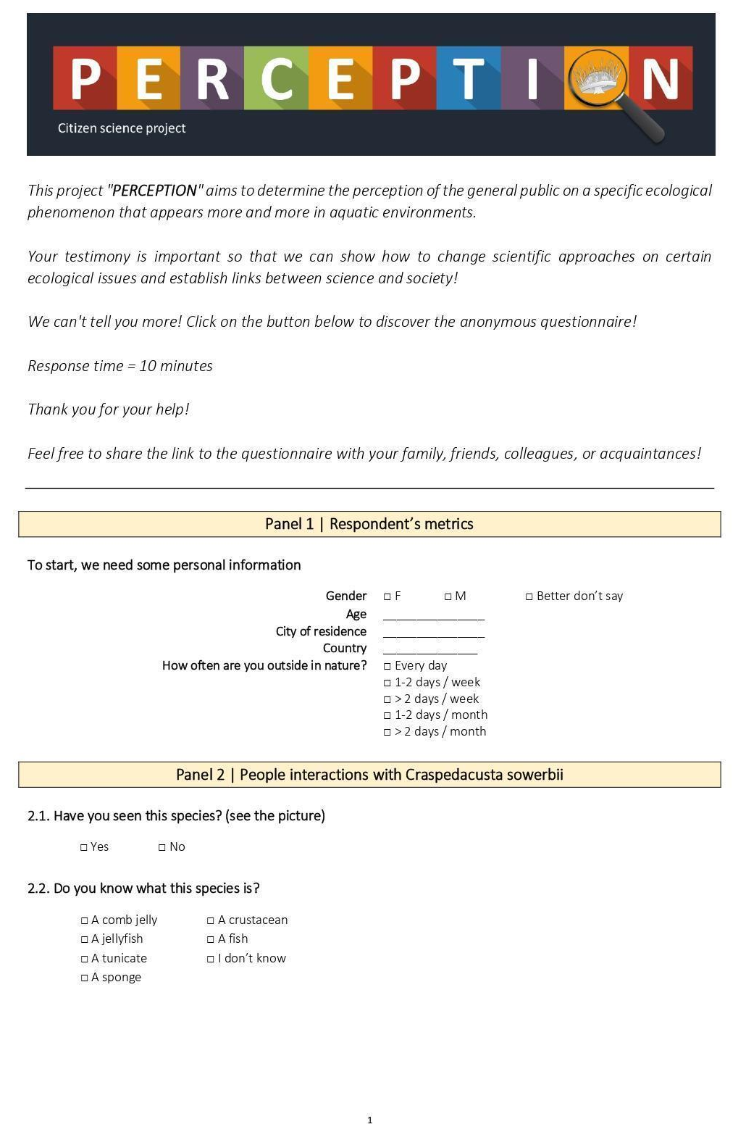
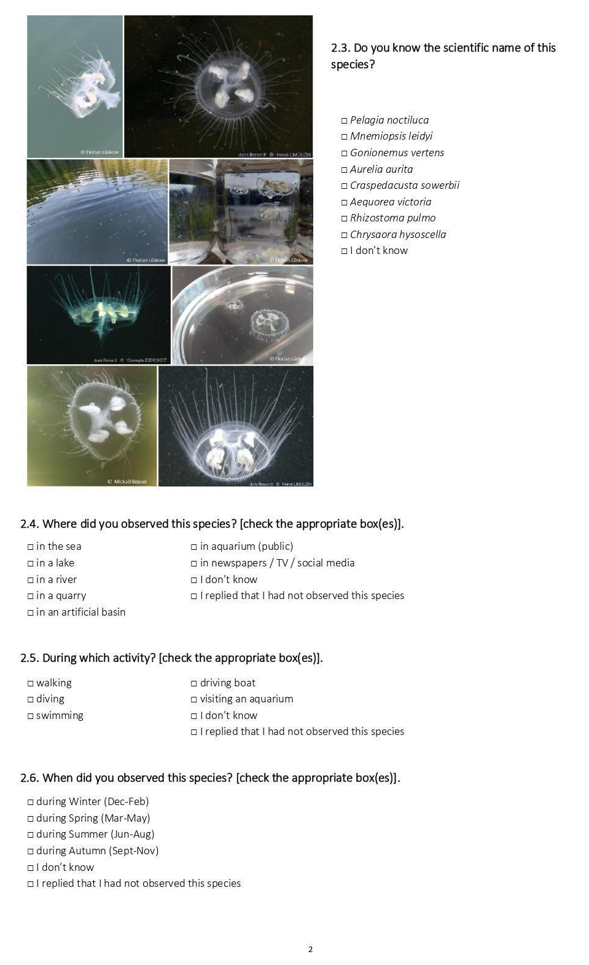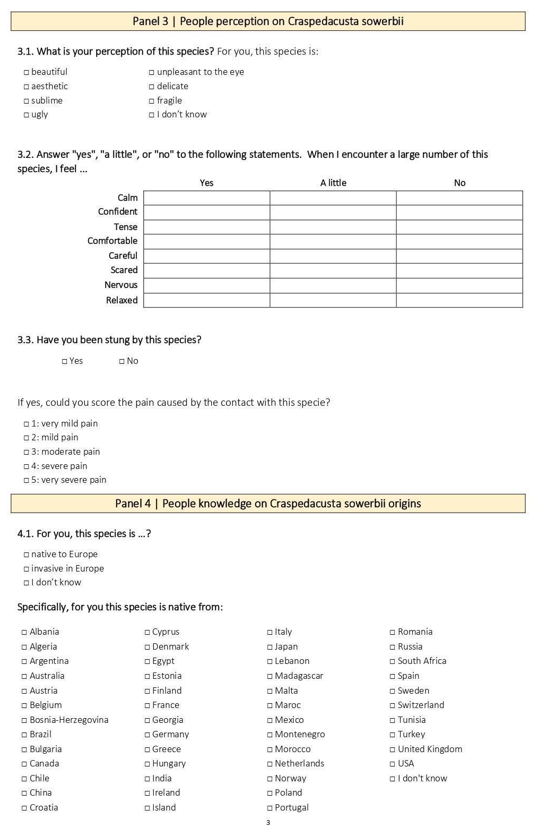
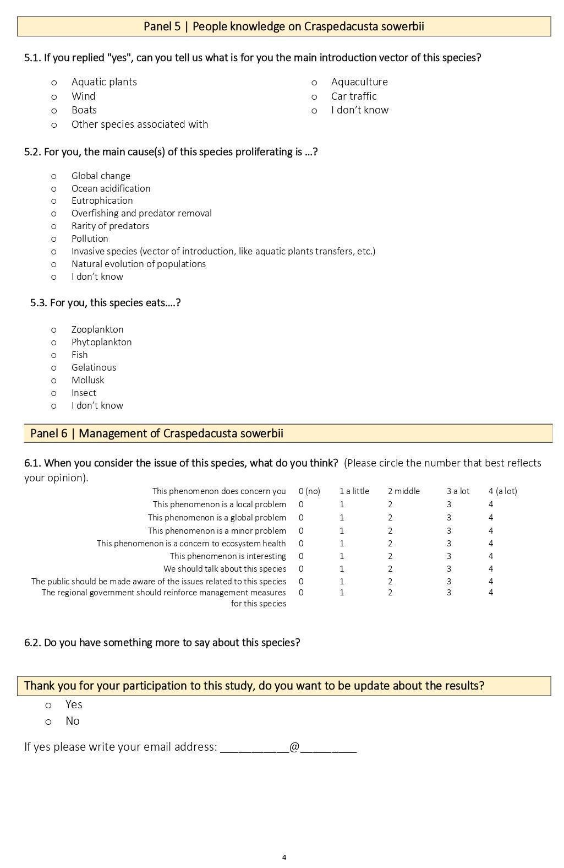
Supplementary Figure 2. Generalized linear model (GLM) showing the trend between the number of Craspedacusta sowerbii occurrences (extracted from Marchessaux et al. 2021) and the total number of responses for each country studied.
