Legends of SPE & IFE
Serum protein Electrophoresis (SPE) were done using capillary electrophoresis method on Sebia Minicap and Immunofixation electrophoresis (IFE) on Hydrasys analyzer using an agarose gel based commercially available kit from Sebia that includes monospecific antisera for IgG, IgA, IgM and light chains kappa (κ) and lambda (λ).
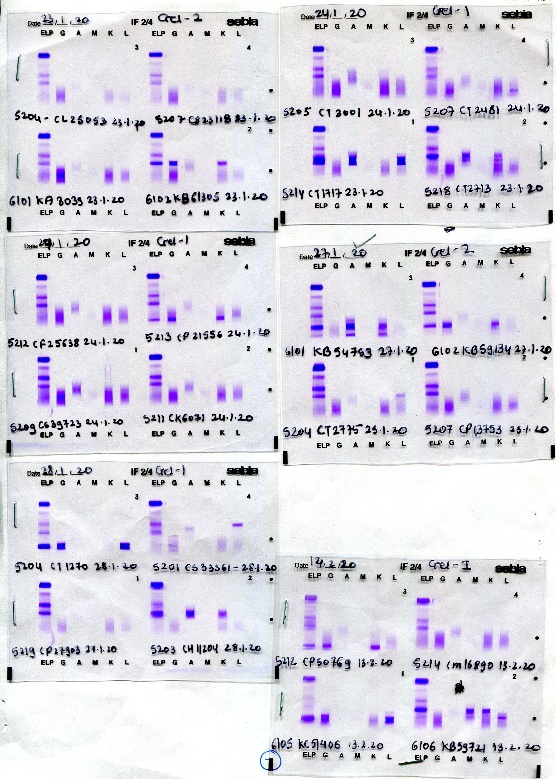
Case1: SPE revealed one sharp discrete bands in the beta region and one band in gamma globulin region (Fig 1). Densitometric analysis of monoclonal components revealed M spike 1= 1.8 g/dl and M spike 2= 200 mg/dl. IFE revealed two bands of IgA kappa (Fig 2).
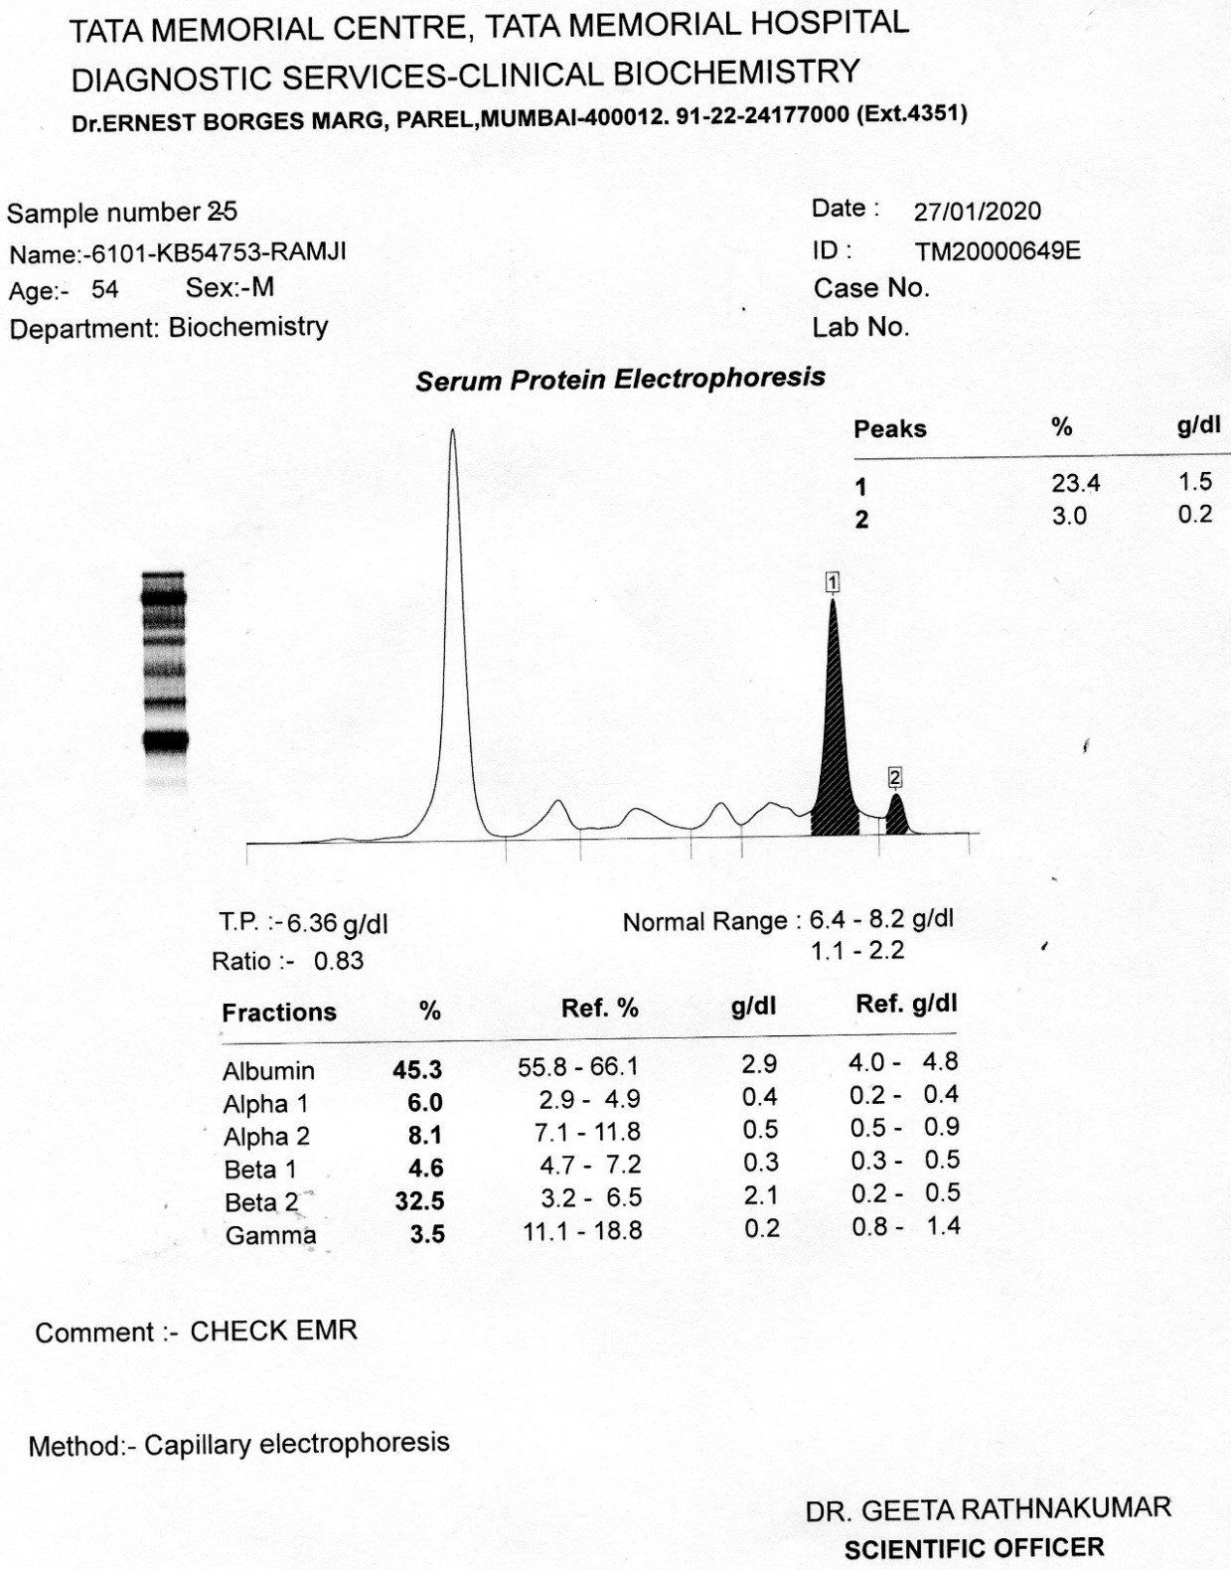
Fig 1- SPE of Case 1 Fig 2- IFE of Case 1
Case 2: SPE revealed one discrete band in the gamma globulin region (Fig 3). Densitometric analysis of monoclonal components revealed M spike 500 mg/dl. IFE revealed bands in IgG kappa and IgG Lambda region (Fig 4).
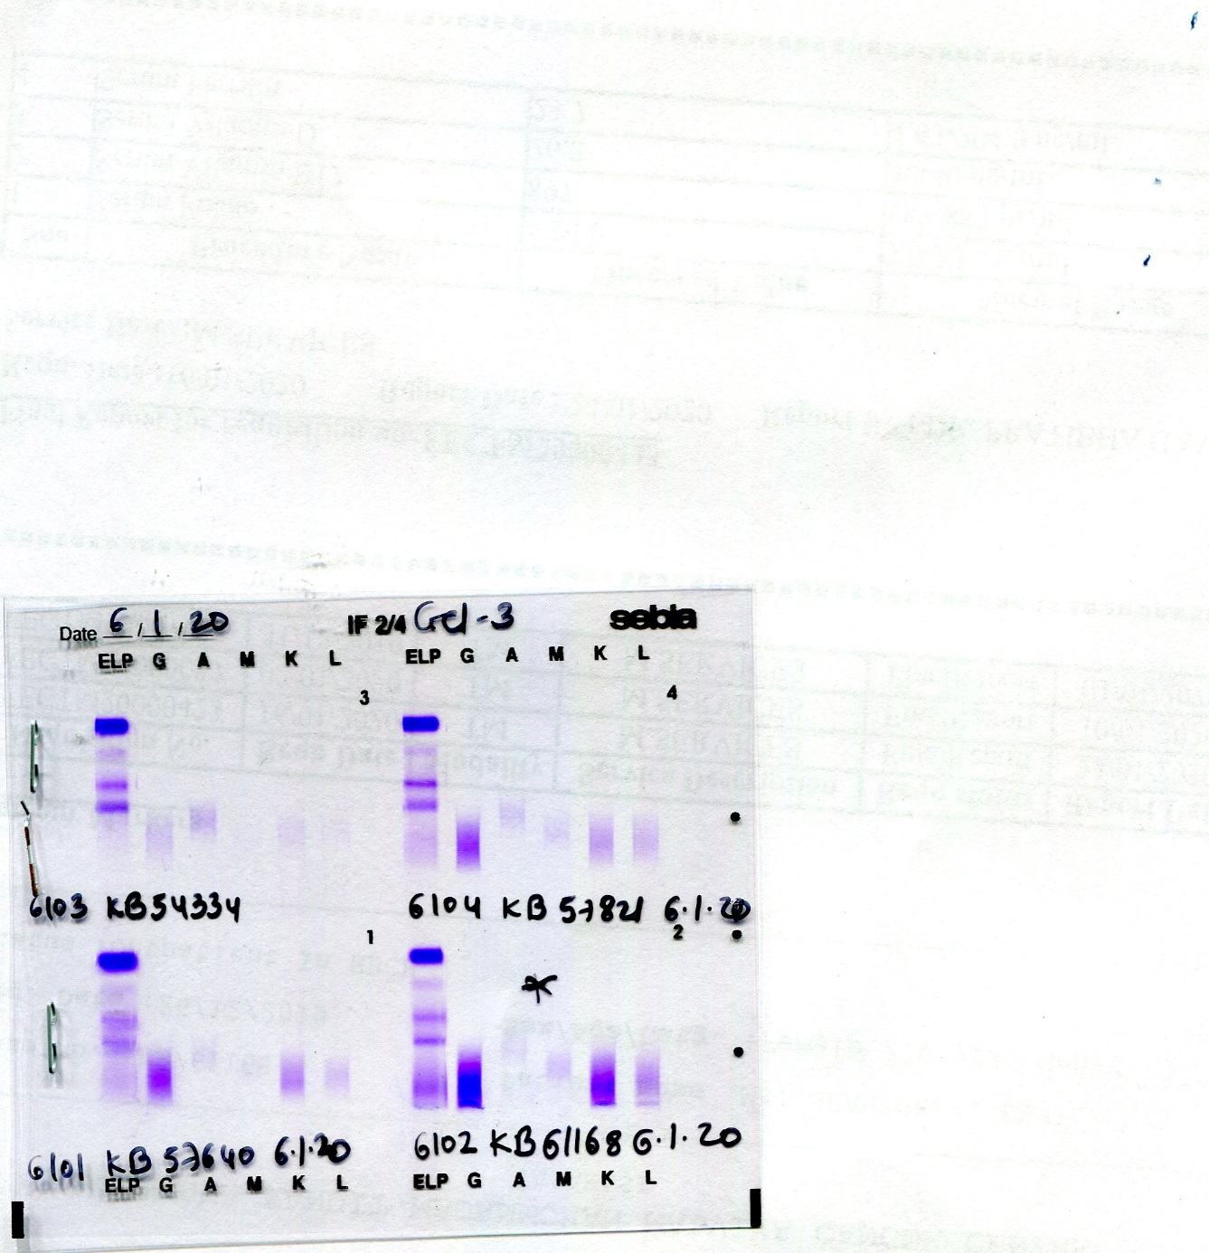
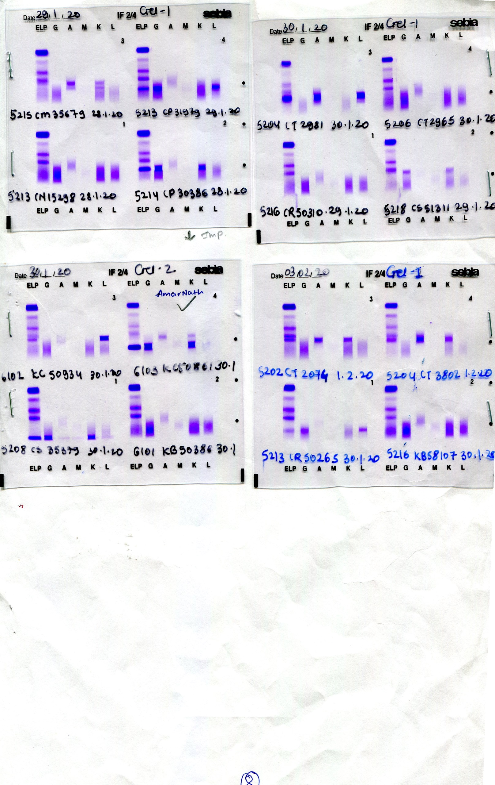
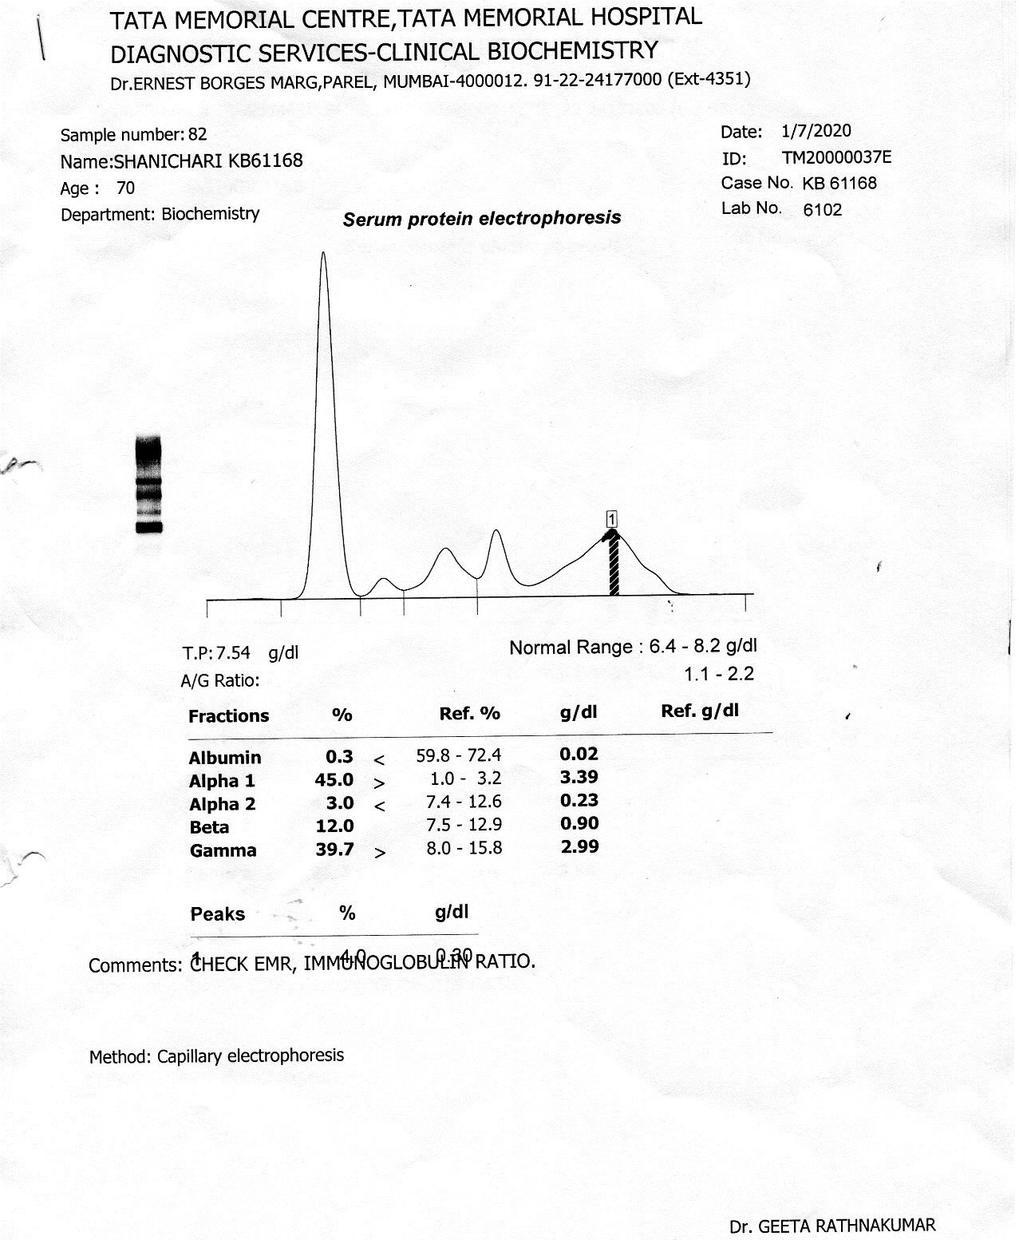
Fig 3- SPE of Case 2 Fig 4- IFE of Case 2
Case 3: Serum protein electrophoresis revealed one sharp discrete band and one faint band in the beta region region (Fig 5). Densitometric analysis of monoclonal components revealed M spike 1= 200 mg/dl and M spike 2= 200 mg/dl. On Immunofixation Electrophoresis, serum revealed two bands of IgM kappa and IgM Lambda(Fig 6).
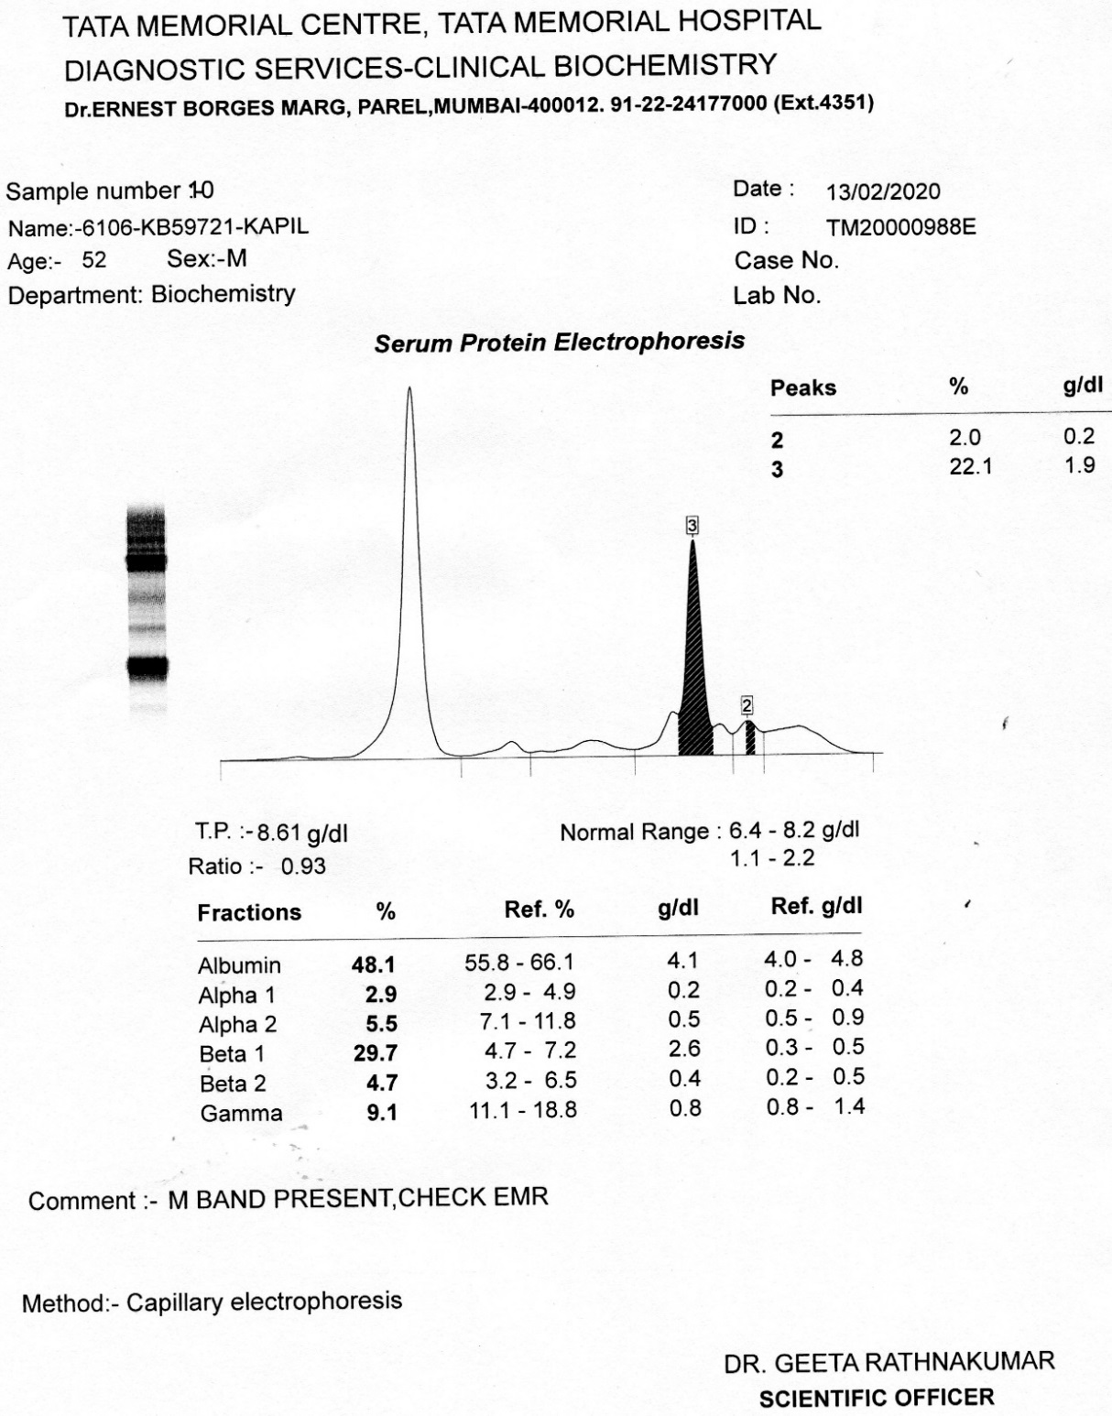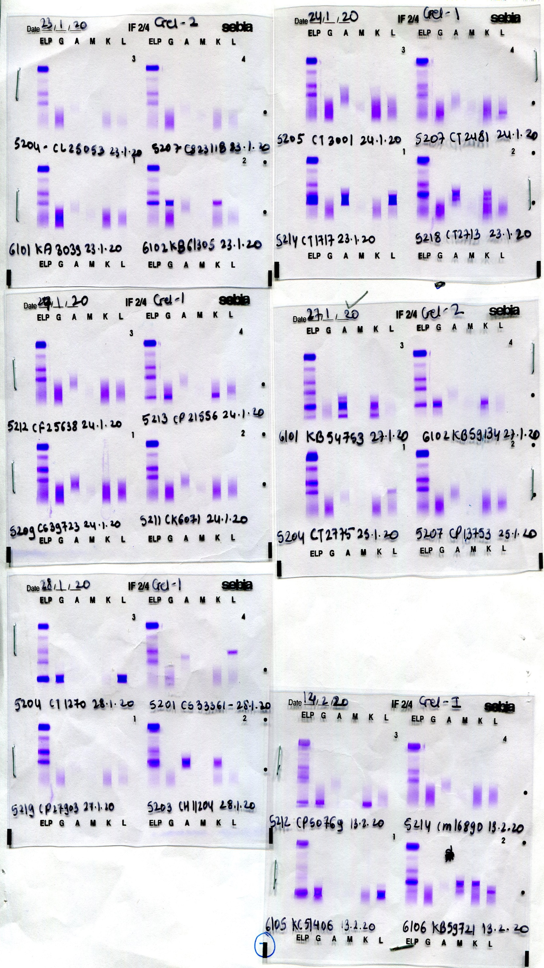
Fig 5- SPE of Case 3 Fig 6- IFE of Case 3
Case 4: Serum protein electrophoresis revealed one faint band in beta region and one sharp discrete band in gamma globulin region (Fig 7). Densitometric analysis of monoclonal components revealed M spike 1= 200 mg/dl and M spike 2= 9.3 g/dl. On Immunofixation Electrophoresis, serum revealed two bands, one of IgG Kappa and another IgA Kappa (Fig 8).
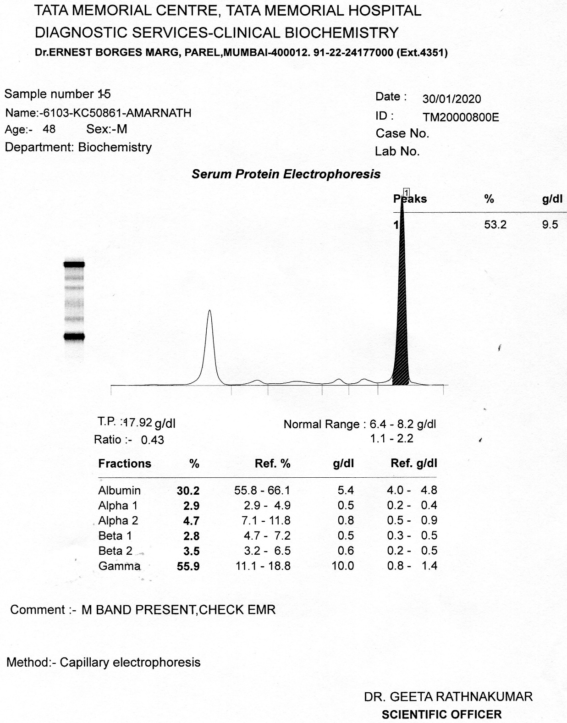
Fig 7- SPE of Case 4 Fig 8- IFE of Case 4

Case 1 : Ramji Prasad – KB/54753, Case 2: Shanicharidevi- KB/61168,
Case 3: Kapil dev Singh- KB/59721, Case 4: Amarnath- KC/50861

