Protocol Name: | Clinical Study on the Application of Low-Dose 2L Lactulose Combined with Linaclotide in Bowel Preparation before Colonoscopy
Short Title： | Bowel preparation before colonoscopy
Version Number: | 1.0
Version Date: | 2024-09-24
Research unit | Department of Gastroenterology, Jinling Hospital, Affiliated Hospital of Medical School, Nanjing University
Ethics Approval: | Jinling Hospital, Affiliated Hospital of Medical School, Nanjing University（Ethics Number：DZQH-KYLL-24-35）
Study Participants： | Patients aged 18-80 years undergoing colonoscopy
Planned Sample Size： | 444 patients
Planned Study Period： | 2024-09 to 2025-09
Chief Investigator： | Name:JI Xuan  Institution:1 Department of Gastroenterology,Jinling Clinical Medical College，Nanjing Medical University;  2 Department of Gastroenterology, Jinling Hospital, Affiliated Hospital of Medical School, Nanjing University  Telephone: +86 13140718720  Email：xuanji@nju.edu.cn
Clinical Research Protocol

Approval:

PI or Sponsor Signature (Name and Title) Date
Confidentiality Statement
The information in this document contains proprietary or confidential business information and shall not be disclosed unless required by law. Under any circumstances, if such information is disclosed to an individual, it must be informed that such information is proprietary or confidential and must not be disclosed to others. These restrictions apply to all proprietary or confidential information provided to you in the future.

CONTENTS
1. List of Abbreviations 1
2. Protocol Synopsis 2
3. Flow Chart 8
4. Background 9
5. Study Purpose 10
6. Study Design 10
7. Patients 11
8. Drugs and Interventions 12
9. Sample Size 14
10. Randomization 14
11. Blinding and Masking 15
12. Outcomes 15
➢ Primary Outcome 15
➢ Secondary Outcomes 16
13. Assessment of Outcomes 16
14. Study Procedures 20
15. Adverse Experience Reporting and Documentation 21
16. Statistical Methods and Considerations 23
17. Data Management 26
18. Ethical Principles and Ethics Committee 27
19. Clinical Study Completion 29
20. Publications 31
21. Responsibilities 31
22. References 32

List of Abbreviations
ADR Adenoma detection rate
AEs Adverse events
BBPS Boston bowel preparation scale
BBS Bowel bubble score
BMI Body mass index
CRC Colorectal cancer
CRF Case report form
GCP Good clinical practice
ITT Intention-to-treat
PP Per-protocol
PEG Polyethylene glycol
PDR Polyp detection rate
SAE Serious adverse events
SAP Statistical analysis plan
SOP Standard operating procedure
VAS Visual analogue scale

Protocol Synopsis
Title | Clinical Study on the Application of Low-Dose 2L Lactulose Combined with Linaclotide in Bowel Preparation before Colonoscopy.
Objective | This study will evaluate the effectiveness of three bowel preparation regimens (2L lactulose + linaclotide group, 2L lactulose group, and 3L polyethylene glycol group) by assessing bowel cleansing rates (using the Boston Bowel Preparation Scale) and conducting quantitative analysis of bowel bubbles during colonoscopy. The comparative analysis will focus on efficacy, tolerability, adverse events, and prognostic outcomes, with the aim of improving bowel preparation quality for colonoscopy recipients.
Study Design | This study is a single-center, single-blind, randomized controlled clinical trial. Participants meeting the inclusion criteria will be randomly assigned to three groups in a 1:1:1 ratio.
Research unit | Department of Gastroenterology, Jinling Hospital, Affiliated Hospital of Medical School, Nanjing University.
Inclusion criteria | Patients aged18-80 years undergoing colonoscopy.
Study Design and Detailed Plan | - Study Design  A single-center, single-blind, randomized controlled clinical study.  - Outcomes  Primary Outcome：Rate of adequate bowel preparation (based on the Boston Bowel Preparation Scale score).  Secondary Outcomes  - Bowel Bubble Score;  - Palatability;  - Tolerability;  - Acceptability;  - Willing to repeat;  - Compliance;  - Sleep quality.  - Colonoscopy findings;  - Polyp detection rate (PDR);  - Adenoma detection rate (ADR);  - Cancer detection rate;  - Cecal intubation rate;  - Incidence of adverse events (AEs).  - Sample size  Sample size calculation was performed using PASS 15 software. Based on prior study data, the assumed adequate bowel preparation rates were 86% for the 2L lactulose group, 90% for the 2L lactulose + L group, and 69% for the 3L PEG group. The primary comparisons focused on differences between the two experimental groups and the control group. A two-sided significance level (α) of 0.05 was set for both tests, with 80% power (1−β). Participants were allocated in a 1:1:1 ratio. Accounting for a 20% dropout rate, the final planned enrollment was 138 patients per group, totaling 414 patients.  - Patients  Inclusion Criteria: Subjects must meet all the following conditions to participate in the trial:  - Signed written informed consent;  - Aged 18–80 years, regardless of gender;  - Ability to adhere to the follow-up schedule, objectively describe symptoms, and cooperate in completing questionnaires/scales;  - Non-pregnant, non-lactating women, and no plans for pregnancy during the trial period;  - No participation in other clinical trials within 3 months prior to or during the trial.  Exclusion Criteria: Subjects must be excluded if any of the following conditions apply:  - Presence of contraindications to colonoscopy (e.g., gastrointestinal obstruction/perforation, severe acute inflammatory bowel disease, toxic megacolon, severe heart failure, renal failure, or hepatic failure);  - Diagnosis of galactosemia;  - Pregnant or lactating women;  - Known allergy to bowel preparation medications;  - Individuals who would withdraw from the trial for any other reason.  Exclusion Criteria after Enrollment：Are found to be ineligible (i.e., do not meet inclusion criteria or meet any exclusion criteria) after enrollment; Fail to provide timely or accurate follow-up data as required; Withdraw informed consent.  Withdrawal Criteria：Subjects (or their legal representatives, e.g., parents/legal guardians) may withdraw from the trial at any time for any reason, including:Withdrawal of informed consent by the subject or legal representative; Subject perception of inadequate efficacy or unexplained loss to follow-up. Upon withdrawal, researchers may not initiate further direct contact with the subject to obtain new data (including clarification forms for data queries).  Termination Criteria：The investigator or sub-investigator reserves the right to permanently terminate a subject’s participation if: The subject experiences intolerable adverse events; The risk-benefit ratio for the subject becomes unacceptable in the investigator’s judgment. Termination is permanent; once a subject is withdrawn, they cannot be re-enrolled in the trial.  - Study Steps  Preparations before intervention  All three groups will, 1 or 3 days prior to colonoscopy, avoid high-fiber vegetables, seeded fruits (e.g., dragon fruit), and other foods with seeds/pits; follow a low-fiber, low-residue diet; finish dinner by 18:00 (6 PM) and fast thereafter. On the evening before the examination, they will consume a semi-liquid or liquid diet. On the day of the colonoscopy, complete fasting and fluid restriction will be maintained.  Intervention  (1) 2L Lactulose Group: 2L lactulose oral solution (Lactulose Oral Solution, Duphalac, 15ml/bag, 6 bags/box): At 20:00 on the evening before colonoscopy, dissolve 2 boxes (180ml) of lactulose into 1000ml of water and drink; 4 hours prior to colonoscopy, dissolve the 3rd box of lactulose into 1000ml of water, add 1 bottle of simethicone emulsion (for degassing, 20ml/bottle), and drink until pale yellow or clear liquid stool is produced.  (2) 2L Lactulose + Linaclotide Group (2L Lactulose + L): 2L lactulose + 290 ug linaclotide (Linaclotide Capsules, Linzess, 290μg/capsule, 7 capsules/box): At 12:00 noon on the day before colonoscopy, take 1 linaclotide capsule (290μg) orally; after 20:00 on the same evening, follow the lactulose administration method described above in two divided doses.  - 3L Polyethylene Glycol II (PEG, Fortrans, 137.12g) Group: 4L PEG: At 20:00 on the day before colonoscopy, dissolve 1 bag of PEG into 1L of water and drink evenly within 2 hours; 6 hours prior to colonoscopy, dissolve the 2nd bag of PEG into 2L of water, add 1 bottle of simethicone emulsion, and drink.  After intervention  To replenish fluid loss during the examination, patients should subsequently consume an adequate amount of fluids to maintain adequate hydration. If severe or persistent diarrhea occurs, seek medical attention promptly.  Safety assessment  Major adverse reactions are recorded as nausea, vomiting, abdominal distension, abdominal pain, etc.
Statistic Analysis | Specialized statistical software was used to conduct subgroup analysis and other treatments on the research variables.

Flow Chart
Population
- Age 18-80 years;
- Individuals scheduled to undergo elective colonoscopy.
Inclusion and
exclusion criteria
Randomization
1:1:1
Bowel Preparation
2L Lactulose + L
2L Lactulose group

3L PEG group
- Primary Outcome
Adequacy rate of bowel preparation.
- Secondary Outcomes
Bowel bubble score
Palatability
Tolerability
Acceptability
Colonoscopy findings
Adverse event

Background
Electronic colonoscopy is the most critical method for diagnosing colorectal diseases, and the quality of the procedure is closely related to the effectiveness of bowel preparation^{[1]}. High-quality bowel preparation can enhance the lesion detection rate during colonoscopy and improve the safety of endoscopic treatment^{[2]}. The selection and proper use of bowel cleansing agents are important factors influencing the quality of bowel preparation before colonoscopy. Lactulose, polyethylene glycol (PEG) electrolyte solution, and linaclotide are three commonly used laxatives that can be applied as preparations for colonoscopy^{[3-6]}.
Polyethylene glycol (PEG) is currently the most widely used bowel cleansing agent globally. However, its clinical application has limitations due to the large volume of fluid intake required and poor palatability, which affect patient compliance^{[7,8]}. Lactulose oral solution, an osmotic laxative, is widely used for treating adult constipation and is one of the recommended agents for bowel preparation before pediatric colonoscopy^{[9,10]}. Clinical practice has shown that lactulose oral solution demonstrates favorable efficacy in adult bowel preparation before colonoscopy, with advantages such as good taste, minimal intestinal irritation, high patient compliance, and a broad applicable population^{[11-14]}. Linaclotide, the world’s first guanylate cyclase agonist, exerts dual mechanisms by increasing intestinal fluid secretion and transit while reducing pain nerve sensitivity. As a drug for treating constipation-predominant irritable bowel syndrome, it has been clinically applied with proven safety ^{[15-17]}.
To further optimize bowel preparation protocols, we propose combining linaclotide with lactulose for bowel preparation before colonoscopy to evaluate their safety and efficacy. Given the scarcity of domestic and international studies on lactulose combined with linaclotide, this study will conduct a comparative analysis of these laxatives, aiming to provide more alternative cleansing regimens for bowel preparation.

Study Purpose
This study will primarily evaluate the adequacy rate of bowel preparation in patients, comparing the effectiveness, tolerability, adverse reactions, prognosis, and other aspects of three bowel preparation regimens: the 2L lactulose + L group, the 2L lactulose group, and the 3L PEG group, with the aim of improving the cleanliness of bowel preparation for patients undergoing colonoscopy.

Study Design
This study is a investigator-initiated, single-center, single-blind, randomized controlled trial. This study strictly adheres to the principles of the Declaration of Helsinki and has been approved by the Medical Ethics Committee of our hospital (Ethics Number: DZQH-KYLL-24-35), and has been registered on ClinicalTrials.gov (Registration Number: NCT06748638).

Patients
- Inclusion Criteria:
- Signed written informed consent;
- Aged 18–80 years, regardless of gender;
- Ability to adhere to the follow-up schedule, objectively describe symptoms, and cooperate in completing questionnaires/scales;
- Non-pregnant, non-lactating women, and no plans for pregnancy during the trial period;
- No participation in other clinical trials within 3 months prior to or during the trial.
- Exclusion Criteria:
- Presence of contraindications to colonoscopy (e.g., gastrointestinal obstruction/perforation, severe acute inflammatory bowel disease, toxic megacolon, severe heart failure, renal failure, or hepatic failure);
- Diagnosis of galactosemia;
- Pregnant or lactating women;
- Known allergy to bowel preparation medications;
- Individuals who would withdraw from the trial for any other reason.
- Exclusion Criteria after Enrollment：Are found to be ineligible (i.e., do not meet inclusion criteria or meet any exclusion criteria) after enrollment; Fail to provide timely or accurate follow-up data as required; Withdraw informed consent.
- Withdrawal Criteria：Subjects (or their legal representatives, e.g., parents/legal guardians) may withdraw from the trial at any time for any reason, including:Withdrawal of informed consent by the subject or legal representative; Subject perception of inadequate efficacy or unexplained loss to follow-up. Upon withdrawal, researchers may not initiate further direct contact with the subject to obtain new data (including clarification forms for data queries).
- Termination Criteria：The investigator or sub-investigator reserves the right to permanently terminate a subject’s participation if: The subject experiences intolerable adverse events; The risk-benefit ratio for the subject becomes unacceptable in the investigator’s judgment. Termination is permanent; once a subject is withdrawn, they cannot be re-enrolled in the trial.

Drugs and Interventions
Drugs | Interventions
2L Lactulose Group:  lactulose oral solution, Duphalac, 15ml/ bag, 6 bags/box. | At 8:00 PM the night before the examination: Pour the contents of 2 lactulose sachets into a cup, add 1000ml of water, and consume the mixture. 4 to 6 hours before the examination, dissolve the third box of lactulose into 1000ml water, and drink it; Until pale yellow or clear dung water is drawn.
2L Lactulose + L Group:  Lactulose + linaclotide 290μg (linaclotide capsule, Lingzeshu, 290ug/ capsule, 7 capsules/box). | 1 capsule of linalotide (290ug) taken orally half an hour before meal at 12:00 noon on the previous day， and two doses were taken after 20:00 according to the above Lactulose-taking method.
3L PEG Group:  Polyethylene Glycol （PEG）：Heshuang, 137.12g. 68.56g/ bag, each bag containing 1.46 g of sodium chloride, 5.68 g of anhydrous sodium sulfate,0.74g of potassium chloride,1.68g of sodium bicarbonate, and 59g of PEG 4000; Shenzhen Wanhe Pharmaceutical Co Ltd, Shenzhen, China. | A bag of PEG was dissolved into 1L at 20:00 1d before the examination, and was drunk at a constant rate within 2h; 4 to 6 hours before the inspection, dissolve the second bag of PEG into 2L water and drink it.

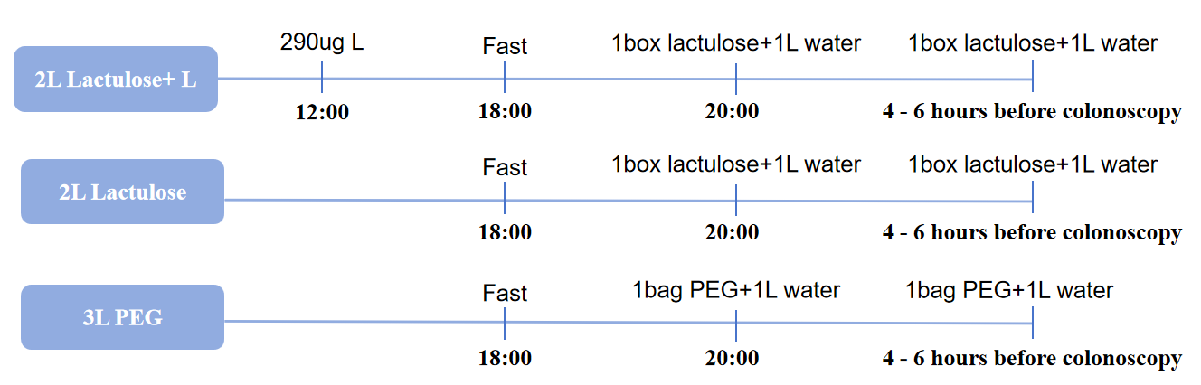

Sample Size
Sample size calculation was performed using PASS 15 software. Based on prior study data^{[16,18-20]}, the assumed adequate bowel preparation rates were 86% for the 2L lactulose group, 90% for the 2L lactulose + L group, and 69% for the 3L PEG group. The primary comparisons focused on differences between the two experimental groups and the control group. A two-sided significance level (α) of 0.05 was set for both tests, with 80% power (1−β). Participants were allocated in a 1:1:1 ratio. Accounting for a 20% dropout rate, the final planned enrollment was 138 patients per group, totaling 414 patients.

Randomization
Randomization will be done by a web-based APP (Jinlingshu) on mobile phone or computer (https://jinlingshu.com/). The automated system will assign an appropriate set of study medication to each patient. Patients will be randomly assigned in a 1:1:1 ratio to one of three groups: 2L Lactulose + L group, 2L Lactulose group, or 3L PEG group. Randomization will be stratified by participating centre with permutation block size of 6. Randomization will be completely concealed by having both web-based real-time allocation (All drugs will have a unique number. Subjects will be assigned a random serial number according to the time they were enrolled, and corresponding masked medications will be provided).

Blinding and Masking
A single-blind (observer-blind) approach was implemented, with treatment allocations concealed from clinical assessors and data collection personnel. The DSMB reviewed unmasked safety data throughout the trial.

Outcomes

Primary Outcome
The primary efficacy outcome measure was the adequate bowel preparation rate. Adequate bowel preparation was defined as a total oston Bowel Preparation Scale (BBPS) score ≥6 and segmental scores ≥2 in all colon segments. The adequate rate was calculated as: adequate rate=Adequately prepared cases/Total cases ×100%.Each colonic segment was scored on a scale of 0-3 points, with a total score ranging from 0-9 points. Higher scores indicated better bowel preparation quality.

Secondary Outcomes
- Bowel Bubble Score;
- Palatability;
- Tolerability;
- Acceptability;
- Willing to repeat;
- Compliance;
- Sleep quality.
- Colonoscopy findings;
- Polyp detection rate (PDR);
- Adenoma detection rate (ADR);
- Cancer detection rate;
- Cecal intubation rate;
- Incidence of adverse events (AEs).

Assessment of Outcomes
- Demographic and Baseline Characteristics
- Evaluators will assess participants at different time points. Baseline assessments include sociodemographic characteristics (age, gender and BMI) , medical history, first-time colonoscopy，primary indications for colonoscopy (screening/health check-up, diagnostic evaluation of symptoms, follow-up/surveillance) and others.
- Boston Bowel Preparation Scale(BBPS)
The BBPS is a standardized tool for assessing the quality of bowel preparation before colonoscopy, developed by the Boston University Medical Center. This scale divides the colon into three parts (the right colon, the transverse colon, and the left colon), and scores each part separately, with a total score range of 0 to 9 points.
Boston Bowel Preparation Scale (BBPS)
Score | Description
0 | The bowel is unprepared, with large amounts of solid stool or thick liquid that cannot be cleared by suction or washing, preventing effective mucosal observation.
1 | The bowel preparation is inadequate, with significant liquid or debris requiring suction or washing to complete the examination (may miss some mucosal details).
2 | The colon is mostly clean, with only a small amount of clear liquid or fine debris that does not interfere with endoscopic observation (requires minimal or no washing).
3 | The colon is completely clean, with no residual stool, liquid, or debris. The mucosal surface is clearly visible.
One independent and experienced endoscopists (With an annual experience performing approximately 1000 endoscopic treatments, will undergo standardised training to proficiently employ the BBPS for assessing bowel preparation quality), blinded to the participant’s group allocation, will assess using the BBPS, and then two researchers will review it. Total BBPS scores and segment-specific scores (right colon, transverse colon, left colon) were compared among the three groups.
- Bowel Bubble Score (BBS)
This scoring system evaluates the amount of bubbles/froth in the intestinal lumen during endoscopy. Commonly used to assess: Efficacy of pre-procedure simethicone administration and mucosal visualization quality. The higher the score, the more debris present, reflecting worse bowel preparation quality.
Bowel Bubble Score (BBS)
Score | Description
Ⅰ | No bubbles.
Ⅱ | Mild bubble interference (<25% mucosal obscuration).
Ⅲ | Moderate (25-50%).
Ⅳ | Severe (>50%).
- Palatability: Best/Moderate/Worse
- Tolerability
To assess patient discomfort during bowel preparation (e.g., before colonoscopy), the Visual Analogue Scale (VAS) can be adapted to quantify subjective sensations. The scoring criteria are adjusted as follows:

0 Points: “No discomfort”. Patients feel no abdominal distension, pain, or nausea. 1-3 Points: “Mild discomfort”. Slight abdominal tightness or bloating, no interference with daily activities. 4-6 Points: “Moderate discomfort”. Noticeable abdominal distension/pain or mild nausea, requiring some activity adjustment. 7-10 Points: "Severe discomfort”. Intense abdominal pain, persistent nausea/vomiting, or inability to tolerate oral intake.
- Acceptability
- Willing to repeat: Yes/No.
- Sleep quality: Good, fair, poor.
- Compliance: Yes/No.
- Colonoscopy findings
- Polyp Detection Rate (PDR), Adenoma Detection Rate (ADR) and Cancer detection rate: Defined as the percentage of patients with polypoid lesions detected or pathologically confirmed adenomas or cancer.
- Cecal intubation rate: Percentage of patients with colon intubation to the cecum.
- Incidence of adverse events: Nausea, vomiting, bloating, abdominal pain, etc.

Study Procedures

Screening
Figure 1 and Figure 2 below present the flowcharts for screening and the day of colonoscopy, respectively.
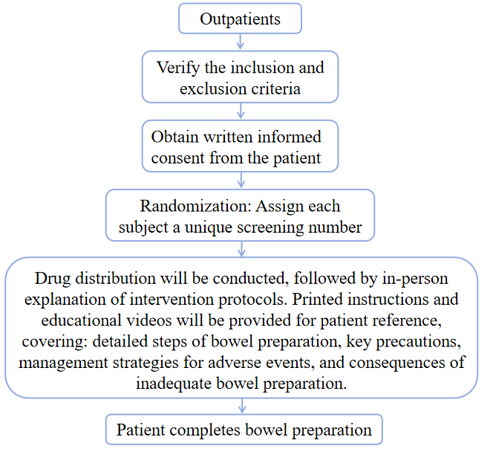

On the day of colonoscopy
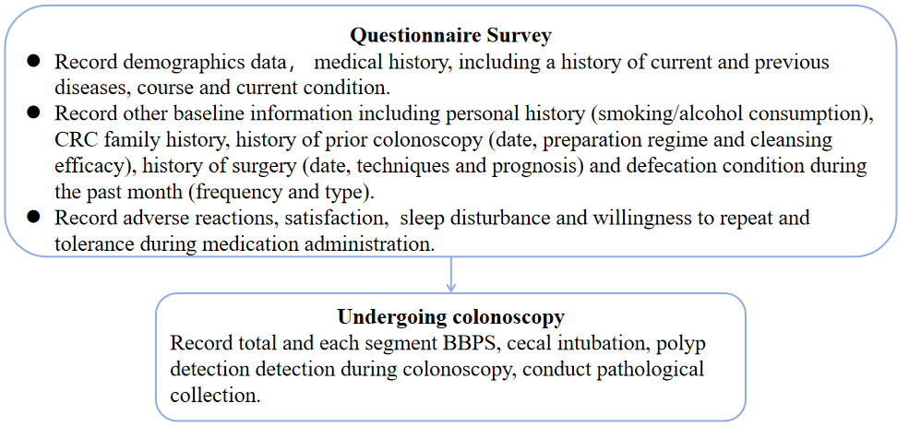

Adverse Experience Reporting and Documentation

Adverse Events
Any adverse medical occurrence in a trial participant after enrollment, regardless of causal relationship to the investigational product, will be recorded as an Adverse Event (AE). This includes:
- Emergence of new symptoms or diagnoses;
- Clinically significant worsening of pre-existing conditions (in severity or frequency);
- Abnormal diagnostic test results with medical relevance;
- Pre-existing stable conditions without deterioration should not be reported as AEs.
During the study period, various adverse events were recorded and their severity was judged, with particular emphasis on observing adverse events (such as digestive tract obstruction or perforation, intestinal obstruction or gastric retention; Severe active inflammatory bowel disease or toxic megacolon; Consciousness disorder; Allergic to the drug components therein; Unable to swallow independently; After ileostomy; Chronic kidney disease, etc).

Criteria for Judging the Severity of Adverse Events:
- Mild: Does not affect the normal life of the subjects;
- Moderate: To a certain extent, it affects the normal life of the subjects;
- Severe: Significantly affects the normal life of the subjects.

Relationship of Adverse Events:
- Unrelated: Adverse events definitively caused by external factors (e.g., comorbidities, environmental exposures) and unrelated to drug administration per predefined criteria.
- Possibly: Clinical events (including lab abnormalities) with plausible temporal drug association but also explainable by concurrent conditions/medications; withdrawal data may be unclear.
- Probably: Clinical events temporally linked to drug use, unlikely due to other causes, with reversible response upon discontinuation.
- Related: Clinical events with reasonable evidence suggesting drug causation, supported by temporal proximity and/or withdrawal response.

Serious Adverse Event
Serious adverse events(SAE): When an adverse event meets one or more of the following conditions, regardless of whether it is related to treatment or not, it should be regarded as a serious adverse event: life-threatening; Death; Resulting in hospitalization or prolonging of hospital stay; Permanent or severe disability; It leads to congenital malformations.
Upon occurrence of an SAE, immediate medical intervention shall be initiated, and an assessment shall be conducted to determine whether the event was anticipated. If the event is determined to be a Suspected and Unexpected Serious Adverse Reaction (SUSAR), it must be reported within 24 hours to the clinical trial institution, ethics committee, drug regulatory authority, and health administration department.

Statistical Methods and Considerations
Before conducting the final analysis of study data, a comprehensive Statistical Analysis Plan (SAP) will be formulated to outline all planned statistical procedures. This SAP will incorporate any revisions or adjustments to the analytical methods described in the following sections.

Data Sets Analyzed
All randomized participants were included in the study. Two efficacy analysis sets and a safety analysis set will be utilized.
The intention-to-treat (ITT) analysis set comprised all patients who were randomized and received treatment, excluding those who met inclusion criteria but did not take any study medication or undergo colonoscopy.
The PP analysis set included patients who completed all study procedures, excluding those with inadequate bowel preparation, incomplete colonoscopy, or non-compliance with the study drug regimen.
All randomized patients have received at least one dose of the investigational drug, defined as the Safety Population.

Demographic and Baseline Characteristics
The following demographic variables at screening will be summarized: age, gender, height, weight, body mass index (BMI), personal history (drinking, smoking), medical history (hypertension, diabetes, coronary heart disease, abdominal pelvic surgery, previous colectomy, constipation and others).

Analysis of Primary Outcome
The primary endpoint is to determine whether the 2L Lactulose + L regimen is superior to the 2L Lactulose and 3L PEG regimens. The 95% confidence intervals (CIs) for the bowel preparation adequacy rate were summarized using the Wilson method.

Analysis of Secondary Outcomes
The secondary outcomes included the Boston Bowel Preparation Scale (BBPS), Bowel Bubble Score (BBS), colonoscopy findings, including polyp detection rate, adenoma detection rate, and cancer detection rate, cecal intubation rate, palatability, tolerability and acceptability, sleep quality, willingness to repeat the procedure, and adverse events (AEs). Additionally, a subgroup analysis was conducted for patients with constipation.
For normally distributed or approximately normally distributed data, results are presented as mean ± standard deviation, and between-group comparisons were performed using one-way ANOVA followed by LSD post-hoc tests. For skewed data, median (interquartile range) was used for description, and comparisons were conducted via the Kruskal-Wallis test. Categorical data are expressed as frequencies (percentages) [n (%)], with comparisons of rates or proportions performed using the chi-square test or Fisher's exact test. A two-sided P-value <0.05 was considered statistically significant.
Safety and tolerability data will be summarized by treatment group.

Data Management

Data Collection
Study data will be recorded using Case Report Forms (CRFs). Relevantstudy-related source data files and patient follow-up data will be transcribed onto the CRFs. Data transcribed into the CRFs must be consistent with the original documents. Dedicated data management personnel will verify the data, and any discrepancies identified will be inquired to the investigators via query forms. Data modifications and confirmations will be made based on the investigators' responses, with all changes truthfully documented in the response forms. Additional query forms may be issued if necessary.

Data Input
Data management personnel will create study-specific data tables using Excel spreadsheets based on the study protocol and the observation items outlined in the CRF. To ensure the accuracy of data entry, a dual data entry and verification mechanism will be implemented. Any discrepancies identified during data entry will be resolved following the same procedures as described above.

Data Verification
After the completion of data entry and verification, a data review meeting will be convened. Data management personnel, the principal investigator, statistical analysts, and other relevant parties will jointly review the data. This meeting will finalize the definition and determination of various analysis populations, verify the number of cases in each analysis set, assess the relationship between all adverse events and the investigational drug, and decide whether safety laboratory monitoring indicators that were normal pre-treatment/abnormal post-treatment or worsened from abnormal pre-treatment to abnormal post-treatment have clinical significance, as well as their relationship to the investigational treatment.

Database Lock
Once all data have been entered into the database, all queries (issues identified during data verification) have been resolved, and the analysis populations have been defined and finalized, the database lock can be initiated. After locking, the data files will not undergo further modifications and will be submitted to statistical analysts for analysis.

Ethical Principles and Ethics Committee
This study adheres to the ethical principles for medical research involving human participants as outlined in the Declaration of Helsinki. The study protocol shall be reviewed and approved by an Ethics Committee (Institutional Review Board, IRB).
Prior to study initiation, the following documents must be submitted for Ethics Committee review: the study protocol, any amendments, patient information/informed consent forms, any other written materials provided to participants, participant recruitment procedures, current CVs and/or other qualification certificates for participating investigators (as required by the local Ethics Committee), and any documents related to investigator remuneration. Written approval from the Ethics Committee must be obtained before the study commences.
During the study, investigators must promptly report the following to the Ethics Committee in accordance with local regulations:
- Suspected and Unexpected Serious Adverse Reactions (SUSARs) reasonably attributed to the investigational product;
- Substantial amendments to the study protocol;
- Non-substantial amendments, as defined by local regulations;
- Immediate actions taken to address risks to participants arising from deviations from the study protocol;
- New information or changes in study procedures that may adversely affect participant safety (including new risk/benefit analyses impacting planned participant follow-up);
- Annual written summaries of study status;
- Any other documents required by the local Ethics Committee.
- Revised versions of documents shall not be implemented prior to Ethics Committee approval, except when necessary to eliminate imminent harm to participants.
Investigators must maintain accurate and complete records of all submissions to the Ethics Committee. All records must be retained in the investigator’s file, with copies submitted to the sponsor.

Clinical Study Completion

Study Completion
Subjects who complete all visits are considered to have completed the study. Subjects who withdraw from study treatment prematurely for any reason prior to the completion of the treatment phase are considered as having not completed the study (i.e., early withdrawal).

Early Withdrawal
If a subject withdraws from the study prior to its completion, the reasons for withdrawal must be documented in the Case Report Form (CRF) and the original medical records. Subjects may withdraw from the study for any reason.
If any of the following events occurs, the principal investigator may request the sponsor to terminate the study, promptly report to the clinical research unit and the hospital ethics committee, and halt the study:
- A significant and indisputable difference emerges between one study group and another;
- Significant severe postoperative complications occur in the control or experimental group.

Post-Study Follow-up
Study completion (including early withdrawal) constitutes the end of the study. Except for adverse events (AEs)/serious adverse events (SAEs), no follow-up is conducted after the study ends. Any AEs occurring during the study are monitored and followed up until resolution. All SAEs must be followed up until resolution.

Quality Assurance
Investigators participating in clinical trials must possess professional expertise and capabilities relevant to clinical trials, undergo qualification review, and maintain a relatively stable team. Trial personnel shall receive training on the study protocol and the relevant standard operating procedures (SOPs) currently in effect for this trial prior to study initiation, ensuring that trial personnel fully understand and comprehend the clinical trial protocol and the specific connotations of each indicator.

Confidentiality
All materials provided by the sponsor to the investigators are non-public information and must be kept confidential; they shall not be disclosed to any organizations or institutions not directly involved in the study.
Investigators must ensure the anonymity of subjects. All medical data and lifestyle information of subjects will undergo computerized processing and, under strict confidentiality, be transferred solely to the sponsor or official health authorities.

Publications
The preparation and submission of manuscripts presenting study findings shall follow procedures established through mutual written agreement between investigators and participating institutions. Publication or presentation of any research outcomes must comply with all relevant current laws and regulations.

Responsibilities
Participating study centers and investigators must adhere to established GCP principles, applicable national and international regulations, and comply with the provisions of this protocol when implementing the study procedures.

References
[1] Dai C, Tian W, Huang YH, et al. Effectiveness of 4 L, 2 L, and 1 L PEG bowel preparation for colonoscopy in patients with ulcerative colitis: a retrospective study [J]. Rev Esp Enferm Dig, 2023.
[2] Theunissen F, Lantinga MA, Ter Borg PCJ, et al. Efficacy of different bowel preparation regimen volumes for colorectal cancer screening and compliance with European Society of Gastrointestinal Endoscopy performance measures [J]. United European Gastroenterol J, 2023,11(5): 448-457.
[3] Menacho AM, Reimann A, Hirata LM, et al. Double-blind prospective randomized study comparing polyethylene glycol to lactulose for bowel preparation in colonoscopy [J]. Arq Bras Cir Dig, 2014,27(1): 9-12.
[4] Jagdeep J, Sawant G, Lal P, et al. Oral Lactulose vs. Polyethylene Glycol for Bowel Preparation in Colonoscopy: A Randomized Controlled Study [J]. Cureus, 2021,13(4): e14363.
[5] Stein DJ, Copland A, McDaniel D, et al. Single-Dose Linaclotide Is Equal in Efficacy to Polyethylene Glycol for Bowel Preparation Prior to Capsule Endoscopy [J]. Dig Dis, 2019,37(4): 297-302.
[6] 郭存果, 傅思华. 利那洛肽联合复方聚乙二醇电解质应用于老年慢性便秘患者肠道准备的效果评价 [J]. 中国医药导报, 2024,21(14): 95-97.
[7] Yan H, Huang H, Yang D, et al. 3 L split-dose polyethylene glycol is superior to 2 L polyethylene glycol in colonoscopic bowel preparation in relatively high-BMI (>/= 24 kg/m(2)) individuals: a multicenter randomized controlled trial [J]. BMC Gastroenterol, 2023,23(1): 427.
[8] Xiong Z, Fang Y, Feng F, et al. 2L polyethylene glycol combined with castor oil versus 4L polyethylene glycol for bowel preparation before colonoscopy among inpatients [J]. Medicine (Baltimore), 2023,102(29): e34294.
[9] Lu J, Cao Q, Wang X, et al. Application of Oral Lactulose in Combination With Polyethylene Glycol Electrolyte Powder for Colonoscopy Bowel Preparation in Patients With Constipation [J]. Am J Ther, 2016,23(4): e1020-1024.
[10] Ramos JA, Carvalho D, Arantes VN. Novel regimen for colonoscopy bowel preparation with oral lactulose: a prospective comparative study [J]. Clin Endosc, 2024,57(6): 775-782.
[11] Wenqi S, Bei Z, Yunrong W, et al. Lactulose vs Polyethylene Glycol for Bowel Preparation: A Single-Center, Prospective, Randomized Controlled Study Based on BMI [J]. Clin Transl Gastroenterol, 2024,15(1): e00652.
[12] 王莉, 张春林. 乳果糖口服溶液和复方聚乙二醇电解质散在结肠镜检查前肠道准备中的应用效果对比 [J]. 临床内科杂志, 2024,41(02): 126-128.
[13] 郭松, 李军文, 谢林娟, et al. 乳果糖在结肠镜检查前肠道准备应用效果的Meta分析 [J]. 当代护士(下旬刊), 2022,29(07): 25-31.
[14] 胡洁琼, J J, G S, et al. 口服乳果糖或聚乙二醇在结肠镜检查中肠道准备的作用对比：一项随机对照研究 [J]. 结直肠肛门外科, 2021,27(05): 501-502.
[15] Maeda N, Higashimori A, Kabata D, et al. Efficacy of 1 L Polyethylene Glycol Plus Ascorbic Acid With Linaclotide Versus Senna for Bowel Preparation: A Multicenter, Endoscopist-Blinded, Randomized Controlled Trial (Apple Trial) [J]. Am J Gastroenterol, 2025.
[16] Pan P, Chen H, Wang T, et al. Effect of 3-day linaclotide administration to reduce the PEG volume for colonoscopy bowel preparation: A multicenter, noninferiority, randomized controlled trial [J]. Am J Gastroenterol, 2025.
[17] 年媛媛, 孟宪梅, 江振宇, et al. 利那洛肽在结肠镜肠道准备中的辅助应用价值—随机对照单盲临床研究 [J]. 临床消化病杂志, 2024,36(01): 47-52.
[18] Hassan C, East J, Radaelli F, et al. Bowel preparation for colonoscopy: European Society of Gastrointestinal Endoscopy (ESGE) Guideline - Update 2019 [J]. Endoscopy, 2019,51(8): 775-794.
[19] Wu J, Liu S, Li S, et al. Bowel preparation efficacy and discomfort of 2 L polyethylene glycol combined with linaclotide versus 3 L polyethylene glycol: a noninferiority, prospective, multicenter, randomized controlled trial [J]. Therap Adv Gastroenterol, 2024,17: 17562848241299739.
[20] Xu H, He Z, Liu Y, et al. Application of linaclotide in bowel preparation for colonoscopy in patients with constipation: A prospective randomized controlled study [J]. J Gastroenterol Hepatol, 2024,39(12): 2752-2759.

