Supplementary Figures
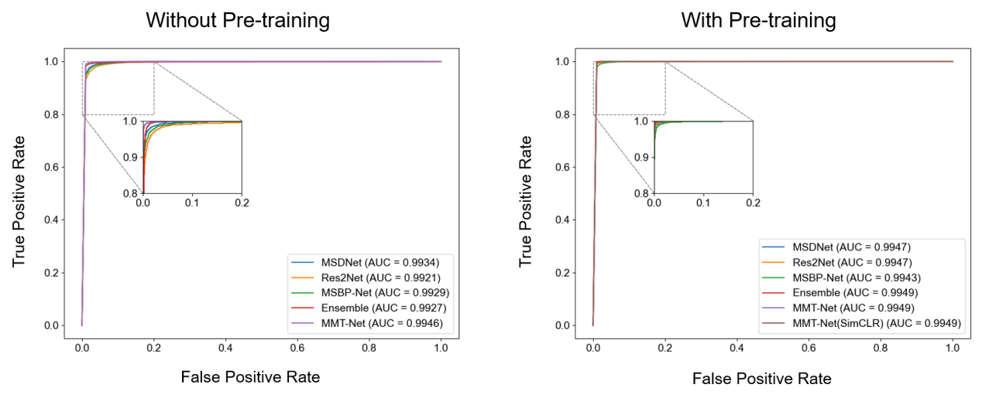
Supplementary Fig. 1 ROC curves comparison of multi-scale models with macro-average AUC.

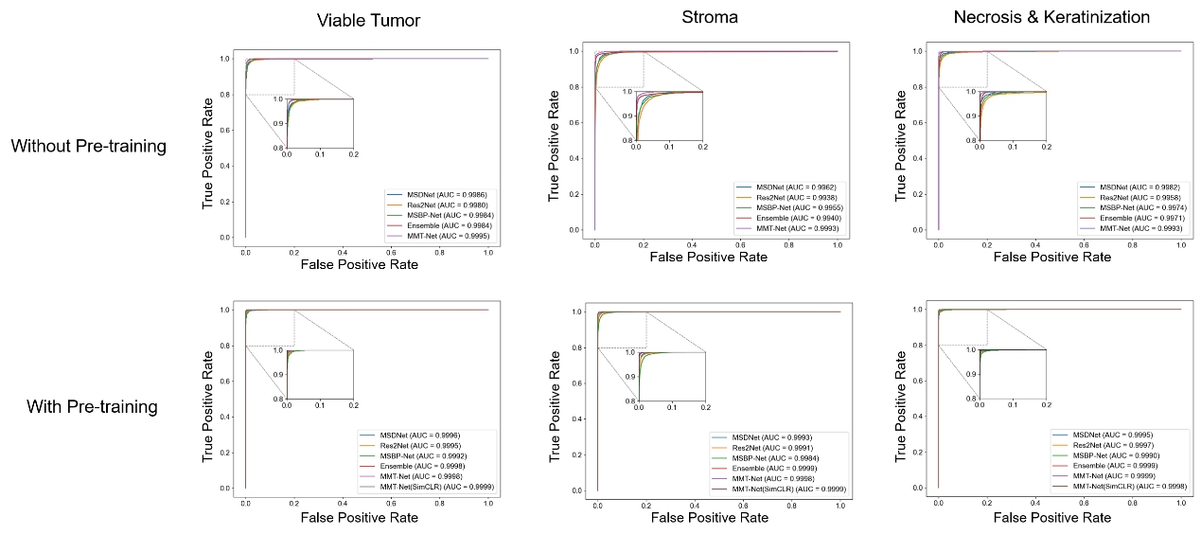
Supplementary Fig. 2 ROC curves for three histological regions.
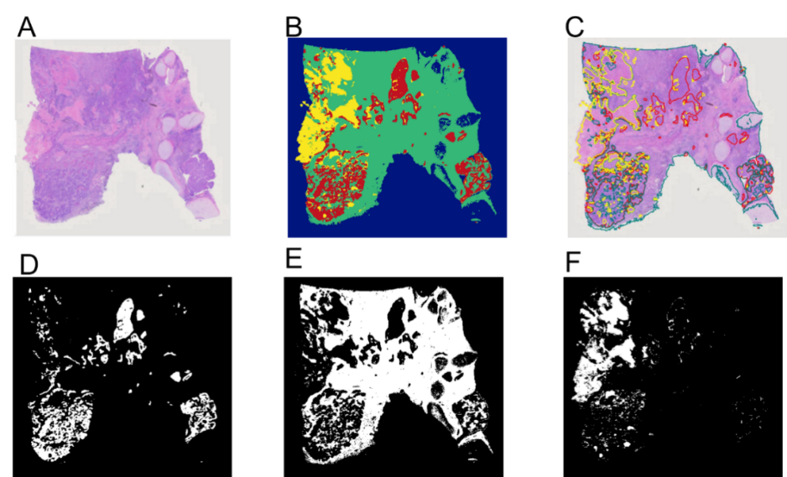
Supplementary Fig. 3 Pattern generation annotation files. (A) Original WSI; (B) Model predicted classification diagram; (C) Annotation diagram generated by the model on the original WSI; (D,E,F) Mask diagrams generated by the model, which are respectively the viable tumor area, stroma area, and necrotic & keratinized area.

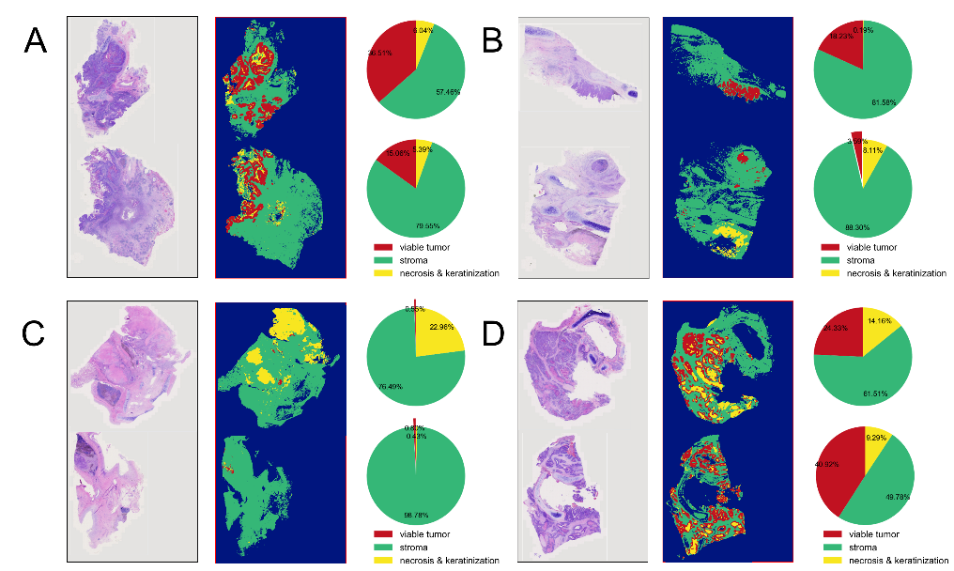
Supplementary Fig. 4 WSI-level panoramic classification map. (A, B, C, D) represent model prediction results from four different patients' WSIs. For each case, the left image shows the original WSI, the middle image depicts the classification map constructed from the model's predictions of corresponding patches, and the right pie chart quantitatively displays the percentage of different categories within each WSI.
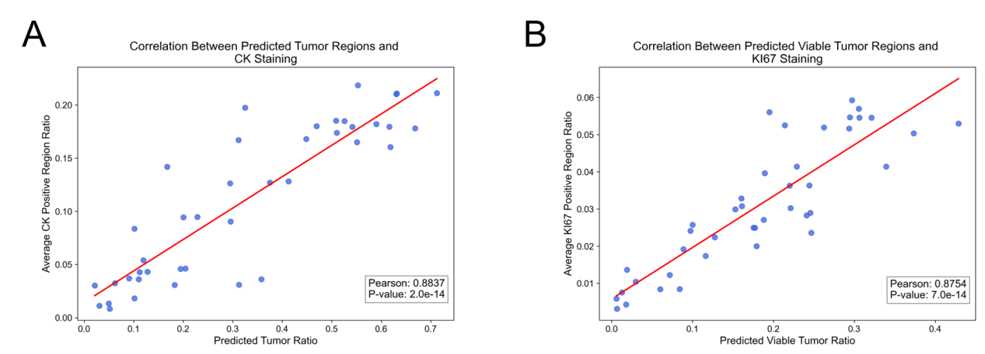
Supplementary Fig. 5 Scatter plots showing correlation between model-predicted ratios and CK/Ki67 staining ratios. (A) Correlation between model-predicted tumor and CK staining ratios; (B) Correlation between model-predicted viable tumor regions and Ki67 staining ratios.

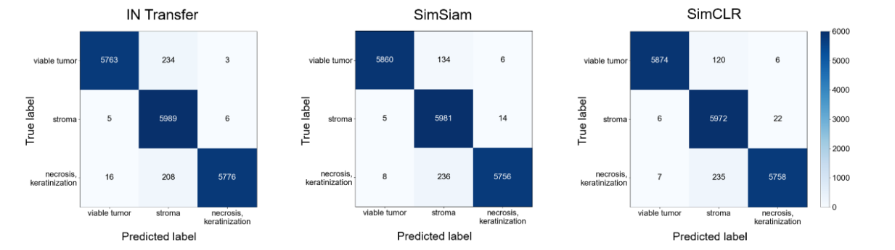
Supplementary Fig. 6 Confusion matrices for transfer learning and self-supervised feature extraction under fine-tuning.

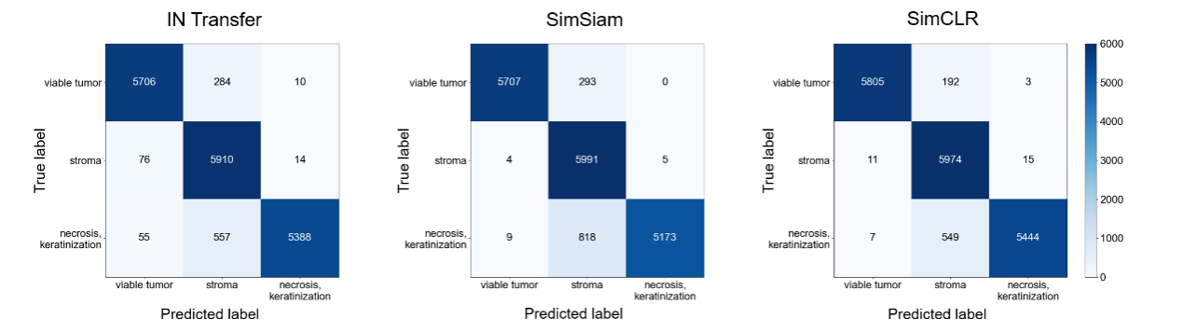
Supplementary Fig. 7 Confusion matrices for transfer learning and self-supervised feature extraction under linear evaluation.

Supplementary Tables
Supplementary Table 1 Experimental Environment Configuration.
Configuration Parameter | Value
Processor Model | Intel(R) Xeon(R) Silver 4116 CPU
Processor Frequency | 2.10 GHz
GPU Model | NVIDIA Tesla T4
Operating System | CentOS release 7.8
Programming Language | Python 3.7
Deep Learning Framework | PyTorch 1.8.1

Supplementary Table 2 Comparison of pre-training strategies on patch-level three-class classification results in the test set.
Method | Pre-training | Accuracy(%) | F1-score(%)
Ensemble | ImageNet | 98.43 | 98.44
Ensemble | SimCLR | 99.04 | 99.04

Supplementary Table 3. Comparison of transfer learning and self-supervised strategies in feature extraction.
 | Linear Evaluation |  |  | Fine-tuning
Method | Accuracy(%) | F1-score(%) |  | Accuracy(%) | F1-score(%)
IN Transfer | 94.47 | 94.51 |  | 97.54 | 97.40
SimSiam | 93.73 | 93.80 |  | 97.76 | 97.77
SimCLR | 95.68 | 96.11 |  | 97.80 | 97.81

Supplementary Texts
Supplementary Text 1 The self-supervised model training details
In the SimCLR and SimSiam frameworks, we adopted the data augmentation strategies from the original papers, including color jittering, Gaussian blur, and horizontal flipping. The training process was set to 200 epochs, with each batch containing 128 samples. We set the initial learning rate to 0.2 and used stochastic gradient descent as the optimizer. At the same time, we also adopted a warm-up strategy, where the learning rate would increase linearly in the first 10 epochs, and in the following 190 epochs, we used a cosine annealing learning rate scheduling strategy. This setting helps balance the model's learning speed and stability to achieve better training results.
Supplementary Text 2 The specifics of the downstream classification tasks
During the training for the downstream classification task, we only adopted data augmentation strategies such as color jittering, horizontal flipping, and color normalization. The training process was set to 50 epochs, and an early stopping strategy was introduced, i.e., if the performance of the model does not improve for 10 consecutive epochs, we will stop the training. Each batch contains 64 samples, the initial learning rate is set to 0.01, and stochastic gradient descent is also used as the optimizer. At the same time, we also adopted a warm-up strategy, where the learning rate would increase linearly in the first 1000 steps, and in the subsequent epochs, we used a stepwise learning rate scheduling strategy. This setting aims to improve the stability of model training while ensuring learning efficiency.
Supplementary Text 3 Evaluation metrics for model predictions
The model's performance is evaluated using ACC and F1-score, which are calculated based on true positive (TP), false negative (FN), false positive (FP), and true negative (TN), The formulas for these metrics are as follows:
$$\begin{aligned}ACC=\frac{TP+TN}{TP+TN+FP+FN} \#\left(1\right)\end{aligned}$$
$$\begin{aligned}F1-Score=2⋅\frac{PR⋅RE}{PR+RE} \#\left(2\right)\end{aligned}$$
where $PR=\frac{TP}{TP+FP}$ and $RE=\frac{TP}{TP+FN}$. Receiver operating characteristic (ROC) curve is also computed along with their area under the curve (AUC) values for model evaluation. Specifically, the ROC curve is obtained by plotting the true positive rate (TPR) against the false positive rate (FPR) at varying thresholds, where $TPR=\frac{TP}{TP+TN}$, $FPR=\frac{FP}{FP+TN}$.The macro-average AUC was calculated as the average of the AUC values across all classes:
$$\begin{aligned}Macro-Average AUC= \frac{1}{C}\sum_{i=1}^{C}{AUC_{i}} \#\left(3\right)\end{aligned}$$
Supplementary Text 4 Constructs of other multi-scale models
MSDNet: Multi-scale dense networks, proposed for resource efficient image classification problem, incorporate multiple classifiers, considered early-exit (intermediate) classifiers, into a single deep neural network. The network exploits dense connectivity among the intermediate feature maps in a horizontal and vertical direction, generating features from the fine to coarse scale, i.e., multi-scale features. Utilizing the multi-scale features via the dense connectivity, all the classifiers, including one average pooling layer and one linear layer, are inter-connected to each other, the early classifiers do not interfere with later classifiers, and the final classifier achieves the high accuracy.
Res2Net: Res2Net is a multi-scale backbone architecture that has been successfully applied to multiple computer vision tasks. It introduces the Res2Net block that captures information at multiple receptive fields (i.e., multi-scale) by constructing a hierarchical residual-like connection within a single residual block. To fuse multi-scale information, multiscale feature maps are concatenated and pass through a 1x1 convolution.
MSBP-Net: MSBP-Net is a multi-scale network architecture designed for pathology image classification. The model introduces a novel mechanism to encode multi-scale features as binary pattern codes, which are then converted into decimal representations to capture relationships across scales. These encoded patterns are seamlessly integrated within the neural network framework, enabling cooperative and discriminative utilization of multi-scale features.
Ensemble: Ensemble is used for predicting the Major Pathological Response (MPR) after neoadjuvant therapy in non-small cell lung cancer (NSCLC). Its architecture is based on multiple ResNet50 networks, each designed to capture multi-scale features from histology images. The model processes 256×256 input images and integrates outputs from these networks, which are then passed through global average pooling, fully connected layers, and a softmax function to make the final predictions.

Due to the imbalance in our dataset, i.e., the number of non-tumor patches far exceeds the number of residual tumor patches, we introduced the Focal Loss function, which has demonstrated significant advantages in dealing with class imbalance problems. At the same time, we chose accuracy and average F1 score as the metrics to evaluate the performance of the model. These metrics can comprehensively reflect the model's performance in classification tasks.

Supplementary Text 5 Analysis of patch-level correlation between model predictions and immunohistochemical staining
We analyzed the correlation between the MMT-Net model’s predictions and immunohistochemical (IHC) staining results using a whole-slide image (WSI) from a patient treated with neoadjuvant therapy (NAT). The WSI was not included in model training. Two IHC staining techniques were employed: CK, to identify epithelial-originated cells, and Ki-67, to evaluate cell proliferation activity.
To address spatial and size discrepancies between the WSI and IHC-stained images, the WSI was divided into patches, with each region containing 4096 patches. The MMT-Net model provided predictions for three categories: viable tumor, stroma, and necrosis & keratinization. Each patch was assigned a label based on the category with the highest prediction score. For CK, we analyzed the correlation between epithelial-originated cells and model-predicted viable tumor and necrosis & keratinization regions. For Ki-67, the relationship between cell proliferation activity and model-predicted viable tumor regions was assessed.
As shown in Supplementary Fig. 5, Pearson correlation coefficients were calculated to quantify the strength of these relationships, with scatter plots used for visualization. The statistical significance of the correlations was evaluated based on p-values, ensuring rigorous validation of the results.

