Supplementary Information
- Additional Experimental Results
1.1 Mathematics
Similar to code, mathematical expressions are segmented by tokenizers. Most tokenizers have a vocabulary size of 30-120 thousand, which is vastly insufficient to encompass the space of numbers and symbols. A multi-token setting could reassemble these tokens into the relevant expressions.
After training the models on the MetaMathQA dataset¹, they are evaluated using MATH-500². CAFT achieved 24.6% (±1.67) and 25.2% (±0.73) on LoRA and full fine-tuning, while their next-token counterparts achieved 22.9% (±1.03) and 23.7% (±0.57). This represents a 1.7% and 1.5% improvement in accuracy on LoRA and full fine-tuning.
Importantly, this experimental setting is highly unfavorable to CAFT. First, the MetaMathQA dataset primarily features natural language reasoning, rather than long, recurring mathematical expressions; the latter, however, benefits the most from our proposed method. Additionally, math problems, unlike the rest of the downstream tasks, are evaluated entirely on their final answers. Thus, CAFT primarily enhances the intermediate chain-of-thought reasoning, thereby only indirectly influencing model accuracy. Nevertheless, CAFT’s performance despite these challenges highlights its effectiveness.
1.2 Text Generation
In this task, we explore the use of CAFT for domain-specific text generation, i.e., clinical text summarization. Brief Hospital Course (BHC) summaries are short summaries that describe a patient's hospital stay. By referencing often voluminous clinical notes, BHC summaries are tediously written by clinicians. This significant time burden could be alleviated by leveraging LLMs to create these summaries.
As shown in Extended Data Table 3, CAFT methods consistently outperform their next-token counterparts. Unlike tasks like math and coding, text generation is uncontrolled; it exhibits significantly larger linguistic diversity, ranging from natural language text to domain-specific acronyms. Given the relative sparsity of multi-token concepts, there was a concern that the model would fail to learn these representations. However, the clear improvement in performance shows that the auxiliary heads effectively capture ideas spanning multiple tokens, even when they are not as prevalent.
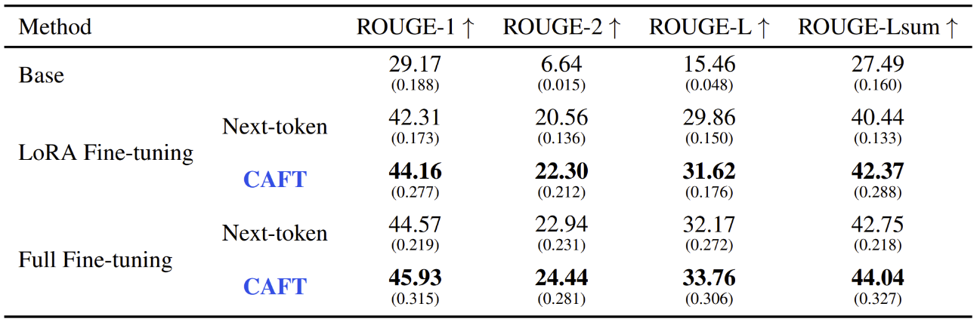
Supplementary Table 1 | Model performances for clinical text summarization using the MIMIC-IV-BHC dataset.
1.3 De Novo Protein Design
The goal of de novo protein design is to generate proteins that exhibit the desired functions and characteristics. In conventional protein design, a protein backbone structure at the atomic level is first defined, followed by finding a sequence consistent with that structure. De novo protein design, on the other hand, generates the protein from scratch, without relying on existing sequences or other starting points. This method holds immense promise for protein engineering, potentially paving the way for creating proteins with novel architectures and functions, and enabling precise control over the proteins' functions and characteristics³. However, de novo design is deeply challenging given the immense space of potential sequences and unintuitive grammar of protein sequences.
As shown in Extended Data Table 4, CAFT consistently outperforms the baseline in both sequence and structural similarity. In particular, multi-token training leads to significantly higher sequence alignment. Additionally, the proportion of structurally similar protein generations has greatly increased. 25.0% of generated sequences have a high pLDDT score (typically defined as >70.0) for the CAFT model, compared to the 20.0% of the next-token model; similarly, 20.0% have a high TM-score (typically defined as >50.0) as compared to 15.8%.
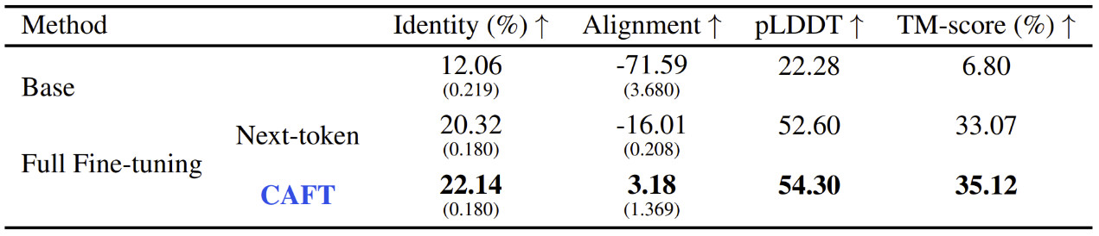
Supplementary Table 2 | Model performances for de novo protein design using the Mol-Instructions dataset.
- Theoretical Assessment
Concept-Aware Fine-Tuning (CAFT) modifies standard next-token fine-tuning by adding auxiliary multi-token losses to the training objective:
$$L_{n}\left(θ\right)=L_{1}\left(θ\right)+Ω\left(θ\right).$$
While CAFT improves empirical performance, its generalization properties for non-convex architectures like Transformers need to be analyzed. We use the algorithmic stability framework of Hardt et al. (2016)⁴, which applies to non-convex $β$-smooth losses, and extend it to CAFT by carefully characterizing how multi-head losses affect gradient magnitude, smoothness, and variance.
We decompose the CAFT objective into the main head and auxiliary heads:
$$\begin{aligned}L_{n}\left(θ\right)≔L_{1}\left(θ\right)+Ω\left(θ\right), Ω\left(θ;z\right) ≔ \sum_{k=2}^{m}{w_{k}} l_{k}\left(θ;z\right), w_{k}=λ γ α_{k-2}≥0.\#\left(1\right)\end{aligned}$$
Here $λ$ is the (global) auxiliary weight (renamed from $β$ to avoid conflict with smoothness), $γ$ is the schedule factor, and $\{α_{k}\}$ is a geometric decay.
We analyze SGD with stepsizes $\{η_{t}\}_{t=1}^{T}$:
$$\begin{aligned}θ_{t+1} = θ_{t}-η_{t}∇l\left(θ_{t};z_{i_{t}}\right), l=l_{1}+Ω.\#\left(2\right)\end{aligned}$$
Datasets $S,S^{'}$ differ by one example. Coupled runs on $S,S^{'}$ produce $\{θ_{t}\}$ and $\{θ_{t}^{'}\}$. Let $Δ_{t}≔\left\|θ_{t}-θ_{t}^{'}\right\|$. On-average stability (w.r.t. $l_{1}$) after $T$ steps is
$$\begin{aligned}ϵ_{T}≔\sup_{S,S^{'},z}{E}\left[\left|l_{1}\left(A_{T}\left(S\right),z\right)-l_{1}\left(A_{T}\left(S^{'}\right),z\right)\right|\right].\#\left(3\right)\end{aligned}$$
To obtain the theoretical bound, we consider the following assumptions.
Assumption 1 ($β$-smoothness of each head) For all $k$ and all $z$, $l_{k}\left(⋅;z\right)$ is $β_{k}$-smooth:
$\left\|∇l_{k}\left(θ;z\right)-∇l_{k}\left(θ^{'};z\right)\right\|≤ β_{k}\left\|θ-θ^{'}\right\|$. We use $β_{k}≤β$.
Assumption 2 (Bounded gradients) For all $k$ and $\left(θ,z\right)$, $\left\|∇l_{k}\left(θ;z\right)\right\|≤G$.
Aggregate auxiliary mass. Define
$$\begin{aligned}ρ≔\sum_{k=2}^{m}{w_{k}} = \sum_{k=2}^{m}{λ}γα_{k-2}.\#\left(4\right)\end{aligned}$$
If $α_{j}=α^{j}$ with $α∈\left(0,1\right)$, then $ρ=λγ α \frac{1-α^{m-1}}{1-α}≤\frac{λγ α}{1-α}$.
Lemma C.1 (Global gradient bound for CAFT loss) Under Assumption 2, for all $\left(θ,z\right)$,
$$\begin{aligned}\left\|∇l\left(θ;z\right)\right\|=\left.\left\|∇l_{1}\left(θ;z\right)+\sum_{k=2}^{m}{w_{k}} ∇l_{k}\left(θ;z\right)\right\|\right.≤\left(1+ρ\right) G.\#\left(5\right)\end{aligned}$$
Proof. Triangle inequality and A2.
Effective smoothness. A naive bound gives $\left\|∇l\left(θ;z\right)-∇l\left(θ^{'};z\right)\right\|≤β\left(1+ρ\right) \left\|θ-θ^{'}\right\|$. Empirically, auxiliary heads reduce the across-sample gradient variance, which effectively lowers the smoothness factor appearing in the stability recursion. We encode this via
$$\begin{aligned}β_{\text{eff}}≔β\left(1-κ\right), 0≤κ<1,\#\left(6\right)\end{aligned}$$
where $κ$ is the relative variance-reduction ratio. Setting $κ=0$ recovers the naive constant; replacing $β_{\text{eff}}$ by $β\left(1+ρ\right)$ yields a fully conservative variant.
Remark 1. There are some ways to approximate this variance-reduction ratio $κ$. Let $g_{t}\left(z\right)≜∇l\left(θ_{t};z\right).$ On a held-out batch, estimate the across-sample variance $\hat{Var_{t}}=\frac{1}{B}\sum_{b=1}^{B}{{\left\|g_{t}\left(z_{b}\right)-{\overline{g}}_{t}\right\|}^{2}}$ with/without CAFT, and set
$$\begin{aligned}\hat{κ}=1-\frac{\frac{1}{T}\sum_{t=1}^{T}{\hat{Var_{t}^{\text{(CAFT)}}}}}{\frac{1}{T}\sum_{t=1}^{T}{\hat{Var_{t}^{\text{(Base)}}}}}, β_{\text{eff}}←β\left(1-\hat{κ}\right).\#\left(7\right)\end{aligned}$$
Condition on $\left(θ_{t},θ_{t}^{'}\right)$ and couple $i_{t}=i_{t}^{'}$ uniformly in $\{1,…,n\}$. With probability $1-\frac{1}{n}$ both runs see the same point; with probability $\frac{1}{n}$ they see the differing point. From (2),
$$\begin{aligned}Δ_{t+1}=\left\|θ_{t}-η_{t}∇l\left(θ_{t};z_{i_{t}}\right)-θ_{t}^{'}+η_{t}∇l\left(θ_{t}^{'};z_{i_{t}}^{'}\right)\right\|\end{aligned}$$
$$\begin{aligned}≤Δ_{t}+η_{t}\left\|∇l\left(θ_{t};z_{i_{t}}\right)-∇l\left(θ_{t}^{'};z_{i_{t}}^{'}\right)\right\|.\#\left(8\right)\end{aligned}$$
Taking expectation over the coupling and applying effective smoothness for the same-point case and Lemma C.1 for the different-point case:
$$E\left[Δ_{t+1} ∣ θ_{t},θ_{t}^{'}\right]≤Δ_{t}+η_{t}\left(\left(1-\frac{1}{n}\right) β_{\text{eff}}Δ_{t}+\frac{1}{n} E\left\|∇l\left(θ_{t};z\right)-∇l\left(θ_{t}^{'};z^{'}\right)\right\|\right)$$
$$\begin{aligned}≤\left(1+β_{\text{eff}}η_{t}\right) Δ_{t} + \frac{2\left(1+ρ\right)G}{n} η_{t}.\#\left(9\right)\end{aligned}$$
Taking total expectation preserves (9).
Iterating (9) from $t=1$ to $T$ yields
$$\begin{aligned}E\left[Δ_{T}\right] ≤ \frac{2\left(1+ρ\right)G}{n} \sum_{t=1}^{T}{η_{t}}\prod_{j=t+1}^{T}{\left(1+β_{\text{eff}}η_{j}\right)}.\#\left(10\right)\end{aligned}$$
If $η_{t}≡ η$ is constant:
$$\begin{aligned}\prod_{j=t+1}^{T}{\left(1+β_{\text{eff}}η\right)}={\left(1+β_{\text{eff}}η\right)}^{T-t}, \sum_{t=1}^{T}{η{\left(1+β_{\text{eff}}η\right)}^{T-t}}=\frac{{\left(1+β_{\text{eff}}η\right)}^{T}-1}{β_{\text{eff}}},\#\left(11\right)\end{aligned}$$
hence
$$\begin{aligned}E\left[Δ_{T}\right] ≤ \frac{2\left(1+ρ\right)G}{n}⋅\frac{{\left(1+β_{\text{eff}}η\right)}^{T}-1}{β_{\text{eff}}}.\#\left(12\right)\end{aligned}$$
For $β_{\text{eff}}η≪1$ and moderate $T$, ${\left(1+β_{\text{eff}}η\right)}^{T}-1≈β_{\text{eff}}ηT$:
$$\begin{aligned}E\left[Δ_{T}\right] ≈ \frac{2\left(1+ρ\right)G}{n} ηT.\#\left(13\right)\end{aligned}$$
By the mean-value theorem and bounded gradient of the evaluation loss $l_{1}$,
$$\begin{aligned}\left|l_{1}\left(θ_{T};z\right)-l_{1}\left(θ_{T}^{'};z\right)\right|≤\sup_{ξ}\left\|∇l_{1}\left(ξ;z\right)\right\|⋅\left\|θ_{T}-θ_{T}^{'}\right\|≤G Δ_{T}.\#\left(14\right)\end{aligned}$$
Taking expectation and using (10) gives the tight stability bound:
$$\begin{aligned}ϵ_{T} ≤ \frac{2\left(1+ρ\right)G^{2}}{n} \sum_{t=1}^{T}{η_{t}\prod_{j=t+1}^{T}{\left(1+β_{\text{eff}}η_{j}\right)}}.\#\left(15\right)\end{aligned}$$
If one prefers a simple but conservative bound by also upper-bounding the evaluation gradient with Lemma C.1, an extra $\left(1+ρ\right)$ appears:
$$\begin{aligned}ϵ_{T}^{\left(\text{cons}\right)} ≤ \frac{2{\left(1+ρ\right)}^{2}G^{2}}{n} \sum_{t=1}^{T}{η_{t}\prod_{j=t+1}^{T}{\left(1+β_{\text{eff}}η_{j}\right)}}.\#\left(16\right)\end{aligned}$$
Constant stepsize corollary. From (16) and (12):
$$\begin{aligned}ϵ_{T}^{\left(\text{cons}\right)} ≤ \frac{2{\left(1+ρ\right)}^{2}G^{2}}{n}⋅\frac{{\left(1+β_{\text{eff}}η\right)}^{T}-1}{β_{\text{eff}}} ≈ \frac{2{\left(1+ρ\right)}^{2}G^{2}}{n} ηT \left(β_{\text{eff}}η≪1\right).\#\left(17\right)\end{aligned}$$
The tight version replaces ${\left(1+ρ\right)}^{2}$ by $\left(1+ρ\right)$.
Non-constant stepsizes. Using $\log\left(1+x\right)≤x$,
$$\begin{aligned}\prod_{j=t+1}^{T}{\left(1+β_{\text{eff}}η_{j}\right)}≤\exp\left(β_{\text{eff}}\sum_{j=t+1}^{T}{η_{j}}\right),\#\left(18\right)\end{aligned}$$
so
$$\begin{aligned}ϵ_{T}^{\left(\text{cons}\right)} ≤ \frac{2{\left(1+ρ\right)}^{2}G^{2}}{n} \sum_{t=1}^{T}{η_{t}} \exp\left(β_{\text{eff}}\sum_{j=t+1}^{T}{η_{j}}\right).\#\left(19\right)\end{aligned}$$
Theorem C.2 (CAFT Generalization via On-average Stability) Under Assumption 1-Assumption 2, with probability at least $1-δ$ over the sample $S$ and SGD randomness,
$$\begin{aligned}E_{z}\left[l_{1}\left(\hat{θ},z\right)\right] ≤ L_{1}\left(\hat{θ}\right) + ϵ_{T} + \sqrt{\frac{\ln\left(1/δ\right)}{2n}},\#\left(20\right)\end{aligned}$$
where $\hat{θ}=θ_{T}$ and $ϵ_{T}$ is given by (15) (tight) or (16) (conservative).
Proof. Apply the on-average stability generalization theorem⁴ and the stability parameter above.
Theoretical Insight. For CAFT and single-token (STP), the on-average stability parameters after $T$ SGD steps satisfy
$$\begin{aligned}ε_{T}^{\text{CAFT}}≤\frac{2\left(1+ρ\right)G^{2}}{n} \sum_{t=1}^{T}{η_{t}\prod_{j=t+1}^{T}{\left(1+β_{\text{eff}}η_{j}\right)}},\#\left(21\right)\end{aligned}$$
$$\begin{aligned}ε_{T}^{\text{STP}}≤\frac{2G^{2}}{n} \sum_{t=1}^{T}{η_{t}\prod_{j=t+1}^{T}{\left(1+β η_{j}\right)}},\#\left(22\right)\end{aligned}$$
where $ρ=\sum_{k≥2}{w_{k}}$ is the total auxiliary mass (small under geometric decay), and $β_{\text{eff}}=β\left(1-κ\right)$ with $κ∈\left[0,1\right)$ the relative reduction of across-sample gradient variance (empirically measured).
If $η_{t}≡η$, then
$$\begin{aligned}ε_{T}^{\text{CAFT}}≤\frac{2\left(1+ρ\right)G^{2}}{n}⋅\frac{{\left(1+β_{\text{eff}}η\right)}^{T}-1}{β_{\text{eff}}}, ε_{T}^{\text{STP}} ≤ \frac{2G^{2}}{n}⋅\frac{{\left(1+βη\right)}^{T}-1}{β}.\#\left(23\right)\end{aligned}$$
Let
$$\begin{aligned}R≔\frac{ε_{T}^{\text{CAFT}}}{ε_{T}^{\text{STP}}}=\left(1+ρ\right)⋅\frac{β}{β_{\text{eff}}}⋅\frac{{\left(1+β_{\text{eff}}η\right)}^{T}-1}{{\left(1+βη\right)}^{T}-1}.\#\left(24\right)\end{aligned}$$
Using $\log\left(1+x\right)≈x$ for $βη≪1$,
$$\begin{aligned}R≈\underset{\text{magnitude inflation}}{\underbrace{\frac{1+ρ}{1-κ}}}⋅\underset{\text{variance-smoothing gain}}{\underbrace{e^{-κ β η T}}}.\#\left(25\right)\end{aligned}$$
If $R<1$, CAFT is more stable and generalizes better than single-token prediction. Under the small-stepsize approximation, a sufficient condition for $R<1$ is
$$\begin{aligned}κβηT>\log{\frac{1+ρ}{1-κ}}.\#\left(26\right)\end{aligned}$$
Also, for non-constant stepsizes, replace $β η T$ by $β\sum_{t=1}^{T}{η_{t}}$.
Remark 2. In structured tasks (e.g., those with strong syntactic or template constraints), main and near-future heads typically exhibit negative covariance on a batch (a control–variates effect), which increases $κ$ and, together with a small auxiliary mass $ρ$, makes the stability-improving condition (26) hold. In contrast, for free-form text with highly diverse continuations, negative covariance weakens, $κ$ becomes small or even negative, and condition (26) can fail, explaining mixed outcomes on open-ended generation. To satisfy (26) in practice, one should (i) increase $κ$: keep only a few near-future heads; use small, geometrically decaying positive weights; gate (drop or downweight) heads whose covariance with the main head is non-negative; and optionally solve a tiny NNLS/QP on a held-out mini-batch to minimize $\sum_{z}{{\left\|\left.g_{1}\left(z\right)+\sum_{k}{w_{k}g_{k}\left(z\right)}\right.\right\|}^{2}}$, ensuring batch variance does not increase. (ii) shrink $ρ$: set a small global auxiliary scale, enforce fast geometric decay so far heads die quickly, and employ a decaying schedule late in training. Concept-level supervision then comes at zero deployment cost: supervising multiple future tokens enforces cross-token structure in the shared representations, reduces the average gradient Lipschitz $β_{\text{eff}}$, and does not affect inference because auxiliary heads are discarded.
- CAFT Hyperparameter Search
For the CAFT-specific hyperparameters, i.e., $α$, $β$, and $γ$, the objective is to incentivize models to leverage the auxiliary losses and ultimately optimize for $L_{1}$. We conducted an extensive hyperparameter search and found the following settings to be robust across all tasks. For the sake of demonstration, we show a search using the molecule generation dataset (L+M-24) in Extended Data Figure 2, illustrating model perplexities over training steps for various hyperparameter settings of LoRA and full fine-tuning. The default settings are $α=0.8$, $β=0.01$, and $γ=$ RSine schedule, unless otherwise specified in the graph legends. The RSine schedule is compared against the sine schedule (where the weight increases over steps) and the constant schedule (where $γ=1$ for all steps).
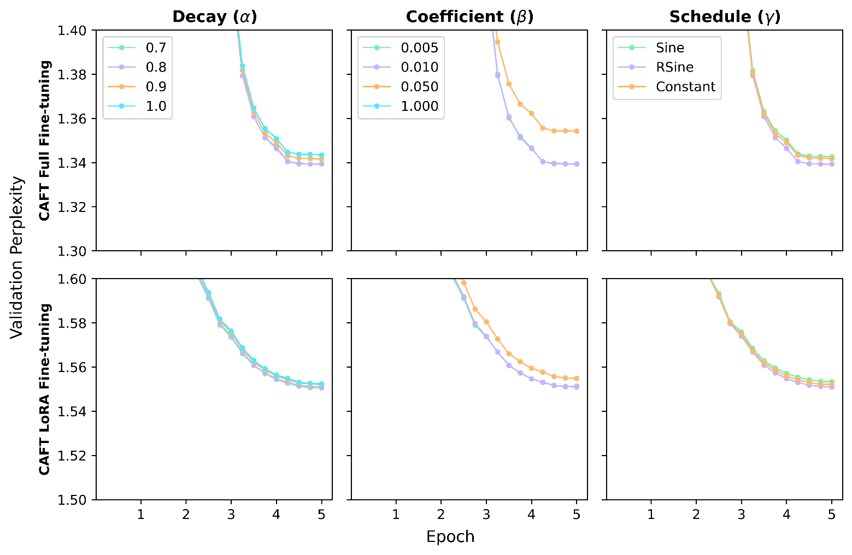
Supplementary Figure 1 | CAFT hyperparameter search using the L+M-24 dataset as case study, for both LoRA and full fine-tuning. The default settings are $α=0.8$, $β=0.01$, and $γ=$ RSine schedule, unless otherwise specified in the graph legends. The curves for $β=1.00$ do not appear in the plots as their perplexities are $>1.40$ for full fine-tuning and $>1.60$ for LoRA.
We find that the aforementioned default CAFT settings perform better than alternative values. CAFT is fairly robust to the choice of hyperparameters, so long as the relative weight of auxiliary heads is managed, i.e., $α≤0.8$ and $β≤0.01$. Additionally, the RSine schedule is preferred over the sine and constant schedule. We conclude that, in practice, the default settings can be used as is and do not need to be further tuned. Additionally, we note that a naïve implementation of multi-token prediction, as is commonly done in pretraining, typically has values of $α=1.0$, $β=1.00$, and $γ=$ constant schedule. Our results show that these values substantially deteriorate performance, especially for $β=1.00$. The dynamic scaling of auxiliary heads is therefore crucial to CAFT’s effectiveness in fine-tuning.
As for general training hyperparameters, CAFT is typically more robust to hyperparameters than conventional fine-tuning. Because CAFT affords more information during training, there is a lower risk of overfitting: Higher learning rates and LoRA rank & dropout can be used for better performance. For example, full fine-tuning's optimal learning rate is lower than full CAFT's. In practice, we recommend that practitioners start with the same hyperparameters as conventional fine-tuning, and then adjust accordingly if underfitting is observed.
- Ablations
Several ablations are conducted to CAFT’s architectural and training decisions. First, we investigate the performance difference between CAFT models with different numbers of auxiliary heads, i.e., 1-4 heads. We use the protein design task as a case study for full fine-tuning and molecule generation for LoRA (because LoRA is not applicable to the protein design task). The results, as illustrated in Supplementary Figure 2, show that model perplexity decreases as the number of auxiliary heads increases. While we expect that performance will continue improving for >4 auxiliary heads, this leads to diminishing returns given the increase in model size. As validated by other works^{5,6}, 4 auxiliary heads provide the strongest results without drastically increasing training costs.
Next, we investigate how training the auxiliary heads affects the CAFT model performance. Recall that the auxiliary heads are first trained using a task-agnostic instruction-tuning dataset (henceforth known as “pretraining”). Additionally, for text generation, molecule generation, and protein design tasks, the auxiliary heads are trained for 1 epoch on the task-specific dataset prior to the main fine-tuning (henceforth known as “pre-finetuning”). Using the BHC text summarization task as a case study, Supplementary Figure 3 shows that the combination of both methods improves model performance for both full and LoRA fine-tuning.
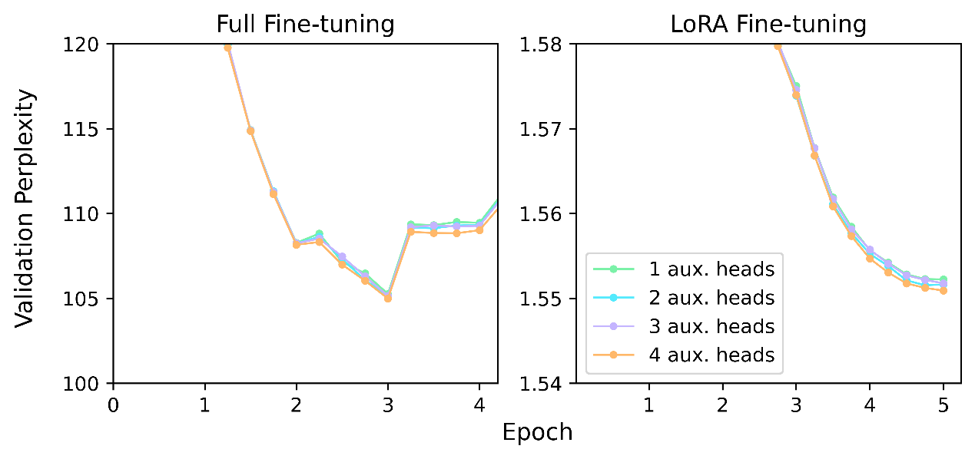
Supplementary Figure 2 | Validation perplexity over steps for de novo protein design full fine-tuning and molecule generation LoRA fine-tuning.

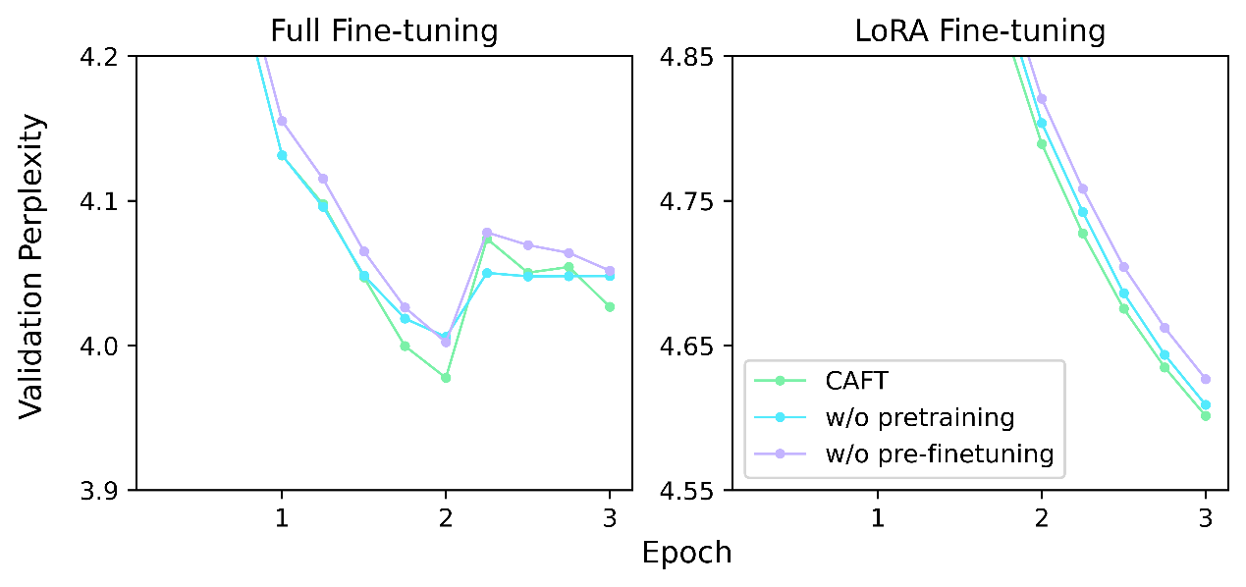
Supplementary Figure 3 | Validation perplexity over steps for BHC text summarization. This ablation examines training performance for (i) CAFT without auxiliary head training (see “w/o pretraining”), and (i) CAFT without fine-tuning the auxiliary heads for 1 epoch on the task dataset prior to the main training (see “w/o pre-finetuning”).
- Additional Background
Large language model optimization. LLMs are generally trained to predict the next token autoregressively: Given a sequence $x_{1:t}$, predict the next token $x_{t+1}$. The foundations of this approach were first introduced by a seminal work in 1948⁷, and have since grown to form the core of modern LLMs^{8,9}. The mechanism for model optimization is as follows: the model's raw outputs are passed through a softmax activation function to compute its probability distribution for the predicted $x_{t+1}$. It is then compared against the ground truth one-hot probability distribution to compute the cross-entropy loss, which is used to optimize the model weights through backpropagation. Modern LLMs are constructed based on the decoder-only Transformer architecture^{10,11}.
LLM training pipeline. There are generally two main phases of LLM training¹²: pretraining and post-training. During pretraining, models are trained on a massive text corpus in an unsupervised fashion. The goal is to teach language modeling skills and general knowledge. In practice, this phase is responsible for the majority of total compute used. The resulting models, such as DeepSeek V3¹³ and Llama3-8B-Base¹⁴, serve as "base" models for the next phase: post-training, where they are further trained on supervised datasets to learn specific skills and output formats. This is typically done via supervised fine-tuning and reinforcement learning¹⁵, where the former consumes the majority of the compute cost in this phase.
Downstream Fine-tuning. Importantly, foundational models are often further trained by industry practitioners and researchers to perform domain-specific tasks, such as math¹⁶, reasoning¹⁷, and even molecular generation¹⁸. However, because fine-tuning all model parameters may be too computationally expensive, parameter-efficient fine-tuning methods such as LoRA¹⁹ and QLoRA²⁰ were introduced.
Multi-token prediction. A growing body of literature finds that the next-token training paradigm performs poorly on lookahead tasks²¹ and compositional tasks²², and is highly inefficient relative to human children²³. In response, two existing works introduce multi-token training to the pretraining phase^{13,24}. Prior to our work, multi-token training in the post-training phase saw worse performance than the conventional next-token setting^{5,6}. Orthogonal to these works, several speculative decoding methods leverage multi-token prediction to serve as drafts for future tokens^{6,25}. Their primary purpose is to improve inference speed and generally observe minor performance degradation. Our proposed method, CAFT, builds upon both bodies of literature to unlock multi-token prediction's potential for fine-tuning.
Concept-based Learning. Several works have sought to incorporate concepts into neural networks. Concept bottleneck models are trained to predict human-labeled concepts, which are then used for final prediction; these are typically used for computer vision tasks^{26,27}. The Large Concept Model²⁸, defining sentences as concepts, performs next-sentence prediction in an embedding space. Finally, recent works on training LLMs to reason in continuous latent spaces^{29,30} also draw inspiration from conceptual thinking.

1. Yu, L. et al. MetaMath: Bootstrap Your Own Mathematical Questions for Large Language Models. Twelfth Int. Conf. Learn. Represent. (2024).
2. Lightman, H. et al. Let’s verify step by step. Twelfth Int. Conf. Learn. Represent. (2023).
3. Kortemme, T. De novo protein design—From new structures to programmable functions. Cell 187, 526–544 (2024).
4. Hardt, M., Recht, B. & Singer, Y. Train faster, generalize better: Stability of stochastic gradient descent. 33rd Int. Conf. Mach. Learn. 1225–1234 (2016).
5. Gloeckle, F., Idrissi, B. Y., Rozière, B., Lopez-Paz, D. & Synnaeve, G. Better & faster large language models via multi-token prediction. 41st Int. Conf. Mach. Learn. 15706–15734 (2024).
6. Cai, T. et al. Medusa: Simple LLM Inference Acceleration Framework with Multiple Decoding Heads. 41st Int. Conf. Mach. Learn. 5209–5235 (2024).
7. Shannon, C. E. A mathematical theory of communication. Bell Syst. Tech. J. 27, 379–423 (1948).
8. Devlin, J., Chang, M.-W., Lee, K. & Toutanova, K. Bert: Pre-training of deep bidirectional transformers for language understanding. Proc. 2019 Conf. North Am. Chapter Assoc. Comput. Linguist. Hum. Lang. Technol. ACL 1, 4171–4186 (2019).
9. Brown, T. et al. Language models are few-shot learners. Adv. Neural Inf. Process. Syst. 33, 1877–1901 (2020).
10. Vaswani, A. et al. Attention is all you need. Adv. Neural Inf. Process. Syst. 30, (2017).
11. Radford, A., Narasimhan, K., Salimans, T. & Sutskever, I. Improving language understanding by generative pre-training. (2018).
12. Li, J., Tang, T., Zhao, W. X., Nie, J.-Y. & Wen, J.-R. Pre-trained language models for text generation: A survey. ACM Comput. Surv. 56, 1–39 (2024).
13. Liu, A. et al. Deepseek-v3 technical report. ArXiv Prepr. ArXiv241219437 (2024).
14. Dubey, A. et al. The llama 3 herd of models. ArXiv E-Prints arXiv-2407 (2024).
15. Ouyang, L. et al. Training language models to follow instructions with human feedback. Adv. Neural Inf. Process. Syst. 35, 27730–27744 (2022).
16. Li, J. et al. Numinamath: The largest public dataset in ai4maths with 860k pairs of competition math problems and solutions. Hugging Face Repos. 13, 9 (2024).
17. Chen, M. K., Zhang, X. & Tao, D. Justlogic: A comprehensive benchmark for evaluating deductive reasoning in large language models. ArXiv Prepr. ArXiv250114851 (2025).
18. Fang, Y. et al. Mol-Instructions: A Large-Scale Biomolecular Instruction Dataset for Large Language Models. Twelfth Int. Conf. Learn. Represent. (2024).
19. Hu, E. J. et al. Lora: Low-rank adaptation of large language models. 10th Int. Conf. Learn. Represent. 1, 3 (2022).
20. Dettmers, T., Pagnoni, A., Holtzman, A. & Zettlemoyer, L. Qlora: Efficient finetuning of quantized llms. Adv. Neural Inf. Process. Syst. 36, 10088–10115 (2023).
21. Bachmann, G. & Nagarajan, V. The Pitfalls of Next-Token Prediction. 41st Int. Conf. Mach. Learn. 2296–2318 (2024).
22. Dziri, N. et al. Faith and fate: Limits of transformers on compositionality. Adv. Neural Inf. Process. Syst. 36, 70293–70332 (2023).
23. Frank, M. C. Bridging the data gap between children and large language models. Trends Cogn. Sci. 27, 990–992 (2023).
24. Gloeckle, F., Idrissi, B. Y., Rozière, B., Lopez-Paz, D. & Synnaeve, G. Better & faster large language models via multi-token prediction. ArXiv Prepr. ArXiv240419737 (2024).
25. Stern, M., Shazeer, N. & Uszkoreit, J. Blockwise parallel decoding for deep autoregressive models. Adv. Neural Inf. Process. Syst. 31, (2018).
26. Kumar, N., Berg, A. C., Belhumeur, P. N. & Nayar, S. K. Attribute and simile classifiers for face verification. IEEE 12th Int. Conf. Comput. Vis. 365–372 (2009).
27. Koh, P. W. et al. Concept bottleneck models. 37th Int. Conf. Mach. Learn. 5338–5348 (2020).
28. Barrault, L. et al. Large concept models: Language modeling in a sentence representation space. ArXiv Prepr. ArXiv241208821 (2024).
29. Hao, S. et al. Training large language models to reason in a continuous latent space. ArXiv Prepr. ArXiv241206769 (2024).
30. Zhang, Z. et al. Soft thinking: Unlocking the reasoning potential of llms in continuous concept space. ArXiv Prepr. ArXiv250515778 (2025).

