SUPPLEMENTARY MATERIALS
Bridge nucleic acid/DNA gapmers as inhibitors of gene expression by multiple antisense mechanisms

Angel J. Magaña, Kimberly Phan, Jesse Lopez, Maria S. Ramirez, Marcelo E. Tolmasky*

Center for Applied Biotechnology Studies, Department of Biological Science, College of Natural Sciences and Mathematics, California State University Fullerton, Fullerton, CA 92831, USA

Full length/uncropped gels

Figure 3
RNase P - RNAA
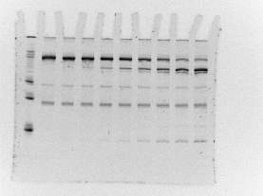

RNase P - LDAA
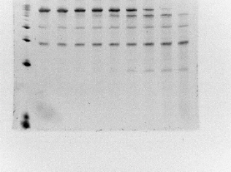

Figure 3 continued

RNase P – EDAA
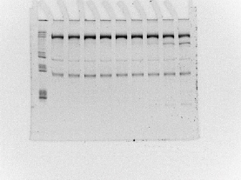

RNase P – BDAA
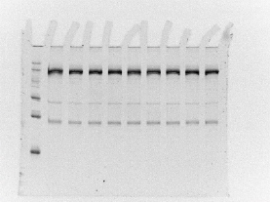
0 2 4 8 15 30 60 120 240

Figure 3 continued
RNase P – MDAA

RNase H – DNAA

Figure 3 continued
RNase H – LDAA
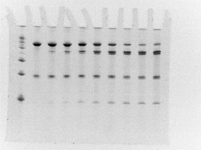

RNase H – EDAA

Figure 3 continued
RNase H – BDAA

RNase H – MDAA
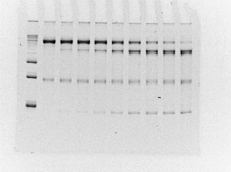

Figure 4
Panel A
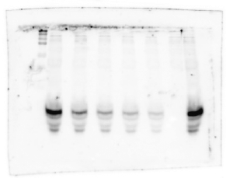

Panel B
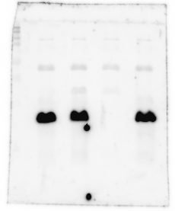

Panel C
