Additional file 5: Table S4. Conserved sequence of motifs for TaHsfs.

Motif | Logo | E-value | Sites | Width
1. | 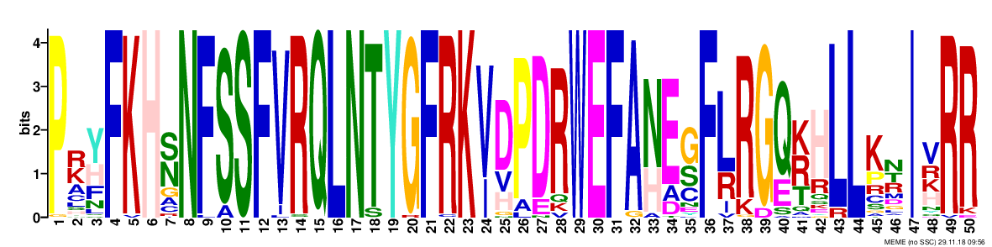 | 7.2e-2131 | 50 |  | 50
2. | 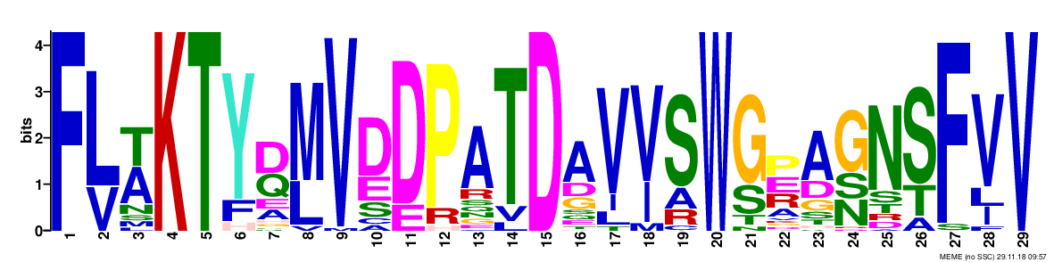 | 1.9e-965 | 50 |  | 29
3. | 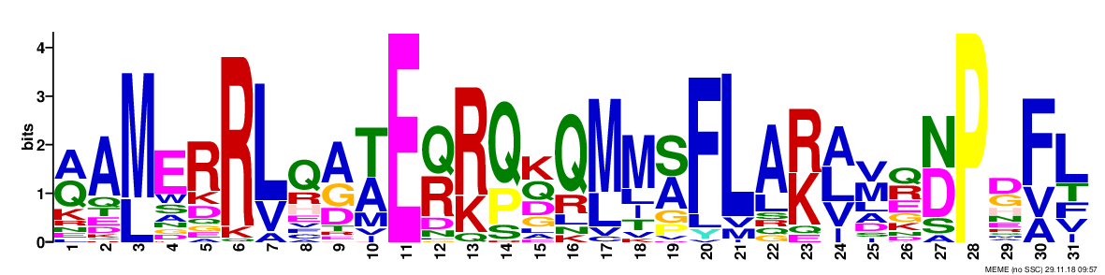 | 3.9e-578 | 46 |  | 31
4. | 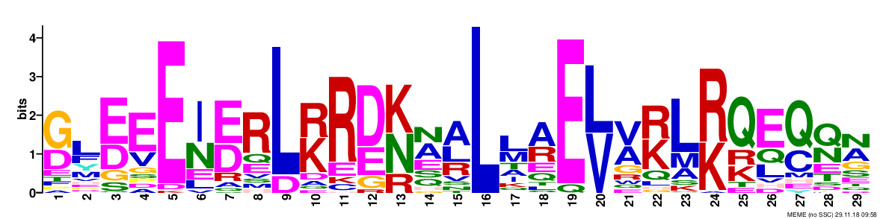 | 4.4e-505 | 49 |  | 29
5. | 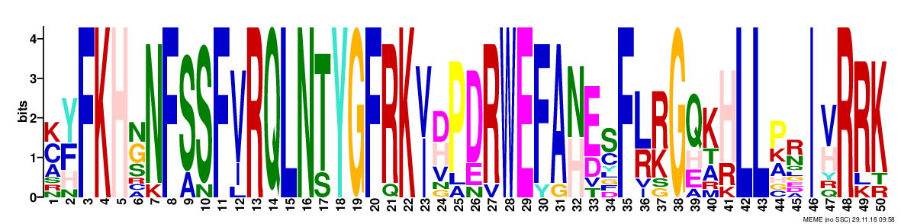 | 4.7e-316 | 11 |  | 50
6. | 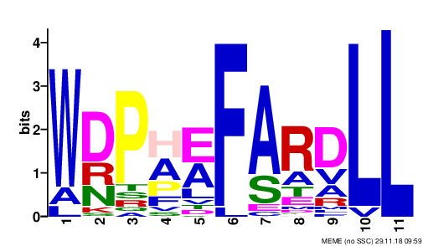 | 5.8e-191 | 50 |  | 11
7. | 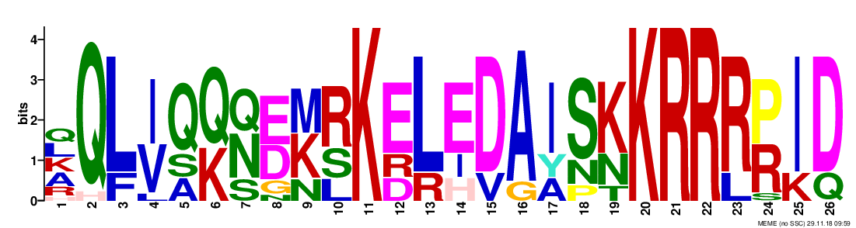 | 2.5e-178 | 15 |  | 26
8. | 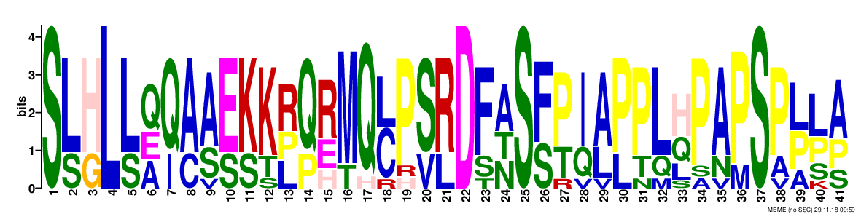 | 3.8e-169 | 11 |  | 41
9. | 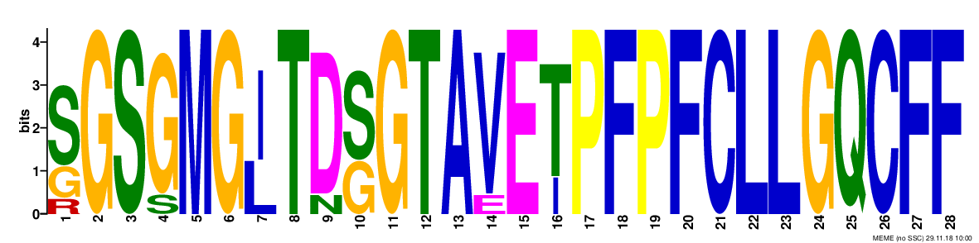 | 8.9e-131 | 8 |  | 28
10. | 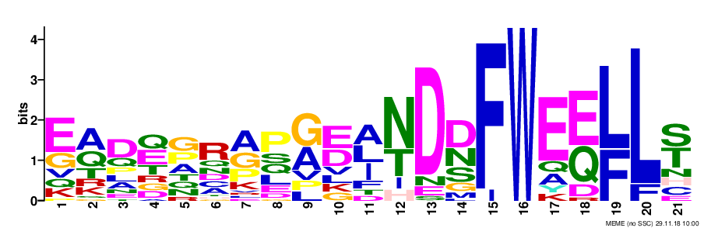 | 2.2e-124 | 26 |  | 21
11. | 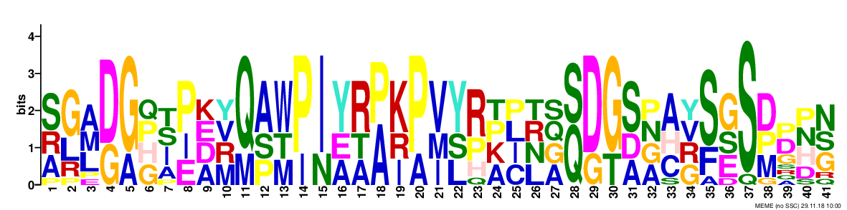 | 1.5e-122 | 12 |  | 41
12. | 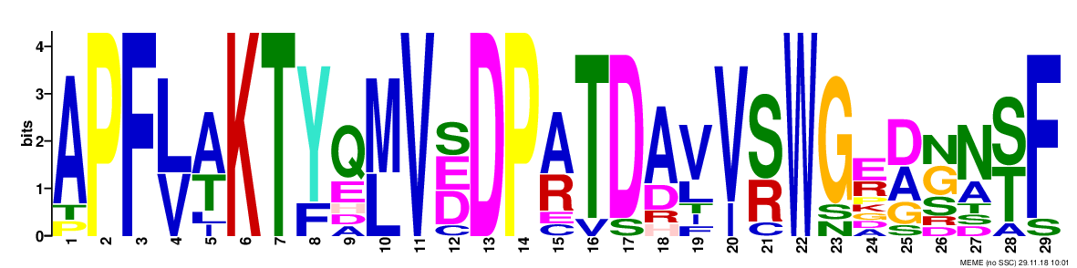 | 1.8e-110 | 10 |  | 29
13. | 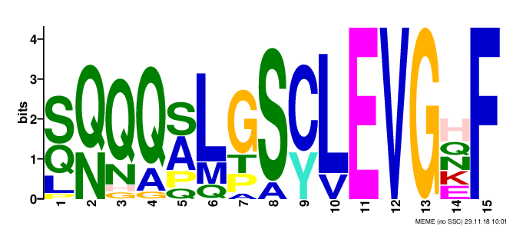 | 4.7e-101 | 17 |  | 15
14. | 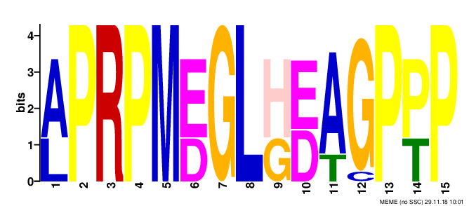 | 3.4e-098 | 14 |  | 15
15. | 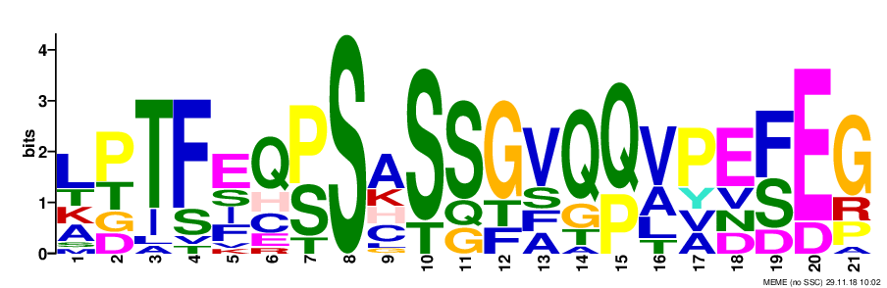 | 5.9e-083 | 17 |  | 21

