Supporting information of

Application of machine learning in high-throughput screening of binary alloys for the hydrogenation of benzene

Authors:
Zhili Chang ª, Guangquan Li ª, Wenjun Cai ª, Haolan Liu ^{b,*}, Guangcheng Zhang ^{c,*}, Weitao Ou ^{d,*}

ª Lanzhou Petrochemical Research Center, Petrochemical Research Institute, PetroChina, Lanzhou 730060, P. R. China.
^{b} Material Research Institute, Henan Academy of Sciences, Zhengzhou 450002, P. R. China.
^{c} Zhejiang Hengyi Petrochemical Research Institute Co., Ltd., Hangzhou 311200, P. R. China.
^{d} School of Chemistry, Sun Yat-sen University, Guangzhou 510275, P. R. China.

* Corresponding author
Weitao Ou & Guangcheng Zhang & Haolan Liu
Email: ouwt3@mail3.sysu.edu.cn (W. Ou) & ZhangGChem@163.com (G. Zhang) & haolan0128@163.com (H. Liu)
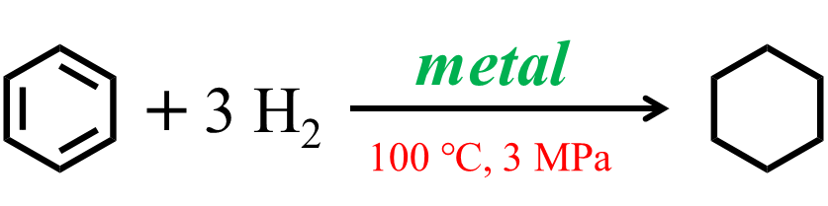
Scheme S1. The hydrogenation of benzene to cyclohexane.
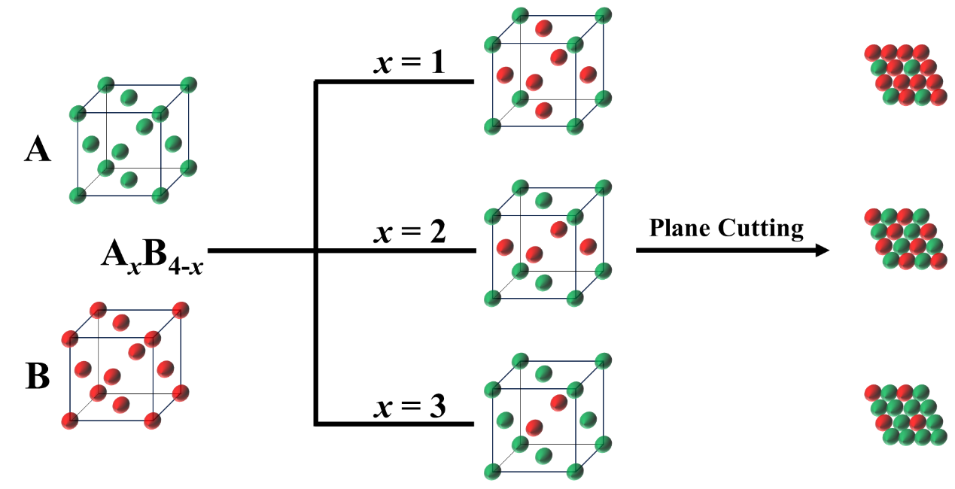
Fig. S1. Schematic diagram of A_{x}B_{4-x} alloy models.
Table S1. Physical and chemical properties of elements.
Element | N ª | M ^{b} | R/ nm ^{c} | S ^{d} | V ^{e} | X ^{f} | I/ eV ^{g} | E/ eV ^{h}
Ag | 47 | 107.9 | 0.134 | 47 | 11 | 1.93 | 731 | 125.62
Al | 13 | 26.98 | 0.118 | 13 | 3 | 1.61 | 577.5 | 41.76
Au | 79 | 197 | 0.134 | 79 | 11 | 2.54 | 890.1 | 222.75
Bi | 83 | 209 | 0.146 | 83 | 5 | 2.02 | 703 | 90.92
Ca | 20 | 40.08 | 0.174 | 20 | 2 | 1 | 589.8 | 2.37
Cd | 48 | 112.4 | 0.148 | 48 | 12 | 1.69 | 867.8 | -68
Co | 27 | 58.93 | 0.116 | 27 | 9 | 1.88 | 760.4 | 63.87
Cr | 24 | 52 | 0.118 | 24 | 6 | 1.66 | 652.9 | 65.21
Cu | 29 | 63.55 | 0.117 | 29 | 11 | 1.9 | 745.5 | 119.16
Fe | 26 | 55.85 | 0.117 | 26 | 8 | 1.83 | 762.5 | 14.57
Ga | 31 | 69.72 | 0.126 | 31 | 3 | 1.81 | 578.8 | 29.06
Ge | 32 | 72.61 | 0.122 | 32 | 4 | 2.01 | 762 | 118.9
In | 49 | 114.8 | 0.144 | 49 | 3 | 1.78 | 558.3 | 37.04
Ir | 77 | 192.2 | 0.127 | 77 | 9 | 2.2 | 880 | 150.88
Mg | 12 | 24.31 | 0.136 | 12 | 2 | 1.31 | 737.7 | -40
Mn | 25 | 54.94 | 0.117 | 25 | 7 | 1.55 | 717.3 | -50
Mo | 42 | 95.94 | 0.130 | 42 | 6 | 2.16 | 684.3 | 72.1
Nb | 41 | 92.91 | 0.134 | 41 | 5 | 1.6 | 652.1 | 88.51
Ni | 28 | 58.69 | 0.115 | 28 | 10 | 1.91 | 737.1 | 111.54
Pb | 82 | 207.2 | 0.147 | 82 | 4 | 2.33 | 715.6 | 34.41
Pd | 46 | 106.4 | 0.128 | 46 | 10 | 2.2 | 804.4 | 54.22
Pt | 78 | 195.1 | 0.130 | 78 | 10 | 2.28 | 870 | 205.32
Re | 75 | 186.2 | 0.128 | 75 | 7 | 1.9 | 760 | 5.82
Rh | 45 | 102.9 | 0.125 | 45 | 9 | 2.28 | 719.7 | 109.7
Ru | 44 | 101.1 | 0.125 | 44 | 8 | 2.2 | 710.2 | 101.31
Sb | 51 | 121.8 | 0.140 | 51 | 5 | 2.05 | 834 | 101.05
Sc | 21 | 44.96 | 0.144 | 21 | 3 | 1.36 | 633.1 | 18
Sn | 50 | 118.7 | 0.140 | 50 | 4 | 1.96 | 708.6 | 107.2
Tc | 43 | 99 | 0.127 | 43 | 7 | 1.9 | 702 | 53
Ti | 22 | 47.87 | 0.132 | 22 | 4 | 1.54 | 658.8 | 7.28
V | 23 | 50.94 | 0.122 | 23 | 5 | 1.63 | 650.9 | 50.91
W | 74 | 183.8 | 0.130 | 74 | 6 | 2.36 | 770 | 78.76
Y | 39 | 88.91 | 0.162 | 39 | 3 | 1.22 | 600 | 29.6
Zn | 30 | 65.39 | 0.125 | 30 | 12 | 1.65 | 906.4 | -58
Zr | 40 | 91.22 | 0.145 | 40 | 4 | 1.33 | 640.1 | 41.8
ª N represents atomic number.
^{b} M represents relative atomic mass.
^{c} R represents atomic radius.
^{d} S represents the number of outer electrons.
^{e} V represents the number of valence electrons.
^{f} X represents electronegativity.
^{g} I represents the first ionization energy.
^{h} E represents the first electron affinity.
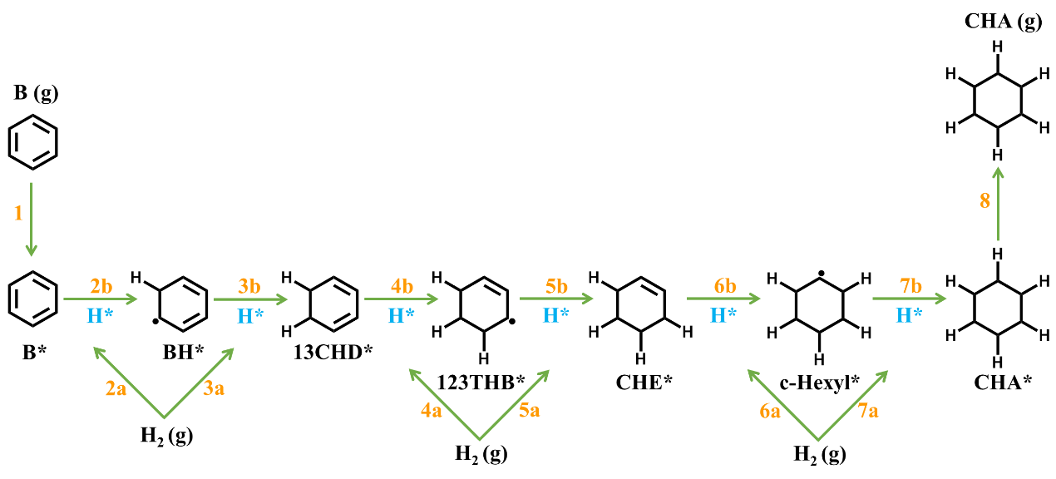
Scheme S2. Reaction pathway of benzene hydrogenation.

According to the literature, the hydrogenation of benzene on metal catalysts primarily follows the Horiuti-Polanyi process. First, benzene and hydrogen are co-adsorbed on the catalyst surface, with ΔE_{B} and ΔE_{H} representing the adsorption energies for benzene and hydrogen on the surface, respectively (see steps 1 and 2a in Scheme S1). And then, two dissociated hydrogens attack activated benzene (B*) at one of its conjugated π bonds, forming 1,3-cyclohexadiene (13CHD*) (see steps 2b and 3b in Scheme S1). Afterwards, two dissociated hydrogens attack another conjugated π bond of 13CHD*, resulting in cyclohexene (CHE*) (see steps 4b and 5b in Scheme S1). Subsequently, two more dissociated hydrogens attack the rest of conjugated π bond of CHE*, generating activated cyclohexane (CHA*). Finally, CHA* desorbs to yield stable cyclohexane (CHA).
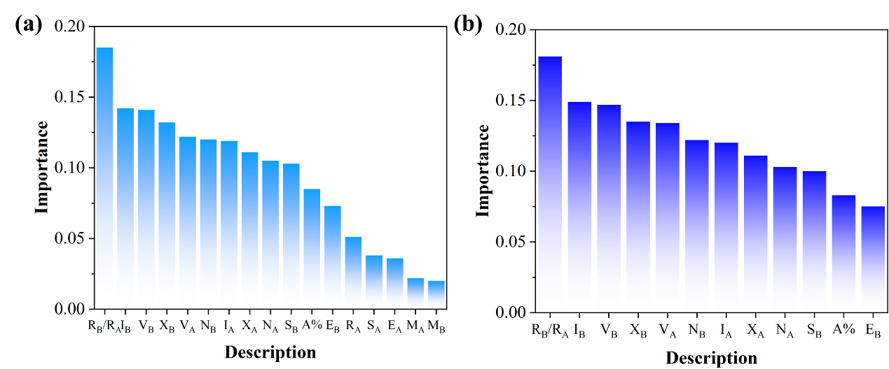
Fig. S2. Descriptor importance in varied models of the adsorption energy of hydrogen (a) before and (b) after descriptor reduction.

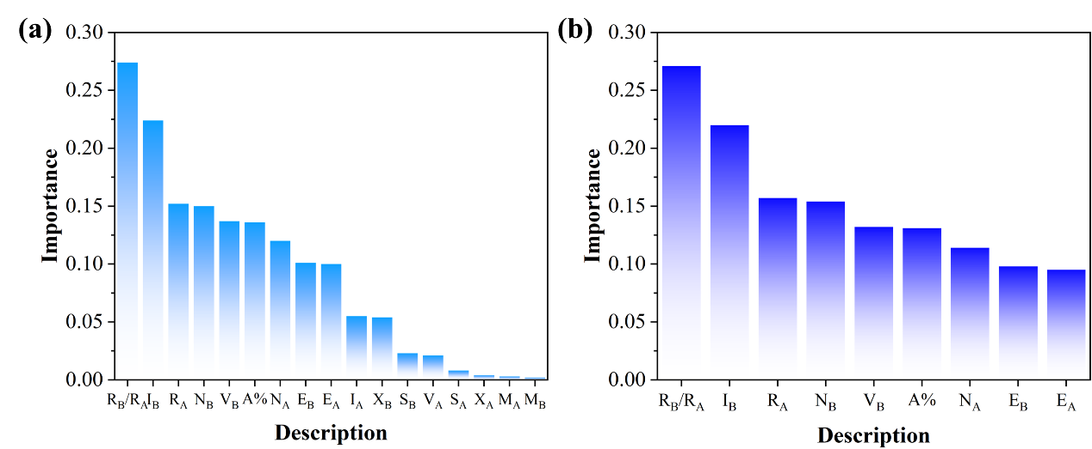
Fig. S3. Descriptor importance in varied models of the adsorption energy of hydrogen (a) before and (b) after descriptor reduction.
Table S2. Hyperparameter of LGBM model.
Data set | Learning rate | Iterations | Number of evaluators
ΔE_{B} | 0.01 | 1200 | 100
ΔE_{H} | 0.1 | 600 | 100

Table S3. Hyperparameter of XGBT model.
Data set | Learning rate | Iterations | Number of evaluators
ΔE_{B} | 0.1 | 600 | 80
ΔE_{H} | 0.1 | 600 | 80

Table S4. Hyperparameter of MLP model.
Data set | Learning rate | Hidden layer parameter | Optimizer | Activation function
ΔE_{B} | 0.01 | (15, 26, 18) | Adam | tanh
ΔE_{H} | 0.02 | (15, 26, 18) | Adam | tanh

Table S5. Hyperparameter of SVM model.
Data set | Kernel function | Penalty parameter | Gamma value
ΔE_{B} | rbf | 3 | 1
ΔE_{H} | rbf | 3 | 1

