Supporting Information
Thamina Acterª, Tony Thomas Nokrek^{b}, Md. Masud Rana^{b}, Durjoy Chakraborty^{b}, M H M Imrul Kabirª, Md Al-Mamun^{b, c}, Md Shahedul Islam^{b}, Kamarun Monira Mow^{d}, Nizam Uddin^{b*}

ª Department of Mathematical and Physical Sciences, East West University, A/2, Jahurul Islam Avenue, Jahurul Islam City, Aftabnagar, Dhaka 1212, Bangladesh
^{b} Department of Nutrition and Food Engineering, Daffodil International University, Daffodil Smart City (DSC), Birulia, Savar, Dhaka 1216, Bangladesh
^{c} Materials Science Division, Atomic Energy Centre Dhaka-1000, Bangladesh
^{d} Department of Computer Science and Engineering, East West University, A/2, Jahurul Islam Avenue, Jahurul Islam City, Aftabnagar, Dhaka 1212, Bangladesh

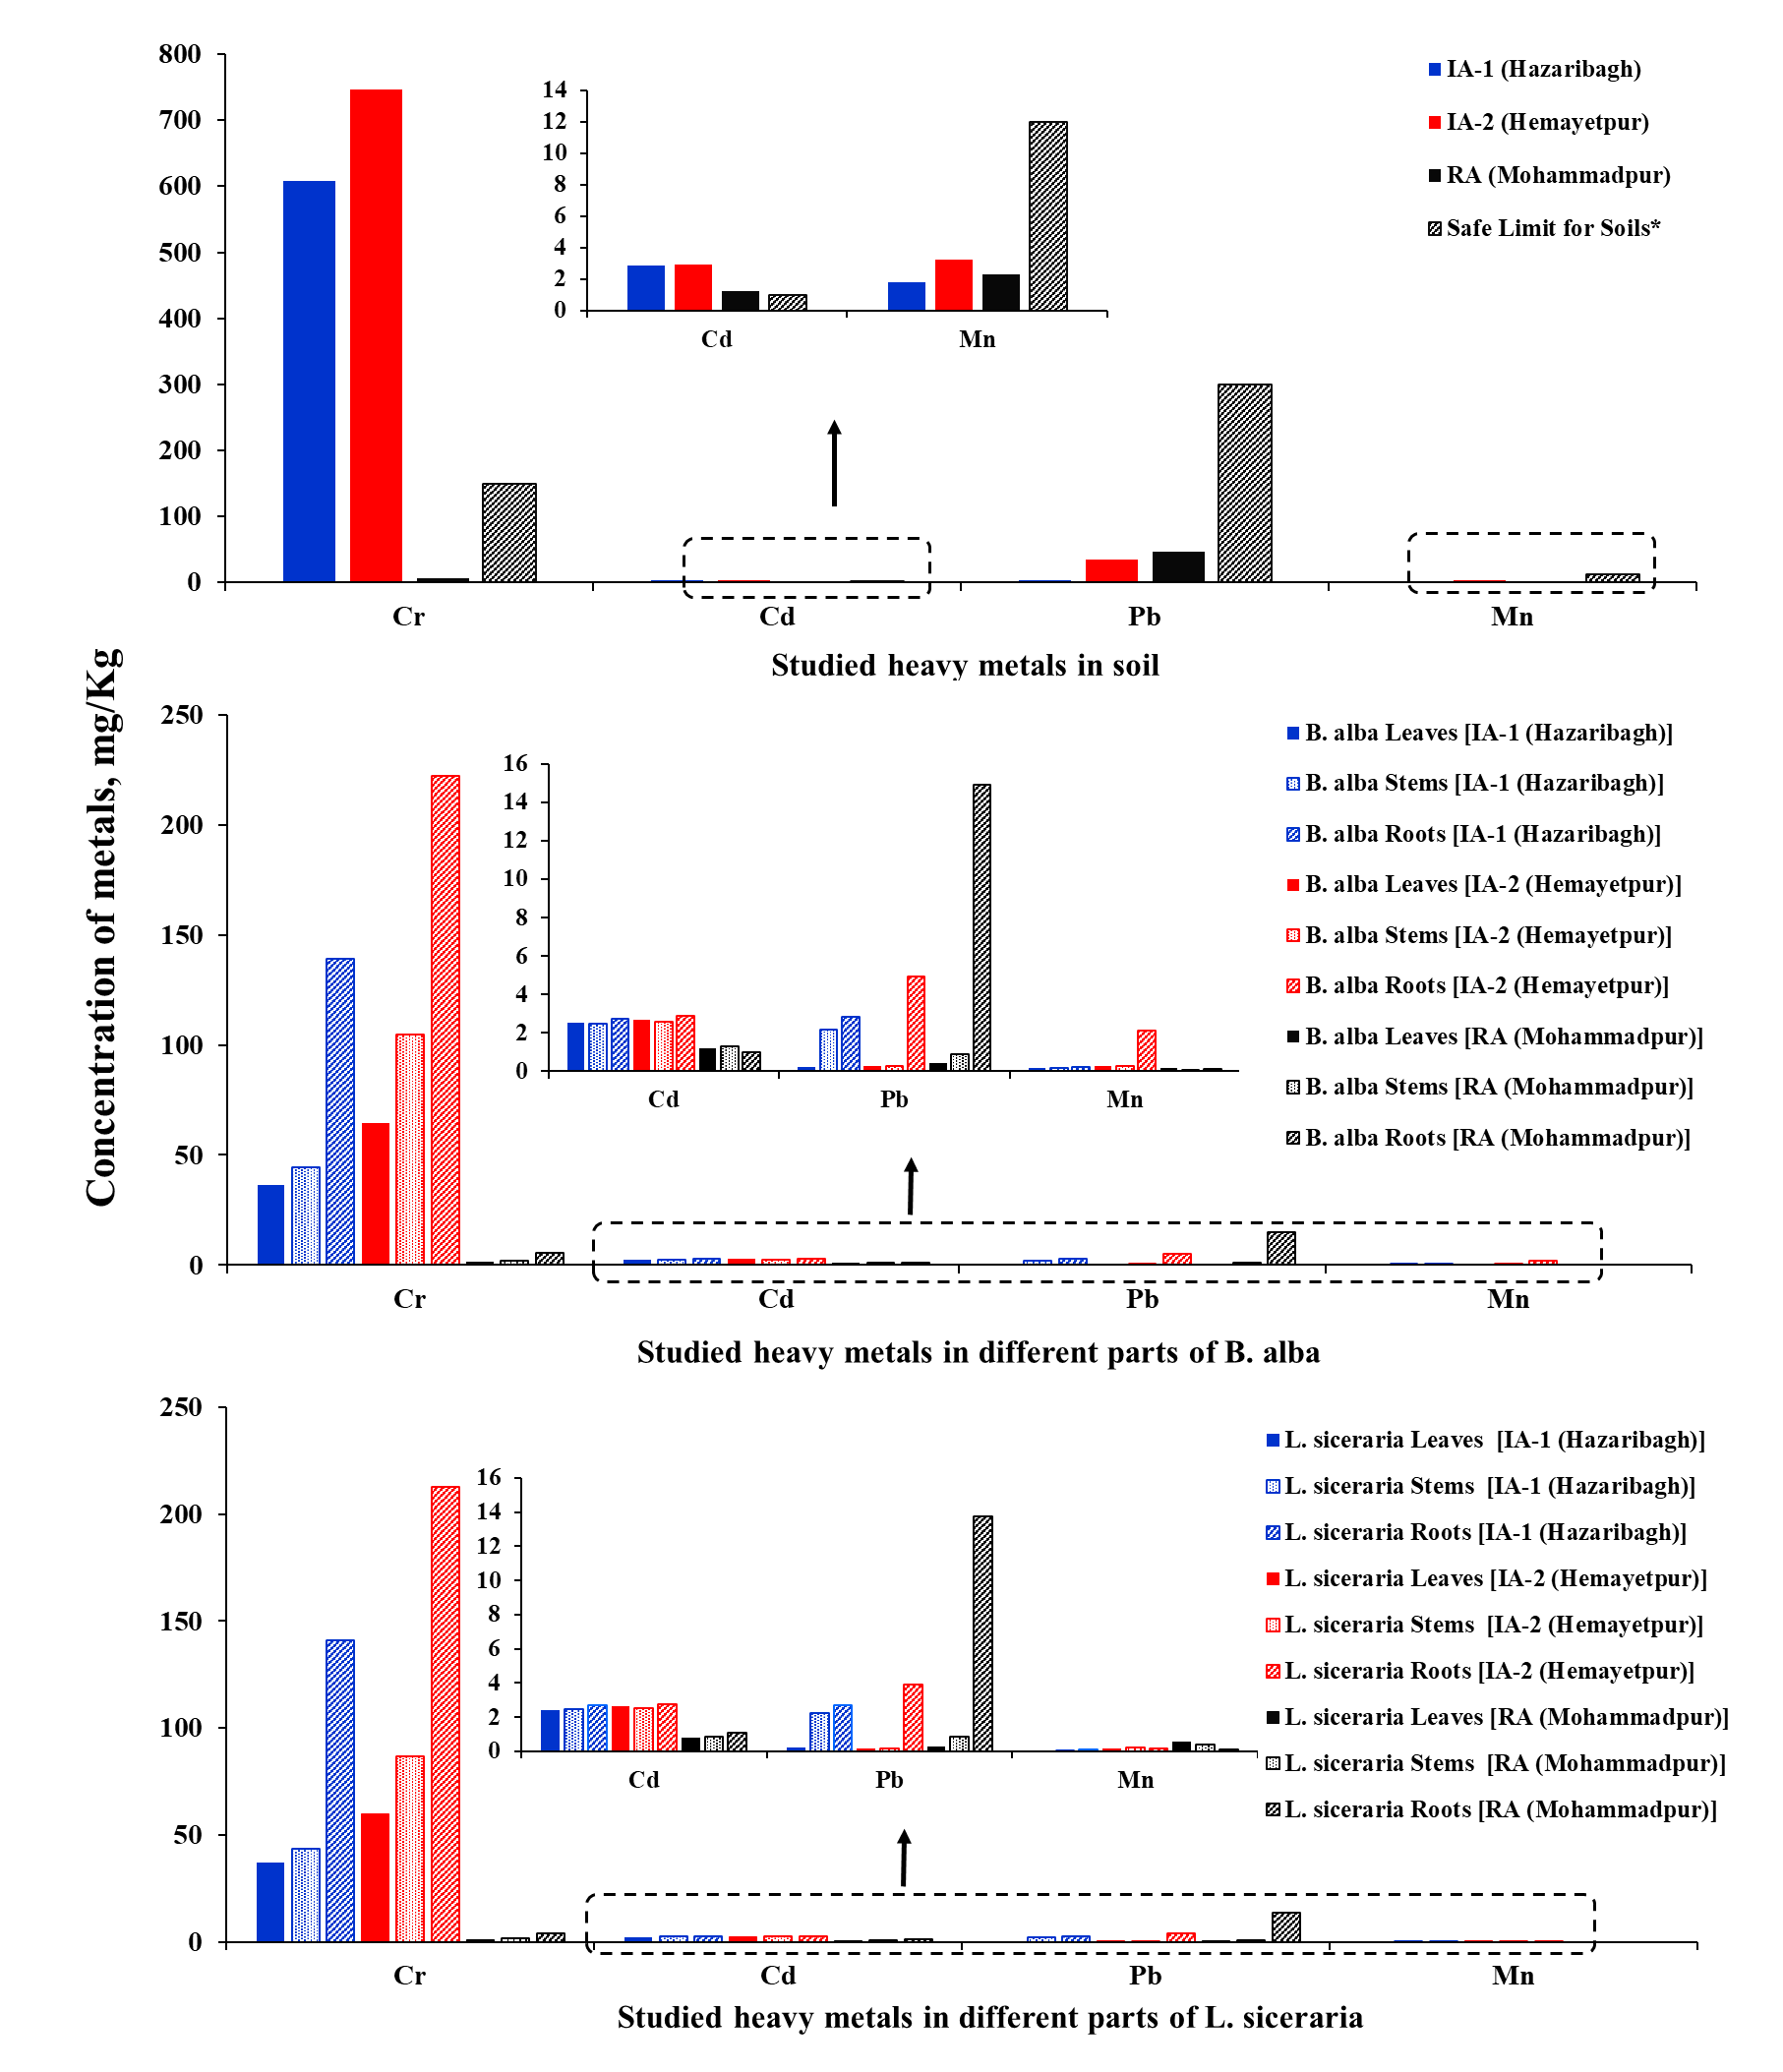
Figure S1: Concentration of four heavy metals (mg/Kg) measured in soil-vegetable systems of the studied areas.

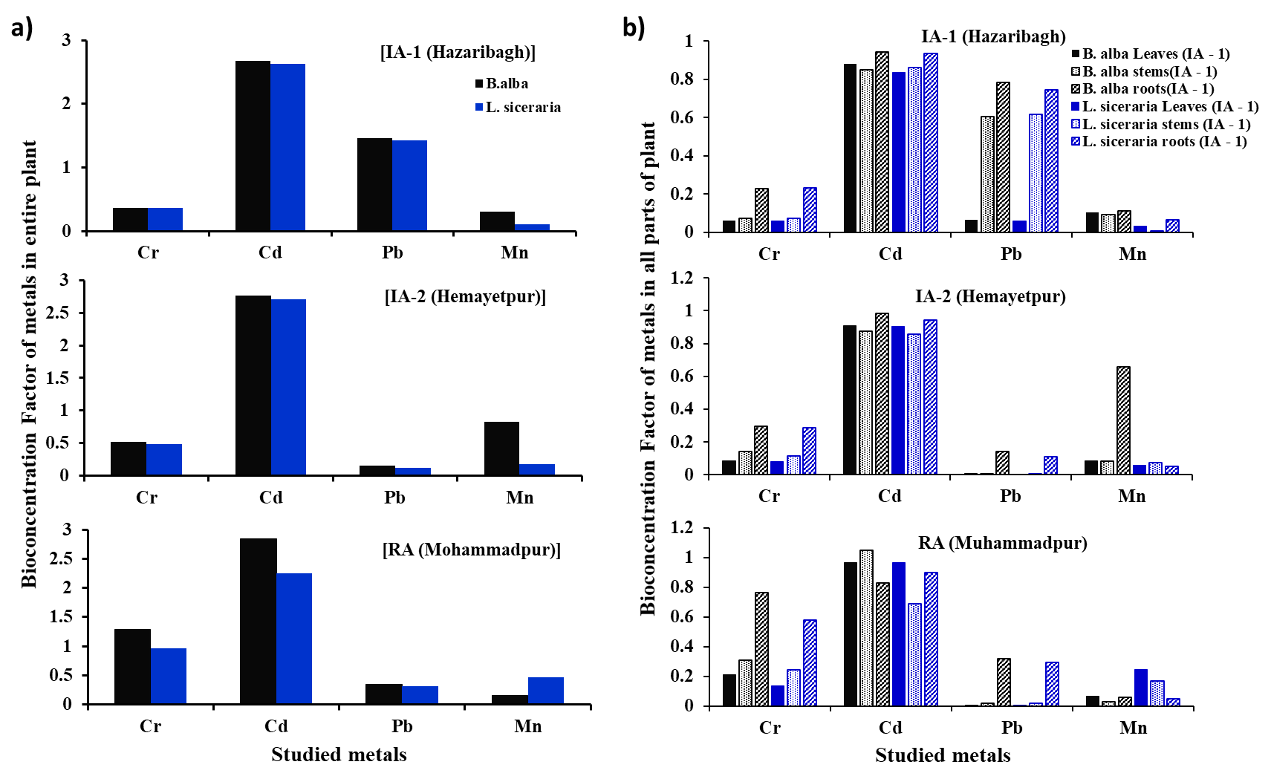
Figure S2: Assessment of bioaccumulation of the studied plants, a) the whole plant b) different portions of the plants, in the three studied areas.
Table S1: Introductory information of Input parameters for calculating health hazard indices.
Definition | Values
Exposure frequency (EF), days/ year | 350
Exposure duration (ED), years | 30
Exposure time (ET), h/day | 24
Averaging time for non-carcinogens (AT), days | 365 × ED
Averaging time for carcinogens (AT), days | 365 × 70
Body weight of exposed individual (BW), kg | 70
Exposed skin surface area (SA), cm² | 5700
Soil-to-skin adherence factor (AF), mg/cm²/h | 0.07
Dermal absorption fraction (ABS), Unitless | 0.001
Particle emission factor (PEF), m³ /kg | 1.36 × 10⁹
Unit’s conversion factor (CF), kg/mg | 1 × 10⁻⁶
Ingestion rate of soil (IRS), mg/day | 100
Ingestion rate of vegetables (IR_{vegetable}), kg/d | 0.345
Inhalation rate of soil (IR_{inh}), m³ /day | 12.8

Table S2: Summary of reference values for calculation of non-carcinogenic risk through oral, dermal, inhalation and diet pathways.
Studied metals | oral ingestion RfD, mg/kg of body weight per day (mg/kg bw/day) | Dermal Reference Dose (RfD), mg/kg/day | Inhalation Reference Concentration (RfC) values, mg/m³ | diet RfD values, mg/kg
Cr | 0.002 | 0.003 | 0.0002 | 0.025
Cd | 0.001 | 0.0002 | 0.0002 | 0.0175
Pb | 0.0035 | 0.0006 | 0.0005 | 0.025
Mn | 2 | 0.04 | 0.05 | 0.714

Table S3: Summary of reference values for calculation of carcinogenic risk through oral, dermal, inhalation and diet pathways.
Studied metals | oral slope factor for ingestion exposure (SF_{ing}) (mg/kg/day)⁻¹ | oral slope factor for diet exposure (SF_{diet}) (mg/kg/day)-1 | Inhalation unit risk (IUR) values m³/µg | Gastrointestinal absorption factor, ABS_{GI}
Cr | 0.04 | 0.0025 | 0.000005 | 0.013
Cd | 0.005 | 0.0016 | 0.00004 | 0.025
Pb | 0.0085 | 0.0085 | 0.000013 | 1
Mn | 0.12 | 0.027 | 0.00002 | N/A

Table S4: Non-carcinogenic risks (HQ) associated with the studied metals in IA soil-vegetable systems through four exposure pathways.
Risk Factor | Heavy metal | Pathways | Ingestion soil | dermal soil | Inhale soil | Diet
[IA-1 (Hazaribagh)] | Cr | Risk | 0.178629159 | 0.000475154 | 0.000168122 | 6.538121
[IA-1 (Hazaribagh)] | Cr | Contribution (%) | 2.659203328 | 0.007073481 | 0.00250278 | 97.33122
[IA-1 (Hazaribagh)] | Cd | Risk | 0.001696673 | 3.38486E-05 | 7.98434E-07 | 0.573489
[IA-1 (Hazaribagh)] | Cd | Contribution (%) | 0.294960601 | 0.005884464 | 0.000138805 | 99.69902
[IA-1 (Hazaribagh)] | Pb | Risk | 0.000602181 | 1.40158E-05 | 3.96731E-07 | 0.196468
[IA-1 (Hazaribagh)] | Pb | Contribution (%) | 0.305544677 | 0.007111552 | 0.0002013 | 99.68714
[IA-1 (Hazaribagh)] | Mn | Risk | 5.31311E-07 | 1.05997E-07 | 2.00023E-09 | 0.000617
[IA-1 (Hazaribagh)] | Mn | Contribution (%) | 0.086023809 | 0.01716175 | 0.000323854 | 99.89649
[IA-2 (Hemayetpur)] | Cr | Risk | 0.21896184 | 0.000582438 | 0.000206082 | 12.78823
[IA-2 (Hemayetpur)] | Cr | Contribution (%) | 1.683289156 | 0.004477549 | 0.001584272 | 98.31065
[IA-2 (Hemayetpur)] | Cd | Risk | 0.001720157 | 3.43171E-05 | 8.09485E-07 | 0.601266
[IA-2 (Hemayetpur)] | Cd | Contribution (%) | 0.285256158 | 0.00569086 | 0.000134238 | 99.70892
[IA-2 (Hemayetpur)] | Pb | Risk | 0.005949679 | 0.000138479 | 3.91979E-06 | 0.036863
[IA-2 (Hemayetpur)] | Pb | Contribution (%) | 13.85092755 | 0.322380339 | 0.009125317 | 85.81757
[IA-2 (Hemayetpur)] | Mn | Risk | 9.48141E-07 | 1.89154E-07 | 3.56947E-09 | 0.001362
[IA-2 (Hemayetpur)] | Mn | Contribution (%) | 0.069573953 | 0.013880004 | 0.000261925 | 99.91628
[RA (Mohammadpur)] | Cr | Risk | 0.002043053 | 5.43452E-06 | 1.92287E-06 | 0.25318
[RA (Mohammadpur)] | Cr | Contribution (%) | 0.800473785 | 0.00212926 | 0.000753387 | 99.19664
[RA (Mohammadpur)] | Cd | Risk | 0.000716243 | 1.4289E-05 | 3.37055E-07 | 0.237845
[RA (Mohammadpur)] | Cd | Contribution (%) | 0.300216438 | 0.005989318 | 0.000141278 | 99.69365
[RA (Mohammadpur)] | Pb | Risk | 0.007858541 | 0.000182908 | 5.17739E-06 | 0.098841
[RA (Mohammadpur)] | Pb | Contribution (%) | 7.352118458 | 0.171120557 | 0.004843749 | 92.47192
[RA (Mohammadpur)] | Mn | Risk | 6.75147E-07 | 1.34692E-07 | 2.54173E-09 | 0.001665
[RA (Mohammadpur)] | Mn | Contribution (%) | 0.040525374 | 0.008084812 | 0.000152566 | 99.95124

Table S5: Carcinogenic risks (CR) associated with the studied metals in IA soil- vegetable systems through four exposure pathways.
Risk Factor | Heavy metal | Pathways | Ingestion soil | dermal soil | Inhale soil | Diet
[IA-1 (Hazaribagh)] | Cr | Risk | 1.42903E-05 | 4.38603E-06 | 1.68122E-13 | 0.000409
[IA-1 (Hazaribagh)] |  | Contribution (%) | 3.34426244 | 1.026431318 | 3.93443E-08 | 95.62931
[IA-1 (Hazaribagh)] | Cd | Risk | 8.48337E-09 | 1.35395E-09 | 6.38748E-15 | 1.61E-05
[IA-1 (Hazaribagh)] |  | Contribution (%) | 0.052798202 | 0.008426593 | 3.97539E-08 | 99.93878
[IA-1 (Hazaribagh)] | Pb | Risk | 1.79149E-08 | 7.14803E-11 | 2.57875E-15 | 4.17E-05
[IA-1 (Hazaribagh)] |  | Contribution (%) | 0.042892025 | 0.000171139 | 6.17408E-09 | 99.95694
[IA-1 (Hazaribagh)] | Mn | Risk | 1.27515E-07 | 5.08784E-10 | 2.00023E-15 | 1.19E-05
[IA-1 (Hazaribagh)] |  | Contribution (%) | 1.060640529 | 0.004231956 | 1.66375E-08 | 98.93513
[IA-2 (Hemayetpur)] | Cr | Risk | 1.75169E-05 | 5.37636E-06 | 2.06082E-13 | 0.000799
[IA-2 (Hemayetpur)] |  | Contribution (%) | 2.130607575 | 0.653932632 | 2.5066E-08 | 97.21546
[IA-2 (Hemayetpur)] | Cd | Risk | 8.60078E-09 | 1.37268E-09 | 6.47588E-15 | 1.68E-05
[IA-2 (Hemayetpur)] |  | Contribution (%) | 0.051057059 | 0.008148707 | 3.8443E-08 | 99.94079
[IA-2 (Hemayetpur)] | Pb | Risk | 1.77003E-07 | 7.06242E-10 | 2.54786E-14 | 7.83E-06
[IA-2 (Hemayetpur)] |  | Contribution (%) | 2.209471158 | 0.00881579 | 3.18042E-07 | 97.78171
[IA-2 (Hemayetpur)] | Mn | Risk | 2.27554E-07 | 9.0794E-10 | 3.56947E-15 | 2.62E-05
[IA-2 (Hemayetpur)] |  | Contribution (%) | 0.859401656 | 0.003429013 | 1.34808E-08 | 99.13717
[RA (Mohammadpur)] | Cr | Risk | 1.63444E-07 | 5.01648E-08 | 1.92287E-15 | 1.58E-05
[RA (Mohammadpur)] |  | Contribution (%) | 1.019146617 | 0.312799616 | 1.199E-08 | 98.66805
[RA (Mohammadpur)] | Cd | Risk | 3.58121E-09 | 5.71562E-10 | 2.69644E-15 | 6.66E-06
[RA (Mohammadpur)] |  | Contribution (%) | 0.053741304 | 0.008577112 | 4.0464E-08 | 99.93768
[RA (Mohammadpur)] | Pb | Risk | 2.33792E-07 | 9.32828E-10 | 3.3653E-14 | 2.1E-05
[RA (Mohammadpur)] |  | Contribution (%) | 1.100789318 | 0.004392149 | 1.58453E-07 | 98.89482
[RA (Mohammadpur)] | Mn | Risk | 1.62035E-07 | 6.46521E-10 | 2.54173E-15 | 3.21E-05
[RA (Mohammadpur)] |  | Contribution (%) | 0.502218576 | 0.002003852 | 7.87794E-09 | 99.49578
Table S6: Rotated factor loadings (Varimax normalized) of studied samples.
Parameter | IA-1 |  | IA-2 |  | RA
Parameter | PC1 | PC2 | PC1 | PC2 | PC1 | PC2 | PC3
Cr | -0.53 | -0.31 | -0.51 | -0.37 | -0.55 | -0.001 | -0.68
Cd | -0.51 | 0.17 | -0.47 | 0.78 | -0.3 | -0.92 | 0.27
Pb | -0.44 | 0.77 | -0.51 | -0.48 | -0.59 | 0.13 | -0.08
Mn | -0.5 | -0.52 | -0.51 | 0.13 | -0.51 | 0.38 | 0.68
Standard Deviation | 1.81 | 0.72 | 1.88 | 0.58 | 1.67 | 0.93 | 0.58
Proportion of variation | 82.49% | 13.04% | 88.57% | 8.52% | 69.55% | 21.77% | 8.54%
Cumulative proportion | 82.49% | 95.53% | 88.57% | 97.09% | 69.55% | 91.33% | 99.87%

