Appendix
Trimethylamine N-oxide (TMAO) as a prognostic marker among patients at nutritional risk
A secondary analysis of the randomized clinical trial EFFORT

Adina Stern^{1*}, Carla Wunderle^{1*}, Pascal Tribolet^{1,3,4}, Peter J. Neyer⁵, Luca Bernasconi⁵, Zeno Stanga ⁶, Beat Mueller^{1,2}, and Philipp Schuetz^{1,2}

¹Medical University Department, Division of General Internal and Emergency Medicine, Division of Endocrinology, Diabetes and Metabolism, Kantonsspital Aarau, 5001 Aarau, Switzerland
²Medical Faculty of the University of Basel, 4056 Basel, Switzerland
³Department of Health Professions, Bern University of Applied Sciences, 3008 Bern, Switzerland
⁴Department of Nutritional Sciences, Faculty of Life Sciences, University of Vienna, Josef-Holaubek-Platz 2, 1090 Vienna, Austria
⁵Institute of Laboratory Medicine, Kantonsspital Aarau, 5001 Aarau, Switzerland
⁶Division of Diabetes, Endocrinology, Nutritional Medicine and Metabolism, Bern University Hospital and University of Bern, 3010 Bern, Switzerland
*equally contributing first authors
Correspondence: schuetzph@gmail.com

Keywords: TMAO, carnitine, choline, mortality, MACE, nutritional support, clinical outcomes, polymorbid medical inpatient
Corresponding author & requests for reprints: Philipp Schuetz, Medical University Department, Division of General Internal and Emergency Medicine, Kantonsspital Aarau, Tellstrasse 25, 5001 Aarau, Switzerland, schuetzph@gmail.com
Clinical trial registration: clinicaltrials.gov as NCT02517476 (registered 7 August 2015)
Tables

Supplemental Table A.1 Baseline characteristics demonstrating the main EFFORT population, and stratified by population not included in this analysis and included in TMAO analysis 3

Supplemental Table A.2 Association of baseline characteristics with TMAO concentrations at time of admission 4

Supplemental Table A.3 Association of nutritional baseline characteristics with TMAO concentrations at time of admission 5

Supplemental Table A.4 Associations of carnitine concentration with all-cause mortality and major cardiovascular events (MACE) 6

Supplemental Table A.5 Associations of choline concentration with all-cause mortality and major cardiovascular events (MACE) 7

Figures

Supplemental Figure A.1 Study Flow Chart 8

Supplemental Figure A.2 Kaplan Meier survival analysis regarding TMAO quartiles and time to death within 5 years 9

Supplemental Figure A.3 Forest plot for the effect of nutritional therapy on major adverse cardiovascular events (MACE) 10

Supplemental Table A.1 Baseline characteristics demonstrating the main EFFORT population, and stratified by population not included in this analysis and included in TMAO analysis

Supplemental Table A.1
Baseline characteristics demonstrating the main EFFORT population, and stratified by population not included in this analysis and included in TMAO analysis

 |  | Overall EFFORT population | EFFORT population not included in subanalysis | TMAO subanalysis group | p-valueª
Sociodemographics
 | Patient number, n | 2028 | 1810 | 218
 | Male sex, n | 1064 (52.5%) | 939 (51.9%) | 125 (57.3%) | 0.13
 | Age years, mean (SD) | 72.6 (14.1) | 72.5 (14.1) | 73.4 (13.6) | 0.34
Nutritional assessment
 | BMI, mean (SD), kg/m² | 24.8 (5.3) | 24.8 (5.4) | 24.4 (5.0) | 0.24
 | Weight at admission, mean (SD), kg | 70.9 (16.7) | 71.0 (16.8) | 69.8 (15.1) | 0.45
NRS total score, n
 | 3 | 624 (30.8%) | 567 (31.3%) | 57 (26.1%) | 0.002
 | 4 | 775 (38.2%) | 702 (38.8%) | 73 (33.5%)
 | 5 | 524 (25.8%) | 444 (24.5%) | 80 (36.7%)
 | ≥6 | 105 (5.2%) | 97 (5.4%) | 8 (3.7%)
Intervention group, n |  | 1015 (50.0%) | 910 (50.3%) | 105 (48.2%) | 0.56
Main diagnosis, n
 | Infection | 613 (30.2%) | 552 (30.5%) | 61 (28.0%) | 0.44
 | Cancer | 374 (18.4%) | 306 (16.9%) | 68 (31.2%) | <0.001
 | Cardiovascular disease | 205 (10.1%) | 183 (10.1%) | 22 (10.1%) | 0.99
 | Frailty | 194 (9.6%) | 182 (10.1%) | 12 (5.5%) | 0.031
 | Lung disease | 125 (6.2%) | 116 (6.4%) | 9 (4.1%) | 0.19
 | Gastrointestinal disease | 164 (8.1%) | 152 (8.4%) | 12 (5.5%) | 0.14
 | Neurological disorders | 95 (4.7%) | 92 (5.1%) | 3 (1.4%) | 0.014
 | Renal disease | 68 (3.4%) | 53 (2.9%) | 15 (6.9%) | 0.002
 | Metabolic disease | 62 (3.1%) | 56 (3.1%) | 6 (2.8%) | 0.78
 | Other diseases | 55 (2.7%) | 53 (2.9%) | 2 (0.9%) | 0.084
Other Comorbidities, n
 | Hypertension | 1109 (54.7%) | 983 (54.3%) | 126 (57.8%) | 0.33
 | Malignant disease | 667 (32.9%) | 564 (31.2%) | 103 (47.2%) | <0.001
 | Renal insufficiency | 641 (31.6%) | 567 (31.3%) | 74 (33.9%) | 0.43
 | Coronary heart disease | 566 (27.9%) | 512 (28.3%) | 54 (24.8%) | 0.27
 | Diabetes mellitus | 428 (21.1%) | 387 (21.4%) | 41 (18.8%) | 0.38
 | Congestive heart failure | 353 (17.4%) | 312 (17.2%) | 41 (18.8%) | 0.56
 | Chronic obstructive pulmonary disease | 303 (14.9%) | 279 (15.4%) | 24 (11.0%) | 0.085
 | Peripheral artery disease | 186 (9.2%) | 162 (9.0%) | 24 (11.0%) | 0.32
 | Cerebrovascular disease | 162 (8.0%) | 138 (7.6%) | 24 (11.0%) | 0.082
 | Dementia | 75 (3.7%) | 65 (3.6%) | 10 (4.6%) | 0.46

ªp-values represent comparisons between the overall EFFORT study population not included in this subanalysis and the TMAO subanalysis group.
EFFORT, Effect of Early Nutritional Support on Frailty, Functional Outcomes, and Recovery of Malnourished Medical Inpatients Trial. TMAO, Trimethylamine N-oxide. IQR, interquartile range. n, number, %, percentage. SD, standard deviation. NRS, Nutritional Risk Screening 2002. BMI, body mass index.

Supplemental Table A.2 Association of baseline characteristics with TMAO concentrations at time of admission

Supplemental Table A.2
Association of baseline characteristics with TMAO concentrations at time of admission

 |  | overall univariate | overall multivariate
 |  | Coefficient (95%CI) p-value | Coefficient (95%CI) p-value
Sociodemographics
 | Male sex | 0.20 (-0.13 to 0.54) p=0.239 | 0.21 (-0.10 to 0.52) p=0.182
 | Age | 0.02 (0.01 to 0.03) p=0.001 | 0.02 (0.00 to 0.03) p=0.006
Biomarkers
 | Carnitine | 0.01 (0.01 to 0.02) p<0.001 | 0.01 (0.01 to 0.02) p<0.001
 | Choline | 0.07 (0.04 to 0.10) p<0.001 | 0.04 (0.01 to 0.07) p=0.010
 | CRP | 0.00 (-0.01 to 0.00) p<0.001
Main Diagnosis
 | Infection | -0.81 (-1.17 to -0.46) p<0.001 | -1.12 (-1.51 to -0.74) p<0.001
 | Cancer | -0.38 (-0.74 to -0.02) p=0.037 | -0.73 (-1.11 to -0.35) p<0.001
 | Cardiovascular disease | 0.41 (-0.14 to 0.96) p=0.143 | -0.54 (-1.11 to 0.02) p=0.060
 | Frailty | 0.84 (0.11 to 1.56) p=0.023 | 0.08 (-0.58 to 0.74) p=0.815
 | Lung disease | -0.16 (-1.00 to 0.68) p=0.704
 | Gastrointestinal disease | 0.65 (-0.07 to 1.38) p=0.078
 | Neurological disorder | -0.07 (-1.50 to 1.37) p=0.927
 | Renal disease | 1.80 (1.18 to 2.41) p<0.001
 | Metabolic disease | 0.47 (-0.55 to 1.49) p=0.365
 | Other | 0.75 (-1.0 to 2.51) p=0.396
Comorbidities
 | Hypertension | 0.50 (0.16 to 0.83) p=0.004 | 0.20 (-0.11 to 0.50) p=0.201
 | Malignant disease | -0.18 (-0.51 to 0.15) p=0.287
 | Renal Insufficiency | 1.02 (0.69 to 1.34) p<0.001 | 0.79 (0.48 to 1.09) p<0.001
 | Coronary heart disease | 0.26 (-0.12 to 0.65) p=0.184
 | Diabetes mellitus | 0.73 (0.32 to 1.15) p=0.001 | 0.36 (-0.01 to 0.74) p=0.057
 | Congestive heart failure | 0.70 (0.28 to 1.12) p=0.001 | 0.36 (-0.05 to 0.76) p=0.087
 | Chronic obstructive pulmonary disease | -0.22 (-0.75 to 0.32) p=0.426
 | Peripheral artery disease | 0.87 (0.35 to 1.39) p=0.001
 | Stroke | 0.25 (-0.28 to 0.79) p=0.347
 | Dementia | 0.00 (-0.79 to 0.80) p=0.990

TMAO, Trimethylamine N-oxide. CI, confidence interval. CRP, C-reactive protein.
The final multivariate model for sociodemographic predictors included sex, age, body mass index (BMI), NRS total score, and the precursors of TMAO (choline and carnitine). The clinical model included primary diagnoses (infection, cancer, cardiovascular disease, and frailty) and relevant comorbidities such as hypertension, renal insufficiency, diabetes mellitus, and heart failure.

Supplemental Table A.3 Association of nutritional baseline characteristics with TMAO concentrations at time of admission

Supplemental Table A.3
Association of nutritional baseline characteristics with TMAO concentrations at time of admission

 |  | overall univariate | overall multivariate
 |  | Coefficient (95%CI) p-value | Coefficient (95%CI) p-value
Nutritional status
Weight (kg) |  | -0.01 (-0.02 to 0.01) p=0.364
Height (cm) |  | 0.02 (0.00 to 0.03) p=0.130
BMI (kg/m²) |  | -0.02 (-0.06 to 0.01) p=0.164 | -0.03 (-0.06 to 0.00) p=0.043
NRS total score |  | -0.03 (-0.23 to 0.16) p=0.738
 | 4 | -0.09 (-0.53 to 0.35) p=0.688 | -0.24 (-0.65 to 0.16) p=0.238
 | 5 | -0.11 (-0.53 to 0.32) p=0.630 | -0.27 (-0.68 to 0.13) p=0.181
 | 6 | 0.03 (-0.91 to 0.96) p=0.954 | -0.34 (-1.20 to 0.52) p=0.433
Weight loss
 | weight loss > 5% in 3 months | -0.10 (-0.52 to 0.32) p=0.633
 | weight loss > 5% in 2 months | -0.18 (-0.68 to 0.32) p=0.488
 | weight loss > 5% in 1 month | 0.09 (-0.38 to 0.57) p=0.699
Loss of appetite |  | -0.47 (-0.98 to 0.03) p=0.066
Reduced food intake
 | less than 50-75% | -0.10 (-0.70 to 0.50) p=0.744
 | less than 25-50 % | -0.37 (-0.94 to 0.19) p=0.194
 | less than 25 % | -0.20 (-0.83 to 0.42) p=0.522
Severity of illness
 | none or mild | -0.21 (-1.61 to 1.20) p=0.771
 | moderate | -0.82 (-2.24 to 0.60) p=0.256
 | severe | -0.49 (-3.27 to 2.29) p=0.728

The final multivariate model for sociodemographic predictors included sex, age, body mass index (BMI), NRS total score, and the precursors of TMAO (carnitine and choline).
Supplemental Table A.4 Associations of carnitine concentration with all-cause mortality and major cardiovascular events (MACE)

Supplemental Table A.4
Associations of carnitine concentration with all-cause mortality and major cardiovascular events (MACE)
30-day mortality
 | Survivors  (n = 167) | Non-Survivors  (n = 51) | Unadjusted  HR (95% Cl) p-value | Adjusted  HR (95% Cl) p-value
Carnitine, first quartile, n | 47 (28.1%) | 8 (15.7%) | Reference | Reference
Carnitine, second quartile, n | 40 (24.0%) | 14 (27.5%) | 1.93 (0.81 to 4.61) p=0.137 | 1.61 (0.66 to 3.88) p=0.292
Carnitine, third quartile, n | 39 (23.4%) | 16 (31.4%) | 2.21 (0.94 to 5.16) p=0.068 | 1.99 (0.85 to 4.67) p=0.114
Carnitine, fourth quartile, n | 41 (24.6%) | 13 (25.5%) | 1.73 (0.72 to 4.18) p=0.222 | 1.47 (0.60 to 3.60) p=0.404
180-day mortality
 | Survivors  (n = 126) | Non-Survivors  (n = 92) | Unadjusted  HR (95% Cl) p-value | Adjusted  HR (95% CI) p-value
Carnitine, first quartile, n | 33 (26.2%) | 22 (23.9%) | Reference | Reference
Carnitine, second quartile, n | 32 (25.4%) | 22 (23.9%) | 1.12 (0.62 to 2.02) p=0.707 | 0.92 (0.50 to 1.67) p=0.774
Carnitine, third quartile, n | 32 (25.4%) | 23 (25.0%) | 1.18 (0.66 to 2.13) p=0.569 | 1.15 (0.64 to 2.06) p=0.649
Carnitine, fourth quartile, n | 29 (23.0%) | 25 (27.2%) | 1.23 (0.69 to 2.19) p=0.474 | 1.03 (0.57 to 1.85) p=0.933
5-year mortality
 | Survivors  (n = 73) | Non-Survivors  (n = 145) | Unadjusted  HR (95% Cl) p-value | Adjusted  HR (95% CI) p-value
Carnitine, first quartile, n | 19 (26.0%) | 36 (24.8%) | Reference | Reference
Carnitine, second quartile, n | 22 (30.1%) | 32 (22.1%) | 0.91 (0.56 to 1.46) p=0.690 | 0.76 (0.47 to 1.23) p=0.266
Carnitine, third quartile, n | 19 (26.0%) | 36 (24.8%) | 1.08 (0.68 to 1.72) p=0.736 | 1.07 (0.67 to 1.70) p=0.789
Carnitine, fourth quartile, n | 13 (17.8%) | 41 (28.3%) | 1.26 (0.81 to 1.98) p=0.304 | 1.10 (0.69 to 1.74) p=0.692
MACE (major adverse cardiovascular events)
 | No MACE  (n = 166) | MACE  (n = 52) | Unadjusted  HR (95% Cl) p-value | Adjusted  HR (95% CI) p-value
Carnitine, first quartile, n | 47 (28.3%) | 8 (15.4%) | Reference | Reference
Carnitine, second quartile, n | 39 (23.5%) | 15 (28.8%) | 2.26 (0.87 to 5.89) p=0.095 | 1.87 (0.70 to 5.04) p=0.213
Carnitine, third quartile, n | 39 (23.5%) | 16 (30.8%) | 2.41 (0.93 to 6.23) p=0.069 | 2.14 (0.81 to 5.65) p=0.124
Carnitine, fourth quartile, n | 41 (24.7%) | 13 (25.0%) | 1.86 (0.70 to 4.94) p=0.211 | 1.51 (0.55 to 4.15) p=0.425

MACE, major adverse cardiovascular events. n, number, %, percentage. HR, hazard ratio. CI, confidence interval.
Supplemental Table A.5 Associations of choline concentration with all-cause mortality and major cardiovascular events (MACE)

Supplemental Table A.5
Associations of choline concentration with all-cause mortality and major cardiovascular events (MACE)
30-day mortality
 | Survivors  (n = 167) | Non-Survivors  (n = 51) | Unadjusted  HR (95% Cl) p-value | Adjusted  HR (95% Cl) p-value
Choline, first quartile, n | 45 (26.9%) | 10 (19.6%) | Reference | Reference
Choline, second quartile, n | 42 (25.1%) | 12 (23.5%) | 1.24 (0.54 to 2.88) p=0.612 | 1.24 (0.54 to 2.88) p=0.612
Choline, third quartile, n | 41 (24.6%) | 14 (27.5%) | 1.39 (0.62 to 3.13) p=0.424 | 1.39 (0.62 to 3.13) p=0.424
Choline, fourth quartile, n | 39 (23.4%) | 15 (29.4%) | 1.57 (0.71 to 3.50) p=0.267 | 1.57 (0.71 to 3.50) p=0.267
180-day mortality
 | Survivors  (n = 126) | Non-Survivors  (n = 92) | Unadjusted  HR (95% Cl) p-value | Adjusted  HR (95% CI) p-value
Choline, first quartile, n | 32 (25.4%) | 23 (25.0%) | Reference | Reference
Choline, second quartile, n | 33 (26.2%) | 21 (22.8%) | 0.93 (0.51 to 1.67) p=0.801 | 0.93 (0.51 to 1.67) p=0.801
Choline, third quartile, n | 32 (25.4%) | 23 (25.0%) | 1.00 (0.56 to 1.78) p=0.997 | 1.00 (0.56 to 1.78) p=0.997
Choline, fourth quartile, n | 29 (23.0%) | 25 (27.2%) | 1.14 (0.64 to 2.00) p=0.660 | 1.14 (0.64 to 2.00) p=0.660
5-year mortality
 | Survivors  (n = 73) | Non-Survivors  (n = 145) | Unadjusted  HR (95% Cl) p-value | Adjusted  HR (95% CI) p-value
Choline, first quartile, n | 21 (28.8%) | 34 (23.4%) | Reference | Reference
Choline, second quartile, n | 14 (19.2%) | 40 (27.6%) | 1.20 (0.76 to 1.90) p=0.428 | 1.20 (0.76 to 1.90) p=0.428
Choline, third quartile, n | 20 (27.4%) | 35 (24.1%) | 1.01 (0.63 to 1.61) p=0.982 | 1.01 (0.63 to 1.61) p=0.982
Choline, fourth quartile, n | 18 (24.7%) | 36 (24.8%) | 1.17 (0.73 to 1.87) p=0.517 | 1.17 (0.73 to 1.87) p=0.517
MACE (major adverse cardiovascular events)
 | No MACE  (n = 166) | MACE  (n = 52) | Unadjusted  HR (95% Cl) p-value | Adjusted  HR (95% CI) p-value
Choline, first quartile, n (%) | 45 (27.1%) | 10 (19.2%) | Reference | Reference
Choline, second quartile, n (%) | 42 (25.3%) | 12 (23.1%) | 1.29 (0.50 to 3.29) p=0.600 | 1.30 (0.49 to 3.45) p=0.594
Choline, third quartile, n (%) | 40 (24.1%) | 15 (28.8%) | 1.69 (0.68 to 4.18) p=0.258 | 1.36 (0.53 to 3.46) p=0.520
Choline, fourth quartile, n (%) | 39 (23.5%) | 15 (28.8%) | 1.73 (0.70 to 4.29) p=0.236 | 1.58 (0.61 to 4.06) p=0.346

MACE, major adverse cardiovascular events. n, number, %, percentage. HR, hazard ratio. CI, confidence interval.
Supplemental Figure A.1 Study Flow Chart
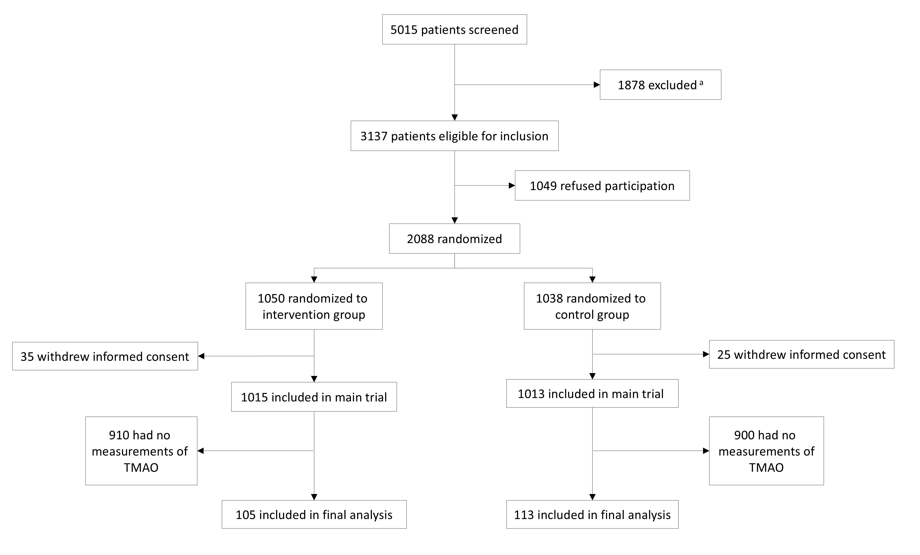

TMAO, Trimethylamine N-oxide
ª Reasons for exclusion: 145 surgical patients, 268 unable to ingest oral nutrition, 158 terminal condition, 719 already receiving nutritional therapy upon admission, 31 anorexia nervosa, 161 acute pancreatitis, 81 acute liver failure, 6 cystic fibrosis, 11 stem-cell transplantation, 27 malnutrition after gastric bypass operation, 43 contraindication against nutritional support, 228 earlier inclusion in the trial

Supplemental Figure A.2 Kaplan Meier survival analysis regarding TMAO quartiles and time to death within 5 years

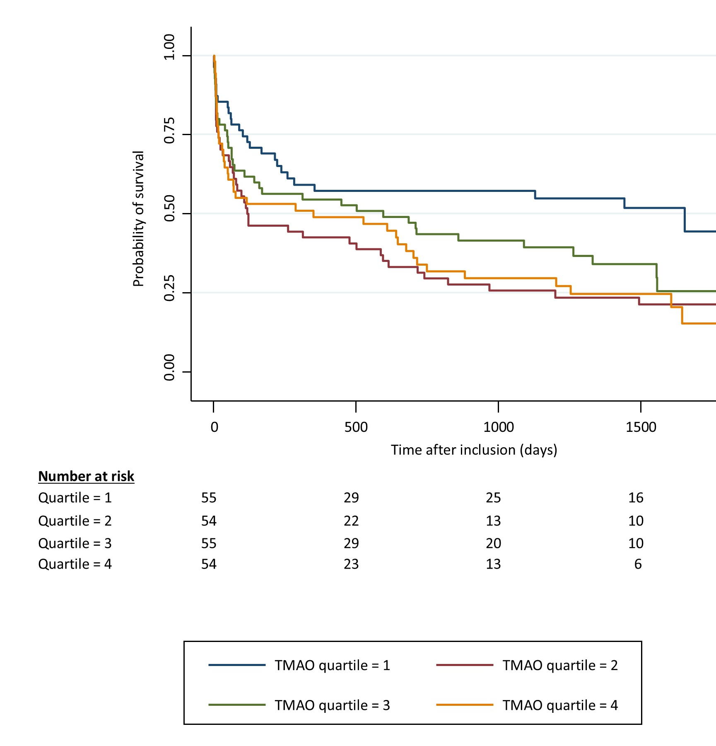

TMAO, Trimethylamine N-oxide

Supplemental Figure A.3 Forest plot for the effect of nutritional therapy on major adverse cardiovascular events (MACE)

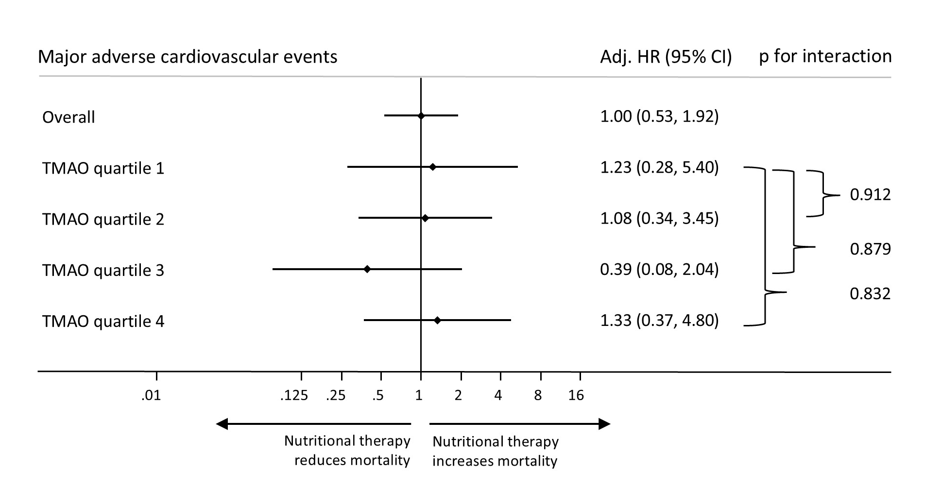

MACE, major adverse cardiovascular events. Adj. HR, adjusted hazard ratio. CI, confidence interval.
Adjusted for sex, age, NRS total score and randomization group.

