SUPPLEMENTARY INFORMATION

Supplementary Table S1. Raw Scores on Vineland Adaptive Behavior Scales – Second Edition (Vineland-2)

 | Subject 2 |  | Subject 3 |  |  | Subject 4 |  | Subject 5
Skill Area | Month 12# | Month 24 | BL | Month 12 | Month 24 | BL | Month 12 | BL | Month 12
Receptive Communication | 21 | 23 | 5 | 8 | 11 | 9 | 11 | 16 | 25
Expressive Communication | 18 | 38 | 9 | 11 | 10 | 12 | 15 | 12 | 14
Written Communication | 0 | 2 | 0 | 0 | 0 | 0 | 0 | 2 | 7
Personal DLS | 4 | 9 | 0 | 5 | 5 | 0 | 4 | 4 | 8
Domestic DLS | 0 | 0 | 0 | 0 | 0 | 0 | 0 | 0 | 0
Community DLS | 2 | 5 | 0 | 0 | 1 | 0 | 0 | 1 | 1
Interpersonal Relationships | 21 | 26 | 21 | 19 | 22 | 21 | 23 | 15 | 19
Play & Leisure Time | 6 | 20 | 6 | 7 | 8 | 5 | 6 | 6 | 9
Coping Skills | 10 | 17 | 4 | 4 | 4 | 3 | 5 | 4 | 4
Gross Motor | 8 | 16 | 0 | 4 | 6 | 4 | 6 | 1 | 8
Fine Motor | 10 | 17 | 0 | 0 | 1 | 6 | 9 | 1 | 12
DLS, Daily Living Skills
#BL assessment not performed

Supplementary Figure S1: FDOPA PET demonstrates increased AADC activity in midbrain and striatum 3 months after gene transfer.

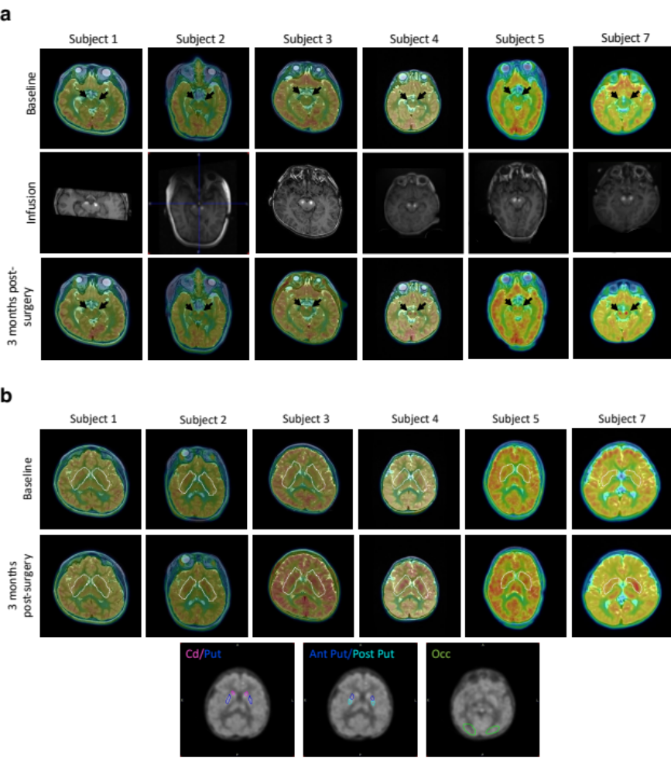
a, Images in the top row show FDOPA uptake in the midbrain before AAV2-hAADC infusion (baseline). The center row shows representative slices of the infusion at the midbrain for each subject as visualized by the MR-tracer (white regions in midbrain). Bottom row images present the FDOPA uptake in the same area of the midbrain 3 months after surgery. Black arrows in top and bottom rows point to the infusion target (SNc and VTA). b, Images in top and center rows show FDOPA uptake at the level of striatum. White dotted line indicates the striatum (caudate nucleus and putamen), the postsynaptic nucleus of the nigrostriatal pathway. Images in bottom row show representative slices used to select VOIs. Ki data were normalized by referencing them to the FDOPA uptake in the occipital lobe (VOI/Occ ratio).

